Intolerance of Uncertainty predicts paranoia over time: Evidence from a UK sample

Yingyixue Lei¹
Anton Martinez¹
Vyv Huddy¹
Jayne Morriss²,
Lyn Ellett²
Richard Bentall ^{1*}

¹School of Psychology, University of Sheffield, Sheffield (UK)
² School of Psychology, Faculty of Environmental and Life Sciences, University of Southampton, Southampton, UK

* Correspondence: Richard Bentall, University of Sheffield, Sheffield (UK), Clinical Psychology Unit, Department of Psychology, Cathedral Court, 1 Vicar Lane, S1 2LT

Abstract
Paranoia, often associated with schizophrenia spectrum disorders, also exists on a continuum with ordinary mistrust and is prevalent in non-clinical populations. Recent research suggests that Intolerance of Uncertainty (IU), a dispositional trait reflecting a negative response to uncertainty, may play a significant role in predicting paranoia. This study aimed to examine the longitudinal relationship between IU and paranoia, using data from the Covid-19 Psychological Research Consortium Study (C19PRC). 2025 participants representative of the UK population were recruited and assessed across three waves over nine months. Path analysis revealed that IU consistently predicted paranoia over time, even after controlling for negative affective traits such as neuroticism, and common co-occurring symptoms such as anxiety, and depression. Partial correlation analyses revealed stronger relationships between paranoia and Inhibitory IU than Prospective IU. These findings suggest that IU is a stable and independent predictor of paranoia. This study extends previous cross-sectional research by providing longitudinal evidence of associations between IU and paranoia and suggests that IU may represent a promising target for future research on intervention strategies.
Keywords: Intolerance of Uncertainty; Paranoia; Anxiety; Depression; Longitudinal

Introduction
Intolerance of Uncertainty (IU) is a dispositional trait that reflects a strong negative reaction to situations of uncertainty. IU is characterised via two dimensions: prospective IU (cognitive appraisals of threat related to future uncertainty) and inhibitory IU (behavioural inhibition related to uncertainty) (Robichaud, Koerner, & Dugas, 2019). Individuals with high levels of IU find uncertainty distressing and make substantial efforts to avoid or eliminate it (Buhr & Dugas, 2006).
The high comorbidity observed among psychiatric conditions may, in part, be attributed to shared underlying vulnerabilities (Braga et al., 2013; Buckley et al., 2009). IU has emerged as a critical transdiagnostic dimension that plays a significant role in the development and maintenance of various psychological disorders, including anxiety, depression, and schizophrenia spectrum conditions (Morriss et al., 2024). It is considered to be a general psychological vulnerability, reflecting an enduring fear of the unknown, and is closely linked to cognitive factors such as anxiety sensitivity, fear of negative evaluation, and rumination (Hong & Cheung, 2015). IU has been consistently associated with depression, with clinical samples showing higher levels of IU compared to non-clinical individuals (Carleton et al., 2012; Gentes & Ruscio, 2011). Moreover, IU is elevated in individuals with anxiety-related disorders and eating disorders, underscoring its role as a common factor across various conditions (Brown et al., 2017). These findings highlight IU as a core transdiagnostic vulnerability factor, influencing the manifestation and persistence of a broad range of psychological difficulties.
At the same time, some studies have attempted to link IU to psychosis. Recent literature reviews have revealed that higher intolerance of uncertainty is associated with more severe psychotic symptoms, particularly paranoia (Morriss et al., 2024). Paranoia involves the mistaken belief that others are intentionally seeking to cause harm to the individual (Freeman & Garety, 2014). Although paranoia is frequently considered a feature of schizophrenia spectrum and other psychotic disorders, existing evidence indicates that it exists on a continuum with ordinary mistrust and suspiciousness (Elahi et al., 2017). The prevalence of paranoia in individuals without a psychiatric diagnosis range from 2% to 30% according to how it is measured (Bebbington et al., 2013; American Psychiatric Association, 2013). Paranoia is thought to be closely associated with reasoning biases, which play a significant role in its development and maintenance (Phillips et al., 2000; Freeman et al., 2008). Intolerance of uncertainty has been identified as a key factor contributing to these biases, including a tendency to jump to conclusions, an increased tendency to overestimate threat scenarios, and excessive seeking of threat-related cues (Broom et al., 2007; Zheng et al., 2022; Shihata et al., 2016; Bauer et al., 2020). These observations suggest that IU may play a crucial role in the cognitive processes underlying paranoia. Zheng (2022) found that, even after controlling for worry, IU is independently associated with all four domains of paranoid thinking: persecutory beliefs, interpersonal sensitivities, mistrust, and ideas of reference. This association remains significant when anxiety is also controlled for (King & Dudley, 2017; Startup et al., 2016).
However, these studies are limited in their sample sizes (fewer than 400 participants) and are cross-sectional in nature, measuring variables at only a single point in time. Consequently, they do not provide longitudinal evidence regarding the relationship between paranoia and IU. Therefore, this study aims to advance our understanding by using a large longitudinal dataset collected over a period exceeding six months. Our analyses will compare the effect of IU on paranoia with its effect on depression and anxiety, given that Freeman's (2008) cognitive model of persecutory ideation suggests that depression may also be a strong predictor of paranoid thinking, and given previous research indicating as association between IU and both emotional conditions. We also control for neuroticism as a general measure of emotional reactivity.
In summary, we hypothesize that, after controlling for neuroticism, anxiety, and depression, IU will predict paranoia across time.

Methodology

Participants/procedure
This study is conducted on the data collected in the first (23-28 March 2020, n = 2025, 48% female, M_{age} = 45.45 years [SD = 15.9], 91% white background) second (22 April-1 May 2020, n = 1406) and forth (25 November-22nd December 2020, n = 1271) waves of the longitudinal Covid-19 Psychological Research Consortium Study (C19PRC; McBride et al., 2021 ) . To address missing data, we employed multiple imputation using five imputed datasets, which allowed for more accurate estimation while preserving sample size. Data from the third wave were not utilized, as the paranoia measure was only administered in Waves 1, 2, and 4. The study was funded by the Universities of Sheffield and Ulster, with additional support from the Economic and Social Research Council (see Acknowledgment). Participants aged 18 years and older were recruited online in the United Kingdom by the survey company Qualtrics, using quota sampling based on age, sex, and household income to ensure representativeness of the UK population. The University of Sheffield granted ethical approval for the C19PRC study (Reference number 033759). Each participant received information about the study's purpose, was assured of the confidentiality of their data, informed of their right to withdraw from the study at any point, and gave informed consent.

Measures
Paranoid beliefs were measured at waves 1, 2 and 4 using the short 5-item version of the persecutory subscale of the Persecution and Deservedness Scale (PADS; Melo et al., 2009) developed by McIntyre et al. (2018). Items include statements such as “I’m often suspicious of other people’s intentions towards me” and “People will almost certainly lie to me.” Participants rated their agreement on a scale from 1 (strongly disagree) to 5 (strongly agree), total score range 5-25. In the current study, Cronbach's alpha for this scale was 0.86 at wave 1, 0.92 at wave 2, and 0.87 at wave 4.
Depression was measured at waves 1, 2 and 4 using Patient Health Questionnaire‐9 (The PHQ-9; Kroenke, Spitzer, & Williams, 2001). The PHQ-9 evaluates each of the nine DSM-IV criteria for depression over the past two weeks on a scale from “0” (not at all) to “3” (nearly every day). Example items include “Little interest or pleasure in doing things” and “Feeling tired or having little energy”. total score range 0-27. In the current study, Cronbach's alpha for this scale was 0.92 at wave 1, 0.86 at wave 2, and 0.94 at wave 4.
Anxiety was measured at waves 1, 2 and 4 using the Generalized Anxiety Disorder Scale‐7 (The GAD-7; Spitzer, Kroenke, Williams, & Löwe, 2006). Participants were asked how often they were bothered by each symptom over the past two weeks. Example items include statements such as “Feeling nervous, anxious or on edge” and “Becoming easily annoyed or irritable”.Response options included “not at all,” “several days,” “more than half the days,” and “nearly every day,” scored as 0, 1, 2, and 3, total score range 0-21. respectively. In the current study, Cronbach's alpha for this scale was 0.94 at wave 1, 0.94 at wave 2, and 0.96 at wave 4.
Intolerance of Uncertainty was measured at wave 1 using the Intolerance of Uncertainty Scale (IUS-12; Carleton et al., 2007). Example items include statements such as “Unforeseen events upset me greatly” and “Uncertainty keeps me from living a full life”. The first seven items assessed fear and anxiety regarding future events, categorized as Prospective IU. and the remaining five items assessed inhibition of action or experience due to uncertainty, thus categorized as Inhibitory IU. Participants rated their agreement on a five-point scale ranging from 1 (not at all characteristics of me) to 5 (entirely characteristic of me), total score range 12- 60. In the current study, Cronbach's alpha for this scale was 0.90 at wave 1.
Neuroticism was measured at wave 1 using the sum score of the two neuroticism items from the Big Five Inventory-10 (BFI-10; Rammstedt & John, 2007): "I see myself as someone who is relaxed, handles stress well" and "I see myself as someone who gets nervous easily." Participants rated their level of agreement with these statements on a five-point scale, ranging from 1 (Disagree strongly) to 5 (Agree strongly), total score range 2-10. The correlation between two items on the scale in this study was Pearson’s r = 0.487.

Statistical analysis
Our analyses aimed to estimate and compare the specific associations between IU and paranoia, depression, and anxiety. First, we present bivariate correlations between the variables measured. For bivariate correlation analyses, we adopted an a priori alpha level of p < .01 to account for the large number of comparisons and the large sample size, thereby reducing the likelihood of Type I errors. We then employ Structural Equation Modeling (SEM), with IU as a latent variable, using the Prospective IU and Inhibitory IU dimensions as indicators. To ensure model identification, a fixed loading approach was applied for the latent variable IU. Specifically, the loading of Prospective IU was constrained to 1.0. This is a standard practice in structural equation modelling when a latent variable has only two indicators, and it allows for just-identification of the measurement model. The outcome variables were paranoia, depression, and anxiety. To isolate the unique contribution of IU to each outcome, neuroticism was included in the model as a covariate. This approach enabled us to examine the extent to which IU independently predicted variations in paranoia, depression, and anxiety. We also controlled for the following demographic variables: age, ethnicity, education level, and gender. Separate SEM models were conducted examining the effect of IU on paranoia, depression and anxiety data at waves 1, 2, and 4, but with IU always at wave 1. Thus, we aimed to test the extent to which IU at wave 1 was associated with the clinical outcomes cross-sectionally, and 1 month and 8 months later. Wald tests and semi-partial correlations were used in each model to test for differences in the magnitude of association between IU and the three outcomes. The model is shown schematically in Figure 1.
Meanwhile, to determine whether IU predicts changes in paranoia over time, above and beyond baseline levels of paranoia, we used a longitudinal structural equation model that included autoregressive paths for paranoia at all waves. Specifically, paranoia at Wave 2 was regressed on Wave 1 paranoia, and paranoia at Wave 4 was regressed on both Wave 1 and Wave 2 paranoia. This modelling approach allowed us to control for the temporal stability of paranoia and to assess whether IU explains residual changes in paranoia across time. The full model is shown in Figure 2.
All analyses were conducted in R 4.3.1 using the lavaan package. The SEM function was employed for calculating the regression models, and the lavTestWald function was used for testing the equality of constraints between regression coefficients.
We present the following goodness-of-fit indices: the chi-square test, the Comparative Fit Index (CFI), the Tucker-Lewis Index (TLI), the Root Mean Square Error of Approximation (RMSEA), and the Standardized Root Mean Squared Residual (SRMR). A CFI value close to or greater than 0.95 indicates a good fit. TLI values close to or greater than 0.95 also suggest a good fit. RMSEA values less than 0.06 are indicative of a good fit, with values up to 0.08 considered acceptable. SRMR values less than 0.08 are generally interpreted as indicating an acceptable fit (Hu and Bentler, 1999).
The adequacy of the sample size used in the present study (N = 2025) was supported by both theoretical guidelines and statistical power analysis. First, according to Beran and Violato (2010), Monte Carlo simulations can be used to determine adequate sample size for SEM. Their findings suggest that for a model with one latent variable and five observable indicators, a minimum of 10 participants per indicator (i.e., approximately 50 participants in total) is sufficient. Given that our model includes a total sample size of 2025 participants, the current study far exceeds the minimum requirements suggested by this guideline. Second, we used the RMSEA-based approach proposed by MacCallum et al. (1996) to assess power, testing a deviation from close fit (RMSEA = .05) to mediocre fit (RMSEA = .08). The analysis showed a power of 1.00, indicating that our sample size (N = 2025) was more than adequate to detect meaningful model misfit.

Figure 1：General schematic model of relationships tested. Separate models were calculated with IU always at time 1 and outcome variables at each of the three time points.
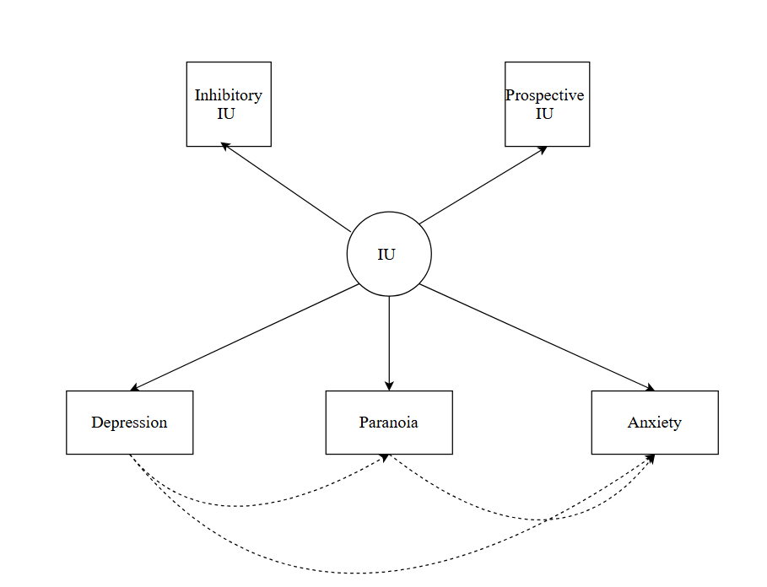

Figure 2. Longitudinal path model of IU predicting changes in paranoia at Waves 2 and 4, with autoregressive controls.
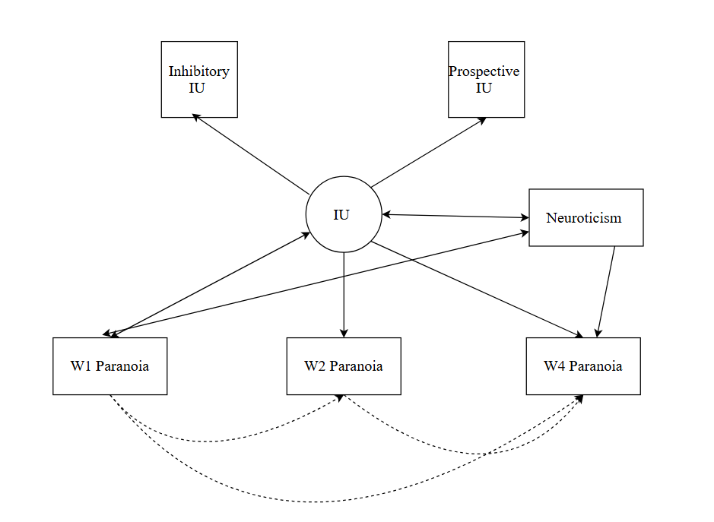

Results
Table 1 shows bivariate correlations between the measures used in this study. The results indicate that both Prospective and Inhibitory IU are significantly correlated with paranoia, depression, and anxiety across all time points. In general, Inhibitory IU shows stronger correlations with neuroticism (r = .560), W1 paranoia (r = .542), and W1 GAD (r = .495), compared to prospective IU's correlations with the same variables: neuroticism (r = .379), W1 paranoia (r = .350), and W1 GAD (r = .403), indicating medium to large effect sizes. For paranoia, both Prospective and Inhibitory IU showed significant positive relationships across time, with Inhibitory IU consistently displaying higher correlation coefficients. Similarly, both dimensions of IU were positively associated with depression and anxiety, again with Inhibitory IU exhibiting stronger associations.
Table 1: Bivariate correlations between Prospective IU, Inhibitory IU and other variables
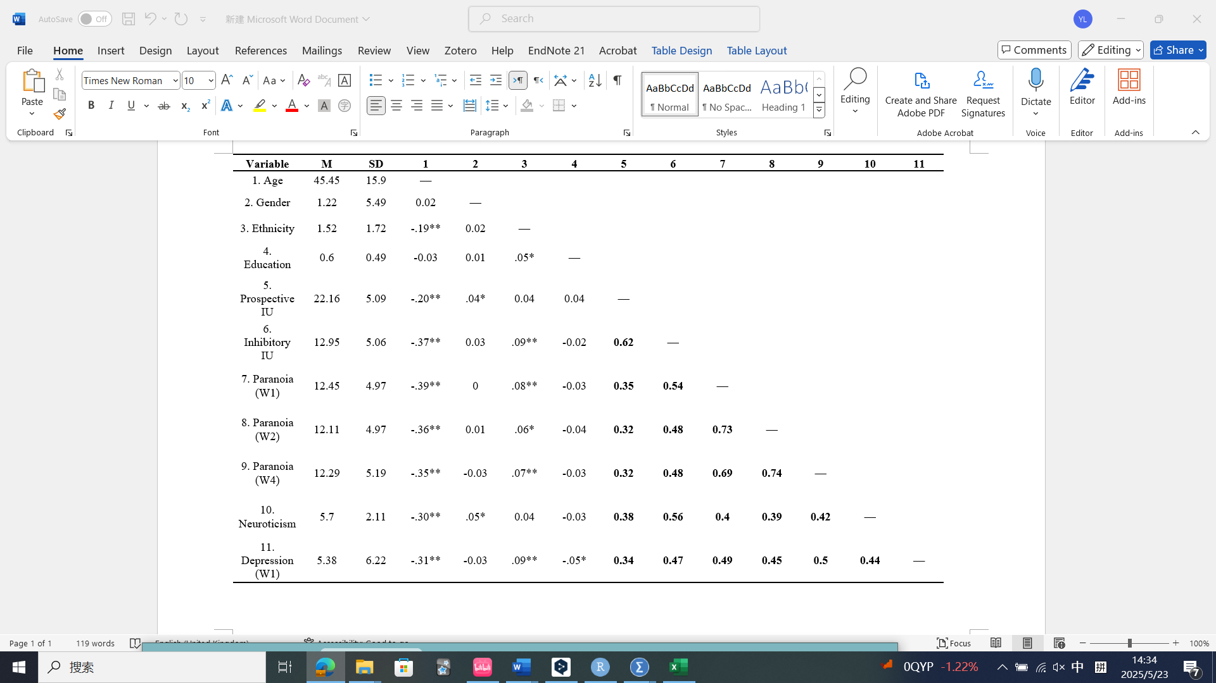
**. Correlation is significant at the 0.01 level (2-tailed).

Steiger's Z tests, revealed significant differences in the strength of correlations between prospective and inhibitory intolerance of uncertainty (IU) with paranoia at all time points, confirming that inhibitory IU is more strongly related to paranoia than prospective IU. Specifically, at W1, the Z value was -11.45, p < .001; at W2, the Z value was -9.35, p < .001; and at W4, the Z value was -8.83, p < .001.
Fit indices for the models at the three time points are shown in Table 2. All fall within the acceptable ranges, indicating that the models had good fit.

Table 2：Model fit indices
Time point for outcomes | χ² | p | CFI | TLI | SRMR | RMSEA
W1 | 153.48 | < .001 | .979 | .943 | .029 | .063
W2 | 133.92 | < .001 | .982 | .952 | .028 | .058
W4 | 120.936 | < .001 | .984 | .959 | .055 | .028

At all three time points a robust association was observed between IU and paranoia, controlling for neuroticism and demographic variables (Table 3). Similar robust associations were found between IU and both anxiety and depression (also shown in Table 3).
Table 3：Path estimation of models.
Time points | Path | Standardized Regression weights | p
W1 | IU → paranoia | .677 | < .001
 | IU → depression | .636 | < .001
 | IU → anxiety | .524 | < .001
W2 | IU → paranoia | .553 | < .001
 | IU → depression | .590 | < .001
 | IU → anxiety | .544 | < .001
W4 | IU → paranoia | .529 | < .001
 | IU → depression | .534 | < .001
 | IU → anxiety | .402 | < .001

Note. To assess the impact of participant attrition, a sensitivity analysis was conducted using only participants who completed all three waves of data collection (N = 1037). The pattern of results remained consistent with the full sample analysis (N = 2025, 5-imputed datasets). Core paths (e.g., from IU to paranoia) remained statistically significant and of similar magnitude, and overall model fit was slightly improved in the reduced sample. This suggests that the reported findings are robust to the exclusion of single-wave participants.
The result of Longitudinal path model shows an excellent Model fit (CFI = 1.000, RMSEA = .000, SRMR = .003). As shown in Table 4, IU at Wave 1 significantly predicted paranoia at both Wave 2 and Wave 4, with controlling for the baseline of paranoia.
Table 4. Standardized path coefficients from the longitudinal path model predicting paranoia at wave 2 and wave 4
Outcome | Time Point | β | SE | p-value
Paranoia | Wave 2 | 0.089 | 0.037 | < .001
Paranoia | Wave 4 | 0.043 | 0.034 | .046

The results of the Wald tests, together with semi-partial correlations between IU and three psychopathology measures are shown in Table 5. Note that a semi-partial correlation of less than .09 should be considered trivial (Cohen, 1992). The Wald tests show no significant differences between the associations for paranoia and depression at any time point. However, at wave 1, IU was more strongly associated with paranoia than with anxiety, a pattern that was also observed at wave 4 but not at wave 2. Similarly, IU was more strongly associated with depression than with anxiety at waves 1 and 4, but no significant differences were found at wave 2. These patterns align with the findings from the semi-partial correlation analysis, which demonstrated that IU was consistently associated with paranoia at all waves, with the strongest association occurring at wave 1, followed by a gradual decrease at waves 2 and 4. In contrast, IU had only a trivial association with depression at waves 1 and 2, but a small yet nontrivial association emerged at wave 4. For anxiety, IU showed a weak association at waves 1 and 2, but this effect was no longer evident at wave 4.

Table 5：Wald test results
Timepoints | Variables | IU (sr) | Wald test: IU → Paranoia vs. IU →Depression | Wald test: IU → Paranoia vs. IU →Anxiety | Wald test: IU → Depression vs. IU → Anxiety
W1 | Paranoia | .292***
 | Depression | -.013 | .458 | 7.42** | 9.33**
 | Anxiety | .069**
W2 | Paranoia | .218***
 | Depression | -.014 | .458 | .030 | 2.01
 | Anxiety | .073**
W4 | Paranoia | .203***
 | Depression | .058** | .00829 | 6.09** | 15.4***
 | Anxiety | -0.038
*P < 0.05; **P < 0.01; ***P < 0.001

Discussion
In this study, we first examined whether IU could predict paranoia across three time points. Path analysis revealed that IU's standardized regression coefficients for paranoia were large and significant at all three time points (W1, W2, and W4), indicating that IU indeed has an independent predictive effect on paranoia. This is consistent with the findings of previous cross-sectional studies (King & Dudley, 2017; Startup et al., 2016; Morriss et al., 2024). Hence, these results support our hypothesis that IU can predict paranoia across time, even after controlling for potential confounding factors such as neuroticism, anxiety, and depression. The SEM models at all three time points demonstrated good fit, indicating that IU has cross-temporal predictive power for paranoia. These results were further supported by a longitudinal analysis that accounted for the temporal stability of paranoia. Even after controlling for earlier levels of paranoia, IU at Wave 1 significantly predicted increases in paranoia at later time points. This suggests that IU plays a unique and enduring role in the exacerbation of paranoid ideation over time. These findings supplement previous cross-sectional studies by providing the first evidence of longitudinal effects.
Across these three time points, IU's regression weights for anxiety were consistently smaller compared to those for paranoia, which might seem surprising given the very large literature on the contribution of IU to anxiety (for meta-analysis see, Gentes et al., 2011). This difference was reflected in the significant Wald test results observed at two of the time points, indicating that the strength of the association between IU and paranoia was greater than that with anxiety. This pattern of results suggests that IU may be more strongly associated with cognitive-affective processes characteristic of paranoia than with those underlying general anxiety. This result is consistent with the observation that IU has a more significant impact on paranoia than general anxiety-related phenomena, as found in some previous studies (Sun et al., 2019; Zheng et al., 2022). One possible explanation is that individuals with higher IU tend to perceive ambiguous information as threatening, a tendency more closely related to paranoia than to anxiety or depression (Dugas et al., 2005). Uncertain social situations are common in daily life, are particularly likely to activate negative schemas in those who have other vulnerabilities to paranoia such as insecure attachment styles (Sitko et al., 2014; Wickham et al., 2015) and defensive explanatorily styles, leading to interpersonal suspicion and social referencing (Zheng et al., 2022).
We also examined the differential impact of the two dimensions of Intolerance of Uncertainty, Prospective IU and Inhibitory IU, on paranoia. The results showed that Inhibitory IU had stronger associations with paranoia across all time points compared to Prospective IU, a finding that is in line with a previous cross-sectional study with a multisite international sample (Morriss et al., 2024). The inhibitory IU subscale reflects an individual's tendency to experience behavioural inhibition and decision-making paralysis when faced with uncertainty and is strongly associated with a tendency to excessively attend to uncertainty-related stimuli, (Pineles et al., 2009; Fergus et al., 2013). In as much as paranoia is characterised by excessive sensitivity to the possibility of threat (Green & Phillips, 2004) and fear and avoidance of potentially threatening situations (Freeman at al 2007), it is possible that this facet of intolerance of uncertainty exacerbates these tendencies.
However, we also find that the paths from IU to depression and paranoia across the three time points did not differ significantly, indicating that the impact of IU on both expressions of psychopathology may be comparable. This may help to explain the high comorbidity rates for the two conditions. Hence, numerous studies have demonstrated an association between depressive symptoms and paranoid thoughts in the general population (Saarinen et al. 2018); more than 25% of individuals with depression exhibit clinical symptoms of paranoia, and at least 50% of patients with schizophrenia suffer from severe depression (Ramklint & Ekselius, 2003; Moritz et al., 2017; Saarinen et al., 2018). Further research may explore if IU is a common mechanism underlying this effect. Regarding the clinical implications of this study, evidence-based psychological treatments targeting intolerance of uncertainty have already been employed in treating patients with anxiety disorders (Hebert & Dugas, 2019). The present findings offer theoretical support for the potential relevance of such interventions in the context of paranoia. However, it is important to note that the current data are correlational and nonexperimental, and therefore do not establish causal relations between IU and paranoia. Further research, including experimental and longitudinal intervention designs, is necessary to determine the mechanisms of change and to evaluate the efficacy and directionality of such approaches for individuals experiencing paranoid ideation.

Strengths and limitations
To our knowledge, this study is the first of its kind to use a large longitudinal sample to provide evidence of a cross-temporal association between IU and paranoia. This relationship appears to be independent of anxiety.
This study has some limitations. First, the first wave of data was collected at the onset of the first nationwide lockdown during the COVID-19 pandemic. Since paranoia and anxiety are believed to be heightened in situations of threat and uncertainty, and pandemic-specific paranoia has been shown to be prevalent during Covid-19 (Kingston et al., 2023; Ellett et al., 2023), these beliefs may have been influenced by the global impact of the pandemic at both social and personal levels, which could affect the generalizability of the results. Future research can benefit from using data collected outside the context of the COVID-19 pandemic. Second, while several demographic covariates (age, gender, education level, and ethnicity) were included in the models, the limited variability in ethnicity—91% of participants identified as White—may constrain the interpretability of its contribution. Follow-up analyses indicated that the inclusion or exclusion of this variable did not meaningfully alter the results, suggesting that its predictive contribution was minimal. Ethnicity was modelled dichotomously (White vs. non-White), but given the low proportion of non-White participants, future research should aim to recruit more ethnically diverse samples to enhance the generalizability of findings and better evaluate potential moderating effects of cultural background. Finally, the data used in this study were collected over a short-term period (approximately nine months), and it would be useful to conduct longitudinal studies over a longer timeframe.

Conclusion
This study provides evidence that IU significantly predicts paranoia across multiple time points, reinforcing its role as an independent predictor of paranoid thoughts. The consistent and statistically significant regression coefficients observed at each time point demonstrate IU's stable influence on paranoia, even when accounting for potential confounding factors such as neuroticism, anxiety, and depression.

References
American Psychiatric Association. (2013). Diagnostic and statistical manual of mental disorders (5th ed.). American Psychiatric Publishing.
Bauer, E. A., MacNamara, A., Sandre, A., Lonsdorf, T. B., Weinberg, A., Morriss, J., & van Reekum, C. M. (2020). Intolerance of uncertainty and threat generalization: A replication and extension. Psychophysiology, 57(5), e13546. https://doi.org/10.1111/psyp.13546
Bebbington, P. E., McBride, O., Steel, C., Kuipers, E., Radovanoviĉ, M., Brugha, T., Jenkins, R., Meltzer, H. I., & Freeman, D. (2013). The structure of paranoia in the general population. The British Journal of Psychiatry, 202(6), 419–427. https://doi.org/10.1192/bjp.bp.112.119032
Beran, T. N., & Violato, C. (2010). Structural equation modeling in medical research: A primer. BioMed Central Research Notes, 3(1), 1-10. https://doi.org/10.1186/1756-0500-3-267
Braga, R. J., Reynolds, G. P., & Siris, S. G. (2013). Anxiety comorbidity in schizophrenia. Psychiatry Research, 210(1), 1–7. https://doi.org/10.1016/j.psychres.2013.07.030
Broome, M. R., Johns, L. C., Valli, I., Woolley, J. B., Tabraham, P., Brett, C., Valmaggia, L., Peters, E., Garety, P. A., & McGuire, P. K. (2007). Delusion formation and reasoning biases in those at clinical high risk for psychosis. BRITISH JOURNAL OF PSYCHIATRY, 191. https://doi.org/10.1192/bjp.191.51.s38
Brown, M., Robinson, L., Campione, G. C., Wuensch, K., Hildebrandt, T., & Micali, N. (2017). Intolerance of Uncertainty in Eating Disorders: A Systematic Review and Meta-Analysis. European Eating Disorders Review, 25(5), 329–343. https://doi.org/10.1002/erv.2523
Buckley, P. F., Miller, B. J., Lehrer, D. S., & Castle, D. J. (2009). Psychiatric Comorbidities and Schizophrenia. Schizophrenia Bulletin, 35(2), 383–402. https://doi.org/10.1093/schbul/sbn135
Buhr, K., & Dugas, M. J. (2006). Investigating the construct validity of intolerance of uncertainty and its unique relationship with worry. Journal of Anxiety Disorders, 20(2), 222–236. https://doi.org/10.1016/j.janxdis.2004.12.004
Carleton, R. N., Mulvogue, M. K., Thibodeau, M. A., McCabe, R. E., Antony, M. M., & Asmundson, G. J. G. (2012). Increasingly certain about uncertainty: Intolerance of uncertainty across anxiety and depression. Journal of Anxiety Disorders, 26(3), 468–479. https://doi.org/10.1016/j.janxdis.2012.01.011
Carleton, R. N., Norton, M. A. P. J., & Asmundson, G. J. G. (2007). Fearing the unknown: A short version of the Intolerance of Uncertainty Scale. Journal of Anxiety Disorders, 21(1), 105–117. https://doi.org/10.1016/j.janxdis.2006.03.014
Cohen, J. (1992). A power primerr. Psychol. Bull. 112, 155–159. doi: 10.1037/0033-2909.112.1.155
Dugas, M. J., Hedayati, M., Karavidas, A., Buhr, K., Francis, K., & Phillips, N. A. (2005). Intolerance of Uncertainty and Information Processing: Evidence of Biased Recall and Interpretations. Cognitive Therapy and Research, 29(1), 57–70. https://doi.org/10.1007/s10608-005-1648-9
Elahi, A., Perez Algorta, G., Varese, F., McIntyre, J. C., & Bentall, R. P. (2017). Do paranoid delusions exist on a continuum with subclinical paranoia? A multi-method taxometric study. Schizophrenia Research, 190, 77–81. https://doi.org/10.1016/j.schres.2017.03.022
Ellett, L., Schlier, B., Kingston, J. L., Zhu, C., So, S. H., Lincoln, T. M., Morris, E. M. J., & Gaudiano, B. A. (2023). Pandemic paranoia in the general population: International prevalence and sociodemographic profile. Psychological Medicine, 53(12), 5748–5755. https://doi.org/10.1017/S0033291722002975
Fergus, T. A., Bardeen, J. R., & Wu, K. D. (2013). Intolerance of Uncertainty and Uncertainty-Related Attentional Biases: Evidence of Facilitated Engagement or Disengagement Difficulty? Cognitive Therapy and Research, 37(4), 735–741. https://doi.org/10.1007/s10608-012-9509-9
Freeman, D., & Garety, P. (2014). Advances in understanding and treating persecutory delusions: A review. Social Psychiatry and Psychiatric Epidemiology, 49(8), 1179–1189. https://doi.org/10.1007/s00127-014-0928-7
Freeman, D., Pugh, K., Antley, A., Slater, M., Bebbington, P., Gittins, M., Dunn, G., Kuipers, E., Fowler, D., & Garety, P. (2008). Virtual reality study of paranoid thinking in the general population. The British Journal of Psychiatry, 192(4), 258–263. https://doi.org/10.1192/bjp.bp.107.044677
Freeman, D., Pugh, K., & Garety, P. (2008). Jumping to conclusions and paranoid ideation in the general population. Schizophrenia Research, 102(1), 254–260. https://doi.org/10.1016/j.schres.2008.03.020
Gentes, E. L., & Ruscio, A. M. (2011). A meta-analysis of the relation of intolerance of uncertainty to symptoms of generalized anxiety disorder, major depressive disorder, and obsessive–compulsive disorder. Clinical Psychology Review, 31(6), 923–933. https://doi.org/10.1016/j.cpr.2011.05.001
Green, M. J., & Phillips, M. L. (2004). Social threat perception and the evolution of paranoia. Neuroscience & Biobehavioral Reviews, 28(3), 333–342. https://doi.org/10.1016/j.neubiorev.2004.03.006
Hebert, E. A., & Dugas, M. J. (2019). Behavioral Experiments for Intolerance of Uncertainty: Challenging the Unknown in the Treatment of Generalized Anxiety Disorder. Cognitive and Behavioral Practice, 26(2), 421–436. https://doi.org/10.1016/j.cbpra.2018.07.007
Hong, R. Y., & Cheung, M. W.-L. (2015). The Structure of Cognitive Vulnerabilities to Depression and Anxiety: Evidence for a Common Core Etiologic Process Based on a Meta-Analytic Review. Clinical Psychological Science, 3(6), 892–912. https://doi.org/10.1177/2167702614553789
Hu, L., & Bentler, P. M. (1999). Cutoff criteria for fit indexes in covariance structure analysis: Conventional criteria versus new alternatives. Structural Equation Modeling: A Multidisciplinary Journal, 6(1), 1–55. https://doi.org/10.1080/10705519909540118
King, A., & Dudley, R. (2017). Paranoia, Worry, Cognitive Avoidance and Intolerance of Uncertainty in a student population. Journal of Applied Psychology and Social Science, 3(2), Article 2.
Kingston, J. L., Schlier, B., Ellett, L., So, S. H., Gaudiano, B. A., Morris, E. M. J., & Lincoln, T. M. (2023). The Pandemic Paranoia Scale (PPS): Factor structure and measurement invariance across languages. Psychological Medicine, 53(6), 2652–2661. https://doi.org/10.1017/S0033291721004633
Kroenke, K., Spitzer, R. L., & Williams, J. B. W. (2001). The PHQ-9. Journal of General Internal Medicine, 16(9), 606–613. https://doi.org/10.1046/j.1525-1497.2001.016009606.x
MacCallum, R. C., Browne, M. W., & Sugawara, H. M. (1996). Power analysis and determination of sample size for covariance structure modeling. Psychological Methods, 1, 130-149. doi: 10.1037/1082-989X.1.2.130.
McBride, O., Murphy, J., Shevlin, M., Gibson-Miller, J., Hartman, T. K., Hyland, P., Levita, L., Mason, L., Martinez, A. P., McKay, R., Stocks, T. V., Bennett, K. M., Vallières, F., Karatzias, T., Valiente, C., Vazquez, C., & Bentall, R. P. (2021). Monitoring the psychological, social, and economic impact of the COVID-19 pandemic in the population: Context, design and conduct of the longitudinal COVID-19 psychological research consortium (C19PRC) study. International Journal of Methods in Psychiatric Research, 30(1), e1861. https://doi.org/10.1002/mpr.1861
McIntyre, J. C., Wickham, S., Barr, B., & Bentall, R. P. (2018). Social Identity and Psychosis: Associations and Psychological Mechanisms. Schizophrenia Bulletin, 44(3), 681–690. https://doi.org/10.1093/schbul/sbx110
Melo, S., Corcoran, R., Shryane, N., & Bentall, R. P. (2009). The persecution and deservedness scale. Psychology and Psychotherapy: Theory, Research and Practice, 82(3), 247–260. https://doi.org/10.1348/147608308X398337
Moritz, S., Göritz, A. S., McLean, B., Westermann, S., & Brodbeck, J. (2017). Do depressive symptoms predict paranoia or vice versa? Journal of Behavior Therapy and Experimental Psychiatry, 56, 113–121. https://doi.org/10.1016/j.jbtep.2016.10.002
Morriss, J., Butler, D., & Ellett, L. (2024). Intolerance of uncertainty and psychosis: A systematic review. British Journal of Clinical Psychology, n/a(n/a). https://doi.org/10.1111/bjc.12509
Morriss, J., Gaudiano, B. A., So, S. H., Kingston, J., Lincoln, T., Morris, E. M. J., & Ellett, L. (2024). Associations between intolerance of uncertainty, paranoia, anxiety, and depression: Evidence from an international multisite sample. Mental Health Science, n/a(n/a), e81. https://doi.org/10.1002/mhs2.81
Phillips, M. L., Senior, C., & David, A. S. (2000). Perception of threat in schizophrenics with persecutory delusions: An investigation using visual scan paths. Psychological Medicine, 30(1), 157–167. https://doi.org/10.1017/S0033291799001397
Pineles, S. L., Shipherd, J. C., Mostoufi, S. M., Abramovitz, S. M., & Yovel, I. (2009). Attentional biases in PTSD: More evidence for interference. Behaviour Research and Therapy, 47(12), 1050–1057. https://doi.org/10.1016/j.brat.2009.08.001
Ramklint, M., & Ekselius, L. (2003). Personality traits and personality disorders in early onset versus late onset major depression. Journal of Affective Disorders, 75(1), 35–42. https://doi.org/10.1016/S0165-0327(02)00028-9
Rammstedt, B., & John, O. P. (2007). Measuring personality in one minute or less: A 10-item short version of the Big Five Inventory in English and German. Journal of Research in Personality, 41(1), 203–212. https://doi.org/10.1016/j.jrp.2006.02.001
Robichaud, M., Koerner, N., & Dugas, M. J. (2019). Cognitive Behavioral Treatment for Generalized Anxiety Disorder: From Science to Practice (2nd ed.). Routledge. https://doi.org/10.4324/9781315709741
Saarinen, A., Hintsanen, M., Hakulinen, C., Pulkki-Råback, L., Lehtimäki, T., Raitakari, O., & Keltikangas-Järvinen, L. (2018). The co-occurrence between depressive symptoms and paranoid ideation: A population-based longitudinal study. Journal of Affective Disorders, 229, 48–55. https://doi.org/10.1016/j.jad.2017.12.045
Sitko, K., Bentall, R. P., Shevlin, M., O'Sullivan, N., & Sellwood, W. (2014). Associations between specific psychotic symptoms and specific childhood adversities are mediated by attachment styles: An analysis of the National Comorbidity Survey. Psychiatry Research, 217, 202-209. https://doi.org/10.1016/j.psychres.2014.03.019
Shihata, S., McEvoy, P. M., Mullan, B. A., & Carleton, R. N. (2016). Intolerance of uncertainty in emotional disorders: What uncertainties remain? Journal of Anxiety Disorders, 41, 115–124. https://doi.org/10.1016/j.janxdis.2016.05.001
Spitzer, R. L., Kroenke, K., Williams, J. B. W., & Löwe, B. (2006). A Brief Measure for Assessing Generalized Anxiety Disorder: The GAD-7. Archives of Internal Medicine, 166(10), 1092–1097. https://doi.org/10.1001/archinte.166.10.1092
Startup, H., Pugh, K., Dunn, G., Cordwell, J., Mander, H., Cernis, E., Wingham, G., Shirvell, K., Kingdon, D., & Freeman, D. (2016). Worry processes in patients with persecutory delusions. BRITISH JOURNAL OF CLINICAL PSYCHOLOGY, 55(4). https://doi.org/10.1111/bjc.12109
Sun, X., So, S. H., Chan, R. C. K., Chiu, C.-D., & Leung, P. W. L. (2019). Worry and metacognitions as predictors of the development of anxiety and paranoia. Scientific Reports, 9(1), 14723. https://doi.org/10.1038/s41598-019-51280-z
Wickham, S., Sitko, K., & Bentall, R. P. (2015). Insecure attachment is associated with paranoia but not hallucinations in psychotic patients: The mediating role of negative self esteem. Psychological Medicine, 45, 1495-1507.https://doi.org/10.1017/S0033291714002633
Zheng, S., Marcos, M., Stewart, K. E., Szabo, J., Pawluk, E., Girard, T. A., & Koerner, N. (2022). Worry, intolerance of uncertainty, negative urgency, and their associations to paranoid thinking. Personality and Individual Differences, 186, 111382. https://doi.org/10.1016/j.paid.2021.111382

Supplementary Material

Table S1. Standardized Regression Coefficients from IU to Clinical Outcomes Without Covariates Across Waves
Outcome Variable | Wave | β (IU → Outcome) | p | CFI | RMSEA | SRMR
Paranoia | W1 | .843 | < .001 | .993 | .078 | .015
Depression | W1 | .930 | < .001
GAD | W1 | .902 | < .001
Paranoia | W2 | .750 | < .001 | .997 | .057 | .008
Depression | W2 | .852 | < .001
GAD | W2 | .829 | < .001
Paranoia | W4 | .781 | < .001 | 1.000 | .015 | .004
Depression | W4 | .833 | < .001
GAD | W4 | .755 | < .001

To test the robustness of our findings, we conducted sensitivity analyses in which all structural equation models were rerun without controlling for any covariates (neuroticism, age, gender, education, ethnicity). As shown in Table S1, IU remained a significant predictor of paranoia, depression, and anxiety at all three time points. Model fit indices remained excellent.

Acknowledgement
Data collection for the first two waves of the C19PRC study was funded by the Universities of Sheffield and Ulster and by the UK Economic and Social Research Council grant for all subsequent waves (A longitudinal mixed-methods population study of the UK during the COVID-19 pandemic: Psychological and social adjustment to a global threat; grant number ES/V004379/1).

