***Supplemental Figure 1:* Primary outcome by stratification factors from randomization by study arm.**

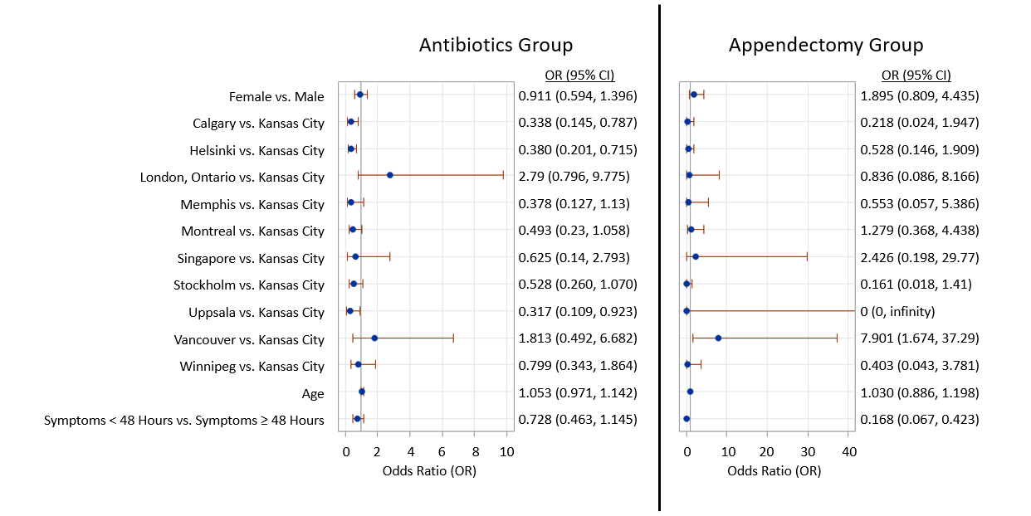

Odds ratios are presented along with their 95% confidence intervals. Kansas City (USA) was used as the reference group for all other participating sites.