**Conceptual origins and geomorphic evolution of the temple of Amun-Ra at Karnak (Luxor, Egypt)**

Benjamin T. Pennington1, Angus Graham2,*, Aurélia Masson-Berghoff3,4, Marie Millet5, Jan Peeters6, Willem H. J. Toonen7,8, Timotheus G. Winkels9, Luke H. Sollars10, Virginia. L. Emery11, Kristian D. Strutt12, Dominic S. Barker12

1 Geography & Environmental Science, University of Southampton, UK

2 Department of Archaeology, Ancient History and Conservation, Uppsala Universitet, Sweden

3 Department of Greece & Rome, The British Museum, London, UK

4 Department of Egypt & Sudan, The British Museum, London, UK

5 Department of Egyptian Antiquities, Musée du Louvre, Paris, France

6 Jebel Barkal Archaeological Project, Kelsey Museum of Archaeology, University of Michigan, Ann Arbor, USA

7 Faculty of Science, Earth & Climate, Vrije Universiteit Amsterdam, The Netherlands

8 Egyptology Unit, Katholieke Universiteit Leuven, Belgium

9 Water and Environment Group, WSP, Nieuwegein, The Netherlands

10 Independent Researcher, Salisbury, UK

11 National Park Service, Fort Union National Monument, Watrous, USA

12 Department of Archaeology, University of Southampton, UK

*Corresponding author (email: angus.graham@arkeologi.uu.se)

**Abstract**

Despite almost a century and a half of excavation, the dynamic landscape into which the temple complex of Karnak was embedded is not well understood. Presenting the results of the first comprehensive geoarchaeological survey of the area, the authors show that Karnak was built upon a fluvial terrace segment surrounded by river channels in an island configuration potentially recalling the ‘primeval mound’ of Egyptian creation myths. Permanent occupation of the site became possible after 2520 BC ±420 years, likely during the Old Kingdom. Subsequent landscape changes were dramatic, with the occupants of the island responding both opportunistically and proactively.

**Introduction**

Five hundred metres east of the present course of the River Nile near Luxor (Egypt) stands one of the ancient world’s largest temple complexes—Karnak—at the ancient Egyptian religious capital of Thebes (Barguet 1962). Occupied for some three thousand years, religious areas were dedicated to three main deities: Amun-Ra, Montu and Mut (Figure 1), with additional deities also incorporated into the built architecture. Karnak’s principal domain is the approximately 30ha temple precinct of Amun-Ra (Figure 2).

Archaeological investigations have been ongoing at the site for approximately 150 years (Legrain 1929; Barguet 1962; Arnaudiès & Laroze 2007; Gabolde 2018), yet the dynamic riverine landscape within which the temple was conceived, built and extended has not been understood in detail and the age of earliest occupation continues to be debated. Most researchers favour a First Intermediate Period (*c.* 2152–1980 BC; see also online supplementary material (OSM) Table S1) origin for Karnak based on in-situ excavated archaeological remains and a written reference to a temple of a ‘Ra-Amun’ from the reign of Intef I, II or III (traditionally Intef II *c.* 2066–2017 BC; Postel 2004: 72–73; Hornung *et al.* 2006: 491; Ullmann 2007: 4; Millet 2008: 308–9; Charloux & Mensan 2011: 231; Larché 2020: 121). These earliest excavated remains are found in the eastern part of the complex and south-east of the Sacred Lake (Figure 2: E4–6) and variously consist of mudbrick walls (including silos at E4) associated with ceramic material from the First Intermediate Period/early Eleventh Dynasty (Charloux *et al*. 2021: 928, 931; Gabolde 2018: 154–66; Millet 2007, 2008). Further north, near the Ptah Temple (Figure 2), a hearth is dated to the mid-Eleventh Dynasty (Eleventh Dynasty = *c.* 2080–1940 BC; Hornung *et al.* 2006: 491) (Charloux *et al*. 2021: 24, fig. 4). Other authors suggest Predynastic occupation (3900–3100 BC) at Karnak, based on material from old excavations and objects *ex situ* (Legrain 1906a: 21; Franchet 1917: 87, 99; Gabolde 2018: 135–36, 167).

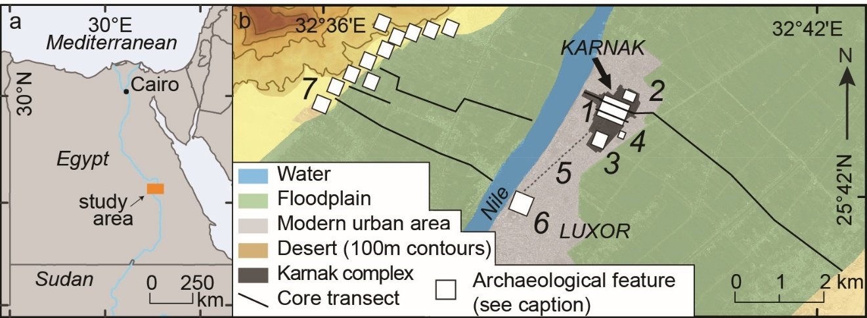

**Figure 1.** Location of study area: a) within Egypt; b) locally.Archaeological features: 1 Amun-Ra temple complex, Karnak; 2 Montu temple complex, North Karnak; 3 Mut temple complex; 4 Kom el-Ahmar; 5 Avenue of Sphinxes; 6 Luxor Temple; 7 Numerous temples and necropoleis (not all shown). The core transects outside the Karnak area are published (Toonen *et al.* 2018, 2019; Peeters *et al.* 2024).

Recent attempts to reconstruct the palaeoenvironmental setting of early Karnak (Gabolde 2018; Charloux *et al.* 2021) have primarily relied on details obtained from archaeological excavations and limited coring (Millet 2007: pl. 39; Bunbury *et al.* 2008; Ghilardi & Boraik 2011). These attempts have often tried to locate ancient river channels by identifying palaeosurfaces sloping down to presumed channel depressions, and by cross-comparing pottery levels found in different excavations. They bring together ideas that an unidentified river channel, of unknown date and size, likely existed east of the site (Redford 1988: 37, fig. 8), and that a second channel was probably present during the Middle Kingdom (*c*. 1980–1760 BC) west of the north-south axis of the Amun-Ra temple—an axis defined by the monumental gateways of the seventh to tenth pylons (Figure 2) (Legrain 1906b: 137–61; Bunbury *et al.* 2008: 364, 367). This second channel may have subsequently shifted westward (Bunbury *et al.* 2008: 364, 367; Ghilardi & Boraik 2011; Boraik *et al.* 2017: 130–35). The site was thus at some point possibly situated on an island (Egli 1959: 40–43; Millet 2008: 324–30; Graham 2010), whose northern limit may have been at North Karnak (Figure 2). A channel could have existed further north of this point, as an early Middle Kingdom surface slopes downwards to the north-west (Jacquet 1983: 95), and ceramics potentially dating from the Middle Kingdom onwards are found at relatively deep levels, suggesting a topographic depression (Bunbury *et al.* 2008: 365; Graham 2010: 134; Boraik *et al.* 2017: 123). South of the Amun-Ra temple, Late Period ceramics (664–332 BC) at depths of up to 12m may suggest another channel depression, constraining the southern limit of the settlement (Lauffray 1968: 339).

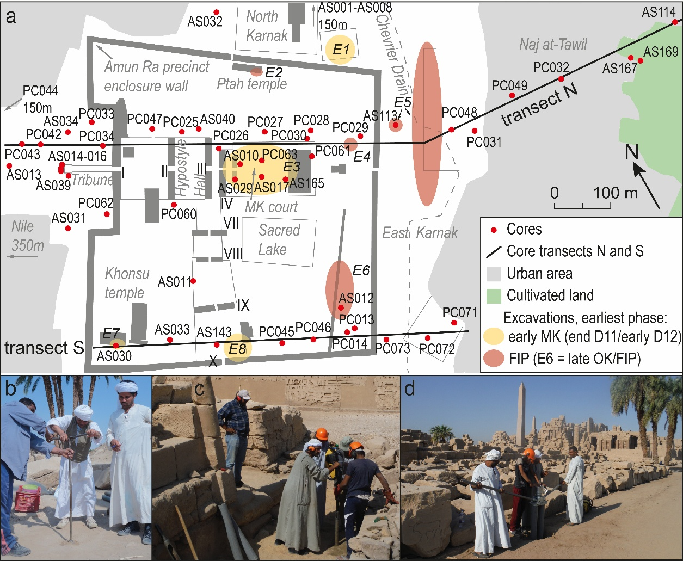

**Figure 2.** Location of coring sites and transects. a) Temple of Amun-Ra, Karnak. Pylons (monumental gateways) are indicated with Roman numerals; archaeological excavations as follows: E1 Karnak North (Jacquet 1983: 80, 95–96, 2001: 13–14); E2 Ptah Temple (Charloux *et al.* 2018, 2021: 924–26); E3 MK Court (Carlotti *et al.* 2010; Charloux & Mensan 2011; Larché 2020); E4 Osirian Catacombs (Charloux *et al.* 2021: 928); E5 East Karnak (Redford *et al.* 1991); E6 SE Sacred Lake (Millet 2007, 2008; Masson-Berghoff 2021); E7 Opet Temple (Charloux *et al.* 2012: 255); E8 Xth pylon court (Azim 1980). The Chevrier Drain is modern. b) hand auger in use at AS040; c) percussion corer in use at PC026; d) extracting drilled sediments at PC027.

Although informative, these recent reconstructions remain incomplete, drawn as they are from data that are fragmentary, spatially restricted to excavation localities—limiting the scope for palaeoenvironmental conclusions—and often collected as a byproduct of other research objectives. Few dedicated palaeogeographic surveys of the area have been conducted, and fewer than 10 deep (>5m) sediment cores have been published in any detail (Lauffray 1968, 1969; Bunbury *et al.* 2008; Ghilardi & Boraik 2011; Charloux *et al.* 2021). The geoarchaeological survey conducted by Bunbury and colleagues (2008) provides a notable exception, as part of a research programme that preceded the present study. The preliminary reconstruction presented therein was based primarily on 15 sediment cores with an average depth of 4.9m set in locations limited by the hand-augering method.

As detailed below, the present programme builds on this earlier work with a dataset more than four times larger, derived from cores strategically placed to align with the research objectives. Coring covers both the Karnak site and its surroundings, and the data collected are synthesised with archaeological information (Gabolde 2018; Charloux *et al.* 2021), luminescence dating as well as an updated understanding of local floodplain dynamics (Toonen *et al.* 2018; Peeters *et al.* 2024). As a result, the reconstructions presented here are the most comprehensive interpretations currently available.

We present information from 61 sediment cores (average depth: 6.4m, maximum depth: 11.65m) (Figure 2, Table S2), most of which were archaeologically dated through analysis of the tens of thousands of ceramic fragments they contained (Table S3). By positioning these cores at relatively even intervals, broadly along northern (‘N’) and southern (‘S’) west–east transects through the site (Figure 3), two cross-sections of sub-surface deposits were created. These cross-sections were then interpreted using standard geoarchaeological methods (Miall 1996; Brown 1997; Toonen *et al.* 2018). Isochrons, based on typologically dated ceramic fragments, reveal the palaeotopography (Figure 3) and shed light on the dynamic nature of the environment (Figure 4).

The work is palaeogeographically contextualised (Figure 1) using lithological and chronostratigraphic information from approximately 150 cores similarly drilled across the wider local area (Toonen *et al.* 2018, 2019; Peeters *et al.* 2024), and a novel set of 48 optically stimulated luminescence (OSL) ages from the vicinity of Karnak (Peeters *et al.* 2024).

**Methods**

Sediments were retrieved using an Eijkelkamp hand auger (ASnnn) and/or a Cobra TT percussion corer (PCnnn) (Figure 2b–d) and their basic sedimentological characteristics were analysed in the field (see OSM). Recovered sediments were wet-sieved in approximately 100mm intervals, and fractions were manually sorted into ceramic and non-ceramic material. Ceramic fragments were assigned an age within a Karnak-specific typology (see OSM). Through this, archaeological chronostratigraphies were ascertained for most cores in as much detail as possible (Table S3).

**Results**

Our survey reveals that the entire Karnak zone is ultimately founded on sandy deposits (Figure 3: Units T, A, B). Based on their sedimentary characteristics, particularly their fine to medium sand grade, well-sorted nature and fining-upwards sequences, these deposits are interpreted as river channel sediments, though not all were laid down simultaneously. Further east, and also at isolated localities within the temple precinct, silts prevail (Units C & D). These record infills of abandoned river channels (Unit C) or floodplain sedimentation (Unit D), as fine material is dropped from suspension in low-energy conditions. Atop these sands and silts typically lies several metres of cultural material: heterogeneous deposits comprising the ‘archaeology’ of the site (Unit E), as well as windblown cover (Unit F).

**Figure 3.** Simplified transects through Karnak: a) transect N; b) transect S. Cores/excavations indicated to aid location (not all shown). Figures S1–3 provide further detail. Elevation: masl, metres above sea level.

***Karnak’s river terrace foundation***

Although all the basal deposits are sands, a difference in age is inferred between the lowermost sands in the central/eastern zone of Karnak (Unit T: from the Middle Kingdom Court to East Karnak/east of the Sacred Lake), and the sands at either side (Units A & B) (Figure 3). Unit T contains no in-situ ceramic fragments except at its surface, but Units A and B (and all others) usually contain tens to hundreds of ceramic fragments per vertical metre of cored sediment. This suggests that Unit T was deposited pre-occupation, but Units A and B were deposited contemporaneously with occupation. These units are also lithologically distinct.

Further detail is provided by ceramic typology. The oldest ceramics atop Unit T date from sometime between the Sixth and early Eleventh dynasties: *c*. 2305–1980 BC (core AS012 and excavations E4–6) (Figure 2, Table S3), placing them within the First Intermediate Period or possibly the late Old Kingdom (Old Kingdom = *c*. 2591–2152 BC). They are of a similar age to the oldest ceramics within Units A and B (early Eleventh Dynasty: *c*. 2080–1980 BC; Hornung *et al.* 2006: 491), in cores AS143 and PC014. This also suggests Unit T is older than Units A and B.

This age difference is reflective of the fact that Unit T, at an elevation of approximately 72m above sea level (masl), is an old river terrace—a preserved remnant of an earlier riverplain—a conclusion supported by 29 more cores drilled to the east of Karnak (Peeters *et al.* 2024) (Figure 1). The relatively large grain size (150–350µm) of Unit T sands suggests deposition by fast-flowing water. Later, this alluvial plain was eroded on both its eastern and western sides by incising river channels, leaving a segment of high ground—a terrace (island)—in the east/south-east of the present site that then became occupied. The courses of the river channels that carved out this island are marked by Units A and B. Unit A is interpreted as lower channel bar sediments: sands laid down near the margins of the channels (Miall 1996), which generally fine upwards into the upper bar and levee sediments of Unit B. After deposition of Unit T ceased, the terrace top lay above the normal level of inundation; since Unit B deposits dating to the early Middle Kingdom are nowhere situated atop this terrace.

The 29 cores drilled further east (Peeters *et al.* 2024) show that the terrace existed for several kilometres in this direction, and they also provide an OSL age for the terminal phase of deposition at this level of 4.54±0.42 ka (2520 BC ±420 yr). The fluvial erosion on either side that formed the terrace/island would thus have taken place after this date.

The age of this river terrace is important because it places a temporal constraint upon earliest occupation at Karnak. When this area was being actively deposited by fast-flowing water, at and prior to 2520 BC ±420 years, it was unsuitable for permanent occupation/construction, although non-permanent activities may have occurred there during annual stages of low flow. After this date, incision resulted in the formation of the terrace segment/island, upon which occupation could have been initiated. This chronology corroborates the ceramic information: the earliest ceramics date from sometime between *c*. 2305–1980 BC, within the OSL 68.27% (1σ) confidence interval.

The coring results cannot precisely delimit the northern or southern margins of the island. Five cores further south, at the temple of Mut, provide little information, primarily encountering Unit E only (AS024–028: Figure S3). However, the narrowness of the terrace observed in transect S (Figure 3b) suggests proximity to its southern tip, corroborating previous ideas (see Introduction). The northern limit may be at North Karnak, based on earlier cores and excavation data (Bunbury *et al.* 2008). The island may, therefore, have extended from North Karnak to near the southern enclosure wall, an area of approximately 10ha (Figure 4a). A small channel crossed the terrace at the rear of the extant Amun-Ra temple, shown by Unit C in PC030 and PC061(Figure 3a); the ceramic records of these cores suggest that the channel gradually silted up through the Middle Kingdom and Second Intermediate Period (Second Intermediate Period = *c*.1759–1539 BC) (Table S3).

It also appears that another, smaller terrace segment lay in the south-west corner of the site, upon which the Opet Temple was constructed (Figures 3b & 4a), since early Middle Kingdom archaeology is found atop Unit T (AS030) in this location (Charloux *et al.* 2012). The deposits here (Unit T) are lithostratigraphically correlated with the main terrace segment. They were deposited concurrently and were originally continuous across the area. However, by the early Middle Kingdom (if not before) the areas were interposed by an incised channel (Units A, B, C in AS033, AS143, PC060, AS011, hosting early Middle Kingdom ceramics), thus placing early occupation on individual islands (Figure 4a).

**Figure 4.** Palaeolandscape reconstruction of Karnak: a) beginning of the MK; b) end of the MK; c) start of the NK; d) middle of the NK; e) end of the TIP; f) end of the PP.

***Western Nile Channels***

The channel that separated the ‘Opet terrace’ from the main Karnak terrace was one of various minor river courses in what is now the western part of Karnak. During the early Middle Kingdom this channel had its eastern bank near the third pylon, within the courtyards of the seventh to tenth pylons, themselves constructed centuries later during the New Kingdom (*c*. 1539–1077 BC) (Figures 2 & 4a). This bank is indicated by an interpreted erosional margin in the ‘start MK’ isochron (Figure 3: near AS143 & PC025), and archaeological investigations showing a sloped margin (Legrain 1906b). This channel, itself marked by Unit A, was also active earlier, as First Intermediate Period ceramics are found in AS143 within levee and bar deposits. The width of the channel was 90–150m, as its western bank was east of the ‘Opet terrace’ segment at AS030. Recent interpretations may further constrain the placement of its eastern margin under the New Kingdom Hypostyle Hall (Larché 2023).

The southern part of this channel—west of the later eighth to tenth pylons—naturally silted up in the later Middle Kingdom (Figure 4b), recorded by ceramics of this period embedded within channel fill deposits (AS011, AS033: Table S3), with Second Intermediate Period and New Kingdom cultural deposits above (Unit E). This process allowed for a land connection between the ‘Opet terrace’ and the main terrace (the focus of early Karnak) in the south-east. However, the channel maintained a river connection north of the ‘Opet terrace’ through the Second Intermediate Period (Figure 4b), as the infill in this section is dated to the beginning of the New Kingdom (PC060, PC025, PC047: Table S3).

Part of this northern section of the channel, immediately south of what was shortly to become the Hypostyle Hall, was deliberately filled in with a 3.6m-thick deposit of desert sand (Unit X in core PC060; see OSM). Since this deposit is bracketed above and below by sediments hosting similar late Seventeenth Dynasty/early Eighteenth Dynasty ceramics (around *c.* 1540 BC; Hornung *et al.* 2006: 492), it seems likely this infilling took place at the beginning of the New Kingdom (Figure 4c). This action targeted a channel that was already silting up, as channel fill deposits lie underneath Unit X, and PC047 and PC025 directly north of the Hypostyle Hall also indicate a natural silting up at this time (Figure S1). Another minor channel may also have naturally silted up a little further west, in the vicinity of the first pylon (itself constructed later), recorded by Unit C in cores PC062 and PC034 (Figures 3a & 4b–c).

All these fluvial changes seem to be connected to the development of a substantial river channel further to the west, which was present by the New Kingdom, if not before (Figure 4b–c). This channel subsequently migrated westwards to become the main modern branch of the Nile (Figures 1 & 4d–f). Deposits indicating its existence (Units A & C) were retrieved from cores AS031, AS039 and AS034 and all others further west. This channel is dated by the earliest (Middle Kingdom–early New Kingdom) ceramics encountered in fluvial deposits in AS039, as well as from a radiocarbon date in fluvial sediments which suggests its existence certainly by the early New Kingdom (Ghilardi & Boraik 2011). Subsequent westward movement of the channel is shown by more recent ceramics in Units A and B further west in PC042–044 (Table S3), as well as the upward-sloping nature of the units in this direction (Figure 3a). As the river migrated and aggraded, it left younger deposits at higher levels (prior to *c*. 2000 BC the river was incising, it was aggrading thereafter; Peeters *et al.* 2024). Fine-grained sediments at PC043 may also record a subaerially-exposed bar within the Nile (Figure 4e–f), potentially corroborating textual sources (Boraik *et al.* 2017: 99–101, 103–6) (see OSM).

***Eastern Nile Channel***

A key finding of our research is the evidence for and dating of a substantial Nile channel to the east of Karnak. Bar and levee deposits in this location (Units A & B), and the occurrence of relatively young ceramics (New Kingdom–Macedonian/Ptolemaic period; Macedonian/Ptolemaic period = 332–30 BC) at lower levels than older, early Middle Kingdom surfaces further west (Figure 3) provide evidence for a channel depression. That this channel was active during the First Intermediate Period and early Middle Kingdom is indicated by the plentiful, stratified early Middle Kingdom ceramics embedded in fluvial bar deposits in PC049, and First Intermediate Period ceramics in riverine deposits in PC014 (Figure 3). The channel then shifted eastwards during the Middle Kingdom and/or Second Intermediate Period (Figure 4a–c). In the early Middle Kingdom, the channel’s western margin was in East Karnak, between PC048 and PC049 in the north (near PC031: see OSM), and between PC073 and PC072 in the south, shown by the steep slope in the ‘start MK’ isochron between these cores (Figure 3). By the New Kingdom, however, the western margin was between PC049 and PC032 in the north (within the modern village of Naj at-Tawil), and further east than any of the cores drilled in transect S, indicating an eastward shift of approximately 150m. The New Kingdom archaeology at Kom al-Ahmar, slightly further south (Figure 1), also required the river to have moved by this time (Redford 1994: 28). As it shifted east, the former riverbank in the south may have become a marshy area favoured for waste disposal, shown by large amounts of bone, ceramic and mudbrick fragments within deposits included in Unit C in PC071 and PC072 (Figure 3b).

This eastern river channel was a substantial branch of the Nile, with its eastern terminal margin located east of AS114. During the Third Intermediate Period (*c*. 1076–664 BC), the channel had a width between 220 and 500m, suggesting that it was likely a major Nile branch during the earlier history of Karnak.

The main part of this channel finally silted up during or just after the Macedonian/Ptolemaic period, indicated by mixed New Kingdom–Macedonian/Ptolemaic period ceramics in cores AS169 and AS114 within fine-grained sediments reflecting waning flow. Core PC032, hosting mixed New Kingdom–Roman/Byzantine period ceramics (Roman/Byzantine period = 30 BC – AD 642) in similar sediments, likely represents the final residual channel, or perhaps a maintained canal, that silted up later still (Figure 4f). Two OSL dates from this core at 68.13–68.51masl (Peeters *et al.* 2024) confirm the dating of this residual channel infill as AD 470±140 years, based on a combined 68.27% probability from both dates. Afterwards, this area became part of the Nile’s east-bank floodplain.

**Discussion: interconnected cultural and natural landscapes**

As at other places in the Nile Valley (Hassan 1997; Pennington *et al.* 2020; Toonen *et al.* 2022), the natural riverine landscapes at Karnak appear strongly connected to cultural dynamics. They can be linked to the religious and cosmogonical views of the inhabitants, who also opportunistically adapted to changes in their physical environment.

In addition, the work provides dates for the earliest possible occupation of Karnak, which was constrained by the formation of the site’s original landscape setting: the river terrace underlying central/eastern Karnak. Fluvial deposition at this level ended after 2520 BC ±420 years; prior to this time the area was unsuitable for permanent occupation and construction.

Following fluvial deposition, subsequent channel incision took place to the east and west, creating the terrace-segment/island where occupation at Karnak began—in the south and east of the present site, and on the smaller ‘Opet terrace’ segment. Ascertaining exact dates is difficult, in part due to restrictions on taking samples from the site, but if all chronological indicators are taken into account then some conclusions can be drawn. The available chronological indicators are:

* The OSL age of Unit T, reflecting active fluvial deposition of Karnak’s natural foundation (2520 BC ±420 years);
* The earliest (late Old Kingdom–) First Intermediate Period ceramics atop the (post-incision) fluvial terrace (*c*. 2305–1980 BC);
* First Intermediate Period ceramics in the surrounding river deposits (*c*. 2080–1980 BC);
* Probable religious architecture during the First Intermediate Period reign of Intef II (*c*. 2066–2017 BC) (Hornung *et al.* 2006: 491; Ullmann 2007: 4, fig. 2.2; Gabolde 2018: 170–73);
* No significant soil formation at the top of the terrace, nor many aeolian deposits between Unit T and Unit E, both of which suggest little time elapsed between Unit T’s deposition and occupation at the site.

Taking all information together, it seems most likely that deposition of Unit T ended and subsequent incision took place at some point during the Old Kingdom (*c*. 2591–2152 BC), with occupation soon thereafter. A Predynastic or earlier origin for Karnak is therefore not viable.

The site itself, upon a raised terrace segment and forming an island, may have potent symbolism—a simple but striking example of site selection, connecting human action, the natural environment and religious views.

The Pyramid Texts, from the late Old Kingdom, indicate that the creator god manifested as ‘high ground’ (Bickel 1994: 67–70). The texts further attest to the notion that land ‘came out’ or ‘emerged’ from ‘the lake’ (Popielska-Grzybowska 2016: 162), although they do not at this time provide a clear connection between the ‘primeval mound’ and the ‘Waters of Chaos’ (Bickel 1994: 67–68; see below). The terrace segment upon which Karnak was founded is the only area of high ground surrounded by water thus far identified in the Theban area. No other topographic highs existed between this location and the western desert edge, and higher terrain further east was not surrounded by permanent watercourses (Peeters *et al.* 2024: 649). Although it is uncertain whether the Pyramid Texts were well-known in Thebes at this time, their references to Amun (Gabolde 2018: 390–99), make this a likely possibility. As such, it is tempting to suggest that the Theban elites chose Karnak’s location for the dwelling place of a new form of Amun, ‘Ra-Amun’ (Ullmann 2007: 4–6; Gabolde 2018: 473–74), as it fitted the cosmogonical picture of high ground emerging from surrounding water (Gabolde 2018: 201–3). Of course, caution must be heeded with such a link. The pragmatic location of Karnak on non-flooded land across from at-Tarif, a focus of Old Kingdom–First Intermediate Period activity (Arnold 1976; Gabolde 2018: 96–97), may also have been a factor in site selection.

Nonetheless, the choice of location does foretell the later, more developed, Egyptian cosmogony. The Middle Kingdom Coffin Texts and later documents clearly develop the idea of high ground—the ‘primeval mound’—rising from the inundation, embodied as the Waters of Chaos/‘Nun’ (Bickel 1994: 29–31, 68–69). During the early Middle Kingdom, Karnak would have recreated this cosmogony each year: as the annual flood abated, the mound upon which Karnak was built would have appeared to rise from the receding water.

The illusion of Karnak rising from the inundation would also have been enhanced by a further aspect of the site’s geological configuration. A surface of early Middle Kingdom ceramics lying atop bar deposits in PC026, AS029 and PC048 (transect N) and PC045 and PC073 (transect S) (Figures 3 & 4a) indicate that an area of land 1m lower than the terrace top (at approximately 71masl) surrounded the terrace in the early Middle Kingdom. During flood conditions this level would have been inundated, since early Middle Kingdom levee deposits of Unit B lie directly above, while the top of the terrace remained dry. As the flood receded, the island could have doubled in area (Figure 4a) as the bar deposits ‘came out’ of the water, thus completing the impression of the upward movement of the mound. Seasonal activity would have been possible on the lower levels.

The occupants of the island were also opportunistic in adapting to changes in the local fluvial environment. The post-New Kingdom westward expansion of the temple (Bunbury *et al.* 2008: 351) demonstrates the progressive utilisation of new land, with the construction of the seventh to tenth and first to third pylons as the western channels silted up (Figure 4b–d). In some instances, changes to the landscape were made proactively, indicated by the dumping of desert sand into a channel just south of what was shortly to become the Hypostyle Hall (PC060).

Given that a large river channel originally lay to the east of the site, it would be instructive to consider further archaeological surveys in that area. Early archaeological features may be focused there, dating from before the eastern channel moved away and the western channel became a larger, more clearly-defined feature in the landscape (Figure 4a–e). A change of temple orientation from east to west based upon architectural evidence has even been proposed, with the earliest temple facing east (Larché 2007: 481–83), though this remains contentious (Gabolde 2018: 225–26).

**Conclusion**

New data from 61 sediment cores has allowed for a more detailed palaeogeographic reconstruction of evolving landscape settings at Karnak. Earliest possible occupation at the site is constrained probably to the Old Kingdom, and activity there demonstrates a coupling between the natural environment and the religious, functional, and constructional aspects of the temple. Understanding the evolution of Karnak—from a small island to one of the defining institutions of Ancient Egypt—is thus only possible with advancing knowledge of its ever-changing environment.

**Acknowledgments**

We thank the Egyptian Ministry of Tourism and Antiquities, all at the Centre Franco-Égyptien d'Étude des Temples de Karnak (CFEETK), and at Chicago House (Luxor / University of Chicago), the Farouk family, and our local team members. The research was carried out under the auspices of the Egypt Exploration Society (London).

**Funding Statement**

The work was supported by the Knut och Alice Wallenbergs Stiftelse (KAW 2013.0163) and Uppsala Universitet (HUMSAM 2014/17) to A.G. as Wallenberg Academy Fellow 2014 –20, together with a small grant from M och S Wångstedts Stiftelse (A.G.).

**Data availability statement**

The summary geological data supporting the findings of this study are available in Zenodo at <https://doi.org/10.5281/zenodo.11581016>. Technical details of the sedimentary interpretation as well as detailed sedimentary figures, core metadata and ceramic chronostratigraphies are provided in the Online Supplementary Material.

**Competing Interest Declaration**

Competing interests: The authors declare none. The views expressed in the article do not necessarily represent the views of the NPS or the government of the United States.

**References**

Arnaudiès, A. & E. Laroze. 2007. Localisation des interventions archéologiques dans le temple de Karnak, 1967-2004. *Cahiers de Karnak* 12: 91–103.

Arnold, D. 1976. *Gräber des Alten und Mittleren Reiches in El-Tarif*. Mainz am Rhein: Deutsches Archäologisches Institut. Abteilung Kairo.

Azim, M. 1980. La fouille de la cour du Xe pylône. Rapport préliminaire. *Cahiers de Karnak* 6: 160–61.

Barguet, P. 1962. *Le temple d’Amon-Rê à Karnak: Essai d’exégèse*. Cairo: Institut Français d’Archéologie Orientale.

Bickel, S. 1994. *La cosmogonie égyptienne avant le Nouvel Empire*. Fribourg, Switzerland: Orbis Biblicus et Orientalis, 134.

Boraik, M., L. Gabolde & A. Graham. 2017. Karnak’s quaysides: evolution of the embankments from the eighteenth dynasty to the Graeco-Roman period, in H. Willems & J.-M. Dahms (ed.) *The Nile: Natural and cultural landscape in Egypt.*: 97–144. Bielefeld: Transcript Verlag.

Brown, A.G. 1997. *Alluvial Geoarchaeology: Floodplain archaeology and environmental change*. Cambridge: Cambridge University Press.

Bunbury, J.M., A. Graham & M.A. Hunter. 2008. Stratigraphic landscape analysis: charting the Holocene movements of the Nile at Karnak through ancient Egyptian time. *Geoarchaeology* 23: 351–73.

Carlotti, J.-F., E. Czerny & L. Gabolde. 2010. Sondage autour de la plate-forme en grès de la “cour du Moyen Empire” à Karnak. *Cahiers de Karnak* 13: 111–93.

Charloux, G. & R. Mensan. 2011. *Karnak avant la XVIIIe dynastie*. Paris: Soleb.

Charloux, G., R. Angevin, S. Marchand, H. Monchot, J. Roberson & H. Virenque. 2012. *Le parvis du temple d’Opet à Karnak: exploration archéologique, 2006-2007*. Cairo: Institut Français d’Archéologie Orientale.

Charloux, G. et al. 2018. Le temple ‘primitif’ de Ptah à Karnak. *Bulletin de l’Institut Français d’Archéologie Orientale* 117: 125–29.

Charloux, G., M.A. Abady Mahmoud, A.M.S. Elnasseh & S. Marchand. 2021. The shifting Nile and the origins and development of ancient Karnak. *Antiquity* 95: 919–39.

Egli, E. 1959. *Geschichte des Städtebaues: Erster Band: Die alte Welt*. Erlenbach: Eugen Rentsch.

Franchet, L. 1917. Travaux effectués en Égypte. *Rapport sur une mission en Crète et en Égypte (1912-1913), dans Nouvelles archives des missions scientifiques* 22: 83–99.

Gabolde, L. 2018. *Karnak, Amon-Rê: la genèse d’un temple, la naissance d’un dieu (avec des rapports de Sylvie Marchand et de Samuel Guérin)*. Cairo: Institut Français d’Archéologie Orientale.

Ghilardi, M. & M. Boraik. 2011. Reconstructing the Holocene depositional environments in the western part of ancient Karnak temples complex (Egypt): a geoarchaeological approach. *Journal of Archaeological Science* 38: 3204–16.

Graham, A. 2010. Islands in the Nile: a geoarchaeological approach to settlement locations in the Egyptian Nile Valley and the case of Karnak, in M. Bietak, E. Czerny & I. Forstner-Müller (ed.) *Cities and Urbanism in Ancient Egypt*: 125–43. Vienna: Österreichischen Akademie der Wissenschaften.

Hassan, F.A. 1997. The dynamics of a riverine civilization: a geoarchaeological perspective on the Nile Valley, Egypt. *World Archaeology* 29: 51–74.

Hornung, E., R. Krauss & D.A. Warburton. 2006. *Ancient Egyptian Chronology*. Leiden: Brill.

Jacquet, J. 1983. *Karnak-Nord V (Fouilles de l’Institut français d’archéologie orientale 31)*. Cairo: Institut Français d’Archéologie Orientale.

—. 2001. *Karnak-Nord IX (Fouilles de l’Institut français d’archéologie orientale 44)*. Cairo: Institut Français d’Archéologie Orientale.

Larché, F. 2007. Les nouvelles observations sur les monuments du Moyen et du Nouvel Empire dans la zone centrale du temple d’Amon à Karnak. *Cahiers de Karnak* 12: 407–592.

—. 2020. *Chronologie des vestiges découverts sous le temple de Karnak*. Turnhout: Brepols.

—. 2023. Sous le sol de la Salle Hypostyle et de son voisinage à Karnak, in F. Colin (eds.) *Au-delà de Karnak : recueil d'études offert à Claude Traunecker*, Cahiers de l'ENIM (CENIM) 35: 357–404. Paris: Khéops.

Lauffray, J. 1968. Nouvelles découvertes aux temples de Karnak. *Comptes-rendus des séances de l’Académie des Inscriptions et Belles-Lettres* 112: 337–51.

—. 1969. Rapport sur les travaux de Karnak. Activités du Centre franco-égyptien en 1967-1968. *Cahiers de Karnak* 2: 111–35.

Legrain, G. 1906a. Excavations and explorations, in F.L. Griffith (ed.) *Archaeological report: comprising the work of the Egypt Exploration Fund and the progress of egyptology during the year 1905-1906*: 21–23. London: Egypt Exploration Fund.

—. 1906b. Nouveaux renseignements sur les dernières découvertes faites à Karnak (15 novembre 1904 - 25 juillet 1905). *Recueil de travaux relatifs à la philologie et à l’archéologie égyptiennes et assyriennes* 28: 137–61.

—. 1929. *Les temples de Karnak*. Brussels: Vromant & Co.

Masson-Berghoff, A. 2021. *Le quartier des prêtres dans le temple d’Amon à Karnak*. Leuven: Peeters.

Miall, A.D. 1996. *The Geology of Fluvial Deposits*. New York: Springer-Verlag.

Millet, M. 2007. Architecture civile antérieure au Nouvel Empire: rapport préliminaire des fouilles archéologiques à l’est du lac Sacré 2001–2003. *Cahiers de Karnak* 12: 681–743.

—. 2008. Installations antérieures au Nouvel Empire au sud-est du Lac sacré du temple d’Amon de Karnak. PhD Thesis; École doctorale Mondes anciens et médiévaux, Sorbonne Université.

Peeters, J. et al. 2024. Shift away from Nile incision at Luxor ~4,000 years ago impacted ancient Egyptian landscapes. *Nature Geoscience* 17: 645–53.

Pennington, B.T., P. Wilson, F. Sturt & A.G. Brown. 2020. Landscape change in the Nile Delta during the fourth millennium BC: a new perspective on the Egyptian Predynastic and Protodynastic periods. *World Archaeology* 52: 550–65.

Popielska-Grzybowska, J. 2016. Contexts of the appearance of water in the Pyramid Texts: an introduction. *Études et Travaux* 29: 157–67.

Postel, L. 2004. *Protocoles des souverains égyptiens et dogme monarchique au début du Moyen Empire*. Turnhout: Brepols, Fondation égyptologique Reine Élisabeth.

Redford, D.B. 1988. Interim Report on the 20th Campaign (17th Season) of the Excavations at East Karnak. *Journal of the Society for the Study of Egyptian Antiquities* 18: 36–47.

—. 1994. *The Excavations of Kom el-Ahmar and Environs*. Toronto: Akhenaten Temple Project.

Redford, D.B., S.E. Orel, S. Redford & S. Shubert. 1991. East Karnak Excavations, 1987-1991. *Journal of the American Research Center in Egypt* 28: 75–106.

Toonen, W.H.J. et al. 2018. Holocene fluvial history of the Nile floodplain at ancient Thebes (Luxor, Egypt) and its relation with cultural dynamics and basin-wide hydroclimatic variability. *Geoarchaeology* 33: 273–90.

Toonen, W.H.J. et al. 2019. Amenhotep III’s Mansion of Millions of Years in Thebes (Luxor, Egypt); submergence of an elevated mound by river floods and Nile sediments. *Journal of Archaeological Science: Reports* 25: 195–205.

Toonen, W.H.J., K. Cortebeeck, S. Hendrickx, B. Bader, J. Peeters & H. Willems. 2022. The hydro-geomorphological setting of the Old Kingdom town of al-Ashmūnayn in the Egyptian Nile Valley. *Geoarchaeology* 37: 267–83.

Ullmann, M. 2007. Thebes: Origins of a ritual landscape, in P.F. Dorman & B.M. Bryan (ed.) *Sacred space and sacred function in Ancient Thebes*: 3–27. Chicago: Oriental Institute of the University of Chicago.

**[ONLINE SUPPLEMENTARY MATERIAL]**

**Conceptual origins and geomorphic evolution of the temple of Amun-Ra at Karnak (Luxor, Egypt)**

Benjamin T. Pennington1, Angus Graham2,*, Aurélia Masson-Berghoff3,4, Marie Millet5, Jan Peeters6, Willem H. J. Toonen7,8, Timotheus G. Winkels9, Luke H. Sollars10, Virginia. L. Emery11, Kristian D. Strutt12, Dominic S. Barker12

1 Geography & Environmental Science, University of Southampton, UK

2 Department of Archaeology, Ancient History and Conservation, Uppsala Universitet, Sweden

3 Department of Greece & Rome, The British Museum, London, UK

4 Department of Egypt & Sudan, The British Museum, London, UK

5 Department of Egyptian Antiquities, Musée du Louvre, Paris, France

6 Jebel Barkal Archaeological Project, Kelsey Museum of Archaeology, University of Michigan, Ann Arbor, USA

7 Faculty of Science, Earth & Climate, Vrije Universiteit Amsterdam, The Netherlands

8 Egyptology Unit, Katholieke Universiteit Leuven, Belgium

9 Water and Environment Group, WSP, Nieuwegein, The Netherlands

10 Independent Researcher, Salisbury, UK

11 National Park Service, Fort Union National Monument, Watrous, USA

12 Department of Archaeology, University of Southampton, UK

*Corresponding author (email: angus.graham@arkeologi.uu.se)

Extended Methodology

Sediments were retrieved using an Eijkelkamp hand auger (cores coded ASnnn), or Cobra TT percussion corer (cores coded PCnnn), before being analysed with a hand lens in the field in terms of their basic sedimentary characteristics (grain size, sedimentary texture (Ditzler *et al.* 2017), sorting, rounding, mineralogy, Munsell colour, organic material, inclusions). Summary supporting geological information are provided on Zenodo as outlined in the Data Availability Statement. The cores and the transects along which they were placed were then interpreted using standard sedimentological, geomorphological and geoarchaeological methods (Miall 1996; Brown 1997). The two transects (N and S) were primarily drilled in 2017–2018 (Table S2) using the percussion corer, which was able to penetrate archaeological deposits effectively. Prior to this date (see Table S2), earlier investigations with the hand auger were often limited to excavations within the temple complex and were less spatially systematic. This was due to the fact that it was often not possible to hand-auger through the sometimes dense anthropogenic debris, which often included (pebble-sized) ceramic and stone fragments. Core locations were primarily surveyed using either RTK-DGPS or total station using the Survey of Egypt datum (Table S2). The sediments recovered were divided in *c.*10cm intervals, wet-sieved through 2mm and 4mm mesh, and each sieved fraction sorted manually into ceramic and non-ceramic material. For the majority of cores, within each sieved fraction of each sample, each item of non-ceramic material was identified (rhizo-concretions, bone, quartz, mudbrick etc.) and counted and overall abrasion and rounding was recorded. All sieved non-ceramic and ceramic material is stored at Karnak in the storerooms of the Ministry of Tourism and Antiquities, for possible future re-study.

After the ceramics recovered from the cores had been sieved and isolated, they were studied from each core in sequential order to provide full archaeological stratigraphies for the majority of the cores (Graham *et al.* 2012: 30–32). The ceramic material was studied with no knowledge of the sedimentary data or interpretation to avoid bias. All sherds from each sieved fraction within each 10cm sample in these cores were analysed in terms of total number of sherds, total weight, size range, fragment type (rim, base, handle, body), decoration, technique (handmade, slow wheel, quick wheel), abrasion, rounding, hardness, material (Nile silt, marl clay, oasis, Aswan, import), fabric and period. The fabric system used is a local system based upon analysis of material originating from stratified settlement contexts from the First Intermediate Period through to the Roman Period in Karnak, excavated between 2001–2007 (Masson 2007, 2009, 2011, 2012, 2015, 2016; Millet 2007, 2008; David *et al.* 2016; Masson-Berghoff 2021): some of these fabrics correspond to the well-known Vienna system (Arnold & Bourriau 1993; Bourriau *et al.* 2000). Each diagnostic sherd was drawn, photographed, and recorded individually. Through this process, a chronology for each core was established (Table S3). In numerous instances, changes in the ceramic assemblage corresponded to independently-observed changes in the hosting sediments, lending weight to both interpretations. Using both artefactual and ‘articlast’ (Rapp & Hill 2006: 29, 51–52) information from the sherds, it was also possible to identify when downhole contamination during the coring process had occurred, ruling out the use of certain material from the chronology of the remaining assemblage.

Priority for comprehensive ceramic determination as described above was given to deep (>*c.*5m) cores that yielded plentiful, well stratified ceramics in significant locations. Five cores which terminated at shallow depths did not have their ceramics studied, while 15 for which it would not necessarily have been more productive to look at exhaustively were analysed via a ‘bulk assessment’ (Table S3, Figures S1–S3 indicate which ones). The ceramics from these cores were not systematically examined with a fresh break and a lens. Instead, priority was given to diagnostics (forms and specific fabrics) or sherds that retained surface treatments (slip, decoration), although general observations on the amount of material and the state of preservation were also noted for each sample; some of these cores also did not have their non-ceramic clasts individually studied. Nonetheless, the large number of ceramics present in many of these cores – including numerous diagnostics – still allows for a very high degree of confidence in their chronological interpretation: a sequence was noted only when there were clear shifts and none of the material was contradictory.

This research programme from which this work originates – the Theban Harbours and Waterscapes Survey (THaWS) – has been directed since 2010 by Angus Graham. The permit granted by the Ministry of Tourism and Antiquities to the Egypt Exploration Society covers an area of approximately 70 km2 within the Nile Valley from at-Tarif in the north to south of Birket Habu on both the east and west banks of the floodplain and includes the Temple of Karnak complex. A precursor research programme, the Karnak Land- and Waterscapes Survey (KLaWS) was co-directed by Judith Bunbury (University of Cambridge, UK) and Angus Graham (at the time University College London, UK) from 2002 until 2009 (Bunbury *et al.* 2008). This research programme worked principally within the area of the Karnak complex.

Sedimentary interpretation – technical details

The deposits encountered in the sediment cores can be divided into eight main sedimentary units (Figures S1–3). They display many similarities with other deposits within the Theban floodplain region (Toonen *et al.* 2018, 2019; Peeters *et al.* 2024), and in the vicinity of other archaeological sites in Egypt situated in proximal fluvial contexts (Tronchère *et al.* 2009; Pennington & Thomas 2016; Hassan *et al.* 2017; Pennington 2019; Toonen *et al.* 2022).

At the base of the sequence lies Unit T (terrace), localised both within central/eastern Karnak and also in the vicinity of AS030. This unit usually consists of very well sorted, micaceous fine to medium sands (150–350µm), although near the top there are also interbedded coarse silts. Texturally the unit comprises loams to sands (Ditzler *et al.* 2017). The deposits include short (1–2m) fining upward sequences and usually have a Munsell colour in the vicinity of 10YR 4/2. Small calcareous rhizoliths (Klappa 1980), other small concretions (manganese and iron suspected), and black mottling (reduction haloes around organic matter as it decomposes) are frequent, especially within the finer upper parts of the unit; some plant remains and other organic materials are also present in these upper sections. The relatively large grain size of the sediments suggests deposition by reasonably fast-moving water, while the concretions suggest minor soil formation processes within a setting that was subsequently subaerially exposed.

The unit contains no convincing *in situ* ceramic fragments. While 17 tiny (mm-scale), undatable, abraded fragments were recovered from the unit (all of which would likely have been missed in a standard archaeological investigation of these layers), they are all thought to result from downhole contamination from the coring process. When a core segment was retrieved for study (every ~10cm with the hand auger / 1m with the percussion corer), sometimes a very small amount of surface sediment fell down the hole, despite best efforts. At Karnak, where the modern-day surface (Unit F, below) contains plentiful minute abraded fragments, on occasion a few mm-scale sherds would have unavoidably fallen in too. They are not considered to have been originally hosted within Unit T. Such tiny numbers of miniscule fragments are of course present as 'background noise' within the other units. However, these other units also contain tens of thousands of *in situ* fragments (as 'signal'), so the noise is lost. In Unit, where a signal is absent, such noise is of course noticeable in Table S3.

Some aspects of Unit A (bar deposits) are similar to Unit T, in that Unit A also comprises sandy deposits with fining upwards sequences. However, the sequences are longer, Unit A is less variable in grain size and it contains very little (if any) organic material or rhizoliths, nor any black mottling. Instead, it contains frequent ceramic material, often smoothed by water erosion. It is also texturally more homogeneous (sandy loams to sands), often a little finer (125–250µm), a little less micaceous, and has a slightly lighter colour (commonly 10YR 4/3). The unit comprises a textbook example of fluviatile bar sediments deposited in an ancient branch of the Nile. The fining-up sequences are typical, while the lack of rhizoliths and organic matter are to be expected in a fluvial channel where deposition is taking place within flowing water and there is no subsequent subaerial exposure. The unit is very similar to other such deposits encountered elsewhere in Egypt (Garzanti *et al.* 2015; Pennington & Thomas 2016; Pennington 2019; Toonen *et al.* 2022).

Unit A often fines upward into Unit B (upper bar/levee), which usually comprises very dark brown (often 10YR 3/2), well-sorted, micaceous very fine sands (loams to sandy loams) with frequent black mottling, rhizoliths, ceramics and other anthropogenic material. The finer grain size (30–150µm) reflects a lower energy of deposition than the lower bar deposits of Unit A, and the presence of rhizoliths reflects minor soil formation processes within a periodically subaerially exposed environment, as would be expected on a levee or upper bar.

Unit C (channel fill) consists of highly organic-rich, micaceous, often-poorly-sorted loamy sediments of a variable colour (in the range spanned by 7.5YR 6/3, 2.5Y 4/4, 10YR 3/2 and N2.5/0). The matrix is often made up of coarse silt or very fine sand (30–125µm), and laminations appear present within the material. However, large quantities of ceramics, limestone, sandstone, charcoal and other anthropogenic debris often obscure the ‘natural’ sedimentary signal. No rhizoliths are generally recorded. The sediments are mapped as channel fill deposits by comparison with other examples and textbook processes (Toonen *et al.* 2012).

Unit D (floodplain) is made up of well-sorted dark brown (7.5YR 4/2), sparsely micaceous silts (10–40µm) – usually silty clay loams. Small quantities of ceramic material are continually encountered within the sediments as well as rhizoliths and black (presumed manganese) nodules. The unit records distil fluvial deposition within the Theban floodplain context and is very commonly encountered within the local wider area (Toonen *et al.* 2018; Peeters *et al.* 2024).

Unit E (cultural debris) comprises poorly-sorted, heterogeneous, sometimes mottled sediments of a variable colour (7.5YR 4/4 to 2.5Y 3/2), displaying no clear trends in grain-size, but containing large quantities of ceramics and other artefacts. Texturally they are usually sandy to silty loams of coarse silt to fine sand grade (30–125µm). By comparison with anthropogenic deposits within archaeological excavations both within Karnak (French 1991) and elsewhere in Egypt (Pennington & Thomas 2016; Pennington 2019; Toonen *et al.* 2022) it is clear that these sediments represent the cultural layers of the site itself, with few ‘natural’ processes operating. At the very top of the sequence, and sometimes indistinguishable from Unit E, lies Unit F (windblown cover), usually made up of fine sand (~175µm) containing small ceramic fragments. This cover was many meters thick in some places before archaeological excavations began in the nineteenth century (Fourier 1812; Traunecker & Golvin 1984).

One further unit only encountered within PC060 (Unit X), is made up of 3.6m of non-micaceous coarse sand (usually 500–600µm), although some pebble-sized grains can be up to 20mm, containing no ceramics, although one large lump of sandstone was encountered. The sediments are ultimately thought to come from the desert by virtue of their distinct mineralogy and texture, which have not been encountered anywhere within the local floodplain landscape (Toonen *et al.* 2018, 2019; Peeters *et al.* 2024), but are similar to observed deposits on the nearby desert margin. Above Unit X in PC060 are cultural deposits (Unit E) dating to the Second Intermediate Period (SIP) / New Kingdom (NK), while directly underneath lie channel fill deposits that also date from the SIP / early NK (late Dynasty 17/early Dynasty 18). This unit as a whole is therefore interpreted as an anthropogenic dumping of material at the beginning of the New Kingdom.

A number of other cores interpreted to have lain within complex transitional or other environments are described below:

AS010 (Figure S1): foundation deposit. The sandy, quite inhomogeneous deposits of this core, contain various anthropogenic components (charcoal, sherds, chunks of mud) and do not display clear lithostratigraphic parallels with surrounding cores (AS029, PC026, PC063, AS017), all of which contain natural sediments in their lower sections. They are mapped as Unit E. Below ~72masl they are interpreted as a foundation, given their low absolute position.

AS143 (Figure S1): channel margin.During the early Middle Kingdom (MK), AS143 appears to indicate a shallow (2m deep) environment near the riverbank, since FIP – early MK ceramics are found here only 2m lower (depths of 68.55–71.25masl) than the contemporaneous presumed ground surface in PC045 (see main text: discussion). The hosting sediments are also identified as upper bar deposits, also suggesting a lower energy environment at the edge of the channel.

PC027 (Figure S1): Roman/Byzantine Period (RP) cut fill.Much of this core (Unit C) appears to be an anomalous late (RP or later) dump/ditch/cut feature, by virtue of mixed NK–RP ceramics throughout the core (Table S3). This chronology indicates it has nothing in common with any other core drilled.

PC030 & PC061 (Figure S1): chute channel/cross-bar channel. As is common in these types of fluvial environments (Bridge 2003: 146–47), a small cross-bar channel was located within the terrace, represented by deposits of Unit C in cores PC030 and PC061 at the rear of the extant Amun-Ra temple (Figure 3a). Ceramics from these cores suggest this channel gradually silted up through the MK and Second Intermediate Period (SIP, c.1759-1539BCE) (Table S3), suggesting that it conveyed little flow except during peak annual discharge. It likely also extended southwest (Figure 4a), since earlier work in this location encountered layers of organic black silt – presumed Unit C – at comparable depths (Lauffray 1968, 1969).

PC031 (Figure S1): channel margin. During the early MK this area was near the channel margin, since on one side PC048 hosts early MK bar deposits forming the land surface at ~71.5masl; on the other, PC049 is situated in the early MK river channel with contemporaneous deposits lower than 65.6masl. PC031 sees early MK ceramics at 69.5masl – i.e. forming a slope between the two. However, the deposits in PC031 are mapped as Unit C (channel fill), while either side (PC048 & PC049) are bar deposits (Unit A). PC031, therefore, represents a marshy area of quiescent flow, rather than a ‘clean’ river bank. This is not dissimilar to that which exists in PC071 and PC072 (see main text: eastern channel).

PC043 (Figure S1): island/subaerially exposed bar. Significantly finer-grained sediments recovered from PC043 (Units C and B) when compared to surrounding cores likely represent sheltered, downstream deposition within the lee of an island/subaerially exposed bar (Figure 4e–f), corroborating textual sources which suggest that islands/subaerial bars existed in the area during the NK–PP (Boraik *et al.* 2017: 99–101, 103–6). A paleosol encountered at 72.3masl also suggests an oscillating water table within a subaerially exposed setting. Since very little ceramic material was recovered here this feature cannot be dated with certainty.

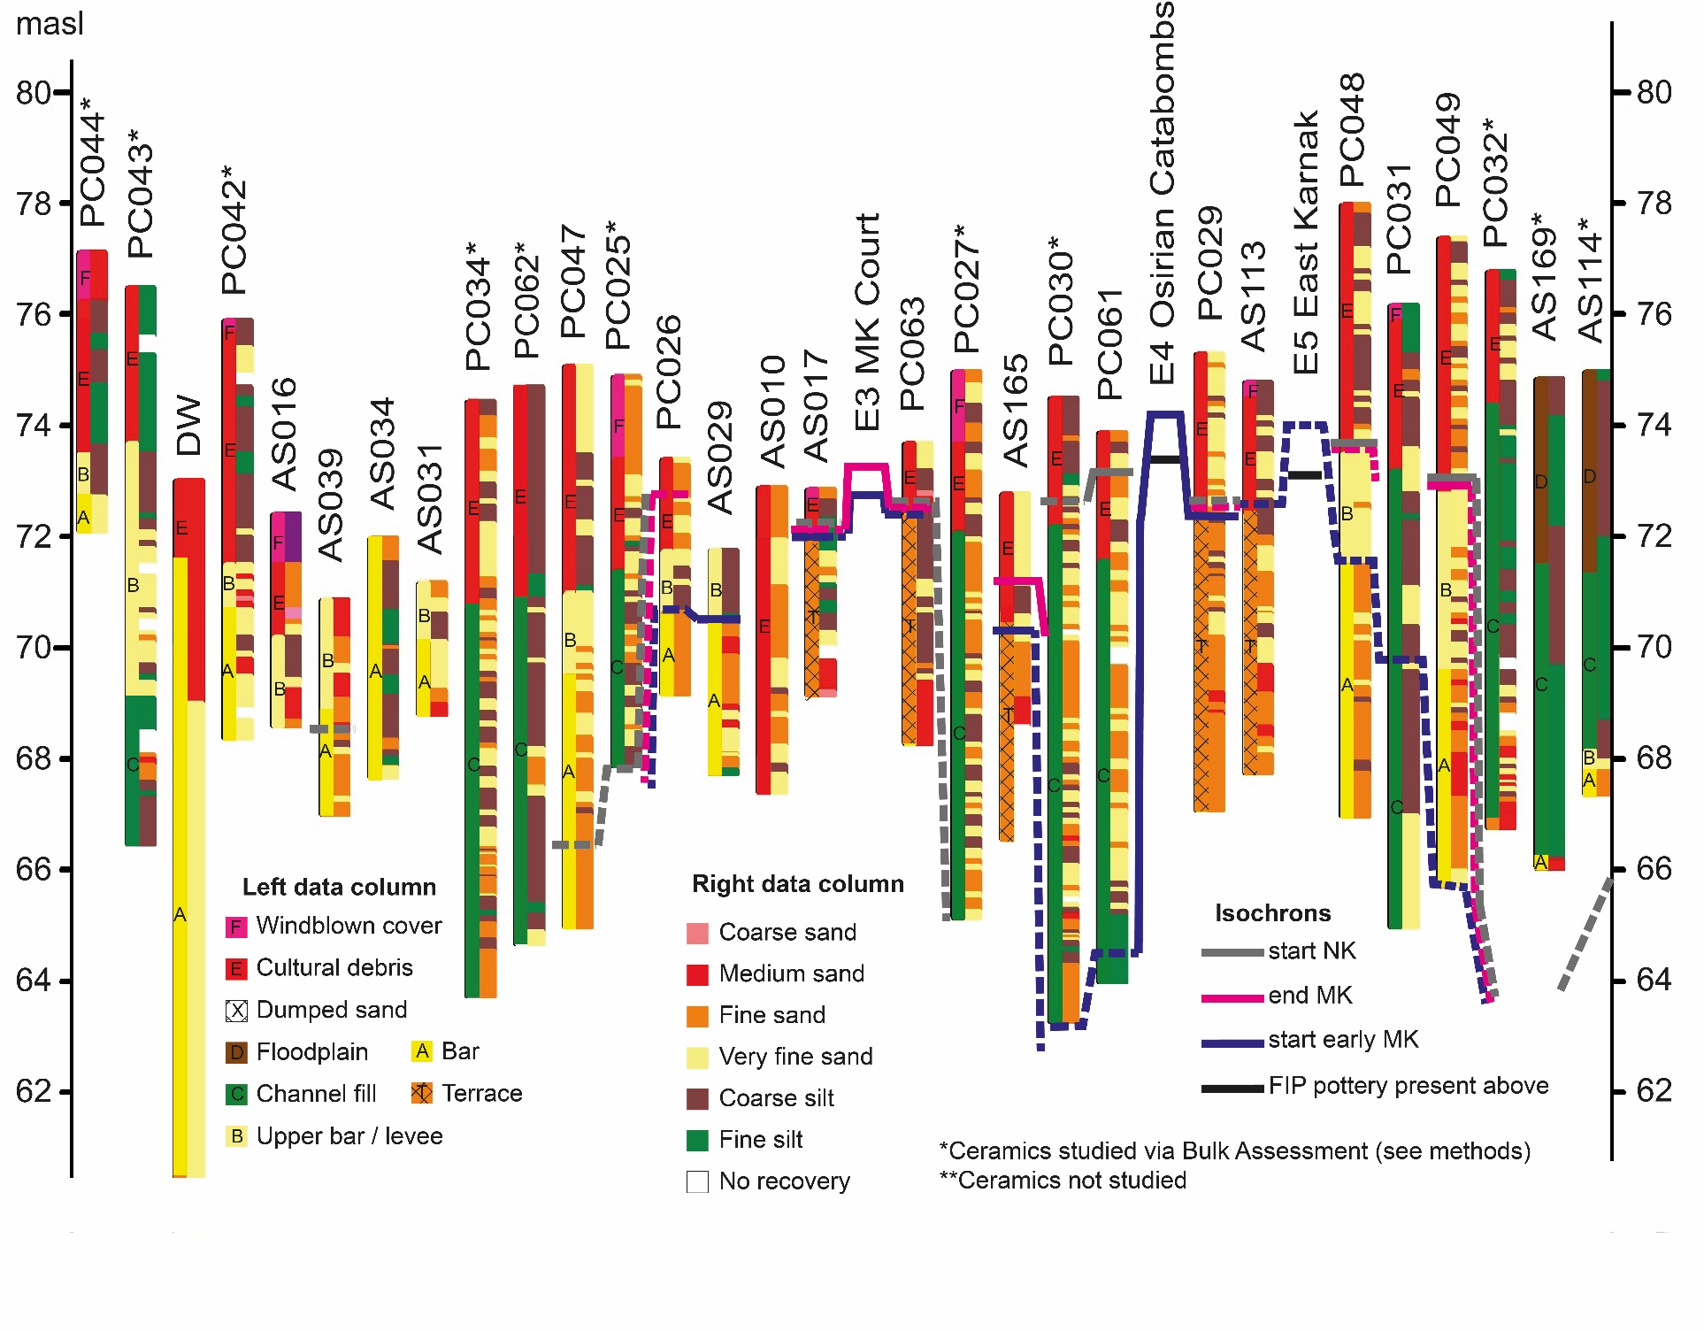

*Figure S1. Stratigraphic, lithological, and chronostratigraphic data from the cores drilled along transect N, relevant excavations (Millet 2008; Charloux et al. 2021) and core ‘DW’ (Ghilardi & Boraik 2011). For locations see Fig. 2 (horizontal axis not to scale).*

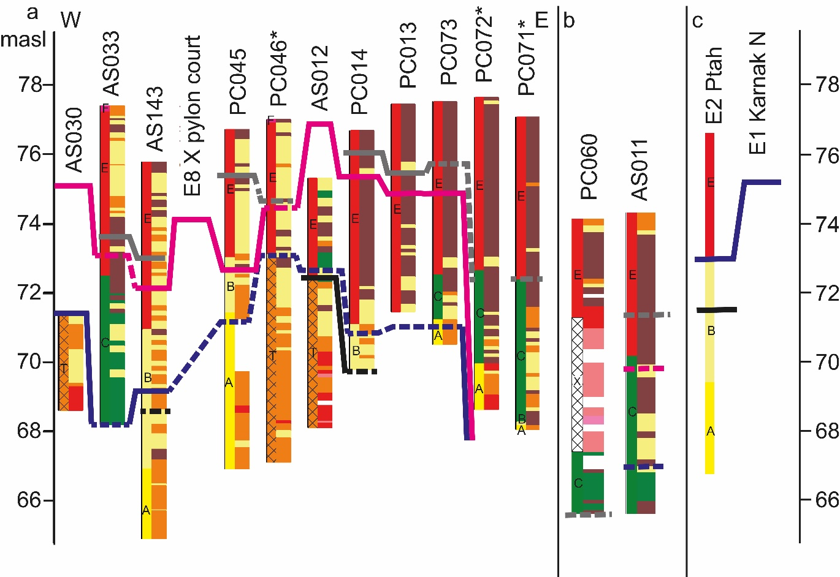

*Figure S2. Core Data. a) Cores drilled along transect S. Isochrons at AS030 and AS012 above the level of the core come from excavations E7 and E6 (Figure 2) (Millet 2008; Charloux et al. 2012) within which these cores were undertaken. b) Cores drilled south of the Hypostyle Hall. c) Cores and excavations near the northern enclosure wall (Charloux et al. 2021). For key, see Figure S1.*

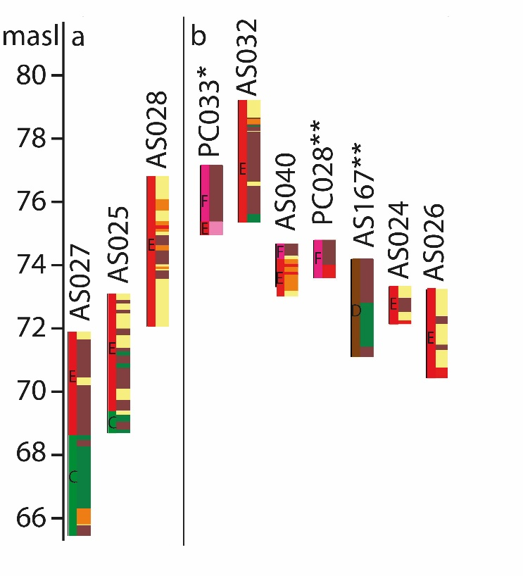

*Figure S3. Core Data. a) Cores drilled to the south of the tenth pylon. b) Shallow cores not published elsewhere (cores AS001–008, AS013–015 are presented previously (Bunbury et al. 2008)). For key, see Figure S1.*

Table S1. Chronological periodisation. Calendar dates follow dynasty numbers, and are approximate prior to 664 BC. Dynasty numbers 9, 10, 14 and 15 are not applicable for the Theban region.

|  |  |  |  |
| --- | --- | --- | --- |
| **Time period** | **Abbreviation** | **Dynasty** | **Age** |
| Neolithic Period | - | - | 5500 – 3900 BC (Tassie 2014) |
| Predynastic Period | - | - | 3900 – 3100 BC (Dee *et al.* 2013; Tassie 2014) |
| Early Dynastic Period | ED | D1 – D2 | 3100 – 2592 BC (Hornung *et al.* 2006; Dee *et al.* 2013) |
| Old Kingdom | OK | D3 – D6 | 2592 – 2152 BC (Hornung *et al.* 2006) |
| First Intermediate Period | FIP | D7 – Early D11 | 2152– 1980 BC (Hornung *et al.* 2006) |
| Middle Kingdom | MK | Late D11 – D13 | 1980 – 1760 BC (Hornung *et al.* 2006) |
| Second Intermediate Period | SIP | D16 – D17 | 1759 – 1539 BC (Hornung *et al.* 2006) |
| New Kingdom | NK | D18 – D20 | 1539– 1077 BC (Hornung *et al.* 2006) |
| Third Intermediate Period | TIP | D21 – D25 | 1076 – 664 BC (Hornung *et al.* 2006) |
| Late Period | LP | D26 – D31 | 664 – 332 BC (Hornung *et al.* 2006; Payraudeau 2020) |
| Macedonian and Ptolemaic Periods | PP | - | 332 – 30 BC (Hornung *et al.* 2006) |
| Roman and Byzantine Periods | RP | - | 30 BC – AD 642 (Lloyd 2010) |

Table S2. Locations of cores drilled at Karnak. Easting and Northing are in UTM 36N; Elevation refers to the top of the core with respect to the Survey of Egypt datum.

|  |  |  |  |  |  |
| --- | --- | --- | --- | --- | --- |
| **Core** | **Easting** | **Northing** | **Elevation (masl)** | **Total Depth**  **(m)** | **Date** |
| AS001[1]*,[2]† | 466078.75 | 2844874.52 | 76.41 | 0.29 | Spring 2002 |
| AS002*,† | 466083.13 | 2844872.10 | 76.79 | 10.95 | Spring 2002 |
| AS003*,† | 466106.18 | 2844940.01 | 76.55 | 5.51 | Spring 2002 |
| AS004*,† | 466102.92 | 2844938.89 | 76.66 | 3.70 | Spring 2004 |
| AS006*,† | 466106.42 | 2844939.77 | 76.67 | 7.80 | Spring 2004 |
| AS007*,† | 466115.41 | 2844946.12 | 76.05 | 2.88 | Spring 2004 |
| AS008*,† | 466111.91 | 2844948.47 | 75.91 | 7.32 | Spring 2004 |
| AS010† | 465767.72 | 2844529.70 | 72.88 | 5.48 | Spring 2004 |
| AS011† | 465597.96 | 2844386.59 | 74.19 | 8.64 | Spring 2004 |
| AS012†,[3]‡ | 465807.64 | 2844221.76 | 75.30 | 7.20 | Spring 2004 |
| AS013† | 465414.57 | 2844710.93 | 76.11 | 2.24 | Spring 2004 |
| AS014† | 465489.19 | 2844675.48 | 71.97 | 2.34 | Spring 2004 |
| AS015† | 465487.54 | 2844673.29 | 71.98 | 1.91 | Spring 2004 |
| AS016† | 465487.79 | 2844666.41 | 72.40 | 3.79 | Spring 2004 |
| AS017†,‡ | 465792.87 | 2844492.80 | 72.84 | 3.68 | Spring 2004 |
| AS024* | 465414.96 | 2843764.80 | 73.35 | 1.18 | Spring 2006 |
| AS025* | 465409.45 | 2843767.48 | 73.12 | 4.42 | Spring 2007 |
| AS026* | 465434.28 | 2843758.77 | 73.26 | 2.81 | Spring 2007 |
| AS027* | 465349.07 | 2843822.63 | 71.91 | 6.46 | Spring 2007 |
| AS028* | 465587.37 | 2844001.45 | 76.85 | 4.76 | Spring 2007 |
| AS029‡ | 465748.63[4]§ | 2844507.74 | 71.74 | 3.99 | Spring 2007 |
| AS030‡ | 465423.70 | 2844348.16 | 71.44 | 2.84 | Spring 2007 |
| AS031 | 465445.98 | 2844547.16 | 71.17 | 2.37 | Spring 2007 |
| AS032 | 465860.90§ | 2844807.75 | 79.27 | 3.87 | Spring 2007 |
| AS033 | 465514.36 | 2844310.23 | 77.39 | 9.20 | Spring 2008 |
| AS034 | 465528.58 | 2844727.42 | 71.97 | 4.30 | Spring 2008 |
| AS039‡ | 465486.45 | 2844653.72 | 70.85 | 3.85 | Spring 2012 |
| AS040 | 465733.39§ | 2844617.71 | 74.71 | 1.66 | Spring 2012 |
| AS113‡,[5]¶ | 466045.30 | 2844460.98 | 74.70 | 7.00 | Autumn 2017 |
| AS114¶ | 466568.98 | 2844391.83 | 74.89 | 7.60 | Autumn 2017 |
| AS143 | 465583.45 | 2844266.02 | 75.70 | 10.88 | Spring 2018 |
| AS165 | 465829.09 | 2844465.60 | 72.76 | 6.20 | Spring 2018 |
| AS167 | 466468.58 | 2844370.78 | 74.22 | 3.10 | Autumn 2018 |
| AS169¶ | 466483.01 | 2844360.38 | 74.84 | 9.20 | Autumn 2018 |
| PC013 | 465812.93 | 2844178.72 | 77.39 | 6.00 | Autumn 2016 |
| PC014 | 465798.77 | 2844178.67 | 76.61 | 6.90 | Autumn 2016 |
| PC025¶ | 465707.04 | 2844628.59 | 74.81 | 7.00 | Autumn 2017 |
| PC026‡,¶ | 465748.90 | 2844570.53 | 73.31 | 4.20 | Autumn 2017 |
| PC027¶ | 465834.94 | 2844558.14 | 74.89 | 9.80 | Autumn 2017 |
| PC028 | 465903.11 | 2844527.63 | 74.76 | 1.20 | Autumn 2017 |
| PC029¶ | 465981.76 | 2844473.09 | 75.22 | 8.20 | Autumn 2017 |
| PC030¶ | 465894.29 | 2844512.92 | 74.41 | 11.20 | Autumn 2017 |
| PC031¶ | 466164.74 | 2844387.35 | 76.10 | 11.20 | Autumn 2017 |
| PC032¶ | 466343.62 | 2844397.21 | 76.70 | 10.00 | Autumn 2017 |
| PC033 | 465572.53 | 2844723.51 | 77.14 | 2.20 | Autumn 2017 |
| PC034¶ | 465572.23 | 2844668.68 | 74.37 | 10.70 | Autumn 2017 |
| PC042¶ | 465479.98 | 2844726.80 | 75.82 | 7.50 | Autumn 2017 |
| PC043¶ | 465447.01 | 2844744.85 | 76.41 | 10.00 | Autumn 2017 |
| PC044¶ | 465309.58 | 2844791.32 | 77.05 | 5.00 | Autumn 2017 |
| PC045 | 465686.94 | 2844214.24 | 76.65 | 9.80 | Spring 2018 |
| PC046 | 465739.27 | 2844194.58 | 76.94 | 9.90 | Spring 2018 |
| PC047¶ | 465661.14 | 2844654.99 | 75.01 | 10.10 | Spring 2018 |
| PC048¶ | 466129.62 | 2844407.31 | 77.91 | 11.00 | Spring 2018 |
| PC049¶ | 466251.71 | 2844411.59 | 77.31 | 11.65 | Spring 2018 |
| PC060 | 465633.48 | 2844519.57 | 74.24 | 8.60 | Spring 2018 |
| PC061 | 465888.01 | 2844480.71 | 73.85 | 9.85 | Spring 2018 |
| PC062 | 465522.61 | 2844555.75 | 74.68 | 10.00 | Autumn 2018 |
| PC063 | 465806.83 | 2844515.42 | 73.68 | 5.40 | Autumn 2018 |
| PC071 | 465973.79 | 2844104.66 | 77.06 | 9.00 | Spring 2019 |
| PC072 | 465919.02 | 2844103.08 | 77.63 | 9.00 | Spring 2019 |
| PC073 | 465853.04 | 2844135.68 | 77.50 | 7.00 | Spring 2019 |

Table S3. Core chronostratigraphies from ceramic data (all cores on Figures 2–4). Dashes (–) indicate that the material may encompass the range given, or date from any point within the time period. B.A. indicates "Bulk Assessment" (see extended methodology).

|  |  |  |  |  |
| --- | --- | --- | --- | --- |
| **Core** | **Year studied** | **Sherds (number)** | **Elevation (masl)** | **Archaeological period** |
| **AS010[6]\*** | 2005 | 99 | 72.42–72.88 | MK–LP |
|  |  |  | 69.24–72.12 | MK–NK |
|  |  |  | 68.00–69.24 | Mainly MK |
|  |  |  | 67.40–68.00 | No ceramics |
| **AS011** | 2005 & 2009 | 3073 | 71.15–73.55 | NK–PP |
|  |  |  | 69.83–71.15 | MK–LP |
|  |  |  | 66.91–69.83 | Early MK–MK (mid-Dynasty 12) |
|  |  |  | 65.55–66.91 | No dating possible |
| **AS012** | 2005 | 141 | 72.61–75.30 | MK |
|  |  |  | 72.43–72.61 | Late OK–FIP (Dynasty 6 – early Dynasty 11) |
|  |  |  | 68.1–72.29 | Very few sherds, thought to be downhole contaminants |
| **AS013** | Not studied[7]† | - | - | - |
| **AS014** | Not studied | - | - | - |
| **AS015** | Not studied | - | - | - |
| **AS016\*** | 2005 | 376 | 68.61–71.49 | MK–RP |
| **AS017*,[8]‡** | 2005 | 14 | 72.46–72.84 | NK–RP |
|  |  |  | 72.29–72.46 | SIP–TIP |
|  |  |  | 71.89–72.29 | No dating possible |
|  |  |  | 69.16–71.89 | No ceramics |
| **AS029** | 2009 | 247 | 70.56–71.74 | Early MK |
|  |  |  | 67.75–70.56 | Various small ceramics, no dating possible[9]§ |
| **AS030** | 2009 | 2 | - | No ceramics except two downhole contaminants |
| **AS031** | 2009 | 119 | 68.80–71.17 | TIP–PP |
| **AS032** | 2007 | 1106 | 77.42–79.27 | NK–PP |
|  |  |  | 76.43–77.42 | NK–LP |
|  |  |  | 75.40–76.43 | NK |
| **AS033** | 2009 | 1869 | 75.52–77.39 | RP |
|  |  |  | 74.40–75.14 | NK–RP |
|  |  |  | 73.61–74.40 | NK |
|  |  |  | 73.31–73.61 | MK–SIP |
|  |  |  | 72.57–73.31 | MK |
|  |  |  | 71.51–72.57 | MK, probably Dynasty 12 |
|  |  |  | 68.31–71.51 | Early MK |
|  |  |  | 68.19–68.31 | No dating possible |
| **AS034** | 2009 | 613 | 67.67–71.97 | NK–PP |
| **AS039** | 2012 | 485 | 68.94–70.85 | NK |
|  |  |  | 68.45–68.94 | MK–NK |
|  |  |  | 67.00–68.45 | MK–early NK |
| **AS040** | 2012 | 187 | 73.41–74.71 | TIP–PP/RP? |
|  |  |  | 73.05–73.41 | NK |
| **AS113** | 2019 | 113 | 72.60–74.70 | MK–NK / MK–SIP |
|  |  |  | 72.48–72.60 | Early MK? |
|  |  |  | 71.01–72.48 | 5x tiny sherds, possibly contaminants |
|  |  |  | 67.70–71.01 | No ceramics |
| **AS114** | 2018 | B.A. | 68.49–74.89 | No dating possible |
|  |  |  | 67.29–68.49 | NK–PP |
| **AS143** | 2018 | 2076 | 73.40–75.70 | NK–RP |
|  |  |  | 73.00–73.40 | NK |
|  |  |  | 72.70–73.00 | SIP–NK |
|  |  |  | 72.10–72.70 | (MK–)SIP |
|  |  |  | 71.25–72.10 | MK |
|  |  |  | 69.28–71.25 | Early MK |
|  |  |  | 68.55–69.28 | FIP (Dynasty 11) |
|  |  |  | 65.65–68.55 | Very few sherds; no dating possible |
|  |  |  | 64.82–65.65 | No ceramics |
| **AS165** | 2019 | 318 | 70.96–72.76 | MK–NK[10]¶ |
|  |  |  | 70.16–70.96 | Early MK–MK |
|  |  |  | 66.56–70.16 | No ceramics |
| **AS167** | Not studied[11]# | - | - | - |
| **AS169** | 2019 | B.A. | 74.24–74.84 | No dating possible |
|  |  |  | 69.49–74.24 | NK–PP? |
|  |  |  | 66.04–69.49 | No dating possible |
| **PC013** | 2017 | 1150 | 76.79–77.39 | Mixed |
|  |  |  | 75.79–76.79 | SIP–NK |
|  |  |  | 75.39–75.79 | MK–NK |
|  |  |  | 74.29–75.39 | MK–SIP |
|  |  |  | 73.89–74.29 | MK |
|  |  |  | 71.99–73.89 | Few sherds; MK inferred |
|  |  |  | 71.39–71.99 | Early MK |
| **PC014** | 2017 | 1682 | 76.11–76.61 | Mixed |
|  |  |  | 76.01–76.11 | SIP–NK |
|  |  |  | 75.01–76.01 | MK–SIP |
|  |  |  | 72.51–75.01 | MK |
|  |  |  | 71.01–72.51 | Early MK |
|  |  |  | 69.71–71.01 | FIP (Dynasty 11?) |
| **PC025** | 2018 | B.A. | 74.61–74.81 | RP |
|  |  |  | 74.31–74.61 | MK–RP |
|  |  |  | 72.61–74.31 | TIP–PP (mostly Dynasty 25–26) |
|  |  |  | 71.51–72.61 | MK–NK |
|  |  |  | 67.81–71.51 | SIP–NK |
| **PC026** | 2019 | 471 | 72.91–73.31 | No dating possible |
|  |  |  | 72.51–72.91 | Mixed MK–NK? |
|  |  |  | 70.56–72.51 | MK–SIP |
|  |  |  | 69.11–70.56 | No ceramics |
| **PC027** | 2018 | B.A. | 65.09–74.89 | Mixed NK–RP |
| **PC028** | Not studied[12]|| | - | - | - |
| **PC029** | 2019 | 1035 | 72.55–75.29 | MK–NK |
|  |  |  | 72.12–72.55 | SIP–NK |
|  |  |  | 67.02–72.12 | No ceramics |
| **PC030** | 2018 | B.A. | 73.91–74.41 | RP |
|  |  |  | 73.51–73.91 | No dating possible |
|  |  |  | 73.31–73.51 | TIP–PP |
|  |  |  | 72.41–73.31 | MK–NK? |
|  |  |  | 64.71–72.41 | Early MK–MK? Mixture of material |
|  |  |  | 64.31–64.71 | MK |
|  |  |  | 63.21–64.31 | Early MK? |
| **PC031** | 2018 | 1594 | 75.80–76.10 | Mixed |
|  |  |  | 74.70–75.80 | SIP–NK |
|  |  |  | 73.10–74.70 | Downhole contamination |
|  |  |  | 69.50–73.10 | Early MK plus downhole contamination |
|  |  |  | 64.90–69.50 | Sporadic sherds throughout; no dating possible |
| **PC032** | 2018 | B.A. | 66.70–76.70 | Mixed NK–RP?[13]** |
| **PC033** | 2019 | B.A. | 75.94–77.14 | RP |
|  |  |  | 74.94–75.94 | No ceramics |
| **PC034** | 2018 | B.A. | 73.77–74.37 | PP–RP |
|  |  |  | 72.57–73.77 | LP–PP |
|  |  |  | 72.07–72.57 | Sporadic sherds throughout; no dating possible |
|  |  |  | 70.57–72.07 | MK–NK |
|  |  |  | 63.67–70.57 | Sporadic sherds throughout; no dating possible[14]†† |
| **PC042** | 2019 | B.A. | 70.72–75.82 | PP–RP |
|  |  |  | 69.82–70.72 | MK–RP |
|  |  |  | 69.62–69.82 | RP |
|  |  |  | 68.32–69.62 | NK–RP?[15]‡‡ |
| **PC043** | 2018 | B.A. | 75.81–76.41 | RP–Modern |
|  |  |  | 75.11–75.81 | RP? |
|  |  |  | 66.42–75.11 | Sporadic sherds throughout; no dating possible |
| **PC044** | 2019 | B.A. | 75.85–77.05 | No ceramics |
|  |  |  | 75.35–75.85 | RP |
|  |  |  | 72.05–75.35 | No ceramics |
| **PC045** | 2019 | 2335 | 76.15–76.65 | NK–RP |
|  |  |  | 75.55–76.15 | NK |
|  |  |  | 73.65–75.55 | SIP–NK |
|  |  |  | 73.35–73.65 | SIP? |
|  |  |  | 72.65–73.35 | MK–SIP |
|  |  |  | 71.35–72.65 | MK (below 72.35m is Dynasty 12) |
|  |  |  | 71.25–71.35 | No dating possible |
|  |  |  | 68.25–71.25 | Early MK? |
|  |  |  | 67.45–68.25 | No dating possible |
|  |  |  | 66.85–67.45 | No ceramics |
| **PC046** | 2018 | B.A. | 76.44–76.94 | Mixed RP–Modern? |
|  |  |  | 75.94–76.44 | RP |
|  |  |  | 74.74–75.94 | MK–RP? |
|  |  |  | 74.04–74.74 | MK–NK |
|  |  |  | 73.84–74.04 | Early MK |
|  |  |  | 67.04–73.84 | Very few sherds, thought to be downhole contaminants |
| **PC047** | 2019 | 2457 | 71.81–75.01 | TIP–LP |
|  |  |  | 71.01–71.81 | NK–TIP |
|  |  |  | 69.61-71.01 | NK |
|  |  |  | 66.31–69.61 | SIP–NK (Dynasty 17/Early Dynasty 18)[16]§§ |
|  |  |  | 64.91–66.31 | No ceramics |
| **PC048** | 2018 | 794 | 76.61–77.91 | NK–RP/Mixed |
|  |  |  | 75.51–76.61 | NK–PP |
|  |  |  | 73.71–75.51 | NK/Mixed |
|  |  |  | 73.31–73.71 | NK |
|  |  |  | 72.81–73.31 | MK (early MK?) |
|  |  |  | 72.21–72.81 | Very few mm-scale sherds |
|  |  |  | 71.41–72.21 | MK |
|  |  |  | 70.51–71.41 | Early MK? |
|  |  |  | 68.91–70.51 | No ceramics |
|  |  |  | 68.51–68.91 | MK?/Possibly downhole contamination |
|  |  |  | 66.91–68.51 | No ceramics |
| **PC049** | 2018 | 1411 | 73.01–77.31 | Mixed |
|  |  |  | 72.81–73.01 | NK–TIP |
|  |  |  | 68.71–72.81 | MK (Dynasty 12)[17]¶¶ |
|  |  |  | 65.66–68.71 | Early MK |
| **PC060** | 2018 | 665 | 73.64–74.24 | RP |
|  |  |  | 72.49–73.64 | SIP–NK (late Dynasty 17/early Dynasty 18) |
|  |  |  | 67.44–72.49 | No dating possible |
|  |  |  | 65.64–67.44 | SIP–NK (late Dynasty 17/early Dynasty 18) |
| **PC061** | 2018 | 1670 | 73.25–73.85 | NK |
|  |  |  | 71.65–73.25 | SIP |
|  |  |  | 70.35–70.75 | SIP |
|  |  |  | 68.05–70.25 | MK–SIP |
|  |  |  | 66.35–68.05 | early MK? |
|  |  |  | 64.75–66.35 | early MK? (fewer sherds) |
|  |  |  | 64.00–64.75 | No ceramics |
| **PC062** | 2018 | B.A. | 73.98–74.68 | LP–PP |
|  |  |  | 73.68–73.98 | MK–NK? |
|  |  |  | 70.18–73.68 | Downhole contamination |
|  |  |  | 64.68–70.18 | No ceramics |
| **PC063** | 2018 | 25 | 72.58–73.74 | RP?/Mixed? |
|  |  |  | 69.48–72.58 | Very few mm-scale sherds, thought to be contamination |
|  |  |  | 68.28–69.48 | No ceramics |
| **PC071** | 2019 | B.A. | 75.93–77.06 | TIP–PP |
|  |  |  | 74.56–75.93 | No dating possible |
|  |  |  | 72.86–74.56 | NK–TIP |
|  |  |  | 72.36–72.86 | NK |
|  |  |  | 69.06–72.36 | SIP–NK |
|  |  |  | 68.06–69.06 | Few small sherds; no dating possible |
| **PC072** | 2019 | B.A. | 76.93–77.63 | Mixed? TIP–PP? |
|  |  |  | 73.83–76.93 | Mixed? Modern? |
|  |  |  | 69.87–73.83 | NK? Mixed? Modern? |
|  |  |  | 68.63–69.87 | MK?/NK? |
| **PC073** | 2019 | 3454 | 77.20–77.50 | No dating possible |
|  |  |  | 75.60–77.20 | MK–NK |
|  |  |  | 74.90–75.60 | MK–NK (Dynasty 17?) |
|  |  |  | 73.90–74.90 | MK–NK (Dynasty 13?) |
|  |  |  | 73.10–73.90 | MK–NK (Dynasty 12?) |
|  |  |  | 72.10–73.10 | MK–SIP |
|  |  |  | 71.20–72.10 | Early MK[18]## |
|  |  |  | 70.70–72.10 | No dating possible |
|  |  |  | 70.50–70.70 | No ceramics |

**References**

Arnold, D. & J. Bourriau. 1993. *An Introduction to Ancient Egyptian Pottery*. Mainz am Rhein: Deutsches Archäologisches Institut Abteilung Kairoa.

Boraik, M., L. Gabolde & A. Graham. 2017. Karnak’s quaysides: evolution of the embankments from the eighteenth dynasty to the Graeco-Roman period, in H. Willems & J.-M. Dahms (ed.) *The Nile: Natural and cultural landscape in Egypt.*: 97–144. Bielefeld: Transcript Verlag.

Bourriau, J., P.T. Nicholson & P. Rose. 2000. Pottery, in P.T. Nicholson & I. Shaw (ed.) *Ancient Egyptian Materials and Technology*: 121–47. Cambridge: Cambridge University Press.

Bridge, J.S. 2003. *Rivers and Floodplains: Forms, Processes, and Sedimentary Record*. Oxford: Blackwell Science.

Brown, A.G. 1997. *Alluvial Geoarchaeology: Floodplain archaeology and environmental change*. Cambridge: Cambridge University Press.

Bunbury, J.M., A. Graham & M.A. Hunter. 2008. Stratigraphic landscape analysis: charting the Holocene movements of the Nile at Karnak through ancient Egyptian time. *Geoarchaeology* 23: 351–73.

Charloux, G., R. Angevin, S. Marchand, H. Monchot, J. Roberson & H. Virenque. 2012. *Le parvis du temple d’Opet à Karnak: exploration archéologique, 2006-2007*. Cairo: Institut Français d’Archéologie Orientale.

Charloux, G., M.A. Abady Mahmoud, A.M.S. Elnasseh & S. Marchand. 2021. The shifting Nile and the origins and development of ancient Karnak. *Antiquity* 95: 919–39.

David, R., Z. Barahona Mendieta, R. David, G. Leçuyot, A. Marangou, S. Marchand, A. Masson-Berghoff, G. Schreiber & A. Simony. 2016. Theban ceramics in Hellenistic context - fabrics classification, in R. David (ed.) *Céramiques ptolémaïques de la région thébaine, Cahiers de la Céramique Égyptienne 10*: 11–22. Cairo: Institut Français d’Archéologie Orientale.

Dee, M., D. Wengrow, A. Shortland, A. Stevenson, F. Brock, L.G. Flink & C.B. Ramsey. 2013. An absolute chronology for early Egypt using radiocarbon dating and Bayesian statistical modelling. *Proceedings of the Royal Society of London A: Mathematical, Physical and Engineering Sciences* 469: 1–10.

Ditzler, C., K. Scheffe & H.C. Monger (ed.). 2017. *Soil survey manual* (United States Department of Agriculture Handbook 18). Washington, D.C.: Government Printing Office.

Fourier, B. 1812. *Description de l’Égypte: Antiquités, planches, vol III*. Paris: Imprimerie Impériale.

French, C.A.I. 1991. An analysis of the sediment at East Karnak. *Journal of the Society for the Study of Egyptian Antiquities* 11: 263–78.

Garzanti, E., S. Andò, M. Padoan, G. Vezzoli & A. El-Kammar. 2015. The modern Nile sediment system: processes and products. *Quaternary Science Reviews* 130: 9–56.

Ghilardi, M. & M. Boraik. 2011. Reconstructing the Holocene depositional environments in the western part of ancient Karnak temples complex (Egypt): a geoarchaeological approach. *Journal of Archaeological Science* 38: 3204–16.

Graham, A., K.D. Strutt, M.A. Hunter, S. Jones, A. Masson, M. Millet & B.T. Pennington. 2012. Theban harbours and waterscapes survey, 2012. *Journal of Egyptian Archaeology* 98: 27–42.

Hassan, F.A., M.A. Hamdan, R.J. Flower, N.A. Shallaly & E. Ebrahem. 2017. Holocene alluvial history and archaeological significance of the Nile floodplain in the Saqqara-Memphis region, Egypt. *Quaternary Science Reviews* 176: 51–70.

Hornung, E., R. Krauss & D.A. Warburton. 2006. *Ancient Egyptian Chronology*. Leiden: Brill.

Klappa, C.F. 1980. Rhizoliths in terrestrial carbonates: classification, recognition, genesis and significance. *Sedimentology* 27: 613–29.

Lauffray, J. 1968. Nouvelles découvertes aux temples de Karnak. *Comptes-rendus des séances de l’Académie des Inscriptions et Belles-Lettres* 112: 337–51.

—. 1969. Rapport sur les travaux de Karnak. Activités du Centre franco-égyptien en 1967-1968. *Cahiers de Karnak* 2: 111–35.

Lloyd, A.B. 2010. *A Companion to Ancient Egypt*. Chichester: Wiley-Blackwell.

Masson, A. 2007. Le quartier des prêtres du temple de Karnak: Rapport préliminaire de la fouille de la Maison VII. *Cahiers de Karnak* 12: 593–655.

—. 2009. Vivre à la porte du sacré, les maisons des prêtres dans le sanctuaire d’Amon. *Les dossiers d’archéologie* 16: 48–55.

—. 2011. Persian and Ptolemaic ceramics from Karnak: change and continuity. *Cahier de la céramique égyptienne* 9: 269–310.

—. 2012. Domestic and cultic vessels from the quarter of priests in Karnak: the fine line between the profane and the sacred, in B. Bader & M. Ownby (ed.) *Functional Aspects of Egyptian Ceramics within their Archaeological Context: Proceedings of a Conference held at the McDonald Institute for Archaeological Research, Cambridge, July 24th–July 25th, 2009*. Leuven: Orientalia Lovaniensia Analecta.

—. 2015. Toward a new interpretation of the fire at North-Karnak? A study of the ceramic from the building NKF35. *Cahiers de Karnak* 15: 189–213.

—. 2016. Ptolemaic ceramics of the Theban region between tradition, imitation and innovation: the Priests’ Quarter as a study case, in R. David (ed.) *Céramiques ptolémaïques de la région thébaine, Cahiers de la Céramique Égyptienne 10*: 149–64. Cairo: Institut Français d’Archéologie Orientale.

Masson-Berghoff, A. 2021. *Le quartier des prêtres dans le temple d’Amon à Karnak*. Leuven: Peeters.

Miall, A.D. 1996. *The Geology of Fluvial Deposits*. New York: Springer-Verlag.

Millet, M. 2007. Architecture civile antérieure au Nouvel Empire: rapport préliminaire des fouilles archéologiques à l’est du lac Sacré 2001–2003. *Cahiers de Karnak* 12: 681–743.

—. 2008. Installations antérieures au Nouvel Empire au sud-est du Lac sacré du temple d’Amon de Karnak. PhD Thesis; École doctorale Mondes anciens et médiévaux, Sorbonne Université.

Payraudeau, F. 2020. *L’Égype et la vallée du Nil: Tombe 3, les époques tardives (1069-332 av. J.-C.)*. Paris: Presses universitaires de France.

Peeters, J. et al. 2024. Shift away from Nile incision at Luxor ~4,000 years ago impacted ancient Egyptian landscapes. *Nature Geoscience* 17: 645–53.

Pennington, B.T. 2019. Palaeoenvironments of the northwest Nile Delta: the ancient landscape context of Kom al-Ahmer/Kom Wasit, in M. Kenawi (ed.) *Kom al-Ahmer - Kom Wasit I: Excavation in the Metelite Nome, Egypt ca. 600 BC – AD 1000*: 56–66. Oxford: Archaeopress.

Pennington, B.T. & R.I. Thomas. 2016. Paleoenvironmental surveys at Naukratis and the Canopic branch of the Nile. *Journal of Archaeological Science: Reports* 7: 180–88. https://doi.org/10.1016/j.jasrep.2016.03.053.

Rapp, G.R. & C.L. Hill. 2006. *Geoarchaeology: The Earth-science Approach to Archaeological Interpretation*. New Haven: Yale University Press.

Tassie, G.J. 2014. *Prehistoric Egypt: Socioeconomic transformations in North-east Africa from the Last Glacial Maximum to the Neolithic, 24,000-4,000BC*. London: Golden House Publications.

Toonen, W.H.J., M.G. Kleinhans & K.M. Cohen. 2012. Sedimentary architecture of abandoned channel fills. *Earth Surface Processes and Landforms* 37: 459–72.

Toonen, W.H.J., A. Graham, B.T. Pennington, M.A. Hunter, K.D. Strutt, D.S. Barker, A. Masson-Berghoff & V.L. Emery. 2018. Holocene fluvial history of the Nile floodplain at ancient Thebes (Luxor, Egypt) and its relation with cultural dynamics and basin-wide hydroclimatic variability. *Geoarchaeology* 33: 273–90.

Toonen, W.H.J. et al. 2019. Amenhotep III’s Mansion of Millions of Years in Thebes (Luxor, Egypt); submergence of an elevated mound by river floods and Nile sediments. *Journal of Archaeological Science: Reports* 25: 195–205.

Toonen, W.H.J., K. Cortebeeck, S. Hendrickx, B. Bader, J. Peeters & H. Willems. 2022. The hydro-geomorphological setting of the Old Kingdom town of al-Ashmūnayn in the Egyptian Nile Valley. *Geoarchaeology* 37: 267–83.

Traunecker, C. & J.-C. Golvin. 1984. *Karnak: résurrection d’un site*. Paris: Payot.

Tronchère, H., F. Salomon, Y. Callot, J.-P. Goiran, L. Schmitt, I. Forstner-Müller & M. Bietak. 2009. Geoarchaeology of Avaris: first results. *Ägypten und Levante* 28: 327–40.

1. * Core not shown on Figures 2–4. AS001–008 lie further north and are presented elsewhere (Bunbury *et al.* 2008); AS024–028 are further south: their records are shown on Figure S3.
2. † Core previously published (Bunbury *et al.* 2008), although record and ceramic stratigraphy re-examined in the current work, where applicable.
3. ‡ Core drilled within archaeological excavation. Ceramics from the excavations lying directly above the top of AS012 and AS030 were also studied by the project.
4. § The XY locations of cores AS029, AS032, AS040 are correct to approximately 75cm, 1m and 4m respectively (with associated vertical errors). All other core locations were surveyed by total station (AS001–AS039) or RTK-DGPS (others) with a negligible XYZ error.
5. ¶ Basic core record included in a previously published dataset (Peeters *et al.* 2024).
6. * Ceramics from cores AS010, AS016 and AS017 were studied by Sally-Ann Ashton and Irmgard Hein, without the insights of some of the local excavations.
7. † AS013–015 all terminated at very shallow depths due to impenetrable debris.
8. ‡ Only large sherds looked at in this core.
9. § Sherds heavily abraded.
10. ¶ Some sherds have concretions.
11. # Terminated at a very shallow depth; AS169 regarded as representative of the area.
12. || Terminated at a very shallow depth.
13. ** In lower part of core, sherds are very rolled and blackened by water.
14. †† Possibly all downhole contamination.
15. ‡‡ The sherds are few, very abraded, and difficult to date.
16. §§ Sherds damaged by water.
17. ¶¶ Sherds abraded in lower part of this sequence.
18. ## Sherds damaged by water.