**Supporting Information (ESI) for:**

**Differentiation of lactose sample batches from surface impurities by OrbiSIMS**

Bin Yan1*, Junting Zhang1, Eleonora Paladino2, Mark Nicholas2, Paulina Rakowska1, Tony Bristow3, and Ian Gilmore1*

1. National Physical Laboratory, NiCE-MSI, Teddington, Middlesex, UK.

2. Inhalation Product Development, Pharmaceutical Technology and Development, Operations, AstraZeneca, Gothenburg, Sweden.

3. Chemical Development, Pharmaceutical Technology and Development, Operations, AstraZeneca, Macclesfield, UK.

**Contact: bin.yan@npl.co.uk; ian.gilmore@npl.co.uk**

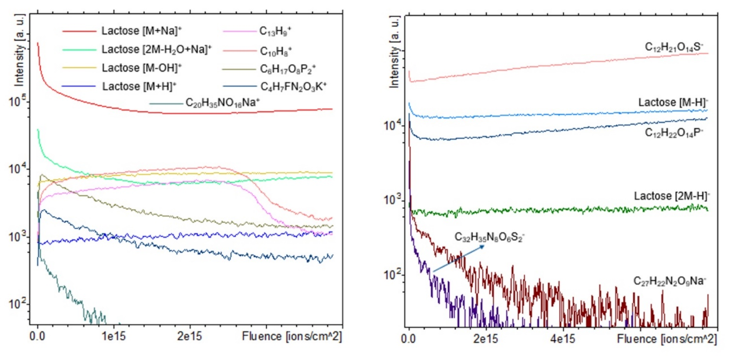

**Supplementary Figure 1.** 20 keV Ar3000+ GCIB Orbitrap MS negative ion intensity depth profile of lactose particle for selected ions from lactose and impurities. All the signals are summed over a 400 × 400 µm area. Different trends can be observed for lactose, its salt adducts and impurities.



**Supplementary Figure 2.** (Column 1) 3D rendered 30 keV Bi3+ ToF MS positive ion images (XY: 450×450 µm containing 256×256 pixels; Z: 30 scans) of lactose acquired by dual beam-dual analyzer operation mode; (Column 2-4) 2D ToF MS images at different depths. Except for Na+, ions are annotated based on their m/z values detected by orbitrap MS interleaved with ToF-SIMS images.



**Supplementary Figure 3.** A comparison between 30 keV Bi3+ ToF MS positive ion spectrum (top) and 20 keV Ar3000+ GCIB-Orbitrap MS positive ion spectrum (bottom) of lactose acquired by dual beam-dual analyzer operation mode



**Supplementary Figure 4.** Scatter plot of pixel intensity of (top left) C6H11O5+ to sodiated lactose; (top right) lactose fragment by losing OH group to sodiated lactose; (bottom left) C6H11O5+ to lactose fragment by losing OH group; (bottom right) the impurity C4H7FN2O3K+ to sodiated lactose. It was observed that the distribution of lactose-related ions was highly correlated, while that of impurity varied significantly.



**Supplementary Figure 5.** 2D 30 keV Bi3+ ToF MS negative ion images of lactose acquired by dual beam-dual analyzer operation mode. The field of view is 300×300 µm which contains 256×256 pixels and in total 50 scans are accumulated along the depth. Ions are annotated based on their m/z values detected by orbitrap MS interleaved with ToF-SIMS images. Distribution differences between impurity ions and lactose-related ions are circled in green.



**Supplementary Figure 6.** PCA of inhalation-grade lactose from batches 2 and 3 using first two scans of 20 keV Ar3000+ Orbitrap negative ion spectra collected at the uppermost surface. (a) Scores plot for PC 1 and PC 2; (b) PC1 loadings vector plotted as loadings coefficient versus peak m/z values for the data set.



**Supplementary Figure 7.** (a) PC2 loadings vector plotted as loadings coefficient versus peak m/z values; and (b) key ions contributing to the separation of different batches, identified from the component 2 scores and variable importance in projection (VIP) values obtained from PCA and PLS-DA of inhalation-grade lactose. The analysis was based on the first two scans (uppermost surface) of 20 keV Ar₃₀₀₀⁺ Orbitrap negative ion spectra collected from five different batches.



**Supplementary Figure 8.** PCA and PLS-DA of inhalation-grade lactose from five different batches using first two scans (uppermost surface) of 20 keV Ar3000+ Orbitrap positive ion spectra. (a) Scores plot for PC 1 and PC 2. (b) PC1 Loadings vector plotted as loadings coefficient versus peak m/z values for the data set. (c) PLS-DA Scores plot for the first two components. (d) Key ions driving the separation of different batches identified from component 1 scores of variable importance in projection (VIP). The coloured boxes on the right indicate the relative intensities of the corresponding ion in each batch under study. The spectra data was processed by normalization to total ion counts, removing PMA substrate peaks and scaled by the inverse square root of the mean value for each peak across all samples.



**Supplementary Figure 9.** PCA of inhalation-grade lactose from (a, b) batches 2&3 and (c, d) batches 4&5. (a, c) Scores plot for PC 1 and PC 2 using first two scans of 20 keV Ar3000+ Orbitrap positive ion spectra collected at the uppermost surface. (c, d) Loadings vector plotted as loadings coefficient versus peak m/z values for the data set. The spectra data was processed by normalization to total ion counts, removing PMA substrate peaks and scaled by the inverse square root of the mean value for each peak across all samples.



**Supplementary Figure 10.** PCA and PLS-DA of inhalation-grade lactose from five different batches: (a, c) Scores plot for PC 1 vs. PC 2 and the first two PLS-DA components for positive ion data; (b, d) corresponding scores plots for negative ion data. Data were collected using the TOF.SIMS5 instrument with a 30 keV Bi3+ primary ion beam for lactose particles segmented from the substrate. (e, f) PCA scores plots for paired batches 2 and 3 in positive and negative ion modes, respectively.