A study of the atmospherically relevant reaction DMS + Cl₂
in the absence and presence of water, using electronic structure methods

Lydia Rhyman^{a,b*}, Edmond P. F. Lee^{c}, Ponnadurai Ramasami^{a,b*} and John M. Dyke^{c*}

ªComputational Chemistry Group, Department of Chemistry, Faculty of Science, University of Mauritius, Réduit 80837, Mauritius

^{b}Centre For Natural Product Research, Department of Chemical Sciences, University of Johannesburg, Doornfontein, Johannesburg 2028, South Africa

^{c}School of Chemistry, University of Southampton, Highfield, Southampton SO17 1BJ, UK

Abstract
The thermodynamics and mechanisms of the atmospherically relevant reaction between DMS and molecular chlorine (Cl₂) were investigated in the absence and presence of a single water molecule, using electronic structure methods. Stationary points on the reaction surfaces were located using density functional theory (DFT) with the M06-2X functional with aug-cc-pVTZ (aVTZ) basis sets. Then fixed point calculations were carried out using the UM06-2X/aVTZ optimised stationary point geometries, with aug-cc-pVnZ basis sets (n = T and Q), using the domain-based local pair natural orbitals coupled cluster [DLPNO-UCCSD(T)] method, to give DLPNO- CCSD(T)/CBS//M06-2X/aVTZ relative energies
The reaction can proceed in three ways depending on the initial van der Waals complex formed i.e. via DMS + Cl₂:H₂O, DMS:H₂O + Cl₂, or DMS:Cl₂ + H₂O. It was found that based on computed equilibrium constants for complex formation and estimated initial concentrations of DMS, Cl₂ and H₂O in the atmosphere that [DMS.H₂O] and [Cl₂.H₂O] are likely to be much greater than [DMS.Cl₂] under atmospheric conditions. It was found that both with and without water the reaction can proceed by two pathways (i) formation of the products CH₃SCH₂Cl + HCl + (H₂O) via a covalently bound intermediate (CH₃)₂SCl₂(H₂O) and (ii) formation of the products via a cis-CH₃SClCH₂:HCl(H₂O) intermediate, where (H₂O) applies to the with-water case. Although the pathways and mechanisms are similar in the without-and with-water cases, the relative energies of the transition states are significantly lower and the potential energy diagram is much more complex in the with-water case. However, under tropospheric conditions the overall DMS + Cl₂ rate coefficient is unlikely to be affected by the presence of water as the concentrations of DMS.H₂O and Cl₂.H₂O are estimated to be much lower than the concentrations of DMS, Cl₂ and H₂O. This work extends our earlier study of the reaction of dimethyl sulphide (DMS) with atomic chlorine (Cl) with and without water (PCCP 2023, 25, 4780-4793),

- Introduction
In this work the atmospherically important reaction between molecular chlorine and dimethyl sulphide (DMS), (reaction (1)) is studied.
CH₃SCH₃ + Cl₂ → CH₃SCH₂ + HCl ---------(1) in the absence and presence of a single water molecule.
The sulphur cycle in the earth’s atmosphere has been the subject of intensive investigation in recent years because of the need to assess the contribution of anthropogenically produced sulphur to acid rain, visibility reduction and climate modification (1-4). Anthropogenic emissions of sulphur to the atmosphere are dominated by SO₂ whereas natural (biogenic) sulphur emissions are thought to be dominated by dimethyl sulphide derived from oceanic phytoplankton initiated by ultraviolet radiation from the sun (5-8). At present, anthropogenic emissions of sulphur dominate; however, these emissions are predominantly in the northern hemisphere. In the southern hemisphere, and in particular from the southern oceans, natural emissions are extremely important. Typical day-time and night-time [DMS] levels in the troposphere are 120 and 50 pptv respectively (8).
The main DMS oxidation reactions in the atmosphere are DMS + OH during the day and DMS + NO₃ at night . Subsequent oxidation leads to formation of species such as SO₂, H₂SO₄ and CH₃SO₃H (methane sulfonic acid or MSA). These species may contribute significantly to the acidity of the atmosphere and in the case of sulphuric acid to cloud formation. Recently molecular chlorine has been observed in coastal marine air. This is produced at night, as well as during the day, from heterogeneous reactions of ozone with wet sea-salt and is enhanced by the presence of ferric ions (9-13). Night-time Cl₂ mixing ratios are higher than those during the day because of Cl₂ photolysis during the day. Comparison of recent experimentally measured Cl₂ concentrations in the lower atmosphere shows that typical day-time and night-time [Cl₂] levels are 5 and 50 pptv respectively (14-19). The DMS + Cl₂ reaction, which occurs mainly at night, provides another route for DMS loss and hence SO₂ production. This could contribute to explaining the discrepancy between known DMS decay rates and observed SO₂ production rates. Water is the third most abundant species in the troposphere behind only N₂ and O₂ with concentrations of up to 7.4×10¹⁷ molecules.cm⁻³ (100% relative humidity; 0.03 atm.) (12). Recently, it has been demonstrated that water can change the rate coefficient of a reaction, by forming complexes with the reagents, products and transition states and lower their energies, and in this way, the activation barrier for a reaction may be reduced (20-27).
We have previously studied the reaction of DMS with molecular chlorine (DMS + Cl₂) using UV photoelectron spectroscopy (PES), infrared matrix isolation spectroscopy and electronic structure calculations (28-30). It was found that this reaction proceeds through the formation of a covalent reaction intermediate ((CH₃)₂SCl₂), in which sulphur is four coordinate. This then decomposes into the final products, monochlorodimethylsulphide (CH₃SCH₂Cl) and hydrogen chloride (HCl). Also, using PES as the detection technique, the room temperature rate coefficient of DMS + Cl₂ has been measured as (3.4 ± 0.7) × 10⁻¹⁴ cm³.molecule⁻¹s⁻¹(28), four orders of magnitude lower than the DMS + Cl room temperature rate coefficient. One objective of our studies on DMS reactions of atmospheric importance is to investigate the effect of water on the reactions DMS + Cl and DMS + Cl₂ using electronic structure methods. The DMS + Cl reaction has recently been investigated in this way (31). It was found that this reaction proceeds via four channels and, although water changes the mechanisms of these channels significantly, the presence of water was found not to affect the overall reaction rate coefficient under atmospheric conditions. Following on from this study, the aim of this present work is to study the reaction DMS + Cl₂ with and without water using electronic structure methods to establish the reaction energetics and mechanisms, and to determine if the energies of the transition states relative to the reagents are changed significantly when a single water molecule is present. In the earlier, mainly experimental, studies (28-30) a schematic potential energy diagram was constructed for the DMS + Cl₂ reaction. Minimum energy structures and transition states were located at the MP2/aug-cc-pVDZ level. In the present work, electronic structure calculations are performed at a higher level on the DMS + Cl₂ reaction in the absence and presence of a single water molecule to obtain improved relative energies, thermochemical values and structures of the energy minima and transition states.

- Computational Details
Electronic structure calculations were carried out to optimise the geometries of the reactants, reactant complexes, transition state structures (TSs), product complexes and products. As in our previous DMS + Cl work (31), the M06-2X functional was used with aug-cc-pVTZ (aVTZ) basis set (32). These computations were performed in the spin unrestricted formalism. The M06-2X functional was chosen because it has been shown to perform particularly well for TS structures and reaction barrier heights in benchmark studies on main group compounds (33-37). Harmonic vibrational frequencies were calculated to verify the nature of the stationary points (minima and TSs), and to provide the zero-point energy (ZPE) and the thermodynamic contributions to the enthalpy and free energy changes. Intrinsic reaction coordinate (IRC) calculations were also performed to ensure that a given TS connects with the desired minima (38,39).
Fixed point calculations were carried out using the UM06-2X/aVTZ optimised stationary point geometries, with the aug-cc-pVnZ basis sets (n = T and Q), using the domain-based local pair natural orbitals coupled cluster (DLPNO-UCCSD(T)) approach (40-44). These were DLPNO-UCCSD(T)/aVnZ//UM06-2X/aVTZ (n = T and Q) calculations; the total energies obtained were extrapolated to the CBS limit employing the two parameter formula (equation 2) (45,46):-
$E(x)=E_{CBS}+Ax^{-3}$ ---------------------- (2)
where x= 3 (aVTZ) and 4 (aVQZ)
This DLPNO-UCCSD(T) method employs localised orbitals and obtains the correlation energy as a sum over the correlation energies of electron pairs. It recovers a large part of the CCSD(T) correlation energy at low computational cost.
All DFT computations were carried out using Gaussian 16 (47) running on SEAGrid (48-51).The DLPNO-UCCSD(T) single point calculations were performed using the ORCA package (52,53).

- Results and Discussion
When one water molecule is added to DMS+Cl₂, the reaction could proceed in three ways depending on the initial reaction (van der Waals) complex formed i.e. DMS + Cl₂:H₂O, DMS:H₂O + Cl₂, DMS:Cl₂ + H₂O. The computed minimum energy structures of the three van der Waals complexes Cl₂:H₂O, DMS:H₂O, DMS:Cl₂ at the M06-2X/aVTZ level are shown in Figure 1.
Figure 1: Optimised minimum energy geometries of Cl₂:H₂O, DMS:H₂O and DMS:Cl₂.[Should we indicate the hydrogen bonding in the molecules or delete these?---NO, PLEASE DELETE-H-bonds in DMS.H₂O]
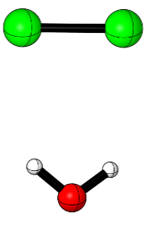 | 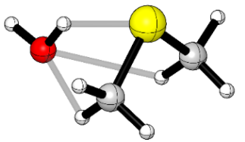 | 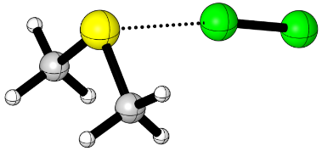
Cl₂:H₂O | DMS:H₂O | DMS:Cl₂

It was found that a common feature of the DMS + Cl₂ reaction with and without added water was that in each case the reaction can proceed along two pathways:- (i) the reactants to the covalently bound intermediate (CH₃)₂SCl₂ (H₂O) and on to the reaction products CH₃SCH₂Cl + HCl + (H₂O) and (ii) on a separate surface, the reactants to cis-CH₃SClCH₂:HCl (H₂O), and on to the products CH₃SCH₂Cl + HCl + (H₂O), where (H₂O) applies to the with-water case. The computed minimum energy structures of (CH₃)₂SCl₂•H₂O and cis-CH₃SClCH₂:HCl•H₂O at the M06-2X/aVTZ level are shown in Figure 2.

Figure 2: Optimised minimum energy geometries of (CH₃)₂SCl₂•H₂O and cis-CH₃SClCH₂:HCl•H₂O.
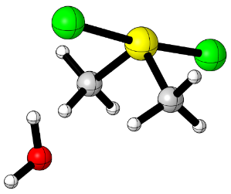 | 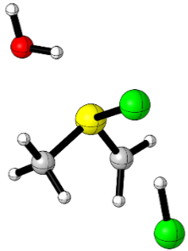
(CH₃)₂SCl₂•H₂O | cis-CH₃SClCH₂:HCl•H₂O

The schematic potential energy diagram obtained at the DLPNO-CCSD(T)/CBS//M06-2X/aVTZ level for the DMS+Cl₂ reaction, in the absence of water, is shown in Figure 3. The M06-2X/aVTZ and DLPNO-CCSD(T)/CBS//M06-2X/aVTZ relative electronic energies (ΔE, including zero-point energy (ZPE) corrections), relative enthalpies (ΔH^{φ}_{f,298K} ) and relative free energies (ΔG^{φ}_{f,298K}) of the energy minima and transition states located are shown in Table 1. Comparison of the results shown in Figure 3 with the results obtained in the earlier, mainly experimental, work (28) at the MP2/aug-cc-pVDZ level (summarised in Figure 7 of ref.(28)) shows that the earlier results are incomplete with some stationary points not located, and the results are more approximate than the results presented here. In both cases pathways (i) and (ii) described above were identified. A summary of the relative energies of the common stationary points obtained in this work and in the lower level work of ref.(28) is given in Table 1. In this table it can be seen that the present M06-2X/aVTZ and DLPNO-CCSD(T)/CBS results agree very well with each other, which supports their reliability, with the earlier lower-level MP2 energy values being mostly lower than the DLPNO-CCSD(T) values.
For formation of (CH₃)₂SCl₂ from the reactants, quoting the higher level DLPNO ΔE values (with the lower level ΔE values from ref.(28) shown in italics in brackets), the reactants first form a van der Waals complex DMS:Cl₂ (at -4.9 (-9.5) kcal.mol⁻¹) which converts via a transition state (TS1 at 10.1(4.5) kcal.mol⁻¹) to (CH₃)₂SCl₂ (at -17.7 (-26.3) kcal.mol⁻¹). In comparison, cis-CH₃SClCH₂:HCl (at -6.5 (-14.7) kcal.mol⁻¹) is formed from the van der Waals complex DMS:Cl₂ via passage over a TS (TS4 at 25.2 kcal.mol⁻¹ (not located in ref.28)) to give DMSCl:Cl (at +7.7 (2.4) kcal.mol⁻¹) which converts via TS5 (at 14.8 (11.4)) kcal.mol⁻¹) to give cis-CH₃SClCH₂:HCl (see Figure 3). The route from the covalently bound intermediate (CH₃)₂SCl₂ to the products is over TS2 (at 6.1 (2.7) kcal.mol⁻¹) to CH₃SClCH₂:HCl (at -1.6 kcal.mol⁻¹ (not located in ref.(28)), and then over TS3 (at 16.0 (8.3) kcal.mol⁻¹) to the product complex (trans-CH₃SCH₂Cl:HCl at -29.5 (-42.1) kcal.mol⁻¹) and on to the products CH₃SCH₂Cl + HCl (at -28.8 (-32.0) kcal.mol⁻¹). The route from the intermediate cis-CH₃SCH₂Cl:HCl to the products is via TS6 (at -2.6 (-10.8) kcal.mol⁻¹) to cis-CH₃SCH₂Cl:HCl (at -32.2 (-42.1) kcal.mol⁻¹) then via TS7 (at -27.1 kcal.mol⁻¹ (not located in ref.28) ) to the product complex trans-CH₃SCH₂Cl:HCl (at -29.5 (-42.1) kcal.mol⁻¹) and on to the products CH₃SCH₂Cl + HCl (at -28.8 (-32.0) kcal.mol⁻¹). As can be seen from Figure 3, for the pathway via (CH₃)₂SCl₂ the highest barrier (rate determining) is TS3 (at 16.0 kcal.mol⁻¹) whereas for the pathway via cis-CH₃SClCH₂:HCl the highest barrier is TS4 (at 25.2 kcal.mol⁻¹).

Figure 3: Energy profile for the reaction of DMS + Cl₂ in the absence of water using the DLPNO-CCSD(T)/CBS//M06-2X/aVTZ method.

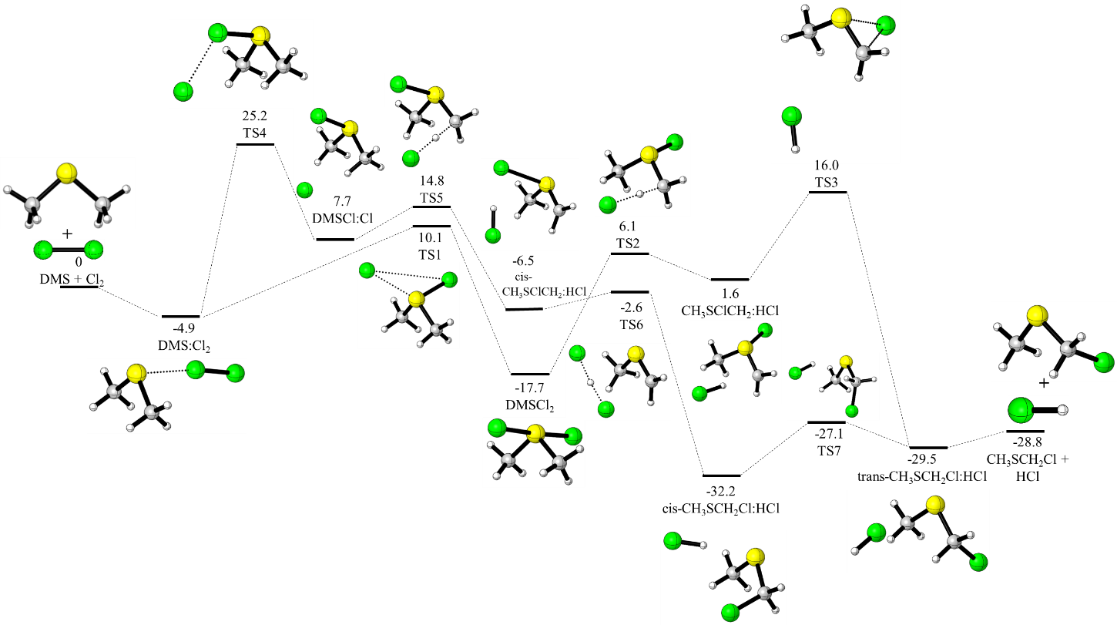
Table 1: DMS + Cl₂ Relative electronic energies (∆E, kcal.mol⁻¹), relative enthalpies (in brackets, ΔH^{φ} _{f,298K} kcal.mol⁻¹)ª and relative free energies (in italic, ΔG^{φ} _{f,298K} kcal.mol⁻¹).

 | M06-2X/aVTZ | DLPNO-CCSD(T)/CBS//M06-2X/aVTZ | MP2/aug-cc-pVDZ (ref.28)
DMS:Cl₂ | -5.5  (-5.1)  2.3 | -4.9  (-4.6)  2.8 | -9.47
TS1 | 11.6  (10.8)  21.7 | 10.1  (9.4)  20.3 | 4.50
DMSCl₂ | -16.3  (-16.5)  -7.1 | -17.7  (-17.9)  -8.5 | -26.29
TS2 | 6.5  (5.9)  15.9 | 6.1  (5.5)  15.5 | 2.75
CH₃SClCH₂:HCl | 1.6  (1.7)  9.7 | -1.6  (-1.4)  6.6 | Not locatrednot located
TS3 | 18.9  (19.4)  25.3 | 16.0  (16.6)  22.4 | 8.35*
CH₃SCH₂Cl:HCl | -28.6  (-28.3)  -20.9 | -29.5  (-29.3)  -21.8 | -42.15
CH₃SCH₂ Cl + HCl | -27.6  (-27.3)  -27.3 | -28.8  (-28.4)  -28.5 | -32.06
TS4 | 26.1  (25.6)  34.8 | 25.2  (24.7)  36.0 | not located
DMSCl:Cl | 9.1  (8.8)  18.4 | 7.7  (7.4)  17.1 | 2.43
TS5 | 14.7  (14.1)  24.2 | 14.8  (14.3)  24.4 | (14.19 quoted in Ref.(28))  11.38*  (TS3 of ref.(28))
cis-CH₃SClCH₂:HCl | -3.9  (-3.8)  4.9 | -6.5  (-6.5)  2.2 | -14.69
TS6 | -1.7  (-2.2)  7.3 | -2.6  (-3.0)  6.5 | -10.83  (TS4 of ref.(28))
cis-CH₃SCH₂Cl:HCl | -31.3  (-31.1)  -23.8 | -32.2  (-31.9)  -24.7 | -42.15
TS7 | -26.5  (-26.9)  -17.8 | -27.1  (-27.6)  -18.5 | not located
ªThe thermal correction to the enthalpy obtained using the M06-2X/aVTZ method were added to the DLPNO-CCSD(T) single point energy (ZPE is included in the electronic energies).
*Not reported in the literature, we located the TS3 using the MP2/aVDZ method.

The schematic reaction profiles of the DMS+Cl₂ reaction in the presence of one water molecule are shown in Figures 4 and 5. Figure 4 shows profiles which involve reaction via the hydrated covalently bound intermediate (CH₃)₂SCl₂•H₂O and Figure 5 shows profiles which involve reaction via the hydrated intermediate cis-CH₃SClCH₂:HCl. Overall, most of the minima and transition states seen in Figure 3 (in the absence of water) for pathways (i) and (ii) have counterparts in Figure 4 and 5 respectively (with water present).

Figure 4: Energy profiles for the reaction of DMS + Cl₂ + H₂O via the hydrated covalently bound intermediate (CH₃)₂SCl₂•H₂O using the M06-2X/aVTZ and DLPNO-CCSD(T)/CBS//M06-2X/aVTZ methods. The M06-2X/aVTZ relative electronic energies (∆E) including ZPE are reported in the figure, with the DLPNO-CCSD(T)/CBS//M06-2X/aVTZ values shown in brackets; values are in kcal.mol⁻¹).THERE SHOULD BE A DOTTED LINE FROM DMS.Cl.H₂O to TS1.H₂O—PLEASE ADD
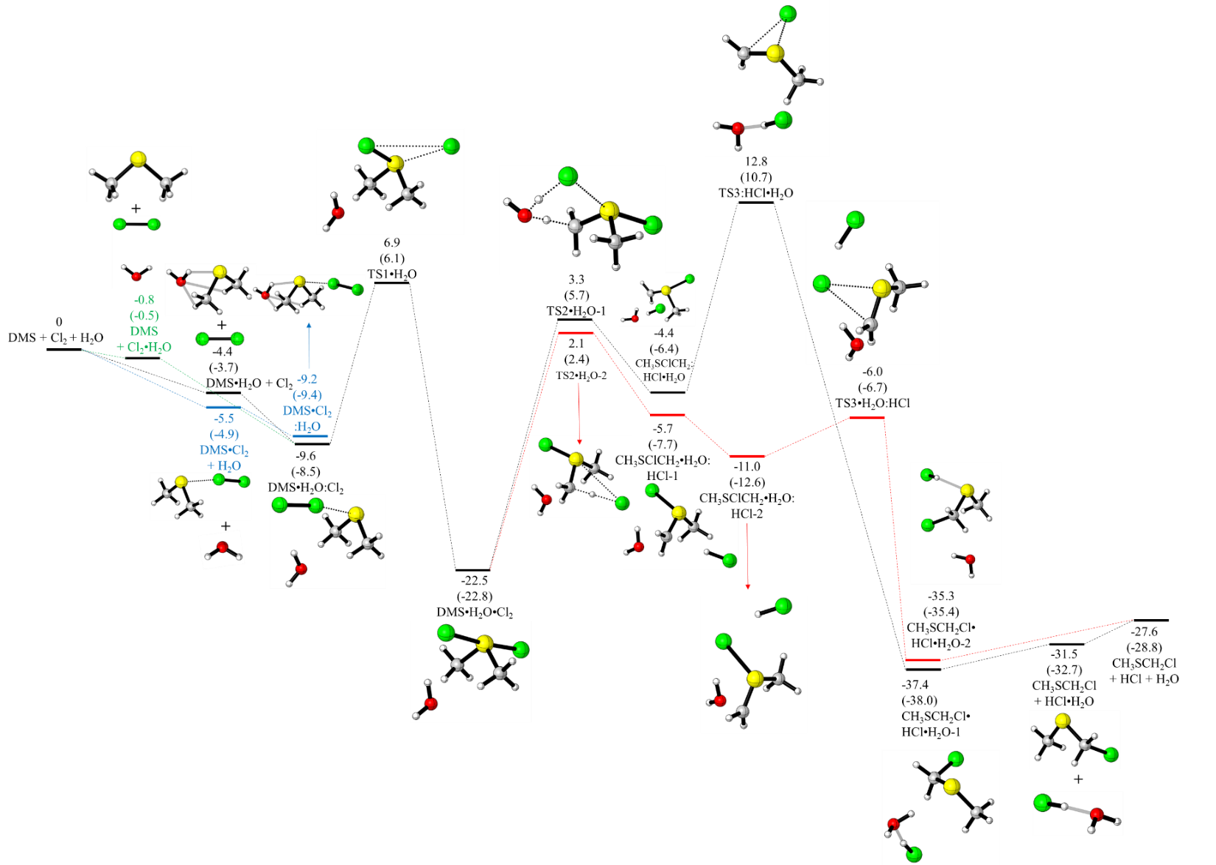

Figure 5: Energy profiles for the reaction of DMS + Cl₂ + H₂O using the M06-2X/aVTZ and DLPNO-CCSD(T)/CBS//M06-2X/aVTZ methods via the hydrated intermediate cis-CH₃SClCH₂:HCl. The M06-2X/aVTZ relative electronic energies (∆E) including ZPE are reported in the figure, with the DLPNO-CCSD(T)/CBS//M06-2X/aVTZ values shown in brackets; values are in kcal.mol⁻¹).
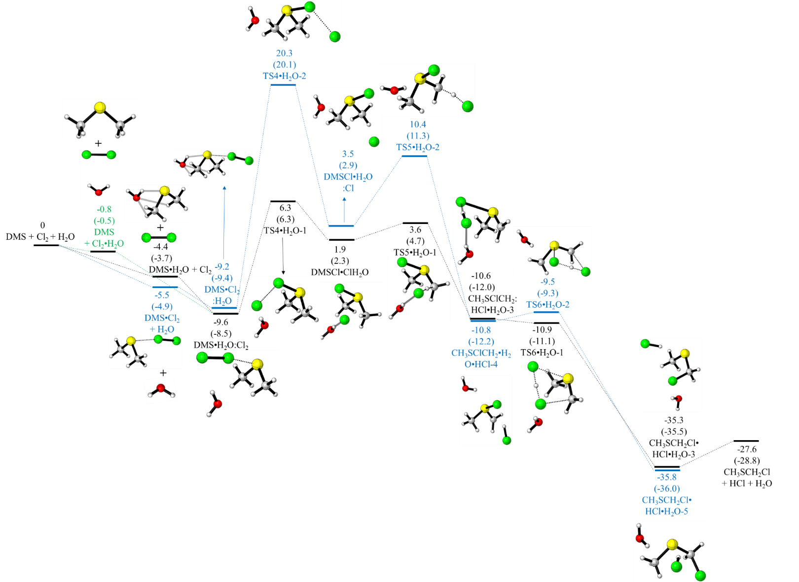

As stated earlier, when one water molecule is added to DMS+Cl₂, the reaction could proceed via DMS + Cl₂•H₂O, DMS•H₂O + Cl₂, DMS•Cl₂ + H₂O. As shown in Figures 4 and 5, the relative energies of these relative to DMS+Cl₂+H₂O are DMS+Cl₂•H₂O (-0.5 kcal.mol⁻¹) > DMS•H₂O +Cl₂ (-3.7 kcal.mol⁻¹) > DMS•Cl₂+H₂O (-4.9 kcal.mol⁻¹) (all values quoted are the higher level DLPNO ΔE values). DMS + Cl₂•H₂O and DMS.H₂O + Cl₂ correlate with a DMS•H₂O•Cl₂ minimum at -8.5 kcal.mol⁻¹, whereas DMS•Cl₂ + H₂O correlates with another DMS•H₂O•Cl₂ minimum at -9.4 kcal.mol⁻¹ . As shown in Figure 4 , both minima (at -8.5 and -9.4 kcal.mol⁻¹) convert via TS1•H₂O ( at +6.1 kcal.mol⁻¹) to the solvated covalently bound intermediate (CH₃)₂SCl₂•H₂O [Should we write is as DMS• Cl₂•H₂O to be consistent with the figures?—I THINK IT IS BETTER TO KEEP THE NOTATION AS IT IS] (at -22.8 kcal.mol⁻¹). In contrast, on the cis-CH₃SClCH₂:HCl.H₂O pathway (Figure 5), only the DMS.H₂O.Cl₂ minimum at -8.5 kcal.mol⁻¹ converts via TS4•H₂O-1 to a DMSCl.Cl.H₂O minimum energy structure at +2.3 kcal.mol⁻¹ which converts via TS5•H₂O-1 (at +4.7 kcal.mol⁻¹) to a hydrated cis-CH₃SClCH₂•HCl minimum at -12.2 kcal.mol⁻¹ and the DMS.Cl₂.H₂O minimum at -9.4 kcal.mol⁻¹ converts via TS4.H₂O-2 (at +20.1 kcal.mol⁻¹ ) to a DMSCl.H₂O.Cl structure at +2.9 kcal.mol⁻¹ which converts via TS5.H₂O-2 at 11.3 kcal.mol⁻¹ to CH₃SClCH₂.HCl.H₂O-3 at -12.0 kcal.mol⁻¹. For the pathway via the intermediate (CH₃)₂SCl₂ in Figure 3 each stationary point has an equivalent in Figure 4. Significantly, taking the largest barriers in the no-water case, TS3 at +16.0 kcal.mol⁻¹ is lowered to TS3•H₂O.HCl at -6.7 kcal.mol⁻¹(although there is a higher TS3 on a separate surface; TS3•HCl.H₂O at 10.7 kcal.mol⁻¹). Similarly, the cis-CH₃SClCH₂:HCl pathway, TS4 (Figure 3) is lowered from +25.2 kcal.mol⁻¹ to TS4•H₂O-1 at +6.3 kcal.mol⁻¹(although there is a higher TS4 on a separate surface; TS4•H₂O-2 at +20.1 kcal.mol⁻¹) and TS6 is lowered from -2.6 kcal.mol⁻¹ to TS6•H₂O-1 at -11.1 kcal.mol⁻¹ (Figure 5). Also, it can be seen that TS6•H₂O-1 converts directly to a product complex (CH₃SCH₂Cl•HCl•H₂O-3 at -35.5 kcal.mol⁻¹) (there is no TS7 to trans-CH₃SCH₂Cl:HCl as in the DMS+Cl₂ case with no water).
The computed relative electronic energies ΔE, as well as the relative (ΔH^{φ}_{f,298K} ) and (ΔG^{φ}_{f,298K}) values, for the minima and transition states located in the with-water case are listed in Table 2.
Table 2: DMS + Cl₂ + H₂O Relative electronic energies (∆E, kcal.mol⁻¹), relative enthalpies (in brackets, ΔH^{φ}_{f,298K}, kcal.mol⁻¹)ª and relative free energies (in italic, ΔG^{φ}_{f,298K}, kcal.mol⁻¹).

 | M06-2X/aVTZ | DLPNO-CCSD(T)/CBS//M06-2X/aVTZ
DMS•H₂O + Cl₂ | -4.4  (-4.5)  2.5 | -3.7  (-3.8)  3.2
DMS + Cl₂•H₂O | PLEASE INSERT ENTRIES HERE | PLEASE INSERT  ENTRIES HERE
DMS• Cl₂ + H₂O | -5.5  (-5.1)  2.3 | -4.9  (-4.6)  2.8
DMS•H₂O:Cl₂ | -9.6  (-9.5)  6.9 | -8.5  (-8.4)  8.0
DMS•Cl₂:H₂O | -9.2  (-8.8)  5.5 | -9.4  (-9.1)  5.2
TS1•H₂O | 6.9  (6.2)  24.9 | 6.1  (5.4)  24.1
DMS•H₂O•Cl₂ | -22.5  (-22.9)  -5.0 | -22.8  (-23.2)  -5.3
TS2•H₂O-1 | 3.3  (1.7)  22.2 | 5.7  (4.1)  24.5
CH₃SClCH₂:HCl•H₂O | -4.4  (-4.6)  12.2 | -6.4  (-6.6)  10.1
TS3:HCl•H₂O | 12.8  (13.1)  27.9 | 10.7  (10.9)  25.7
CH₃SCH₂Cl•HCl•H₂O-1 | -37.4  (-37.6)  -23.2 | -38.0  (-38.3)  -23.8
TS2•H₂O-2 | 2.1  (1.5)  19.6 | 2.4  (1.8)  19.9
CH₃SClCH₂•H₂O:HCl-1 | -5.7  (-5.7)  10.6 | -7.7  (-7.7)  8.6
CH₃SClCH₂•H₂O:HCl-2 | -11.0  (-10.9)  5.6 | -12.6  (-12.6)  3.9
TS3•H₂O:HCl | -6.0  (-6.8)  11.7 | -6.7  (-7.6)  10.9
CH₃SCH₂Cl•HCl•H₂O-2 | -35.3  (-35.1)  -19.9 | -35.4  (-35.2)  -20.0
TS4•H₂O-1 | 6.3  (5.0)  25.1 | 6.3  (5.0)  25.1
DMSCl:Cl•H₂O | 1.9  (1.0)  19.9 | 2.3  (1.5)  20.4
TS5•H₂O-1 | 3.6  (2.8)  21.6 | 4.7  (3.8)  22.6
CH₃SClCH₂:HCl•H₂O-3 | -10.6  (-10.9)  6.4 | -12.0  (-12.3)  5.0
TS6•H₂O-1 | -10.9  (-11.8)  7.0 | -11.1  (-12.0)  6.8
CH₃SCH₂Cl•HCl•H₂O-3 | -35.3  (-35.1)  -20.0 | -35.5  (-35.3)  -20.2
TS4•H₂O-2 | 20.3  (19.9)  36.8 | 20.1  (19.7)  36.5
DMSCl•H₂O:Cl | 3.5  (3.3)  20.5 | 2.9  (2.7)  19.9
TS5•H₂O-2 | 10.4  (10.0)  27.2 | 11.3  (10.9)  28.0
CH₃SCH₂Cl•HCl•H₂O-4 | -10.8  (-10.9)  6.2 | -12.2  (-12.3)  4.8
TS6•H₂O-2 | -9.5  (-10.2)  8.0 | -9.3  (-10.0)  8.2
CH₃SCH₂Cl•HCl•H₂O-5 | -35.8  (-35.5)  -21.2 | -36.0  (-35.7)  -21.4
CH₃SCH₂Cl + HCl•H₂O | -31.5  (-31.7)  -25.6 | -32.7  (-32.9)  -26.7
CH₃SCH₂Cl + HCl + H₂O | -27.6  (-27.3)  -27.3 | -28.8  (-28.4)  -28.5
ªThe thermal correction to the enthalpy obtained using the M06-2X/aVTZ method were added to the DLPNO-CCSD(T) single point energy (ZPE is included in the electronic energies).

As already described, the minimum energy geometries and formation energies (ΔE) relative to their reagents were computed for the van der Waals complexes DMS•H₂O, Cl₂•H₂O and DMS•Cl₂ at the UM06-2X/aVTZ and DLPNO-CCSD(T)/CBS//M06-2X/aVTZ levels. Also, the standard free energies (ΔG^{φ}_{f,298K}) and equilibrium constants (K_{eq},298K) were computed for the formation of these complexes. This was done in order to determine the approximate relative concentrations of these complexes under typical tropospheric conditions. The computed ΔE, ΔG^{φ}_{f,298K} and K_{eq} values are shown in Table 3, at the two levels of theory used. The following typical day-time/night-time concentrations of DMS, Cl₂ and H₂O were assumed, using values mentioned earlier:-
[DMS] 120/50ppt (2.95×10⁹/1.23×10⁹ molecules.cm⁻³),
[Cl₂] 5/50ppt (1.23×10⁸/1.23×10⁹ molecules.cm⁻³) and [H₂O] 7.38×10¹⁷/7.38×10¹⁷ molecules.cm⁻³ (8, 12,14-19,31)
With these estimated concentrations and the computed equilibrium constants for complex formation (Table 3), the estimated concentrations of the complexes at 298 K in the troposphere were in the order (Table 4)
(a) [DMS•H₂O] > (b)[Cl₂•H₂O] >> (c) [DMS•Cl₂],
with computed day-time/night-time values (in molecules.cm⁻³, at the DLPNO-CCSD(T)/CBS//M06-2X/aVTZ level ) of
[DMS•H₂O] = 3.8×10⁵/1.6×10⁵, [Cl₂•H₂O] = 9.6×10³/9.6×10⁴, [DMS•Cl₂] =1.3×10⁻⁴/5.3×10⁻⁴
Clearly, DMS•H₂O is the dominant complex under atmospheric conditions with Cl₂•H₂O slightly lower and DMS•Cl₂ much lower. [DMS•H₂O] and [Cl₂•H₂O] are comparable at night but [Cl₂•H₂O] is an order of magnitude lower than [DMS•H₂O] during the day . However, given that the estimated concentrations of DMS•H₂O and Cl₂•H₂O are much lower than the estimated concentrations of DMS, Cl₂ and H₂O, water will not affect the overall rate coefficient under typical tropospheric conditions.
To demonstrate how these numbers were derived, the day-time [DMS•H₂O] is taken as an example.
For the reaction
DMS + H₂O = DMS•H₂O -----------(3)
the equilibrium constant, K_{eq} at 298 K, has been calculated as 4.3×10⁻³ at the DLPNO-CCSD(T)/CBS//M06-2X/aVTZ level (see Table 3).
Then K_{eq} = [DMS•H₂O]/P^{φ} /(([DMS] / P^{φ}) [H₂O]/ P^{φ}) ------(4)
= [DMS•H₂O]P^{φ} /([DMS] .[H₂O]) -------(5)
where P^{φ} is the standard pressure of 1 atmosphere (2.46x10¹⁹ molecues.cm⁻³).
Using the day-time values for [DMS] and [H₂O] listed in Table S1 (and quoted earlier in the text), with K_{eq}= 4.3×10⁻³ gives [DMS•H₂O] = 3.80×10⁵ molecules.cm⁻³
Table 3: Computed reaction energy (ΔE, kcal.mol⁻¹) without ZPE correction, reaction free energy (ΔG^{φ} _{298K}, kcal.mol⁻¹) and equilibrium constant (K_{eq}) at 298K for formation of (a) DMS•H₂O, (b) Cl₂•H₂O and (c) DMS•Cl₂

 | (a) | (a) | (a) | (b) | (b) | (b) | (c) | (c) | (c)
 | ΔE | ΔG^{φ}_{298K} | K_{eq} | ΔE | ΔG^{φ} _{298K} | K_{eq} | ΔE | ΔG^{φ}_{298K}
UM06/2X/aVTZ | -5.86 | 2.54 | 1.4 × 10⁻² | -1.43 | 3.26 | 4.1 × 10⁻³ | -5.98 | 2.27 | 2.2 × 10⁻²
DLPNO-CCSD(T)/CBS//  M06-2X/aVTZ | -5.17 | 3.22 | 4.3 × 10⁻³ | -1.16 | 3.52 | 2.6 × 10⁻³ | -5.44 | 2.81 | 8.7 × 10⁻³

Table 4 Estimated Day-time and Night-time concentration ratios of [DMS•H₂O], [Cl₂•H₂O] and [DMS•Cl] in the troposphere obtained using the appropriate K_{eq} values in Table 1 and estimated concentrations in Table S2

 | UM06-2X/aVTZ  Day-Time | DLPNO-UCCSD(T)/CBS//  UM06-2X/aVTZ  Day-Time | UM06-2X/aVTZ  Night-Time | DLPNO-  UCCSD(T)/CBS  //UM06-2X/aVTZ  Night-Time
[DMS•H₂O]/[Cl₂•H₂O] | 0.82×10² | 0.39×10² | 3.4 | 1.58
[DMS•H₂O]/[DMS•Cl₂] | 3.8×10⁹ | 2.9×10⁹ | 3.8×10⁸ | 2.9×10⁸
[DMS•Cl₂]/[Cl₂•H₂O] | 2.1×10⁻⁸ | 1.3×10⁻⁸ | 0.86×10⁻⁸ | 0.58×10⁻⁸

As can be seen from Table 3, for formation of DMS•H₂O, Cl₂•H₂O and DMS•Cl₂ the computed K_{eq} (ΔG^{φ}_{f,298K}) values at the highest level (DLPNO-CCSD(T)/CBS) are 4.3×10⁻³(3.22 kcal.mol⁻¹), 2.6×10⁻³(3.52 kcal.mol⁻¹) and 8.7×10⁻³(2.81 kcal.mol⁻¹). These K_{eq} values need to be larger (i.e. the ΔG^{φ}_{f,298K} values need to be more negative) in order for water to have any effect on the overall observed reaction rate. As described above, given the estimated values of [DMS], [Cl₂] and [H₂O] in the lower troposphere, [DMS•H₂O] and [Cl₂•H₂O] are expected to be much larger than [DMS•Cl₂]. In order for the concentrations of DMS•H₂O and Cl₂•H₂O to be comparable with those of DMS and Cl₂, the DLPNO-CCSD(T)/CBS K_{eq} values for formation of these two complexes would have to increase by at least 3 orders of magnitude (ΔG^{φ}_{f,298K} values for these complex formation reactions would have to decrease by ~ 4.2 kcal.mol⁻¹ to ~ -1.0 kcal.mol⁻¹). It is important to note that for these complexation reactions, ΔS is negative and hence –TΔS makes a positive contribution to ΔG (in ΔG = ΔH - TΔS). Hence, a drop in temperature with altitude, as occurs in the troposphere up to ~15km at the tropopause (typically from 298 to 220K) will give rise to more negative values of ΔG. However, it can be seen from equ.(5) that [DMS•H₂O] depends on [H₂O]. Similarly [Cl₂•H₂O] depends on [H₂O]. Balloon-borne infrared emission measurements (54) show that water concentrations show a significant decrease with altitude being highest in the first 2km of the atmosphere. At 3km (typical temp. T_{typ}= 284K) the [H₂O] values are approximately half of the 1km (T_{typ} = 287K) values and at 5km (T_{typ} = 280K) [H₂O] values are an order of magnitude lower than the 1km value. Hence although the temperature drop with height would favour more negative ΔG values for the complexation reactions (a),(b) and (c) (and hence give larger K_{eq} values and larger complex concentrations), the large decrease of [H₂O] with height up to the tropopause, particularly in the first 5 km, is more significant and will dominate over the effect of a decrease in temperature, giving much lower complex concentrations at heights greater than 2 km than those below 2 km.
As can be seen from Figures 3-5, on including water in the DMS + Cl₂ reaction, the energy profiles are changed significantly. For example, for pathway (i) via the intermediate (CH₃)₂SCl_{2 ,} TS1 (10.1 kcal.mol⁻¹) and TS3 (16.0 kcal.mol⁻¹) are lowered significantly in the presence of water to TS1.H₂O (6.1 kcal.mol⁻¹) and TS3.H₂O.HCl (-6.7 kcal.mol⁻¹) respectively and there are two routes from TS1.H₂O (6.1 kcal.mol⁻¹) via TS3.H₂O.HCl (-6.7 kcal.mol⁻¹) and via TS3.HCl.H₂O (10.7 kcal.mol⁻¹). The highest barrier in pathway(i) in the lower energy route in the presence of water is TS1.H₂O (6.1 kcal.mol⁻¹) compared to the highest barrier in the absence of water at TS1 (10.1 kcal.mol⁻¹). For pathway (ii) via a cis-CH₃SClCH₂:HCl intermediate the very high barrier at TS4 without water (25.2 kcal.mol⁻¹) is lowered to TS4.H₂O-1 (6.3 kcal.mol⁻¹) , which is the highest barrier for this pathway. This is comparable in energy to the highest barrier of the lower energy route for pathway (i), via TS1.H₂O (6.1 kcal.mol⁻¹). Hence in the presence of water both pathways (i) and (ii) contribute to the overall reaction whereas the absence of water only pathway(i) via the intermediate (CH₃)₂SCl₂ contributes.

4.0 Conclusions
The present investigation of the DMS + Cl₂ reaction at the DLPNO-CCSD(T)/CBS//M06-2X/aVTZ level provides complete energy level diagrams for the reaction pathways which were not present in the earlier, lower-level MP2/aug-cc-pVDZ calculations. Potential energy diagrams computed for this reaction in the absence and presence of one water molecule at this higher level indicate that two pathways are present in both cases; they are (i) formation of the products CH₃SCH₂Cl+HCl + (H₂O) via a covalently bound intermediate (CH₃)₂SCl₂•(H₂O) and (ii) formation of the products via a cis-CH₃SClCH₂:HCl (H₂O) intermediate where (H₂O) applies to the with-water case. In general, the potential energy diagram is much more complex in the with-water case than in the no-water case and activation energy barriers are significantly reduced.
Three pathways were considered in the presence of water:-
DMS + Cl₂•H₂O, DMS•H₂O + Cl₂, DMS•Cl₂ + H₂O
It was found that the reaction can proceed via all three pathways. However, as it is expected that [DMS•Cl₂ ] will be much lower than [DMS•H₂O] and [Cl₂•H₂O] in the atmosphere, reaction via DMS•Cl₂ + H₂O is likely to be insignificant. Also, as the estimated concentrations of Cl₂•H₂O, DMS•H₂O , and DMS•Cl₂ are much lower than those of DMS, H₂O and Cl₂ in the lower troposphere under typical atmospheric conditions, the effect of water on the overall DMS + Cl₂ rate coefficient in the atmosphere is likely to be negligible.
It is expected that in the absence of water pathway (i) will be dominant whereas in the presence of water both pathways (i) and (ii) will contribute to the overall reaction.

5.0 Acknowledgements
This work used the Extreme Science and Engineering Discovery Environment (XSEDE), which is supported by National Science Foundation grant number OCI-1053575. LR and PR would also like to acknowledge computing facilities from the Centre for High Performance Computing of South Africa. LR also acknowledges the postdoctoral fellowship from the Higher Education Commission (formerly known as Tertiary Education Commission) of Mauritius.

- References
1. R. J. Charlson, J. E. Lovelock, and M. O. Andreae, S. G. Warren, Nature 1987, 326, 655-661.
2. S. F. Watts, Atmos. Environ. 2000, 34, 761-779.
3. T. S. Bates, B. K. Lamb, A. Guenther, J. Dignon, and R. E. Stoiber, J. Atmos. Chem. 1992, 14, 315-337.
4. H. Berresheim, P. H. Wine, and D. D. Davis, in Composition, Chemistry and Climate of the Atmosphere, (Ed.:R. Nostrand), New York, 1995, pp. 251.
5. S. E. Schwarz, Nature 1988, 336, 441-445.
6. C. F. Cullis, and M. M. Hirschler, Atmos. Environ. 1980, 14, 1263-1278.
7. T. S. Bates, J. D. Cline, R. H. Gammon, and S. R. Kelly-Hansen, J. Geophys. Res. 1987, 92, 2930-2938.
8. A.Bandy, D.C.Thornton, B.W.Blomquist, S.Chen, T.P.Wade, J.C.Ianni, G.M.Mitchell, and W.Nader Geophys Lett 1996, 23, 741-744
9. M. O. Andrea and P. J. Crutzen, Science 1997, 276, 1052-1058.
10. R. Vogt, P. J. Crutzen, and R. Sander Nature 1996, 383, 327-330.
11. B. J. Finlayson-Pitts Anal. Chem. 2010, 82, 770-776.
12. B. Finlayson-Pitts, and J. R. Pitts Chemistry of the Upper and Lower Atmosphere, Academic Press: San Diego, CA, 2000.
13. J. D. Raff, B. Njegic, W. L. Chang, M. S. Gordon, D. Dabdub, B. Gerber, and B. J. Finlayson-Pitts Proc. Natl. Acad. Sci. U.S.A. 2009, 106, 13647-13654.
14. C.B.Faxon, J.K.Bean, and L.H.Ruiz Atmosphere 2015, 6, 1487-1506.
15. B.D.Finley, and E.S. Saltzman Geophys. Res. Lett. 2006, 33, L11809.
16. M.J.Lawler, B.D.Finley, W.C.Keene, A.A.P. Pszenny, K.A. Read, R. von Glasow, and E.S.Saltzman Geophys. Res. Lett. 2009, 36, L08810.
17. J.Liao, L.G.Huey, Z.Liu, D.J. Tanner, C.A.Cantrell, J.J.Orlando, F.M.Flocke, P.B. Shepson, A.J.Weinheimer, S.R.Hall, K.Ullmann, H.J. Beine, Y. Wang, E.D.Ingall, C.R. Stephens, R.S.Hornbrook, E.C. Apel, D.Riemer, A.Fried, R.L.Mauldin III, J.N. Smith, R.M.Staebler, J.A. Neuman, and J.B.Nowak Nature Geoscience 2014, 7, 91-94.
18. T.P.Riedel, T.H. Bertram, T.A. Crisp, E.J. Williams, B.M. Lerner, A. Vlasenko, S.M.Li, J. Gilman, J.de Gouw, D.M. Bon, N.L.Wagner, S.S. Brown and J.A.Thornton Environ. Sci. Technol. 46, 10463-10470.
19.C.W.Spicer, E.G.Chapman, B.J. Finlayson-Pitts, R.A.Plastridge, J.M. Hubbe, J.D.Fast, and C.M.Berkowitz Nature 1998, 394, 353-356.
20.R.J.Busek, J.S.Francisco and J.M.Anglada Int Rev Phys Chem 2011, 30, 335-369
21. V.Vaida, J.Chem Phys 2011, 135, 020901
22. V.Vaida, H.G.Kjaergaard, P.E. Hulze and D.J.Donaldson Science 2003, 299, 1566-1568
23. V.Vaida, H.G.Kjaergaard and K.J.Feierabend Int Rev Phys Chem 2003, 22, 203-219
24. K.Morokuma and C.Muguruma J.Am Chem Soc 1994, 116, 10316-10317
25. R.S.Zhu and M.C.Lin Chem Phys Lett 2002, 354, 217-226
26. R.R.Li, J.R.A.Gorse, M.C.Sauer and S.Gordon J.Phys Chem 1980 , 84, 819-821
27. M.A.Allodi, M.E.Dunn, J.Livada, K.N.Kirshner and G.C.Shields J.Phys Chem A 2006, 110, 13283-13289
28.J. M. Dyke, M. V. Ghosh, D. J. Kinnison, G. Levita, A. Morris, and D. E. Shallcross Phys. Chem. Chem. Phys. 2005, 7, 866-873.
29.J. M. Dyke, M. V. Ghosh, M. Goubet, E. P. F. Lee, and G. Levita Chem. Phys. 2006, 324, 85-95.
30.S. Beccaceci, J. S. Ogden, and J. M. Dyke, Phys. Chem. Chem. Phys. 2010, 12, 2075-2082.
31.L.Rhyman, E.P.F.Lee, P.Ramasami, and J.M.Dyke Phys Chem Chem Phys 2023, 25, 4780-4793
- R. A. Kendall, T. H. Dunning Jr., and R. J. Harrison J. Chem. Phys. 1992, 96, 6796-6806..
- Y. Zhao, and D. G. Truhlar Acc. Chem. Res. 2008, 41, 157-167.
- J. J. Zheng, Y. Zhao, and D. G. Truhlar J. Chem. Theory Comput. 2009, 5, 808-821.
- L. Goerigk, and S. Grimme Phys. Chem. Chem. Phys. 2011, 13, 6670-6688.
- X. F. Xu, I. M. Alecu, and D. G. Truhlar J. Chem. Theory Comput. 2011, 7, 1667-1676.
- M.Bursch, J.M.Mewes, A.Hansen and S.E.Grimme Angew Chem Int Ed 2022, 61, e202205735
- C. Gonzalez, and H. B. Schlegel J. Chem. Phys. 1989, 90, 2154-2161.
- C. Gonzalez, and H. B. Schlegel J. Phys. Chem. 1990, 94, 5523-5527.
- C. Riplinger, and F. Neese J. Chem. Phys. 2013, 138, 034106 .
- C. Riplinger, B. Sandhoefer, and A. Hansen, F. Neese J. Chem. Phys. 2013, 139, 134101 (14 pages).
- C. Riplinger, P. Pinski, U. Becker, E. F. Valeev, and F. Neese J. Chem. Phys. 2016, 144, 024109
- M. Saitow, U. Becker, C. Riplinger, E. F. Valeev, and F. Neese J. Chem. Phys. 2017, 146, 164105 (32 pages).
- Y. Guo, C. Riplinger, U. Becker, D. G. Liakos, Y. Minenkov, L. Cavallo and F. Neese, J. Chem. Phys. 2018, 148, 011101 .
- T.Helgaker, W,Klopper, H.Koch and J.Noga J.Chem Phys 1997, 106, 9639-9646
- A.Halkier, T.Helgaker, P.Jorgensen, W.Klopper, H,.Koch, J.Olsen, and A.K.Wilson Chem Phys Lett 1998, 286, 243-252
- M. J. Frisch, G. W. Trucks, H. B. Schlegel, G. E. Scuseria, M. A. Robb, J. R. Cheeseman, G. Scalmani, V. Barone, G. A. Petersson, H. Nakatsuji, X. Li, M. Caricato, A. V. Marenich, J. Bloino, B. G. Janesko, R. Gomperts, B. Mennucci, H. P. Hratchian, J. V. Ortiz, A. F. Izmaylov, J. L. Sonnenberg, D. Williams-Young, F. Ding, F. Lipparini, F. Egidi, J. Goings, B. Peng, A. Petrone, T. Henderson, D. Ranasinghe, V. G. Zakrzewski, J. Gao, N. Rega, G. Zheng, W. Liang, M. Hada, M. Ehara, K. Toyota, R. Fukuda, J. Hasegawa, M. Ishida, T. Nakajima, Y. Honda, O. Kitao, H. Nakai, T. Vreven, K. Throssell, J. A. Montgomery, Jr., J. E. Peralta, F. Ogliaro, M. J. Bearpark, J. J. Heyd, E. N. Brothers, K. N. Kudin, V. N. Staroverov, T. A. Keith, R. Kobayashi, J. Normand, K. Raghavachari, A. P. Rendell, J. C. Burant, S. S. Iyengar, J. Tomasi, M. Cossi, J. M. Millam, M. Klene, C. Adamo, R. Cammi, J. W. Ochterski, R. L. Martin, K. Morokuma, O. Farkas, J.B.Foresman and D.J.Fox
Gaussian16, Revision C.01, Gaussian, Inc., Wallingford CT, 2016.
48. S.Pamidighantam, E. Nakandala, C. Abeysinghe, S. R. Wimalasena, S. Yodage, S. Marru, and M. Pierce Int. Conf. Comput. Sci 2016, 80, 1927-1937.
49.N. Shen, Y. Fan, and S. Pamidighantam J. Comput. Sci. 2014, 5, 576-589.
50.R. Dooley, K. Milfeld, C. Guiang, S .Pamidighantam, and G. Allen J. Grid. Comput. 2006, 4, 195-208.
51.K. Milfeld, C. Guiang, S. Pamidighantam, and J. Giuliani Proceedings of the 2005 Linux Clusters: The HPC Revolution, Apr. 2005.
52. F. Neese Mol. Sci. 2012, 2, 73-78.
53. F. Neese, F. Wennmohs, U. Becker, and C. Riplinger J. Chem. Phys. 2020, 152, 224108 (19 pages).
54. L. Palchetti, G. Bianchini, B. Carli, U. Cortesi, and S. Del Bianco Atmos Chem Phys 2008, 8, 2885-2894

