Using Machine Assisted Topic Analysis (MATA) to expedite thematic analysis of free-text data: exemplar investigation of factors influencing health behaviours and wellbeing during the COVID-19 pandemic

Short running title: Machine learning-based thematic analysis

Objectives: Investigate the use of machine learning to expedite thematic analysis of longitudinal qualitative data concerning factors that influenced health behaviours and wellbeing during the COVID-19 pandemic.
Design: Qualitative investigation using Machine Assisted Topic Analysis (MATA) of free-text data collected from a prospective cohort.
Methods: Free-text survey data (2,177 responses from 762 participants) of influences on health behaviours and wellbeing were collected, among UK participants recruited online, using Qualtrics at 3, 6, 12 and 24 months after the COVID-19 pandemic started. MATA, which employs Structural Topic Modelling (STM), was used (in R) to discern latent topics within the responses. Two researchers independently labelled topics and collaboratively organised them into themes, with ‘sense checking’ from two additional researchers. Plots and rankings were generated showing change in topic prevalence by time. Total researcher time to complete analysis was collated.
Results: Fifteen STM-generated topics were labelled and integrated into six themes: influences of and impacts on 1) health behaviours, 2) physical health and 3) mood, and 4) how these interacted, partly moderated by 5) external influences of control, and 6) reflections on wellbeing and personal growth. Topic prevalence varied meaningfully over time aligning with changes in the pandemic context. Themes were generated (excluding write-up) with 20 hours combined researcher time.
Conclusions: MATA shows promise as a resource-saving method for thematic analysis of large qualitative datasets whilst maintaining researcher control and insight. Findings show the interconnection between health behaviours, physical health and wellbeing over the pandemic, and the influence of control and reflective processes.

Statement of Contribution
What is already known on this subject?
- AI is increasingly being used to analyse qualitative data to reduce the resources and time required for manual analysis of large qualitative data sets
- Current methods of AI supported analysis have strengths and weaknesses, with approaches that allocate full control to the AI having only moderate consistency with researchers
- C-19 pandemic research lacks qualitative/people generated perceptions of impacts over time
What does this study add?
- MATA provides a hybrid machine and human analysis approach which maintains researcher control over thematic generation and interpretation
- Findings identify key self-reported factors shaping health behaviours, mood, and well-being during the COVID-19 pandemic using open-ended responses, capturing lived experiences and a more granular view of pandemic impact
- The prevalence of person-generated factors shaping health behaviours, mood, and well-being over a two year period from the start of the C-19 pandemic

Background
Qualitative research is an established mainstay of psychological enquiry [] and health research []. Qualitative methodologies provide critical tools for investigating a range of ‘how and why’ research questions, many of which cannot be adequately answered using quantitative methodologies [2]. In recent decades, technological advances have benefited quantitative enquiry and analysis substantially through improved software, processing power and modelling capability, enabling increasingly large and complex data sets to be interrogated. However, such technological advances have benefited qualitative research methods much less. While computer-assisted qualitative data analysis software (CAQDAS) has existed for many years, ultimately qualitative analysis is undertaken manually, which is considerably time- and resource-intensive [].

Healthcare data is one of the fastest growing sources of data across all industries [] and increasingly this includes qualitative data. Qualitative data can come from a variety of sources in addition to deliberate qualitative investigation, including healthcare records, healthcare service and technology survey data, patient recorded data, social media etc. Furthermore, generative Artificial Intelligence (AI) agents or ‘chatbots’ have demonstrated the ability to undertake qualitative interviews using open ended questions via a digital interface []. The scalability potential of using AI to collect qualitative data, alongside the large amounts of qualitative data being generated by healthcare services and other sources, highlight the increasing need to manage large qualitative datasets.

Large qualitative datasets are sometimes referred to as ‘Big Qual’ and have been defined as datasets that include data from more than 100 participants [] or simply more qualitative data that an individual or small team can feasibly analyse manually []. While there are epistemological questions about if and when such large data sets are required to adequately answer qualitative research questions [], Big Qual datasets are growing in number and volume, and will increasingly become a valuable source of insight to ultimately help improve health and healthcare. However, as it is not feasible to analyse Big Qual using manual analysis approaches new analysis methods are needed [7].

Recent advances in the use of AI provide opportunities for enhancing the analysis of large qualitative datasets. Approaches, such as topic modelling (a type of natural language processing) [], supervised text classification [] and large language models (LLMs) [] have been investigated for undertaking or supporting qualitative analysis. Evidence to date indicates that the use of AI tools improves the efficiency and reduces the resource requirements for qualitative analysis compared to manual approaches [11,,]. However, an important dimension is the extent to which the AI has full control of the final thematic or descriptive structure, and thus its reliability and authenticity, or is instead used for analysis augmentation.

Large Language Models (LLMs) show promise in qualitative analysis by identifying novel themes and theoretical links that human researchers may not identify [,]. However, concerns about bias and low consistency with researchers suggest more research is needed before granting them full control [11,14,,]. The use of AI to augment human directed analysis, rather than replace it, is an alternative that may circumvent some of the current limitations with LLM-controlled qualitative analysis. Natural Language Processing (NLP) enhances the scalability and efficiency of text analysis, although on its own it lacks the depth and recognition of nuance and cultural contexts that humans bring to qualitative analysis [7]. Using NLP to support, rather than control, qualitative analysis enables rapid AI-identified concepts but with a layer of verification and ultimate control from the researcher.

Machine-Assisted Topic Analysis (MATA) [12,] combines computational analysis with the expertise and insights of experienced qualitative researchers, leveraging both artificial and human intelligence to handle large volumes of text data. MATA employs Structural Topic Model (STM), as proposed by Roberts et al. (2019) [], which discerns latent topics within texts. STM operates under the premise that documents are composites of topics, and it aids in extracting and delineating principal themes within a text corpus, mapping them onto individual documents. This method is particularly useful for systematically analysing extensive volumes of unstructured text.

One of the key strengths of STM lies in its incorporation of document-level metadata into the topic modelling process [19]. This metadata can range from a document's creation date to the characteristics of its source (e.g., participants) and acts as covariates in the model. This integration allows for a nuanced estimation of the relationship between such variables and the discussed topics, enhancing the depth of analysis. It affects both the frequency of discussion of particular topics and the overall interpretive quality of the analysis. STM is instrumental for qualitative researchers, facilitating the identification of patterns and assisting in deriving deeper insights, interpreting, and summarizing the topics. The output of STM is a series of topics that identify key patterns and categories from large datasets which can be interpreted and understood in context by the researchers to enable them to generate overarching themes from the data.

MATA was developed in response to the increasing need for rapid analysis of large quantities of free-text data, a challenge that became especially evident during the COVID-19 pandemic. For example, datasets like the UK NHS Test and Trace data [18] where rapid actionable insights were crucial to improve the management of the pandemic. COVID-19 impacts over time have been summarised quantitatively by cohort studies , including identifying health trends such as changes to health behaviours [,,], impacts of long covid [], initial increased mental health issues [], and widening health inequalities [21,,]. However, there is a lack of qualitative examination of longitudinal qualitative cohort data, which could serve to contextualise quantitative cohort findings, provide additional insights and individual-centred perspectives on pandemic impacts [2]. One such dataset is the C-19 Health Behaviour and Wellbeing Daily Tracker Study []. This study investigated how the pandemic affected health behaviour and wellbeing/mental health over time and included free-text questions which hitherto were not able to be analysed due to resource-limitations.

- This paper has two parallel aims. Firstly, it aims to describe the process of applying MATA for analysing qualitative free-text data in a large longitudinal dataset. Secondly, it describes the application of MATA to answer the question of which factors were self-reported to influence health behaviours, mood and wellbeing over a two-year period since the COVID-19 pandemic started, among participants of the C-19 Health Behaviour and Wellbeing Daily Tracker Study [27]. This second aim serves as both a demonstration of the method and an investigation into this under-investigated research question. Objectives relating to this second aim are: Explore factors (as thematic topics), reported in free-text responses at 3, 6, 12 and 24 months follow up, that are perceived to influence health behaviours, mood and wellbeing
- Explore the prevalence of identified factors at each follow up timepoint and change in prevalence over time

Methods

Design and participants
Qualitative investigation of free-text data collected in follow up surveys from a prospective cohort of UK residents recruited in April 2020.

Participants were 18 years and above, living in the UK, with access to a smartphone. Participants were recruited online and were purposively sought to include people with a high-risk physical condition for COVID-19 (in line with UK national definitions in 2020), those living in an area of high deprivation and those with a self-reported mental health issue. Recruitment was via social media and targeted to vulnerable groups (e.g., women’s groups, mental health support groups).

Procedure
Once enrolled and after completing the baseline questionnaire and a 12-week measurement period of daily ecological momentary assessments [27], all participants were invited to complete follow up surveys at 3, 6, 12 and 24 months post-baseline. Surveys were hosted on Qualtrics XM software. These online surveys were prompted by text message, with several reminders, and collected data on COVID-19, health behaviour and wellbeing/mental health-related measures. For further details about the parent study see the project Open Science Framework page (https://osf.io/dm853/) and the wave 1 findings article [27].

At the end of each follow up survey, participants were invited to answer a free-text question inviting them to “Please… tell us what factors have influenced your health behaviours, mood and sense of wellbeing over the last [3/12] months.” The 3, 6 and 12 month survey enquired about the last 3 months and the 24 month survey about the last 12 months. The responses to this free-text data are the focus of this article. The follow-up surveys were conducted at four key timepoints over a 21-month period during the Covid-19 pandemic. The 3-month survey was collected in July 2020, when England was beginning to emerge from the first national lockdown. The 6-month survey was collected in October 2020, as COVID-19 cases were rising and local tiered restrictions were introduced. The 12-month survey was collected in April 2021, shortly after England had exited a second lengthy national lockdown. Finally, the 24-month survey was collected in April 2022, following gradual lifting of all remaining restrictions.

Machine-assisted topic analysis (MATA)
Structured data, comprising participant identifier, timepoint, age, gender, deprivation, COVID-19 risk factors, and the prevalence of mental health issues, were included in the models as covariates to account for their potential influence on the outcomes. These variables provided a foundation for the analysis, ensuring that key demographic, socioeconomic, and health-related factors were considered systematically.

Data preprocessing was conducted using R (version 3.5.2) and included the following steps:
- Cleaning Free-Text Responses: Free-text data were handled using a combination of base R functions and the quanteda (version 2.0.1) and STM (version 1.3.3) packages. Initial cleaning involved removing punctuation, symbols, and numbers from the text, ensuring consistency and preparing it for further processing.
- Removing Incomplete or Redundant Data: Observations containing missing values or duplicate entries were identified and removed to maintain the integrity of the dataset.
- Tokenisation of Text: The cleaned free-text responses were converted into tokens—individual words—using the quanteda package. Tokenisation facilitated the transformation of textual data into a structured format suitable for analysis.
- Eliminating Stop Words: Commonly used words with minimal analytical value, such as "and" or "the", were removed to focus on more meaningful content.
- Stemming Tokens: Words were reduced to their root forms through a process called stemming. This step acted as a normalisation process, reducing variability in the text and decreasing the size of the dictionary.

Structural Topic Modelling of the free-text data
We employed the Structural Topic Model (STM) as our topic modelling method [12]. Diagnostic analysis was conducted prior to running the models to identify the optimal number of topics. This process involved balancing semantic coherence and exclusivity, guided by relevant metrics and the specific aims of the analysis.

To identify the best model configuration, we tested models with 5 to 40 topics, incorporating the structured data reported above as covariates. We evaluated the models based on their semantic coherence scores [] and residuals. Following a visual examination of diagnostic plots (Appendix 1), we determined that a model with 15 topics was optimal for the analysis. To facilitate qualitative analysis, we extracted 20 representative ‘quotes’ for each topic from the dataset.

Researcher interpretation of topics and generation of themes
The aim of the researcher-led qualitative analysis was to interpret the output, agree upon narrative labels for the topics, and organise topics into a broader thematic structure, identifying factors as outlined in Objective #1.

We analysed the STM in 5 stages:
- EW and FN independently categorised the machine output (in Excel) by writing short descriptive notes for each quote within a topic and then reviewing the notes for similarities of meaning to identify topic meaning.
- EW and FN then met to compare their independent interpretation of machine output, resolve any disagreements in the interpretation through discussion and agree the draft MATA code labels for each topic.
- EW and FN worked together to organise the MATA code labels into broader themes.
- PB and SH separately reviewed the text analysis and labels to ‘sense check’ the interpretation. EW, FN, PB and SH met to discuss the MATA code labels and broader theme labels and structure, agreeing on a consensus of interpretation through collaborative discussion.
- EW conducted an analytical write-up of the qualitative analysis which consisted of re-reviewing free-text responses provided in each topic in the context of the researchers’ interpretation of topic meaning. The write-up was reviewed by the other researchers. As is typical in qualitative research, this stage was an iterative process and resulted in some changes to label headings and thematic structure. Changes were agreed by the team and summarised in the findings section.

Prevalence of topics by timepoint
To meet objective #2, exploratory analysis was undertaken on the prevalence of topics at each follow up timepoint and change in prevalence over time. The prevalence of each user response to each topic was averaged to calculate a mean topic weighting for each follow up timepoint (3, 6, 12 and 24 months; the higher the mean weighting score indicating greater prevalence at that time). How prevalence of topics changed over time in comparison to each other was explored by plotting topic prevalence at each time point using line graphs. Prevalence scores were converted to rankings for each timepoint for ease of interpretation (1 = most prevalent through to 15 = least prevalent).

Findings
The characteristics of the sample are shown in Table 1.
Table 1 Baseline sample description (N=762)
Characteristic |  | %ª | N^{b}
Age category (years)
 | 18-24 | 7.6 | 58
 | 25-44 | 32.4 | 246
 | 45-64 | 46.0 | 349
 | 65+ | 14.0 | 106
Gender
 | Male | 25.4 | 191
 | Female | 74.6 | 562
Ethnicity
 | White | 96.3 | 731
 | Other | 3.7 | 28
Number of adults in household
 | 1 (living alone) | 21.2 | 161
 | 2 | 57.8 | 439
 | 3 | 13.7 | 104
 | 4+ | 7.5 | 56
Keyworker
 | Yes | 26.8 | 204
 | No/not working | 73.2 | 558
Employment status
 | Employed/self-employed/freelance | 60.2 | 459
 | Not working (student/home carer/retired) | 23.9 | 182
 | Never worked or long-term unemployed | 0.3 | 2
 | Unemployed and looking for work (not due to COVID-19) | 1.6 | 12
 | Out of work/furloughed/leave of absence (due to COVID-19) | 10.6 | 81
 | Unable to work because of sickness or disability | 3.4 | 26
Index of Multiple Deprivation (IMD) quintile (1=most deprived)^{c}
 | 1 | 11.4 | 85
 | 2 | 15.8 | 118
 | 3 | 25.0 | 187
 | 4 | 22.6 | 169
 | 5 | 25.3 | 189
COVID-19 at risk health condition
 | Very high risk health condition | 7.2 | 55
 | Increased risk health condition | 24.5 | 187
 | No increased risk health condition | 68.2 | 520
Self-reported mental health issue
 | Yes | 5.8 | 44
 | No | 94.2 | 718
ª Percentages may not add up to 100 due to rounding
^{b} Due to missing data, totals may not add to 1,044
^{c} Combined using IMD decile scores from England (2019), Northern Ireland (2017), Scotland (2020) and Wales (2019)

Total researcher time to complete analysis
Stages 1-4 of the researcher interpretation took approximately 20 hours of combined researcher time, with Stage 5 (write up) taking approximately 28 hours.

Self-reported influential factors during the pandemic
The final thematic structure of the researcher interpretation of the 15 machine generated topics from free-text responses is shown in Figure 1, showing thematic clusters of topics resulting in six broader themes. Table 2 defines each topic and provides example quotations, summarising the core meaning of each topic and outlining what differentiates the topics, rather than an attempt to describe everything within the topic.

Figure 1: Thematic map of topic labels clustered into broader themes
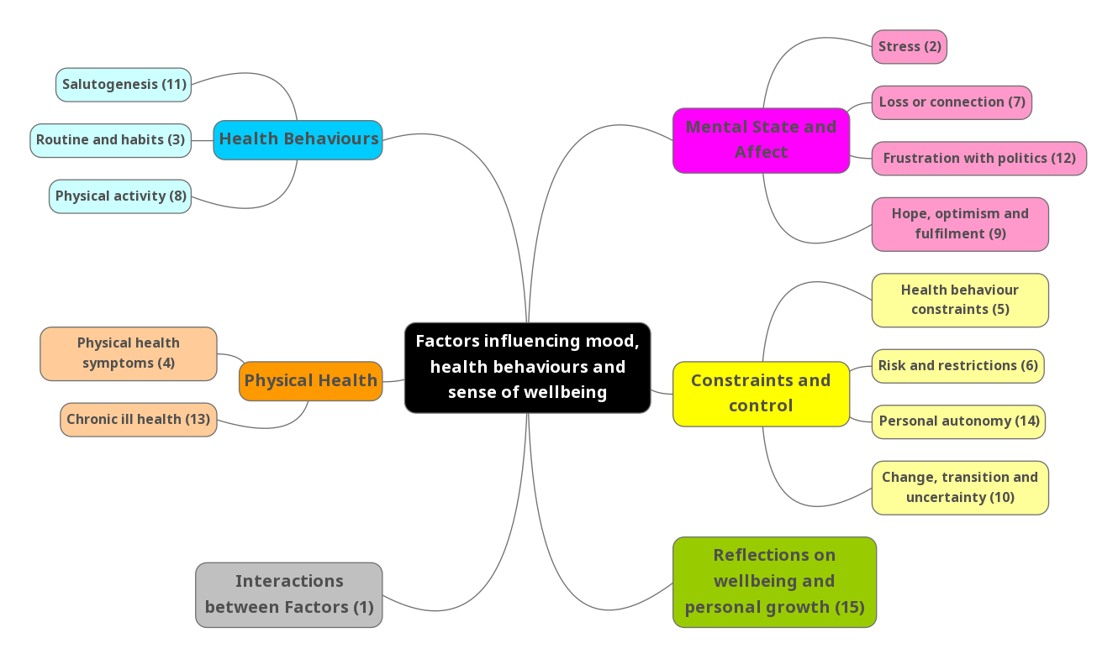

Table 2: Topic Labels, thematic group, and descriptions with example quotes
Topic label | Topic thematic group | Topic description | Topic example quote
Salutogenesis | Health Behaviours | Recognising self-care behaviours that improved health and wellbeing, predominantly sleep, healthy diet, exercise, fulfilling hobbies and activities, and positive social connection with friends/family. | "Video calls with my family and friends. Plenty of sleep. No unexpected visitors. Mostly good weather. Online connection to my church. Time to cook and eat well. Kindness of my colleagues at work especially my managers"
Routines and habits | Health Behaviours | Building positive routines and habits to undertake health behaviours. Low mood and external constraints (e.g. lockdown, weather) were identified as hindering healthy habits, with some struggling against unhealthy temptations. Efforts to recalibrate and then plan for future positive behaviour change discussed. | “At the beginning of lockdown, I was already drinking more than I should. After lockdown started my levels of drinking increased. I decided I’d had enough of drinking on [date], so gave up drinking on that date, except for the occasional beer. Unfortunately, after the clocks changed, I started drinking wine again and, since then, have been drinking wine daily. I will try to give up again in the near future and I will keep trying until I succeed."
Physical activity | Health behaviours | Positive impacts of physical activity on wellbeing such as destressing, socialising and providing a sense of achievement. Barriers included physical health issues, low motivation, and pandemic-related constraints, while facilitators included time availability, access to the outdoors, and dog ownership. | "Being able to go to the gym has been an enormous help. Good weather for my bike ride too."
Physical health symptoms | Physical health | Physical health symptoms (mostly musculoskeletal, but also respiratory, dental, and hormonal related symptoms). Consequences such as fatigue, weight changes and chronic pain. Self-directed treatment (e.g. gentle exercise) discussed in some quotes, whilst others covered frustration with delays to healthcare with private care being sought as a result. | “I am currently suffering with Frozen Shoulder on my right shoulder. Painful to sleep and discomfort to raise arm above head.”
Chronic ill health | Physical health | Impact and concern brought about by living with ‘chronic ill health’, primarily long-covid, although other conditions featured. Limitations in mobility, cognition, and mental health, with heightened anxiety over covid risks, access to healthcare, financial insecurity and general uncertainty about the future were all reported. | “I have a number of long covid difficulties: Fatigue, breathlessness like breathing through a blanket. Painful eyes, lips and skin rashes. Can’t breath through my nose due to pain. Aching arms, hands & feet. Occasional flu-like symptoms. All of these present together/separately and generally each day. I do not have a day without symptoms. This has caused my usually very busy life to close-down. I isolate myself and feel there will be no future without this, or at all. I feel that 6 months after initial diagnosis of covid, I may not ever return to good health.”
Stress | Mental state and affect | Increased ‘stress’, predominantly work and family-related (but also environmental e.g., problem neighbours, moving house), triggering feelings of pressure, anxiety, and exhaustion. Juggling stressors without respite, led to feelings of failure and guilt. Some described stress being compounded by perceived lack of support from employers or partners. | "Lack of childcare to enable working. Utterly exhausted by having to juggle work and homeschooling."
Loss and connection | Mental state and affect | Most quotes discussed bereavement. Pandemic restrictions also featured and were described as resulting in loss of social connection or fulfilment in life. Negative impacts on mood, confidence, motivation and sense of identity were reported. Some quotes, however, described finding solace in new roles or rekindling social connection and activities post-restrictions. | “I live alone I have followed the guidelines and therefore usually see no one apart from 5 work colleagues when I go to office one day a week.... Possibly because I’m 65 and have hardly driven anywhere for 12 months I am now anxious at thought of driving a few miles - pre covid I’d have driven 600 miles to see son in [Scottish city] and not given it another thought - I travelled through [Asian country] on my own 2 years ago - the isolation has knocked my confidence"
Frustration with politics | Mental State and affect | Frustration primarily with the Government’s perceived incompetence regarding pandemic management. Frustrations extended in some quotes to broader political issues like Brexit, corruption, conflicts, and ‘culture wars’. Some participants expressed anxiety about the future, fearing decline in quality of life and global stability. A few quotes described a sense of mistrust in decision makers, exacerbated by perceived political failures and irresponsible media reporting. | “The government's poor handling and lack of accountability, and in particular the Cummings saga had the biggest detrimental impact on my wellbeing in the whole of lockdown.”
Hope, optimism and fulfilment | Mental State and affect | Discussions on taking specific action to improve mental state such as seeking support, implementing routines and new activities, and setting goals and plans. External circumstances such as change in season, lockdown easing and vaccinations, were described as contributing to these positive feelings and there were expressions of gratitude. Some quotes, however, also included negative feelings and factors influencing those. | “Being vaccinated. Spring coming & a sense that things are improving for everyone. Covid rate going down - My family are being pretty stoic about when we can all get together again. We have been very lucky to have not lost any close family members to it. Have been content with what I have on the whole which I know is much more than many people have. I did manage to do Dry January which was affirming that I can stop drinking should I chose."
Health behaviour constraints | Constraints and control | Perceived lack of control regarding factors impacting on their ability to engage in healthy behaviours. Factors including limiting health conditions, covid anxiety, lack of time due to caring and/or work responsibilities, and changes in living circumstances. Facilitators discussed as increasing a sense of control were easing of pandemic measures, online communication, support and medication. | “Covid fatigue and adverse reaction to the booster (heart inflammation) finally resolved and I could get back to exercising.”
Risk and restrictions | Constraints and control | Perceptions of covid ‘risk and restrictions’. Covid risk was perceived to be increased due to health conditions, covid rule-breakers and Governmental mishandling. To reduce risk, participants discussed following covid rules and self-imposed restrictions such as avoiding public spaces. To reduce covid anxiety, some participants discussed information seeking or, conversely, avoiding media. Anxiety was also expressed in relation to ability to work or being separated from friends/family due to restrictions. | “Disregard by the general population that they will keep to the rules. It scares me. I have stayed in my family bubble and rarely gone to the public domain. Would turn if I felt a place was too crowded."
Personal autonomy | Constraints and control | Lack of control over ‘personal autonomy’, resulting in reduced motivation and feelings of loneliness, boredom, and anxiety. Threats to personal autonomy included the pandemic measures (featured in most quotes), but also the increased perception of the world becoming a riskier place. This was reported as being due to covid rule-breakers prioritising their own autonomy over risk to others, overexposure to media and news consumed by covid and other negative news stories, and the perception that people were generally becoming more intolerant. | "When in total Lockdown felt more in control than I do now - thought there would be a definite end and sense of closure to things. Now still social distancing and things still not back to normal. Still can't hug people and meet for proper large family gatherings, etc."
Change, transition and uncertainty | Constraints and control | Changes were predominantly in relation to work or education, although some quotes discussed changes such as moving house or relationship changes. Many changes were reported as being out of the participants’ control. Both positive and negative effects were described such as impacts on mood, financial security, and stability. A few quotes discussed anxiety due to changes in work practices leading to greater exposure to covid. | “Having graduated in July, job hunting and the prospect of a relationship breakdown, have greatly impacted all.”
Interactions between factors |  | A standalone theme about the interactions between factors i.e. health behaviours, physical health, mental state and external constraints. The interactions between these factors had negative, mixed or positive impacts. A common example of negative impacts was that experiencing ill health (physical health) and waiting for treatment (external constraint), led to low mood (mental state). An example of a mixed interaction, prevalent in a few of the quotes, was that easing of lockdown (external constraint) meant that participants were able to exercise/socialise more (health behaviour), but had anxiety doing so (mental state). There were also examples of feedback loops, for example, low mood (mental state) leading to overeating (health behaviour) leading to increased low mood. Another example was developing motivation to exercise (mental state), then exercising (health behaviour), leading to improved mood. | “I have had frequent UTIs, blood markers have shown up showing abnormal liver function and now CA125 levels are high. I am waiting a pelvis scan to check for ovarian cancer, this is affecting my mindset and energy levels at the moment."  “The easing of restrictions has made me a lot more willing to be active however also nervous and anxious due to not knowing how the outcome will be."
Reflections on wellbeing and personal growth |  | A standalone theme about reflections of the lockdown measures on wellbeing and personal growth. Many quotes referenced lockdown being a quieter, slower, or less demanding time, resulting in stronger relationships and sense of community, pursuit of interests, enjoyment of nature, starting new challenges and developing a sense of gratitude. Personal revelation and appreciation about a sense of importance in life featured in many of the quotes (e.g., accepting a dislike of socialising, appreciating the simplicity of having less choice). Other quotes discussed barriers to personal growth. | "Covid hasn't bothered me one bit. I've thoroughly enjoyed every minute of lockdown. Far from diminishing my quality of life it has enhanced it wonderfully. What I've learned from all this is that I'm not really someone who enjoys socialising. I'm far happier at home with my wife and cat. Socialising is more stressful than prior to Covid I realised."

Main theme narrative meaning and topic prevalence
Six main themes were derived from the analysis of the 15 topics and are narratively summarised below with topic labels in italics and illustrative quotes. Topic prevalence in relation to each timepoint is discussed below, structured by main themes, and shown in Table 3 and Figures 2-6.

Table 3: Scores and rankings for each topic by timepoint
Topic | Theme | 3 months |  | 6 months |  | 12 months |  | 24 months
 |  | Score | Rank | Score | Rank | Score | Rank | Score | Rank
Salutogenesis | Health Behaviours | .1274 | 1 | .0803 | 4 | .0981 | 1 | .0661 | 6
Routines and habits | Health Behaviours | .0600 | 7 | .0780 | 5 | .0772 | 5 | .0626 | 7
Physical activity | Health behaviours | .0417 | 14 | .0607 | 9 | .0710 | 7 | .0525 | 11
Physical health symptoms | Physical health | .0462 | 12 | .0595 | 10 | .0738 | 6 | .1105 | 2
Chronic ill health | Physical health | .0624 | 6 | .0936 | 2 | .0857 | 2 | .1456 | 1
Stress | Mental state and affect | .0985 | 2 | .0906 | 3 | .0804 | 3 | .0707 | 5
Loss and connection | Mental state and affect | .0682 | 5 | .0467 | 13 | .0594 | 8 | .0587 | 10
Frustration with politics | Mental State and affect | .0960 | 4 | .0948 | 1 | .0559 | 11 | .0738 | 4
Hope, optimism and fulfilment | Mental State and affect | .0356 | 15 | .0545 | 12 | .0503 | 14 | .0449 | 13
Health behaviour constraints | Constraints and control | .0451 | 13 | .0452 | 14 | .0534 | 12 | .0493 | 12
Risk and restrictions | Constraints and control | .0552 | 10 | .0632 | 7 | .0570 | 9 | .0591 | 9
Personal autonomy | Constraints and control | .0965 | 3 | .0626 | 8 | .0508 | 13 | .0292 | 15
Change, transition and uncertainty | Constraints and control | .0595 | 8 | .0555 | 11 | .0566 | 10 | .0612 | 8
Interactions between factors |  | 0.0588 | 9 | 0.0702 | 6 | .0801 | 4 | .0766 | 3
Reflections on wellbeing and personal growth |  | .0490 | 11 | .0445 | 15 | .0503 | 15 | .0394 | 14

Figure 2: Health behaviour broad theme topic mean score by timepoint
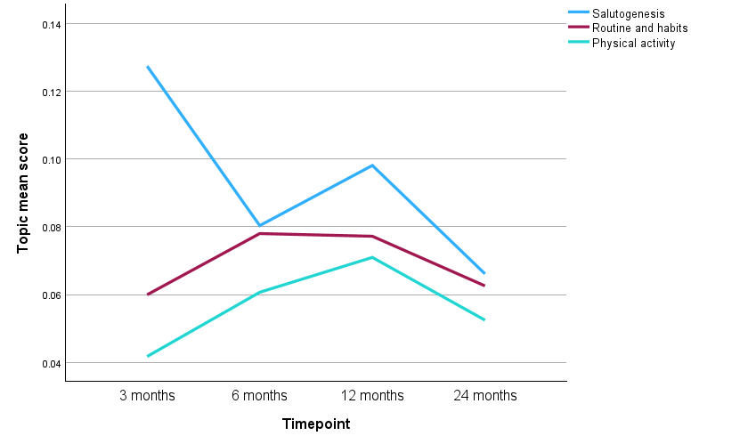

Figure 3: Physical health broad theme topic mean scores by timepoint
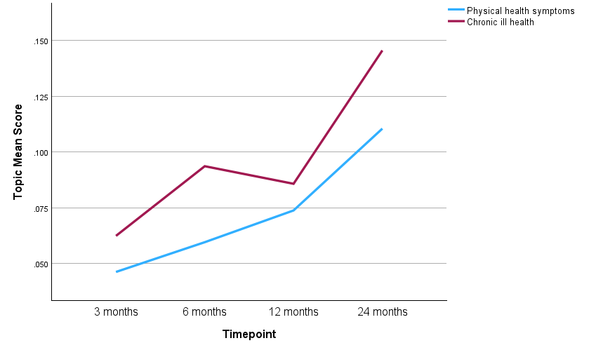

Figure 4: Mental state and affect broad theme topic mean scores by timepoint

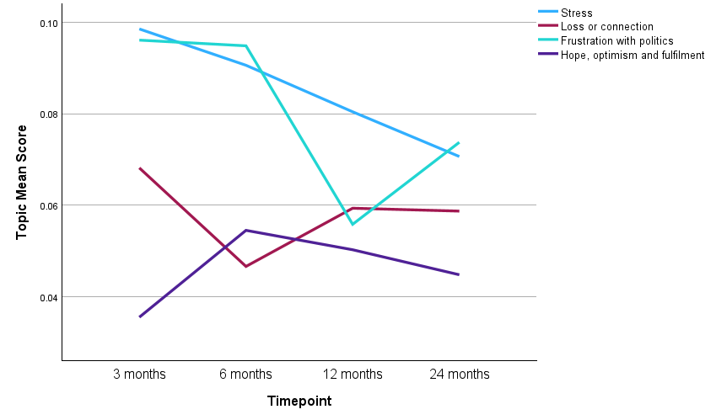

Figure 5: Interactions between factors topic mean score by timepoint
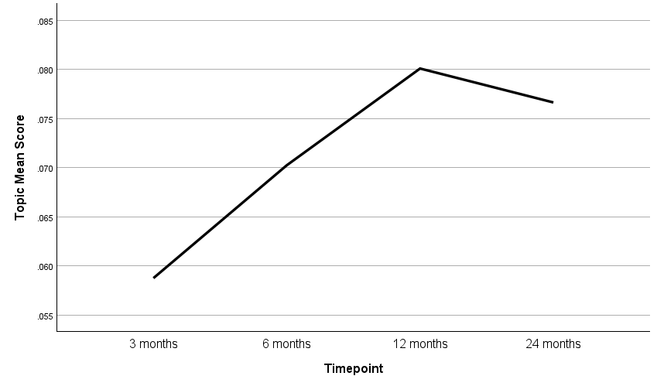

Figure 6: Constraints and control broad theme topic mean scores by timepoint
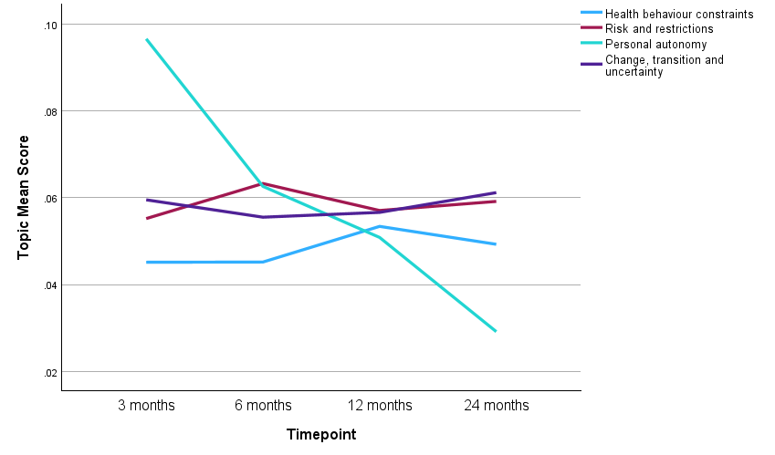

Figure 7: Reflections on wellbeing and personal growth topic mean score by timepoint
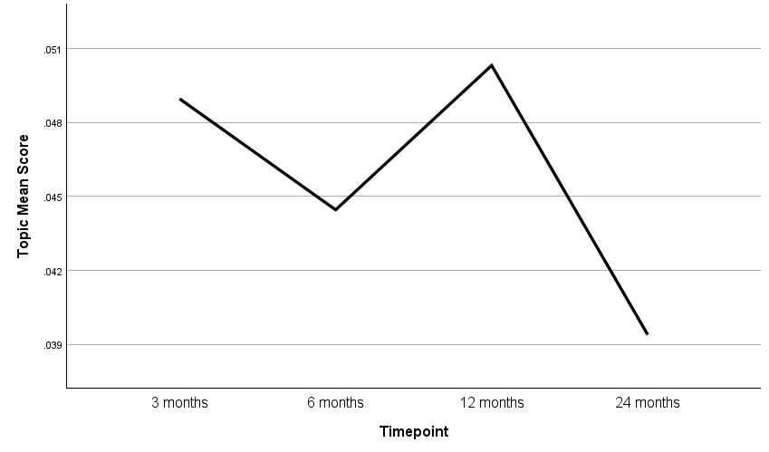

Health behaviours
This theme related to participants’ identification of healthy behaviours perceived as important to their sense of wellbeing, promoting salutogenesis, (particularly physical activity, but also behaviours such as sleep, healthy eating, hobbies and social connection) and their ability to establish or recalibrate plans, routines, and habits to support the behaviours. Barriers to undertaking health behaviours included low mood, physical health issues, external constraints (e.g. pandemic measures), while facilitators included time, resources, access to outdoor spaces, and dog ownership. Aspects of this theme are illustrated in the quote below:

“Being on reduced hours at work, and being static and not checking tickets, not walking through the train, meant I needed to up my exercise to help lose weight. The walks/jogs have made me happier, healthier and done wonders for me mentally. Only downside not being able to see my 2 teenage daughters, but we have talked and spoke online every few days and every day I get closer to seeing them.” (Routines and Habits)

Salutogensis was the most prevalent topic at 3 months and 12 months (Table 3, Figure 2), just after the strictest lockdown periods. Routines and habits showed relatively consistent prevalence across the timepoints; 5th most prevalent topic at 6 and 12 months and 7th at 3 and 24 months. Physical activity was 14th most prevalent topic at 3 months but had increased in prevalence at the other time points; 9th, 7th, 11th respectively.

Physical health
Participants described physical health symptoms (e.g. musculoskeletal, respiratory) or chronic ill health, with long-covid featuring in many responses. Physical health was described as impacting mental health and ability to undertake activities, including health behaviours. Problems accessing healthcare and delays to treatment were a source of frustration, with some participants describing turning to the private sector as a result. This sense of frustration is evident in this quote:

"Long waiting list for apparently urgent surgery (15 months so far) has increased my depression as well as my chronic pain, as well as exacerbating my other chronic illnesses (fibromyalgia, CFS, IBS, migraines). Worsening health has led to increased need for rest and time in bed, missing out on lots of things- including the ability to work, affecting my wages, increasing my anxiety as I am struggling to pay bills. All because of the length of the waiting list for gynaecology surgery." (Chronic ill health)

Twenty-four months post-lockdown, both of the topics within this theme demonstrated the highest prevalence of all topics (Table 3, Figure 3). The prevalence of physical health symptoms rose sharply at each timepoint (ranked 12th/10th/6th/2nd respectively), and similarly chronic Ill health started as 12th most prevalent at 3 months, then rose sharply to 2nd (6 and 12 months) and then 1st (24 months) most prevalent.

Mental state and affect
Participants reported influences on mental states. External influences included stress filled environments, predominantly related to managing work and family, which resulted in feelings of exhaustion, failure and guilt. Lockdown measures preventing social connection, and experiencing bereavement, were described as generating feelings of loss and grief. Perceived governmental misgovernance and incompetencies influenced feelings of frustration with politics and anxiety about the future:

"The useless way this government has handled this pandemic, the useless track and trace system which is the key to getting us out of this clusterf*ck, and the billions of billions of handouts to cronies, impact on my mental health, as do the treatment of refugees, BLM issues. Hard to stay positive." (Frustration with politics)

Positive influences on mood included easing of pandemic measures, vaccinations, and changing seasons/weather, which were described as generated feelings of hope, optimism and fulfilment. Participants also discussed self-directed influences such as support seeking and engaging in health behaviours.

As shown on Table 3 and Figure 4, stress was among the top-third most prevalent topics at all timepoints, with a slight reduction in prevalence over time (2nd/3rd/3rd/5th respectively). Loss and connection was the 5th most prevalent at 3 months and then fluctuated between in the bottom and middle-third at the other times points (13th/8th/10th respectively). Frustration with politics was the 4th most prevalent topic at 3 months, then was most prevalent at 6 months before dropping to 11th most prevalent at 12 months and then back up to 4th at 24 months. Hope, optimism and fulfilment was the least prevalent topic at 3 months and then remained in the bottom-third topics for the other timepoints (12th/14th/13th respectively).

Interactions between factors
Interactions between factors is a main theme consisting of a standalone topic. Participants explicitly reported interactions between all or some of the factors identified in the above three themes. Interactions between health behaviours, physical health, and mental state, modified by external constraints, could have positive, negative, or mixed impacts. For example, a common mixed impact was improved physical health but increased covid anxiety, because of engagement in outdoor physical activity, instigated by pandemic measures easing. The quote below is an example of a feedback loop, showing the positive impact of treatment on mood which enabled healthy behaviours which further improved mood:

"I started medication and therapy for my anxiety and depression episode which started in the summer. Since then, I've felt more motivated to look after my health (diet and exercise) and have been feeling more optimistic about the future. I've been feeling much less anxious on a daily basis."

Table 3 and Figure 5 shows that the interactions between factors topic increased in prevalence over the study period moving from 9th most prevalent at 3 months, to 6th at 6 months, 4th at 12 months and 3rd at 24 months.

Constraints and control
Participants reported influences on their perceived sense of control over personal autonomy, ability to undertake health behaviours, and change, transition or uncertainty relating to work or personal circumstances. Constraints included limiting health conditions, lack of time, pandemic measures, and covid risk and restrictions. Regarding perceived covid risk, prevalence of covid ‘rule breakers’, exposure to negative media reporting, work practices increasing covid exposure, and perceived government mishandling increased the perception of risk, resulting in covid anxiety. The easing of pandemic measures, online communication, and accessing support/treatment was discussed as increasing one’s sense of control. Paradoxically, constraining one’s freedom was also seen as a way to gain control amidst the uncertainty of the pandemic:

“Sense of safety for not having to leave the house every day; avoiding public crowds or busy places" (Risks and restrictions)

Personal autonomy reduced in prevalence over time from 3rd most prevalent at 3 months, then 8th at 6 months, 13th at 12 months and least prevalent (15th) at 24 months (Table 3, Figure 6). Risk and restrictions was consistently in the middle-third most prevalent topics across timepoints (10th/7th/9th/9th respectively). Health behaviour constraints was consistently in the bottom-third most prevalent topics (13th/14th/12th/12th respectively). Change, transition, and uncertainty was also relatively consistent over time, ranking between 8th to 11th most prevalent (8th/11th/10th/8th respectively).

Reflections on wellbeing and personal growth
Reflections on wellbeing and personal growth is a main theme consisting of a standalone topic. Some participants reported that the pandemic was a quieter, less demanding time, that allowed for personal growth:

“I've LOVED the lockdown. It's been enormously enjoyable and I rather miss it now it's over. I've loved the quietness, the peace, the absence of annoying things like sport, trashy TV stuff, and big events. I've loved being free from the "let's go out, meet friends and have fun" sort of thing that happens in life. I've loved the absence of traffic, how stress-free shopping has been. How much calmer and more relaxed everyone else has been. I've been amazingly busier than ever with my own interests. I've had a sense of fulfilment and achievement from all that.”

Some participants discussed the strengthening of relationships, fostering community, encouraging hobbies, and starting businesses. Participants reflected on life’s priorities, embracing simplicity and developing gratitude. Barriers to reflection and personal growth (such as time) were also discussed by some.

At 3 months, this topic was the 11th most prevalent and for the other timepoints prevalence deceased to 15th at 6 and 12 months and 14th at 24 months (Table 3, Figure 7).

Discussion
MATA uses machine learning to identify patterns within large textual datasets, grouping data into topics, which are subsequently interpreted for meaning by researchers. Rather than a ‘human in the loop’ approach, MATA facilitates a ‘human in control’ approach over the analytic process, using AI to enhance efficiency while preserving the “qualities” (e.g., depth and contextual understanding) essential to qualitative research. This paper’s first aim was to describe the process of applying MATA to qualitative free text data, collected as part of the C-19 Health Behaviour and Wellbeing Daily Tracker Study [27]. MATA was an efficient approach to analyse the large qualitative dataset. All 15 topics were able to be interpreted by the research team, reinforcing this number of topics as optimal, whereas a previous study using MATA generated ‘nonsense topics’, which researchers were unable to interpret meaning [12].

As with previous studies employing MATA [12, 18], researcher time was considerably reduced, especially relating to the coding, theme generation and conceptualisation stages of thematic analysis []. The reduction in time directly resulted from researchers having to read and interpret only 300 ‘best fit’ free-text responses (20 per topic), as opposed to all 2,172 responses. In addition, the machine generation of the 15 topics meant that the researchers bypassed the time-consuming inductive coding stage of manual thematic analysis, and instead undertook a quicker process of ‘reverse coding’ to interpret conceptual meaning of topics (Stage 1 in our procedure). The time taken to complete the analytic write-up after theme generation (Stage 5 in our procedure), which was conducted by a researcher without machine input, was not reduced and was comparable to the time usually taken in manual qualitative analysis. This stage however was particularly important to the interpretation process for this study, given the machine rather than researcher generated the initial topics. It allowed for researchers to check for contextual accuracy, investigate the deeper meaning of the topics and differences between them, and develop a coherent narrative about the themes using example data.

The use of AI for qualitative analysis is increasing and this can create risks. One example risk is the quantification of qualitative data. This could risk oversimplifying findings by overlooking outliers, nuanced responses, and systemic influences such as broader social determinants. Balancing efficiency with depth and maintaining contextual understanding remains a critical challenge. We argue that MATA may help to mitigate concerns about the quality of AI-driven models in analysing participant’s experiences while maintaining the depth and contextual understanding associated with qualitative research, as the process of human analysis was designed to be both collaborative and transparent.

The second aim of the paper was to explore which factors were reported to influence health behaviours, mood and wellbeing during the COVID 19 pandemic. Six main themes were identified by researchers by interpreting the 15 topics for conceptual meaning and then clustering topics into themes. Themes were split into three key areas involved in contributing to pandemic impacts relating to behaviour, health and wellbeing, and three higher order themes relating to the complex interactions of those key areas, and how constraints and control and reflections on wellbeing and personal growth could modify impacts. The main themes align with and complement previously published qualitative findings derived from our parallel studies on the same longitudinal cohort which used established qualitative methodologies (interviews, photo elicitation and thematic analysis) [,]. The key themes we identified in these other qualitative studies, namely-disruption, adaptation, loss and salutogenesis, are evident as equivalent MATA topics/themes, enhancing validity across study elements via triangulation of data sources and methods. In addition, similar themes related to pandemic health and wellbeing impacts, health behaviours, and coping strategies and adaption, have been identified in the wider covid qualitative literature, albeit with smaller samples [,] or focused on specific populations [,,]. International ‘Big Qual’ studies found that long term wellbeing was substantially shaped by experiences of loss at the start of the pandemic [,] further highlighting the need to explore such datasets to understand how wellbeing and behaviour can be supported over time.

Whilst data collection for our previous studies and the wider qualitative covid literature was conducted within relatively narrow time-frames, the exploratory findings presented here offer temporal insight into how themes may have played out longitudinally by reporting the prevalence of generated topics at different timepoints (3, 6, 12 and 24 months post lockdown. For example, the topic of ‘Stress’ was most prevalent as England was emerging from the first lockdown (3 months), then decreased slightly over time. This aligns with studies that found that increases in mental health issues during the first UK lockdown subsequently declined as restrictions eased, although levels of psychological distress remained elevated compared to pre-pandemic [,,]. The increased prevalence of the topic of ‘Salutogenesis’ immediately after 2020 and 2021 hard lockdowns (3 months and 12 months) likewise corresponds with literature indicating that these periods could facilitate purposeful engagement in meaningful, and sometimes new, activities to support physical and mental health [31,,,,]. Of particular note within our findings is the topic of concerns around ‘physical health’, an aspect of ‘disruption’ identified in our prior work [30, 31], with both topics in the theme initially having low prevalence, rising over time to have the highest prevalence at 24 months when nearly all restrictions had been lifted. While national UK statistics indicate relative stability in self-reported general health over this period [,], other evidence relating to an ongoing backlog in healthcare service provision highlights the importance of continued surveillance of the longer-term experience of secondary, negative health consequences [34,].

Strengths and Limitations
A key strength of the study was its longitudinal design covering a period of significant social challenge and change, covering almost two-years from when England was beginning to emerge from the first national lockdown to when nearly all restrictions had lifted. MATA enabled the rapid analysis of this large longitudinal qualitative dataset that would not have been feasible to analyse manually within the available resources. The reduced time required relative to manual analysis, which can be over four times as time consuming [12], demonstrates the method’s ability to improve the efficiency of coding and theme generation. Furthermore, MATA’s efficiency increases as dataset get larger, as larger datasets would not typically require any additional analysis time.

The analysis was conducted using a systematic and established method, MATA, which has been validated and used on other datasets [12,18]. This approach ensured rigorous implementation of the methodology and reliable interpretation of the results. Instead of relying on general-purpose AI platforms, such as LLMs, which have been criticised for their lack of transparency and interpretability [, ] as ‘black-box’ models - a bespoke topic modelling approach provided greater transparency and control. It enabled a collaborative process where experienced qualitative researchers and domain experts retained oversight and active involvement in the production of the findings, ensuring the themes were coherent and interpretable. Whilst providing researchers control over interpretation, what may be lost with this approach, however, are the ‘lightbulb moments’ in manual qualitative research where a single participant with a unique position or unusual context gives a perspective that illuminates understanding, advancing knowledge, from an N of 1 perspective.

While weighting metrics enabled a non-biased method of allocating free text entries into a primary topic, some responses could plausibly fit into multiple topics, leading to occasional overlap and reducing specificity in interpretation. This highlights the need for caution in defining topic boundaries and ensuring nuanced analysis. The themes generated through MATA were consistent with findings from other qualitative studies in the C-19 Health Behaviour and Wellbeing Daily Tracker Study [30, 31], supporting the validity of the findings and demonstrating the method’s ability to produce meaningful insights.

Covariates can be included in the MATA analysis allowing for quantitative exploration of the qualitative findings, as demonstrated in this paper by ranking and plotting mean prevalence scores by timepoint. This process could also be taken to understand how topics vary across participant characteristics (e.g. gender, deprivation), helping to detect patterns that might not be easily discernible in qualitative analysis alone. This mixed-methods approach has the potential to increase generalisability and replicability of analysis and could assist in forming hypotheses about sociocultural influences. However, caution should be applied where it is used, as it could lead to erroneous conclusions. This is especially relevant when data relates to perspectives self-reported by participants, rather than systematically measured phenomena. Our interpretation of the prevalence data was assisted by triangulating with previous study findings and the literature, and we advocate for triangulation where possible.

While MATA reduces the need for researcher reflexivity, it remains essential for researchers to critically engage with the interpretation of machine-generated topics. This is particularly important given the rise of LLMs, where the potential for algorithmic bias is not only a concern but may be further exacerbated by these technologies [,]. Developing reflexive practices tailored to machine-assisted analysis is essential to address biases inherent in data and algorithms. To the authors’ knowledge, no established methods currently exist to systematically guide this process, highlighting an urgent need for methodological development.

Implications for research, practice, policy
MATA provides a practical solution for analysing large-scale qualitative datasets quickly and rigorously while utilizing qualitative research expertise to extract meaning, interpret findings, work collaboratively, and apply theoretical frameworks. Its application in this study demonstrates its potential to become a standard method for researchers working with Big Qual datasets, particularly in contexts where scalability and efficiency are critical [,]. The broader applicability of MATA to diverse qualitative data types, such as in-depth interview transcripts, is uncertain. Further investigation is required to determine its suitability for richer, less structured datasets.

The use of AI in qualitative analysis may challenge epistemological foundations of qualitative research by applying a reductionist approach to data analysis. This may be seen to be at odds with interpretivism, which emphasises exploration of subjective meanings and constructed realities in analysis. Taking a pragmatist position, MATA was considered the best approach for this study, given the large longitudinal dataset, but need for flexibility in interpretation that human-led analysis provides to ensure validity. Adopting a ‘human in control’ approach, such as MATA, may be more reflective of critical realism, acknowledging computer generated patterns in the textual data exist, but allowing for human exploration of conceptual meaning situated in the wider societal context. As technology advances, and human adoption of it increases, we may see new paradigms emerge however [].

The quantification of qualitative data raises important considerations about balancing efficiency with the depth and quality of machine outputs. Researchers must critically evaluate how quantification impacts the interpretative process and ensure that the outputs are meaningful, nuanced, and transparent. Whilst this process was undertaken through discussion for this study, as AI assisted qualitative analysis evolves and becomes more prevalent, it will become necessary to develop evaluation tools. A key step in this process involves the development of an evaluation framework tailored to machine-assisted analysis methods, such as topic modelling. Such a framework would provide researchers with quality indicators for assessing AI-generated outputs, ensuring that scalability does not come at the expense of interpretative rigour.

Reflexivity in Big Qual requires redefinition to address systemic biases inherent in data and algorithms. The use of AI approaches such as natural language processing, and in particular LLMs, in qualitative research brings new ethical challenges, particularly in ensuring the transparency, reliability, and fairness of AI-generated outputs. A quality evaluation framework that can be systematically applied to evaluate the quality of AI output of Big Qual data is needed. This would ensure that the findings remain ethical, nuanced, and aligned with the principles of qualitative research, increasing the quality, transparency and trust in the utility of Big Qual methods.

AI models often prioritize dominant patterns in training data, which can lead to the amplification of majority viewpoints while marginalizing less prevalent perspectives [17]. This risk of underrepresenting minority voices highlights the need for intentional efforts to counteract bias. Incorporating user-centred, participatory approaches should help ensure that AI tools are designed and applied in a way that is both equitable and ethically sound [].

Conclusion
Th application of MATA to qualitative free-text data demonstrated its ability to efficiently identify meaningful patterns while maintaining researcher oversight. We identified key self-reported factors influencing health behaviours, mood, and wellbeing across different time points during the COVID-19 pandemic. This study advances machine-assisted topic analysis by demonstrating a hybrid approach that increases researcher control and interpretability. As AI continues to shape research methods, ensuring transparency and conceptual rigour remains critical. Future research should focus on developing systematic evaluation frameworks to ensure transparency, reliability, and the mitigation of both machine- and human-“induced” bias. Reflexivity is important in this process, particularly given the risks of algorithmic bias in AI-driven methods. Additionally, participatory, user-centred approaches are needed to ensure that AI-driven qualitative analysis is applied ethically and equitably, with frameworks that integrate both evaluation and reflexivity to uphold the rigour of qualitative research. By incorporating covariate analysis MATA exemplifies how computational approaches can complement qualitative methodologies, offering a more integrated mixed-methods framework that preserves depth while enabling insights into different patterns and groups, especially those who are marginalised.

Data availability statement: The data that support the findings of this study are available from the corresponding author upon reasonable request

References

Madill, A. and Gough, B. (2008). Qualitative research and its place in psychological science. Psychological Methods, 13(3), pp.254–271. doi:https://doi.org/10.1037/a0013220.
Pope, C. and Mays, N. (1995). Qualitative Research: Reaching the parts other methods cannot reach: an introduction to qualitative methods in health and health services research. BMJ, [online] 311(6996), pp.42–45. doi:https://doi.org/10.1136/bmj.311.6996.42.
Nevedal, A.L., Reardon, C.M., Opra Widerquist, M.A., Jackson, G.L., Cutrona, S.L., White, B.S. and Damschroder, L.J. (2021). Rapid versus traditional qualitative analysis using the Consolidated Framework for Implementation Research (CFIR). Implementation Science, 16(1).
Reinsel, D., Gantz, J. and Rydning, J. (2018). The Digitization of the World From Edge to Core. [online] Available at: https://www.seagate.com/files/www-content/our-story/trends/files/idc-seagate-dataage-whitepaper.pdf?gid=164649.
Juraimi, S. A., Ze, W. L., & Pink, A. E. (2024). A pilot study examining the use of conversational AI-powered chatbots to understand consumer perceptions. Appetite, 199.
Brower, R.L., Jones, T.B., Osborne-Lampkin, L., Hu, S. and Park-Gaghan, T.J. (2019). Big Qual: Defining and Debating Qualitative Inquiry for Large Data Sets. International Journal of Qualitative Methods, [online] 18, p.160940691988069. doi:https://doi.org/10.1177/1609406919880692.‌
Weller, S., Davidson, E., Edwards, R. and Jamieson, L. (2023). Big Qual. Springer eBooks. Springer Nature. doi:https://doi.org/10.1007/978-3-031-36324-5.‌
Vasileiou, K., Barnett, J., Thorpe, S. and Young, T. (2018). Characterising and Justifying Sample Size Sufficiency in interview-based studies: Systematic Analysis of Qualitative Health Research over a 15-year Period. BMC Medical Research Methodology, [online] 18(1), pp.1–18. doi:https://doi.org/10.1186/s12874-018-0594-7.‌
Leeson, W., Resnick, A., Alexander, D. and Rovers, J. (2019). Natural Language Processing (NLP) in Qualitative Public Health Research: A Proof of Concept Study. International Journal of Qualitative Methods, 18, p.160940691988702. doi:https://doi.org/10.1177/1609406919887021.‌
Smith, J. and Tissing, R. (2018). Using Computational Text Classification for Qualitative Research and Evaluation in Extension. Journal of Extension, 56(2). doi:https://doi.org/10.34068/joe.56.02.04.
Prescott, M.R., Yeager, S., Ham, L., Rivera, C.D., Serrano, V., Narez, J., Dafna Paltin, Delgado, J., Moore, D.J. and Montoya, J. (2024). Comparing the Efficacy and Efficiency of Human and GenAI Qualitative Thematic Analyses (Preprint). JMIR AI, 3, pp.e54482–e54482. doi:https://doi.org/10.2196/54482.
Towler, L., Bondaronek, P., Trisevgeni Papakonstantinou, Amlôt, R., Chadborn, T., Ainsworth, B. and Yardley, L. (2023). Applying machine-learning to rapidly analyze large qualitative text datasets to inform the COVID-19 pandemic response: comparing human and machine-assisted topic analysis techniques. Frontiers in Public Health, 11. doi:https://doi.org/10.3389/fpubh.2023.1268223.
Cheligeer, C., Yang, L., Nandi, T., Doktorchik, C., Quan, H., Zeng, Y. and Singh, S. (2022). Natural language processing (NLP) aided qualitative method in health research. Journal of Integrated Design and Process Science, pp.1–18. doi:https://doi.org/10.3233/jid-220013.‌
Hamilton, L., Elliott, D.S., Quick, A.J., Smith, S. and Choplin, V. (2023). Exploring the Use of AI in Qualitative Analysis: A Comparative Study of Guaranteed Income Data. International journal of qualitative methods, 22. doi:https://doi.org/10.1177/16094069231201504.‌
Wachinger, J., Bärnighausen, K., Schäfer, L.N., Scott, K. and McMahon, S.A. (2024). Prompts, Pearls, Imperfections: Comparing ChatGPT and a Human Researcher in Qualitative Data Analysis. Qualitative Health Research. doi:https://doi.org/10.1177/10497323241244669.
Kon, M.H.A., Pereira, M.J., Molina, J.A.D.C., Yip, V.C.H., Abisheganaden, J.A. and Yip, W. (2024). Unravelling ChatGPT’s potential in summarising qualitative in-depth interviews. Eye. [online] doi:https://doi.org/10.1038/s41433-024-03419-0.
Peterson, A.J. (2024). AI and the Problem of Knowledge Collapse. arXiv (Cornell University). doi:https://doi.org/10.48550/arxiv.2404.03502.‌
P. Bondaronek, T. Papakonstantinou, C. Stefanidou and T. Chadborn (2023). User feedback on the NHS test & Trace Service during COVID-19: The use of machine learning to analyse free-text data from 37,914 UK adults. pp.100401–100401. doi:https://doi.org/10.1016/j.puhip.2023.100401.‌
Roberts ME, Stewart BM, Tingley D (2019). “stm: An R Package for Structural Topic Models.” Journal of Statistical Software, 91(2), 1–40. doi:10.18637/jss.
Herle M, Smith AD, Bu F, Steptoe A, Fancourt D. Trajectories of eating behavior during COVID-19 lockdown: Longitudinal analyses of 22,374 adults. Clin Nutr ESPEN. 2021 Apr;42:158-165. doi: 10.1016/j.clnesp.2021.01.046. Epub 2021 Feb 9. PMID: 33745572; PMCID: PMC7871880.
Bann D, Villadsen A, Maddock J, Hughes A, Ploubidis GB, Silverwood R, Patalay P. Changes in the behavioural determinants of health during the COVID-19 pandemic: gender, socioeconomic and ethnic inequalities in five British cohort studies. J Epidemiol Community Health. 2021 Dec;75(12):1136-1142. doi: 10.1136/jech-2020-215664. Epub 2021 May 26. PMID: 34039660; PMCID: PMC8159672.
Anyanwu P, Moriarty Y, McCutchan G, Grozeva D, Goddard M, Whitelock V, Cannings-John R, Quinn-Scoggins H, Hughes J, Gjini A, Hepburn J, Osborne K, Robling M, Townson J, Waller J, Whitaker KL, Brown J, Brain K, Moore G. Health behaviour change among UK adults during the pandemic: findings from the COVID-19 cancer attitudes and behaviours study. BMC Public Health. 2022 Jul 28;22(1):1437. doi: 10.1186/s12889-022-13870-x. PMID: 35902822; PMCID: PMC9332100.
Bowyer RCE, Huggins C, Toms R, Shaw RJ, Hou B, Thompson EJ, Kwong ASF, Williams DM, Kibble M, Ploubidis GB, Timpson NJ, Sterne JAC, Chaturvedi N, Steves CJ, Tilling K, Silverwood RJ; CONVALESCENCE Study. Characterising patterns of COVID-19 and long COVID symptoms: evidence from nine UK longitudinal studies. Eur J Epidemiol. 2023 Feb;38(2):199-210. doi: 10.1007/s10654-022-00962-6.
Saunders R, Buckman JEJ, Suh JW, Fonagy P, Pilling S, Bu F, Fancourt D. Variation in symptoms of common mental disorders in the general population during the COVID-19 pandemic: longitudinal cohort study. BJPsych Open. 2024 Feb 12;10(2):e45. doi: 10.1192/bjo.2024.2.
Finch D, Tinson A. The continuing impact of COVID-19 on health and inequalities [Internet]. London: The Health Foundation; 2022 Aug 24 [cited 2025 Jun 19]. Available from: https://www.health.org.uk/reports-and-analysis/briefings/the-continuing-impact-of-covid-19-on-health-and-inequalities
British Medical Association. The impact of the pandemic on population health and health inequalities [Internet]. London: BMA; 2024 Sep 18 [cited 2025 Jun 19]. Available from: https://www.bma.org.uk/advice-and-support/covid-19/what-the-bma-is-doing/the-impact-of-the-pandemic-on-population-health-and-health-inequalities
Naughton F, Ward E, Khondoker M, Belderson P, Marie Minihane A, Dainty J, Hanson S, Holland R, Brown T, Notley C. Health behaviour change during the UK COVID-19 lockdown: Findings from the first wave of the C-19 health behaviour and well-being daily tracker study. Br J Health Psychol. 2021 May;26(2):624-643. doi: 10.1111/bjhp.12500. Epub 2021 Jan 6. PMID: 33410229; PMCID: PMC9291054.
Mimno, D, Wallach, HM, Talley, E, Leenders, M, and McCallum, A. Optimizing semantic coherence in topic models. EMNLP. (2011) 2011:262–72.
Braun, V. and Clarke, V. (2006). Using Thematic Analysis in Psychology. Qualitative Research in Psychology, [online] 3(2), pp.77–101. doi:https://doi.org/10.1191/1478088706qp063oa.‌
Notley C, Belderson P, Hanson S, Ward E, Brown TJ, Naughton F; COVID-19 health behaviour, wellbeing tracker study group. Disruption and adaptation in response to the coronavirus pandemic - Assets as contextual moderators of enactment of health behaviours. Br J Health Psychol. 2022 Sep;27(3):1153-1171. doi: 10.1111/bjhp.12592. Epub 2022 Mar 23. PMID: 35319145; PMCID: PMC9111661.
‌ Hanson S, Belderson P, Ward E, Naughton F, Notley C. Lest we forget. Illuminating lived experience of the Covid-19 pandemic and lockdown. Soc Sci Med. 2023 Sep;332:116080. doi: 10.1016/j.socscimed.2023.116080. Epub 2023 Jul 7. PMID: 37451941.
Griffin, T., Grey, E., Lambert, J. et al. Life in lockdown: a qualitative study exploring the experience of living through the initial COVID-19 lockdown in the UK and its impact on diet, physical activity and mental health. BMC Public Health 23, 588 (2023). https://doi.org/10.1186/s12889-023-15441-0
Bieniak KH, Bedree H, Geanous N, Greenley RN, Miller SA, Buscemi J, Tran ST. Thematic analysis of COVID-19's impacts on transitions among emerging adults. Health Care Transit. 2024 Feb 23;2:100052. doi: 10.1016/j.hctj.2024.100052.
Derrer-Merk E, Reyes-Rodriguez MF, Soulsby LK, Roper L, Bennett KM. Older adults' experiences during the COVID-19 pandemic: a qualitative systematic literature review. BMC Geriatr. 2023 Sep 20;23(1):580. doi: 10.1186/s12877-023-04282-6.
Macpherson K, Cooper K, Harbour J, Mahal D, Miller C, Nairn M. Experiences of living with long COVID and of accessing healthcare services: a qualitative systematic review. BMJ Open. 2022 Jan 11;12(1):e050979. doi: 10.1136/bmjopen-2021-050979.
Bailey C, Guo P, MacArtney J, Finucane A, Swan S, Meade R, Wagstaff E. The Experiences of Informal Carers during the COVID-19 Pandemic: A Qualitative Systematic Review. Int J Environ Res Public Health. 2022 Oct 18;19(20):13455. doi: 10.3390/ijerph192013455.
Lowe CT, Trask CM, Rafiq M, MacKay LJ, Letourneau N, Ng CF, Keown-Gerrard J, Gilbert T, Ross KM. Experiences and Impacts of the COVID-19 Pandemic: A Thematic Analysis. COVID. 2024; 4(4):429-442. https://doi.org/10.3390/covid4040028
Yael Albo, Eran Leck, Orly Nathan, Naama Wolf, Eran Zaidise, COR and CORONA: analysis of COVID-19’s subjective lasting impact on wellbeing, employing conservation of resources theory, Journal of Public Health, 2025;, fdaf021, https://doi.org/10.1093/pubmed/fdaf021
Fancourt, D., Steptoe, A. and Bu, F. (2020). Trajectories of anxiety and depressive symptoms during enforced isolation due to COVID-19 in England: A longitudinal observational study. The Lancet Psychiatry, 8(2), pp.141–149. doi:https://doi.org/10.1016/s2215-0366(20)30482-x.‌
Daly, M., Sutin, A. and Robinson, E. (2020). Longitudinal changes in mental health and the COVID-19 pandemic: Evidence from the UK Household Longitudinal Study. Psychological Medicine, 52(13), pp.1–37.‌
Dhensa-Kahlon, R.K., Wan, S.T., Coyle-Shapiro, J.A-M. and Teoh, K.R.-H. (2025). The mental health impact of repeated COVID-19 enforced lockdowns in England: evidence from the UK Household Longitudinal Study. BJPsych Open, 11(1). doi:https://doi.org/10.1192/bjo.2024.803.
Williams, L., Rollins, L., Young, D., Fleming, L., Grealy, M., Janssen, X., Kirk, A., MacDonald, B. and Flowers, P. (2021). What have we learned about positive changes experienced during COVID-19 lockdown? Evidence of the social patterning of change. PLOS ONE, [online] 16(1), p.e0244873. doi:https://doi.org/10.1371/journal.pone.0244873.‌
Williams, L. (2021). Fitter, better rested, more appreciative: research reveals the positive changes experienced by some during lockdown. The Conversation. [online] 20 Jan. Available at: https://theconversation.com/fitter-better-rested-more-appreciative-research-reveals-the-positive-changes-experienced-by-some-during-lockdown-152907.‌
Ellen, C., Patricia, D.V., Miet, D.L., Peter, V., Patrick, C., Robby, D.P., Kristine, O., Maria, R.-B., Arnaud, S., Antonio, M.-B.J., Judit, F.-S.A., Laura, V.-M. and de Velde Dominique, V. (2021). Meaningful activities during COVID-19 lockdown and association with mental health in Belgian adults. BMC Public Health, 21(1). doi:https://doi.org/10.1186/s12889-021-10673-4.
Griffin, T., Grey, E., Lambert, J., Gillison, F., Townsend, N. and Solomon-Moore, E. (2023). Life in lockdown: a qualitative study exploring the experience of living through the initial COVID-19 lockdown in the UK and its impact on diet, physical activity and mental health. BMC Public Health, 23(1). doi:https://doi.org/10.1186/s12889-023-15441-0.‌
Impact of the COVID-19 pandemic on health-care use among patients with cancer in England, UK: a comprehensive phase-by-phase time-series analysis across attendance types for 38 cancersTan, Yen Yi et al.The Lancet Digital Health, Volume 6, Issue 10, e691 - e704
Knight, K.J., Fordham, R.J., Crabtree, N.J. and Knapp, K.M. (2024). Evaluating the impact of COVID-19 on DXA waiting lists and osteoporosis prescription trends in England 2019–2023. Osteoporosis International, 35(8), pp.1451–1460. doi:https://doi.org/10.1007/s00198-024-07120-6.
Zhai, Y. and Du, X. (2020). Loss and grief amidst COVID-19: A path to adaptation and resilience. Brain, Behavior, and Immunity, 87, pp.80–81. doi:https://doi.org/10.1016/j.bbi.2020.04.053.‌
Kornblith, A.E., Singh, C., Devlin, G., Addo, N., Streck, C.J., Holmes, J.F., Kuppermann, N., Grupp-Phelan, J., Fineman, J., Butte, A.J. and Yu, B. (2022). Predictability and stability testing to assess clinical decision instrument performance for children after blunt torso trauma. PLOS digital health, 1(8), pp.e0000076–e0000076. doi:https://doi.org/10.1371/journal.pdig.0000076.‌
Ziems, C., Held, W.A., Omar Ahmed Shaikh, Chen, J., Zhang, Z. and Yang, D. (2023). Can Large Language Models Transform Computational Social Science? arXiv (Cornell University). doi:https://doi.org/10.48550/arxiv.2305.03514.
Hu, T., Yara Kyrychenko, Rathje, S., Collier, N., van and Roozenbeek, J. (2024). Generative language models exhibit social identity biases. Nature Computational Science. [online] doi:https://doi.org/10.1038/s43588-024-00741-1.
Zack, T., Lehman, E., Mirac Suzgun, Rodriguez, J.A., Leo Anthony Celi, Gichoya, J., Jurafsky, D., Szolovits, P., Bates, D.W., Abdulnour, R.-E.E., Butte, A.J. and Alsentzer, E. (2024). Assessing the potential of GPT-4 to perpetuate racial and gender biases in health care: a model evaluation study. The Lancet Digital Health, 6(1), pp.e12–e22. doi:https://doi.org/10.1016/s2589-7500(23)00225-x.
Brower RL, Jones TB, Osborne-Lampkin L, Hu S, Park-Gaghan TJ. Big Qual: Defining and Debating Qualitative Inquiry for Large Data Sets. https://doi.org/101177/1609406919880692
Chandrasekar, A., Clark, S.E., Martin, S., Vanderslott, S., Flores, E.C., Aceituno, D., Barnett, P., Vindrola-Padros, C. and San, V. (2024). Making the most of big qualitative datasets: a living systematic review of analysis methods. Frontiers in Big Data, 7. doi:https://doi.org/10.3389/fdata.2024.1455399.‌
Williams, R.T. (2024). Paradigm shifts: exploring AI’s influence on qualitative inquiry and analysis. Frontiers in Research Metrics and Analytics, 9. doi:https://doi.org/10.3389/frma.2024.1331589.‌
Birhane, A., Isaac, W., Prabhakaran, V., Díaz, M., Elish, M. and Gabriel, I. (2022). Power to the People? Opportunities and Challenges for Participatory AI. [online] doi:https://doi.org/10.1145/3551624.3555290. ‌

