Changes in surface topography during running-in of bearing steel contacts under mixed lubrication
Terry Harvey¹, Maruti Sakhamuri¹, Robert Wood¹ and Bernd Vierneusel²
¹ National Centre for Advanced Tribology (nCATS), Department of Mechanical Engineering, School of Engineering, Faculty of Engineering and Physical Sciences, University of Southampton, SO17 1BJ, UK.
²Schaeffler Technologies AG & Co. KG, Georg-Schäfer-Straße 30, 97421 Schweinfurt, Germany

E-mail: harveyt@soton.ac.uk

Received xxxxxx
Accepted for publication xxxxxx
Published xxxxxx
Abstract
Under mixed lubrication conditions, running-in is typically associated with a change in surface topography as surfaces conform at the very beginning of bearing operation. During this period, exposed roughness peaks of both bodies initially come into contact and can undergo plastic deformation or mild abrasive wear.

This study focuses on running-in of rolling bearings, which typically have low initial roughness. Tests are performed on a twin roller machine at varying loads, entrainment velocities and slip ratios. To preclude the effect of additives, a synthetic base oil was used (PAO4). Due to the shape and low roughness of the samples a contacting profilometer was employed to measure the roughness. The variation in roughness between samples was much more than any difference measured before and after testing, indicating that low initial roughness limits the degree of running-in. The parametric analysis indicated reductions relating to entrainment velocity and contact pressure due their effect on film thickness and intensity of asperity interactions. The effect of slip can be attributed to increased shear cycles between the roughness peaks on the one hand but also appeared to be more complex, as the friction levels increase with slip and this in turn influenced the temperature and thus operating viscosity in the contact producing thinner films. Further, it could be demonstrated that the highest degree of roughness reduction occurs at small values of the relative lubricant film height. Consequently, the relative lubricant film height for all tests was adjusted to a similar level after completion, indicating that beyond a certain threshold of relative film height, the wear of surface roughness peaks ceases. As expected due to the low initial roughness of rolling bearings, the changes in roughness under mixed friction conditions found in the study are rather small. However, dependencies of the changes on the load parameters could be determined, which can form an important basis for future modeling.

Keywords: roughness, rolling bearing, wear, running-in

1. Introduction
Running-in is an initial surface and subsurface conditioning process that occurs in a sliding or rolling contact [1]. It is sometimes associated with decreasing material wear rates during the early stage of operating as surfaces conform and equalize in roughness. Roughness peaks are either removed or plastic deformed until a steady-state condition occurs [2-5]. To meet the growing demands on predicting surface fatigue processes, an understanding of these mechanisms and the creation of a systematic description of running-in processes is essential. Changes in the peak height parameter R_{p} is considered as a good indicator for the running-in process [2]. Radii of curvature of asperity and wavelength [2,6] have also been found to change through running-in. Lohner et al. [7] and Wang et al. [8] investigated the change in R_{a}, R_{pk}, and Rsk during running-in. They conclude that where Ra was initially higher, the Ra tended to retain a higher value at the end of running-in. This means that the degree of running-in is limited.
Clarke et al. [2] investigated surface profiles before and after running-in using a twin disc tribometer, using 2-D surface relocation technique using discs of different hardness (652HV and 801HV) and found that removal of the asperity tips from the softer and faster disc showed plastic deformation, see Figure 1. They also explored roughness parameters, and noted that R_{p} and to a certain extent R_{z} reduce, is in agreement with [3,10], additionally R_{a}, R_{v} and R_{q} decrease in the first load stage for the fast disc but remain in measurement variation for the slow disc indicating no change.

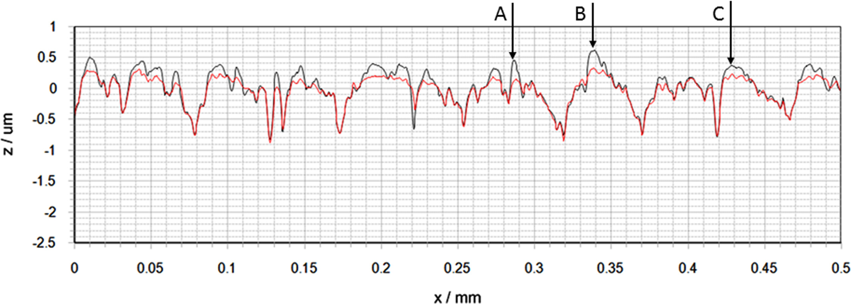
Figure 1: Surface profiles using relocation technique to retrace the same points before (black line) and after testing (red line) [2].

It is well known that understanding running-in for lubricated contacts is vital, with research dating back to 1968 by Østvik and Christensen [11] who studied line contacts made of unhardened carbon steel, SAE 1045, under conditions of mixed lubrication in both sliding and rolling-sliding contacts. They observed that the load carrying capacity of lubricant increased with operating time, which they suggested was due to the gradual conforming of the asperities of the two surfaces. Similarly, Kelly et al. [12] conducted twin disc tribometer tests (1992) on case hardened steel discs. They observed that disc bulk temperatures increased with and without prior running-in during various load-steps. They found that for a run-in surface the point of thermal instability, indicating severe surface degradation, is achieved at a much higher load and test duration. This was related to a the reduction of the surface roughness and the formation of a micro-elasto-hydrodynamic film for the run-in samples.
Hansen et al. (2020) [5] concluded that surface roughness measurements indicated a reduction of <20% after running-in of the roughest surface considered and thus the calculation of λ yielding unrealistic estimates of the lubrication quality, indicating boundary lubrication (λ = 0.24). While ECR measurements indicated full film elasto-hydrodynamic lubrication [5]. This underlines the importance of knowledge about the running-in, but also the need to consider changes in roughness during operation in time-dependent evaluation indicators. The authors show that different slide-to-roll ratios (SRR) prouced different behaviour on the fast and slow surfaces. While the slip increased roughness on the fast surface, it typically had minimal influence on the slow surface. Results also show that all three variables strongly influence the change in surface geometry, both individually and through both two- and three factor interactions. The SSR is therefore one of the most important variables for the influence on running-in processes.
In a recent paper, [13], the influence of pressure, slide-roll ratio, and entrainment velocity on two-dimensional surface roughness parameters during the running-in process was evaluated using a full-factorial experimental programme. Hardened EN36 steel discs (714 HV) are used on a twin-disk rig to simulate gear tooth contacts. Tests were conducted under elastohydrdynamic (EHL) conditions and SRRs of 0.25, 0.375, and 0.5. Two-dimensional surface profiles were obtained in-situ prior to running and after each test stage. The discs had a mean R_{a} of 0.42 µm, with all values between 0.37 µm – 0.46 µm, representative of gear tooth roughness.
The results show that as pressure increases the amount of plastic deformation and frictional effects which consequently increases the temperature, thins the lubricant film and encourages abrasive wear. This aligns with the work of Li and Kahraman [14] and Mallipeddi et al [15].
Increased entrainment velocities protected the surface through generation of a thicker lubricant film. This protection did not extend to the largest asperity peaks (determined by R_{p}, R_{z}) which still exceeded the film and were reduced in height. The effect of specific lubricant film thickness, λ, on the surface modification was not presented as it was not possible to isolate and understand each contributing factor to λ [16].
Further Yuan et al. [17] employed a pin-and-disc testing machine to study the effects of surface roughness and load on the wear resistance of GCr15 bearing steel with SAE-30 lubrication oil. The friction coeffcient was analyzed to study the infuence of surface roughness and load on the running-in quality. They found, the running-in quality to be related to the initial surface roughness, where a lower initial surface roughness leads to a higher ammount of running-in.
In previous works the authors of this paper have studied the surface wear mechanisms during running-in and their dependence on slip [18]. AISI 52100 steel specimens were tested in a mini traction machine (MTM) in the presence of a PAO base oil, in the mixed lubrication regime [18]. 3-D optical profilometry and scanning electron microscopy (SEM) were used to exam asperity scale surface topography changes as a function of the slide-to-roll ratio it was found that changes occur as early as the first few load cycles. Plastic flow from peaks into adjacent valleys and asperity removal were the main mechanisms observed.
While not directly related to rolling bearings, work for cold rolling process contacts by Gargourimotlagh et al. [19] showed running-in of rough surface with different starting topographies under various loading conditions. It was found that the deformation behaviour and evolution trend of surfaces with high initial surface plasticity are independent of loading conditions. In addition, initial hardness ratio and surface work hardening play important roles in the modification rate of rough surfaces and how a steady state of contacting surfaces is achieved.
The current state of research presented here clearly demonstrates that progress has been made in recent years in understanding and describing running-in processes. However, the reported results also point out that not all of the interrelationships have yet been fully clarified. Therefore, the task was set to conduct a systematic investigation of the main factors influencing running-in, with the aim of deriving a model description of these processes. At the same time, the choice of the test rig and the boundary conditions minimizes the potential influence of disturbances as much as possible.
2. Methodology
2.1 Test Samples and Lubricant
Each test employed a pair of rollers of 12 mm width, one was a flat cylindrical roller of 39 mm diameter, while the other was a crowned roller of 41 mm diameter, with a crowned radius of 200 mm. The large curvature of the crowned roller enabled a large contact width allowing better characterization of the changes during testing. The difference in diameters was to increase the duration of running-in as every part of the each roller would conform to the other, rather than a single point of contact (if no slip is employed). The rollers were manufactured by Schaeffler Technologies AG & Co. KG of AISI 52100 bearing steel, the samples were ground and polished to achieve an Rq of 0.05 μm or better. The hardness of the discs was measured as 838 ± 22 HV. All the tests were carried out utilizing PAO8 synthetic base oil, from Exxon USA, which has a dynamic viscosity of 0.005393 Pa s at the test rig temperature of 100°C.

2.2 Test Equipment and test conditions
Experiments were carried out employing a Phoenix Tribology TE74S twin disc tribometer, see Figure 2. Test rig (online) outputs including torque/friction, load, rotation speed/entrainment velocity, lubricant inlet and outlet temperatures were recorded at 0.1 Hz aquisition rate.

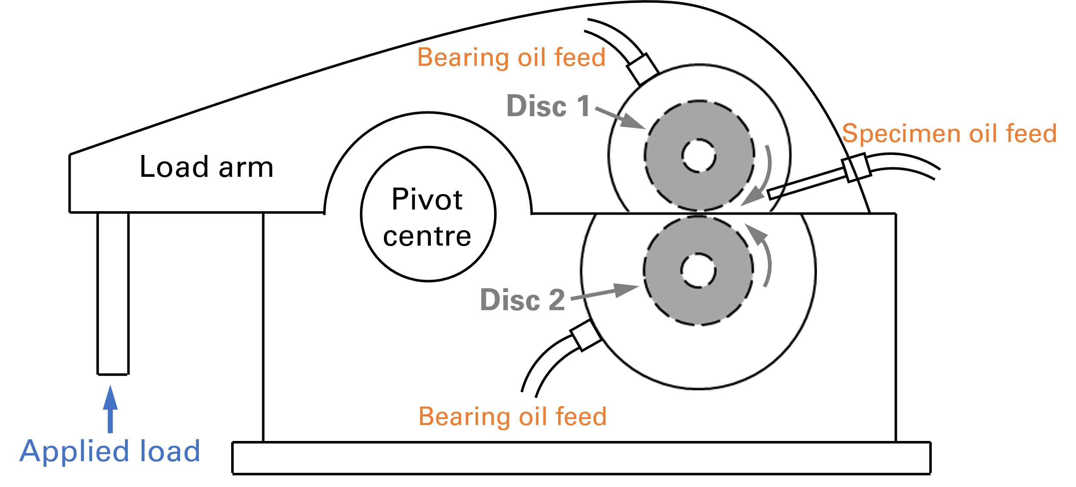
Figure 2 Schematic diagram of the TE74 twin disc tribometer [20].

In total 26 tests were conducted varying three key operating parameters, namely load (contact pressure), rotation speed (entrainment velocity), and slip ratio (SRR). The data is primarily analysed as parametric series, but also as a whole set. Table 1 shows a full list of test conditions. The parametric series are varied from a single test condition that is common to all three parameters, this is 2 GPa, 3.01 m/s and 0% slip, this is Test 3, see Table 1. The contact pressure parametric set consists of 3 tests – Tests 1 to 3, while the velocity set consists of Test 03, 06, 07, 12 to 15. The last set, of slip, consists of Tests 03 to 05 and 08 to 11. Tests 16 to 26 are part of the factorial type analysis.
The range of test conditions was developed based on the rig capabilities to allow realistic rolling bearing conditions, based on advice from Schaeffler Technologies.

Test ID | Pressure (GPa) | Entrain. Vel. (m/s) | Slip (%)
Test 01 | 3 | 3.01 | 0
Test 02 | 1 | 3.01 | 0
Test 03 | 2 | 3.01 | 0
Test 04 | 2 | 3.01 | 10
Test 05 | 2 | 3.01 | 2
Test 06 | 2 | 5.58 | 0
Test 07 | 2 | 0.43 | 0
Test 08 | 2 | 3.01 | 12
Test 09 | 2 | 3.01 | 6
Test 10 | 2 | 3.01 | 4
Test 11 | 2 | 3.01 | 8
Test 12 | 2 | 0.86 | 0
Test 13 | 2 | 2.15 | 0
Test 14 | 2 | 3.86 | 0
Test 15 | 2 | 4.72 | 0
Test 16 | 1 | 3.86 | 6
Test 17 | 3 | 3.86 | 6
Test 18 | 2 | 0.43 | 6
Test 19 | 2 | 5.58 | 6
Test 20 | 1.3 | 0.54 | 7
Test 21 | 2 | 0.43 | 12
Test 22 | 1 | 0.86 | 0
Test 23 | 2 | 0.86 | 0
Test 24 | 3 | 0.86 | 0
Test 25 | 2 | 0.86 | 6
Test 26 | 2 | 0.86 | 12
Table 1 Test matrix.

All the tests were run for a duration of 100,000 cycles (rotations of the samples), to ensure running-in was completed, so that all the samples were tested for the same rolling distance and this is observed by the frictional shown in Figure 3.

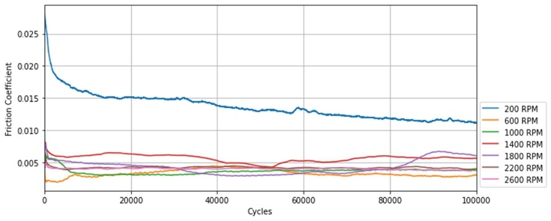
Figure 3: Friction plots for zero slip tests at different rotation speeds.
2.3 Roughness Evaluation
The shape and high quality surface finish of the samples limited the choice of proper measurement equipment that could be usedprecise enough to detect small changes; optical non-contact techniques were investigated and discarded: for the Alicona G4 InfiniteFocus the surface was too low; while for Proscan 2200 the noise on motion stage was too high and for white light interferometry the samples were too curved which created artifacts. Therefore, a contacting profilometer, a Taylor Hobson Intra Touch with a tip radius of 2 µm was employed. For each sample three axial measurements were conducted, each covering a length of 5 mm and evenly spaced across the circumference of the test sample, as illustrated in Figure 6.

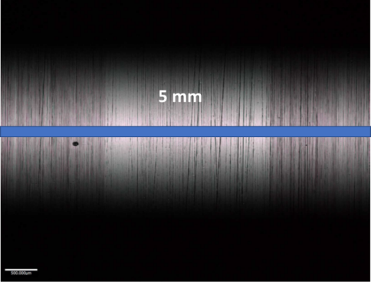
Figure 4 A schematic of the axial roughness measurement conducted on a tested twin disc tribometer sample. (Measurement line not to scale).

Each of the measurements involved part of the tested (where the two roller contact) and part of the untested (outside) surfaces over the 5 mm length, see Figure 4. The two parts of the unworn surface were stitched together and analysed as a whole, as shown by Figure 5. The boundaries on either sides of the wear track were identified manually. For each sample, the standard roughness values of R_{a}, R_{q}, R_{v}, R_{p}, R_{sk} and R_{ku} were calculated. As R_{a} and R_{q} produced near identical trends, only R_{a} has been used in the analysis. But it should be noted R_{q} is used in the calculation of minimum film thickness and subsequently the lambda values.

Figure 5 Processing a filtered roughness profile by separating the tested and untested regions.

3. Results and Discussion
Due to the low surface roughness of the samples, the first part of the analysis was on the variability in surface finishing, as this has an influence of the fidelity of the analysis.
By analysing all the data (all tests and both samples) for before and after testing, it was found that trends for R_{a}, R_{q}, and R_{p} are all similar and R_{a} is shown as an examples – see Figure 6. Overall, as indicated by the legend. the average change due to running-in was a reduction of 5 nm and as seen by the plot the spread of data of around 20 nm in both the pre and post-test measurements, indicates that the variability in surface finishing is higher than the average change. For R_{v} (shown in Figure 7), the average reduction/change between before and after testing is 16 nm, which is larger than the difference observed for R_{a}, interestingly the spread in values narrows after testing. For the third and fourth order parameters, skewness becomes slightly more negative and spreads a little, while kurtosis doesn’t change.

Figure 6 Histogram of the roughness distriubtion of Ra values before and after testing.
Figure 7 Histogram of the roughness distribution of Rv values before and after testing.

In the next part, individual changes in roughness parameters in the parametric sets will be explored. For the relationship between entrainment velocity in Figure 8, a clear trend is observed R_{a}. Lower entrainment velocities produce larger reductions for the crowned (Cr) and cylindrical (Cy) sample, while the converse is seen at the highest velocities with almost negligible differences. The influence of slip on the Ra value does not appear to follow any systematic pattern (Figure 11). At 0% and 12% slip, the roughness values before and after the test are nearly identical. At intermediate slip values around 4%, the smoothing effect is highest. However, the influence of contact pressure follows a trend where the smoothing effect increases with rising pressure, as shown in Figure 12.

Figure 8 Entrainment velocity parametric analysis of variation in roughness (R_{a}) for the crowned (Cr) and cylindrical (Cy) sample before and after testing. Note the Cr and Cy are at the same entrainment velocities, they are spread out for visual clarity.

Figure 9 Slip parametric analysis of variation in roughness (R_{a}) for the crowned (Cr) and cylindrical (Cy) before and after testing.

Figure 10 Contact Pressure parametric analysis of variation in roughness (Ra) for the crowned (Cr) and cylindrical (Cy) before and after testing.

Figures 13 to 15 show the average difference (of both crowned and cylindrical samples) for R_{a} (left axis), R_{p} and R_{v} (right axis). In this way, the effect of the run-in becomes more clearly visible, as fluctuations in the initial value for the roughness are relativized. The propagation of errors produces very large error bars, but the trends in the average values are the same for the three roughness parameters in the parametric sets (i.e. within each figure) and reflect the observation in the previous analysis.

Figure 11 Entrainment velocity parametric analysis of variation in combined roughness before and after testing.

Figure 12 Slip parametric analysis of variation in roughness variation in combined roughness before and after testing.

Figure 13 Contact Pressure parametric analysis of variation in roughness (R_{a}) variation in combined roughness before and after testing.

The trends observed in the previous part are mostly expected from a tribological perspective; for the entrainment velocity the small changes at high velocities are likely caused by the lubricant film that minimises asperity contacts, while at lower velocities (and moving in boundary lubrication) the increase in asperity contact and less support by the lubricant is producing more intense flattening of roughness peaks (it is still relatively small, as indicated by a reduction in the roughness parameters. For contact pressure, the higher values produce an increase removal of roughness peaks, this is partly as the lubricant film is reduced and partially obeying abrasive laws (Archard like behaviour) with mild wear being proportional to applied load. The slip is not quite what is expected as the highest wear is seen at moderate levels of slip (increased sliding is thought to increase wear normally). It is possible that various effects are superimposed here or that running-in effects in the direction of movement are not fully visible in the roughness analysis, which is only carried out as a line measurement transverse to the direction of movement.

Exploring the tribological aspect further both contact pressure and entrainment velocity influence the (minimum) film thickness, h_{min} and thus subsequently lambda, Λ, the equation for both are shown in Equations 1 and 2 [21].
$h_{min}={\left(\frac{Vη_{0}}{E^{'}R_{x}}\right)}^{0.68}{\left(αE^{'}\right)}^{0.49}{\left(\frac{W}{E^{'}R_{x}^{2}}\right)}^{-0.073}$ (Eq. 1)
$$Λ=\frac{h_{min}}{\sqrt{\left({R_{q1}}^{2}+{R_{q2}}^{2}\right)}}(Eq. 2)$$
Where W = load; η₀ = dynamic viscosity; E’ = reduced modulus; R_{x} = radius of curvature; α = pressure viscosity coefficient; V = entrainment velocity. The RMS roughness values R_{q1} and R_{q2} are for the two surfaces, in this case the crowned and cylindrical rollers. Exploring the dataset as a whole this produces the histogram shown in Figure 14, the initial lambda values were designed to produce a broad range, mixed to EHL, the post-test values indicate a narrowing the spread showing some conformality during running-in.
Figure 14 Histogram of the Lambda values before and after testing.

To explore this a little deeper, entrainment velocity (which from Equation 1 has the greater influence on film thickness and thus lambda) can be plotted against lamdba, but for before/initial and after/final, as shown in Figure 15. The initial values, as designed, are linearly spread from low to high values on both axes. The final values appear to have been ‘normalised’, not just the low entrainment velocities, increasing Lambda values as expected, but the highest entrainment velocities actually reducing which is not expected. Similar plots for variation with slip and contact pressure also show the same narrowing of spread around this ‘normalised’ region, but no other relationship is observed, thus the plots have not been included (for brevity).

Figure 15 Plot of lambda values against entrainment velocity before and after testing for all tests.

As Lambda is directly related to (composite) roughness and minimum film thickness, how is the change in roughness influenced by the film thickness? Figure 16 is one such plot, where the average difference for R_{a} is plotted against film thickness for the 0% slip tests. The plots for R_{p}, R_{v} and Rsk are very similar in trend, with low film thickness producing the largest changes roughness and low changes at high film thickness as expected in a lubricated system with asperity interactions.

Figure 16 Plot of relative change in Ra against minimum film thickness for tests with 0% slip.

Adding in slip data/tests, as shown in Figure 17, complicates the analysis slightly, the general trend seen for no slip tests is present, but there is a cluster of around 0.08 µm film thickness with higher roughness changes. This is also seen in the R_{p} and R_{v} plots, for Rsk it is much more scattered and hard to discern any pattern.

Figure 17 Plot of relative change in Ra against minimum film thickness for all tests.

Most of the findings fit with tribological and lubrication theory, in that with lower film thicknesses (lower entrainment velocities) produce more asperity to asperity contacts. Higher contact pressures also intensify running-in but the effect is less distinct than that of entrainment velocity, probably as this a smaller exponent on film thickness. Figure 12 shows that the presence of slip increases the roughness reduction, and this reduction matches the coefficient of friction (measured towards the end of the tests) data, plotted shown in Figure 18. As for the effects of slip on the plots above this is likely frictional heating changing the actual film thickness (values calculated from bulk temperature).

Figure 18 Plot of friction for test parametric tests (2 GPa, 3.01 m/s) averaged over the last part of the test.

Exploring all the data for R_{a}, R_{p} and R_{v} across the majority of the tests, there is a reduction in the average values of the pair of rollers there is a reduction in value. In most cases, this reduction is also seen individually for both rollers. However. there are a few cases where a slight positive change is observed. The largest average reduction in Ra was just over 8 nm (for R_{p}/R_{v} this was 39 nm) and these reductions occurred in the low velocity slip tests. The average reductions were 5 and 16 nm for R_{a} and R_{v} (see Figures 6 and 7), indicating that both so the original roughness and the reductions are very small.
Most literature running-in studies have employed at least one or both surfaces that are relatively rough (in comparison to this study) and that makes it difficult to compare. However Hansen [5] did explore three roughnesses in rolling pin-on-disc with the lowest level comparable to the present study. The data is presented in a qualitatively manner, via colourmaps, before and after testing (also shown in Figure 2) and indicate very little change/wear and tabulated roughness also indicate very little change, but a generally, a reduction quite similar as shown in to this study.

4. Conclusions/Summary
This study investigates the running-in process of rolling bearings under mixed lubrication conditions, with a focus on surface roughness changes. Running-in is characterized by an initial adaptation of surfaces which can lead to a reduction in roughness peak heights through plastic deformation or mild abrasive wear. Experiments were conducted using a twin roller machine with varying loads, entrainment velocities, and slip ratios, employing a synthetic base oil (PAO4) to eliminate additive effects. The roughness evaluation utilized a contacting profilometer due to the high-quality surface finish of the samples.
The results showed that variations in roughness before and after testing were very small, with an overall reduction in roughness parameters such as R_{a} and R_{v}. The study identified trends related to entrainment velocity, contact pressure, and slip, highlighting their effects on film thickness and asperity interactions. The findings align with tribological theories, indicating that lower film thickness and higher contact pressures lead to more intense running-in, while slip increased roughness reduction partly due to frictional heating.
The experiments show a general trend towards reduced roughness. Despite the small magnitude of changes, the results contribute to understanding the factors influencing the running-in process, highlighting the significance of entrainment velocity and contact pressure. The analysis also confirms that low initial roughness limits the degree of running-in, leading to surfaces stabilized within mixed lubrication regimes. This study provides insights into the mechanisms of running-in and lays groundwork for further exploration into systematic modeling of these processes.

Acknowledgements
The authors would like to thank Schaeffler Technologies AG & Co. KG for funding this work and their support and advice over the duration of this research project and funding from the EPSRC: EP/S005463/1.
References
- Blau PJ "Running-in: Art or engineering?," Journal of Materials Engineering, 13 (1) 47-53 (1991).
- Clarke A, Weeks AIJJ, Snidle RW and Evans HP Tribology International, 101 59-68 (2016) doi: 10.1016/j.triboint.2016.03.007.
- Blau PJ "On the nature of running-in," Tribology International, 38 (11-12) SPEC. ISS. 1007-1012 (2005).
- Abbott EJ and Firestone FA “Specifying Surface Quantity - A Method Based on Accurate Measurements and Comparisons” Mech. Eng. (Am. Soc. Mech. Eng.) 55 569-572 (1933).
- Hansen J, Björling M, and Larsson R “Topography transformations due to running-in of rolling-sliding non-conformal contacts” Tribology International 144 (2020), doi: 10.1016/j.triboint.2019.106126.
- Sosa M, Björklund S, Sellgren U and Olofsson U “In situ surface characterization of running-in of involute gears” Wear. 340–341 41-46 (2015).
- Lohner T, Mayer J, Michaelis K, Höhn B-R and Stahl K “On the running-in behavior of lubricated line contacts”, Proc. of the Inst. of Mech. Eng. Part J: J. of Eng. Trib. 231 441-452 (2017).
- Wang W, Wong PL and Zhang Z “Experimental study of the real time change in surface roughness during running-in for PEHL contacts” Wear 244 140-146 (2000).
- Jamari, "Running-in as an Engineering Optimization," J Ti Undip Jurnal Teknik Industri, 2 (1) 1-10 (2007), doi: 10.12777/jati.2.1.1-10.
- Ismail R, Tauviqirrahman M, Jamari and Schipper DJ, "Topographical Change of Engineering Surface due to Running-in of Rolling Contacts" New Tribological Ways May 2014 (2011).
- Østvik R and Christensen H "Changes in Surface Topography with Running-In," Proc. of the Inst. of Mech. Eng., Conference Proceedings 183 (16) 57-65 (1968).
- Kelly DA, Barnes CG, Freeman RW and Critchlow GW "Running in and the enhancement of Scuffing Resistance" Proc. of the Inst. of Mech. Eng. Part C: J. of Mech. Eng. Sci. 206 (September) 425-429 (1992).
- Britton WM, Clarke A and Evans HP (13 Aug 2024): “An Experimental Investigation Replicating the Surface Behavior of Ground Steel Gears in Mixed Lubrication Using Twin-Disk Testing Part 1: Running-in” Tribology Transactions, 68(1), 121–141 (2025) DOI: 10.1080/10402004.2024.2387779.
- Li S and Kahraman A “Micro-pitting fatigue lives of lubricated point contacts: Experiments and model validation” International Journal of Fatigue 48 9-18 (2013).
- Mallipeddi D, Norell M, Sosa M and Nyborg L “Influence of running-in on surface characteristics of efficiency tested ground gears” Tribology International 115 45- 58 (2017).
- Olver AV “Gear lubrication – a review” Proc. of the Inst. of Mech. Eng. Part J: J. of Eng. Trib. 216(5) 255-267 (2002).
- Yuan Z, Jiang Z, Zhou Z et al. “Effect of surface roughness on friction and wear behavior of GCr15 bearing steel under different loads” Surf. Sci. Tech. 2 28 (2024). https://doi.org/10.1007/s44251-024-00057-2
- Sakhamuri MSD, Harvey TJ, Vierneusel B and Wood RJK, “Wear induced changes in surface topography during running-in of rolling-sliding contacts” Wear 522 204685 (2023) https://doi.org/10.1016/j.wear.2023.204685
- Gargourimotlagh MD, Matthews D and de Rooij M “An investigation into the evolution of surface topography and contact characteristics of rolling elements under repeated rolling contact” Tribology International 208 110644 (2025) https://doi.org/10.1016/j.triboint.2025.110644.
- Tian Z, Lu P, Wang, S, Merk, D and Wood, RJK Influence of ZDDP tribofilm on micropitting formation and progression, Tribo. Int. 199 109938 (2024).
- Hamrock BJ and Dowson D "Isothermal Elastohydrodynamic Lubrication of Point Contacts: Part III—Fully Flooded Results." ASME. J. of Lubrication Tech. 99(2): 264–275 (1977) https://doi.org/10.1115/1.3453074.

