**Clinical and Histological Predictors of Disease Severity in Boys with Lichen Sclerosus: A prospective multicentre observational study.**

Jonathan J Neville1, Sumita Chhabra2, Georgina Bough1, Helen Figgins3, Patrick Green2, Claudia Koh2, Charlotte Melling2, Rajeev Shukla2, Anju Goyal3, Nigel J Hall1, Harriet Corbett2*

1. University Surgery Unit, University of Southampton, Southampton, United Kingdom
2. Alder Hey Children's Hospital NHS Foundation Trust, Liverpool, United Kingdom
3. Royal Manchester Children's Hospital, Manchester, United Kingdom

*Corresponding author: Ms Harriet Corbett, Alder Hey Children's Hospital NHS Foundation Trust, Liverpool, L12 2AP, United Kingdom, [Harriet.Corbett@alderhey.nhs.uk](mailto:Harriet.Corbett@alderhey.nhs.uk)

**FUNDING**

This work was funded by The Urology Foundation Small Projects Fund. JJN is supported by a NIHR Academic Clinical Fellowship. The views expressed are those of the author(s) and not necessarily those of the NHS, the NIHR or the Department of Health.

**CONFLICTS OF INTEREST**

None to declare.

**KEYWORDS**

Lichen sclerosus, balanitis xerotica obliterans, circumcision, preputioplasty, paediatric surgery, urology

**ABSTRACT**

**Background**

Lichen sclerosus is an inflammatory dermatosis resulting in progressive phimosis and meatal stenosis. Following circumcision, a proportion of boys require further interventions to manage ongoing symptoms. We investigated whether clinical or histopathological disease severity associated with persistent symptoms or need for further interventions after circumcision.

**Method**

A prospective observational study was undertaken at three paediatric surgery centres in the United Kingdom. Boys aged ≤16 years undergoing surgery for suspected lichen sclerosus were included and followed-up for one year. Disease appearance was graded using pre-defined criteria during surgery. Histological disease severity in resected foreskins was reported. Ongoing symptoms and subsequent interventions were recorded. The primary outcome was the requirement for further surgery.

**Results**

Ninety-three boys were included. Median age at surgery was 9.5 years (interquartile range: 7.4–11.8). Lichen sclerosus was confirmed histologically in 82/86 (95%). Further surgery after circumcision occurred in 6/93 (6%). Clinical features of disease at surgery and histopathological severity were not associated with further surgery. At follow-up 18/93 (19%) reported symptoms, this was more common in boys requiring an emergency circumcision (6/75 [8%] versus 5/18 [28%], p=0.034). Boys with meatal involvement were more likely to receive medical or surgical treatments (18/75 [24%] versus 9/18 [50%], p=0.042).

**Conclusions**

Emergency presentation and involvement of the urethral meatus at circumcision associate with ongoing symptoms after circumcision. In this cohort, the appearance of disease at surgery and the severity of disease on histopathology did not correlate with outcome. However further studies are required to validate the value of histological staging.

**INTRODUCTION**

Lichen sclerosus, also referred to as balanitis xerotica obliterans, is a chronic progressive inflammatory dermatosis of unknown aetiology that can affect the foreskin, glans and meatus. It occurs in 40 per 100,000 boys per year and causes progressive pathological phimosis, spraying or difficulties voiding, and recurrent balanitis [1]. The diagnosis is clinical and may be confirmed on histology. The mainstay of treatment is circumcision, although preputioplasty with intralesional steroid injection can be considered to preserve the foreskin [2]. Anti-inflammatory and immunomodulatory creams and ointments are also used as an alternative or an adjunct to surgery. However, there is limited data supporting the efficacy of topical treatments [3].

Following circumcision 10 – 20% of boys with lichen sclerosus require further surgical interventions [4, 5]. Currently no clinical or histopathological features have been identified which associate with the requirement for further surgery after circumcision. Glans and meatal involvement at index surgery have been observed to associate with post-operative steroid use, but not subsequent dilatation or meatotomy [5]. Identification of features predicting a more severe disease phenotype in lichen sclerosus may facilitate earlier treatment and targeted interventions. This information would also be useful for counselling patients and caregivers peri-operatively. A grading system that reflected disease severity, and accurately predicted cases of lichen sclerosus at high risk of relapse after intervention, would allow clinicians to plan treatment and follow-up accordingly. Such a system would also provide a standardized means to classify lichen sclerosus for future research, facilitating meta-analysis and improving reproducibility.

The aim of this study was to create a standardised grading system that describes lichen sclerosus severity intra-operatively. A secondary aim of the study was to investigate whether clinical features or histological severity of lichen sclerosus associated with ongoing symptoms or the requirement for further interventions after circumcision.

**METHODS**

A prospective observational study conducted at three paediatric surgery tertiary centres in the United Kingdom. Boys aged ≤16 years old undergoing circumcision for suspected lichen sclerosus were eligible for inclusion. Boys who had undergone previous penile surgery or were undergoing circumcision for other indications were excluded. Boys meeting the inclusion criteria were approached for consent in outpatient clinics or immediately prior to surgery. Consent was provided by legal guardians, and assent was also given by the patient when appropriate.

Demographic details, topical treatments prior to surgery, and mode of presentation (elective or emergency) were recorded. During surgery the operating surgeon described the severity of the lichen sclerosus using a predefined scoring system (Table 1). The scoring system was defined and agreed upon by the study team prior to the start of the study. In a subset of boys, intra-operative severity scoring was performed by two surgeons independently. Standardised intra-operative photographs were also taken of the dorsal, ventral and lateral penis pre- and post-foreskin retraction. These photographs were used by an independent panel of eight surgeons to grade the severity of the lichen sclerosus using the scoring system. Agreement of severity scoring between the operating surgeon and the second operating surgeon, and within the independent panel was assessed.

In boys with histologically confirmed lichen sclerosus, the severity of disease in the resected foreskin specimen was graded one (mild; Figure 1A – B) to three (severe; Figure 1D) by a single consultant histopathologist at each centre [6]. If specimens showed features from multiple severity grades, the most severe grade was recorded. Boys were followed up one year from the date of surgery with face-to-face appointments or a telephone call. After completion of follow-up boys received a gift voucher. Complications, presence and type of symptoms during follow-up, and requirement for further medical or surgical treatments were recorded. The study primary outcome was the requirement for further surgery post-circumcision. Secondary outcomes included the persistence of symptoms and the requirement for any further medical or surgical treatments following circumcision. Ethical approvals were obtained (21/LO/0845).

Data are presented as median (interquartile range) unless otherwise specified. Continuous non-parametric data were compared using the Mann-Whitney U test. Categorical data were compared using Chi-squared or Fisher’s exact tests as appropriate. Post-hoc analysis was conducted for significant associations using pairwise Chi-squared tests with Bonferroni correction for multiple comparisons. Agreement was assessed using Fleiss’ Kappa (κ). Correlation between the clinical feature score and histology grade were assessed using Kendall’s tau for ordinal data. All tests were two-sided. A p-value <0.05 was considered significant. Statistical analysis was conducted in SPSS v29. This study is reported in accordance with STROBE guidelines [7].

**RESULTS**

Ninety-three boys underwent a circumcision for suspected lichen sclerosus and were included in the study. Median age at surgery was 9.5 years (7.4 – 11.8). Histopathology was available in 86/93 (92%) and lichen sclerosus was confirmed in 82/86 (95%). Topical steroids had been prescribed pre-operatively in 54/93 (58%). Eleven (12%) boys presented as an emergency in acute urinary retention. Eight (9%) boys underwent a circumcision and a meatal dilatation. No boys underwent circumcision and meatoplasty or meatotomy. Surgical complications occurred in 14/93 (15%) of boys and included eight (9%) post-operative wound infections, post-operative bleeding in three (3%), and post-operative urinary retention in two (2%) boys.

Intra-operative grading was completed in all cases (Table 1). The most common features present at surgery were a non-retractile foreskin (82%), involvement of <33% of the outer foreskin (56%), circumferential scarring of the outer foreskin (74%), no visible involvement of the inner foreskin (37%), no visible involvement of the glans (45%), no involvement of the urethral meatus (71%), and involvement of the frenulum (61%; Figure 2). Comparing the clinical phenotype in boys stratified into age groups (5 – 8 years, 9 – 12 years, 13 – 16 years) showed that boys aged 13 – 16 years more commonly had retractile foreskins compared to boys aged 9 – 12 years (4/40 [9%] versus 8/18 [44%], p = 0.001). No other clinical features differed across the three age groups (Supplementary Table 1). Based on the intra-operative grading a summative severity score was defined. The median severity score was 14 (range: 2 – 22).

To validate the disease severity grading 16 boys (17%) underwent intra-operative grading by two surgeons independently. Substantial agreement between the two surgeons was observed (κ = 0.730, p < 0.001). Further to this, standardised intra-operative photographs from 76 boys were independently graded by eight surgeons (totalling 576 separate gradings). A moderate agreement was observed (κ = 0.528, p < 0.001).

Histology showed stage one lichen sclerosus in 18/86 (21%), stage two in 14/86 (16%) and stage three in 50/93 (58%). Four (5%) boys underwent circumcision but had no features of lichen sclerosus on histology. Boys with stage three histological disease had significantly greater disease burden in the inner foreskin (Supplementary Table 2). Histology stage did not associate with greater involvement of the glans, frenulum or meatus at time of surgery. A moderate correlation was observed between the summative disease severity score and histology stage (Kendall’s tau 0.288, p <0.001). The summative score had an AUC of 0.713 (95% CI 0.472 – 0.955, p = 0.151) for predicting positive lichen sclerosus histology (Supplementary Figure 1A).

One-year follow-up data was available for 87/93 (94%) of boys. Further surgery after circumcision was undertaken in 6/93 (6%) boys. Two boys underwent a meatal dilatation, and four boys underwent a meatoplasty. No clinical features were associated with the requirement for further surgery (Table 1). Age at surgery, the use of previous topical steroids, emergency presentation, performance of a meatal dilatation, development of surgical complications and histological stage did not associate with further surgery (Table 2). The summative severity score had an AUC of 0.530 (95% CI 0.269–0.790, p = 0.808) for predicting further surgery (Supplementary Figure 1B).

Subsequent treatment (medical or surgical) was required in 18/93 (19%) boys post-circumcision (Table 3). Boys with meatal involvement were more likely to receive further medical or surgical treatments (18/75 [24%] versus 9/18 [50%], p=0.042). Ongoing symptoms following circumcision were reported in 18/93 (19%) boys, and included post-voiding dribbling in three, spraying whilst voiding in three, voiding with a fine stream in three, pain on voiding in two, bedwetting in one, and bleeding per urethra in one. Ongoing symptoms were unspecified in five boys. A higher proportion of boys with ongoing symptoms post-circumcision presented initially as an emergency (5/18 [28%] versus 6/75 [8%], p = 0.020). Intra-operative disease features and histology grade did not associate with ongoing symptoms post-circumcision (Table 4). Of the boys with ongoing symptoms 4/18 (22%) underwent surgery.

**DISCUSSION**

We have designed a clinical grading system for lichen sclerosus that can be used to describe the disease intra-operatively. The grading system shows good agreement between independent raters, correlates with histopathology severity, and can identify positive lichen sclerosus histology. This grading system can be used to standardise disease descriptions in future research studies. However, in this cohort the grading system did not associate with disease outcomes, and therefore its clinical utility is limited.

Further surgery was required in 6% of boys in this cohort within the one-year follow-up period. This is lower than previously published studies, which report reintervention rates of 10 – 20% [4, 5]. Meatal involvement was identified at surgery in 29% of boys, which is similar to the 20 – 30% reported in the literature [4, 5, 8]. In our cohort, half of boys who underwent further medical or surgical treatment had meatal involvement identified at surgery. Meatal involvement appears to be a key risk factor for ongoing symptoms following circumcision. However, there remains debate over whether to perform a meatal procedure alongside circumcision [8]. There is evidence to suggest that performing a meatotomy at time of circumcision is associated with an increased risk of subsequent meatal intervention [5]. In this study, circumcision and meatal dilatation did not associate with the requirement for further treatment. Objective assessment of urinary flow using uroflowmetry may identify boys who would benefit from further meatal interventions, particularly in those with meatal disease at initial surgery [9]. Surgeons should closely follow-up boys with meatal disease identified at circumcision, but further research is required to identify the optimal timing of meatal intervention.

The distribution and burden of clinical disease did not differ significantly with age in this cohort, except for older boys (13 – 16 years) having a higher proportion of retractile foreskins. The distribution of disease did associate with histopathology severity, with greater involvement of the inner foreskin in stage three disease. Singh and colleagues evaluated the distribution of lichen sclerosus on histopathology specimens and observed that early disease (determined by histological severity) was localised to the tip of the foreskin, whereas established disease predominantly affected the inner prepuce [10]. Together these results suggest that more severe lichen sclerosis predominantly affects the inner foreskin. However, in a prospective study of 471 boys with lichen sclerosus, Kiss *et al.* reported no association between histological severity and clinical appearances of the disease (foreskin retractability) [6]. Kiss and colleagues also reported no meatal involvement, recurrent symptoms or interventions in their cohort. In this study, we observed that 67% of boys who underwent further surgery had stage three histology. This suggests that histological severity may influence outcome, but this study was underpowered to confirm a significant association.

Strengths of this study are its prospective data collection across three paediatric surgery centres and detailed follow-up. Reproducibility of the surgical grading system was assessed twice in a subset of the data, by an independent second surgeon intra-operatively and by a panel of raters assessing standardised photographs. Less strong agreement was observed in the latter suggesting that static images may not be as useful as dynamic assessment intra-operatively. Data was not collected on the strength and duration of prior topical steroid treatments. As such, no conclusions can be drawn on the efficacy of topical therapies. Follow-up was limited to one-year post-circumcision. Boys may have developed recurrent symptoms and required repeat intervention after this time, resulting in an under-estimation of post-operative problems. Although, typically reinterventions are undertaken within one year of circumcision [4, 8]. A further consideration is that the surgical grading system requires retraction of the diseased foreskin to describe the involvement of the inner prepuce, glans, meatus and frenulum. As such, it is only suitable for intra-operative use in the majority of patients.

Our findings indicate that histological grade did not correlate with clinical outcome. In most cases, lesions with varying histological grades coexisted within the same specimen. In our grading approach, the overall grade was assigned based on the highest grade present. We did not assess the relative proportion or extent of each histological grade within individual specimens. Therefore, it remains uncertain whether a scoring system that incorporates the distribution or proportion of different grades would offer greater prognostic value. Additionally, we did not evaluate the presence of pathological involvement at the surgical margins, which could also have prognostic implications.

Since the macroscopic and microscopic appearance of disease in the foreskin does not appear to associate with outcome following circumcision, further work should focus on the development and validation of a symptom score for boys with lichen sclerosus. This score could be used to risk stratify boys for treatment and classify severity for future randomised control trials.

In conclusion, boys who present in an emergency, and those with meatal involvement at surgery, are more likely to have persistent problems after circumcision requiring further medical or surgical treatment. Timely intervention may prevent boys presenting as an emergency and reduce the number of boys that are symptomatic post-operatively. These data will be useful counselling boys and their caregivers undergoing circumcision for lichen sclerosus. Secondarily, the clinical grading system reported here correlates with histological disease severity and can be completed by independent surgeons with good levels of agreement. With validation in larger cohorts, this system may be considered for use in further research to describe the severity of lichen sclerosus at time of surgery. Unfortunately, our grading system does not associate with ongoing symptoms or requirement for further interventions, so its clinical use is limited.

**REFERENCES**

1. Celis S, Reed F, Murphy F, Adams S, Gillick J, Abdelhafeez AH, Lopez PJ. Balanitis xerotica obliterans in children and adolescents: a literature review and clinical series. J Pediatr Urol. 2014 Feb;10(1):34-9. doi: 10.1016/j.jpurol.2013.09.027. Epub 2013 Nov 14. PMID: 24295833.
2. Wilkinson DJ, Lansdale N, Everitt LH, Marven SS, Walker J, Shawis RN, Roberts JP, Mackinnon AE, Godbole PP. Foreskin preputioplasty and intralesional triamcinolone: a valid alternative to circumcision for balanitis xerotica obliterans. J Pediatr Surg. 2012 Apr;47(4):756-9. doi: 10.1016/j.jpedsurg.2011.10.059. PMID: 22498393.
3. Folaranmi SE, Corbett HJ, Losty PD. Does application of topical steroids for lichen sclerosus (balanitis xerotica obliterans) affect the rate of circumcision? A systematic review. J Pediatr Surg. 2018 Nov;53(11):2225-2227. doi: 10.1016/j.jpedsurg.2017.12.021. Epub 2018 Jan 3. PMID: 29395150.
4. Homer L, Buchanan KJ, Nasr B, Losty PD, Corbett HJ. Meatal stenosis in boys following circumcision for lichen sclerosus (balanitis xerotica obliterans). J Urol. 2014 Dec;192(6):1784-8. doi: 10.1016/j.juro.2014.06.077. Epub 2014 Jun 30. PMID: 24992332.
5. Faily S, Chhabra S, Corbett HJ. Meatal Surgery at the Time of Circumcision for Lichen Sclerosus (LS/BXO) Does Not Reduce the Need for Later Meatal Intervention: A Retrospective Cohort Study. J Pediatr Surg. 2024 Sep;59(9):1846-1850. doi: 10.1016/j.jpedsurg.2024.05.010. Epub 2024 May 21. PMID: 38862295.
6. Kiss A, Király L, Kutasy B, Merksz M. High incidence of balanitis xerotica obliterans in boys with phimosis: prospective 10-year study. Pediatr Dermatol. 2005 Jul-Aug;22(4):305-8. doi: 10.1111/j.1525-1470.2005.22404.x. PMID: 16060864.
7. von Elm E, Altman DG, Egger M, Pocock SJ, Gøtzsche PC, Vandenbroucke JP; STROBE Initiative. The Strengthening the Reporting of Observational Studies in Epidemiology (STROBE) statement: guidelines for reporting observational studies. J Clin Epidemiol. 2008 Apr;61(4):344-9. doi: 10.1016/j.jclinepi.2007.11.008. PMID: 18313558.
8. Holbrook C, Tsang T. Management of boys with abnormal appearance of meatus at circumcision for balanitis xerotica obliterans. Ann R Coll Surg Engl. 2011 Sep;93(6):482-4. doi: 10.1308/003588411X587145. PMID: 21929920; PMCID: PMC3369335.
9. Arena S, Russo T, Impellizzeri P, Parisi S, Perrone P, Romeo C. Utility of uroflowmetry during the follow-up of children affected by balanitis xerotica obliterans (BXO). Arch Ital Urol Androl. 2018 Jun 30;90(2):123-126. doi: 10.4081/aiua.2018.2.123. PMID: 29974722.
10. Singh L, Sengar M, Goyal S, Mansi M, Khurana N, Mohta A. Childhood Phimosis Secondary to Lichen Sclerosus: Is There a Spatial Pattern of Histopathological Changes? Am J Dermatopathol. 2018 Nov;40(11):824-828. doi: 10.1097/DAD.0000000000001248. PMID: 30124504.

**TABLES**

Table 1 – Clinical severity grading and further surgical intervention. The summative score was created by adding the score values in parentheses for each patient.

|  |  |  |  |
| --- | --- | --- | --- |
| **Grading domain (score value)** | **No further surgical intervention**  **(n = 87)** | **Further surgical intervention (n = 6)** | **p-value** |
| Retractability of foreskin  Fully (0)  Partial (1)  Poorly - meatus seen only (2)  Not retractile (3) | 4 (5%)  3 (3%)  9 (10%)  71 (82%) | 1 (17%)  0 (0%)  0 (0%)  5 (83%) | 0.50 |
| Appearance of outer foreskin  No visible involvement (0)  <33% area involved (1)  33 – 66% area involved (2)  >66% area involved (3) | 10 (11%)  49 (56%)  15 (17%)  13 (15%) | 1 (17%)  3 (50%)  2 (33%)  0 (0%) | 0.60 |
| Degree of circumferential outer foreskin involvement  <90 (1)  90 – 180 (2)  180 – 270 (3)  >270 (4) | 14 (16%)  3 (3%)  5 (6%)  65 (75%) | 1 (17%)  0 (0%)  1 (17%)  4 (67%) | 0.73 |
| Appearance of inner foreskin  No visible involvement (0)  <33% area involved (1)  33 – 66% area involved (2)  >66% area involved (3) | 32 (37%)  17 (20%)  15 (17%)  23 (26%) | 2 (33%)  1 (17%)  1 (17%)  2 (33%) | 0.99 |
| Degree of circumferential inner foreskin involvement  <90 (1)  90 – 180 (2)  180 – 270 (3)  >270 (4) | 34 (39%)  11 (13%)  7 (8%)  35 (40%) | 3 (50%)  0 (0%)  1 (17%)  2 (33%) | 0.69 |
| Appearance of glans  No visible involvement (0)  <33% area involved (1)  33 – 66% area involved (2)  >66% area involved (3) | 40 (46%)  19 (22%)  11 (13%)  17 (20%) | 2 (33%)  1 (17%)  1 (17%)  2 (33%) | 0.84 |
| Involvement of urethral meatus (1) | 24 (28%) | 3 (50%) | 0.35 |
| Involvement of frenulum (1) | 53 (61%) | 4 (67%) | 1.00 |

Table 2 – Demographic and clinical details and further surgical intervention.

|  |  |  |  |
| --- | --- | --- | --- |
|  | **No further surgical intervention**  **(n = 87)** | **Further surgical intervention**  **(n = 6)** | **p-value** |
| Median age in years (IQR) | 9.5 (7.3 – 11.4) | 10.7 (9.5 – 11.6) | 0.40 |
| Previous topical steroids | 49 (56%) | 5 (83%) | 0.70 |
| Emergency circumcision | 11 (13%) | 0 (0%) | 1.00 |
| Circumcision and meatal dilatation | 7 (8%) | 1 (17%) | 0.43 |
| Histology severity grade (n = 86)  No LS  Stage one  Stage two  Stage three | 3 (3%)  17 (20%)  14 (16%)  46 (53%) | 1 (17%)  1 (17%)  0 (0%)  4 (67%) | 0.36 |
| Post-operative complications | 12 (14%) | 2 (33%) | 0.22 |

IQR – interquartile range, LS – lichen sclerosus.

Table 3 –Clinical details and any further medical or surgical treatments.

|  |  |  |  |
| --- | --- | --- | --- |
|  | **No further treatment**  **(n = 75)** | **Further treatment**  **(n = 18)** | **p-value** |
| Previous topical steroids | 42 (56%) | 12 (67%) | 0.41 |
| Emergency circumcision | 8 (11%) | 3 (17%) | 0.48 |
| Circumcision and meatal dilatation | 6 (8%) | 2 (11%) | 0.65 |
| Retractile foreskin | 15 (20%) | 2 (11%) | 0.38 |
| Glans involvement | 41 (55%) | 10 (56%) | 0.95 |
| Meatal involvement | 18 (24%) | 9 (50%) | 0.03* |
| Frenulum involvement | 47 (63%) | 10 (56%) | 0.58 |
| Histology severity grade (n = 86)  No LS  Stage one  Stage two  Stage three | 2 (3%)  16 (21%)  11 (16%)  41 (59%) | 2 (13%)  2 (13%)  3 (19%)  9 (56%) | 0.34 |
| Post-operative complications | 10 (13%) | 4 (22%) | 0.34 |

*Significant result. IQR – interquartile range, LS – lichen sclerosus.

Table 4 – Clinical details and ongoing symptoms post-circumcision.

|  |  |  |  |
| --- | --- | --- | --- |
|  | **No further symptoms**  **(n = 75)** | **Further symptoms**  **(n = 18)** | **p-value** |
| Previous topical steroids | 44 (59%) | 10 (56%) | 0.81 |
| Emergency circumcision | 6 (8%) | 5 (28%) | 0.02* |
| Retractile foreskin | 14 (19%) | 3 (17%) | 0.84 |
| Glans involvement | 41 (55%) | 10 (56%) | 0.95 |
| Meatal involvement | 21 (28%) | 6 (33%) | 0.65 |
| Frenulum involvement | 46 (61%) | 11 (61%) | 0.99 |
| Histology severity grade (n = 86)  No LS  Stage one  Stage two  Stage three | 1 (1%)  14 (21%)  12 (18%)  41 (60%) | 3 (17%)  4 (22%)  2 (11%)  9 (50%) | 0.05 |
| Post-operative complications | 10 (13%) | 4 (22%) | 0.34 |

*Significant result. LS – IQR – interquartile range, lichen sclerosus.

**FIGURES**

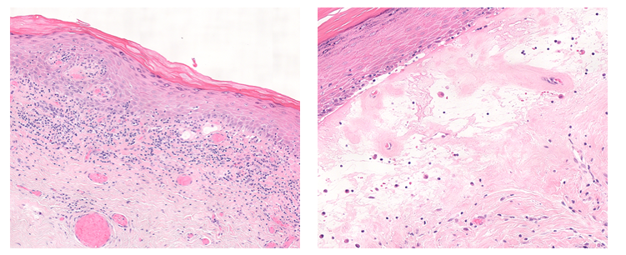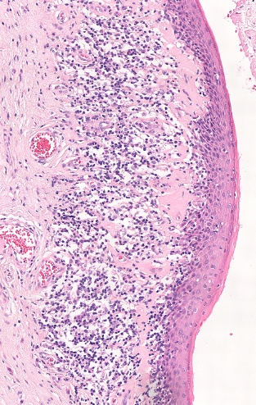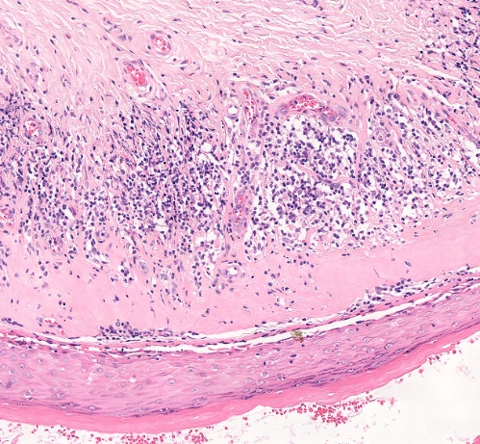

**A**

**B**

**C**

**D**

Figure 1 – Histological severity grades of lichen sclerosus. Stage 1: Hydropic degeneration of the basal cells with an inflammatory infiltrate at the dermo-epidermal junction (A) and/or oedema in the upper dermis (B). Stage 2: Partial homogenization of the collagen in the upper dermis. Band of hyalinisation is not well demarcated (C). Stage 3: Hyperkeratosis, atrophy of the stratum malpighii, and a pale staining hyalinised homogenous zone in the upper dermis above a band of inflammatory cells (D).

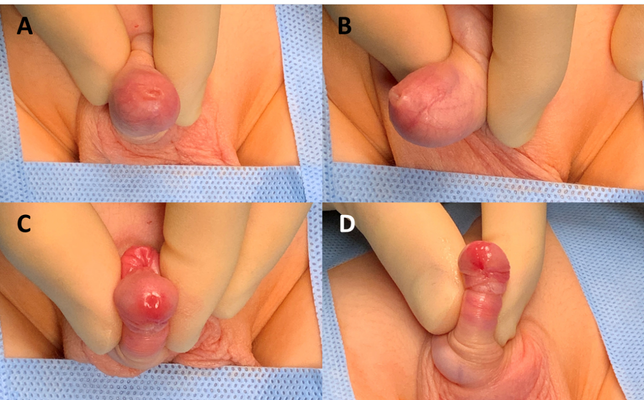

Figure 2 – ‘Typical’ lichen sclerosus clinical features on presentation. Non-retractile foreskin with circumferential scarring to <33% of the outer prepuce (A and B). Post-retraction images of a normal appearing glans, urethral meatus and inner prepuce (C and D), and an affected frenulum (D). This patient had stage one histopathology.

**SUPPLEMENTARY**

Supplementary Table 1 – Clinical phenotype by age group.

|  |  |  |  |  |
| --- | --- | --- | --- | --- |
| **Score Domain** | **Age 5 – 8 years**  **(n = 31)** | **Age 9 – 12 years**  **(n = 44)** | **Age 13 – 16 years**  **(n = 18)** | **p-value** |
| Retractable foreskin | 5 (16%) | 4 (9%) | 8 (44%) | 0.004* |
| Outer foreskin involvement | 27 (87%) | 41 (93%) | 14 (78%) | 0.23 |
| Inner foreskin involvement | 20 (65%) | 31 (70%) | 8 (44%) | 0.15 |
| Glans involvement | 17 (55%) | 27 (61%) | 7 (39%) | 0.27 |
| Meatal involvement | 10 (32%) | 12 (27%) | 5 (28%) | 0.89 |
| Frenulum involvement | 18 (58%) | 27 (61%) | 12 (67%) | 0.84 |

*Significant result

Supplementary Table 2 – Clinical phenotype by histopathology stage (n = 86).

|  |  |  |  |  |  |
| --- | --- | --- | --- | --- | --- |
| **Score Domain** | **No lichen sclerosus**  **(n = 4)** | **Stage one**  **(n = 18)** | **Stage two**  **(n = 14)** | **Stage three**  **(n = 50)** | **p-value** |
| Retractability of foreskin  Fully  Partial  Poorly  Not retractile | 0 (0%)  0 (0%)  1 (25%)  3 (75%) | 0 (0%)  1 (6%)  5 (28%)  12 (67%) | 0 (0%)  0 (0%)  1 (7%)  13 (93%) | 4 (8%)  0 (0%)  1 (2%)  45 (90%) | 0.03* |
| Outer foreskin involvement | 2 (50%) | 17 (94%) | 13 (93%) | 46 (92%) | 0.04* |
| Inner foreskin involvement | 1 (25%) | 7 (39%) | 8 (57%) | 39 (78%) | 0.01* |
| Involvement of glans | 2 (50%) | 7 (39%) | 9 (64%) | 30 (60%) | 0.41 |
| Involvement of urethral meatus | 1 (25%) | 1 (6%) | 4 (29%) | 19 (38%) | 0.08 |
| Involvement of frenulum | 2 (50%) | 7 (39%) | 11 (79%) | 33 (66%) | 0.10 |

*Significant result

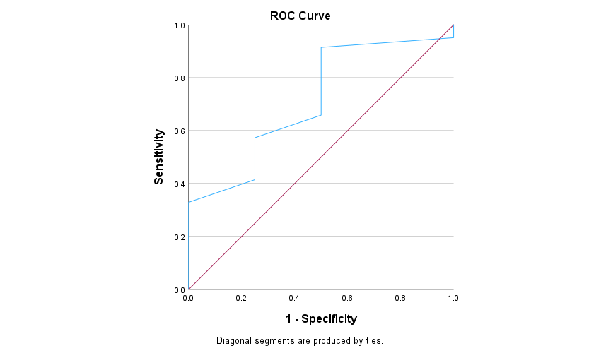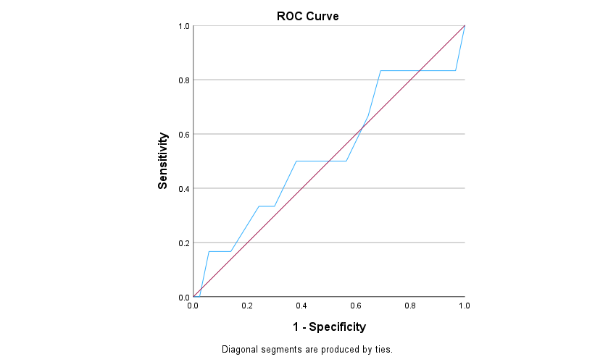

**A**

**B**

Supplementary Figure 1 – Receiver operating characteristic (ROC) curves for the summative clinical features score for predicting positive lichen sclerosus histology (A) and further surgical intervention (B).