**Free-Running CFD Analysis of ONRT Course-Keeping in Calm and Head Waves for Energy-Efficient RPM Control Strategies**

**Muhammed Talha Ozdenoglu[1], Stephen Turnock, and Tahsin Tezdogan**

Department of Civil, Maritime and Environmental Engineering, School of Engineering, University of Southampton, Boldrewood Innovation Campus, Building 176, SO16 7QF, U.K.

**1. Introduction**

The accurate prediction of ship manoeuvring behaviour in various sea conditions is essential for ensuring safety, energy efficiency, and design optimisation, especially for advanced naval hull forms such as the Office of Naval Research Tumblehome (ONRT) surface combatant. In response to evolving demands in naval hydrodynamics and control technologies, computational fluid dynamics (CFD) simulations have become an indispensable tool, offering high-fidelity insights into complex fluid–structure interactions and propulsion dynamics.

This study presents an initial step in a broader research effort aimed at developing and validating energy-efficient propulsion control strategies. Herein, we focus on two ONRT benchmark scenarios involving free-running self-propelled simulations: one in calm water and the other in regular head waves. Both utilize a rudder-based autopilot controller for course keeping and a fixed RPM twin-propeller setup to mirror experimental conditions. These cases serve as numerical baselines, allowing future comparisons with advanced adaptive control frameworks that aim to reduce energy consumption in waves by regulating the propeller RPM in real-time.

**Literature review:**

The use of CFD for predicting ship manoeuvring and course-keeping performance has seen increasing application, particularly for benchmark hulls such as the ONRT surface combatant. Araki et al. (2023) highlighted the value of free-running simulations in evaluating side force and yaw dynamics under realistic conditions. Durasević et al. (2024) further demonstrated improved agreement with experiments by employing a partially rotating grid (P method) over traditional actuator disc models.

Rudder control strategies, typically based on PID-type autopilots, have been commonly implemented for heading stabilization in CFD-based simulations. Zhang et al. (2024) applied such methods on ONRT with a stern flap to enhance efficiency in resonance waves, while Kim et al. (2021) captured 6DOF motions using overset grid approaches. Though full manoeuvring scenarios such as zig-zag and turning circles have been studied (e.g., Shang et al., 2021), limited work has focused on steady course-keeping in waves as a foundation for propulsion control development.

The accuracy of propeller modelling also plays a key role in such simulations. While body-force actuator disc methods remain efficient (Jin et al., 2019), discretized models more accurately capture stern flow effects (Aram & Mucha, 2023). Wang et al. (2018) compared actuator disk and discretized propeller models in ONRT manoeuvring simulations under wave conditions, showing that the discretized model provided more accurate predictions of yaw response and added resistance. They also implemented a heading control scheme, highlighting the importance of accurate propulsion modelling for realistic manoeuvring behaviour. In this study, a discretized propeller model is similarly used to better capture stern flow effects.

In parallel, modern control theory has underscored the importance of adapting to environmental disturbances and system uncertainty. Xu et al. (2021) proposed an adaptive controller capable of handling model variability, and Fossen & Lekkas (2016) reviewed advanced observer-based and allocation strategies for marine craft positioning. These approaches suggest a shift toward more responsive control systems in complex seaways.

Despite these developments, there remains a gap in systematically validating ONRT behaviour under fixed RPM and autopilot rudder control in both calm and wave conditions. This study addresses that gap, providing a validated numerical baseline for future research into energy-efficient propulsion strategies.

**2. Methodology**

The present study investigates the course-keeping performance of the ONR Tumblehome (ONRT) model using free-running CFD simulations in calm water and regular head waves. An autopilot rudder controller and fixed RPM twin-propeller setup are applied to replicate conditions from the upcoming ONRT benchmark cases of the Wageningen Workshop (2025). Validation is supported by experimental free-running tests previously conducted at IIHR and reported by Sanada et al. (2013), which provide reference trajectories and performance metrics.

These simulations were conducted as part of a larger research project that aims to develop energy-efficient propulsion strategies through the implementation of advanced RPM controllers. The current work serves as a validated numerical foundation for future comparisons, by establishing the hydrodynamic performance of the ONRT model under standard conditions using fixed control inputs.

To ensure physical realism, six degrees of freedom (6DOF) were enabled using a dynamic fluid–body interaction (DFBI) approach, allowing the hull to respond freely in surge, sway, heave, roll, pitch, and yaw. The computational fluid domain was carefully designed to allow accurate wave propagation and minimize reflections, and the mesh was refined around the free surface and hull appendages.

**2.1. CFD Simulation Setup**

The simulations were performed using a Reynolds-Averaged Navier–Stokes (RANS)-based solver with a volume-of-fluid (VOF) free surface approach and the SST k-ω turbulence model. All simulations followed the International Towing Tank Conference (ITTC) best practices and prior validation strategies from recent ONRT studies. Key setup parameters are presented in Table 1 below:

Table 1: Simulation Setups

| **Parameter** | **Case 1.0: Calm Water** | **Case 1.1: Head Waves** |
| --- | --- | --- |
| **Scale** | 1/48.935 | 1/48.935 |
| **Froude Number** | 0.20 | 0.20 |
| **Advance Velocity (m/s)** | 1.11 | 1.11 |
| **Wave Parameters** | - | λ/L = 1.0, H/λ = 0.02 |
| **Wave Frequency (Hz)** | - | 0.7 |
| **Rudder Control** | Autopilot (Kp = 1.0) | Autopilot (Kp = 1.0) |
| **Degrees of Freedom** | 6 DOF | 6 DOF |
| **Solver** | RANS (STAR-CCM+) | RANS (STAR-CCM+) |
| **Turbulence Model** | SST k-ω | SST k-ω |
| **Free Surface Method** | VOF | VOF |
| **y+ Range** | <100 | <100 |

*Note: λ = incident wavelength; H = wave height; L = model waterline length; Kp = proportional gain in rudder control law; DOF = degrees of freedom.*

**2.2. Control Logic and Propeller Modelling**

The rudder angle was determined at each time step using a proportional heading controller of the form:

δ(t)=Kp​⋅(ψC​−ψ(t)) (1)

with a gain Kp​=1.0 and a desired heading angle ψC=0∘. This simple autopilot was sufficient to stabilize yaw deviations in both calm and wave conditions.

The controller continuously corrected the heading error by applying proportional rudder commands, enabling the ship to maintain its desired course without overshoot or instability.

**2.3. Simulation Cases**

Two validation cases matrix were completed using a CFD setup with 6DOF motion, fixed RPM propulsion, and a proportional rudder autopilot:

Case 1.0 – Calm Water Self-Propelled Free Running

* Twin propellers operated at constant RPM derived from self-propulsion convergence.
* Rudder controlled by proportional autopilot (heading controller).
* Evaluated parameters include yaw rate, heading error, and rudder activity.

Case 1.1 – Regular Head Waves Free Running Course keeping

* Regular waves generated with λ/L = 1.0 and H/λ = 0.02
* Wave frequency f = 0.7 Hz
* Rudder autopilot-maintained heading in presence of wave-induced yawing
* Propeller RPM fixed as in calm water case to assess added power demand

These cases serve as baseline assessments before implementing the proposed advanced RPM control strategy in future simulations. Upcoming work will incorporate phase-aware control and energy minimisation frameworks under different wave conditions. The principal dimensions and mass properties of the ONRT model used in these simulations are listed in Table 2, based on data reported in Sanada et al. (2013).

Table 2: Model particulars. Adapted from Sanada et al. (2019).

|  |  |  |  |
| --- | --- | --- | --- |
| Parameters | Symbol | Model Values (scale 1:48.935) | Unit |
| Length of waterline | Lwl | 3.147 | m |
| Waterline beam | Bwl | 0.384 | m |
| Draft | T | 0.112 | m |
| Displacement Volume (fully appended) | ∇ | 0.07314 | m3 |
| Displacement Mass (fully appended) | **∆** | 72.6 | kg |
| Longitudinal centre of buoyancy (aft of FP) | LCB | 1.625 | m |
| Vertical center of gravity | VCG | 0.156 | m |
| Propeller Diameter | D | 0.1066 | m |
| Number of blades | Z | 4 | - |
| Propeller shaft angle | 𝜀 | 5 | ° |

**3. Results & Discussions**

The current study presents initial CFD results of free-running ONRT simulations under fixed RPM and autopilot-controlled rudder conditions. These results serve as a benchmark foundation for a broader research project focused on the development and evaluation of advanced RPM control strategies in wave environments. The aim is not only to validate the simulation methodology against known behaviours but also to establish meaningful performance indicators for subsequent controller comparisons.

**3.1. Calm Water Self-Propelled Simulation (Case 1.0)**

Figure 1 illustrates the yaw rate, heading error, and rudder angle history for the calm water simulation. The ONRT model maintains a stable trajectory with a small and consistent yaw rate near zero. The heading error remains within a tight band throughout the run, indicating successful convergence to the desired heading angle using the proportional rudder controller.

The rudder angle fluctuates minimally, generally staying below ±1°, which validate the autopilot’s ability to maintain heading with minimal control effort. These low control inputs and motion disturbances provide a reliable reference baseline against which wave condition performance can later be compared. Furthermore, the steady rudder usage and negligible yaw oscillations highlight a well-balanced propulsive and hydrodynamic setup under nominal conditions.

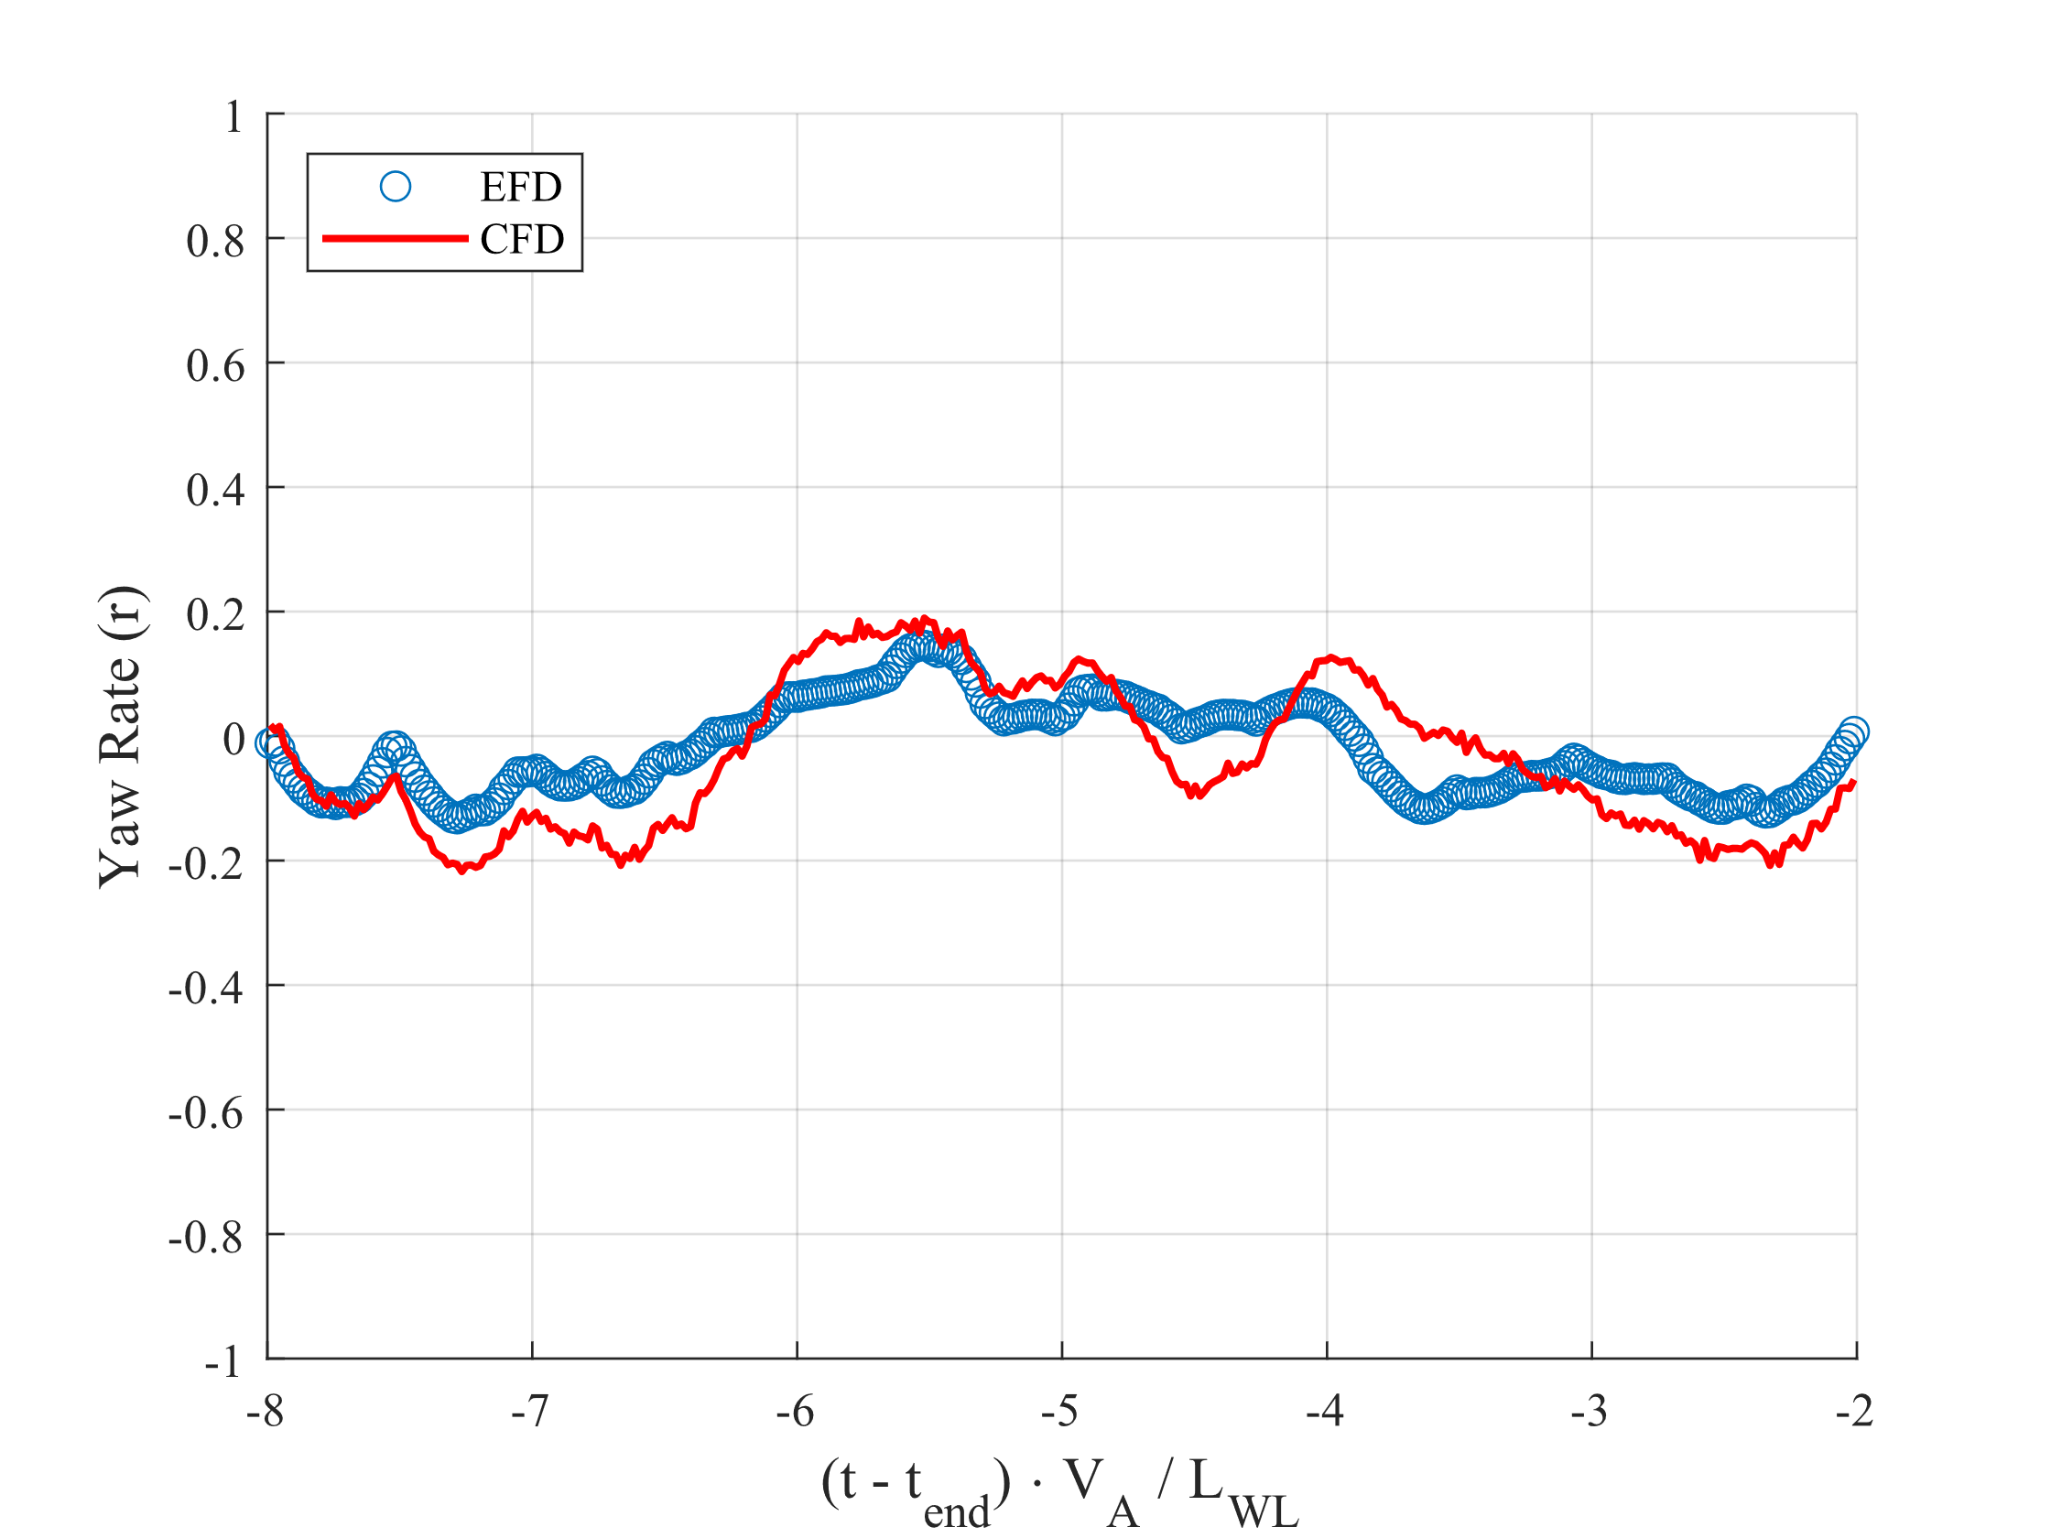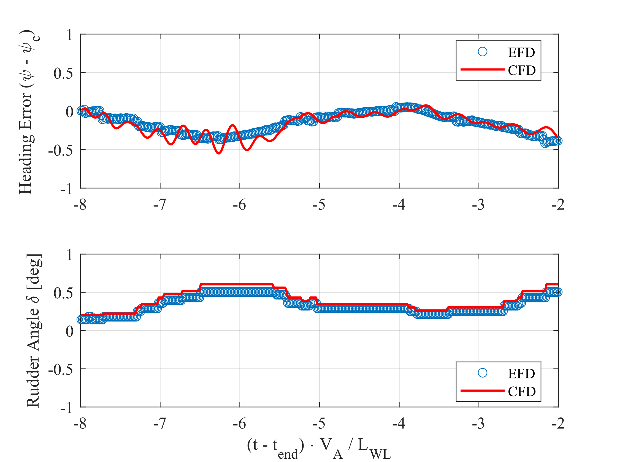

Figure1: Yaw rate, heading error, and rudder angle in calm water (Case 1.0). CFD and EFD results show consistent heading control with low rudder effort. EFD data adapted from Sanada et al. (2013).

**3.2. Head Wave Course-Keeping Simulation (Case 1.1)**

In contrast, Figure 2 shows the same control and motion variables for the head wave simulation. The added unsteadiness introduced by regular waves (λ/L = 1.0, H/λ = 0.02, f = 0.7 Hz) results in more dynamic yaw behaviour. The yaw rate plot shows periodic variations that align with wave encounters and heading error values exhibit a slight drift before stabilizing.

The rudder deflection increases modestly to maintain course, reaching levels of around ±1°, with clear wave-induced fluctuations. These elevated and more variable rudder demands reflect the additional control effort required in seaway conditions, even with the same fixed RPM setting used in calm water.

While the course-keeping remains within acceptable limits, the lack of propulsion adaptation (i.e., fixed RPM) likely contributes to increased energy consumption due to continuous corrective steering. These findings further reinforce the necessity of introducing an advanced RPM control strategy that can dynamically respond to wave-induced resistance and steering loads.

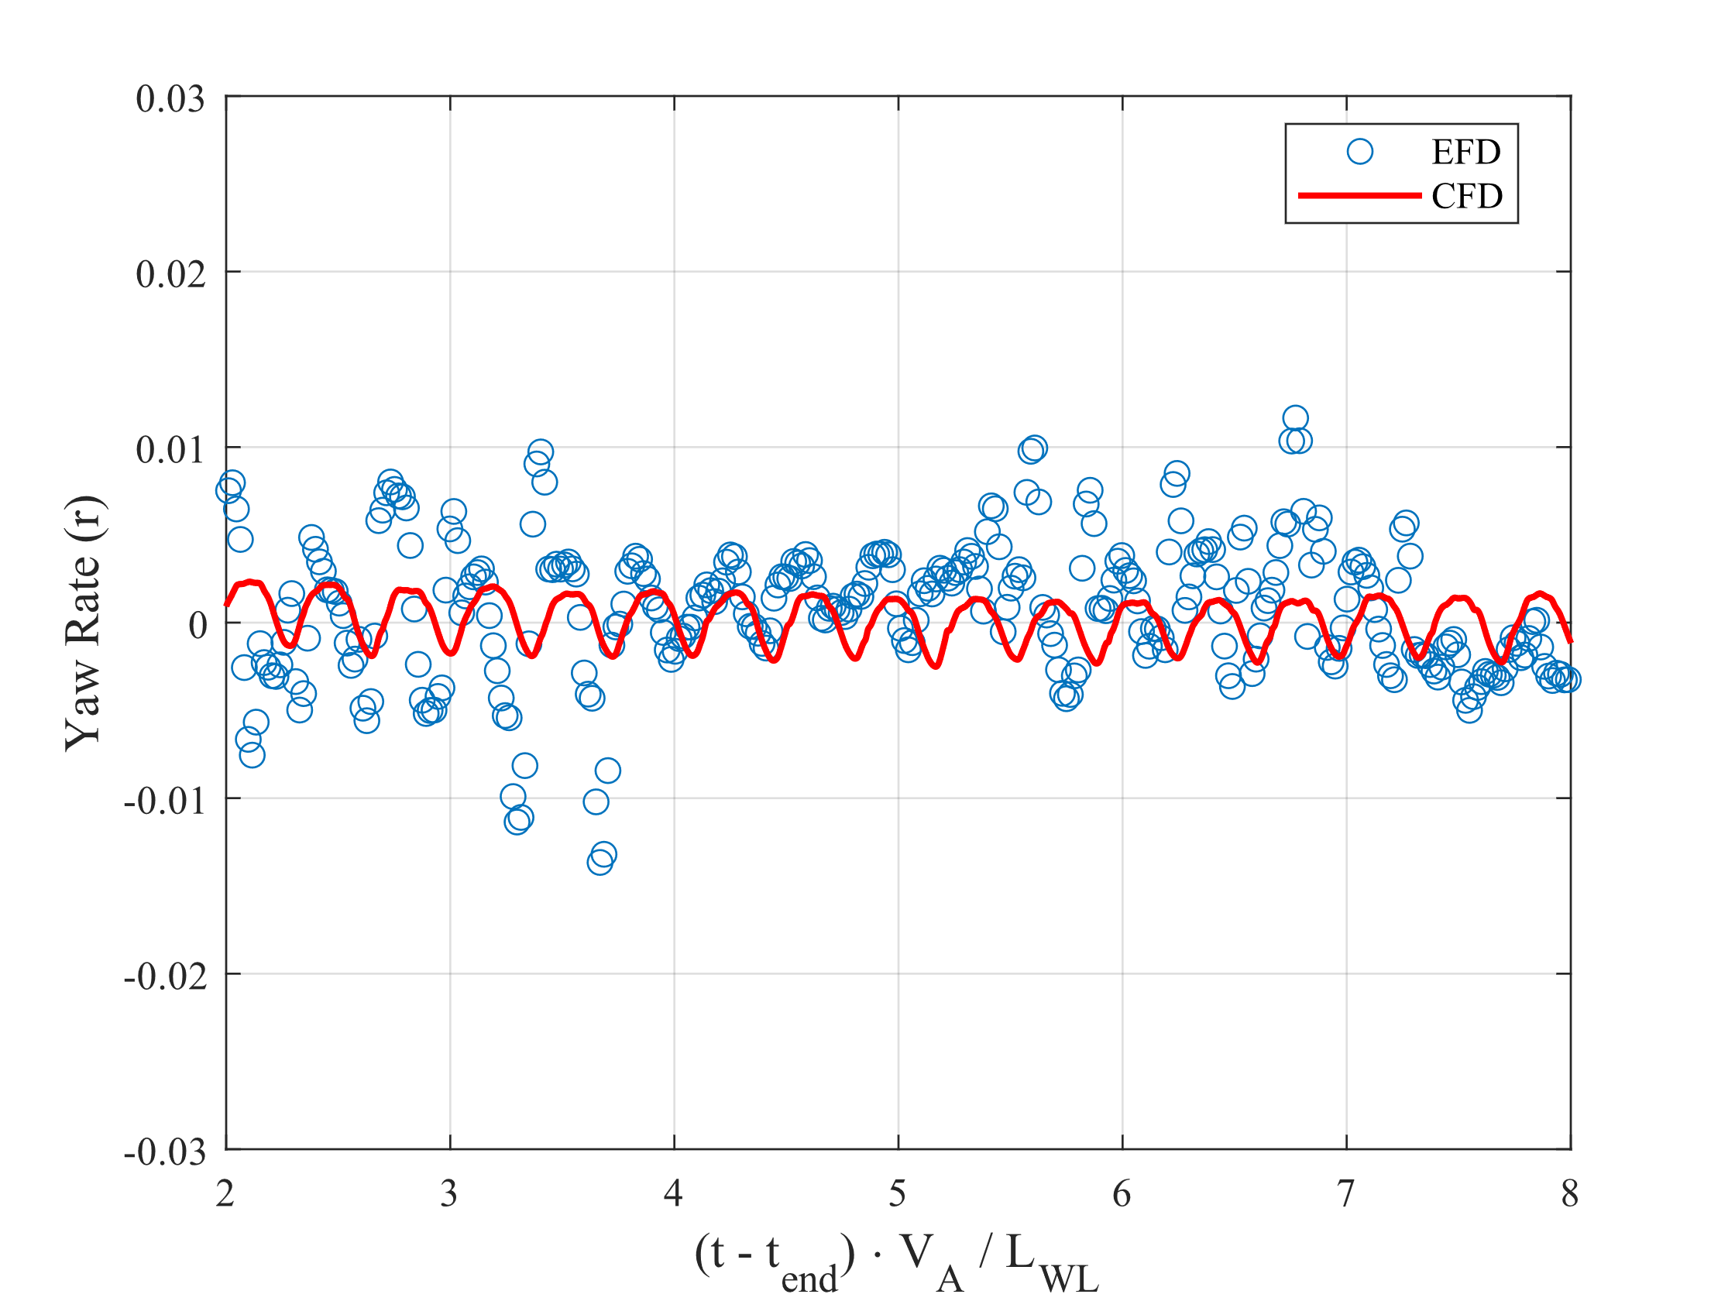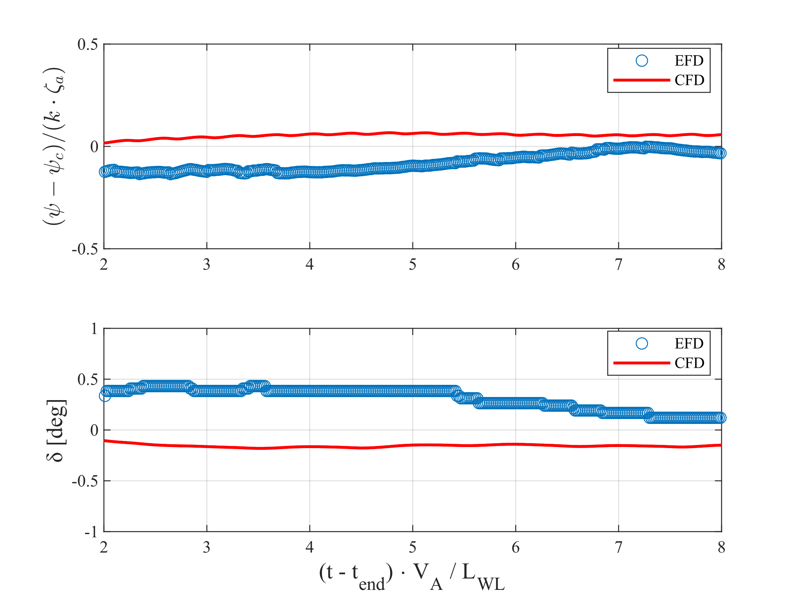

Figure 2: Yaw rate, heading error, and rudder angle in head waves (Case 1.1). CFD captures rudder activity and yaw oscillations. EFD data adapted from Sanada et al. (2013 and 2019).

The results presented here establish the viability of the current setup for benchmarking control and energy metrics, forming the foundation for the next phase of the project involving the design and testing of advanced, wave-responsive RPM controllers.

**4. Conclusions and Future Work**

This study presents the results of free-running CFD simulations of the ONRT surface combatant in calm water and regular head wave conditions using a fixed RPM twin-propeller configuration and a proportional rudder autopilot controller. The simulations accurately reproduce stable course-keeping in calm water and demonstrate realistic motion and heading compensation in waves.

These validated results provide a crucial numerical baseline for ongoing work toward implementing advanced RPM control strategies aimed at reducing propulsion energy demand in seaways. Future work will include:

* Integration of wave-phase-aware RPM control algorithms.
* Evaluation under stern quartering and oblique waves.
* Comparison with experimental energy consumption trends.
* Application of irregular sea states (e.g., JONSWAP) and voyage optimisation metrics.

Ultimately, this research aims to develop robust control architectures that enhance the autonomy and energy efficiency of surface combatants operating in realistic environments.

**4.1 Limitations**

The current study is limited to:

* Fixed RPM propulsion: The simulations use a constant revolution rate derived from calm water self-propulsion results. It does not capture potential improvements from dynamic RPM control in waves.
* Simplified rudder control: The autopilot logic is based on a proportional heading controller (P-control only), which does not adapt to varying sea states or heading dynamics.
* Limited wave scenarios: Only regular head waves (Case 1.1) have been simulated. The other regular wave conditions and irregular seaways (e.g., JONSWAP) are not yet included.

**4.2 Recommendations**

* Implementing an advanced RPM control strategy: Introduce a dynamic propulsion controller capable of adjusting revolutions based on wave phase, added resistance, or feedback from power demand trends such as phase-aware PID or Model Predictive Control (MPC), depending on the complexity of the sea-state response.
* Incorporate actuator dynamics and saturation limits: This will better replicate real-world rudder and propulsion system behaviours, particularly under high-frequency wave excitation.
* Extend to irregular wave conditions: Future simulations should consider irregular sea spectra such as JONSWAP or ITTC-defined long-crested seas to evaluate controller robustness.
* Evaluate energy efficiency metrics: Establish performance indicators such as fuel-equivalent energy consumption, RMS yaw error, or added resistance-to-thrust ratio to quantify control benefits.

These directions will strengthen the relevance of the proposed control system and contribute to practical implementation scenarios for Maritime Autonomous Surface Ships (MASS) or future naval platforms.

**5. Acknowledgements**

This work was supported by the University of Southampton’s high-performance computing resources, including the IRIDIS 5 and 6 cluster, and the hydrodynamic research infrastructure at the Faculty of Engineering and Physical Sciences. The authors gratefully acknowledge the Iowa Institute of Hydraulic Research (IIHR) for providing experimental data for the validation phase of this study.

**6. References**

Araki, Y., Ohmori, T., & Hino, T. (2023). Evaluation of manoeuvring hydrodynamic forces and course stability using CFD. *Journal of Marine Science and Engineering*, *11*(7), 1180.

Aram, A., & Mucha, P. (2023). A comparative CFD study of propeller models for naval ships under manoeuvring conditions. *Marine Systems & Ocean Technology*, *18*(2), 145–154.

Ðurasević, S., Gatin, I., & Jasak, H. (2024). Numerical simulations of the ONRT ship manoeuvring in calm water and head waves with the partially rotating grid method. *Ocean Engineering*, *312*, 119056.

Fossen, T. I., & Lekkas, A. M. (2016). A survey of dynamic positioning control systems. *Annual Reviews in Control*, 42, 129–151.

Jin, Y., Kim, S., & Kim, W. (2019). A comparison of propeller modelling methods for self-propelled manoeuvring simulations. *Applied Ocean Research*, *86*, 101927.

Kim, Y., Park, H., & Kwon, S. (2021c). CFD-based prediction of manoeuvring characteristics in waves for twin-screw vessels. *Ocean Engineering*, *235*, 109384.

Sanada, Y., Tanimoto, K., Takagi, K., Toda, Y., Stern, F. (2013), Trajectories and Local Flow Field Measurements around ONR Tumblehome in Manoeuvring Motion, *Ocean Engineering*, Vol. 72, pp. 45-65.

Sanada, Y., Elshiekh, H., Toda, Y. and Stern, F., “ONR Tumblehome course keeping and manoeuvring in calm water and waves,” J Mar Sci Technol., Vol. 24, 2019, pp. 948-967.

Wageningen Workshop. (2025). *ONRT Free-Running Benchmark Test Cases*. To be presented at the Workshop, Wageningen, The Netherlands, November 17–19, 2025.

Wang, J., & Wan, D. (2018). Numerical simulation of ONRT manoeuvring in oblique and head waves using body force and discretized propeller models. *Journal of Hydrodynamics*, *30*(4), 634–644.

Xu, H., Jiang, Y., & He, R. (2021). Adaptive control for autonomous ships with uncertain model and unknown parameters. *Ocean Engineering*, 239, 109822.

Zhang, L., Du, C., Ni, Y., Shang, Y., & Zhang, J. (2024). Mechanism of speed loss reduction and propulsion efficiency improvement of ONR Tumblehome with active-controlled stern flaps in resonance waves. *Journal of Marine Science and Engineering*, *12*(5), 822.

1. Corresponding author.

   *E-mail address:* M.T.Ozdenoglu@soton.ac.uk