Understanding the new-to-old interfacial bonding mechanism of geopolymer for concrete repair: Insight into effects of surface moisture of substrate

Guiyan Xiong ^{a,b}, Xiaolu Guo ^{a, *}, Andrew Cundy ^{c}, Fayza S. Hashem ^{d}, Min Wu ^{e}
ª Key Laboratory of Advanced Civil Engineering Materials of Ministry of Education, School of Materials Science and Engineering, Tongji University, Shanghai 201804, China;
^{b} School of Civil and Environmental Engineering, Changsha University of Science & Technology, Changsha 410114, China;
^{c} GAU-Radioanalytical, School of Ocean and Earth Science, University of Southampton, National Oceanography Centre (Southampton), Southampton, UK
^{d} Chemistry Department, Faculty of Science, Ain Shams University, Cairo, Egypt
^{e} Department of Civil and Architectural Engineering, Aarhus University, Aarhus C, 8000, Denmark

* Corresponding author
^{a, *}Dr and Professor, Xiaolu Guo
School of Materials Science and Engineering, Tongji University,
4800 Caoan Road, Shanghai 201804, PR China.
Email address: guoxiaolu@tongji.edu.cn (X.L. Guo),
Phone: (86) 21-69582144.

Abstract
Geopolymer, a waste-based material with excellent thermal, mechanical, or chemical properties and low embodied carbon, can serve as an effective repair material for structural rehabilitation. In this work, three kinds of cementitious substrates with varying surface moisture conditions were prepared before applying fresh geopolymer repair material, i.e., dry (C-D), ambient (C-A) and saturated (C-S). Interfacial flexural-tensile strength, direct tensile strength and slant shear strength were tested to evaluate the interfacial bonding strength of the geopolymer-cement composites, and the bonding mechanism was revealed through X-ray Diffraction (XRD) and Back Scattered Electron (BSE)-Energy Dispersive Spectrometer (EDS) methods. Interfacial bonding strength results indicate that having a dry substrate surface is disadvantageous for relatively long-term bonding performance. The interfacial product was found to be geopolymer gel from XRD and EDS analysis, with the Ca content of the interfacial products increasing with a rise in surface moisture. The “Overlay transition zone (OTZ)” was defined based on the wall effect of unreacted particles packing of repairing material, and its thickness was found to be ca. 30 µm. The OTZ thickness of samples with an initially dry concrete surface was greater than that with ambient moisture and water-saturated samples, and there were more unreacted particles within its OTZ. Finally, the complex effects of varying surface moisture were explained by the integrated analysis of interfacial products and microstructures.
Keywords: Geopolymer; New-to-old interface; Overlay Transition Zone (OTZ); Surface moisture; Bonding mechanism

1.Introduction
As concrete remains the predominant construction material globally, the demand for repairing and rehabilitating existing concrete structures is growing, particularly as built infrastructure ages [1]. In the USA alone, over 60,000 bridges are structurally deficient, while in China, the number exceeds 80,000 [2]. Moreover, in China, the numbers of new buildings and urban pavement infrastructure are still rapidly increasing, meaning the need for rehabilitation will even further grow. At present, the most used construction and repairing material is Portland cement-based cementitious material. However, approximately 7% of global carbon dioxide (CO₂) emissions are attributed to the cement production industry, with each ton of cement manufacturing generating approximately 650-920 kg of CO₂ [3,4]. Therefore, to support net-zero strategies, there is an urgent need to develop alternative cost-effective, eco-friendly and efficient concrete repair materials. Geopolymer is a low-embodied carbon “green” cementitious material, which can be produced by alkali-activation of an aluminosilicate raw material, enabling significantly reduced CO₂ emissions [5]. Geopolymer materials have been shown to exhibit high bonding strength [6], high early strength [7], and excellent durability [8,9], and are promising materials for concrete repair [10,11].
An important issue for the effective application of materials for concrete repair is to understand the nature of the new-to-old interface between the repair material and concrete substrate. For repaired structures, due to the different properties of the repair material and the substrate, especially under varying stress and strain conditions, the new-to-old interface is usually regarded as the weakest link [12]. The transition zone between the substrate and repairing material is defined as the “Overlay Transition Zone (OTZ)”, and is generally believed to be similar to the transition zone between aggregate and cement paste in cementitious materials [13]. For example, Beushausen et al. [14] defined the OTZ based on changes in paste content and aggregate content in overlay, similar to the wall effect between cement pastes and aggregates, and found that the thickness of the OTZ was approximately 100 μm.
Surface treatment is a key factor, alongside the physical and chemical/ mineralogical properties of repair materials and curing conditions, that affect bonding strength between the old substrate and the new repair material [15–17]. It is widely accepted that higher surface roughness generally enhances bond strength [18–20]. A roughened surface can increase the specific surface area of the old concrete substrate, enhance mechanical interlocking between the old and new surfaces, and improve the bond strength or adhesion between the materials [21]. However, generation of excessive roughness may weaken the surface zone; therefore, there should be an optimal limit for surface roughness [22]. In addition to surface roughness, the surface moisture of the substrate can play a potentially important role in interfacial bonding, as water transfer from the repair material to the substrate depends on the moisture condition of the interface, influenced by the moisture imbalance between the two layers [23]. The control of surface moisture on interfacial bonding is not well-constrained however, and there is still controversy over whether improved bonding performance is exhibited with dry surfaces or wet surfaces of the substrates. For example, Varga et al. [24] found that when additional moisture was supplied to the substrate surface, increased bond strength was observed, as providing extra moisture at the substrate interface resulted in increased formation of hydration products, enhancing the densification of the grout-concrete interface and thereby boosting tensile bond strength [25]. Despite the positive effect on interfacial hydration products with wet surface, however, the effect of surface moisture on bonding strength varied depending on the testing method [1]. Samples with a wet substrate exhibited higher bonding strength compared to dry substrates in pull-off tests, but that the opposite results were observed in slant shear tests. In addition, Farzad et al.[26] found that in slant shear tests, when normal strength concrete was used as repairing material, samples showed higher ultimate stress values in wet conditions compared to dry surfaces. Conversely, when ultra high performance concrete (UHPC) was used for repairing, slightly higher bond strength was observed on dry substrates than on wet ones. Therefore, clarifying the effect of substrate surface moisture on the bonding performance needs to consider both the types of repairing materials, and also the testing methods used to determine bonding performance.
Further, while OTZ reaction products (including C-S-H, C-A-S-H and N-A-S-H gels) and their role in enhancing bonding strength between geopolymer and concrete substrates were examined preliminarily [27,28], only a limited number of studies have examined the impact of surface moisture of substrate on reaction products at the new-to-old interface and on the microstructures of the OTZ and tried to explain the varying bonding strength from the insight of the microstructures and products at the new-to-old interface, despite the importance of these features for promoting resistance and durability in repaired composites [21]. Xue et al. [29] used X-Ray Computed Tomography (CT) method to observe the new-to-old interface. They found that with a pre-dried substrate, significant shrinkage cracking occurred in the repaired composites from CT images, while with a water-saturated substrate, a large and discontinuous void region at the interface was observed, reducing the bonding strength. Beushausen et al. [14] indicated that higher surface moisture in the substrate led to a higher porosity and lower hydration degree in the OTZ, resulting in decreased bonding strength of the repaired composites. Igor de la et al. [24] reported that the presence of extra moisture accelerated the shape transformation of products from large (randomly-oriented) blade-shaped crystals to denser ‘equant’ crystals, thereby increasing the contact area and in turn increasing the bonding strength. It is clear therefore that both the microstructures and the interfacial products at the new-to-old interface may be significantly affected by moisture, and so it is fundamentally important to better constrain the role of surface moisture on the bonding properties and mechanisms of the OTZ in order to better prepare material substrates, and produce more durable repairs.
Accordingly, most current studies on the effects of surface moisture at the new-to-old interface have focused on Portland cement-based materials (especially UHPC), and limited studies examined the new-to-old interface when using geopolymer for concrete repair. Therefore, few studies paid attention to the effect of surface moisture on the interfacial bonding of geopolymer repair materials. Consequently, in this work, substrates with differing surface moisture contents (dry, ambient, saturated) were prepared, and then the bonding properties of geopolymer-cement composites were measured by interfacial flexural-tensile strength, direct tensile strength, and slant shear strength. Then, the interfacial products were characterized by their X-ray diffraction (XRD) patterns, and Back Scattered Electron (BSE)-Energy Dispersive Spectrometer (EDS) analysis. In addition to BSE analysis of mortar samples, the BSE images of paste samples were also analyzed in detail to further determine constituents (unreacted particles, hardened pastes, and pores), avoiding the effect of aggregates. Finally, the effects of surface moisture on the interfacial products between the geopolymer and the substrate, as well as on the bonding mechanism of the geopolymer repairing material, were assessed.

2.Materials and methods
The chemical compositions of the fly ash (FA) and slag powder (Slag) used here are shown in Table 1, and the mix proportion of the geopolymer repair material was the same as type “ERG-0” used in our previous study [30,31], i.e., fly ash: slag powder =7:3 (mass ratio), 10% content of alkali activator (by Na₂O mass, M=1.4), 0.36 of water-to-binder ratio and 2.5 of sand-to-binder ratio.

Table 1 Chemical compositions (by mass) of fly ash (FA) and slag powder (Slag) by XRF analysis
Compound  (wt%) | SiO₂ | Al₂O₃ | CaO | Fe₂O₃ | MgO | TiO₂ | K₂O | Na₂O
FA | 56.68 | 26.92 | 3.48 | 6.30 | 0.81 | 1.44 | 2.92 | 0.71
Slag | 32.95 | 14.46 | 44.05 | 0.61 | 5.45 | 0.73 | 0.28 | 0.32
42.5 ordinary Portland cement was used to prepare the substrates, with water-to-cement ratio of 0.4 and sand-to-cement ratio of 2.5. The curing ages of cement substrates used for preparing geopolymer-cement composites were all in excess of 28 days, to mimic real-world scenarios as closely as possible. In this work, the curing ages of substrates for repair are about 60 days.
To study the effect of surface moisture of the substrate, three types of treatments were implemented (Fig.1). For obvious comparison, extreme dry and saturated surfaces were prepared. Cement substrates with dry surfaces were prepared by placing them into an oven at 60 °C for 2 days, and saturated surfaces were prepared by immersing the cement samples into tap water for 2 days. For ambient surfaces, the cement samples were placed in an ambient environment (23 ± 2 °C and RH 55 ± 5%) after standard curing for 28 days until being applied fresh geopolymer pastes. The sample ID, i.e., C-D, C-A, C-S represented the cement substrate with dry surface (D), ambient surface (A), and saturated surface (S), respectively (see Fig.1) when applying fresh geopolymer repairing material. Prior to being repaired by geopolymer, all cement substrates were taken into the ambient environment 1 hour ahead, to allow dry samples to cool. On saturated samples, surface excess water was removed by careful wiping.
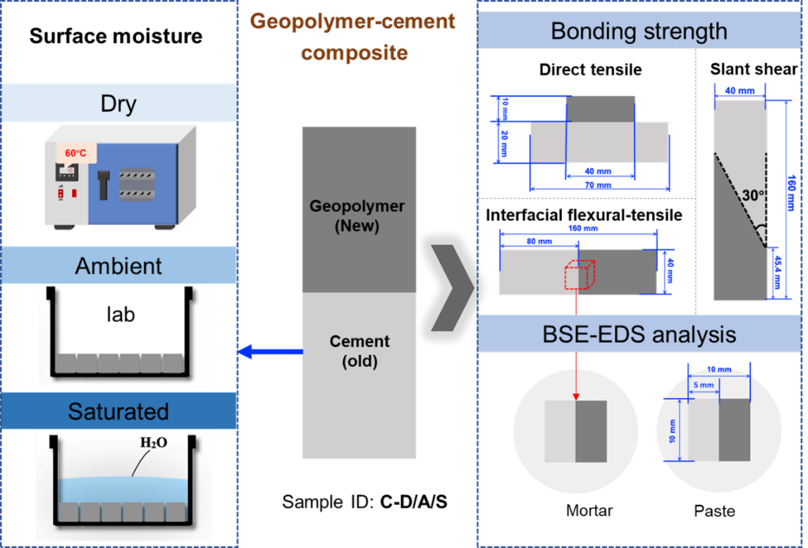

Fig.1 Experimental program of surface moisture preparation of substrates
In this work, the bonding properties of the geopolymer-cement composite were tested and determined by three testing methods shown in Fig.2.
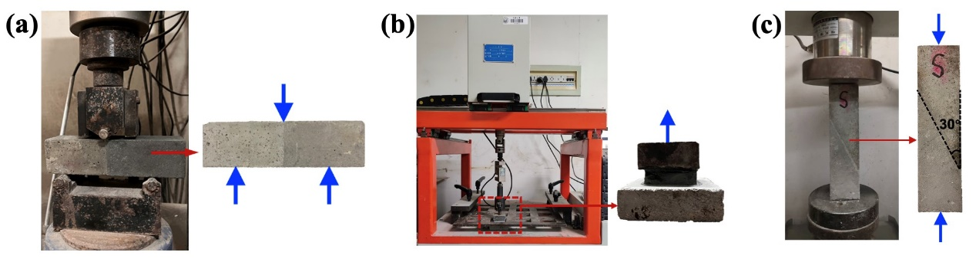

Fig.2 Testing methods of bonding strength (a) Interfacial flexural-tensile test (b) Direct tensile test (c) Slant shear test.
The interfacial flexural-tensile strength at various targeted ages (1 d, 3 d, 7 d, 28 d and 60 d) was obtained (see Fig.2(a)) according to [32]. The direct tensile strength at these targeted ages was measured (see Fig.2(b)) according to [33]. Slant shear strength (see Fig.2(c)) testing was also performed to evaluate the bond strength. The inclination (α) was set at 30°, applying a compressive force on a cross-sectional area of the sample, which subjects the interface to principal shear stress and principal compressive stress [34].Then the slant shear strength was obtained by dividing the compressive force at failure by the joint area.
The mineral compositions of the interfacial products were qualitatively analyzed by X-Ray Diffraction (XRD), and detailed information can be found in the previous study [35]. Back Scattered Electron (BSE) images of mortar and paste samples were collected using a ZEISS Sigma 300, and Energy Dispersive Spectrometer (EDS) was also used to investigate elemental composition. Sample preparation methods can also be found in our previous study [35]. Mortar samples for BSE images were removed from the samples used for interfacial flexural-tensile strength testing (see Fig.1). Paste samples for BSE images were prepared separately and the mix proportion for geopolymer and cement paste was the same as used for the mortar, except without sand addition. The curing ages of composite samples for BSE observations were all greater than 28 d.

3.Results

3.1 Bonding strength

3.1.1 Interfacial flexural-tensile strength
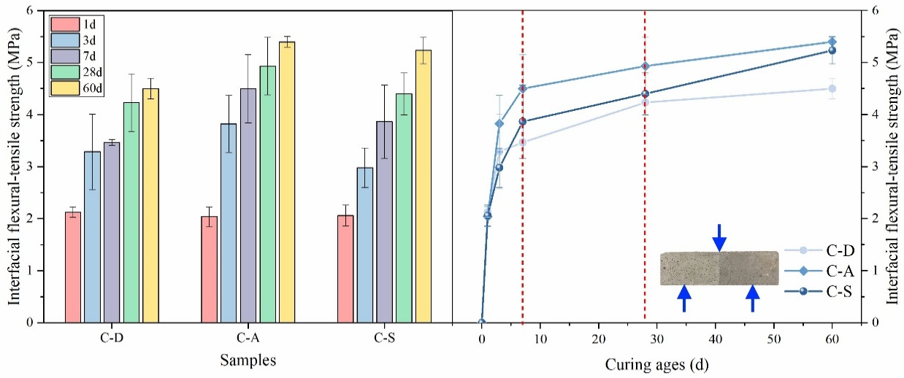

Fig.3 The interfacial flexural-tensile strength of samples
After different surface moisture treatment of the substrates, the interfacial flexural-tensile strength of the repaired composites at the targeted ages is shown in Fig.3. In order to show the influence of curing ages, the interfacial flexural-tensile strength at each age is also plotted in the right-hand figure. When loading, failure occurred along the interface. After 1 d, the surface moisture preparation had little effect on the observed interfacial flexural-tensile strengths, which were all around 2.2 MPa. From 3 d however, the interfacial flexural-tensile strengths of sample C-A were always higher than sample C-D and sample C-S. From 7 d, the interfacial flexural-tensile strengths of sample C-S and C-A were always higher than sample C-D, especially at 60 d, where the difference was particularly pronounced, indicating that a dry surface of the substrate is not advantageous for relatively long-term interfacial bonding. Further discussions and explanations are presented in Section 4 Discussions. Based on the right-hand part of Fig.3, the interface flexural-tensile strength at 7 d has already reached over 70% of that at 28 d, verifying that geopolymer is a promising fast repair material. Furthermore, the increase rates of C-A, C-D and C-S samples at later ages, i.e., from 28 d to 60 d, were 6.38%, 9.53% and 18.86%, respectively, indicating that the increasing rate of the interfacial flexural-tensile strength was higher than that of the other two systems.

3.1.2 Direct tensile strength
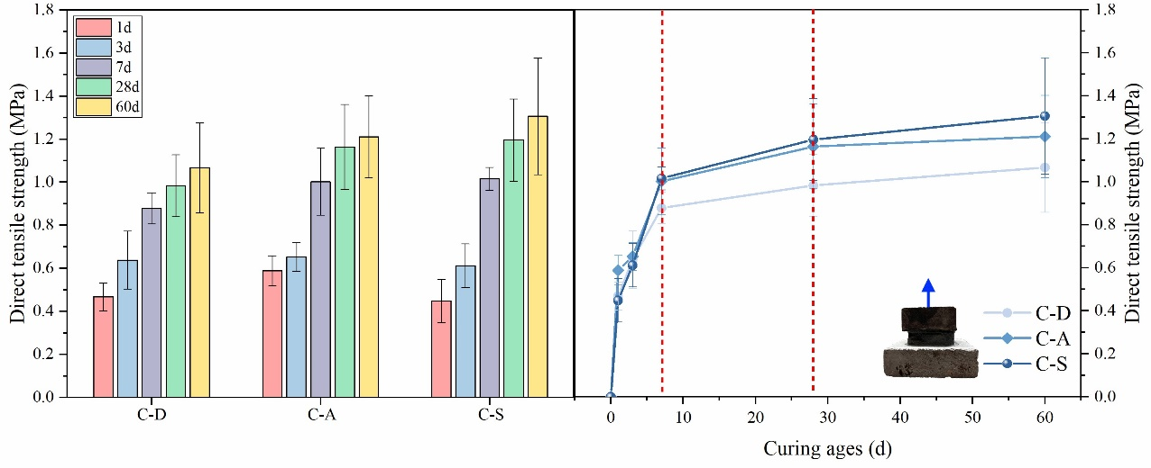

Fig.4 The direct tensile strength of samples
The direct tensile strength of composite samples with different initial surface moisture is shown in Fig.4, similarly, also plotted in the right-hand figure to show the trend with curing ages. In direct tensile tests, failure also occurred along the interface. It can be observed that after 1 d, the direct tensile strength of the sample with a dry surface (C-A) was slightly higher than that of sample C-D and sample C-S. At 3 d, the direct tensile strength of C-D, C-A, and C-S were similar, around 0.7 MPa. From 7 d, the direct tensile strength of sample C-A and sample C-S were consistently higher than sample C-D, with samples with a saturated surface (C-S) slightly higher strength than sample C-A, followed by sample C-D. Similarly, the direct tensile strength at 7 d had reached over 70% of that observed after 28d, and in later ages, the increase in strength of sample C-S was higher than for the other two systems. In terms of increasing strength rate, the direct tensile strength of the samples rapidly increases within the first 7 days and then shows slower growth after 7 days.

3.1.3 Slant shear strength
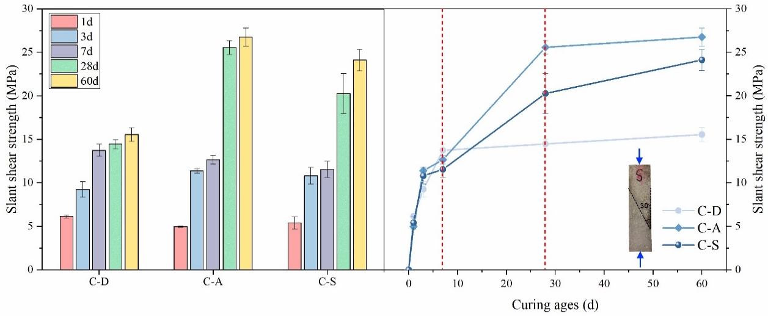

Fig.5 The slant shear strength of samples
The slant shear strength of the composites is shown in Fig.5, with the same data plotted in the right-hand figure to show the trend with curing ages. During slant shear testing, all samples initially exhibited interfacial slip, with partial matrix failure developing subsequently in some samples. After 1 d, samples had similar slant shear strengths, with sample C-D showing slightly higher strength. In the early stages of curing (e.g., 1 d, 3 d, 7 d), the slant shear strength of sample C-D remained at a relatively high level compared to the other sample types. At later stages however (e.g., 28 d, 60 d), the rate of increase in strength of sample C-D was very slow, much lower than sample C-A and sample C-S. Similarly, the rate of strength increase of C-S from 28 d to 60 d was higher than in the other two systems. In contrast to the interfacial flexural-tensile strength and direct tensile strength data, there were still obvious increases in slant shear strength after 7 d, mainly because slant shear strength is essentially a combination of compressive and shear forces. Therefore, the slant shear strength still increased significantly at later ages due to the strength increase of the geopolymer itself.
Overall, different testing methods reflect the interfacial bonding strength under different stress states. Amongst the three types of testing methods for bonding strength (i.e. different loading direction), the interfacial flexural-tensile strength reflects the bonding properties under mixed mode stresses (flexural and tensile stresses), while the direct tensile strength reflects the most direct bonding properties (only involving tensile stress), and the slant shear strength is the combination of compressive and shear forces, so it would be affected by the properties of matrix. In any cases, it can still be concluded that (based on the above bonding results) surface moisture preparation has little effect on the bonding performance at 1 d, while at later ages a dry surface is disadvantageous for later bonding performance - in particular, highest rates of strength increase between 28 d and 60 d are seen for samples with a saturated surface (C-S). Except for slant shear strength, the bonding strength at 7 d reached over 70% that at 28 d, showing great potential for rapid repair (as a high early strength material). Hani et al. [36] reached similar conclusions, reporting that geopolymer mortar can achieve 80% of its 28-day strength within 3 d. From bonding strength values, considering both early and later bonding strength, it seems that samples prepared at ambient surface moisture content exhibited better strength, i.e., no extra surface moisture treatment of the substrate. This is important as, as noted by Lukovic et al. [37], for cement based repairing material, “medium water absorption (neither impermeable nor very open capillary)” is probably the condition to be expected for most of the concretes that require repair.

3.2 Interfacial products at the new-to-old interface

3.2.1 XRD analysis
After the slant shear strength test at 28 d, distinctive mineral products with different colors were found on the interfacial surface for C-S (as shown in Fig.6(a)), with resulting XRD patterns shown in Fig.6(b)). The sample from the geopolymer mortar part (G) is mainly quartz, geopolymer gel, calcite, and monohydrocalcite, while the sample from the cement mortar part (C) is mainly quartz, C-S-H gel, calcite and portlandite. The XRD pattern of the interfacial products (I) is similar to that of the geopolymer (G), and indicate the presence of quartz, geopolymer gel, and calcite, suggesting the products at the interface are still geopolymerization products. The peak at around 30° representing geopolymer gel and calcite in the interfacial product is more obvious than that of geopolymer, although is less prominent than in the cement.
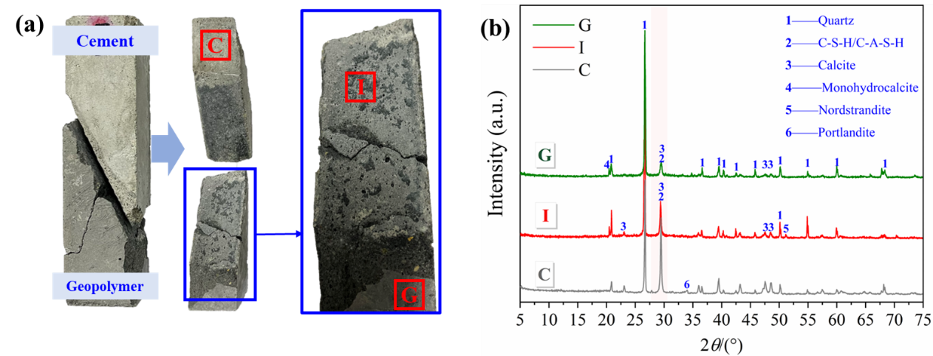

Fig.6 XRD sampling locations (a), and patterns (b) of products

3.2.2 Element distribution analysis
In order to understand the effect of surface moisture on the interfacial bonding of the geopolymer repair material on a microscopic scale, BSE images of the C-D, C-A and C-S samples were examined (Fig.7), along with elemental mapping results, showing Si (green), Ca (red), and Al (yellow) elements. EDS line analysis was also carried out to observe the compositional changes from the cement substrate to the geopolymer repairing material.
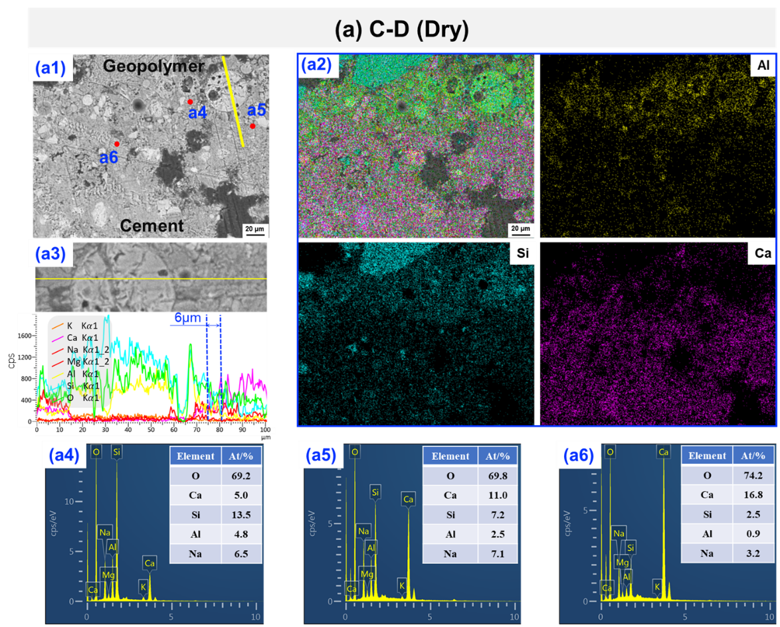
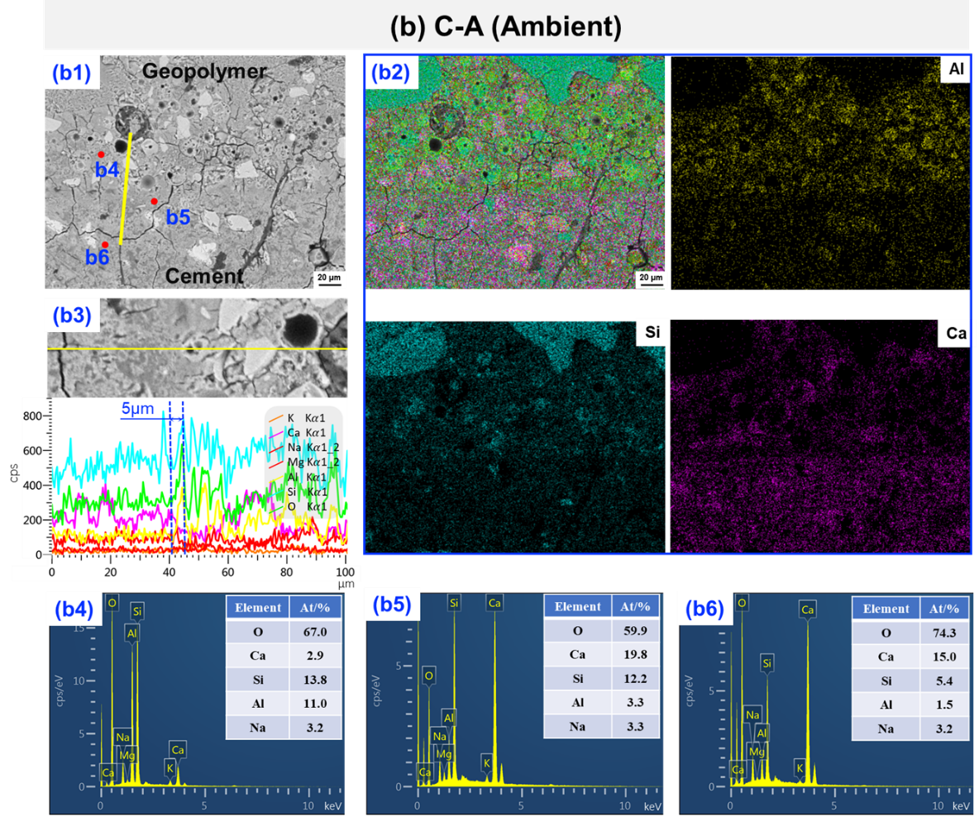
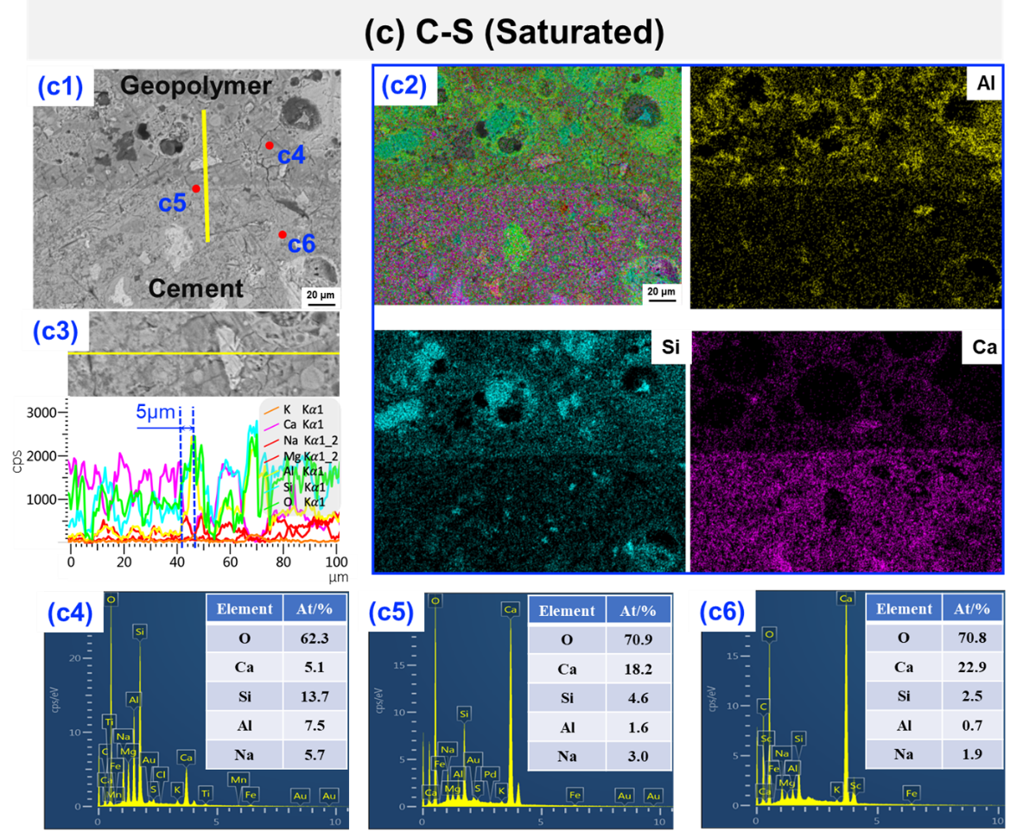

Fig.7 Typical BSE images of mortar samples with dry (C-D), ambient (C-A) and saturated (C-S) surface of initial substrates ((a) C-D; (b) C-A; (c) C-S.)
From the elemental mapping results (see Fig.7 (a2), (b2), (c2)), as expected the Si (green) and Al (yellow) content in geopolymer is higher than that of cement substrate, and the Ca (red) content in cement is higher than that in the geopolymer. Due to the significant difference in Ca content between the geopolymer and cement, the Ca element map can effectively distinguish the two materials. The boundary shown in the Ca element map of sample C-D is very indistinct, while that of sample C-S is very clear and obvious.
From line EDS results (see Fig.7 (a3), (b3), (c3)), there were gradual transitions in element composition moving from the cement substrate to the geopolymer repair material, with no sudden changes, indicating a good bond between the geopolymer and the substrate [27]. Again, due to the significant difference in Ca content between the geopolymer and cement, the thickness of the “Product Transition Layer” can be approximately determined by the changes in Ca, Si and Al content from the line spectrum analysis. Based on this method, the thickness of the product transition layer of C-D is approximately 6 µm, and for C-A and C-S, the thickness of product transition layer is around 5 µm, indicating that the surface moisture of cement had little effect on the thickness of transition zone defined by the change of Ca, Si and Al content from EDS line results. A previous study by Wang et al. [38] reported a similar method with this study. They defined the width of interfacial transition zone according to the changes of Ca/Si and Na/Ca ratios through BSE-EDS analysis, and they found that the widths of ground granulated blast-furnace slag based geopolymer and fly ash based geopolymer were found to be 7 µm and 3 µm, respectively.
From EDS point analysis results (Fig.7 (a4-a6)、(b4-b6)、(c4-c6)), regardless of the initial surface moisture of the cement substrates, the Ca content of the interfacial product (see Fig.7 (a5), (b5), (c5)) is higher than that of the geopolymer (see Fig.7 (a4), (b4), (c4)) but lower than that of the cement substrate (see Fig.7 (a6), (b6), (c6)). The effect of surface moisture on the type of interfacial products will be further discussed in Section 3.2.4.

3.2.3 Constituent distribution analysis
In order to further clarify the constituent distribution (unreacted particles, hardened pastes and pores) and avoiding the complicating effect of the presence of aggregates, the BSE images of composites of geopolymer pastes and cement pastes with different surface moisture were also observed as shown in Fig.8. Based on EDS line analysis gradual transitions of each element were also observed for paste samples, with a gradual decrease of Ca content and gradual increase of Si and Al content moving from cement to geopolymer. Similarly, for C-D, C-A, and C-S, the widths of the product transition layer defined by the change of Ca content from EDS line results were about 5 µm. It is interesting to observe that for C-S, there is a bright band of about 5 µm width at the new-to-old interface (see Fig.8 (c)), induced by high Ca content. Apart from line EDS analysis, EDS point analysis at 10 µm intervals was also performed. Three regions were divided along the line: geopolymer (G), interface (I), and cement (C). The results and analysis of these points will be further discussed in Section 3.2.4.
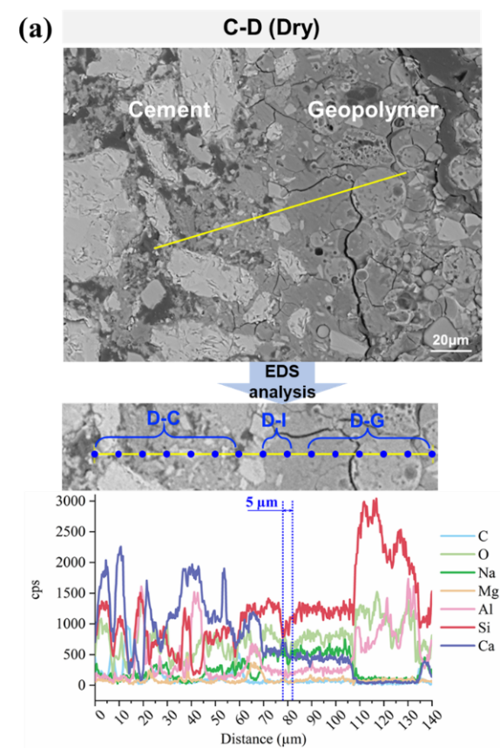 | 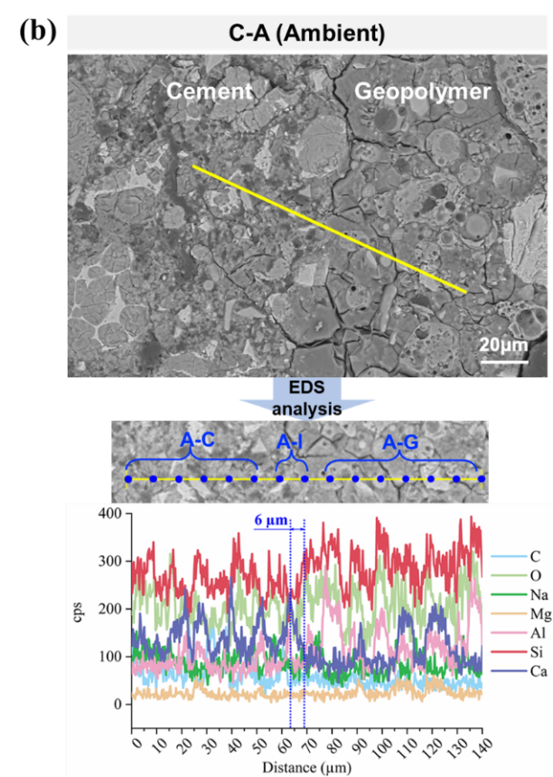
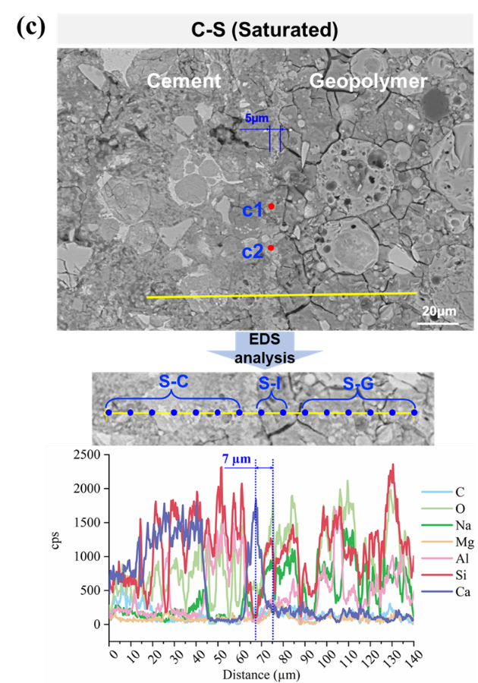

Fig.8 Typical BSE images of paste samples ((a) C-D; (b) C-A; (c) C-S.)
The distribution of constituents at every 5 µm far from the substrate surface was studied by statistical analysis of segmented BSE images. Image segmentation was performed based on various grey values and specific shapes of raw materials such as spherical fly ash and irregular slag. Yellow, red, and green colors were used to denote unreacted raw materials, pores (including cracks), and hardened pastes, respectively. Subsequently, images were divided into separate regions along the horizontal direction, with 5 µm of each region, and then the proportions of unreacted particles, hardened pastes and pores in each region were calculated as shown in Fig.9.
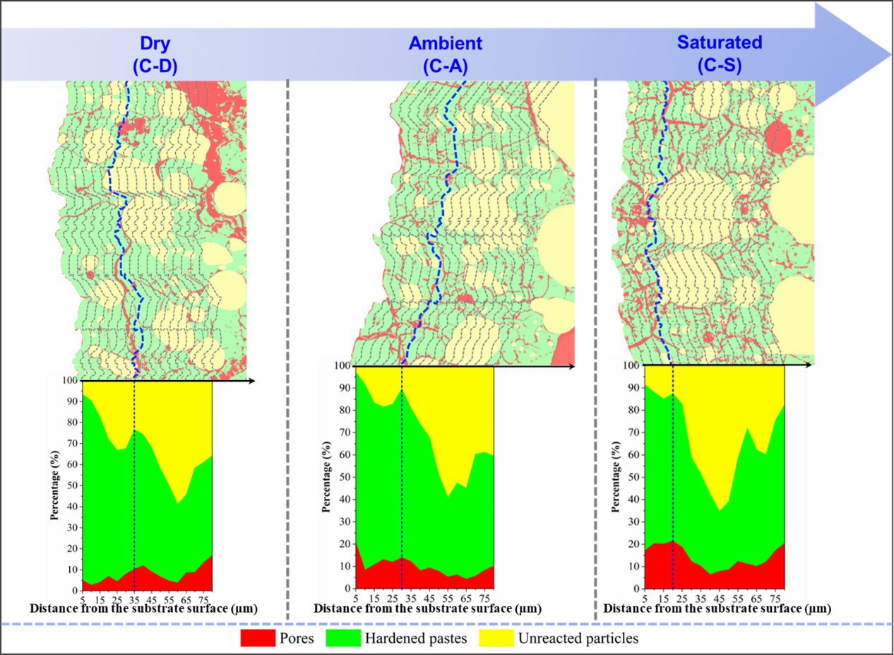

Fig.9 The effect of surface moisture on the constituent distribution at the new-to-old interface
From the constituent distribution analysis based on the image analysis method in Fig.9, the contents of unreacted raw materials are relatively low in the area near the cement substrate and then rise. From the corresponding BSE images, it can be observed that the high amount of unreacted particles mainly includes fly ash and slag with large particle size. This phenomenon may be induced by the wall effect of unreacted particles packing [39]. When Luo et al. [40] defined the thickness of the interfacial transition zone (ITZ) in fly ash based geopolymer concrete, they found that the fly ash contents started low near the aggregate and gradually increased to a stable level induced by a wall effect, and the thickness of the zone before the stable stage is around 30 µm, i.e., the thickness of ITZ is 30 µm. Similarly, in this work, the contents of unreacted particles remained at a relatively low value near to the substrate and then increased. So, if the “overlay transition zones (OTZ)” could be defined by the wall effect of unreacted particles packing, i.e., the unreacted particles content from the start to the high value, then the OTZ thickness of C-D, C-A, C-S samples are 35 µm, 30 µm and 20 µm, respectively. The value of OTZ thickness is in agreement with the thickness of the interfacial transition zone (ITZ) between fly ash based geopolymer paste and aggregate, i.e., 30 µm also determined by the wall effect [40]. Additionally, within the OTZ, the highest proportion of unreacted particles of C-D is 33%, followed by C-A and C-S, 18% and 15%, respectively. This indicates that there are more unreacted raw materials within the OTZ when there is less surface moisture in the substrate. As for the pores within the OTZ, the highest proportion of pores of C-S is 22%, followed by C-A and C-D, respectively, indicating higher porosity within the OTZ with the increase of surface moisture of substrates.

3.2.4 Ternary phase diagram analysis
In order to distinguish the phases present, Fig.10 plots a CaO–SiO₂–Al₂O₃ ternary phase diagram of the C-D, C-A and C-S geochemical data presented in Fig.7 and Fig.8, where Ca, Si, and Al contents are renormalized to 100% on the oxide basis. Following [41–43], areas and their corresponding phases are marked with dashed ovals. Since the line spectrum passes through many unreacted particles from Fig.8, such as fly ash, unhydrated cement particles, and so on, not all dots are present in the marked areas. As can be seen, the main types of geopolymer product (green dots) are C-(N)-A-S-H gel and N-A-S-H gel. It is obvious that the Ca content of the interfacial products (red markers) increased with an increase in surface moisture. The interfacial product of C-D is mainly C-(N)-A-S-H gel, the same as C-A while the Ca content of interfacial products of C-A is higher than that of C-D. The interfacial product of C-S is mainly a combination of C-(N)-A-S-H gel and probably C-S-H gel. It can be speculated that when the cement substrate was treated by immersing into water, more calcium ions leached out from the cement substrate, participating in the interfacial geopolymerization reaction. This can be confirmed by the lower calcium content in the cement products (gray markers) observed in Fig.10 (c).
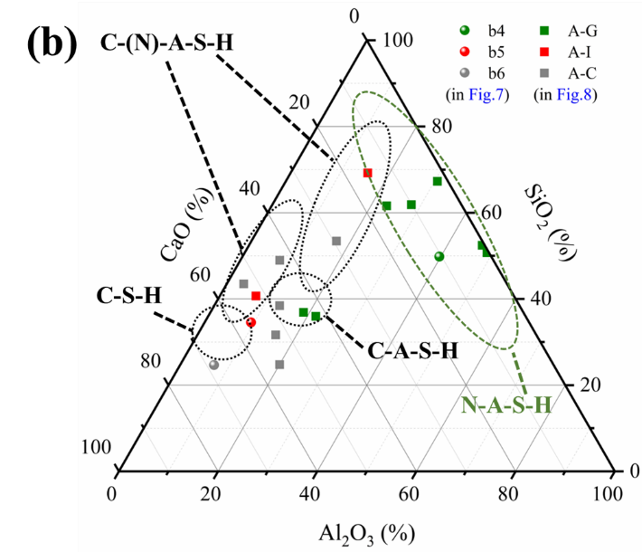
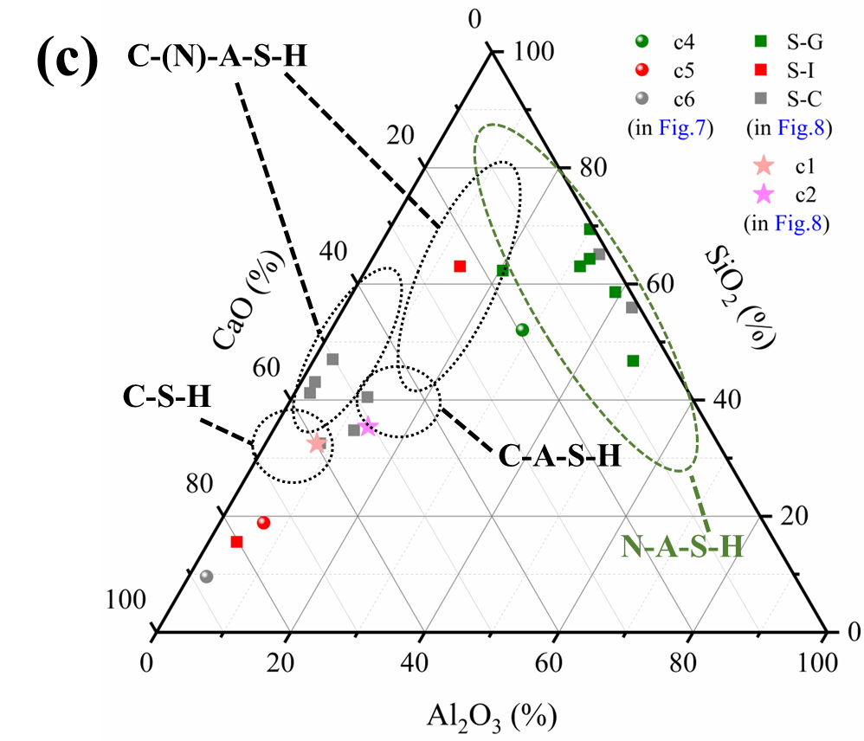

Fig. 10 The effect of surface moisture of substrate on the ternary phase diagram of interfacial products ((a) C-D; (b) C-A; (c) C-S.)

4. Discussions of the effect of surface moisture on geopolymer repairing materials
When applying fresh repair material, the condition of the existing substrate surface is critical. What happens when there are different surface moisture conditions? From a theoretical viewpoint, if the existing substrate surface is dry, it would absorb moisture from the fresh material, potentially densifying the interfacial microstructure [1]. Conversely, an extremely dry surface of substrate would result in the absorption of too much water from the fresh repairing material, leading to insufficient hydration near the interface and reduced adherence with the repairing material [15,23]. Meanwhile, if there is extra moisture at the interface, this would reduce the moisture transfer from the fresh overlay into the substrate, promoting better hydration and minimizing shrinkage induced by moisture migration [24]. However, an excess of water would impede hydrates penetration into the grooves or valleys of the interface, thereby diminishing the adherence between the overlay and the substrate [15].

4.1 Effect of testing methods on bonding performance of repairing materials
As mentioned above, when applying fresh repairing material, with a dry substrate surface, the substrate would absorb moisture from the fresh overlay material and this potential water transfer will draw in particles to fill depressions in the substrate. So, how does this particle settling effect induced by water movement affect the bonding properties? This may be distinguished by the testing method used: when the loading direction is parallel with the particle settling direction or with gravity (see Fig.11), i.e., in the interfacial flexural-tensile test or direct tensile test, the solid-solid (unhydrated) contacts resulting from particle settling would not make a contribution to the bonding, meaning that the bonding strength is primarily influenced by the amount of hydration products formed that link across the interface from the repair material to the substrate [1]. When the loading direction deviated from the settling direction, i.e., in the slant shear test, the solid-solid contacts may generate friction when resisting debonding, contributing to the bonding strength. This may explain the 1d slant shear data where the dry surface exhibited slightly higher strength than the test systems with higher surface moisture.
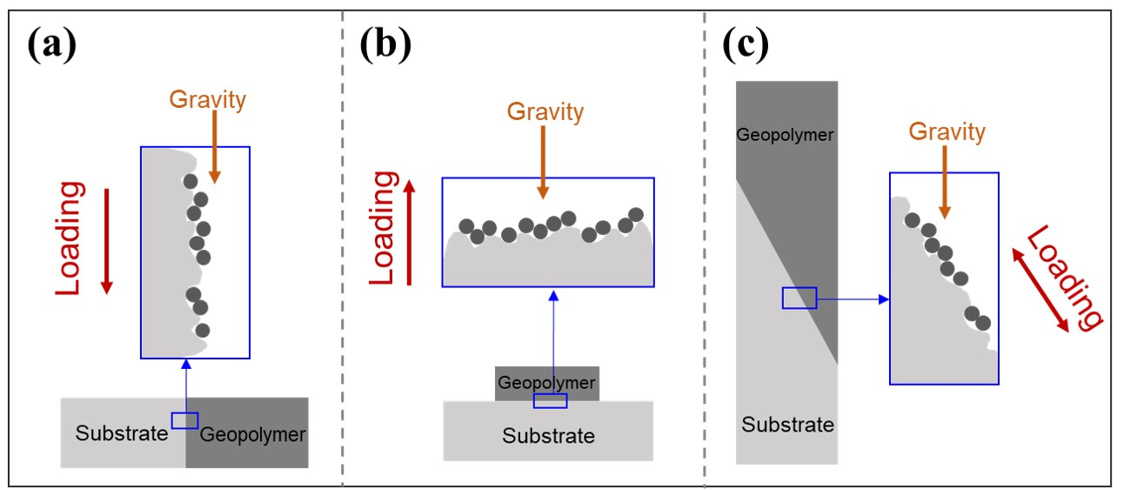

Fig.11 Schematic of the relationship between the particle settling effect and applied testing methods (The idea of densification effect is from Ref.[1])

4.2 The new-to-old interfacial bonding mechanism of geopolymer repair material
As for the bonding mechanism of the geopolymer repairing material, from previous studies [35] there are two main bonding forces, i.e., the mechanical interlocking (or frictional) force (mainly due to surface roughness) and chemical bonding force [44]. Unlike with common cement-based repair materials, there are extra chemical reactions occurring around the repairing interface when applying geopolymer based repair materials [45]. According to Section 3.2.4, the interfacial products of C-D and C-A are mainly C-(N)-A-S-H gel, and the interfacial product of C-S is mainly a combination of C-(N)-A-S-H gel and probably C-S-H gel. The increased Ca ion contents of interfacial products with increased surface moisture may provide direct evidence for the chemical reactions occurred at the new-to-old interface.

4.3 Effect of surface moisture on Overlay Transition Zone (OTZ)
As noted in Section 1, most researchers agree to the existence of an “Overlay Transition Zone (OTZ)”, although definition of this varies, with some thinking that the OTZ is similar to the interfacial transition zone (ITZ) between pastes and aggregates [13,14]. Old concrete differs from aggregate however as, for example, old concrete is more porous and chemically active than aggregate [44]. Particularly for geopolymer based repair material, chemical reactions will be induced at the OTZ, but pastes won’t react with aggregates. Therefore, in this study, the OTZ was defined according to the wall effect of unreacted particles packing. Based on this, the OTZ thickness was found to be around 30 µm and significantly affected by the substrate’s surface moisture. From Fig.9, the thickness of OTZ increased with the rise of surface moisture of substrates, and the thickness of samples with dry, ambient and saturated surface samples are 35 µm, 30 µm and 20 µm. Also, more unreacted raw materials within the OTZ are found for the sample with less surface moisture of substrate, indicating that a drier surface of substrate would lead to wider OTZ and higher content of unreacted particles within the OTZ.

4.4 Effect of surface moisture on interfacial bonding properties of geopolymer
For geopolymer based repairing material, when fresh geopolymer (new) is poured onto the cement substrate (old), the different surface moisture of the old substrate may create a potential moisture transfer across the interface due to the presence of moisture gradients. Additionally, the varying moisture can lead to different chemical reactions at the interface, resulting in different products at the interface. Based on this, the effect of surface moisture of the substrates as well as on the new-to-old interfacial bonding mechanism of geopolymer repair materials can be summarized in Fig.12. As the substrate surface becomes drier, the migration of moisture at the interface becomes more pronounced. So, for C-D, the boundary of Ca mapping is indistinct, the thickness of the OTZ is wider and there are also more unreacted particles at the OTZ. For C-S, the boundary shown in Ca mapping is very obvious and clearly defined, and the Ca content of the interfacial product is higher.
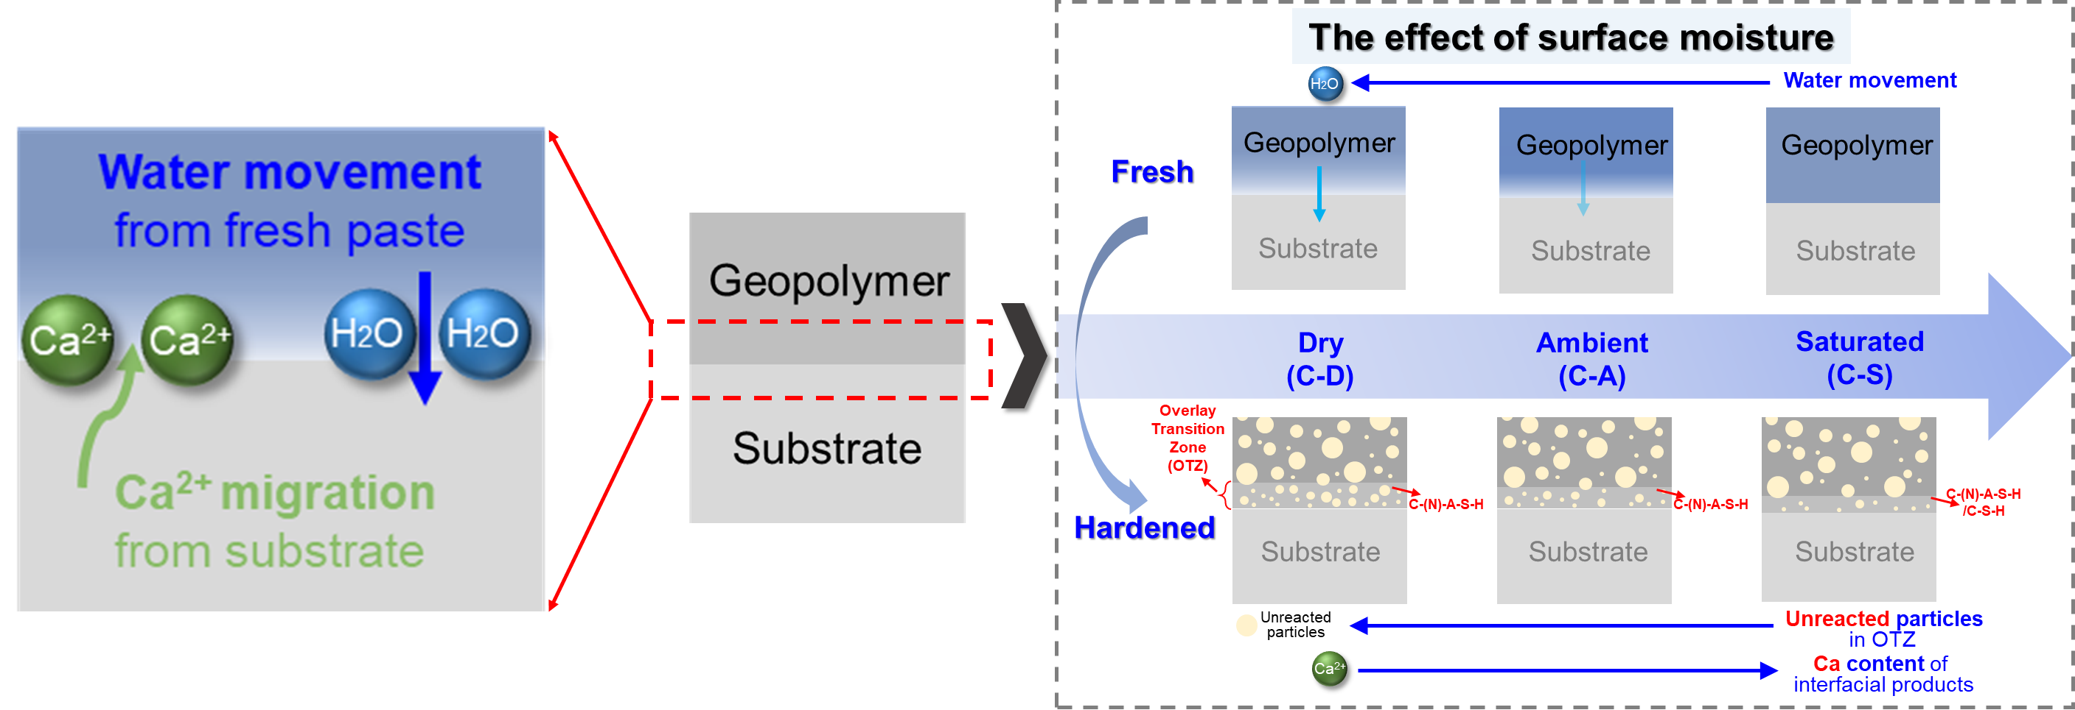

Fig.12 Schematic illustration of the effect of surface moisture of the substrate. Solid blue arrows on the right indicate direction of increase in movement extent (of water), number (of particles) and Ca content.
Accordingly, the complex effects of varying surface moisture can be explained by the integrated analysis of interfacial products and microstructures. (1) When the surface of substrate is wetter, on the one hand, the Ca ion contents of interfacial products are higher probably induced by Ca leaching from the cement substrate. Combined with the bonding strength data in Section 3.1, it can be concluded that interfacial products with higher Ca contents generated may be more advantageous for relatively long-term bonding performance. Meanwhile, there are less unreacted particles at the OTZ probably due to sufficient moisture, also smaller thickness of OTZ, which is more beneficial for interfacial bonding properties. On the other hand, higher porosity is observed within the OTZ for sample with higher surface moisture (Fig.9), which are not conducive to the interfacial bonding properties. (2) When sample with drier surface of substrate, the potential water transfer induced by moisture gradient would densify the interfacial microstructure resulting from the potential particles settling effect, which may contribute to the early bonding properties. However, there are more unreacted particles within the OTZ and also wider OTZ. Combined with the bonding strength data, a wider OTZ with more unreacted particles may mean weaker bonding properties. Considering both early and later bonding strength, it seems that samples prepared at ambient surface moisture content exhibited better strength, i.e., no extra surface moisture treatment of the substrate. These guidelines would support practical implementation in concrete repair applications.

5. Conclusions and prospects
In this paper, three kinds of cement substrates with varying surface moisture conditions, i.e., dry (C-D), ambient (C-A) and saturated (C-S), were prepared before applying fresh geopolymer repair material. Then interfacial bonding strength and interfacial products were investigated to understand the effect of surface moisture of substrates on the new-to-old interfacial bonding mechanism of geopolymer. Based on the results from this study, the following conclusions were obtained:
(1) From interfacial flexural-tensile strength and direct-tensile strength results, the bonding strength at 7 d had reached over 70% of that at 28 d, indicating that fly ash-slag powder based geopolymer is a promising material for fast repair. At 1 d, the surface moisture of the substrate had little effect on the bonding strength. Using a dry surface was not advantageous for the improvement of later bonding strength, and samples with a water-saturated surface exhibited greater mechanical strength growth from 28 d to 60 d compared with the other two conditions.
(2) From EDS mapping results, the interfacial change in Ca for the originally wet surface (C-S) is very well-defined and obvious, while the same in the sample with a dry surface (C-A) is much more gradual. Due to the significant difference of Ca, Si, and Al content between the geopolymer and cement, the change of Ca, Si, Al content in the EDS line data can show a “Product Transition Layer”. The initial surface moisture had little effect on the thickness of the product transition layer, however, all around 5 µm.
(3) The interfacial product was found to be geopolymer gel from XRD results. Also, according to a ternary phase diagram of CaO-SiO₂-Al₂O₃ from EDS results, the main types of geopolymer product are C-(N)-A-S-H gel and N-A-S-H gel. The Ca content of the interfacial products increased with an increase in surface moisture. The interfacial products of C-D and C-A are mainly C-(N)-A-S-H gel, and the interfacial product of C-S is mainly a combination of C-(N)-A-S-H gel and probably C-S-H gel.
(4) According to the statistical analysis of segmented BSE images based on the distribution of constituents (unreacted particles, hardened pastes, pores) at 5 µm distances from the substrate surface, the contents of unreacted raw materials are relatively low in the area near the cement substrate and then rise, probably induced by the wall effect of unreacted particles packing. Based on this, the “overlay transition zones (OTZ)” thickness of C-D, C-A, C-S samples are 35 µm, 30 µm and 20 µm, respectively.
(5) For geopolymer based repairing material, the bonding mechanism involves additional chemical reactions at the new-to-old interface, which can be affected by the potential water transfer between fresh repair material and the substrate surface induced by moisture gradients. With dry cement substrates, this water movement effect caused a wider OTZ and there were more unreacted particles in the OTZ. The Ca content of the interfacial products is higher when implementing the preparation of a saturated surface, probably induced by Ca leaching from the cement substrate.
Overall, this study focused on the effect of surface moisture of the cement substrate on the bonding properties of geopolymer repair material and the interfacial products at the new-to-old interface. However, in this work, only extreme dry and saturated surfaces were prepared, as well as ambient surfaces for comparison, and environment moisture conditions were not considered. Also, only bonding strength up to 60 days were tested. In future studies, precisely controlled moisture gradients should be created, combined with X-CT, nanoindentation and Neutron Radiography methods, aiming to provide a full view of the new-to-old interface between geopolymer and cement substrates and to establish the connections between moisture distribution over time, products components, microstructures and mechanical properties at the new-to-old interface. In a whole, precise, visualized and quantitative investigation of the new-to-old interface or OTZ should be emphasized to further understand the bonding mechanism and improve the interfacial properties, and particularly how these varies with curing age. For real repair applications, larger samples, long-term bonding properties (1 year or even longer) and field environmental conditions when applying should also be considered, which would support the transition of geopolymer repair materials from laboratory settings to full engineering applications.

CRediT authorship contribution statement
Guiyan Xiong: Conceptualization, Methodology, Investigation, Visualization, Writing-Original Draft, Writing-Reviewing and Editing.
Xiaolu Guo: Conceptualization, Supervision, Writing-Reviewing and Editing, Funding acquisition.
Andrew Cundy: Writing-Reviewing and Editing, Supervision, Funding acquisition.
Fayza S. Hashem: Writing-Reviewing and Editing.
Min Wu: Writing-Reviewing and Editing, Supervision.

Declaration of Competing Interest
The authors declare that they have no known competing ﬁnancial interests or personal relationships that could have appeared to inﬂuence the work reported in this paper.

Acknowledgement
The authors acknowledge the financial support received from the National Natural Science Foundation of China (No. 12411530113 and 52178241), the Fundamental Research Funds for the Central Universities (No. 2023-2-YB-20), the visiting scholar funding of the State Key Laboratory of Disaster Reduction in Civil Engineering (Grant No. SLDRCE25-F-32).

References
[1] D.P. Bentz, I. De la Varga, J.F. Muñoz, R.P. Spragg, B.A. Graybeal, D.S. Hussey, D.L. Jacobson, S.Z. Jones, J.M. LaManna, Influence of substrate moisture state and roughness on interface microstructure and bond strength: Slant shear vs. pull-off testing, Cem. Concr. Compos. 87 (2018) 63–72. https://doi.org/10.1016/j.cemconcomp.2017.12.005.
[2] F. Pacheco-Torgal, 1 - Introduction to the second edition of eco-efficient repair and rehabilitation of concrete infrastructures, in: F. Pacheco-Torgal, R.E. Melchers, X. Shi, A. Sáez (Eds.), Eco-Effic. Repair Rehabil. Concr. Infrastruct. Second Ed., Woodhead Publishing, 2024: pp. 1–10. https://doi.org/10.1016/B978-0-443-13470-8.00011-3.
[3] M.-F. Kai, J.-G. Dai, Understanding geopolymer binder-aggregate interfacial characteristics at molecular level, Cem. Concr. Res. 149 (2021) 106582. https://doi.org/10.1016/j.cemconres.2021.106582.
[4] M. Sumesh, U.J. Alengaram, M.Z. Jumaat, K.H. Mo, M.F. Alnahhal, Incorporation of nano-materials in cement composite and geopolymer based paste and mortar – A review, Constr. Build. Mater. 148 (2017) 62–84. https://doi.org/10.1016/j.conbuildmat.2017.04.206.
[5] Y. Luo, H.J.H. Brouwers, Q. Yu, Understanding the gel compatibility and thermal behavior of alkali activated Class F fly ash/ladle slag: The underlying role of Ca availability, Cem. Concr. Res. 170 (2023) 107198. https://doi.org/10.1016/j.cemconres.2023.107198.
[6] A. Sicakova, The Influence of Different Pre-Treatments of Concrete Surface on the Bond Strength of Geopolymer-Type Coating Layer, Sustainability 10 (2018) 4053. https://doi.org/10.3390/su10114053.
[7] P. Duan, C. Yan, W. Luo, A novel waterproof, fast setting and high early strength repair material derived from metakaolin geopolymer, Constr. Build. Mater. 124 (2016) 69–73. https://doi.org/10.1016/j.conbuildmat.2016.07.058.
[8] M.H. Al-Majidi, A.P. Lampropoulos, A.B. Cundy, O.T. Tsioulou, S. Al-Rekabi, A novel corrosion resistant repair technique for existing reinforced concrete (RC) elements using polyvinyl alcohol fibre reinforced geopolymer concrete (PVAFRGC), Constr. Build. Mater. 164 (2018) 603–619. https://doi.org/10.1016/j.conbuildmat.2017.12.213.
[9] X. Guo, G. Xiong, Resistance of fiber-reinforced fly ash-steel slag based geopolymer mortar to sulfate attack and drying-wetting cycles, Constr. Build. Mater. (2020) 121326. https://doi.org/10.1016/j.conbuildmat.2020.121326.
[10] T. Phoo-ngernkham, V. Sata, S. Hanjitsuwan, C. Ridtirud, S. Hatanaka, P. Chindaprasirt, High calcium fly ash geopolymer mortar containing Portland cement for use as repair material, Constr. Build. Mater. 98 (2015) 482–488. https://doi.org/10.1016/j.conbuildmat.2015.08.139.
[11] Y.-C. Ding, T.-W. Cheng, Y.-S. Dai, Application of geopolymer paste for concrete repair, Struct. Concr. 18 (2017) 561–570. https://doi.org/10.1002/suco.201600161.
[12] M. Luković, B. Šavija, H. Dong, E. Schlangen, G. Ye, Micromechanical Study of the Interface Properties in Concrete Repair Systems, J. Adv. Concr. Technol. 12 (2014) 320–339. https://doi.org/10.3151/jact.12.320.
[13] H. Beushausen, M.G. Alexander, Bond strength development between concretes of different ages, Mag. Concr. Res. 60 (2008) 65–74. https://doi.org/10.1680/macr.2007.00108.
[14] H. Beushausen, B. Höhlig, M. Talotti, The influence of substrate moisture preparation on bond strength of concrete overlays and the microstructure of the OTZ, Cem. Concr. Res. 92 (2017) 84–91. https://doi.org/10.1016/j.cemconres.2016.11.017.
[15] B. Omar, K. Fattoum, B. Maissen, Influence of the Roughness and Moisture of the Substrate Surface on the Bond between Old and New Concrete, Contemp. Eng. Sci. 3 (2010) 139–147.
[16] D.S. Santos, P.M.D. Santos, D. Dias-da-Costa, Effect of surface preparation and bonding agent on the concrete-to-concrete interface strength, Constr. Build. Mater. 37 (2012) 102–110. https://doi.org/10.1016/j.conbuildmat.2012.07.028.
[17] W.W.A. Zailani, M.M.A.B. Abdullah, R.A. Razak, M.R.R.M.A. Zainol, M.F.M. Tahir, Bond Strength Mechanism of Fly Ash Based Geopolymer Mortars: A Review, IOP Conf. Ser. Mater. Sci. Eng. 267 (2017) 012008. https://doi.org/10.1088/1757-899X/267/1/012008.
[18] Y. He, X. Zhang, R.D. Hooton, X. Zhang, Effects of interface roughness and interface adhesion on new-to-old concrete bonding, Constr. Build. Mater. 151 (2017) 582–590. https://doi.org/10.1016/j.conbuildmat.2017.05.049.
[19] B.A. Tayeh, B.H. Abu Bakar, M.A. Megat Johari, Y.L. Voo, Mechanical and permeability properties of the interface between normal concrete substrate and ultra high performance fiber concrete overlay, Constr. Build. Mater. 36 (2012) 538–548. https://doi.org/10.1016/j.conbuildmat.2012.06.013.
[20] X. Guo, H. Li, S. Wang, Effects of pre-corroded steel fibers on mechanical properties and interface bond behavior of ultra-high performance concrete-normal concrete, Constr. Build. Mater. 356 (2022) 129234. https://doi.org/10.1016/j.conbuildmat.2022.129234.
[21] A.D. Espeche, J. León, Estimation of bond strength envelopes for old-to-new concrete interfaces based on a cylinder splitting test, Constr. Build. Mater. 25 (2011) 1222–1235. https://doi.org/10.1016/j.conbuildmat.2010.09.032.
[22] B. Wang, S. Xu, F. Liu, Evaluation of tensile bonding strength between UHTCC repair materials and concrete substrate, Constr. Build. Mater. 112 (2016) 595–606. https://doi.org/10.1016/j.conbuildmat.2016.02.149.
[23] S. Austin, P. Robins, Y. Pan, Tensile bond testing of concrete repairs, Mater. Struct. 28 (1995) 249. https://doi.org/10.1007/BF02473259.
[24] I. de la Varga, J. Munoz, D.P. Bentz, B. Graybeal, Effect of the Interface Moisture Content on the Bond Performance between a Concrete Substrate and a Non-Shrink Cement-Based Grout, NIST (2015) 1–3. https://www.nist.gov/publications/effect-interface-moisture-content-bond-performance-between-concrete-substrate-and-non (accessed July 2, 2022).
[25] I. De la Varga, J.F. Muñoz, D.P. Bentz, R.P. Spragg, P.E. Stutzman, B.A. Graybeal, Grout-concrete interface bond performance: Effect of interface moisture on the tensile bond strength and grout microstructure, Constr. Build. Mater. 170 (2018) 747–756. https://doi.org/10.1016/j.conbuildmat.2018.03.076.
[26] M. Farzad, M. Shafieifar, A. Azizinamini, Experimental and numerical study on bond strength between conventional concrete and Ultra High-Performance Concrete (UHPC), Eng. Struct. 186 (2019) 297–305. https://doi.org/10.1016/j.engstruct.2019.02.030.
[27] E. Gomaa, A. Gheni, M.A. ElGawady, Repair of ordinary Portland cement concrete using ambient-cured alkali-activated concrete: Interfacial behavior, Cem. Concr. Res. 129 (2020) 105968. https://doi.org/10.1016/j.cemconres.2019.105968.
[28] J. Fan, H. Zhu, J. Shi, Z. Li, S. Yang, Influence of slag content on the bond strength, chloride penetration resistance, and interface phase evolution of concrete repaired with alkali activated slag/fly ash, Constr. Build. Mater. 263 (2020) 120639. https://doi.org/10.1016/j.conbuildmat.2020.120639.
[29] S. Xue, F. Meng, P. Zhang, J. Wang, J. Bao, L. He, Influence of substrate moisture conditions on microstructure of repair mortar and water imbibition in repair-old mortar composites, Measurement 183 (2021) 109769. https://doi.org/10.1016/j.measurement.2021.109769.
[30] G. Xiong, X. Guo, Effects and mechanism of superplasticizers and precursor proportions on the fresh properties of fly ash – slag powder based geopolymers, Constr. Build. Mater. 350 (2022) 128734. https://doi.org/10.1016/j.conbuildmat.2022.128734.
[31] G. Xiong, X. Guo, H. Zhang, Preparation of epoxy resin-geopolymer (ERG) for repairing and the microstructures of the new-to-old interface, Compos. Part B Eng. 259 (2023) 110731. https://doi.org/10.1016/j.compositesb.2023.110731.
[32] JC∕T 2381-2016 Repairing Mortar, (2016). http://www.standardcnjc.com/index/standard/detail/id/987.html (accessed 30 June, 2022).
[33] JGJ/T 70-2009 Standard for test method of basic properties of construction mortar, (n.d.). https://www.mohurd.gov.cn/gongkai/zhengce/zhengcefilelib/200903/20090317_187371.html (accessed June 22, 2023).
[34] M. EL Afandi, S. Yehia, T. Landolsi, N. Qaddoumi, M. Elchalakani, Concrete-to-concrete bond Strength: A review, Constr. Build. Mater. 363 (2023) 129820. https://doi.org/10.1016/j.conbuildmat.2022.129820.
[35] G. Xiong, X. Guo, H. Zhang, Preparation of epoxy resin-geopolymer (ERG) for repairing and the microstructures of the new-to-old interface, Compos. Part B Eng. 259 (2023) 110731. https://doi.org/10.1016/j.compositesb.2023.110731.
[36] H. Alanazi, M. Yang, D. Zhang, Z. (Jerry) Gao, Bond strength of PCC pavement repairs using metakaolin-based geopolymer mortar, Cem. Concr. Compos. 65 (2016) 75–82. https://doi.org/10.1016/j.cemconcomp.2015.10.009.
[37] M. Lukovic, G. Ye, Effect of Moisture Exchange on Interface Formation in the Repair System Studied by X-ray Absorption, Materials 9 (2015) 2. https://doi.org/10.3390/ma9010002.
[38] Y.-S. Wang, K.-D. Peng, Y. Alrefaei, J.-G. Dai, The bond between geopolymer repair mortars and OPC concrete substrate: Strength and microscopic interactions, Cem. Concr. Compos. 119 (2021) 103991. https://doi.org/10.1016/j.cemconcomp.2021.103991.
[39] W. Li, Z. Luo, Y. Gan, K. Wang, S.P. Shah, Nanoscratch on mechanical properties of interfacial transition zones (ITZs) in fly ash-based geopolymer composites, Compos. Sci. Technol. 214 (2021) 109001. https://doi.org/10.1016/j.compscitech.2021.109001.
[40] Z. Luo, W. Li, K. Wang, A. Castel, S.P. Shah, Comparison on the properties of ITZs in fly ash-based geopolymer and Portland cement concretes with equivalent flowability, Cem. Concr. Res. 143 (2021) 106392. https://doi.org/10.1016/j.cemconres.2021.106392.
[41] H.H. Nguyễn, P.H. Nguyễn, Q.-H. Lương, W. Meng, B.Y. Lee, Mechanical and autogenous healing properties of high-strength and ultra-ductility engineered geopolymer composites reinforced by PE-PVA hybrid fibers, Cem. Concr. Compos. 142 (2023) 105155. https://doi.org/10.1016/j.cemconcomp.2023.105155.
[42] B. Walkley, R. San Nicolas, M.-A. Sani, G.J. Rees, J.V. Hanna, J.S.J. van Deventer, J.L. Provis, Phase evolution of C-(N)-A-S-H/N-A-S-H gel blends investigated via alkali-activation of synthetic calcium aluminosilicate precursors, Cem. Concr. Res. 89 (2016) 120–135. https://doi.org/10.1016/j.cemconres.2016.08.010.
[43] R. Xiao, X. Jiang, M. Zhang, P. Polaczyk, B. Huang, Analytical investigation of phase assemblages of alkali-activated materials in CaO-SiO2-Al2O3 systems: The management of reaction products and designing of precursors, Mater. Des. 194 (2020) 108975. https://doi.org/10.1016/j.matdes.2020.108975.
[44] X. Hui-cai, L. Geng-ying, X. Guang-jing, Microstructure model of the interfacial zone between fresh and old concrete, J. Wuhan Univ. Technol.-Mater Sci Ed 17 (2002) 64–68. https://doi.org/10.1007/BF02838421.
[45] W.W.A. Zailani, M.M.A.B. Abdullah, M.F. Arshad, R.A. Razak, M.F.M. Tahir, R.R.M.A. Zainol, M. Nabialek, A.V. Sandu, J.J. Wysłocki, K. Błoch, Characterisation at the Bonding Zone between Fly Ash Based Geopolymer Repair Materials (GRM) and Ordinary Portland Cement Concrete (OPCC), Materials 14 (2021) 56. https://doi.org/10.3390/ma14010056.

