Getting Dusty with Mice: domestic experiments in more-than-human methods
Abstract

This intervention models and evaluates an innovative creative method for more-than-human geography: the reappropriation of non-toxic tracking dust from professional pest management as a means of understanding and revealing animal worlds. Combined with the use of black light, the application of the dust in sites of suspected rodent activity makes visible the otherwise hidden feral mouse movements in the researcher’s own home. Consequently, it responds to calls for greater methodological experimentation to engage with animals’ own ‘beastly places’ and recognises urban homes as sites of unwanted and ambivalent more-than-human entanglements. It also defamiliarizes the researcher’s own home, transforming it into an ad-hoc laboratory, disrupting notions of order and cleanliness as well as anthropocentric scale through highlighting rodent presence and agency. While this method literally illuminates unruly natures within the home, its ethical implications are far from straightforward. To what extent are the mice unknowing and unwilling collaborators? And in rendering their worlds visible, do we also hasten their loss and destruction? This method forces a reckoning with the shared yet unequal precarity of home for both domestic pests and the researcher-as-renter.

Non-toxic ultraviolet tracking dust is commonly applied by professional pest management (PPM) technicians investigating a suspected rodent infestation, particularly for identifying points of entry, feeding and nesting sites. One lays the dust in a spot of likely rodent activity. Any rodents that traverse it collect small particles on their feet and consequently reveal their movements, leaving footprints only visible under black light. This CGIP intervention reflects on the potentials of reappropriating this technology from PPM to capture animals’ own world-making practices or ‘beastly places’, following long-standing calls within cultural geographies to expand the repertoire of more-than-human methodological approaches. Mouse sightings in my own home provided an opportunity for an unexpected multispecies collaboration (Figure 1). This was timely given my ongoing multi-year research investigating the social, emotional and financial impacts of living with unwanted nonhuman others, as well as the overlooked and undervalued embodied knowledges of PPM. Conducting this experiment in my own apartment worked to defamiliarize experiences of home, transforming domestic space into an ad-hoc multispecies field site. This experimental method raises thorny questions of visibility and interspecies ethics: what can be seen, at which scale and to what cost?
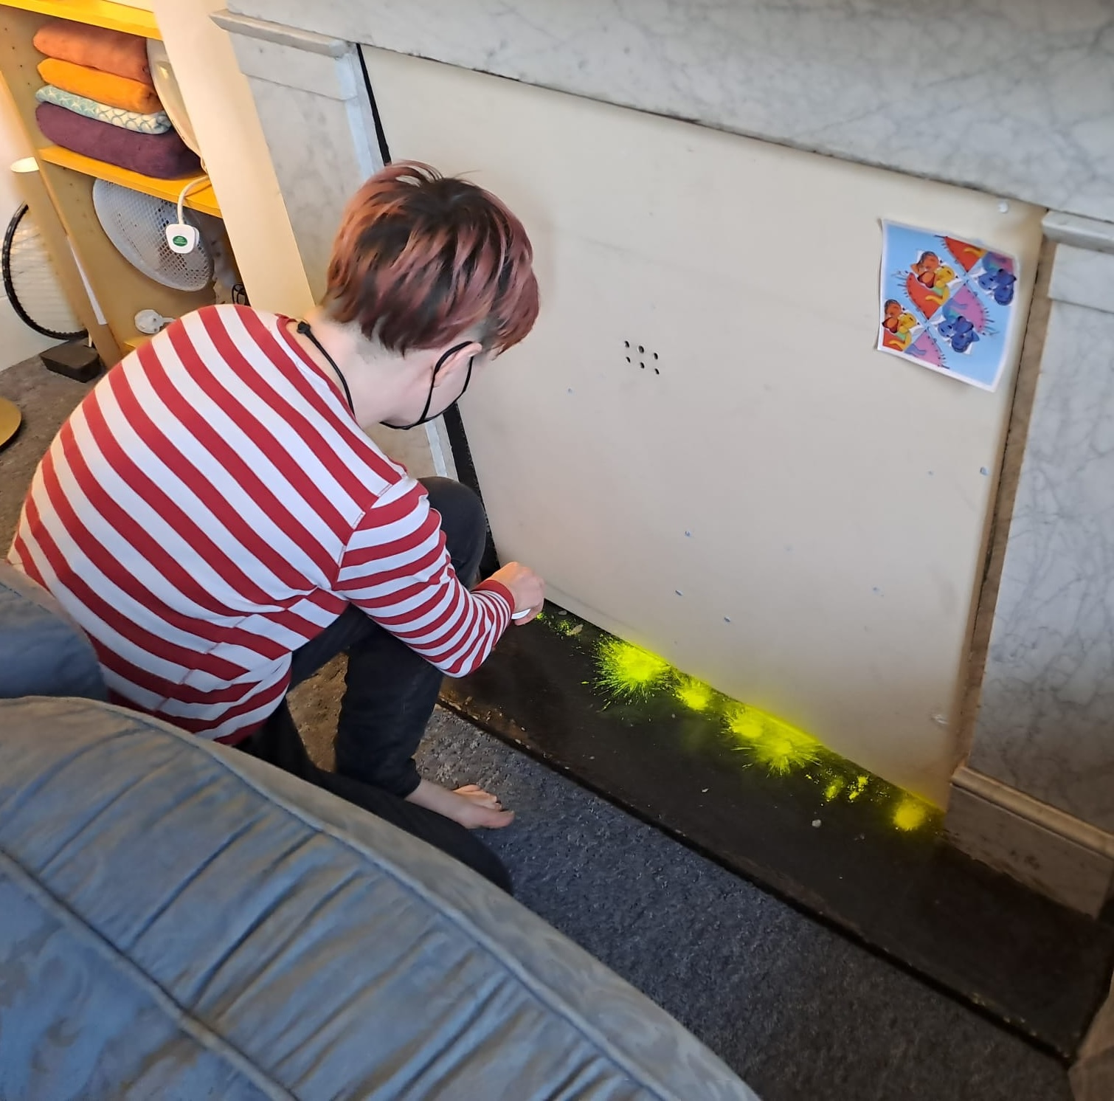
Figure 1. Author applies dust in their own home. Credit: Author’s housemate.
Initiating the experiment

I liberally spread the dust across the kitchen floor of my second storey shared North London apartment, a flat notable for its threadbare carpets, poor insulation and surprisingly affordable rent. The evidence of pest presence is undeniable following a night of nocturnal scurrying. Through the glare of the black light torch rodent geographies come into sight (Figure 2). I begin to see locations and routes favoured by the mice, rendering parts of the apartment that were previously overlooked newly visible. Perhaps predictably, preferred areas are those spaces least disturbed by my housemates and I. Living room activity centres around the fireplace that is boarded up, inhibiting human access and thereby granting exclusive territory to the mice. Trails also lead to and from the tower of miscellany: the shelving unit piled high with the vaguely sentimental and nominally useful ownerless detritus of a long-standing house share. We rarely venture into the corner, but the mice do. The mice, my housemates and I are entangled and commensal but not convivial. We have a common home, yet one that is not deliberately and communally enjoyed but temporally and spatially carved up between us, staking out our own corners and taking shifts.
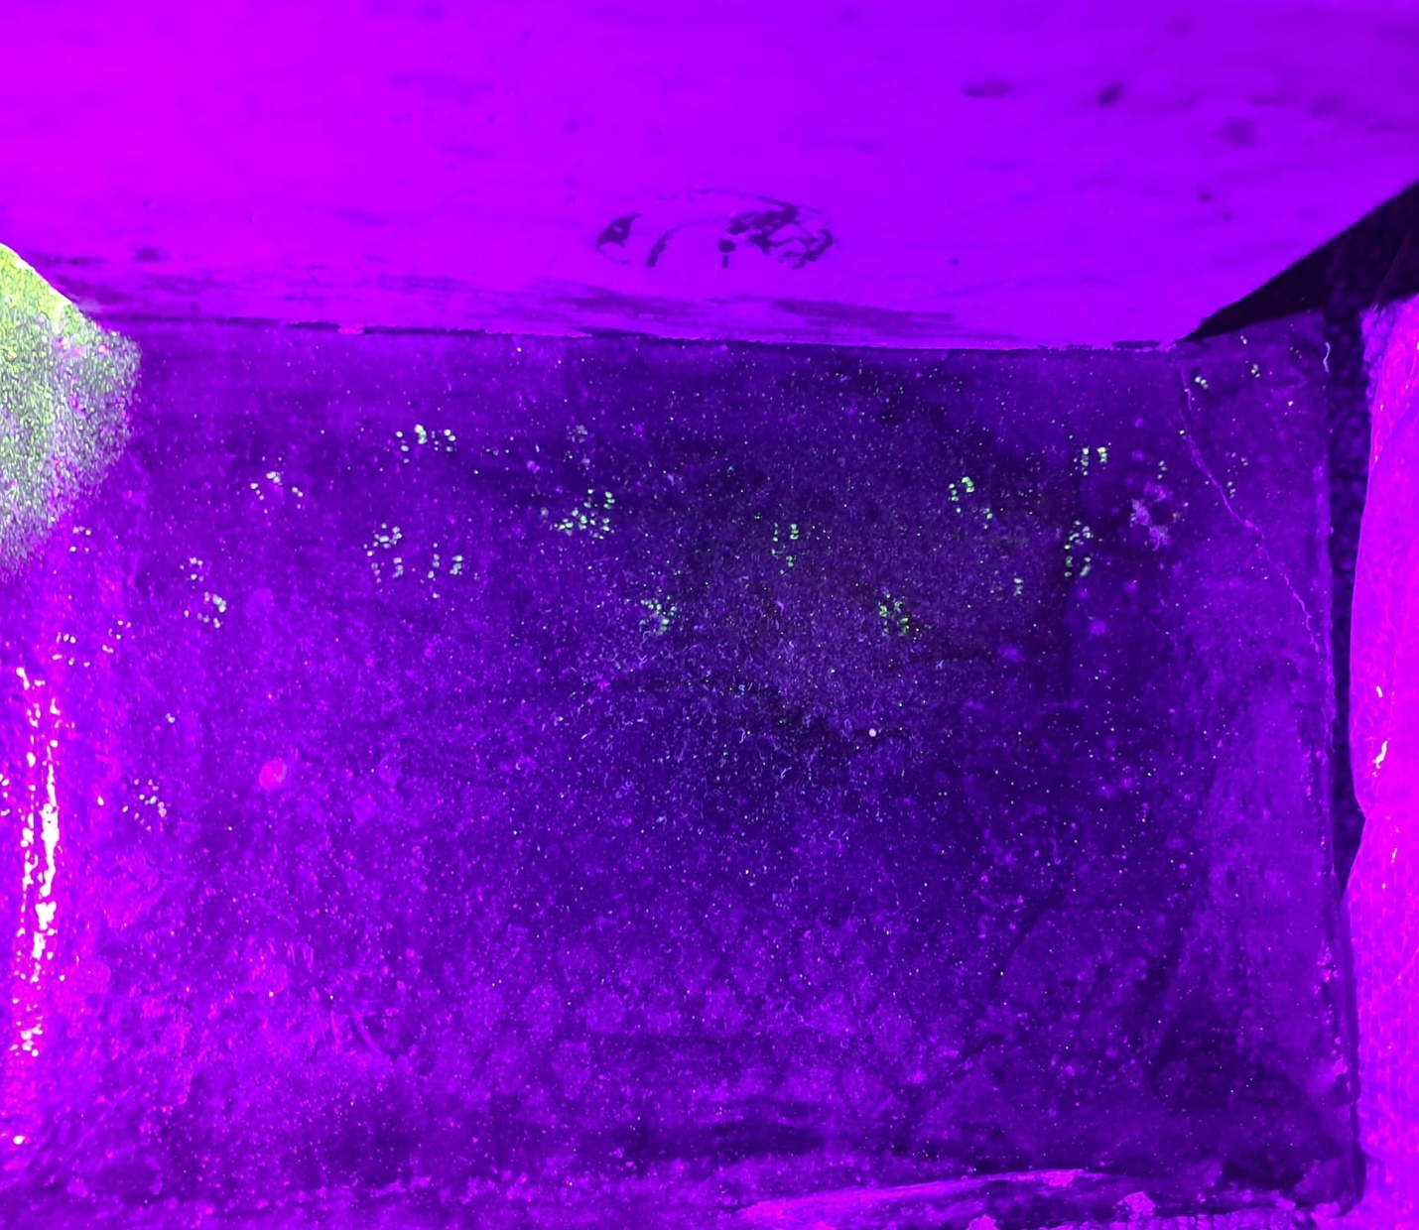
Figure 2. Black light reveals mouse paw prints heading right. Credit: Author.
The dust demonstrates that the kitchen is the real murine hotspot, particularly the area behind the washing machine and bin, the nether regions of dust pans and tote bags. Here I witness consistent activity night on night: a palimpsest of mouse tracks layering over historic movements (Figure 3). What preserves the marks is also our continuing spatial separation as avoidant commensals, as the dust is only precariously affixed. The tracks that one night diverge from the main rodent thoroughfare, instead heading into the main corridor of the galley kitchen, are quickly erased by the footfall of quotidian human actions. The mouse world becomes less visible when it leaves its interstitial domain.
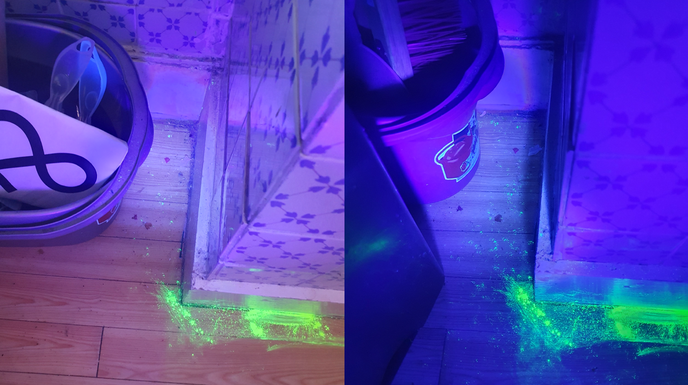
Figure 3. One night (left) versus three nights worth of activity (right). Credit: Author.

The tracks also bring home new questions of scale. I think of the macaques that precariously traverse Delhi’s skylines utilising power cables as I follow the footprints and witness miniscule acts of infrastructural reappropriation. The skirting board becomes a runway, a robust ledge enabling the mice to propel themselves onto the mound of disused tote bags, ostentatiously frolic and then ascend to the tap, where their trail then goes cold.
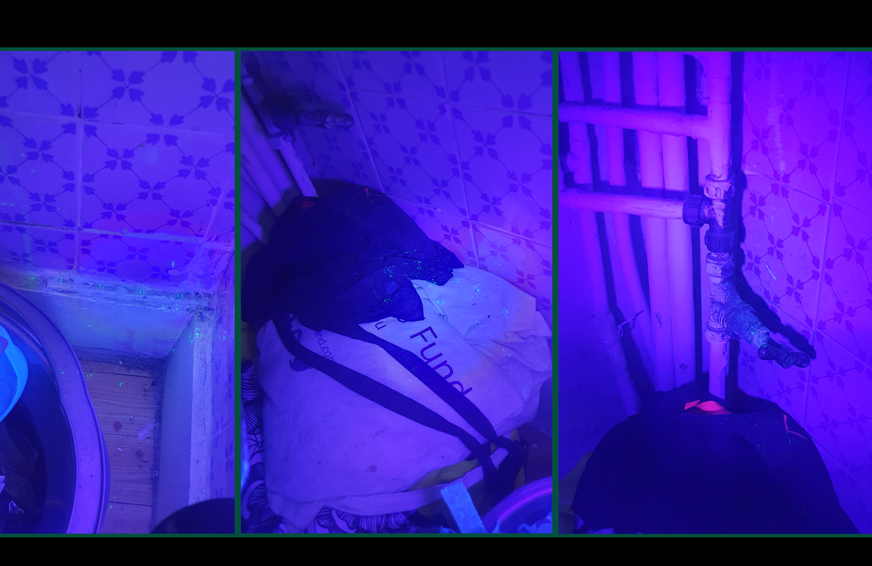
Figure 4. Dust marks the ascending rodent thoroughfare. Credit: Author.

Crouched on the kitchen floor, I reckon with the labour of interspecies communication, of, for instance, learning to read the writing of water voles, inscribed by droppings and the paw prints left on muddy banks. Here the mice have said their piece. In reply, I retain the dust but start to disassemble this rodent landscape. The fluorescent dust-marked and scat-dotted tote bags are binned. Their neighbourhood stripped bare, we wait to see what the mice will do next. They make no attempt to return to the tap via the mop bucket. For now, their routes seem grounded. And they take no advantage of the newly cleared vista, instead obeying their thigmotaxic tendencies and cautiously edging along the wall.
Yet questions linger unanswered. Where are they nesting? And where are they getting in? I begin my thinking at the intimate level of the personal and domestic with my modestly sized apartment turned field site. Yet this scale of analysis remains too large and removed. I am still failing to ground myself in mouse geographies, positioned aloof with my torch. I throw myself more directly into their terrain, evicting the crockery from our shabbily backless cupboard, and crawl in. Behind I find yet more evidence of previous eviction attempts: multiple rodenticide-laced bait boxes, rusted wire wool stuffed into a hole. Here I see a side of my home that was not only overlooked but previously invisible, until I bring myself to the level of the mice. The cupboard’s lack of back had led to years of errant jars, tubs and protein shake containers cascading into a dusty clutter across the floor. I dispose of all of these, conscious they are another possible rodent causeway, and search for further evidence of trails, switching between head torch and black light but the mice evade me. No UV dust winks back.
The multiple tracks suggest that while mice are undeniably present, we are far from overrun. Only on the first night did we find markings in the living room. The palimpsest of kitchen tracks suggest only one, perhaps two mice are wandering the floors at night, and fortunately there’s no sign they’re ascending to the counter tops. The scant data I hold highlights the limitations of my knowledge and my methods: the dimensions of mouse worlds that still cannot be seen and known. I am both physically and conceptually limited by the maisonette flat as a segment of the house, itself an arbitrary unit within a row of Victorian terraces. For the mice this might just be one small fraction of their grand intermural territory. These walls are not boundaries, but vehicles for movement and homes in their own right.
I also start to wonder who the mouse is, and why it ventures to my kitchen solo, recognising animal geography’s imperative to look beyond the species to the individual. Is it an outcast from a larger colony, building a new life following the violence of exile? Is it a juvenile mouse, more adventurous than its cautious elders, expanding its feeding range into my home only to return to the security of next door's nest? Or is it perhaps not a house mouse (Mus musculus), but a field mouse (Apodemus sylvaticus), branching into new indoor terrain? This increasingly common London phenomenon not only blurs the fabled binaries of town mouse and country mouse but reveals these commensal rodents as subjects of ongoing anthropogenic transformation.

Abrupt Endings

This method raises ethical queries, but beyond the purview of formal institutional protocols, due to the non-invasive nature of the dust, placing it below the threshold for animal ethics review, as well as the ambiguity of hosting the experiment within my own home and transforming the mundane (amateur domestic pest management) into the spectacular and experimental. I recognise the potential to attend to interspecies somatic sensibilities and non-verbal modes of consent. Yet the mouse or mice I share a home with have little option to refuse this experimental process: these substantial mounds of dust are literally in their way. This touches on resistance, a contentious term within animal geographies, but also emic to professional pest management. For PPM resistance is both biological (when poisons no longer take effect) and behavioural (when rodents are defiantly trap shy). Resistance brings animal agency to the fore, even if only glimpsed as a refusal of human intentions. I know the mice I share a home with are resistant: their pleasure paths take them directly past poison-laden bait boxes, which they either eschew or feel no effects from.
This dust is a tool for generating new knowledge and making otherwise unseen lifeworlds visible. It may be non-toxic, but that does not mitigate its dangers. As cultural geographers we must reckon with the cost of such knowledge and the consequences of exposing our entanglements. My domestic experiments reaffirm feminist geographical analyses of the home as a site of inequality, power and danger. Mid-experiment I receive notice that our landlady is visiting the flat. Any illusion of home as a secure, contained and autonomous space—a Yi-Fu Tuan humanist geographical fantasy—is further undermined. I clear away the mounds of dust, for fear that as tenants we will be deemed weird, dirty and irresponsible for letting rodents run riot in our kitchen (Figure 5). It is not only my home that is at stake: the historic boxes of rodenticide suggest an appetite for lethal modes of eviction. I actively work to hide the mice and our knowledge of them. Hiding these items and traces brings to mind not my previous encounters with unwanted cohabitants (the time we had moths, the many times my friends had bed bugs) but year after year the times that we disassembled beds, hid clothing, post and gendered items, wiped names from notice boards, all to conceal our informal and strategic tenancy digressions. Subletters, live-in partners, living rooms turned bedrooms: improvisations necessary to make London rental life liveable. Always conscious of our status as fungible and ultimately disposable, only a section 21 away from finding a new home. Clearing the dust throws into sharp relief our mutual housing precarity, shared across species, and how my actions have worked to jeopardise us both.
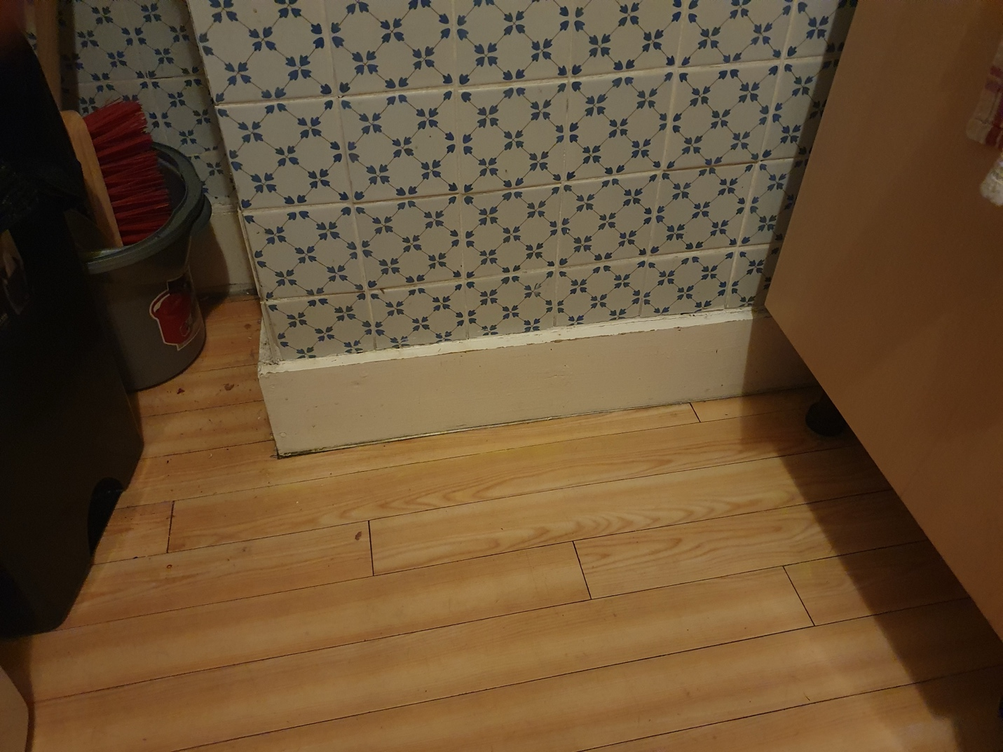
Figure 5. All visible evidence of the experiment is expunged. Credit: Author
Our flat is purified. Respectable. But under the black light the footprints remain. These animal geographies are just as visible as always, as long as you know where and how to look.
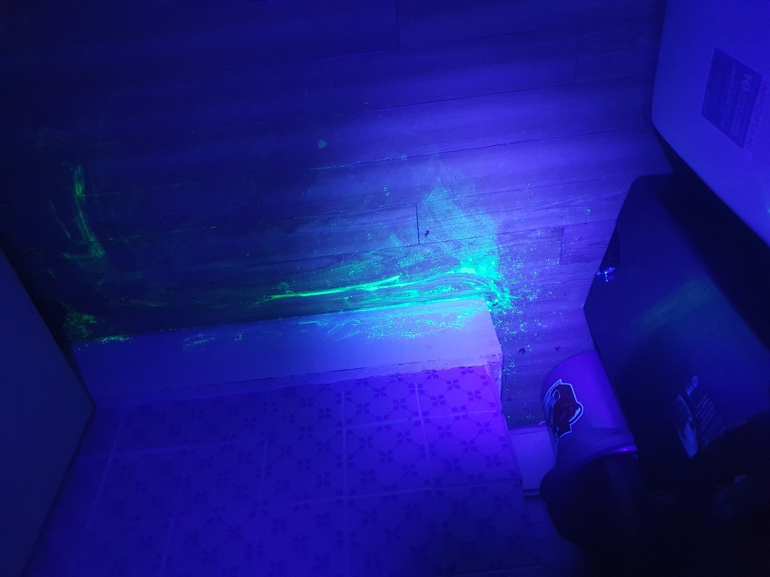
Figure 6. Despite cleaning, the dust remains visible under the black light. Credit: Author
Notes

75% of PPM technicians reported using the dust at least sometimes, with more than 30% using it often. J. McCay, Future of Pest Management Survey: Executive Report (2024), pp. 18–19.
C. Philo and C. Wilbert, Animal Spaces, Beastly Places: New Geographies of Human-Animal Relations (Florence, United States: Taylor & Francis, 2000); T. Hodgetts and J. Lorimer, ‘Methodologies for animals’ geographies: cultures, communication and genomics’, cultural geographies, 22(2), 2015, pp. 285–295.
H. Fair, ‘Labor, violence and the unfamiliar: Animals’ geographies of the more-than-human home’, Progress in Environmental Geography, 3(4), 2024, pp. 332-351.
J. A. Smith, ‘Beyond Dominance and Affection: Living with Rabbits in Post-Humanist Households’, Society & Animals, 11(2), 2003, pp. 181–197.
M. Barua, Lively cities: Reconfiguring urban ecology (University of Minnesota Press, 2023).
S. Hinchliffe, M. B. Kearnes, M. Degen and S. Whatmore, ‘Urban Wild Things: A Cosmopolitical Experiment’, Environment and Planning D: Society and Space, 23(5), 2005, pp. 643–658.
On the porosity of pest movements see D. D. Biehler, ‘Permeable homes: A historical political ecology of insects and pesticides in US public housing’, Geoforum, 40(6), 2009, pp. 1014–1023.
C. Bear, ‘Being Angelica? Exploring individual animal geographies’, Area, 43(3), 2011, pp. 297–304.
B. Greenhough and E. Roe, ‘Ethics, Space, and Somatic Sensibilities: Comparing Relationships between Scientific Researchers and Their Human and Animal Experimental Subjects’, Environment and Planning D: Society and Space, 29(1), 2011, pp. 47–66.
C. Philo, ‘Animals, Geography, and the City: Notes on Inclusions and Exclusions’, Environment and Planning D: Society and Space, 13(6), 1995, pp. 655–681.
S. Bowlby, S. Gregory and L. McKie, ‘“Doing home”: Patriarchy, caring, and space’, Women’s Studies International Forum, 20(3), 1997, pp. 343–350; N. Gregson and M. Lowe, ‘’Home’-Making: On the Spatiality of Daily Social Reproduction in Contemporary Middle-Class Britain’, Transactions of the Institute of British Geographers, 20(2), 1995, pp. 224–235.
Y.-F. Tuan, ‘Home’, in S. Harrison, S. Pile and N. J. Thrift (eds), Patterned Ground: Entanglements of Nature and Culture (London: Reaktion Books, 2004), pp. 164–165.

