SUPPLEMENTAL MATERIALS

Virtual-Reality Induced Nostalgia: Duration and Psychological Benefits

İrem Yılmaz-Özdemir, Tim Wildschut, Constantine Sedikides, and Erich W. Graf
University of Southampton

Author Note
İrem Yılmaz-Özdemir: https://orcid.org/0000-0002-8477-0891
Tim Wildschut: https://orcid.org/0000-0002-6499-5487
Constantine Sedikides: https://orcid.org/0000-0003-4036-889X
Erich W. Graf: https://orcid.org/0000-0002-3162-4233

We have no known conflict of interest to disclose. Corresponding author: İrem Yılmaz-Özdemir, School of Psychology, University of Southampton, Southampton SO17 1BJ, United Kingdom. Email: I.Ozdemir@soton.ac.uk
Table of Contents

S1: Panoramic Views of Virtual Reality Environments in Experiments 1-2 3
S2: Results for Negative Affect in Experiments 1-2 5
S3: Nostalgic Word Cloud 7
S4: Instructions in Experiment 2 8
S5: Descriptives and Reliabilities for Dependent Variables by Time Point: Experiment 2 10
S6: Results for Positive Affect, Self-Esteem, and Meaning in Experiment 2 11
S7: Experiment S1

S1: Panoramic Views of Virtual Reality Environments in Experiments 1-2
Figure S1
Panoramic View of Nostalgic and Control Virtual Environments in Experiment 1
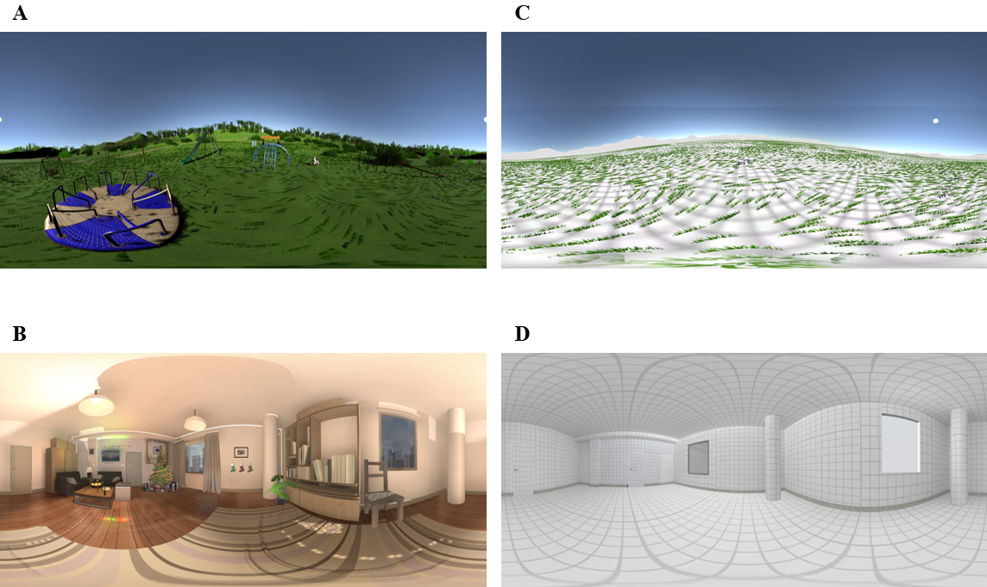Note. Panel A: Panoramic view of the playground environment. Panel B: Panoramic view of the Christmas environment. Panel C: Panoramic view of the empty outdoor space in the control condition (matching the playground environment). Panel D: Panoramic view of the empty living room in the control condition (matching the Christmas environment).
Figure S2
Panoramic View of Nostalgic and Control Virtual Environments in Experiment 2
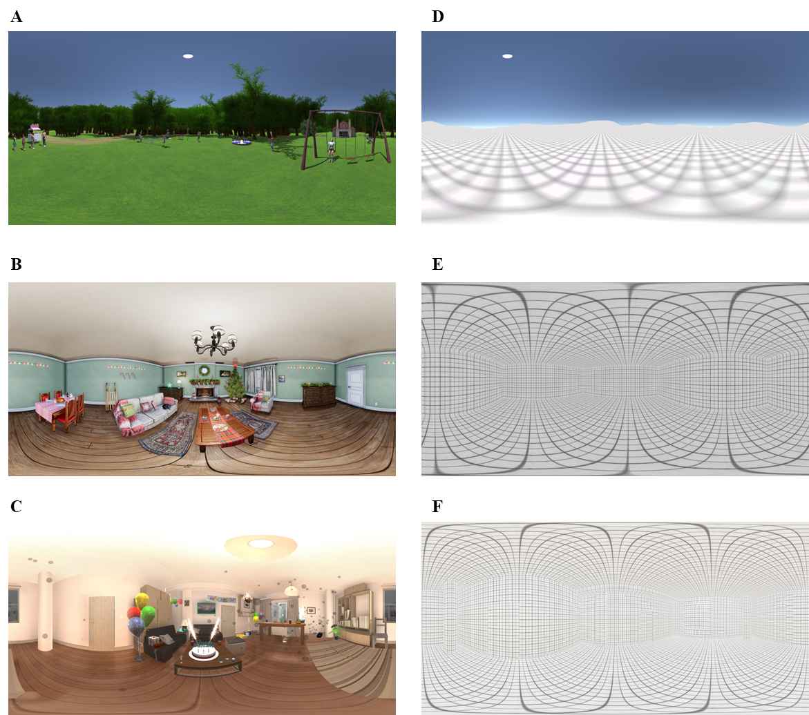
Note. Panel A: Panoramic view of the playground environment. Panel B: Panoramic view of the Christmas environment. Panel C: Panoramic view of the birthday environment. Panel D: Panoramic view of the empty outdoor space in the control condition (matching the playground environment). Panel E: Panoramic view of the empty living room in the control condition (matching the Christmas environment). Panel F: Panoramic view of the empty living room in the control condition (matching the birthday environment).
S2: Results for Negative Affect in Experiments 1-2
In Experiment 1, there were no significant effects of nostalgia, induction method, or Nostalgia × Induction Method on negative affect, Fs(1, 163) = 1.42, ps > .235, η_{p}² < .009 (Figure S3). Overall, negative affect was very low.
Figure S3
Negative Affect as a Function of Nostalgia and Induction Method in Experiment 1
Note. Error bars are standard errors.

In Experiment 2, there were no significant effects of nostalgia, induction method, or time (nor any significant interaction effects) on negative affect (Figure S4). The Nostalgia × Induction Method interaction was trending, F(1, 244) = 2.76, p = .098, η_{p}² = .011, indicating that nostalgia (vs. control) tended to decrease negative affect in the ERT (Figure S2, left panel) and increase it in the VRT (right panel). Overall, negative affect was very low.
Figure S4
Negative Affect as a Function of Nostalgia, Induction Method, and Time in Experiment 2
Note. Error bars are standard errors

S3: Nostalgic Word Cloud
Figure S5
Word Cloud Based on 717 Nostalgic Narratives
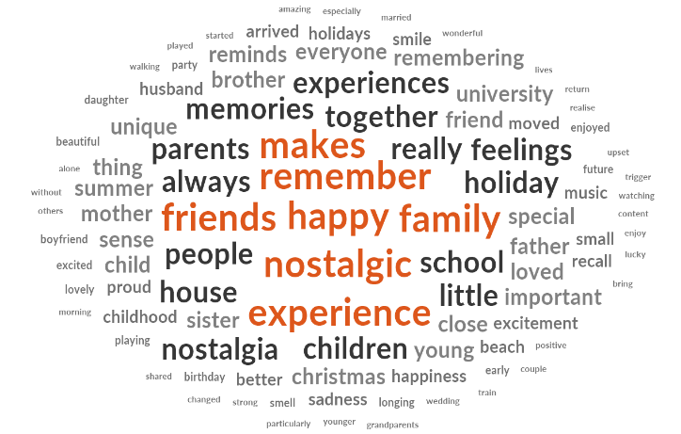
Note. Font size indicates relative word frequency. The word cloud excludes stop words.

S4: Instructions in Experiment 2
Nostalgia-Event Reflection Task
According to the Oxford Dictionary, ‘nostalgia’ is defined as ‘a sentimental longing for the past.’ Please think of a nostalgic event in your life related to either (a) a Christmas Holiday, (b) your childhood, or (c) one of your birthdays. Specifically, try to think of a past event that makes you feel most nostalgic. Bring this nostalgic experience to mind. Immerse yourself in the nostalgic experience. How does it make you feel? Using the space provided below, for the next five minutes, we would like you to write about the nostalgic event. Immerse yourself in this nostalgic experience. Describe the experience in detail and how it makes you feel.
Control-Event Reflection Task
Please think of an ordinary event in your life (i.e. an ordinary event that happened outside or at home). Specifically, try to think of a past event that is ordinary. Bring this ordinary experience to mind. Immerse yourself in the ordinary experience. How does it make you feel? Using the space provided below, for the next five minutes, we would like you to write about the ordinary event. Immerse yourself in this ordinary experience. Describe the experience in detail and how it makes you feel.

Nostalgia-Virtual Reality Task
According to the Oxford Dictionary, ‘nostalgia’ is defined as a sentimental longing for the past. Please think of a nostalgic event in your life related to the virtual scene that you chose. Specifically, try to think of a past event that makes you feel most nostalgic regarding the virtual environment that you are in now. Bring this nostalgic experience to mind. Immerse yourself in the nostalgic experience. How does it make you feel? For the next five minutes, we would like you to talk about the nostalgic event while looking around. Immerse yourself in this nostalgic experience. Describe the experience in detail and how it makes you feel. Please push the button on the controller and start describing your nostalgic memory.
Control-Virtual Reality Task
Please bring to mind an ordinary event (everyday, regular) in your life. Specifically, try to think of an event that is ordinary. Bring this ordinary experience in mind. Immerse yourself in the ordinary experience. How does it make you feel? For the next five minutes, we would like you to talk about the ordinary event while looking around. Immerse yourself into this ordinary experience. Describe the experience in detail and how it makes you feel. Please push the button on the controller and start describing your ordinary memory.

S5: Descriptive Statistics and Reliabilities for Dependent Variables by Time Point in Experiment 2
 | α | M | SD
Time 1
Felt nostalgia | .97 | 4.70 | 1.82
Positive affect | .86 | 4.06 | 1.35
Self-esteem | .90 | 3.84 | 1.30
Social connectedness | .91 | 3.93 | 1.59
Empathy | .94 | 3.76 | 1.40
Self-continuity | .77 | 4.22 | 1.44
Meaning | .91 | 4.21 | 1.43
Benefits index | .86 | 4.00 | 0.90
Time 2
Felt nostalgia | .97 | 2.85 | 1.66
Positive affect | .86 | 3.65 | 1.28
Self-esteem | .94 | 3.54 | 1.29
Social connectedness | .94 | 3.50 | 1.54
Empathy | .95 | 3.44 | 1.36
Self-continuity | .86 | 3.76 | 1.41
Meaning | .95 | 3.75 | 1.48
Benefits index | .90 | 3.61 | 0.99
Time 3
Felt nostalgia | .98 | 2.57 | 1.60
Positive affect | .88 | 3.48 | 1.33
Self-esteem | .94 | 3.41 | 1.30
Social connectedness | .94 | 3.40 | 1.53
Empathy | .96 | 3.30 | 1.40
Self-continuity | .89 | 3.64 | 1.45
Meaning | .96 | 3.66 | 1.55
Benefits index | .91 | 3.48 | 1.04
Time 4
Felt nostalgia | .98 | 2.26 | 1.55
Positive affect | .91 | 3.31 | 1.40
Self-esteem | .96 | 3.30 | 1.38
Social connectedness | .95 | 3.31 | 1.56
Empathy | .97 | 3.17 | 1.43
Self-continuity | .90 | 3.46 | 1.50
Meaning | .96 | 3.56 | 1.52
Benefits index | .92 | 3.35 | 1.12
Time 5
Felt nostalgia | .97 | 2.17 | 1.53
Positive affect | .91 | 3.25 | 1.44
Self-esteem | .96 | 3.30 | 1.43
Social connectedness | .94 | 3.29 | 1.58
Empathy | .96 | 3.09 | 1.44
Self-continuity | .91 | 3.40 | 1.52
Meaning | .96 | 3.50 | 1.55
Benefits index | .92 | 3.31 | 1.14
S6: Results for Positive Affect, Self-Esteem, and Meaning in Experiment 2
For positive affect, the main effect of nostalgia (vs. control) was not significant but the Nostalgia × Time interaction effect was so (Figure S6). Specifically, nostalgia interacted with the linear trajectory of positive affect over time. Tests of simple nostalgia effects showed that this effect was significant at the first three time points: Time 1, F(1, 244) = 5.91, p = .016, η_{p}² = .024; Time 2, F(1, 244) = 4.22, p = .041, η_{p}² = .017; Time 3, F(1, 244) = 4.86, p = .028, η_{p}² = .020. The nostalgia effect was not significant at subsequent time points, Fs(1, 244) < 0.16, ps > .692, η_{p}² < .001.
Figure S6
Positive Affect as a Function of Nostalgia and Time in Experiment 2
Note. Error bars are standard errors.
For self-esteem, results revealed a significant induction method main effect that was qualified by a Induction Method × Time interaction effect (Figure S7). Yet, induction method did not interact with either the linear or quadratic trajectory of self-esteem. Induction method did, however, interact with the cubic trajectory of self-esteem, F(1, 244) = 5.16, p = .024, η_{p}² = .021. Participants completing the ERT scored higher on self-esteem than those completing the VRT at Time 3, F(1, 244) = 4.05, p = .045, η_{p}² = .016, and Time 5, F(1, 244) = 8.77, p = .003, η_{p}² = .035, but not at any of the other time points, Fs(1, 244) < 2.56, ps > .111, η_{p}² < .010.
Figure S7
Self-Esteem as a Function of Induction Method and Time in Experiment 2
Note. Error bars are standard errors.
For meaning, results showed a trending Nostalgia × Induction Method × Time interaction effect (Figure S8). Polynomial contrasts revealed a significant Nostalgia × Induction Method × Quadratic Trajectory interaction effect, F(1, 244) = 3.98, p = .047, η_{p}² = .016. In the ERT condition, the Nostalgia × Quadratic Trajectory interaction was not significant (Figures S8, left panel), F(1, 244) = 0.06, p = .810, η_{p}² < .001, but in the VRT condition it was so (right panel), F(1, 244) = 6.66, p = .010, η_{p}² = .027. In the VRT condition, the simple effect of nostalgia (vs. control) was significant or trending at the three intermediate time points: Time 2, F(1, 244) = 5.87, p = .016, η_{p}² = .023; Time 3, F(1, 244) = 2.86, p = .092, η_{p}² = .012; Time 4, F(1, 244) = 3.01, p = .084, η_{p}² = .012. The nostalgia effect was not significant at the first or last time point, Fs(1, 244) < 0.77, p > .381, η_{p}² < .003.
Figure S8
Meaning in Life as a Function of Nostalgia, Induction Method, and Time in Experiment 2
Note. Error bars are standard errors.
S7: Experiment S1
In the VRT conditions of Experiments 1-2, participants not only immersed themselves in a virtual environment but also received instructions to recall an autobiographical memory related to that environment. Thus, those experiments did not present unequivocal evidence that being immersed in a nostalgic virtual environment is, in itself, sufficient to evoke nostalgia. To address this limitation, in Experiment S1 we presented online participants with video recordings of either the nostalgic or control virtual environments that we used in Experiment 2, but did not instruct them to recall an autobiographical memory related to those environments. After viewing the environments, participants rated their felt nostalgia. We hypothesized that those who viewed the nostalgic (compared to control) environments would feel more nostalgic. We preregistered Experiment S1: https://aspredicted.org/nx32-c8k9.pdf
Method
Participants and Design
We ran a power analysis using G*Power (Faul et al., 2007), assuming a medium effect size (f = .25). The analysis indicated that 128 participants would be required to achieve 80% power (α = .05). We recruited a total of 130 participants (65 women, 64 men, 1 other) through Prolific (M_{age} = 41.72, SD_{age} = 14.91). Participants completed the experiment online and received £0.30 ($.40) as compensation. The majority (95.4%) reported English as their first language. The study protocol was approved by the University of Southampton ethics committee (Reference: 105386).
We induced nostalgia (vs. control) with video recordings of the virtual environments used in Experiment 2. We randomly assigned participants to the nostalgia (n = 65) or control (n = 65) condition.
Procedure and Materials
Participants received following instructions: “In the next section, you will be asked to watch several short videos. Please make sure to watch each video all the way to the end and pay close attention while watching. Before you begin, please ensure that your speakers are on and the volume is up.” Participants then viewed three videos corresponding to their assigned condition. Those in the nostalgia condition watched videos of the three nostalgic virtual environments we used in Experiment 2 (Christmas-themed living room, childhood playground, and birthday-themed living room), in random order. Those in the control condition watched videos of the three control environments we used in Experiment 2, also in random order. We presented the videos via Qualtrics with participants using their own computer and display hardware; in this experiment virtual reality headsets were not used. Each video lasted 15 seconds and consisted of a 360⁰ rotation through the virtual environment from a first-person point of view (available at https://osf.io/tn3pr/?view_only=59f788cbff354c2ab29b5516f2734cee). After watching the videos, participants completed the same measure of felt nostalgia as in Experiments 1-2 (1 = strongly disagree, 7 = strongly agree; α = .99, M = 3.59, SD = 1.94).
Results
An ANOVA revealed that participants in the nostalgia condition (M = 4.64, SD = 1.70) felt significantly more nostalgic than those in the control condition (M = 2.55, SD = 1.53), F(1, 128) = 54.18, p < .001, η² = .297. This finding indicates that just viewing the nostalgic (compared to control) environments (without being instructed explicitly to recall an autobiographical memory related to them) was sufficient to evoke the emotion.

