

Inclusive pedagogies in physical education: Students’ voices for professional development

March 2020

UNIVERSITY OF BIRMINGHAM
Authored by: Dr. Kyriaki Makopoulou
and Prof. Kyriaki Messiou





Executive Summary
  - This is the final report of a nine-month research project undertaken by the University of Birmingham on the implementation and impact of a novel Continuing Professional Development (CPD) initiative, the Inclusive Inquiry.
  - The Inclusive Inquiry encourages teachers to respond positively to learner diversity and to utilise student voice as an asset for both student learning and teacher CPD.
  - The Inclusive Inquiry proposes that a small number of students are trained to be researchers and form, with their PE teachers, a working group with the aim to engage in a number of interactive processes. These include the observation and evaluation of a series of research lessons to inform and shape PE provision and teachers’ CPD.
  - Between July 2019 and March 2020, a range of innovative activities were undertaken in order to provide evidence of the impact of the Inclusive Inquiry on teacher and student outcomes; and to understand the factors that support and hinder its implementation in the context of secondary Physical Education (PE) provision.
  - The study was carried out in two case study secondary schools in England and involved a total of 6 PE teachers and 15 student-researchers.
  - The methods employed include: two individual semi-structured interviews with the PE teachers (one prior to the start and one following completion of the project), observations of 8 PE lessons and meetings of the working groups, and interviews with the student-researchers at the end of the project.
  - Findings suggest that the PE teachers valued their involvement in the project, acknowledging that engaging with students’ voice is not only feasible that it can also provide insights about current practice and how to move practice forward.
  - Specific reported outcomes for the PE teachers included: developing a better understanding of students’ perceptions about effective inclusive PE, introducing changes to their practices to respond to students’ suggestions and ideas, and acknowledging the significant wider benefits to students involved in the project directly as well as their peers.
  - The student-researchers reported benefits to them personally, ranging from personal attributes such as confidence, to technical attributes such as improved research skills. There was evidence to suggest that the II approach empowered students to engage more fully with PE practices.
  - Teachers in one of the schools involved believed that the Inclusive Inquiry will have a longer-term impact on their department and the school as they have realized the potential of using student voice in a different, novel and much more empowering way.
  - More research adopting collaborative and transformative designs is needed, so the benefits of engaging with the views of young people in various school subjects is understood. Examining the potential of students training other students to become researchers is also needed.

Introduction

Background and rationale
The present study sought to support Physical Education (PE) teachers in transforming their pedagogies in the context of Inclusive PE (IPE). In line with contemporary broad conceptualisations of inclusion, IPE is defined as a process of valuing equally all learners and overcoming barriers to ensure their presence, participation and achievement (UNESCO, 2017). Building on work already undertaken (Messiou et al., 2016), we implemented and evaluated a novel collaborative action research Continuous Professional Development (CPD) approach, the Inclusive Inquiry.
Inclusive Inquiry has been developed and evaluated by Prof Messiou and her colleagues as part of two large European-funded studies (Messiou an Ainscow, 2020; Messiou & Ainscow, 2018; Messiou et al., 2016). Grounded in Clark et al.’s (1995) organisational paradigm, Inclusive Inquiry focuses on practices within schools that facilitate or hinder inclusion. It encourages teachers to respond positively to learner diversity and to utilise student voice as an asset for both student learning and teacher development (Messiou et al., 2016). Although there is an extensive line of PE research seeking to advance understanding of equity and inclusion (Hay & Penney, 2013; Evans, 2003), and some empirical investigations engaging students in redesigning PE from the standpoint of critical pedagogy (Enright & O’Sullivan, 2010; O’Connor et al., 2016; Petrie et al., 2013), the present study sought to advance this line of inquiry by utilising student voice as the catalyst for transformative teacher CPD (Messiou & Ainscow, 2015).
This study is timely and necessary. In the context of rising concerns over mental health issues reported by young people (Parkin et al., 2018) and physical inactivity and childhood obesity (World Health Organisation, 2018), there has never been a more pertinent time for concerted efforts to transform PE. Furthermore, schools are under increasing pressure to ensure high quality IPE provision, as a ‘vital platform’ for social integration (UNESCO, 2015, p. 6). However, with accumulative evidence on the prevalence and durability of PE practices that are in large parts exclusionary in nature (Brown & Evans, 2004; Dagkas & Armour, 2012; Flintoff & Fitzgerald, 2012; Grimminger, 2014; Munk & Agergaard, 2015), and recent figures suggesting that 20% of students in England have negative views about PE (Sport England, 2018), addressing inclusion ‘remains a notable challenge’ for the PE profession (Penney et al., 2017, p.2). We argue that the challenge of IPE implementation needs to be addressed via appropriate CPD.
There is substantial evidence that current initial teacher education (ITE) and CPD programmes are largely failing to prepare teachers adequately for the inclusion of diverse learners (Forlin, 2010; Hodkinson, 2010; OECD, 2009; Rieser 2013). In our own independent evaluation of a national CPD programme on IPE in England (Makopoulou, 2018), we concluded that most CPD providers involved in the implementation of the day-long workshop missed opportunities to foster teachers to question their underlying beliefs/attitudes and to review their pedagogies. A restrictive, uncritical view on how inclusion can be achieved (‘inclusion is differentiation and it’s easy’) was prevalent (Makopoulou et al., 2019). In the light of this evidence, we suggest that a more radical approach to CPD is needed to ensure all students fully benefit from PE lessons. Drawing upon calls highlighting the urgent need to disrupt traditional and prevailing teaching approaches through participatory research (Waitoller & Artiles, 2013), Inclusive Inquiry was deemed the most promising and innovative tool to fulfill the study aim.

Study objectives and research questions
Our study had the following objectives:
- To implement the Inclusive Inquiry Approach and to evaluate its impact on both teacher and student outcomes; and
- To determine the factors that enable and hinder Inclusive Inquiry implementation and impact.

The study was designed to answer the following research questions:
- What is the impact of Inclusive Inquiry on teachers’ perceptions, pedagogies and self-efficacy about IPE?
- What is the impact of Inclusive Inquiry on students and their peers?
- What barriers and enablers have the research participants experienced in the process of implementing Inclusive Inquiry in their schools?

The notion of inclusion
In the context of the present study, inclusive education is understood broadly; a concept which rejects outright the segregation of learners based on ability, gender, language, care status, socio-economic background, sexuality, race, religion, ethnic origin, etc. Inclusion is about the child’s fundamental right to participate in and receive appropriate schooling. We are now less concerned with children’s supposed ‘special educational needs’ and more concerned with identifying contextual barriers in schools and pedagogies that perpetuate and accentuate learning ‘difficulties’, and at the same time understanding the features within schools that facilitate positive responses to diversity. The ultimate aim is to develop an education system in which diversity and equity are unproblematically striven for. Thus, internationally, the rhetoric around inclusion is based on ‘a paradigm shift from a deficit/model of disability to one of social/human rights’ (Rieser, 2013, p. 1). In this context, the school’s statutory duty is to address and remove ‘the structural and cultural barriers to inclusion’ (Pantic & Florian, 2015, p. 335) in order to ensure the presence, participation and achievement of all learners (UNESCO, 2017) This means that inclusion is about extending the comprehensive ideal in education, and recent conceptualisations incorporating notions of intersectionality reinforce this (Fitzpatrick, 2019).

Methods

Sampling and participants
School and teacher recruitment
The present study was carried out in two case study secondary schools in England, with diverse student populations and approaches to inclusion, and which volunteered to participate in the study. Working closely with two schools was a realistic aspiration within the available resources, giving us access to varied pedagogies and experiences; and the case study design offered the required depth to capture and understand the complexity of CPD processes (Thomas, 2016).
Contact with School A was established in a bottom-up manner directly through a member of the PE department, who sought and obtained approval to participate in the study from the Head of PE and senior leadership. In contrast, School B was recruited through a top-down method by approaching the Head of School via email. Following ethical clearance from senior staff, the Head of PE was informed about the School’s participation in the study and who then chose three members of staff to take part in the project.
In School A, there was a wide variety in experience of the teachers who took part. Kathy (female) (all names used in the report are pseudonyms) had been teaching for just over two years, Sam (male) had been teaching for 11 years in the same school, and Kate (female) had over twenty years of PE teaching experience and additionally was a senior leader at the school. The three teachers at School B had a much narrower experience range. Teachers Ross (male) and Rebecca (female) were in their NQT year and Carly (female) was in her second year in teaching.

Student selection
From each school, and in line with previous applications of Inclusive Inquiry (Messiou and Ainscow, 2018; Messiou, 2014), the intention was to recruit three PE teachers and 9 students who would be trained to be researchers (three per teacher/class) to form a working group. Each school was given the freedom to choose students from whichever year group they thought was feasible. Both schools decided to involve year 8 students as the students had no immediate exam pressure, but with sufficient experience on the nature and quality of PE provision to draw upon. Once the year group was decided, the three PE teachers were advised to select three student-researchers from one of their classes. We explained that teachers should not select students on the basis of predetermined groups/categories. There was however guidance that students with various forms of engagement in and commitment to PE lessons should be selected, including those who were seen to be ‘hard to reach’. Specifically, drawing upon situated learning theory and the notion of Legitimate Peripheral Participation (Lave and Wenger, 1991), the teachers were advised to recruit:
  - One student who was consistently an ‘insider’ - i.e. their participation and engagement in PE was ‘core’ and they fully identified with existing PE practices;
  - One student who sought to contribute to PE lessons but whose engagement and performance was more ‘peripheral’ compared to the insider; and
  - One student who appeared to be ‘marginalised’, as participation was limited compared to others and who found it difficult to identify with existing practices.
After consideration, a potential fourth category of students, the ‘outsiders’ (i.e. students who do not show up for lessons or place themselves outside of the activities of the class, Munk & Agergaard, 2015), was not included in the selection criteria for the student-researchers because there was little evidence that students in both schools were consistently outsiders in PE lessons. There were also concerns that a student in this category would not engage fully in the project.
In School A, nine students were initially recruited, three from each teacher’s group. This consisted of three male students and six female students, representing the one male and two female classes that they were from. Students in School A were taught in mixed ability and single-gender groups. Three students did not complete the project due to illness (training day and key data collection day was missed by one female student), poor attendance (due to learning difficulties and anxiety of one of the male students) or engagement (lack of commitment by a female student). In contrast, School B delivered their PE classes in mixed ability and mixed gender groups. The selected students consisted of four males and five females with each teacher’s group being represented by three students. For all year 8 students, it was the first time they had ever been involved in work such as this.

The Inclusive Inquiry: key principles
In line with the idea of a ‘lesson study’ originated in Japan (Cheung, 2014), the Inclusive Inquiry proposes that students with their teachers form a working group with the aim to engage in a number of interactive processes. These include collaborative planning of a research lesson, mutual observation (as one of the teachers implements the lesson in one class with the other teachers and student-researchers observing using an Observation Grid, Messiou et al., 2014), and follow-up discussion with the aim to make recommendations for improvement. The processes of co-planning, implementation, observation, and evaluation are repeated three times, with each teacher delivering one (ideally) evolving research lesson.
The unique dimension of Inclusive Inquiry is locating student voice central in these collaborative processes. Both schools were advised to implement the following steps:
- Teachers and student-researchers to participate in university-led training with the aim to develop theoretical understandings on research and to develop competency in collecting and analysing data (details below);
- Student-researchers to collect initial evidence from their peers about their views and perceptions about current PE provision, collate and make sense of the evidence (under the guidance of the University researchers) in order to identify key priorities and IPE strategies that could be implemented in the research lessons;
- Teachers and student-researchers to participate in collaborative planning of all three research lessons to find positive and meaningful ways to respond to student voice (with the focus on teaching and learning).
- Teachers and student-researchers to observe all research lessons whenever possible, and to engage in a reflective evaluation process, driven by student voice.

Previous application suggests that it is student voice that ‘brings a critical edge to the process’ and which ‘has potential to challenge teachers to go beyond the sharing of existing practices’ (Messiou et al., 2016, p. 56). To support these collaborative processes, the University-led training was a pivotal aspect of the project.

University-led training
The university-led training took place in the school premises and was delivered by the researchers. PE teachers were only present for the first hour of training, during which time the purpose of the project and the expectations for the working groups were explained in detail. Fostering a shared understanding of inclusion (between teachers, student-researchers and University researchers) was also important in order to form the basis of all subsequent activities. University researchers were conscious that the students might be apprehensive at the start of the project, so tasks were integrated into the training day which were designed to foster communication between the groups and researchers.
The purpose of research and different methods of conducting research (e.g., interviews, questionnaires, focus groups) were subsequently introduced and discussed with the student-researchers. Student ownership of the process was important and flexibility was given to the students to design and to subsequently test three methods out on the other two groups of student-researchers, before discussing the pros and cons of each method. Following this discussion, students were then encouraged to agree on their preferred method/s and home in on the key questions that they would use in the data collection stage. It is important to note that the two schools differed slightly in the student-researchers’ preferred data collection methods, with School B using an eight-item questionnaire and School A using a combination of questionnaire items and interviews with their peers.
In the third part of the training, students were guided through ways to analyse research findings. A hands-on approach was adopted as students were guided to look closely at the data in their groups and to identify patterns and themes. Real data was used as they analysed findings from the earlier trialling of various methods. This was an important aspect so that students could understand how to identify patterns and key themes from the data collected. It was also important to understand that whichever research methods they chose, it should enable them to work towards achieving the aims of their project. Students and university staff also discussed relevant and tested protocols for observing lessons so that data could be collected without disturbing the teaching and learning process. In the final part of the training, key issues that were important when completing research, such as confidentiality, anonymity and ethics were discussed.

Data collection and analysis
The evaluation processes and impact, the study relied mainly on qualitative methods. To ensure that the processes of data collection and analysis were rigorous, the conduct of this study was grounded upon recent published work and guidelines outlining contemporary methodological thinking (e.g., Smith & McGannon, 2017). During the data collection period, the researchers were in regular contact with the PE teachers to discuss their views on the Inclusive Inquiry project, what worked well, what needed to be adapted or what barriers they encounter in the process. For the same purpose, the researchers were present during key events taking place in the school, such as meetings of the working groups to discuss existing IPE pedagogies, to co-plan, implement, and evaluate the research lesson. Detailed field-notes were recorded during all these activities (related to research question iii).
In terms of impact on teachers (research question i), each PE teacher was interviewed at two different time points: 1) prior to the start of the Inclusive Inquiry; and 2) following completion of the project. The purpose of the first interview was to ascertain information about each teachers’ current ideas and practices in IPE. Lasting approximately thirty to forty minutes, teachers were also asked about the school’s policies on inclusion and whether any student voice was currently adopted within the school or department. Drawing upon Ball’s (2009) work, the second interviews were structured around three impacting variables: 1) Agency – how engagement in the IAA has influenced teachers’ perceptions and attitudes about inclusion and IPE; 2) Advocacy – how PE teachers’ pedagogies differ as a result of the IAA; and 3) Efficacy – how engagement in the IAA has influenced their sense of efficacy – i.e. their belief in their ability to implement IPE.
Interviews with student-researchers were conducted at the end of the process with the aim to collect evidence on their thoughts and experiences about all aspects of the Inclusive Inquiry, including the quality, relevant and appropriateness of the university-led training. Their perceptions on the importance and impact of the Inclusive Inquiry were also explored as well as what barriers they encountered in the process and what could happen next. For both the teacher and student interviews, a semi-structure interviewing approach was employed to both ensure consistency between the different interviews and allow for unanticipated themes/issues to emerge, thus enabling richer data to be generated.
For triangulation purposes, and for collecting hands-on evidence on the evolving IPE pedagogies as enacted in practice, all three research lessons were observed. An open-ended, ethnographic approach was adopted for these observations with the aim to collect in-depth, detailed field-notes on inclusive / exclusive teacher behaviours, tasks and interactions with students. Data were analysed using constant comparative method, involving open coding, axial coding and ultimately selective coding to condense and draw themes from the data.

Results

Case study school A
As a result of being involved with the Inclusive Inquiry, all three teachers reported positive impact on their IPE by reconsidering the importance of inclusion in their lesson planning. Additionally, all three teachers felt that the feedback from student voice was important in shaping existing practices. Students from School A also reported benefits to them personally, ranging from personal attributes such as confidence, to technical attributes such as improved research skills.

School Background
School A was an academy school of 1038 pupils located in a semi-rural region of the East Midlands. The school mainly consisted of pupils from a White-British heritage. The number of pupils eligible for free school meals and those considered to have special educational needs were below the national average. In 2018, the school was put into ‘special measures’ by Ofsted but has recently received more positive feedback as it was acknowledged that attempts to positively transform the culture of the school by improving relationships between pupils and staff were evident (Ofsted, 2019). At the time of the research, the PE department did not formally use student voice to inform practice.

Inclusive Inquiry implementation
University-led training
Inclusive Inquiry was implemented over a four-month period, beginning with the university-led training (October 2019). At the start of the training day, students were quiet and appeared a little overwhelmed by the content, but by the end of the training day, confidence had noticeably grown in all students. It was observed that both students and teachers already had a good basic understanding of what inclusion means in PE, and were able to go beyond commonly held beliefs such as ‘it is including students with Special Educational Needs and Disabilities' (SEND). Students interacted positively with their teachers in the first hour of the training day; and overall, students seemed to revel in the responsibility associated with taking part in the project. They all approached the tasks with a mature attitude.
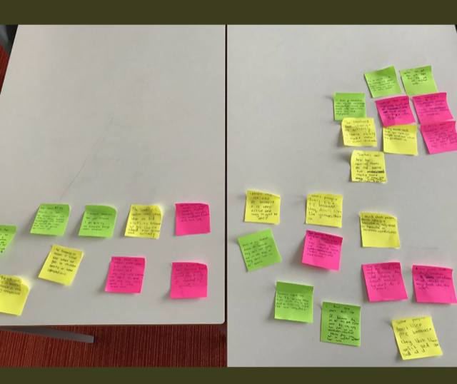
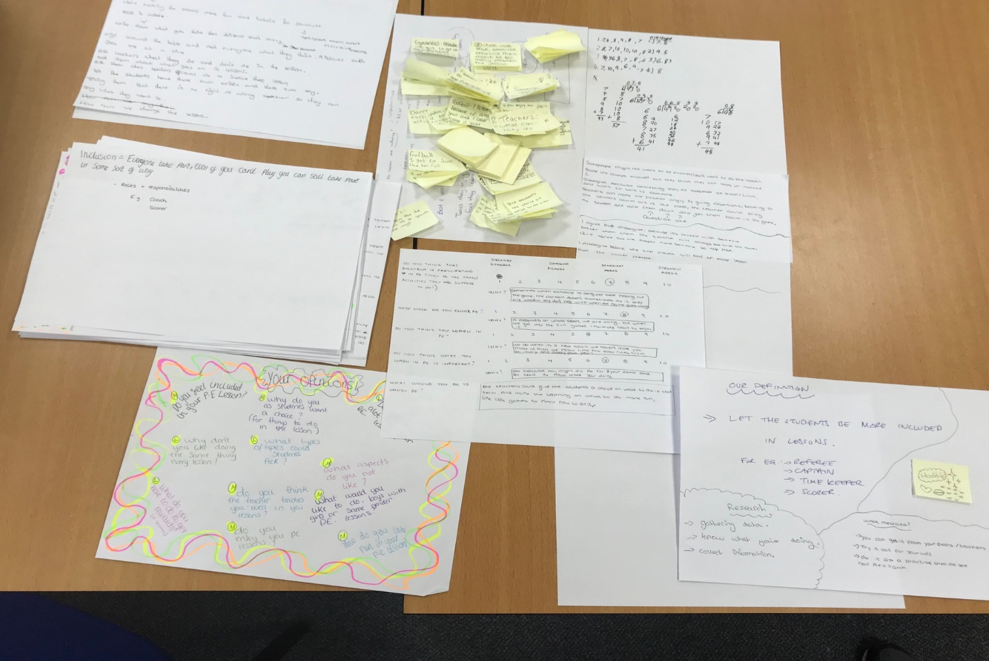
Data collection by student-researchers
Following the training day, the students collected and analysed data from their year 8 peers (i.e. classmates) under the guidance of the university researchers (December 2019) [Please note that due to an OFSTED visit to the school, the time between the training and data collection was much longer than anticipated]. Before meeting with the teachers to plan the first lesson (January 2020), university staff and student-researchers met to discuss the key findings from their analysis and the points they would like to make to the staff in the meeting so that clear aims could be identified.
Baseline data by student-researchers
Key findings included the following:
- Overall, year 8 students (peers) already held very positive opinions of PE; PE was perceived to be highly inclusive to a high degree;
- Students enjoyed having roles within PE lessons, in line with the sport education model already experienced this academic year and which was found to be a very popular, naturally inclusive approach to PE;
- The way the teachers use questions could have an impact on the inclusivity of a PE lesson. One specific strategy suggested was that teacher should not rely on the same students who tended to put their hands up all the time.
These clear points facilitated a positive collaborative lesson planning meeting with staff and student-researchers in which pupils were clearly listened to by the teachers as part of a two-way dialogue.

Research Lesson #1
A university researcher, alongside four of the student-researchers (all female) observed the first research lesson, taught by the male PE teacher to a group of 25 year 8 pupils (including the two student-researchers who participated in the lesson). The other PE teachers-members of the working group were unable to observe this (or any of the three research lessons) due to teaching and other commitments.
This was the second lesson on hockey, an activity which, according to the female student-researchers who observed the lesson, was not the most popular activity amongst the year population. The teacher designed the lesson around the sport education model, as recommended by the student-researchers in the planning phase. Sam informed us that he would pick the groups so that they would be balanced but then students could select their own pre-ordained roles within the group. Students could also make decisions over the content of the lesson. Specifically, in the first part of the main lesson which involved skill training in the SE groups, the groups decided the skills they wanted to work. A number of options was offered (e.g., passing, dribbling, shooting etc.). Skill coaches from each team were called in and the teacher explained that although they will choose a skill, they could deviate from the suggested activities.
At the end of the lesson, the researcher met with student-researchers to prepare for the planning meeting. There was agreement that the following aspects of the research lesson 1 worked particularly well: (1) Sport Education was indeed an effective tool to make lessons inclusive. Roles made all students feel part of the team; (2) Overall, students felt they learn and progressed in their skills; (3) The teacher’s overall approach made a difference as interactions with Sam made them feel motivated to learn and valued; (3) The idea that students had choice of tasks / skills was perceived very positively, as the lesson was tailored to their needs.
In terms of the specific strategies that could be implemented in the second research lesson, the student-researchers asked to have a go at having a choice over tasks, as they had never experienced it. Some ideas that were suggested by the students were not appropriate or feasible and staff took care to explain why some ideas could not be implemented, for example such as logistical reasons for not being able to do Uni-Hoc in an outdoor setting; or having a mixed gender lesson as the third research lesson. Another suggestion by the students was a rule that everyone should touch the puck before a shot could be taken. Teachers explained that this would be difficult to action and very few shots would end up being taken. Instead, they suggested a rule of three passes before a shot or a designated pupil who was less confident could be enlisted to take any restarts to help them feel included.
The actual planning session with the working group did not take place at the end of the day as planned as teachers to attend urgent meetings (related to student welfare, after-school clubs, trips etc.). The key messages from the meeting with student-researchers was passed on to Sam.

Research Lesson #2
A researcher, alongside six student-researchers observed the second research lesson, taught by Kate to a group of approximately twenty-two year 8 girls (including the three student-researchers who participated in the lesson).

The second research lesson was Uni-Hoc taught by Kate. Again, the Sport Education model was used due to its positive perception of being inclusive. Student-researchers’ notes were positive about the lesson, recording that; the tasks were short and sharp which kept students engaged, the teacher offered very clear explanations so that all students understood her expectations, the competition element of the lesson was fair and balanced and that the rules of umpire, timer and analyst were effective in promoting an inclusive climate. It was noted that the same students were volunteering to take additional responsibilities in the lesson and that the same students were responding to Kate’s questions to the class. This was therefore an aspect that needed further development.
In the planning and reflection meeting afterwards, it was felt that the lesson was both fun and inclusive by the student-researchers. They also stated that in the third lesson to be delivered by Kathy, they would like to see her challenge the students that were not volunteering for roles or to answer questions and that this could partly be ameliorated by having a ‘hands down’ policy when asking questions to the class.

Results
Impact on teachers (and their PE lessons)
All three teachers reported that their involvement in the project had increased their awareness of IPE and had an impact on their practices. Primarily, the project allowed all three staff to (re)position the issues of inclusion center stage during planning; and to ensure that various approaches to inclusion underpinned lesson activities:
‘In terms of the project, it has made me question ‘Am I doing enough to make sure that all the kids are included?’, so it has made me think a bit more about my planning (Teacher Kate).

The issues students raised not only confirmed that the PE provision in this school was of high quality but also brought to the teachers’ attention new ideas that they had not previously considered. Kate claimed that student voice ‘opened up our eyes’ (Teacher Kate) to new ideas such as using a ‘hands down’ policy when questioning the class so that all students can be encouraged to participate in discussions and to share their views. Sam acknowledged that listening to his students during collaborative meetings enabled him to develop a much better understanding about what they really thought about PE and his lessons:
‘It has certainly been valuable because I can go with what I think the students appreciate or enjoy whilst learning PE…but unless you involve them in the process, you are not going to actually know what they like’ (Teacher Sam).

Although lessons were judged to be of an already inclusive standard by the students in the data collection phase, all staff acknowledged that they could further improve on this. For instance, being more flexible with the use of the Sport Education (SE) model, using a ‘hands down’ questioning policy, and teaching students to be the masters of their own differentiation within a lesson, were examples of approaches to inclusion that the PE teachers were hoping to embed in their lessons. Specifically, the value students placed on choice also made Sam think of giving them more ownership in making their own differentiations, an approach that had not been considered before:
‘I am considering using the STEP (Space, Task, Equipment, People) model - and I have laid the foundations today - so the next time I see them they can use it for when they are leading their parts for the warm up or the activity, they will start to differentiate even more with the tasks’ (Teacher Sam).

Student-researchers agreed that the lessons had become more inclusive as a result of the project. Changes implemented were small albeit significant:
‘It changed the lessons a little bit, not loads, but little snippets of it have been improved, like the roles and stuff, that helped people get more involved in the lessons, and if we didn’t do that, I think there would be more people feeling less included’ (Student Lucy).

All teachers believed that the Inclusive Inquiry will have a longer-term impact on their department and the school as they have realized the potential of using student voice in a different, novel and much more empowering way:
‘Student voice is very powerful, not only in PE, but to shape future practice across the school. ….One of the key things is getting the students to collect the students’ voice because it is a far more honest opinion’ (Teacher Kate).
Impact on students
Teachers reported that students had really enjoyed taking part in the project and particularly enjoyed finding out the views of their peers through interviews and questionnaires:
‘They have loved interviewing, that’s what they have spoken about the most and getting other peoples’ views on our PE lessons’ (Teacher Kathy).

Student-researchers appreciated the opportunity to learn from and reflect on the three different ways the three teachers delivered PE:
‘I was learning from researching in the lessons. When we were outside with Sam’s lesson, people were like asking about the rules and I didn’t know them so they were showing me stuff and I thought that’s really nice, I already like that. And when they were moving around, their hand to eye coordination, I thought that was really interesting.’ (Student Lucy).

Student-researchers also felt that the processes they engaged in enabled them to better understand how other people think and that viewpoints vary (and that such diversity should be understood and respected):
‘I got more patient and it helped with my brain and helped me to learn because I know other peoples’ viewpoints and I know I can change how I act around people who maybe don’t like PE as much as I do’ (Student Lucy).

Teachers and students also noted that through increased responsibility of being involved in the project, and particularly the data collection and lesson planning stages, the student-researchers had developed various skills, including leadership and communication skills, with one teacher commenting that the students appeared very proud of their work:
‘I think they have felt quite proud by having their clipboards and working with you guys as well’ (Teacher Kate).

‘I have seen the passion in them going out and observing lessons, talking to other students, moving out of their comfort zone’ (Teacher Sam).

All students reported that they appreciated having the opportunity to view lesson planning through the eyes of staff, and to better understand the complexity of teaching and learning:
‘They have been allowed to see from a different view, not just turn up, do your PE lesson and go…., it’s turn up, understand and see where the subjects are at and look at things from a more mature approach (Teacher Kate).

Finally, a consistent finding was that being involved in the project had developed students’ levels of confidence having had the opportunity to speak to peers, staff and researchers:
‘They have been so inspired that we have chosen them to do something like this and given them this kind of responsibility, they have absolutely loved it’ (Teacher Kathy).

‘We talked to people, so we spoke out and I have been more confident in that’ (Student Jack).

‘I have learned how to try to make things change and I am more confident because I am not a very confident person’ (Student Ashleigh).

Enablers to Inclusive Inquiry implementation and impact
A key enabling factor in this school was that all three PE teachers involved valued the opportunity for feedback from their students and had very positive attitudes towards their involvement in the project. All students were also highly committed and approached the project in a very positive and mature manner. All student-researchers felt that the opportunity to incorporate student voice in such a way was a powerful tool in improving the quality and inclusivity of PE lessons. Part of the success of this was attributed to the students being responsible for collecting the data, rather than the staff. Student-researchers felt pupils would be more likely to give an honest opinion to a fellow student in contrast to a teacher.
‘Other people don’t like PE and you have got to find out why they didn’t like it’ (Student Lucy).

‘I don’t think students want to go up to a teacher and say what they think they should be doing’ (Student Maddison).

The training stage was considered to be effective and useful by the students with comments such as ‘it was interesting’ (Pupil Maddison) and ‘it was really helpful because we had not done anything like this before’ (Pupil Ben). All student-researchers of differing academic abilities agreed that the university-led training was appropriately pitched and challenging. Furthermore, all students felt that they had been listened to by their teachers during the collaborative lesson planning stage. The approach by staff was conducive to this being effective in asking the students what they thought or could suggest and also explaining in a respectful way why certain ideas could not be implemented. This was felt to improve teacher and student relationships and enabled students to be realistic with their suggestions.
Students reported that the data collection phase added value to the project because it allowed them to accurately capture the thoughts and opinions of their peers.
‘I felt as though that actually helped to finding out how PE lessons could be changed in a better way because we found the general idea of how the PE lessons were going currently’ (Student Ben).

Both staff and students reported that having students collect the data from their peers was a major factor in eliciting honest and insightful comments compared to a staff-led student voice initiative as this allowed increased honesty and confidence amongst the student population (i.e. peers would feel in communicating with student-researchers). Although the mean score for inclusivity of PE lessons was high during the data collection, students recognised the need for continual improvement and reflection on the efficacy of PE lessons and seemed to feel proud of their achievements in contributing towards this: ‘I felt like the teachers took in what we were saying’ (Student Maddie).

Barriers to Inclusive Inquiry implementation and impact
Given the busy nature of schools and the various commitments that PE teachers have to extra-curricular and whole-school activities, it was not possible to have all staff and students present at every lesson planning meeting. Some students were also involved in extra-curricular activities such as performing arts rehearsals. As a consequence, in this school, it was not possible to implement all aspects of Inclusive Inquiry in full.
The need for further time to carry out project related activities was a consistent barrier to project implementation. Specifically, students reported that they would have appreciated more time to be set aside for interviewing their peers in the data collection phase. They felt that they would be able to obtain more detailed responses in formal one-to-one interviews where there would be fewer distractions, although they acknowledged that this would be time consuming. The data collection was a slight issue for some of the students in that the environment was not as quiet or as structured as they would have liked to fully engage some of their peers.
‘Sometimes they [students they interviewed] wouldn’t listen and went off talking by themselves’ (Student Ashleigh).

A suggestion to remove this barrier was to look at completing the data collection in more classroom-based settings where peers may see this as a more formal activity, thus improving the quality of the data (the interviews took place in the school’s library). To facilitate project implementation, students also suggested that the training stage of the project should be as close as possible to the data collection stage so that they can clearly remember the key points from that session and implement them effectively.
‘Me and Ashleigh forgot what we were doing because the training had been quite a long time ago, but I think when we got into it, we remembered’ (Student Maddison).

For one teacher, the timing the Inclusive Inquiry is implemented is important, arguing in favour of conducting the observations / research lessons at the start of a unit of work so it would be a more natural time to implement changes and new ideas.
‘So the roles, you can’t maybe have all the roles you wanted at the start of a unit. For example, if we had the meeting before the start of handball, we would go from that straight away and not throw it in halfway’ (Teacher Kathy).

Furthermore, an interesting point was raised by Kathy regarding an issue that other schools may experience. School A’s PE lessons received a high initial score for inclusivity from the data collection and Kathy commented that although staff in School A felt confident in leading inclusive lessons, other PE departments may not feel so confident in delivering IPE and may benefit from having IPE modeled to use this as a basis for improvement.
‘I think if we were in a school where it was lower, me as a teacher, I would benefit from seeing an inclusive lesson or what students considered an inclusive lesson because I already know how these guys teach’ (Teacher Kathy).

Case study school B
As a result of being involved with the Inclusive Inquiry, all three teachers reported positive impact on their practices, including a reconsideration of groupings, use of questioning, and overall planning. All student-researchers articulated personal and technical benefits ranging from improved levels of confidence and empathy to enhanced levels of knowledge of how to conduct research. Although they welcomed the idea of student voice as a tool for feedback and enhancing pedagogy, teachers questioned whether it would be better to use older students as student-researchers.

School Background
School B was an academy free school of just over 700 students located in a large city in the West Midlands. The school was highly varied in terms of the different ethnicities of students. The number of students eligible for free school meals and those considered to have special educational needs were above the national average and rising. Inclusion was a priority of the school and there was a specific SEND policy and inclusion section on the school’s website. In 2018, the school was rated ‘good’ in all areas by Ofsted, which was its first inspection. At the time of the research, the PE department did not formally use student voice to inform practice.

Inclusive Inquiry implementation
University-led training
Inclusive Inquiry was implemented over a four-month period, beginning with the university-led training (October 2019). Students interacted positively with their teachers in the first hour of the training day and were able to confidently give answers on their thoughts of what inclusion was. Ideas of how to collect the data were discussed with the students and they tested a questionnaire, interview and mixed method during the training session. Questions were refined and checked for relevance to the research question before the students eventually decided on a questionnaire consisting of eight items consisting of Likert scale responses and more open-ended questions to allow respondents to contribute more detailed answers where appropriate.

Data collection by student-researchers
Students collected and analysed data from their year 8 classmates under the guidance of the university researcher (December 2019). Data was collected from half of the year group in the sports hall at the start of a PE lesson and student-researchers monitored made themselves available to answer any questions that their peers had. The data was analysed immediately afterwards. The student-researchers worked in their groups of three and used data codes and tally charts to record the responses. The three groups then brought their data together to give overall results. A useful task to assist with this was to use a blank copy of the questionnaire to record an overview of the results that could be used at the meeting with the teachers to clearly present the results.

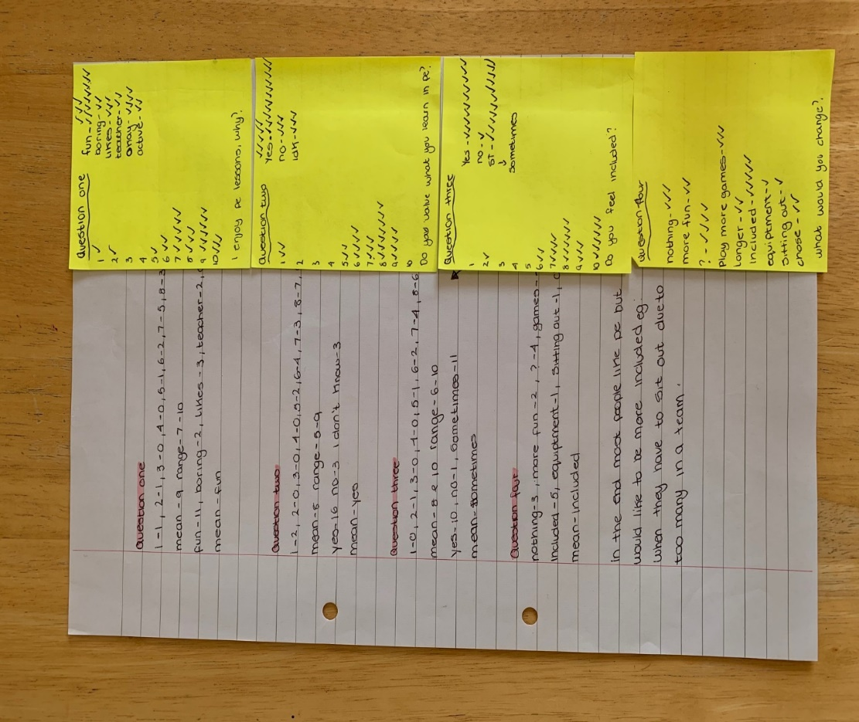

Baseline data by student-researchers
In School B, students’ response to the perceived enjoyment and inclusivity of PE lessons varied. The average score for enjoyment and perceived inclusivity of PE was around 70%, with multiple responses at both the top and bottom end of the scale. Evidence collected by the student-researchers suggested that their peers thought the main reason for taking part in PE was for health and fitness purposes. The type of activity was found to be a reason for not liking PE and that not equal attention was being given to students during lessons. Positive facets of PE lessons identified included working as a group, effective demonstrations and opportunities for competition. Interestingly, around 20% of the peers who completed the student-researchers questionnaire did not appear to know what inclusion was, with many other answers being very simplistic in their nature, such as ‘including people’. When asked how teachers could make lessons more inclusive, the main responses included allowing students to pick their own groups (i.e. people who can work with), spending a greater proportion of the lesson active and giving choices of activities.
A meeting was held prior to the first lesson, attended by all the teachers and the student-researchers. During this meeting, the student-researchers summarized the main findings from the questionnaire. Following a discussion with Ross (who was due to deliver the first research lesson) and the student-researchers, it was decided that the focus would be on including opportunities for group work, including both cooperative and competitive tasks, and sharing the teacher’s focus on to different students. The student-researchers highlighted that the data showed that their peers enjoyed competition as a mechanism for experiencing a ‘fun’ lesson and Ross gave some suggestions as to how he could implement this into the warm-up and the first task in the handball lesson. The planning was highly collaborative with plenty of reference to the research findings.

Research Lesson #1
A researcher, alongside six of the student-researchers observed the first research lesson, taught by Ross to a group of 25 year 8 pupils (including the three student-researchers who participated in the lesson). The other PE teachers-members of the working group were unable to observe this (or any of the three research lessons) due to teaching and other commitments.

The first research lesson was not implemented as planned. A lesson had been planned on handball, but this was changed at the last minute due to poor weather. Instead, a fitness lesson was delivered and Ross had to think on his feet about how he could implement the ideas of the students. Group work and competition were included in the same task. Ross organised the students into groups based on their school house and collectively, they had to keep score of their physical efforts on each station before feeding back their cumulative totals at regular points. Some student-researchers commented that this was inclusive because everyone had a role to play in the combined total of the group, although some felt having a choice as to who they could work with would have been preferable. In this instance, teacher selection of the groups was a better method as it allowed for the groups to be balanced in terms of capability. Student-researchers also commented that it was clear that Ross was sharing his focus during questioning, where he picked different pupils each time to answer questions.

Research Lesson #2
A researcher, alongside six of the student-researchers observed the second research lesson, delivered by Rebecca to a group of 25 year 8 pupils (including the three student-researchers who participated in the lesson). The lesson took place in the sports hall and aimed to improve flight through the medium of trampoline and gymnastic-based work.

In addition to the inclusive strengths of Ross’ lesson that had been highlight by student-researchers, they also proposed that demonstrations were effective in helping pupils learn. Discussions in the planning stage with Rebecca led to this being part of her planning, and she said she would pick different students who would volunteer to demonstrate. During the lesson, very few demonstrations took place. Student-researchers also proposed that students be allowed to select their own groups. Once this was implemented, it was deemed by both Rebecca and the observers to be unsuccessful. The lesson was regularly disrupted by poor behavior by students due to the friendship groups students were in, and Rebecca felt that if she had more control over the selection of the groups, student behavior would not have been so much of a problem. A further contributor to the off-task behavior was the use of iPads. Although Rebecca had introduced this to give students more defined roles and responsibility, students were often found to be misusing the iPads instead of using them for their purpose of analysis.

Research Lesson #3
A researcher, alongside six of the student-researchers observed the second research lesson, delivered by Carly to a group of 24 year 8 pupils (including the three student-researchers who participated in the lesson). The lesson took place in the assembly hall and was the first lesson in a new block of work in table tennis.

Groupings had formed a key part of the planning meeting before the final lesson. One student-researcher gave the suggestion of allowing pupils to work with a partner of their choice, but when they went into groups of four, the teacher would select the other pair that they would join with. This was an excellent suggestion by the student-researcher after having considered the findings of the data collection and observing groupings in previous lessons. In Carly’s lesson, this method of grouping was trialed. Observations of the lesson concluded that this had facilitated improved levels of student behavior and it could be useful in some activities and circumstances, but consideration should be given to the similarity of the ability level of the pairs who are joining up to make a four. Another student-researcher suggested trying ‘tiered demonstrations’ to support less able and challenge more able. Carly planned for this in her table tennis lesson and student-researchers noted that this was an effective tool in promoting IPE as it allowed pupils of different ability levels to access the work due to the differentiated approach.

Results
Impact on teachers (and their PE lessons)
Staff perceptions of the project were largely positive with regard to the impact on staff and students, although to a lesser degree than School A (as explained in the ‘Barriers’ section). All teachers reported that it was useful to have a mechanism for student voice specific to PE, as this had the potential to bring unique insights into students’ thinking.
‘I think the overall concept of using student voice is a successful one because the students can tell you what they enjoy and what they don’t.’ (Teacher Ross)

‘I think sometimes you can get stuck in your own opinions and you don’t really get other peoples’ views and I think getting the opinion of the kids is one of the most beneficial things – they knew you would be going into their lessons doing things that they want to do’. (Teacher Rebecca)

The three teachers reported positive impact on them in slightly different ways. Ross reported that his involvement in the Inclusive Inquiry project helped him improve the relationship between him and the student-researchers in that he had started to learn about them as a person and as a student.
‘I think me as a person and as a teacher, I get to see a different a perspective of them’ (Teacher Ross).

Both female teachers described the positive impact the project has had on their planning by drawing more attention to every task being inclusive for students.
‘I think the project has definitely made me think a bit more about my inclusive practice and when I am planning, I have now got that at the forefront of my mind in making sure that every child can access the learning (Teacher Carly).

It was reported that the feedback provided by the student-researchers allowed all teachers to reconsider their planning and provide fresh ideas, which would have a positive impact on the quality of lessons. Specifically, trialing new grouping methods has provided a tool that Carly felt that she could use in future. A student-researcher suggested that allowing students to pick a partner to work with before being assigned to another pair by the teacher would be a more effective grouping method in comparison to just working with friends or the teacher dictating all members of the group at all times. Finally, teachers were also unanimous in agreeing that one positive impact was on their use of questioning as a tool for IPE.
‘I like the ‘think, pair, share’ idea so everyone should then have an answer. I would take that forward’ (Teacher Carly).

Impact on students
Both staff and students reported benefits to the students as a result of being involved in the project. Staff reported that the students had enhanced their evaluative skills by explaining their reasoning in meetings with staff, demonstrating good levels of maturity.
‘The three students that I selected were mature enough to give a good view rather than just saying what is the easiest response for my friends – it makes it more valuable and is a good source of information’ (Teacher Ross).

Teachers agreed that the project had allowed students to grasp a deeper understanding of the logistics behind planning for PE lessons that teachers do. As a result of this, it was noted to be a vehicle for developing a mutual respect between staff and student-researchers.
‘It was nice to for them to see from a different point of view and pupils like Katie can get put into groups and understand why’ (Teacher Carly).

Rebecca felt that this was showcased by students ‘taking more of a leadership role in the lesson and if they know the rest of the class isn’t listening, they will tell everyone to be quiet’. Rebecca also raised the potential for the benefits to be long-lasting if the students can continue to perform a research role, particularly if they are eventually used to upskill other students.
‘They can train the next generation’ (Teacher Rebecca).

Students reported that they had developed technical skills in the form of being able to conduct research, something that none of them ever had the opportunity to develop before. Many students reported that they had enjoyed being part of the project and had improved their knowledge of inclusion.
‘I think I have enjoyed it and I think the people who have been working with me have enjoyed it’ (Teacher Zaki).

Personal skills such as improved empathy, listening and communication were mentioned by some students with the most consistent finding being improved levels of confidence as a result of speaking up in front of staff and researchers.
‘I have developed how to make people feel more included, before, I don’t think I would have thought about that. But now in PE lessons, if I see someone, I will go up to them and help them’ (Student Dior).

‘I think my courage has got better talk to people by going around asking people’ (Student Mason).

Enablers to Inclusive Inquiry implementation and impact
The project was perceived to have been enabled by staff listening to the ideas of the students in the lesson planning stage. All students reported that they felt listened to and that they had seen evidence of their suggestions being implemented by teachers.
‘They have taken my advice I have given’ (Student Katie).

A particularly good example of this from a lesson planning meeting was Carly asking the students to think about why they could not always be in a group just with their friends. This provoked some excellent responses from the student-researchers and provided a clear rationale for not choosing that method, which developed the understanding of the students in the logistics of lesson planning. Rebecca endorsed her colleague’s claim by stating that:
‘I think sometimes you do lessons and think that doesn’t work, but when they planned it as well and they saw something that didn’t work and they understood from our perspective why it didn’t work and what could be improved’ (Teacher Ross).

This was echoed by the students:
‘I think that the reflection and planning meetings were the best part in the whole thing – it made us have an input in our lessons because the teachers don’t always see things from our perspective, so it made become way better’ (Student Dior).

Student-researchers valued the training stage, articulating that this provided clarity and direction for the forthcoming project.
‘…before that I did not know how to collect data’ (Student Alana).

Additionally, many student-researchers reported that a key enabler of the project was that it was the students collecting data from their peers and not the staff or university performing the data collection, as they felt that the responses from the peers would be more honest. This had consequently a positive impact, as genuine issues arisen by students came to the fore and were discussed in the lesson planning stage. In the interviews, many students commented that this could be an effective approach to use in the future in PE and across the whole-school, creating a sustaining and wider-reaching impact for the school.
‘If the data collection is with students, then they are more comfortable, but if you are doing it with your PE teacher, you might want to hide your real feelings’ (Student Alana).

Barriers to Inclusive Inquiry implementation and impact
Although staff valued the opportunity to listen to students’ suggestions about how to make their lessons more inclusive in the planning stage, there was the suggestion that some of the ideas generated by students were not useful in addressing inclusivity, perhaps due to a lack of knowledge.
‘I think the idea of more training would be beneficial because it helps students select the areas and give that feedback better’ (Teacher Ross).

One teacher suggested that year 8 students are not sufficiently qualified to provide feedback to professionals in comparison to trained teachers who have more experienced at evaluation and reflection. To address this issue, more attention could be drawn to examples in the training stage without wanting to stunt the opportunity for students to be creative in their suggestions. Using year 10 students was also proposed as a potential alternative.
‘Maybe if it was year 10, especially because year 10s are a bit more mature, they haven’t quite got their GCSEs yet, some of them are a bit less engaged in sport, with them it may get them a bit more switched on’ (Teacher Rebecca).

Logistically and organisationally, implementation was challenging due to the busy nature of teachers and timetabling constraints, as summarized by Rebecca.
‘It can be just so busy and it is difficult to find the time to get everything done and I think sometimes it can be a bit of a mish-mash’ (Teacher Rebecca).

Students did not want to regularly miss the same PE lesson each week, so consideration should be given to this in the planning stage of future projects.
‘I think that the pupils have missed quite a bit of core PE through the project’ (Teacher Carly).

A further suggestion was to consider the activity being the same for all three observed lessons so that it would be easier to track changes and the efficacy of proposed suggestions.
‘I think maybe if it was one activity we would have seen it progress through’ (Teacher Carly).

In contrast to School A where there was a mixture of interviews and questionnaires, School B opted for an 8-item questionnaire. It was felt by students and some staff that the completion of this could have been in a quieter and more formal setting rather than on benches in the sports hall at the start of a PE lesson. Students felt that their peers would take this more seriously in a classroom setting and this would also mean that their answers would have a higher likelihood of being confidential.
‘Many people were writing silly stuff on it so I don’t know if that actually helps because not everyone knows what it’s about, so they write random things in (Student Neremiah).

‘I think trying to get more things done on a day and using longer days to do it rather than lots of little days may have been a bit more beneficial use of your time. It’s tricky because school is just manic’ (Teacher Rebecca).

Conclusion

Main findings
Building on previous publications (e.g., Messiou & Ainscow, 2018), we have started documenting the benefits of this process to teachers and students-researchers. We have observed that student-researchers are able to produce rich data within the available short timeframe, given the established rapport with their peers. There is evidence that student voice can stimulate reflection and the development of new thinking amongst teachers.

Impact on teachers
- All PE teachers argued that student voice was a powerful mechanism for professional development as this had the potential to shed unique insights into students’ thinking.
- As a result of being involved in the project, all PE teachers were able to identify changes in their current practices, including a reconsideration of grouping strategies, a more meaningful use of questioning, increased opportunities for student choice, and a more focused attention to inclusion during planning.
- In school A, the Inclusive Inquiry was believed to have a longer-term impact on their department and the school as the teachers realized the potential of using student voice in a different, novel and much more empowering way.
- The fact that a bottom-up approach was used to recruit School A appears to have been of significance as all three teachers displayed persistent conviction for the value of student voice.
Impact on student-researchers
- All student-researchers articulated a range of benefits ranging from improved levels of confidence and empathy to enhanced levels of knowledge of how to conduct research.
- Teachers and students also noted that through increased responsibility of being involved in the project, and particularly the data collection and lesson planning stages, the student-researchers had developed various skills, including leadership and communication skills.
Enablers and barriers to implementation
- Enablers to implementation included: (i) teachers’ positive attitudes towards student voice (i.e. valuing, listening and responding to student voice); (ii) students’ positive perceptions about the importance of the project and the extent to which they have been listened to by their teachers; (iii) student-researchers’ commitment to - and mature engagement with - the project; (iv) student-researchers’ responsibility for collecting and making sense of data – the data collection phase added value to the process because it allowed students to elicit the thoughts and honest opinions of their peers and to feed these back to the teachers; (v) high-quality and appropriately pitched university-led training
- Barriers to implementation included: (i) partial and inconsistent implementation of certain aspects of the Inclusive Inquiry (i.e. planning meetings were cancelled due to other commitments and PE teachers were unable to observe the research lessons); (ii) teachers’ negative perceptions about the value and potential contribution of student voice; (iii) logistical and organisational constraints (e.g., timetable) that did not permit teachers to fully engage with all aspects of the project; (iv) limited time and unsuitable environment for student-researchers to collect high-quality data; (v) big time lapse between key aspects of the project (e.g., training to data collection, data collection to research lessons); (vi) concerns over the missed PE learning time for student-researchers; and (vii) untargeted timing of implementation of research lessons that does not permit implementation of all ideas/suggestions.

Recommendations
For schools
- The implementation of the Inclusive Inquiry is a feasible and potentially powerful strategy for professional development.
- To move practice forward, however, the approach needs to be implemented consistently following all key steps and principles.
- Organisation support is required to enable teachers overcome potential barriers (e.g., timetable) that prevent them from engaging with the project fully.
- The teachers and schools involved need to also value and respond positively to student voice, including: encouraging students to express their views; taking into account their thoughts and reflections; educating (some of) them to have ownership of key processes, and involving them in the decision-making process.
- Training students as researchers is a key dimension. The content and quality of this training needs attention to ensure that students are adequately prepared and empowered to engage in the project fully.
- The selection of student-researchers also needs careful consideration. Avoiding selecting students on the basis of pre-determined groups/categories (and thus base the project on potentially false assumptions) is important. Rather, students with various forms of engagement and commitment in learning must be given an equal chance.
For researchers
- More research is needed in schools to monitor and capture with greater detail the longer-term impact of the Inclusive Inquiry on teachers, student-researchers, all students, and the schools’ reform process towards greater and more meaningful inclusion of all more broadly.
- Further collaborative/transformative research is urgently needed that moves beyond an understanding of experiences towards concrete and tangible actions that impact on thinking and practices within schools.

