Supplementary Tables

Table S1. *Uploaded separately as a .csv*. This table provides species-specific forest affinity measures for all species which met our sampling criteria in our analysis, stratified by bioregion. As well as sample sizes for each bioregion and for each species in a bioregion. Forest affinity values can be repeating for species, in part due to large number of observations for a species occurring from similar locations (i.e., repeated checklists from the same locations). These values are meant to provide a relative comparison, within a bioregion, of the extent a species relies on high integrity forest.

Supplementary Figures

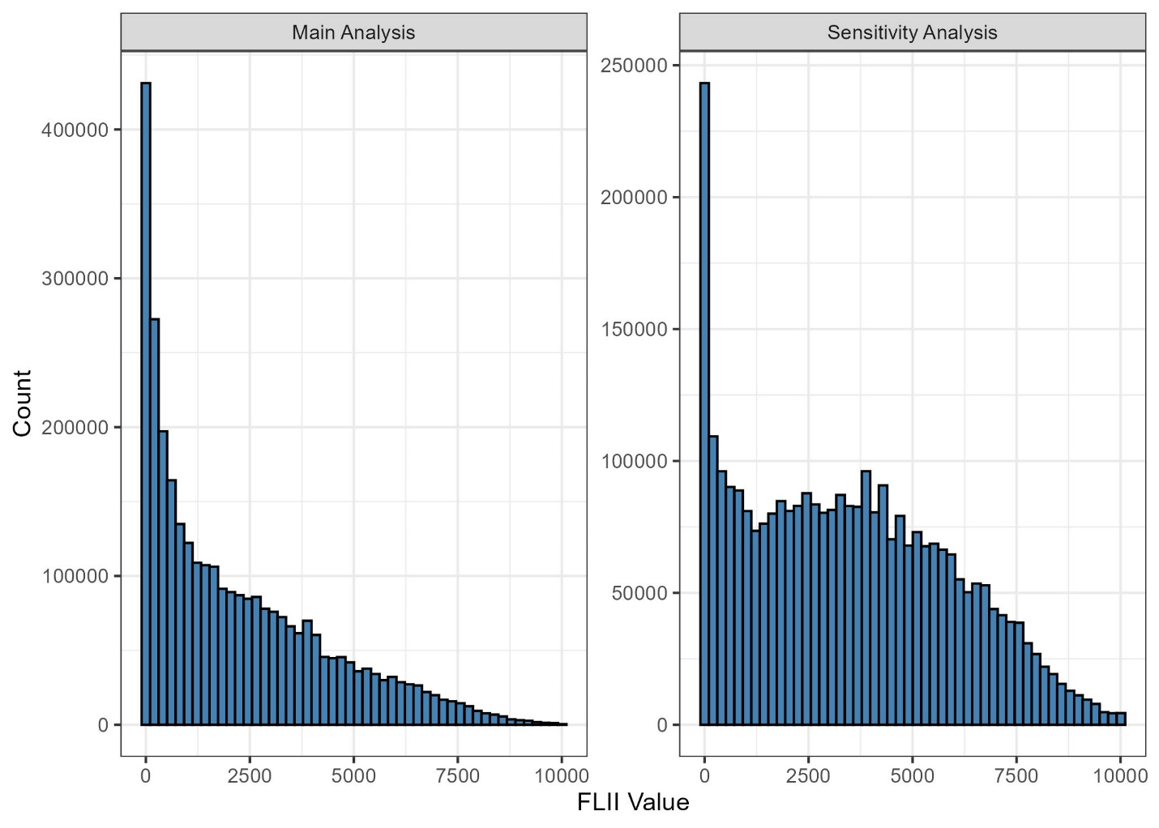
Figure S1. To test whether our results were influenced by the inclusion of non-forest pixels in our FLII calculation, we conducted a sensitivity analysis using an alternative method in which mean FLII was calculated using only forested pixels within the 1 km buffer. This forest-only FLII metric excluded all non-forest (no-data) pixels when computing the average habitat integrity surrounding each checklist. When we compared both methods for calculating FLII using a linear model, we found they were strongly correlated (estimate = 0.94, SE = 0.0004, p < 0.005, Adjusted R² = 0.67). This figure shows the comparison of FLII value distributions calculated using two methods: (left) mean FLII values including non-forest pixels coded as 0, and (right) mean FLII values calculated using only forested pixels (i.e., where FLII values are present). Only checklists that have value from both methods are displayed.
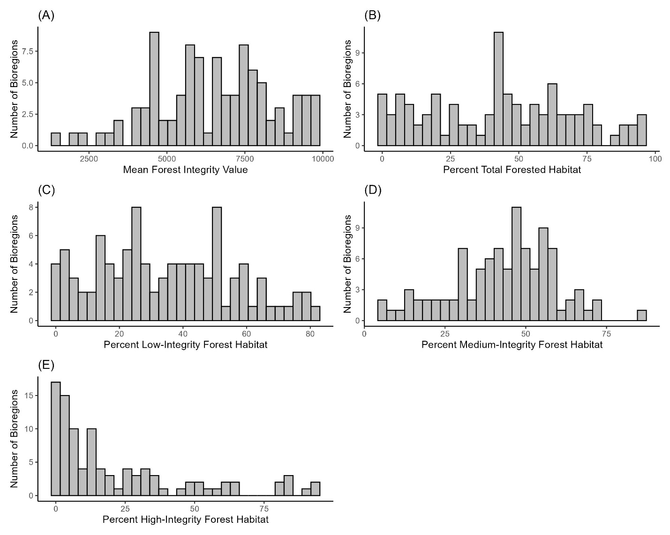
Figure S2. Exploratory analyses used to check the distribution of (A) mean forest integrity value, (B) percent total forested habitat, (C) percent low-integrity forest habitat, (D) percent medium-integrity forest habitat, and (D) percent high-integrity forest habitat from the 98 bioregions used in the all species analyses.
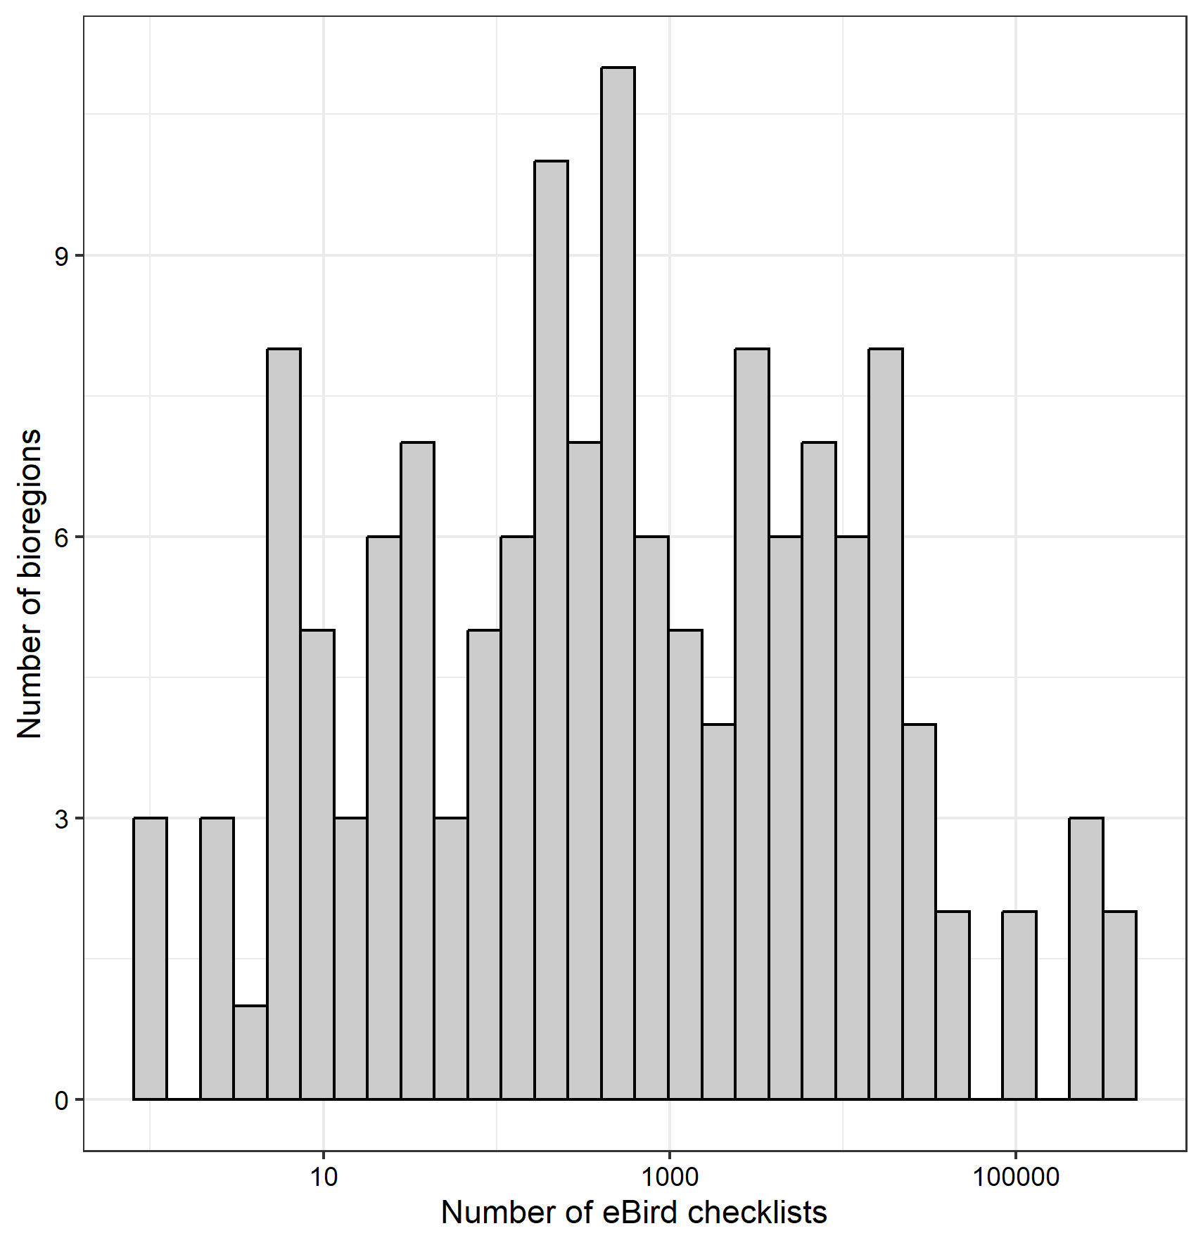
Figure S3. The number of eBird checklists for each bioregion (N=141). We used 100 eBird checklists as a cutoff as exploratory analyses showed that this was a cutoff that provided reasonable certainty of model fits. This method retained 98 bioregions.

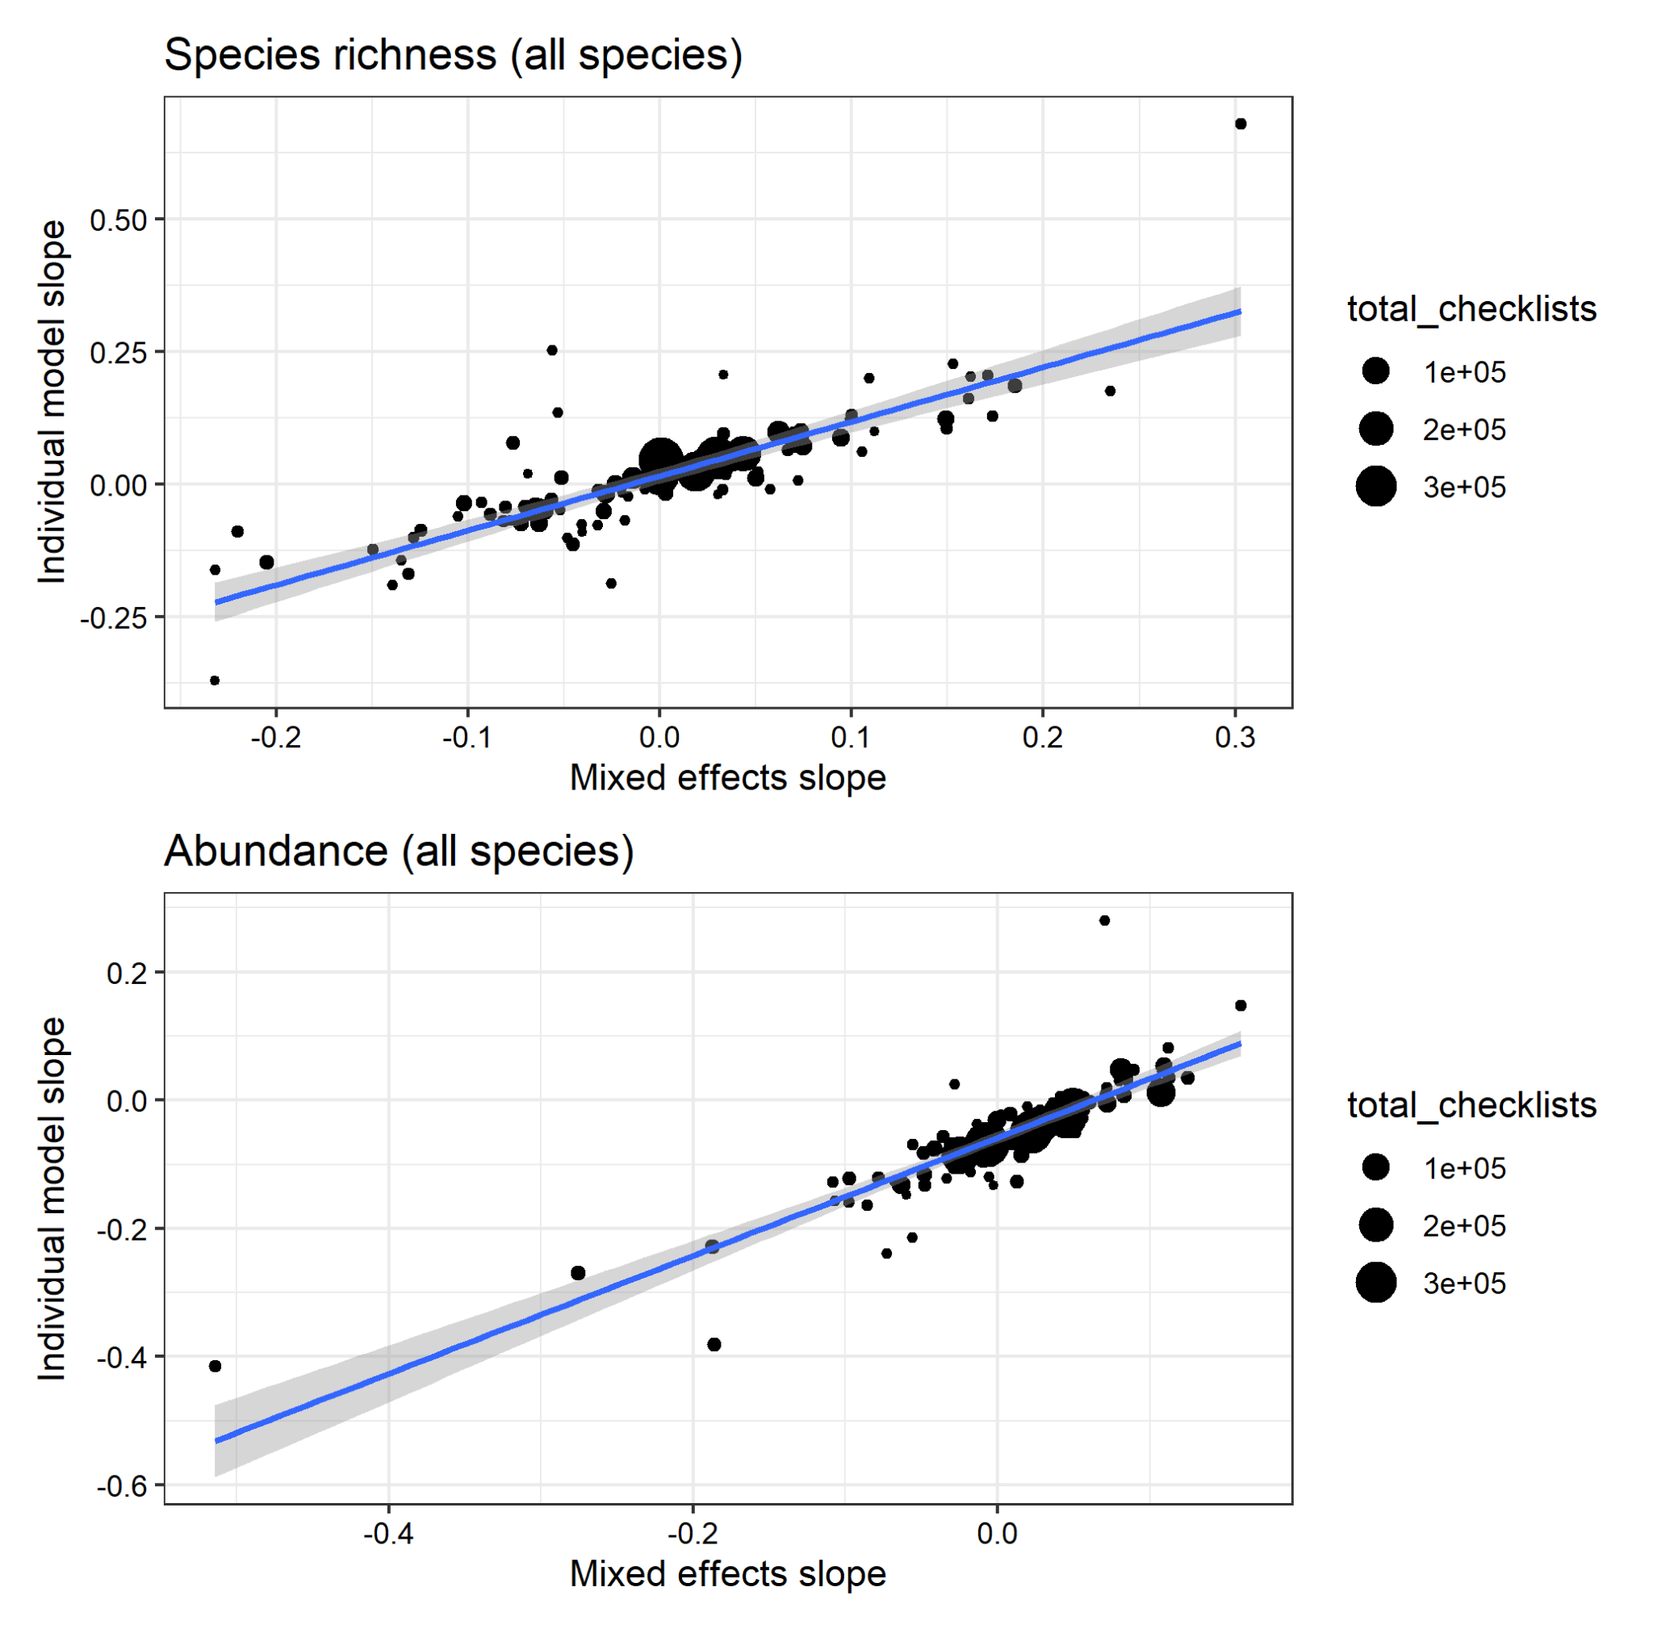
Figure S4. Results of exploratory analyses investigating differences in modelling each bioregion independently (y-axis) and our large mixed effects model (x-axis). The slopes are the response of the biodiversity variable to FLII.

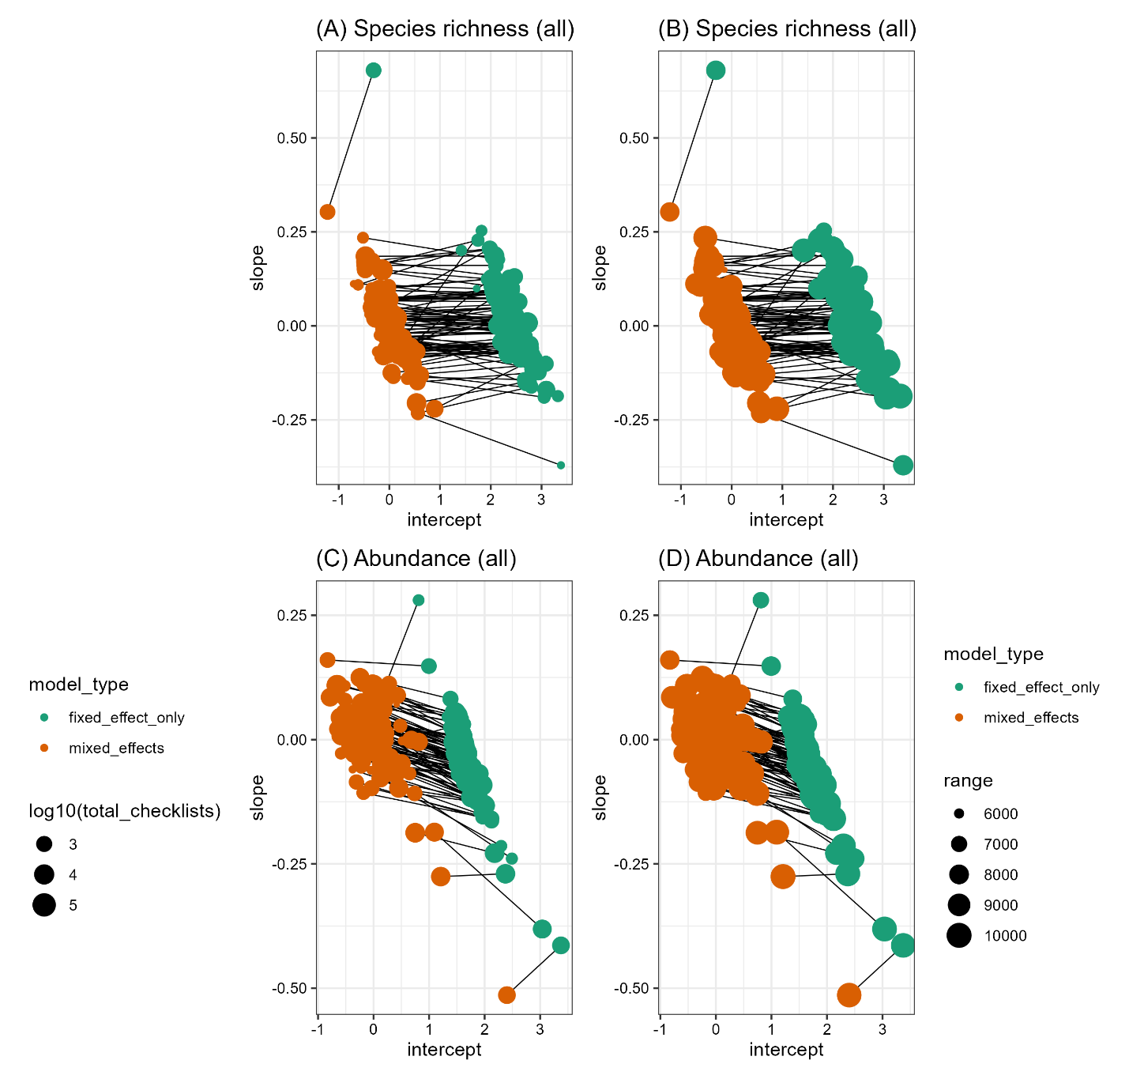
Figure S5. Shrinkage shown for the two models (the top plots represent species richness and bottom represents abundance) focused on the ‘all-species’ analysis. Green points are the intercept and slope from the fixed effect only model, where each bioregion was treated independently, and the orange points are the intercept and slope from the large mixed effects model presented throughout the main text. For panels A and C, the size of the points is scaled according to the number of checklists in a bioregion (log10-transformed), whereas for panels B and D the size of the points is scaled according to the range of Forest Landscape Integrity Index (FLII) values in a bioregion. Because there were no consistent patterns in shifts and total checklists or FLII range in a bioregion, we conclude that there is minimal shrinkage influencing the patterns of the results.

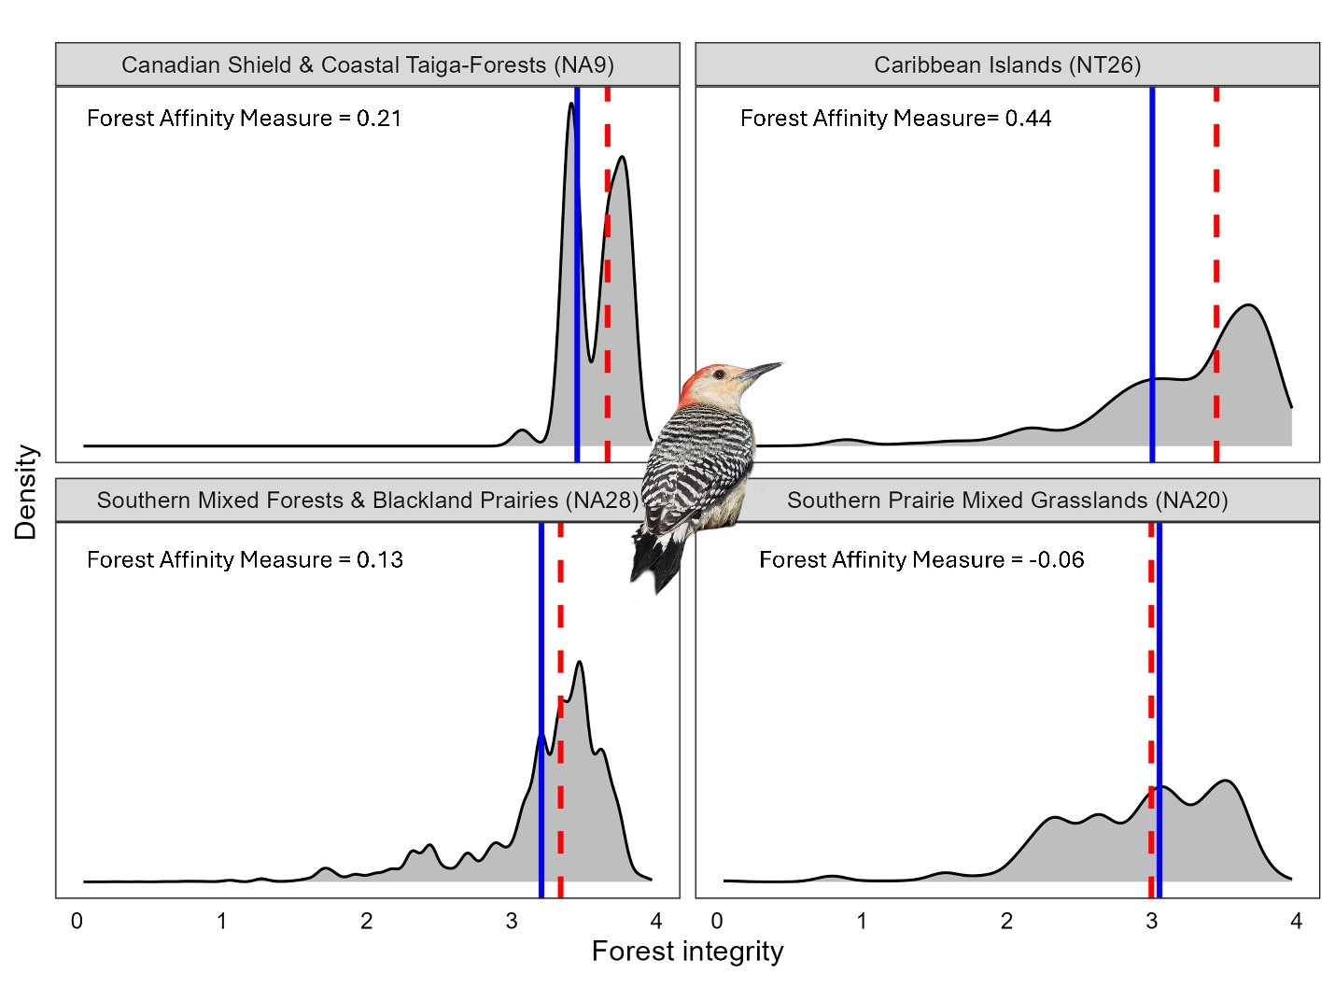
Figure S6. Density of Red-bellied Woodpecker (Melanerpes carolinus) observations by forest integrity value in four different bioregions to illustrates species-specific spatial differences in forest affinity. Forest integrity has been log-transformed. The red line represents the median forest integrity value for the Red-bellied Woodpecker, and the blue line represents the median forest integrity value of the region across all species. The difference between these two values represents the species’ forest affinity measure in each bioregion.

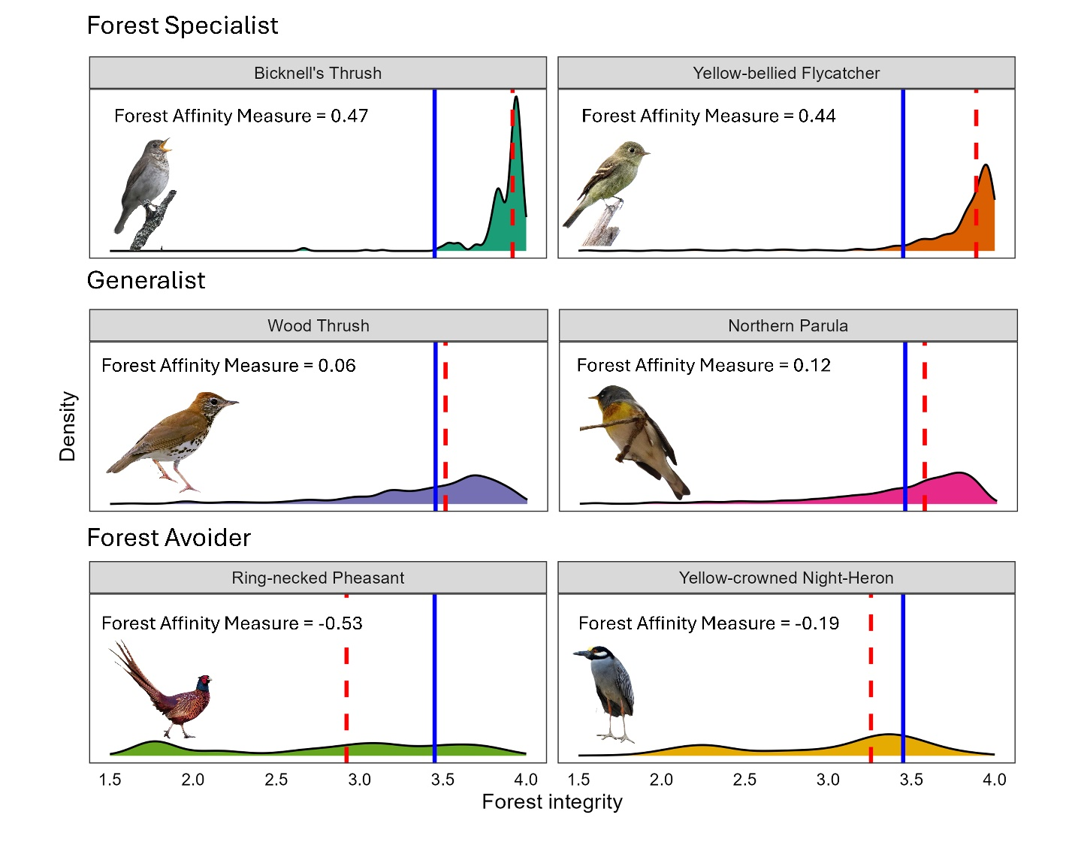
Figure S7. Density of species-specific observations eBird checklists by forest integrity value in the Northeastern American Mixed Forests bioregion. Forest integrity has been log-transformed. Outliers at the lower end of the forest integrity scale were removed from the plots for clarity; however, median values and forest affinity measures were calculated using the full dataset. The red line is the median forest integrity value for the species across all bioregions, and the blue line represents the median forest integrity value for checklists in the bioregion. The difference between these two values represents the species’ forest affinity measure. Bird images are from authors or iNaturalist under CC-BY-NC license from Simon Kiacz (Bicknell’s Thrush), Susan Elliott (Yellow-bellied Flycatcher), Ad Konings (Wood Thrush), Kurilin M S (Ring-necked Pheasant), and Roberto González (Yellow-crowned Night Heron).

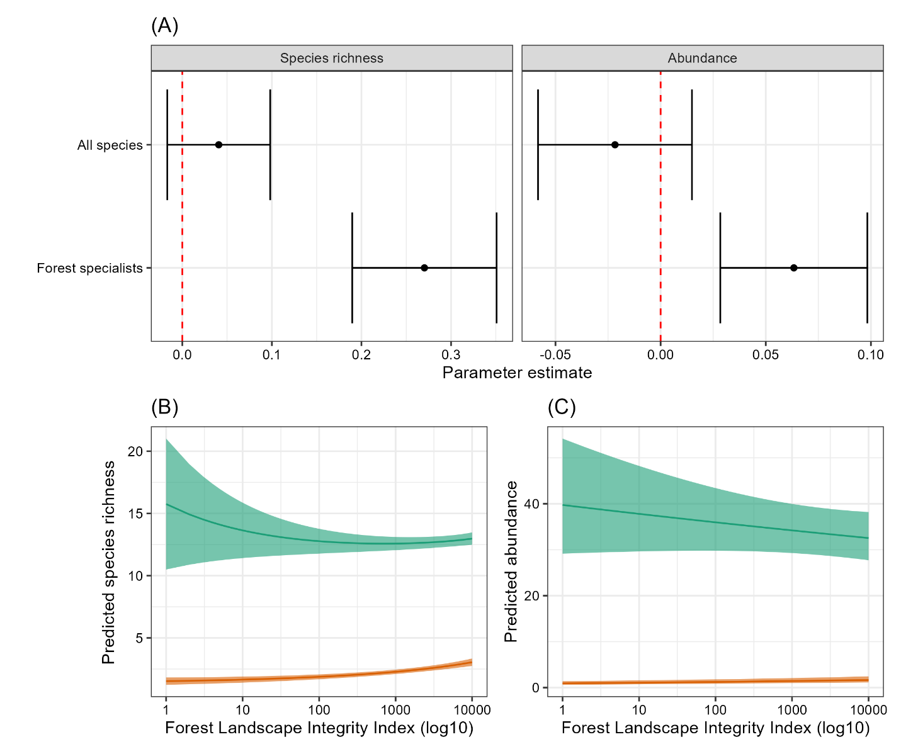
Figure S8. Using the alternate methods of calculating mean FLII (see Figure S1), we report: (A) Model parameter estimates of fixed effects for our four overall generalized additive mixed models (GAMM). (B) Predicted species richness on a given eBird checklist from our GAMM, showing a marginal increase in species richness for all species (green) and a statistically significant increase for forest specialists (orange). (C) Predicted abundance on a given eBird checklist from our GAMM, showing a statistically significant decrease in species richness for all species (green) and a statistically significant increase in abundance for forest specialist species (orange). These results are qualitatively and quantitatively similar to those reported in the main text, confirming robustness of our analysis.
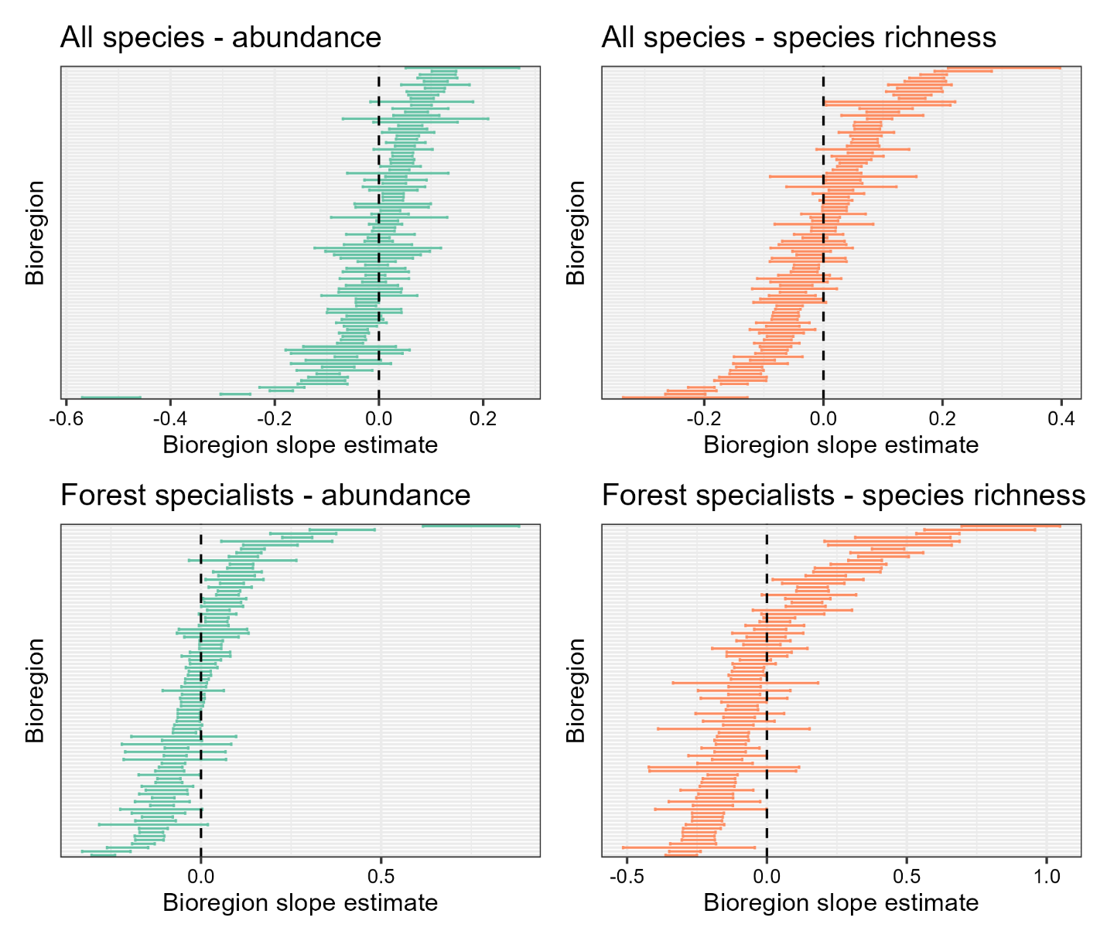
Figure S9. Slope estimates and the corresponding confidence interval for bird diversity responses to FLII by bioregion for all species abundance (top left), all species richness (top right), forest specialist abundance (bottom left), and forest specialist species richness (bottom right). Note the differing x-axes values.

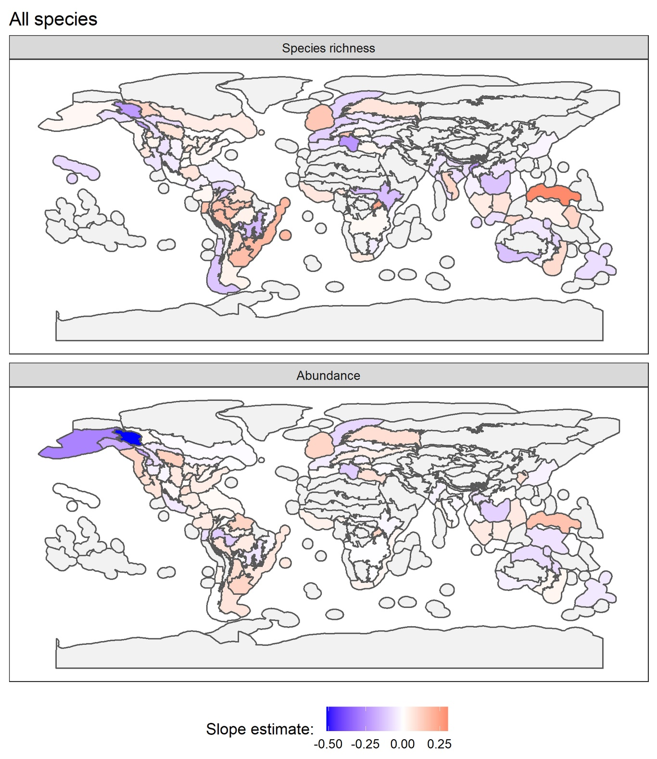
Figure S10. Variability in the relationship between forest integrity and species richness (top) and abundance (bottom) among bioregions for our generalized additive mixed models (GAMM) fitted for all species on a given eBird checklist. The values represent extracted slope estimates from the respective models for each bioregion.

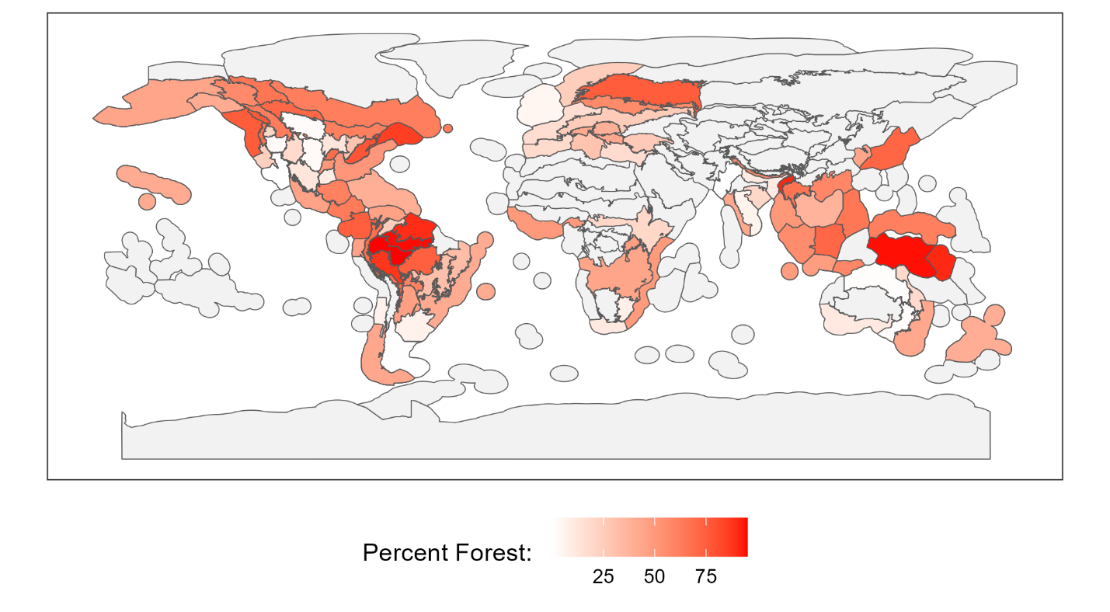
Figure S11. Percent of forest cover by bioregion.

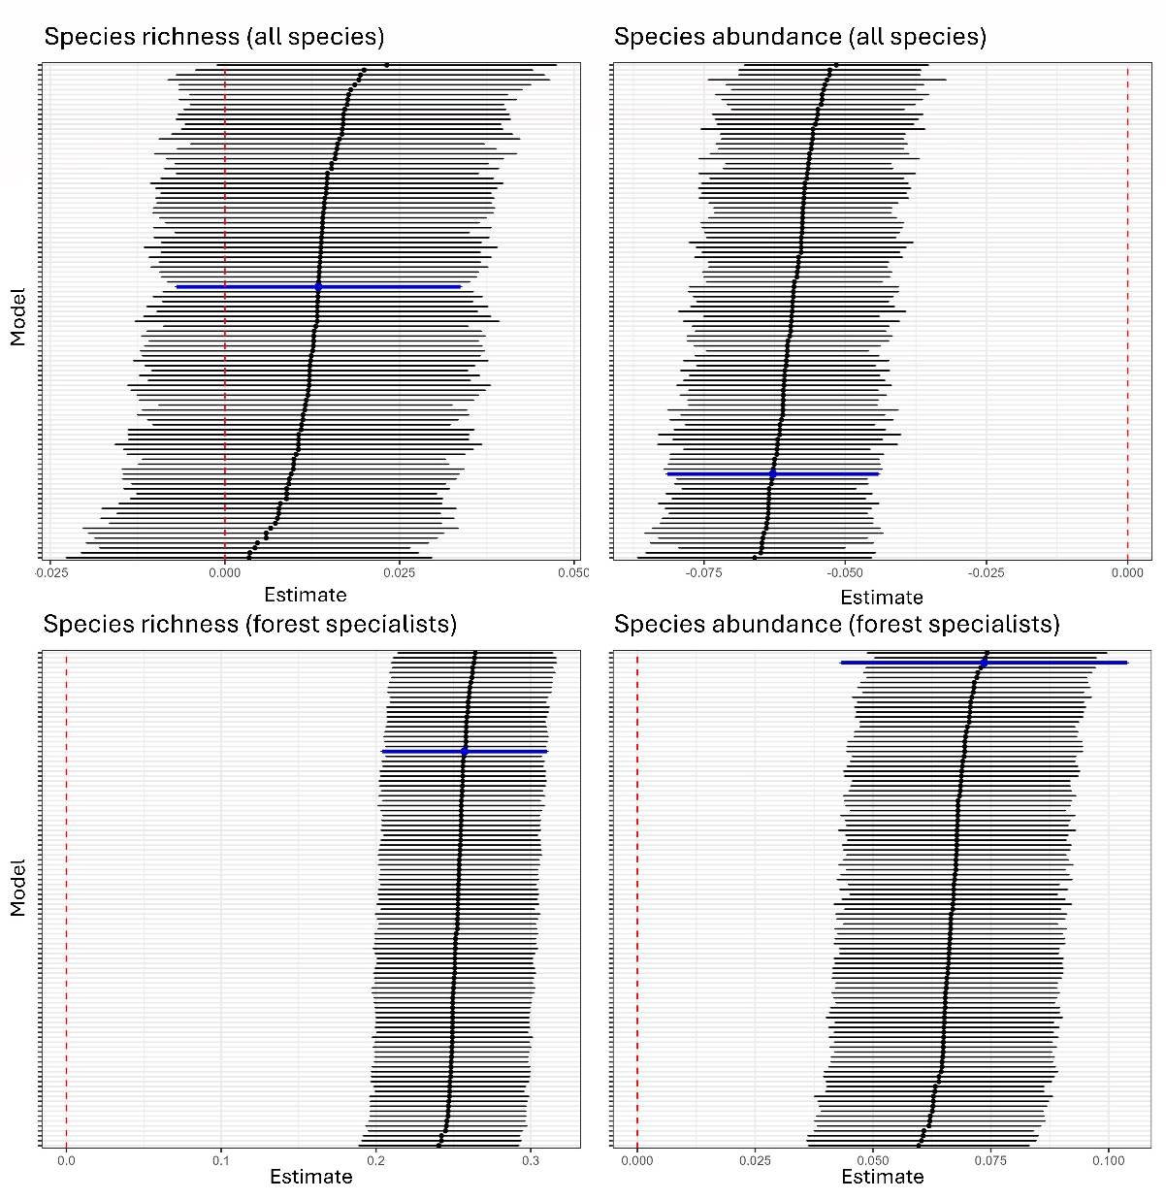
Figure S12. Sensitivity analysis of sampling effort across bioregions. To test whether unequal sampling effort among bioregions biased our results, we conducted a sensitivity analysis in which sampling effort was standardized across regions. Specifically, for the 68 bioregions with ≥500 eBird checklists, we randomly subsampled 500 checklists and reran our generalized additive mixed models (GAMMs) 100 times for each response variable: (A) species richness (all species), (B) species abundance (all species), (C) species richness (forest specialists), and (D) species abundance (forest specialists). Each horizontal line represents the model coefficient and 95% confidence interval from one subsampled run. Black lines indicate estimates from the equal-sample models, while the blue lines show the coefficient estimate from the full dataset (i.e., using all available checklists). The vertical red line marks zero (no effect). Results demonstrate that coefficient estimates from the equal-sample models closely matched those from the full dataset across all four analyses, confirming that variation in checklist numbers across bioregions did not bias the overall conclusions.

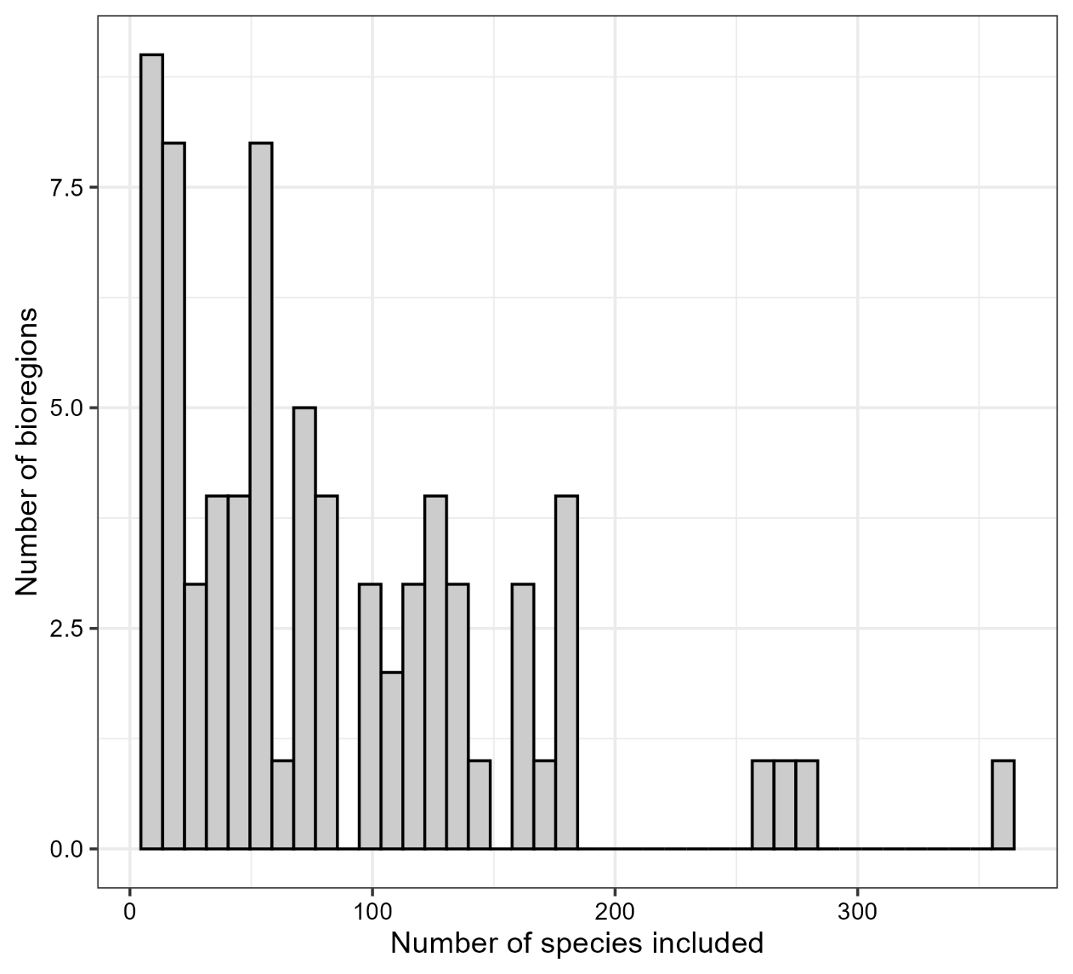
Figure S13. The number of species (N=1,745) that use forest habitat included per bioregion (N=74) in our species-specific affinity score analysis (Objective 2). The mean number of species included per bioregion was 85 ± 72.

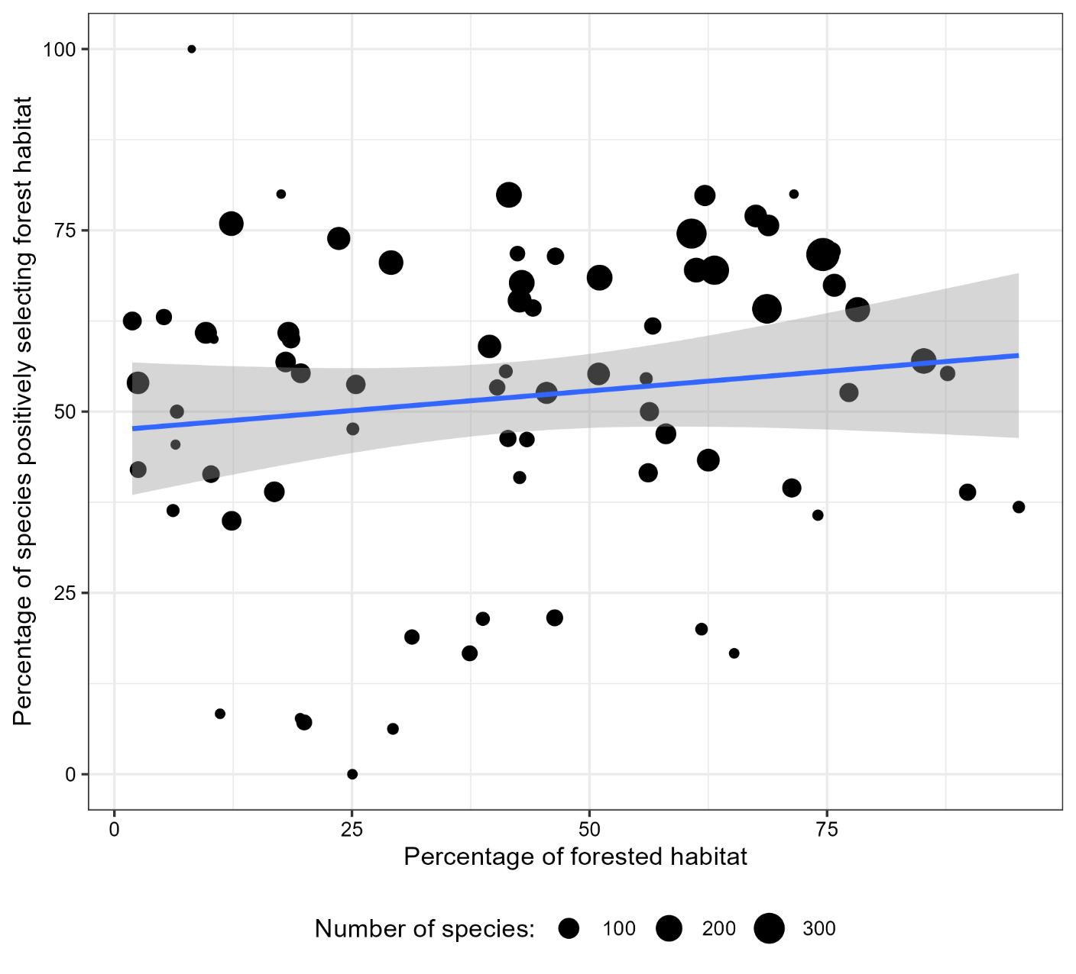
Figure S14. The percentage of forest species positively associated with high forest integrity habitat in a bioregion (y-axis) and the percentage of forested habitat in a bioregion (x-axis) showed some evidence of positive correlation, but this relationship is not significant (Estimate=0.108, SE=0.097, p-value=0.27). Each point represents a bioregion, and the number of species in a bioregion is represented by the size of the point.

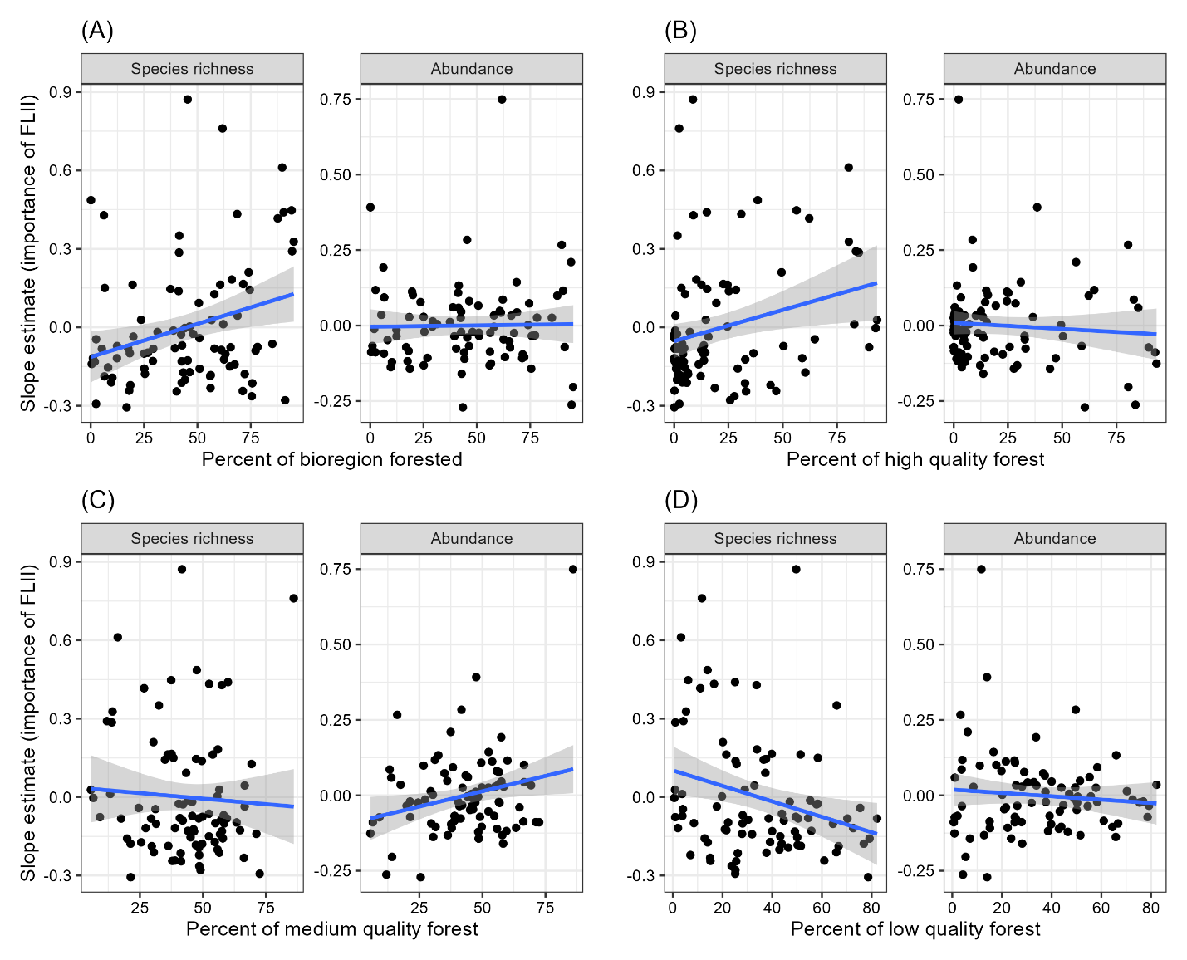
Figure S15. Post-hoc analyses of forest specialists. For forest specialists, we found a significant positive relationship between the percent of bioregion that is forested and the importance of forest coverage on species richness (estimate=0.002, t value=2.709, p-value=0.008; Figure 4A), but no significant relationship on the importance of forest coverage on abundance (estimate=0.000, t value=0.163, p-value=0.871; Figure 4A). For high-quality forest, there was a significant positive relationship by importance of forest coverage on species richness (estimate=0.002, t value=2.509, p-value=0.014; Figure 4B), but no significant relationship by importance of forest coverage on abundance (estimate=0.000, t value=-0.720, p-value=0.474; Figure 4B). For medium-quality forest, there was no significant relationship by importance of forest coverage on species richness (estimate=-0.001, t value=-0.537, p-value=0.593; Figure 4C), but there was a significant positive relationship by importance of forest coverage on abundance (estimate=0.002, t value=2.313, p-value=0.023; Figure 4C). For low-quality forest, there was a significant negative relationship by importance of forest coverage on species richness (estimate=-0.003, t value=-2.602, p-value=0.011; Figure 4D), but there was no significant relationship by importance of forest coverage on abundance (estimate=-0.001, t value=-0.822, p-value=0.413; Figure 4D).

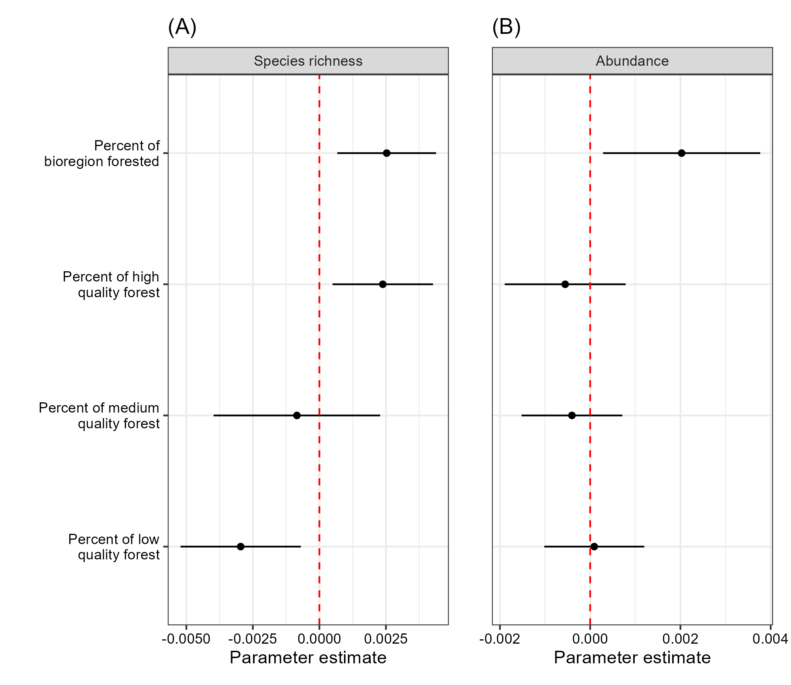
Figure S16. Linear model parameter estimates of percent forest, percent high quality forest, percent medium quality forest, and percent low quality forest for forest specialists.

