Abstract
Aim: Efforts to retain and restore forest integrity — the degree to which a forest’s structure and function are not modified by humans — are increasingly underpinning global biodiversity conservation efforts. However, there is still much uncertainty around how species respond to changes in forest integrity. Geographically variable responses would have consequences for conservation planning assessments and targeted conservation action. Our goal was to quantify the relationship between forest integrity and bird diversity.
Location: Global; 98 bioregions.
Time Period: 2017-2020
Major taxa studied: Birds
Methods: By integrating global-scale spatially explicit forest landscape integrity data with a citizen science bird dataset, we provide the first empirical assessment of the relationship between forest integrity and bird diversity.
Results: We found that both species richness and abundance of forest specialists had a positive association with integrity. However, the relationship between forest integrity and bird diversity varied across bioregions, with bioregions at low latitudes tending to have more positive relationships between forest integrity and species richness. Of the 74 bioregions assessed, 64% had more than half of their species favoring high integrity forests.
Main conclusions: These results support calls for the targeted protection of the world’s remaining high-integrity forests but also showcase that consideration must be given to restoring forest integrity where possible.

Keywords: birds, bird diversity, forest integrity, forest landscape integrity index, species richness, species abundance

Introduction
Worldwide, natural forests are being lost at alarming rates (Seymour and Harris 2019). In addition, forest degradation from anthropogenically induced disturbances is affecting forests in their capacity to support ecosystem functioning and biodiversity (Bullock et al. 2020), and even surpass deforestation as the predominant threat (Matricardi et al. 2020; Bourgoin et al. 2024). Recent estimates suggest that only about 40% of forest cover, globally, has high ecosystem integrity remaining (Grantham et al. 2020). Forests with high integrity, or intactness — for instance, those forests largely free from anthropogenic modification — provide greater ecosystem services such as carbon sequestration (Lewis et al. 2009) and climate regulation (Bonan 2008). High-integrity forests are also thought to be essential for biodiversity, and important for both increased biodiversity levels and for conservation success (Barlow et al. 2016; Betts et al. 2017; Watson et al. 2018). Quantifying the relationship between high-integrity forests and biodiversity — and how this relationship might change geographically — is crucial to inform conservation strategies and ensure their continued protection. Indeed, several global initiatives (e.g., The Bonn Challenge or the Plant a Billion Trees campaign) promote forest restoration at a global scale, and ambitious state-led targets have been set to increase forest area and condition. Characterizing the likely outcomes of such efforts will help ensure efficient targeting.

Previous global analyses that have sought to quantify the relationship between biodiversity and forest quality have relied on categorical analyses, for example by comparing biodiversity in ‘primary’ and ‘disturbed’ forests (e.g., Gibson et al. 2011), while other approaches have used range maps to overlay species’ presences with forest-loss data (e.g., Betts et al. 2017). While such approaches clearly advance our understanding of the impact of forest degradation and deforestation on biodiversity, they potentially miss the local-scale idiosyncrasies in how organisms use forested habitats of variable quality. A more nuanced understanding of how biodiversity responds to forest integrity, for example, along a continuous gradient of low-integrity to high-integrity forest, is needed for better understanding of the relationship between forest integrity and biodiversity. Further, there are geographic differences in forest integrity (Grantham et al. 2020), and it is possible that biodiversity responses to changes in forest integrity also vary among regions as they do for other pressure-state responses (Di Marco et al. 2018; 2019).

Both community-level metrics (e.g., species richness or abundance) and species-specific measures are necessary to quantify the relationship between forest integrity and biodiversity (Pillay et al. 2022). Frequently, species are classified a priori according to their use of forest habitat, for example, as ‘specialists’ (Burivalova et al. 2014; Boulanger et al. 2018), or sometimes as ‘non-forest’, ‘forest-optional’, or ‘forest-exclusive’ (Betts et al. 2017). Such classifications can limit the capacity to generalize across species’ responses as they assume that all species within a group respond equally to forest integrity (Edwards et al. 2010). Continuous measures, where a species is ranked based on its reliance on high integrity forested habitats, could clarify our understanding of the continuum of species-environment relationships in response to forest integrity.

Here, we integrated global-scale citizen science data from eBird with the forest landscape integrity index (Grantham et al. 2020) to empirically quantify the relationship between forest integrity and bird diversity. We had two specific objectives, focused on community-level variation and species-specific associations with forest integrity (Figure 1). First, we quantified how much bird diversity changes (i.e., species richness and abundance) along a gradient of forest integrity. We quantified these patterns using all recorded species and then repeated these analyses after filtering to forest specialist species, as well as tested if, and how, the relationship between forest integrity and bird diversity changes geographically throughout the world. To identify those species most at-risk of high-integrity forest loss in the future and issues with imposing categorical land use affinities onto species, our second objective quantified and ranked species-specific affinity to high integrity forests.

Methods
Bird data
We used the eBird citizen science dataset (eBird basic dataset: ebd_vrs_May2020) to quantify bird diversity at forest locations across the world (Figure 1). eBird is the largest citizen science project, globally, with more than 1 billion bird observations (Sullivan et al. 2014). eBird is a semi-structured project where volunteer birdwatchers submit bird observations in the form of ‘checklists’ and declare whether they recorded every species they were able to identify — in other words, an indication of checklist ‘completeness’. In addition to the spatial coordinates of the sampling location, sampling effort indicators are submitted, including the duration and distance travelled while recording. Regional filters are applied to check unusual bird observations, whereby records of birds that are outside of their known range are reviewed by experts prior to being added to the database (Gilfedder et al. 2019). To minimize potential biases of ‘outliers’ on the influence of bird diversity, we subsetted the eBird dataset to checklists that: (1) were declared complete; (2) wherein observers remained stationary; (3) conducted by one observer; (4) that lasted between 5 and 240 minutes in duration; and (5) contained abundance estimates for every species. Only eBird checklists conducted between January 1st, 2017 and December 31st, 2020 were used in the analyses in order to temporally match our measure of forest integrity (see below).

Forest integrity
To quantify the forest integrity surrounding each bird survey (i.e., eBird checklist) we used the Forest Landscape Integrity Index (https://www.forestintegrity.com/; Grantham et al. 2020).
The Forest Landscape Integrity Index (hereafter FLII) was constructed based on four main data inputs: (1) forest extent (mapped for 2019), (2) observed pressures (e.g., infrastructure, agriculture, tree cover loss), (3) inferred pressure based on proximity to the observed pressures, and (4) degree of forest connectivity. The FLII is mapped at 300 m spatial resolution (Grantham et al. 2020), scaled between 0 (highly modified forest) and 10 (highly intact forest) for the mapped 2019 forest extent (non-forest areas have no data values). However, in our use of the dataset, these values are scaled by a factor of 1,000, resulting in an integer range from 0 to 10,000, to reduce the size of the raster files. All our analyses and visualizations used this scaled version, with model predictions from 1-10,000.

We aggregated all stationary checklists to assign a FLII value with a 1 km buffer. This 1 km buffer allows for aggregation of the FLII and any potential spatial mismatches between the eBird observations and a measure of the nearby landscape. Our analysis was only focused on forested landcover, and therefore any eBird checklist which had no forested pixels within the 1 km buffer was excluded from further analysis. For each buffer that had some forested pixels, we recoded non-forested (i.e., no-data) pixels within that buffer to 0. This means that within each buffer, all non-forest values were assumed to be 0 before taking the mean FLII. This approach assumes that non-forested areas do not contribute to forest integrity, allowing us to generate a continuous measure of forest-specific habitat integrity across all potential eBird checklists. For example, for a record that was obtained within a forest of good habitat condition, but in a forest edge, then the mean habitat condition for that “buffer” will consider all the pixels that were not forest (as a 0 value), giving that record a relatively low mean FLII value. Importantly, we did not restrict the analysis to buffers that were entirely forested as many 1 km buffers contained a mix of forest and non-forested pixels. These methodological decisions were made to ensure we limited our scope of inference to forested landscapes and the interpretation of our results should be focused on forested landscapes and forest integrity. To test whether our results were influenced by the inclusion of non-forest pixels in our FLII calculation, we conducted a sensitivity analysis using an alternative method in which mean FLII was calculated using only forested pixels within the 1 km buffer. This forest-only FLII metric excluded all non-forest (no-data) pixels when computing the average habitat integrity surrounding each checklist. When we compared the methods for calculating FLII using a linear model, we found that they were strongly correlated (estimate = 0.94, SE = 0.0004, p < 0.005, Adjusted R² = 0.67), and the distribution of FLII values was similar between the two methods (Figure S1). We also fit additional models (see below for more details) to test the sensitivity of this methodological approach.

Objective 1: Diversity responses to forest integrity
For each eBird checklist, we derived the following two response variables: (1) species richness (i.e., the sum of all species observed on that checklist); and (2) total abundance (i.e., the sum of all individuals of all species on that checklist). Importantly, our measure of total abundance was treated as a measure of relative abundance (Callaghan et al. 2024), from checklist to checklist, where the same biases are systematic across space and time for eBird. While detectability varies depending on habitat structure (e.g., reduced visibility in dense forests compared to open areas), our approach mitigates sources of variation by filtering for complete, stationary checklists from single observers within a standardized effort range of duration. Moreover, common sources of bias in eBird data — such as observer skill, survey duration, and weather conditions — are expected to be randomly distributed across the gradient of forest integrity (i.e., between high- and low-integrity forest sites). As a result, we assume that relative detectability biases are generally consistent across space and time, allowing for meaningful comparisons of relative abundance between checklists. However, we acknowledge that there remains some variation in detectability, but we believe our large sample size helps sample over this variation to allow for ecological interpretation.

We derived our response variables twice: first, using all species, and second, focusing only on species classified as ‘forest specialists’. We defined forest specialists as those species whose primary habitat is listed as forest in the IUCN Habitat Classification Scheme — a standardized system used by the International Union for Conservation of Nature (IUCN) to describe species’ habitat associations (https://www.iucnredlist.org/resources/habitat-classification-scheme) — and which have a narrow habitat breadth (i.e., assigned to only one habitat type), following Burivalova et al. (2014). While the scientific names of most species were consistent between the IUCN and eBird taxonomic trees, we manually reviewed the few species that were misaligned and corrected scientific names where applicable. For the ‘all-species’ analysis, we also removed any checklists that had <4 species to avoid the influence of rare species being added on single-species lists (Szabo et al. 2010; Walker and Taylor 2017). However, for the ‘forest-specialist analysis’, we did not use this cutoff to preserve as much data as possible, given the smaller sample size inherently necessary for this analysis. Further, each eBird checklist was assigned to a bioregion (https://www.oneearth.org/bioregions-2020/) to investigate the differences in the relationship between bird diversity and FLII throughout the world. Exploratory analyses found a wide range of values for mean forest integrity, percent total forested habitat, percent low-integrity forest habitat, percent medium-integrity forest habitat, and percent high-integrity forest habitat in bioregions, enabling us to effectively compare and summarize trends in bird abundance and species richness at a macroecological scale (Figure S2). Only bioregions with a minimum of 100 eBird checklists were included in modelling to ensure models converged and provided meaningful results (Figure S3).

We used generalized additive mixed models (GAMMs) to quantify the relationship between FLII and bird diversity (Wood 2017). Models were fitted with random intercepts and slopes for bioregions, to allow for the variations in bird diversity-FLII relationships across the world. Specifically, we included one random effect for bioregion (capturing differences in baseline species richness) and a second random effect for the interaction between bioregion and mean forest integrity (allowing the effect of forest integrity on species richness to vary among bioregions). Exploratory analyses comparing slopes obtained from mixed-effects models and separate models for each bioregion showed minimal shrinkage effects on the parameter estimates and was not correlated with any variables of interest in the FLII predictor variable (Figure S4 & S5). We used a cubic regression spline — penalized by the conventional integrated square second derivative cubic spline penalty (Wood 2006) — to account for the nonlinear influence of survey duration on both species richness and abundance. Additionally, our models included a thin plate regression bivariate spline for longitude and latitude to incorporate the spatial nonindependence of the eBird checklists directly into the modelling process. Models were fit using a restricted maximum likelihood estimation (REML). Model performance was evaluated using diagnostic plots, including residuals versus fitted values, Q-Q plots to assess normality, and histograms to examine the distribution of residuals. Based on these diagnostics, we modeled species richness using a Poisson distribution. For abundance, we applied a log10-transformation and used a Gaussian distribution, as this combination yielded better model fits during initial assessments. We transformed our model outputs to visualize our predictions of abundance on the additive scale (e.g., Callaghan et al. 2024). Models were fitted using the ‘bam’ function from the mgcv package (Wood 2004; 2011; 2017) in R and were treated the same for both the ‘all species’ and ‘forest specialists’ models. To assess model goodness-of-fit, we examined the adjusted R² and deviance explained for each model. The species richness models had an adjusted R² of 0.185 and explained 20.6% of the deviance. The species abundance models showed a lower fit, with an adjusted R² of 0.083 and 8.39% deviance explained. For forest specialist species richness, the adjusted R² was 0.175 with 19% deviance explained, while the forest specialist abundance model had an adjusted R² of 0.155 and explained 15.5% of the deviance.

To visualize overall fixed effects that represent the global relationship, averaged across all bioregions, we predicted our response variables (i.e., species richness and abundance) along a continuum of FLII from 1 (minimum) to 10,000 (maximum). To understand how the relationship between bird diversity and FLII varies across bioregions, our model allowed for the strength of this relationship to differ by bioregion (i.e., random slopes). We extracted these bioregion-specific estimates (i.e., slopes) from the model, which reflect how strongly bird diversity is associated with FLII in each bioregion. Post-hoc analyses were then explored that treated the parameter estimate for each bioregion as the response variable, and predictor variables were the percent of total forested habitat, percent of high-integrity forest habitat, percent of medium-integrity forest habitat, and percent of low-integrity forest habitat. To do this, the FLII was classified into low, medium, and high integrity using threshold values of <6000, ≥6000 and <9600, and ≥9600 following Grantham et al. (2020).

Objective 2: Species-specific measures of forest integrity affinity
Because species vary in their responses to forest management (Edwards et al. 2014), our second objective was to provide a descriptive continuous measure of species-specific forest affinity. This forest affinity measure is used to rank species, in a relative fashion, along a continuum from those that are heavily dependent on high integrity forests to those that are more generalist in nature to those that actively avoid high integrity forests (see Figure 1). We adopted the approach of Callaghan et al. (2019; 2020a; 2020b) which was used to calculate urban affinity across a range of species. To calculate forest affinity for each species, we took the following steps: (step 1) overlay all species’ observations (i.e., positive detections) with FLII values; (step 2) calculate the median of this distribution of FLII values (Figure S6 & S7); (step 3) calculate the median of all FLII values for each bioregion; and (step 4) take the median for each species (from step 2) and subtract the bioregion-specific FLII median (from step 3). This then provided a species-specific forest affinity measure for each species within each bioregion, when sampling criteria were met. This calculation was stratified by bioregion because of (a) the differing levels of forest habitat among bioregions and (b) the method requires some level of regional stratification (see Callaghan et al. 2021 for further discussion). Higher relative forest affinity measures (i.e., positive values) indicate a relatively higher proportion of a species’ observations in more high integrity forested areas (i.e., increased forest affinity) and conversely, lower relative forest affinity measures (i.e., negative values) indicate a lower relative proportion of a species’ observations in high integrity forested areas (i.e., decreased forest affinity). These forest affinity measures are relative to one another, and only interpretable within a bioregion due to the overall level and cover of forest integrity differing by bioregion.

To be included in this analysis a species had to have a minimum of 10 observations in a bioregion. Additionally, this was done only for the species that use forest habitats to some extent, as defined by the IUCN habitat classification – all other species were excluded. This set of species is broader than the subset of forest specialists used in Objective 1, including any species listed as using forest habitat in the IUCN habitats classification, regardless of habitat breadth or whether forest is their primary habitat. This broader definition focused on species that use forest to some extent allowed us to capture species with varying degrees of forest association. Importantly, this was a descriptive exploration to provide a comparative raking of species’ forest affinity. Although we do not provide uncertainty measures for each forest affinity measure, the approach has been externally validated for similar large-scale affinity metrics (e.g., urbanization; Callaghan et al. 2020a, 2020b).

All data analysis was conducted in R statistical software and relied heavily on the Tidyverse collection of packages (Wickham et al. 2019). Statistical significance was inferred at alpha <0.05.

Results
Objective 1: Diversity responses to forest integrity
Using more than 2 million bird surveys, culminating in 6,717 total species across 98 bioregions (52.9% of all bioregions), we found a statistically non-significant, but overall positive association of species richness to FLII (estimate=0.013, z value=1.292, SE=0.010, 95% CI: –0.007 to 0.034, p-value=0.196) and a statistically significant negative association of abundance to FLII (estimate=-0.063, t value=-6.587, SE=0.010, 95% CI: -0.081 to -0.044, p-value<0.001). However, when considering only forest specialist species, using more than 1 million bird surveys of 2,495 total species across 87 bioregions, we found that both species richness (estimate=0.257, z value=9.480, SE=0.027, CI: -0.081 to -0.044, p-value<0.001) and abundance (estimate=0.074, t value=4.755, SE=0.015, 95% CI: 0.043 to 0.104, p-value<0.001) had a statistically significant positive association with FLII (Figure 2). These relationships remained consistent in direction and magnitude when using a forest-only FLII metric (see Methods, above) that excluded non-forest pixels from buffer calculations, supporting the robustness of our main findings (see Figure S8).

The relationship between FLII and bird diversity varied in magnitude and sign across bioregions (Figure 3; Figure S9; Figure S10). However, we found that bioregions at low latitudes tended to have more positive relationships between FLII and overall species richness, especially in regions with higher percentages of forest coverage and higher number of reported species (Figure S11). Forest specialists had stronger positive slope values (maximum slope = 0.87, species richness slope range = -0.31 to 0.87, species abundance slope range = -0.27 to 0.75) for abundance and species richness in the tropical regions compared to our all-species analysis (maximum slope = 0.30, species richness slope range = -0.23 to 0.30, species abundance slope range = -0.51 to 0.16). However, for our all-species analysis, there tended to be more bioregions with positive slopes for abundance and species richness in the Nearctic and portions of Palearctic Tundra (Figure S10).

We acknowledge that there was uneven sampling among bioregions (see Discussion). However, because our mixed-effects models already incorporate shrinkage, partially pulling estimates from sparsely sampled bioregions toward the overall mean (Figure S4 & S5), we expected any influence of unequal sampling effort to be limited and our overall results to provide a robust measure of the effect of forest integrity on bird diversity. To further ensure that unequal sampling effort across bioregions did not bias our results, we conducted a sensitivity analysis in which we standardized the number of checklists per bioregion and randomly sampled from the checklists. Specifically, for 68 bioregions with ≥500 checklists, we randomly sampled 500 checklists and reran our GAMMs, described above, 100 times. This analysis showed that coefficient estimates from the equal-sample models were consistent with those from the full dataset (Figure S12), confirming that sampling heterogeneity across regions did not alter our main conclusions.

Objective 2: Species-specific measures of forest integrity affinity
We calculated bioregion-specific forest affinity scores for a total of 1,745 species that use forest habitat across 74 bioregions after filtering for bioregions with 100 checklists and at least 10 species. The mean number of species included was 85 +/- 72 (SD) per bioregion (Figure S13). Of the 74 bioregions, the majority (59%) of bioregions had more than half of their analyzed species favoring high integrity forests, illustrating the overall importance of high integrity forests (e.g., Figure 4). Among bioregions, the mean proportion of positively associated species was 0.52 +/- 0.21 SD, ranging from 0 (Llanos & Dry Forests) to 0.80 (Aegean Sea & East Mediterranean Mixed Forests, Borneo Tropical Forests & Sundaland Heath Forests). Some species with the highest forest affinity scores in their respective bioregions include Red-cockaded Woodpecker (Dryobates borealis), Bearded Bellbird (Procnias averano), Bicknell’s Thrush (Catharus bicknelli), Black Grouse (Lyrurus tetrix), and White-throated Treerunner (Pygarrhichas albogularis). Table S1 provides all species’ forest affinity scores for each respective bioregion. A post-hoc exploratory analysis showed that the proportion of species in a bioregion that showed a preference for high integrity forests was correlated with the proportion of forest extent in a region, though this relationship is not statistically significant (Estimate=0.108, SE=0.097, p-value=0.27; Figure S14). Because FLII calculation was tested using two different approaches (Figure S1), we qualitatively explored how this impacted the forest affinity scores and found consistent results.

Discussion
Our results emphasize the significance of understanding the relationship between forest integrity and bird diversity to guide conservation planning and management, especially for forest specialist species. We demonstrated that when considering all species, regardless of their specialism on forested habitats, there is no strong relationship with forest integrity for species richness and a negative relationship for abundance. However, our results show that forest specialists are more abundant and diverse in areas with higher forest integrity. While species richness metrics provide a general overview of diversity, our finding illustrates the importance of ecologically relevant metrics to capture the ecological importance of specific habitats for forest specialist species. We also describe how these patterns vary geographically with the importance of forest integrity, as detected by our methods specific to forest specialist birds, concentrated predominantly in the tropics. We found species-level variation in forest affinity, which itself varies by bioregion, highlighting that species’ associations with forest integrity are context-dependent and can inform species-specific management practices.

For our all-species analysis, our results are expected given that there are many other conflating variables that correlate with species richness or abundance on a bird survey (Davies et al. 2007), especially given the different resource usage across different functional groups such as those that do not primarily use forest resources (Galitsky and Lawler 2015). The steep decline in abundance on an eBird checklist as a function of forest integrity is probably due to the fact that most abundant birds occur in large wetland habitats (Riffell et al. 2003), which are not the focus of our study and may occur more frequently in lower-integrity forest landscapes (e.g., near forest edges, natural open areas and wetlands, agricultural mosaics, or degraded areas; Grantham et al. 2020). The decline in abundance may also be attributed to the fact that bird abundance may increase as urbanization increases, while species diversity decreases (Batáry et al. 2018). Although urbanization probably impacts a relatively small proportion of the world’s forests, localized influences of urban proximity to lower-integrity forests (e.g., increased abundances of exotic and non-native species) could contribute to the overall decline in abundance of all species in relation to forest integrity. Further, forests with higher integrity often have denser canopies and understories, which can reduce the actual densities of some generalist or disturbance-tolerant bird species (Hansen et al. 1995). In addition, dense vegetation can make it more difficult for observers to detect birds (Anderson et al. 2015). Although our filtering of eBird checklists helps to limit variation in detectability (see Methods), it cannot fully account for structural differences in vegetation across sites. We acknowledge that some bias in detectability may persist, particularly across the extremes of the forest integrity gradient.

When considering only forest specialists, our analysis follows other recent studies that clearly illustrate the importance of high-integrity forest (Pillay et al. 2024). Although the species richness values for forest specialists are low, because they are alpha diversity estimated from eBird checklists, we found a strong positive relationship with forest integrity (Figure 2). The positive relationship between abundance and species richness and forest integrity has been documented in smaller-scale studies (de Oliveira Ramos et al. 2014; Schulze et al. 2019), but our study novelly demonstrates that this trend exists on a global scale for forest specialists. The strength of the relationship appears to be concentrated in bioregions that are dominated by forest ecosystems with high bird species density (i.e., the tropics; Santini et al. 2023; Figure 3). Using bioregions as replicates, we performed post-hoc analyses that looked at the relationship between modelled slope estimates per bioregion for forest specialists only models and found that as the percent of quality forest in a bioregion increases, so too does the relationship between forest integrity and bird diversity (Figure S15 & Figure S16). This suggests that high forest integrity patches are important for maintaining bird diversity, especially in forest specialist species.

Taken together, our results suggest that conservation efforts should prioritize preservation and restoration of high-integrity forests. Although forest cover may be increasing in some regions (Morales-Hidalgo et al. 2015), recently established, young forest stands are likely to be less important for forest specialist birds (Martínez-Abraín and Jiménez 2019) and the role – and success – of different forest management and restoration strategies needs further investigation for these specialized species. Nevertheless, restoration and reforestation efforts are likely critical to increase forest integrity in the long-term, with a focus on natural regeneration (Dorren et al. 2004; Williams et al. 2024) and we support calls that current management of forested regions should focus on reducing or halting logging intensity (Burivalova et al. 2013), limiting road expansion (Laurance et al. 2009) and preventing invasive species establishment and inappropriate fire regimes (Watson et al. 2018), to promote forest integrity. Management in those areas identified as key biodiversity areas (Crowe et al. 2023), as well as forested Indigenous lands (Sze et al. 2022) are also critically important, and will likely require different, targeted management strategies depending on local regional contexts.

While forest restoration and management outcomes are often evaluated using community-level metrics such as species richness and abundance, our second objective went further by quantifying species-specific measures of forest integrity affinity. We quantified forest integrity affinity for greater than 2,000 species globally. By ranking species based on their affinity to higher integrity forests, we identified which species are most reliant on these habitats and which are more adaptable or even avoid intact forests. While it is known that some bird species vary in their affinity to the quality of forest habitat (Hewson et al. 2011; Hansen et al. 1995), this study presents a global dataset of bird species’ forest affinity values for the first time. We believe these values can inform forest management practices across a range of locations and spatial scales and allow for species and community assessments based on individual species responses (e.g., Lambeck 1997). Furthermore, this analysis contributes to our knowledge of biodiversity conservation by illustrating that not all species benefit equally from high-integrity forests. It underscores the importance of maintaining a variety of habitat types to support diverse bird communities, aligning with both previous literature which documents the importance of habitat heterogeneity on bird diversity (Anderle et al. 2023; Goetz et al. 2007) and with other studies that have assessed the impacts of changes in forest integrity on mammal extirpations (Amir et al. 2022).

Our analyses leveraged a growing dataset of bird observations submitted to eBird, providing a global overview of trends in bird abundance and species richness. However, we acknowledge the uneven sampling of eBird data among realms with most of the data from Nearctic (N = 3,808,605), followed by Palearctic Tundra (N = 298,425), Neotropics (N = 277,394), Indomalaya (N = 224,928), Australasia (N = 126,270), Oceania (N = 15,300), Afro tropics (N = 13,401), and Antarctica (N = 465). To help minimize the influence of this unequal sampling, our modeling framework incorporated shrinkage, which reduces the influence of sparsely sampled regions by pulling estimates toward the global mean. Combined with a sensitivity analysis (Figure S12), showing that results were robust even when effort was standardized across bioregions, we conclude that uneven checklist numbers among bioregions did not drive our main findings. Nevertheless, we could not properly assess species richness and abundance in most of Africa, Antarctica, the eastern portion of the Palearctic Tundra, and parts of Oceania. However, this is reflected, in part, in the large confidence intervals (i.e., high uncertainty) for the bioregion-specific analyses. But more explicit adjustments for sampling effort could help provide more localized effect sizes in future work.

Our results revealed that the relationship between forest integrity and bird diversity is not uniform across bioregions: nearly half of the bioregions showed neutral or negative associations between bird diversity and forest integrity (Figure S9 and Figure S10), varying across the specific response variable. This spatial heterogeneity highlights the importance of considering local-level contexts (e.g., region-specific conservation priorities, forest restoration targets, and land-use planning) when interpreting our results. We also acknowledge that our analysis was focused on broad macroecological patterns that inherently do not necessarily reflect local-scale patterns found within a patch of forest (Watson et al. 2004). Future work should look to integrate other metrics that support bird diversity (e.g., landscape scale metrics of natural habitat composition) and incorporate these into the modelling process – assessing the importance of forest integrity when compared with other variables (e.g., wetland cover).

Our findings highlight the variability in species responses to forest integrity and the necessity of considering both community-level and species-specific metrics to fully capture the impact of forest integrity on biodiversity. They provide actionable insights into which species require immediate attention and protection, thereby informing more strategic and effective conservation actions. This method also highlights the utility of large-scale citizen science data, like that from eBird, in advancing our understanding of complex ecological relationships at a global scale. eBird is continuing to grow, allowing for the repeatability of such analyses to understand how bird diversity responds to changes in forest composition. For instance, future studies may examine the impact of forest restoration or deforestation on bird diversity. In all, we detailed the global variability of species responses to forest integrity to inform adaptive conservation strategies for avian conservation.

Data and Code Availability Statement
Full data are available from eBird (https://ebird.org/data/download) and the Forest Landscape Integrity Index (https://www.forestintegrity.com/) respectively. Processed data, and associated code to reproduce these analyses, are available in this Zenodo repository: https://doi.org/10.5281/zenodo.17047621.

References

Amir, Z., Moore, J. H., Negret, P. J., & Luskin, M. S. (2022). Megafauna extinctions produce idiosyncratic Anthropocene assemblages. Science Advances, 8(42), eabq2307.
Anderle, M., Brambilla, M., Hilpold, A., Matabishi, J. G., Paniccia, C., Rocchini, D., ... & Seeber, J. (2023). Habitat heterogeneity promotes bird diversity in agricultural landscapes: Insights from remote sensing data. Basic and Applied Ecology, 70, 38-49.
Anderson, A. S., Marques, T. A., Shoo, L. P., & Williams, S. E. (2015). Detectability in audio-visual surveys of tropical rainforest birds: the influence of species, weather and habitat characteristics. PloS one, 10(6), e0128464.
Batáry, P., Kurucz, K., Suarez‐Rubio, M., & Chamberlain, D. E. (2018). Non‐linearities in bird responses across urbanization gradients: A meta‐analysis. Global Change Biology, 24(3), 1046-1054.
Barlow, J., Lennox, G. D., Ferreira, J., Berenguer, E., Lees, A. C., Nally, R. M., ... & Gardner, T. A. (2016). Anthropogenic disturbance in tropical forests can double biodiversity loss from deforestation. Nature, 535(7610), 144-147.
Betts, M. G., Wolf, C., Ripple, W. J., Phalan, B., Millers, K. A., Duarte, A., ... & Levi, T. (2017). Global forest loss disproportionately erodes biodiversity in intact landscapes. Nature, 547(7664), 441-444.
Bourgoin, C., Ceccherini, G., Girardello, M., Vancutsem, C., Avitabile, V., Beck, P. S. A., ... & Achard, F. (2024). Human degradation of tropical moist forests is greater than previously estimated. Nature, 1-7.
Bonan, G. B. (2008). Forests and climate change: forcings, feedbacks, and the climate benefits of forests. science, 320(5882), 1444-1449.
Boulanger, V., Dupouey, J. L., Archaux, F., Badeau, V., Baltzinger, C., Chevalier, R., ... & Ulrich, E. (2018). Ungulates increase forest plant species richness to the benefit of non‐forest specialists. Global Change Biology, 24(2), e485-e495.
Bullock, E. L., Woodcock, C. E., Souza Jr, C., & Olofsson, P. (2020). Satellite‐based estimates reveal widespread forest degradation in the Amazon. Global Change Biology, 26(5), 2956-2969.
Burivalova, Z., Şekercioğlu, Ç. H., & Koh, L. P. (2014). Thresholds of logging intensity to maintain tropical forest biodiversity. Current Biology, 24(16), 1893-1898.
Callaghan, C. T., Major, R. E., Wilshire, J. H., Martin, J. M., Kingsford, R. T., & Cornwell, W. K. (2019). Generalists are the most urban‐tolerant of birds: a phylogenetically controlled analysis of ecological and life history traits using a novel continuous measure of bird responses to urbanization. Oikos, 128(6), 845-858.
Callaghan, C. T., Major, R. E., Cornwell, W. K., Poore, A. G., Wilshire, J. H., & Lyons, M. B. (2020a). A continental measure of urbanness predicts avian response to local urbanization. Ecography, 43(4), 528-538.
Callaghan, C. T., Benedetti, Y., Wilshire, J. H., & Morelli, F. (2020b). Avian trait specialization is negatively associated with urban tolerance. Oikos, 129(10), 1541-1551.
Callaghan, C. T., Santini, L., Spake, R., & Bowler, D. E. (2024). Population abundance estimates in conservation and biodiversity research. Trends in Ecology & Evolution.
Callaghan, C. T., Sayol, F., Benedetti, Y., Morelli, F., & Sol, D. (2021). Validation of a globally-applicable method to measure urban tolerance of birds using citizen science data. Ecological Indicators, 120, 106905.
Crowe, O., Beresford, A. E., Buchanan, G. M., Grantham, H. S., Simkins, A. T., Watson, J. E., & Butchart, S. H. (2023). A global assessment of forest integrity within Key Biodiversity Areas. Biological Conservation, 286, 110293.
Davies, R. G., Orme, C. D. L., Storch, D., Olson, V. A., Thomas, G. H., Ross, S. G., ... & Gaston, K. J. (2007). Topography, energy and the global distribution of bird species richness. Proceedings of the Royal Society B: Biological Sciences, 274(1614), 1189-1197.
de Oliveira Ramos, C. C., & dos Anjos, L. (2014). The width and biotic integrity of riparian forests affect richness, abundance, and composition of bird communities. Natureza & Conservação, 12(1), 59-64.
Di Marco, M., Venter, O., Possingham, H. P., & Watson, J. E. (2018). Changes in human footprint drive changes in species extinction risk. Nature communications, 9(1), 4621.
Di Marco, M., Ferrier, S., Harwood, T. D., Hoskins, A. J., & Watson, J. E. (2019). Wilderness areas halve the extinction risk of terrestrial biodiversity. Nature, 573(7775), 582-585.
Dorren, L. K., Berger, F., Imeson, A. C., Maier, B., & Rey, F. (2004). Integrity, stability and management of protection forests in the European Alps. Forest Ecology and Management, 195(1-2), 165-176.
Edwards, D. P., Tobias, J. A., Sheil, D., Meijaard, E., & Laurance, W. F. (2014). Maintaining ecosystem function and services in logged tropical forests. Trends in Ecology & Evolution, 29(9), 511-520.
Edwards, D. P., Larsen, T. H., Docherty, T. D., Ansell, F. A., Hsu, W. W., Derhé, M. A., ... & Wilcove, D. S. (2010). Degraded lands worth protecting: the biological importance of Southeast Asia's repeatedly logged forests. Proceedings of the Royal Society B: Biological Sciences, 278(1702), 82-90.
Galitsky, C., & Lawler, J. J. (2015). Relative influence of local and landscape factors on bird communities vary by species and functional group. Landscape Ecology, 30, 287-299.
Gibson, L., Lee, T. M., Koh, L. P., Brook, B. W., Gardner, T. A., Barlow, J., ... & Sodhi, N. S. (2011). Primary forests are irreplaceable for sustaining tropical biodiversity. Nature, 478(7369), 378-381.
Gilfedder, M., Robinson, C. J., Watson, J. E., Campbell, T. G., Sullivan, B. L., & Possingham, H. P. (2019). Brokering trust in citizen science. Society & natural resources, 32(3), 292-302.
Goetz, S., Steinberg, D., Dubayah, R., & Blair, B. (2007). Laser remote sensing of canopy habitat heterogeneity as a predictor of bird species richness in an eastern temperate forest, USA. Remote Sensing of Environment, 108(3), 254-263.
Grantham, H. S., Duncan, A., Evans, T. D., Jones, K. R., Beyer, H. L., Schuster, R., ... & Watson, J. E. M. (2020). Anthropogenic modification of forests means only 40% of remaining forests have high ecosystem integrity. Nature communications, 11(1), 5978.
Hansen, A. J., McComb, W. C., Vega, R., Raphael, M. G., & Hunter, M. (1995). Bird habitat relationships in natural and managed forests in the west Cascades of Oregon. Ecological Applications, 5(3), 555-569.
Hewson, C. M., Austin, G. E., Gough, S. J., & Fuller, R. J. (2011). Species-specific responses of woodland birds to stand-level habitat characteristics: the dual importance of forest structure and floristics. Forest ecology and management, 261(7), 1224-1240.
Lambeck, R. J. (1997). Focal species: A multi‐species umbrella for nature conservation: Especies Focales: Una Sombrilla Multiespecífica para Conservar la Naturaleza. Conservation Biology, 11(4), 849-856.
Laurance, W. F., Goosem, M., & Laurance, S. G. (2009). Impacts of roads and linear clearings on tropical forests. Trends in Ecology & Evolution, 24(12), 659-669.
Lewis, S. L., Lopez-Gonzalez, G., Sonké, B., Affum-Baffoe, K., Baker, T. R., Ojo, L. O., ... & Wöll, H. (2009). Increasing carbon storage in intact African tropical forests. Nature, 457(7232), 1003-1006.
Martínez‐Abraín, A., & Jiménez, J. (2019). Dealing with growing forest insect pests: The role of top‐down regulation. Journal of Applied Ecology, 56(11), 2574-2576.
Matricardi, E. A. T., Skole, D. L., Costa, O. B., Pedlowski, M. A., Samek, J. H., & Miguel, E. P. (2020). Long-term forest degradation surpasses deforestation in the Brazilian Amazon. Science, 369(6509), 1378-1382.
Pillay, R., Watson, J. E., Hansen, A. J., Jantz, P. A., Aragon-Osejo, J., Armenteras, D., ... & Venter, O. (2022). Humid tropical vertebrates are at lower risk of extinction and population decline in forests with higher structural integrity. Nature Ecology & Evolution, 6(12), 1840-1849.
Pillay, R., Watson, J. E., Hansen, A. J., Burns, P., Virnig, A. L. S., Supples, C., ... & Venter, O. (2024). Global rarity of high-integrity tropical rainforests for threatened and declining terrestrial vertebrates. Proceedings of the National Academy of Sciences, 121(51), e2413325121.
Riffell, S. K., Keas, B. E., & Burton, T. M. (2003). Birds in North American Great Lakes coastal wet meadows: is landscape context important?. Landscape Ecology, 18, 95-111.
Santini, L., Tobias, J. A., Callaghan, C., Gallego‐Zamorano, J., & Benítez‐López, A. (2023). Global patterns and predictors of avian population density. Global Ecology and Biogeography, 32(7), 1189-1204.
Schulze, E. D., Craven, D., Durso, A. M., Reif, J., Guderle, M., Kroiher, F., ... & Eisenhauer, N. (2019). Positive association between forest management, environmental change, and forest bird abundance. Forest Ecosystems, 6, 1-12.
Seymour, F., & Harris, N. L. (2019). Reducing tropical deforestation. Science, 365(6455), 756-757.
Sullivan, B. L., Aycrigg, J. L., Barry, J. H., Bonney, R. E., Bruns, N., Cooper, C. B., ... & Kelling, S. (2014). The eBird enterprise: An integrated approach to development and application of citizen science. Biological Conservation, 169, 31-40.
Szabo, J. K., Vesk, P. A., Baxter, P. W., & Possingham, H. P. (2010). Regional avian species declines estimated from volunteer‐collected long‐term data using List Length Analysis. Ecological Applications, 20(8), 2157-2169.
Sze, J. S., Childs, D. Z., Carrasco, L. R., & Edwards, D. P. (2022). Indigenous lands in protected areas have high forest integrity across the tropics. Current Biology, 32(22), 4949-4956.
Walker, J., & Taylor, P. D. (2017). Using eBird data to model population change of migratory bird species. Avian Conservation & Ecology, 12(1).
Watson, J. E., Evans, T., Venter, O., Williams, B., Tulloch, A., Stewart, C., ... & Lindenmayer, D. (2018). The exceptional value of intact forest ecosystems. Nature Ecology & Evolution, 2(4), 599-610.
Watson, J. E., Whittaker, R. J., & Dawson, T. P. (2004). Habitat structure and proximity to forest edge affect the abundance and distribution of forest-dependent birds in tropical coastal forests of southeastern Madagascar. Biological Conservation, 120(3), 311-327.
Wickham, H., Averick, M., Bryan, J., Chang, W., McGowan, L. D. A., François, R., ... & Yutani, H. (2019). Welcome to the Tidyverse. Journal of open source software, 4(43), 1686.
Williams, B. A., Beyer, H. L., Fagan, M. E., Chazdon, R. L., Schmoeller, M., Sprenkle-Hyppolite, S., ... & Crouzeilles, R. (2024). Global potential for natural regeneration in deforested tropical regions. Nature, 636(8041), 131-137.
Wood, S. N. (2017). Generalized additive models: an introduction with R. chapman and hall/CRC.
Wood, S. N. (2006). Low-rank scale-invariant tensor product smooths for generalized additive mixed models. Biometrics, 62(4), 1025-1036.
Wood, S. N. (2004). Stable and efficient multiple smoothing parameter estimation for generalized additive models. Journal of the American Statistical Association, 99(467), 673-686.
Wood, S. N. (2011). Fast stable restricted maximum likelihood and marginal likelihood estimation of semiparametric generalized linear models. Journal of the Royal Statistical Society Series B: Statistical Methodology, 73(1), 3-36.

Figures
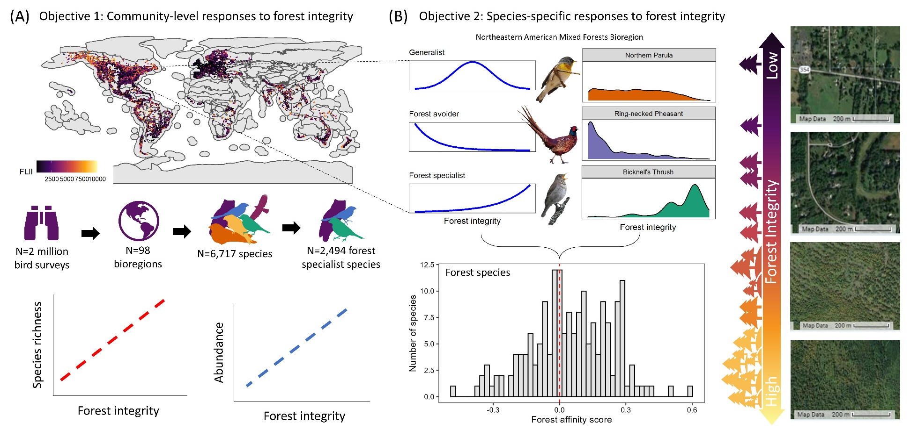
Figure 1. Conceptual figure highlighting our two objectives of the paper. (A) Objective 1 was focused on documenting the relationship between bird diversity and forest integrity across 98 bioregions for both species richness and abundance. This analysis was performed for ‘all species’ and for ‘forest specialists’. (B) Objective 2 was focused on providing an empirical analysis of forest affinity for all species, ranking species from highly dependent on high forest integrity patches to those who avoid forest integrity patches. Our goal was to extend the conceptual classification of generalist, specialist, and avoider, where the conceptual curves are shown in blue lines, and the real empirical data for each species (Northern Parula, Ring-necked Pheasant, and Bicknell’s Thrush) are shown by the density plots.

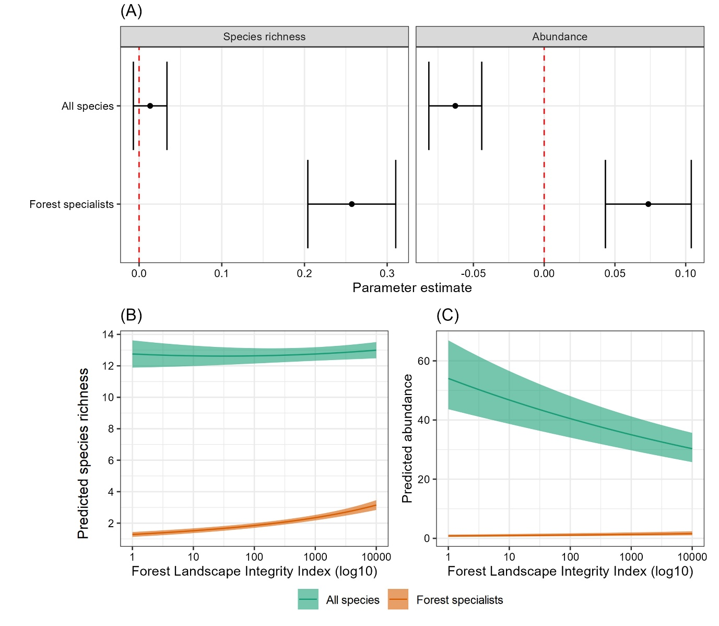
Figure 2. (A) Model parameter estimates of fixed effects for our four overall generalized additive mixed models (GAMM). (B) Predicted species richness on a given eBird checklist from our GAMM, showing a marginal increase in species richness for all species (green) and a statistically significant increase for forest specialists (orange). (C) Predicted abundance on a given eBird checklist from our GAMM, showing a statistically significant decrease in species richness for all species (green) and a statistically significant increase in abundance for forest specialist species (orange).

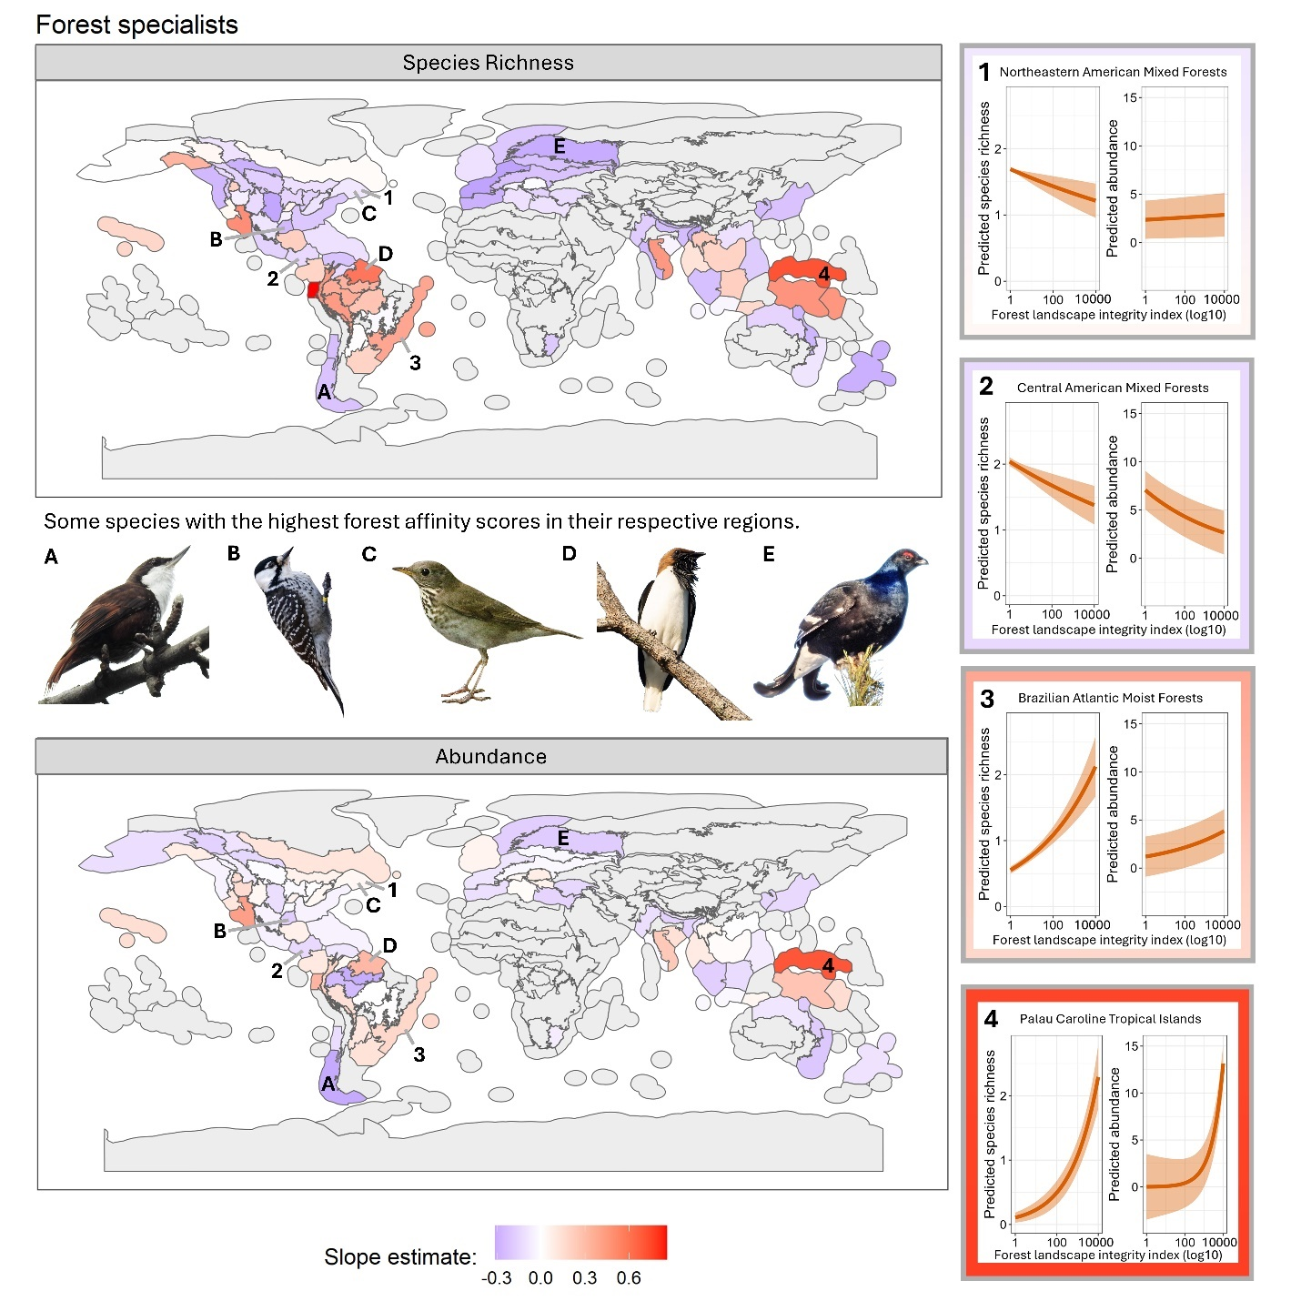

Figure 3. Variability in abundance and species richness among bioregions for our generalized additive mixed models fitted for forest specialists for species richness (top map) and abundance (bottom map) on a given eBird checklist. The values represent extracted slope estimates from the respective models for each bioregion. The maps for our ‘all species’ models are in Figure S10. The plots in the middle display predicted species richness (left) and abundance (right) by forest landscape integrity index for 4 bioregions. To display the locations of these bioregions on the map, we created numerical labels. Additionally displayed are some species with the highest forest affinity scores in their respective regions, White-throated Treerunner (Pygarrhichas albogularis), Red-cockaded Woodpecker (Dryobates borealis), Bicknell’s Thrush (Catharus bicknelli), Bearded Bellbird (Procnias averano), and Black Grouse (Lyrurus tetrix). Associated bioregions are labeled with alphabetical symbols on the map. Bird images are from iNaturalist under CC-BY-NC license from Rocío Elisa (White-throated Treerunner), Will Stuart (Red-cockaded Woodpecker), er-birds (Bicknell’s Thrush), Nina Wenóli (Bearded Bellbird), and vyatka (Black Groose).

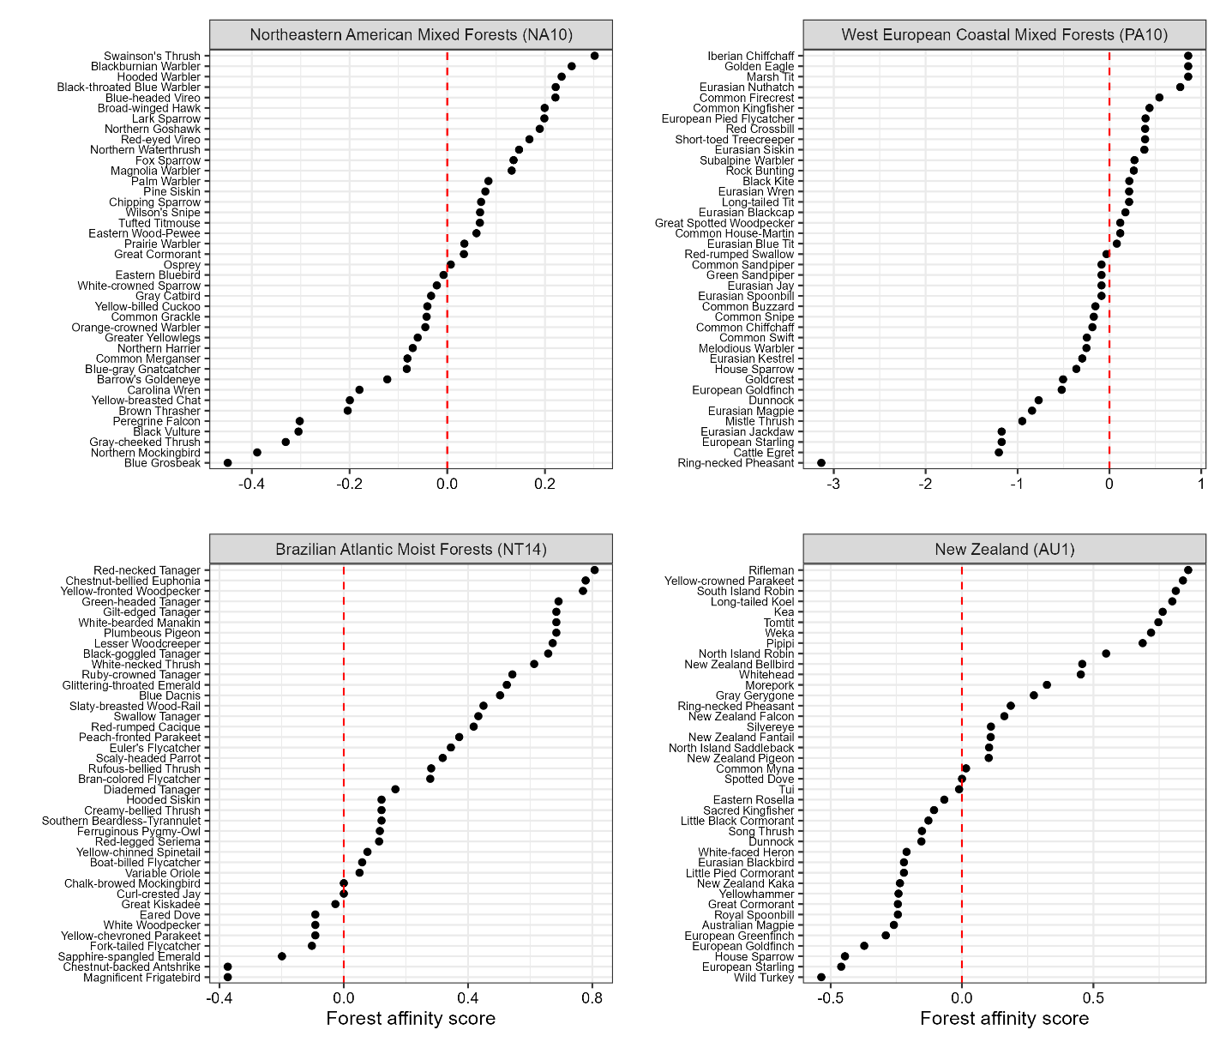
Figure 4. Four bioregions, with 40 randomly chosen species from each bioregion, illustrating the differences in forest affinity scores for each species. Species to the right of 0 are positively associated with high integrity forest areas, and species to the left of 0 are negatively associated with high integrity forest areas. All data are available in Table S1.

Short Titles for Supplementary Material
- Figure S1. Comparison of forest integrity metrics (with vs. without non-forest pixels) ensuring robustness in our conclusions
- Figure S2. Distribution of forest integrity and habitat characteristics across bioregions
- Figure S3. Number of eBird checklists per bioregion
- Figure S4. Comparison of slopes from independent vs. mixed-effects models
- Figure S5. Shrinkage effects in our mixed-effects models
- Figure S6. Species-specific forest affinity example: Red-bellied Woodpecker
- Figure S7. Species-specific forest affinity examples: Northeastern American Mixed Forests
- Figure S8. Sensitivity of overall results to alternative FLII calculations
- Figure S9. Bioregion variability in species richness and abundance (all species)
- Figure S10. Variability of forest integrity and species richness results shown spatially
- Figure S11. Percent forest cover by bioregion
- Figure S12. Sensitivity analysis of standardized sampling effort across bioregions
- Figure S13. Number of forest-using species per bioregion
- Figure S14. Proportion of forest species associated with high-integrity habitat
- Figure S15. Post-hoc analyses of forest specialists by forest type
- Figure S16. Linear model estimates of forest integrity metrics for specialists
- Table S1. Species-specific forest affinity scores across bioregions

