Enhanced Charge Transport at the Interface in P3HT-Tellurium Nanowires Hybrid Materials for High Thermoelectric Performance

Syed Zulfiqar Hussain Shah^{1,2*}, Weng Weei Tjiu², Haiwen Dai³, Jose Recatala-Gomez³, Pauline Kasongo-Ntumba⁴, Repaka Durga Venkata Maheswar², Zainul Aabdin^{2#}, Oliver Fenwick^{4#}, Kedar Hippalgaonkar^{2,3#}, Iris Nandhakumar^{1#}, Pawan Kumar^{2#}

1. Department of Chemistry, University of Southampton, Southampton SO17 1BJ, United Kingdom.
2. Institute of Materials Research and Engineering, Agency for Science Technology and Research
(A*STAR), Singapore 138634, Republic of Singapore.
3. School of Materials Science and Engineering, Nanyang Technological University, 50 Nanyang
Avenue, Block N4.1, 639798, Singapore.
4. School of Engineering and Materials Science, Queen Mary University of London, Mile End Road, London E1 4NS, United Kingdom.
* First Author, Corresponding Authors#

In this study, the effects of molecular weight of poly(3-hexylthiophene-2,5-diyl) (P3HT) and the lengths of tellurium (Te) nanowires on the thermoelectric transport properties of organic-inorganic hybrid thermoelectric materials were systematically investigated. Our findings indicate that the integration of longer Te nanowires (10 μm) with P3HT of different molecular weights (ranging from 50 to 143 kDa) enhances the thermoelectric properties of the hybrid material, resulting in a power factor of 303 ± 38 µW/mK² for Te₈₀-P3HT₂₀ hybrid material with optimal doping. Thermal conductivity measurements were performed, and a power factor of 0.25 W/m-K was achieved for Te₈₀-P3HT₂₀ with a ZT value of 0.36 at room temperature, which represents the highest reported value for such Te-P3HT based hybrid materials to date. This research offers critical insights into the synergistic effects of nanowire length and polymer molecular weight, paving the way for the development and refinement of advanced thermoelectric materials tailored for efficient energy conversion applications.
Keywords: Nanomaterials, thermoelectric materials, hybrid materials, P3HT polymer, thin film, doping, microstructural characterization, Seebeck coefficient, electrical conductivity, power factor.

Introduction
Organic-inorganic hybrid thermoelectric materials hold significant appeal for the fabrication of flexible TE devices due to their ability to combine the advantageous characteristics of organic materials, such as low thermal conductivity and solution processability, with the structural and electronic tunability offered by inorganic nanostructures [1,2,3]. The distinctive feature of hybrid materials is their significantly enhanced performance, originating from non-linear interactions occurring at the nanoscale interfacial layer that is formed between organic and inorganic components. [4, 5, 6,7]. The effectiveness of thermoelectric materials is determined by a synergy of the Seebeck coefficient (S), electrical conductivity (σ) and thermal conductivity (κ), all encapsulated in the figure of merit, $zT=\frac{S^{2}σT}{κ}$. To enhance the performance of thermoelectric materials, it is essential to have a low thermal conductivity (κ) and a high power-factor (PF=S²σ).

It has been hypothesized that manipulating the length or diameter of nanowires could potentially enhance the thermoelectric performance of organic-inorganic hybrid materials. S.K. Yee [8] conducted a study in which tellurium nanowires (TeNWs) of varying sizes (length/diameters) were grown and embedded into a conducting polymer, poly(3,4-ethylenedioxythiophene): polystyrene sulfonate) (PEDOT: PSS), forming an organic-inorganic hybrid system. The longer nanowires, encapsulated in PEDOT: PSS and doped with a polar solvent (5 vol%) of dimethyl sulfoxide, (DMSO), exhibited a power factor of 100 µW/mK² at room temperature. Unfortunately, the maximum length of TeNWs was ~1µm. Later, Sahu et al., [6] synthesized tellurium nanowires with an ultrahigh aspect ratio (length/diameter ~ 1000) and combined them with PEDOT: PSS to fabricate a hybrid system and reported a power factor of close to 145 µW/mK². N.E. Coates [24] conducted the synthesis of Te nanowires and uniformly coated them with PEDOT: PSS, achieving a power factor (PF) of 35 µW/mK² with a thermal conductivity (κ) of 0.16 W/m-K, resulting in a ZT ~ 0.07 at room temperature. Y. Wang et al., [16] integrated Te nanorods with polyaniline (PANI) to produce Te-PANI nanocomposite hybrid films. These hybrid films exhibited a PF ~ 105 µW/mK², κ ~ 0.21 W/m-K, and ZT ~ 0.15. However, reports on Poly(3-hexylthophene)-P3HT based inorganic nanocomposites are very rare in the literature. Kumar et. al. predicted that P3HT based hybrid will exhibit superior TE performance compared to PEDOT: PSS due to a higher scattering rate [7]. He M., et al., [25] embedded Bi₂Te₃ into P3HT to fabricate P3HT/ Bi₂Te₃ nanocomposite hybrid films. They reported a PF ~ 13.6 µW/mK² coupled with a thermal conductivity of 0.54 W/m-K and ZT values ~ 0.007 for P3HT/Bi₂Te₃ hybrid films. Later Liang et al., [26] fabricated P3HT-TeNWs nanocomposite hybrid films, achieving an electrical conductivity of 21.3 S/cm and a Seebeck coefficient of 67.1 µV/K. The highest reported PF of ~ 10 µW/mK² was achieved by doping the hybrid films with a 30% FeCl₃ dopant. Recently our work on Te-P3HT has demonstrated PF~64.8 µW/mK² by controlling the oxidation of TeNWs [DOI:10.1002/advs.202400802]. Whilst many polymer/inorganic composites have demonstrated significantly higher Seebeck coefficients, their electrical conductivity was low. The formation of an intimate interfacial contact between nanofiller and polymer proves to be a significant challenge due to insufficient interactions. As a result, carrier transport in organic-inorganic composites is greatly impeded.[27]

In this study we report the fabrication of long nanowires of tellurium (~13±1.5µm) which were incorporated into a matrix of Poly (3-hexylethiophene)-P3HT using two different molecular weights of P3HT (50-70kDa, & 80-143kDa). Our work illustrates that an enhanced templating effect of P3HT along the TeNWs occurs, which improves the interfacial charge transport within the polymer-inorganic nanocomposites. The resulting thermoelectric nanocomposites of P3HT-TeNWs demonstrated a high power factor of 303 ± 38 µW/mK², which was accompanied by a thermal conductivity of 0.25 W/m-K, yielding a ZT value of 0.36 at room temperature. This represents a 32-fold increase (in power factors) compared to previously reported values in the literature for the Te-P3HT hybrid system [26] and 2 fold enhancement compared to Te-PEDOT:PSS enhancement.[6,9] Furthermore, we conducted a systematic investigation of the impact of altering the nanowire concentration within the polymer matrix. Further, we explored the doping levels corresponding to each concentration and assessed the thermoelectric performance of the polymer nanocomposite materials.

Results and Discussion
Hybrid films of Tellurium nanowires (TeNWs) and Poly (3-hexylethiophene) (P3HT) were fabricated with different ratios of TeNWs to P3HT (10-90 wt.%). The preparation involved dispersing TeNWs and P3HT in chlorobenzene followed by drop casting. Optical micrographs of the resulting films demonstrate a consistently uniform thermoelectric thin film, as illustrated in Supplementary Figure S1. In addition, the scanning electron microscope (SEM) image presented in Supplementary Figure S2 reveals nanowires extending over several microns [8±0.2 to 13±1.5µm]. The thickness of TeNWs-P3HT nanocomposite films was measured by a surface profilometer and varied from 1.31 ± 0.34 µm to 2.25 ± 0.11µm. X-ray photoelectron spectroscopy (XPS) was employed to analyse the elemental composition and oxidation states in the fabricated thin films. The results are depicted in Figure 1. The XPS survey spectra, illustrated in Figure1(a) up to 1200 eV, revealed the presence of tellurium, carbon, and oxygen. All spectra were calibrated using the carbon C 1s peak at 284.8 eV as a reference. Core-level peaks corresponding to Te 3d, C 1s, and O 1s were observed in thin films of tellurium nanowires. The O 1s peak at approximately 530 eV indicated an oxidized surface of tellurium nanowires (TeNWs) [28]. However, the oxidation is relatively minimal, with only about 9 atomic percent detected on the surface. In Figure 1(b), peaks at 573.07 eV and 583.3 eV were identified as the Te 3d_{5/2} and Te 3d_{3/2} core levels, respectively, suggesting the metallic state of tellurium.[29] Notably, peaks at 576 eV and 586 eV indicated surface oxidation of tellurium nanowires within a depth of 5 nm from the film surface.[30] Additional examination of thin films at a depth of ~1-3 µm was carried out using SEM energy-dispersive X-ray spectroscopy (EDX), as depicted in Supplementary Figure S3.
Figure 1: High-resolution X-ray photoelectron spectroscopy (XPS) spectra of TeNWs film: survey scan (a), XPS core level spectra of Te 3d (b) and core level spectra of O 1s (c).

Transmission Electron Microscopy (TEM) was utilized to conduct detailed microstructural analyses, to examine whether the of polymer coatings were conformal across individual nanowires. Low-magnification TEM images acquired for TeNWs, TeNWs-P3HT (50-70 kDa), and TeNWs-P3HT-P6 (80-143 kDa) samples showed identical microstructures without any noticeable change in diameter or texture (Figure 2a-c). However, as expected, magnified TEM images of individual nanowires (Figure 2d-f) confirmed a uniform conformal coating of the polymer (P3HT) layer on the hybrid nanowires surface (Te-P3HT and Te-P3HT-P6). The thickness of the conformal coating varies from 3 to 10 nm across the surface of the nanowires with an average thickness of about 5 nm for both cases. High-resolution TEM (HR-TEM) images (Figure 2g-i) and Fast Fourier Transform (FFT) (Figure 2j-l) of the individual nanowires revealed that the nanowires are single crystalline, and their c-axis i.e. [001] crystallographic direction is always aligned along the length of the nanowires with an interplanar spacing of ~ 0.59 nm. Furthermore, cross-sectional views of the TeNWs shows that the nanowires have a hexagonal shape, bounded by the six (100) facets (Figure 3). TEM images in plane-view (Figure 2a-c) and in cross-section (Figure 3a-b and 3h-i) show that the nanowires are several microns in length and about 60 nm in diameter.

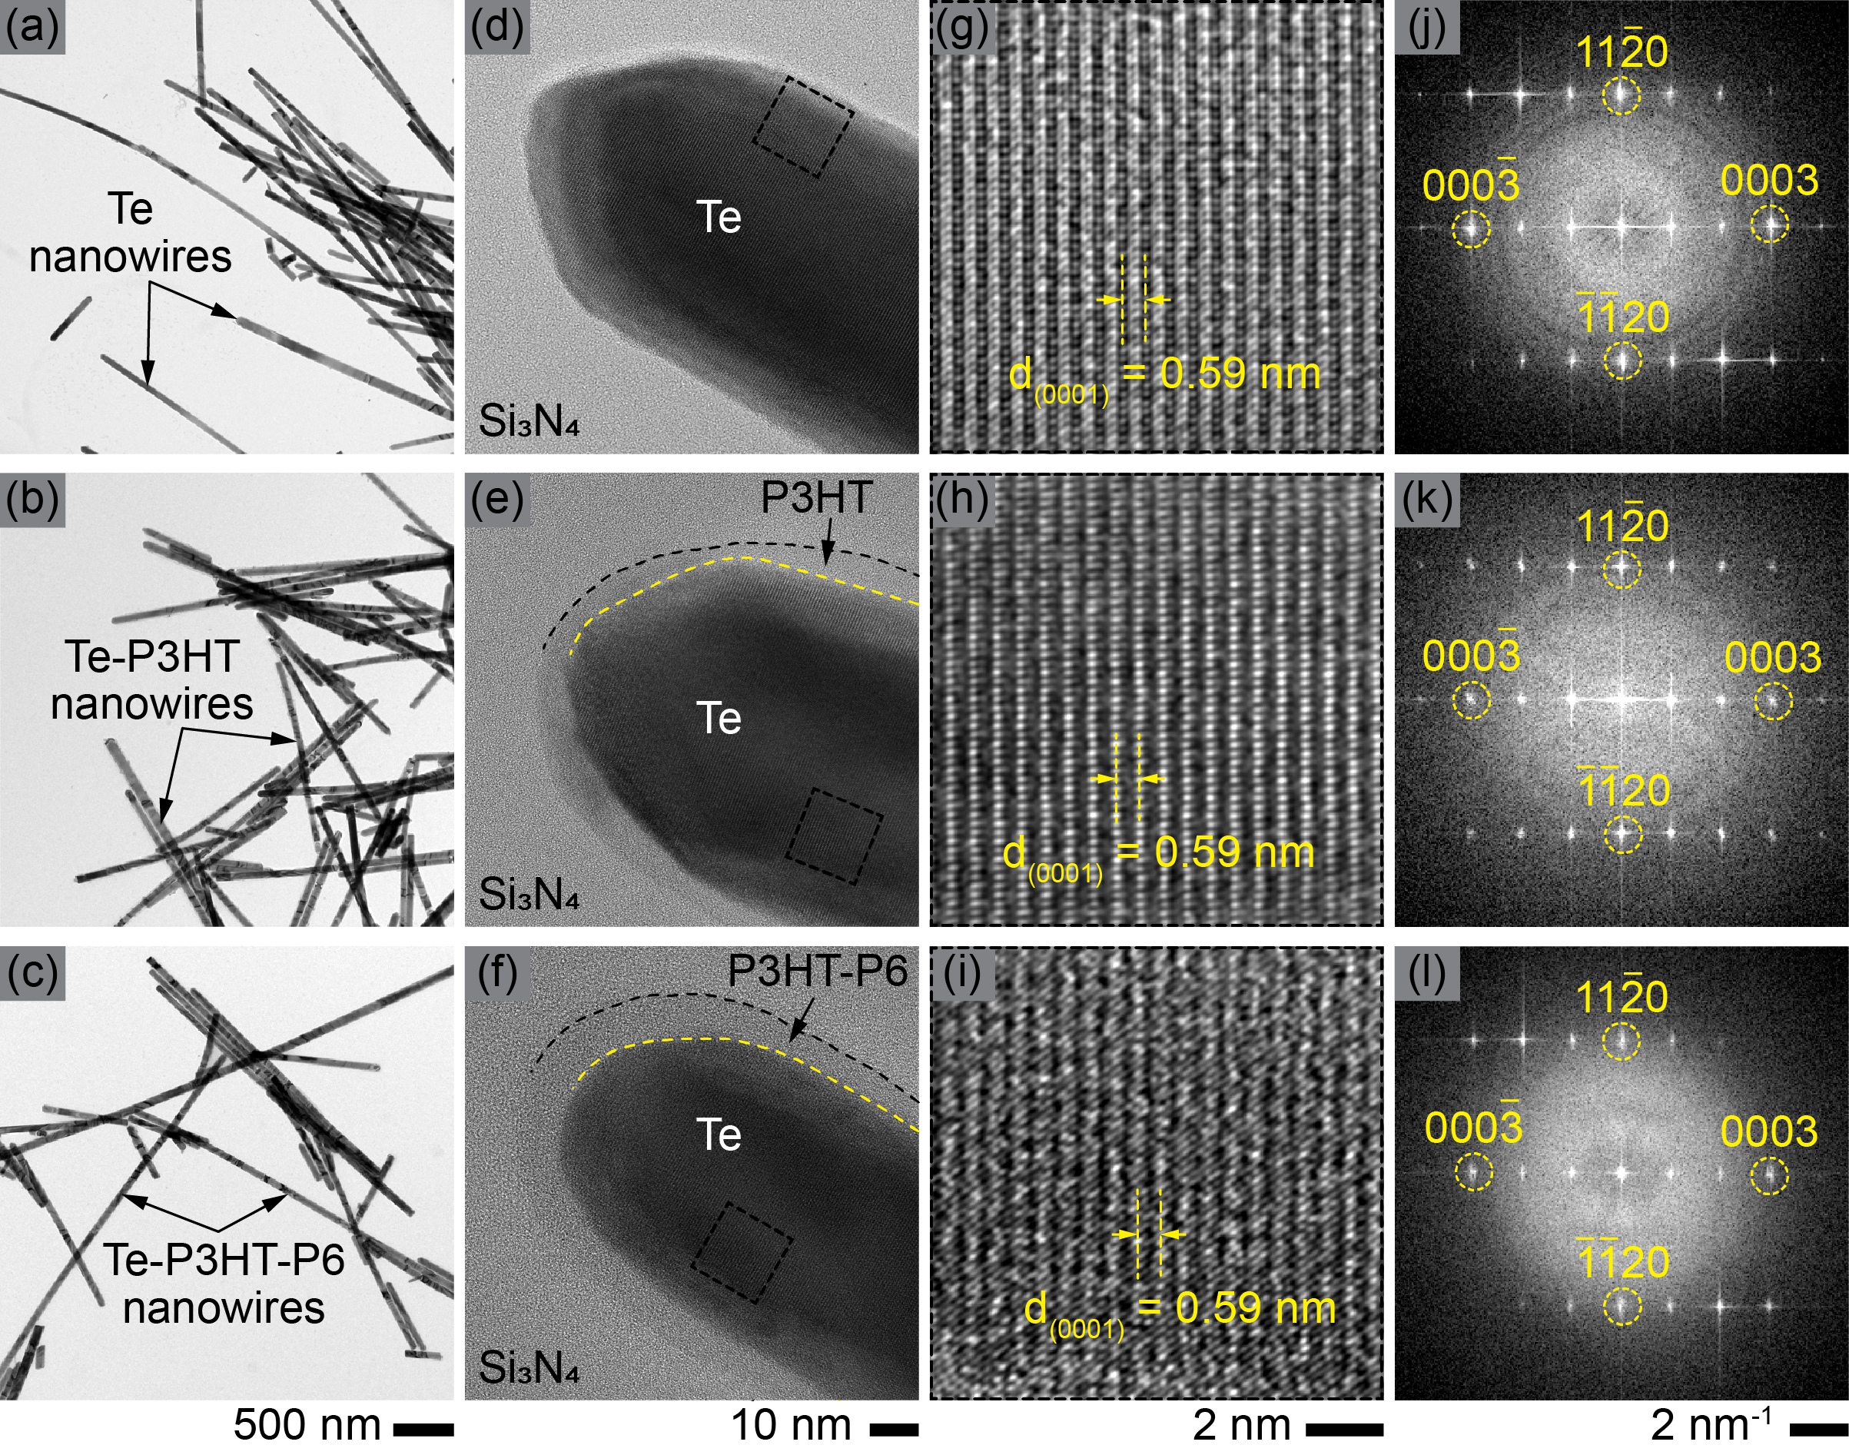
Figure 2: (a-c) Overview, (d-f) high-magnification, and (g-i) high-resolution TEM images showing the morphology of TeNWs, TeNWs-P3HT (50-70 kDa) and TeNWs-P3HT-P6 (80-143 kDa) nanowires, respectively. A uniform conformal coating of the amorphous polymer (P3HT) layer can be seen on the surface of the TeNWs-P3HT nanowires. (j-i) Fast Fourier Transform (FFT) of the single nanowires shown in d-f, respectively.

To understand and correlate the distribution of chemical species observed in XPS and SEM-EDX results (Figure 1 and Supplementary Figure S3), we performed Scanning Transmission Electron Microscope (STEM) imaging and Electron Energy Loss Spectroscopy (EELS) mapping using a probe size of about 1 nm. EELS elemental mapping of Te nanowires in cross-sectional view shows a Te core (red map), presence of O (green map) and C (blue map) around the nanowire edges (Figure 3c-e and SI Figure S5). Closer inspection of the overlay maps (Figure 3f) and the line profile across a single nanowire (Figure 3g) reveals that the nanowire core is free from oxidation. Both the XPS and STEM-EELS results are in excellent agreement, indicating surface oxidation of tellurium nanowires for the non-coated nanowires. However, the hybrid i.e. coated nanowires EELS mapping indicates presence of S around the nanowires (purple map in Figure 3k). Furthermore, the line-profile across the single nanowire of hybrid sample shows no oxygen signal (Figure 3n, SI Figure S6). It is important to highlight that a 25 nm thick C layer was deposited using a sputtering system as part of the FIB cross-section sample preparation process to protect the nanowire surface from beam damage during FIB cutting. Therefore, the C observed in the EELS map originates from the FIB process rather than from the nanowire synthesis.

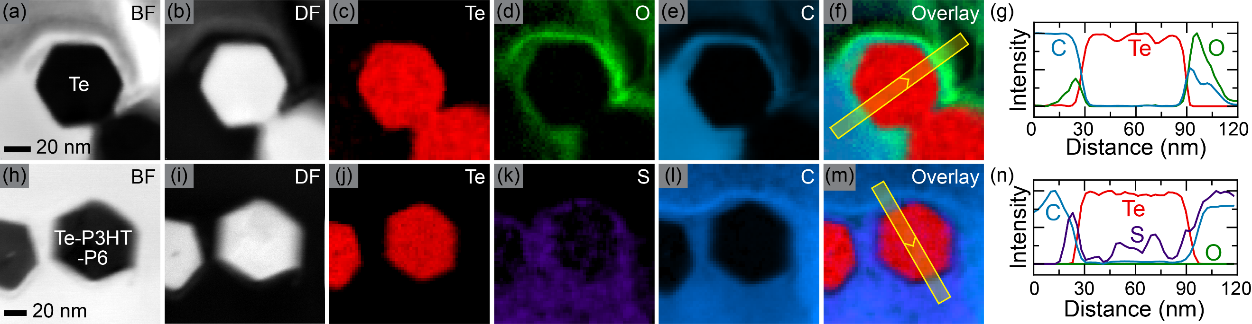
Figure 3: (a) Bright-field (BF) and (b) dark-field (DF) STEM images showing cross-section view of the Te-NWs. Elemental EELS maps of (c) Te (red), (d) O (green), (e) C (blue), and (f) overlay (Te + O + C) image for the Te-NWs. (g) Normalized line-profile across a single nanowire marked with the yellow strips in (f) showing chemical composition variation across the nanowire for the Te-NWs. (h-n) Corresponding data for the TeNWs-P3HT showing absence of O and presence of S (purple) around the edges of NWs.

Hybrid films, composed of varying weight percent (wt%) ratios of TeNWs and P3HT, were doped in an FeCl₃/acetonitrile solution. Subsequently, the thermoelectric (TE) transport properties of TeNWs-P3HT nanocomposite hybrid films with different molecular weights of P3HT (MW: 50-70kDa and 80-143kDa), were measured using standard methods as outlined in the experimental section. In Figure 4, the thermoelectric properties of hybrid systems are presented as a function of TeNWs concentration by weight for a fixed doping level. Optimal doping levels of 0.03M and 0.02M were achieved for TeNWs-P3HT (50-70kDa) and TeNWs-P3HT-P6 (80-143kDa) hybrid films[data for all doping is in SI Figure S7]. Figure 4(a) illustrates that the Seebeck coefficient increases monotonically with increasing concentration of TeNWs. Specifically, the Seebeck coefficient ranged from 51± 1.7 µV/K to 146.23 ± 1.6 µV/K as the TeNWs concentration increased from 10 to 90% in the 0.03M doped hybrid sample. The electrical conductivity increases non-monotonically by increasing TeNWs content, changing from ~ 46.4 ± 3.34 S/cm to ~136 ± 2.52 S/cm for 10% to 80% TeNWs, before decreasing to ~ 93.5 ± 4.76 S/cm (90% TeNWs). Similar trends were observed for TeNWs-P3HT-P6 (80-143kDa) hybrid systems (Figure 4a), where the electrical conductivity for the 0.02M doped hybrid films showed an initial increase up to ~106.38 ± 10.21 S/cm at 40% NWs content. Subsequently, it declined to ~ 51.26 ± 3.49 S/cm for 70% NWs and rose again to 90.46 ± 11.01 S/cm for 80% NWs, and dropped to 44.61 ± 3.86 S/cm for 90% NWs. The Seebeck coefficients in both hybrid systems exhibited a consistent increase with increasing NWs content. Figure 4(b) presents power factors as a function of NWs content for TeNWs-P3HT (50-70kDa) and TeNWs-P3HT-P6 (80-143kDa) hybrid systems, highlighting the improvement from 12.1 ± 0.95 µW/mK² (10% TeNWs) to 248 ± 4.67 µW/mK² (80% TeNWs) for the 0.03M FeCl₃ doped hybrid system and 11.31 ± 0.86 µW/mK² (10% TeNWs) to ~ 303.4 ± 38.15 µW/mK² (80% TeNWs) for the TeNWs-P3HT-P6 (80-143kDa) hybrid system.
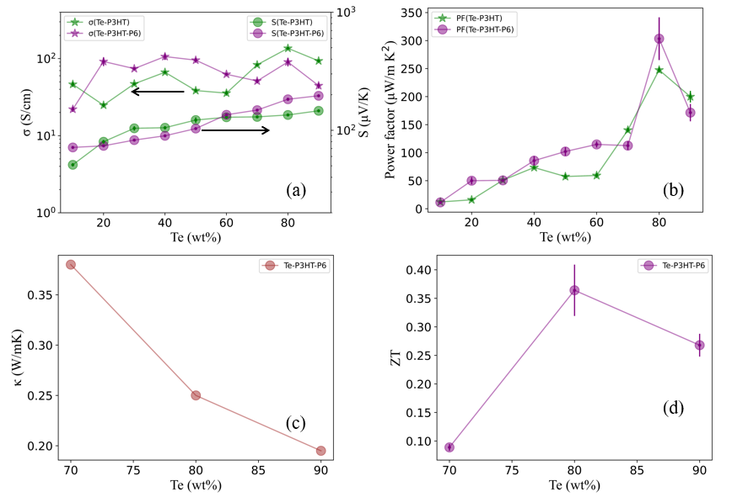

Figure 4: Exploring Thermoelectric Properties: TeNWs-P3HT hybrid systems reveal (a) conductivity and Seebeck coefficient, (b) power factor in hybrid (10-90 wt% TeNWs) with P3HT (M.W. 50-70 kDa), and with higher molecular weight P3HT-P6 (M.W. 80-143 kDa). (c) Thermal conductivity Te-P3HT-P6 hybrid materials, and (d) ZT values as a function of TeNWs concentration. Error bars depict standard deviation from multiple measurements, ensuring result reliability.

We conducted thermal conductivity measurements on TeNWs-P3HT-P6 (M.W. 80-143 kDa) films for three samples with 70%, 80%, and 90% weight percentages of TeNWs for which high power factors of…. were achieved. Figure 4(c) illustrates the average thermal conductivities of doped samples with Te wt%. The thermal conductivity dropped with increasing Te NWs content. The thermal conductivities of doped TeNWs-P3HT films with 90, 80, and 70 wt% nanowires (NWs) were found to be 0.19 ± 0.04 Wm⁻¹K⁻¹, 0.24 ± 0.02 Wm⁻¹K⁻¹, and 0.33 ± 0.01 Wm⁻¹K⁻¹, respectively. These values are notably low and are in agreement with the intrinsic lattice thermal conductivities of conducting polymer films (typically 0.2- 0.5 Wm⁻¹K⁻¹). [33]. ZT were then calculated based on these thermal conductivity value and are plotted as a function of Te wt% in Figure 4(d). The highest ZT value of 0.36 was achieved for Te₈₀-P3HT₂₀ samples. To the best of our knowledge this is the highest reported value for P3HT-based inorganic nanocomposite hybrid p-type materials to-date. Table 1 provides a comparison of thermoelectric transport properties of different conducting polymers/inorganic hybrid materials at room temperature.

Nanocomposites | Ref. | σ(S/cm) |  | S (µVK⁻¹) | S²σ(µWm⁻¹K⁻²) | κ (Wm⁻¹K⁻¹) | ZT
PEDOT:PSS/Sb₂Te₃ | 38 |  | 341 | 92.6 | 275 | 0.44 | 0.2
PEDOT:PSS/Bi₂Te₃ | 39 |  | 123.72 | 24.5 | 7.45 | 0.047 | 0.048
PEDOT:PSS/Bi₂Te₃ | 40 |  | 1000 | 45 | 205 | 0.29 | 0.2
PEDOT:PSS/Cu₂Se | 42 |  | 1047 | 50.8 | 270 | 0.25 | 0.3
PEDOT:PSS/Te-NR | 41 |  | 19.3 | 163 | 51 | 0.22 | 0.1
PEDOT:PSS/Te-NW | 24 |  | 11 | 180 | 35 | 0.16 | 0.07
PANI/ Bi₂Te₃ | 18 |  | 11.6 | 36 | 1.5 | 0.10 | 0.005
PANI/ Te-NR | 16 |  | 102 | 102 | 105 | 0.21 | 0.15
P3HT/ Bi₂Te₃ | 25 |  | 10 | 117 | 13.6 | 0.54 | 0.007
P3HT/ TeNWs | our work |  | 90.5 | 183.13 | 303 | 0.25 | 0.36
Table 1 provides an overview of the transport properties of conducting polymer-inorganic binary hybrid systems.

Subsequently, we investigated the charge transport within the P3HT-TeNWs hybrid system by employing the Boltzmann Transport framework formulated for conducting polymers by Kang and Snyder (Kang-Snyder Model).[34] The Kang-Snyder model represents the energy-dependent conductivity, $σ_{E}\left(E,T\right)$, using the expression:
$σ_{E}\left(E,T\right)=σ_{E_{0}}\left(T\right){\left(\frac{E-E_{t}}{k_{B}T}\right)}^{s}$ (1)
where, E_{t} is the transport edge (energy) below which conductivity has no contribution even at finite temperature, ‘s’ is the energy-dependent scattering parameter and ‘σ_{E0}’ is the energy-independent transport parameter, utilized for modeling TE transport in conducting polymers across a broad range of conductivities. k_{B} represents the Boltzmann constant. The total conductivity is defined as:
$σ=\int_{0}^{∞}{σ_{E}\left(E,T\right)\left(-\frac{∂f}{∂E}\right)ⅆE}$ (2)
By substituting equation (1) into equation (2), and performing integration by parts, the total conductivity can be articulated as:
$σ=σ_{E_{0}}\left(T\right)×sF_{s-1}\left(η\right)$ (3)
Where $η=\frac{E_{F}-E_{t}}{k_{B}T}$ is the reduced chemical potential and F is the Fermi integral. The corresponding Seebeck coefficient (S) is expressed as:
$S=\frac{k_{B}}{ⅇ}\left[\frac{\left(s+1\right)F_{s}\left(η\right)}{sF_{s-1}\left(η\right)}-η\right]$ (4)
The reduced chemical potential (η) is determined by utilizing experimental Seebeck coefficient values for a specific value of the energy-dependent parameter 's'. In Figure 6(a), the Seebeck coefficient is depicted as a function of conductivity for TeNWs-P3HT (50-70kDa) and TeNWs-P3HT-P6 (80-143kDa) hybrid films doped with 0.03M and 0.02M FeCl₃, respectively. The data was obtained by conducting de-doping experiments, involving a heat treatment at 70 ⁰C to gradually reduce dopants and consequently reduce the electrical conductivity. As anticipated, the Seebeck coefficient exhibits an increase with decreasing conductivity. It was noted that power factors exhibited a gradual decline corresponding to the decreasing electrical conductivity.
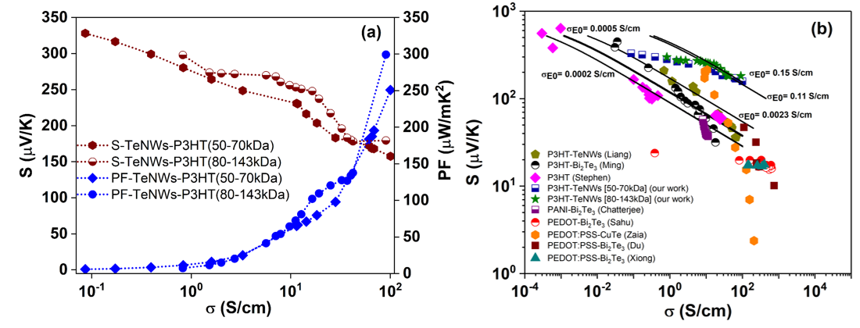
Figure 6. The application of the Kang-Snyder charge transport (CT) model to P3HT-inorganic hybrid systems. (a) Displays the experimental relationship between Seebeck coefficient (S) and electrical conductivity (σ) for 0.02M and 0.03M FeCl₃-doped TeNWs-P3HT hybrid systems. In (b) the data includes the electrical conductivity versus Seebeck coefficient for TeNWs-P3HT (olive stars) and TeNWs-P3HT ( half-filled royal blue squares) from this study, along with TeNWs-P3HT (dark yellow pentagons), Bi₂Te₃-P3HT ( half-filled black circles), pure P3HT (magenta square), PANI-Bi₂Te₃ ( half-filled purple squares), PEDOT-Bi2Te3 (half-filled red circles), PEDOT:PSS-CuTe (organ hexagons), PEDOT:PSS-Bi₂Te₃ (wine squares), and PEDOT:PSS-Bi₂Te₃ (dark cyan triangles). Our experimental data aligns with the energy-dependent scattering parameter s = 3 curve, featuring energy-independent transport parameters σ_{E0} of 0.11 S/cm and 0.15 S/cm for TeNWs-P3HT (50-70kDa) and TeNWs-P3HT (80-143kDa) hybrid films, respectively.

In Fig. 6(b), we compared different binary inorganic-organic hybrid materials. Figure 6(b) shows the Seebeck coefficient as a function of the electrical conductivity of TeNWs-P3HT (80-143kDa) [olive stars, this work], TeNWs-P3HT (50-70kDa) [half-filled royal blue squares, this work], TeNWs-P3HT [ dark yellow pentagons, Liang Z.][26], pure P3HT [ magenta squares, Kang, & Snyder][34], and Bi₂Te₃-P3HT [half-filled black circles, Ming H.].[25], PANI-Bi₂Te₃ [half-filled purple squares, Chatterjee][18] PEDOT-Bi₂Te₃ [half-filled red circles, Sahu][6], PEDOT:PSS-CuTe [organ hexagons, Zaia][4 ], PEDOT:PSS-Bi₂Te₃ [wine squares, Du] [43], and PEDOT:PSS-Bi₂Te₃ [dark cyan triangles, Xiong] [11]. As can be seen, in our study the Seebeck coefficient and electrical conducticivity for the Te NW/P3HT hybrid materials exceed those reported in the literature. The Kang-Snyder model has been employed to analyse a range of P3HT based systems. As illustrated in Figure 6(b), the experimental results for various P3HT-based hybrid materials consistently reveal an energy-dependent scattering parameter of s= 3. In our TeNWs-P3HT (80-143kDa) hybrid system, σ_{E0}​ yieled a value of 0.15 S/cm, which represents a 65 times enhancement compared to other TeNWs-P3HT hybrid systems documented in the existing literature [26] and a value that is ~10 times higher than our previous study on Te-P3HT hybrid materials [DOI:10.1002/advs.202400802]. Notably, the Te-P3HT hybrid material exhibits the highest σ_{E0}​ value, which may be primarily attributed to the more effective templating of P3HT on the Te surface as discussed in detail in our previous TeNWs-P3HT hybrid material work [DOI:10.1002/advs.202400802]. Longer nanowires with well-defined structures contribute significantly to enhancing both the templating effect and interfacial charge transport. [7,24] Further a high molecular weight polymer (with an extended chain length) to encapsulate the nanowires facilitates better charge transport at the interfacial layer, providing a large, well-ordered polymer region (templating effect) along the nanowires.[13]

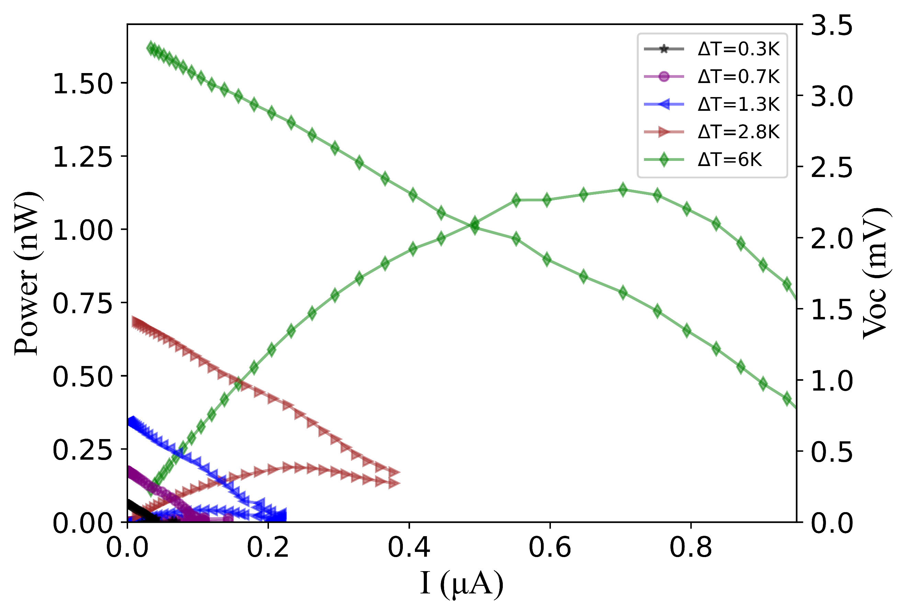
Figure 7: Power output and open circuit voltage from TE device made from Te₈₀-P3HT-P6₂₀ hybrid martial as a function of current.

Figure 7 shows power load curves from a TE device made from Te₈₀-P3HT-P6₂₀ hybrid film. Different temperature gradients were applied to the device and the power output was measured as a function of current. A maximum power output of 1nW was achieved for a delta T of 6 K.

Conclusions
In summary we have demonstrated that the TE properties in P3HT-TeNWs hybrid systems can be significantly enhanced by incerasing the length of NWs and employing high molecular weights of polymer due a strong templating effect. TEM study revealed conformal polymer coatings and NWs that were oxidation free. To the best of our knowledge, a power factor of 303 µW/mK² with a ZT of 0.26 is the highest value reported for the P3HT-TeNWs hybrid system to date. Our work will provide new directions to improve TE properties, and in general, charge transport in hybrid TE materials.

Acknowledgments
S.S., P.K., and K.H. would like to acknowledge funding from the Accelerated Materials Development for Manufacturing Program at A*STAR via the AME Programmatic Fund by the Agency for Science, Technology, and Research under Grant No. A1898b0043. S. S. and I.N. would like to thank A*STAR Graduate Academy’s ARAP programme for funding S.S.’s graduate studies in IMRE, A*STAR. I.N. wishes to acknowledge financial support by the Engineering and Physical Sciences Research Council (EPSRC) for Grant No. EP/T026219/1.

Materials and Methods
Reagents
Ethylene glycol (purity >99%, Sigma Aldrich, anhydrous), polyvinylpyrrolidone (PVP-K30, molecular weight ~40,000, Fluka), potassium hydroxide (purity ≥85% KOH basis, pellets, white, Merck), tellurium dioxide (purity 99.995% TeO₂, Aldrich), hydrazine hydrate (N₂H₄ 50-60%, Sigma Aldrich), Poly(3-hexylthiophene) (molecular weight ~50-70kDa, regioregular electronic grade, Rieke Metals), P3HT (molecular weight ~80-143kDa, Oxford University London), iron trichloride (purity ≥99.99%, anhydrous, powder, Aldrich), acetonitrile (purity 98%, Sigma Aldrich), chlorobenzene (purity >99%, anhydrous, Sigma Aldrich) were utilized in their as-received state without additional purification.

Synthesis of Inorganic-Organic Nanocomposites
Inorganic nanostructures of tellurium were synthesized through an aqueous solution method using established procedures from the literature.[36] A stock solution of Poly (3-hexylthiophene) P3HT in chlorobenzene (10mg/mL) was prepared and subjected to magnetic stirring at 80 ⁰C on a hotplate. Subsequently, the desired quantity of the polymer solution was combined with varying weight percentages (10% to 90%) of tellurium nanowires (TeNWs). These mixtures underwent power sonication for 60 minutes in pulse mode (15 seconds ON and 5 seconds OFF) to achieve a uniform dispersion before being drop-casted onto Si and quartz substrates.

Thin Film Fabrication
To produce the hybrid films comprising TeNWs-P3HT, the solutions were applied via drop-casting onto circular quartz substrates with a 20 mm diameter for the evaluation of thermoelectric (TE) transport properties. For the analysis of scanning electron microscopy (SEM), and X-ray photoelectron spectroscopy (XPS), the films were drop-cast onto (1×1) cm² Si substrates. Subsequently, these films were subjected to an overnight annealing process at 100 °C on a hotplate within a nitrogen-filled glovebox to eliminate any remaining solvent. To introduce doping into the hybrid films, a p-type dopant FeCl₃ was dissolved in acetonitrile at various molar concentrations, and the hybrid films were immersed into the dopant solution, followed by swift drying to maintain uniformity. The films were consistently protected from exposure to air throughout the entire procedure. Before the drop-casting step, all substrates underwent a cleaning regimen involving sequential sonication in acetone and isopropanol for 10 minutes each, followed by UV-ozone exposure at 100 °C for 10 minutes.

Characterization
Scanning electron microscopy (SEM) imaging was conducted on a JEOL JSM 7800F Prime-scanning electron microscope (SEM) operating at 5 keV. X-ray photoelectron spectroscopy (XPS) was carried out using an AXIS Supra spectrometer (Kratos Analytical, UK) equipped with a hemispherical analyzer and a monochromatic Al Kα source (1487 eV) running at 15 mA and 15 kV. The XPS spectra were acquired over an analysis area of 700×300 µm² at a take-off angle of 90⁰, with a pass energy of 160 and 20 eV for survey and high-resolution scans, respectively. Charge compensation was achieved using low energy electron flooding, and Casa XPS software was employed for deconvolution of the raw data.
Focused Ion Beam (FIB) cross-sectioning of the drop-casted nanowires was performed on a Zeiss Crossbeam 540 equipped with carbon GIS and Ga ion source. Three amorphous carbon layers were initially deposited onto the nanowires, including a 25 nm layer via a sputtering system outside the FIB chamber, a 50 nm layer via e-beam, and a 700 nm layer via ion-beam. Ga ion-beam was used for the FIB lamella preparation, followed by fine-polishing using a 30kV 50pA probe and cleaning with a 5kV 10pA probe.
For Transmission Electron Microscopy (TEM) analysis, all plane-view samples were prepared by drop casting a 20 µL solution on a standard 3 mm copper mesh grid with a continuous lacey carbon-coated film (Cat. No. 3830C-CF, SPI Supplies, West Chester, USA). Suspension solution was prepared by mixing 50 µg of powder containing the nanowires (TeNWs) into 1 mL ACS-grade water (Cat. No. 320072, Sigma-Aldrich Co. LLC, St. Louis, USA) and TeNWs-P3HT composite solution was diluted in chlorobenzene. The suspension solutions were thoroughly mixed using a vortex mixer (Scientific Industries Inc., New York, USA) for 2 minutes before drop casting on the TEM grid to achieve uniform dispersion. Grids were air-dried for about 1 hour before loading inside the TEM. Grid samples were placed onto a standard low-background TEM double tilt holder (Thermo Fisher Scientific, Waltham, MA USA). TEM images were captured using Titan 80-300 keV (Thermo Fisher Scientific, Waltham, MA USA; formerly produced by FEI), equipped with a 4096×4096 pixels² OneView CMOS camera (Gatan, Inc., Pleasanton, CA, USA) while STEM-EELS using Tecnai G2 80-200 keV TEMs (Thermo Fisher Scientific), equipped with a 2048×2048 pixels² Gatan camera. TEM images and EELS data were processed using Digital Micrograph (DM) (Gatan, Inc., Pleasanton, CA, USA) and open-source ImageJ (National Institutes of Health) software to crop, enhance contrast and brightness.
Thermoelectric Measurements

The Seebeck coefficients of the hybrid thermoelectric (TE) films were determined using a Portable Thermoelectric Meter (PTM-3, Joule Yacht) with a 0.1µV/K resolution for the Seebeck coefficient. A temperature gradient (∆T) of 25⁰C was maintained between the hot and cold probe ends, which were approximately 5mm apart. The thicknesses of the fabricated films were estimated using an Alpha-Step IQ surface profiler. Films were centrally scratched with a toothpick and scanned at various points to assess the uniform thickness. Electrical conductivity measurements were conducted using a standard four-point probe setup with a Keithley 2450 source meter. After obtaining the IV characteristic curves, the sheet resistance was multiplied by the geometric factor, as reported in the literature, [37] and then multiplied by the film thickness to obtain resistivity (ρ) values. The electrical conductivity (σ) of the films was subsequently calculated using the equation 𝜎 =1/𝜌. The power factor (PF) of the TE materials was determined as PF= S²𝜎. Multiple samples were utilized for the measurements, and each sample underwent testing at least four times from different points to ensure the reproducibility of the results.

The LINSEIS Thin Film Analyzer (TFA) was employed to assess thermal conductivities using the 3-omega technique, employing the Völklein geometry and measuring electrical conductivities. The films were deposited by drop-casting the solution onto TFA chips, with Kapton tape shielding the chip pads. The films were then allowed to dry overnight at 100 °C. A freshly prepared 20 mM solution of FeCl₃ in acetonitrile was used to dope the hybrid films. Prior to doping, the chip pads and contacts were completely covered with Kapton tape. The protected films were immersed in the dopant solution for 1 minute, after which excess dopant was removed by spin drying at 2000 rpm for 60 seconds. This entire procedure was conducted under an inert atmosphere. Three hysteresis cycles were performed for each batch, ranging from 20 °C to 100 °C, and three different measurements were taken for a hybrid film. Film thickness was determined using a Dektak XT profilometer instrument, applying a force ranging from 1 mg to 3 mg, with a tip radius of 2 μm. Ten measurements were conducted on each sample, and the average of these measurements was calculated and used as the film thickness. Finally, figure of merit at room temperature was calculated as $zT=\frac{PF}{κ}K$.

References:

- Zaia EW, Gordon MP, Yuan P, Urban JJ. Progress and perspective: soft thermoelectric materials for wearable and Internet‐of‐Things applications. Advanced Electronic Materials. 2019 Nov;5(11):1800823
- Russ B, Glaudell A, Urban JJ, Chabinyc ML, Segalman RA. Organic thermoelectric materials for energy harvesting and temperature control. Nature Reviews Materials. 2016 Aug 2;1(10):1-4.
- Patidar D, Saxena NS. Influence of CdS nano additives on the thermal conductivity of poly (vinyl chloride)/CdS nanocomposites. Advances in Nanoparticles. 2013 Feb 19;2(01):11-5
- Zaia EW, Sahu A, Zhou P, Gordon MP, Forster JD, Aloni S, Liu YS, Guo J, Urban JJ. Carrier scattering at alloy nanointerfaces enhances power factor in PEDOT: PSS hybrid thermoelectrics. Nano Letters. 2016 May 11;16(5):3352-9.
- Zaia EW, Gordon MP, Niemann V, Choi J, Chatterjee R, Hsu CH, Yano J, Russ B, Sahu A, Urban JJ. Molecular Level Insight into Enhanced n‐Type Transport in Solution‐Printed Hybrid Thermoelectrics. Advanced Energy Materials. 2019 Apr;9(13):1803469.
- Sahu A, Russ B, Su NC, Forster JD, Zhou P, Cho ES, Ercius P, Coates NE, Segalman RA, Urban JJ. Bottom-up design of de novo thermoelectric hybrid materials using chalcogenide resurfacing. Journal of Materials Chemistry A. 2017;5(7):3346-57.
- Kumar P, Zaia EW, Yildirim E, Repaka DM, Yang SW, Urban JJ, Hippalgaonkar K. Polymer morphology and interfacial charge transfer dominate over energy-dependent scattering in organic-inorganic thermoelectrics. Nature communications. 2018 Dec 17;9(1):5347.
- Yee SK, Coates NE, Majumdar A, Urban JJ, Segalman RA. Thermoelectric power factor optimization in PEDOT: PSS tellurium nanowire hybrid composites. Physical Chemistry Chemical Physics. 2013;15(11):4024-32.
- Gordon MP, Haas K, Zaia E, Menon AK, Yang L, Bruefach A, Galluzzo MD, Scott MC, Prasher RS, Sahu A, Urban JJ. Understanding Diameter and Length Effects in a Solution‐Processable Tellurium‐Poly (3, 4‐Ethylenedioxythiophene) Polystyrene Sulfonate Hybrid Thermoelectric Nanowire Mesh. Advanced Electronic Materials. 2021 Mar;7(3):2000904.
- Wang W, Li C, Li X, Jia Y, Jiang F, Liu C, Tan R, Xu J. Fabrication of freestanding tellurium nanofilm and its thermoelectric performance. Thin Solid Films. 2018 May 31;654:23-9.
- Xiong J, Wang L, Xu J, Liu C, Zhou W, Shi H, Jiang Q, Jiang F. Thermoelectric performance of PEDOT: PSS/Bi₂Te₃-nanowires: a comparison of hybrid types. Journal of Materials Science: Materials in Electronics. 2016 Feb;27:1769-76.
- Yoon SE, Kim B, Chun SY, Lee SY, Jeon D, Kim M, Lee S, Seo BE, Choi KS, Kim FS, Kim T. Impact of molecular weight on molecular doping efficiency of conjugated polymers and resulting thermoelectric performances. Advanced Functional Materials. 2022 Aug;32(32):2202929.
- Mardi S, Pea M, Notargiacomo A, Yaghoobi Nia N, Carlo AD, Reale A. The molecular weight dependence of thermoelectric properties of poly (3-hexylthiophene). Materials. 2020 Mar 19;13(6):1404.
- Qu S, Yao Q, Yu B, Zeng K, Shi W, Chen Y, Chen L. Optimizing the Thermoelectric Performance of Poly (3‐hexylthiophene) through Molecular‐Weight Engineering. Chemistry–An Asian Journal. 2018 Nov 2;13(21):3246-53.
- Yao Q, Wang Q, Wang L, Chen L. Abnormally enhanced thermoelectric transport properties of SWNT/PANI hybrid films by the strengthened PANI molecular ordering. Energy & Environmental Science. 2014;7(11):3801-7.
- Wang Y, Zhang SM, Deng Y. Flexible low-grade energy utilization devices based on high-performance thermoelectric polyaniline/tellurium nanorod hybrid films. Journal of Materials Chemistry A. 2016;4(9):3554-9.
- Ju H, and Kim J. Chemically exfoliated SnSe nanosheets and their SnSe/poly (3, 4-ethylenedioxythiophene): poly (styrenesulfonate) composite films for polymer based thermoelectric applications. ACS nano. 2016 Jun 28;10(6):5730-9.
- Chatterjee K, Mitra M, Kargupta K, Ganguly S, Banerjee D. Synthesis, characterization and enhanced thermoelectric performance of structurally ordered cable-like novel polyaniline–bismuth telluride nanocomposite. Nanotechnology. 2013 Apr 26;24(21):215703.
- Zhang B, Sun J, Katz HE, Fang F, Opila RL. Promising thermoelectric properties of commercial PEDOT: PSS materials and their Bi2Te3 powder composites. ACS applied materials & interfaces. 2010 Nov 24;2(11):3170-8.
- Wang L, Yao Q, Xiao J, Zeng K, Qu S, Shi W, Wang Q, Chen L. Engineered molecular chain ordering in single‐walled carbon nanotubes/polyaniline composite films for high‐performance organic thermoelectric materials. Chemistry–An Asian Journal. 2016 Jun 21;11(12):1804-10.
- Wang L, Yao Q, Shi W, Qu S, Chen L. Engineering carrier scattering at the interfaces in polyaniline-based nanocomposites for high thermoelectric performances. Materials Chemistry Frontiers. 2017;1(4):741-8.
- Jin Bae E, Hun Kang Y, Jang KS, Yun Cho S. Enhancement of thermoelectric properties of PEDOT: PSS and tellurium-PEDOT: PSS hybrid composites by simple chemical treatment. Scientific reports. 2016 Jan 5;6(1):18805.
- Hong CT, Lee W, Kang YH, Yoo Y, Ryu J, Cho SY, Jang KS. Effective doping by spin-coating and enhanced thermoelectric power factors in SWCNT/P3HT hybrid films. Journal of Materials Chemistry A. 2015;3(23):12314-9.
- Coates NE, Yee SK, McCulloch B, See KC, Majumdar A, Segalman RA, Urban JJ. Effect of interfacial properties on polymer–nanocrystal thermoelectric transport. Advanced Materials. 2013 Mar 20;25(11):1629-33.
- He M, Ge J, Lin Z, Feng X, Wang X, Lu H, Yang Y, Qiu F. Thermopower enhancement in conducting polymer nanocomposites via carrier energy scattering at the organic–inorganic semiconductor interface. Energy & Environmental Science. 2012;5(8):8351-8.
- Liang Z, Boland MJ, Butrouna K, Strachan DR, Graham KR. Increased power factors of organic–inorganic nanocomposite thermoelectric materials and the role of energy filtering. Journal of Materials Chemistry A. 2017;5(30):15891-900.
- Wang L, Liu Y, Zhang Z, Wang B, Qiu J, Hui D, Wang S. Polymer composites-based thermoelectric materials and devices. Composites Part B: Engineering. 2017 Aug 1;122:145-55.
- Zavabeti A, Aukarasereenont P, Tuohey H, Syed N, Jannat A, Elbourne A, Messalea KA, Zhang BY, Murdoch BJ, Partridge JG, Wurdack M. High-mobility p-type semiconducting two-dimensional β-TeO2. Nature Electronics. 2021 Apr;4(4):277-83.
- Liu S, Peng N, Bai Y, Ma D, Ma F, Xu K. Self-formation of thickness tunable Bi 2 Te 3 nanoplates on thin films with enhanced thermoelectric performance. RSC advances. 2016;6(38):31668-74.
- Han MK, Kim S, Kim HY, Kim SJ. An alternative strategy to construct interfaces in bulk thermoelectric material: nanostructured heterophase Bi 2 Te 3/Bi 2 S 3. RSC advances. 2013;3(14):4673-9.
- Snyder GJ, Toberer ES. Complex thermoelectric materials. Nature materials. 2008 Feb;7(2):105-14.
- E. Bilotti et al., “Organic thermoelectric composites materials,” in Comprehensive Composite Materials II, Elsevier, 2017, pp. 408–430. doi: 10.1016/B978-0-12-803581-8.10024-4.
- Degousée T, Untilova V, Vijayakumar V, Xu X, Sun Y, Palma M, Brinkmann M, Biniek L, Fenwick O. High thermal conductivity states and enhanced figure of merit in aligned polymer thermoelectric materials. Journal of Materials Chemistry A. 2021;9(29):16065-75
- Kang SD, Snyder GJ. Charge-transport model for conducting polymers. Nature materials. 2017 Feb;16(2):252-7.
- Gelbstein Y. Morphological effects on the electronic transport properties of three-phase thermoelectric materials. Journal of Applied Physics. 2012 Dec 1;112(11).
- Zhang G, Kirk B, Jauregui LA, Yang H, Xu X, Chen YP, Wu Y. Rational synthesis of ultrathin n-type Bi2Te3 nanowires with enhanced thermoelectric properties. Nano letters. 2012 Jan 11;12(1):56-60.
- Smits FM. Measurement of sheet resistivities with the four‐point probe. Bell System Technical Journal. 1958 May;37(3):711-8.
- We JH, Kim SJ, Cho BJ. Hybrid composite of screen-printed inorganic thermoelectric film and organic conducting polymer for flexible thermoelectric power generator. Energy. 2014 Aug 14;73:506-12.
- Thongkham W, Lertsatitthanakorn C, Jiramitmongkon K, Tantisantisom K, Boonkoom T, Jitpukdee M, Sinthiptharakoon K, Klamchuen A, Liangruksa M, Khanchaitit P. Self-assembled three-dimensional Bi2Te3 nanowire–PEDOT: PSS hybrid nanofilm network for ubiquitous thermoelectrics. ACS applied materials & interfaces. 2019 Jan 18;11(6):6624-33.
- Kim WS, Anoop G, Jeong IS, Lee HJ, Kim HB, Kim SH, Goo GW, Lee H, Lee HJ, Kim C, Lee JH. Feasible tuning of barrier energy in PEDOT: PSS/Bi2Te3 nanowires-based thermoelectric nanocomposite thin films through polar solvent vapor annealing. Nano Energy. 2020 Jan 1;67:104207.
- See KC, Feser JP, Chen CE, Majumdar A, Urban JJ, Segalman RA. Water-processable polymer− nanocrystal hybrids for thermoelectrics. Nano letters. 2010 Nov 10;10(11):4664-7.
- Lu Y, Ding Y, Qiu Y, Cai K, Yao Q, Song H, Tong L, He J, Chen L. Good performance and flexible PEDOT: PSS/Cu2Se nanowire thermoelectric composite films. ACS applied materials & interfaces. 2019 Mar 18;11(13):12819-29.
- Du Y, Cai KF, Chen S, Cizek P, Lin T. Facile preparation and thermoelectric properties of Bi₂Te₃ based alloy nanosheet/PEDOT: PSS composite films. ACS applied materials & interfaces. 2014 Apr 23;6(8):5735-43.

