Thermoelectric Properties Enhancement of Tellurium Nanowires by Surface Passivation

Syed Zulfiqar Hussain Shah^{1,2*}, Zainul Aabdin¹, Weng Weei Tjiu¹, Wei Nong^{3, 4}, Jose Recatala-Gomez³, Chellappan Vijila¹, Zhai Wenhao¹, Repaka Durga Venkata Maheswar¹, Gang Wu⁴, Kedar Hippalgaonkar^{1, 3#}, Iris Nandhakumar^{2#}, Pawan Kumar^{1#},

1. Institute of Materials Research and Engineering (IMRE), Agency for Science, Technology and Research (A*STAR), 2 Fusionopolis Way, Innovis #08-03, Singapore 138634, Republic of Singapore.
2. Department of Chemistry, University of Southampton, Southampton SO17 1BJ, United Kingdom.
3. School of Materials Science and Engineering, Nanyang Technological University, 50 Nanyang
Avenue, Block N4.1, 639798, Singapore.
4. Institute of High-Performance Computing, Agency for Science Technology and Research
(A*STAR), Singapore 138632, Republic of Singapore.
Avenue, Block N4.1, 639798, Singapore.
* First Author, Corresponding Authors#

Abstract

The pursuit of high-performance thermoelectric materials is of paramount importance in addressing energy sustainability and environmental concerns. Here, we explore the multifaceted impact of sulfur passivation in the matrix of tellurium nanowires (TeNWs), encompassing environmental control, thermoelectric properties, and charge carrier mobility. In this study, we present the facile production of TeNWs using an aqueous solution synthesis approach. The synthesized TeNWs were subsequently subjected to surface modification involving sulfur moieties. Our findings demonstrate that sulfur passivation not only effectively safeguards the nanowires from environmental degradation but also significantly augments their thermoelectric properties. Notably, the highest recorded values were achieved at 560 K for passivated tellurium nanowires, exhibiting a Seebeck coefficient of 246 µV/K, electrical conductivity of 14.2 S/cm, and power factors of 86.7 µW/m-K². This strategy presents a promising avenue for the development of advanced thermoelectric materials for applications in energy harvesting, waste heat recovery, and sustainable energy conversion technologies.

Keywords: Nanomaterial, sulfur linker, thermoelectric, thin film, power factor, electrical conductivity, Seebeck coefficient.

Introduction
The pursuit of thermoelectric semiconductors capable of efficiently converting waste heat into clean electrical energy has captivated the realm of renewable energy exploration.^{1,2} The advancement in both the materials and processes associated with thermoelectric systems has propelled thermoelectric technology into the realm of promising next-generation energy sources, aligning it with other environmentally friendly energy solutions. The thermoelectric performance, quantified by the ZT value, is formulated as follows:
$${ZT=(S}^{2}σT)/k$$
where S is the Seebeck coefficient, $σ$ is the electrical conductivity, T is the absolute temperature, $k$ is the thermal conductivity, and $S^{2}σ$ is the power factor (PF).^{1,2} The lower $k$ and the higher PF values, the better will be the TE performance of the semiconductor material. ^{1,12,13} The thermoelectric properties of elemental tellurium make it a noteworthy material for thermoelectric devices. Key characteristics such as a high Seebeck coefficient and low thermal conductivity of elemental tellurium contribute to maintaining elevated thermoelectric efficiency. Consequently, researchers have performed doping and alloying for a range of diverse materials to enhance the figure of merit of thermoelectric materials, aiming for improved performance.^{1,2} Among the various elemental materials, one dimensional (1D) nanowires of Tellurium have found extensive utilization in the creation of thermoelectric, photoconductors, as well as high-resistivity and piezoelectric devices.³⁻⁶ The introduction of tellurium nanostructures with reduced dimensionality is poised to introduce novel applications or elevate the capabilities of presently employed devices.⁷ To date, an array of tellurium nanowires (TeNWs) featuring diverse diameters and lengths have been synthesized using a range of techniques, encompassing both solution-based and vapor-phase methods.^{8-11,21-26} It is crucial to note that the efficiency of charge transport and the mobility of charge carriers within nanowires are predominantly influenced by the characteristics of their surfaces, encompassing their preparation and subsequent defect densities.²⁷ The surface properties of nanowires significantly impact phonon scattering, thereby affecting the overall thermal conductivities exhibited by nanowires.²⁷ Furthermore, surface imperfections on nanowires can act as traps for charge carriers, diminishing doping effectiveness, and promoting electron-hole recombination, consequently reducing diffusion lengths.²⁸ Specifically, impurities tend to inhabit surface and subsurface substitutional sites, rendering them electrically inactive.²⁸ Therefore, without proper management of nanowire surface properties, achieving precise control over the properties of devices manufactured using nanowires proves challenging.
Nanostructured materials synthesized through solution-based methods typically exhibit low electrical conductivity. This reduced conductivity can be attributed to bulky long chain insulating ligands such as polyvinylpyrrolidone (PVP) attached to their surface to facilitate a stable dispersion and surface oxidation on the TeNWs.¹⁸ Eliminating the residual PVP, which functions as a capping agent in nanowire synthesis, poses a challenge due to its adhesive properties. Typically, a highly energy-intensive technique known as Spark-Plasma-Sintering (SPS) is employed to eliminate these surfactants, aiming to achieve a refined product suitable for thermoelectric (TE) applications. Besides, surface passivation (a chemical process to make the surface passive i.e. virtually inert)- a necessary step in fabricating nanowire-based devices - becomes unavoidable.^{28,29} Nanowire surface passivation naturally occurs through oxidation, wherein an oxide layer forms around the wire upon exposure to air, rendering the surface virtually inert. Consequently, it becomes imperative to devise efficient transport mechanisms within nanostructured materials to minimize the scattering of charge carriers at the interfaces of these materials.
The challenges mentioned earlier have been tackled in this article by designing nanostructured materials and incorporating suitable ligands to efficiently modify their surface characteristics. In this context, sulfur moieties are recognized as elementary linkers renowned for their ability to bind with diverse chalcogenide-based nanostructure systems.¹⁴ Studies indicate that S²⁻ ions initially infiltrate the polymer coating (PVP) of the synthesized nanowires (NWs) and adhere to any un-passivated surface tellurium (Te) atoms. As S²⁻ ions concentration increases, the polymer coating is gradually expelled, resulting in an augmentation of surface sites available for S²⁻ attachment. Ultimately, under heavily doped conditions, nearly all polymer material is displaced, leading to complete coverage of the NW surface by S²⁻ atoms.¹⁵ Nevertheless, the criteria for selecting linkers rely on their capacity to prevent the aggregation of individual nanostructures and enhance dispersion in various solvents. Thus, the presence of sulfur ions on the nanostructures' surface, carrying a surface charge, bestows stability upon them in polar solvents such as water and hexane. This stability is achieved by inhibiting aggregation through electrostatic repulsion among individual nanoparticles.¹⁴
In this study, we opted an aqueous solution chemical synthesis route to produce tellurium nanowires. This approach is distinguished by its low-energy input and yields high-quality nanomaterials with precise control over their dimensions and chemical composition. During the synthesis process, PVP served as a capping agent, while hydrazine hydrate acted as a reducing agent for TeO₂. Subsequently, the synthesized TeNWs were employed to modify their surface through the introduction of sulfur linkers (S²⁻ ions) via a brief mixing procedure. This involves combining a nanowire dispersion with sodium sulfide (Na₂S) in DI water, subjecting the mixture to continuous magnetic stirring for 30 minutes followed by centrifugation for 45 minutes at 10000 rpm. The precipitated nanostructures were then re-dispersed in DI water and centrifuged again for 45 minutes. This process was repeated three times, adhering to a literature protocol,¹⁴ to yield a final purified product of sulfur-capped tellurium nanowires (hereafter, denoted as S²⁻TeNWs).We report a significant enhancement in the power factor of S²⁻TeNWs thin film. We demonstrate that Na₂S passivation not only acts as a robust shield to effectively prevent the oxidation of tellurium nanowires, but also results in a substantial increase in charge carrier mobility. The resulting S²⁻TeNWs thin film exhibited a high power-factor of 86.7 µW/m-K² at 560K, the highest value reported in the literature.^{3,18} Due to enhanced phonon scattering at interfaces, tellurium nanowires demonstrate a low thermal conductivity of ~ 0.16 W/m-K.¹⁸ Thus, it is recommended to concentrate on enhancing the power factor rather than ZT values.

Results and Discussion
Our materials exhibit excellent dispersibility, as demonstrated in the Supporting Information Fig. S1 through Zeta Potential measurements, enabling us to create uniform films on silicon and quartz substrates. Fig. 1 (a &b) displays scanning electron microscopy (SEM) images of films formed by drop-casting nanowires dispersed in ethanol and isopropanol solution.
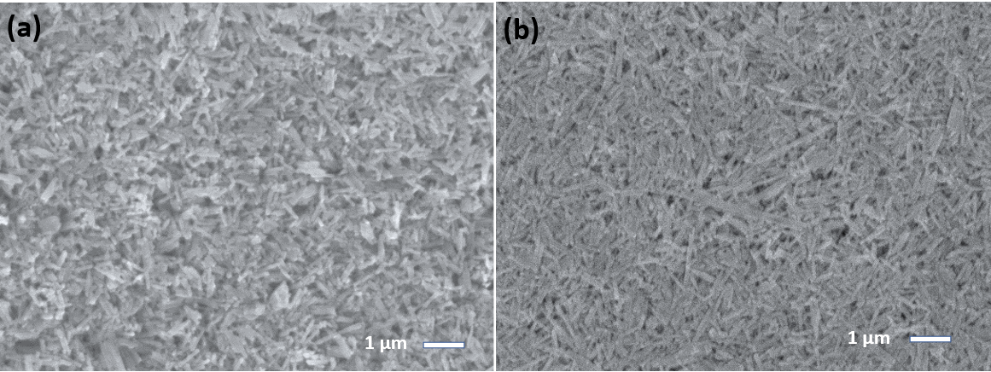
Fig. 1: Microstructures of (a)TeNWs and (b) S²⁻TeNWs films. Films were fabricated via drop-casting on Silicon substrates in nitrogen filled glovebox environment with O₂ <1ppm, and H₂O <1ppm. High-resolution X-ray photoelectron spectroscopy (XPS) spectra of TeNWs and S²⁻TeNWs films: survey scan (c & d) and XPS core level spectra of Te 3d (e & f) of bare TeNWs, and sulfur capped TeNWs, respectively.
Despite their porous nature, these films revealed a compact and interconnected network of nanowires. Notably, the sulfur capped TeNW (S²⁻TeNWs) films exhibited a more homogeneous and smoother morphology in comparison to the bare TeNWs film. Incorporating sulfur plays an important role to selectively target and effectively passivate any unoccupied surface Te sites that could be susceptible to oxidation, thus contributing to exceptional stability. The presence of sulfur within the TeNW matrix has been effective in mitigating surface oxidation, as evidenced by X-ray photoelectron spectroscopy (XPS) analysis presented in Fig.1 (c-f) and the EDX analysis shown in Supporting Information Fig S2. XPS analysis reveals that the nanowires primarily consist of elemental tellurium, characterized by a Te 3d binding energy of 572.39 eV. XPS analysis of S²⁻TeNWs shows no peak ~169 eV which confirms there is no chemical interaction between Te and sulfur. In quantitative terms, the analysis indicates that S²⁻TeNWs film contains approximately 2.7% sodium (Na), 19.33% sulfur (S), and 29.16% tellurium (Te). Additionally, surface oxidation was initially detected in TeNWs films at approximately 14.77 atomic percent (at%), which was subsequently reduced to 10.02 at% with the sulfur passivation within the TeNWs matrix, the core level O 1s spectra of bare TeNWs and S²⁻TeNWs films are also shown in the Supporting Information Fig S2-b. The peak detected at ~ 400 eV is assigned to the presence of nitrogen, potentially arising from the use of hydrazine as a reducing agent in the synthesis of tellurium nanowires.
To get a precise estimation, especially on the length and the diameters of the nanowires, we acquired low-magnification TEM images by dispersing the nanowires on a standard TEM grid (Supporting Information Fig. S3). Measurements show that the nanowire lengths ranged from 1.0 to 2.5 µm, whereas the diameter ranged from 45 nm to 55 nm for TeNWs and from 54 to 62 nm for S²⁻TeNWs. This clearly indicates that the nanowire diameter increased by ~ 8 nm after sulfur capping. It is quite likely that ultrasonication of the samples prior to drop casting the sample onto TEM grid resulted in breaking up the longer nanowires into smaller pieces.

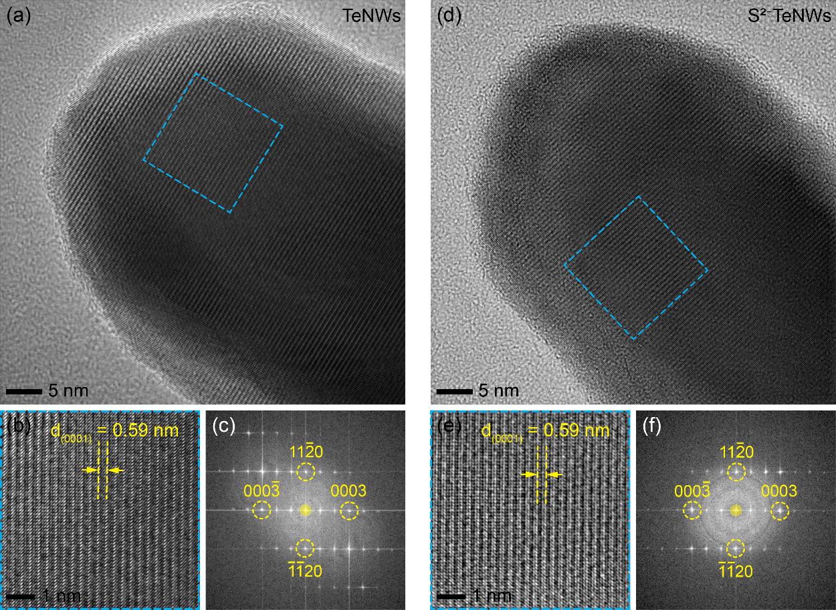
Fig. 2: High-resolution TEM images of (a) TeNWs and (d) S²⁻TeNWs, showing the morphology of the NWs. (b) and (e) A zoom-in section from the selected regions showing lattice fringes. (c) and (f) Fast Fourier Transform (FFT) of the selected regions showing that in both cases the nanowires are grown along the c-axis with a lattice fringe spacing of 0.59 nm that matches well with reported d-spacing of Te along (001).

To prove that sulfur is exclusively localized on the surface of the tellurium nanowires (TeNWs) and does not infiltrate the bulk, we acquired high-resolution TEM images and STEM-EDX maps (Fig. 2 and 3). High-resolution TEM images show no change in lattice parameter in both cases and the measured d-spacing (d₀₀₀₁ = 0.59 nm) matches well with the pristine Te (Fig. 2). This indicates that the bulk of the Te NWs should be free from any sulfur. Fast Fourier Transform (FFT) of the selected regions (Fig. 2(c)and 2(f)) shows that in both cases the nanowires are grown along the c-axis.

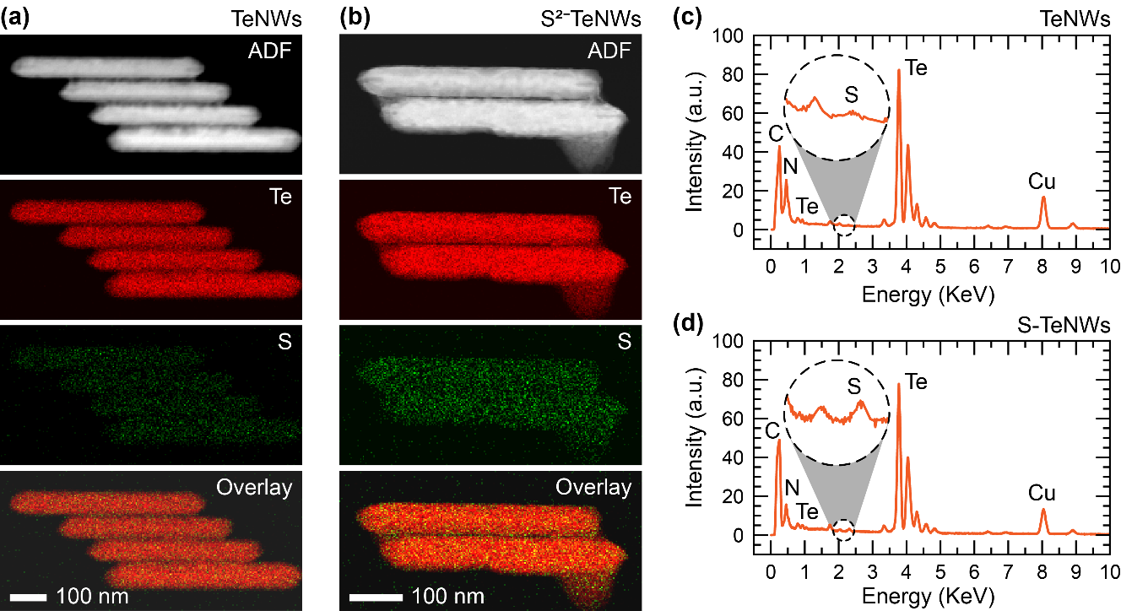
Fig. 3: STEM-EDX elemental mapping of (a) TeNWs and (b) S²⁻TeNWs showing annular dark-field (ADF) image, Te (red) and S (green) elemental maps and an overlay map of Te and S. A representative spectra of (c) TeNWs and (d) S²⁻TeNWs showing marginally larger peak of S K_{α} at 2.307 keV for S coated TeNWs.
Area | Elements | TeNWs |  | S²⁻TeNWs
Area | Elements | at. % | error % | at. % | error %
Small Area  Single NW | S K | 0.06 | 84 | 0.80 | 41
Small Area  Single NW | Te L | 99.94 | 0.5 | 99.20 | 1
Large Area  Multiple NWs | S K | 0.64 | 25 | 1.75 | 4
Large Area  Multiple NWs | Te L | 99.36 | 0.4 | 98.25 | 0.2

Table 1: Quantitative elemental composition of S and Te for TeNWs and S²⁻TeNWs extracted from STEM-EDX mapping.

To further understand the distribution of the sulfur, we acquired STEM-EDX mapping data (Fig. 3). A careful quantitative analysis of sulfur and Tellurium elemental composition reveals that there is slight increase (~ 1 at. %) in sulfur content for S²⁻TeNWs compared to TeNWs (Table 1). However, due to a relatively small quantity of sulfur and poor sensitivity and spatial resolution of our EDX detector, the sulfur maps show a uniform distribution over the whole surface of the NWs and there is no evidence that the sulfur is preferentially attached to the NWs surface. To clarify this issue, we acquired STEM-EELS maps for sulfur capped tellurium nanowires (S²⁻TeNWs) (Fig. 4). Due to a better spatial resolution in the STEM-EELS, we can detect a better map of sulfur distribution (Fig. 4a). The average line profiles of the overlay map clearly illustrate that sulfur is concentrated within the surface region, while tellurium is predominantly confined to the core region (Fig. 4b). Further analysis on TeNWs & S²⁻TeNWs is also shown in SI Fig. S4.
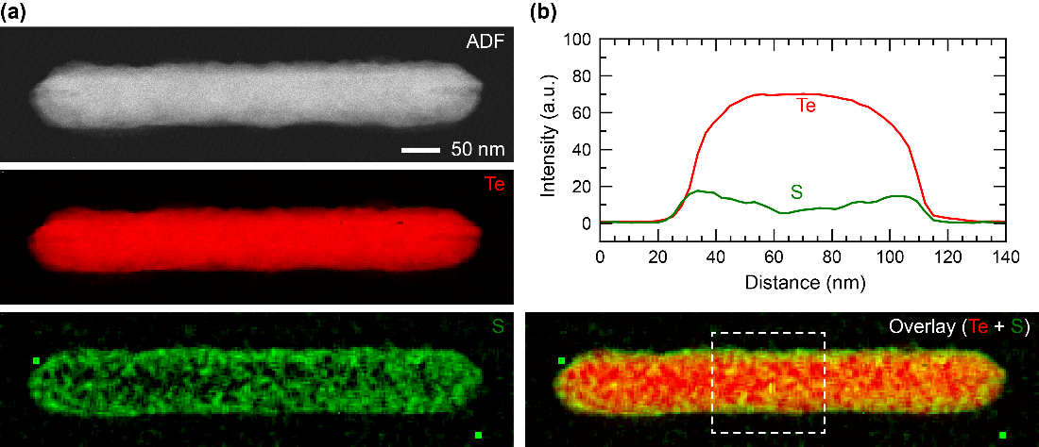
Fig. 4: STEM-EELS elemental mapping of sulfur capped Te-NWs: (a) Annular dark-field (ADF) STEM image of a selected NW and corresponding elemental (Te, S) elemental EELS maps. (b) Overlay map of Te and S (bottom) and averaged and normalized line-profile across the nanowire marked with the white dotted rectangle in the overlay map.

To evaluate the thermoelectric characteristics of TeNWs and S²⁻TeNWs, we generated drop-casted thin films on (13×4) mm² quartz substrates for ZEM3 system, by depositing a solution of TeNWs and S²⁻TeNWs (suspended in a mixture of IPA and ethanol, with a ratio of 3:2), followed by an annealing process at 300 ⁰C in a nitrogen-rich environment for a duration of one hour. Fig. 5 shows the temperature-dependent thermoelectric properties of the TeNWs film and the S²⁻TeNWs films. The positive Seebeck coefficient values in both TeNWs and S²⁻TeNWs films indicate their behavior as p-type semiconductors. As temperature increases, Seebeck coefficient drops as a function of temperature until 450 K and then start increased as temperature increases further for both TeNWs and S²⁻TeNWs films. Above 460 K, Seebeck value of both TeNWs and S²⁻TeNWs films matches closely. Similar trend of Seebeck coefficient has been reported by T. Fukuroi et. al.,³² and by Hua Peng et. al.,¹ for Te bulk material. On the other hand, electrical conductivity of TeNWs displays a gradual increase, progressing from 0.12 S/cm to 6.62 S/cm as the temperature varies from 300 K to 560 K. These changes result in the highest power factor, reaching 42.1 µW/mK² at 560 K.
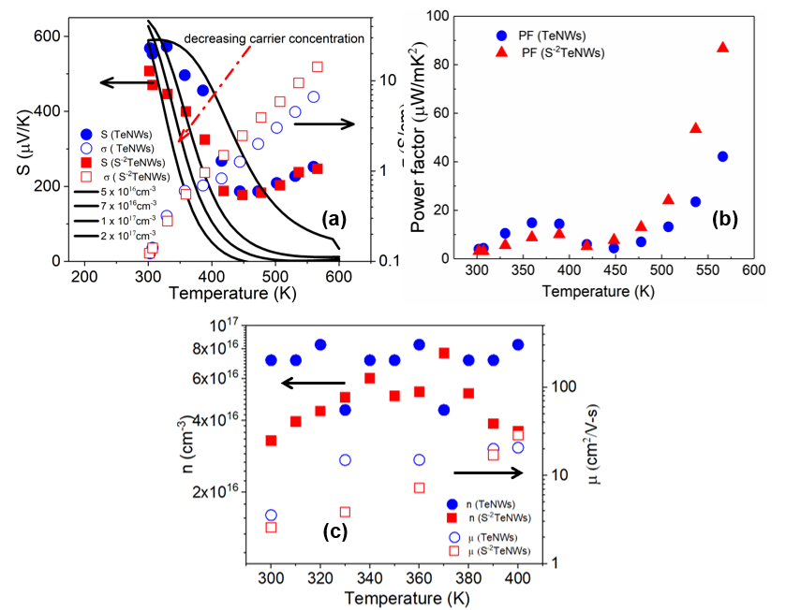
Fig. 5: (a)Temperature dependent Seebeck coefficient, electrical conductivity and (b) power factor of TeNWs and S²⁻TeNWs films. (c) Carrier concentration and mobility as a function of temperature. Temperature-dependent Seebeck coefficient and electrical conductivity properties were acquired through the system, ZEM3. The black solid lines are theoretical Seebeck coefficient values derived using Boltz trap for 4 different carrier concentration.

Furthermore, we observed an enhancement in thermoelectric performance with the introduction of sulfur in the TeNWs matrix. The thermoelectric properties depicted in Fig. 5 (a & b) reveal that the S²⁻TeNWs film follows a similar trend to the TeNWs, yet with superior power factors. The Seebeck coefficient of S²⁻TeNWs shows similar trend as TeNWs. However, we achieved a gradual increase in electrical conductivity from 0.12 to 14.3 S/cm while increasing the temperature from 300 to 560 K, leading to a rise in power factors to 86.7 µW/mK². Hall measurements were performed to deduce carrier concentration and mobility in TeNWs and S²⁻TeNWs films (See SI for more details). Carrier concentration and mobility are plotted as a function of temperature in figure 5(c). As can see, carrier concentration is bit higher thorough out the temperature range (300-400 K) in S²⁻TeNWs films compared to TeNWs films which give rise to bit lower Seebeck coefficient as observed in figure 5(a). Room temperature carrier concentration for both films was found ~3-5 x10¹⁶cm⁻³ for S²⁻TeNWs films and ~8 x10¹⁶ cm⁻³ for TeNWs film, respectively. Similar carrier concentration has been reported by Fukuroi et al., in pristine Te bulk at room temperature.³² On the hand, mobility increases as temperature increases for both the systems. Mobility value for TeNWs was bit higher for 300 K but, a crossover observed at 400 K.
An analytical study of temperature dependent Seebeck coefficient is done using Boltz trap (more details in SI).³³ Seebeck coefficients values at different temperature were calculated under the constant relaxation time approximation (CRTA). Black lines in figure 5(a) show the temperature dependence of the theoretical Seebeck coefficient for 4 fixed intrinsic carrier concentrations which are closer to measured using Hall measurement for TeNWs (8 e¹⁶cm⁻³) and S²⁻TeNWs films (5e¹⁶cm⁻³). As observed, experimental data is bit lower than the theoretical data. The lower value could be explained by changing intrinsic carrier concentration as temperature increases. At room temperature, intrinsic carrier concentration of Te material can be written as:
$n_{i}=\sqrt{pn}=2{\left(4π\frac{k_{B}T}{h^{2}}\right)}^{\frac{3}{2}}{(m_{h}^{*}m_{e}^{*})}^{3/4}e^{-\frac{E_{g}}{2k_{B}T}}$ (1)
$p=2{\left(4π\frac{k_{B}T}{h^{2}}\right)}^{\frac{3}{2}}{(m_{h}^{*})}^{3/2}e^{-\frac{E_{g}}{2k_{B}T}}$ (2)
$n=2{\left(4π\frac{k_{B}T}{h^{2}}\right)}^{\frac{3}{2}}{\left(m_{e}^{*}\right)}^{\frac{3}{2}}e^{-\frac{E_{g}}{2k_{B}T}}$ (3)

Where $m_{h}^{*}{ and m}_{e}^{*}$ are effective mass of holes and electrons and $E_{g}$ is the band gap. Tellurium has low band gap of 0.35 eV which decreases as temperature increases.^{34,35} Due to temperature dependent band gap, both p and n type carrier concentration increases. Consequently, the Seebeck coefficient decreases as a function of temperature. On the other hand, conductivity will increase as observed in figure 5(a). This phenomenon is corroborated by previous studies by Hua Peng et al., T. Fukuroi et al., and Siqi Lin et al.^{1,32,2}.

Table 2. Summary of Transport Properties of Thin Films based on Tellurium Nanowires.
Material | σ(S/cm) | S(µV/K) | PF (µW/m-K²) | T | κ(W/m-K) | ZT
Te-bulk (2) | 59 | 300 | 531 | 300K | 1.69 | 0.10
TeNWs (3) | 0.26 | 568 | 8.44 | 300K | - | -
TeNWs (18) | 0.0129 | 551 | 0.39 | 300K | 0.16 | 7.2×10⁻⁴
TeNWs (24) | 0.1 | 400 | 1.6 | 300K | - | -
TeNWs (25) | 0.08 | 408 | 2.7 | 300K | 2- (bulk value) | 4.4×10⁻⁴
TeNWs (26) | 0.015 | 758 | 0.9 | 300K | - | -
Te-PVP (31) | 3.8 | 346 | 45.5 | 300K | 0.98 | 0.01
TeNWs (our work) | 6.62 | 252 | 42.1 | 560K | - | -
S²⁻TeNWs (our work) | 14.3 | 246 | 86.7 | 560K | - | -

Conclusion
In conclusion, our study demonstrates a significant enhancement in the thermoelectric (TE) properties of Tellurium nanowires (TeNWs) by modifying the surface of the TeNWs using sulfur moieties. This surface modification not only resulted in the improvement of the TE properties but also effectively reduced oxidation within the TeNWs matrix, as confirmed by Energy Dispersive X-ray (EDX) and X-ray Photoelectron Spectroscopy (XPS) analyses. Moreover, our research demonstrated the successful adherence of sulfur onto the TeNWs' surfaces, as validated by Scanning Transmission Electron Microscopy-Energy Loss Spectroscopy (STEM-EELS) elemental mapping. Our comprehensive analyses utilizing Raman spectra, UV-Vis, X-ray Diffraction (XRD), and Transmission Electron Microscopy (TEM) supported the notion that the presence of sulfur did not induce any structural alterations in the TeNWs. Notably, our work has achieved a high-power factor of 86.7 µW/mK², which is the highest reported value to date for tellurium nanowires. Our results hence open up a new avenue for advancing the thermoelectric properties of tellurium-based nanostructured materials, offering promising prospects for their utilization in various energy harvesting and conversion applications.

Acknowledgments
S.S., P.K., and K.H. would like to acknowledge funding from the Accelerated Materials Development for Manufacturing Program at A*STAR via the AME Programmatic Fund by the Agency for Science, Technology, and Research under Grant No. A1898b0043. S. S. and I.N. would like to thank A*STAR Graduate Academy’s ARAP program for funding S.S.’s graduate studies in IMRE, A*STAR. I.N. wishes to acknowledge financial support by the Engineering and Physical Sciences Research Council (EPSRC) for Grant No. EP/T026219/1.
Materials and Methods
Reagents
The synthesis of tellurium nanowires and their surface modification by sulfur ligands involved the use of the following reagents: ethylene glycol (with a purity exceeding 99%, anhydrous grade, obtained from Sigma Aldrich), tellurium dioxide (with a purity of 99.995%, sourced from Aldrich), polyvinylpyrrolidone (PVP-K30, with a molecular weight approximately 40,000, acquired from Fluka), potassium hydroxide (with a minimum purity of 85% on a KOH basis, from Merck), hydrazine hydrate (N₂H₄ 50-60%, provided by Sigma Aldrich), and sodium sulfide (with a purity of 99.5%, in the form of Na₂S powder, anhydrous grade, obtained from Aldrich). These reagents were employed as purchased without further purification.
Synthesis of Tellurium Nanowires and Surface Modification
Established protocols from the literature were employed for both the synthesis of tellurium nanowires and the subsequent surface modification of these nanowires using sodium sulfide.^{14,15,17} To synthesize Tellurium (Te) nanowires, 20 ml of ethylene glycol was introduced into a three-neck flask connected to a standard Schlenk line. Subsequently, 0.2 g of PVP, 0.6 g of NaOH, and 0.4788 g of TeO₂ powder were added to the flask. The mixture was then heated to 160°C, following which 1 ml of hydrazine hydrate was introduced as the reducing agent. After one hour of reaction time, uniform Te nanowires were formed. Upon completion of the reaction, the solution was cooled to room temperature and subjected to centrifugation at 10,000 rpm for 2 hours and 30 minutes. The supernatant was then decanted, and the precipitated nanowires were dispersed in acetone: DI-water (3:1) and centrifuged at 10,000 rpm for 30 minutes. This process was repeated thrice to ensure the elimination of any residual contaminants and to obtain a pure final product. For the surface modification of the synthesized TeNWs, equimolar quantities of TeNWs and Na₂S linker were dissolved in deionized (DI) water, followed by 10 minutes of sonication and 30 minutes of magnetic stirring. Subsequently, the mixture underwent centrifugation at 10,000 rpm for 45 minutes. Upon decanting the supernatant, the precipitated sulfur-capped nanowires were re-dispersed in DI water and subjected to another round of centrifugation for 30 minutes. To ensure the removal of any unbound species and achieve a pristine product, this process was iterated three times. Finally, the sulfur capped TeNWs texture was dried under vacuum overnight.
Thin Film Fabrication
The nano-powders consisted of tellurium nanowires and sulfur capped tellurium nanowires were dispersed in isopropanol and ethyl alcohol (3:2) solution to obtain a homogenous and stable suspension followed by 30 min power sonication in pulse mode (15 see ON, 5sec OFF) before being drop-casted onto silicon and quartz substrates.

The solutions were drop-casted onto circular quartz substrates with a diameter of 20 mm to measure thermoelectric (TE) transport properties. To perform X-ray diffraction (XRD), scanning electron microscopy (SEM) equipped with EDX, and X-ray photoelectron spectroscopy (XPS), the films were deposited onto silicon (Si) substrates measuring (1×1) cm², and this deposition process took place at 70°C on a hotplate. Subsequently, the drop-casted films were annealed at 100°C overnight within a nitrogen-filled glovebox to remove any residual solvent. It is important to note that the films remained unexposed to ambient air throughout this process.
Before drop-casting, all substrates were thoroughly cleaned which involved sequential sonication in acetone and isopropanol for a duration of 10 minutes. Following this, the substrates were subjected to UV-ozone treatment at 100°C for a period of 10 minutes. Since the nanowires initially did not show any electrical conductivity, they were subjected to additional annealing at 300°C for one hour.
Characterization
X-ray diffraction patterns were gathered using a Bruker D8 Advanced X-ray powder diffractometer employing Cu Kα radiation at ambient temperature. For X-ray photoelectron spectroscopy (XPS), an AXIS Supra spectrometer (Kratos Analytical, UK) was employed, featuring a hemispherical analyzer and a monochromatic Al Kα source (1487 eV) operating at 15 mA and 15 kV. XPS spectra were acquired from a measurement area of 700×300 µm² at a take-off angle of 90⁰. Survey scans used a pass energy of 160 eV, while high-resolution scans used 20 eV. Charge compensation was achieved through the application of low-energy electron flooding. The raw data was subsequently deconvoluted using Casa XPS software. Raman spectroscopy was carried out with a macro-Raman system (Technospex) using 532 nm laser excitation. The setup was calibrated using a silicon wafer with known peak at 520.7cm⁻¹.
Ultraviolet visible spectroscopy (UV-Vis) was conducted by employing a Shimadzu UV-3600 Spectrophotometer in the UV-VIS-NIR range, with a baseline spanning from 300 to 3300 cm⁻¹. Data acquisition was carried out using UV-Probe 2.33 software. The nanowires were dispersed in DI-water at a concentration of 0.1 mg per 3 ml, and quartz cuvettes were employed to measure the absorption spectra in UV-Vis. Scanning Electron Microscopy (SEM) imaging was conducted using a JEOL JSM 7800F Prime scanning electron microscope at an operational voltage of 5 keV. For Transmission Electron Microscopy (TEM) analysis, samples were prepared by applying a 20 µL solution onto a standard 3 mm copper mesh grid with a continuous lacey carbon-coated film (Cat. No. 3830C-CF, SPI Supplies, West Chester, USA). To create the suspension solutions, 50 µg of powder containing the nanowires (TeNWs and S²⁻TeNWs) were mixed with 1 mL of ACS-grade water (Cat. No. 320072, Sigma-Aldrich Co. LLC, St. Louis, USA). These suspension solutions were thoroughly blended for 2 minutes using a vortex mixer (Scientific Industries Inc., New York, USA) to ensure uniform dispersion of the nanoparticles. Grids were air-dried naturally for approximately 1 hour before being loaded into the TEM. The grid samples were placed onto a standard low-background TEM double tilt holder (Thermo Fisher Scientific, Waltham, MA USA). TEM images were acquired using Titan 80-300 keV and Tecnai G2 80-200 keV TEMs (Thermo Fisher Scientific, Waltham, MA USA; formerly produced by FEI), which were equipped with a 4096×4096 pixels² OneView CMOS camera (Gatan, Inc., Pleasanton, CA, USA). STEM-EDX and STEM-EELS were acquired using Tecnai G2 80-200 keV TEMs. Subsequently, TEM images were processed using Digital Micrograph (DM) software (Gatan, Inc., Pleasanton, CA, USA) and the open-source ImageJ software (National Institutes of Health) to enhance contrast and brightness.
Thermoelectric Transport Properties Measurements
We conducted a simultaneous temperature-dependent measurement of the Seebeck coefficient and electrical conductivity for thin films of TeNWs and S²⁻TeNWs using the Seebeck coefficient-electrical resistance measurement system ZEM-3 with temperature intervals of 30 degrees. For the calculation of the electrical conductivity, we obtained linear current-voltage (IV) curves at various temperatures and extracted the resistance at each temperature from the slope of the IV curves. To estimate the thickness and width of the thin films, we employed an Alpha-Step IQ surface profiler and then the resistivity (ρ) was computed. Finally, electrical conductivity (σ) was obtained as σ = 1/ ρ.
References
(1) Peng, H.; Kioussis, N.; Snyder, G. J. Elemental tellurium as a chiral p -type thermoelectric material. Phys. Rev. B - Condens. Matter Mater. Phys. 2014, 89 (19), 1–7. https://doi.org/10.1103/PhysRevB.89.195206
(2) Lin, S.; Li, W.; Chen, Z.; Shen, J.; Ge, B.; Pei, Y. Tellurium as a high-performance elemental thermoelectric. Nat. Commun. 2016, 7, 1–6. https://doi.org/10.1038/ncomms10287
(3) Park, H.; Son, W.; Lee, S. H.; Kim, S.; Lee, J. J.; Cho, W.; Choi, H. H.; Kim, J. H. Aqueous chemical synthesis of tellurium nanowires using a polymeric template for thermoelectric materials. CrystEngComm 2015, 17 (5), 1092-7.
(4) Mayers, B.; Xia, Y. One-dimensional nanostructures of trigonal tellurium with various morphologies can be synthesized using a solution-phase approach. J. Mater. Chem. 2002, 12 (6), 1875–1881. https://doi.org/10.1039/b201058e
(5) Mo, M.; Zeng, J.; Liu, X.; Yu, W.; Zhang, S.; Qian, Y. Controlled hydrothermal synthesis of thin single-crystal tellurium nanobelts and nanotubes. Adv. Mater. 2002, 14 (22), 1658–1662.
(6) Liu, Z.; Li, S.; Yang, Y.; Hu, Z.; Peng, S.; Liang, J.; Qian, Y. Shape-controlled synthesis and growth mechanism of one-dimensional nanostructures of trigonal tellurium. New J. Chem. 2003, 27 (12), 1748–1752. https://doi.org/10.1039/b306782c
(7) Liu, Z.; Hu, Z.; Xie, Q.; Yang, B.; Wu, J.; Qian, Y. Surfactant-assisted growth of uniform nanorods of crystalline tellurium. J. Mater. Chem. 2003, 13 (1), 159–162. https://doi.org/10.1039/b208420a
(8) Lu, Q.; Gao, F.; Komarneni, S. Biomolecule-assisted reduction in the synthesis of single-crystalline tellurium nanowires. Adv. Mater. 2004, 16 (18), 1629–1632. https://doi.org/10.1002/adma.200400319
(9) Zhu, Y.; Wang, W.; Qi, R.; Hu, X. Microwave‐assisted synthesis of single‐crystalline tellurium nanorods and nanowires in ionic liquids. Angew. Chemie 2004, 116 (11), 1434–1438. https://doi.org/10.1002/ange.200353101
(10) Tang, Z.; Wang, Y.; Sun, K.; Kotov, N. A. Spontaneous transformation of stabilizer-depleted binary semiconductor nanoparticles into selenium and tellurium nanowires. Adv. Mater. 2005, 17 (3), 358–363. https://doi.org/10.1002/adma.200400894
(11) Mohanty, P.; Park, J.; Lee, G.; Kim, B. Fabrication of single crystalline cadmium nanowires by a facile low temperature vapor phase method. J. Nanosci. Nanotechnol. 2006, 6 (11), 3376–3379. https://doi.org/10.1166/jnn.2006.014
(12) Dresselhaus, M. S.; Chen, G.; Tang, M. Y.; Yang, R.; Lee, H.; Wang, D.; Ren, Z.; Fleurial, J. P.; Gogna, P. New directions for low-dimensional thermoelectric materials. Adv. Mater. 2007, 19 (8), 1043–1053. https://doi.org/10.1002/adma.200600527
(13) Li, J. F.; Liu, W. S.; Zhao, L. D.; Zhuo, M. High-performance nanostructured thermoelectric materials. NPG Asia Mater. 2010, 2 (4), 152-8.
(14) Sahu, A.; Russ, B.; Su, N. C.; Forster, J. D.; Zhou, P.; Cho, E. S.; Ercius, P.; Coates, N. E.; Segalmane, R. A.; Urban, J. J. Bottom-up design of de novo thermoelectric hybrid materials using chalcogenide resurfacing. J. Mater. Chem. A 2017, 5 (7), 3346-57.
(15) Sahu, A.; Russ, B.; Liu, M.; Yang, F.; Zaia, E. W.; Gordon, M. P.; Forster, J. D.; Zhang, Y. Q.; Scott, M. C.; Persson, K. A.; Coates, N. E.; Segalman, R. A.; Urban, J. J. In-situ resonant band engineering of solution-processed semiconductors generates high performance n-type thermoelectric nano-inks. Nat. Commun. 2020, 11 (1), 2069.
(16) Kumar, P.; Repaka, D.V.; Hippalgaonkar, K. Lithography-free resistance thermometry based technique to accurately measure seebeck coefficient and electrical conductivity for organic and inorganic thin films. Rev. Sci. Instrum. 2017, 88 (12).
(17) Yang, H.; Finefrock, S. W.; Albarracin Caballero, J. D.; Wu. Y. Environmentally benign synthesis of ultrathin metal telluride nanowires. J. Am. Chem. Soc. 2014, 136 (29), 10242–10245. https://doi.org/10.1021/ja505304v.
(18) Wang, W.; Li, C.; Li, X.; Jia, Y.; Jiang, F.; Liu, C.; Tana, R.; Xu, J. Fabrication of freestanding tellurium nanofilm and its thermoelectric performance. Thin Solid Films 2018, 654, 23–29. https://doi.org/10.1016/j.tsf.2018.03.073.
(19) Goldsmid, H. J. Introduction to thermoelectricity. Berlin: Springer; 2010, 121, 46.
(20) Müller, E.; Zabrocki, K.; Goupil, C.; Snyder, G.; Seifert, W. Functionally graded thermoelectric generator and cooler elements. CRC Handbook of Thermoelectrics: Thermoelectrics and its Energy Harvesting. 2012.
(21) Zhang, B.; Hou, W.; Ye, X.; Fu, S.; Xie, Y. 1D tellurium nanostructures: photothermally assisted morphology‐controlled synthesis and applications in preparing functional nanoscale materials. Adv. Func. Mater. 2007, 17 (3), 486-92.
(22) Wang, T.; Liu, C.; Xu, J.; Zhu, Z.; Liu, E.; Hu, Y.; Li, C.; Jiang, F. Thermoelectric performance of restacked MoS₂ nanosheets thin film. Nanotechnology 2016, 27 (28), 285703.
(23) Wang, X.; Meng, F.; Tang, H.; Gao, Z.; Li, S.; Jin, S.; Jiang, Q.; Jiang, F.; Xu, J. Design and fabrication of low resistance palm-power generator based on flexible thermoelectric composite film. Synthetic Metals 2018, 235, 42-8.
(24) Yee, S. K.; Coates, N. E.; Majumdar, A.; Urban, J. J.; Segalman, R. A. Thermoelectric power factor optimization in PEDOT: PSS tellurium nanowire hybrid composites. Physic. Chem. Chemic. Phys. 2013, 15 (11), 4024-32.
(25) See, K. C.; Feser, J. P,; Chen, C. E.; Majumdar, A.; Urban, J. J.; Segalman, R. A. Water-processable polymer− nanocrystal hybrids for thermoelectrics. Nano letters 2010, 10 (11), 4664-7.
(26) Liang, Z.; Boland, M. J.; Butrouna, K.; Strachan, D. R.; Graham, K. R. Increased power factors of organic–inorganic nanocomposite thermoelectric materials and the role of energy filtering. J. Mater. Chem. A 2017, 5 (30),15891-900.
(27) Schmidt, V.; Wittemann, J. V.; Senz, S.; Gösele, U. Silicon nanowires: a review on aspects of their growth and their electrical properties. Adv. Mater. 2009, 21 (25-26), 2681-702.
(28) Amato, M.; Rurali, R. Surface physics of semiconducting nanowires. Progress in Surface Science 2016, 91 (1), 1-28.
(29) Nicollian, E. H. Surface passivation of semiconductors. J.Vac. Sci.Tech. 1971, 8 (5), 39-49.
(30) König, J. D.; Nielsen, M. D.; Gao, Y. B.; Winkler, M.; Jacquot, A.; Böttner, H.; Heremans, J. P. Titanium forms a resonant level in the conduction band of PbTe. Physic. Rev. B 2011, 84 (20), 205126.
(31) Yang, L.; Gordon, M. P.; Menon, A. K.; Bruefach, A.; Haas, K.; Scott, M. C.; Prasher, R. S.; Urban, J. J. Decoupling electron and phonon transport in single-nanowire hybrid materials for high-performance thermoelectrics. Sci. Adv. 2021, 7 (20), eabe6000.
(32) Fukuroi, T.; Tanuma, S.; Tobisawa, S. Electrical properties of antimony-doped tellurium crystals. Sci. Rep. Res. Inst. Ser. A 1952, 4, 283-97.
(33) Madsen, G. K.; Singh, D. J. Boltz TraP. A code for calculating band-structure dependent quantities. Comp. Phys. Commun. 2006,175 (1), 67-71.
(34) Yang, D. Q.; Zhu, L. Q.; Wang, J. L.; Xia, W.; Zhang, J. Z.; Jiang, K.; Shang, L. Y.; Li, Y. W.; Hu, Z. G. Band Structure and Lattice Vibration of Elemental Tellurium Investigated by Temperature‐Dependent Mid‐and‐Far Infrared Transmission and Raman Spectroscopy. Physica Status Solidi B 2022, 259 (7), 2100625.
(35) Grosse, P. The Physics of Tellurium. Springer Tracts in Modern Physics; 48; Springer: Berlin, 1969.

