A randomised, crossover trial exploring the patient perspective and effectiveness of biosimilar adalimumab transition: IBD Reference and Biosimilar adalimumab Cross over Study (iBaSS)

David Young^{1,2} (ORCiD 0000-0003-0102-5739), Clare Harris^{2,3} (ORCiD 0000-0002-8233-7509), Sohail Rahmany³ (ORCiD 0000-0003-0924-2690), Inês Iria⁴, João Gonçalves⁴, Janet Addison⁵, Justin Harvey⁶, Sue Latter⁷ (ORCiD 0000-0003-0973-0512), Fraser Cummings^{2,3} (ORCiD 0000-0002-9659-3247)

¹ Pharmacy Department, University Hospital Southampton NHS Foundation Trust, Southampton, United Kingdom.
² Faculty of Medicine, University of Southampton, Southampton, United Kingdom.
³ Department of Gastroenterology, University Hospital Southampton NHS Foundation Trust, Southampton, United Kingdom.
⁴ iMed – Research Institute for Medicines, Faculdade de Farmacia, Universidade Lisboa, Lisboa, Portugal.
⁵ Biogen UK, Maidenhead, United Kingdom.
⁶ Department of Statistics and Actuarial Science, Stellenbosch University Stellenbosch, South Africa.
⁷ School of Health Sciences, University of Southampton, Southampton, United Kingdom.

Address for correspondence:
David Young
Pharmacy Department
University Hospital Southampton NHS Foundation Trust
Tremona Road
Southampton, UK
SO16 6YD
david.young@uhs.nhs.uk

Word count: 3,407 words

Abstract

Background
Patient satisfaction has been positively associated with adherence which is expected to impact outcomes. Although vital for successful implementation of biosimilar medicines, little is known about the patient perspective of transition.

Aim
The aim of this study was to investigate clinical outcomes and patient experience of transitioning between reference adalimumab and a biosimilar (SB5).

Method
iBaSS is a phase IV single-centre, prospective, randomised, single-blind, cross-over study in adult subjects with Crohn’s disease. Participants, stable on adalimumab before consent, received 24 weeks of treatment with both reference adalimumab and SB5. The primary outcome was the proportion of patients maintaining baseline clinical status throughout each treatment period, with patients’ perspective of disease control and treatment satisfaction assessed as secondary outcomes.

Results
A total of 112 participants, representative of the heterogeneous patient populations encountered in routine clinical practice, were enrolled. A similar proportion of participants maintained baseline clinical status through each treatment period: 81.8% with reference adalimumab and 79.5% with SB5. Patient reported outcomes (IBD-Control questionnaire (SB5: 15.5; reference adalimumab 15) and TSQM), adverse events and therapeutic drug monitoring remained consistent through both treatment periods, although a higher median injection pain VAS score was noted with SB5 (53/100 versus 6/100 with reference adalimumab). The number of switches undertaken in the study did not impact serum drug concentration or immunogenicity.

Conclusion
This study, mimicking real world adalimumab transition, demonstrates that patients undertaking brand transition can be expected to have consistent clinical and satisfaction outcomes.
Clinical trial registered with EudraCT (number 2018-004967-30).

Keywords
Biosimilar Pharmaceuticals
Adalimumab
Crohn Disease
Patient Reported Outcome Measures

Patient Satisfaction

Impact statements
- Biosimilar medicines are critical to ensuring sustainability of healthcare systems, improving access to treatment and fostering innovation.
- Patient satisfaction is critical to the successful implementation of these medicines and a better understanding of the patient perspective of transition is essential.
- Patients undertaking brand transition to a biosimilar can be expected to have consistent effectiveness, safety and satisfaction outcomes.
- These findings endorse patient and healthcare professional confidence in the use of biosimilar medicines.

Main text

Introduction
Crohn’s disease (CD) is a relapsing inflammatory bowel disease characterised by chronic inflammation of the gastrointestinal tract with progressive damage [1]. Uncontrolled inflammation is associated with symptoms such as abdominal pain, diarrhoea, and fatigue as well as the development of long-term stricturing and penetrating complications. Biological medicines have been shown to improve patient outcomes through reduced complications, surgery and hospitalisations [2] however the expense of these therapies is known to be the main driver in the cost of treating patients with CD [3]. Adalimumab is a biological medicine targeting tumour necrosis factor α (TNFα), a pro-inflammatory cytokine implicated in CD, and is widely prescribed for this indication [4]. Biosimilar medicines have demonstrated quality, structural, functional and preclinical similarity, and equivalent clinical efficacy as the previously authorised biological medicine [5] (‘reference product’) and have the potential to reduce the financial burden of biological medicines [6]. The standard maintenance therapy for inflammatory bowel disease involves administering a 40 mg injection of adalimumab every two weeks, using either a prefilled single-use pen or syringe. Common adverse effects observed in routine clinical practice primarily include injection site reactions and infections. Biosimilar adalimumab has been available in Europe since October 2018.
Commodification of biosimilar (and reference) medicines has reduced drug acquisition costs, profit margins and value-added services (such as bundled therapeutic drug monitoring). As this develops, patients will be expected to undertake multiple product transitions with diminishing financial savings on each switch and the resources available to support patients and clinical teams undertaking these changes will decrease. Studies in multiple indications have consistently demonstrated that switching from reference to biosimilar adalimumab has no impact on efficacy, safety or immunogenicity [7], [8]. Treatment satisfaction has been positively associated with adherence [9] which is therefore expected to impact outcomes, as well as minimising the nocebo effect [10]. From the patient perspective, successful transition has more subtle and subjective features and therefore is critical to the successful implementation of biosimilar medicines. As more biosimilar products become available and cost differences between products reduce it is likely that patient factors will become more relevant.

Aim
The aim of this study was to investigate clinical outcomes and patient experience of transitioning between reference adalimumab (Humira®; AbbVie Ltd., UK) and the adalimumab biosimilar (SB5; Imraldi®; Biogen Biosimilars, UK).

Ethics approval
Ethics approval for the study was granted by the London (Chelsea) research ethics committee 29th April 2019 (reference 19/LO/0167).

Method

Study design
iBaSS is a phase IV prospective, randomised, single-blind, crossover study in a representative population of adult subjects with CD at University Hospital Southampton NHS Foundation Trust (UHS) (EudraCT number 2018-004967-30). The pragmatic study was designed to mimic the optimal care pathway of patients transitioning to a biosimilar (Supplementary Figure 1).

Patients
Patients eligible for inclusion were aged 18 years and over with a confirmed diagnosis of CD in remission or with mild disease activity (modified Harvey-Bradshaw Index (mHBI) score <8); established on a stable dose of reference adalimumab or SB5 for 12 weeks before recruitment and only previously exposed to that product with no expectation of regimen modification. Eligibility was initially limited to patients treated with reference adalimumab although this was later broadened to patients using SB5 as this became the first-line adalimumab product locally. Exclusion criteria were: planned discontinuation of adalimumab; scheduled surgical procedure or hospitalisation within 12 months of randomisation; and women who were pregnant or breast-feeding.

Study procedures
Study recruitment commenced 1st July 2019 but was suspended due to the COVID-19 pandemic from 23rd March 2020 to 9th July 2020. Eligible patients were screened, consented and recruited into the clinical trial. Following consent, participants were randomised 1:1 to one of two treatment sequences: (TS1) reference adalimumab followed by SB5 or (TS2) SB5 followed by reference adalimumab. The randomisation sequence was generated using ALEA randomisation software (FormsVision BV, Abcoude, The Netherlands) using fixed blocks of 10 and stratification according to adalimumab product use prior to enrolment. UHS pharmacy department managed treatment sequence allocation to maintain the blinding of the study team. Participants continued with their previous adalimumab dosing regimen using commercially available pre-filled pens. Pharmacy staff and participants were asked not to disclose the allocated adalimumab product to the clinical trial physicians during the trial. To ensure blinding, medication supply and return of unused pens occurred remote from the research team. Patients were reviewed every 12 weeks and received each adalimumab product for 24 weeks. Data collected at baseline (immediately prior to randomisation) and each study visit included disease activity (mHBI and PRO-2), patient’s perspective of disease control (IBD-Control questionnaire [11] and satisfaction with medication (Treatment Satisfaction Questionnaire for Medication (TSQM; version 1.4) [12]), routine laboratory measures (including C-reactive protein), therapeutic drug monitoring and faecal calprotectin. The IBD-Control questionnaire, generic to all patients with inflammatory bowel disease, was developed to measure disease control from the patient perspective. The IBD-Control-8 subscore is based on questions covering the patient’s opinion of the impact of symptoms on quality of life and the effectiveness of treatment resulting in a score from 0 to 16 (0 indicating worst possible control) and the IBD-Control-VAS is a single, overall summary of disease control ranging from 0 to 100 (0 indicating worst possible control).
The TSQM comprises 14 items, with five specifically addressing side effects. Responses are recorded on a 2-, 5-, or 7-point Likert scale and then converted into four domain scores—effectiveness, side effects, convenience, and global satisfaction—ranging from 0 to 100, with 0 indicating maximum dissatisfaction. Questionnaires were issued to patients without modification. All doses of medication were self-administered by participants at home with administration and injection pain recorded (visual analogue scale (VAS; 0-100)) at each dose. Projected dosing schedules were determined factoring in the prescribed dosing frequency (subsequently accounting for regimen modifications as appropriate) to obtain the expected number of doses between study visits. This was compared to the actual number of doses administered to ascertain adherence (the "proportion of prescribed drug taken” [13]). Participants completed the IBD-Control questionnaire and TSQM at home every two and four weeks respectively. Modification of medication regimen during the trial period was permitted in line with routine clinical practice. Other therapies for CD were maintained throughout. Study visits were planned to align with the patient exhausting their supply of adalimumab and as close as feasible to the subsequent dose, facilitating measurement of a trough drug concentration.

Study outcomes
The primary outcome was the proportion of patients maintaining baseline clinical status throughout each treatment period. Treatment failure was defined as an increase in mHBI score of ≥3 (corresponding to a 100-point change in Crohn’s Disease Activity Index score [14]) and/ or a decline in IBD-Control score of ≥4 points compared to baseline. Secondary endpoints were to evaluate changes in disease activity, medical treatment, immunogenicity, biochemical markers and safety.

Statistical analysis
The apriori planned sample size of 150 patients (75 per arm) was determined to provide 90% power to demonstrate equivalence of SB5 to reference adalimumab. An equivalence margin of 15% and an alpha error of 5% (2-sided) respective 2.5% (1-sided) were assumed. A range of values were used for the proportion of participants expected to maintain baseline clinical status and drop-out rate. The primary analysis population (per protocol population; PPS) included all subjects that were randomised, known to have received at least one dose of study medication and had all relevant measurements to calculate the primary endpoint (mHBI and IBD-Control at baseline, week 24 and week 48). A secondary analysis population (full analysis population; FAS), included all subjects who were randomised and known to have received at least one dose of study medication, was used to assess the robustness of the results as well as the analysis of safety and pharmacokinetic data. Longitudinal data were analysed according to the current adalimumab product received at the specific visit. For continuous endpoints means, standard deviation, medians and range were calculated and categorical endpoints are presented as absolute (n) and relative (%) frequencies. A mixed effects model, employing a logit link for binary outcomes and an identity link for continuous outcomes, was applied to discern the consistency of results throughout the trial period. Where a significant difference was identified, a Wilcoxon test was performed to compare baseline and each subsequent visit, along with a direct comparison of the final visit for each treatment period. Minimal clinically important difference (MCID) was estimated as one half of the standard deviation of the baseline values [15]. Statistical analyses were conducted using SAS software, version 9.4 (SAS Institute Inc., Cary, NC).

Results

Patient characteristics
Overall, 318 patients prescribed adalimumab as routine clinical care at UHS were pre-screened with 97 not meeting the eligibility criteria, most commonly due to discontinuation of adalimumab or a plan to do so. A total of 112 participants were enrolled (CONSORT diagram shown in Figure 1) and 94 participants (83.9%) completed the full 48 week trial. No evidence of dose administration was recorded for three participants (one lost to follow-up and two withdrew consent to participate before the week 12 visit) who were excluded from the FAS. Six participants were excluded from the final analysis due to incomplete data (three with a stoma making the mHBI unsuitable and three with missing components on the IBD-Control). Patient demographics and clinical characteristics were similar in both groups (Table 1). Compared to patients pre-treated with reference adalimumab, those prescribed SB5 had similar characteristics, except for being earlier in their disease course (median disease duration 2 versus 10 years) and with fewer participants having a severe (stricturing or fistulising) phenotype (Supplementary Table 1).

Clinical efficacy
The primary endpoint of maintaining baseline clinical status following 24 weeks treatment with each product was achieved by a similar proportion of participants: 72 (81.8%) with reference adalimumab and 70 (79.5%) with SB5 (p=0.69). Scores from the mHBI (Supplementary Table 2) and biochemical measures (Supplementary Table 3) were also consistent across both reference adalimumab and SB5 for the whole trial period. After accounting for the baseline values across the whole treatment period, a significant difference was identified in PRO-2 scores between reference adalimumab and SB5 (p=0.04). The numerical difference was not clinically relevant and there was no discernible difference between the two products when scores were compared at the end of each treatment period (p=0.55).

Patient reported outcomes
IBD-Control scores at baseline (14 and 88 respectively for the IBD-Control-8 and IBD-Control-VAS respectively) and the end of each treatment phase were very similar (Figure 2): 15 and 86.5 respectively for reference adalimumab and 15.5 and 83.5 respectively for SB5 (p=0.46 and p=0.07 respectively). Fatigue, pain and waking at night with CD symptoms were commonly reported: 75% (82/109), 62% (68/109) and 61% (66/109) of participants respectively reporting these at least once during the trial. Domain TSQM scores by treatment sequence are shown in Figure 3. When the treatment sequence results were combined, a statisticaly significant difference (p<0.01) was observed between the products across all domains (Supplementary Table 4). The domain MCIDs were estimated as global satisfaction 9.6, effectiveness 10.9, side effects 7.3 and convenience 8.4. The difference between all domain scores at baseline and each follow-up visit were less than the respective MCID suggesting that these differences are unlikely to be clinically meaningful.

Adalimumab serum trough levels and anti-adalimumab antibody levels
Baseline adalimumab and anti-adalimumab antibody concentrations were maintained throughout both treatment phases (Figure 4): 9.7 μg/mL (interquartile range, 6.6 to 13.6) and 3.8 ng/mL (interquartile range, 0 to 15) respectively following treatment with reference adalimumab and 9.4 μg/mL (interquartile range, 5.5 to 13.9) and 5.5 ng/mL (interquartile range 0 to 23.9) respectively with SB5. Both measures remained stable regardless of the number of adalimumab product transitions undertaken during the study period (Supplementary Figure 2).

Safety, tolerability and adherence
Over the full course of the trial, 77.1% (84/109) of participants reported at least one adverse effect. Frequency of treatment emergent adverse events was broadly similar between reference adalimumab and SB5 (Table 2). The most common adverse events were fatigue, abdominal pain, arthralgia and lung infection. The number of participants with treatment emergent serious adverse events (SAEs) was similar between the treatment groups: six with reference adalimumab and nine with SB5. The majority of these were CD-related and in only one case was the adalimumab discontinued as a result of the SAE (small intestinal obstruction deemed not related to the study medication).
The treatment period median injection pain VAS score with reference adalimumab was lower (6.0 (interquartile range, 2.5 to 14.4)) than with SB5 (52.8 (interquartile range, 27.4 to 69.2)). Adherence was similar across both products (Supplementary Table 5) and one participant, pre-treated with reference adalimumab, withdrew prematurely (during the SB5 treatment period) as a result of an injection site reaction. Routine blood safety monitoring results across both treatment periods were similar to baseline (Supplementary Table 6).
A total of 15 participants withdrew over the course of the trial: six during treatment with reference adalimumab and nine during treatment with SB5. Three participants underwent dose escalation as a result of secondary loss of response: two during treatment with SB5 and one during reference adalimumab treatment.

Discussion

Statement of key findings
In this randomised controlled trial (RCT) we compared reference adalimumab (Humira®; AbbVie Ltd., UK) with one specific adalimumab biosimilar (SB5; Imraldi®; Biogen Biosimilars, UK) with a focus on outcomes that are important to patients. We report that the results were similar in both groups (reference adalimumab versus SB5) in respect to disease control, biomarkers of disease activity and overall adverse events. As well as reducing drug expenditure, availability of biosimilars has increased patient access to biological medicines in the UK. In 2021 the national health technology assessment body (the National Institute for Health and Care Excellence) undertook a partial review of the cost effectiveness of anti-TNFα medicines for the treatment of rheumatoid arthritis (previously restricted to those with severely active disease) and concluded that, with access to biosimilar medicines, this was now cost-effective for patients with moderately active symptoms [16]. In healthcare systems where patients bear the burden of the cost of these therapies one could speculate patient benefit through reduced insurance premiums or lower ‘out-of-pocket’ costs [17].
This study design allowed each participant to experience both adalimumab products and was designed to mimic real-world transition between products. Through a combination of disease activity scores and biochemical markers we have demonstrated that patients were stable at entry into the trial which was essential given the trial design. The demographics show a trial cohort that is representative of those patients with CD treated with biological medicines in routine clinical practice. Whilst the study was underpowered, we believe that the prospective design and completeness of the data provides valuable insights, in particular with the focus on patient-reported outcomes. The fact that they are recorded directly by the patient means that they are not subject to clinician interpretation and give richer detail about patient satisfaction than has previously been reported. An associated interview study exploring the participants’ experience of undertaking transition between adalimumab products, via qualitative research methods, is published separately [18].

Interpretation
Maintenance of baseline clinical status, disease activity scores and biochemical markers demonstrated similar efficacy between the two adalimumab products. The combination of IBD-Control and TSQM gives a good indication of overall patient satisfaction with each product and our data show similar satisfaction between products. The sole clinically meaningful difference between the two products was related to injection experience with a higher injection pain score associated with SB5. Injection pain is subjective making the crossover design particularly useful to explore this issue; although it is recognised that multiple factors including needle size, injection volume and excipients are implicated [19]. The devices for both reference adalimumab and SB5 use a similar size needle. Whilst the difference in injection volume (0.4 mL vs. 0.8 mL respectively) may have a minor impact on injection experience, it is suspected that the presence of citrate-based buffers in the SB5 formulation is the cause for injection pain [19], [20]. Interestingly, most participants were willing to tolerate this for relatively short period of the trial but frequently cited this as the main reason for requesting to change to a biosimilar adalimumab product that is formulated without citrate (ABP501) for ongoing treatment following the trial (Supplementary Table 7). In many instances, the first dose of this was administered immediately following the final study visit and appeared to be well-tolerated.
Previous authors have reported that the nocebo phenomenon, adverse symptoms induced by negative expectations associated with a change to an therapeutically equivalent medicine, may contribute to higher injection pain scores on switching [21]. With more time for counselling available in the clinical trial, compared to routine clinical practice, we were able to implement many of the strategies suggested to minimise nocebo effects [10], [22]. Consequently, in the associated interview study, patients reported feeling supported through the transition [18] and thus we believe that the nocebo effect was minimised. This is supported by consistent injection pain and IBD-Control-VAS scores over the trial period (Supplementary Figure 3 and Supplementary Figure 4). Similarly, the overall incidence of adverse effects was the similar in each treatment period. Despite reasonable objective control of their disease, the relatively high overall incidence of adverse events (approximately one-half of participants experiencing an adverse event in each treatment period) was striking and demonstrates the morbidity burden on patients.
Multiple, bidirectional switches between reference and multiple biosimilars of the same biological medicine are already a consideration in routine clinical practice. These are likely to become commonplace as the number of biosimilar products increases and competition forces changes in drug acquisition costs. While positive data about clinical outcomes of multiple switches is available, there remains a lack of information about the effect on immunogenicity [23], [24]. It is reassuring that there was no difference in the immunogenicity rates in our work, regardless of the number of switches undertaken by participants.
Strengths and Weaknesses
A notable strength of this study is the completeness and prospective nature of the data collected, including therapeutic drug monitoring and humanistic patient-reported outcomes measures. The crossover design is particularly valuable in assessing patient experience as it allows participants to experience and give feedback on each brand. The main limitation of this study was the underpowering due to recruitment difficulties, principally because of the COVID-19 pandemic. During the pandemic, resources were rightly focused on COVID-19-related research. Further, patients were discouraged from attending hospitals for non-essential purposes and this included our cohort. All patients using immunosuppressive biological medicines, such as adalimumab, were recommended to continue with their treatment in the interests of maintaining disease control and reducing the need for oral corticosteroids or emergency inpatient admission. Several mitigations were introduced to maximise participant safety, including careful screening for COVID-19 infection, introduction of remote study visits and use of personal protective equipment. We believe that sufficient participants completed the study to provide valuable insights, although we recognise that inferential statistics provided must therefore be interpreted with caution. Further limitations included that the RCT was single-blinded meaning that participants were aware which adalimumab product they were receiving throughout the trial and, although this had the potential to introduce observer bias, techniques recognised to minimise the nocebo effect were employed including education about biosimilars and careful monitoring. While one might contend that implementing a double-blind design could have further reduced the influence of the nocebo effect, it would have precluded the evaluation of the specific impact of individual devices. Such assessment is pivotal in understanding the patient experience, serves as a significant distinguishing factor among products and is discussed further in the associated interview study. While it is recognised that endoscopic outcomes are the gold standard in assessing disease activity in CD, this was neither feasible nor appropriate for a study designed to mimic routine clinical practice although faecal calprotectin was included and has been shown to be a reliable, non-invasive surrogate [25]. In the UK, these treatments are provided to patients without any direct financial burden. It is acknowledged that pharmacoeconomic considerations (including the magnitude of direct patient contributions and social desirability) may be relevant in regions where there is a direct cost to patients. Despite these limitations, we believe that the pragmatic study design and high-quality data makes the results generalisable.

Conclusion
This study has demonstrated similar clinical, safety, patient satisfaction and pharmacokinetic outcomes between reference adalimumab and a biosimilar (SB5) in a real-world population of patients with CD. Participants reported a higher injection pain score with the biosimilar, compared to reference, adalimumab although this was generally manageable. Patient perception and satisfaction was similar for both.

Acknowledgments
The authors are grateful to all of the participants for their contribution to the trial. With thanks to PHARMExcel for supporting the management of the trial. The contribution of Ulrich Freudensprung to the development of the statistical analysis plan is acknowledged. Clinical trial registered with EudraCT (number 2018-004967-30).

Funding
This is an investigator-initiated study with financial support from Biogen Idec Ltd..

Conflicts of interest
DY has received personal fees from Galapagos.
SR has received travel grant from Celltrion Healthcare and honoraria from Celltrion Healthcare and Galapagos.
JG has acted as a speaker for Sandoz, AstraZeneca, Pfizer, Samsung Bioepis, and Libbs, and has received research funding from AstraZeneca and Pfizer.
JA is an employee of and may hold stocks in Biogen.
FC has served as consultant, advisory board member, or speaker for AbbVie, Amgen, Celltrion, Falk, Ferring, Gilead, Galapagos, Janssen, MSD, Napp Pharmaceuticals, Pfizer, Pharmacosmos, Sandoz, Biogen, Samsung, Tillotts and Takeda. He has received research funding from Biogen, Amgen, Hospira/Pfizer, Celltrion, Takeda, Janssen, GSK and AstraZeneca.
The other authors have no conflicts of interest to declare.

References
1. Peyrin-Biroulet L, Panés J, Sandborn WJ, et al. Defining Disease Severity in Inflammatory Bowel Diseases: Current and Future Directions. Clin Gastroenterol Hepatol. 2016;14(3):348-354.e17. doi: https://doi.org/10.1016/j.cgh.2015.06.001
2. Berg DR, Colombel JF, Ungaro R. The Role of Early Biologic Therapy in Inflammatory Bowel Disease. Inflamm Bowel Dis. 2019;25(12):1896-1905. doi: https://doi.org/10.1093/ibd/izz059
3. Burisch J, Vardi H, Schwartz D, et al. Health-care costs of inflammatory bowel disease in a pan-European, community-based, inception cohort during 5 years of follow-up: a population-based study. Lancet Gastroenterol Hepatol. 2020;5(5):454-464. doi: https://doi.org/10.1016/S2468-1253(20)30012-1
4. D’Haens GR, Van Deventer S. 25 years of anti-TNF treatment for inflammatory bowel disease: lessons from the past and a look to the future. Gut. 2021;70(7):1396-1405. doi: https://doi.org/10.1136/gutjnl-2019-320022
5. Committee for Medicinal Products for Human Use. Guideline on Similar Biological Medicinal Products. European Medicines Agency; 2014. Accessed 01.09.2021. https://www.ema.europa.eu/en/documents/scientific-guideline/guideline-similar-biological-medicinal-products-rev1_en.pdf
6. Blackstone EA, Joseph PF. The economics of biosimilars. Am Health Drug Benefits. 2013;6(8):469-478.
7. García‐Beloso N, Altabás‐González I, Samartín‐Ucha M, et al. Switching between reference adalimumab and biosimilars in chronic immune‐mediated inflammatory diseases: A systematic literature review. Br J Clin Pharmacol. 2022;88(4):1529-1550. doi: https://doi.org/10.1111/bcp.15101
8. Gisbert JP, Gaffney K, Young D, et al. Current evidence on the use of the adalimumab biosimilar SB5 (Imraldi TM ): a multidisciplinary perspective. Expert Opin Biol Ther 2022;22(2):109-121. doi: https://doi.org/10.1080/14712598.2022.2012146
9. Dias-Barbosa C, Balp, Kulich K, et al. A literature review to explore the link between treatment satisfaction and adherence, compliance, and persistence. Patient Prefer Adherence. 2012;6:39-48. doi: https://doi.org/10.2147/PPA.S24752
10. Rezk MF, Pieper B. Treatment Outcomes with Biosimilars: Be Aware of the Nocebo Effect. Rheumatol Ther. 2017;4(2):209-218. doi: https://doi.org/10.1007/s40744-017-0085-z
11. Bodger K, Ormerod C, Shackcloth D, et al. Development and validation of a rapid, generic measure of disease control from the patient’s perspective: the IBD-Control questionnaire. Gut. 2014;63(7):1092-1102. doi: https://doi.org/10.1136/gutjnl-2013-305600
12. Atkinson MJ, Sinha A, Hass SL, et al. Validation of a general measure of treatment satisfaction, the Treatment Satisfaction Questionnaire for Medication (TSQM), using a national panel study of chronic disease. Health Qual Life Outcomes. 2004;2(1):12. doi: https://doi.org/10.1186/1477-7525-2-12
13. Vrijens B, De Geest S, Hughes DA, et al. A new taxonomy for describing and defining adherence to medications. Brit J Clinical Pharma. 2012;73(5):691-705. doi: https://doi.org/10.1111/j.1365-2125.2012.04167.x
14. Vermeire S, Schreiber S, Sandborn WJ, et al. Correlation Between the Crohn’s Disease Activity and Harvey–Bradshaw Indices in Assessing Crohn’s Disease Severity. Clin Gastroenterol Hepatol. 2010;8(4):357-363. doi: https://doi.org/10.1016/j.cgh.2010.01.001
15. Norman GR, Sloan JA, Wyrwich KW. Interpretation of Changes in Health-related Quality of Life: The Remarkable Universality of Half a Standard Deviation. Medical Care. 2003;41(5):582-592. doi: https://doi.org/10.1097/01.MLR.0000062554.74615.4C
16. National Institute for Health and Care Excellence. Adalimumab, etanercept, infliximab and abatacept for treating moderate rheumatoid arthritis after conventional DMARDs have failed [Technology appraisal guidance No. TA715]. Published online July 14, 2021. Accessed 14.03.2023. https://www.nice.org.uk/guidance/ta715/resources/adalimumab-etanercept-infliximab-and-abatacept-for-treating-moderate-rheumatoid-arthritis-after-conventional-dmards-have-failed-pdf-82611135252421
17. Mulcahy AW, Hlavka JP, Case SR. Biosimilar Cost Savings in the United States: Initial Experience and Future Potential. Rand Health Q. 2018;7(4):3.
18. Young D, Cummings F, Latter S. Patient perspectives of successful adalimumab biosimilar transitioning in Crohn’s disease: an interview study. Eur J Hosp Pharm. 2024;31(2):143-149. doi: https://doi.org/10.1136/ejhpharm-2022-003371
19. St Clair-Jones A, Prignano F, Goncalves J, et al. Understanding and Minimising Injection-Site Pain Following Subcutaneous Administration of Biologics: A Narrative Review. Rheumatol Ther. 2020;7(4):741-757. doi: https://doi.org/10.1007/s40744-020-00245-0
20. Nash P, Vanhoof J, Hall S, et al. Randomized Crossover Comparison of Injection Site Pain with 40 mg/0.4 or 0.8 mL Formulations of Adalimumab in Patients with Rheumatoid Arthritis. Rheumatol Ther. 2016;3(2):257-270. doi: https://doi.org/10.1007/s40744-016-0041-3
21. Lukas M, Malickova K, Kolar M, et al. Switching From Originator Adalimumab to the Biosimilar SB5 in Patients With Inflammatory Bowel Disease: Short-term Experience From a Single Tertiary Clinical Centre. J Crohns Colitis. 2020;14(7):915-919. doi: https://doi.org/10.1093/ecco-jcc/jjaa001
22. Harris C, Harris RJ, Young D, et al. Clinical Outcomes and Patient Experience of Biosimilar to Biosimilar Infliximab Switching in Patients with Inflammatory Bowel Disease: A Prospective, Single-Centre, Phase IV Interventional Study with a Nested Qualitative Study. Sugumaran A, ed. GastroHep. 2023;2023:1-14. doi: https://doi.org/10.1155/2023/1248526
23. Allocati E, Godman B, Gobbi M, et al. Switching Among Biosimilars: A Review of Clinical Evidence. Front Pharmacol. 2022;13:917814. doi: https://doi.org/10.3389/fphar.2022.917814
24. Mysler E, Azevedo VF, Danese S, et al. Biosimilar-to-Biosimilar Switching: What is the Rationale and Current Experience? Drugs. 2021;81(16):1859-1879. doi: https://doi.org/10.1007/s40265-021-01610-1
25. Mosli MH, Zou G, Garg SK, et al. C-Reactive Protein, Fecal Calprotectin, and Stool Lactoferrin for Detection of Endoscopic Activity in Symptomatic Inflammatory Bowel Disease Patients: A Systematic Review and Meta-Analysis. Am J Gastroenterol. 2015;110(6):802-819. doi: https://doi.org/10.1038/ajg.2015.120

Figures
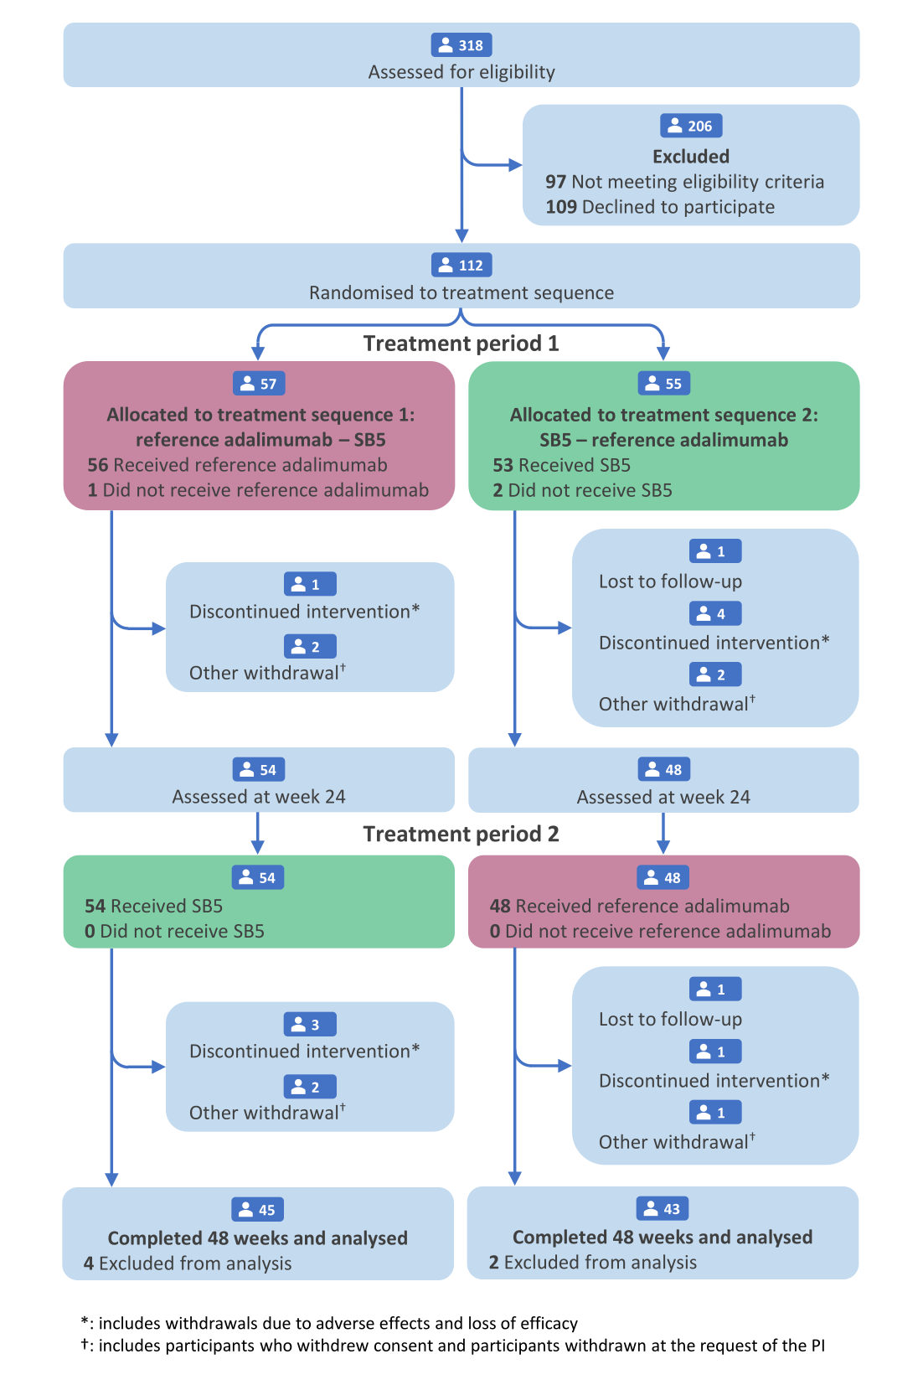
Fig. 1 CONSORT flow diagram for the trial
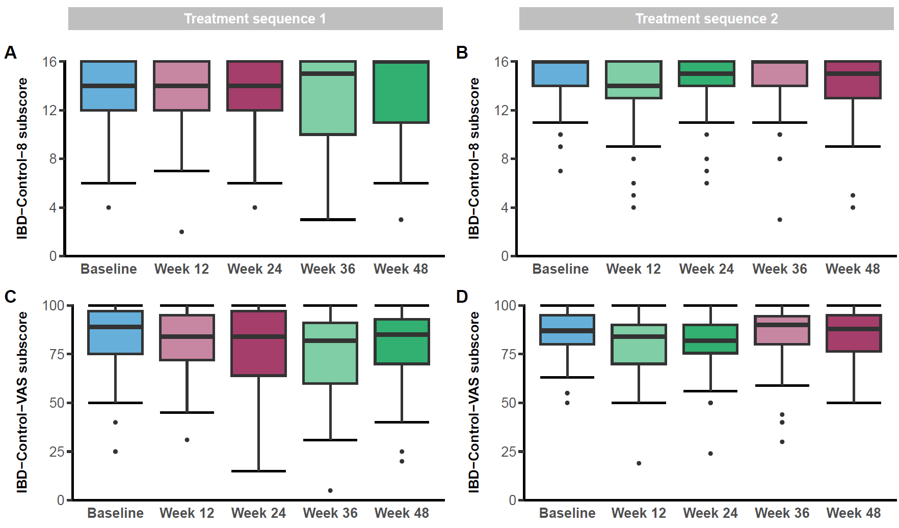
Fig. 2 IBD-Control-8 (A and B) and IBD-Control-VAS (C and D) subscores for TS1 (A and C) and TS2 (B and D) at baseline (blue) and following treatment with reference adalimumab (red) and SB5 (green)
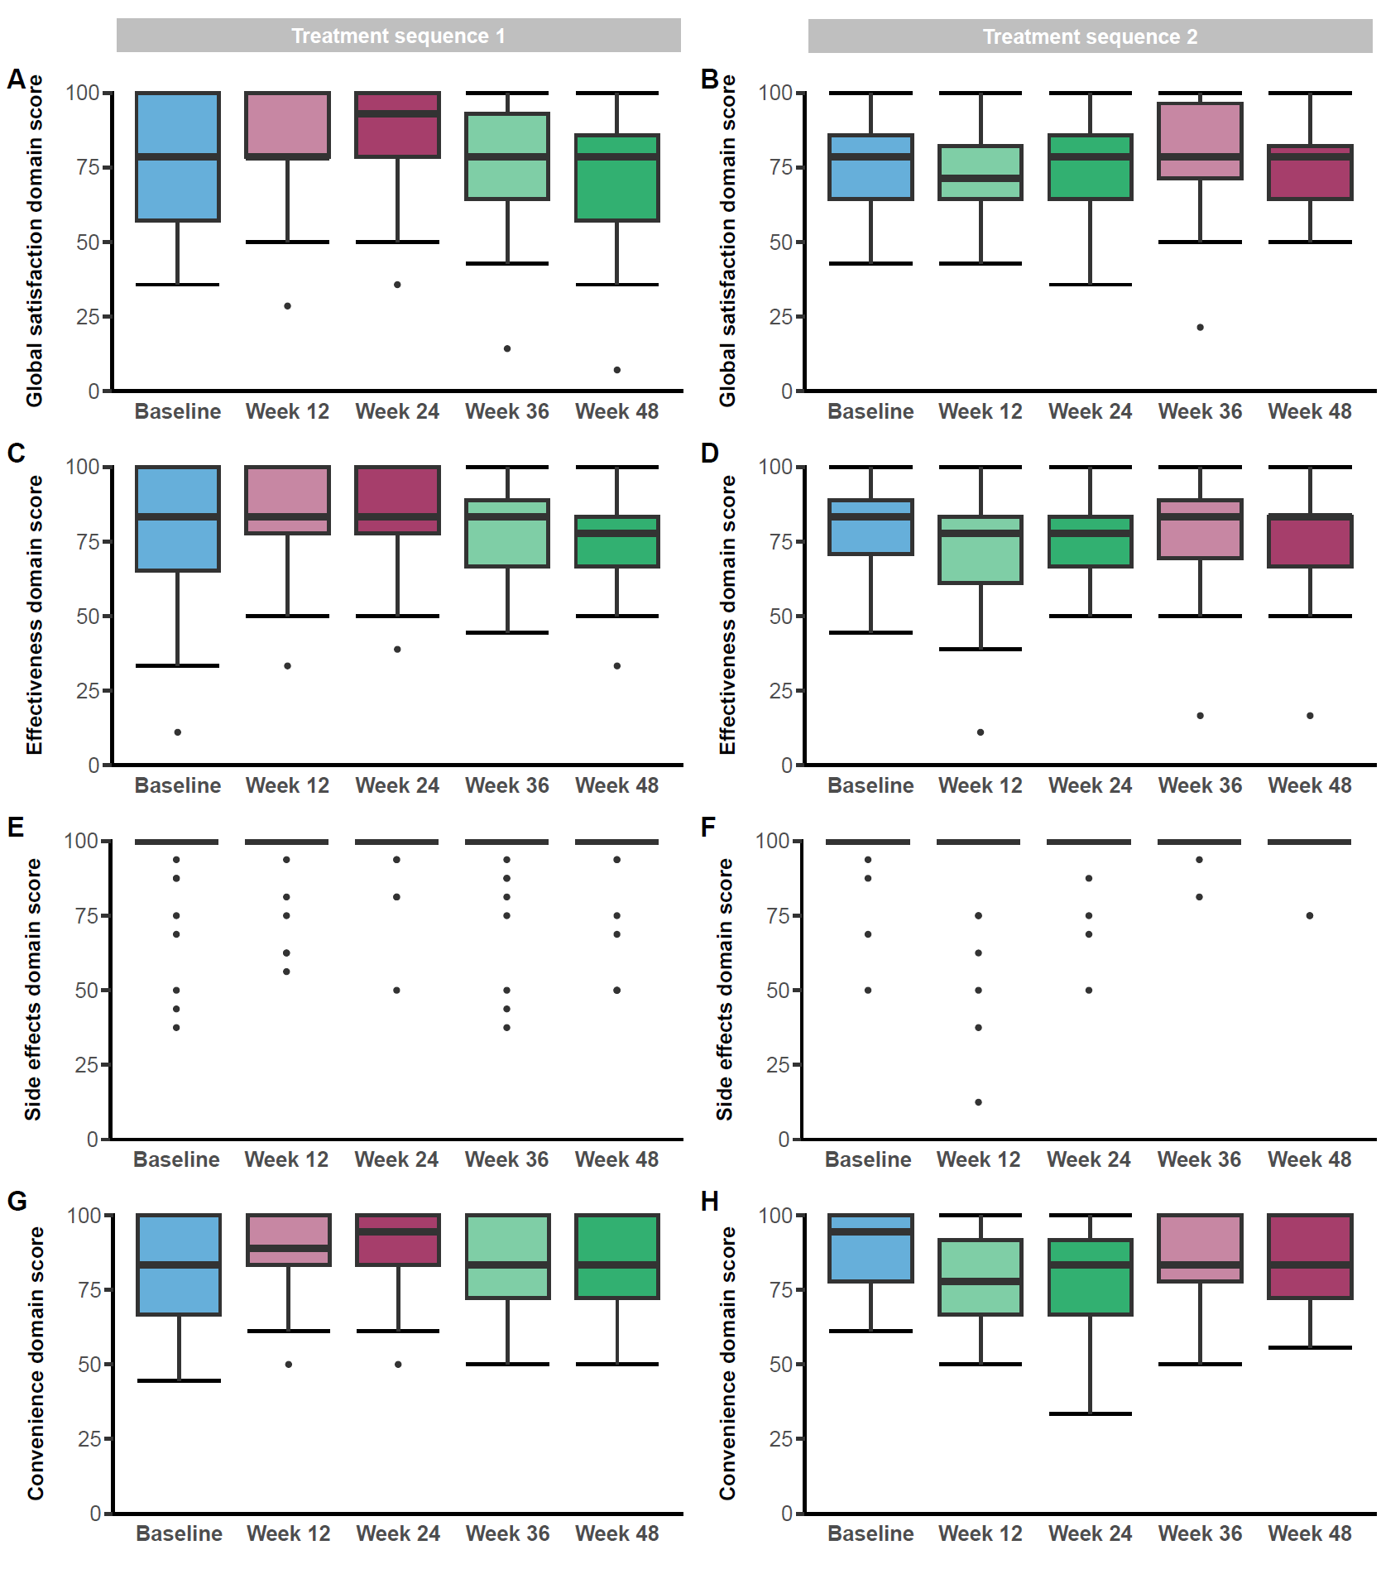
Fig. 3 TSQM domain scores for TS1 (A, C, E and G) and TS2 (B, D, F and H) at baseline (blue) and following treatment with reference adalimumab (red) and SB5 (green)

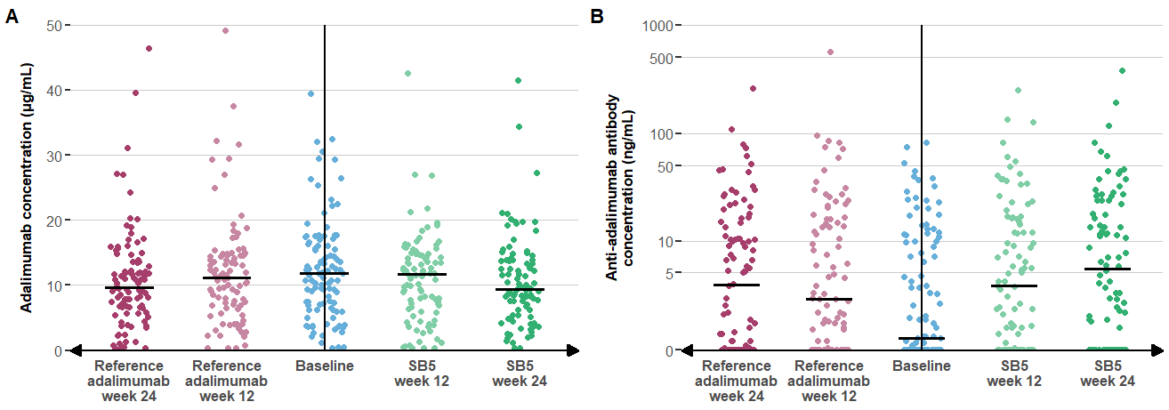
Fig. 4 Therapeutic drug monitoring (including (A) adalimumab concentration and (B) immunogenicity) at baseline and during treatment with each adalimumab product, presented with the baseline values central and increasing time on each product in each direction on the x-axis

Tables
Table 1 | Baseline demographic and clinical characteristics
 |  |  |  | TS1  (n=45) | TS2  (n=43) | Overall  (n=88)
Gender, n (%) |  |  | Male | 24 (53.3) | 21 (46.7) | 46 (52.3)
 |  |  | Female | 21 (46.7) | 21 (48.8) | 42 (47.7)
Age at consent (years), median (IQR) |  |  |  | 39 (30-51) | 42 (30-55) | 41 (30-52)
Time since CD diagnosis (years), median (IQR) |  |  |  | 9 (4-16) | 10 (4-18) | 9 (4-17)
Smoking status, n (%) |  |  | Current | 4 (8.9) | 5 (11.6) | 9 (10.2)
 |  |  | Never/ former | 41 (91.1) | 38 (88.4) | 79 (89.8)
Montreal classification | Age at diagnosis, n (%) |  | A1 (≤ 16 years) | 7 (15.6) | 7 (16.3) | 14 (15.9)
Montreal classification |  |  | A2 (17-40 years) | 27 (60.0) | 23 (53.5) | 50 (56.8)
Montreal classification |  |  | A3 (> 40 years) | 11 (24.4) | 13 (30.2) | 24 (27.3)
Montreal classification | Disease location, n (%) |  | L1 (ileal) | 11 (24.4) | 14 (32.6) | 25 (28.4)
Montreal classification |  |  | L2 (colonic) | 9 (20.0) | 6 (14.0) | 15 (17.0)
Montreal classification |  |  | L3 (ileocolonic) | 25 (55.6) | 23 (53.5) | 48 (54.5)
Montreal classification |  |  | + L4 (upper GI tract) | 7 (15.6) | 5 (11.6) | 12 (13.6)
Montreal classification | Disease behaviour, n (%) |  | B1 (inflammatory) | 27 (60.0) | 16 (37.2) | 43 (48.9)
Montreal classification |  |  | B2 (stricturing) | 11 (24.4) | 21 (48.8) | 32 (36.4)
Montreal classification |  |  | B3 (penetrating) | 7 (15.6) | 6 (14.0) | 13 (14.8)
Montreal classification | Perianal disease modifier, n (%) |  |  | 16 (35.6) | 9 (20.9) | 25 (28.4)
Previous bowel resection, n (%) |  |  |  | 12 (26.7) | 19 (44.2) | 31 (35.2)
Prior exposure to biological medicine other than adalimumab, n (%) |  |  |  | 14 (31.1) | 11 (25.6) | 25 (28.4)
Duration of adalimumab exposure (years), median (IQR) |  |  |  | 2 (2-5) | 4 (2-6) | 3 (2-5)
Pre-treatment status |  |  | Reference adalimumab | 39 (86.7) | 36 (83.7) | 75 (85.2)
 |  |  | SB5 | 6 (13.3) | 7 (16.3) | 13 (14.8)
C-reactive protein (mg/L), median (IQR) |  |  |  | 1 (1-3) | 1 (1-5) | 1 (1-3)
Calprotectin (µg/g), median (IQR) |  |  |  | 18 (7-32) | 24 (9-95) | 20 (8-62)
mHBI score, median (IQR) |  |  |  | 1 (1-4) | 2 (0-4) | 2 (1-4)
Count of patients with mHBI ≥5 |  |  |  | 7 (15.6) | 7 (16.3) | 14 (15.9)
Currently taking concomitant immunosuppressive therapy at baseline, n (%) |  |  |  | 24 (53.3) | 20 (46.5) | 44 (50.0)
Dosing frequency |  |  | 40 mg Q2W | 37 (82.2) | 39 (90.7) | 76 (86.4)
 |  |  | 40 mg QW or 80 mg Q2W | 8 (17.8) | 4 (9.3) | 12 (13.6)

Table 2 | Treatment emergent adverse events (by MedDRA system organ class)
 | Reference adalimumab  (n=104) | SB5  (n=107)
Number of participants with any event, n (%) | 49 (47.1) | 63 (58.9)
System organ class, n (%)
- Blood and lymphatic system disorders | 0 | 1 (0.9)
- Cardiac disorders | 1 (1.0) | 0
- Ear and labyrinth disorders | 0 | 2 (1.9)
- Eye disorders | 2 (1.9) | 3 (2.8)
- Gastrointestinal disorders | 17 (16.3) | 18 (16.8)
- General disorders and administration site conditions | 11 (10.6) | 16 (15.0)
- Immune system disorders | 1 (1.0) | 1 (0.9)
- Infections and infestations | 24 (23.1) | 31 (29.0)
- Injury, poisoning and procedural complications | 4 (3.8) | 5 (4.7)
- Investigations | 0 | 2 (1.9)
- Musculoskeletal and connective tissue disorders | 4 (3.8) | 8 (7.5)
- Neoplasms benign, malignant and unspecified (including cysts and polyps) | 0 | 1 (0.9)
- Nervous system disorders | 6 (5.8) | 7 (6.5)
- Psychiatric disorders | 0 | 1 (0.9)
- Reproductive system and breast disorders | 1 (1.0) | 1 (0.9)
- Respiratory, thoracic and mediastinal disorders | 4 (3.8) | 3 (2.8)
- Skin and subcutaneous tissue disorders | 4 (3.8) | 7 (6.5)
- Surgical and medical procedures | 1 (1.0) | 1 (0.9)
- Vascular disorders | 1 (1.0) | 1 (0.9)
Table footnote: A participant is counted only once at the SOC level, even if the subject experienced more than one AE within a specific SOC.

