Submitted: 26-09-2024
Manuscript title: Effect of Episodic Pre-Failure Cyclic Loading on Whole-Life Geotechnical Properties of Soft Clays
Authors:
Author 1
- Noor Laham
- Postgraduate Researcher
- Civil, Maritime & Environmental Engineering, University of Southampton, Southampton, UK
- Boldrewood Innovation Campus, Burgess rd, Southampton SO16 7QF, United Kingdom
- ORCID: 0000-0001-8289-149X
- nl1d19@soton.ac.uk, noorlaham.12@gmail.com
Author 2
- Katherine Kwa
- Senior Research Fellow
- Civil, Maritime & Environmental Engineering, University of Southampton, Southampton, UK
- Boldrewood Innovation Campus, Burgess rd, Southampton SO16 7QF, United Kingdom
- ORCID: 0000-0002-4675-8736
- K.A.Kwa@soton.ac.uk
Author 3
- Yusuke Suzuki
- Senior Specialist
- Geotechnique Testing, Norwegian Geotechnical Institute, Oslo, Norway
- Sandakerveien 140, 0484 Oslo, Norway
- ORCID: 0000-0002-6953-5033
- Yusuke.suzuki@ngi.no
Author 4
- David White
- Professor of Infrastructure Geotechnics
- Civil, Maritime & Environmental Engineering, University of Southampton, Southampton, UK
- Boldrewood Innovation Campus, Burgess rd, Southampton SO16 7QF, United Kingdom
- ORCID: 0000-0002-2968-582X
- David.white@soton.ac.uk
Author 5
- Susan Gourvenec
- Professor in Offshore Geotechnical Engineering
- Civil, Maritime & Environmental Engineering, University of Southampton, Southampton, UK
- Boldrewood Innovation Campus, Burgess rd, Southampton SO16 7QF, United Kingdom
- ORCID: 0000-0002-2628-7914
- Susan.Gourvenec@southampton.ac.uk
Corresponding author: Noor Laham, University of Southampton, Southampton, UK
Number of words in main text: 4021
Number of figures: 17
Number of tables: 2

ABSTRACT
Changes in soil properties due to loading and consolidation during the life of infrastructure affect the soil response to future events. This concept is encapsulated in the whole-life geotechnical design approach which accounts for the evolution of properties such as strength, stiffness and consolidation coefficient, to improve forecasts of system response through and beyond the design life.
This paper explores the changing properties of a soft clay from episodes of pre-failure cyclic loading and consolidation through a series of stress-controlled cyclic direct simple shear (DSS) tests. The scenario is relevant to offshore applications where infrastructure is subject to cyclic seasonal loading, and is particularly relevant to floating offshore wind anchoring systems as these are located in deeper water, farther from shore where soft clays are common. The results quantify the effect of cyclic stress amplitude, number of cycles per packet, and number of consolidation intervals, on the clay properties. The results show increases in undrained strength by up to 70%, stiffness by up to 50% and consolidation coefficient by a factor of up to 30, highlighting the importance of accounting for whole-life effects for reliable and efficient geotechnical design.

KEY WORDS: Offshore engineering; Geotechnical engineering; Direct simple shear; Cyclic loads; Clay.

LIST OF NOTATIONS
$e$ void ratio, $e_{0}$ value after initial consolidation
$Δs$ settlement during consolidation
$G_{s}$ specific gravity of solid fraction
$s_{u}$ undrained strength
$s_{u0}$ monotonic undrained strength
$Δu$ excess pore water pressure
$γ$ monotonic shear strain
$γ_{cy}$ cyclic shear strain
$γ_{v}$ volumetric strain
$κ$slope of post-shearing recompression line
$κ_{o}$ slope of oedometer recompression line
$λ_{o}$slope of oedometric normal compression line
$ϕ^{'}$ friction angle
$σ_{v}^{'}$ vertical effective stress
$σ_{vc}^{'}$ consolidation vertical effective stress
$σ_{ve}^{'}$ vertical effective stress after cyclic loading
$τ$ monotonic shear stress
$τ_{cy}$ cyclic shear stress
$τ_{av}$ average shear stress
$c_{v}$ coefficient of consolidation, $c_{v0}$ value at normally-consolidated condition
$G_{max}$ small strain shear modulus, $G_{max⁡(0)}$ value at normally-consolidated condition
$G_{s}$ secant shear modulus
$N$number of cycles per loading packet
$N_{ep}$number of episodes, each comprising a loading packet and a consolidation period
$N_{t}$ total number of cycles applied, where $N_{t}=N_{ep}×N$

INTRODUCTION

Whole-Life Geotechnical Design
Foundations and anchoring systems supporting onshore and offshore infrastructure experience varying loads from environmental and operational conditions. These loads can alter the geotechnical properties of the surrounding soil, affecting the subsequent response and capacity. Whole-life geotechnical design couples the life cycle of imposed actions with the evolving geotechnical properties to forecast the changing response and reliability of the system throughout the design life (Gourvenec 2020).
For normally and lightly overconsolidated fine-grained soils, a key mechanism in whole-life analysis is the beneficial consolidation effects that cause hardening, and an increase in strength, stiffness, and consolidation coefficient, following dissipation of excess pore pressures generated from loading. Such whole-life effects have been quantified experimentally in penetrometer tests (Hodder et al. 2013, O’Loughlin et al. 2017), element tests (Yasuhara et al. 1991, Laham et al. 2021), and large scale and centrifuge scale modelling of pipelines (Smith & White 2014), sliding foundations (Cocjin et al. 2014, 2017), anchors (Han et al. 2016, Zhou et al. 2019) and piles in clay (Lai et al. 2020, White et al. 2022). These examples illustrate how whole-life changes in geotechnical properties influence the optimisation and reliability of geotechnical design. These effects offer opportunities for more efficient systems including reductions in foundation or anchor size, reduced fatigue risk, and reassessment for late life reassessment or decommissioning choices (Gourvenec 2020).
The study presented here provides insights relevant to a range of infrastructure, although the testing was targeted towards floating offshore wind, which is a topical challenge that could benefit by embracing whole-life geotechnical design. A rapid acceleration of offshore wind development is required for the energy transition, as indicated by a global ambition to install 2000 GW of capacity by 2050; 35 times the current installed capacity (IRENA, GWEC 2021). The corresponding geotechnical requirements have been estimated to include the design and installation of up to 4500 anchors annually (Gourvenec, 2024). This creates impetus for more efficient foundation and anchor systems and more efficient seabed characterization methods. Whole-life geotechnical design is one of the tools available to support this.

Characterisation of whole-life geotechnical properties
Adoption of whole-life geotechnical design principles requires a systematic approach to the direct simple shear (DSS) element test protocol is widely used in offshore site investigation because it is cost-effective, requiring smaller specimens compared to triaxial testing (Airey et al. 1985, Dyvik et al. 1987) while also allowing systematic investigation of cyclic shearing behaviour. The DSS apparatus also mobilises an intermediate soil strength between triaxial compression and extension, which is often adopted as an average value throughout a failure mechanism for capacity assessment (Kinner & Ladd 1973, Mayne 1985, Randolph 2000). Previous uni-directional cyclic DSS tests have characterised cyclic softening response to build cyclic strain or excess pore pressure accumulation contour diagrams ‘SN-curves’ (Andersen, 2009, 2015; Zografou et al., 2018) or to investigate the influence on sample disturbance on their cyclic response (Yang et al., 2018). Multi-directional cyclic DSS tests have also been performed to understand cyclic softening response during earthquakes (Ishihara, 1980, Boulanger et al., 1993; Kammerer et al., 2004, Yang et al., 2019) and for cyclic multidirectional loading on foundations (De Groot, 1996; Sibley 2016) and shared anchors (Herduin, 2019). Episodic DSS tests have explored the effect of consolidation episodes on soil recompression response (Yasuhara & Andersen 1991) and stiffness and strength (Laham et al. 2021). These studies involved episodic loading consisting of pre-failure shearing where the applied shear stresses applied cyclically (Yasuhara & Andersen 1991) or monotonically (Laham et al., 2021) are a fraction of the monotonic undrained shear strength, at constant volume interspersed by consolidation periods, to represent, for example, multiple storm events.
This study explores the response of soft clays to episodes of pre-failure undrained cyclic shearing with intervening periods of consolidation through a suite of DSS tests. This study considers a wider range of loading histories and focuses on the evolution of strength, stiffness, and consolidation properties, which has not been systematically addressed. The principles explored are relevant to a range of clays and applications, while the specific loading histories and normally consolidated clay considered is particularly relevant to the emergent challenge of floating offshore wind. Variables explored include (i) number of undrained cycles of loading per packet, $N$; (ii) number of cyclic loading episodes, $N_{ep}$; and (iii) the amplitude of the applied cyclic shear stresses, $τ_{cy}$.

EXPERIMENTAL PROGRAM

Direct Simple Shear (DSS) Apparatus
The direct simple shear (DSS) tests were performed at the NGI Oslo laboratory, using the Geonor DSS apparatus (Figure 1). The apparatus has two load cells ((4) and (12) in Figure 1) that measure vertical and horizontal loads on the specimen (1). A wire-reinforced rubber membrane (2) imposes a zero lateral strain boundary condition on the specimen. Vertical and horizontal displacements are measured by displacement transducers (8, 9 & 10). During consolidation, the vertical load is applied using dead weights (15) via a lever arm (14). During a constant volume stage, active height control is achieved using the in-house control system (Modlab) that drives the motor (17) to maintain a specified specimen height (Dyvik & Suzuki, 2019). The specimen height is measured by a displacement transducer (10). Any change in vertical load to maintain the set height is equivalent to the excess pore pressure generation in undrained condition (Dyvik et al. 1987). Monotonic horizontal movement is imposed by controlled displacement (13) while cyclic horizontal loads are applied by a pneumatic control system.
During re-consolidation, the height control is turned off and excess pore pressure is permitted to dissipate, and the specimen changes height under the applied consolidation stress. The parameter $κ,$the slope of the post-shearing recompression line, is derived from the change in void ratio and the change in the natural log of the vertical effective stress. The coefficient of consolidation $c_{v}$ is calculated using the Taylor root time method from the settlement response during each re-consolidation period (Taylor 1948).
Bender elements were embedded in the top and bottom platens providing a direct measurement of small strain shear stiffness through the test (Dyvik & Madshus, 1985).

Specimen Preparation and Assembly
Reconstituted normally consolidated OnsØy clay, with properties listed in Table 1, was prepared from a slurry at a water content of twice the liquid limit. The slurry was mixed under a vacuum for 8 hours and then consolidated in a steel tube of 76 mm inner diameter and 300 mm tall. Consolidation was carried out in 4 load increments. The vertical load was doubled in each increment to reach a final consolidation stress of 50 kPa after one month. This stress level was chosen to target the minimum strength that is practical for specimen preparation. Individual specimens were extruded from the prepared tubes of consolidated clay and trimmed to a diameter of 66.7 mm and a height of 16 mm.
The extruded specimen was prepared between the top cap and the bottom pedestal, each with embedded porous filters with small pins, and the wire-reinforced membrane was stretched over the specimen. The specimen was then gently placed in the DSS apparatus and consolidated to 100 kPa, in 4 load increments with the load doubled at each increment. The displacement during consolidation was recorded to calculate the specimen height before shearing (ASTM D6528-17, 2017).
Table 1. Characteristics of reconstituted OnsØy clay
OnsØy clay properties
Liquid limit (LL): % | 70
Plastic limit (PL): % | 44
Specific gravity Gs | 2.76
Angle of internal friction φ′:º | 34
Normalised undrained shear strength under DSS condition $s_{u}/{σ'}_{vc}$ | 0.25
Void ratio at $σ_{v}^{'}=1$ kPa on NCL, N | 2.17
Void ratio at $σ_{v}^{'}=1$ kPa on CSL, $e_{cs}$ | 1.95
Slope of oedometer test normal compression line $λ_{o}$ | 0.18
Slope of oedometer test unload-reload line $κ_{o}$ | 0.034

Testing Program and Loading Scope
Table 2 summarises the DSS tests performed in this study. An initial test determined the monotonic undrained strength after consolidation to $σ_{vc}^{'}=$100 kPa, at a shear strain rate of 4 %/hr to 20% shear strain. This consolidation stress is within the range of effective stresses found in soft clays at depths typically relevant to anchors for floating offshore wind turbines (FOWT). This study also focusses on clays that are initially normally consolidated, since these are the conditions most conductive to changes in properties through episodic loading. Clays with a low over-consolidation ratio are found in many European offshore wind frontiers, including the Irish Sea (Coughlan et al. 2023) and the North Sea, for example in the Witch Ground (Paul & Jobson 1991), and the Norwegian Channel, (Petrie et al. 2022), as well as the region of the Hywind Tampen floating offshore wind farm, (RevOcean, 2024).
Test sets 2 to 5 comprised stress-controlled episodic cyclic tests with a loading pattern illustrated in Figure 2. These tests investigated the evolution of undrained strength, stiffness, and consolidation coefficient through episodes of undrained cyclic loading and intervening full consolidation. All specimens were consolidated to $σ_{vc}^{'}=$100 kPa, before being subjected to $N_{ep}$ loading and consolidation episodes. The cyclic loading was performed under constant volume condition with $N$ cycles per episode at a constant cyclic stress amplitude $τ_{cy}$ spanning a range of proportions of the monotonic strength. The cyclic stress was symmetric for all tests (i.e., average shear stress $τ_{av}$= 0 kPa) and was applied at a frequency of 0.1 Hz, which is typical of a wave period (Andersen et al. 1988). During the consolidation periods the specimen was allowed to settle under $τ=$ 0 kPa. The consolidation phase was terminated when the settlement over 30 minutes was less than 0.01 % of the specimen height. The episodic loading was followed by a displacement-controlled monotonic shearing stage, at the same rate as the monotonic test in set 1. In test sets 2 to 5, various combinations of $N_{ep}$, $N$ and $τ_{cy}$were applied$.$
A long term episodic cyclic test was performed first to explore the number of episodes required to approach a stable soil response (E055_10_100 in test set 2, for $N_{ep}=$10,$N=$100 $\& τ_{cy}=$0.55$s_{u0}$). Tests with different $N_{ep}$, and the same $τ_{cy}$ were also performed to identify the change in $s_{u}$ from $N_{ep}=$ 1, 3, 5 and 10 (Table 2).
Eight other stress-controlled episodic cyclic tests with the same number of episodes ($N_{ep}=$5) were performed and have been grouped in Table 2 by test set based on $τ_{cy}$. These tests capture the effect of varying $N(=$10, 50, 100 & 1000) at different cyclic stress amplitudes ($τ_{cy}=$0.35, 0.55 & 0.70$s_{u0}$). After the 5th episode, all of these tests were sheared monotonically to failure to determine the change in strength. Each of these tests involved extensive testing times of up to 2 weeks and it is recommended that further testing should involve non-symmetric loading cycles.
The range in the applied cyclic stress ratio (CSR = $τ_{cy}/s_{u}$) and number of cycles per packet, $N,$ were also selected to span a variety of responses and to achieve good coverage of the shear stress ratios required to build SN curves (e.g. similar to Skau et al., 2023). The chosen CSRs and value of $N$=100 is similar to the CSRs and equivalent number of cycles, $N_{eq}$ in design storms, albeit at the high end (Andersen, 2015; Randolph & Gourvenec, 2011; Allen et al., 2020; Kwa et al., 2023; Skau et al., 2023). This bias towards the high range of the selected CSRs and $N_{eq}$ towards a higher range of practical relevance is for two reasons (i) to make response effects more discernable and (ii) because the study aims to unlock the use of reduced partial factors in design (i.e. higher CSRs), taking account of gains in strength that are shown later.

Table 2. Summary of DSS tests performed.
Test Set | Test name | Test type | Shear stress ratio $τ_{cy}/s_{u0}$ | Total number of cycles per packet N$(-)$ | Total number of episodes $N_{ep} (-)$ | Total number of cycles $N_{t}(-)$ | Void ratio after initial consolidation $e_{0}*$ | Final reduction in void ratio  $$Δe_{f}=e_{0}-e_{f}$$ | Final strength $s_{uf}$(kPa)
1 | Mon | Monotonic | - | - | - | - | 1.320 | 0.000 | 25.0
2 | E055_10_100 | Episodic | 0.55 | 100 | 10 | 1000 | 1.326 | 0.025 | 31.9
2 | E055_3_100 | Episodic | 0.55 | 100 | 3 | 300 | 1.303 | 0.019 | 29.2
2 | E055_1_100 | Episodic | 0.55 | 100 | 1 | 100 | 1.311 | 0.015 | 26.7
3 | E035_5_10 | Episodic | 0.35 | 10 | 5 | 50 | 1.329 | 0.008 | 26.7
3 | E035_5_100 | Episodic | 0.35 | 100 | 5 | 500 | 1.327 | 0.013 | 29.3
3 | E035_5_1000 | Episodic | 0.35 | 1000 | 5 | 5000 | 1.323 | 0.017 | 34.1
4 | E055_5_10 | Episodic | 0.55 | 10 | 5 | 50 | 1.325 | 0.023 | 28.1
4 | E055_5_100 | Episodic | 0.55 | 100 | 5 | 500 | 1.326 | 0.025 | 31.6
4 | E055_5_1000 | Episodic | 0.55 | 1000 | 5 | 5000 | 1.322 | 0.035 | 41.9
5 | E070_5_10 | Episodic | 0.70 | 10 | 5 | 50 | 1.320 | 0.026 | 28.3
5 | E070_5_50 | Episodic | 0.70 | 50 | 5 | 250 | 1.330 | 0.031 | 34.6
 | E070_5_100 | Episodic | 0.70 | 100 | 5 | 250 | 1.330 | failed after 71 cycles in packet 1
* Refers to void ratio after sample has been docked in the DSS and consolidated to $σ_{vc}^{'}=$ 100 kPa.

RESULTS AND ANALYSIS

Monotonic response
The effective stress path (ESP) during monotonic shear demonstrates the usual fall in effective stress due to a rise in excess pore pressure as the stress path bends left to the critical state line (CSL) (Figure 3a). The CSL was determined from the final shearing stage at 20% shear strain in all tests (see the open dots in Figure 3). The solid data markers indicate the initial state of the normally consolidated specimens when first consolidated to $σ_{vc}^{'}$=100 kPa. The one-dimensional normal consolidation line (NCL) is shown dotted in Figure 3b, based on an oedometer test, where two unloading-reloading loops of 1280 kPa to 160 kPa and 5120 kPa to 1280 kPa were applied on soil specimen to measure an average value of unload-reload line.

Episodic cyclic response
The episodic cyclic response of the normally-consolidated specimens all followed similar trends with increasing $N$ and $N_{ep}$. An example of results from a selected test, with the highest applied $τ_{cy}/s_{u0}$=0.7 (Test Set 5) is described in detail first, as it has the clearest trend in episodic cyclic responses, prior to a comparison of all tests. The selected test, E070_5_50 ($τ_{cy}/s_{u}$ = 0.70, with $N_{ep}$= 5 packets of loading of $N=$ 50 cycles each, is shown in Figure 4.
During each packet, softening was observed, demonstrated by a decrease in small strain shear modulus, $G_{max}$, (Figure 4a), relative to the normally consolidated condition, $G_{max⁡(0)}$, measured at $σ_{vc}^{'}$ prior to shearing. The shear strain amplitude, $γ$ (Figure 4b) and excess pore water pressure, $Δu$ increase during each packet (Figure 4c), but reductions occur in each subsequent episode after the intervening consolidation. The resulting effective stress path is shown in Figure 4d.
During the consolidation periods, the pore pressure dissipation led to settlement (Figure 4e) and densification, quantified by the reduction in void ratio (Figure 4f) and accompanied by a rise in normalised shear modulus, $G_{max }/G_{\max{(0)}}$ – by a greater amount than the fall during the previous cyclic loading, leading to a net rise in stiffness (Figure 4a). In this figure, the episode count, $N_{ep}$ is defined such that half values represent the state at the end of the cyclic loading and whole values represent the end of the following consolidation period, which completes each episode. Consolidation coefficient $c_{v}$ also increased with each consolidation period (Figure 4g). The reduction in void ratio during the consolidation stage, $Δe$, (Figure 4f) was used to calculate the post-shearing recompression modulus, $κ=Δe/\ln\left({σ'}_{ve}/{σ'}_{vc}\right)$, where ${σ'}_{ve}$ is the vertical effective stress after cyclic loading, prior to consolidation, and decreased with each episode (Figure 4h).
The softening and hardening effects became very small after 5 episodes. For example, for the test shown in Figure 4, $Δu$ in the last episode was 0.3% of the value in the first episode (Figure 4c). Similarly, the settlement in episode 5 was 7% of the settlement in the first episode (Figure 4e).
A single test was carried out for 10 episodes of cyclic loading and intervening consolidation, i.e. $N_{ep}$=10, (E055_10_100), and confirmed that negligible changes ($Δu$ < 0.1 kPa) occurred after $N_{ep}$> 5 as shown in Figure 5. A summary of the episodic results (Figures 5a to f) shows that the softening and hardening effects stabilise for $N_{ep}$ >5. The remaining tests in the programme were therefore subjected to 5 episodes of cyclic loading and consolidation (see Table 2). The next sections discuss those results and examine the effects of varying $N$ and (${τ_{cy}}/{s_{u0}}$) on the soil response. The response under cyclic shear is considered first (Section 3.3), followed by the response during subsequent consolidation (Section 3.4) then finally the evolution of geotechnical parameters (Section 3.5).

Episodic cyclic response: Shearing

Shear response - Excess pore water pressure
The excess pore pressure generated in a packet depended on $N$ and (${τ_{cy}}/{s_{u0}}$), as illustrated in Figure 6. Specimens loaded at a higher cyclic amplitude experienced larger increase in excess pore water pressure for the same number of cycles and each consolidation phase led to reduced excess pore pressure in subsequent packets – as shown by the trend in all tests on Figure 6. The specimen loaded at $τ_{cy}/s_{u0}$= 0.70 (test set 5 in Table 2) could not withstand 100 cycles of continuous loading, failing after 71 cycles in the first packet, at an excess pore water pressure of 58 kPa (Figure 6b). The excess pore pressure generated in each episode for each test is presented in Figure 7, showing that the build-up always reduced in subsequent packets, for all number of cycles of loading in each packet.

Shear response - Shear strain
The shear strain increased with the applied cyclic amplitude and the number of cycles per packet as shown in Figure 8, mirroring the excess pore pressure generation (Figure 6). A progressive decrease in cyclic shear strain, was also observed with each packet, as is also evident in Figure 8, again mirroring the excess pore pressure response (Figure 7).
The reducing strain is reflected in increased stiffness after each re-consolidation phase, as illustrated by the secant shear modulus in the final cycle of each episodic test (Figure 9). A lower secant shear modulus results from a higher number of cycles per packet. However, the shear modulus increases with each packet due to stiffening during consolidation, and a reduced tendency for softening during subsequent cycles. This is a further quantification of the changing soil response and increasing resilience from intervening consolidation.

Episodic cyclic response: Consolidation

Volumetric strain and void ratio change
Dissipation of the excess pore water pressure led to volumetric strain and a reduction in void ratio during each consolidation phase. The shear-volumetric strain paths from each test illustrate that specimens loaded to a higher shear stress and subjected to a greater number of cycles per packet experienced a correspondingly larger volumetric strain on consolidation (Figure 10). The reduction in void ratio reduces in successive consolidation periods (Figure 11), as each specimen becomes denser and stiffer. This is consistent with the observed trends of reducing excess pore pressure generation following consolidation (Figures 6 & 7).

Post-shearing recompression modulus, $κ$
The volumetric response through episodic loading can be followed in $e-ln⁡(σ_{v}^{'})$ space (Figure 12). This form of representation shows the recompression response as a sloping line joining horizontal lines that represent the excess pore pressure generation during adjacent packets of cyclic loading. The post-shearing recompression paths, which have a gradient of $κ/log_{10}{e}=2.3κ$ on a log plot to base 10 (Burland 1990), are not parallel. This indicates that the post-shearing recompression modulus, $κ$, is influenced by the previous loading history, and specifically the loading amplitude and the number of preceding loading and consolidation episodes.
Changes in recompression modulus, $κ$ show an increasing stiffness with increasing episodes for all loading levels (Figure 13). Also, lower values of $κ$ – meaning a stiffer response – are associated with recompression following higher cyclic stress amplitude and more cycles per packet. This trend is also highlighted in Figure 12b, comparing the indicated values $κ_{AA^{'}}, κ_{BB^{'}'}$ and $κ_{CC^{'}}.$
The varying recompression modulus from reconsolidation following cyclic shearing is compared with the recompression modulus observed in an oedometer test, $κ_{o}$, which relates to reloading after one-dimensional unloading without shearing. It has been previously recognised that the stiffness during post-shearing recompression differs from the reloading stiffness seen in an oedometer (Yasuhara & Andersen 1991, Yasuhara et al. 1992). The measured post-shearing $κ$ varies in magnitude from ten times $κ_{o}$ for early episodes and small amplitude cycles, to half $κ_{o}$ for later episodes under high cyclic loading (Figure 13).

Evolution of engineering properties

Coefficient of consolidation
The duration of the re-consolidation phase is affected by the increase in recompression stiffness (i.e. reduction in $κ$, Figure 13). The calculated consolidation coefficient, c_{v} increased by factors between 10 and 30 by the end of 5 episodes of cyclic shear and consolidation (Figure 14). Specimens subjected to higher cyclic amplitudes and more cycles experienced greater increases in $c_{v}$. This trend is connected to the greater densification and stiffening following reconsolidation after severe loading conditions (as seen in Figures 12 and 13). An implication of the trend of increasing $c_{v}$ with episodes of loading and reconsolidation, is that changes in strength and stiffness will occur more quickly after each loading episode, due to the faster consolidation.

Undrained shear strength
The increases in undrained shear strength from episodes of loading and re-consolidation are shown in Figure 15, from the monotonic shearing stage at the end of each episodic test, normalised by $s_{u0}$ measured from the initial monotonic test.
The results show a consistent trend of increasing strength following episodes with higher cyclic stress amplitude and more cycles per packet, consistent with the observed greater densification (Figure 12). For the highest cyclic stress amplitude and the greatest number of cycles per packet (E055_5_1000), a 70% increase in $s_{u}$ was observed. Tests at the intermediate level of cyclic amplitude and cycles per packet typically showed increases in $s_{u}$ of 20-30%, with the lowest load level and shortest packets still exhibiting ∼10% gain in strength (E035_5_10).
These observations from pre-failure loading conditions show that the excess pore pressure generation and cyclic softening is mirrored by the level of strength gain from subsequent consolidation, since the level of softening affects the potential for subsequent densification and hardening.

Small strain shear modulus$G_{max}$
The small strain shear stiffness evolves with episodes of cyclic loading and consolidation, as was observed for undrained strength. The decrease in the cyclic shear strain $γ_{cy}$ and post-shearing recompression modulus κ between episodes indicate stiffening (Figures 8, 9, and 13). In test sets 4, 5 and 6, bender element measurements at the end of each packet of loading and consolidation period revealed the changes in small strain shear modulus $G_{max}$relative to the initial value $G_{max⁡(0)}$ (Figure 16). $G_{max}$ increased with episodes, with a higher gain in tests subjected to higher cyclic stress amplitudes and number of cycles. The highest gain was in the test with the greatest number of cycles and highest stress level and showed a 50% increase in $G_{max}$ (E055_5_1000). Specimens subjected to intermediate amplitude and numbers of cycles experienced a 20-25 % increase in $G_{max}$, while the lowest cyclic amplitude with the fewest cycles (E035_5_10) experienced a 10% gain.

The observed changes in shear stiffness are much smaller than the changes in volumetric recompression stiffness (Figure 13) but are similar to the observed changes in undrained strength (Figure 15). The relationship between $G_{max}/G_{\max\left(0\right)}$and $s_{u}/s_{u\left(0\right)}$ at the end of each test is shown in Figure 17, with a linear trend of
$G_{max}/G_{\max\left(0\right)}=0.7 {(s}_{u}/s_{u\left(0\right)}-1)+1$ (1)
such that changes in one parameter can support an estimate of the other.

CONCLUSIONS
This study has systematically explored the changing properties of normally-consolidated clay when subjected to alternating stages of cyclic undrained shearing and re-consolidation, in a test format referred to as episodic cyclic loading. The results demonstrate the capability of DSS element tests to explore the evolution in soil properties for different loading scenarios that mimic realistic design conditions, where the influence of realistic long term cyclic actions can be simulated along with the drainage and consolidation processes over the same timescale. Systematic variations in the soil response are evident across a range of cyclic loading levels and durations, and it is found that the specimens reach a relatively stable long-term state after five episodes of cyclic loading and full consolidation.
The results from the suite of DSS tests quantify changes in shear and volumetric response with different episodes of undrained cyclic loading interspersed with consolidation, due to sequential softening during cyclic loading and hardening during consolidation.
Significant changes in the geotechnical properties were observed through each episodic test, including increases in strength, stiffness, and coefficient of consolidation. Changes observed included gains relative to the initial condition of up to 70% in strength, 50% in small strain shear stiffness, a five-fold increase in volumetric reloading stiffness and a rise in consolidation coefficient by a factor of 30. These significant changes highlight the importance of accounting for whole-life effects in geotechnical design.
Accounting for these enhancements provides the opportunity for more efficient structures including reductions in foundation or anchor size. For example, if the seabed around an anchor strengthens from experiencing low-level loading early in life, prior to the likely maximum design load, the required design capacity can be reduced in proportion to the gain in strength. This also translates to reduction in the materials required to fabricate anchors and therefore lighter anchors which are easier to transport to site. Accounting for changes in anchor capacity and seabed stiffness also provide opportunities for, reduced risk of fatigue, and better-informed decommissioning processes for offshore infrastructure. The methods outlined in this testing procedure and the trends shown in these results can be used directly to expand current methods of cyclic strength assessment to incorporate consolidation and densification effects in soft clays. In addition, these results provide an extensive dataset to assist the enhancement of constitutive models to capture the detailed response of soft soil through episodic loading.

ACKNOWLEDGEMENTS
This study forms part of the activities of the Royal Academy of Engineering Chair in Emerging Technologies Centre of Excellence for Intelligent & Resilient Ocean Engineering (IROE) at the University of Southampton through a collaboration project “Characterisation of Geotechnical Properties for Whole-Life Design” with the Norwegian Geotechnical Institute (NGI). Financial support of the Norwegian Research Council under their basic funding program for NGI is acknowledged. Noor Laham is supported through a Rayleigh Scholarship administered by the University of Southampton, and by the Norwegian Geotechnical Institute. Susan Gourvenec and Katherine Kwa are supported by the Royal Academy of Engineering, with Susan Gourvenec supported under the Chairs in Emerging Technologies scheme and Katherine Kwa holding a RAEng Research Fellowship. David White is supported by the EPSRC Offshore Renewable Energy Supergen Hub (EPSRC grant EP/Y016297/1).

REFERENCES
Airey, D. W., Budhu, M. & Wood, D. M., 1985. Some aspects of the behaviour of soils in simple shear. In Developments in soil mechanics and foundation engineering: stress-strain modelling of soils (eds P. K. Banerjee and R. Butterfield), vol. 2: 185–213. London, UK: Elsevier Applied Science Publishers.
Allen, C., Viscelli, A., Dagher, H., Goupee, A., Gaertner, E., Abbas, N., Hall, M., & Barter, G., 2020. Definition of the UMaine VolturnUS-S Reference Platform Developed for the IEA Wind 15-Megawatt Offshore Reference Wind Turbine: IEA Wind TCP Task 37. https://www.nrel.gov/docs/fy20osti/76773.pdf
Andersen, K.H., Kleven, A. & Heien, D., 1988. Cyclic soil data for design of gravity structures. Journal of Geotechnical Engineering ,114(5): 517-539.
Andersen, K. H. (2009). Bearing capacity under cyclic loading – offshore, along the coast, and on land. The 21st Bjerrum Lecture presented in Oslo, 23 November 2007. Can. Geotech. J. 46, No. 5, 513–535.
Andersen, K. H. (2015). Cyclic soil parameters for offshore foundation design. In Frontiers in offshore geotechnics III (ed. V. Meyer), pp. 5–82. Leiden, the Netherlands: CRC Press/ Balkema
ASTM D6528-17, 2017, Standard Test Method for Consolidated Undrained Direct Simple Shear Testing of Fine Grain Soils, ASTM International, West Conshohocken, PA, www. astm.org
Bjerrum, L. & Landva, A., 1966. Direct simple-shear tests on a Norwegian quick clay. Geotechnique, 16(1), pp. 1-20.
Burland, J.B., 1990. Thirtieth Rankin Lecture: On the compressibility and shear strength of natural clays. Geotechnique, 40(3): 329-378.Cerfontaine, B., White, D.J., Kwa, K., Gourvenec, S.M., Knappett, J.A., Brown, M.J., 2023. Anchor Geotechnics for Floating Offshore wind: Current Technologies and Future Innovations. Ocean Engineering (In Press).
Boulanger, R. W., Chan, C. K., Seed, H. B., Seed, R. B., & Sousa, J. B. (1993). A low-compliance bi-directional cyclic simple shear apparatus. Geotechnical Testing Journal, 16(1), 36-45.
Cocjin, M., Gourvenec, S., White, D. & Randolph, M., 2014. Tolerably mobile subsea foundations-Observations of performance. Geotechnique, 64(11): 895-909.
Cocjin, M., Gourvenec, S. & White, D. &. R. R., 2017. Theoretical framework for predicting the respone of tolerably mobile subsea installations. Geotechnique, 67(7): 608-620.
Coughlan, M., Trafford, A., Corrales, S., Donohue, S., Wheeler, A.J. & Long, M., 2023. Geological and geotechnical characterisation of soft Holocene marine sediments: A case study from the north Irish Sea. Engineering Geology, volume 313, No. 106980. https://doi.org/10.1016/j.enggeo.2022.106980
Dyvik, R. & Madshus, C., 1985. Lab measurements of $G_{max}$ using bender element. Advances in the art of testing soils under cyclic conditions, ASCE, New York, pp. 186-196.
Dyvik, R., Berre, T., Lacasse, S. & Raadim, B., 1987. Comparison of truly undrained and constant volume direct simple shear tests. Geotechnique, 37(1): 3-10.
Dyvik, R. & Suzuki, Y., 2019. Effect of volume change in undrained direct simple shear tests. Geotechnical testing journal, 42(4):20170287.
http://dx.doi.org/10.1520/GTJ20170287
DeGroot, D. J., Ladd, C. C., & Germaine, J. T. (1996). Undrained multidirectional direct simple shear behavior of cohesive soil. Journal of geotechnical engineering, 122(2), 91-98.
Gourvenec, S., 2020. Whole-Life Geotechnical Design: what is it?what's it for?so what?and what next? In proceedings of the 4th International Symposium on Frontiers in Offshore Geotechnics. Deep Foundations Institute, pp. 206–246.
Gourvenec, S., 2024. Offshore Geotechnical Challenges of the Energy Transition, Special Issue: Accelerating the energy transition with energy geotechnics, Journal for Geomechanics for Energy and the Environment, Volume 39, No. 100584. https://doi.org/10.1016/j.gete.2024.10058
Han, C., Wang, D., Gaudin, C., O’Loughlin, C. D. & Cassidy, M. J., 2016. Behaviour of vertically loaded plate anchors under sustained uplift. Géotechnique, 66(8): 681-693.
Hodder, M., White, D. & Cassidy, M., 2013. An effective stress framework for the variation in penetration resistance due to episodes of remoulding and reconsolidation. Géotechnique 63(1): 30–43. https://doi.org/10.1680/geot.9.P.145.
IRENA, GWEC (2021). A next Decade Action Agenda to ad-vance SDG7 on sustainable energy for all, in line with the goals of the Paris Agreement on Climate Change. www.un.org 20/09/2024.
Ishihara, K., & Yamazaki, F. (1980). Cyclic simple shear tests on saturated sand in multi-directional loading. Soils and Foundations, 20(1), 45-59.
Kinner, E. & Ladd, C., 1973. Undrained bearing capacity of footings on clay. Proceedings of 8th International Conference on Soil Mechanics and Foundation Engineering, Volume 1: 209-2015.
Kwa, K. A., White, D. J., Tosdevin, T., Jin, S., & Greaves, D., 2023. Whole-life modelling of anchor capacity for floating systems: The RSNCSI approach. Applied Ocean Research, 138, 103671.
Kammerer AM, Wu J, Riemer MF, Pestana JM, Seed RB. A new multi-directional direct simple shear testing database. In: Proceedings of the 13th World Conference on Earthquake Engineering, 2004, pp. Paper No. 2083, 15 pages.
Herduin, M. (2019). Multi-directional loading on shared anchors for offshore renewable energy: Definition and preliminary investigation into soil behaviour and anchor performance.
Laham, N., Kwa, K., Gourvenec, S. & White, D., 2021. Episodic simple shear tests to measure strength changes for whole life geotechnical design. Geotechnique Letters, 11(1): 103-111.
Lai, Y., Wang, L., Hong, Y. & B., H., 2020. Centrifuge modeling of the cyclic lateral behavior of large-diameter monopiles in soft clay: Effects of episodic cycling and reconsolidation. Ocean Engineering 200, No. 107048.
Mayne, P., 1985. A review of undrained strength in direct simple shear. Soils Found. 25(3): 64–72.
O’Loughlin, C.D., White, D.J. & Stanier, S.A. 2017. Plate anchors for mooring floating facilities–A view towards unlocking cost and risk benefits. In Proceedings of the 8th Offshore Site Investigation Geotechnics International Conference Proceeding, Volume 2: 978–986. London, UK: Society for Underwater Technology.
Paul, M.A. & Jobson, L.M., 1991. Geotechnical properties of soft clays from the Witch Ground Basin, central North Sea. Geological Society, London, Engineering Geology Special Publications, Volume 7: 151-156. https://doi.org/10.1144/GSL.ENG.1991.007.01.12
Petrie, H.E., Eide, C.H., Haflidason, H. & Watton, T., 2022. A conceptual geological model for offshore wind sites in former ice stream settings: the Utsira Nord site, North Sea. Journal of the Geological Society, Volume 179(5). https://doi.org/10.1144/jgs2021-163
Randolph, M. & Gourvenec, S., 2011. Offshore Geotechnical Engineering. Spon Press.
Randolph, M.P., 2000. Effect of strength anisotropy on capacity of foundations. In Developments in Theoretical Geomechanics: The John Booker Memorial Symposium (eds D. W. Smith and J. P. Carter), pp. 313–327. Rotterdam, The Netherlands: CRC Press/Balkema.
RevOcean, 2024.www.revocean.org. 20/09/2024. Hywind | REV Ocean
Skau, K.S., Dahl, B.M., Jostad, H.P., Suzuki, Y., De Sordi, J.& HavmØllert, O, 2023. Response of lightly overconsolidated clay under irregular cyclic loading and comparison with predictions from the strain accumulation procedure. Géotechnique, 73(2): 1087-1099. https://doi.org/10.1680/jgeot.21.00139
Smith, V. B. & White, D. J., 2014. Volumetric hardening in axial pipe soil interaction. In Offshore Technology Conference-Asia Offshore Technology Conference, Volume 2: 1611-1621.
Sibley, E. L. D. (2016). Drained cyclic preshearing effects on the liquefaction resistance of sands (Doctoral dissertation, University of Illinois at Urbana-Champaign).
Taylor, D., 1948. Fundamentals of soil mechanics. New York, USA: John Wiley and Sons.
Truong, P., Lehane, B. M., Zania, V. & Klinkvort, R. T., 2019. Empirical approach based on centrifuge testing for cyclic deformations of laterally loaded piles in sand. Géotechnique, 69(2): 133–145. https://doi.org/10.1680/jgeot.17.P.203.
White, D., Doherty, J., Guevara, M. & Watson, P., 2022. A cyclic p-y model for the whole-life response of piles in soft clay. Elsevier, Computers and Geotechnics, 141(104519). https://doi.org/10.1016/j.compgeo.2021.104519
Yasuhara, K. & Andersen, K., 1991. Recompression of normally consolidated clay after cyclic loading. Soils and foundations, 31(1): 83-94.
Yasuhara, K., Hirao, K. & Fl Hyde, A., 1992. Effects of cyclic loading on undrained strength and compressibility of clay. Japanese society of soil mechanics and foundation engineering, 32(1): 100-116.
Yang, S., Andersen, K. H., Lunne, T., & Yetginer, G. (2018). Effect of sample disturbance on cyclic shear strength of normally to lightly OC clays. International Journal of Geotechnical Engineering.
Yang, M., Seidalinov, G., & Taiebat, M. (2019). Multidirectional cyclic shearing of clays and sands: Evaluation of two bounding surface plasticity models. Soil Dynamics and Earthquake Engineering, 124, 230-258.
Zhou, Z., O'Loughlin, C. D., White, D. J. & Stanier, S. A., 2019. Improvements in plate anchor capacity due to cyclic and maintained loads combined with consolidation. Géotechnique, pp. 1-18.
Zografou, D., Gourvenec, S., & O'Loughlin, C. D. (2019). Response of normally consolidated kaolin clay under irregular cyclic loading and comparison with predictions from the accumulation procedure. Géotechnique, 69(2), 106-121.

Figures List:
Figure 1 Schematic of Geonor DSS apparatus: (1) Specimen, (2) Reinforced rubber membrane, (3) Pedestal, (4) Vertical load cell, (5) Shaft, (6) Ball bushing, (7) Sliding box, (8) Horizontal displacement transducer, (9) Vertical displacement transducer, (10) Displacement transducer for active height control, (11) Ball bushing, (12) Horizontal Load cell, (13) Motor and gear box for horizontal displacement control, (14) Lever arm (1:10), (15) Weights, (16) Clamping. (17) Motor and gear box to adjust vertical load for constant volume tests. (Modified from Bjerrum and Landva, 1966). 21
Figure 2 Schematic of applied episodic cyclic loading, showing number of cycles per packet, $N$, and the number of episodes, $Nep$. 21
Figure 3 (a) Effective stress path for monotonic DSS test performed at constant volume, and (b) initial and final soil states for all tests presented in e-ln($σv'$) space. 22
Figure 4 Example of soil response in episodic test (results from tests with$N=$50, $Nep=$5 &$τcy=0.70su0$) showing (a) stiffness change, (b) stress-strain response, (c) excess water pore pressure generation, (d) effective stress path, (e) specimen settlement during intervening consolidation phase, (f) effective stress-volume path, (g) coefficient of consolidation change and (h) recompression line slope change. 24
Figure 5 Long term stabilisation of response through episodes of cyclic shearing and intervening consolidation (test E055_10_100) (a) maximum cyclic shear strain amplitude, (b) generated permanent excess pore water pressure, (c) soil settlement during re-consolidation, and the subsequent evolution of (d) normalised small strain shear modulus $Gmax/Gmax⁡(0)$, (e) normalised coefficient of consolidation $cv/cv0$ and (f) normalised soil strength $su/su0$. 24
Figure 6 Excess pore water pressure generation throughout episodic tests with different cyclic amplitudes $τcy=$0.35$su0$, 0.55$su0$ & 0.7$0su0$ and with (a) $N=$1000 (b) $N=$ 100 (c) $N=$ 50 and (d) $N=$10 cycles per packet. (Intervening consolidation in between packets as indicated with the botted line) 25
Figure 7 Accumulated permanent pore water pressure generated during each loading packet at different cyclic stress amplitudes (a) $τcy=$0.35$su0$, (b) $τcy=$0.55$su0$ & (c) $τcy=$0.7$0su0$. 25
Figure 8 Cyclic shear strain amplitude during episodic tests with different cyclic amplitudes $τcy=$0.35$su0$, 0.55$su0$ & 0.7$0su0$ for (a) $N=$1000 (b) $N=$ 100 (c) $N=$ 50 and (d) $N=$10 cycles per packet. (Intervening consolidation in between packets is indicated with the botted line) 25
Figure 9 Change in final-cycle secant shear modulus ($Gs)$ with episodes ($Nep$) at different cyclic stress amplitudes (a) $τcy=$0.35$su0$, (b) $τcy=$0.55$su0$ & (c) $τcy=$0.7$0su0$. 26
Figure 10 Shear and volumetric strains at different cyclic stress amplitudes (a) $τcy=$0.35$su0$, (b) $τcy=$0.55$su0$ & (c) $τcy=$0.7$0su0$. 26
Figure 11 Reduction in void ratio with episodes ($Nep$) at different cyclic stress amplitudes (a) $τcy=$0.35$su0$, (b) $τcy=$0.55$su0$ & (c) $τcy=$0.7$0su0$. 26
Figure 12 Effective stress paths in $e-log⁡(σv')$ due to shear and consolidation at different cyclic stress amplitudes (a) $τcy=$0.35$su0$, (b) $τcy=$0.55$su0$ & (c) $τcy=$0.7$0su0$. 27
Figure 13 Evolution of the post-shearing recompression modulus$κ$ during cyclic episodes at different cyclic stress amplitudes (a) $τcy=$0.35$su0$, (b) $τcy=$0.55$su0$ & (c) $τcy=$0.7$su0$. 27
Figure 14 Normalised evolution of consolidation coefficient $cv$/$cv0$during cyclic episodes at different cyclic stress amplitudes and number of cycles of loading per packet. 27
Figure 15 Normalised evolution of strength $su/su0$ after 5 episodes for varying numbers of cycles per packet and cyclic amplitudes. 28
Figure 16 Normalised evolution of stiffness during cyclic episodes. 28
Figure 17 Comparison of normalised gains in shear modulus $Gmax/Gmax⁡(0)$and undrained shear strength $su/su0$. 28

Tables List:
Table 1. Characteristics of reconstituted OnsØy clay 9
Table 2. Summary of DSS tests performed. 11

Figure 1 Schematic of Geonor DSS apparatus: (1) Specimen, (2) Reinforced rubber membrane, (3) Pedestal, (4) Vertical load cell, (5) Shaft, (6) Ball bushing, (7) Sliding box, (8) Horizontal displacement transducer, (9) Vertical displacement transducer, (10) Displacement transducer for active height control, (11) Ball bushing, (12) Horizontal Load cell, (13) Motor and gear box for horizontal displacement control, (14) Lever arm (1:10), (15) Weights, (16) Clamping. (17) Motor and gear box to adjust vertical load for constant volume tests. (Modified from Bjerrum and Landva, 1966).
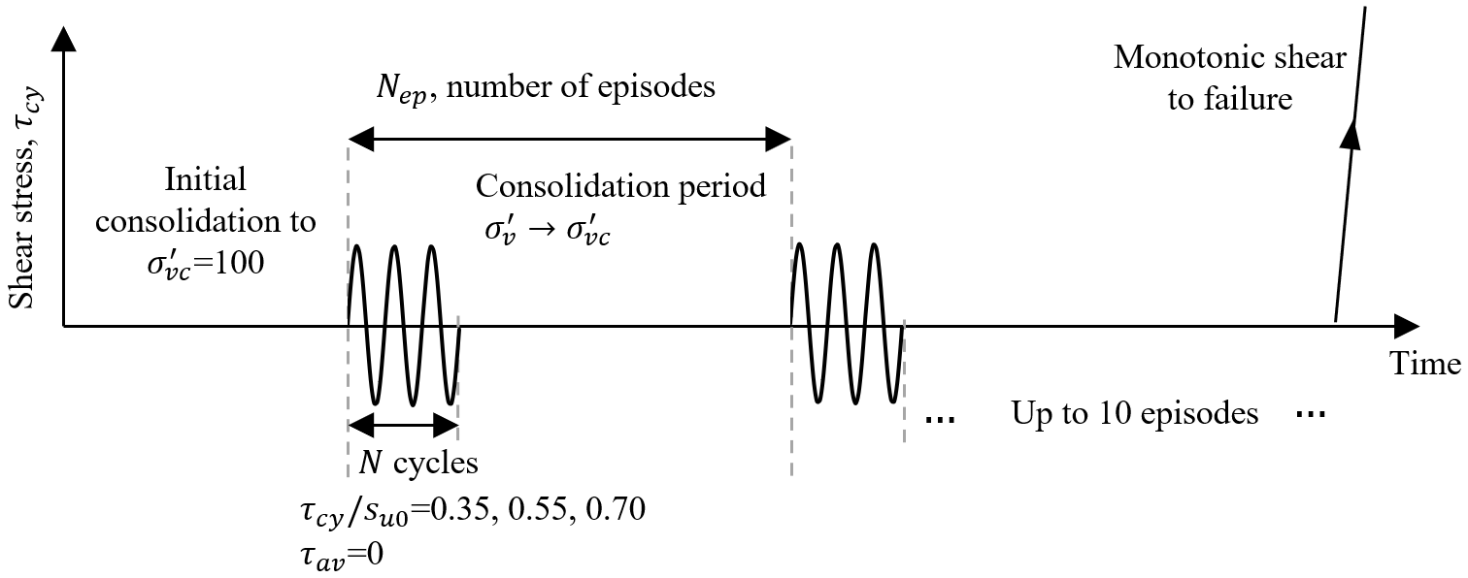
Figure 2 Schematic of applied episodic cyclic loading, showing number of cycles per packet, $N$, and the number of episodes, $N_{ep}$.
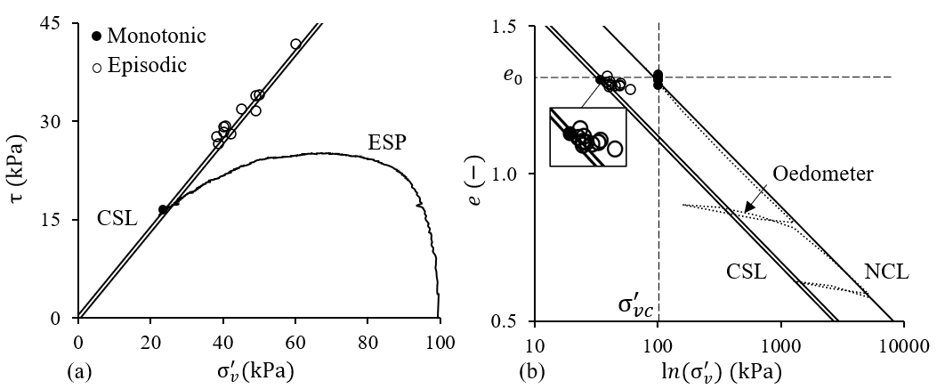
Figure 3 (a) Effective stress path (ESP) for monotonic DSS test performed at constant volume, and (b) initial and final soil states for all tests presented in e-ln($σ_{v}^{'}$) space.

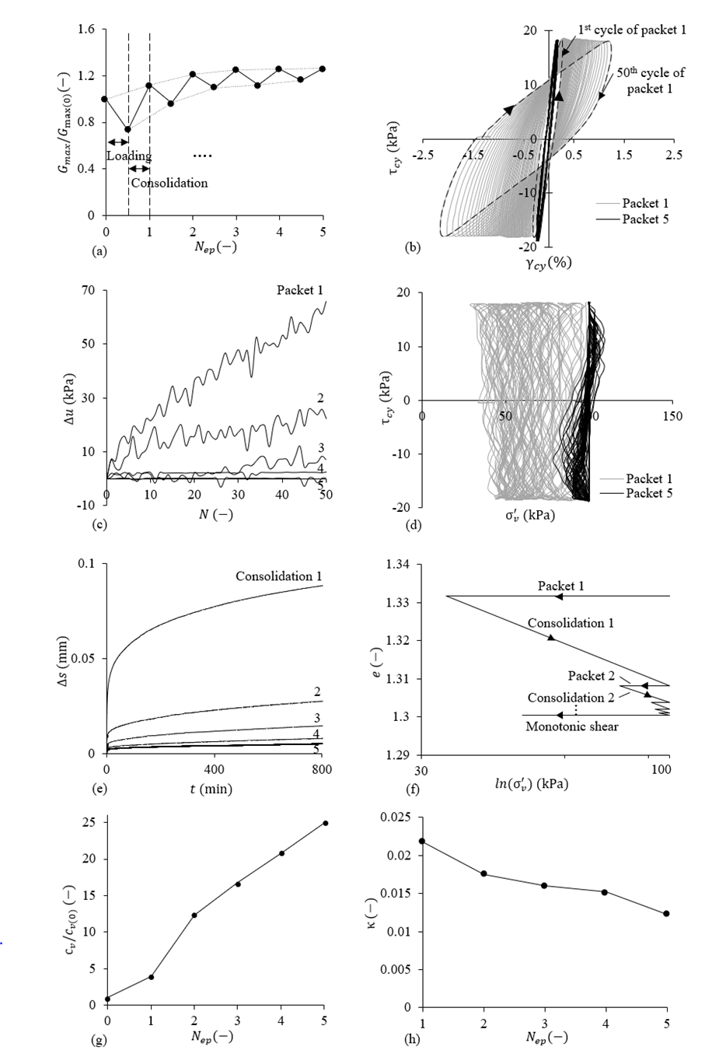
Figure 4 Example of soil response in episodic test (results from tests with$N=$50, $N_{ep}=$5 &$τ_{cy}=0.70s_{u0}$) showing (a) stiffness change, (b) stress-strain response, (c) excess water pore pressure generation, (d) effective stress path, (e) specimen settlement during intervening consolidation phase, (f) effective stress-volume path, (g) coefficient of consolidation change and (h) recompression line slope change.
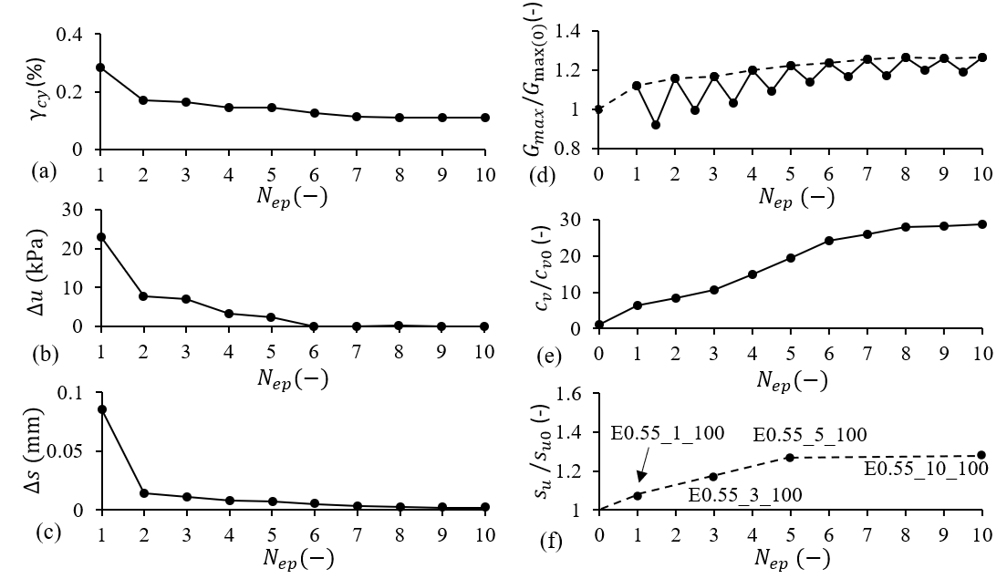
Figure 5 Long term stabilisation of response through episodes of cyclic shearing and intervening consolidation (test E055_10_100) (a) maximum cyclic shear strain amplitude, (b) generated permanent excess pore water pressure, (c) soil settlement during re-consolidation, and the subsequent evolution of (d) normalised small strain shear modulus $G_{max}/G_{max⁡(0)}$, (e) normalised coefficient of consolidation $c_{v}/c_{v0}$ and (f) normalised soil strength $s_{u}/s_{u0}$.
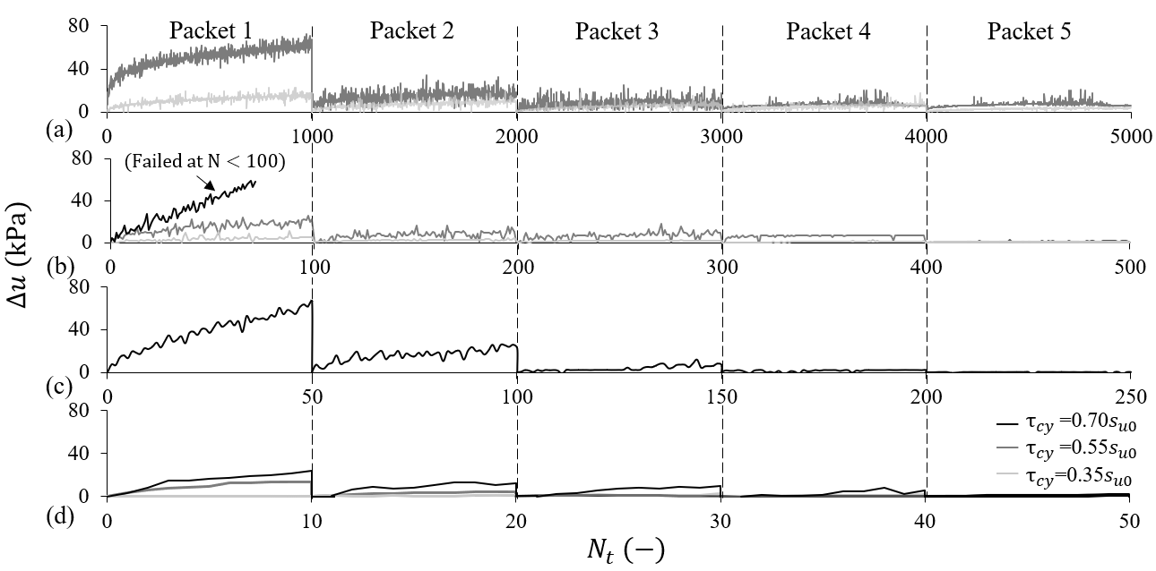
Figure 6 Excess pore water pressure generation throughout episodic tests with different cyclic amplitudes $τ_{cy}=$0.35$s_{u0}$, 0.55$s_{u0}$ & 0.7$0s_{u0}$ and with (a) $N=$1000 (b) $N=$ 100 (c) $N=$ 50 and (d) $N=$10 cycles per packet. (Intervening consolidation in between packets as indicated with the botted line)
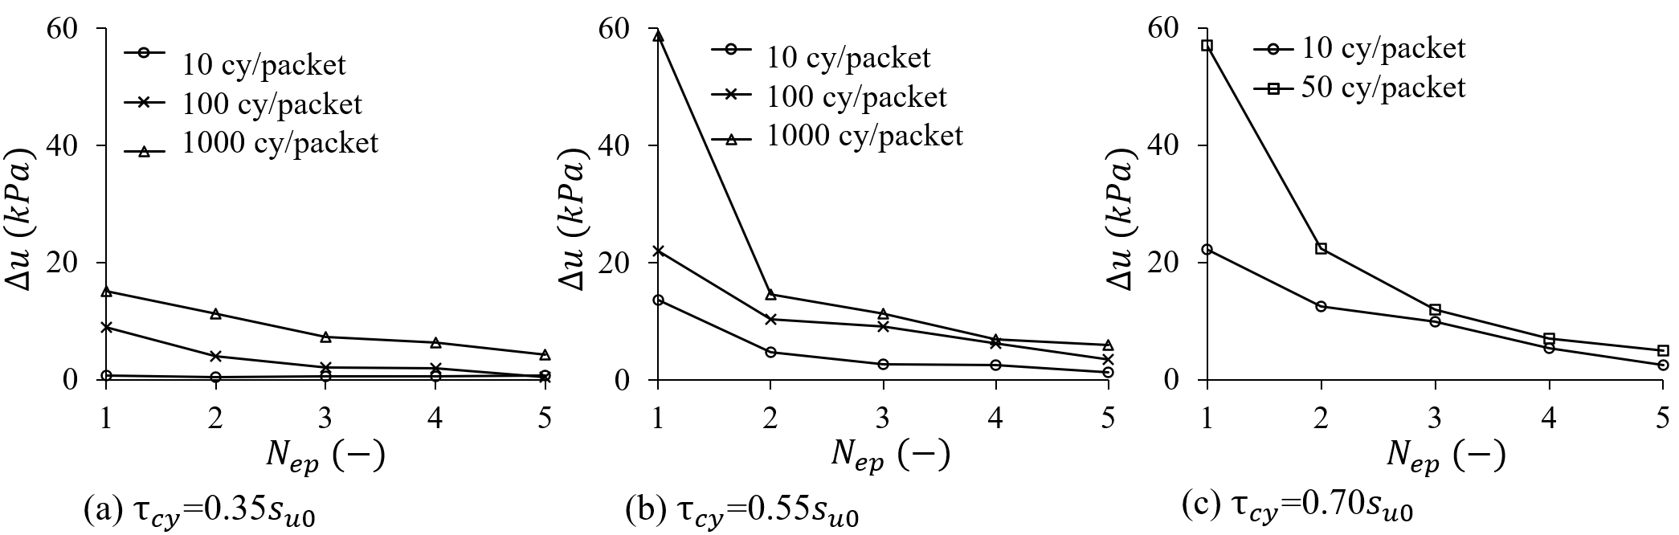
Figure 7 Accumulated permanent pore water pressure generated during each loading packet at different cyclic stress amplitudes (a) $τ_{cy}=$0.35$s_{u0}$, (b) $τ_{cy}=$0.55$s_{u0}$ & (c) $τ_{cy}=$0.7$0s_{u0}$.
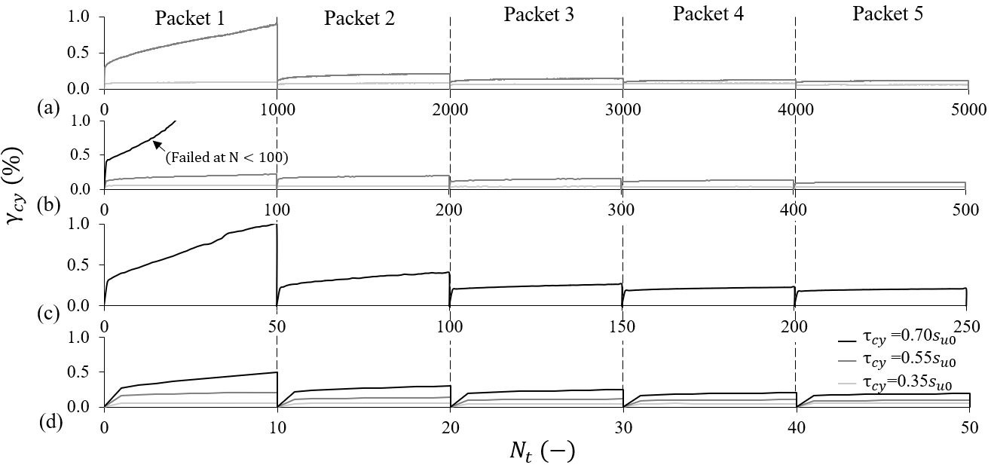
Figure 8 Cyclic shear strain amplitude during episodic tests with different cyclic amplitudes $τ_{cy}=$0.35$s_{u0}$, 0.55$s_{u0}$ & 0.7$0s_{u0}$ for (a) $N=$1000 (b) $N=$ 100 (c) $N=$ 50 and (d) $N=$10 cycles per packet. (Intervening consolidation in between packets is indicated with the botted line)
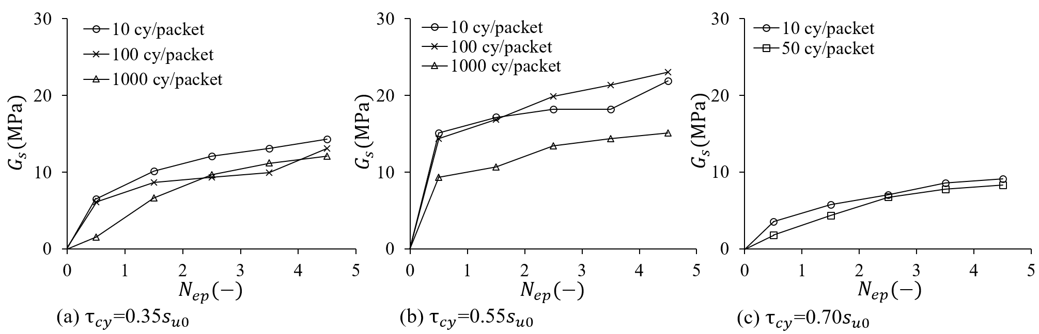
Figure 9 Change in final-cycle secant shear modulus ($G_{s})$ with episodes ($N_{ep}$) at different cyclic stress amplitudes (a) $τ_{cy}=$0.35$s_{u0}$, (b) $τ_{cy}=$0.55$s_{u0}$ & (c) $τ_{cy}=$0.7$0s_{u0}$.
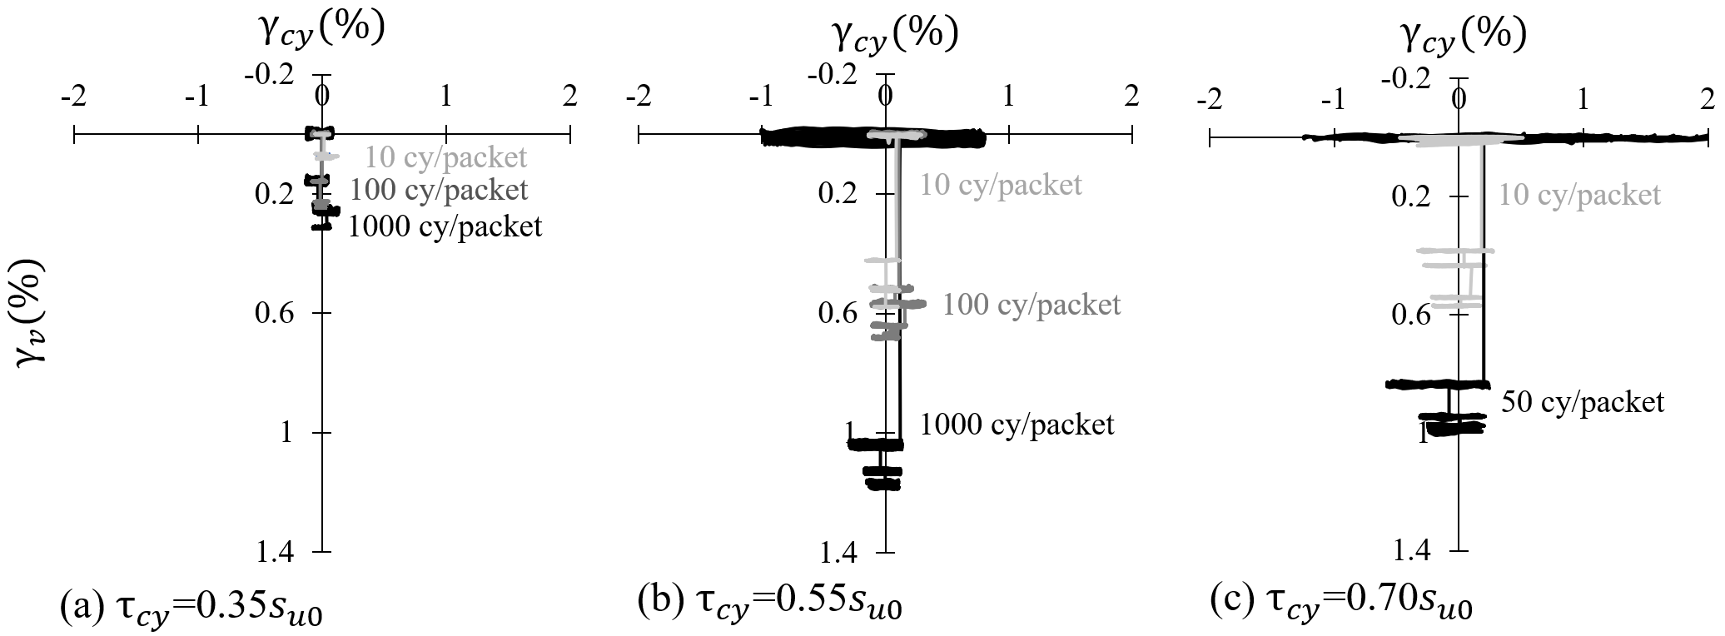
Figure 10 Shear and volumetric strains at different cyclic stress amplitudes (a) $τ_{cy}=$0.35$s_{u0}$, (b) $τ_{cy}=$0.55$s_{u0}$ & (c) $τ_{cy}=$0.7$0s_{u0}$.
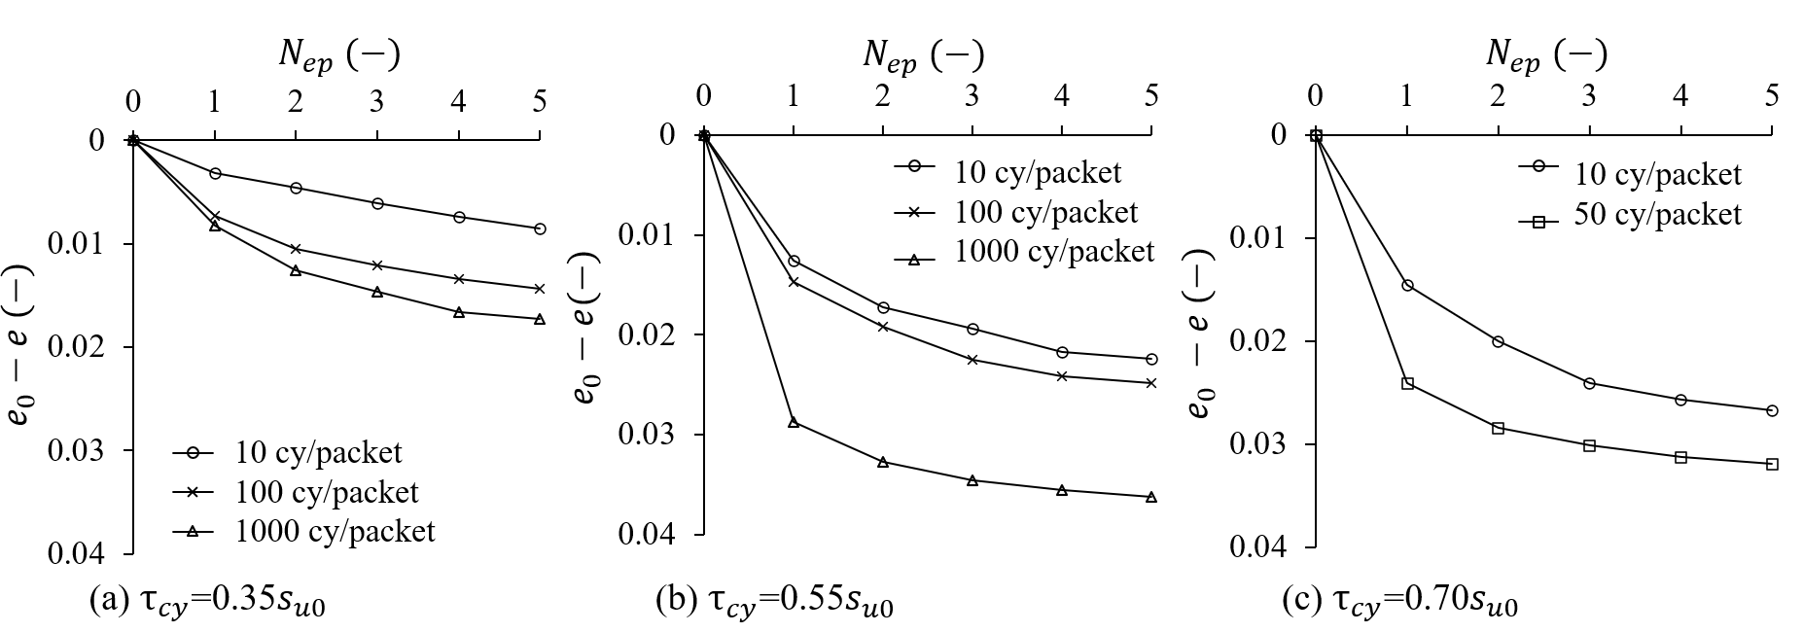
Figure 11 Reduction in void ratio with episodes ($N_{ep}$) at different cyclic stress amplitudes (a) $τ_{cy}=$0.35$s_{u0}$, (b) $τ_{cy}=$0.55$s_{u0}$ & (c) $τ_{cy}=$0.7$0s_{u0}$.

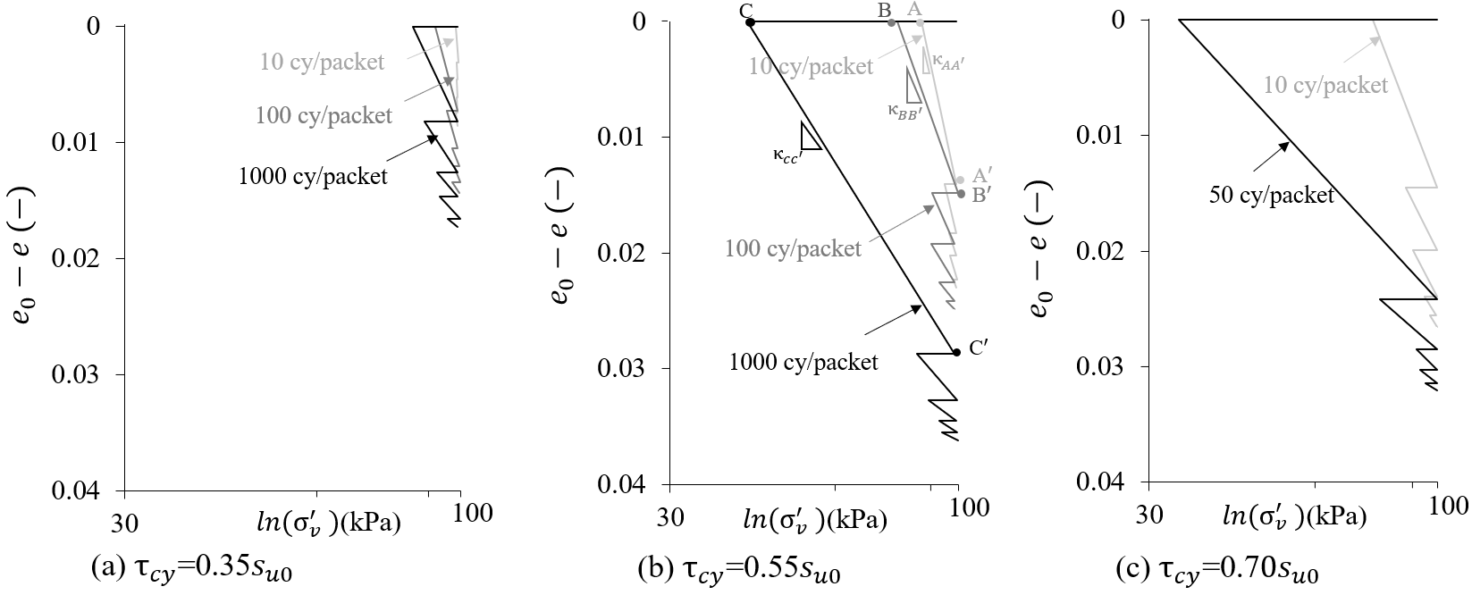
Figure 12 Effective stress paths in $e-log⁡(σ_{v}^{'})$ due to shear and consolidation at different cyclic stress amplitudes (a) $τ_{cy}=$0.35$s_{u0}$, (b) $τ_{cy}=$0.55$s_{u0}$ & (c) $τ_{cy}=$0.7$0s_{u0}$.
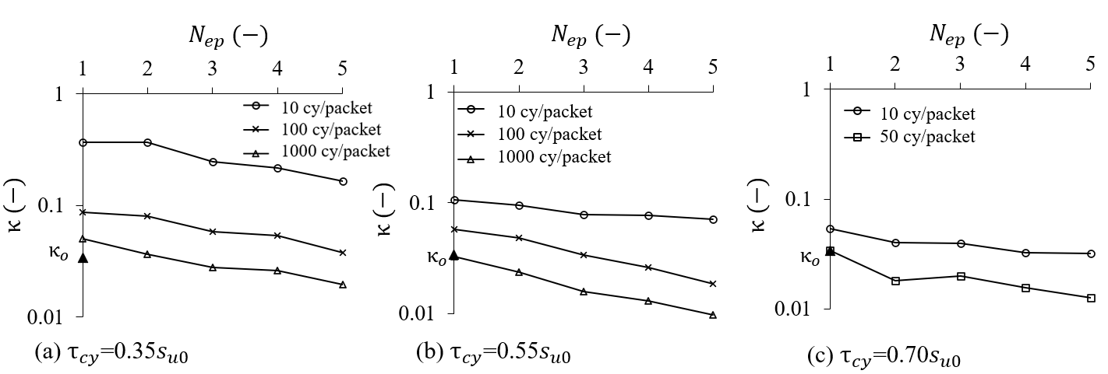
Figure 13 Evolution of the post-shearing recompression modulus$κ$ during cyclic episodes at different cyclic stress amplitudes (a) $τ_{cy}=$0.35$s_{u0}$, (b) $τ_{cy}=$0.55$s_{u0}$ & (c) $τ_{cy}=$0.7$s_{u0}$.
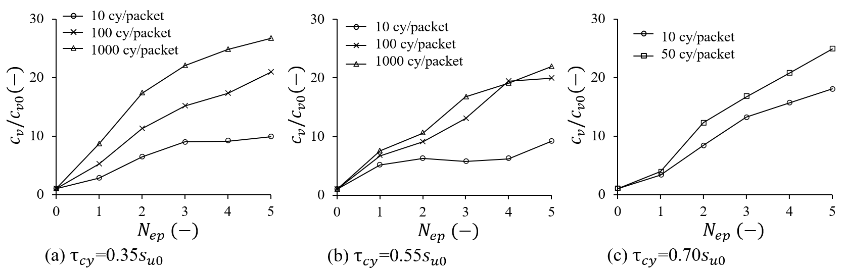
Figure 14 Normalized evolution of consolidation coefficient $c_{v}$/$c_{v0}$during cyclic episodes at different cyclic stress amplitudes and number of cycles of loading per packet.
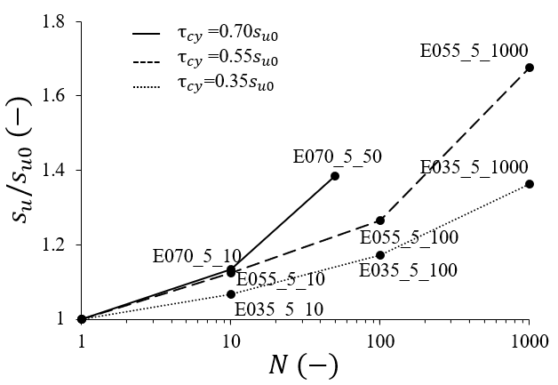
Figure 15 Normalised evolution of strength $s_{u}/s_{u0}$ after 5 episodes for varying numbers of cycles per packet and cyclic amplitudes.
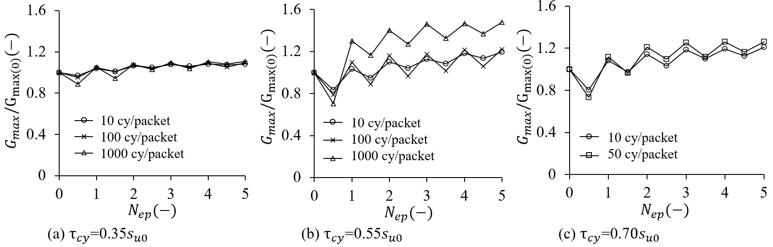
Figure 16 Normalised evolution of stiffness during cyclic episodes.
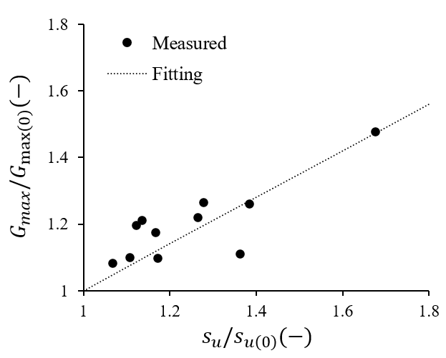
Figure 17 Comparison of normalised gains in shear modulus $G_{max}/G_{max⁡(0)}$and undrained shear strength $s_{u}/s_{u0}$.

