Paraglacial conditions, climate and isostacy control river incision and terrace
development; the example of the River Lune, NW England
Paul A. Carling^{1,2}, Mahmoud Abbas³, Ou Xianjiao³, Cai Jialing³, Ding Ying Ying⁴, Peter. M. Atkinson^{2,1,5}, Zhang Xujiao⁴, Zhou Yanlian ⁶
¹ School of Geography and Environmental Science, University of Southampton, Southampton, SO17 1BJ, UK.
² Lancaster Environment Centre, Lancaster University, Bailrigg, Lancaster, LA1 4YW, UK.
³ School of Geography and Tourism, Jiaying University, Meizhou 514015, China.
⁴ School of Earth Science and Resources, China University of Geosciences, Beijing 100083, China.
⁵ College of Surveying and Geo-Informatics, Tongji University, No.1239, Siping Road, Shanghai, PR China, 200092
⁶Key Laboratory of Mountain Hazards and Engineering Resilience, Institute of Mountain Hazards and Environment, Chinese Academy of Sciences, Chengdu 610299, China.
*Corresponding author: pma@lancaster.ac.uk

Abstract
Within Britain, post-last-glacial river terraces are frequently indicators of catchment-wide extrinsic eustatic and isostatic drivers, as the landscape adjusted through paraglacial conditions and latterly experienced temperate climates. Climate drove changes in river discharge and sediment loads at the catchment scale, mediated by local intrinsic controls on terrace formation. The terraces of the River Lune, NW England, are described and related primarily to climatic drivers with a subordinate role for isostacy. Localized drivers include: 1) glacial over-deepening; 2) terrace effacement due to change in the river style; 3) a moraine blocking the river course; 4) the influence of bedrock gorges. Humans may have had a reinforcing effect on climatically-driven terrace formation.
The terrace levels are from highest to lowest: T1 to T3. The T1 level is a degraded, broad, glacifluvial surface; an ice-front braidplain that formed early during deglaciation (c. < 19 ka). The T2 level consists of gravel deposits on straths cut into bedrock, till or the T1 deposits, where the river bed aggraded during the Windermere Interstadial, then incised during the Younger Dryas. The T1 and T2 levels formed during the last glacio-eustatic sea level fall. The T3 level is broadly synonymous with the modern floodplain, which developed from the Early Mediaeval Period, due both to changes in climate and human use of the catchment. In upstream reaches, this level is in the process of abandonment. Major bedrock controls on terrace formation occur at the Lune Gorge and at the Knot Anticline. The latter limited isostatic and eustatic drivers from propagating incision upstream from the modern coast.
Key Words
River Lune, fluvial terraces, eustacy, isostacy, Younger Dryas, Early Mediaeval Period

- Introduction
Herein, we address the question as to whether the formation of post-glacial river terraces in north-
west England and their abandonment are reflections of catchment-wide extrinsic forcing or are the result of more localized drivers which may vary significantly throughout the drainage network. As will be shown, the River Lune in north-west England is an exemplar of the controls on river development through paraglacial conditions to more temperate climatic conditions. Consequently, the purpose of this study is to elucidate, for the first time, the controls and the timing of River Lune terrace development, with a view to increasing our understanding of regional post-glacial riverine landform adjustment.

During the Dimlington stadial (30 – 14.7 ka; Merritt et al., 2019; Livingstone et al., 2012; Mitchell, 2013) of the Devensian stage, the maximum extent of the British-Irish Ice Sheet in northern England occurred during the Last Glacial Maximum (LGM: 25.5 ka to 19 ka; Clark et al., 2009; i.e., within Marine oxygen Isotope Stage 2 (MIS 2)). Converging ice streams from the Irish Sea basin and the Cumbrian and Pennine hills covered Lancashire after c. 22 ka (Worsley, 2015). With rapid down-wasting of ice occurring from c. 20 ka (Hubbard et al., 2009), the final retreat of the warm-based ice from the vicinity of the River Lune was well advanced between 18 and 16 ka (Livingstone et al., 2012) with the broader region being ice-free by 14.7 ka. The generally cool transition to the warmer epoch (the Holocene; 11.7 cal ka to present; MIS 1)) was interrupted by a warmer interstadial that, in the Cumbrian mountains, has been termed the Windermere Interstadial (Coope and Pennington, 1977) occurring ~ 13.9 to 12.9 cal ka (Marshall et al., 2002) followed by colder conditions (Bickerdike et al., 2018) during the Younger Dryas (~ 12.9 to 11.7 cal ka). The Windermere Interstadial is roughly equivalent to the Bølling-Allerød interval of NW Europe (Mangerud et al., 1974; Walker et al., 1994) and its climate broadly pertained across England, Scotland and Wales (Hughes et al., 2022). Taken together these climatic adjustments have been termed the Last Glacial–Interglacial Transition (c. 16–8 ka for the broader North Atlantic region; Lowe et al., 2001; Rasmussen et al., 2014). The initial deglacial period and the Last Glacial–Interglacial Transition exhibited considerable climatological and ecological temporal and spatial variability leading to complex landform responses.

The retreating ice margins revealed a paraglacial landscape (Church and Ryder, 1972; Ballantyne, 2002a; Zhang et al., 2025) wherein the surface morphology related to river channel development adjusted rapidly. The initial main driver for riverine landscape adjustment was climate-driven change in the runoff regimen as the glacial meltwater of the deglacial period was replaced by a precipitation dominated discharge regimen during the Last Glacial–Interglacial Transition (Smith et al., 1996; Yorke et al., 2024). Also, sediment supply to channels reduced as glacial and periglacial conditions waned (Li et al., 2025), and bare catchment slopes became vegetated (Bridgland, 2000; Bridgland and Westaway, 2014). At the same time, as the ice load was reduced over wide areas, regional factors, specifically glacio-isostasy and glacio-eustasy, mediated the base levels of rivers, driving channel evolution at the catchment-scale (Bridgland et al., 2010). During the deglaciation, isostatic and eustatic adjustments tended to operate over longer relaxation time scales than those of climatic factors (Foreman and Straub, 2017), with isostacy-eustacy driving aggradation or incision up-system, from the coast towards the headwaters of smaller catchments (Bridgland, 2024), thus, interacting with the discharge-driven river channel adjustments.

Within this paraglacial context, river terraces are important indicators of landscape adjustment as they tend to develop throughout much of a river basin, reflecting both climatic and isostatic-eustatic basin-scale controls. Within northern England, any pre-Devensian river terraces, within the limits of the last ice sheet, were destroyed by glacial erosion (Bridgland et al., 2010). Consequently, the initial evolution of river terraces within the former Devensian ice limits may be related to local paraglacial MIS 2 climatic controls as the landscape progressively emerged from beneath the ice (Ballantyne, 2019), as well as to regional controls exerted by post-glacial eustatic and isostatic adjustments. Paraglacial conditions (Ballantyne, 2002a & b) reduced as the glacial termination transitioned to the Holocene, with the heterogeneity of conditions within the catchment being dependent on such factors as sediment grain size, sediment quantity, river discharge and vegetation cover, amongst others. The following section provides the regional context within which terraces developed.

2. The River Lune in Context

2.1 General context for river terrace development

Given there has been no previous comprehensive study of the Lune river terraces, it is necessary to outline the context of the study. The River Lune catchment (c. 1000 km²) drains south from the southern Shap Fells (eastern extension of the Cumbrian mountains) as well as from catchments in the Pennine hills and the Howgill Fells (Fig. 1). The largely upland catchment lies entirely within the extent of the late Devensian ice sheet and includes a lowland plain around Morecambe Bay. From c. 20 ka ice margins retreated within the catchment northwards and eastwards (Clark et al., 2022) and to the north-west fairly continuously (Pinson et al., 2013; Avery et al, 2019), exposing the lower course of the river before the upland reaches were exposed (Brandon et al., 1998). A short-lived ice readvance occurred around 19 ka (Chiverrell et al., 2018) which affected the upper course of the Lune, north of the Howgill Fells. Yet, it is probable that the majority of the river course was free of ice within a 3 ka window following c. 19 ka (Clark et al., 2022; Carling et al., 2023a and b), during which time the Lune was fed by meltwater as the ice sheet receded. Given the rapid ice retreat from the catchment, discharges of both meltwater and glacigenic sediment will have decreased quickly, leading to initial channel adjustments over time scales of typically 10³ years, or less (Straub and Wang, 2013; Foreman and Straub, 2017). Within the context of river channel evolution, the main valley and tributaries exhibit flights of river terraces which, as will be shown within the Results, are indicators of the adjustments in the bed of the river that occurred initially during the period of paraglacial conditions and thence through a longer period of more temperate climate. At the same time, isostatic and eustatic adjustments to the relative elevation of the land surface occurred as ice retreated. Within the Holocene, anthropogenic factors came into play which appear to have affected channel changes, at least locally (Harvey, 1985; 2017; Chiverrell et al., 2007; 2008).

The fall of 213 m, from Newbiggin-on-Lune near the source of the Lune to the coast near Lancaster, occurs over 77 km, giving an average slope for the main river of only 0.003, but the long profile is subject to considerable variability related to structural controls. The Lune rises in the Howgill Fells (Fig. 1) and flows due west over an alluvial bed flanked by a low-terrace-cum-floodplain, up to 400 m wide, below soliflucted till benches that blanket the lower valley-side slopes. In the headwater Howgill Fell tributaries, two terrace flights post-date the benches (Harvey, 1985). Within the context of the present study, this stretch of the river upstream of Tebay village (Fig. 1; all locations mentioned in the text but not shown on Fig. 1 are listed within Table S1) is termed the upper Lune and the bedrock is chiefly Silurian and Devonian sandstones and siltstones and Carboniferous limestone. A significant right-bank tributary, the Birk Beck, largely bedrock confined, flows above Coniston Group (Silurian) sandstones and siltstones. At Tebay, the River Lune turns abruptly south, through the Lune Gorge, where its’ slightly sinuous course is closely confined by the Howgill Fells to the east and southern Shap Fells to the west. Here the river has a rocky bed, cut within Coniston Group bedrock and a discontinuous series of three terraces flights are evident with negligible floodplain (Harvey, 2017; his fig 4.1). A large right-bank tributary, the Borrow Beck, flowing over Coniston Group bedrock, joins the Lune within the gorge.
Below Kirkby Lonsdale (Fig. 1), the lower Lune is alluvial, and the floodplain broadens to 600 m wide above Carboniferous bedrock. Below the confluence of the tributary River Wenning, alluvial channel meandering is evident, and the floodplain broadens to 1 km wide, with alluvial terraces largely effaced by lateral cutting. Here, the modern single-thread river has been laterally stable for at least 150 years with localized instability occurring just north of Caton and at Arkholme (Orr, 2000), where meander scrolls occur on the floodplain. The channel is closely confined again in a short bedrock gorge at Crook O’ Lune (Caton), after which the floodplain broadens a little, to discharge to the ocean via the Lune estuary (the ‘Outer Lune’ on the Admiralty Chart, 2010, for Morecambe Bay), with the tidal limit at Skerton (Fig. 1). Before the end of the LGM, ice streams emanating largely from the Lake District ice cap deposited thick sequences of glacial diamicton (Knight, 1977) in the now submerged valleys beneath Morecambe Bay, as well as till sheets, moraines and extensive drumlin fields across the Lancashire plain (Brandon et al., 1998). Consequently, residual stagnating ice (Longworth, 1985), glacial over-deepening of valleys and the disposition of glacial landforms are further potential controls on the course and character of the River Lune as it emerged from beneath the ice (Moseley and Walker, 1952).
2.2 Structural framework for river terrace development
At an unknown date, the River Lune entrenched through the Pendle Grit Knot Anticline, at Crook O’ Lune (Fig. 1), to form the gorge noted in the last section (Brandon et al., 1998). Breaching of the anticline may be related to the timing of the development of the sub-tidal valley immediately west of Lancaster. The deep offshore valley, incised to rockhead at 116 m (Brandon et al., 1998) below the UK sea level datum (Fig. S2), may indicate a pre-Devensian origin for the now submerged lower Lune course (Thomas, 1999) as, during the late Devensian, sea level in Morecambe Bay fell to only around 40 m below the sea level (bsl) datum (Fig. S2). The relationship of the offshore bathymetric levels to the altitude of the crest of the anticline is important as, being in the south of the region, this river reach was the first to be ice-free.
Figure 1: The study area includes the catchment of the River Lune and minor catchments to the north and south of Lancaster, showing selected tributaries and main towns and villages. Inset is the catchment location within the UK. SRTM digital elevation model has a 90 m spatial resolution.
Thus, the controls on alluvial river terrace development upstream of the Knot anticline might include variations in base level, induced by sea level changes and glacio-isostacy since the last glaciation (Milne & Shennan, 2025), being propagated through the location of the anticline. Regional base level changes can induce substantial knickpoint development, cutting headwards from the coast into both valley fill and bedrock. However, local structural and morphological features, such as the Knot Anticline, within the catchment can provide local base level controls upstream of the coast, complicating any focus on the control exerted by the coastal base level.
2.3 Isostatic and eustatic framework for river terrace development
Isostatic depression of the land surface in northern England, due to the presence of a thick ice cover during the LGM (Bradley et al., 2011), was moderated by enhanced denudation due to ice erosion (Westaway, 2009) and possibly by forebulge development (Wingfield, 1995), resulting in a compensatory uplift rate. Local LGM uplift rates are not available but a regional rate of c. 0.18 mm a⁻¹ occurred during the Mid-Pleistocene (Green et al., 2012). Overall, Quaternary crustal motion resulted in a slight tilting of the catchment land surface towards the south (Stone et al., 2010; Peltier et al., 2015). Faulting in the Lancashire plain (Brandon et al., 1998) occurs at too small a spatial scale to have influenced the overall regional picture of isostatic adjustment (see England and Molnar, 1990, for context). So, despite uncertainty with respect to absolute depression of the land surface (Shennan et al., 2012), as ice decayed from c. 20 ka, rebound within Morecambe Bay occurred from a sea level of about 15 m bsl or lower (Supplementary Information, Fig. S2). Empirical estimates of glacio-isostatic recovery (e.g., + 18 m, over the last 13,000 years; Andrews et al., 1973) have been confirmed by recent modelling studies (Andrews et al., 2021). The rate of uplift in Morecambe Bay was up to 36.7 mm a⁻¹ prior to 6.75 ka (Zong and Tooley, 1996), reducing to 0.35 ± 0.12 mm a⁻¹ for onshore sites during the last 6,000 years (Shennan, 1989). From 9 ka, the rate of sea level rise exceeded the isostatic rebound (Andrews et al., 2021) and the sea level within Morecambe Bay rose quickly from c. 5 m bsl around 7 ka (Pennington, 1978) to c. 0.5 m above sea level (asl) around 5 ka (Peltier et al., 2002; Shennan et al., 2018), oscillating slightly until present (Fig. S2). Thus, glacio-isostatic rebound of the land in the study area before 9 ka outpaced any increase in eustatic sea level and subsequent Holocene adjustments in sea level have been minor. Andrews et al., (2021) argued that the transgression effectively ended c. 6 ka (Bonsall et al., 1989; Bonsall, 2007; Lloyd et al., 2013) with sea levels ~ 1 m above present.

Given the small size of the catchment, the absolute effects of isostacy might only be slightly greater in the southern lowland reaches of the river than in the uplands to the north, as the low altitude low gradient reaches of the Lune would be sensitive to uplift. The effect of neotectonism on relative land-level changes has been minimal since c. 5.8 ka (Zong and Tooley, 1996; Shennan et al., 2012) so any changes to river level subsequently would not relate to tectonism. Nonetheless, relative sea level is high now compared with during the deglacial period, the Last Glacial–Interglacial Transition, and much of the early Holocene, when river terraces were forming. As the ice receded, the rate of glacio-isostatic rebound at first exceeded the glacio-eustatic rise in sea level such that the River Lune would have continued to incise towards a low rock-base, offshore of the present coastline (Brandon et al., 1998) until such time as the eustatic changes in sea level predominated.

- Material and methods

After field reconnaissance, four sub-reaches of the Lune drainage network were selected as key examples of river incision processes and controls. These reaches are within: 1) the Birk Beck, a right bank tributary in the upper Lune catchment; 2) the Borrow Beck, a right bank tributary in Borrowdale within the southern Shap Fells; 3) the upper Lune near Tebay; and 4) the lower Lune between Caton and Lancaster. Within each study reach, the main terrace levels were numbered from highest to lowest, for example, T1 to T3. Main terraces are those that can be traced throughout much of the Lune catchment. Subsidiary terrace levels and fragments of terrace levels that occur only over short reach lengths are described but are unnumbered except for two examples labelled T2A. It should be noted that levels with the same number do not necessarily correlate, in terms of age and altitude, when comparing sub-catchments, as is made clear within the Results. For each level, morpho-stratigraphical information was recorded.
Field survey was undertaken using a hand-held Garmin global positioning system to mark the extent of terraces, starting and finishing each survey from an Ordnance Survey (OS) ground survey height, marked on the OS 1:25,000 series of maps. These locations were transferred to Google Earth (GE) to visually relate point locations to landscape features (Schillaci et al., 2015). Point GE elevations and/or NEXTMapTM digital elevations (5 m spatial resolution; ± 1 m vertical resolution) were adjusted (if necessary) to be consistent with OS benchmarks, spot heights and OS contour altitudes to provide definitive planar coordinates (relative accuracy < 4 %; Harley, 1975). Given the errors in remotely-sensed altitudes, the relative levels of flights of terraces and the modern riverbed were checked in the field using a clinometer, range finder, graduated staff and tape measure surveys. In Borrowdale, a Leica total station was used to map a complex of terrace fragments, the altitudes of which were too close together to utilize GE or NEXTMap data. The stratigraphy and sedimentology of natural cut-sections within terrace levels were logged and photographed. Carbon-14 (¹⁴C) and infrared stimulated luminescence (IRSL) assays were applied to key sediment samples taken from stratigraphic sections to date the timing of sediment deposition within terrace levels (see Supplementary Information section 2.1). Two ¹⁴C samples also were taken to date tufa deposits to constrain the age of a terrace level. Dating control assisted in defining the temporal stages in terrace development and abandonment at key locations. For conciseness, the dating protocols and stratigraphic and sedimentological information are provided within Supplementary Information sections 2 and 3.

- Results
4.1 Structural control of the River Lune long profile
The long profile of the River Lune, upstream of the tidal limit, exhibits no substantial knickpoints that unequivocally might be related to base level changes (Fig. 2 and Supplementary Information section 1.3 ). Rather, there are four major breaks of slope that are structurally controlled. In ascending order: 1) Crook O’ Lune, where the river crosses the Knot Anticline and cuts through the Pendle Grit; 2) Kirkby Lonsdale where the river crosses a fault that separates the Sedbergh Conglomerate to the north and the Urswick Limestone to the south; 3) as the river emerges from the southern end of the Lune gorge there is probable fault-control leading to steepening of the gradient at Crook of Lune (NB: see footnote to Table 1); and finally, near Tebay there is an alluvial flat upstream of the Lune gorge (Carling et al., 2013a). The alluvial flat at Tebay is associated with a glacially-scoured, deep, diamicton-filled trough and a further trough occurs immediately upstream from Crook O’ Lune (Fig. 2) (Brandon et al.,1998; Carling et al., 2023a). A distinct break of slope occurs on the Borrow Beck (Table 1), just below where a moraine crosses the valley base (Carling et al., 2023a) with the gradient of the lower V-shaped valley being twice that of the U-shaped valley above the moraine. Small knickpoints occur within headwaters, for example, on the upper Lune at Wath (Pattison, 1990), and three occur on the Birk Beck which appear to have been arrested by fault and lithological control (Table 1).
Table 1: Breaks of slope and knickpoints on the River Lune and selected tributaries.
River | Location | Type | Northing (º) | Westing (º) W | Altitude asl (m)
Lune | Crook O’ Lune¹ | Anticline breach | 54.0754 | 2.7484 | 20
Lune | Kirkby Lonsdale | Break of slope | 54.2025 | 2.5893 | 50
Lune | Crook of Lune¹ | Break of slope | 54.3530 | 2.5791 | 130
Lune | Tebay | Alluvial flat | 54.4408 | 2.5978 | 178
Lune | Wath | Knickpoint | 54.4402 | 2.4896 | 230
Borrow Beck | Borrowdale | Break of slope | 54.4052 | 2.6337 | 204
Birk Beck | Scout Green | Knickpoint | 54.4625 | 2.6318 | 201
Birk Beck | Rampshowe | Knickpoint | 54.4665 | 2.6365 | 213
Birk Beck | Docker Force | Knickpoint | 54.4728 | 2.6408 | 220
¹NB: Note two distinct locations with similar names.
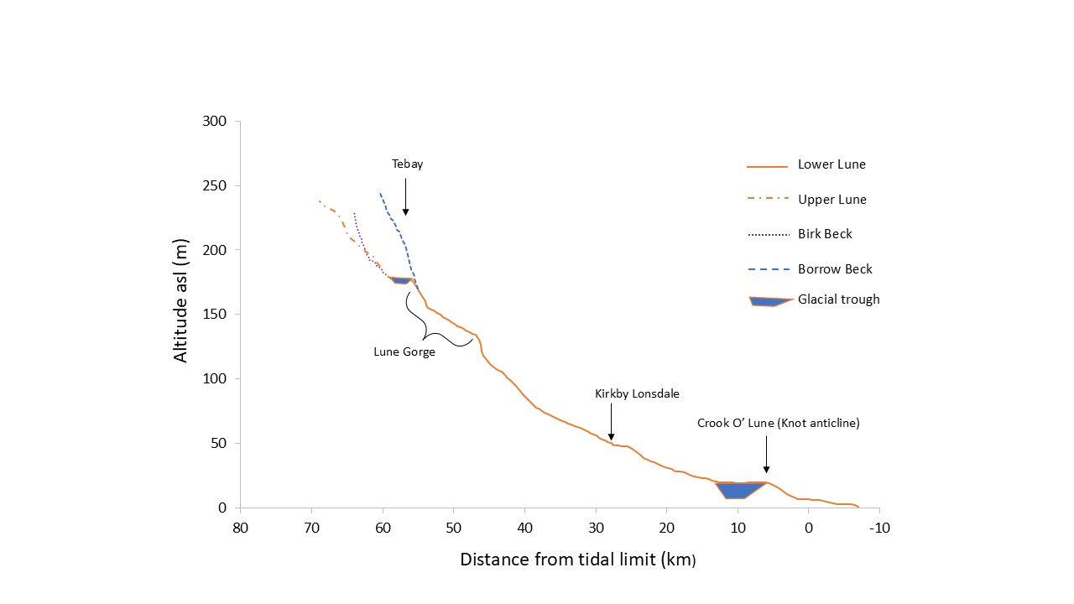
Figure 2: Long profiles of the River Lune and selected tributaries, showing locations of structural controls on river gradient. Knickpoints noted in the main text are too small to signify at this scale. Depths of glacial troughs represent the average depths.

4.2 Birk Beck terraces
Birk Beck is a headwater right-bank tributary of the River Lune, located within the Shap Wells structural trough (McCormac, 2003). Near Scout Green, head-cutting by the stream has exposed the Shap Wells Conglomerate sandwiched between the overlying Blind Beck Sandstone to the east and the underlying Bannisdale Formation to the west (Capewell, 1954). The exposure of the conglomerate narrows northwards along the course of the stream and terminates at Docker Force, a 5 m high, vertical, structurally controlled waterfall (Capewell, 1954) (Table 1). Two further knickpoints occur (Table 1) close to Scout Green, the lower of the two cutting into the conglomerate. It is evident that the narrow northern exposure of the conglomerate is due to incision by the stream and, below Docker Force, a series of two main terrace levels (T1 and T2) extend southwards to the confluence with the River Lune (Pattison, 1990).
Description and interpretation of the T1 terrace level: The T1 level is the highest of two main strath terraces, occurring at altitudes between 224 and 207 m near Scout Green (Fig. 3 and 4) and cut into till, with a negligible alluvial gravel capping. It is now much degraded and dissected by minor surface water drainage channels, such that it occurs as a discontinuous bench immediately below soliflucted till-covered hill slopes to the west of Birk Beck, being most prominent between Gibson Hill (GH: Fig. 4) and Scout Green. To east of the Birk Beck it occurs only as a terrace fragment (N 54.459227º; W 2.624926º), just south of Scout Green, beyond which it is replaced by a drumlin landscape (centre-bottom of Fig. 4). The T1 level can be traced north to just south of Docker Force (Fig. 4), grading towards the level of the top of the falls, although the terrace does not extend to the falls. The base of a stratigraphic section (N 54.456071º; W 2.626391º; Elevation c. 196 to 197 m) is not revealed, but the terrace surface at the top of the sequence consists of truncated till with a veneer of water-worn pebbles. It is probable that glacial diamicton filled the valley such that the T1 level represents a poorly developed glacifluvial outwash braidplain cut into the till cover, as many headwater stream courses in northern England similarly are infilled by till (Woolacott, 1905; Anderson, 1940) or have incised into thick glacial diamicton (Bridgland and Westaway, 2014). Nonetheless, as will be shown, this level was not occupied for long before rapid down-cutting left it abandoned.
Description and interpretation of the T2 terrace level: The prominent ‘main’ terrace (T2) is a broad strath terrace as far downstream as Low Scales (Table S1), usually with a thin alluvial cover (< 2 m thick) although, farther down the valley (into the Tebay trough), the fill can be several metres thick beneath an alluvial terrace. The elevation is typically 10 to 15 m below T1 (Fig. 3). Sections depicting the intersection of the alluvial deposits with the basement rocks or diamicton/till are few and poor. Those that do occur show a flat interface between the basement rocks (or till) and a thin, boulder-rich alluvium above. Local curvilinear embayments cut into the till slopes below T1 show that the river at the T2 level had sufficient power for lateral erosion of the confining till slopes. However, the general absence of deep embayments along the terrace margins indicates that the river did not have a strongly meandering habit, but multiple braiding channels migrated freely and rapidly across the plain, trimming-off the till margins. This terrace level locally displays small palaeochannels (Fig. 3) incised into the bedrock close to the modern stream margins (see Supplementary Information section 3.1 for further details).
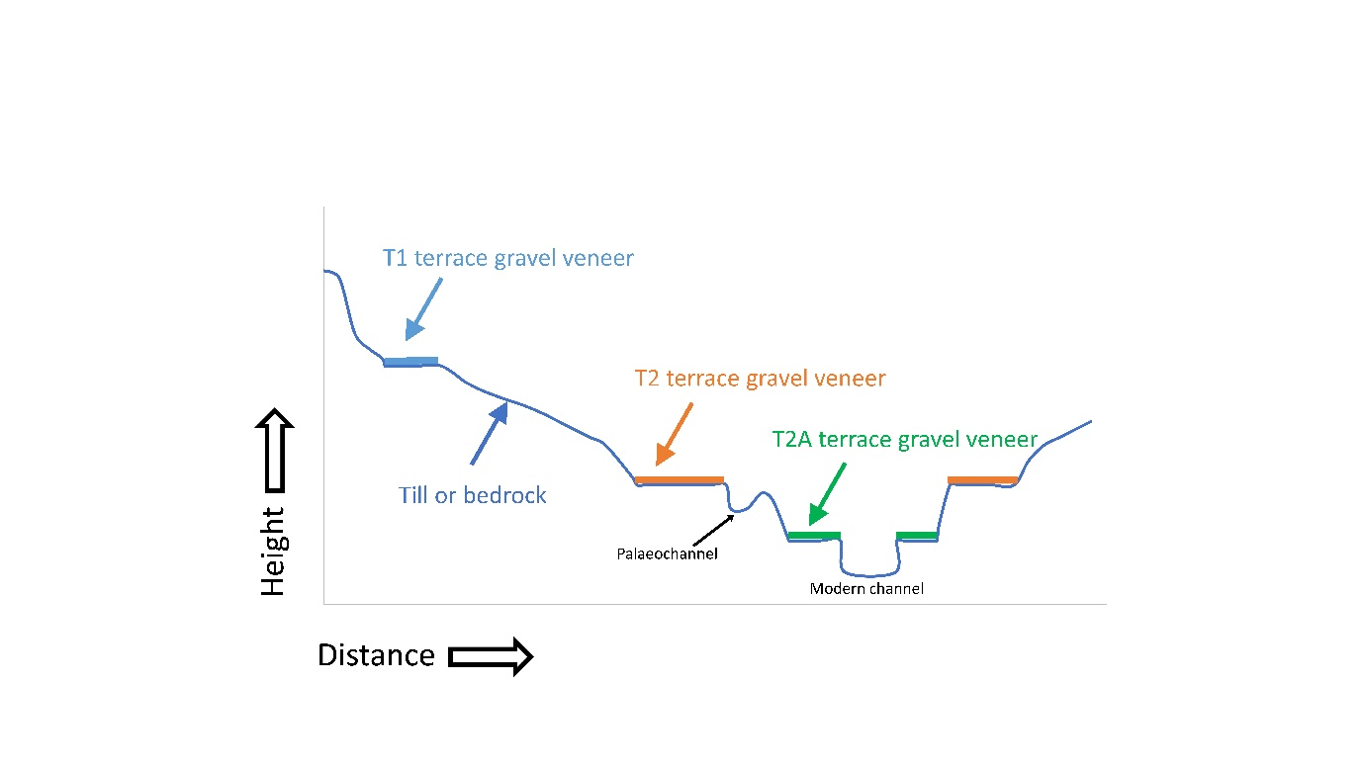
Figure 3: Cartoon of the relationship of terrace levels to the modern river at Scout Green. View is looking upstream.
The T2 level has a planar surface which is more continuous than the T1 surface and is deposited on an extensive bedrock or till planated surface locally ornamented by a few bedrock knobs that now crop-out above the terrace surface. This terrace level grades upstream to a knickpoint near Rampshowe (Table 1). Down-cutting preceded the terrace development, incising the bedrock and till planated surface, before alluviation occurred as a coarse-gravel to sandy braided outwash plain that would eventually constitute T2 (Fig. S5 A). As the stream latterly cut down, local bedrock-confined channels (e.g., Palaeochannel; Fig. 3) started to form before the T2 level was abandoned and the stream became constrained to its present course. Close to the confluence with the River Lune, this level is coincident with the T3 terrace level of the upper Lune, due to alluviation of the Tebay glacial trough (Fig. 2), as is discussed subsequently in section 5.1.
Description and interpretation of the T2A terrace level: Below T2, and either side of the modern river channel, a minor narrow terrace level occurs locally with widths of up to 15 to 50 m, c. 2 m to 3 m below T2 (Figs. 3 and 4). It is especially evident to the west of Scout Green where it grades upstream to the top of a knickpoint (Table 1). T2A has no distinct sections, except for a temporary section (2025) that revealed a thin till and alluvial gravel cover above a bedrock strath (Fig. S5 B). This level represents a minor standstill in the incision from T2 to the modern bed level.
Description and interpretation of the modern channel: The modern channel bed level is incised into bedrock some 3 m to 4 m below the T2 terrace level (Figs 3 and 4). The slot is typically flat-floored, some 30 m wide, with vertical to steep rock side walls. Infrequent, narrow higher bedrock benches either side of the modern channel indicate that a broader channel existed before the final incision to present-day level. Local boulder and coarse cobble deposits occur as point bars, but otherwise a planar bedrock surface is exposed with scattered, rounded, flood-transported boulders.
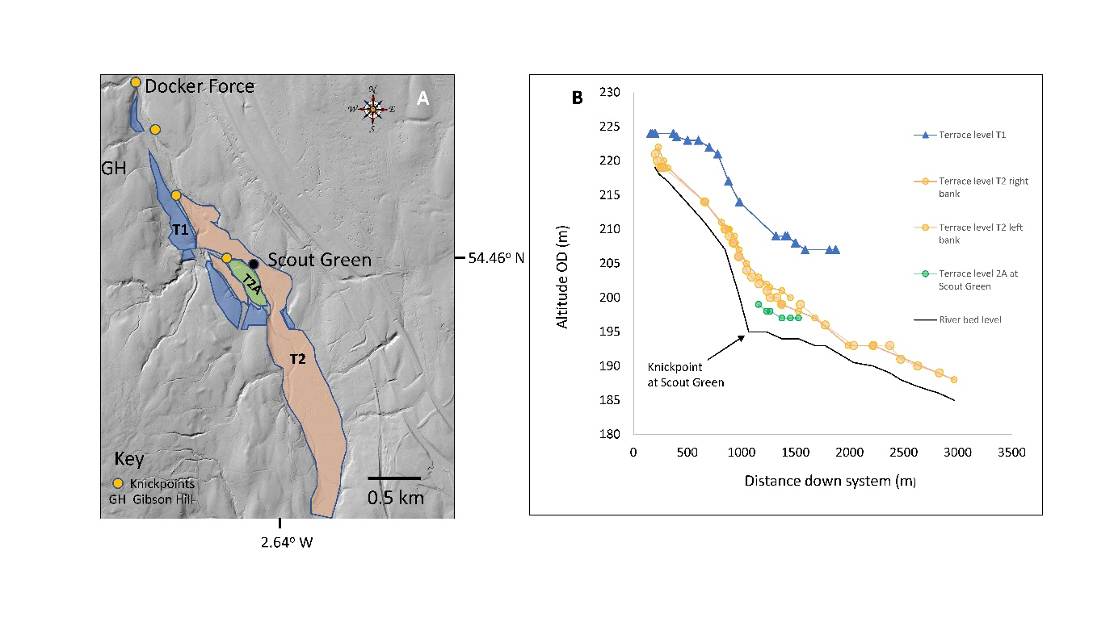
Figure 4: Birk Beck terraces south of Docker Force. A) Planview image of terrace levels near the hamlet of Scout Green. Stream flow is top to bottom of image. NEXTMap digital elevation model has a 5 m resolution; B) Long profiles of the terrace levels below Docker Force.
4.3 Borrowdale terraces
Except for the lower 2 km, Borrowdale is a glaciated U-shaped valley cut into Coniston series fine muddy sandstones. The lower 2 km is distinctly V-shaped. Rough Gill (Fig. 5A) is located just downstream of the limit of abundant Shap granite boulder deposition on the valley slopes (Carling et al., 2023a) which may indicate the position of a glacier terminus, although there is no cross-valley moraine here. A large alluvial fan (Fig. S6) at this location, prograding directly over basal till, has proven important for dating terrace development (see section 4.9). A clearly defined sequence of two main terrace levels (T2, T3) occurs downstream of Rough Gill as far as the Eelman Syke moraine (Fig. 5A). Within the breach of the moraine there is a complex of short terrace fragments unrelated to the main terrace flights (Fig. 5B).
Description and interpretation of the T1 terrace level: Except for a high-elevation fragment (N 54.421092°; W 2.664407°) just below Rough Gill, and at the upper limit of the Eelman Syke moraine (N 54.409112°; W 2.644550°), which may be remnants of an early deglacial glacifluvial outwash braidplain, there is no high-level surface comparable with T1 in the Birk Beck catchment.
Description and interpretation of the T2 terrace level: The highest continuous terrace level (T2) is a strath cut into till with a 1.5 m-thick capping of alluvial gravel containing no organic deposits (Fig. S7). Clasts in sections consist of both Lakeland volcanic lithologies, Shap granite and the predominant local siltstones (see Supplementary Information section 3.2). Falling from 244 m at 1 km downstream of Rough Gill to 223 m close to the Eelman Syke moraine (Fig. 6A) the gradient is 0.01. Just upstream of the moraine, the gradient of the terrace level steepens to 0.018 and T2 is absent in the breach through the moraine. Downstream of the moraine, the valley gradient more than doubles as the U-shaped valley is replaced by a V-shaped valley. Consequently, for the 1 km downstream of the moraine, terraces are absent or poorly developed, until terrace fragments reoccur in the 1 km reach above the confluence with the River Lune.
The series of short terraces within the breach of the moraine (Fig. 5), being at higher altitudes, clearly precede the development of the T2 level as the Borrow Beck cut down rapidly through the moraine during a period of paraglacial conditions. Other than a bedrock strath fragment, the other short terrace levels are cut into the moraine with a veneer of gravel. In contrast to the gradient of the T2 level, these short terrace fragments exhibit steeper gradients (up to 0.038), most of which grade upstream to elevations above the T2 level (Fig. 5B) and none extend upstream from the moraine. The T2 level represents a broad outwash braidplain that formed in front of the receding glacier with the local base level afforded by the Eelman Syke moraine. The T2 level, close to Low Borrowdale Farm, consists of coarse gravel capped by a thin veneer of fine sand (Figure S7) which sand layer thickens locally to 1.5 m where small gutters on a braidplain were filled with sand as the T2 level was progressively abandoned during incision to the T3 level. An IRSL sample was taken from the base of a gutter to constrain the timing of abandonment of the T2 level, as is detailed latterly.
Description and interpretation of the T3 terrace level: The T3 level is a strath cut into till with an alluvial thin gravel capping, never more than 2 m thick (Figs. S8 and S9). Being incised within the T2 level, the breadth of the T3 level is less than the breadth of the T2 level. Whilst the basal deposits can be gravelly, the upper portion of sections can be sandy in contrast to the T2, the sections of the latter being
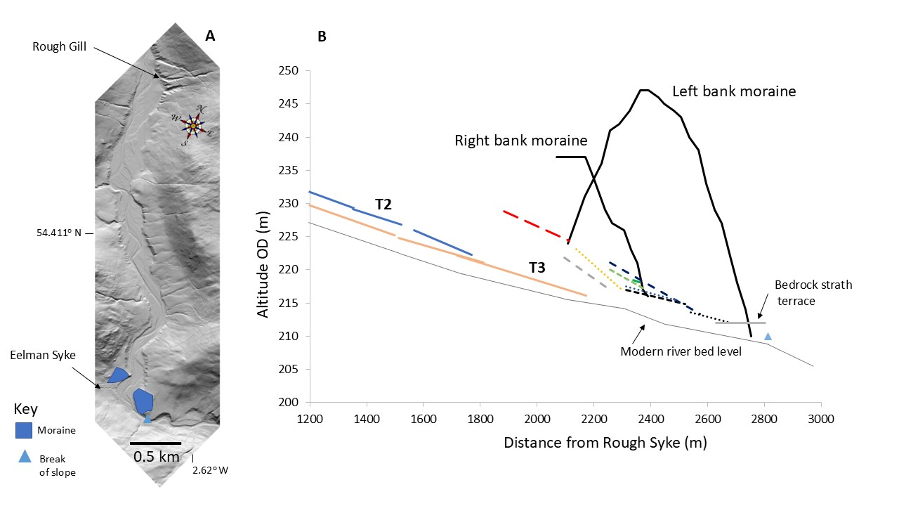
Figure 5: Borrow Beck terraces in Borrowdale. A) Planview of Borrowdale, upstream of the Eelman Syke moraine. Stream flow is top to bottom of image. NEXTMap digital elevation model has a 5 m spatial resolution; B) Long profiles of the terrace levels just upstream and through the Eelman Syke moraine. To aid clarity, data points are not plotted.
predominantly gravel. Unlike T2, the T3 terrace contains frequent organic flasers (wavy lenses) and wood fragments. The T3 level was established due to a pause in incision before subsequent downcutting to the modern river level. The morphological transition from the T2 outwash plain to a lower narrower channel, below the T3 level, reflects a concomitant reduction in sediment transport (Peirce et al., 2018; Brenna et al., 2022) as the glacifluvial sediment supply reduced. Alluviation followed the incision to form the T3 level, as is indicated by the thin layers of gravel and sand above a till strath level (Figs. S6 and S7). However, sandy top-sets within the terrace section indicate an increase in fine sediment availability (late in the T3 development period) in contrast to the T2 level (see Discussion and Supplementary Information section 3.2 for details). An IRSL sample and two samples for ¹⁴C dating were taken from near the base of the sandy-gravels to constrain when alluviation began to develop the deposits that would become the T3 level, as is detailed latterly.
4.4 Upper Lune valley terraces
As with Borrowdale, the T1 level noted in Birk Beck has proven impossible to identify in the upper Lune valley so it is regarded as absent, possibly buried beneath the soliflucted valley margins (Harvey, 1985; Harvey and Chiverrell, 2004). Pattison (1990) reported two terrace levels (here termed T2 and T3), with the lower broad level of T3 extending along either side of the upper Lune from Newbiggin-on-Lune westwards to just east of Tebay (BGS, 2008). The extent of these terraces has not been mapped, but good examples of both levels occur at the confluence of the tributary Chapel Beck with the River Lune, set against drumlin terrain and a possible kame terrace (Fig. 6). The T2 level is fragmentary and only formed (or has been preserved) discontinuously, possibly overprinted by alluvial fans on the southern side of the Lune valley. The fans are undated but likely have a long complex history, commencing with the final stages of deglaciation and permafrost degradation.
Description and interpretation of the T2 terrace level: The T2 level can be seen at Bybeck Farm and eastwards to Coatflatt (Fig. 6) at around 184 to 185 m altitude, c. 6m above the modern river level and cut into a kame terrace (Fig. 6; Pattison, 1990). The T2 level consists of cryogenically involuted fine gravel, containing a mix of well-weathered, local lithologies (Fig. S10), as well as clasts from the Howgill Fells to the south and locally-derived fragments of tufa. At Marl Crag (see Supplementary Information section 3.4) a c. 2 m thick outcrop of tufa is preserved on the margin of the kame surface above scree (Carling, 2024). Extrapolating the surface of the scree southwards over the Lune valley, to the west of Wath, might indicate that at least 15 to 24 m of former valley fill has been eroded between the level of the scree and the modern riverbed (Pattison, 1990; Carling et al., 2023a) as the river incised, pausing to form both the T2 and T3 levels. Today, > 24 m thickness of deposits occur beneath the T3 level near Tebay. This thick fill is due to glacial over-deepening near Tebay as well as the constriction afforded by the narrowing of the valley into the bedrock defile of the Lune Gorge.
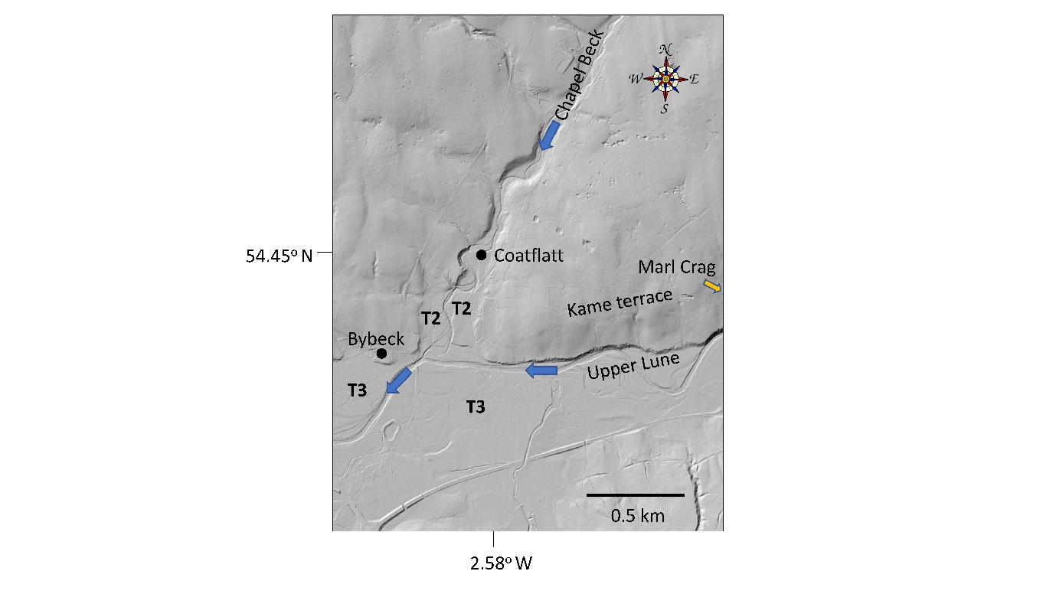
Figure 6: Locations of the T2 and T3 terrace levels at the confluence between the Chapel Beck and the upper River Lune. Marl Crag lies just to the east of the image. NEXTMap digital elevation model has a 5 m spatial resolution.
Description and interpretation of the T3 terrace level: The T3 level is broad (c. 0.35 km) and spatially continuous, for example, just south of Coatflatt Hall, c. 1.5 m to 2 m above the modern riverbed at altitudes between 181 and 183 m (Fig. 6). A small head cut into this level occurs at the Wath knickpoint (Table S1). This surface floods occasionally, so can be considered a terrace/floodplain transition. Incision appears to have continued into the 19th C (see Supplementary Information section 3.3). Sections consist of horizontally-layered pebbles and small cobbles, all well-rounded (Fig. S11). Unlike the T2 level, the clasts here are unweathered, primarily the greywackes from the Howgill Fells with a scattering of red and yellow local sandstones. Close to the confluence with the Birk Beck, this level is coincident with the Birk Beck T2 terrace level, presumably due to alluviation locally burying the Birk Beck T2 level that lies closer to Tebay. The thickness of deposits, just above Tebay, reflects the inability of the river to regrade its bed by downcutting through the rock barrier at Tebay Gorge.
4.5 Lower Lune terraces
The T2 and T3 terrace levels found within the upper Lune catchment can be traced intermittently throughout the length of the Lune gorge as strath terraces cut into till (Fig. S18). For brevity, these levels are not described here (see Supplementary Information section 3.5). South of Kirkby Lonsdale, strath terraces give way to the lower Lune aggradational terraces, developed above reworked glacifluvial deposits, or till. These two levels occur below a level (T1) that occurs intermittently along the lower Lune cut into deposits mapped by the BGS (2008) as till or stratified glacifluvial deposits (Brandon et al., 1998) (Fig. S19). The aggradational terrace level (T2) initially is prominent but becomes fragmented south of Whittington due to an increase in meandering habit of the river in the lower course having cut out the T2 deposits. The final example of a more-or-less continuous T2 terrace occurs at Hornby (Fig. 1) after which the T2 level is not preserved (Fig. S20) until Crook O’ Lune where a fragment occurs. Below the T2 level, the T3 level is at first very narrow (< 100 m and non-flooding) downstream of the Lune Gorge but broadens as an extensive floodplain, up to 1 km wide, south of Hornby.
Description and interpretation of the T1 terrace level: The T1 level south of Whittington (see Table S1) is indistinct, undulating and dissected, reflecting its relative age. In addition, it sometimes exhibits relict benches and flats at slightly different levels related to short-term still stands in down-cutting and competition between the main river and tributaries, such as at Four Lane Ends (Table S1). In contrast, on the south side of the river at the Crook O’ Lune, the T1 level (Caton Terrace: Brandon et al., 1998) is planar and distinct (Figs. 7 and 8A). Well-rounded coarse-cobbles and small boulders from the confluent Artle Beck occur within this level (Brandon et al., 1998). The T1 level here is certainly a remnant of formerly more extensive glacifluvial outwash braidplains noted further upstream and is etched into deposits that are locally extensive and mapped by the BGS (1995) as glacifluvial (Brandon et al., 1998). Tracing the T1 level west of the Knot Anticline is difficult today due to urbanization, yet Reade (1904) reported a distinct T1 terrace level in the vicinity of Halton (when the area was undeveloped) and this level is mapped by the BGS (1995) as a ribbon of glacifluvial deposits.

Description and interpretation of the T2 terrace level: The T2 level is at an elevation of 23 m asl at Hornby. At Crook O’ Lune, a terrace fragment occurs within the gorge through the Knot Anticline grading seawards from an upstream elevation of around 21 m asl (Moseley and Walker, 1952; Brandon et al., 1998) (Figs. 7 and 8A). The T2 terrace gravels are locally reworked glacifluvial deposits, flanked by till (Figs. 8B and 9). Seaward of the Knot Anticline, borehole logs (Brandon et al, 1998)
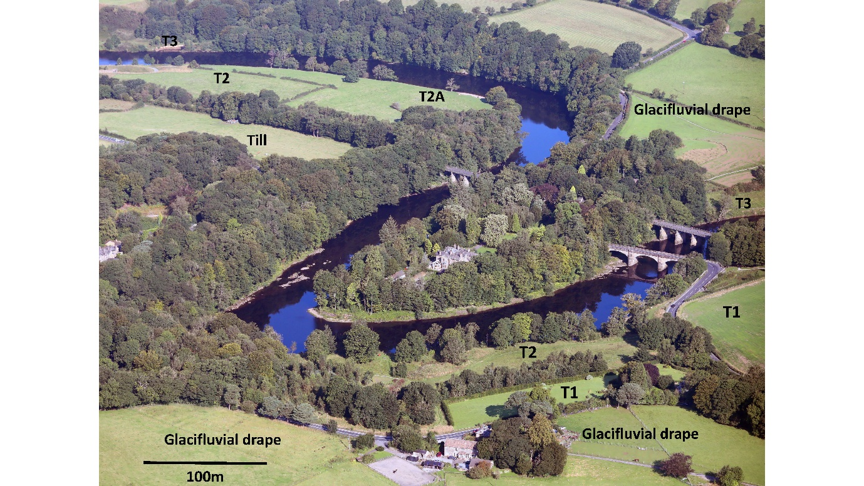
Figure 7: Oblique aerial view to the NW of the river at Crook O’ Lune where the river breaches the Knot anticline through a short bedrock gorge. For interpretation of the labels see the main text. Image copyright of Alamy Ltd and reproduced with permission. Scale bar applies to the middle distance.
show that the base of the terrace gravels extends to 10 m bsl (N: 54.06974º; W: 2.78265º) reflecting glacial or river incision (near the present coast) that occurred before the aggradation to the T2 level. As both the elevation of the T1 (23 m) and T2 levels (21 m) (Figs. 7 and 8A ) are below the elevation of the top of the anticline (c. 100 m asl), so the latter was breached already when the T1 level was established. The presence of the anticline, acting as a bedrock local control on the former river level (as it does today), would have resulted in a steepening of the gradient of the river to seaward of Crook O’ Lune, when it was cutting down to the T2 level. Given the fragmentary nature of the T2 level within, and to the immediate west of the gorge, it is difficult to extrapolate the gradient of the T2 surface (Fig. 8A) from Crook O’ Lune seawards to define the approximate position of sea level at the time when the T2 level was developed (this issue is addressed within the section 4.6).
Description and interpretation of the T2A terrace level: Within the Crook O’ Lune gorge, a distinct terrace level is present below the T2 level and herein is termed the T2A level (Figs. 7 and 8A). However, this level does not flood and so cannot be equated with the upstream T3 level detailed below. The T2A level grades steeply to seaward and is interpreted as a local stillstand in the incision process (mediated by the barrier of the Knot Anticline) from the T2 level to the modern-day floodplain (T3). With reference to the least-squares regression curve for the T2A level (Fig. 8A), it is evident that the river (when occupying the T2A level) graded to present sea level some 9.7 km to the west of Crook O’ Lune, so sea level when T2 was occupied was not dissimilar to today, as the zero Ordnance Datum level is just west of the tidal limit at Skerton. From 4 km downstream of Crook O’ Lune, it is not possible to differentiate a T2A level from the T3 level (Fig. 8A) as both levels grade seawards to the same altitude (within an urban landscape with made-ground present), so terrace level altitudes are mapped in Fig. 8A and Fig. 9 as an ’undifferentiated terrace level’. Below this latter level there is a 9.5 m thickness of alluvial fill above bedrock (Brandon et al., 1998) as recorded from a borehole (N 54.06522º; W 2.78684º).
Figure 8: A) Terrace levels upstream and downstream of Crook O’ Lune (0 km). 95% confidence limits on the regressions within the Gorge are shown by colour-shaded bands (see section 4.6); B) Superficial deposits (after British Geological Survey Geoindex Onshore). Boxed area is Fig. 9 below.

Figure 9: Terrace levels within the Crook O’ Lune gorge. Superficial deposits after British Geological Survey Geoindex Onshore©). River flow direction is arrowed. The topography is a DEM (British National Grid Terrain 3D layer) with 1 m resolution.
Description and interpretation of the T3 terrace level: From south of Melling (Table S1) to Crook O’ Lune the river corridor follows the alignment of the Quernmore Tunnel Valley (Brandon et al., 1998). The valley fill above rockhead, and beneath the T3 terrace, averages c. 30 m, with a thickness of 70 m being recorded within one borehole. The thickness of the deposits reflects a considerable degree of glacial over-deepening of the valley floor prior to alluviation to the present level. Closer to Crook O’ Lune, the Quernmore Tunnel Valley shallows and veers SW towards Quernmore (Table S1). Nonetheless, just upstream of Crook O’ Lune (Fig. 7 and 8), the T3 level consists of a 4 m thickness of fine alluvium overlying a 5 to 10 m thickness of gravel (Brandon et al., 1998). Here the incision of the Quernmore Tunnel Valley is to a level c. 5 m asl (Brandon et al., 1998), that is, below the level of the bedrock reach through the Knot Anticline which lies at c. 12 m asl. Thus, glacial over-deepening (Fig. 2) of the Quernmore Tunnel Valley trough ensured that the Knot Anticline functioned as a local base level for Lune drainage during early deglaciation. With reference to the least-squares regression curve for the T3 level (Fig. 8A), it is evident that the river (occupying the T3 level) graded through the Knot Anticline close to the present sea level some 11 km west of Crook O’ Lune. Consequently, isostatic uplift in the estuarine portions of the system was negligible in the late Holocene, in accordance with the conclusions of Zong and Tooley (1996) and Shennan et al. (2012), noted above.
4.6 Paraglacial controls on the dynamics of terrace level incision
Given the relatively high elevation of the T1 and T2 and the T2A levels just upstream of the Crook O’ Lune gorge (Fig. 8), and the presence of extensive glacifluvial deposits either side of the gorge (Fig. 9), it is evident that during deglaciation the river bed level graded to sea level further west than at present. The 95% confidence limits for the linear regression equations defining the slopes of these three terrace levels indicate that in all cases the base levels were to the west of the present coastline. As shall be shown below, the highest terrace level (T1) was abandoned due to rapid incision of an early post-glacial broad braidplain that typified the Lune system (both upstream and downstream of the Lune Gorge) during the period of paraglacial conditions due to high seasonal peak river discharges as sediment supply was progressively reduced (Bridgland, 2010). As the T2 level can be traced through the Knot Anticline, breaching of the anticline must have occurred during the deglacial period, if not before, prior to the formation of the T2 level. Extrapolating the T2 level in the Crook O’ Lune gorge seaward gives an elevation of around 12 m asl at the position of modern sea level. As the trend line is not well-defined (Fig. 8A), the 12 m value must be treated with considerable caution but given the 95% confidence interval, it is comparable with the estimated regional glacio-isostatic uplift of 18 m (Andrews et al., 1973; Andrews et al., 2021) that occurred since 17 to 15 ka (Fig. S2). Thus, the increase in the elevation of the base level for the T2 level near the coast is more readily associated with regional-scale isostacy than eustasy. However, as is shown in the next section, the legacy of local base level controls over-printing the regional trend in terrace formation has been preserved in the landscape.
4.7 Local adjustments to river long profile mediate terrace formation
The broad, coarse-grained, T2 terrace surfaces found in the upland sub-catchments of the Lune reflect a legacy of the paraglacial high runoff (Kormann et al., 2015) and enhanced sediment supply (Church and Ryder, 1972). Thus, the T2 levels upstream of Tebay, exhibit a degree of ‘legacy glacial conditioning’ (Marren and Toomath, 2014; Mason and Polvi, 2023) in that the thick deposits of diamicton, into which the T2 level is etched, reflect the importance of the base level control at the upstream end of the Lune Gorge (Fig. 2) mediating the deposition of thick units of coarse diamicton in ice proximal locations during the deglaciation. This structural base level control may have been augmented by a moraine and glacier (the latter emanating from Borrowdale) blocking the Lune Gorge 4.5 km downstream from Tebay (Carling et al., 2013a) until c. 18 ka (Carling et al, 2023b).
In contrast to the fairly continuous incision noted above for the upper Lune, Borrowdale exemplifies evidence for continuous incision at the larger scale mediated by local base level control, as is explained next. The disruption in the Borrowdale terrace development within the breach of the Eelman Syke moraine (Fig. 5) shows the local effects of progressive downcutting through the base level control afforded by the moraine. Here, the T2 terrace, upstream of the Eelman Syke moraine, grades to an elevation 40 m below the top of the moraine, showing that the moraine already was incised when a braidplain was present during deglaciation. The absence of moraine-dammed lacustrine deposits upstream of the moraine and the complex of minor terraces within the moraine breach both indicate that fluvial incision through the moraine was rapid, leading to a lowering of the local base level and the establishment of the T2 level, as the T1 braidplain was abandoned. Nonetheless, the presence of two main terrace levels (T2 and T3) in each of Borrowdale, the upper Lune and the Birk Beck valleys cannot be related to local base level controls in each valley. Rather, as two main levels also can be traced throughout the lower Lune valley, the T2 and T3 levels must represent the likely propagation of two phases of incision from near the coast landward throughout the whole of the River Lune catchment, as will be considered latterly within the Discussion. Concomitant with the abandonment of the T2 level, progressive narrowing of the wetted channel is evident in all the study reaches and more widely across the Lune headwater streams. This narrowing is particularly well-demonstrated in the case of the Birk Beck, as detailed next.
Although, each terrace level within Birk Beck increases in breadth down system, at any given location the overall breadth of each former palaeochannel decreases with a decrease in altitude (Fig. 10). Thus, terrace level breadths at each surveyed section represent a time-series of the variation in the incision process at that location. Consequently, the reduction in the breadth of the time-sequence of palaeochannel levels, at individual locations within 2 km of Docker Force, reflects a decrease in both the fluid discharge and the available sediment load since deglaciation. A potential ice-front coarse-gravel braidplain (T1 level – c. 220 m wide?) is reduced to a sediment-starved bedrock confined modern river (some 30 m wide). Yet, competence has been sustained through channel narrowing, as the modern stream can transport 1 m boulders in flood conditions (Richardson et al., 2003).
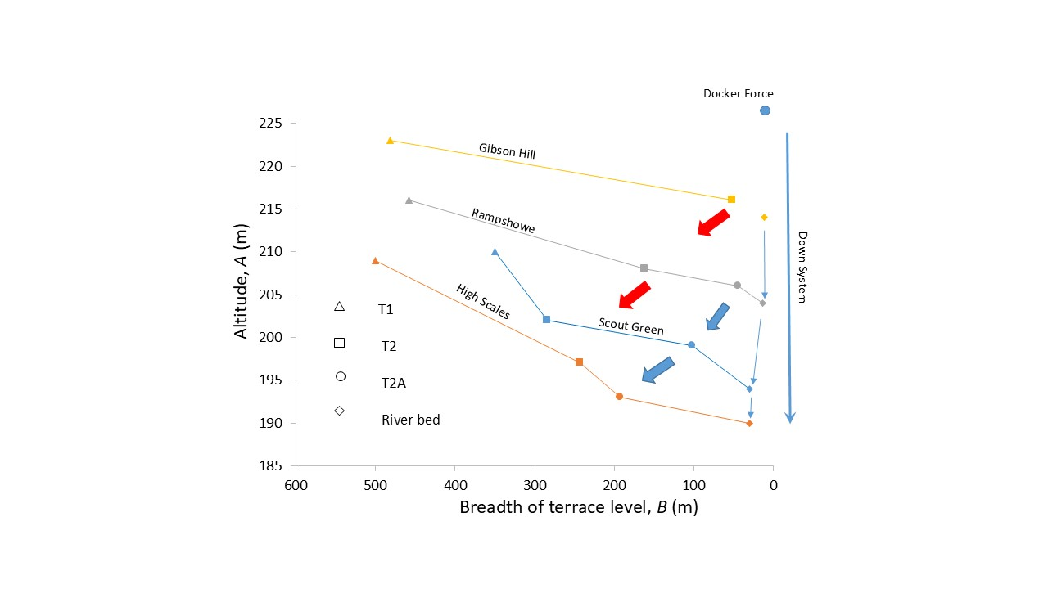
Figure 10: Variation in the breadth of the former Birk Beck stream channel as indicated by the breadth (B) of terrace levels at various altitudes (A), in relation to the breadth of the modern riverbed. Arrows represents the increase in terrace and riverbed breadth as altitude reduces, from small blue arrows (riverbed), through blue (T2A terrace) to red arrows (T2 terrace).
The morphological transition from a braided outwash plain to a lower narrower channel, below the T1 level, in the Birk Beck valley (and within Borrowdale – not illustrated), reflects a concomitant reduction in sediment transport (Peirce et al., 2018; Brenna et al., 2022) as the glacifluvial sediment supply reduced. The glacial meltwater regimen (associated with level T1), with unvegetated slopes, subsequently was replaced by a precipitation-dominated regimen (Smith et al., 1996), vegetated slopes and a reduced sediment supply. The modern, narrow, bedrock-floored channel of the Birk Beck reflects a minimal coarse sediment load today.
4.8 Palaeodischarge
The broad T1 terrace levels certainly reflect higher discharges of water and sediment than are found today within the Lune catchment. During glacial ice down-wasting, high river discharges would have occurred due to seasonal ice and snow melt dominating the runoff regimen (Kormann et al., 2015), leading to enhanced sediment supply to the valley floors (Cavalli et al., 2019). The proglacial environment would have been transport-limited, as copious coarse and fine sediment was released from the receding glaciers and from unvegetated slopes (Gurnell and Clark, 1987; Carrivick and Heckmann, 2017). An abundant coarse sediment supply during initial deglaciation would have led to aggraded and widened valley floors (Slingerland and Smith, 2004), lying above any glacial diamicton infill, resulting in the T1 levels. In this context, both the T1 and the T2 terrace surfaces of the upper Lune exhibit characteristics of braidplains which provide clues as to the palaeodischarge conditions. A braiding river maintains a depth that produces a bed shear stress close to critical for bedload transport (Sambrook Smith et al., 2010; Phillips and Jerolmack, 2016) such that, as discharge increases, additional dry braids are reoccupied, or new braids form across the braidplain (Anderson and Anderson, 2010). In effect, the breadths of braidplains increase with discharge (Smith et al., 1996) and the converse also applies. It has been observed already that the breadths of the braidplain terrace flights are reduced as incision progressed (Fig. 8), which reflects a reduction in discharge through time as the system transitioned from braiding to single channel (Li et al., 2023). The incision from the T2 level to a narrower level on which the T3 level developed probably was rapid, as there is a general lack of evidence for minor intermediate terrace levels (such as T2A ; Birk Beck) and for lateral-cutting into the till banks flanking the valleys, as would be expected to occur if an intermediate bed elevation was maintained for a lengthy time (Limaye and Lamb, 2016). However, during paraglacial conditions, without anthropogenic disturbances, sediment supply will have declined as slopes became vegetated at the same time as both stream flow competence and capacity reduced. As discharge reduces, braiding systems tend to exhibit fewer channels, concentrating flow, leading to incision and reduced sediment flux (Germanoski and Schumm, 1993; Egozi and Ashmore, 2008).

4.9 Dating the terrace development
The T1 level: The absence of datable material from the glacifluvial outwash and the T1 terrace levels means that absolute dating of the T1 level currently is not possible. However, the short-lived ice readvance that occurred around 19 ka (Livingstone et al., 2012; Chiverrell et al., 2018; Davies et al., 2019) in the upper Lune valley appears largely to have effaced the T1 level within the valley of the Birk Beck (as noted above). Thus, the Birk Beck T1 level possibly was forming prior to 19 ka, which would indicate headwater ice-free conditions at least locally. This surprisingly early date might suggest that an ice-free-window existed in the upper Lune course due to complex deglacial ice movements in this area (Carling et al., 2023a). This notion is not entirely unreasonable, as Evans et al., (2021) noted that the western margins of the Pennines could have been ice-free early during deglaciation with the surrounding uplands remaining under ice cover.
The T2 level: The highest T2 terrace level at all locations was barren of organic remains (precluding ¹⁴C dating), and the coarseness of the T2 terrace deposits largely precluded conventional luminescence dating of fines, restricting sampling to local pockets of sandy sediment. The absence of organic deposits suggests cold climate conditions with little or no vegetation cover on hillslopes at the time of terrace aggradation. Importantly, tufa fragments, indicative of warming conditions, as well as
Table 2: Summary of IRSL results and analysis
Sample | North  (º) | West  (º) | Depth (m) | D_{e} (Gy) | Acceptance rate | OD (%) | U (ppm) | Th (ppm) | K (%) | Water content  (%) | Cosmic dose (mGy/yr) | Dose rate (mGy/yr) | MAM-3 age (ka)
Borrow Beck T3 | 54.40717 | 2.64423 | 0.62 | 42.6±7.8 | 27/300 | 98±14 | 3.03±0.4 | 9.63±0.6 | 2.27±0.04 | 28±5 | 0.21±0.02 | 3.43±0.13 | 12.4 ± 2.3
Birk Beck T2 | 54.46398 | 2.63421 | 1.5 | 26.5±4.4 | 99/300 | 83±6 | 1.98±0.3 | 8.81±0.6 | 2.02±0.04 | 24±5 | 0.18±0.02 | 3.07±0.12 | 8.6 ± 1.5
Borrow Beck T2 | 54.41222 | 2.65167 | 0.9 | 44.3±6.9 | 70/300 | 87±8 | 2.89±0.4 | 10.43±0.7 | 2.33±0.04 | 27±5 | 0.19±0.02 | 3.5±0.14 | 12.6 ± 2
Lune Gorge apron | 54.39083 | 2.58889 | 0.5 | 39.7±7.4 | 44/300 | 85±9 | 2.09±0.3 | 8.42±0.6 | 1.77±0.04 | 21±5 | 0.22±0.02 | 2.97±0.12 | 13.3 ± 2.5
Lune Gorge T2 | 54.39194 | 2.59083 | 0.92 | 33.7±6.4 | 52/300 | 101±10 | 2.24±0.3 | 8.69±0.6 | 1.72±0.04 | 29±5 | 0.19±0.02 | 2.78±0.11 | 12.1 ± 2.3

intraclasts of (previously) frozen silt/clay, are common in the T2 deposits of the Upper Lune and the bedding is cryogenically involuted (Carling, 2024), indicative of cold climate conditions. The tufa beds, lying at a higher elevation than the T2 level, were deposited around 14,044 – 13,808 cal yr BP (Carling, 2024) which is near the beginning of the Windermere Interstadial when carbonate production was high (Marshall et al., 2002). Runoff (Bromley, et al., 2014) and lateral cutting of the tufa would have been pronounced during the Younger Dryas summer months, leading to incorporation of Windermere Interstadial tufa fragments in the aggrading clastic terrace deposits. Then, the T2 level along the upper Lune would have been abandoned due to incision sometime towards the end of the Windermere Interstadial or early within the Younger Dryas to become cryoturbated subaerially during the cold Younger Dryas winter months (Schenk et al., 2018). This interpretation is supported by an IRSL date of 13.3 ± 2.5 ka (Table 2) for a colluvial apron at the foot of a moraine bank near Salterwath Bridge in the Lune Gorge. This apron is at a slightly higher elevation (156 m O.D.) than the T2 level (152 m O.D) nearby, for which an IRSL date of 12.1 ± 2.3 ka (Table 2) relates to final deposition of fines to form the T2 level. Finally, an IRSL date of 12.6 ± 2 ka (Table 2) relates to the abandonment of the Borrow Beck T2 level. This latter date follows a period of aggradation of gravel to build the T2 level in Borrowdale, which ended with the deposition of the topmost sandy-layer on the terrace level (Fig. S6), following which the river cut down to below the T3 level. An IRSL date (Table 2) for the initial accumulation of the sediment at the base of the T2 level along Birk Beck indicates aggradation occurring at a later mean date (8.6 ± 1.5 ka) than along the Borrow Beck and within the Lune Gorge. However, as is common in fluvial samples, incomplete bleaching (see Supplementary Information section 2.1) may mean that the terrace-related ages are broadly synoptic. Although the top end of the Lune Gorge imposed a local base level control on both the upper Lune terraces and the Birk Beck terraces, incision of the upper Lune deposits was fairly continuous throughout the Last Glacial–Interglacial Transition with a hiatus to form the T2 level, until c. 1 ka, around which time the T3 level was formed, as is explained next.
The T3 level: In Borrowdale, an alluvial sediment (containing specks of organic material) at the interface between the toe of the Rough Gill fan (Fig. S6; Fig. 5) and the basal till was dated as having been deposited between 1359 and 1290 cal BP (radio-carbon sample Beta-630347; Supplementary Information section 2.1). Lateral river cutting previously might have truncated any fan at this location, so this dated alluvium should represent the final phase of repeated progradation of an alluvial fan across the till surface (Lewin et al., 2005). Alternatively, the date range can represent the termination of the only period of fan development, at Rough Gill, onto a river-washed till surface due to enhanced delivery of valley-side sediment to the stream course. The date range is early mediaeval, a period of increased sediment supply to the channel leading to coarse-sediment aggradation in the river channel, before the formation of the T3 level, as is explained below.
Downstream of Rough Gill, near to Eelman Syke (Fig. 5), an IRSL sample (Table 2) 20 cm above the basal gravel layer provides a date of 12.4 ± 2.3 ka (Table 2). Taking account of the uncertainty in this date and the date for abandonment of the T2 level (reported above), it appears that rapid incision from the T2 level was followed by a minor degree of aggradation of gravel. Fifteen metres upstream from the IRSL sample, an organic flaser, 0.15 cm below the top of basal small-pebble layers, was dated as having been deposited between 958 and 900 cal BP (radio-carbon sample Beta-630345; Supplementary Information section 5). Comparing this date with the IRSL date indicates that a prolonged period of channel stability likely occurred before the finer T3 deposits began to aggrade along the margins of the Borrow Beck. This ¹⁴C sample represents the initial timing of aggradation of a fining-upwards deposit above a slightly aggraded coarse river gravel (0.5 m thick) that lies on a river-eroded till basement. The timing of the aggradation of fines is several centuries after the final development of the Rough Gill fan. Nonetheless, further incision of the riverbed, leading to a reduction in frequency and power of overbank flooding, must have already commenced at the time of the deposition of the organic flaser, as reduced power would be the driver for the development of the fining-upward sequence (see Supplementary Information section 3.2). A wood fragment, 0.25 m above the organic flaser, returned a date lying within the range 915-770 cal BP (radio-carbon sample Beta-630346; Supplementary Information section 5). If the deposition rate (c. 3 mm a⁻¹), indicated by the difference in the mean times of deposition of the two ¹⁴C samples (Beta-630345 and Beta-630346), applies to the 0.93 m-thick fine overbank sequence, then the complete fines sequence can have been deposited within three centuries. Thus, the development of the deposits that would later form the T3 terrace is related to a short interval of alluviation in the late Norse period (Harvey et al., 1981) when settlement and land use extended into the previously under-utilized uplands of the Cumbrian mountains (Winchester, 1987).
- Discussion
5.1 Correlating terrace levels
There is little literature related to the problem of correlating and discriminating between different terrace level fragments where continuous levels are absent (vis Kondolf and Piégay, 2016), or where absolute dating control is lacking. In some northern UK catchments up to nine terrace levels have been identified (River Tyne: Yorke et al., 2024) in contrast to the three main terrace levels reported herein. Even if levels can be discriminated using absolute dating methods, unless the levels are extensive (thus, readily related to catchment-scale controls: climate, eustacy and isostacy) many fragmentary intermediate terrace levels more readily might be related to local within-catchment controls (e.g., bedrock, moraine local base levels, meandering and interaction of the Lune with confluent streams). This dichotomy underpins the decision as to what level of detail is relevant in the search for order within the landscape, as well as in science more generally (Endersby, 2024). Herein, as in several river catchments of southern Lancashire (Price et al., 1963), we have identified three main catchment-scale terrace levels that relate to basinwide-extrinsic controls and we detail examples of intrinsic local controls that generated intermediate fragmentary terrace levels.
Although generally the main extensive terrace levels (T1, T2 and T3) can be correlated between sub-catchments, spatially and altitudinally these levels are not necessarily distinctive. For example, Birk Beck has no T3 level in its upper bedrock confined course; rather the non-flooding T2 level bedrock strath transitions to an alluvial floodplain downstream and, finally, it is at the same altitude as the T3 level in the upper Lune valley near the confluence with the Lune. In a similar vein, the T3 level within the Lune Gorge (Fig. S18) does not flood, but south of Hornby (Fig. S20) it floods frequently. This behaviour indicates that the lower courses of some tributary reaches and the main stem have become aggraded due to local base level controls (Lune Gorge at Tebay and the Knot Anticline) such that a T3 level might overlay a buried T2 level immediately upstream of the Lune Gorge. In addition, the base level control at the Knot Anticline has led to lateral meandering immediately upstream, cutting out much of the evidence for terraces older than T3, as the lower Lune transitioned downstream from a slightly sinuous planform to a strongly meandering planform.
5.2 Terrace development histories
Despite the complexity noted above, it is clear that three main terrace levels occur throughout the Lune system and the controls on their development are addressed next. Despite the evidence being compromised by dissection, the fragments of the T1 glacifluvial outwash plain indicate that this surface was once extensive (< 1 km wide). This level is dominated by coarse gravel, especially within the headwater catchments. In addition, the remnant surfaces tend to slope outwards from the valley-sides towards the modern river. These observations indicate rapid and largely continuous incision from a broad braidplain during early paraglacial conditions until the river reached the T2 level. It is possible that the T1 surface is more extensive but, in many locations, it may be overprinted by late-glacial or Younger Dryas solifluction deposits (Ballantyne, 2019); sub-surface investigations would be required to indicate how prevalent this overprinting has been. In contrast to the uneven and discontinuous T1 surface, stabilization of the river level at the elevation of the T2 surface allowed extensive planar surfaces to be preserved when the river cut down again towards the T3 terrace level.
It is important to realise that any significant post-glacial down-cutting into bedrock never progressed farther upstream than the barrier of the Knot Anticline at Crook O’ Lune, as the regrading of the channel is a balance between the rate of base level lowering and sediment supply. Within this context, it is evident that the deepening of the more substantial Lune Gorge must pre-date the last glaciation, as the bedrock of the Lune Gorge is a far more significant barrier to incision than the Knot Anticline and till, possibly-pre-Devensian in age, has been reported on bedrock at river level within the Lune Gorge (Millward et al., 2010). A major early deglacial phase of aggradation occurred immediately upstream of the local Crook O’ Lune base level whilst the marine base level was low, due to aggradational pulses associated with paraglacial conditions (Pratt et al., 2002). This scenario is consistent with the formation of strath terraces in the upper Lune, as epitomized by the tributaries Chapel Beck and Birk Beck, whereby the glacifluvial trough fill (upstream of Tebay) was incised as paraglacial conditions with high sediment yield were replaced in the Holocene by lower sediment yield. The headwater streams incised the basal till, leaving thin veneers of alluvial terraces as the flow became laterally concentrated through time, leading to further incision. As exemplified by the Birk Beck, this process eventually can lock the channel into a bedrock slot that narrows as the local base level falls (Wobus et al., 2006).
The Lune catchment is relatively small, such that the response to base level changes would be rapid (Foreman and Straub, 2017). A single base level fall could have resulted in multiple waves of autogenic ‘small’ knickpoints translating upstream, cumulatively leading to the readjustment of the riverbed profile to a lower level (Lavaissière et al., 2022). Nonetheless, local changes in relief, such as subsidiary terrace levels and remnant terrace fragments, can be preserved within this catchment-scale adjustment (Roberts, 2021), as is the case at the Eelman Syke moraine within Borrowdale. In contrast to the local controls, the T2 and T3 levels can be traced throughout the broader Lune catchment, which argues for an extrinsic control such as climate, eustacy or isostacy on the formation of these catchment-wide terraces.
5.3 Eustatic and isostatic controls on terrace development
The presence of two main distinctive terrace levels (T2 and T3) throughout the Lune system indicates, in all probability, that following the initial incision to form the T1 level, two significant waves of incision progressed up through the river network from the vicinity of the coast. These waves of incision predominately incised the alluvium alone, as the rock barrier of the Knot Anticline limited further, deeper incision. The paraglacial river bed level, as indicated by the relatively high elevation of the T1 level, would have been elevated due to two controls. Firstly, the lower part of the Lune Basin would be adjusted to a higher relative sea level at the time of the glacial recession (Fig. S2), with sea levels being high due to isostatic depression related to glacial loading. The riverbed level would having risen to form broad braidplains due to increased supply of sediment during enhanced meltwater fluxes from the ice sheet receding northwards (Brandon et al., 1998), with much coarse sediment stored in the river system (Price et al., 1963) in contrast to the finer material reaching the coast (Knight, 1977). In the upper part of the system, the abundance of coarse debris washed out from the receding ice was difficult to transport leading to the formation of thick glacifluvial deposits in the valley bottoms and within glacially scoured troughs (e.g., the trough beneath the Tebay flat). Although the fluid discharge from the receding ice may have been greater than the modern precipitation-driven runoff, the spreading of the runoff over the T1 braidplains in rivulets would have resulted in a reduction in potential power for sediment transport. The lack of power is reflected in the coarseness of the bed material on the T1 and T2 terrace surfaces of the upper Lune tributaries and the often-poor degree of clast rounding (Supplementary Information section 3.3) of the gravel accumulated in the upper reaches. Consequently, the low-gradient upper Lune valley was alluviated by 5 m to 15 m (Pattison, 1990) under paraglacial conditions whilst the lower Lune graded above a sedimentary fill, greater than 70 m thick in the Quernmore Tunnel Valley, to a level c. 23 m asl just upstream of the Knot Anticline. However, as sediment supply declined, incision from the initial aggraded level (T1) was rapid because sea level was low (Fig. S2). A pause in incision occurred during the Windermere Interstadial with the T2 level forming at the transition to the Younger Dryas, c. 12.9 ka (as witnessed at Chapel Beck). Incision recommenced during the Younger Dryas (as indicated within Borrowdale) with progressive bed level reduction towards the present modern river level interrupted by climatically induced alluviation (Rough Syke fan) in the Early Mediaeval Period, followed by anthropogenic disturbance, to form the initial T3 level during the Norse period (10th C CE; Quatermaine & Leech, 2012). Given that the T3 level is still flooded annually at some locations, the T3 level has continued to aggrade locally whilst being abandoned elsewhere, most notably within the upper Lune catchment.
Because the T2 level dates from after 13 ka, its formation cannot be related to reduced base level at the coast imposed by sea level, as sea level was rising at that time, so the role of isostacy must be considered. When considering the drivers of relative sea level change, modelling of British Late Pleistocene glacio-isostacy must be interpreted with caution (Simms et al., 2022; Bridgland, 2024). Yet Peltier et al. (2002) predicted minimal MIS 1 isostatic rebound in northern England with rebound having occurred in the latter part of MIS 2. In this context, the highest alluvial terrace (T2) in the lower part of the system grades to an elevation some 14 m asl at the present coastline. However, the elevation cannot be used as an indicator of isostatic uplift, because at that time (Fig. S2) the river was grading through the Knot Anticline to a relative sea level at least 20 m below present sea level and well to the west of the modern coastline. So, reducing the T2 level by the post-glacial glacio-isostatic uplift of 10 to 15 m (Peltier et al., 2002; Shennan et al., 2018), places the elevation of the downstream termination of the former river course close to O.D., i.e. at the location of the modern coastline. Consequently, any T1 and T2 terrace levels well to the west of the Knot Anticline, would have been buried by alluvium accumulating as sea level rose post 13 ka, with eustatic adjustments outpacing isostatic adjustments from c. 9ka. The degree of uplift reported by Peltier et al. (2002) and Shennan et al. (2018), can be expected to be similar northwards, as the ice load was removed from the whole of the Lune valley in as little as 3 ka (Carling et al., 2023a and b).
Given that the Knot Anticline was breached before the Last Glacial–Interglacial Transition, subsequent minor glacio-isostatic uplift has not resulted in significant Lune valley incision into bedrock. In addition, it is notable that most of the terraces in the upper Lune catchment are straths cut into till, with only the modern channels having reached bedrock. Nonetheless, Bridgland et al. (2010) see glacio-isostatic rebound as an essential driver for post-glacial incision into alluvial valley fill. However, modelling of British Late Pleistocene glacio-isostacy has predicted minimal post-MIS 2 isostatic rebound in northern England (See Supplementary Information section 1.4). Thus, any significant incision due to isostacy must be related to early deglacial conditions at the latest. The abandonment of the T1 and T2 levels more likely relate to climatically-driven changes to river discharge:sediment supply ratios, as is evident with the abandonment of the T2 level following the transition from the Windermere Interstadial to the Younger Dryas, as is made clear in the section 5.4 below.
5.4 Ages of terrace levels
The ¹⁴C tufa dates constraining the development of the T2 terrace level in the upper Lune are consistent with the IRSL date for Borrowdale, indicating abandonment of the T2 level sometime around the transition from the Windermere Interstadial into the Younger Dryas.
The ¹⁴C dates associated with the Borrowdale T3 level are consistent with the broader regional picture (Chiverrell, 2006; Chiverrell et al., 2007; Ballantyne, 2019), especially within the neighbouring Howgill Fells (Harvey, 2017; Harvey and Renwick, 1987), whereby episodes of fan development included a ‘wet shift’ in climate around 1500 years ago followed by a marked 10th C decrease in tree pollen, terminating in alluviation from the late 10th C of a low terrace level (here level T3) and subsequent river incision as fans and slopes stabilized. Thus, the timing of the development of the Rough Gill fan is consistent with a climatic control related to a wetter climate, exacerbated by Celtic and Romano-British tree clearance and grazing pressure which, in the relatively remote upland valley of Borrowdale, occurred somewhat later than in the accessible coastal lowlands of the Lake District (Chiverrell, 2006).
Further intensified land use change, related to the c. 10th C Norse colonization (Walker, 1966; Harvey et al., 1981; Winchester, 1987) spreading throughout the Lune catchment, may account for an accelerated sediment production and aggradation to the level of the T3 terrace before slope stabilization led to further incision within the river channel towards the modern bed level. However, making the linkage between landscape disturbance and early settlement is fraught with difficulty (Paterson et al., 2014). Consequently, the role of human activity in relation to the development of the T3 level remains uncertain.
5.5 Offshore conditions
Although the offshore course of the deglacial River Lune has not been a focus of this study, the role of the Knot Anticline as a potential base level requires comment. It has been suggested that the Lune Deep is glacially over-deepened (Holmes and Tappin, 2005). Nonetheless, the steep fall in the profile of the River Lune from Lancaster through the Lune Deep to c. -44 m OD is typical of the result of the significant base level fall during full glaciation wherein there was insufficient time for subglacial drainage following the pre-glacial river course to regrade the river bed profile (Anderson and Anderson, 2010; their fig. 12.31) through the thick mass of bedrock within the Knot Anticline. Given the degree of base level fall indicated, any initial over-deepening might be related to glaciation(s) prior to the Devensian. The broad gravelly alluvial spreads from west of Halton towards Morecambe (Brandon et al., 1998) cannot readily be related to the River Lune discharging through the narrow Knot gorge but rather more likely reflect frequent switching of the position of subglacial water courses discharging to partially drift-filled channels down to -30 m OD at Heysham.
Between 19 ka and 13 ka, relative sea level was falling rapidly due to isostatic uplift due to glacial unloading outpacing a rise in the level of the ocean due to meltwater from deglaciation. The lower Lune would have begun downcutting as soon as relative sea level began to fall, but the rate of headward recession via any knickpoints was inadequate to propagate any significant bedrock incision far upstream, as is witnessed by the lack of significant knickpoint development upstream of Crook O’ Lune (Supplementary Information section 1.3). Rather, significant recession of the bedrock long profile related to isostacy was halted at the Knot Anticline. Bed level subsequently was related to a base level defined by low sea level at around 13 ka (Fig. S2) before rising sea level inundated the lower course, west of Skerton, laying down river alluvium and estuarine deposits that have replaced, or now bury, any terrace levels to the west (Brandon et al., 1998; Thomas, 1999).
- Conclusions
The course of the River Lune is pre-Devensian, although further study is required to confirm the exact timing of development phases. Glaciation deepened the valley in places but the presence of till/glacifluvial deposits at the same level as the modern bedrock channel in several reaches indicates that the glacial valleys were largely infilled by diamicton that was rapidly incised by deglacial and Last Glacial–Interglacial Transition drainage. The steep riverbed profile in the Lune Deep indicates that the river had incised to a low off-shore base level prior to the last glaciation. Certainly, significant subglacial drainage occurred across the Knot escarpment at Crook O’ Lune throughout the last glaciation, with the Lune becoming ‘locked-in-place’ at Crook O’ Lune during deglaciation.
The highest glacifluvial outwash braidplain (T1 terrace level) grades across the Knot escarpment but this T1 level was abandoned rapidly early within the deglacial period as the supply of coarse sediment was exhausted. A short cessation in incision occurred, during the Windermere Interstadial, when alluviation occurred such that the T2 terrace level formed as incision recommenced during the Younger Dryas. Short-term aggradation of T3 deposits occurred from the 6th C CE, following a shift to wetter climatic conditions, with further accumulation of the T3 level in the late 10th C CE when anthropogenic-induced accelerated catchment erosion led to aggradation on the valley floors. The slight fall in sea level to the modern level led to the incision of alluvium that formed the T3 terrace level.
Overall, the broad glacifluvial braid plains, which formed during the early deglacial period, were abandoned rapidly as the river adjusted to the reduction in fluid and sediment discharge with incision driven by a lowering sea level. To compensate for reduced load, the river incised into the alluvial and till fill, vestiges of increasingly narrower braid plains were preserved as flights of two main terraces, giving way to a single modern channel flanked by a low terrace/floodplain in the lower reaches. Incision continues today with the river being particularly incised in the upper reaches. Under paraglacial conditions, the presence of moraines and the accumulation of diamicton in the valley bases caused localized variation in the number of terraces, as well as variation in the elevations and grades of these terraces.
Acknowledgements
We are grateful to the many landowners and tenant farmers who allowed fieldwork access to their agricultural holdings and who supplied local information. Thanks are due to Fred and Tor Cavendish of Low Borrowdale Farm for access permission, tea and conversation; to Edward Beck of Barugh House for access to Marl Crag; to Leonne Hodgson of Coatflatt Hall for access to the Coatflatt T2 terrace and to Graeme Mawson of Sproat Ghyll Farm for access to Birk Beck. David Evans (Durham University) is thanked for provision of NEXTMapTM digital elevation topography data. Barbara Rumsby assisted in topographic surveying in Borrowdale. The comments of Ian Evans and an anonymous referee were appreciated and led to clarification of the text.
Authors contributions: CRediT
Carling: Conceptualization, Formal analysis, Investigation, Methodology, Project Administration, Validation, Writing – original draft, Writing – review and editing; Abbas: Methodology, Writing – original draft; Ou: Methodology, Writing – original draft; Ling: Investigation; Ding: Investigation, Visualization; Atkinson: supervision, Writing – review and editing; Zhang: Resources, supervision; Zhou: visualization.
Funding sources
Financial support from the National Natural Science Foundation of
China (Grant no. 41972192) awarded to Zhang contributed to the Marl Crag ¹⁴C dates. Ding’s academic visit to Lancaster University was supported by the China Scholarship Council (CSC no. 202106400056).
References
Anderson, R.S. and Anderson, S.P., 2010. Geomorphology: The Mechanics and Chemistry of Landscapes, Cambridge University Press. ISBN: 978-0521519786

Anderson, W., 1940. Buried-valleys and late-glacial drainage systems in north west Durham. Proceedings of the Geologists’ Association, 51, 274-281. https://doi.1016/S0016-7878(40)80007-2
Andrews, J.T., Beaumont, H., Cove, S., Heinz, I., Schroeder, H. 2021. A rapid rise in relative sea level ~9–7 cal ka bp along the SW Cumbria coast, NW England. J. Quaternary Sci., 36, 497–507. https://doi.org/10.1002/jqs.3321
Andrews, J. T., King, C. A. M., Stuiver, M. 1973. Holocene sea level changes, Cumberland coast, northwest England: eustatic and glacio-isostatic movements. Geologie en Mijnbouw, 52, 1-12.

Avery, R.S., Kemp, A.E.S. Bull, J.M., Pearce, R.B., Vardy, M.E., Fielding, J.J., Cotterill, C.J., 2019. A new varve sequence from Windermere, UK, records rapid retreat prior to the Lateglacial Interstadial (G1-1). Quaternary Science Reviews, 225, 105894. https://doi.org/10.1016/j.quascirev.2019.105894

Ballantyne, C.K., 2002a. Paraglacial geomorphology. Quaternary Science Reviews, 21, 1935-2017. https://doi.org/10.1016/S0277-3791(02)00005-7

Ballantyne, C.K., 2002b. A general model of paraglacial landscape response. The Holocene, 12, 371-376. https://doi.org/10.1191/0959683602hl553fa

Ballantyne, C.K., 2019. After the ice: Lateglacial and Holocene landforms and landscape evolution in Scotland. Earth and Environmental Science Transactions of the Royal Society of Edinburgh, 110, 133–171. https://doi.org/10.1017/S175569101800004X

BGS, 1995. Geological Survey of England and Wales 1:50,000 Geological Map Series, New Series Sheet Lancaster. Bedrock & Superficial Deposits, Lancaster.

BGS, 2008. Geological Survey of England and Wales 1:50,000 Geological Map Series, New Series Sheet Kendal. Bedrock & Superficial Deposits, Kendal.

Bickerdike, H.L., Evans, D.J.A., Stokes, C.R., Ó Cofaigh, C., 2018. The glacial geomorphology
of the Loch Lomond (Younger Dryas) Stadial in Britain: a review. Journal of Quaternary
Science, 33, 1–54. https://doi.org/10.1002/jqs.3010

Bonsall, C. 2007. Human‐Environment Interactions during the Late Mesolithic of the Cumbria coastal plain. In Studies in Northern Prehistory: Essays in Memory of Clare Fell. Cumberland and
Westmorland Antiquarian and Archaeological Society, Cherry, P. (ed). Kendall; 25–43.

Bonsall, C., Sutherland, D.A., Tipping, R. et al. 1989. The Esmeaks project: late Mesolithic settlement and environment in North‐West England. In The Mesolithioc in Europe, Bonsall, C. (ed). Edinburgh: John Donald, 175–205.

Bradley, S.L., Milne, G.A., Shennan, I., et al., 2011. An improved glacial isostatic adjustment model for the British Isles. Journal of Quaternary Science, 26, 541–552. https://doi.org/10.1002/jqs.1481

Brandon, A., Aitkenhead, N., Crofts, R.G., Ellison, R.A., Evans, D.J., Riley, N.J., 1998. Geology of the country around Lancaster. Memoir of the British Geological Survey, Sheet 59 (England and Wales).
Brenna, A., Bizzi, S., Surian, N., 2022. A width-based approach to estimating historical changes in coarse sediment fluxes at river reach and network scales. Earth Surface Processes and Landforms, 47, 2560-2579. https://doi.org/10.1002/esp.5395
Bridgland, D.R., 2000. River terrace systems in north-west Europe: an archive of environmental change, uplift and early human occupation. Quaternary Science Reviews, 19, 1293-1303. https://doi.org/10.1016/S0277-3791(99)00095-5
Bridgland, D.R., 2010. The record from British Quaternary river systems within the context of global fluvial archives. Journal of Quaternary Science, 25, 433–446. https://doi.org/10.1002/jqs.1383
Bridgland, D.R., 2024. The contribution of Rob Westaway to the study of fluvial archives. Geomorphology, 451, 109098. https://doi.org/10.1016/j.geomorph.2024.109098
Bridgland, D.R., Westaway, R., Howard, A.J., Innes, J.B., Long, A.J., Mitchell, W.A., White, M.J., White, T.S., 2010. The role of glacio-isostacy in the formation of post-glacial river terraces in relation to the MIS 2 ice limit: evidence from northern England. Proceedings of the Geologists’ Association, 121, 113-127. https://doi.org/10.1016/j.pgeola.2009.11.004
Bridgland, D.R., Westaway, R., 2014. Quaternary fluvial archives and landscape evolution: a global synthesis. Proceedings of the Geologists’ Association, 125, 600-629.

Bromley, G. R. M., Putnam, A.E., Rademaker, K.M., Borns, H.W., 2014. Younger Dryas deglaciation of Scotland driven by warming summers. Proceedings of the National Association for Science, 111, 6215–6219. https://doi.org/10.1073/pnas.1321122111

Capewell, G C. 1954. The post-Silurian pre-marine Carboniferous sedimentary rocks of the eastern side of the English Lake District. Quarterly Journal of the Geological Society of London, 111, 23–46. https://doi.org/10.1144/GSL.JGS.1955.111.01-04.03

Carling, P.A. 2024. The tufa deposits of Marl Crag ̶ description and environmental significance. The Cumberland Geologist, 4, 10-15.

Carling, P.A., Jansen, J.D., Su, T., Andersen, J., Knudsen, M.F., 2023b. Ice buttressing-controlled rock slope failure on a cirque headwall, Lake District, UK. Earth Surface Dynamics, 11, 817–833, 2023 https://doi.org/10.5194/esurf-11-817-2023

Carling, P.A., Su, T., Meshkova, L., 2023a. Distribution of Devensian glacial erratics and related evidence elucidate complex ice flow changes across a former ice divide: Northern England. Proceedings of the Geologists’ Association, 134, 139-165. https://doi.org/10.1016/j.pgeola.2023.01.002

Carrivick, J.L., Heckmann, T., 2017. Short-term geomorphological evolution of proglacial systems. Geomorphology, 287, 3-28. https://doi.org/10.1016/j.geomorph.2017.01.037

Cavalli, M., Heckmann, T., Marchi, L., 2019. Sediment connectivity in proglacial areas. In: Heckmann, T., Morche, D. (eds) Geomorphology of Proglacial Systems. Geography of the Physical Environment. Springer, Cham. https://doi.org/10.1007/978-3-319-94184-4_16

Chiverrell, R.C., 2006. Past and future perspectives upon landscape instability in Cumbria, northwest England. Regional Environmental Change, 6, 101–114. https://doi.10.1007/s10113-005-0005-6

Chiverrell, R.C., Harvey, A.M., Foster, G.C., 2007. Hillslope gullying in the Solway Firth-Morecambe Bay region, Britain: a response to human impact and/or climatic deterioration? Geomorphology, 84, 317-343. https://doi.org/10.1016/j.geomorph.2005.12.014

Chiverrell, R.C., Harvey, A.M., Hunter (née Miller), S.Y., Millington, J., Richardson, N.J., 2008. Late Holocene environmental change in the Howgill Fells, Northwest England. Geomorphology, 100, 41-69. https://doi.org/10.1016/j.geomorph.2007.04.036

Chiverrell, R.C., Smedley, R.K., Small, D., Ballantyne, C.K., Burke, M.J., Callard, S.L., Clark, C.D., Duller, G.A.T., Evans, D.J.A., Fabel, D., Van Landeghem, K., Livingstone, S., Ó Cofaigh, C., Thomas, G.S.P., Roberts, D.H., Saher, M., Scourse, J.D., Wilson, P., 2018. Ice margin oscillations during deglaciation of the northern Irish Sea Basin. Journal of Quaternary Science, https://doi.org/10.1002/jqs.3057

Church, M., Ryder, J.M. 1972. Paraglacial sedimentation: a consideration of fluvial processes conditioned by glaciation. Geological Society of America Bulletin, 83, 3059-3072. https://doi.org/10.1130/0016-7606(1972)83[3059:PSACOF]2.0.CO;2

Clark, P.U., Dyke, A.S., Shakun, J.D., Carlson, A.E., Clark, J., Wohlfarth, B., Mitrovica, J.X.,
Hostetler, S.W., McCabe, M., 2009. The last glacial maximum. Science, 325, 710–714. https://doi.org/10.1126/science.1172873
Clark, C. D., Ely, J. C., Hindmarsh, R. C. A., Bradley, S., Ignéczi, A., Fabel, D., Ó Cofaigh, C., Chiverrell, R. C., Scourse, J., Benetti, S., Bradwell, T., Evans, D. J. A., Roberts, D. H., Burke, M., Callard, S. L., Medialdea, A., Saher, M., Small, D., Smedley, R. K., Gasson, E., Gregoire, L., Gandy, N., Hughes, A.L.C., Ballantyne, C., Bateman, M.D., Bigg, G. R., Doole, J., Dove, D., Duller, G. A. T., Jenkins, G. T. H., Livingstone, S. L., McCarron, S., Moreton, S., Pollard, D., Praeg, D., Sejrup, H. P., van Landeghem, K. J. J., Wilson, P., 2022. Growth and retreat of the last British–Irish Ice Sheet, 31 000 to 15 000 years ago: the BRITICE-CHRONO reconstruction. Boreas. https://doi.org/10.1111/bor.12594.
Coope, G.R., Pennington, W., 1977. The Windermere Interstadial of the Late Devensian, pp 337-339. Discussion of Coope, G.R., 1977. Fossil coleopteran assemblages as sensitive indicators of climatic changes during the Devensian (Last) cold stage. Phil. Trans. Soc. Lond. B., 280, 313-340.
Davies, B.J., Livingstone, S.J., Roberts, D.H., Evans, D.J.A., Gheorghiu, D.M., Ó Cofaigh, C., 2019. Dynamic ice stream retreat in the central sector of the last British-Irish Ice Sheet. Quaternary Science Reviews, 225, 105989. https://doi.org/10.1016/j.quascirev.2019.105989
Egozi, R., Ashmore, P., 2008. Defining and measuring braiding intensity. Earth Surface Processes & Landforms, 33, 2121–2138. https://doi: 10.1002/esp.1658

Endersby, J., 2024. Lumpers and Splitters: Darwin, Hooker, and the Search for Order. Science, 326, 1496-1499. https://doi.org/10.1126/science.1165915

England, P., Molnar, P., 1990. Surface uplift, uplift of rocks, and exhumation of rocks. Geology, 18, 1173–1177. https://doi.org/10.1130/0091-7613(1990)018%3C1173:SUUORA%3E2.3.CO;2

Evans, D.J.A., Roberts, D.H., Bateman, M.D., Clark, C.D., Medialdea, A., Callard, L., Grimoldi, E., Chiverrell, R.C., Ely, J., Dove, D., Ó Cofaigh, C., Saher, M., Bradwell, T., Steven, G., Moreton, S.G., Fabel, D., Bradley, S.L., 2021. Retreat dynamics of the eastern sector of the British–Irish Ice Sheet during the last glaciation. Journal of Quaternary Science, 1–32 https://doi.org/10.1002/jqs.3275.

Foreman, B. Z., Straub, K.M., 2017. Autogenic geomorphic processes determine the resolution and fidelity of terrestrial paleoclimate records. Science Advances, 3: e1700683. https://doi.org/10.1126/sciadv.1700683

Germanoski, D., Schumm, S.A., 1993. Changes in braided river morphology resulting from aggradation and degradation. Journal of Geology, 101, 451–466.

Green, P.F., Westaway, R., Manning, D.A.C., Younger, P.L., 2012. Cenozoic cooling and denudation in the North Pennines (northern England, UK) constrained by apatite fission-track analysis of cuttings from the Eastgate Borehole. Proceedings of the Geologists’ Association, 123, 450-463. https://doi.org/10.1016/j.pgeola.2011.11.003
Gurnell, A.M., Clark, M.J., 1987. Glacio-fluvial sediment transfer: an alpine perspective. John Wiley and Sons Chichester, 524pp ISBN: 0471909297.
Harley, J. B., 1975. Chapter 11 The accuracy of Ordnance Survey maps, in: Ordnance Survey Maps a descriptive manual, HMSO, London, ISBN 10:0319000001.

Harvey, A.M. 1985. The river systems of north-west England. pp 122- 142 In: The Geomorphology of North-west England (ed. R.H. Johnson), Manchester University Press, Manchester.

Harvey, A.M., 2017. Excursion Guide to the Geomorphology of the Howgill Fells, Dunedin, Edinburgh, 118pp.

Harvey, A.M., Chiverrell, R.C., 2004. Carlingill, Howgill Fells. In: Chiverrell, R.C., Plater, A.J.,
Thomas, J.S.P. (Eds.), The Quaternary of the Isle of Man and North West England, Field Guide. Quaternary Research Association, London, pp. 177–193.

Harvey, A. M., Oldfield, F., Baron, A. F., Pearson, G. W., 1981. Dating of post glacial landforms in the Central Howgills. Earth Surface Processes and Landforms, 6, 401-412. https://doi.org/10.1002/esp.3290060502

Harvey, A. M., Renwick, W. H., 1987. Holocene alluvial fan and terrace formation in the Bowland Fells, northwest England. Earth Surface Processes and Landforms, 12, 249–257. https://doi.org/10.1002/esp.3290120304

Holmes, R., Tappin, D. R., 2005. DTI Strategic Environmental Assessment Area 6, Irish Sea, seabed and surficial geology and processes. British Geological Survey Commissioned Report, CR/05/057.

Hubbard, A., Bradwell, T., Golledge, N., Hall, A., Patton, H., Sugden, D., Cooper, R., Stoker,
M., 2009. Dynamic cycles, ice streams and their impact on the extent, chronology and deglaciation of the British-Irish Ice Sheet. Quaternary Science Reviews, 28, 758–776. https://doi.org/10.1016/j.quascirev.2008.12.026

Hughes, P.D., Clark, C.D., Gibbard, P.L., Glasser, N.F., Tomkins, M.D., 2022. Britain and Ireland: glacial landforms during the Bølling-Allerød Interstadial. Chapter 33, pp 319-327 In: European Glacial Landscapes: The Last Deglaciation. David Palacios, Nuria Andrés, Philip D. Hughes, José M. García-Ruiz (Editors), Elsevier, https://doi.org/10.1016/C2021-0-00331-X

Knight, D.J., 1977. Morecambe Bay feasibility study ─sub-surface investigations. Quarterly Journal of Engineering Geology, 10, 303-310. https://doi.org/10.1144/GSL.QJEG.1977.010.03.10
Kondolf, G. M., Piégay, H., 2016. Tools in Fluvial geomorphology, Second Edition, Wiley, Chichester, 541pp.
Kormann, C., Francke, T., Renner, M., and Bronstert, A., 2015. Attribution of high-resolution streamflow trends in Western Austria􀂱an approach based on climate and discharge station data. Hydrology and Earth System Sciences, 19, 1225-1245. https://doi.org/10.5194/hess-19-1225-2015.
Lavaissière, L. de, Bonnet, S., Guyez, A., Davy, P., 2022. Autogenic knickpoints in laboratory landscape experiments. Earth Surface Dynamics, 10, 229-246. https://doi.org/10.5194/esurf-10-229-2022
Lewin, J., Macklin, M.G., and Johnstone, E., 2005. Interpreting alluvial archives: sedimentological factors in the British Holocene fluvial record. Quaternary Science Reviews, 24, 1873-89. https://doi.org/10.1016/j.quascirev.2005.01.009
Li, W., Colombera, L., Yue, D., Mountney, N.P., 2023. Controls on the morphology of braided rivers and brad bars: An empirical characterization of numerical models. Sedimentology, 70, 259-279. https://doi.org/10.1111/sed.12830
Li, J., Wang, G., Ma, J., Huang, P., Song, C., Sun, S., et al., 2025). Structural connectivity shaped by cryospheric degradation modulates sediment transport dynamics in High Mountain Asia. Water Resources Research, 61, e2024WR038654. https://doi.org/10.1029/ 2024WR038654
Limaye, A. B. S., Lamb, M.P., 2016. Numerical model predictions of autogenic fluvial terraces and comparison to climate change expectations. Journal of Geophysical Research Earth Surface, 121, 512–544. https://doi:10.1002/2014JF003392
Livingstone, S.J., Evans, D.J.A., Cofaigh, C.Ó., Davies, B.J., Merritt, J.W., Huddart, D., Mitchell,
W.A., Roberts, D.H., Yorke, L., 2012. Glaciodynamics of the central sector of the last
British-Irish Ice Sheet in Northern England. Earth-Science Reviews, 111, 25–55. https://doi.org/10.1016/j.earscirev.2011.12.006

Lloyd, J.M., Zong, Y., Fish, P., Innes, J.B., 2013. Holocene and Lateglacial relative sea-level change in north‐west England: implications for glacial isostatic adjustment models. Journal of Quaternary Science, 28, 59–70. https://doi.org/10.1002/jqs.2587

Longworth, D., 1985. The Quaternary History of the Lancashire Plain, 178-200. In: The Geomorphology of North-west England (ed. R.H. Johnson), Manchester University Press, Manchester.

Lowe, J., Hock, W.Z., INTIMATE group, 2001. Inter-regional correlation of palaeoclimatic records for the Last Glacial-Interglacial Transition: a protocol for improved precision recommended by the INTIMATE project group. Quaternary Science Reviews, 20, 1175-1187.

Mangerud, J., Andersen, S.T., Berglund, B.E., 1974. Quaternary stratigraphy of Norden, a proposal for terminology and classification. Boreas, 3, 109-126. https://doi.org/10.1111/j.1502-3885.1974.tb00669.x
Marshall, JD, Jones, RT, Crowley, SF, Oldfield, F, Nash, S, and Bedford, A, 2002. A high resolution Late-Glacial isotopic record from Hawes Water, Northwest England, Climatic oscillations: calibration and comparison of palaeotemperature proxies. Palaeogeog Palaeoclimatol Palaeoecol, 185, 25-40. https://doi.org/10.1016/S0031-0182(02)00422-4

Marren, P. M., Toomath, S. C., 2014. Channel pattern of proglacial rivers: topographic forcing due to glacier retreat. Earth Surface Processes and Landforms, 39, 943–951. DOI: 10.1002/
esp.3545. https://doi: 10.1002/esp.3545

Mason, R.J., Polvi, L.E., 2023. Unravelling fluvial versus glacial legacy controls on boulder-bed
river geomorphology for semi-alluvial rivers in Fennoscandia. Earth Surface Processes and Landforms, 1-20. https://doi.org/10.1002/esp.5666

McCormac, M. 2003. The Upper Palaeozoic rocks and Quaternary deposits of the Shap and Penrith district, Cumbria (part of Sheet 30, England and Wales). British Geological Survey Research Report, RR/01/10. 30pp
Merritt, J.W., Hall, A.M., Gordon, J.E., Connell, E.R., 2019. Late Pleistocene sediments, landforms
and events in Scotland: a review of the terrestrial stratigraphic record. Transactions of the Royal Society of Edinburgh, 110, 39–91. https://doi.org/10.1017/S1755691018000890

Millward, D., McCormac, M., Soper, N.J., Woodcock, N.H., Rickards, R.B., Butcher, A., Entwisle, D., Raine, M.G., 2010. Geology of the Kendal district — brief explanation of the geological map Sheet 39 Kendal. https://webapps.bgs.ac.uk/Memoirs/docs/B06091.html

Milne, G., Shennan, I., 2025. Isostasy: Glaciation-induced sea-level change. Encyclopedia of Quaternary Science (3rd Edition) S. Elias (Ed.), 6, 39-47. https://doi.org/10.1016/B978-0-323-99931-1.00137-9

Mitchell, W.A., 2013. Glaciation and Quaternary evolution. In: Waltham, A., Lowe, D. (Eds.), Caves and Karst of the Yorkshire Dales. British Cave Research Association, Nottingham, pp. 29–64.

Moseley, F., Walker, D., 1952. Some aspects of the Quaternary Period in North Lancashire. The Naturalist, 77, 41-54.
Orr, H.G., 2000. The impact of recent changes in land use and climate on the river Lune: implications for catchment management. Unpublished PhD thesis, Lancaster University.

Paterson, C., Parsons, A.J., Newman, R.M., Johnson, N. and Howard Davis, C., 2014. Shadows In The Sand: Excavation Of A Viking-Age Cemetery At Cumwhitton, Cumbria. Lancaster Imprints 22. Lancaster: Oxford Archaeology North.

Pattison, J. 1990. Geology of the Orton and Sunbiggin Tarn districts: 1:10 000 sheets NY 60 NW and NE. British Geological Survey Technical Report, WA/90/12.

Peirce, S., Ashmore, P. and Leduc, P., 2018. The variability in the morphological active width: Results from physical models of gravel-bed braided rivers. Earth Surface Processes and Landforms, 43, 2371–2383. https://doi.org/10.1002/esp.4400

Peltier, W.R., Argus, D.F., Drummond, R., 2015. Space geodesy constrains ice age terminal deglaciation: The global ICE-6G C (VM5a) model. Journal of Geophysical Research Solid
Earth, 120, 450–487. https://doi.org/10.1002/2014JB011176

Peltier, W.R., Shennan, I., Drummond, R., Horton, B., 2002. On the postglacial isostatic adjustment of the British Isles and the shallow viscoelastic structure of the Earth. Geophys. J. Int., 148, 443-475. https://doi.org/10.1046/j.1365-246x.2002.01586.x

Pennington, W., 1978. Quaternary Geology, Chapter 4, pp. 207-225 In: F. Moseley (Ed.) The Geology of the Lake District, Occasional Publication N. 3, Yorkshire Geological Society, 284pp.

Phillips, C.B., Jerolmack, D.J., 2016. Self-organization of river channels as a critical filter on climate signals. Science, 352, 694-697. https://doi.org/10.1126/science.aad3348
Pinson L.K., Vardy, M.E., Dix, J.K., Henstock, T.J., Bull, J.M., Maclachan, S.E., 2013. Deglacial history of lake Windermere, UK: implications for the central British and Irish Ice Sheet. Journal of Quaternary Science, 28, 83-94. https://doi:10.1002/jqs.2595
Pratt, B., Burbank, D.W., Heimsath, A., Ojha, T., 2002. Impulsive alluviation during early Holocene strengthened monsoons, central Nepal Himalaya. Geology, 30, 911–914. https://doi.org/10.1130/0091-7613(2002)030%3C0911:IADEHS%3E2.0.CO;2

Price, D., Wright, W.D., James, R.C.B., Tonks, L.H., Whitehead, T.H., 1963. Geology of the Country Around Preston. Memoir of the Geological Survey of Great Britain, London. https://webapps.bgs.ac.uk/Memoirs

Quartermaine, J., Leech, R.H., 2012. Cairns, fields and cultivation: archaeological landscapes of the Lake District Uplands. Lancaster Imprints 22. Oxford Archaeology North, Lancaster.

Rasmussen, S.O., Bigler, M., et al., 2014. A stratigraphic framework for abrupt climatic changes during the Last Glacial period based on three synchronized Greenland ice-core records: refining and extending the INTIMATE event stratigraphy. Quaternary Science Reviews, 106, 14–28. https://doi.org/10.1016/j.quascirev.2014.09.007

Reade, C.M., 1904. Glacial and post-glacial features of the lower valley of the River Lune and its estuary. Proceedings of the Liverpool Geological Society, 9, 163-196.

Richardson, K., Benson, I., Carling, P.A., 2003. An instrument to record sediment movement in bedrock channels, 228-235 In Erosion and Sediment Transport Measurement in Rivers: Technological and Methodological Advances, J. Bogen, T. Fergus, D. E. Walling (eds.). Proceedings of the Oslo Workshop, June 2002, IAHS Publication 283, 238pp.

Roberts, G.G., 2021. Emergent simplicity despite local complexity in eroding fluvial landscapes. Geology, 49, 1322–1326, https://doi.org/10.1130/ G48942.1

Sambrook Smith, G.H., Best, J.L., Ashworth, P.J., Lane, S.N., Parker, N.O., Lunt, I.A., Thomas, R.E., Simpson, C.J. 2010. Can we distinguish flood frequency and magnitude in the sedimentological record of rivers? Geology 38, 579–582. https://doi.org/10.1130/G30861.1

Schillaci, C., Braun, A., Kropácek, J., 2015. Terrain Analysis and Landform Recognition, in: Clarke, L.E., Nield, J.M. (Eds.), Geomorphological Techniques (Online Edition). British Society for Geomorphology, London, UK, Chapter 2.4.2.

Shennan, I., 1989. Holocene crustal movements and sea-level changes in Great Britain. Journal of Quaternary Science, 4, 77-89. https://onlinelibrary.wiley.com/doi/pdf/10.1002/jqs.3390040109

Shennan, I., Bradley, S.L., Edwards, R., 2018. Relative sea-level changes and crustal movements in Britain and Ireland since the Last Glacial Maximum. Quaternary Science Reviews, 188, 143–159. https://doi.org/10.1016/j.quascirev.2018.03.031

Shennan, I., Milne, G., Bradley, S., 2012. Late Holocene vertical land motion and relative sea‐level changes: lessons from the British Isles. Journal of Quaternary Science, 27, 64-70. https://doi.org/10.1002/jqs.1532
Simms, A.R., Best, L., Shennan, I., Bradley, S.L., Small, D., Bustmante, E., Lightowler, A., Osleger, D., Sefton, J., 2022. Investigating the roles of relative sea-level change and glacio-isostatic adjustment on the retreat of a marine based ice stream in NW Scotland. Quaternary Science Reviews, 277, 107366. https://doi.org/10.1016/j.quascirev.2021.107366

Slingerland, R., Smith, N.D., 2004. River avulsions and their deposits. Annual Review of Earth and Planetary Sciences, 32, 257-285. https://doi.org/10.1146/annurev.earth.32.101802.120201
Smith, L. C., Isacks, B.L., Bloom, A.L., Murray, A.B., 1996. Estimation of discharge from three braided rivers using synthetic aperture radar (SAR) satellite imagery: potential application to ungaged basins. Water Resources Research, 32, 2021–2037. https://doi.org/10.1029/96WR00752

Stone, P., Millward, D., Young, B., Merritt, J. W., Clarke, S. M., McCormac, M., Lawrence, D. J. D., 2010. Main Late Devensian glaciation of north-west England, In: British Regional Geology: Northern England. Fifth edition. Keyworth, Nottingham: British Geological Survey.

Straub, K.M., Wang, Y. 2013. Influence of water and sediment supply on the long-term evolution of alluvial fans and deltas: Statistical characterization of basin-filling sedimentation patterns. J. Geophys. Res. 118, 1602–1616. https://doi.org/10.1002/jgrf.20095

Thomas, G.S.P., 1999. Northern England, pp 91-98 In A revised correlation of Quaternary deposits in the British Isles, D.Q. Bowen (Editor), Geological Society Special Report No 23., The Geological Society, Bath, UK, 174pp.
Walker, D., 1966. The Late Quaternary History of the Cumberland Lowland. Philosophical Transactions of the Royal Society of London. Series B, Biological Sciences, 251, 1-210.
Walker, M.J.C., Bohncke, S.J.P., Coope, G.R., O‘Connell, M., Usinger, H., Verbruggen, C., 1994. The Devensian/Weichselian Late-glacial in northwest Europe (Ireland, Britain, north Belgium, The Netherlands, northwest Germany). Journal Of Quaternary Science, 9, 109-118. https://doi.org/10.1002/jqs.3390090204
Westaway, R., 2009. Quaternary uplift of northern England. Global and Planetary Change, 68, 357-382. https://doi.org/10.1016/j.gloplacha.2009.03.005
Westaway, R., Bridgland, D.R. 2014. Relation between alternations of uplift and subsidence revealed by Late Cenozoic fluvial sequences and physical properties of the continental crust. Boreas, 43, 505-527. https://doi.org/10.1111/bor.12051.
Winchester, A. J. L. (1987). Landscape and society in medieval Cumbria. Edinburgh, John Donald. 178pp. ISBN 978-0859761796.
Wingfield, R.T.R., 1995. A model of sea-levels in the Irish and Celtic seas during the end-Pleistocene to Holocene transition. pp 209-242 In: R.C. Preece (Editor) Island Britain: a Quaternary perspective, Geological Society Special Publication 96.
Wobus, C., Tucker, G., Anderson, R.S., 2006. Self-formation of bedrock channels. Geophysical Research Letters, 33: L18408, doi:10.1029/2006GL027182.
Woolacott, D., 1905. Superficial deposits and Pre-glacial valleys of Northumberland and Durham Coalfield. Quarterly Journal of the Geological Society, 61, 64-95.
Worsley, P., 2015. Late Pleistocene geology of the Chelford area of Cheshire. Mercian Geologist, 18, 202-212.
Yorke, L., Chiverrell, R.C., Schwenninger, J-L., 2024. Lateglacial and early Holocene evolution of the Tyne Valley in response to climate climatic shifts and possible paraglacial landscape legacies. Geomorphology, 109007. https://doi.org/10.1016/j.geomorph.2023.109007
Zhang, T., Li, D., Carrivick, J., 2025. Glacial and periglacial processes in a changing climate, Chapter 8 In: Climate and Anthropogenic Impacts on Earth Surface Processes in the Anthropocene, A. Beylich, D. Vázquez Tarrío, D. Li, M. Oliva, M. Morellón Marteles (Editors), Elsevier. 137-153. ISBN: 9780443132155
Zong, Y, Tooley, M J., 1996. Holocene sea-level changes and crustal movements in Morecambe Bay, northwest England. Journal of Quaternary Science, 11, 43–58. https://doi.org/10.1002/(SICI)1099-1417(199601/02)11:1%3C43::AID-JQS217%3E3.0.CO;2-T

