Safety, Efficacy and Immunogenicity of a Salmonella Paratyphi A vaccine

Authors:
Naina McCann, MCRP^{1,2}, Margarete Paganotti Vicentine, MRCP^{1,2}, Narges Ebrahimi, MSc^{1,2} Melanie Greenland, BSc^{1,2}, Brian Angus, MD^{1,2}, Andrea M Collins, PhD^{3,4}, Thomas Darton, DPhil⁵, Katherine Emary, DPhil^{1,2}, Saul N Faust, PhD^{,6,7}, Amy Flaxman, DPhil^{1,2}, Noshi Maria, PhD^{1,2}, Christopher A Green, DPhil⁸, Claudia Juarez Molina, DPhil^{1,2}, Ravindra Paidisetti, MS⁹, Rajeka Lazarus, DPhil^{10,11}, Grace C Macaulay MBChB ^{1,2}, Florence Mclean PhD^{1,2}, V. Krishna Mohan, PhD⁹, M. Gangadhara Naidu, PhD⁹, Maheshi N Ramasamy, DPhil^{1,2, 12}, D. Yogeswara Rao, PhD⁹, Nisha Singh, DPhil^{1,2}, Sophie Vernon BSc^{1,2}, Young Chan Kim, DPhil^{1,2}, Myron M Levine, MD¹³, Xinxue Liu, PhD^{1,2}*, Andrew J Pollard, PhD^{1,2}* and VASP Study Team**

*Joint last authors

**VASP Study Team
Aley P^{1,2}, Albana X⁶, Babbage G⁶, Baughn H^{1,2}, Brito Mutunayagam^{1,2} S, Brown C⁸, Camara S^{1,2}, Chan S^{3,4} Chisala W⁵, Cifuentes Gutierrez L^{1,2}, Clutterbuck E^{1,2}, Comma E^{1,2}, Day N^{1,2}, De Masio C^{1,2}, Gill H^{1,2}, Hanumunthadu B^{1,2}, Huq R^{3,4}, Hyder-Wright A^{3,4}, Islam M^{1,2}, Jones E^{1,2}, Kanji N^{1,2}, Khan M⁵, Mackay V¹⁰, Mahmud R^{1,2}, Molina M⁶, Morshead G^{1,2}, Mweu P^{1,2}, Mujaddi Y^{1,2}, Noristani R^{1,2}, Pantazi E^{1,2}, Payne RO⁵, Pelia D⁵, Penciu F¹⁰, Phillips K¹⁰, Presland L⁶, Parker T⁸, Reed T⁶, Robinson H^{1,2}, Sahoo S^{1,2}, Shaw R,^{1,2} Sherry E⁸, Shrestha S^{1,2}, Singha A^{1,2}, Skidmore P^{1,2}, Smith W^{1,2}, Stuart A^{1,2}, Tester K⁸, Tilzey G¹⁰, Turnbull I^{1,2}, White R^{1,2}, Wright L¹⁰, Yao A^{1,2}

Institutions:
- Oxford Vaccine Group, Department of Paediatrics, Centre for Clinical Vaccinology and Tropical Medicine, Churchill Hospital, Headington, Oxford, UK OX3 7LE
- NIHR Oxford Biomedical Research Centre, Oxford, UK
- Liverpool University Hospitals Foundation Trust
- Liverpool School of Tropical Medicine, Liverpool, UK
- Sheffield Teaching Hospitals NHS Foundation Trust, Sheffield, UK
- NIHR Southampton Clinical Research Facility and Biomedical Research Centre, University Hospital Southampton NHS Foundation Trust;
- Faculty of Medicine and Institute for Life Sciences, University of Southampton, Southampton, UK
- NIHR/Wellcome Clinical Research Facility, University Hospitals Birmingham NHS Foundation Trust, Birmingham, UK
- Bharat Biotech International Ltd, Genome Valley, Hyderabad, India
- Bristol Medical School, University of Bristol
- UKHSA Southwest Regional Laboratory and Vaccine Development and Evaluation Centre, Bristol, UK
- Oxford University Hospitals NHS Foundation Trust, Oxford, UK
- Center for Vaccine Development and Global Health, University of Maryland School of Medicine, Baltimore, MD, USA

Corresponding author:
Dr Naina McCann
Oxford Vaccine Group,
Centre for Clinical Vaccinology and Tropical Medicine,
Churchill Hospital, Old Road, Headington, Oxford, OX3 7LE
Naina.mccann@paediatrics.ox.ac.uk

Trial registration no: ISRCTN Registry 15485902

Abstract

Background

Salmonella enterica serovar Paratyphi A (also known as S. Paratyphi A) is responsible for over 2 million cases of enteric fever annually. There are no licensed vaccines against S. Paratyphi A.

Methods
In a double-blind, randomized, placebo-controlled trial we evaluated an orally administered live, attenuated vaccine (CVD 1902) using a controlled human infection model. Healthy U.K. adults were assigned in a 1:1 ratio to receive two doses of CVD 1902 or placebo 14 days apart. Twenty-eight days after the second dose, participants were challenged orally with S. Paratyphi A. The primary end point was a diagnosis of S. Paratyphi A infection within 14 days after challenge. Secondary endpoints included safety and immunogenicity.

Results
A total of 72 participants underwent randomization, of whom 34 in the CVD 1902 group and 36 in the placebo group were challenge with S. Paratyphi A. The median age of the participants was 32 years (range 20 to 54 years) and 46% were women. The number of adverse events was generally similar in the two groups and no vaccine-related serious adverse events were identified. CVD 1902 induced serum IgG and IgA responses to the O antigen of S. Paratyphi A. No increases in serum IgG and IgA titres occurred in the placebo group. In the intention-to-treat population, an S. Paratyphi A infection was diagnosed within 14 days after challenge in 21% of the participants in the CVD 1902 group and in and 75% of those in the placebo group (p <0.001), resulting in a vaccine efficacy of 73% (95% confidence interval [CI] 46 to 86). The vaccine efficacy was 69% (95% CI, 42 to 84) in the per-protocol analysis.

Conclusions
In healthy U.K. adults who were challenged with S. Paratyphi A in a controlled human infection model, a two-dose series of CVD 1902 led to protection against S. Paratyphi A infection without safety concerns. (Funded by the Medical Research Council; VASP ISRCTN Registry number, 15485902).

Introduction
Enteric fever is a systemic febrile illness caused by Salmonella enterica serovars Typhi and Paratyphi (also known as S. Typhi and S. Paratyphi) A, B and C. The disease is a major public health concern, causing more than 100,000 deaths and resulting in more than 8 million disability-adjusted life years annually (1). Control of enteric fever can be achieved by providing safely managed drinking water (defined as water that is accessible on site, available without interruption, and free of contaminants), but more than 2 billion persons remain without safe water (2). Vaccination offers an alternative approach to control, and the recent development and implementation of typhoid conjugate vaccines is a considerable step towards achieving this goal (3). However, up to 30% of all cases of enteric fever, or more than 2 million cases each year, are caused by S. Paratyphi A, for which there is no licensed vaccine (1).
Several vaccines against S. Paratyphi A are in development (4). One vaccine candidate is CVD 1902, an engineered orally administered live, attenuated vaccine developed at the University of Maryland. This vaccine, which was constructed by deleting the guaBA chromosomal operon and clpX gene from wild-type S. Paratyphi A reference strain ATCC 9150, was shown in a phase 1 trial to be safe and immunogenic (5). Evidence from a re-challenge trial conducted in the United Kingdom showed that previous exposure to wild-type S. Paratyphi A protects against infection after re-challenge, a finding that provides further support for a live, attenuated vaccine (6). Orally administered vaccines also offer logistical advantages over injectable vaccines, including ease of administration and less complicated manufacturing processes (7).
The assessment of efficacy in candidate S. Paratyphi A vaccines is problematic because a large number of participants who would be needed for field trials owing to the relatively low incidence of paratyphoid (also called paratyphoid fever) (8, 9). The World Health Organization recently endorsed the use of vaccine efficacy data from controlled human infection models (also known as human challenge studies) in combination with safety data from field investigations, immunogenicity data, and results of postlicensure effectiveness studies to support licensure of S. Paratyphi A vaccines(10, 11). In the current trial, we used a controlled human infection model involving oral challenge with S. Paratyphi A to evaluate to efficacy, safety and immunogenicity of CVD 1902 in healthy adult volunteers in the United Kingdom.

Methods

Trial Design and Oversight
We conducted this phase 2b, double-blind, randomized, placebo-controlled trial at six U.K. research centres in Oxford, Birmingham, Southampton, Bristol, Sheffield and Liverpool. Written informed consent was obtained from all participants, and the trial was conducted in accordance with the principles of the Declaration of Helsinki.
The trial protocol (available with the full text of this article at NEJM.org) was approved by the University of Oxford (which oversaw the trial), the Berkshire Ethics Committee and the Medicines and Healthcare Products Regulatory Agency. An independent data and safety monitoring committee provided safety oversight and had access to unblinded data throughout. Full details about trial oversight can be found elsewhere (12), in the trial protocol, and in the Supplementary Appendix. The authors vouch for the integrity and accuracy of the data and for the fidelity of the trial to the protocol.

Participants
Healthy volunteers 18 and 55 years of age with no history of enteric fever were recruited. Volunteers were asked to complete an online questionnaire and were interviewed by means of a telephone call to confirm their medical history. Those who were invited to attend an in-person visit underwent an extensive evaluation to assess their eligibility for the trial. A full list of inclusion and exclusion criteria is provided in the Supplementary Appendix.
Participants were recruited and followed up at their local site. All participants received vaccination or placebo and were challenged with S. Paratyphi A at the Oxford site.

Trial procedures
On the day of enrolment, participants were assigned in a 1:1 ratio to receive CVD 1902 or placebo. A randomization list using varying block sizes (2 and 4) was used. Preparation of the vaccine was conducted by an unblinded laboratory team. Randomization of participants and administration of vaccine or placebo were performed by an unblinded clinical team that was not involved in outcome evaluation. During the trial, the investigators and participants were unaware of the trial-group assignments. Unblinding of the assignments was scheduled to occur when the last participant had completed their visit on day 28 after challenge.
The trial vaccine and placebo were given as a two-dose series with a 14-day interval between doses. CVD 1902 was administered orally as a 30mL solution (minimum dose 2 x 10¹⁰ colony-forming units). Placebo was given orally as a 30-ml was sodium bicarbonate solution (1.3% weight per volume). One minute before vaccine or placebo was administered, participants ingested 120 ml of oral sodium bicarbonate solution to neutralize gastric acid. After each doses, participants were monitored for 30 minutes and recorded symptoms in an electronic for 7 days (on days 0 to 6).
Approximately 4 weeks after the second dose (prespecified window, 23 to 60 days), participants were challenged orally with 1x10³ to 5x10³ colony-forming units of wild-type S. Paratyphi A strain NVGH308 (clinical isolate ED199). The strain was isolated in 2006 from a patient in Nepal with acute paratyphoid and was manufactured by GeniBet BioPharmaceuticals in accordance with Good Manufacturing Practices. One minute before ingestion of the challenge inoculum, participants drank 120 ml of sodium bicarbonate solution. After challenge, participants were monitored for 15 minutes and were asked to record symptoms, including temperature twice per day, in an electronic diary for 21 days.
Symptoms were managed in the outpatient setting. Participants underwent clinical assessment and had a blood culture obtained at recruitment sites daily for 14 days after challenge. S. Paratyphi A infection was diagnosed on the basis of a prespecified composite of an S. Paratyphi A-positive blood culture obtained more than 72 hours after challenge or a fever (temperature > 38°C) that persisted for at least 12 hours.
Participants with a diagnosis of S. Paratyphi A infection were given ciprofloxacin for 7 or 14 days as first-line treatment; the duration of ciprofloxacin treatment was extended from 7 days to 14 days during the trial owing to a small increase in the number of positive convalescent-phase stool samples. Participants with a positive blood culture commenced treatment at the time that gram-negative bacilli were identified in the blood culture, and confirmatory testing was subsequently performed. Participants with a clinical diagnosis commenced treatment at the time that a second fever was recorded. Participants without a diagnosis of S. Paratyphi A infection were treated with a 7-day course of ciprofloxacin starting on day 14 after challenge. Beginning at least 1 week after the completion of antibiotic therapy, three stool cultures were obtained (with at least 48 hours between cultures) to confirm the clearance of S. Paratyphi A from stool. Participants attended additional follow-up visits on days 28, 90, 180 and 365 after challenge. Additional details about the trial design and procedures are provided in the Supplementary Appendix.

End Points
The primary end point was a diagnosis of S. Paratyphi A infection according to the prespecified composite criteria (an S. Paratyphi A-positive blood culture obtained more than 72 hours after challenge or a fever that persisted for at least 12 hours) within 14 days after oral challenge with wild-type S. Paratyphi A. Secondary end points included the safety, immunogenicity and clinical and microbiologic end points after challenge. Safety was assessed on the basis of solicited symptoms recorded by the participants in electronic diaries, adverse events that occurred within 90 days after challenge, and serious adverse events that occurred within 365 days after challenge. Immunogenicity end points included serum IgG and IgA antibody responses to S. Paratyphi A lipopolysaccharide and FliC (flagellin) antigens on days 14 and 42 after the first dose as assessed with an in-house standardized indirect enzyme-linked immunosorbent assay (ELISA). Additional details about the trial end points are provided in the Supplementary Appendix.

Statistical analysis
On the basis of data from the previous S. Paratyphi A challenge studies involving the same controlled human infection model and strain, we estimated that a diagnosis of S. Paratyphi A infection within 14 days after challenge would occur in approximately 58% of the participants in the placebo group (6, 13). Using this estimate, we calculated that 33 participants per group would be needed to provide the trial with 90% power to show a protective effect of 70% with CVD 1902 as compared with placebo at a two-sided significance level of 0.05.
The between-group difference in the percentage of participants with a diagnosis of S. Paratyphi A infection within 14 days after challenge was assessed with the Pearson’s chi-squared test. Vaccine efficacy was calculated as 1 minus the ratio of the percentage of participants with a diagnosis of S. Paratyphi A infection in the vaccine group as compared with the placebo group. Vaccine efficacy was analyzed separately in the intention-to-treat and per-protocol populations, and all immunogenicity end points were analyzed on an intention-to-treat basis. The intention-to-treat population included all the participants who underwent randomization, received two doses of vaccine or placebo regardless of trial-group assignment, and were successfully challenged in the controlled human infection model. The per-protocol population included all the participants who underwent randomization, received two doses of the assigned oral solution (vaccine and placebo), and were successfully challenged in the controlled human infection model; participants were assessed according to the oral solution received. The safety population included all the participants who received at least one dose of vaccine or placebo and provided data on solicited symptoms after each dose, provided at least one stool sample, or both.
Between-group comparisons of antibody titres were assessed as geometric mean ratios with 95% confidence intervals. Logistic regression was performed to analyze the association between antibody levels on the day of challenge and the risk of a diagnosis of S. Paratyphi A infection. During the immunogenicity analyses, we identified labelling errors in baseline samples obtained from two participants. We therefore conducted a sensitivity analysis of immunogenicity end points that excluded data for these two participants., Subgroup analysis of vaccine efficacy were performed according to baseline anti-O IgG titer (<148.5 vs > 148.5 EU per milliliter and <802.2 vs > 802.2 EU per millilieter) and the interval between second dose and challenge (<28 days vs. > 28 days). The 95% confidence intervals for secondary end-point analyses were not adjusted for multiplicity and may not be used in the place of hypothesis testing. Data were analyzed with R software, version 4.3.2.

Results

Participants
From April 2022 through November 2023, a total of 1589 volunteers were assessed for eligibility. Of the 171 volunteers who were screened in-person, 72 were enrolled and underwent randomization to the CVD 1902 group (35 participants) or the placebo group (37 participants). Baseline characteristics were similar in the two groups (Table 1).
One participant in the vaccine group withdrew after the first dose, and one participants in the placebo group was withdrawn by the investigator after the first dose. A total of 70 participants received two doses of vaccine or placebo and were included in the per-protocol and intention-to-treat analyses (Fig. 1). One participant assigned to the placebo group received two doses of vaccine; this participant was included in the placebo group in the intention-to-treat analysis and in the CVD 1902 group in the per-protocol analysis.

Figure 1 – Screening, Randomization, and Challenge
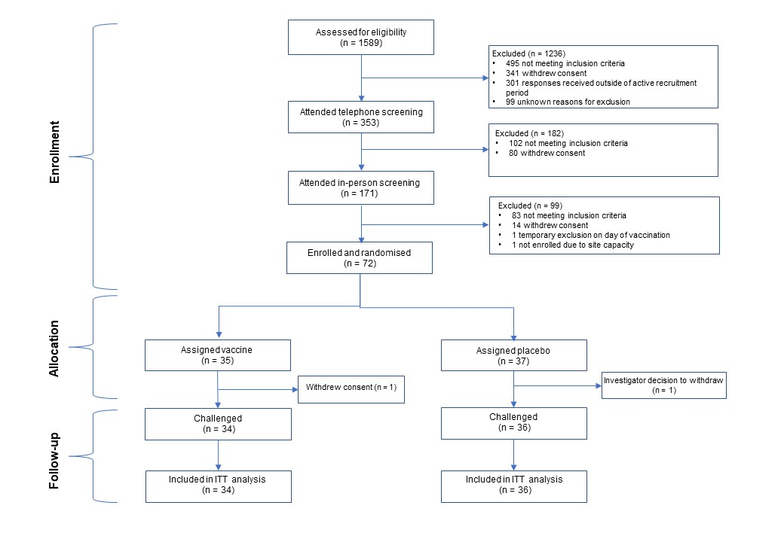

Figure 1. Screening, Randomization, and Challenge
The intention-to-treat analysis included all the participants who underwent randomization, received two doses of vaccine or placebo regardless of trial-group assignment, and were successfully challenged in the controlled human infection model. One participant who was assigned to the placebo group received two doses of vaccine; this participant was included in the placebo group in the intention-to-treat analysis.

Table 1 – Characteristics of the Participants at Baseline*
Characteristic | CVD 1902 group (n= 35) | Placebo group  (n = 37) | Total  (n= 72)
Median age (range) | 28 (20-54) | 33 (20-53) | 31.5 (20-54)
Median body-mass index (range)** | 24.5 (19.1- 33.2) | 26.6 (20.5 - 38.4) | 25.4 (19.1-38.4)
Sex at birth – no (%)
Female | 15 (43%) | 18 (49%) | 33 (46%)
Male | 20 (57%) | 19 (51%) | 39 (54%)
Race or ethnic group*** - no (%)
White British | 25 (71%) | 26 (70%) | 51 (71%)
White other | 2 (6%) | 7 (19%) | 9 (13%)
Asian | 2 (6%) | 1 (3%) | 3 (4%)
Mixed | 4 (11%) | 2 (5%) | 6 (8%)
Other | 2 (6%) | 1 (3%) | 3 (4%)
Site enrolled – no (%)
Oxford | 25 (71%) | 24 (65%) | 49 (68%)
Liverpool | 4 (11%) | 4 (11%) | 8 (11%)
Birmingham | 3 (9%) | 3 (8%) | 6 (8%)
Southampton | 1 (3%) | 3 (8%) | 4 (6%)
Bristol | 1 (3%) | 1 (3%) | 2 (3%)
Sheffield | 1 (3%) | 2 (5%) | 3 (4%)
*Percentages may not sum to 100 because of rounding.
** The body-mass index is the weight in kilograms divided by the square of the height in metres.
*** Race and ethnic group were reported by the participant.

Vaccine safety
After the first dose, nausea or vomiting and feeling generally unwell were reported more commonly in the vaccine group than in the placebo group (Fig. 2). The majority of the solicited symptoms were reported by the participants as being mild to moderate in severity (Fig. 2 and Table S1 in the Supplementary Appendix). The percentage of participants with abnormal biochemical and hematologic markers on day 7 after the first dose of vaccine or placebo were also generally similar in the two groups, as were markers on day 7 after the second dose (Tables S2 and S3).
Four serious adverse events were reported during the trial (two in vaccine participants and two in placebo participants). None of the serious adverse events were assessed by the investigators to be related to the vaccine or placebo (Table S4). Unsolicited adverse events were similar in the two groups (Table S5).

Figure 2. Severity of Solicited Symptoms after Receipt of Vaccine or Placebo
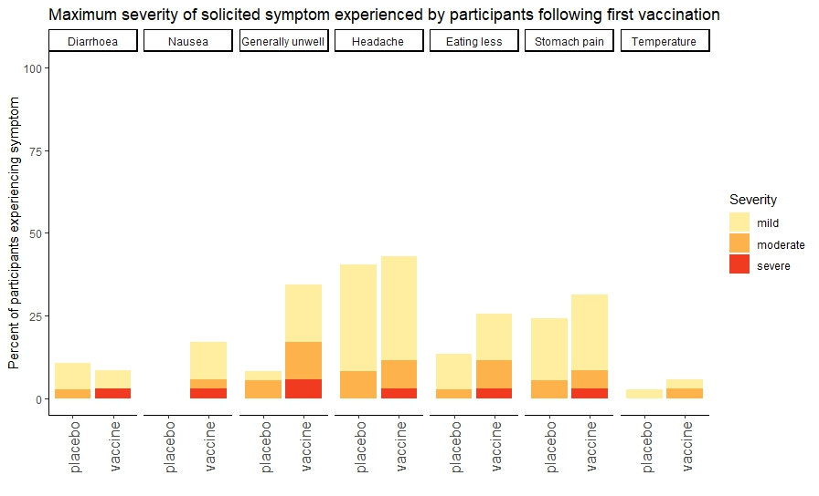
A)
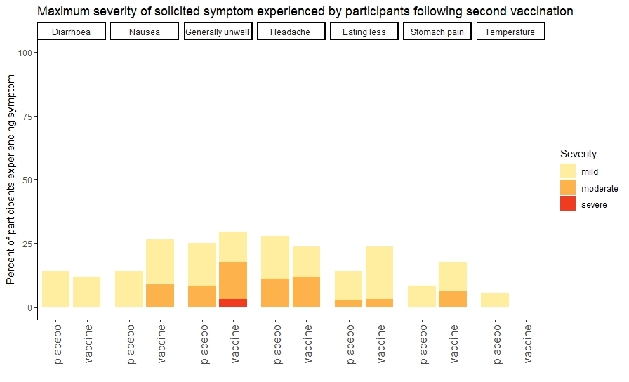
B)
Figure 2. Severity of Solicited Symptoms after Receipt of Vaccine or Placebo.
Shown is the severity of solicited symptoms that occurred between days 0 and 6 after the first dose of vaccine of placebo (Panel A) and between days 0 and 6 after the second dose (Panel B) as reported by the participants in electronic diaries. Data are for the safety analysis population, which included all the participants who received at least one dose of vaccine or placebo and provided data on solicited symptoms after each dose, provided at least one stool sample, or both. For each solicited symptom, the maximum severity reported by the participant across days 0 through 6 is shown. The criteria used by the participants in the assessment of symptom severity are provided in the Supplementary Appendix.

Immunogenicity
Levels of serum IgG and IgA antibodies to the O antigen of S. Paratyphi A on days 14 and 42 after the first vaccine dose were higher than that at baseline (Fig. 3 and Table S7). The geometric mean anti-O IgG titre increased from 126 ELISA units (EU) per milliliter (95% confidence interval [CI] 66 to 241) at baseline to 314 EU per milliliter (95% CI 167to 590) on day 14 after the first vaccine dose, and the geometric mean IgA titer increased from 20 EU per milliliter (95% CI 16 to 26) to 70 EU per milliliter (95% CI 49 to 99) on day 14. On day 42 after the first vaccine dose (28 days after the second dose), the geometric mean anti-O IgG titer was similar to that on day 14 (292 EU per milliliter; 95% CI 158 to 539) whereas the geometric mean anti-O IgA titer was lower than that on day 14 (33 EU per milliliter; 95% CI 24 to 45) but remained higher than at baseline. In the placebo group, the geometric mean anti-O IgG and IgA antibody titers on day 14 and 42 were similar to those at baseline. No IgG or IgA response to the S. Paratyphi A FliC antigen occurred after the receipt of vaccine or placebo (Fig. S4). In the sensitivity analysis conducted without data from the two participants with labelling errors, results were generally similar to those in the primary immunogenicity analysis (Table S8).
Anti-O IgG and IgA titers and anti-FliC IgG and IgA titers that were measured immediately before challenge on day 42, were generally similar among the participants who went on to have S. Paratyphi A infection and those who did not (Fig. S5). No clear association between the anti-O IgG titer and the risk of diagnosis was detected, but the risk among participants with higher anti-O IgA titers appeared to be lower than the risk among those with lower anti-O IgA titres (Fig. S6).

Figure 3. Anti-O IgG and IgA Antibody Responses

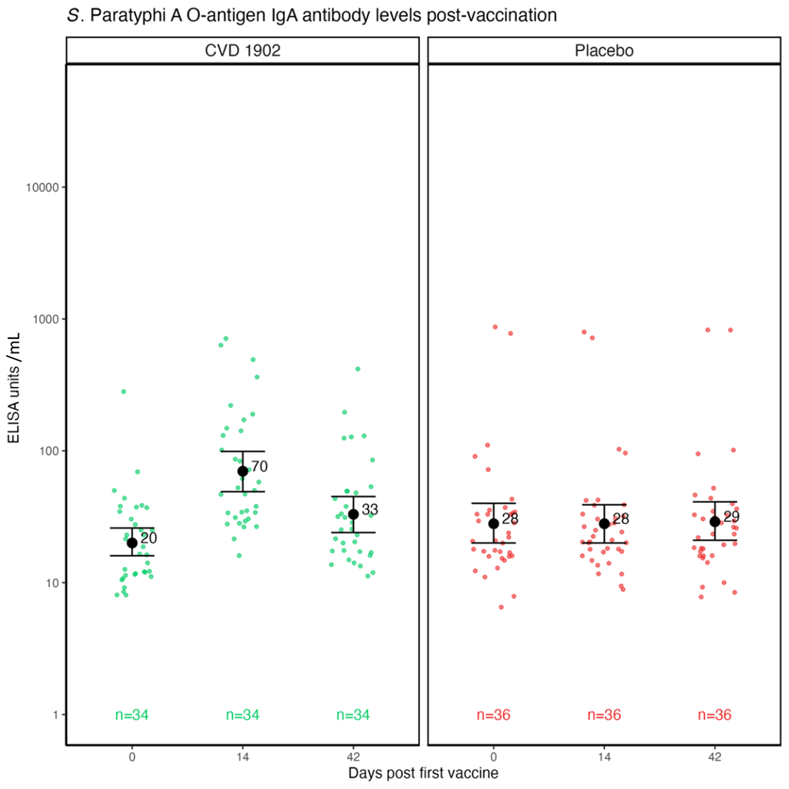
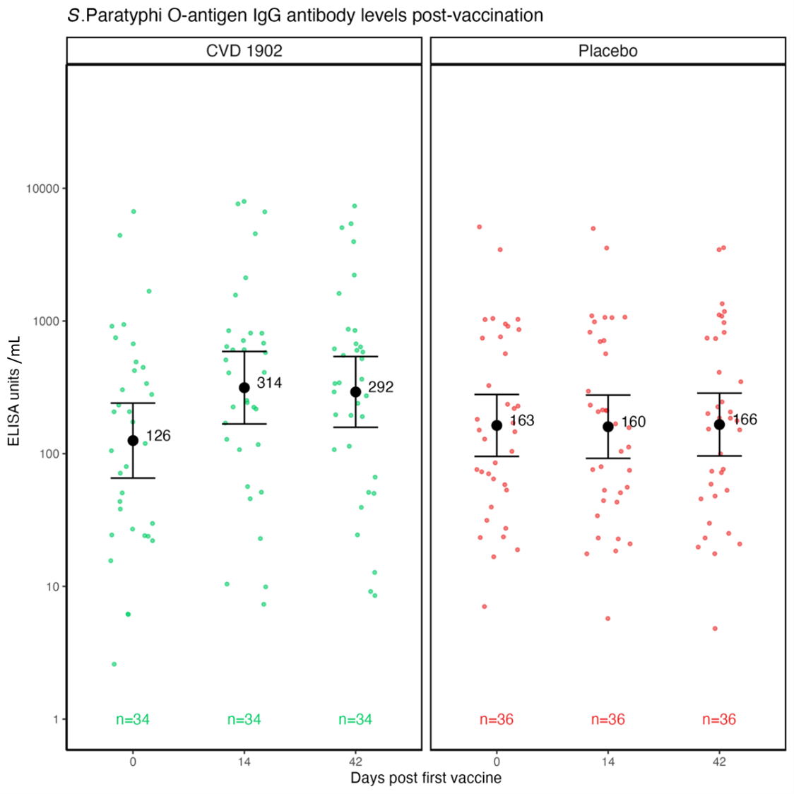
A) B)

Figure 3. Anti-O IgG and IgA Antibody Responses.
Levels of serum IgG (Panel A) and IgA (Panel B) against the O antigens of Salmonella enterica serovar Paratyphi A at baseline, 14 days after the first dose of vaccine or placebo, and 42 days after the first dose (28 days after the second dose) are shown. Antibody titres were assessed with an in-house standardized enzyme-linked immunosorbent assay (ELISA). Individual dots represent individual participant values and error bars represent the mean geometric mean titres and 95% confidence interval for each timepoint.

Vaccine efficacy
An S. Paratyphi A infection was diagnosed according to the prespecified composite criteria within 14 days after challenge (primary end point) in 7 participants (21%) in the CVD 1902 group and 27 (75%) in the placebo group (p <0.001). The vaccine efficacy was 73% (95% CI, 46 to 86) in the intention-to-treat analysis and 69% (95% CI, 42 to - 84) in the per-protocol analysis (Table S9).
The median time between the second dose of vaccine or placebo and challenge was 28 days (range, 26 to 85). A total of 68 participants underwent challenge within the prespecified window (23 to 60 days after the second dose). Two participants underwent challenge 85 days after the second dose; vaccine efficacy was 72% (95% CI, 44 to 86) after exclusion of these two participants from the analysis.
Subgroup analyses were performed according to baseline anti-O IgG titer and the interval between the second dose and challenge. Vaccine efficacy was similar across subgroups (Table S10).
Among the 34 participants with a primary end-point event, S. Paratyphi A infection was diagnosed in 32 (94%) on the basis of a positive blood culture obtained more than 72 hours after challenge. In two participants (both in the placebo group), S. Paratyphi A infection was initially diagnosed because of a persistent fever, but both participants were later found to also have a positive blood culture.

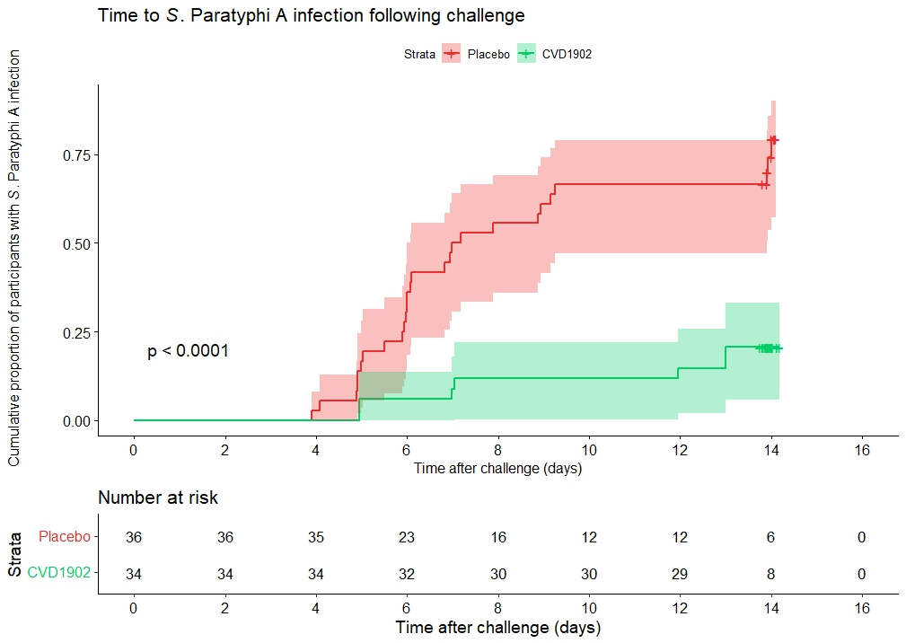
Figure 4 – Time to Diagnosis of S. Paratyphi A Infection.
Figure 4. Time to Diagnosis of S. Paratyphi A Infection.
Shown are Kaplan-Meier curves for a diagnosis after challenge with S. Paratyphi A in a controlled human infection model. An S. Paratyphi A infection was diagnosed within 14 days after challenge (primary end point) in 21% of the participants in the vaccine group and 75% of those in the placebo group (P <0.001 by the Pearson chi-square test). Diagnosis was based on a prespecified composite of an S. Paratyphi A-positive blood culture obtained more than 72 hours after challenge or a fever (temperature, ≥ 38°C) that persisted for at least 12 hours. Shaded areas indicate 95% confidence intervals, which were calculated with the log-transformation method. Tick marks indicate censored data.

Clinical and microbiological endpoints
Among the participants with a diagnosis, clinical manifestations of S. Paratyphi A infection were similar in the trial groups. Fever (temperature, ≥ 38°C) associated with S. Paratyphi A infection occurred in 29% of the participants in the CVD 1902 group and 19% of those in the placebo group. No participants in either group received a diagnosis of severe enteric fever as defined according to prespecified criteria (Fig. S1 and Table S6).
The median time between challenge and diagnosis was 7.0 days in the CVD 1902 group and 6.1 days in the placebo group. The median time between the first occurrence of persistently negative blood cultures was also similar in the groups (3.0 days with CVD 1902 and 2.7 days with placebo (Fig. S2). The number of participants with a positive stool culture more than 72 hours after challenge was lower with CVD 1902 (in 8 of 34 participants, 24%) than with placebo(in 18 of 36, 50%) (Fig. S3).
Three participants in the placebo group had a relapse (defined as recurrence of S. Paratyphi A bacteraemia after previous successful treatment) after completing antibiotic therapy, and 7 participants (3 in the vaccine group and 4 in the placebo group) had a stool culture positive for S. Paratyphi A at least 1 week after completing antibiotic therapy. All these participants were treated again with antibiotics and had three consecutive negative stool cultures by the end of the trial.

Discussion
In this randomized, placebo- controlled trial, we evaluated the efficacy of a candidate S. Paratyphi A vaccine using a controlled human infection model. In the intention-to-treat analysis, the risk of a diagnosis of S. Paratyphi A infection was 73% (95% CI, 46 -86) lower in the CVD 1902 group than in the placebo group.
There are currently no licensed vaccines against S. Paratyphi A. FliC and O:2 lipopolysaccharide are thought to be the antigens that are most likely to induce a protective immune response because they have been shown to correlate with protection against other enteric pathogens (14). The current trial showed that CVD 1902 induced serologic IgG and IgA responses to the O antigen of S. Paratyphi A. However, levels of these anti- bodies before challenge did not correlate with protection against a diagnosis, although there was a trend toward a correlation between higher levels of anti-O antibodies and protection, particularly with IgA.
Trials of intramuscular vaccines against S. Typhi showed that IgA and IgG responses to the capsular polysaccharide Vi antigen correlated with protection from infection (15, 16). Correlates of protection with orally administered live, attenuated S. Typhi vaccines have been more difficult to elucidate than those with intramuscularly administered S. Typhi vaccines (17). In a human challenge study involving two orally administered live, attenuated vaccines against S. Typhi, Ty21a and M01ZH09, antibody responses to lipopolysaccharide did not correlate with protection from infection (18). Protection against typhoidal salmonella after receipt of a live, attenuated vaccine might be driven by an immune response involving multiple antigens and potentially not by serum antibodies alone. Indeed, orally administered vaccines against S. Paratyphi A and S. Typhi have previously been shown to elicit strong cell-mediated immune responses (5, 19).
Locally produced mucosal antibodies in the form of secretory IgA probably play an important role in protection from S. Paratyphi A, as they do with other enteric pathogens, such as Vibrio cholerae and respiratory viruses (20, 21). In the current trial, clinical end points among infected participants were generally similar in the two groups, as were microbiologic end points. These findings suggest that the mechanism of the protection conferred by CVD 1902 may be at the mucosal level. Secretory IgA may facilitate protection by directly blocking pathogen attachment to epithelial cells or by means of immune exclusion (e.g., trapping pathogens in mucus or clearing them by means of peristalsis) and antibody-mediated agglutination, as has been shown to occur with S. enterica serovar Typhimurium in vitro (22). Future work to illuminate the mucosal response after vaccination, as well as additional humoral and cellular aspects of immunity, is needed to establish a correlate of protection against S. Paratyphi A. Knowledge of such a correlate would accelerate vaccine development, evaluation, and potentially licensure.
The vaccine efficacy shown in the current trial was higher than that of three licensed S. Typhi vaccines that were assessed in an S. Typhi controlled human infection model: Ty21a (vaccine efficacy, 35%; 95% CI, −5 to 60) and the intra- muscularly administered Vi–tetanus toxoid conjugate vaccine (54.6%; 95% CI, 26.8 to 71.8) and Vi nonconjugate vaccine (52.0%; 95% CI, 23.2 to 70.0) (15, 18). All three vaccines have shown higher efficacy in phase 3 trials performed in regions where S. Typhi is endemic (23). However, the S. Paratyphi A controlled human infection model uses a smaller challenge dose than the S. Typhi model and leads to fewer or less-severe symptoms, with a lower incidence of fever among participants despite a similar incidence of bacteremia (13). One hypothesis for these differences is that S. Paratyphi A causes a substantially greater number of asymptomatic infections and paucisymptomatic infections than S. Typhi, which drives ongoing S. Paratyphi A transmission by means of asymptomatic stool shedding without resulting in hospitalization. The current trial showed that vaccination may reduce the incidence of stool shedding among persons exposed to the pathogen, potentially interrupting the transmission cycle or decreasing the risk of transmission.
Limitations of the current trial include the artificial nature of the controlled human infection model and the enrollment of healthy U.K. adults as compared with persons in the target population of school-age children in areas where S. Paratyphi A is endemic (Table S11). Future field trials involving children in such areas are needed. Use of a controlled human infection model to assess CVD 1902 in an area where the pathogen is endemic would also be a useful intermediate step to evaluate the effect of preexisting immunity on vaccine response; such an investigation is currently in development. However, other controlled human infection models that have been used in vaccine development have shown efficacies similar to those in field trials, including the Vi polysaccharide–tetanus toxoid conjugate vaccine, the R21/Matrix-M malaria vaccine, and the killed, whole-cell monovalent cholera toxin B subunit vaccine (24-29).
A bivalent vaccine targeting S. Paratyphi A and S. Typhi is the most likely path to licensure for an S. Paratyphi A vaccine because such a vaccine offers a comprehensive approach to preventing enteric fever. The current formulation of CVD 1902 requires same-day preparation; as a result, a formulation suitable for clinical use is necessary to proceed toward licensing. Such a formulation could include an orally administered live, attenuated typhoid vaccine. Intramuscularly administered bivalent conjugate vaccines that combine an S. Paratyphi A O:2 conjugate vaccine with a typhoid conjugate vaccine are an alternative option. Two bivalent conjugate vaccine candidates have undergone phase 1 testing, but neither has undergone efficacy assessment, although studies are planned (30, 31).
In the current trial, CVD 1902 showed efficacy against S. Paratyphi A in a controlled human infection model. These findings are a step toward a much-needed S. Paratyphi A vaccine.

Conflicts of Interest
MM Levine is a co-inventor on issued patents related to CVD 1902 as a live oral vaccine to prevent Paratyphoid A fever. Bharat Biotech International Ltd, Hyderabad, India, is the University of Maryland Baltimore’s partner for manufacturing and development of CVD 1902.
AJP is Chair of the UK Department of Health and Social Care’s Joint Committee on Vaccines and Immunisation and was previously chair and is now a member of WHOs technical advisory group on Salmonella vaccines. AJP is a contributor to intellectual property on a COVID19 vaccine licensed by Oxford University Innovation to AstraZeneca. Oxford University has received funding for research on Salmonella vaccines from the Bill & Melinda Gates Foundation, the UK Medical Research Council, the Wellcome Trust, The European Commission and the Serum Institute of India.

All other authors report no conflicts of interest.

Support for Study
This work was supported by the NIHR Oxford Biomedical Research Council and by a grant from the Medical Research Council (MR/RO25347/1). The authors also acknowledge the support of the Oxford University Hospitals NHS Trust who provided laboratory support to the study and are grateful for the involvement and contribution of the study volunteers. We are grateful to the members of the Data Safety Monitoring Committee who provided close monitoring of the study throughout.

References
1. Typhoid and paratyphoid — Level 3 cause | Institute for Health Metrics and Evaluation. 2024.
2. Hannah Ritchie FSaMR. Clean water. 2019. Contract No.: 27/11/2024.
3. Russell AL, Hampton LM, Sinha A, Luquero FJ, Abdelwahab J. Progress in the Typhoid Conjugate Vaccine Program Rollout Supported by Gavi During the COVID-19 Pandemic and the Path Forward. Open Forum Infect Dis. 2023;10(Suppl 1):S13-S6.
4. MacLennan CA, Stanaway J, Grow S, Vannice K, Steele AD. Salmonella Combination Vaccines: Moving Beyond Typhoid. Open Forum Infect Dis. 2023;10(Suppl 1):S58-S66.
5. Wahid R, Kotloff KL, Levine MM, Sztein MB. Cell mediated immune responses elicited in volunteers following immunization with candidate live oral Salmonella enterica serovar Paratyphi A attenuated vaccine strain CVD 1902. Clin Immunol. 2019;201:61-9.
6. Gibani MM, Jin C, Shrestha S, Moore M, Norman L, Voysey M, et al. Homologous and heterologous re-challenge with Salmonella Typhi and Salmonella Paratyphi A in a randomised controlled human infection model. PLoS Negl Trop Dis. 2020;14(10):e0008783.
7. Kwong KW, Xin Y, Lai NC, Sung JC, Wu KC, Hamied YK, et al. Oral Vaccines: A Better Future of Immunization. Vaccines (Basel). 2023;11(7).
8. Meiring JE, Shakya M, Khanam F, Voysey M, Phillips MT, Tonks S, et al. Burden of enteric fever at three urban sites in Africa and Asia: a multicentre population-based study. Lancet Glob Health. 2021;9(12):e1688-e96.
9. Garrett DO, Longley AT, Aiemjoy K, Yousafzai MT, Hemlock C, Yu AT, et al. Incidence of typhoid and paratyphoid fever in Bangladesh, Nepal, and Pakistan: results of the Surveillance for Enteric Fever in Asia Project. Lancet Glob Health. 2022;10(7):e978-e88.
10. World Health Organisation I, Vaccines and Biologicals. Paratyphoid fever 2022 [Available from: https://www.who.int/teams/immunization-vaccines-and-biologicals/diseases/paratyphoid-fever.
11. Organization WH, editor December 2022.
12. McCann N, Emary K, Singh N, McLean F, Camara S, Jones E, et al. Accelerating clinical development of a live attenuated vaccine against Salmonella Paratyphi A (VASP): study protocol for an observer-participant-blind randomised control trial of a novel oral vaccine using a human challenge model of Salmonella Paratyphi A infection in healthy adult volunteers. BMJ Open. 2023;13(5):e068966.
13. Dobinson HC, Gibani MM, Jones C, Thomaides-Brears HB, Voysey M, Darton TC, et al. Evaluation of the Clinical and Microbiological Response to Salmonella Paratyphi A Infection in the First Paratyphoid Human Challenge Model. Clin Infect Dis. 2017;64(8):1066-73.
14. Holmgren J, Parashar UD, Plotkin S, Louis J, Ng SP, Desauziers E, et al. Correlates of protection for enteric vaccines. Vaccine. 2017;35(26):3355-63.
15. Jin C, Hill J, Gunn BM, Yu WH, Dahora LC, Jones E, et al. Vi-specific serological correlates of protection for typhoid fever. J Exp Med. 2021;218(2).
16. Dahora LC, Jin C, Spreng RL, Feely F, Mathura R, Seaton KE, et al. IgA and IgG1 Specific to Vi Polysaccharide of Salmonella Typhi Correlate With Protection Status in a Typhoid Fever Controlled Human Infection Model. Front Immunol. 2019;10:2582.
17. McCann N, Paganotti Vicentine M, Kim YC, Pollard AJ. The use of controlled human infection models to identify correlates of protection for invasive Salmonella vaccines. Front Immunol. 2024;15:1457785.
18. Darton TC, Jones C, Blohmke CJ, Waddington CS, Zhou L, Peters A, et al. Using a Human Challenge Model of Infection to Measure Vaccine Efficacy: A Randomised, Controlled Trial Comparing the Typhoid Vaccines M01ZH09 with Placebo and Ty21a. PLoS Negl Trop Dis. 2016;10(8):e0004926.
19. Sztein MB, Salerno-Goncalves R, McArthur MA. Complex adaptive immunity to enteric fevers in humans: lessons learned and the path forward. Front Immunol. 2014;5:516.
20. Leung DT, Chowdhury F, Calderwood SB, Qadri F, Ryan ET. Immune responses to cholera in children. Expert Rev Anti Infect Ther. 2012;10(4):435-44.
21. Sinha D, Yaugel-Novoa M, Waeckel L, Paul S, Longet S. Unmasking the potential of secretory IgA and its pivotal role in protection from respiratory viruses. Antiviral Res. 2024;223:105823.
22. Mantis NJ, Rol N, Corthesy B. Secretory IgA's complex roles in immunity and mucosal homeostasis in the gut. Mucosal Immunol. 2011;4(6):603-11.
23. Batool R, Qamar ZH, Salam RA, Yousafzai MT, Ashorn P, Qamar FN. Efficacy of typhoid vaccines against culture-confirmed Salmonella Typhi in typhoid endemic countries: a systematic review and meta-analysis. Lancet Glob Health. 2024;12(4):e589-e98.
24. Datoo MS, Dicko A, Tinto H, Ouedraogo JB, Hamaluba M, Olotu A, et al. Safety and efficacy of malaria vaccine candidate R21/Matrix-M in African children: a multicentre, double-blind, randomised, phase 3 trial. Lancet. 2024;403(10426):533-44.
25. Venkatraman N, Silman D, Bellamy D, Stockdale L, Bowyer G, Edwards NJ, et al. R21 in Matrix-M adjuvant in UK malaria-naive adult men and non-pregnant women aged 18–45 years: an open-label, partially blinded, phase 1–2a controlled human malaria infection study. The Lancet Microbe. 2025;0(0).
26. Black RE, Levine MM, Clements ML, Young CR, Svennerholm AM, Holmgren J. Protective efficacy in humans of killed whole-vibrio oral cholera vaccine with and without the B subunit of cholera toxin. Infect Immun. 1987;55(5):1116-20.
27. Clemens JD, Sack DA, Harris JR, Van Loon F, Chakraborty J, Ahmed F, et al. Field trial of oral cholera vaccines in Bangladesh: results from three-year follow-up. Lancet. 1990;335(8684):270-3.
28. Jin C, Gibani MM, Moore M, Juel HB, Jones E, Meiring J, et al. Efficacy and immunogenicity of a Vi-tetanus toxoid conjugate vaccine in the prevention of typhoid fever using a controlled human infection model of Salmonella Typhi: a randomised controlled, phase 2b trial. Lancet. 2017;390(10111):2472-80.
29. Shakya M, Voysey M, Theiss-Nyland K, Colin-Jones R, Pant D, Adhikari A, et al. Efficacy of typhoid conjugate vaccine in Nepal: final results of a phase 3, randomised, controlled trial. Lancet Glob Health. 2021;9(11):e1561-e8.
30. Kulkarni PS, Potey AV, Bharati S, Kunhihitlu A, Narasimha B, Yallapa S, et al. The safety and immunogenicity of a bivalent conjugate vaccine against Salmonella enterica Typhi and Paratyphi A in healthy Indian adults: a phase 1, randomised, active-controlled, double-blind trial. Lancet. 2024;403(10436):1554-62.
31. Nakakana U CI, Gotze M et al. Safety and immunogenicity of a Bilvalent vaccine against Salmonella Typhi and Salmonella Paratyphi A: Interim Data from a Phase 1 randomised controlled observer-blind trial among healthy adults in Europe. American Society of Tropical Medicine and Hygeine; Nov 13th-17th 2024; New Orleans, United States of America. ASTMH Abstract Book2024. p. 20.

