Dugong chirp type classification based on fundamental contour extraction and hierarchical cluster analysis

Ying Jiang^{1,}, Zongwei Liu^{1,a}, Chunmei Yang^{1,a}, Paul White², Xiaoyan Wang¹, Lian-Gang Lü^{1,a,}, Tao Xia³, Xuelei Zhang³, Kongkiat Kittiwattanawong⁴
1 First Institute of Oceanography, and Key Laboratory of Marine Science and Numerical Modeling, Ministry of Natural Resources, 6 Xianxialing Road, Qingdao 266061, China
² Institute of Sound and Vibration Research, University of Southampton, Southampton, SO17 1BJ, United Kingdom
³First Institute of Oceanography, and Key Laboratory of Marine Eco-Environmental Science and Technology, Ministry of Natural Resources, 6 Xianxialing Road, Qingdao 266061, China
⁴ Phuket Marine Biological Center, Phuket 83000, Thailand

Abstract
A steady decrease in the Dugong (Dugong dugon) population has been notices worldwide. Considering the social function and utilization rate, dugong chirp classification has become an important bioacoustics research topic, which may help marine biologists monitor the change of their population, study their behavioral context in different environments and optimise the protection policy. However, the objective classification of dugong chirps has not been adequately addressed in the literature. In this paper, an automatic fundamental contour extraction using the tempo-frequency variables to describe the contours of the fundamental frequency of the chirps is presented. With the automatic fundamental contour extraction, the time-frequency information of dugong chirps can be effectively represented, which gives a good classification performance. Following the principles used for the classification of dolphin whistles, three variables were chosen and performed with hierarchical cluster analysis. Based on these results and further visual examination, five categories of chirps were identified. A simple classification criterion was proposed which could be used in the automatic and effective identification of chirp types. Our findings enrich the known repertoire of dugong chirps, and may be useful in future passive acoustic monitoring studies.

Keywords: dugong chirp type, classification, fundamental contour extraction, hierarchical cluster analysis

Introduction
The dugong (Dugong dugon) is a benthic herbivorous marine mammal belonging to the order of Sirenia (Marsh et al., 2002). The International Union for Conservation of Nature currently ranks this species as vulnerable, facing a high risk of extinction in the wild (Marsh and Sobtzick, 2019).
Dugongs have poor eyesight (Dexler and Freund, 1906), and so acoustic signals play a major role in their social interactions and communication. Dugong chirps are the most frequently reported dugong vocalization, and account for approximately 90% of all calls recorded in both wild and captive dugongs (Anderson and Barclay, 1995; Hishimoto et al., 2005; Ichikawa et al., 2003, 2006, 2011; Okumura et al., 2007). They are short (typically <300 ms), frequency-modulated signals with two or more harmonics in the 3 – 18 kHz band (Anderson and Barclay, 1995; Ichikawa et al., 2006). Anderson and Barclay (1995) argued that dugongs shared a function-specific repertoire of chirps, and some chirps were used as signatures to distinguish neighbors from possible mates or challengers. Frequency modulation can endow chirps with considerable information content and may enable acoustic features to be individualized (Anderson and Barclay, 1995). Thus, passive acoustic monitoring and automatic detection of dugong vocalizations have been performed, mostly on the basis of chirps (Duan et al., 2022; Ichikawa, 2007; Ichikawa et al., 2006, 2012; Tanaka et al., 2016, 2017).
Chirps are often produced in a sequence, starting in an up-sweep and then turning into down-sweeps within several hundred milliseconds (Anderson and Barclay, 1995; Ichikawa et al., 2006). At present, just duration and few parameters describing the contour of the fundamental frequency (such as its initial, terminal and mean frequency) are extracted from each detected signal and used to characterize them (Anderson and Barclay, 1995; Ichikawa et al., 2003, 2006, 2009, 2010, 2011, 2012). This is an inadequate feature set with which to represent the time-evolutionary characteristics of dugong chirps.
In this study, an automatic fundamental contour extraction was proposed for dugong chirps, as an extension of our previous paper (Jiang et al., 2020). A set of 10 acoustic variables were determined for the contour representation. Next, the categorization of chirps in terms of the acoustic variables were identified based on hierarchical clustering analysis (HCA). Finally, a classification criterion was summarized, which could be used for simple classification of dugong chirp types.

Materials and methods

Study sites
Two passive smart acoustic hydrophone systems (LoPAS, SonicInfo Co. Ltd., China; frequency response: 2 Hz to 50 kHz, sensitivity: ˗196 dB±6 dB re 1 V/µPa) were placed around Libong Island in locations shown in Fig. 1. One was located at station I from March 20 to 21, 2019 and then moved to station III from March 21 to 28, 2019, whereas the other was placed at station II from March 20 to 28, 2019. The systems were moored 1 m above the sea bed and recorded continuously. Recordings were .wav files at 24 bits with a sampling rate of 128 kHz.
The sea floor is flat and at a depth of 4.82±0.09 m with few obstacles; the water column has a mixed-layer profile, with a water temperature of 29.2±0.1 ℃, which suggests a uniform propagation horizontally in any direction (Ichikawa et al., 2011).
Fig. 1. Map of the study site. Locations of the operated acoustic systems are shown by red pentagrams.
Boat-based and drone-based (SZ DJI Technology Co., Ltd, China) visual surveys were conducted during the daytime (i.e., from 9 am to 3 pm) under calm sea conditions (Beaufort < 2) and satisfactory visibility (> 1 km). A wooden boat (11.3 m in length and 2.4 m in width) was operated for daily trips, switching between the stations (Fig. 1). Two experienced observers, who have been conducting visual observations of dugongs in Thai waters for many years, visually scanned for dugongs from the front of the bow to 90° of the port and the starboard. The observation platform was built on the boat and was 1.84 m high with a sunshade roof to prevent reflections affecting visibility. Another observer controlled the flight altitude and camera angle of the drone. A sighting event was recognized as animals surfaced to breathe (Anderson and Barclay, 1995). Simultaneously, photographs and videos were obtained from the drone. For every dugong sighting, information, including the time, location, group size, surface behavior, and the presence/absence of calves, was recorded. During the surveys, no marine mammal species other than dugongs were observed in the two areas.

Data analysis

Detection of chirps
The sound recordings were first analyzed as spectrograms [Hamming window, 4096-point fast Fourier transform (FFT), 50% window overlap] in Adobe Audition CC 2020, producing a frequency resolution of 31.25 Hz and a time resolution of 16 ms. The chirps were detected visually and aurally based on their similarity with previous reports and recordings of dugong chirps (Anderson and Barclay, 1995; Ichikawa et al., 2003, 2006, 2009, 2011), and were selected for further analysis according to three criteria: (1) high signal-to-noise ratio, based on clearly audible in the recording and the fundamental frequency component being clearly visible in the spectrogram (Hoffman et al., 2017); (2) no overlap between any parts of two or more chirps; and (3) a gap between the two adjacent chirps longer than 60 ms, or longer than each adjacent chirp (Anderson and Barclay, 1995; Bazúa-Durán and Au, 2002).

Extraction of fundamental contours and acoustic variables
The contours and acoustic variables of the chirps were extracted with a custom-made routine that was developed in a previous study using MATLAB (Jiang et al., 2020). A set of ten parameters, previously used to characterise dolphin whistles, (Au and Hastings, 2008; Jiang et al., 2020) were automatically obtained from the detected chirps with a custom-made MATLAB routine (Table 1). The full set of parameters were: (1) duration of chirp (D) (s), (2) minimum frequency (MNF) (kHz), (3) maximum frequency of fundamental wave (MXFF) (kHz), (4) initial frequency of fundamental wave (INF) (kHz), (5) terminal frequency of fundamental wave (TMF) (kHz), (6) bandwidth of fundamental wave (BWF) (MXFF−MNF in kHz), (7) maximum frequency of chirp (MXFC) (kHz), (8) bandwidth of chirp (BWC) (MXFC−MNF in kHz), (9) number of harmonics (NH) and (10) number of inflection points (NP). Figure 2 was a schematic diagram of some extracted parameters.
Table 1. Description of acoustic parameters of dugong chirps.
Abbreviation | Unit | Description
D | s | Duration of the chirp
MNF | Hz | Minimum frequency, which is the lowest frequency of the chirp
MXFF | Hz | Maximum frequency of fundamental wave (the first harmonic)
INF | Hz | Initial frequency of fundamental wave
TMF | Hz | Terminal frequency of fundamental wave
BWF | Hz | Bandwidth of fundamental, which is MXFF minus MNF
MXFC | Hz | Maximum frequency of chirp (considering all harmonics)
BWC | Hz | Bandwidth of chirp, which is MXFC minus MNF
NH | – | Number of harmonics
NP | – | Number of inflection points. As reported by Au and Hasting (2008), an inflection point is defined as a point at which the slope of the contour reverses in direction.
Fig. 2. A chirp spectrogram with some of the extracted parameters of the contour labeled.

Classification of chirps
The chirps were classified based on a subset of only three parameters using HCA. The three parameters selected were INF, TMF, and NP, these are used as the main basis of six general broad categories for dolphin whistles (Au and Hastings, 2008). The two main inspection criteria for HCA were: (1) belonging to a category with more than 90% similarity; and (2) more than 10 in each category. All fundamental contours of the type classifications generated by HCA were then verified visually. A specific classification criterion was proposed to distinguish the chirp types based on the characteristic of each type.

Results
More than 730 GB of underwater sound data were obtained in this study. Detailed values were shown in Wang et al. (2022). In total, 13642 calls were detected as chirps, and 1537 signals were selected for analysis.

Classifications

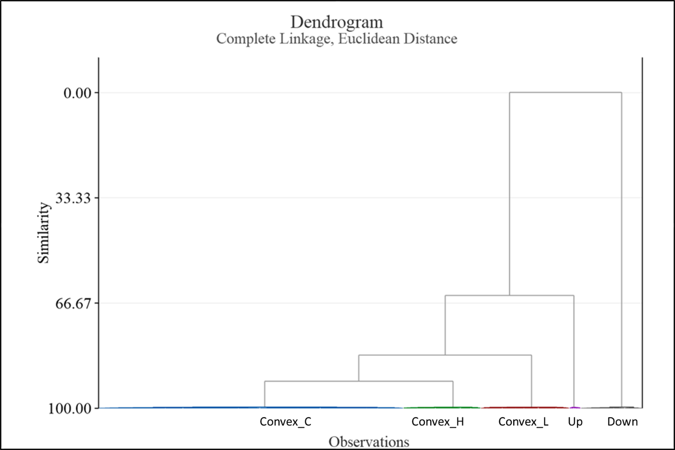
Fig. 3. Dendrogram of the chirps recorded from dugongs, based on HCA. Different main clusters (similarity over 99.6%) are shown in different colors.
HCA was used to cluster the three parameters of INF, TMF, and NP, and a dendrogram (Fig. 3) was constructed from the HCA results. Five main clusters were determined with similarity scores all exceeding 99.6%.
According to the results of HCA and further examination, the chirps were identified as five contour types: upsweep (up), downsweep (down), and three categories of convex contours, distinguished by the relative values of INF and TMF. Thereinto convex type, it includes three categories: convex_C (similar INF and TMF), convex_L (INF smaller than TMF) and convex_H (INF larger than TMF). This naming of the contours mirrors that used in an earlier study on dolphin vocalizations (Au and Hastings, 2008). An example of each contour type is shown in Fig. 4 (a–e). The statistics of the acoustic parameters for each type are presented in Table 2.
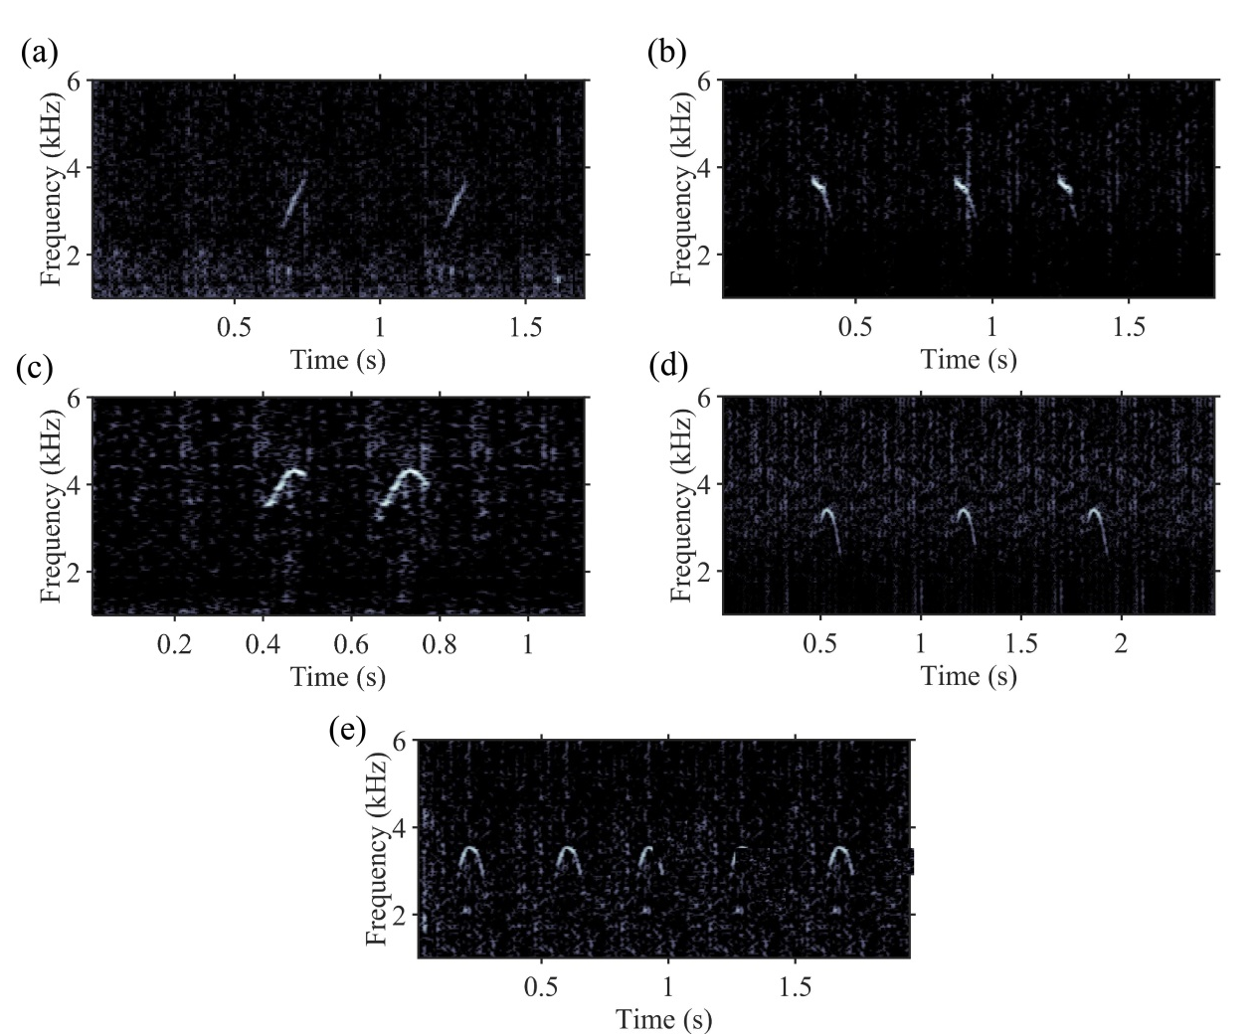
Fig. 4. Examples of spectrograms showing representative (a) upsweep, (b) downsweep, (c) convex_L, (d) convex_H, and (e) convex_C by dugongs. Spectrogram settings: hamming window, FFT size = 4096 points, frequency overlap = 50%, producing a frequency resolution of 31.25 Hz and a time resolution of 16 ms.

According to Fig. 4 and Table 2, the classification criterion of five fundamental-contour categories was given as follow (Table 3).
- Upsweep: chirps that were frequency modulated with the instantaneous frequency increasing over time and did not contain any inflection points (INF < TMF, NP = 0).
- Downsweep: chirps that were frequency modulated with the instantaneous frequency decreasing over time and did not have any inflection points (INF > TMF, NP = 0).
- Convex_L: chirps that were frequency modulated with the instantaneous frequency initially increasing and then decreasing over time, and the ending frequency higher than the beginning, with a difference exceeding 10% of the beginning frequency(INF < TMF and $TMF - INF>{INF}/{10}$, NP = 1).
- Convex_H: chirps that were frequency modulated with the instantaneous frequency initially increasing and then decreasing over time, and the beginning frequency higher than the ending, with a difference exceeding 10% of the ending frequency (INF > TMF and $INF - TMF>{TMF}/{10}$, NP = 1).
- Convex_C: chirps that were frequency modulated with the instantaneous frequency initially increasing and then decreasing over time, and the difference in frequency between the beginning and the ending of approximately 10% or less of the smaller value ( $\left|INF - TMF\right|<{\min_{}{(TMF, INF)}}/{10}$, NP = 1).
The above classification standard will be important for future research by enabling automatic and effective identification of these five fundamental-contour chirp types.

Table 2. Descriptive statistics of acoustic characteristics of fundamental-contour types of chirps by wild dugongs in Libong Island, Thailand. Minimum, maximum, average ($\overline{x}$) and standard deviation ($s$) are shown for acoustic variables for each type.
Parameters | Statistics | Up  (n=11) | Down  (n=43) | Convex _H  (n=274) | Convex _L  (n=316) | Convex _C  (n=893)
D (s) | $$\overline{x}±s$$ | 0.10±0.03 | 0.12±0.05 | 0.10±0.03 | 0.08±0.03 | 0.08±0.04
D (s) | Range | 0.05~0.16 | 0.05~0.24 | 0.03~0.25 | 0.02~0.25 | 0.03~0.25
INF (kHz) | $$\overline{x}±s$$ | 3.02±0.94 | 4.44±1.43 | 3.58±1.11 | 3.44±1.74 | 3.35±1.18
INF (kHz) | Range | 2.12~5.30 | 2.75~10.42 | 1.12~9.85 | 1.84~12.59 | 0.99~12.23
TMF (kHz) | $$\overline{x}±s$$ | 4.06±0.91 | 3.20±1.42 | 3.17±1.11 | 3.80±1.75 | 3.37±1.21
TMF (kHz) | Range | 3.04~6.26 | 1.28~8.84 | 1.12~9.85 | 2.15~12.84 | 1.13~12.38
MNF (kHz) | $$\overline{x}±s$$ | 3.02±0.94 | 3.20±1.42 | 3.17±1.11 | 3.44±1.74 | 3.31±1.11
MNF (kHz) | Range | 2.12~5.30 | 1.28~8.84 | 1.12~9.85 | 1.84~12.59 | 0.99~9.31
MXFF (kHz) | $$\overline{x}±s$$ | 4.17±1.00 | 4.44±1.43 | 3.88±1.10 | 4.03±1.72 | 3.71±1.17
MXFF (kHz) | Range | 3.22~6.76 | 2.75~10.42 | 1.66~10.11 | 2.21~12.84 | 1.18~12.38
BWF (kHz) | $$\overline{x}±s$$ | 0.61±0.45 | 0.68±0.25 | 0.64±0.41 | 0.64±0.43 | 0.62±0.33
BWF (kHz) | Range | 0.07~2.09 | 0.07~2.29 | 0.07~2.45 | 0.08~1.45 | 0.07~1.15
MXFC (kHz) | $$\overline{x}±s$$ | 4.17±1.00 | 4.23±1.13 | 4.07±1.39 | 4.13±1.82 | 3.88±1.37
MXFC (kHz) | Range | 3.22~14.19 | 1.93~18.82 | 1.66~10.90 | 2.21~12.84 | 1.18~14.39
BWC (kHz) | $$\overline{x}±s$$ | 0.74±0.91 | 0.70±1.10 | 0.75±0.34 | 0.75±0.86 | 0.74±0.77
BWC (kHz) | Range | 0.07~6.06 | 0.07~15.78 | 0.08~8.15 | 0.08~10.79 | 0.08~11.99
NH | $$\overline{x}±s$$ | 0.05±0.16 | 0.12±0.97 | 0.41±0.70 | 0.11±0.48 | 0.29±0.68
NH | Range | 0~1 | 0~4 | 0~2 | 0~2 | 0~4
NP | $$\overline{x}±s$$ | 0.00±0.00 | 0.00±0.00 | 1.00±0.00 | 1.00±0.00 | 1.00±0.00
NP | Range | 0~0 | 0~0 | 1~1 | 1~1 | 1~1
Table 3. Description of the classification criterion for five fundamental-contour categories.
Category | Description | Formula
Upsweep | frequency increasing over time and without any inflection points | INF < TMF, NP = 0
Downsweep | frequency decreasing over time and without any inflection points | INF > TMF, NP = 0
Convex_L | frequency increasing and then decreasing over time, and the ending frequency at least 10% higher than the beginning frequency | $TMF - INF>{INF}/{10}$, NP = 1
Convex_H | frequency increasing and then decreasing over time, and the beginning frequency at least 10% higher than the ending frequency | $INF - TMF>{TMF}/{10}$, NP = 1
Convex_C | frequency increasing and then decreasing over time, and the difference between the beginning and ending frequency less than 10% of the smaller one | $\left|INF - TMF\right|<{\min_{}{(TMF, INF)}}/{10}$, NP = 1

Characteristics of chirp types

The duration of convex contours (comprising convex_L, convex_H and convex_C) were slightly shorter than the other two types: up and down (t test, p < 0.05; Table 2). Up and down types had a higher mean value and narrower range of MXFF, but a lower mean value and narrower range of MNF than the convex contours. The MXFC of up and down types had higher averages and wider ranges than the convex contours. The average of BWF for each type was approximately the same. The mean values of NHs of three convex contours were slightly more than those of the other two types.
In our recordings, convex_C was the most commonly encountered (893 of 1537, 58.1%), followed by convex_L (316 of 1537, 20.6%), convex_H (274 of 1537, 17.8%) and down (43 of 1537, 2.8%), whereas up was lowest (11 of 1537, 0.7%). In total chirps with convex contours accounted for 96.5% of those measured.

Discussion
This study reports the first objective description of five fundamental contour types of chirped vocalizations from dugongs, based on the detailed acoustic parameters of fundamental contours. The fundamental frequencies of the chirps are most commonly reported by increasing with time initially and then decreasing with time in the ending portion (Anderson and Barclay, 1995; Ichikawa et al., 2006), which was a pattern referred to as convex in this study. The second chirp type (frequency decreasing over the time, corresponding to the down type in this study) has been described in a study in Shark Bay (Parsons et al., 2013) in which only two chirp types were reported. The lack of standardization in techniques and classification categories has hindered the determination of the repertoire of chirps. Our results may provide a way to overcome these difficulties.
More acoustic parameters of chirps were determined in this study than had been considered previously, which is helpful in describing the level of variation in chirps that may exist among populations and species within sirenians (Brady et al., 2022; Dietrich et al., 2022). Difference in fundamental frequencies of chirps has been reported for the captive young dugong (Marsh et al., 1978) and the captive adult dugong (Nair and Lal Mohan, 1975; Nair et al., 1975). All sirenians may produce chirps (Anderson and Barclay, 1995). The variance of duration of chirps was predominant between dugong and manatee, but slight between West Indian and Amazonian manatees (Anderson and Barclay, 1995). Future studies should aim to address whether or not intra and interspecific differences exist in chirp repertoires.
The convex contour in this study was the main shape of dugong chirps (accounting for 96.5% of all). Hishimoto et al. (2005) reported that captive male dugongs in Toba Aquarium produce more chirps during sexual and physical activities. Dugong mating activity exhibits seasonality, and mating behaviour has been observed in March around Libong Island (Adulyanukosol et al., 2007). High proportion and recorded in the mating season led us to speculate that the convex-contour chirps might be related to such mating activity. Identifying and discriminating the callers might further clarify the function of the convex-contour chirps. Additional studies joint with behavioral observation are necessary to better understand the function of every contour type chirp.
The features of chirps in this study differed from those reported previous studies (Anderson and Barclay, 1995; Ichikawa et al., 2003). Chirps in this study were lower in frequency and longer in duration than those reported in Australia (Anderson and Barclay, 1995). These findings might suggest that dugongs adapt chirps to different environments. Longer durations might be used to avoid noise masking effects. Lower frequency chirps are suited to shallower water, given their function of ranging (Anderson and Barclay, 1995; Ichikawa et al., 2011). The durations of chirps were shorter, and the frequencies were lower than those reported by Ichikawa et al. (2003) in a similar location to this study, possibly caused by a high-pass filter (cutoff frequency of 1000 Hz) and a threshold of duration (above 50 ms) employed by Ichikawa et al. (2003).

Conclusions
In conclusion, this study is the first report on the objective standardization in method and classification categories of dugong chirps on the basis of the shapes of the fundamental frequency contours. Five typical types of chirps were identified through hierarchical cluster analysis, and the detailed acoustic characteristics of each type were described. Classification criteria based on the INF, TMF, and NP were proposed. These results may be important when considering passive acoustic monitoring of dugong or understanding potential intra and interspecific differences in chirp repertoires among local populations or species. Classification of dugong chirp types could be considered as a major step for biologists studying dugong recognition and behavior. Detailed behavioral studies and the use of an acoustic recording array would facilitate gathering of more information and aid in interpreting the function of every chirp type.

Data Availability Statement
This survey on dugongs in Thailand was supported by the China-ASEAN Maritime Cooperation Fund. Prof. Xue-lei Zhang and Dr. Kongkiat Kittiwattanawong are the Chinese and Thai project leaders of the China-ASEAN Maritime Cooperation Fund, respectively. We also obtained the required permits from both the National Research Council of Thailand and the National Park Service of Thailand before conducting our survey. Hence, this study was approved by Thai’s government, and the data was recorded with the supports of several members of Phuket Marine Biological Center. The priority was always given to not disturb animals.
The data that support the findings of this study are available from the corresponding author, upon reasonable request.

Acknowledgements
We are grateful for the kind acceptance for this study by the National Research Council of Thailand and National Park Service of Thailand. We also thank the members of the Phuket Marine Biological Centre and the Dugong Guard from Libong Camp in this survey.
This work was supported by the National Natural Science Foundation of China (No. 42276196 and 41906170) and China-ASEAN Maritime Cooperation Fund.

References
Adulyanukosol K, Thongsukdee S, Hara T, Arai N, Tsuchiya M. Observations of dugong reproductive behavior in Trang Province, Thailand: further evidence of intraspecific variation in dugong behavior. Mar Biol 2007; 151(5):1887–91.
Anderson PK, Barclay R. Acoustic signals of solitary dugongs: physical characteristics and behavioral correlates. J Mammal 1995; 76:1226–37.
Ando-Mizobata N, Ichikawa K, Arai N, Kato H. Dugong vocalization in relation to ambient noise. In: Proceedings of the 6th International symposium on SEASTAR 2000 and Asian Bio-logging Science. The 10th SEASTAR 2000 Workshop; 2011. p. 55–9.
Au WWL, Hastings MC. Principles of Marine Bioacoustics. US: Springer; 2008. p. 411–9.
Bazúa-Durán C, Au WWL. The whistles of Hawaiian spinner dolphins. J Acoust Soc Am 2002; 112:3064–72.
Brady B, Ramos EA, May-Collado L, Landrau-Giovannetti N, Lace N, Arreola MR, et al. Manatee calf call contour and acoustic structure varies by species and body size. Sci Rep 2022; 12:19597. https://doi.org/10.1038/s41598-022-23321-7
Caldwell MC, Caldwell DK. Individualized whistle contours in bottle-nosed dolphins (Tursiops truncatus). Nature 1965; 207:434–5.
Caldwell MC, Caldwell DK, Tyack PL. Review of the signature whistle hypothesis for the Atlantic bottlenose dolphin, Tursiops truncates. In: Leatherwood S, Reeves RR, editors. The bottlenose dolphin: Recent Progress in Research, San Diego: Academic Press; 1990. p. 199–234.
Chilvers BL, Delean S, Gales NJ, Holley DK, Lawler IR, Marsh H, et al. Diving behaviour of dugongs, Dugong Dugon. J Exp Mar Biol Ecol 2004; 304:203–24. https://doi.org/10.1016/j.jembe.2003.12.010.
Clark J, Yallop C, Fletcher J. An Introduction to Phonetics and Phonology. Blackwell: Oxford; 2007. p. 204–96.
Dexler H, Freund L. Contributions to the physiology and biology of the dugong. Am Nat 1906; 40:49–72.
Dietrich A, von Fersen L, Hammerschmidt K. Signature Calls in West Indian Manatee (Trichechus manatus manatus)? Aquat Mamm 2022; 48(4):349–54.
Dreher JL, Evans WE. Cetacean communication. In: Tavolga N, editor. Marine Bio-Acoustics. England: Pergamon, Oxford; 1964. p. 373–93.
Duan D, Lü LG, Jiang Y, Liu Z, Yang C, Guo J, et al. Real-time identification of marine mammal calls based on convolutional neural networks. Appl Acoust 2022; 192: 108755.
Fitzgerald MB, Wright B. A perceptual learning investigation of the pitch elicited by amplitude-modulated noise. J Acoust Soc Am 2005; 118:3794–803.
Herzing DL. Vocalizations and associated underwater behavior of free-ranging Atlantic spotted dolphins, Stenella frontalis and bottlenose dolphins, Tursiops truncates. Aquat Mamm 1996; 22:61–80.
Hines E, Adulyanukosol K, Duffus DA. Dugong (Dugong Dugon) abundance along the Andaman Coast of Thailand. Mar Mammal Sci 2005; 21:536–49.
Hishimoto Y, Ichikawa K, Akamatsu T, Arai N. The acoustical characteristics of dugong calls and the behavioral correlates observed in Toba aquarium. In: Proceedings of the 2nd International symposium on SEASTAR2000 and Asian Bio-logging Science. The 6th SEASTAR2000 Workshop; 2005. p. 25–8.
Ichikawa K. Studies on behavioral ecology and protection measures of the dugongs based on analysis of marine acoustical information [PhD thesis]. Kyoto University; 2007.
Ichikawa K, Akamatsu T, Shinke T, Sasamori K, Adulyanukosol K, Arai N. Detection probability of vocalizing dugongs during playback of conspecific calls. J Acoust Soc Am 2009; 126:1954–9.
Ichikawa K, Akamatsu T, Shinke T, Arai N. Callback response of dugongs to conspecific chirp playbacks. J Acoust Soc Am 2011; 129:3623–9.
Ichikawa K, Akamatsu T, Arai N, Adulyanukosol K. Acoustical analyses on the calls of dugongs. In: Proceedings of the 4th S-EASTAR 2000 Workshop; 2003. p. 72–7.
Ichikawa K, Akamatsu T, Shinke T, Adulyanukosol K. Clumped distribution of vocalising dugongs (Dugong dugon) monitored by passive acoustic and visual observations in Thai waters. In: Proceedings of Acoustics 2012; 2012. p. 130–3.
Ichikawa K, Tsutsumi C, Arai N, Akamatsu T, Adulyanukosol K. Dugong (dugong dugon) vocalization patterns recorded by automatic underwater sound monitoring systems. J Acoust Soc Am 2006; 119:3726.
Ichikawa K, Akamatsu T, Shinke T, Adulyanukosol K. Spatial distribution of dugongs by acoustic and visual observation in Thailand. In: Proceedings of the 9th SEASTAR2000; 2010. p. 39–42.
Jiang Y, Liu Z, Yang C, Lü LG, Yu X, Huang L, et al. High-frequency whistles of Irrawaddy dolphins (Orcaella brevirostris) recorded in Brunei Bay. Mar Mammal Sci 2020; 36:846–57.
Marsh H, Penrose H, Eros C, Hugues J. Dugong, Status Reports and Action Plans for Countries and Territories (UNEP Early Warning and Assessment Report Series 1, Townsville, Australia). 2002. p. 162.
Marsh H, Sobtzick S. Dugong dugon (amended version of 2015 assessment): The IUCN Red List of Threatened Species 2019. Report No. e.T6909A160756767. https://dx.doi.org/10.2305/IUCN.UK.2015-4.RLTS.T6909A160756767.en; 2019 [Accessed on 18 April 2022].
Marsh H, Spain AV, Heinsohn GE. Minireview: Physiology of the dugong. Comp Biochem Physiol 1978; 61:159–68.
Morton ES. On the occurrence and significance of motivation-structural rules in some bird and mammal sounds. Am Nat 1977; 111:855–69.
Nair RV, Lal Mohan RL. Studies on the vocalisation of the sea cow Dugong dugon in captivity. Indian J Fish 1975; 277–8.
Nair RV, Lal Mohan RL, Rao KS. The Dugong dugong Dugon. Bulletin of the Central Marine Fisheries Research Institute 1975; 26:1–42.
Okumura N, Ichikawa K, Akamatsu T, Arai N, Shinke T, Hara T, et al. Stability of call sequence in Dugongs’ vocalization. In: Proceedings of OCEANS’06 Asia Pacific. IEEE; 2007. p. 12–5.
Parsons MJ, Holley D, McCauley RD. Source levels of dugong (Dugong dugon) vocalizations recorded in Shark Bay. J Acoust Soc Am 2013; 134:2582–8.
Sousa-Lima RS, Paglia AP, Fonseca GA. Gender, age, and identity in the isolation calls of Antillean manatees (Trichechus manatus manatus). Aquat Mamm 2008; 34:109–22.
Tanaka K, Ichikawa K, Nishizawa H, Kittiwattanawong K, Arai N, Mitamura H. Differences in Vocalisation Patterns of Dugongs Between Fine-Scale Habitats Around Talibong Island, Thailand. Acoust Aust 2017; 45(2):243–51.
Tanaka K, Nishizawa H, Ichikawa K, Arai N, Kittiwattanawong K. Effects of environmental factors on vocalization pattern of dugongs revealed by generalized linear model. In: Proceedings of 2016 Techno-Ocean; 2016. p. 54–7.
Urick RJ. Principles of underwater sound, 3rd edition. New York: McGraw-Hill Book Company; 1996. p. 202–36.
Wang D, Wursig B, Evans W. Comparisons of whistles among seven odontocete species. In: Kastelein RA, Thomas JA, Nachtigall PE, editors. Sensory systems of Aquatic Mammals, Netherlands: De Spil Publishers Woerdem; 1995. p. 299–324.
Wang X, Jiang Y, Liu Z, Yang C, Duan D, Lü LG. Classification and Characteristics of Dugong's Vocalization Recorded in Thai Waters. Advances in Marine Science 2022; 40(2):320–6. Chinese.

Also at: Laboratory for Regional Oceanography and Numerical Modeling, Qingdao National Laboratory for Marine Science and Technology, Qingdao 266237, China
lvlg@fio.org.cn

