Genetically Engineered Peptides for the Biomimetic Mineralisation of Metal-Organic Frameworks
Smaragda Lymperopoulou,^{†1} Samuel Hoff,^{†2} Anna Sola-Rabada,³ Monika Michaelis,³ Igor Efimov,³ Zayd C. Westcott,³ India J. Willimott,¹ Mauro Chiacchia,¹ Hendrik Heinz,² Carole C. Perry*³ and Darren Bradshaw*¹
¹ School of Chemistry and Chemical Engineering, University of Southampton, UK; ²Chemical and Biological Engineering, University of Colorado Boulder, US; ^{c}Dept of Chemistry and Forensics, School of Science and Technology, Nottingham Trent University, UK.
†These authors contributed equally to this work

Summary
Biomimetic mineralisation of metal -organic frameworks (MOFs) is a promising synthetic strategy for MOF and hybrid bio-MOF composites with significant potential in a variety of applications. While interactions of MOFs with several biological materials have been well-studied, interactions with peptides remain unexplored. Here we use phage display to identify strongly-binding peptides for isoreticular MOFs (UiO-66 and UiO-66-NH₂). Zeta potential and CD spectroscopy measurements combined with MD simulations permit characterization and explanation of the structure and dynamics of the MOF binding peptides, and differences in conformation and binding coefficients, allowing the MOF-peptide recognition mechanisms to be determined. The peptides have been successfully used to control MOF crystallinity and morphology for UiO-X MOFs, from a synthesis where amorphous products form in their absence. The findings presented have significant implications for understanding MOF-peptide interactions, which will be critical for the design and control over MOF structures and for bio-centered applications in the future.

Keywords: metal-organic frameworks, isoreticular MOFs, phage display, peptides, biomimetic synthesis, MD simulations, peptide-MOF interactions

Introduction
Peptides and their assemblies play a crucial role in natural biomineralisation processes, where their myriad functionality and recognition capability can guide the deposition of inorganic phases under strict biological control, permitting formation of hybrid materials with complex hierarchical structures perfectly adapted for specialist biological roles^{1,2}. As such, peptides have desirable properties for biomimetic synthesis approaches, and have been widely exploited to direct or mediate the assembly of inorganic materials and nanoparticles³. This is facilitated by combinatorial biology protocols such as phage-display (Ph.D.)⁴ that are used to identify sequence-specific peptides which preferentially bind to the surfaces of inorganic materials from highly diverse libraries containing 10⁹ - 10¹¹ random sequences dependent on sequence length⁵. Millions of genetically engineered phages bearing different surface peptides are exposed to a target material (known as biopanning) to select the best binding sequence via an evolutionary approach⁶. Ph.D. has been used to successfully identify high-affinity peptides for oxides⁷, noble metal nanoparticles⁸, zeolites⁹ and semiconductors¹⁰ and subsequently employed to control crystal nucleation and growth¹¹, functionalise surfaces¹² and for device formation¹³.
Metal-organic frameworks (MOFs) are crystalline microporous materials of high surface area assembled and sustained by coordination interactions between metal ions/oxoclusters and organic linkers^{14,15}, and have demonstrable applications in molecular separation¹⁶, catalysis¹⁷, sensing¹⁸ and drug delivery¹⁹. MOF composition is infinitely tuneable, and a number of frameworks have previously been prepared from small biological building blocks²⁰, including amino-acids, dipeptides and nucleobases which often confer their inherent chirality and flexibility to the resulting materials leading to novel framework behaviours.
The combination of MOFs with biological species is emerging as an important area toward functional bio-hybrid composites^{21,22}. To date, this chemistry is dominated by the zeolitic-imidazolate frameworks (ZIFs) due to their ease of synthesis under biocompatible reaction conditions, and typically a biomimetic mineralisation approach²³, sometimes in the presence of capping agents²⁴ (referred to as the coprecipitation method), is taken to deposit a microporous MOF shell around the biomolecule or bio-entity, affording a high degree of protection from proteolytic agents, extremes of temperature and organic solvents while maintaining size-selective molecular communication with the external environment. These MOF-biocomposites are expected to find application in biocatalysis²⁵ and therapeutics²⁶, and have the potential to eliminate the cold-chain required for storage and distribution of vaccine-based therapies and virus-like particles²⁷. Further, MOFs can selectivity deposit on protein patterned surfaces²⁸, and the presence of proteins (and other biomolecules) during framework assembly can modify crystal morphology and influence topology selection^{29,30}. In general, functional groups on the surfaces of biomolecules can provide a site for MOF nucleation, and ideally a negative surface charge is required to concentrate metal ions near the bio-surface to enhance framework formation kinetics. This has recently been demonstrated through the use of polyanionic peptide modulators³¹, surface-charge engineering of the electrostatic potential of biomolecules to regulate MOF deposition and control protein spatial location within the resulting biocomposite crystals³² and the chemical functionalisation of carbohydrates to induce rapid MOF assembly³³.
Collectively this indicates that interactions between MOF particle surfaces and/or their framework building blocks with proteins are highly favourable, and they have previously been exploited for protein enrichment through selective separation³⁴ and templating rod-like MOF bionanocomposites by direct growth onto the coat proteins of tobacco mosaic virus³⁵. At present however, very little is known about which sequences (or sequence conformations) of amino acids are likely to interact most strongly with MOFs and how this might be affected by the framework chemical or physical characteristics. This could be addressed by Ph.D. toward MOF targets³⁶ and has the potential to provide a greater understanding of the MOF-peptide interface, access to high-fidelity peptide/protein-based recognition pathways for the preparation of MOF biocomposites and films and enhanced sequence-specific biomimetic synthesis routes to existing and new framework materials.
MOFs are particularly well suited to combinatorial Ph.D. methods given their modular nature, tuneable functionality and structure via the well-established principles of isoreticular chemistry³⁷. This was demonstrated by Keitz and co-workers³⁶ who employed a 12-mer Ph.D. library to identify sequence-specific binding peptides for three prototypical water-stable MOFs, including ZIF-8 [Zn(MeIm)₂ (MeIm = 2-methylimidazole)], Fe-BTC (BTC = 1,3,5-benzenetricarboxylate) and MIL-53(Al)-FA (FA = fumaric acid). Peptide binding was found to be highly sequence dependent and strongest toward the phage display target materials, indicating an ability of the peptides to discriminate between the materials studied. Peptide surface-functionalisation of ZIF-8 was found to further enhance framework stability under physiological conditions and permitted kinetic control of the pH-induced release of dye molecules by slowing framework decomposition. More recently, Foster and co-workers have carried out Ph.D. on metal-organic nanosheets (MONs) as potential biomolecular recognition substrates and reported up to a 4600-fold increase in binding between the on- and off-target 7-mer peptides for a Hf-based nanosheet when determined using surface plasmon resonance³⁸.
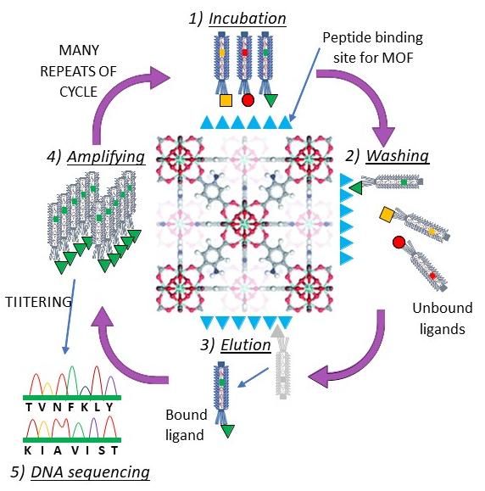
Scheme 1. Illustration of the phage display method to select strongly binding peptides for UiO-66 type MOFs.
In this contribution we further exploit the power of the Ph.D. screening method and demonstrate a finer level of selectivity is possible by identifying sequence-specific peptides for two isoreticular 3-dimensional Zr-based MOFs (Scheme 1) of the UiO-66³⁹ family bearing different functional groups. Peptide conformation and binding toward the MOF targets has been investigated by synchrotron radiation circular dichroism (SRCD) spectroscopy, isothermal calorimetry (ITC) and zeta-potential (ZP) measurements, and molecular dynamics (MD) simulations were employed to rationalise the peptide-binding toward the MOF surfaces. For the first time, we subsequently demonstrate the ability of peptides that have been identified by Ph.D. for MOFs to influence framework crystallinity, crystal morphology and particle size of the Zr-based frameworks in a sequence-specific manner via an aqueous biomimetic synthesis approach.
Results and discussion
We selected the UiO-66 family of Zr-based frameworks of general formula [Zr₆O₄(OH)₄(BDC)₆] (where BDC = 1,4-benzenedicarboxylate) as our targets for Ph.D. due to their high aqueous stability over a wide range of pH⁴⁰. The UiO-66 frameworks consist of a 12-connected secondary-building unit (SBU) cluster linearly linked via the organic components, resulting in a network of face-centred cubic topology (fcu) containing tetrahedral and octahedral cavities.⁴¹ Standard samples of UiO-66 and the amino-functionalised analogue UiO-66-NH₂ (formed from 2-amino-BDC) were prepared by previously reported procedures (see SI) and subsequent immersion of the solids in the buffers and eluants typically employed during Ph.D. revealed the frameworks to be stable under typical biopanning conditions. (Figure S2) Both frameworks are collectively referred to as UiO-66-X throughout this work
Phage display studies and sequence analysis
The MOF targets were each screened against the commercial non-lytic M13 bacteriophage Ph.D.-7 library (New England Biolabs), where each filamentous virus expresses five copies of a unique 7-mer peptide sequence fused to the pIII capsid coat protein at one of its ends⁴². Overall, the M13 combinatorial library contains up to 10⁹ unique 7-mer sequences, allowing us to readily investigate the importance of framework functionality on peptide-binding sequence. Following MOF exposure to the phage library, the solids were removed by microfiltration and washed to remove any weakly or non-bound phages. The most strongly MOF-bound phages were removed using a glycine-HCl elution buffer (pH 2.2), then amplified in an E. coli host prior to use in the next round of the biopanning process. To mitigate against any potential framework surface damage resulting from the elution process, a fresh MOF sample from the same synthesis batch was used for each biopanning round. After at least 3 rounds of biopanning and amplification (scheme 1) the remaining and hence strongest-binding phages were subject to titering and DNA-sequencing to identify the composition of the 7-mer peptide sequences responsible for binding, which are presented in Table 1.
Ph.D. binding to UiO-66-NH₂ reached consensus within three rounds of exposure, identifying TVNFKLY as a single preferential binding sequence for this framework, whereas a small number of binding sequences were found for unfunctionalised UiO-66 following the same number of biopanning rounds (Table 1). This is a clear demonstration that the Ph.D. method can be used to determine peptide-binding sequences for isoreticular UiO-66-X MOFs and indicates that framework functionality such as the amine group in UiO-66-NH₂ could have an important role to play in peptide-MOF binding, thus steering the Ph.D. screen toward a single consensus sequence. For unfunctionalised MOFs however, binding would be expected to be much less specific and largely dependent on a range of hydrophobic and aromatic-type interactions as recently reported for dipeptides adsorbing onto prototypical Zr-based MOFs⁴³, and hence a greater number of sequences all with relatively low frequency is observed.
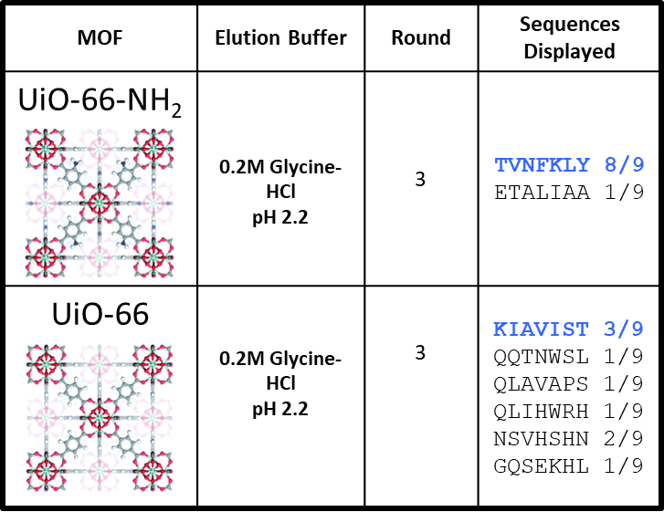
Table 1. Ph.D. results for the MOFs UiO-66 and UiO-66-NH₂ summarising the 7-mer peptide sequences displayed following 3 rounds of biopanning. Sequences taken forward for subsequent binding studies are highlighted in blue. Full details of sequences identified in other rounds are provided in the SI.
When analysing the wider Ph.D. results, it was observed that sequences WSLSELH, GQSEKHL, TVNFKLY and ETALIAA displayed against both frameworks, especially during earlier rounds of biopanning. (Table S1) Analysis of 9 of the observed binding and common sequences across the various rounds of Ph.D. reveals a dominance of residues bearing polar and aliphatic side chains, whereas acidic and aromatic residues barely feature. (Table S2) The most common amino-acids in the Ph.D. peptides were serine (S) and leucine (L) followed by aliphatic valine (V) and a number of other amino-acids, including polar threonine (T), basic histidine (H) and lysine (K), and hydrophobic alanine (A). The general absence of acidic residues in peptide sequences observed by Ph.D. suggests that carboxylate groups may be far less important for MOF recognition, despite their preferred use in biomimetic mineralisation strategies for biocomposite formation³². The prevalence of the observed residues is consistent with the hybrid composition of the frameworks, where polar and charged residues have potential to interact with the SBU clusters⁴⁴ and/or pendant functional amino groups and residues with more hydrophobic side-chains with the organic linkers through hydrophobic and, where applicable, π-π interactions⁴³.
The two Ph.D. binding sequences we selected for further study and analysis are TVNFKLY (UiO-66-NH₂ binder) and KIAVIST, which of all the peptide sequences demonstrating binding toward UiO-66, displayed a slightly higher frequency at round three than the others (Table 1). These two peptides have isoelectric points (pI) of 9.4 and 9.8, respectively, which are higher than the other sequences examined, carry a net charge of +1 at neutral pH and both sequences contain a relatively high proportion of hydrophobic uncharged residues (Table S2, Figure S1). KIAVIST is the more hydrophobic of the two (despite TVNFKLY containing two aromatic residues), which is consistent with KIAVIST being observed by Ph.D. for unfunctionalised UiO-66 but not UiO-66-NH₂ which is (partially) surface decorated with polar amine groups. Interestingly, TVNFKLY is a conserved sequence that has previously been observed to bind to the fcu spinel structure of Fe₃O₄ magnetite⁴⁵, whereas KIAVIST has not previously been observed by the phage display technique.
Peptide-MOF binding affinities
The binding affinities of TVNFKLY and KIAVIST with both UiO-66 and UiO-66-NH₂ were investigated using a combined approach of molecular dynamics, isothermal titration calorimetry (ITC) and zeta potential measurements (ZP). Both the ITC and ZP experiments were conducted in a largely aqueous media in line with our biomimetic mineralisation studies.
To elucidate which residues and binding interactions are likely to be the most important between the Ph.D. peptides and the UiO-66 MOFs, as well as investigating the wider chemistry of the MOF-peptide interface, we have employed molecular dynamics (MD) simulations. For each MOF, the two surface facets (111) and (100) are used to investigate the binding mechanism of KIAVIST and TVNFKLY based on our own parameterized force field (SI). The (100) framework surfaces of the fcu topology are rich in the Zr₆ SBU clusters, and the (111) surfaces are those typically found in the octahedral crystal morphology of UiO-66-type MOFs and are more open in nature. (Figure S3) The contrast between the (100) and (111) surfaces thus provide an opportunity to investigate any specific interactions, respectively, between the Ph.D. peptides and the SBUs and whether these peptides can penetrate into the framework porosity.
In aqueous solution the MOF suspensions were at a pH of 5.0 (unadjusted), and both UiO-66 and UiO-66-NH₂ revealed positive ZPs of + 21 and + 13 mV, respectively (figure 1), which is consistent with the range of ZPs observed for UiO-66 frameworks under similar conditions^{46,47}, indicating this is likely dominated by the charge on the metal cations and/or amine group. Our MD simulations also predict a positive ZP for both MOFs (in a 150 mM aqueous salt solution consistent with the conditions employed for the phage display screening) when starting from a pristine (100) or (111) surface. This arises from partial hydrolysis of the Zr-O bonds in the SBUs resulting in the dissolution of some Zr(IV) into the aqueous environment, which predominantly forms Zr(OH)₄ hydroxide at pH values near 7⁴⁸. (Figure 1a) This is the first time that loss of Zr(IV) ions from the surface of UiO-66-type MOFs has been demonstrated computationally, and is consistent with experimental reference data for the expected Zr species in solution⁴⁸⁻⁵¹ and in good agreement with a recent experimental study on the stability of this framework in common buffer solutions and their saline variants⁵².
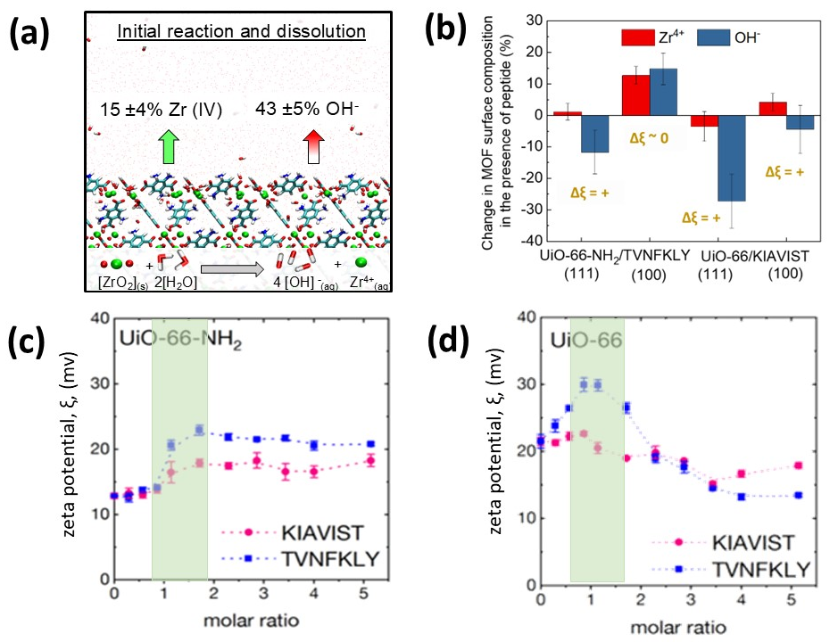
Figure 1. (a) In MD simulations the surfaces of UiO-66 & UiO-66-NH₂ react with water and the change in surface chemistry towards Zr(OH)₄ and similar species results in the dissolution of some surface Zr(IV) and OH⁻ species into solution, at a level of 15% and 40% of Zr(IV) and OH⁻ loss, respectively⁴⁸. The dissolution of more OH− than Zr (IV) creates a positive zeta potential at 0 mole ratio of peptide binding which is confirmed experimentally. (b) Computational results show more dissociation of OH⁻ ions than Zr(IV) ions on both MOF (111) surfaces upon peptide adsorption (TVNFKLY for UiO-66-NH₂ and KIAVIST for UiO-66). The net positive surface charge increases, consistent with an increase in ZP towards larger positive values shown experimentally in (c). A dependence on (hkl) crystal surfaces is noted as MOF (100) surfaces show smaller effects, keeping the surface charge about the same (UiO-66-NH₂) and only slightly more positive upon peptide adsorption. In this process, also multinuclear Zr oxohydroxo species may form on the MOF surfaces.^{48,53} (c) Experimental ZP data for UiO-66-NH₂ and (d) experimental ZP data for UiO-66 with increasing molar ratio of added Ph.D. peptides. As peptides are introduced into the system there is a general increase in zeta potential. Green zones in c and d designate molar ratios which are closest to those represented by the simulation results.

The ZP measurements for UiO-66-NH₂ in the presence of the two peptides show a Langmuir-type profile for molar ratios of added peptide > 1, increasing to + 23 mV (TVNFKLY) and + 18 mV (KIAVIST). (Figure 1c) We fitted the ZP curves according to the procedure outlined in the SI, and the obtained binding constants were K_{D} = 1.2 ± 0.3 µM and 3.2 ± 0.8 µM for TVNFKLY and KIAVIST, respectively. This demonstrates that KIAVIST binds to UiO-66-NH₂ to a lesser extent than the consensus sequence TVNFKLY, consistent with the Ph.D. results. The ZP curves for peptide addition to UiO-66 on the other hand do not follow a Langmuir-type profile (Figure 1d) and after an initial rise at low levels of peptide (where TVNFKLY > KIAVIST) the ZP tends to decrease as more peptide is added. Consequently, no reliable dissociation constants could be obtained from these profiles and instead our discussion of peptide binding toward UiO-66 focuses on the ITC data presented below. We note however, that the UiO-66 ZP profiles are clearly distinct from one another, and from those observed for the same two peptides with UiO-66-NH₂ and likely reflect differing binding mechanisms between the two sequences. Simulation results also predict an increase in ZP for both MOFs during peptide adsorption events. Interestingly these data appear to indicate that peptide adsorption is accompanied by further minor adjustments in the rate of loss of Zr(IV) and hydroxides from the framework particularly at lower peptide:MOF molar ratios (Figure 1b). This clearly highlights the complex nature of the surface chemistry at the MOF-solution bio-interface which could potentially be mediated by the biomolecules themselves. Further, the partial dissociation is of a local nature and may also involve multinuclear Zr-oxohydroxy ions such as Zr₄(OH)₈⁸⁺ and Zr₆O₄(OH)₄¹²⁺ if the pH value decreases below 7^{48,53}, though this does not affect the buffered pH value in the overall sample.
Interactions between the UiO-66-X MOFs and Ph.D. peptides all produced measurable heat effects, and the binding thermodynamics were investigated using isothermal titration calorimetry (ITC)⁵⁴. (Figure 2 and S4) The ITC profiles for all the MOF-peptide combinations reveal a single exothermic process for the binding, as evidenced by a negative change in differential power (Dp) (Figure S4). Interaction strength between the MOFs and peptides was directly evaluated from the ITC data and the dissociation constant (K_{D}) of each system calculated. The K_{D} values for peptide TVNFKLY with UiO-66-NH₂ and UiO-66 were 1.7 ± 0.1 µM and 2.3 ± 0.4 µM, respectively. These results indicate a marginally higher binding affinity of the peptide TVNFKLY towards UiO-66-NH₂, which was the Ph.D. target for this sequence. For KIAVIST, the K_{D} values for UiO-66-NH₂ and UiO-66 were 2.0 ± 0.7 µM and 1.6 ± 0.2 µM, respectively, which are also in broad agreement with Ph.D. results.
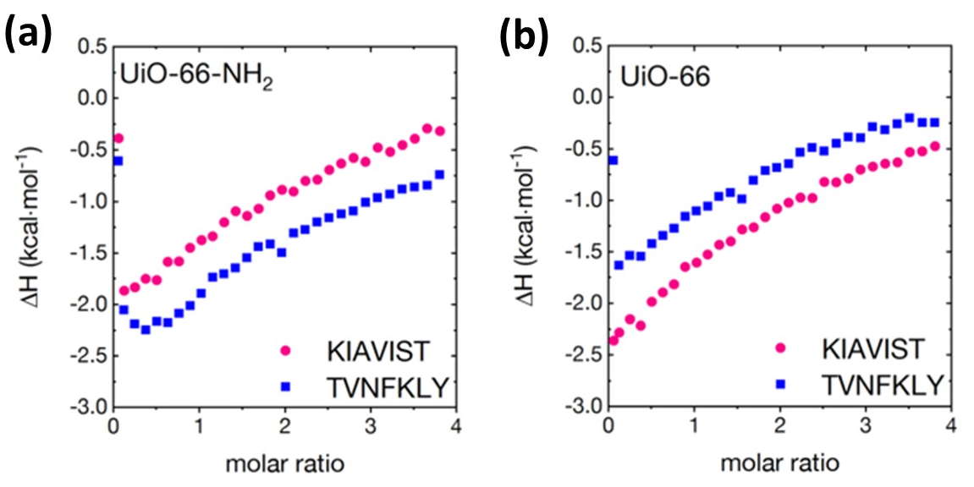
Figure 2. ITC profiles for (a) UiO-66-NH₂ and (b) UiO-66 in the presence of the two Ph.D. peptides, KIAVIST and TVNFKLY.
Based on the K_{D} values the changes in the free energy were calculated. Overall, the interaction between the peptides and MOFs is thermodynamically favourable, resulting in ΔG values of around – 10 kcal/mol (Table S3), which are comparable to other peptide interactions at the abiotic/biotic interface^{11,55,56}, and there are clear distinguishable interaction profiles upon binding of the peptides to the MOFs. We note that the peptides in solution in the absence of the MOFs form aggregates in solution as confirmed by dynamic light scattering (DLS) (KIAVIST 579 ± 30 nm and TVNFKLY 181 ± 36 nm) hence the determined thermodynamic parameters derived from heat changes between the UiO-66-X MOFs and the Ph.D. peptides not only account for MOF-peptide interactions, but also include peptide-peptide interactions, peptide conformational rearrangements and aggregation-disaggregation events in these clearly complex systems; for example, protein unfolding within MOFs and during biocomposite formation has previously been reported^{57,58}. Consequently, it is reasonable that the thermodynamic parameters between the MOFs and peptides investigated here are similar.
The obtained K_{D} values (~10⁻⁶ M) for the UiO-66-X frameworks with the identified Ph.D. peptides are comparable to previous studies, but expectedly show less discrimination between the frameworks than when different framework compositions³⁶ or the homogeneous surfaces of 2D MONs are employed³⁸. As noted, TVNFKLY and KIAVIST have similar properties and are found to be aggregated to some extent in solution, which will further increase their similarity for binding to UiO-66-X, consistent with the strong but generally non-selective binding of larger proteins such as bovine serum albumin (BSA) to MOFs^{36,59}.

Peptide-MOF binding mechanism
To identify which residues and binding interactions are likely to be the most important between the Ph.D. peptides and UiO-66-X MOFs at the molecular level we used a molecular dynamics (MD) simulation approach. Each peptide was examined for its ability to bind to the SBU-rich (100) and open porous (111) surfaces of the two UiO-66-X frameworks (Figure S3) under the conditions employed for the phage display screening.
The contact distances and frequencies of each amino acid within KIAVIST and TVNFKLY with each MOF surface were used to identify which amino acids are critical to the on-target peptide binding, and to determine the overall binding mechanisms. TVNFKLY binding interactions on both the (111) and (100) facets of on-target UiO-66-NH₂ (Figure 3a,b and Figure S5) and off-target UiO-66 (Figures S6c,d and Figure S7) show a large dependence on π-π stacking between the terminal Tyr residue and the MOF BDC ligands (Figure 3a,b, Figure S5), with additional interactions occurring through the C-terminal carboxylate group with exposed Zr(IV) sites and hydroxocomplexes on the (100) surface of UiO-66-NH₂ (Figure 3, S5). While the general interactions between Tyr and the MOF BDC ligands are present on both frameworks, additional water mediated hydrogen bonding is observed between the UiO-66-NH₂ (111) surface amino groups and the terminal Tyr, resulting in a more specific interaction between TVNFKLY and UiO-66-NH₂ (Figure 3ab, S5) compared to UiO-66 where these interactions are absent. (Figure S6 and S7) The results are in good agreement with Ph.D data, which showed TVNFKLY present as a binder through the second round on UiO-66, and as the consensus binder to UiO-66-NH₂, which may be due to the specific interactions of Tyr on the amino functionalized surface. This is further supported by the binding of the aromatic residues Phe and Tyr in TVNFKLY which differ between the two frameworks. (Figure S8) Although both Phe and Tyr bind similarly on UiO-66 spending similar amounts of time in proximity to each surface, only Tyr binds significantly to UiO-66-NH₂ suggesting that the non-specific binding that is observed for UiO-66 is replaced by a more specific interaction on UiO-66-NH₂.
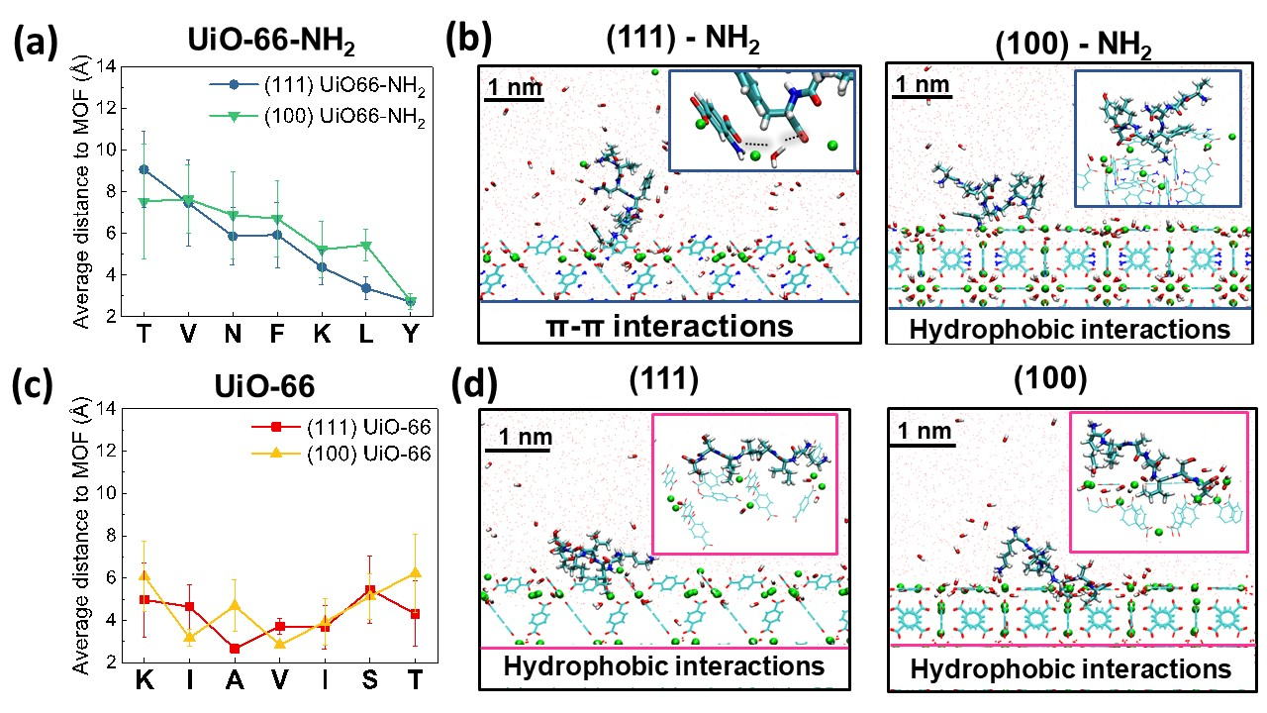
Figure 3. Simulation data summarising key on-target binding between Ph.D. peptides and MOFs. (a) Average distance between each residue of TVNFKLY and UiO-66-NH₂ (111) and (100) surfaces across three independent 8 ns simulations. (b) TVNFKLY binds almost exclusively with Tyrosine, where it is particularly close on the UiO-66-NH₂ surfaces. The terminal Tyr carboxyl group consistently has water mediated hydrogen bonding with the NH₂ group on the (111) surface and is dominated by hydrophobic interactions on the (100). (c) Average distance between each residue of KIAVIST and UiO-66 (111) and (100) surfaces over 8 ns across three independent simulations (d) KIAVIST binding is wholly through hydrophobic interactions on both UiO-66 surfaces which is maximised by some penetration of the isoleucine residues into the surface. Off –target binding is summarized in Figure S6.
Contrary to the semi-specific interactions of TVNFKLY with UiO-66-NH₂, KIAVIST binding occurs mainly through non-specific hydrophobic interactions with both on-target UiO-66 (Figure 3c,d; S9) and off-target UiO-66-NH₂ (Figure S6a,b; S10). KIAVIST interacts strongly with the UiO-66 surface (Figure 3c,d; S9) and only minimally interacts with UiO-66-NH₂ (Figure S6, S10), supported by the average distance of KIAVIST amino-acid residues to the surfaces of the two frameworks. The non-specific binding mechanism of KIAVIST may explain why no consensus binders were found for UiO-66 as these general interactions should be observed for many of the identified peptide sequences (Table S2). The stronger interactions of KIAVIST to UiO-66 within the simulation is based on hydrophobic interactions to both the (100) and (111) surfaces and some penetration of isoleucine (I5) into the surface can be observed (Figure S9). For the (100) facet one of the isoleucine residues binds very strongly as it goes past the exterior layer of carbon rings to interact simultaneously with four BDC aromatic rings, while the open structure of the (111) surface also allows for multiple hydrophobic interactions and penetration of both isoleucine residues. Isoleucine is thus a key hydrophobic binder within KIAVIST, and appears to be key in maintaining peptide binding to the surface (Figure S9).
Positively charged N-terminal ammonium groups in both peptides and Lys, which doubles as the N terminus in KIAVIST, did not play a prominent role on binding. The ammonium groups were typically oriented away from the MOF surface towards the electrolyte (Figure 3 and Figures S5 to S12 in the Supporting Information). The N-terminal ammonium group (T) in TVNFKLY was notably closer to the (111) surface of UiO-66 than to the (100) surface of UiO-66 (Figure S6c) and far from either surface of UiO-66-NH₂ (Figure 3a). The polar residue Asn in TVNFKLY did not show highly specific interactions on these MOF surfaces and may have more of a role as structural scaffolding for the peptide conformation.
We find that distinct surfaces on the same MOF lead to distinct binding trends (Figure 3, S6, S8); however, facet-specific differences appear to be less pronounced than on other materials surfaces such as metals⁶⁰ and hydroxyapatite⁶¹. The dominant entropic contributions to binding observed in isothermal calorimetry for the peptide on all surfaces (Table S3) can be reasoned with release of multiple surface ions from the MOF as well as surface-bound water upon peptide binding as seen in MD simulations (Figure 3b, d, S5 to S7, S9 and S10).
Peptide conformational changes on MOF binding
Conformational changes of the Ph.D. peptides on binding to the MOFs were investigated using synchrotron radiation circular dichroism (SRCD) spectroscopy (Figure 4). The experimental results are supported by Ramachandran plots derived from simulations of the two peptides in solution and upon interaction with the two distinct facets of the MOFs. The Ramachandran plots specifically show conformational sampling of different structural types according to the backbone dihedrals of the peptides.
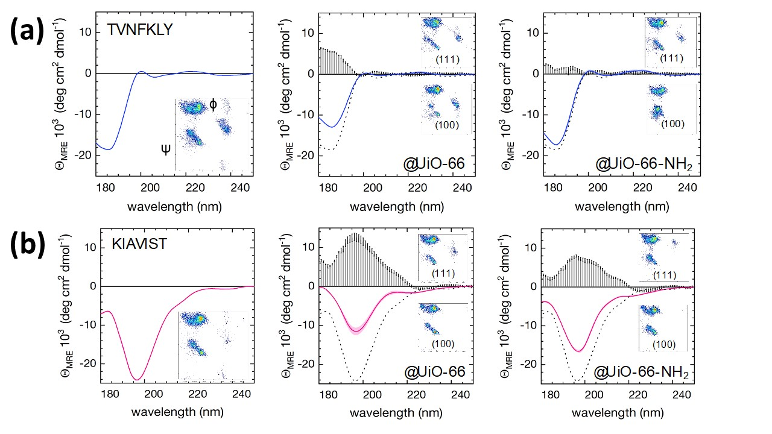
In solution TVNFKLY alone exhibits an uncommon CD spectrum (Figure 4a), with an intense minimum at 185 nm, and above 195 nm an oscillating pattern comprised of two shallow maxima (200 nm and 220 nm) and two shallow minima (205 nm and 235 nm). The associated Ramachandran plot shows that conformational space is largely in the left-handed polyproline PPII and the right and left-handed alpha-helical regions. The CD spectrum of KIAVIST however (Figure 4b) reveals spectral characteristics commonly associated with preferentially unordered conformations, which is further supported by the simulated Ramachandran plot.
Figure 4. Circular dichroism spectroscopy data of (a) TVNFKLY and (b) KIAVIST in solution vs. in the presence of the MOFs (where the dashed lines in the MOF samples indicate the peptide alone). The insets show simulated Ramachandran plots for both the (111) and (100) crystal faces.
Addition of MOF samples to the peptide solutions results in changes to the CD spectra in a manner which can be understood from the simulation data. Interestingly, the CD spectrum of TVNFKLY in the presence of UiO-66-NH₂ remains largely unchanged. For the simulations of the peptide binding on the two facets however, we find clear differences. For the (111) facet the sampling of the phi/psi phase space remains largely unchanged, whereas for the (100) facet the left-handed alpha helical contributions vanish in the Ramachandran plot and are associated with the stronger occurrence of right-handed alpha helices. These data suggest that TVNFKLY may bind preferentially to the (111) facet. We identified changes in the CD spectrum of TVNFKLY in the presence of off-target UiO-66, where the intensity of the spectral oscillations was reduced. For the interaction of TVNFKLY with UiO-66 (111) and (100) the sampling of the conformational phase space by simulation remains largely unchanged, suggesting binding of the peptide to both facets of the unfunctionalised framework.
For KIAVIST, upon interaction with UiO-66 and UiO-66-NH₂ there are clear conformational changes. In both cases, a decrease in the CD signal intensity is observed, which was more strongly pronounced for UiO-66. The Ramachandran plots however show very little difference in secondary structure configurations between the two facets investigated, implying similar general binding to all surfaces studied. For both peptides we find a global preference for unordered conformations. Conformational ‘instability’ is a common feature of biomolecules involved in the recognition and binding to solid materials⁶²⁻⁶⁵ where unordered conformationally labile peptides can enhance their adaptability toward interfacial features at surfaces.
The spectral changes observed for TVNFKLY are in very good agreement with the simulated binding mechanisms. The binding to UiO-66-NH₂ is preferentially mediated with the C-terminal Tyrosine residue through π-π stacking and water mediated hydrogen bonding to the MOF amino group, which appears to allow the peptide to largely preserve its conformational ensemble. KIAVIST shows similar conformational changes for both MOFs in agreement with the similar binding mechanisms we have identified, with the stronger changes observed for interaction with UiO-66. The conformational changes of the peptides observed on MOF binding can be further understood by exploring the density of water molecules at the MOF-peptide interface through MD simulation (Figure 5).

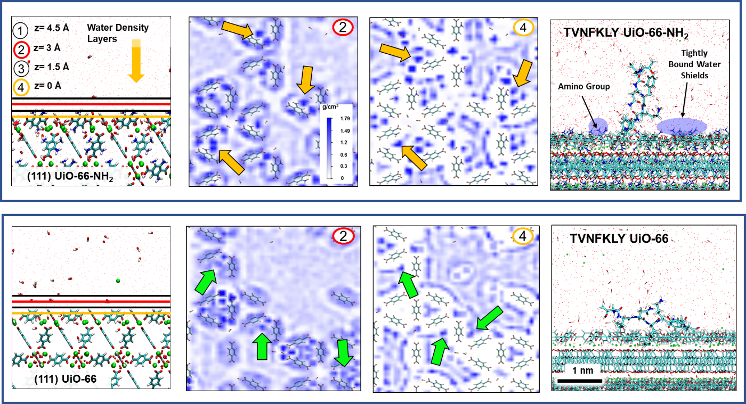
Figure 5. Calculated water density profiles of UiO-66-X (111) surfaces (Top): Side view of the UiO-66-NH₂ (111) facet with color coded lines drawn where density cross sections were calculated; the largest distance is 4.5 Å away from the MOF surface and is defined by the location of the MOF carbon atoms with the largest z-height. Yellow arrows highlight high density water areas centered around the NH₂ groups on this surface. Water density profiles of UiO-66 (111) (Bottom): Side view of the UiO-66 (111) facet with color coded lines drawn where density cross sections were calculated. Green arrows highlight lower density water areas corresponding to the same locations but in the absence of the amine groups. Representative binding conformations of TVNFKLY on both MOF (111) surfaces are shown, revealing the peptide binds flat on the UiO-66 surfaces driven by hydrophobic interactions, whereas tightly bound water molecules around the -NH₂ groups create a barrier for the peptide to bind flat on the surface, resulting in more upright conformations for TVNFKLY on UiO-66-NH₂ and less change in overall conformation compared to its solution-like behaviour. Water density profiles for all cross sections are shown in Figure S11, and those corresponding to the (100) surfaces in Figure S12.
The presence of amino groups on UiO-66-NH₂ endows the functionalized MOF with a more hydrophilic surface which strongly interacts with surface bound water molecules. As TVNFKLY interacts with the UiO-66-NH₂ surface through a specific water-mediated hydrogen bond through the terminal Tyr residue, the more hydrophilic nature of the MOF may be responsible for this binding mode and thereby the differing conformations TVNFKLY occupies when bound to the two MOF surfaces (Figure 5). Simulations identify π-π stacking as a principal mode of interaction of TVNFKLY with both MOF surfaces, however, simultaneous surface binding of the aromatic rings of Tyr and Phe is only observed on UiO-66 (Figure S8). Indeed, on UiO-66-NH₂ the amount of π-π stacking between Tyr and the framework significantly outweighs Phe-MOF interactions, whereas on the UiO-66 surface, the Tyr-MOF and Phe-MOF π-π interaction frequency is indistinguishable. We attribute this clear difference in binding between the two MOFs on the variance in the water density distributions based on the presence of the amino functionality in UiO-66-NH₂. (Figure 5, S11) The hydrophilic surface facilitates water mediated hydrogen bonding for Tyr, making its interaction with the MOF surface significantly more favorable than Phe. Simultaneously, the increased surface hydrophilicity reduces the strength of general hydrophobic interactions. TVNFKLY occupies different distributions of conformations when bound to UiO-66 however, which allows for more hydrophobic interactions, a closer surface approach, and thus more overall contact with the surface (Figure S5). This key difference changes the CD spectra from that of the solution-like behaviour of the peptide as it is now held close to the surface, whereas the functionalized UiO-66-NH₂ surface enforces a more upright bound conformation of the peptide. Increased water density around BDC ligands in UiO-66-NH₂ also explains the reduced interactions of KIAVIST with UiO-66-NH₂ compared to UiO-66 as the main mode of binding for KIAVIST is through hydrophobic residues (Figure S12).
Biomimetic mineralisation with phage display peptides
In this study we have exploited Ph.D. to identify 7-mer peptide sequences that bind to isoreticular frameworks and thus have an excellent opportunity to investigate whether biomimetic mineralisation of UiO-66-X could be conducted in a sequence-specific manner.
For our biomimetic synthesis we have employed the ambient aqueous synthesis route to UiO-66-NH₂ reported by Szilágyi and co-workers⁶⁶ in order to maintain the integrity of the added biomolecules. In this preparation an aqueous solution of ZrOCl₂ pretreated with acetic acid is added to an aqueous solution of BDC-NH₂ in the presence of NaOH. The resulting product was confirmed to be a highly crystalline phase of UiO-66-NH₂ as determined by powder x-ray diffraction (PXRD) and thermogravimetric analysis (TGA) that are consistent with the expected fcu topology and framework composition, respectively. Addition of TVNFKLY, KIAVIST or a random peptide (AVRTQT) at a molar ratio of 0.1:1 wrt Zr(IV) to the synthesis yields crystalline UiO-66-NH₂ with comparable PXRD patterns. (Figure S13) This indicates that the peptides do not disrupt the assembly of the MOF lattice under these conditions, and mass spectrometric (MS) analysis (Figure S14) of the synthesis supernatants reveals the peptides remain intact. The major difference in the synthesis outcome is the peptide dependent crystal morphology and homogeneity. Scanning electron microscopy (SEM) images (Figure S15) show that the no peptide (control) reaction yields small very poorly defined nanocrystal aggregates of UiO-66-NH₂, and while a similar result is obtained with KIAVIST, the small crystals have a more defined shape. However, in the presence of TVNFKLY, the single preferential binder identified by Ph.D. for this framework, the resulting particles are much larger and approximately spherical in shape. In the case of AVRTQT, a mixture of small crystal aggregates and poorly defined spherical structures are observed. This clearly demonstrates that the Ph.D. peptides can exert a sequence-specific effect on the size and morphology of UiO-66-NH₂ particles.
Further characterization of the frameworks using TGA (Figure S16) is consistent with the UiO-66-NH₂ framework composition, with residual masses of 41% (TVNFKLY) and 39% (KIAVIST) (theoretical 42%) indicating that no significant amount of peptides are incorporated into the frameworks. This is further confirmed using a control sample of UiO-66-NH₂ physically mixed with 10 mol% of TVNFKLY, which displays a much greater mass loss below 300 °C as evidenced by two clear peaks in the derivative thermogram (Figure S16) which are absent for those frameworks synthesized in the presence of the peptides. FTIR of the materials also reveals an absence of prominent stretches associated with the peptides, particularly those in the 1000-1200 cm⁻¹ range arising from the amide III backbone C-N stretching and C-N-H bending vibrations are missing. (Figure S17) These stretches are however visible in the control sample of UiO-66-NH₂/10 mol% of TVNFKLY (Figure S18).
The Brunauer Emmet and Teller (BET) surface areas of the frameworks were determined from nitrogen adsorption measurements (Figure S19A, Table S4). The BET area of UiO-66-NH₂ without any peptide arising from this synthesis is 325 m²/g and is lower than typically reported values (800 – 900 m²/g)⁴⁰. No further attempt was made to optimize the surface area⁶⁷ which was not the focus of this study, but significantly, the BET surface areas (323 m²/g for KIAVIST and 312 m²/g for TVNFKLY) and pore size distributions (Figure S19B) of the UiO-66-NH₂ samples prepared under the same conditions in the presence of the peptides are nearly identical. Our synthetic efforts focussed on the effect of the peptide on the framework crystallinity and morphology rather than optimisation of surface area, which is strongly dependent on reaction solvent volume, reaction time, any exchange solvents employed, and the activation time and temperature of the sample.⁶⁷ All of these variables have significant potential to disrupt the action of the peptide so we focussed only on the aqueous synthesis parameters reported by Szilágyi⁶⁶ where we tried to minimise framework pre-assembly by not pre-forming the Zr₆ cluster and this is the origin of the reduced surface area.
Although the incorporation of small amounts of peptides during synthesis or their surface adsorption cannot be ruled out, our combined characterization data from TGA, FTIR and BET, especially when compared to appropriate control samples containing known amounts of peptide, suggests the peptides are largely absent from the products.
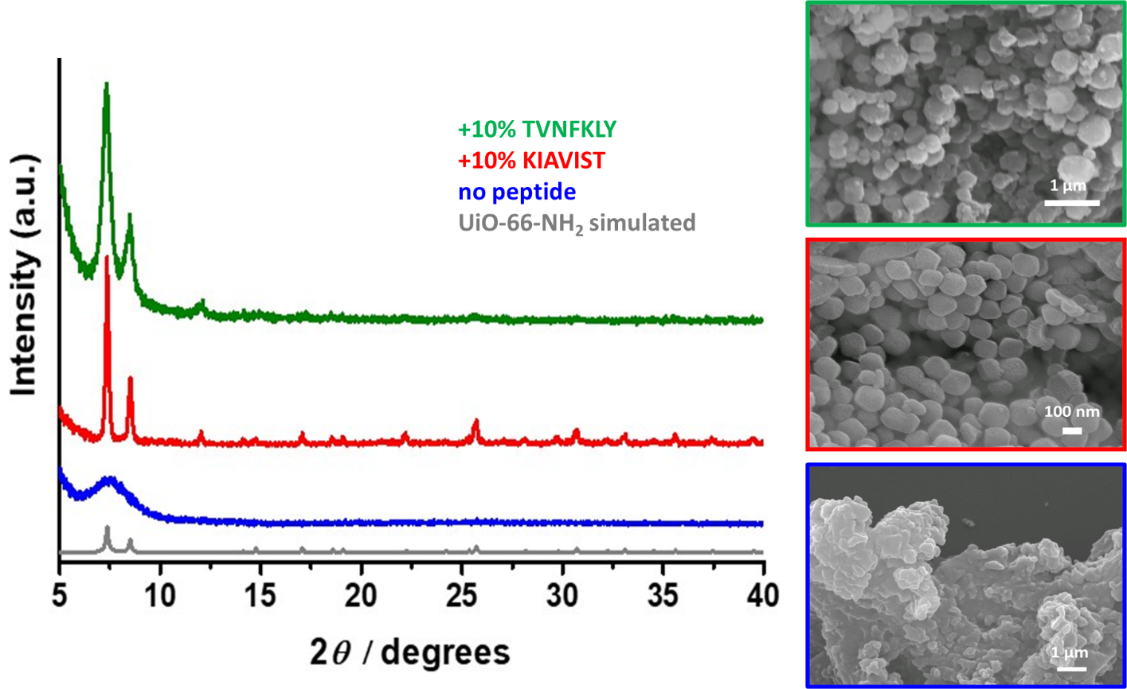
Figure 6. PXRD and SEM data of UiO-66-NH₂ formed under aqueous synthesis conditions at room temperature without added NaOH in the presence and absence of the Ph.D. peptides. The boxes surrounding the SEM images correspond to the diffraction patterns of the same colour. The pattern shown in grey is the expected pattern from the crystal structure.
Even more convincing evidence for the role of the peptides in UiO-66-X biomineralisation was found from syntheses performed in the absence of sodium hydroxide where the synthesis of UiO-66-NH₂ yields an amorphous product (Figure 6 and S20, S21). Addition of TVNFKLY and KIAVIST to the synthesis in the absence of base remarkably yields crystalline materials that both display PXRD patterns that are in excellent agreement with the fcu topology of UiO-66-NH₂. (Figure 6) When the same random peptide AVRTQT is added no solid product is formed, further confirming that the Ph.D. peptides can influence framework formation by facilitating assembly of the desired crystalline phase under synthetic conditions where this does not typically occur.
SEM images of the products show better defined particles of UiO-66-NH₂ are obtained in the presence of the Ph.D. peptides compared to the amorphous aggregates found in the no peptide case (Figure 6). The particle sizes appear to differ slightly between the Ph.D. peptide reactions, and there is a greater particle size distribution when TVNFKLY is used which may be indicative of differences in the growth mechanism (or degree of peptide induced modulation) between the two sequences. As reported for the base synthesis, TGA (Figure S20) and FTIR (Figure S21) of the products alongside appropriate control samples also suggest little to no inclusion of the peptides, and the former further confirms the UiO-66-NH₂ composition and thermal stability. This is significant and indicates that the peptides can influence the crystallization of UiO-66-NH₂ from a starting point where this would typically lead to an amorphous product, reminiscent of natural biomineralisation processes. More widely, biomimetic mineralisation of UiO-66 type MOFs in the presence of proteins under aqueous conditions is relatively uncommon, yielding either amorphous products⁶⁸ or requiring the use of appropriately functionalized amino acid co-modulators to induce crystallinity⁶⁹, and the results reported here clearly highlight the importance of sequence-specific peptides identified by Ph.D. as an alternative biomineralisation strategy for Zr-based MOFs.
We note that the pH of the UiO-66-NH₂ syntheses with and without base differ (2.4 and 1.6, respectively) and that this is likely a key factor in the assembly and crystallinity of UiO-66-NH₂ in these reactions⁷⁰. Interestingly for each subset of experiments (i.e. all those with NaOH or all those without) the pH varies by < 0.3 units from the no peptide reaction when the Ph.D. sequences are added. This strongly suggests that pH is not a major factor when the peptides are employed, supporting a real effect on framework assembly, crystallinity and particle size/morphology. Mass spectrometry (MS) analysis of the aqueous supernatants following all reactions with peptides indicated the presence and intact nature of the added sequences. (Figure S14 and S22) The observed sequence-specific changes in crystal morphology and crystallinity of UiO-66-NH₂ can therefore be attributed to the influence of the added peptides. To confirm this, we added the 7 amino acids which comprise each of the Ph.D. peptides into the aqueous UiO-66-NH₂ syntheses. When the 7 amino acids comprising TVNFKLY or KIAVIST were added separately but simultaneously to the UiO-66-NH₂ synthesis in the absence of NaOH, only poorly crystalline products as evidenced by PXRD and SEM (Figure S23, S24) were obtained compared to those solids formed in the presence of the Ph.D peptides (Figure 6), highlighting a distinct and well-defined outcome when the intact peptides are used suggesting that peptide conformation may also have a role to play.
The requirement for the peptides to be intact to influence framework crystallinity and particle morphology was further confirmed by a microwave-assisted synthesis of UiO-66-NH₂ in DMF at 100 °C in the presence and absence of TVNFKLY. In all cases only poorly crystalline materials were obtained (Figure S25) and MS revealed the peptide was hydrolysed into smaller fragments under these conditions (Figure S26). Although the peptide fragments following microwave synthesis were not specifically identified, the observed partial increase in crystallinity by PXRD may indicate that certain combinations of residues within the Ph.D. sequences are more important than others to MOF biomimetic synthesis which will be the focus of our future studies.
The role of the peptides in the assembly of the frameworks remains unclear at this point. We know that significantly crystalline products can only be formed when two equivalents of base are added to the framework synthesis, and this is true irrespective of whether the metal source is comprised of pre-formed Zr₆ SBU clusters or the cluster-forming units for in-situ formation during the reaction (Figure 6 and S27). This strongly implies the importance of ligand solubility or perhaps the presence of an adequate amount of Na⁺ ions for templating⁷¹. We have no direct evidence that addition of the hydrophobic peptides to the ligands themselves can enhance aqueous solubility e.g. through salt formation, but the peptide plays a striking role on framework assembly when base is absent from the synthesis, which could involve templating, providing a site or aggregated surface for nucleation or facilitating changes in local solvent density at the solid-liquid interface.
All the above experiments were also carried out for the biomimetic mineralisation of unfunctionalised UiO-66. Addition of KIAVIST or TVNFKLY led to the emergence of some broad Bragg peaks approximately coincident with the positions of the (111) and (200) reflections of the 12-connected UiO-66 framework (Figure S28) when the aqueous synthesis was conducted in the presence of base (only unreacted ligand could be recovered in the absence of NaOH). SEM images of the products (Figure S29) are consistent with the PXRD patterns, and particles formed in the presence of KIAVIST are more clearly defined and bear a resemblance to previously reported UiO-66 nanoparticles⁷². The observed influence of the Ph.D. peptides on UiO-66 crystallinity and particle morphology is significantly reduced when compared to the functionalized analogue UiO-66-NH₂ (Figure 6) indicating the importance of specific vs. non-specific interactions to the overall success of the biomimetic mineralisation strategy. This is consistent with Ph.D. results and simulation data which demonstrate that interactions between the peptides and UiO-66 are dominated by hydrophobic interactions.
Conclusions:
In this work we demonstrate that phage display can be employed as an effective tool to identify peptides which can bind to isoreticular 3-D MOFs, exemplified by the two Zr-based frameworks UiO-66 and UiO-66-NH₂. This is a key advance in specificity beyond identifying peptides which bind to unique MOF structures of different composition, where functionalized frameworks can drive the screening to a unique consensus sequence due to specific interactions between the peptide and the MOF functional groups. Binding of peptides to unfunctionalised frameworks on the other hand appear largely governed by non-specific hydrophobic interactions.
Molecular dynamics simulations combined with bulk experiments yielded quantitative and qualitative information about how the two studied peptides (TVNFKLY and KIAVIST) bind to their respective MOF materials (UiO-66-NH₂ and UiO-66 respectively). The simulations facilitate the explanation of bulk zeta potential data and CD-spectra from the MOF surfaces and provides a novel insight into the peptide-MOF interactions, peptide dynamics and conformations, and is consistent with phage display. The data suggests that the association of water molecules with the UiO-66-NH₂ amino groups is key to the specificity of peptide binding to the functionalized framework surface, which is clearly borne out in the differences in peptide conformational behaviour with the two MOFs observed by CD spectroscopy. More general binding of the Ph.D. peptides via hydrophobic interactions is found for UiO-66 where conformations of both peptides are more similar.
Finally, we show that the addition of the Ph.D. peptides to an aqueous MOF synthesis can influence both crystallinity and particle morphology under otherwise unfavourable reaction conditions. While this is an important demonstration of sequence-specific biomimetic mineralisation of Zr-based MOFs using small peptides that exhibit a clear degree of recognition toward the frameworks, the use of peptides as modulators in place of small acidic molecules is clearly not practical for routine MOF synthesis. The mechanism of action of the peptides during framework assembly is currently unclear, and a full study bringing together a range of bulk characterization techniques to monitor the crystallization process as recently reported for zeolitic-imidazolate frameworks (ZIFs)^{57,59,73} in the presence of biomolecules will be required to understand this process.
The use of Ph.D. to identify specific MOF binding peptide sequences as a function of framework composition, topology and crystal size will pave the way to increasing our understanding of how peptides interact with MOF surfaces and will necessarily be augmented by computational efforts. Knowledge of the MOF-peptide interface garnered from Ph.D. studies will be generally important for biomedical applications and has significant scope for the identification of new functional framework materials and enhanced MOF recognition and growth at bio interfaces for the preparation of functional composites and devices.
Methods:
All methods with respect to phage display, simulation and biomimetic mineralisation studies can be found in the supplementary information.
Acknowledgements:
The authors gratefully acknowledge the following organisations for funding this work: Engineering and Physical Sciences Research Council (EP/N025822/1 and EP/N026071/1); US Air Force Office of Scientific Research (AFIOSR) (FA9550-13-1-0040, FA9550-16-1-0213 and FA9550-24-1-0274); the European Research Council (BIOMOF-258613); and the National Science Foundation (OAC 1931587 and DMREF 2323546). The CD spectra were obtained at the DISCO Beamline at Synchrotron Soleil (Proposal 220181468 "Interfacial Conformations: from nanoparticles to metal-organic frameworks") with support from Beamline Scientist Frank Wien and Beamline Manager Matthieu Réfrégiers. We also thank Dave Belton for assistance in collection and analysis of the nitrogen adsorption data.
Author Contributions:
SH carried out all the simulation work under the guidance of HH. SL completed all of the biomimetic mineralisation studies of MOFs with peptides; IE and ZW carried out the phage display and binding work using zeta potentials; MM and ASR conducted the circular dichroism spectroscopy and the isothermal calorimetry; IW and MC carried out early explorations with peptide-based MOF synthesis in the presence of phage-display peptides. CCP and DB conceived the project, obtained funding and provided guidance and scientific leadership. CCP, DB, MM, ASR, SH, SL and HH all contributed to the writing of the manuscript.
Declaration of Interests:
There is nothing to declare.
References:
1. Mann, S. (2001). Biomineralization Principles and Concepts in Bioinorganic Materials Chemistry (Oxford University Press). 10.1093/oso/9780198508823.001.0001.
2. Nudelman, F., and Sommerdijk, N.A.J.M. (2012). Biomineralization as an Inspiration for Materials Chemistry. Angewandte Chemie International Edition 51, 6582-6596. https://doi.org/10.1002/anie.201106715.
3. Chen, C.-L., and Rosi, N.L. (2010). Peptide-Based Methods for the Preparation of Nanostructured Inorganic Materials. Angewandte Chemie International Edition 49, 1924-1942. https://doi.org/10.1002/anie.200903572.
4. Smith, G.P., and Petrenko, V.A. (1997). Phage Display. Chemical Reviews 97, 391-410. 10.1021/cr960065d.
5. Patwardhan, S.V., Patwardhan, G., and Perry, C.C. (2007). Interactions of biomolecules with inorganic materials: principles, applications and future prospects. Journal of Materials Chemistry 17, 2875-2884. 10.1039/B704075J.
6. Jaroszewicz, W., Morcinek-Orłowska, J., Pierzynowska, K., Gaffke, L., and Węgrzyn, G. (2021). Phage display and other peptide display technologies. FEMS Microbiology Reviews 46. 10.1093/femsre/fuab052.
7. Limo, M.J., Sola-Rabada, A., Boix, E., Thota, V., Westcott, Z.C., Puddu, V., and Perry, C.C. (2018). Interactions between Metal Oxides and Biomolecules: from Fundamental Understanding to Applications. Chemical Reviews 118, 11118-11193. 10.1021/acs.chemrev.7b00660.
8. Seker, U.O., and Demir, H.V. (2011). Material binding peptides for nanotechnology. Molecules 16, 1426-1451. 10.3390/molecules16021426.
9. Nygaard, S., Wendelbo, R., and Brown, S. (2002). Surface-Specific Zeolite-Binding Proteins. Advanced Materials 14, 1853-1856. https://doi.org/10.1002/adma.200290019.
10. Whaley, S.R., English, D.S., Hu, E.L., Barbara, P.F., and Belcher, A.M. (2000). Selection of peptides with semiconductor binding specificity for directed nanocrystal assembly. Nature 405, 665-668. 10.1038/35015043.
11. Limo, M.J., Ramasamy, R., and Perry, C.C. (2015). ZnO Binding Peptides: Smart Versatile Tools for Controlled Modification of ZnO Growth Mechanism and Morphology. Chemistry of Materials 27, 1950-1960. 10.1021/acs.chemmater.5b00419.
12. Juds, C., Schmidt, J., Weller, M.G., Lange, T., Beck, U., Conrad, T., and Börner, H.G. (2020). Combining Phage Display and Next-Generation Sequencing for Materials Sciences: A Case Study on Probing Polypropylene Surfaces. Journal of the American Chemical Society 142, 10624-10628. 10.1021/jacs.0c03482.
13. Peltomaa, R., Benito-Peña, E., Barderas, R., and Moreno-Bondi, M.C. (2019). Phage Display in the Quest for New Selective Recognition Elements for Biosensors. ACS Omega 4, 11569-11580. 10.1021/acsomega.9b01206.
14. Furukawa, H., Cordova, K.E., O’Keeffe, M., and Yaghi, O.M. (2013). The Chemistry and Applications of Metal-Organic Frameworks. Science 341, 1230444. doi:10.1126/science.1230444.
15. Janiak, C., and Vieth, J.K. (2010). MOFs, MILs and more: concepts, properties and applications for porous coordination networks (PCNs). New Journal of Chemistry 34, 2366-2388. 10.1039/C0NJ00275E.
16. Zhao, X., Wang, Y., Li, D.-S., Bu, X., and Feng, P. (2018). Metal–Organic Frameworks for Separation. Advanced Materials 30, 1705189. https://doi.org/10.1002/adma.201705189.
17. Dhakshinamoorthy, A., Li, Z., and Garcia, H. (2018). Catalysis and photocatalysis by metal organic frameworks. Chemical Society Reviews 47, 8134-8172. 10.1039/C8CS00256H.
18. Olorunyomi, J.F., Geh, S.T., Caruso, R.A., and Doherty, C.M. (2021). Metal–organic frameworks for chemical sensing devices. Materials Horizons 8, 2387-2419. 10.1039/D1MH00609F.
19. Lawson, H.D., Walton, S.P., and Chan, C. (2021). Metal–Organic Frameworks for Drug Delivery: A Design Perspective. ACS Applied Materials & Interfaces 13, 7004-7020. 10.1021/acsami.1c01089.
20. Anderson, S.L., and Stylianou, K.C. (2017). Biologically derived metal organic frameworks. Coordination Chemistry Reviews 349, 102-128. https://doi.org/10.1016/j.ccr.2017.07.012.
21. Doonan, C., Riccò, R., Liang, K., Bradshaw, D., and Falcaro, P. (2017). Metal–Organic Frameworks at the Biointerface: Synthetic Strategies and Applications. Accounts of Chemical Research 50, 1423-1432. 10.1021/acs.accounts.7b00090.
22. Zhuang, J., Young, A.P., and Tsung, C.-K. (2017). Integration of Biomolecules with Metal–Organic Frameworks. Small 13, 1700880. https://doi.org/10.1002/smll.201700880.
23. Liang, K., Ricco, R., Doherty, C.M., Styles, M.J., Bell, S., Kirby, N., Mudie, S., Haylock, D., Hill, A.J., Doonan, C.J., and Falcaro, P. (2015). Biomimetic mineralization of metal-organic frameworks as protective coatings for biomacromolecules. Nature Communications 6, 7240. 10.1038/ncomms8240.
24. Shieh, F.-K., Wang, S.-C., Yen, C.-I., Wu, C.-C., Dutta, S., Chou, L.-Y., Morabito, J.V., Hu, P., Hsu, M.-H., Wu, K.C.W., and Tsung, C.-K. (2015). Imparting Functionality to Biocatalysts via Embedding Enzymes into Nanoporous Materials by a de Novo Approach: Size-Selective Sheltering of Catalase in Metal–Organic Framework Microcrystals. Journal of the American Chemical Society 137, 4276-4279. 10.1021/ja513058h.
25. Gkaniatsou, E., Sicard, C., Ricoux, R., Mahy, J.-P., Steunou, N., and Serre, C. (2017). Metal–organic frameworks: a novel host platform for enzymatic catalysis and detection. Materials Horizons 4, 55-63. 10.1039/C6MH00312E.
26. Velásquez-Hernández, M.d.J., Linares-Moreau, M., Astria, E., Carraro, F., Alyami, M.Z., Khashab, N.M., Sumby, C.J., Doonan, C.J., and Falcaro, P. (2021). Towards applications of bioentities@MOFs in biomedicine. Coordination Chemistry Reviews 429, 213651. https://doi.org/10.1016/j.ccr.2020.213651.
27. Riccò, R., Liang, W., Li, S., Gassensmith, J.J., Caruso, F., Doonan, C., and Falcaro, P. (2018). Metal–Organic Frameworks for Cell and Virus Biology: A Perspective. ACS Nano 12, 13-23. 10.1021/acsnano.7b08056.
28. Liang, K., Carbonell, C., Styles, M.J., Ricco, R., Cui, J., Richardson, J.J., Maspoch, D., Caruso, F., and Falcaro, P. (2015). Biomimetic Replication of Microscopic Metal–Organic Framework Patterns Using Printed Protein Patterns. Advanced Materials 27, 7293-7298. https://doi.org/10.1002/adma.201503167.
29. Wang, H., Han, L., Zheng, D., Yang, M., Andaloussi, Y.H., Cheng, P., Zhang, Z., Ma, S., Zaworotko, M.J., Feng, Y., and Chen, Y. (2020). Protein-Structure-Directed Metal–Organic Zeolite-like Networks as Biomacromolecule Carriers. Angewandte Chemie International Edition 59, 6263-6267. https://doi.org/10.1002/anie.202000299.
30. Liang, W., Ricco, R., Maddigan, N.K., Dickinson, R.P., Xu, H., Li, Q., Sumby, C.J., Bell, S.G., Falcaro, P., and Doonan, C.J. (2018). Control of Structure Topology and Spatial Distribution of Biomacromolecules in Protein@ZIF-8 Biocomposites. Chemistry of Materials 30, 1069-1077. 10.1021/acs.chemmater.7b04977.
31. Chen, G., Huang, S., Kou, X., Zhu, F., and Ouyang, G. (2020). Embedding Functional Biomacromolecules within Peptide-Directed Metal–Organic Framework (MOF) Nanoarchitectures Enables Activity Enhancement. Angewandte Chemie International Edition 59, 13947-13954. https://doi.org/10.1002/anie.202005529.
32. Maddigan, N.K., Tarzia, A., Huang, D.M., Sumby, C.J., Bell, S.G., Falcaro, P., and Doonan, C.J. (2018). Protein surface functionalisation as a general strategy for facilitating biomimetic mineralisation of ZIF-8. Chemical Science 9, 4217-4223. 10.1039/C8SC00825F.
33. Astria, E., Thonhofer, M., Ricco, R., Liang, W., Chemelli, A., Tarzia, A., Alt, K., Hagemeyer, C.E., Rattenberger, J., Schroettner, H., et al. (2019). Carbohydrates@MOFs. Materials Horizons 6, 969-977. 10.1039/C8MH01611A.
34. Zhong, H., Li, Y., Huang, Y., and Zhao, R. (2021). Metal–organic frameworks as advanced materials for sample preparation of bioactive peptides. Analytical Methods 13, 862-873. 10.1039/D0AY02193H.
35. Li, S., Dharmarwardana, M., Welch, R.P., Ren, Y., Thompson, C.M., Smaldone, R.A., and Gassensmith, J.J. (2016). Template-Directed Synthesis of Porous and Protective Core–Shell Bionanoparticles. Angewandte Chemie International Edition 55, 10691-10696. https://doi.org/10.1002/anie.201604879.
36. Fan, G., Dundas, C.M., Zhang, C., Lynd, N.A., and Keitz, B.K. (2018). Sequence-Dependent Peptide Surface Functionalization of Metal–Organic Frameworks. ACS Applied Materials & Interfaces 10, 18601-18609. 10.1021/acsami.8b05148.
37. Eddaoudi, M., Kim, J., Rosi, N., Vodak, D., Wachter, J., O'Keeffe, M., and Yaghi, O.M. (2002). Systematic Design of Pore Size and Functionality in Isoreticular MOFs and Their Application in Methane Storage. Science 295, 469-472. doi:10.1126/science.1067208.
38. Wood, A.C., Johnson, E.C., Prasad, R.R.R., Sullivan, M.V., Turner, N.W., Armes, S.P., Staniland, S.S., and Foster, J.A. Phage Display Against 2D Metal–Organic Nanosheets as a New Route to Highly Selective Biomolecular Recognition Surfaces. Small n/a, 2406339. https://doi.org/10.1002/smll.202406339.
39. Cavka, J.H., Jakobsen, S., Olsbye, U., Guillou, N., Lamberti, C., Bordiga, S., and Lillerud, K.P. (2008). A New Zirconium Inorganic Building Brick Forming Metal Organic Frameworks with Exceptional Stability. Journal of the American Chemical Society 130, 13850-13851. 10.1021/ja8057953.
40. Zou, D., and Liu, D. (2019). Understanding the modifications and applications of highly stable porous frameworks via UiO-66. Materials Today Chemistry 12, 139-165. https://doi.org/10.1016/j.mtchem.2018.12.004.
41. Chen, Z., Hanna, S.L., Redfern, L.R., Alezi, D., Islamoglu, T., and Farha, O.K. (2019). Reticular chemistry in the rational synthesis of functional zirconium cluster-based MOFs. Coordination Chemistry Reviews 386, 32-49. https://doi.org/10.1016/j.ccr.2019.01.017.
42. Rakonjac, J., Bennett, N.J., Spagnuolo, J., Gagic, D., and Russel, M. (2011). Filamentous Bacteriophage: Biology, Phage Display and Nanotechnology Applications. Current Issues in Molecular Biology 13, 51-76.
43. Loosen, A., de Azambuja, F., and Parac-Vogt, T.N. (2022). Which factors govern the adsorption of peptides to Zr(iv)-based metal–organic frameworks? Materials Advances 3, 2475-2487. 10.1039/D1MA01027A.
44. Conic, D., Pierloot, K., Parac-Vogt, T.N., and Harvey, J.N. (2020). Mechanism of the highly effective peptide bond hydrolysis by MOF-808 catalyst under biologically relevant conditions. Physical Chemistry Chemical Physics 22, 25136-25145. 10.1039/D0CP04775A.
45. You, F., Yin, G., Pu, X., Li, Y., Hu, Y., Huang, Z., Liao, X., Yao, Y., and Chen, X. (2016). Biopanning and characterization of peptides with Fe3O4 nanoparticles-binding capability via phage display random peptide library technique. Colloids and Surfaces B: Biointerfaces 141, 537-545. https://doi.org/10.1016/j.colsurfb.2016.01.062.
46. Morris, W., Wang, S., Cho, D., Auyeung, E., Li, P., Farha, O.K., and Mirkin, C.A. (2017). Role of Modulators in Controlling the Colloidal Stability and Polydispersity of the UiO-66 Metal–Organic Framework. ACS Applied Materials & Interfaces 9, 33413-33418. 10.1021/acsami.7b01040.
47. Azhar, M.R., Abid, H.R., Periasamy, V., Sun, H., Tade, M.O., and Wang, S. (2017). Adsorptive removal of antibiotic sulfonamide by UiO-66 and ZIF-67 for wastewater treatment. Journal of Colloid and Interface Science 500, 88-95. https://doi.org/10.1016/j.jcis.2017.04.001.
48. Brown, P.L., Curti, E., Grambow, B., and Eckberg, C. (2005). Chemical Thermodynamics of Zirconium. OECD Nuclear Agency 8, 108.
49. Veyland, A. (1999). Proprietes thermodynamiques, cinetiques et structurales de complexes simples et mixtes du zirconium(iv) avec les ions hydroxyle et carbonate. Etude par potentiometrie, spectrometrie raman et spectrometrie de resonance magnetique nucleaire.
50. Bilinski, H., Branica, M., Sillén, L.G., Kulonen, E., Brunvoll, J., Bunnenberg, E., Djerassi, C., and Djerassi, C. (1966). PRECIPITATION AND HYDROLYSIS OF METALLIC IONS. II. STUDIES ON THE SOLUBILITY OF ZIRCONIUM HYDROXIDE IN DILUTE SOLUTIONS AND IN 1 M NaCIO4. Acta Chemica Scandinavica 20, 853-861. 10.3891/ACTA.CHEM.SCAND.20-0853.
51. Nazarenko, V.A., and Mandzhgaladze, O.V. (1969). Determination of the formation constants of hydroxo-complexes of zirconium by the method of competing reactions. Russ. J. Inorg. Chem. 14, 639-643.
52. Bůžek, D., Adamec, S., Lang, K., and Demel, J. (2021). Metal–organic frameworks vs. buffers: case study of UiO-66 stability. Inorganic Chemistry Frontiers 8, 720-734. 10.1039/D0QI00973C.
53. Furukawa, H., Gándara, F., Zhang, Y.-B., Jiang, J., Queen, W.L., Hudson, M.R., and Yaghi, O.M. (2014). Water Adsorption in Porous Metal–Organic Frameworks and Related Materials. Journal of the American Chemical Society 136, 4369-4381. 10.1021/ja500330a.
54. Sha, F., Tai, T.-Y., Gaidimas, M.A., Son, F.A., and Farha, O.K. (2022). Leveraging Isothermal Titration Calorimetry to Obtain Thermodynamic Insights into the Binding Behavior and Formation of Metal–Organic Frameworks. Langmuir 38, 6771-6779. 10.1021/acs.langmuir.2c00812.
55. Sola-Rabada, A., Michaelis, M., Oliver, D.J., Roe, M.J., Colombi Ciacchi, L., Heinz, H., and Perry, C.C. (2018). Interactions at the Silica–Peptide Interface: Influence of the Extent of Functionalization on the Conformational Ensemble. Langmuir 34, 8255-8263. 10.1021/acs.langmuir.8b00874.
56. Palafox-Hernandez, J.P., Tang, Z., Hughes, Z.E., Li, Y., Swihart, M.T., Prasad, P.N., Walsh, T.R., and Knecht, M.R. (2014). Comparative Study of Materials-Binding Peptide Interactions with Gold and Silver Surfaces and Nanostructures: A Thermodynamic Basis for Biological Selectivity of Inorganic Materials. Chemistry of Materials 26, 4960-4969. 10.1021/cm501529u.
57. Carpenter, B.P., Rose, B., Olivas, E.M., Navarro, M.X., Talosig, A.R., Hurst, P.J., Di Palma, G., Xing, L., Guha, R., Copp, S.M., and Patterson, J.P. (2024). The role of protein folding in prenucleation clusters on the activity of enzyme@metal–organic frameworks. Journal of Materials Chemistry A 12, 813-823. 10.1039/D3TA05397K.
58. Murty, R., Bera, M.K., Walton, I.M., Whetzel, C., Prausnitz, M.R., and Walton, K.S. (2023). Interrogating Encapsulated Protein Structure within Metal–Organic Frameworks at Elevated Temperature. Journal of the American Chemical Society 145, 7323-7330. 10.1021/jacs.2c13525.
59. Carpenter, B.P., Talosig, A.R., Mulvey, J.T., Merham, J.G., Esquivel, J., Rose, B., Ogata, A.F., Fishman, D.A., and Patterson, J.P. (2022). Role of Molecular Modification and Protein Folding in the Nucleation and Growth of Protein–Metal–Organic Frameworks. Chemistry of Materials 34, 8336-8344. 10.1021/acs.chemmater.2c01903.
60. Ramezani-Dakhel, H., Bedford, N.M., Woehl, T.J., Knecht, M.R., Naik, R.R., and Heinz, H. (2017). Nature of peptide wrapping onto metal nanoparticle catalysts and driving forces for size control. Nanoscale 9, 8401-8409. 10.1039/C7NR02813J.
61. Tavakol, M., Liu, J., Hoff, S.E., Zhu, C., and Heinz, H. (2024). Osteocalcin: Promoter or Inhibitor of Hydroxyapatite Growth? Langmuir 40, 1747-1760. 10.1021/acs.langmuir.3c02948.
62. Hnilova, M., Oren, E.E., Seker, U.O.S., Wilson, B.R., Collino, S., Evans, J.S., Tamerler, C., and Sarikaya, M. (2008). Effect of Molecular Conformations on the Adsorption Behavior of Gold-Binding Peptides. Langmuir 24, 12440-12445. 10.1021/la801468c.
63. Collino, S., and Evans, J.S. (2008). Molecular Specifications of a Mineral Modulation Sequence Derived from the Aragonite-Promoting Protein n16. Biomacromolecules 9, 1909-1918. 10.1021/bm8001599.
64. Oren, E.E., Notman, R., Kim, I.W., Evans, J.S., Walsh, T.R., Samudrala, R., Tamerler, C., and Sarikaya, M. (2010). Probing the Molecular Mechanisms of Quartz-Binding Peptides. Langmuir 26, 11003-11009. 10.1021/la100049s.
65. Slocik, J.M., Govorov, A.O., and Naik, R.R. (2011). Plasmonic Circular Dichroism of Peptide-Functionalized Gold Nanoparticles. Nano Letters 11, 701-705. 10.1021/nl1038242.
66. Pakamorė, I., Rousseau, J., Rousseau, C., Monflier, E., and Szilágyi, P.Á. (2018). An ambient-temperature aqueous synthesis of zirconium-based metal–organic frameworks. Green Chemistry 20, 5292-5298. 10.1039/C8GC02312C.
67. Luu, C.L., Nguyen, T.T.V., Nguyen, T., and Hoang, T.C. (2015). Synthesis, characterization and adsorption ability of UiO-66-NH2. Advances in Natural Sciences: Nanoscience and Nanotechnology 6, 025004. 10.1088/2043-6262/6/2/025004.
68. Jordahl, D., Armstrong, Z., Li, Q., Gao, R., Liu, W., Johnson, K., Brown, W., Scheiwiller, A., Feng, L., Ugrinov, A., et al. (2022). Expanding the “Library” of Metal–Organic Frameworks for Enzyme Biomineralization. ACS Applied Materials & Interfaces 14, 51619-51629. 10.1021/acsami.2c12998.
69. Akpinar, I., Wang, X., Fahy, K., Sha, F., Yang, S., Kwon, T.-w., Das, P.J., Islamoglu, T., Farha, O.K., and Stoddart, J.F. (2024). Biomimetic Mineralization of Large Enzymes Utilizing a Stable Zirconium-Based Metal-Organic Frameworks. Journal of the American Chemical Society 146, 5108-5117. 10.1021/jacs.3c07785.
70. Huelsenbeck, L., Luo, H., Verma, P., Dane, J., Ho, R., Beyer, E., Hall, H., Geise, G.M., and Giri, G. (2020). Generalized Approach for Rapid Aqueous MOF Synthesis by Controlling Solution pH. Crystal Growth & Design 20, 6787-6795. 10.1021/acs.cgd.0c00895.
71. Plabst, M., Köhn, R., and Bein, T. (2010). The influence of the guest ion on the synthesis and sorption properties of an open framework lanthanide tetrakisphosphonate. CrystEngComm 12, 1920-1926. 10.1039/B917338M.
72. Tai, S., Zhang, W., Zhang, J., Luo, G., Jia, Y., Deng, M., and Ling, Y. (2016). Facile preparation of UiO-66 nanoparticles with tunable sizes in a continuous flow microreactor and its application in drug delivery. Microporous and Mesoporous Materials 220, 148-154. https://doi.org/10.1016/j.micromeso.2015.08.037.
73. Ogata, A.F., Rakowski, A.M., Carpenter, B.P., Fishman, D.A., Merham, J.G., Hurst, P.J., and Patterson, J.P. (2020). Direct Observation of Amorphous Precursor Phases in the Nucleation of Protein–Metal–Organic Frameworks. Journal of the American Chemical Society 142, 1433-1442. 10.1021/jacs.9b11371.

