Mental health, coping and related risk factors during the first 2 years of the COVID-19 pandemic in children:
Nationally representative, multi-wave, cross-sectional results from 12 countries from the global COH-FIT study

- Supplementary material -

SUPPLEMENTARY METHODS
The COH-FIT Study

The COH-FIT project, with >230 clinicians/researchers/academics from 49 countries/territories/regions, conducted in 30 languages and six continents, embraces to the authors’ best knowledge currently the largest global network (full list available in our previous publications on COH-FIT methodology [1, 2]) and data sources among COVID-19 related health projects. The COH-FIT study recruited responses in a multi-wave design from non-probability, representative as well as weighted non-representative samples longitudinally at the population level. Since April 27th, 2020 COH-FIT collected over 180,000 responses from adults in over 150 countries. The primary objective of the COH-FIT project is to assess, quantify and understand the impact of the COVID-19 pandemic and related protective measures on the current and pre-COVID-19 recalled aspects of physical and mental health and related well-being, as well as on social, behavioral and coping outcomes in the general population, as well as across specific population risk groups [1, 2]. COH-FIT has a multi-wave structure. Both non-representative sampling via snowball/non-probabilistic approach and representative samples purchased via polling institutes have been collected. For this paper, only high-quality, representative responses from children aged 6-13 years (with help by their caregivers as needed/desired) from 12 countries were analyzed. Being a cross-sectional survey at the respondent level, COH-FIT is a longitudinal survey at the population level with continuous data collection during each wave, capturing responses at different times with different infection/mortality rates, enforces pandemic-related restrictions, etc. Data and outcomes were deliberately broad to provide a fine-grained and transdiagnostic physical, emotional, behavioral and interactional picture of the pandemic’s impact on children and their families, including well-being, mental health, physical health, health-service access/utilization, treatment adherence, interpersonal and family functioning, school and work performance, financial loss, emotions, sleep, etc. The COH-FIT protocol was finalized before first data collection (ClinicalTrials.gov; Identifier: NCT04383470) and was approved separately by all local co-investigators’ institutional ethics committees.

Supporting and endorsing organizations
COH-FIT has been supported by over 30 organizations/institutions and national scientific associations, including the European College of Neuropsychopharmacology Network on the Prevention of Mental Disorders and Mental Health Promotion (ECNP PMD-MHP), European Psychiatric Association (EPA), World Association of Social Psychiatry (WASP), European Lifestyle Medicine Organization (ELMO), among many more (full list available in our previous publications on COH-FIT methodology [1, 2]).

Survey platform, data management and protection
COH-FIT survey data were collected, stored and managed using the Research Electronic Data Capture (REDCap) software tool [3] first hosted at the Department of Neurosciences of the University of Padua, Italy, later transferred to the Charite University, Berlin, Germany. REDCap is a secure, web-based application designed to support data capture for research studies and used in over 3700 institutions worldwide, and provides: 1) an intuitive interface for validated data entry; 2) audit trails for tracking data manipulation and export procedures; 3) automated export procedures for seamless data downloads to common statistical packages; and 4) procedures for importing data from external sources. The application and data part reside on two separate virtual machines. The information is stored in two different datastore nodes to ensure resilience, disaster recovery and business continuity. Backup of all information is ensured daily. The entire system is protected by two perimetral defense levels. All operations are logged as required by GDPR law. The participation to the study was 100% anonymous and voluntary. No individually identifying information or data regarding individuals’ online activity were collected and retained. For all child and adolescent participants, their legal guardians have provided first a full written informed consent electronically on the survey’s platform for the minor to participate in the COH-FIT study prior to the child’s initiation of the survey. Further details have been published in our previous publications on COH-FIT methodology [1, 2].

Study participation
COH-FIT is an on-line anonymous survey for adults as well as, after guardian e-consent, for adolescents (14 - 17 years) and children (6 - 13 years). Participants could respond via a laptop, tablet, or smartphone. If participants wanted to interrupt the survey and come back to it later on, a “Return code” was generated. This code was sent automatically to an individually imputed e-mail address of preference (which was not stored in the database), requesting to rejoin and complete the saved questionnaire.

COH-FIT Questionnaire for children
For children (age 6-13 years), a separate survey instrument with abbreviated/condensed content (covering only a subgroup of relevant items) and simplified/developmentally appropriate language and age-appropriate response options was applied (COH-FIT-Children, COH-FIT-C), based on clinical experience of co-authors, for which parental consent was needed. These questions were tested in a small sample of 15 children of various ages and languages prior to study initiation. After e-consent, parents/guardians were asked to provide information on age, gender, and presence of physical/mental comorbidities of their child, and then handed over the survey to their child take the COH-FIT-C survey with their help as desired/appropriate. Parental assistance was not systematically required or encouraged. Outcome questions were asked for the time period of “2 weeks of regular life prior to the outbreak of the COVID-19 pandemic” (pre-pandemic) and for the “last two weeks prior to taking the survey” (intra-pandemic) (Table S1). The period of two weeks was chosen in order to allow for a reasonable time frame assuring response stability and validity, and also in order to be consistent with the “The CoRonavIruS Health Impact Survey” (CRISIS), conducted by investigators of the National Institute of Mental Health [4]. Symptoms and subjective ratings were rated on a visual analogue scale (VAS) 0-100. COH-FIT translations have been validated only in adults [5], but not in minors. COH-FIT-C has an adaptive format, in that answered questions lead to a prompt/ not a prompt for the respondent to answer additional questions depending on previous answers. The COH-FIT-C questionnaire includes also a comprehensive set of multidimensional demographic, socioeconomic, geographic and other factors relevant for mental health and well-being. The complete COH-FIT-C questionnaire is available upon request.

Data collection
Nationally representative data based on participant sex and geographic national distribution were collected through different polling institutes in different countries at distinct wave periods between April 2020 and June 2022 (overall COH-FIT project duration). In all countries, a sample with analyzable data of at least 250 representative children aged 6-12 years old was targeted. Polling agencies first contacted randomly selected mothers/fathers in their databases. A screening questionnaire was applied for presence of minors in the household and representative characteristics of the child. In minors with representative characteristics, a computer-assisted web interviewing (CAWI) approach was applied, starting with parental consent and information about the child. Thereafter, minors were directly involved in completing the online COH-FIT-C questionnaire.
Data were collected through one-wave (Poland, France, Greece - October/November 2020, Canada - February 2022, Russia - May 2022), two-wave (U.K., U.S.A., Brazil, Italy, Austria - October/November 2020 and March/April 2022), three-wave (Germany - October/November 2020, April 2021 and March/April 2022) or five-wave approach (Spain - October/November 2020, January 2021, June 2021, September 2021 and February 2022). In all countries, except Poland, Austria and Russia, representative data were assessed by the international Polling Institute DOXA. In Poland, data were obtained within the terms of the Bialystok PLUS project, in Austria through the GALLUP Polling Agency and in Russia through the Levada Center Polling Agency. Last representative data were collected in May 2022 (Russia).

Missing data
Missing data was ≤ 1% for all items, except for medical condition (2%), coping strategy “other” (3%), immigration status (10%), and positive COVID-19 test status (64%). The high rate of missingness in the COVID test item reflects the fact this was a contingent question to be completed only if survey respondents had taken a COVID test (as such we did not attempt to impute data for this item). Patterns of missingness were explored across all included variables with the Anderson-Darling rank test [6]. This test was significant (median T = 39.90, median p < .001), suggesting that data were not ‘missing completely at random’, but can be reasonably considered ‘missing at random’, and that imputation can be legitimately performed.

Missing data imputation
Missing item data were imputed using multivariate chained equations with predictive mean matching for continuous [7] and logistic regression analyses for categorical values, respectively. Imputation was performed for all data variables with missing data except for COVID-19 infection test result, as testing would not have been available during the early stages of data collection for many participants, and therefore imputation would have been inappropriate. All available dataset variables were used as predictors, with five iterations of imputation performed for each generated dataset. Predictive mean matching was used for continuous variables and logistic regression analysis for categorical variables. As procedures for combining pooled results from multiple datasets are not all amenable to pooling for certain statistical procedures (based on Ruben’s pooling rules), we chose to report analyses of the first imputed dataset for the analytic results after verifying that results were the same for all five imputed datasets.

Outliers
Outliers were identified using a high threshold of |z| = 5.0, winsoring them to the next highest non-outlying value.

Sample weights
While the sample was obtained through representative sampling via survey organizations, the final dataset consisted of a slightly high proportion of males (Table 1), so post-stratification adjustment weights were used to provide a representative distribution of sex within each country based on national population statistics. For current analyses, we only weighted for sex, as (i) employment and education classifications are not relevant to a child sample, and (ii) population figures frequently report age statistics using age-bands that extend beyond the ones used in our analyses.

P_{C}-score model structure and validation
The P-score has been previously validated by us in adults and adolescents participating in the COH-FIT study [5] as a five-dimensional factor of overall psychopathology. Items composing the P-score have been selected a priori based on clinical judgement. The slightly modified, four-dimensional P_{C}-score in COH-FIT-C followed the same structure and was based on the same items as the validated P-score in adults but without the psychosis factor which was not appropriate for children having too low prevalences. The four retained domains were anxiety, depression, posttraumatic and psychophysiologic symptoms (sleep, concentration difficulties, stress). These domains included (i) five anxiety items extracted from the Generalized Anxiety Disorder 7 (GAD-7) for anxiety [8], (ii) two depression items from the Patient Health Questionnaire 9 (PHQ-9) [9] for depression, (iii) one posttraumatic stress disorder (PTSD) item from the post-traumatic stress disorder (PTSD) Checklist for DSM-5 (PCL-5) [10] for PTSD, and (iv) one sleep and one concentration item from the PHQ-9 [9], as well as one stress item from the WHO-5 well-being scale [11] for the psychophysiological domain.
Here, we performed an internal psychometric validation of the P_{C}-score in children based on confirmatory factor analysis (CFA) of a hierarchical model with a single general P_{C}- score with four sub-dimensions reflecting the theoretical basis for the factor’s development. In addition, we also tested and compared this hierarchical model with other plausible candidate models, specifically, a unidimensional model with a single P_{C}-score and no subdimensions, and a correlated factors model with four correlated factors (anxiety, depression, posttraumatic and psychophysiologic) but no overall general factor.
Criteria for adequate model fit were: comparative fit index (CFI) >0.95, root mean square error of approximation (RMSEA)<.06, and standardized root mean square residual (SRMR) <.08 [12]. We also computed the Bayesian Information Criterion (BIC) where a lower BIC is indicative of better fit. Mean-adjusted maximum likelihood was used to estimate parameters with robust standard errors, and Satorra-Bentler scaled test statistics to account for any non-normality [13]. Overall and individual internal domain reliabilities were estimated with coefficient ω [14].
Equivalence of P_{C}-score measurement across different survey languages and countries, as well as across gender, was tested in a hierarchical manner [15], assessing model fit after applying increasingly restrictive equality constraints across groups. Specifically, we modelled identical factor structures across groups (configural invariance), equal factor loadings (metric invariance) and equal item intercepts (scalar invariance), which is generally considered sufficient for the valid measurement of latent means for any subsequent hypothesis testing. To maximise reliability of estimates, we excluded any subgroups with N<200 (e.g., non-binary gender, or countries with minimal survey responses). Using Chen’s 2007 [16] guidelines, a change in the following fit indices was used as indicative of nonvariance: CFI <-.01 and either RMSEA >.015 or SRMR >.03 (loadings) / SRMR >.01(intercepts). We did not use chi-square tests to assess invariance, given that this approach is excessively sensitive to negligible changes in fit for large sample sizes.

Descriptive trend analyses
Descriptive trends in the well-being and P-score changes over time were explored with cubic regression splines. This approach fits a series of smoothed local piecewise regressions analyses across different time intervals [17] and may be particularly sensitive to revealing sudden temporal changes that might occur with COVID-related events, such as stringency changes. These analyses were performed in the whole sample using ten equally-spaced spline intervals, together with COVID-19 deaths and stringency index. This analytic approach was applied to provide descriptive data on possible trends.

SUPPLEMENTARY RESULTS
Responses per country
Final analyzed data included the following representative child responses per country: n=218-391 in single-wave countries (Poland, France, Greece, Canada, Russia), n=488-585 in two-wave countries (U.K., U.S.A., Brazil, Italy, Austria), n=771 in the three-wave country (Germany), and 1,250 in the five-wave country (Spain).

Data Screening
Missing data were <1% for all items, except immigration status (4.4%), and positive COVID-19 test status (59.3%). The high rate of missingness in the COVID test item reflects the fact this was a contingent question to be completed only if survey respondents had taken a COVID test (therefore, we did not attempt to impute data for this item). Other missing data were imputed using predictive mean matching.

Recall bias analysis
A longer interval between pandemic start and survey completion was not significantly associated with higher pre-pandemic well-being ratings in either a linear (β=.02, p=.192) or quadratic (β=.00, p=.677) fashion. For P_{C}-scores, a linear (β=- .12, p<.0051 but not quadratic trend was found (β=.00, p=.469). Importantly, variation in pre-pandemic scores across time for both outcomes nevertheless appeared to be relatively minimal, suggesting little substantive recall bias/drift.

P_{C}-score model structure and psychometrics
Of the three models tested, the unidimensional model did not demonstrate adequate fit and was not considered further (Figure S2, Table S2). The second-order and correlated-factors model both met established model fit thresholds, with the second-order model exhibiting marginally more favorable fit indices vs. the correlated-factors model for RMSEA (.047 vs. .049) and BIC (607713 vs. 607725). Measurement invariance results indicate that the general factor model satisfies configural, metric and scalar invariance across gender and different survey languages based on Chen’s criteria (see P_{C}-Score validation above), but with measurement invariance criteria for gender being partially met, with all but the CFI change indices supporting adequate fit (Table S5). Overall, these findings largely suggest that the P_{C}-score exhibits satisfactory properties of invariance across different country, language and gender groups.

SUPPLEMENTARY REFERENCES
1. Solmi, M., et al., The collaborative outcomes study on health and functioning during infection times in adults (COH-FIT-Adults): Design and methods of an international online survey targeting physical and mental health effects of the COVID-19 pandemic. J Affect Disord, 2022. 299: p. 393-407.
2. Solmi, M., et al., Physical and mental health impact of COVID-19 on children, adolescents, and their families: The Collaborative Outcomes study on Health and Functioning during Infection Times - Children and Adolescents (COH-FIT-C&A). J Affect Disord, 2022. 299: p. 367-376.
3. Harris, P.A., et al., Research electronic data capture (REDCap)--a metadata-driven methodology and workflow process for providing translational research informatics support. J Biomed Inform, 2009. 42(2): p. 377-81.
4. Nikolaidis, A., et al., The Coronavirus Health and Impact Survey (CRISIS) reveals reproducible correlates of pandemic-related mood states across the Atlantic. Sci Rep, 2021. 11(1): p. 8139.
5. Solmi, M., et al., Validation of the Collaborative Outcomes study on Health and Functioning during Infection Times (COH-FIT) questionnaire for adults. J Affect Disord, 2023. 326: p. 249-261.
6. Korkmaz, S., D. Goksuluk, and G. Zararsiz, MVN: An R Package for Assessing Multivariate Normality. The R Journal, 2014. 6: p. 151-162.
7. van Buuren, S. and K. Groothuis-Oudshoorn, mice: Multivariate imputation by chained equations in R. J Stat Softw, 2011. 45(3): p. 1-67.
8. Altman, E.G., et al., The Altman Self-Rating Mania Scale. Biol Psychiatry, 1997. 42(10): p. 948-55.
9. Kroenke, K., R.L. Spitzer, and J.B. Williams, The PHQ-9: validity of a brief depression severity measure. J Gen Intern Med, 2001. 16(9): p. 606-13.
10. Blevins, C.A., et al., The Posttraumatic Stress Disorder Checklist for DSM-5 (PCL-5): Development and Initial Psychometric Evaluation. J Trauma Stress, 2015. 28(6): p. 489-98.
11. Topp, C.W., et al., The WHO-5 Well-Being Index: a systematic review of the literature. Psychother Psychosom, 2015. 84(3): p. 167-76.
12. Hu, L. and P.M. Bentler, Cutoff criteria for fit indexes in covariance structure analysis: Conventional criteria versus new alternatives. Struct Equ Model A Multidiscip J, 1999. 6: p. 1-55.
13. Satorra, A. and P.M. Bentler, Ensuring positiveness of the scaled difference chi-square test statistic. Psychometrika, 2010. 75(2): p. 243-248.
14. Raykov, T., Estimation of congeneric scale reliability using covariance structure analysis with nonlinear constraints. Br J Math Stat Psychol, 2001. 54(Pt 2): p. 315-23.
15. Vandenberg, R.J. and C.E. Lance, A Review and Synthesis of the Measurement Invariance Literature: Suggestions, Practices, and Recommendations for Organizational Research. Organ Res Methods, 2000. 3: p. 4-70.
16. Chen, F.F., Sensitivity of goodness of fit indexes to lack of measurement invariance. Struct Equ Model, 2007. 14(3): p. 464-504.
17. Hastie, T.J., Generalized Additive Models, in Statistical Models in S, T.J. Hastie and J.M. Chambers, Editors. 1992, Wadsworth & Brooks/Cole Advanced Books & Software.

SUPPLEMENTARY TABLES & FIGURES

Figure S1. Completion rate of COH-FIT-C survey across items.
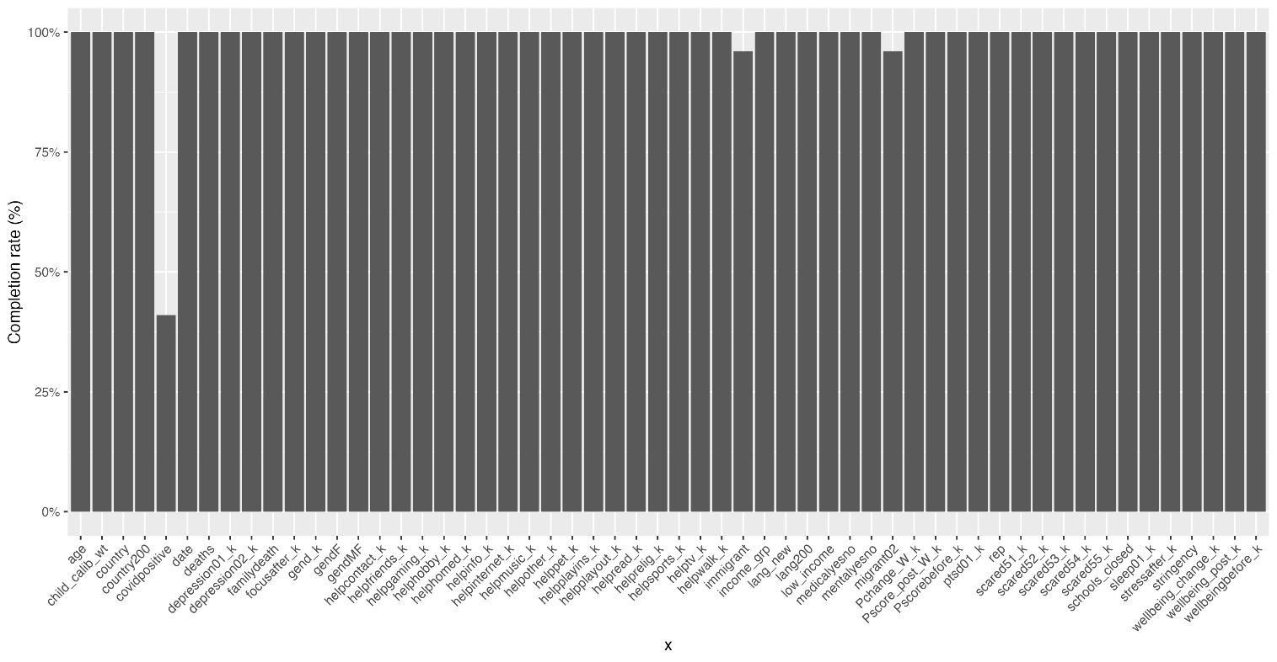

Figure S2. Factor loadings for three model specifications for the P-score in children: A. Unidimensional, B. Correlated-factors, C. Second-order.
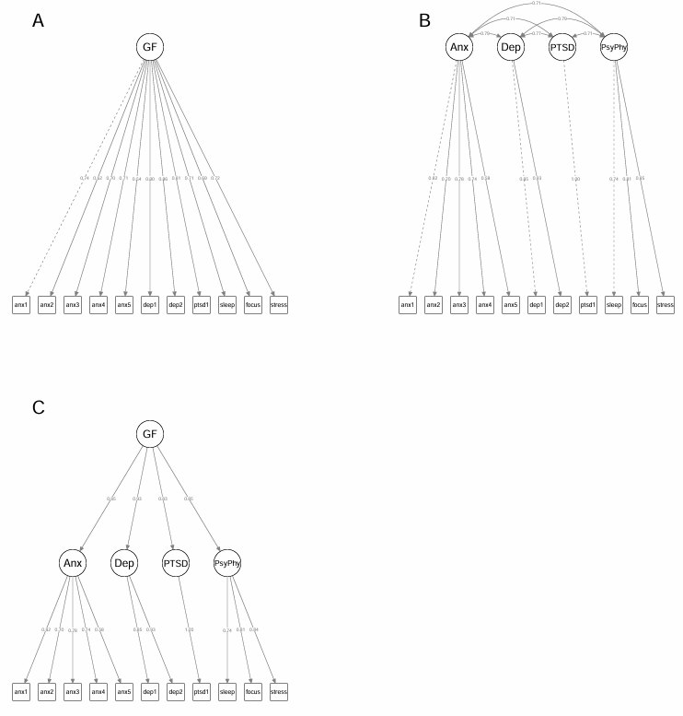
Legend: Key: GF; General factor; Anx: Anxiety; Dep: Depression; PsyPhy: Psychophysiologic. p<.001 for all loadings.
Figure S3. Pre-pandemic WHO-5 well-being scores across different periods of survey administration, in children.

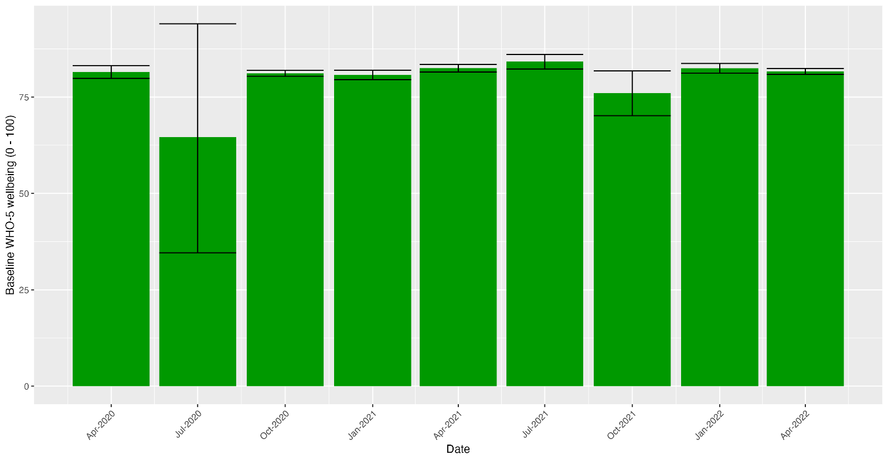

Figure S4. Pre-pandemic P_{C}-score across different periods of survey administration in children.

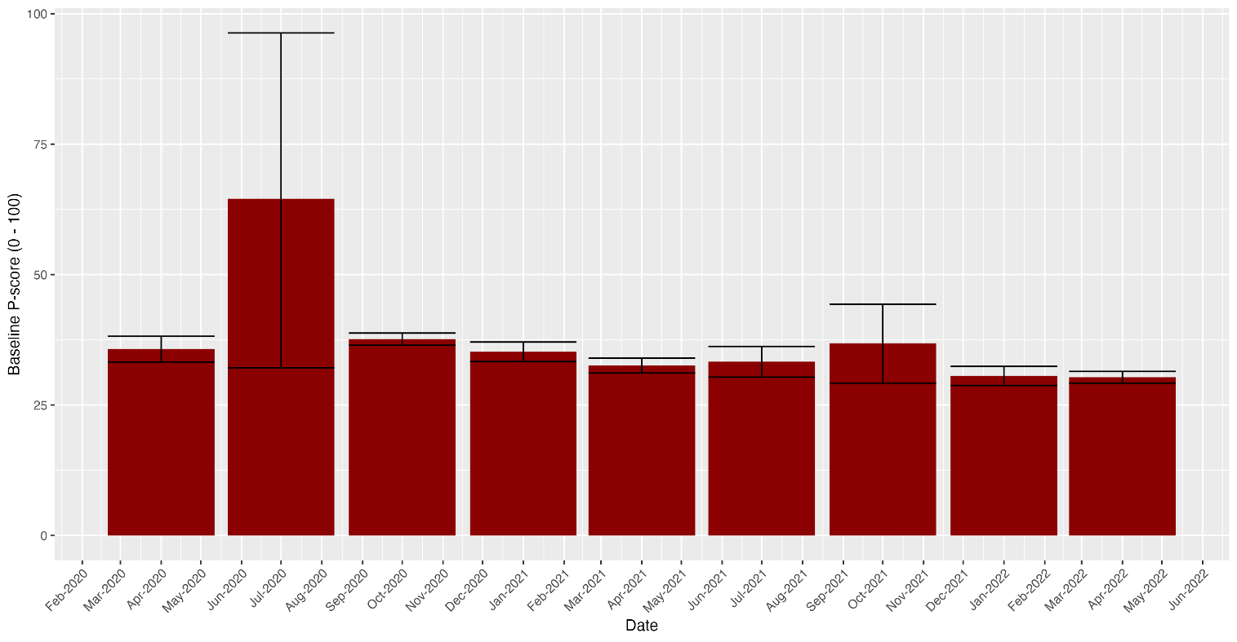

Figure S5. Regression slopes estimating pre- vs. intra-pandemic change in WHO-5 scores estimated from random effects intercept model.

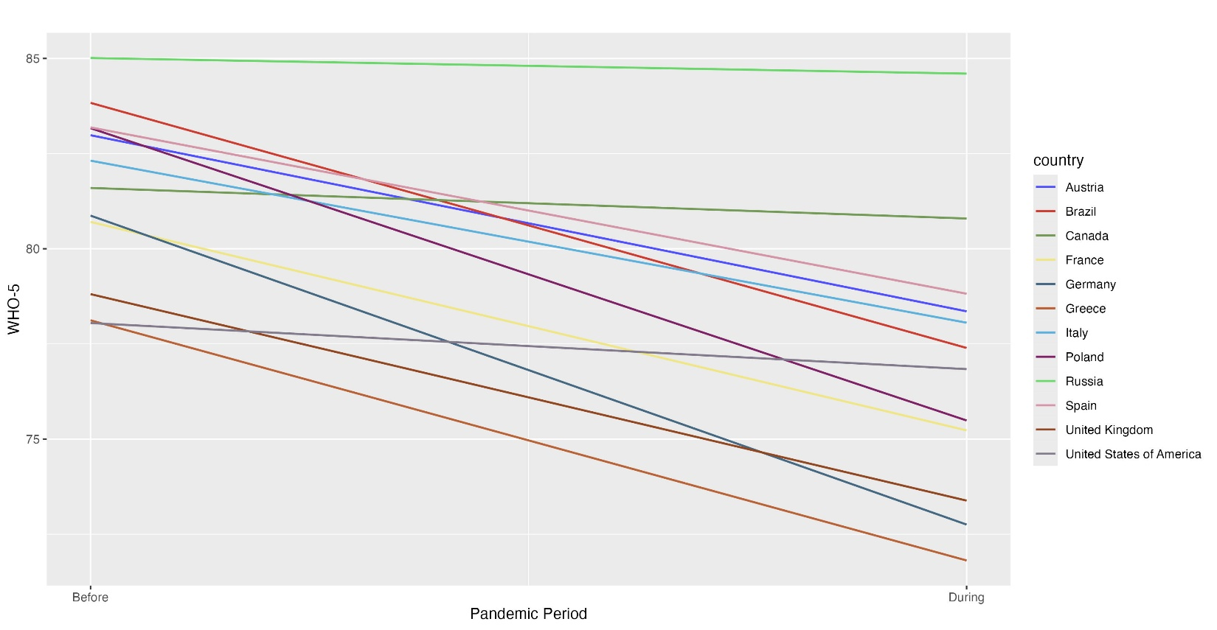

Figure S6. Regression slopes estimating pre- vs. intra-pandemic change in P_{C}- scores estimated from random effects intercept model.
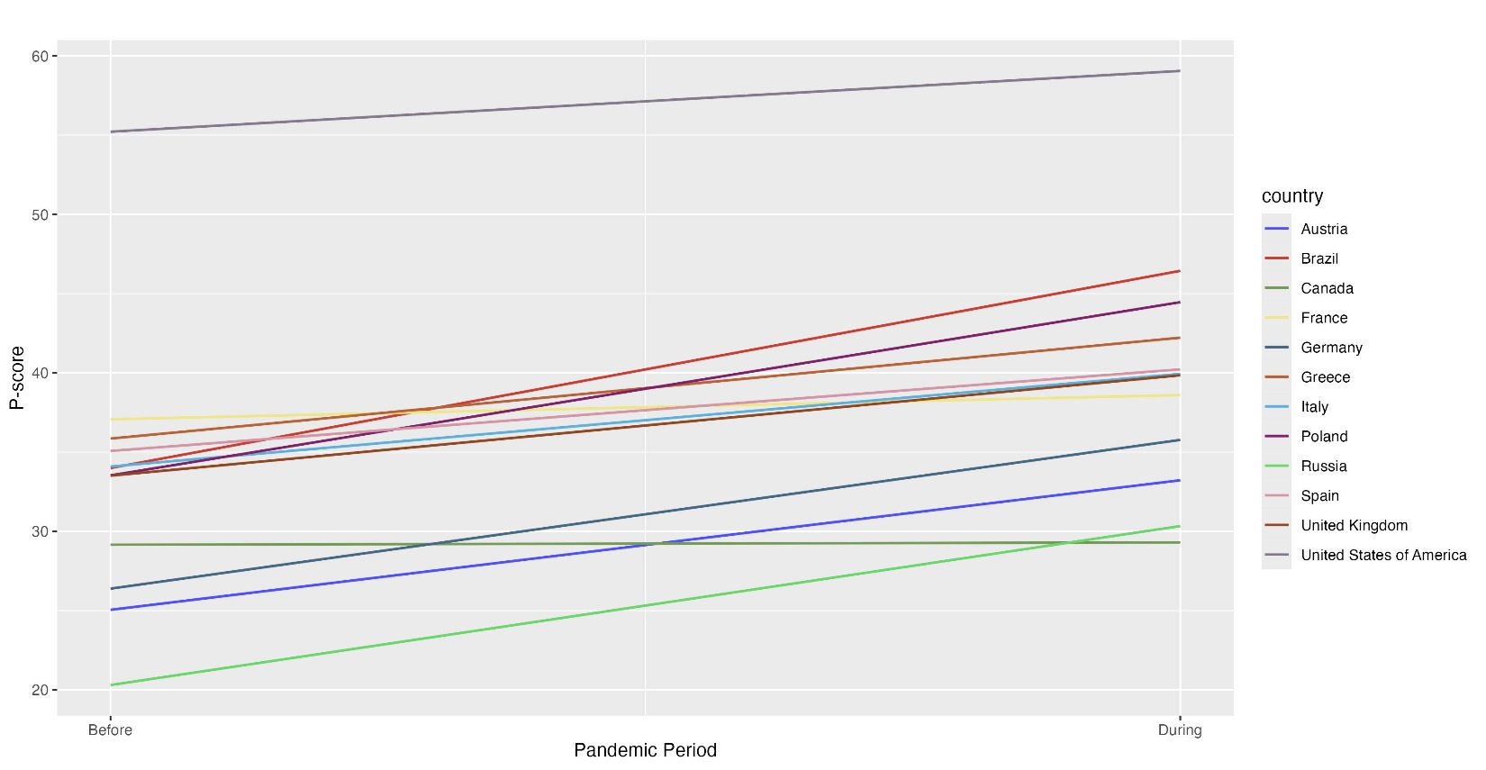

Table S1. Variables used to identify risk factors, and COVID-19 pandemic course
Category | Variable | Item | Response_Options
Demographic
Age | age | How old are you? (in years) | -
First-generation immigration status | country | What country/territory do you live in now? | -
First-generation immigration status | migrant02 | In which country were you born? | -
Gender | gend | What is your gender? | 1, Male  2, Female  3, Other
Enviromental_Clinical
School closure | schoolsclosed_ad | In the last two weeks, which of the following have been closed due to the COVID-19 pandemic? | 1, Schools  2, Restaurants or bars  3, Shops other than food  4, Entertainment (cinema, theatre, sport, etc.)
COVID-19 infection | covidpositive | Did you test positive?* | 1, Yes  0, No
Physical disorder | medicalyesno | Have you ever been diagnosed with a medical disease by a health care professional? | 1, Yes  0, No
Mental disorder | mentalyesno | Have you ever been diagnosed with a mental health conditions by a doctor or psychologist? | 1, Yes  0, No
COVID-19-related loss | familydeath | Has anybody close to you died because of COVID-19? | 1, Yes  0, No
* If responded >0 on “How many times have you been tested for COVID-19?”

Table S2. Fit indices for the three candidate P_{C}-score models.
Model | df | χ² | CFI  (robust) | RMSEA (scaled) | SRMR | BIC
Unidimensional | 44 | 3143.243 | 0.876 | 0.108 | 0.060 | 611760
Second-order | 41 | 595.962 | 0.979 | 0.047 | 0.031 | 607713
Correlated factors | 39 | 596.033 | 0.979 | 0.049 | 0.031 | 607725

Table S3. Loading of COH-FIT P_{C}-score items across genders in children
Domain | COH-FIT Items | Boys | Girls | Difference
Anxiety | Anxiety Item 1 | .83 | .81 | .02
Anxiety | Anxiety Item 2 | .74 | .67 | .07
Anxiety | Anxiety Item 3 | .80 | .75 | .05
Anxiety | Anxiety Item 4 | .75 | .72 | .03
Anxiety | Anxiety Item 5 | .61 | .54 | .07
Depression | Depression Item 1 | .86 | .84 | .02
Depression | Depression Item 2 | .94 | .91 | .03
Post-traumatic | PTSD Item 1 | 1 | 1 | 0
Psychophysiologic | Sleep Item 1 | .75 | .72 | .03
Psychophysiologic | Focus Item 1 | .80 | .82 | -.02
Psychophysiologic | Stress Item 1 | .86 | .83 | .03

Table S4. Reliability estimates* for COH-FIT P_{C}-score general and domain-specific factors in children
 | Anxiety | Depression | Psychophysiologic | Total
alpha | .85 | .88 | .84 | .92
omega | .85 | .88 | .84 | .94
*We do not report results on PTSD as it is composed of 1 item only.

Table S5. Measurement invariance analysis for the with fit statistics for across countries, survey languages and gender.
 |  | Fit |  |  | Change in fit
 | df | CFI | SRMR | RMSEA | ΔCFI | ΔSRMR | ΔRMSEA
Country¹
Configural | 492 | .961 | .090 | .071
Metric | 602 | .977 | .059 | .050 | .016 | -.031 | -.021
Scalar | 668 | .961 | .065 | .061 | -.016 | .006 | .011
Language²
Configural | 410 | .977 | .059 | .057
Metric | 500 | .978 | .055 | .049 | .001 | -.004 | -.008
Scalar | 554 | .966 | .078 | .059 | -.012 | .023 | .010
Gender³
Configural | 82 | .984 | .029 | .047
Metric | 92 | .983 | .034 | .046 | -.001 | .005 | -.001
Scalar | 98 | .982 | .035 | .046 | -.001 | .001 | .000

¹Spain (N=1250), Germany (N=771), United Kingdom (N=585), Austria (N=532), United States of America (N=515), Brazil (N=504), Italy (N=488), Poland (N=391), Canada (N=325), France (N=246), Greece (N=242), Russia (N=218)
²English (N=1335), Spanish (N=1250), German (N=771), Austria (N=532), Brazil (N=504), Italian (N=488), Polish (N=391), French (N=336), Greek (N=242), Russian (N=218)
³Male (N=3308), Female (N=2753)

Table S6. Correlations across WHO-5 well-being score and P_{C} total score and domain scores.

 | WHO-5 | P_{C} (Total) | P_{C} (Anx) | P_{C} (Dep) | P_{C} (PTSD) | P_{C} (Pp)
WHO-5 | [.92] | -
P_{C} (Total) | - .46 | [.92]
P_{C} (Anx) | - .30 | .82 | [.85]
P_{C} (Dep) | - .45 | .87 | .68 | [.88]
P_{C} (PTSD) | - .37 | .85 | .66 | .69 | [ - ]
P_{C} (Pp) | - .52 | .84 | .61 | .68 | .66 | [.84]

Legend: Correlations across WHO-5 wellbeing and P_{C}-score total score and domain scores with tau reliability coefficients in diagonals (Cronbach’s alpha given for the WHO-5 wellbeing scale CFA was performed only for the P_{C} scale). All correlations were highly statistically significant (p < .001). P_{C}-Domains: Anx: Anxiety; Dep: Depression; Pp: Psychophysiologic; PTSD: posttraumatic.

Table S7. Changes in WHO-5 well-being and P_{C}-scores across risk groups in children.
 |  |  |  | Pre-pandemic |  | Intra-pandemic |  | Weighted change
Outcome | Risk Factor | Group | N | M | SD | M | SD | M | Lower CI | Upper CI | p
WHO-5 | COVID-related loss | No  Yes | 5,620  447 | 81.8 | 15.6 | 76.9 | 18.5 | -5.0 | -5.6 | -4.3 | .074
 |  |  |  | 79.5 | 16.8 | 75.9 | 18.2 | -3.7 | -6.0 | -1.4
P_{C}-score | COVID-related loss | No  Yes | 5,620  447 | 32.3 | 22.6 | 39.0 | 23.5 | 6.7 | 5.9 | 7.6 | . 202
 |  |  |  | 51.2 | 26.8 | 58.8 | 26.0 | 7.7 | 4.2 | 11.1
WHO-5 | COVID test status | Negative  Positive | 1,792  679 | 81.8 | 15.4 | 77.2 | 18.3 | -4.6 | -5.7 | -3.5 | .103
 |  |  |  | 80.2 | 16.9 | 76.6 | 19.4 | -3.6 | -5.5 | -1.7
P_{C}-score | COVID test status | Negative  Positive | 1,792  679 | 33.5 | 23.5 | 40.0 | 24.4 | 6.5 | 4.9 | 8.1 | <.001
 |  |  |  | 35.9 | 26.6 | 44.9 | 25.7 | 9.1 | 6.3 | 11.8
WHO-5 | Gender | Female  Male | 2,753  3,308 | 81.3 | 15.9 | 75.9 | 19.1 | -5.4 | -6.3 | -4.5 | .004
 |  |  |  | 82.0 | 15.5 | 77.7 | 17.9 | -4.4 | -5.2 | -3.6
P_{C}-score | Gender | Female  Male | 2,753  3,308 | 33.2 | 22.7 | 41.1 | 23.5 | 7.8 | 6.6 | 9.0 | <.001
 |  |  |  | 34.0 | 24.1 | 39.8 | 24.8 | 5.9 | 4.7 | 7.0
WHO-5 | School closure | No  Yes | 3,699  2,368 | 82.5 | 15.4 | 78.2 | 17.8 | -4.3 | -5.1 | -3.6 | <.001
 |  |  |  | 80.4 | 16.0 | 74.7 | 19.3 | -5.7 | -6.8 | -4.7
P_{C}-score | School closure | No  Yes | 3,699  2,368 | 30.7 | 22.4 | 37.3 | 23.3 | 6.7 | 5.6 | 7.7 | .418
 |  |  |  | 38.4 | 24.5 | 45.4 | 24.8 | 7.0 | 5.6 | 8.4
WHO-5 | Mental disorder | No  Yes | 5,679  388 | 82.3 | 15.2 | 77.6 | 17.8 | -4.7 | -5.3 | -4.1 | .049
 |  |  |  | 72.8 | 19.7 | 65.8 | 23.3 | -7.1 | -10.1 | -4.0
P_{C}-score | Mental disorder | No  Yes | 5,679  388 | 32.5 | 23.0 | 39.0 | 23.6 | 6.5 | 5.6 | 7.3 | <.001
 |  |  |  | 50.7 | 24.6 | 61.8 | 22.8 | 11.3 | 8.0 | 14.7
WHO-5 | Physical condition | No  Yes | 5,621  446 | 81.9 | 15.5 | 77.3 | 18.1 | -4.7 | -5.3 | -4.0 | .001
 |  |  |  | 78.4 | 17.4 | 70.8 | 21.8 | -7.6 | -10.2 | -5.0
P_{C}-score | Physical condition | No  Yes | 5,621  446 | 32.8 | 22.9 | 39.2 | 23.6 | 6.5 | 5.6 | 7.3 | <.001
 |  |  |  | 44.9 | 27.3 | 56.0 | 25.8 | 11.2 | 7.7 | 14.6
WHO-5 | Immigrant status | No  Yes | 5,374  427 | 81.7 | 15.8 | 77.0 | 18.4 | -4.7 | -5.4 | -4.1 | .184
 |  |  |  | 81.6 | 16.1 | 75.9 | 19.4 | -5.8 | -8.2 | -3.4
P_{C}-score | Immigrant status | No  Yes | 5,374  427 | 33.6 | 23.6 | 40.3 | 24.3 | 6.8 | 5.9 | 7.7 | .757
 |  |  |  | 34.1 | 23.7 | 40.6 | 24.5 | 6.6 | 3.4 | 9.8
Legend. LCI: lower confidence interval limit; M: mean; N: sample size, SD: standard deviation; UCI: upper confidence interval limit.
Table S8. Percentage of respondents endorsing importance of coping strategies during COVID-19 pandemic in children

Coping Strategy | Not  important | Somewhat  important | Very  important
Contact with my family | 2.0 | 12.8 | 85.2
Contact with my friends | 3.0 | 29.7 | 67.3
Playing outside | 10.7 | 35.3 | 54.0
My pet | 21.5 | 27.0 | 51.5
Internet use | 8.6 | 40.5 | 50.9
Sports or exercise | 11.5 | 39.8 | 48.7
Listening to music | 10.4 | 42.3 | 47.4
Playing inside | 7.7 | 45.0 | 47.3
School work (including home schooling) | 9.1 | 45.4 | 45.5
Television | 10.5 | 45.2 | 44.3
Walking outside | 14.2 | 41.8 | 44.1
Hobby (for example, playing an instrument) | 14.4 | 43.5 | 42.0
Gaming | 17.1 | 41.5 | 41.4
Reading | 15.5 | 46.9 | 37.6
Information on Coronavirus | 23.2 | 51.3 | 25.5
Religion, meditation or spirituality | 49.2 | 33.0 | 17.8
Other | 46.3 | 38.7 | 15.1

Table S9. Funding information of all COH-FIT contributors.

Country-Network | PI | Funding agency/ grant details
Germany | Christoph U. Correll | Department of Child and Adolescent Psychiatry, Psychosomatics and Psychotherapy, Charité Universitätsmedizin, Berlin, Germany
United Kingdom | Samuele Cortese | NIHR Research Professor (NIHR303122) is funded by the NIHR for this research project. The views expressed in this publication are those of the author(s) and not necessarily those of the NIHR, NHS or the UK Department of Health and Social Care. Samuele Cortese is also supported by NIHR grants NIHR203684, NIHR203035, NIHR130077, NIHR128472, RP-PG-0618-20003 and by grant 101095568-HORIZONHLTH- 2022-DISEASE-07-03 from the European Research Executive Agency.
Denmark | Lau Caspar Thygesen | Trygfonden (ID-no.: 151903)
Austria | Harald Aschauer,  Elena Aschauer,  Monika Schlögelhofer | Biopsychosocial Corporation, Vienna, Austria  www.biopsyc.at
Austria | Harald Aschauer,  Elena Aschauer,  Monika Schlögelhofer | Medizinisch-Wissenschaftlicher Fonds des Bürgermeisters der Bundeshauptstadt Wien; Project number: COVID021; (Scientific Funds of the Major of Vienna), Austria
Switzerland | Andres R Schneeberger,  Christian G. Huber,  Gregor Hasler,  Philippe Conus,  Roland von Känel  Udine E. Lange | Psychiatric Services Grisons, Department of Adult Psychiatry; Universitäre Psychiatrische Kliniken Basel (UPK), University of Basel; University of Fribourg, Fribourg Network of Mental Health (RFSM); University of Lausanne, Department of Psychiatry; University Hospital Zurich, Department of Consultation-Liaison Psychiatry and Psychosomatic Medicine  Andres R. Schneeberger, Christian G. Huber, Gregor Hasler, Philippe Conus, Roland von Känel, and Undine E. Lang have contributed funding from non-restricted personal grants for ethics committee approval, translation to Romansch, acquisition of a Swiss representative sample, and acquisition of participants via a letter campaign.
Spain | Gonzalo Arrondo | Department of Health Planning, Evaluation and Knowledge Management, Government of Navarra, Spain  (Ref. 0011-3638-2020-000010)
Canada | Marco Solmi | 2021 Tamarack Ottawa Race
ECNP | Paolo Fusar-Poli | ECNP Prevention of mental disorders and mental health promotion TWG
France | Philip Gorwood,  Marie Odile Krebs,  Pierre Michel Llorca | Fondation FondaMental: specific grant to support Mental Health during pandemic
Japan | Taishiro Kishimoto | Japan Science and Technology Agency (JST), CREST, Grant Number JPMJCR19F4
Bangladesh | Mohammod Golam Rabbani | The National Foundation of Mental Health of Bangladesh
Poland | Karolina Skonieczna-Żydecka | Program of the Ministry of Science and Health Education under the name of “Regional Initiative of Excellence” in 2019-2022 projecy number 002/RID/2018/19 amount of financing 12.000.000 PLN
Italy | Paolo Brambilla | Ministry of Health (Ricerca Corrente), UOC Psichiatria, Fondazione IRCCS Ca’ Granda Ospedale Maggiore Policlinico, Milano
Italy | Marco Solmi,  Angela Favaro | University of Padua, Neuroscience Department, Italy
Japan | Akihiro Takamiya | Grants for International Activities in Medicine and the Life Sciences, Keio University Medical Science Fund (grant number: 99-096-0001)
Italy | Leonardo Zoccante, Marco Colizzi | Veneto Autism Spectrum Disorder Regional Centre at the Integrated University Hospital of Verona, Italy
France | Marie Odile Krebs,  J Bourgin  Philip Gorwood, Pierre Michel Llorca | Institut de Psychiatrie (CNRS 3557)
Poland | Karol Kamiński  Łukasz Kiszkiel  Pawel Sowa | Internal Funds of Medical University in Białystok  Internal statutory grants of Medical University of Bialystok
Iran | Maryam Moghadasin | University of Kharazmi, Tehran, Iran  Dr. Maryam Moghadasin has expensed from her annual research credit( Grant ) equal to 213180000 Rial, received from Kharazmi University, Iran, Tehran. (ID-no.:36694)
South Africa | Soraya Seedat | Stellenbosch University Special VR (RIPS) fund for Covid-19 research and innovation projects
Ireland | Evan Matthews | Waterford Institute of Technology, Research Connexions award. Total award €3,960 (2,460 allocated to COHFIT dissemination)
Cyprus | Emilia Vassilopoulou  Dimitris Efthymiou | Personal funds-Emilia Vassilopoulou & Dimitris Efthymiou
Brazil | Ary Gadelha | PROESQ - Programa de Esquizofrenia da Universidade Federal de São Paulo (UNIFESP)
Taiwan | Kuan-Pin Su | The authors from Taiwan were supported by the following grants: MOST 109-2320-B-038-057-MY3, 109-2320-B-039-066, and 110-2321-B-006-004 from the Ministry of Science and Technology, Taiwan; and ANHRF109-31 from An Nan Hospital, China Medical University, Tainan, Taiwan.
Korea | Jun Soo Kwon  Minah Kim  Tae Young Lee | This research was supported by the Brain Research Program, and Basic Science Research Program through the National Research Foundation of Korea(NRF) funded by the Ministry of Science, ICT &amp; Future Planning (Grant no. 2017M3C7A1029610; 2019R1A2B5B03100844; 2021R1A2C1006718).
Russia | Oleg Papsuev | Future Comes Today Charitable Foundation, Moscow, Russia
Czech Republic | Denisa Mankova | This work was supported by MH CZ – DRO (NUDZ, 00023752)
France | Marie Odile Krebs  J Bourgin | RHU PsyCARE (ANR -18-RHUS-0014) - National Agency for Research
Sweden | Jari Tiihonen | Karolinska Institutet, Stockholm
China | Liye Zou | This study is supported by Start-up Research Grant of Shenzhen University (20200807163056003) and Start-Up Research Grant (Peacock Plan: 20191105534C).
Greece | Agorastos Agorastos | DAAD Academic Scholarship - Research Stays for University Academics and Scientists, 2024 (Award Nr.: 57698956)

Table S10. Conflict of interest statements of all COH-FIT contributors.
Country | Name, Surname | Conflict of interest
Australia | Michael Berk | MB is supported by a NHMRC Senior Principal Research Fellowship (1059660 and 1156072). MB has received Grant/Research Support from the NIH, Cooperative Research Centre, Simons Autism Foundation, Cancer Council of Victoria, Stanley Medical Research Foundation, Medical Benefits Fund, National Health and Medical Research Council, Medical Research Futures Fund, Beyond Blue, Rotary Health, A2 milk company, Meat and Livestock Board, Woolworths, Avant and the Harry Windsor Foundation, has been a speaker for Abbot, Astra Zeneca, Janssen and Janssen, Lundbeck and Merck and served as a consultant to Allergan, Astra Zeneca, Bioadvantex, Bionomics, Collaborative Medicinal Development, Janssen and Janssen, Lundbeck Merck, Pfizer and Servier – all unrelated to this work.
Australia | Scott Teasdale | ST contracts to Nutrition Research Australia. Nutrition Research Australia conducts independent research funded by government and industry bodies including Nestlé, Nutrition Australia, Cereal Partners Worldwide, Cobram Estate and Meat and Livestock Australia.
Austria | Monika Schlögelhofer | MS has received fees from VeraSci for her role as rater and local language expert which is both unrelated to this work.
Brazil | Ary Gadelha | AG has been a consultant and/or advisor to or has received honoraria from Ache, Daiichi-Sankyo, Torrent, Cristália, and Janssen .Not related to this work.
Brazil | Carlos Gustavo Costardi | CGC has been a consultant and/or advisor to or has received honoraria from Aché and Cristália. Not related to this work.
Brazil | Felipe Barreto Schuch | FBS is part supported by CAPES [grant #001]. Felipe Schuch has written one book for commercial publication. FBS led a study funded by FITXR. FBS is on the Editorial Board of Jornal Brasileiro de Psiquiatria, Mental Health and Physical Activity, and The Brazilian Journal of Psychiatry. FBS has received an honorarium from a co-edited academic book on exercise and mental illness. Also, FBS received funds for writing two guides on mental health during the pandemic times from UpJohn.
Canada | Lakshmi N Yatham | LNY has received honoraria or research grants from Abbvie, Allergan, CANMAT, DSP, Intracellular therapies, Lundbeck, Merck, Otsuka, and Sanofi.
Canada | Marco Solmi | MS has received honoraria/served as a consultant/participated to advisory board for Angelini, Lundbeck, Otsuka.
Chile | Nicolas Crossley | NC has received personal fees from Janssen, outside the submitted work.
France | Julie Bourgin | JB has received punctual support for conferences or scientific dissemination from Janssen, Eisai, Otsuka-Lundbeck.
France | Krebs Marie-Odile | MOK has received punctual support for training activities, conferences or scientific dissemination from Janssen, Eisai, Otsuka-Lundbeck..
France | Philip Gorwood | PG received during the last 5 years fees for presentations at congresses or participation in scientific boards from Alcediag-Alcen, Angelini, GSK, Janssen, Lundbeck, Otsuka, SAGE and Servier.
France | Pierre-Michel Llorca | PML has been a consultant and/or advisor to or have received honoraria from: Abbvie, Allergan, Gedeon Richter, Janssen/J&J, Lundbeck, Merck, Otsuka, Recordati, Sanofi, Takeda, and Teva. He provided expert testimony for Janssen.
Germany | Andreas Meyer-Lindenberg | AML has received consultant fees from:  Boehringer Ingelheim, Elsevier, Brainsway, Lundbeck Int. Neuroscience Foundation, Lundbeck A/S, The Wolfson Foundation, Bloomfield Holding Ltd, Shanghai Research Center for Brain Science, Thieme Verlag, Sage Therapeutics, v Behring Röntgen Stiftung, Fondation FondaMental, Janssen-Cilag GmbH, MedinCell, Brain Mind Institute, Agence Nationale de la Recherche, CISSN (Catania Internat. Summer School of Neuroscience), Daimler und Benz Stiftung, American Association for the Advancement of Science, Servier International, Techspert.io  Additionally he has received speaker fees from:  Italian Society of Biological Psychiatry, Merz-Stiftung, Forum Werkstatt Karlsruhe, Lundbeck SAS France, BAG Psychiatrie Oberbayern, Klinik für Psychiatrie und Psychotherapie Ingolstadt, med Update GmbH, Society of Biological Psychiatry, Siemens Healthineers, Biotest AG, International Society of Psychiatric Genetics
Germany | Christoph U. Correll | CUC has been a consultant and/or advisor to or has received honoraria from: AbbVie, Acadia, Alkermes, Allergan, Angelini, Aristo, Boehringer-Ingelheim, Cardio Diagnostics, Cerevel, CNX Therapeutics, Compass Pathways, Darnitsa, Gedeon Richter, Hikma, Holmusk, IntraCellular Therapies, Janssen/J&J, Karuna, LB Pharma, Lundbeck, MedAvante-ProPhase, MedInCell, Merck, Mindpax, Mitsubishi Tanabe Pharma, Mylan, Neurocrine, Newron, Noven, Novo Nordisk,Otsuka, Pharmabrain, PPD Biotech, Recordati, Relmada, Reviva, Rovi, Seqirus, SK Life Science, Sunovion, Sun Pharma, Supernus, Takeda, Teva, and Viatris. He provided expert testimony for Janssen and Otsuka. He served on a Data Safety Monitoring Board for Compass, Lundbeck, Relmada, Reviva, Rovi, Supernus, and Teva. He has received grant support from Janssen and Takeda. He received royalties from UpToDate and is also a stock option holder of Cardio Diagnostics, Mindpax, LB Pharma and Quantic.
Germany | Katharina Domschke | Member of the Janssen  Steering Committee Neurosciences
Greece | Agorastos Agorastos | Honoraria as speaker/consultant and travel support, all unrelated to this work: Johnson & Johnson Hellas, Janssen-Cilag Pharmaceutical SACI, Angelini Pharma Hellas, Bausch Health Hellas Ltd, ELPEN Pharmaceutical Co. Inc. S.A., Lundbeck Hellas S.A., Viatris Hellas Ltd., Pharmaserve-Lilly S.A., iDNA Genomics, Redordatti Hellas Pharmaceuticals.
Greece | Vasilios P. Bozikas | Honoraria as consultant or speaker, all unrelated to this work, from Angelini, Astra Zeneca, Eli Lilly, Elpen, Galenica, Janssen Cilag, Mylan, Lundbeck, Vianex
Hungary | Istvan Bitter | IB has received in the past 5 years honoraria or consultation fees outside of this work from Angelini, Eli Lilly, Gedeon Richter, Hikma Pharmaceuticals, Janssen/Janssen Cilag, Medichem Pharmaceuticals by Unilab and Sun Pharma.
Iran | Maryam Moghadasin | MM has expensed from her annual research credit (Grant) received from Kharazmi University, Iran, Tehran.
Italy | Marco Colizzi | MC has been a consultant/advisor to GW Pharma Limited, GW Pharma Italy SRL, and F. Hoffmann-La Roche Limited, outside of this work
Italy | Nicola Veronese | NV reports personal fees from Mylan, from IBSA, from Fidia, outside of the submitted work
Italy | Paolo Brambilla | PB has participated to advisory board for Lundbeck.
Italy/UK | Paolo Fusar-Poli | PFP has received grant fees from Lundbeck and honoraria from Lundbeck, Menarini and Angelini, outside the current work.
Japan | Shunya Kurokawa | SK has received speaker’s honoraria from Sumitomo Pharma, Meiji-Seika Pharma and Mochida Pharmaceutical
Japan | Taishiro Kishimoto | Dr. Kishimoto has received consultant fees from Sumitomo Pharma, Novartis, Otsuka and speaker’s honoraria from Banyu, Eli Lilly, Sumitomo Pharma, Janssen, MSD, Novartis, Otsuka and Pfizer. He has received grant support from Takeda, Sumitomo Pharma and Otsuka.
Kazakhstan | Saltanat Nurmagambetova | SN has received consultant/speaker’s fees from Janssen
Poland | Igor Łoniewski | Probiotic company (Sanprobi) co-founder and shareholder.
Poland | Wojciech Marlicz | Probiotic company (Sanprobi) co-founder and shareholder; speaker fees in last 5 years from Alfasigma;  European Lifestyle Medicine Organization (ELMO) - country representative for Poland
Portugal | Pedro Morgado | PM has received in the past 3 years grants, CME-related honoraria, or consulting fees from Angelini, AstraZeneca, Bial Foundation, Biogen, DGS-Portugal, FCT, Janssen-Cilag, Gulbenkian Foundation, Lundbeck, Springer Healthcare, Tecnimede and 2CA-Braga.
Portugal | Sofia Brissos | SB was Medical Affairs Manager for Janssen Portugal from 2010–2013, and has received honoraria for lectures and advisory boards for Janssen, Lundbeck, Otsuka, Jaba Recordati and Angelini. She has also had travel expenses supported by Janssen, Lundbeck, Otsuka, Jaba Recordati, and Angelini
Russia | Oleg Papsuev | OP has received honoraria from Lilly, Lundbeck, Servier unrelated to his work
Spain | Antonia San José Cáceres | ASJC has been a consultant for Roche and is currently involved in clinical trials conducted by Servier.
Spain | Celso Arango | CA has been a consultant to or has received honoraria or grants from Acadia, Angelini, Boehringer, Gedeon Richter, Janssen Cilag, Lundbeck, Minerva, Otsuka, Roche, Sage, Servier, Shire, Schering Plough, Sumitomo Pharma, Sunovion and Takeda.
Spain | Covadonga M. Diaz-Caneja | CMDC has received grant support from the Spanish Ministry of Science and Innovation (PI17/00481, PI20/00721, JR19/00024) and has received honoraria from Angelini and Exeltis.
Spain | Eduard Vieta | EV has received grants and served as consultant, advisor or CME speaker unrelated to the present work for the following entities: AB-Biotics, Abbott, Allergan, Angelini, Sumitomo Pharma, Ferrer, Gedeon Richter, Janssen, Lundbeck, Otsuka, Sage, Sanofi-Aventis, Sunovion, and Takeda.
Spain | Gonzalo Arrondo | GA is supported by a grant from the Department of Health Planning, Evaluation and Knowledge Management, Government of Navarra, Spain (Ref. 0011-3638-2020-000010); the Ramón y Cajal grant RYC2020‐030744‐I funded by MCIN/AEI/ 10.13039/501100011033 and by “ESF Investing in your future”; and the 2022-2023 Institute for Culture and Society (ICS) challenge on "Youth, relationships and psychological well-being" of the University of Navarra.
Spain | Mara Parellada | MP has been a consultant to or has received honoraria or grants from Janssen Cilag, Exeltis, Lundbeck, Roche, Sage, Servier, Servier.
Sweden | Björn Gerdle | Grant from Swedish Research Council (Vetenskapsrådet). Participation in a research project funded by Pfizer and Eli Lilly (financial compensation is paid to Lund University Hospital (Clinical registry NRS))
Sweden | Jari Tiihonen | JT has participated in research projects funded by grants from Janssen to his employing institution; has been a consultant to and/or has received honoraria from and/or given expert testimony for and/or received support for attending meetings from Healthcare Global Village, HLS Therapeutics, Janssen, Lundbeck, Orion Pharma, Otsuka, Teva, WebMD Global.
Switzerland | Roland von Känel | RvK has received honoraria from Vifor unrelated to this work
United Kingdom | Joseph Firth | JF is supported by a University of Manchester Presidential Fellowship (P123958) and a UK Research and Innovation Future Leaders Fellowship (MR/T021780/1) and has received honoraria / consultancy fees from Atheneum, Informa, Gillian Kenny Associates, Big Health, Wood For Trees, Nutritional Medicine Institute, Angelini, ParachuteBH, Richmond Foundation and Nirakara, independent of this work
United Kingdom | Samuele Cortese | SC has declared reimbursement for travel and accommodation expenses from the Association for Child and Adolescent Central Health (ACAMH) in relation to lectures delivered for ACAMH, the Canadian AADHD Alliance Resource, the British Association of Psychopharmacology, Healthcare Convention and CCM Group team for educational activity on ADHD, and has received honoraria from Medice.
United States | Daniel Guinart | DG has been a consultant for and/or has received speaker honoraria from Angelini, Janssen, Lundbeck/Lundbeck Foundation, Otsuka, Teva and Viatris.
United States | John Kane | JK has been a consultant and/or advisor for or has received honoraria from Alkermes, Allergan, LB Pharmaceuticals, H. Lundbeck, Intracellular Therapies, Janssen Pharmaceuticals, Johnson and Johnson, Merck, Minerva, Neurocrine, Newron, Otsuka, Pierre Fabre, Reviva, Roche, Sumitomo Pharma, Sunovion, Takeda, Teva and UpToDate and is a shareholder in LB Pharmaceuticals and Vanguard Research Group
United States | Jose Rubio | JR has received honoraria or speaker fees from TEVA, Lundbeck, royalties from UpToDate, research support from Alkermes
Others | All other authors have no conflict of interest to declare
Table S11. STROBE Statement - Checklist for cross-sectional studies and items that are included in our report.
 | Item No | Recommendation
Title and abstract | 1 | (a) Indicate the study’s design with a commonly used term in the title or the abstract | 
Title and abstract | 1 | (b) Provide in the abstract an informative and balanced summary of what was done and what was found
Introduction
Background/rationale | 2 | Explain the scientific background and rationale for the investigation being reported
Objectives | 3 | State specific objectives, including any prespecified hypotheses
Methods
Study design | 4 | Present key elements of study design early in the paper
Setting | 5 | Describe the setting, locations, and relevant dates, including periods of recruitment, exposure, follow-up, and data collection
Participants | 6 | (a) Give the eligibility criteria, and the sources and methods of selection of participants
Variables | 7 | Clearly define all outcomes, exposures, predictors, potential confounders, and effect modifiers. Give diagnostic criteria, if applicable
Data sources/ measurement | 8 | For each variable of interest, give sources of data and details of methods of assessment (measurement). Describe comparability of assessment methods if there is more than one group
Bias | 9 | Describe any efforts to address potential sources of bias
Study size | 10 | Explain how the study size was arrived at
Quantitative variables | 11 | Explain how quantitative variables were handled in the analyses. If applicable, describe which groupings were chosen and why
Statistical methods | 12 | (a) Describe all statistical methods, including those used to control for confounding
Statistical methods | 12 | (b) Describe any methods used to examine subgroups and interactions
Statistical methods | 12 | (c) Explain how missing data were addressed
Statistical methods | 12 | (d) If applicable, describe analytical methods taking account of sampling strategy
Statistical methods | 12 | (e) Describe any sensitivity analyses
Results
Participants | 13 | (a) Report numbers of individuals at each stage of study—eg numbers potentially eligible, examined for eligibility, confirmed eligible, included in the study, completing follow-up, and analysed
Participants | 13 | (b) Give reasons for non-participation at each stage | N/A
Participants | 13 | (c) Consider use of a flow diagram | N/A
Descriptive data | 14 | (a) Give characteristics of study participants (eg demographic, clinical, social) and information on exposures and potential confounders
Descriptive data | 14 | (b) Indicate number of participants with missing data for each variable of interest
Outcome data | 15 | Report numbers of outcome events or summary measures
Main results | 16 | (a) Give unadjusted estimates and, if applicable, confounder-adjusted estimates and their precision (eg, 95% confidence interval). Make clear which confounders were adjusted for and why they were included
Main results | 16 | (b) Report category boundaries when continuous variables were categorized
Main results | 16 | (c) If relevant, consider translating estimates of relative risk into absolute risk for a meaningful time period
Other analyses | 17 | Report other analyses done—eg analyses of subgroups and interactions, and sensitivity analyses
Discussion
Key results | 18 | Summarise key results with reference to study objectives
Limitations | 19 | Discuss limitations of the study, taking into account sources of potential bias or imprecision. Discuss both direction and magnitude of any potential bias
Interpretation | 20 | Give a cautious overall interpretation of results considering objectives, limitations, multiplicity of analyses, results from similar studies, and other relevant evidence
Generalisability | 21 | Discuss the generalizability (external validity) of the study results
Other information
Funding | 22 | Give the source of funding and the role of the funders for the present study and, if applicable, for the original study on which the present article is based

