Presented to the 5th International Symposium on HSR Socioeconomic Impacts at the University of Naples, September 2025.

Estimating travel time savings and modal shift from airlines: a case study of the proposed Kuala Lumpur to Singapore high-speed rail
David Ashmore¹ and Chester Fung1
¹Transportation Research Group, University of Southampton (UK)
d.p.ashmore@soton.ac.uk
chlf1u21@soton.ac.uk
Abstract
A transport mode which has received considerable attention over the preceding three decades is high speed rail (HSR). HSR typically produces considerable travel time savings over airlines for point-to-point travel up to around a threshold of five hours. HSR has been deployed to great effect in many countries – China, Italy, Spain, France, Germany, and the United Kingdom among them. A HSR system which is mooted, but yet to be built, however, it that linking Malaysia’s capital Kuala Lumpur (KL) with the city state of Singapore. In 2023 KL-Singapore became the busiest airline pairing in the world, and the travel volumes and distance involved should offer considerable scope for HSR to unlock socioeconomic and environmental benefits. Despite publicity, political will, and lengthy discussions, however, the project has yet to come to fruition largely due to capital constraints. Whilst private finance has been suggested as a potential way forward, no credible demand forecasts are in the public domain to stimulate the interest of the private sector and alert the respective public sectors as to likely levels of gap funding required. This study attempts to begin this process by placing an indicative level of demand abstraction from airline to HSR into the public research domain. To do this it draws upon two methods which are used to triangulate each other. Firstly, revealed preference through the development of a diversion curve sourced from a literature review and calibrated against two other published airline-HSR time-based diversion curves. Secondly, generalised cost modelling for synthetic trips using a logistic regression model. The findings of the work show an indicative level of demand abstraction to HSR of around two thirds for the journey time mooted; this in turn will unlock significant economic benefits. The research findings will be of interest to the public sector, research community, manufacturers, and potential investors.
Keywords: High speed rail; modal split; airlines; Singapore; Malaysia.

1 Introduction
Travel time saved is a sub-variable of transport generalised cost, a measure of the overall cost of mode of transport compared to another, and a determinant of modal choice. Furthermore, travel time saved is an overall economic benefit – when a person switches from one transport choice to another and saves time, that time is generally reinvested in economic activity, enhanced productivity, and an improvement in quality of life. Moreover, less time spent travelling means lower vehicle operating costs such as fuel and maintenance. For these reasons when evaluating transport infrastructure investment, travel time saved is a critical, and often substantial, variable in the appraisal process.
A transport mode which has received considerable attention over the preceding decades is high speed rail (HSR). HSR typically produces considerable travel time savings over airlines for point-to-point travel up to around a threshold of five hours. Under this threshold when travelling between two cities, the removal of the need to travel considerable distances to and from airports, and expend significant wait times in airport terminal buildings, results in significant volumes of travellers opting for HSR. The time saved by HSR compared to airlines leads to significant economic and social benefits for both business and leisure trips. In addition, the reduced demand for air travel leads to lower carbon emissions and improved health outcomes.
HSR has been deployed to great effect in many countries – China, Italy, Spain, France, Germany, and the United Kingdom among them. A HSR system which is mooted, but yet to be built, however, it that linking Malaysia’s capital Kuala Lumpur (KL) with the city state of Singapore. In 2023 KL-Singapore became the busiest airline pairing in the world, and the travel volumes and distance involved should offer considerable scope for HSR to unlock socioeconomic and environmental benefits. Despite publicity, political will, and lengthy discussions, however, the project has yet to come to fruition largely due to capital constraints. Whilst private finance has been suggested as a potential way forward, no credible demand forecasts are in the public domain to stimulate the interest of the private sector and alert the respective public sectors as to likely levels of gap funding required.
This study attempts to begin this process by placing an indicative level of demand abstraction from airline to HSR into the public research domain. To do this it draws upon two methods which are used to triangulate each other. Firstly, revealed preference through the development of a diversion curve sourced from a literature review and calibrated against two other published airline-HSR time-based diversion curves. Secondly, generalised cost modelling for synthetic trips using a logistic regression model. The findings of the work show an indicative level of demand abstraction to HSR of around two thirds for the journey time posited. This would in turn will unlock significant economic benefits. The research findings will be of interest to the public sector, research community, manufacturers, and potential investors.

2 Literature background

2.1. Economic links
The Klang Valley, where Kuala Lumpur (KL) is situated, has a population of approximately nine million); Singapore (SG) has around 6 million residents (Sdos, 2024). Given these significant numbers, passenger movement between Malaysia and Singapore has always been high, especially during long weekends and public holidays. The KL-SG route is one of the busiest in the Southeast Asia corridor (Kikuchi and Tanahashi, 2018; DOSM, 2024).
Moreover, Singapore and Kuala Lumpur have strong economic links. Over, 1.18 million Malaysians are working in Singapore (Ho and Tyson, 2011). The total level of exports from Malaysia to Singapore reached £39.7 billion in 2023, making Singapore the second largest trading partner for Malaysia from 2013 onwards (MATRADE, 2024). As of 2023, Malaysia’s largest source of foreign investment was from Singapore totalling £4.09 billion, in sectors such as manufacturing, real estate, and infrastructure (DOSM, 2024). In addition, Malaysia is launching a National Energy Transition Roadmap aiming to attract investment in renewable energy projects, electric car manufacturing and charging infrastructure, and this is expected to foster further collaboration between, creating job opportunities which will increase the travel demand between both cities (Kasim et al., 2024; Lee et al., 2025). Table 1 shows Malaysia’s total trade with key partners (in US$ million) 1981-2022 (Pritish and Francis, 2023). Given the significant economic and cultural ties between the two countries facilitating travel between them remains an ongoing and crucial task.

Table 1: Malaysia’s total trade with key partners (in US$ million), 1981-2022. Source: Pritish and Francis, 2023

2.2. Transport modes
Airlines provide the fastest mode of travel allowing passengers to travel between KL and SG in around an hour. During the low season low-cost carriers offer fares as low as RM78 (£14), making air travel not only the quickest but often the most affordable option for single travellers. This makes flying a very attractive choice especially for business travellers who value time. Driving by car offer flexibility and comfort between the two cities, particularly for families. It allows for point-to-point travel without schedule limitations, unlimited luggage capacity, and the convenience of stopping as desired. The typical one-way route from KL to SG follows the North-South Expressway (NSE), as shown in Figure 1. The total cost for a one-way trip for a group of five is approximately £47, covering fuel, toll fees, VEP and ERP charges, however, travellers must apply for the Singapore VEP pass at least two weeks prior to the departure date (LTA Singapore, 2025). Alternatively, bus or coach services provide the most cost-effective road transport option, with frequent departures every 15 minutes during peak hours; sixteen bus companies operate this route (RedBus,2025). Congested road traffic can, however, increase travel times by more than 50% during long weekends and public holidays, which can in turn heavily disrupt travel plans and trip reliability (Taylor, 2013).

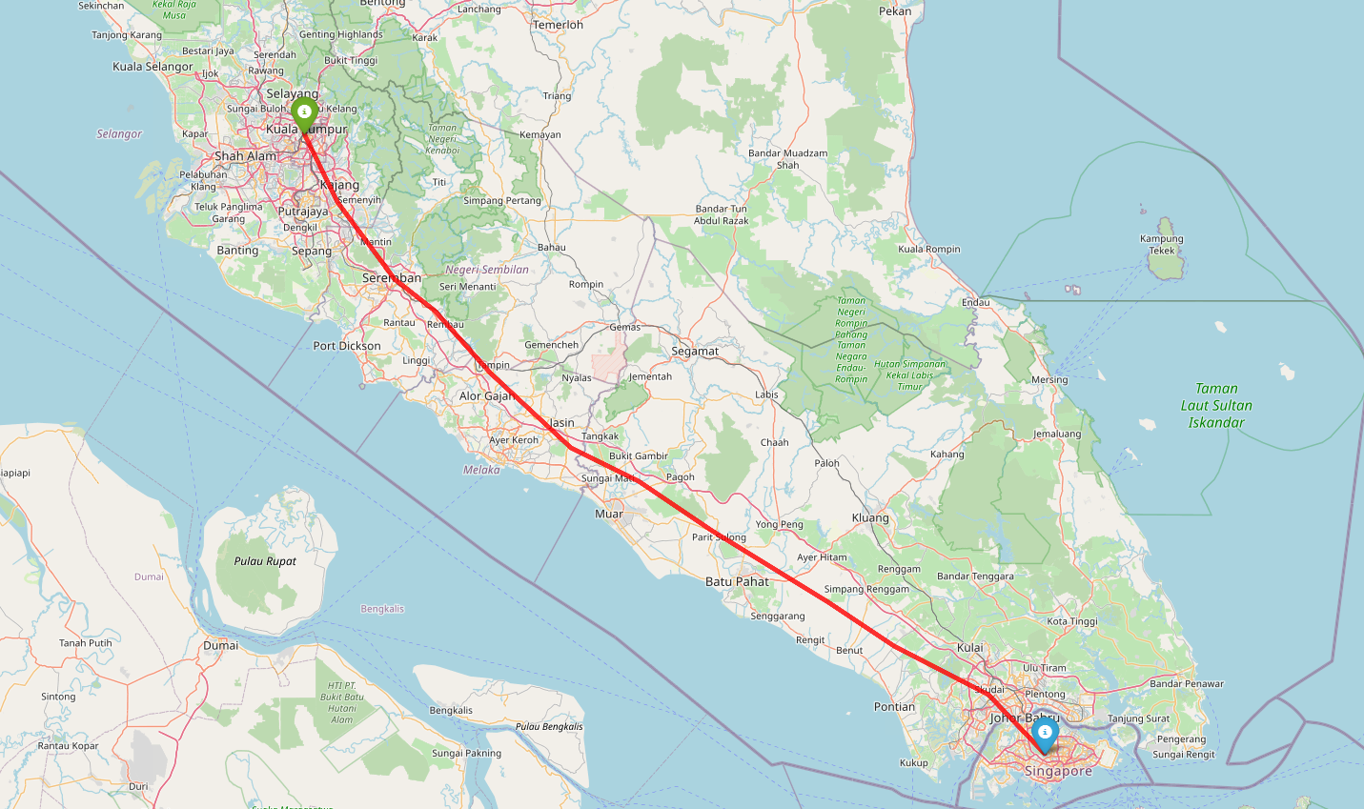
Figure 1: Map of Malaysia and Singapore generated using OpenStreetMap data © OpenStreetMap contributors, licensed under the Open Database License (ODbL).
The current train service operated by Keretapi Tanah Melayu (KTM) is arguably the least favourable among all the modes of transportation. Despite a single ticket only costing RM39 (£7), the rail service is hindered by long travel times, a need for three transfers, and a limited frequency of only three trains per day in each direction (Nurbaya et al., 2025). This inconvenience makes the train service less attractive than air travel; it certainly does not offer the efficiency and convenience that is required for business travel (Bachok et al., 2013; Lee, 2002).
It is also difficult for rail transport to compete with private cars for long-distance trips. This is partly due to a cultural preference for driving in Malaysia, with car ownership being around 73%, and petrol being heavily subsidised by the government (Al-Hussein et al., 2021; Ward et al., 2021). Unless the rail service between KL and SG improves it seems that almost all the current travel market between the two cities will continue to use the more polluting modes of airline and road transport. This is neither good for air quality or the economic and cultural growth of both cities.

2.3. High speed rail
Elsewhere, high speed rail (HSR) has acted as a solution to such issues. By offering higher speeds and greater efficiency than regular stopping rail services, within the countries it has been deployed HSR has significantly affected the travel demand market for both business and leisure travellers. HSR has been deployed to great effect around the world. Examples are below:
- Japan’s high-speed rail - the Shinkansen - began operation in 1964 and is the first high-speed rail system in the world (Takatsu, 2007). The Shinkansen, which travels between Osaka and Tokyo, has reduced travel time by up to 62.8% compared to conventional lines (Takeda, 2024). Cities with HSR stations have experience a 16-34% higher employment rate and a 22% higher population growth compared to cities without HSR stations. The improved connectivity encouraging businesses and industries to set up operation and manufacturing, leading to job creation and economic development (Rungskunroch et al., 2021).
- Spain’s high-speed rail has significantly boosted tourism in the country. Provinces with HSR stations, such as Barcelona have experienced an increase of 53.8% in passengers since the HSR was launched (Albalate and Fageda, 2016). HSR has improved accessibility across Spain, leading to better territorial cohesion - regions that were previously less accessible are now more integrated into the national economy (Monzon et al., 2019). Furthermore, HSR has help redistribute economic activity to more rural areas promoting growth in these regions (Cobos and Escribano, 2023).
- China’s high-speed rail has an extensive coverage of 45,000km (Scio, 2024). The presence of HSR has led to the growth of commercial and business districts around HSR stations, and the improved HSR network has helped reduce urban-rural income inequality by promoting industrial upgrading (Liu and Lin, 2024). Improvement in HSR has also facilitated production agglomeration, expanded market boundaries and economic activity spaces and accelerated the urbanisation of surrounding rural region, eventually reducing the urban-rural income gap (Yunyun and Guo, 2024).
- With the construction of the Atlantic TGV line in France, weekly commuters have transitioned to daily commuting (Blanquart and Koning, 2017). The TGV has created 14,000 jobs, generated £1.3 billion in production, and added £623 million in value after the completion of the HSR between Tours and Bordeaux (Blanquart and Koning, 2017). The Paris-Lyon HSR line has spurred regional and urban investment, particular benefiting consultancies and hotel businesses (Chen and Hall, 2015). In terms of the environment, HSR generates only 2.7 grams of CO2 per km per person between Paris and Marseille, compared to 115.7 grams for individual cars and 153 grams for airplanes (Eprs, 2015).

2.4. High speed rail between Kuala Lumpur and Singapore
A plan for a 350 km long HSR linking KL and SG has been under discussion since 2013 (Toh, 2021), and a bilateral agreement was signed in 2016 by the Prime Ministers of Singapore and Malaysia (MyHSRcorp, 2016). The link is likely to include several smaller cities along a west coast route thereby enhancing connectivity between KL and the surrounding regions (Ward et al., 2021).
Despite early momentum, following a change in the Malaysian government in 2018, the project was scrapped due to high costs, later revived, and again terminated in 2020 as both governments failed to reach an agreement (Salim, 2025). In 2024 the Malaysian and Singaporean governments agreed to revive the project as a public private partnership (PPP) and three biding consortia have been shortlisted, although the Malaysian government has stated it will not provide financial support to any bidding consortia (Salim, 2025).
A key issue with a PPP based on a build operate transfer (BOT) model is whether or not to include revenue risk in the procurement model. By doing so the concessionaire would be able to pay off some (although not all) of the build costs. It may be difficult, however, for the general public when debating the best use of their tax revenues to understand this and the viability and fundability of the scheme, as there are no publicly available or defensible, demand and revenue forecasts, nor estimations of modal shift from airlines based on travel time savings (see Figure 2).
This absence of market shift projections has significant implications. If demand is lower than expected the degree to which the revenue generated does not cover the initial investment and ongoing operational costs remains unclear. Significant shortfalls would increase the government's burden by necessitating greater subsidies and the diversion of funds from other essential services (Chen et al., 2014). In addition, investments in facilities may be underutilised leading to potentially reduced service frequency, and anticipated reductions in pollution may not materialise. Conversely, if demand exceeds expectations HSR could severely impact airlines and airports, possibly leading to financial difficulties or bankruptcy for struggling airlines and downsizing at airports (Scotti and Volta, 2017).
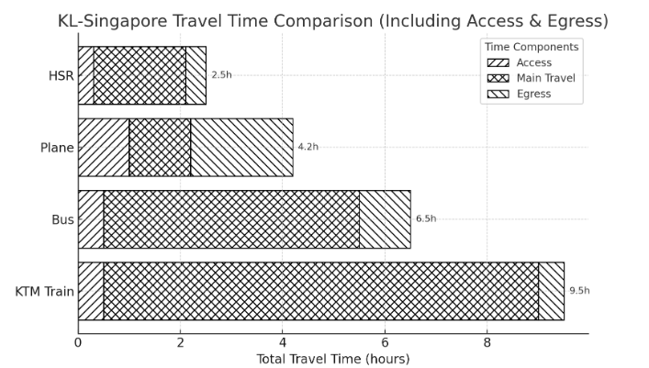
Figure 2: Travel comparison between KTM, bus, plane and HSR. Source: Business Today Editorial, 2024
Given the criticality of modal shift driven by travel time savings, this study focuses on the question: ‘what is the likely impact of the proposed High-Speed Rail between Kuala Lumpur and Singapore in terms of diversion of trips from airlines based upon travel time savings?’

3 Methodology
The study method is shown in Figure 3. The first stage was to assess if there were any demand and mode split forecasts in either the public domain or in the academic literature. Several credible academic databases were scanned - Google Scholar, Science Direct, and Scopus using keyword searches. General internet research was also undertaken examining sources such as the Malaysia and Singapore statistics department, government report, consultancy reports, media and news resources such as CNA, The Star, New Straits Times. After this the authors were able to verify that no existing journal papers or public documents specifically addressed the impacts of HSR on the point-to-point aviation market between KL and SG. Several studies discussed the general impacts of HSR on airlines in other regions (Purba et al., 2021) but whilst these provide useful insights, they could not be directly applied to the KL-SG HSR route due to differences in geographic, economic, and cultural factors (Zhang et al., 2019).
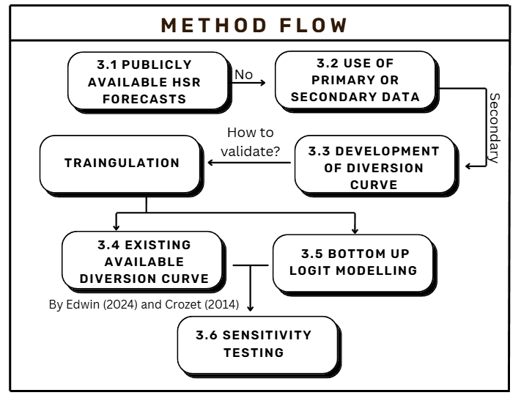
Figure 3: Flow of methodology.
Given the timeframe of the study and the available resources undertaking stated preference surveys in Malaysia was not possible. To make credible estimates therefore it was decided to source secondary data on the revealed impacts of HSR elsewhere. Following this the authors were able to examine the independent variables which are likely to have driven these impacts, and then develop a set of diversion curves to estimate the travel time savings and mode shift for the KL – SG HSR. It is noted that utilising secondary data presents downsides such as a lack of locational relevance and absence of direct application to a specific research question (Smith, 2008).
International HSR demand models and reports were examined for benchmarking including key references such as ‘Demand Forecast of Jakarta- Surabaya HSR’ (Lubis et al., 2019) and ‘Mode-choice model for HSR in Hungary’ (Hegedüs, 2022). Data influencing the HSR market share was extracted, including travel time, routing, and fare costs (Koopmans et al., 2013). A filtering process was then employed to exclude outdated datasets, such as the Taipei-Kaohsiung route (which indicated a 38.2% market share for airlines in year 2007 to 2008 by Jeng and Su [2013]).
The curated point-to-point dataset was then plotted using Python code to examine the variables influencing market share including travel time, and excess HSR travel time compared to airlines. The authors further benefited from being able to source an HSR modal shift benchmarking dataset from a researcher in Australia (Crozet, 2014). This was used to further triangulate the primary diversion curve which compared modal diversion to HSR from airlines based on travel time and excess travel time.
This ‘top down’ results from the diversion curves could then be triangulated using bottom-up modelling using a logit model and generalised costs developed for a series of hypothetical trips with differing values of time and fares. Generalised cost for airline and HSR trips was calculated using fare and time-based components with values of time sourced from the UK Government’s WebTAG (Department for Transport, 2024) and converted to Malaysian dollars using the GDP ratio shown in Table 2.
Country | GDP per capita  (in billion) | Value of Time per hour (£)
United Kingdom | 64.38 | 17.22
Malaysia | 43.10 | 11.53
Table 2: Calculation on the VoT per hour for Malaysia using GDP per capita. Source: International Monetary Fund, 2025
Ten hypothetical sample trips were developed for the KL-SG route – five each for business and leisure travellers. Each hypothetical trip considered an individual's journey from their origin e.g. home, to their final destination which could be a workplace or holiday destination. The mode constants used for both business and leisure travellers were assumed to be the same. Due to the lack of a directly applicable local model parameters were sourced from a model from Riyadh shown in Table 3 (Anwar et al., 2023).
Choice attributes | Coefficient
Wait time for the mode | -0.112
Travel time of the mode | -0.069
Modal Constant for HSR | -0.415
Table 3: Coefficients for choice attributes. Source: Anwar et al., 2023
To undertake sensitivity analysis a ±10% was independently applied to the time and cost variables on both diversion curves and logit models. The results were then assessed to determine the sensitivity of the predicted HSR market share to changes in time and cost.

4 Results

4.1. Estimated travel time savings
The scheme proponents moot a HSR travel time of 90 minutes between KL and SG, and the actual ‘in air’ flight time is already well established at 60 minutes. As is universal for all HSR schemes therefore, there are no travel time savings ‘in vehicle’ when considering HSR versus airlines. The value proposition of HSR comes with lessening the wait times and likely the access and egress times. Airports are often located further from city centres than high speed rail stations (which are typically in the city centre), and the time taken to pass through an airport security, wait for a flight, and reclaim bags is often far in excess of an in-station equivalent. Add to this the values of time for waiting and access and egress being double or more than in-vehicle (Wardman, 2004) and the attractiveness of HSR to a threshold of around three hours becomes clear (Nash, 2015).
The ten synthetic trips are shown in Table 4. As demonstrated (except for Trips 1 and 9, originating and terminating at destinations close to each airport) the travel time savings for the whole trip chain when traveling by HSR is significant - in this instance between 1 and 77 minutes. The advantages arise primarily from HSR having a relatively shorter “in-station” time of around 60 minutes, compared to longer airport processing times, as well as HSR stations being situated closer to urban areas. For the purposes of reading from the diversion curves, however, the original 90-minute HSR trip time and 30-minute excess ‘in vehicle’ travel were used, although it should be noted that driving the effects of each of these modal shifts is a built-in average excess trip time for the other portions of the trip chain.

Trip # | Mode | Est. % of total market | Access time (mins) | Egress time (mins) | Total time (mins) | Travel time savings (mins)
1 | HSR | 76% | 48 | 24 | 222 | -19
1 | Air | 24% | 26 | 27 | 203 | -19
2 | HSR | 100% | 26 | 19 | 195 | 46
2 | Air | 0% | 37 | 24 | 241 | 46
3 | HSR | 97% | 28 | 27 | 205 | 31
3 | Air | 3% | 48 | 8 | 236 | 31
4 | HSR | 99% | 26 | 30 | 206 | 15
4 | Air | 1% | 13 | 58 | 221 | 15
5 | HSR | 100% | 29 | 43 | 222 | 22
5 | Air | 0% | 14 | 50 | 244 | 22
6 | HSR | 99% | 25 | 23 | 198 | 1
6 | Air | 1% | 13 | 36 | 199 | 1
7 | HSR | 86% | 17 | 30 | 197 | 0
7 | Air | 14% | 22 | 25 | 197 | 0
8 | HSR | 100% | 13 | 19 | 182 | 77
8 | Air | 0% | 30 | 49 | 259 | 77
9 | HSR | 22% | 42 | 29 | 221 | -20
9 | Air | 78% | 22 | 29 | 201 | -20
10 | HSR | 66% | 51 | 34 | 235 | 18
10 | Air | 34% | 54 | 19 | 253 | 18
Table 4. Estimated market share and travel time savings for the 10 synthetic trips.

4.2. Estimated modal shift from airlines using diversion curves
The primary diversion curve comparing HSR and air travel was developed based on a comprehensive meta literature review, as detailed in Section 3 and summarised in Table 5 for both actual and excess travel times. Using travel times of 90 and 60 minutes, the corresponding modal shift to HSR was then estimated, with the results shown in Figures 4 and 5.
Figure 6 and 7 compares the developed curve with graphs created by Edwin, 2024 and Crozet, 2014. The diversion forecasted by the primary diversion curve is shown to be 66.8%, around two thirds of the demand.
 | Ref. | Country | Route | Travel  Time (HSR, Hrs) | Travel  Time (Air, Hrs) | Rail market  share increase (%)
1 | Jiménez and Betancor (2012) | Spain | Madrid - Barcelona | 2.48 | 1.25 | 0.17
2 | Chen  (2017) | China | Wuhan -  Guangzhou | 3.3 | 1.83 | 0.45
3 | Chen  (2017) | China | Beijing -  Shanghai | 4.3 | 1.92 | 0.34
4 | Baek (2014) | Korea | Seoul-Busan | 2.6 | 1.08 | 0.59
5 | Oyabu et al. (2018) | Japan | Tokyo-Toyama | 2.23 | 1 | 0.54
6 | Givoni (2006) | France | Paris-Lyon | 1.93 | 1.17 | 0.24
Table 5. Simplify version of the data point collected from the literature review.
Figure 4: Graph of HSR market share to travel time.

Table 6: Market Share Predictions for HSR Travel Time using Exponential and Logistic Regression Models
 | Equation | Predicted Market Share (%)
Exponential Curve | $$y=1.2166e^{-0.4x}$$ | 66.77
Logistic Regression Curve | $$y=1-\frac{0.88}{{1+e}^{0.87∙\left(x-2.13\right)}}$$ | 67.95

Figure 5: Graph of HSR market share to HSR excess time over air.
Table 7: Market Share Predictions for HSR excess Travel Time over Air using Exponential and Logistic Regression Models.
 | Equation | Predicted Market Share (%)
Exponential Curve | $$y=0.4783e^{-0.176x}$$ | 43.80
Logistic Regression Curve | $$y=1-\frac{0.85}{{1+e}^{-0.53∙\left(x-0.25\right)}}$$ | 54.82

Figure 6: Graph of rail market share to travel time (Edwin, 2024).

Table 8: Rail Market Share Predictions for Rail excess Travel Time over Air using Exponential and Logistic Regression Models (Edwin, 2024)
 | Equation | Predicted Market Share (%)
Exponential Curve | $y=0.9824e^{-0.226x}$ | 69.99
Logistic Regression Curve | $$y=1-\frac{0.87}{{1+e}^{-1.03∙\left(x-3.36\right)}}$$ | 88.81

Figure 7: Graph of rail market share to rail excess time over air (Crozet, 2014).
Table 9: Rail Market Share Predictions for Rail Travel Time using Exponential and Logistic Regression Models (Crozet, 2014)
 | Equation | Predicted Market Share (%)
Exponential Curve | $y=0.485e^{-0.004x}$ | 82.41
Logistic Regression Curve | $$y=1-\frac{0.93}{{1+e}^{-1.14∙\left(x-1.76\right)}}$$ | 81.98

4.3. Triangulation using a logit model
The results of the diversion curves were validated through the logit modelling of a series of hypothetical trips for differing origin-destination pairs for two market segments: business and leisure travel. Kuala Lumpur International Airport and Changi Airport were assumed for scheduled airlines, and Subang Airport and Seletar Airport for low-cost carriers. The estimated trips used 5 trips for low cost carriers and 5 for scheduled with an equal split for business and leisure travel. The market share used for leisure and business travellers was 80% and 14%, respectively (Pang, 2017).
The choice model coefficients for time and cost were taken from Riyadh (Anwar et al., 2023) due to there being no equivalent data for Malaysia. For each hypothetical trip the utility of HSR and airline was calculated by multiplying the cost and time for each component by this model’s respective coefficient. The utility values were then used to estimate the probability of each mode choice. At an estimated 65.7% the logit model predictions aligned well with the outputs of the diversion curve.

4.4. Sensitivity testing
Sensitivity testing assessed how a 10% change in key variables - HSR travel time, HSR time excess, cost of travel, and the value of time (VoT) - influenced predicted HSR market share.

Table 10: Summary on the diversion curve with a $±$10%
 | Dataset from literature Review |  |  |  |  | Edwin, 2024 |  |  | Crozet, 2014
 | Travel Time |  | Excess Time |  |  | Travel Time |  |  | Excess Time
 | 10% | 10% | 10% |  | 10% | 10% |  | 10% | 10% |  | 10%
 | HSR Market Share
Logistic Regression Curve | 0.65 | 0.70 | 0.54 | 0.55 |  | 0.87 | 0.90 |  | 0.81 | 0.83
Exponential curve | 0.63 | 0.70 | 0.43 | 0.44 |  | 0.68 | 0.72 |  | 0.81 | 0.84
Table 10 shows an 10% increase or decrease in travel time has a minimal impact on the predicted market share. This demonstrates the robustness of the model and ensures stability under minor fluctuations for the input variables. Conversely, Table 11 shows that a 10% increase in travel time will result in a significant drop in market share compared to cost. This high sensitivity to travel time reflects the fact that business travellers are likely to prioritise punctuality.
The authors would conclude that based on the analysis should HSR be implemented, there would be around two thirds demand abstraction from airlines. This would have significant implications across transport, economic, and environmental domains. These are discussed in the next section.

5 Discussion and conclusions

5.1.1 Impact on airlines
A diversion of two thirds of passengers to HSR would substantially disrupt both low-cost and scheduled airlines. Business travellers are expected to prefer HSR due to shorter door-to-door journeys and city-centre connectivity. Consequently, scheduled airlines such as Malaysia Airlines and Singapore Airlines may face greater losses than Low-Cost Carriers (LCCs) serving more flexible leisure markets. To mitigate these impacts, airlines could pursue either HSR–airline integration (using airports as intermodal hubs - similar to Frankfurt), or route restructuring -reallocating resources to long-haul or underserved destinations.
Table 11: Summary on the logit model with a ±10%
Trips No. | Predicted HSR  Market Share | HSR Travel Time |  | HSR Cost
Trips No. | Predicted HSR  Market Share | +10% | -10% | +10% | -10%
1 | 37% | 14% | 67% | 26% | 48%
2 | 97% | 91% | 99% | 96% | 98%
3 | 52% | 24% | 79% | 41% | 64%
4 | 97% | 91% | 99% | 95% | 98%
5 | 67% | 37% | 88% | 56% | 77%
6 | 83% | 59% | 95% | 76% | 89%
7 | 53% | 25% | 80% | 41% | 65%
8 | 100% | 100% | 100% | 100% | 100%
9 | 5% | 1% | 15% | 3% | 8%
10 | 66% | 36% | 87% | 54% | 76%

5.1.2. Impacts on LCC Airports
Subang Skypark and Seletar Airports, which primarily serve LCCs and short-haul flights, would experience some decline in passenger traffic, retail activity, and terminal revenue. One option of mitigating these is for the airports to ramp up maintenance, repair and overhaul (MRO), and cargo operations.

5.1.3 HSR funding and financial model
Based on the projected diversion rates and 615,000 passengers in 2021 (Wahab et al., 2024), for a one-way fare estimate of RM140 (£25) the rough annual fare revenue would be RM85 million (£15 million) compared with operating costs of RM60 million (£11 million), This, however remains substantially below the RM2.4 billion (£421 million) in annual revenue required to recover the RM70 billion (£12 billion) capital investment over a 30-year period. As expected the HSR will need capital support to build the project - from government or through a privately funded infrastructure concession. The structure of this funding model needs further analysis.

5.1.4 Reduction in pollution
The aircrafts operating the route include the Boeing 737, 737 MAX, Airbus A320, and A320 NEO. According to the International Civil Aviation Organization (ICAO) each Kuala Lumpur–Singapore flight emits 2,398 kg of CO₂ (est. £623 per flight), whereas HSR emits only 90 kg per trip (est. £23 by Hiroshima University, 2025). Therefore, although the initial outlay to build the HSR is sizeable, the long-term environmental benefits are substantial and would contribute to national decarbonisation goals.

5.2 Limitation and further research
This study relies on secondary data and assumptions that may not fully reflect traveller behaviour. Furthermore, factors such as airline loyalty programmes, government policies, and dynamic HSR pricing would need to be considered in further analysis. Future studies should deploy stated preference surveys to gauge localised demand parameters and more detailed cost-benefit analyses that differentiate between peak and off-peak demand, incorporate realistic pricing strategies, and show a comprehensive business case.

6. Conclusions
This study has evaluated the potential impacts of the proposed Kuala Lumpur–Singapore (KL–SG) HSR on air travel demand, and estimated a substantial two thirds modal shift from air to rail. Validation using Edwin's travel time model and Crozet's excess time model (70.0% and 82.4% respectively), along with a ‘bottom-up’ value estimated using ten synthetic trip scenarios and an imported logit model (65.7%) confirmed that the two thirds estimate is well-grounded in other work.
These findings indicate HSR would affect low-cost and scheduled airlines with scheduled carriers likely to experience greater losses. This modal disruption presents opportunities for intermodal cooperation, where airlines and HSR integrate services or restructure routes to improve efficiency.
Beyond its transport implications, the HSR project offers substantial environmental and economic benefits. It can significantly reduce carbon emissions compared to short-haul flights and contribute to national sustainability goals whilst also promoting cross-border trade, tourism, and regional development. A robust financial model will be essential to securing the investment needs to build the link.
Future research should incorporate stated preference surveys and detailed cost-benefit analyses to refine demand forecasts and pricing strategies. Overall, the proposed HSR represents a transformative step toward sustainable regional integration between Malaysia and Singapore, enhancing mobility, economic growth, and environmental performance.
References
- Kikuchi, T., Tanahashi, A., 2018. Profitability of the Kuala Lumpur-Singapore High Speed Rail.
- DOSM, 2024. Department of Statistics Malaysia. URL https://www.dosm.gov.my/portal-main/release-content/statistics-of-foreign-direct-investment-fdi-in-malaysia- .
- Matrade, 2024. Trade Performance for Year 2023 and December 2023 – Matrade. https://www.matrade.gov.my/en/about-matrade/media/press-releases/press-release-2024/6055-trade-performance-for-year-2023-and-december-2023.
- Ho, Y.-J., Tyson, A.D., 2011. Malaysian migration to Singapore: Pathways, mechanisms and status. Malays. J. Econ. Stud. 48, 131–145.
- Matrade, 2024. Trade Performance for Year 2023 and December 2023 – Matrade, https://www.matrade.gov.my/en/about-matrade/media/press-releases/press-release-2024/6055-trade-performance-for-year-2023-and-december-2023.
- Pritish, B., Francis, H., 2023. (PDF) Singapore - Malaysia Economic Ties: Recovering from COVID-19. ResearchGate.
- LTA Singapore, 2025. LTA | Cars and Motorcycles Registered in Malaysia.
- Taylor, M.A.P., 2013. Travel through time: the story of research on travel time reliability. Transp. B Transp. Dyn. 1, 174–194. https://doi.org/10.1080/21680566.2013.859107
- Nurbaya, S., Mustafa, M., Haron, S., Rusli, R., 2025. Service quality attributes affecting the satisfaction of KTM Komuter services: Transportation Planning and Technology: Vol 48 , No 1.
- Lee, T., 2002. An analysis of the demand for passenger rail services in peninsular Malaysia/Lee Tick Seng.
- Ward, A.A.-H., Laiha, M.K., Lip, Y.P., 2021. Investigating the Effect of Social and Cultural Factors on Drivers in Malaysia: A Naturalistic Driving Study. URL https://www.mdpi.com/1660-4601/18/22/11740
- Takatsu, T., 2007. Japan Railway & Transport Review No. 48 (pp.6–21 URL. https://www.ejrcf.or.jp/jrtr/jrtr48/f06_tak.html.
- Rungskunroch, P., Jack, A., Kaewunruen, S., 2021. Socioeconomic Benefits of the Shinkansen Network. Infrastructures 6, 68. https://doi.org/10.3390/infrastructures6050068
- Albalate, D., Fageda, X., 2016. High speed rail and tourism: Empirical evidence from Spain. Transp. Res. Part Policy Pract. 85, 174–185. https://doi.org/10.1016/j.tra.2016.01.009
- Monzon, A., Lopez, E., Ortega, E., 2019. Has HSR improved territorial cohesion in Spain? An accessibility analysis of the first 25 years: 1990–2015. Eur. Plan. Stud. 27, 513–532.
- SCIO, P., 2024. Operator: China’s high-speed rail network 80% complete | english.scio.gov.cn [WWW Document]. URL http://english.scio.gov.cn/pressroom/2024-01/11/content_116934128.html
- Liu, T.-Y., Lin, Y., 2024. Is the High-Speed Railway Network Narrowing the Urban‒Rural Income Gap? Appl. Spat. Anal. Policy 18, 20. https://doi.org/10.1007/s12061-024-09622-6
- Yunyun, W., Guo, J., 2024. Factor Mobility, Boundary Internalization and Market Integration: Evidence from China’s High-Speed Railway. https://doi.org/10.2139/ssrn.4829781
- Blanquart, C., Koning, M., 2017. The local economic impacts of high-speed railways: theories and facts. Eur. Transp. Res. Rev. 9, 1–14. https://doi.org/10.1007/s12544-017-0233-0
- Chen, C.-L., Hall, P., 2015. Chapter 20: High-speed trains and spatial-economic impacts: a British–French comparison on two scales: intra- and inter-regional.
- Toh, T.W., 2021. Timeline of events for terminated KL-Singapore HSR project. Straits Times.
- MyHSRcorp, 2016. KL-SG HSR Bilateral Agreement Signing - Events | MyHSR Corporation.
- Chen, M., Tang, H., Zhang, K., 2014. Some Critical Issues in the Development of Chinese High-Speed Rail: Challenges and Coping Strategies. J. Transp. Technol. 4, 164–174. https://doi.org/10.4236/jtts.2014.42017
- Scotti, D., Volta, N., 2017. Profitability change in the global airline industry. Transp. Res. Part E Logist. Transp. Rev. 102, 1–12. https://doi.org/10.1016/j.tre.2017.03.009
- Smith, E., 2008. Pitfalls and Promises: The Use of Secondary Data Analysis in Educational Research. Br. J. Educ. Stud. 56, 323–339.
- Lubis, H. al-Rasyid, Pantas, V.B., Farda, M., 2019. Demand Forecast of Jakarta-Surabaya High Speed Rail based on Stated Preference Method. Int. J. Technol. 10, 405. https://doi.org/10.14716/ijtech.v10i2.2442
- Hegedüs, M., 2022. Mode-Choice Model for High-Speed Railway in Hungary Using Stated Preference Data.
- Koopmans, C., Groot, W., Warffemius, P., Annema, J.A., Hoogendoorn-Lanser, S., 2013. Measuring generalised transport costs as an indicator of accessibility changes over time. Transp. Policy 29, 154–159. https://doi.org/10.1016/j.tranpol.2013.05.005
- Anwar, A.M., Toasin Oakil, A., Muhsen, A., Arora, A., 2023. What would it take for the people of Riyadh city to shift from their cars to the proposed metro? Case Stud. Transp. Policy 12, 101008. https://doi.org/10.1016/j.cstp.2023.101008

(https://www.myhsr.com.my/kl-sg-hsr/project-overview; https://www.airasia.com/flights/).

