State Tomography of Toroidal Light Pulses
Luka Vignjevic¹, Yijie Shen², Nikitas Papasimakis¹ and Nikolay I. Zheludev¹
¹ Optoelectronics Research Centre & Centre for Photonic Metamaterials, University of Southampton, Southampton, UK
² Centre for Disruptive Photonic Technologies & The Photonics Institute, Nanyang Technological University, Singapore

E-mail: l.vignjevic@soton.ac.uk

Received xxxxxx
Accepted for publication xxxxxx
Published xxxxxx
Abstract
Toroidal pulses, also known as Focused or Flying Doughnuts (FDs), are few-cycle doughnut-shaped pulses of doughnut-like topology that exhibit space-polarisation and space-time couplings resulting in skyrmionic field configurations and regions of energy backflow, while their light-matter interactions involve toroidal and non-radiating (anapole) excitations. In this work, we experimentally generate optical toroidal pulses and analyze their space-polarization and space-time couplings using tomographic techniques. Using tandem projective measurements in the space and polarization degrees of freedom, we characterize the spatially varying polarization of the pulses, whereas space-time nonspeparability is characterized by measuring the angular divergence of the pulse monochromatic components. Space-time and space-polarization nonseparabilty are quantified by concurrence and fidelity (with respect to the ideal pulses). Experimentally generated pulses show high fidelity values of 0.88 and 0.72 for their space-polarization and space-time couplings, respectively. The reported results will be of interest to the fundamental study of toroidal pulses and spatiotemporally structured light more broadly, enabling applications in telecommunications, spectroscopy, metrology, and imaging.

Keywords: toroidal pulses, space-time nonseparability, tomography, optical skyrmions

1. Introduction

Light pulses of toroidal topology, resembling Flying or Focused Doughnuts (FDs), were introduced in 1996 by Hellwarth & Nouchi [1], emerging from a wider family of localised pulses derived by Ziolkowski, known as the modified power spectrum pulses [2]. FDs are exact solutions to Maxwell’s equations exhibiting space-time and space-polarization nonseparable structure, such that the pulse spatial profile is intrinsically linked to the temporal and polarization profile. They were observed for the first time recently in the optical and THz parts of the spectrum [3, 4], followed by demonstration at microwave frequencies [5]. All-optically controlled schemes for the generation of THz FDs were also recently demonstrated [3]. FDs or toroidal light pulses (TLPs) complete toroidal electrodynamics as the propagating counterparts of toroidal excitations in matter [6]. They exhibit a fine topological structure with multiple singularities and extended areas of energy backflow [7]. Their light-matter interactions are non-trivial and they are predicted to efficiently engage non-radiating charge-current configurations [8]. Recently, FDs were generalized to the family of supertoroidal pulses of which they are the fundamental member. Supertoroidal pulses exhibit intriguing topological properties, including skyrmionic behaviour and self-affine areas of energy backflow [9] that can persist upon propagation over arbitrary distances [10].
The exotic properties of toroidal pulses are intricately linked to their space-polarization and space-time nonseparable nature [11]. Thus, in contrast with homogeneously polarized light, FDs cannot be represented by the product of a polarization dependent and a spatially dependent function. Previous work has shown that this is similar to a two qubit system describing a particle where entanglement exists between two degrees of freedom [12, 13]. Thus a space-polarization nonseparable state can be expressed as
 | $$Ψ=α\left|U_{R},\left.R\right\rangle \right.+βe^{iφ}\left|U_{L},\left.L\right\rangle \right.,$$ | (1)
where the right and left hand circular polarization basis states involve different spatial amplitude modes, thus they can not be factorised into a product of each other. The possible states of this superposition can be represented and visualized by a higher order Poincaré sphere [14, 15]. On the other hand, correlations between spatial and temporal frequencies of light (space-time nonseparability) can result in desirable propagation properties [16, 17]. Due to such properties, nonseparable light could have wide applications in areas such as metrology [18, 19], sensing [20] and communication [21, 22].
In the context of toroidal light pulses, space-polarization nonseparability manifests in the form of vectorial (radial or azimuthal) polarization and longitudinal field components emerging from the toroidal topology of the pulse. Space-time (or equivalently space-frequency) coupling leads to spatially varying spectral structure, which is known to control the propagation dynamics of pulses [23]. Whereas the fundamental FD is isodiffracting [17], namely the pulse propagates without distortion in its spatio-spectral structure, supertoroidal pulses propagate without diffraction [10]. Thus, quantitatively characterizing the nonseparable properties of toroidal pulses is crucial for the study of their propagation dynamics and light-matter interactions, as well as their deployment in practical applications. However, characterization methods to date are complex and rely on capturing the instantaneous fields with high temporal and spatial resolution [24], which is particularly challenging at optical frequencies.
There have been recent developments, where Digital Micromirror Devices (DMDs) or Spatial Light Modulators (SLMs) are used to make projections onto different spatial modes of the light, performing a modal decomposition [25-29]. When such measurements are made in tandem with polarization projections, the space polarization coupling of the light can be fully characterized [30, 31]. However, this tomography method has only been applied to characterize monochromatic beams and not been adapted yet to broadband ultrashort pulses. Furthermore, methods have been developed to evaluate the space-time coupling of electromagnetic pulses, where the transverse positions of the intensity peaks for each monochromatic component of the pulse are measured as a function of propagation distance. This allows the degree of coupling between space and time to be quantified [32].
Here, we apply a state tomography approach to the characterization of space-polarization and space-time nonseparability of experimentally generated toroidal pulses. Using space-polarization and space-time tomography on the different monochromatic components of the generated pulse, we quantify the strength of the nonseparability by concurrence, in the space-polarization and space-time domains, respectively, while we measure the similarity to the ideal FD pulses by fidelity. Our work provides a practical route to the characterization of nonseparability of toroidal pulses and will be of interest to the fundamental study of structured light pulses and for the applications of toroidal pulses in information and energy transfer.
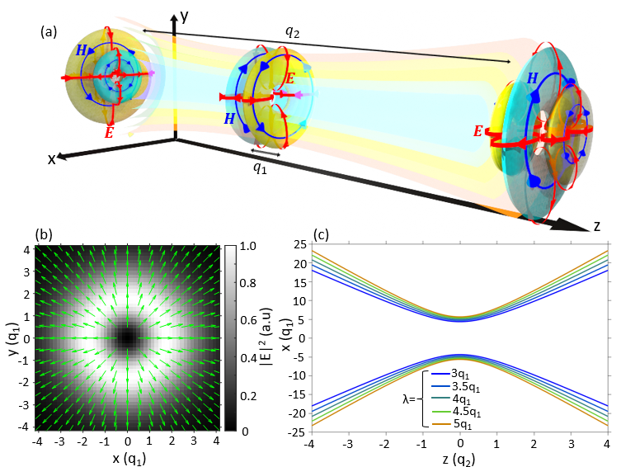
Figure 1. (a) Schematic of a radially polarized (TE) Flying Doughnut pulse as it propagates through the focused region, where q₁ is the pulse length (effective wavelength) and q₂ is the Rayleigh range. Due to a Gouy phase shift, the pulse duration evolves from 1½-cycles away from focus to single-cycle at focus. (b) Intensity (grey-scale image) and polarization (green arrows) profile of the FD in the transverse plane. The spatially varying polarization is a manifestation of the space-polarization nonseparability in the FD. (c) Evolution upon propagation of the intensity maxima positions in the transverse plane (xy plane in (a)) for different monochromatic components of the pulse. All monochromatic components of the pulse propagate with the same Rayleigh range, a behaviour known as isodiffraction.

2. Generation of Toroidal Light Pulses
The electric and magnetic fields of transverse magnetic (TM) toroidal pulses is given by [1]:
 | $$E_{ρ}=-4if_{0}\sqrt{\frac{ϵ_{0}}{μ_{0}}}\frac{ρ\left(q_{2}-q_{1}-2iz\right)}{{\left[ρ^{2}+\left(q_{1}+iτ\right)\left(q_{2}-iσ\right)\right]}^{3}},$$ | (2)
 | $$E_{z}=4f_{0}\sqrt{\frac{ϵ_{0}}{μ_{0}}}\frac{ρ^{2}-\left(q_{1}+iτ\right)\left(q_{2}-iσ\right)}{{\left[ρ^{2}+\left(q_{1}+iτ\right)\left(q_{2}-iσ\right)\right]}^{3}},$$ | (3)
 | $$H_{θ}=4{if}_{0}\frac{ρ\left(q_{2}-q_{1}-2iz\right)}{{\left[ρ^{2}+\left(q_{1}+iτ\right)\left(q_{2}-iσ\right)\right]}^{3}},$$ | (4)

where $τ=z-ct$, $σ=z+ct$, $q_{1}$ is a parameter with units of length that plays the role of effective wavelength, $q_{2}$ defines the depth of the focused region analogous to the Rayleigh range of a Gaussian pulse. Such pulses are radially polarized with longitudinal electric field components (see Figs. 1a&b) and transverse magnetic fields (TM). The vector nature of the polarization is a form of space-polarization nonseparability, where polarization varies with spatial position. Transverse electric (TE), azimuthally polarized, toroidal pulses can be derived with an exchange of electric and magnetic fields in Eq. (3), resulting in azimuthally polarization and longitudinal magnetic field components. As the pulse propagates through the focus, its temporal structure changes from 1 ½ cycle with 3 lobes to 1 cycle with 2 lobes at focus, then back to 1 ½ cycle with reversed polarity, a consequence of the Gouy phase shift [33]. Toroidal pulses are space-time nonseparable, whereby the pulse frequency spectrum varies across the transverse plane. This is illustrated schematically in Fig. 1c, where the trajectories of the intensity maxima of different monochromatic components of the pulse are presented. All monochromatic components of the pulse propagate with the same Rayleigh range, resulting in correlations between frequency and angular dispersion, where the higher the frequency, the lower the angular dispersion. Thus, higher frequency components of the pulse are located nearer the center, while lower frequencies are further out. These properties result in an effect known as isodiffraction [34], where each frequency component of the pulse retains the same relative position with respect to the other frequencies, rendering the spatio-spectral profile of the pulse propagation invariant. Conversely, toroidal pulses can be constructed by a series of in-phase, coaxially propagating, monochromatic azimuthally or radially polarised cylindrical vector beams with the same focal plane and Rayleigh range [17].
The experimental setup for the generation of TLPs is outlined in Fig. 2.(a). A Ti:Sa laser, produces linearly polarized, 10 fs pulses with a FWHM bandwidth of 105 nm, centred at 800 nm. The pulses first pass through a pulse compressor, that applies a spectral phase to pre-compensate for the dispersion of optical components further along the beam path, ensuring that all monochromatic components of the pulse will be in-phase upon entering the characterization part of the setup. The pulses then pass through a 2x beam expander before entering a half-wave plate followed by a segmented waveplate, which converts the input linearly polarized pulses into radially polarized ones. Finally, a pair of off-axis parabolic mirrors and a 100 μm pinhole spatially filter the generated pulse and reduce the spectral dispersion of its Rayleigh range (which is linked to the pulse space-time nonseparability).
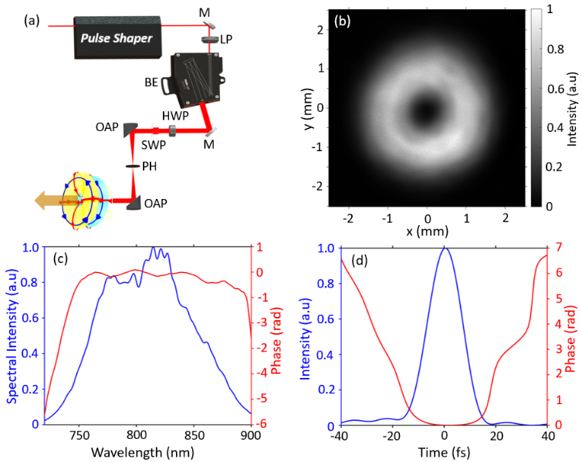
Figure 2. (a) Experimental setup for the generation of toroidal pulses. A 10 fs pulse from a Ti:Sa laser passes through a pulse shaper and a linear polarizer (LP) to remove any pulse ellipticity, before entering a 2x beam expander (BE). A half wave plate (HWP) selects the polarization that enters the segmented waveplate (SWP), which then converts linear polarization to radially or azimuthal. The vector polarized pulse is then passed through a spatial filter consisting of two off axis parabolic mirrors (OAPs) and a pinhole (PH) that removes scattering related artefacts and collimates the pulse. (b) Intensity profile of the generated pulse after collimation. (c-d) Spectral and temporal forms of the generated pulse as obtained by SPIDER measurements.
An image of the experimentally generated pulse is shown in Fig. 2b. The spectrum of the experimentally generated pulses, with the corresponding spectral phase, measured using an FC SPIDER (Spectral Phase Interferometry for Direct Electric field Reconstruction) is given in Fig. 2c. The FWHM of the spectrum was found to be 90 nm, centred at around 805nm and the spectral phase was found to be relatively flat with phase fluctuations under 1 radian over a 150 nm wavelength range. This corresponds closely to the ideal FD pulse, which has a flat spectral phase and indicates the pulse is compressed close to the Fourier limit. Time domain measurements were also collected using the SPIDER and presented in Fig. 2d, showing the pulse envelope and corresponding phase. The pulses have a FWHM duration of 15 fs, which equates to approximately 6 optical cycles. The asymmetry in the phase of the pulse (see Fig. 2d) stems from challenges in effective pulse compression at lower intensities (at the wings of the pulse), where the signal to noise ratio is low. In contrast to our earlier work [4], the generation of toroidal pulses here does not employ a metasurface element following recent observations of the “self-healing” propagation dynamics of imperfect toroidal pulses [5].

3. Space-polarization tomography
To quantify the space-polarization nonseparability of the generated toroidal pulses, we follow a state tomography approach typically employed in the diagnostics of vectorial light beams [29]. The approach is analogous to Stokes polarimetry, except projections are taken in the spatial and polarization degrees of freedom, extending the state space from two to four dimensions. The projective measurements are used to calculate the density matrix, which encapsulates all the space-polarization information about the light:
 | $$ρ={\left(\frac{1}{2}\sum_{m=0}^{3}{ρ_{m}σ_{m}}\right)}^{S}⨂{\left(\frac{1}{2}\sum_{n=0}^{3}{ρ_{n}σ_{n}}\right)}^{P}=\frac{1}{4}\sum_{m,n=0}^{3}{ρ_{mn}σ_{m}^{S}⨂σ_{m}^{P}}$$ | (5)
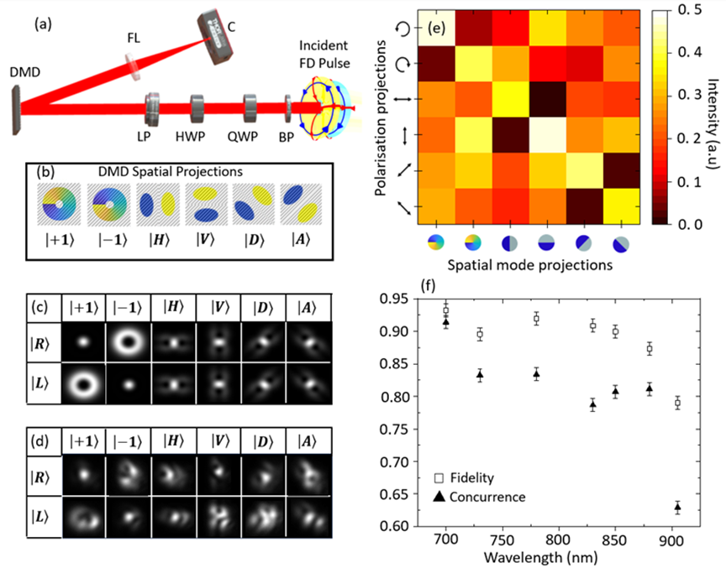
where $ρ_{mn}$ is a $4×4$ matrix of coefficients (see Supplementary S1), the higher dimensional analogue of the Stokes vector, and $σ_{m}, σ_{n}$ are the Pauli spin matrices. This is the Kronecker product of density matrices characterising the spatial and polarization states of the light, as denoted by the $S$ and $P$ superscripts respectively. This results in a four-dimensional Hilbert space on a higher dimensional Poincaré sphere [30].
Figure 3. (a) Schematic of the experimental setup used for space-polarization tomography of toroidal pulses. A bandpass filter (BP) is used to isolate a monochromatic component of the pulse, a quarter waveplate (QWP), half waveplate (HWP) and linear polarizer (LP) are used to make polarization projections. Spatial mode projections are made by a Digital Micromirror Device (DMD). Τhe resulting diffraction orders are projected into the far-field by a Fourier lens (FL) before being captured by the camera (C). (b) DMD masks project the incident light into different spatial modes. (c-d) Images of theoretically calculated (c) and experimentally recorded (d) first order diffraction patterns of a toroidal pulse incident on the DMD. (e) Matrix of tandem spatial mode and polarization projective measurement values at 780nm. (f) Measured fidelity and concurrence values as a function of wavelength.
The state tomography approach is applied to each monochromatic component of the toroidal pulse. These can be decomposed into a superposition of left and right-hand circularly polarized beams with Orbital Angular Momentum (OAM) values of $+1$ and $-1$ respectively and expressed using bra-ket notation as $ψ_{CV}=cosθ∙\left|\left.l=1\right\rangle \right.\left|\left.R\right\rangle \right.+e^{iϕ}∙sinθ∙\left|\left.l=-1\right\rangle \right.\left|\left.L\right\rangle \right.$, where varying the phase, $ϕ$, between the two terms switches the resultant between radial and azimuthal polarizations. This subset of the vector beams can be represented by a Poincaré-like sphere where the azimuthal, spiral and radial polarization states exist along the equator, with spin-orbit coupled beams at the poles [30].
The experimental setup for space-polarizaton tomography follows ref. [35] with the addition of a bandpass filter that selects a monochromatic component of the toroidal pulse (see Fig. 3a). A quarter waveplate, half waveplate and linear polarizer make polarization projections (see Supplementary S2). Note, the use of a half wave plate means all polarization projections are rotated into the horizontal plane, mitigating any errors caused by polarization dependence of any subsequent optical components. The light then is incident on a Digital Micromirror Device (DMD) with spatial mode phase masks encoded, which performs projections onto spatial mode eigenstates. Examples of spatial phase masks can be seen in 3b. The resulting diffraction pattern is then imaged in the Fourier plane of a lens. Examples of numerically calculated diffraction patterns corresponding to an ideal FD pulse are shown in Fig. 3c. The projection value is given by the on-axis intensity of the first diffraction order. To obtain the relative phases between these eigenstates, an overcomplete set of measurements is required, consisting of all the permutations of 6 spatial and 6 polarization projections (36 tandem projections).
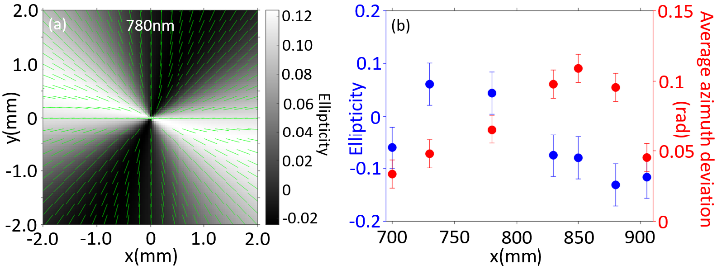
Space-polarization tomography of toroidal pulses was performed at seven different monochromatic components at wavelengths, λ, of 700 nm, 730 nm, 780 nm, 830 nm, 850 nm, 880 nm, and 905 nm, covering the full extent of the generated pulse bandwidth. Characteristic diffraction patterns are presented in Fig. 3d for λ=700 nm. The difference between the simulated and experimental diffraction patterns is mainly due to the finite bandwidth of the bandpass filters used in our experiments. From the on-axis intensity of different diffraction patterns, a tomography matrix can be constructed for each monochromatic component of the pulse. An example of such a matrix is presented in Fig. 3e for λ=780 nm, indicating that this pulse component can be decomposed into the superposition of an RCP beam with +1 OAM and an LCP beam with -1 OAM, which is consistent with a radially polarized (TM) pulse. Similar results are obtained for all wavelengths (see Supplementary S3). The space-polarization nonseparability is quantified by the concurrence, C, which takes values between 0 and 1, corresponding to homogeneous (separable) light and maximally nonseparable light, respectively. The concurrence for the experimentally characterized FD is plotted in Fig. 3f as a function of wavelength. Concurrence is high across the pulse bandwidth with an average value of <C>=0.80, indicating a strong coupling between space and polarization degrees of freedom. The likeness of the experimentally generated pulse to the theoretical FD is quantified by fidelity, F, which varies from 0 to unity. The average fidelity is <F>=0.88, indicating the space polarization structure of the pulse closely resembles the radially polarized nature of the ideal TM FD. The plot also shows a drop in the concurrence and fidelity at higher wavelengths (especially 905nm). This is due to the worse performance of optical elements, such as the DMD, polarization optics and camera at higher wavelengths resulting in increased noise [36]. Further, the mirrors used have differences in reflectivity between s and p polarizations, which increases with increasing wavelength within the bandwidth under consideration, causing the space polarization state of the vector pulse to become distorted. Due to the high degree of collimation of the pulse, temporal reshaping resulting from the Gouy phase shift has a negligible effect on the mode projections.
Figure 4. Space-polarization nonseparability in generated TM toroidal pulses. (a) Ellipticity (gray-scale image) and azimuth rotation (green arrows) at λ=780nm. (b) Average ellipticity and azimuth deviation from the radial direction as a function of wavelength. The average is taken over the transverse plane.

From the space-polarization tomographic measurements, we can reconstruct the polarization state of the toroidal pulse. A characteristic example is shown in Fig. 4a for λ=780 nm, indicating that this component is predominantly linearly polarized with the electric field along the radial direction. Similar results are obtained for all monochromatic components of the toroidal pulse (see Fig. 4b and Supplementary S4). Finally, by applying Gauss’s law on the measured transverse fields, we can estimate the longitudinal field components can be estimated (see Supplementary S4).

4. Space-Time Tomography
Space-time (or space-frequency) tomography was performed by taking the angular spectra of monochromatic components of the pulse, using a Fourier lens and a camera, placed after the bandpass filter and before the quarter waveplate (see Supplementary S5). This allowed the angular divergence of each monochromatic component to be calculated and compared with theoretical predictions for the ideal TLP allowing the $q_{2}$ value of the experimentally generated pulse to be calculated. The relationship between angular divergence and Rayleigh range is given by the following expression
 | $$Z_{r}=\frac{λ}{{Θ_{div}}^{2}π},$$ | (6)
where $Z_{r}$ is the Rayleigh range, $Θ_{div}$ is the angular divergence and $λ$ is the wavelength. Using this information, a density matrix is calculated for the space and time degrees of freedom, where wavelength and angular divergence are discretised into five separate states each. From this matrix, the similarity of the space-time coupling to the ideal TLP can be quantified in the form of the fidelity and the degree of nonseparability in the form of the concurrence [32].
The space-time tomography results of the generated toroidal pulses are shown in Fig. 5a in the form of trajectories of the intensity maxima of the pulse monochromatic components. The trajectories do not cross each other, indicating that the pulse is isodiffracting and follow closely the theoretical ones (corresponding to $q_{1}=200$nm and $q_{2}=1.68×{10}^{7}q_{1}$). The corresponding tomography matrix is shown in the inset to Fig. 5a, from which we calculated the corresponding fidelity to be 0.72 and concurrence of 0.91. These results indicate that the space-time (or equivalently space-frequency) profile of the pulse closely resembles that of an ideal FD and is highly nonseparable. This is illustrated by the angular divergence of each monochromatic component (see Fig. 5b), where all but one of the experimental and theoretical values deviate by less than 0.01 mrad.

5. Conclusions
In summary, we have characterized quantitatively the nonseparable properties of experimentally generated toroidal light pulses. In particular, we have applied state tomography to quantify the space-polarization and space-time coupling of toroidal pulses, which define their topological properties and propagation dynamics. Importantly, we have shown that even in the absence of a gradient metasurface element, ultrafast laser pulses evolve towards the ideal FD pulses in terms of their space-time nonseparability, in accordance with recent works [5]. Our results pave the way towards higher-dimensional tomography of spatiotemporally structured light and will facilitate the deployment of nonseparable broadband beams and pulses in telecommunications, spectroscopy, and metrology applications.

Acknowledgements
The authors acknowledge the support of the European Research Council (advanced grant FLEET-786851, Funder Id: https://doi.org/10.13039/501100000781).

Data availability
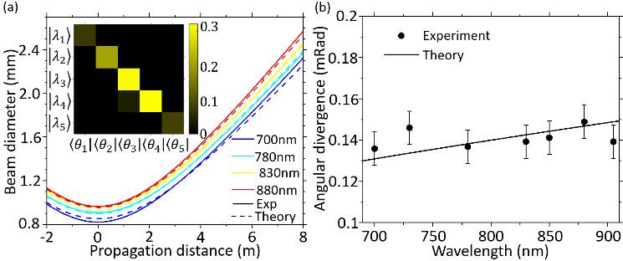
The data from this paper can be obtained from the University of Southampton ePrints research repository https://doi.org/10.5258/SOTON/DXXX.
Figure 5. (a) Trajectories of the intensity maxima of monochromatic components of the experimentally characterized (solid line) and ideal (dashed line) toroidal pulse. Inset: Space-frequency tomography matrix showing the correlation between frequency and angular divergence, where$\left.\left|λ_{1}\right.\right\rangle$, $\left.\left|λ_{2}\right.\right\rangle$, $\left.\left|λ_{3}\right.\right\rangle$, $\left.\left|λ_{4}\right.\right\rangle$, $\left.\left|λ_{5}\right.\right\rangle$ correspond to wavelengths of 700, 780, 830, 850, and 905 nm respectively. $\left\langle \left.θ_{1}\right|\right., \left\langle \left.θ_{2}\right|\right., \left\langle \left.θ_{3}\right|\right.$, $\left\langle \left.θ_{4}\right|\right.$, $\left\langle \left.θ_{5}\right|\right.$ correspond to angular divergences of 0.131, 0.138, 0.143, 0.144, 0.149 mrad, respectively. (b) Experimentally measured (circles) and theoretical (solid line) angular divergence of the toroidal pulse components as a function of wavelength.
References
[1] R.W. Hellwarth, P. Nouchi, Focused one-cycle electromagnetic pulses, Physical Review E, 54 (1996) 889-895.
[2] R.W. Ziolkowski, Localized transmission of electromagnetic energy, Physical Review A, 39 (1989) 2005-2033.
[3] K. Jana, Y. Mi, S.H. Møller, D.H. Ko, S. Gholam-Mirzaei, D. Abdollahpour, S. Sederberg, P.B. Corkum, Quantum control of flying doughnut terahertz pulses, Science Advances, 10 (2024) eadl1803.
[4] A. Zdagkas, C. McDonnell, J. Deng, Y. Shen, G. Li, T. Ellenbogen, N. Papasimakis, N.I. Zheludev, Observation of toroidal pulses of light, Nature Photonics, 16 (2022) 523-528.
[5] R. Wang, P.-Y. Bao, Z.-Q. Hu, S. Shi, B.-Z. Wang, N.I. Zheludev, Y. Shen, Observation of resilient propagation and free-space skyrmions in toroidal electromagnetic pulses, Applied Physics Reviews, 11 (2024) 031411.
[6] V.A.F. N. Papasimakis, V. Savinov, T. A. Raybould and N. I. Zheludev, Electromagnetic toroidal excitations in matter and free space Nature materials, 15 (2016) 9.
[7] A. Zdagkas, N. Papasimakis, V. Savinov, M.R. Dennis, N.I. Zheludev, Singularities in the flying electromagnetic doughnuts, 8 (2019) 1379-1385.
[8] T. Raybould, V. Fedotov, N. Papasimakis, I. Youngs, N. Zheludev, Focused electromagnetic doughnut pulses and their interaction with interfaces and nanostructures, Opt. Express, 24 (2016) 3150-3161.
[9] Y. Shen, Y. Hou, N. Papasimakis, N.I. Zheludev, Supertoroidal light pulses as electromagnetic skyrmions propagating in free space, Nature Communications, 12 (2021) 5891.
[10] Y. Shen, N. Papasimakis, N.I. Zheludev, Nondiffracting supertoroidal pulses and optical “Kármán vortex streets”, Nature Communications, 15 (2024) 4863.
[11] Y. Shen, C. Rosales-Guzmán, Nonseparable States of Light: From Quantum to Classical, Laser & Photonics Reviews, 16 (2022) 2100533.
[12] A. Aiello, F. Töppel, C. Marquardt, E. Giacobino, G. Leuchs, Quantum−like nonseparable structures in optical beams, New Journal of Physics, 17 (2015) 043024.
[13] A. Forbes, A. Aiello, B. Ndagano, Chapter Three - Classically Entangled Light, in: T.D. Visser (Ed.) Progress in Optics, Elsevier2019, pp. 99-153.
[14] G. Milione, H.I. Sztul, D.A. Nolan, R.R. Alfano, Higher-Order Poincar\'e Sphere, Stokes Parameters, and the Angular Momentum of Light, Physical Review Letters, 107 (2011) 053601.
[15] X. Yi, Y. Liu, X. Ling, X. Zhou, Y. Ke, H. Luo, S. Wen, D. Fan, Hybrid-order Poincar\'e sphere, Physical Review A, 91 (2015) 023801.
[16] H.E. Kondakci, A.F. Abouraddy, Diffraction-free space–time light sheets, Nature Photonics, 11 (2017) 733-740.
[17] A. Zdagkas, N. Papasimakis, V. Savinov, N.I. Zheludev, Space-time nonseparable pulses: Constructing isodiffracting donut pulses from plane waves and single-cycle pulses, Physical Review A, 102 (2020) 063512.
[18] F. Töppel, A. Aiello, C. Marquardt, E. Giacobino, G. Leuchs, Classical entanglement in polarization metrology, New Journal of Physics, 16 (2014) 073019.
[19] R. Wang, P.-Y. Bao, X. Feng, J. Wu, B.-Z. Wang, Y. Shen, Single-antenna super-resolution positioning with nonseparable toroidal pulses, Communications Physics, 7 (2024) 356.
[20] X.-B. Hu, B. Zhao, Z.-H. Zhu, W. Gao, C. Rosales-Guzmán, In situ detection of a cooperative target's longitudinal and angular speed using structured light, Opt. Lett., 44 (2019) 3070-3073.
[21] G. Milione, M.P.J. Lavery, H. Huang, Y. Ren, G. Xie, T.A. Nguyen, E. Karimi, L. Marrucci, D.A. Nolan, R.R. Alfano, A.E. Willner, 4 x 20 Gbit/s mode division multiplexing over free space using vector modes and a q-plate mode (de)multiplexer, Opt. Lett., 40 (2015) 1980-1983.
[22] Z. Wan, H. Wang, Q. Liu, X. Fu, Y. Shen, Ultra-Degree-of-Freedom Structured Light for Ultracapacity Information Carriers, ACS Photonics, 10 (2023) 2149-2164.
[23] M. Yessenov, J. Free, Z. Chen, E.G. Johnson, M.P.J. Lavery, M.A. Alonso, A.F. Abouraddy, Space-time wave packets localized in all dimensions, Nature Communications, 13 (2022) 4573.
[24] A. Zdagkas, V. Nalla, N. Papasimakis, N.I. Zheludev, Spatio-temporal characterization of ultrashort vector pulses, APL Photonics, 6 (2021) 116103.
[25] X.-B. Hu, C. Rosales-Guzmán, Generation and characterization of complex vector modes with digital micromirror devices: a tutorial, Journal of Optics, 24 (2022) 034001.
[26] P. Martin, M.M. Marcos, S.D. Daniel, M. Mickael, L. Greta, D.R. Aleksandar, C. Joel, Spatial tomography of light resolved in time, spectrum, and polarization, Proc.SPIE, 2023, pp. PC124250I.
[27] B. Ndagano, H. Sroor, M. McLaren, C. Rosales-Guzmán, A. Forbes, Beam quality measure for vector beams, Opt. Lett., 41 (2016) 3407-3410.
[28] A. Forbes, A. Dudley, M. McLaren, Creation and detection of optical modes with spatial light modulators, Adv. Opt. Photon., 8 (2016) 200-227.
[29] M. McLaren, T. Konrad, A. Forbes, Measuring the nonseparability of vector vortex beams, Physical Review A, 92 (2015) 023833.
[30] E. Toninelli, B. Ndagano, A. Vallés, B. Sephton, I. Nape, A. Ambrosio, F. Capasso, M.J. Padgett, A. Forbes, Concepts in quantum state tomography and classical implementation with intense light: a tutorial, Adv. Opt. Photon., 11 (2019) 67-134.
[31] B. Ndagano, B. Perez-Garcia, F.S. Roux, M. McLaren, C. Rosales-Guzman, Y. Zhang, O. Mouane, R.I. Hernandez-Aranda, T. Konrad, A. Forbes, Characterizing quantum channels with non-separable states of classical light, Nature Physics, 13 (2017) 397-402.
[32] Y. Shen, A. Zdagkas, N. Papasimakis, N.I. Zheludev, Measures of space-time nonseparability of electromagnetic pulses, Physical Review Research, 3 (2021) 013236.
[33] S. Feng, H.G. Winful, R.W. Hellwarth, Gouy shift and temporal reshaping of focused single-cycle electromagnetic pulses, Opt. Lett., 23 (1998) 385-387.
[34] S. Feng, H.G. Winful, Spatiotemporal structure of isodiffracting ultrashort electromagnetic pulses, Physical Review E, 61 (2000) 862-873.
[35] B. Zhao, X.-B. Hu, V. Rodríguez-Fajardo, A. Forbes, W. Gao, Z.-H. Zhu, C. Rosales-Guzmán, Determining the non-separability of vector modes with digital micromirror devices, Applied Physics Letters, 116 (2020).
[36] I. Nape, N. Mashaba, N. Mphuthi, S. Jayakumar, S. Bhattacharya, A. Forbes, Vector-Mode Decay in Atmospheric Turbulence: An Analysis Inspired by Quantum Mechanics, Physical Review Applied, 15 (2021) 034030.

