How Do the Effects of Effort Influence Interactive Search Behavior?
Emma Deverill, Haden Dewis, Fabrizio Lepori, Guido Maiello, Iris H. Russell, & Hayward J. Godwin
University of Southampton, UK

Author Note
Correspondence concerning this article should be addressed to Hayward Godwin, University of Southampton, School of Psychology, Highfield, Southampton, Hampshire, SO17 1BJ. Tel: +44(0)2380 595078; Email: hayward.godwin@soton.ac.uk Department of Psychology, University of Southampton – United Kingdom
We have no conflicts of interest to disclose. The authors wish to thank Guido Maiello and Fabrizio Lepori for their assistance with the setup of the motion capture camera system used in this study.

Abstract
Interactive search refers to tasks wherein a searcher actively manipulates objects to find a target. Here, we examined the influence that physical effort has upon behavior and performance during an interactive search task. We achieved this by asking participants to search in person for a ‘T’ shape embedded upon the side of a set of cubes that varied in weight. Interactive search behaviors were recorded throughout the experiment using an optical motion tracking system. In all cases, we found no evidence that any discernible effects of effort emerged. Despite this, we offer three important contributions to the literature. First, our methodology enabled us to determine that, within our study, interactive search utilized a ‘nearest-next’ strategy, with searchers choosing to interact with the nearest cube to them on each trial. Second, contrary to expectations from purely visual search tasks, rather than waiting and examining the already-visible cube faces at the start of each trial, searchers opted instead to begin interacting with objects immediately. Third, response accuracy rates were no different between target-present and target-absent trials, suggesting that there is at least one point in which interactive search differs from visual search. Our findings lay down the foundation for future and more detailed examinations of live, in-person interactive search tasks.
Keywords: Interactive Search, Visual Search, Effort, Real-World

How Do the Effects of Effort Influence Interactive Search Behavior
Many tasks in daily life require direct interaction with the environment. This can include search tasks, for example searching an overflowing toolbox for a screwdriver or searching a refrigerator for food. Searches of this nature are referred to as interactive search tasks, a term coined by Sauter et al. (2020). During an interactive search, the searcher actively manipulates objects (such as picking them up and rotating them) or alters their position of view in order to successfully detect a target or confirm its absence, primarily through the uncovering of previously obscured visual information. Research on interactive search in the real world to date has involved participants interacting with containers to find hidden marbles (Gilchrist et al., 2001), searching open terrain for coins (Riggs et al., 2017), locating incriminating items in a residential house (Riggs et al., 2018), and sifting through piles of LEGO® bricks to identify specific targets (Hout et al., 2022; Sauter et al., 2020). Interactive search has also been assessed within computer-based environments, wherein participants commonly use a computer mouse, computer keys, or touchscreen to perform interactions, including interpreting medical computed tomography scans (Drew et al., 2013), searches through simulated scans of airport baggage (Godwin et al., 2024), and searches through stacked piles of virtual objects (Solman et al., 2012).
Interactive search extends visual search, which involves the visual scanning of an environment to detect a target object among distractors by introducing additional complexities that are typically absent or minimal in static, non-interactive search tasks (Sauter et al., 2020). One notable complexity is the heightened role of movement-related effort associated with navigating the search array. In static, computer-based visual search tasks, effort is largely restricted to eye movements, which demand minimal physical cost (Araujo et al., 2001). Yet even under these conditions, searchers frequently adopt strategies that are suboptimal for performance in order to minimize effort expenditure (Irons & Leber, 2016). Such findings suggest that searchers evaluate the relative cost of shifting attention across the array against the potential benefit of doing so and only execute shifts when the expected reward outweighs the effort cost (Araujo et al., 2001; Wolfe, 2013).
Static, screen-based paradigms are inherently constrained as they provide only a small fraction of the effort demands that characterize interactive search behavior. This means that findings from such tasks may underestimate the extent to which physical effort shapes behavior in interactive search tasks. Indeed, interactive searches – whether that be interacting with tangible objects in the real-world or interacting with virtual objects on a screen – often requires more movement-related effort than when performing eye movements alone as in standard visual search tasks. As such, these increased movement-related effort costs associated with interacting with the search array may therefore serve as stronger influences on search strategy.
Evidence from other related decision-making tasks support the claim that physical effort shapes behavior. For example, when deciding on which arm to use to perform a target-reaching task, the decision was biased towards use of the limb associated with a lower perceived amount of effort (Wang et al., 2021). Moreover, when resistive load is increased in one hand relative to the other, perceptual judgements become biased towards responses associated with the less effortful hand (Hagura et al., 2017). Even subtle differences in movement-related effort costs can significantly bias a participant’s decision to the least costly option, even when this bias reduces performance accuracy (Marcos et al., 2015).
To our knowledge, only two prior sets of experiments have examined physical effort during interactive search in detail. Moskowitz et al. (2023) tasked participants with controlling a cursor by manipulating a handle to reveal hidden objects in a search array until they detected a target. Here, some of the trials, referred to as force-on trials, implemented a resistive force on the handle, increasing linearly with the cursor’s distance from the starting point. Thus, moving the cursor to more distant objects within the display required greater physical effort. Participants exhibited a tendency for interacting with objects closer to the cursor’s starting position during these force-on trials in comparison to trials where no resistive force was applied. Similarly, Dewis et al. (2025) asked participants to search through a series of four virtual cubes with the use of a computer mouse presented to them on a computer screen. On some trials, a target (a ‘T’ shape) was placed on one face of one of the cubes, whilst ‘L’ shapes served as distractors on the remaining faces of the cubes. In their first experiment, every trial included two ‘heavy’ cubes (less responsive to the cursor) and two ‘light’ cubes (more responsive to the cursor). Participants adopted an ‘easy-first’ strategy wherein they prioritized inspecting the light cubes first, before interacting with the heavier cubes. In. conjunction, the findings of these two experiments suggest that objects and areas of the search array associated with greater movement-related effort costs are attempted to be avoided during virtual interactive search tasks.
Although the findings of Moskowitz et al. (2023) and Dewis et al. (2025) provide an important first step in investigating the relationship of physical effort to interactive search strategies they are limited in two key respects. First, the studies focused exclusively on virtual tasks, leaving open the question of how such strategies generalize to real-world contexts, where other forms of movement such as reaching grasping, lifting, and repositioning tangible objects is required. Second, they do not provide participants experience with interactive search tasks where the entire search array is more or less difficult to work with.
The current study resolved these limitations by taking a different approach to studying interactive search. Here, the study setup followed that of Dewis et al. (2025) in an effort to remain consistent with other work, albeit in the real rather than virtual world; thus, participants completed the task while seated and manipulated four cubes on a desk. Participants engaged in interactions with tangible cubes that were made heavier (185g) and lighter (80g) in terms of weight (see Figure 1). We instead utilized a uniform effort manipulation per trial, with either all heavy cubes or all light cubes making up the search array. This meant that we could directly examine whether participants adapted their overall search strategies depending on the required effort to complete the task. Cube positions and orientations were tracked throughout the experiment through passive marker-based optical motion tracking with a setup consisting of eight separate cameras.

Figure 1
Depiction of Experiment Setup, Stimuli, and Procedure
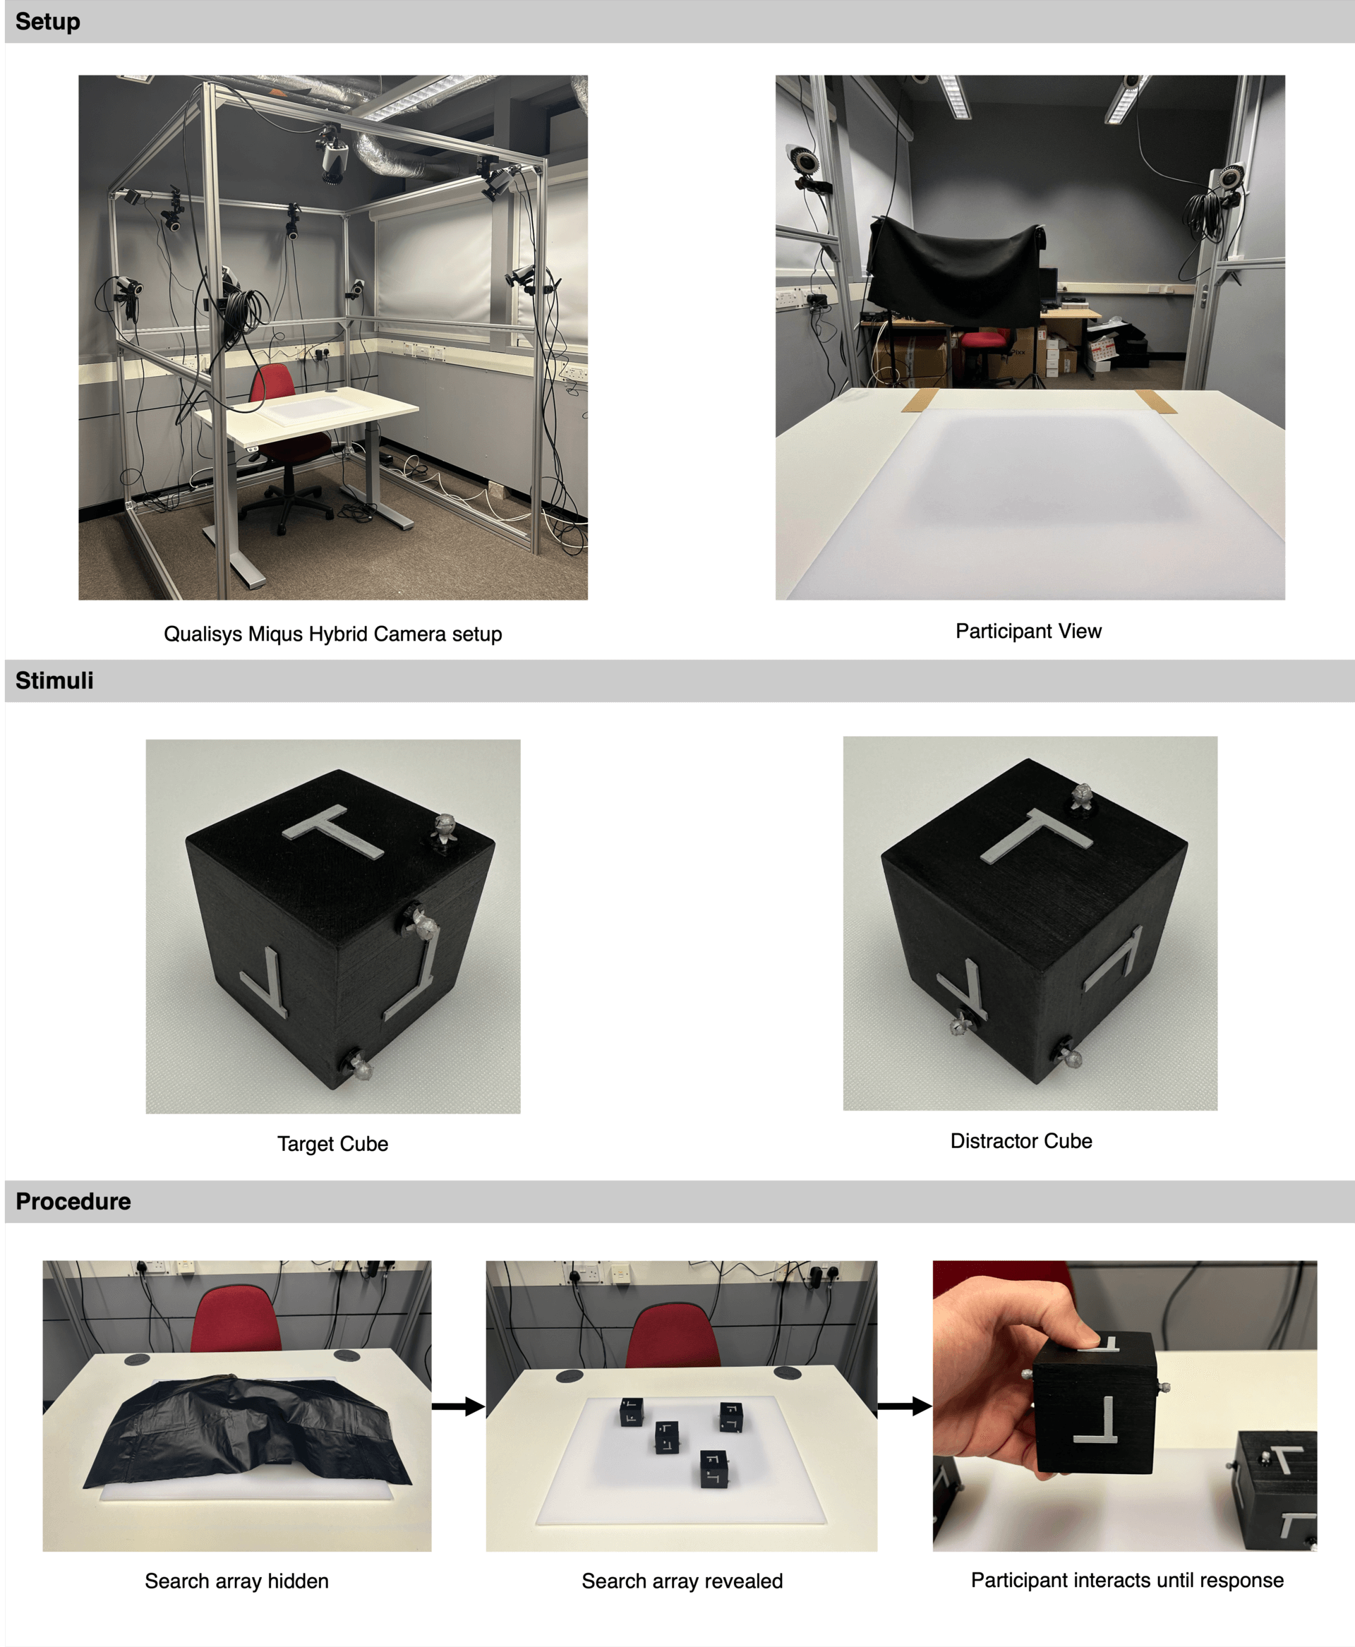
Note. The top panel (Setup) depicts the camera setup used for the experiment and the view participants saw throughout. The middle panel (Stimuli) displays a typical target cube (left) and distractor cube (right) with attached markers. Bottom panel (Procedure) depicts the typical progression of a trial: the search array is delivered to the participant covered, the search array is then revealed, and the participant interacts (or chooses not to) with the search array before giving a response to end the trial.

Our approach enabled us to ask a number of novel questions regarding interactive search and the influence that effort has upon it. Thus far, very little is known regarding how people physically examine real-world objects when searching for targets, and to that extension, much of the work here will be foundational in nature, taking the first steps towards more detailed and formal analyses of interactive search behavior in future work. Overall, we expected a number of key effects to emerge when comparing trials wherein cubes were heavy versus light, and our predictions were drawn from previous studies of visual search. We based our predictions on models and findings from visual search. However, it should be noted that these models may not be supported when tested using interactive search since, at a basic level, visual search does not generally involve revealing concealed information. This basic shift from examining visual information that is already available compared with examining a combination of already-visible visual information and the decisions that result in revealing concealed information very much set visual search apart from interactive search.
First, at a basic level, we expected that response accuracy rates for target-absent trials would be higher than those for target-present trials, since this is what is generally found in visual search tasks (Godwin et al., 2021), even with simple stimuli that are unambiguous. Second, we expected that response times (RTs) for target-absent trials would be longer than those for target-present trials, again since this is what is typically found during visual search (Chun & Wolfe, 1996; Godwin et al., 2021; Godwin, Menneer, Riggs, et al., 2015), with participants terminating search once a target is found. In terms of effort, we expected that response accuracy rates would be reduced for the heavy cubes compared to the light cubes, and that RTs would be faster for the heavy cubes versus the light cubes. These two observations are inter-related: under high levels of effort, we expected searchers to quit their searches rapidly and be more likely to make errors since they had not adequately examined the cubes presented to them (Chun & Wolfe, 1996; Ranganathan et al., 2013; Wang et al., 2021; Wolfe, 2012).
Ours is, to our knowledge, the first study to utilize object-tracking in a real-world environment during interactive search. In turn, this has enabled us to conduct detailed analyses of the behavior’s individuals engaged in whilst interactively searching. The starting orientation and positions of cubes was randomized throughout the experiment, as such, on some target-present trials, the target T shape would have been immediately visible to participants before having picked up a single cube. In such a scenario, a visual search alone is sufficient to locate the target – in other words, a target can be detected in these trials without even picking up a single cube. We therefore examined the likelihood of participants engaging with the search array as a function of target visibility to directly compare interactive search with visual search. In visual search, current leading models and theories hold that search begins with an initial analysis of the search array to seek out potential targets locations (Corbett & Smith, 2020; Moran et al., 2016; Schwarz & Miller, 2016; Wolfe, 2021). Perhaps, then, we wondered whether our participants would examine the initially visible cube faces before picking up any one cube and searching it in detail. With that in mind, we predicted that on some trials, targets would be detected before even a single cube had been picked up and examined.

Method
Participants
Since this study was novel and exploratory in nature, we did not conduct a power analysis in advance. Instead, we utilised previous visual search research to inform our stopping rules for data collection (e.g., Godwin et al., 2010, 2016; Godwin, Menneer, Cave, et al., 2015). We had a target of ~20 participants for this study, which we then increased slightly to allow for the possibility of equipment failure or other problems with the data capture. As such, a total of 25 individuals participated in the experiment. Twelve of these participants were students from the University of Southampton who received compensation in the form of course credit for their participation. The remaining 13 participants were individuals aged 18 and over, recruited on a voluntary basis, through advertisement displayed throughout the University of Southampton and via word-of-mouth. The experiment was approved by the Ethics Committee at the University of Southampton, ERGO 89602, and participants gave informed consent prior to starting the experiment.

Stimuli
The stimuli comprised ten 3D printed cubes: two target cubes and eight distractor cubes. For target cubes, one of the cube’s faces had a “T” shape attached to it whilst the remaining five faces had “L” shapes attached instead. For distractor cubes, each of their six faces had an “L” attached to them (see Figure 1). Across these ten cubes, there was one heavy target cube, one light target cube, four heavy distractor cubes, and four light distractor cubes. Heavy cubes weighed 185 grams and light cubes weighed 80 grams, and their weight was achieved by filling the cubes with sand. The weights were determined through preliminary testing of several differently weighted objects, with the final selection chosen to ensure
that the heavier cubes were perceptibly distinguishable from the light cubes, yet not so heavy as to cause discomfort or excessive strain during and/or after manipulation. All cubes had dimensions of 60mm × 60mm × 60mm (height × width × depth). The heavy and light cubes were not visually distinguishable from one another.
To create the search array for each trial, a bespoke algorithm, created for the purposes of data collection, was used to create a virtual representation of the search array. For each trial, four objects were randomly selected and placed onto a virtual 4 × 3 grid in one of 12 potential positions before being rotated randomly by either 90º, 180º, or 270º around each of its axes (X, Y, Z). The virtual representation was then used by researchers to place the corresponding cubes onto a physical board which contained a real-life version of the virtual grid. The board was 450mm by 600mm and the 4 × 3 grid was always centered on the board. Each grid position was 80mm × 80mm with a gap of 20mm between grid positions. This grid was removed before the start of each trial. Target-absent trials contained four distractor cubes per trial, and target-present trials contained three distractor cubes and one target cube per trial. In each trial, the cubes were all the same weight (light or heavy).

Apparatus
Participants’ interactions with the stimuli were recorded using an array of eight Qualisys Miqus Hybrid cameras. Seven were set to marker mode (recording marker-based motion capture data), whilst the remaining one was set to video mode (recording video data). Our specific setup is shown in Figure 1, with the cameras arranged on a cubicle frame surrounding the workspace covering multiple different visual angles. The cameras tracked the 3D position of reflective markers within the space and were processed by the Qualisys Track Manager software. Each stimulus required a unique combination of markers to be successfully tracked by the software. This was achieved via an additional bespoke algorithm which randomly placed five markers in asymmetrical patterns on the cubes. A partition was placed between the experimenters and participants throughout the study (see Figure 1).

Design and Procedure
This study used a within participants 2 (Presence: Present, Absent) × 2 (Effort: Heavy, Light) repeated-measures design to investigate differences in interactive search behavior between the heavy cubes and light cubes. A target cube was presented on 50 % of trials. High effort cubes were presented to participants on 50 % of trials and low effort cubes on the remaining trials. Trial order was randomized using the same software that determined cube locations on each trial (see the Stimuli section above for more information). On each trial, all cubes were either light or heavy, and trial order was randomized. Participants were not informed prior to each trial regarding the weight of the cubes presented to them, nor were they informed that the cubes would differ in weight prior to the beginning of the experiment.
Following a period of practice interacting with the light cubes and trial procedure, participants then completed a total of 40 trials over the course of approximately 1 hour and were offered the chance to take breaks every 10 trials. Before each trial began, the cubes were set up on the board as described previously. A partition between the participant and the experimenters was used to ensure participants did not see the search array during this process. The search array was then covered using a black sheet to ensure participants would not see any stimuli before the trial had started. The covered board was then placed on the desk in front of the participant. A trial started when one of two experimenters manually pressed a button on the Qualisys software. Whenever a trial started, the Qualisys software triggered an audible chime which the remaining experimenter used as an indication to remove the black sheet and reveal the search array to the participant (see Figure 1). On each trial, participants were asked to search the cubes utilizing a precision grip (finger and thumb) with their dominant hand until they determined the presence or absence of the target, by having the participant state aloud the phrases “Found it” or “Not here” once they had made their decision. Following a participant response, the experimenter immediately stopped the trial by manually pressing a button on the software. The participant response was noted, the search array removed, and the next trial set up. No feedback was given to participants regarding their responses. Experimenters were only visible to the participants whilst the search arrays were being brought to and taken away from the participants. Participants' interactions with the search arrays were being watched by the experimenters behind the partition via live video through the Qualisys camera that was set to video mode, and therefore the participants could not see themselves being watched.

Results
Data Cleaning
We cleaned the data as follows. On some occasions, participants’ hands obscured the optical markers that were necessary for accurate tracking of the cube positions and orientations. Although steps were taken to minimize this risk, e.g., tracking via multiple cameras, it was not possible to avoid entirely. Accurate tracking of object position and orientations through 3D space required continuous tracking of at least three of the five markers attached to an object with a standard deviation of less than 5mm per marker. A trial was deemed as containing poor tracking if any of the objects had less than 3 markers successfully tracked during the moments when participants lifted a cube off the table and when participants placed a cube back onto the table. Without successful tracking during these periods there was no way to know when the interaction with that cube started or when it ended. For analyses of behavioral measures, such as response accuracy and RTs, where motion tracking of objects was not required to compute measures, trials with poor tracking, as previously defined, were not removed from the dataset. However, for analyses where motion tracking was required to compute relevant measures, we took a conservative approach and removed trials where tracking was poor. From a total of 1000 trials, a total of 185 of these were removed due to poor tracking.

Analytic Approach
An exploratory approach was taken when analyzing this dataset to investigate how effort influences interactive search behaviors. As such, we chose to analyze six different dependent measures inspired by previous eye tracking research (see Godwin et al., 2021 for review) and utilized reported effect sizes from other interactive search task research to help guide our interpretations of results (Dewis et al., 2025; Drew et al., 2013; Godwin et al., 2024; Solman et al., 2012). We grouped our dependent measures into three distinct categories. We began by Describing Interactive Search: given the lack of prior research in this area or using tasks remotely similar to that which was used here, we therefore started with a simple overview of some basic characteristics of the behavior that participants engaged in during our experiment. This included analyses of where the first-to-be-picked-up cube was on each trial, as well as, in particular, an examination of the order of selection of objects during search (i.e., did participants simply choose the next-nearest cube after putting one down?). We followed these examinations with Behavioral Measures, which included analyses of response accuracy and RT measures. Finally, we closed with Interaction Measures. These focused on both the probability that participants would pick up any cubes as well as the time spent interacting with each cube.
All analyses were modelled using Bayesian generalized linear mixed effects models (BGLMMs) through the brms package in R (Bürkner, 2017; R Core Team, 2023). The reliability of effects was confirmed using Bayes factors, as calculated via the bayestestR package in R (Makowski et al., 2019). A Bayes factor of greater than 1.00 suggests stronger evidence towards the alternative hypothesis and a Bayes factor of less than 1.00 suggests stronger evidence towards the null hypothesis. For the purpose of discussion, we have deemed modelled effects to be trustworthy when both their Bayes factor was greater than 3.20 and their 95 % credible interval (CI) did not pass through zero. When categorizing the strength of evidence for effects, we have followed the labels set out by Jeffreys (1961): BFs < 3 but > 1 = anecdotal, BFs > 3 but < 10 = moderate, BFs > 10 but < 30 = strong, BFs > 30 but < 100 = very strong, BFs > 100 = extreme.
Where relevant, models used the following fixed factors: Presence (Absent, Present), Effort (Heavy, Light), Location (Center, Edge), Distance (Close, Far), Approach (Next Closest, Not Next Closest), Object Type (Distractor, Target), and Target Visibility (Hidden, Immediately Visible). Each model included random intercepts and slopes for Participant ID, and where relevant, a full random structure that matched fixed effects. Each model was fitted using four chains, with 11,000 iterations and 1000 warmup iterations to allow for accurate Bayes factor analysis (Makowski et al., 2019). All Gelman-Rubin statistics were below 1.10 for all parameters and visual inspection of the chains indicated good mixing. Our BGLMMs used Bernoulli distributions with a logit link functions for all accuracy and probability measures and gaussian distributions for RT and interaction duration measures.

Describing Interactive Search Behavior
Before outlining any analyses, since this is a novel task, we begin by describing some basic characteristics of the interactive search behavior that participants engaged in. Descriptive statistics are depicted in Figure 2, and modelled effects can be found within Table 1.
During our task, participants began their searches typically at one edge of the search array (primarily the right) before proceeding to interact with the next-nearest object to their previous interaction. Both strategies were uninfluenced by effort, see figures 2A and 2B.
In general, participants picked up around half of the cubes within target-present trials before finding the target (M = 0.54, SD = 0.50). However, for target-absent trials, participants were remarkably consistent and always interacted with all four cubes per trial (M = 1.00, SD = 0.00). Revisits to already-inspected cubes were extremely rare (light cubes: M = 0.06, SD = 0.24, heavy cubes: M = 0.05, SD = 0.23). This was in-line with prior research into revisits within interactive search (Gilchrist et al., 2001; Smith et al., 2008).

Figure 2
Descriptive Statistics for all Measures
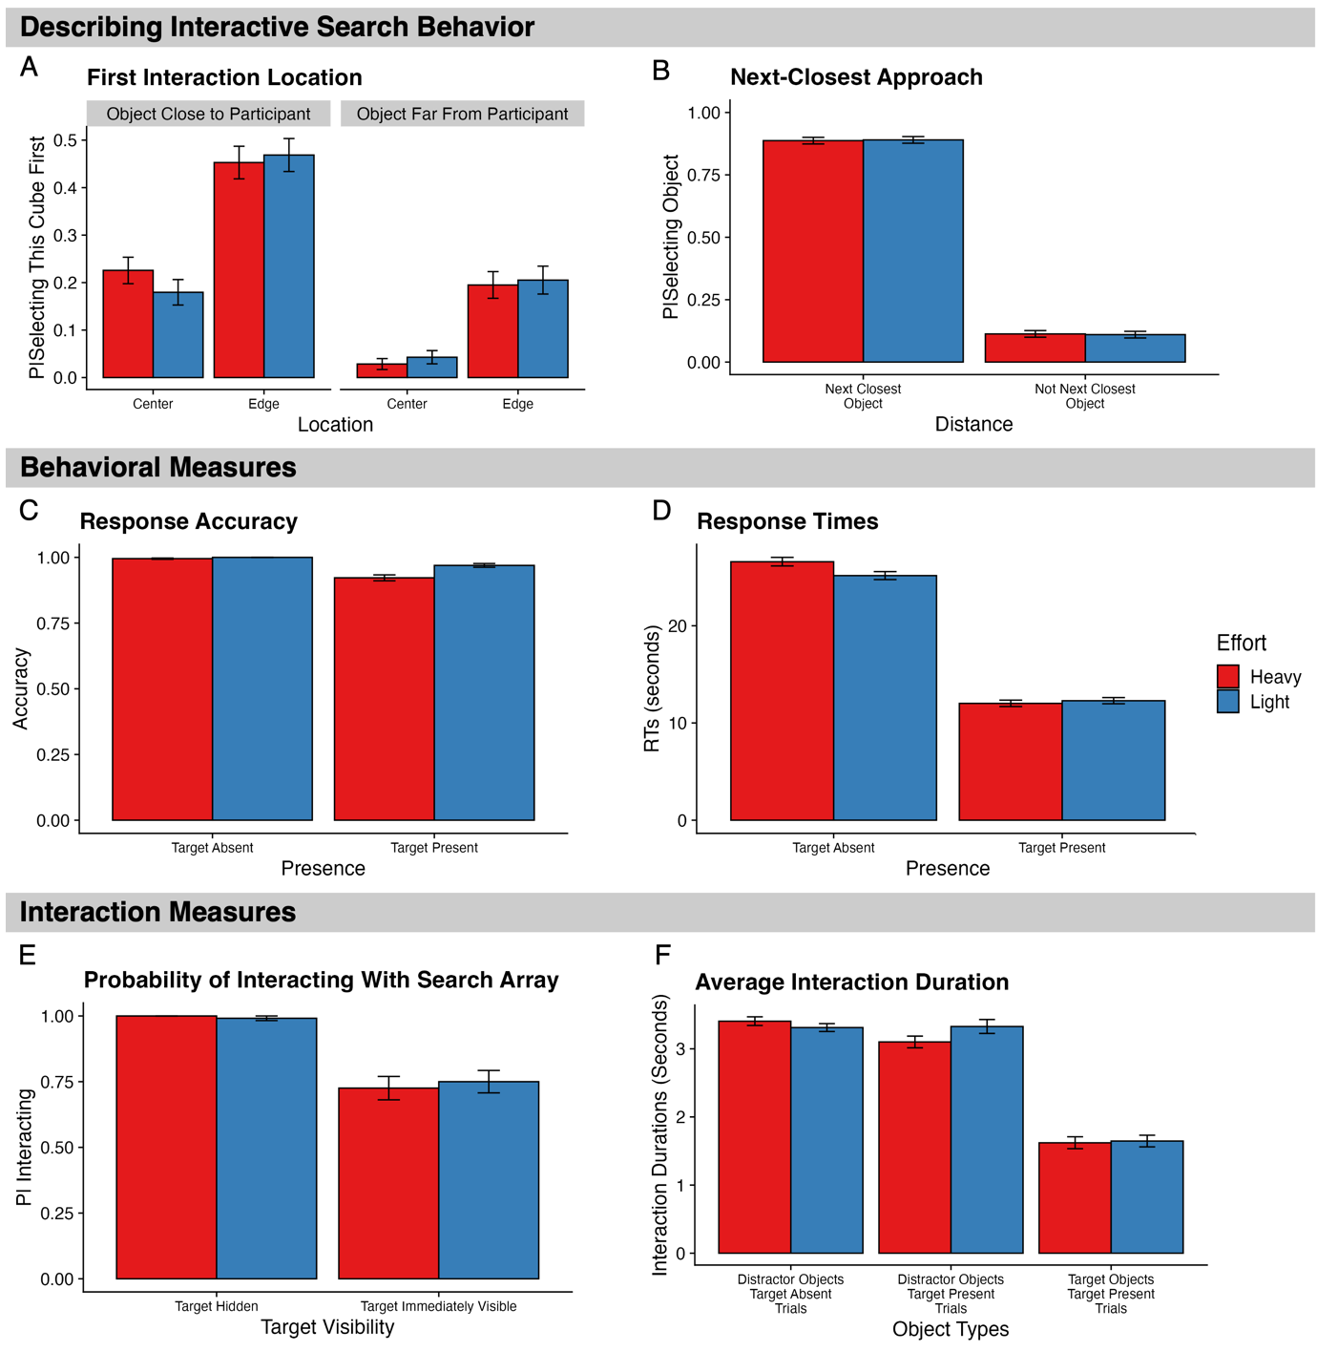
Note. Each panel depicts descriptive statistics for relevant analysis. For describing interactive search behaviors (A, B), the measure of interest was the likelihood of selecting a particular cube. This was then averaged as a function of cube location, distance, and effort for pannel A and as a function of the next closest cube and effort for pannel B. For behavioral measures (C-D), the measures of interest were response accuracy (C), and response time (D). For interaction measures (E-F), the measures of interest were the probability of interacting with the search array (E), and the duration of interactions with objects (F). Error bars represent ±SE; SE = Standard Error.

Table 1
Model Effects and Bayes Factors – Describing Interactive Search Behavior
 | First Interaction Location |  |  |  | Next Closest Approach
Parameter | Estimate | CIs | BF |  | Estimate | CIs | BF
Intercept | -0.93 (0.11) | -1.14 – -0.72 | 3.61×10⁶ |  | 0.00 (0.07) | -0.14 – 0.14 | 0.03
Location (Center, Edge) | 1.03 (0.25) | 0.53 – 1.52 | 270.31
Distance (Close, Far) | -1.39 (0.21) | -1.81 – -0.98 | 2.42×10⁵
Approach (Next Closest, Not Next Closest) |  |  |  |  | -4.08 (0.35) | -4.71 – -3.34 | 6.19×10⁷
Effort (Heavy, Light) | -0.03 (0.10) | -0.23 – 0.17 | 0.10 |  | 0.00 (0.14) | -0.27 – 0.27 | 0.14
Approach × Effort |  |  |  |  | -0.15 (0.38) | -0.90 – 0.61 | 0.40
Location × Distance | 0.05 (0.25) | -0.44 – 0.54 | 0.24
Location × Effort | 0.04 (0.20) | -0.36 – 0.44 | 0.21
Distance × Effort | -0.03 (0.20) | -0.43 – 0.36 | 0.21
Location × Distance × Effort | 0.10 (0.39) | -0.67 – 0.86 | 0.41
Note. CIs = Confidence Intervals; BF = Bayes Factor; Bolded CI values = CIs that did not pass through zero; Bolded BF values = BF > 3.20. Values in parentheses represent the associated standard error values. Effects were deemed reliable if CIs did not pass through zero and BF > 3.20. All R-Hat values = 1.00.
Behavioral Measures
We began by focusing on the standard behavioral measures used across other visual and interactive search experiments. Descriptive statistics can be found in Figure 2C and 2D and modelled effects within Table 2.

Table 2
Model Effects and Bayes Factors – Behavioral Measures
 | Response Accuracy |  |  |  | Response Times
Parameter | Estimate | CIs | BF |  | Estimate | CIs | BF
Intercept | 5.21 (0.61) | 4.24 – 6.60 | 5.70×10¹⁶ |  | 2.74 (0.06) | 2.62 – 2.85 | 3.81×10⁵²
Presence (Absent, Present) | -1.29 (0.69) | -2.63 – 0.08 | 4.31 |  | -0.84 (0.05) | -0.95 – -0.74 | 4.79×10¹³
Effort (Heavy, Light) | 0.42 (0.56) | -0.67 – 1.55 | 0.71 |  | -0.01 (0.03) | -0.07 – 0.05 | 0.03
Presence × Effort | -0.30 (0.83) | -1.92 – 1.33 | 0.87 |  | 0.06 (0.06) | -0.06 – 0.19 | 0.11
Note. CIs = Confidence Intervals; BF = Bayes Factor; Bolded CI values = CIs that did not pass through zero; Bolded BF values = BF > 3.20. Values in parentheses represent the associated standard error values. Effects were deemed reliable if CIs did not pass through zero and BF > 3.20. All R-Hat values = 1.00.

Response Accuracy
Response accuracy rates of were close to ceiling for both the heavy and light conditions regardless of target-presence. We found no reliable evidence that our effort manipulation had any effects on participants’ ability to detect the target. We did not find any differences in accuracy between target-present and target-absent trials, which is unusual and contrary to our predictions since, in visual search tasks, target-present trials typically exhibit lower accuracy rates than target-absent trials (Godwin et al., 2021).

Response Times
Next, we examined RTs for correct-response trials only. Here, we found very strong evidence against any effects of effort. Put simply, participants completed trials within a similar duration regardless of whether cubes were heavy or light. However, we did observe an extremely strong main effect of target presence on RTs. Here, as to be expected, participants were slower to complete target-absent trials compared to target-present trials. This finding is consistent with effects found in visual search tasks, since target-present trials are terminated once a target has been detected, whilst target-absent trials require more exhaustive examinations of the displays (Chun & Wolfe, 1996; Godwin et al., 2021; Godwin, Menneer, Riggs, et al., 2015).

Interaction Measures
Even though our analyses of response accuracy and RTs failed to reveal any evidence of effects of effort, it is possible still that participants engaged in different behaviors when interacting with light and heavy cubes. These differences may have, to some extent, counteracted any potential effects that variations in effort may have elicited. Our last set of analyses therefore focused on the interactions individuals made when searching through cubes. Descriptive statistics can be found in Figure 2E and 2F and the associated modelled effects within Table 3.

Table 3
Model Effects and Bayes Factors – Interaction Measures
 | Likelihood of Interacting |  |  |  | Interaction Durations
Parameter | Estimate | CIs | BF |  | Estimate | CIs | BF
Intercept | 3.19 (0.41) | 2.47 – 4.09 | 3.55×10⁹ |  | 0.68 (0.22) | 0.26 – 1.10 | 10.33
Target Visibility (Hidden, Immediately Visible) | -2.86 (0.63) | -4.09 – -1.59 | 1.13×10³
Presence (Absent, Present) |  |  |  |  | -0.15 (0.41) | -0.95 – 0.65 | 0.44
Effort (Heavy, Light) | 0.06 (0.47) | -0.88 – 0.99 | 0.46 |  | -0.01 (0.20) | -0.41 – 0.39 | 0.20
Object Type (Distractor, Target) |  |  |  |  | -0.74 (0.41) | -1.54 – 0.06 | 2.16
Target × Visibility Effort | 0.40 (0.76) | -1.10 – 1.89 | 0.86
Presence × Effort |  |  |  |  | 0.01 (0.40) | -0.78 – 0.81 | 0.41
Presence × Object Type |  |  |  |  | -0.30 (0.82) | -1.90 – 1.30 | 0.88
Effort × Object Type |  |  |  |  | -0.08 (0.40) | -0.88 – 0.71 | 0.42
Presence × Effort × Object Type |  |  |  |  | -0.05 (0.80) | -1.62 – 1.53 | 0.81
Note. CIs = Confidence Intervals; BF = Bayes Factor; Bolded CI values = CIs that did not pass through zero; Bolded BF values = BF > 3.20. Values in parentheses represent the associated standard error values. Effects were deemed reliable if CIs did not pass through zero and BF > 3.20. All R-Hat values = 1.00.
Probability of Interacting with Search Array
On a proportion of trials (19.94%), some cubes were placed in orientations such that the target object (the T shape) was visible to participants before any interactions occurred at the start of the trial. Since many current and leading models of search hold that individuals will conduct an initial scan of the environment, then we expected, should such an initial scan be occurring, these targets would be found prior to any interactions taking place. To assess this, we used a measure which quantified the probability that a participant would interact with the search array. Here, higher values indicated a higher probability that participants would interact with the array and lower values indicated the opposite.
Our analyses revealed that when the target was initially visible, on only 25 % of these trials did participants detect the target without interacting with any cubes. It seems likely that participants were not noticing the target on these 25 % of trials via an initial visual scan, but were instead simply stumbling upon them moments before their first interaction. As each trial contained four cubes, there was a 25 % chance that the first cube a participant selected to interact with would be the target, of which could be found without interaction. To confirm this, we conducted two separate Bayesian one sample t-tests, for both light cubes and heavy cubes, between the likelihood of interacting with the search array and a null hypothesis of μ = 0.75 (the likelihood value of interacting with the search array after accounting for the 25 % likelihood of locating the target by chance). Both analyses used a JZS prior with an r value 0.707. Bayes factors indicated substantial evidence in favor of the null hypothesis for both light cubes (BF₁₀ = 0.13) and heavy cubes (BF₁₀ = 0.11). We can therefore conclude from this that rather than conducting any form of detailed examination of the available visual information at the start of each trial, searchers were instead selecting a cube from their preferred starting area (i.e., the cube closest to them) and immediately interacting with it.

Interaction Duration
Our final analysis focused on the average time that participants spent interacting with objects when searching. Here, we expected participants to search heavy cubes less exhaustively than the light cubes due to the extra effort and load required to rotate the heavier cubes. This should manifest itself in shorter interaction durations for heavy cubes compared to light cubes. However, to our surprise, our analyses did not confirm this. Instead, our models revealed moderate evidence against effort influencing interaction durations. Put simply, it appears that participants spent similar amounts of time interacting with heavy cubes as they did light cubes, suggesting that they simply compensated for the increased effort. Likewise, we found no reliable evidence that differing object types, i.e., distractor cubes versus target cubes, influenced interaction durations, nor did target-presence.

Discussion
We engage in many interactive searches on a daily basis, and interactive search also underpins many societally-important tasks such as radiologists searching through computed tomography scans for abnormalities (Drew et al., 2013), or airport security searching through baggage for threats (Godwin et al., 2024). Despite the common nature of interactive searches, little prior reesarch has examined interactive search in detail (Drew et al., 2013; Godwin et al., 2024; Riggs et al., 2017, 2018; Solman et al., 2012). Here, we developed a novel interactive search task that involved seeking out target objects that had been attached to the sides of physical cubes. Unlike past research, object interactions were tracked in real-time using an optical motion tracking setup. As such, ours is the first study, to our knowledge, that has acquired such detailed data regarding interactive search behavior to date. On some trials, cubes were heavy, and on other trials, they were light. The goal here was to understand what effects increasing levels of effort by increasing the cube weight had upon interactive search behaviour and perormance.
Our expectation was that, when searching through heavy cubes, the increased level of effort would impair performance. We predicted that response accuracy rates would be reduced, and RTs would reduce as well. This we assumed would be an interconnected set of findings, with participants choosing to terminate their searches earlier when the cubes required more effort to interact with. The consequence of earlier quitting, then would be that more errors would be made since participants had not engaged in an exhaustive and accurate search (Chun & Wolfe, 1996). This is not what we found: instead, we found no evidence of any effects of effort in terms of either response accuracy or RTs.
Next, we examined the interactive search behavior that participants engaged in. Here, we made two sets of predictions. First, we examined the probability of interacting with the display. Our reason for doing so was that models of visual search assume that search begins with brief analysis of the search array to determine potential target locations (Corbett & Smith, 2020; Moran et al., 2016; Schwarz & Miller, 2016; Wolfe, 2021). In the context of interactive search, we examined this measure to determine whether our participants opted to visually search through the visible faces of the cubes that were presented to them prior to selecting a cube and examining it. We found that this was not the case: instead, it seems within our experiment, participants began by selecting the cube nearest to them before systematically interacting with the next closest cube to their previous interaction until all cubes had been examined. This could be a general principle true of many interactive searches – the fact that searchers focus on nearest objects and proceed in a proximity-driven fashion – likely due to the increased motoric costs of interactive compared with visual searches. Past work examining interactive searches in the real world have not focused on such issues (e.g., Hout et al., 2022; Riggs et al., 2017, 2018; Sauter et al., 2020). However, it should be noted that since our cubes were all the same color, participants had no reason to pick a certain cube over any others since from their perspective, each cube was no more likely to contain a target than the others. That being said, prior work examining eye movements and visual search has found that searchers tend to focus on the center of a search array first (Zelinsky et al., 1997). It appears then, that the fundamental biases regarding object selection differ between visual and interactive search. In the context of our study, we believe that the tendency observed here to examine the next-nearest object is likely the ‘default’ for interactive searches. Future work that involves interactive search of real-world objects that are visually distinguishable from one another would help to unpick this idea further. For example, this could include real-world experiments wherein, as in Dewis et al. (2025), some objects are heavier than others and can be distinguished by their color (heavy objects being one color and light objects being a second color). As noted above, Dewis et al. (2025) found that participants focused on the light objects first in each trial, but since that was a virtual interactive search study, if we were to repeat that study in the real world using our current paradigm, we may well find that the focus on light objects first would be reduced or eliminated entirely.
In addition to this, we also analyzed the time spent examining each cube, under the notion that participants would search the heavy cubes for less time given the effort to physically hold and manipulate them. For both measures, as was the case with the behavioral measures, we found no evidence of any kind regarding effects of effort.
In all cases, then, we found no evidence that any discernible effects of effort had emerged. We were surprised by this pattern of results, in part because they did not match our expectations, but also because, during the data collection itself, participants often commented that the heavier cubes felt more fatiguing or even frustrating to work with. This is especially the case given that participants were only lifting the cubes with a precision grip, meaning that they were relying on only a thumb and one finger to pick up and place down the cubes. Certainly when we piloted the experiment, we found the cubes to ‘feel’ effortful to pick up, manipulate and put down, and the participants in our study also commented to that effect (some even gave out an audible sigh when interacting with the heavy cubes!). What we have found then, is a disconnect between the perceived or subjective exertion of effort and any resultant impairments in performance. We believe that our heavy cubes were more effortful for participants to work with, but that the increased effort was insufficient to directly impair search performance. Rather than be negatively affected by the heavier cubes, participants instead “rose to the challenge” because the additional effort involved in searching the heavy cubes did not exceed their threshold or limit for performance. Of course, it is worth noting that the absence of effects may simply be a result of the context of our task, i.e., although we found no effects of effort, that is not to say that effort does not influence interactive search. To truly determine this, however, further research is needed, likely with heavier cubes or other approaches that make the search more effortful and demanding.
Despite the lack of effects regarding effort, we can still ask an important question: how comparable is visual search to interactive search? Our analyses revealed that target-absent RTs (M = 25.46, SD = 11.88) were around twice the length of target-present RTs (M = 12.24, SD = 7.32), as is the case in visual search. One discrepant finding did emerge, however. We found that response accuracy rates for target-absent trials were no different to those for target-present trials. This was unexpected since in visual search, target-present trial accuracy is typically lower than target-absent trial accuracy. What can explain this discrepancy? We believe it not to be a consequence of low set size; although participants need only interact with four cubes, a total of 24 objects (T and L shapes) still needed to be examined per trial. This is, in fact, a larger object set size than many standard visual search tasks. One possible answer is that interactive search operates at a slower speed than visual search, and the byproduct of this is that searchers examine targets and distractors for longer periods of time, resulting in more accurate detection rates. For example, envision a standard visual search task where a searcher has fixated a target for 150 ms yet proceeds to miss that target. In an interactive search task, where searchers must manually rotate and manipulate a cube such as in our study, it would unlikely that a searcher would rotate that cube at such a velocity that any of the faces would only be visible for as brief a period of time as 150ms. As such, this increased exposure time may enable the observed increased rates of target detection found within our study.
Overall, we utilized a novel methodology to gain some fine-grained insights into interactive search performance and behavior. Although we found no evidence of any effects of effort, we offer three important contributions to the literature. First, our methodology and tracking of individual cubes enabled us to determine that interactive search utilizes a ‘nearest-next’ strategy with searchers interacting with the nearest cube to them on each trial, at least within our study. Second, we found that rather than waiting and examining the already-visible cube faces at the start of each trial, searchers opted instead to simply select a cube and begin interacting with it. Third, we found that there is at least one point in which interactive search is not the same as visual search, in terms of the fact that response accuracy rates were no different between target-present and target-absent trials. We note the importance of more detailed examinations of the effects of effort in interactive search in future research, primarily using heavier weights or objects that are somehow more demanding to work with.

References

Araujo, C., Kowler, E., & Pavel, M. (2001). Eye movements during visual search: The costs of choosing the optimal path. Vision Research, 41(25), 3613–3625. https://doi.org/10.1016/S0042-6989(01)00196-1
Bürkner, P.-C. (2017). brms: An R Package for Bayesian Multilevel Models Using Stan. Journal of Statistical Software, 80(1), 1–28. https://doi.org/10.18637/jss.v080.i01
Chun, M. M., & Wolfe, J. M. (1996). Just Say No: How Are Visual Searches Terminated When There Is No Target Present? Cognitive Psychology, 30(1), 39–78. https://doi.org/10.1006/cogp.1996.0002
Corbett, E. A., & Smith, P. L. (2020). A diffusion model analysis of target detection in near-threshold visual search. Cognitive Psychology, 120, 101289. https://doi.org/10.1016/j.cogpsych.2020.101289
Dewis, H., Metcalf, C. D., Warner, M. B., Polfreman, R., & Godwin, H. J. (2025). Easy does it: Selection during interactive search tasks is biased towards objects that can be examined easily. Attention, Perception, & Psychophysics. https://doi.org/10.3758/s13414-025-03083-w
Drew, T., Vo, M. L.-H., Olwal, A., Jacobson, F., Seltzer, S. E., & Wolfe, J. M. (2013). Scanners and drillers: Characterizing expert visual search through volumetric images. Journal of Vision, 13(10), 3–3. https://doi.org/10.1167/13.10.3
Gilchrist, I. D., North, A., & Hood, B. (2001). Is Visual Search Really like Foraging? Perception, 30(12), 1459–1464. https://doi.org/10.1068/p3249
Godwin, H. J., Hout, M. C., Alexdóttir, K. J., Walenchok, S. C., & Barnhart, A. S. (2021). Avoiding potential pitfalls in visual search and eye-movement experiments: A tutorial review. Attention, Perception, & Psychophysics, 83(7), 2753–2783. https://doi.org/10.3758/s13414-021-02326-w
Godwin, H. J., Liversedge, S. P., Mestry, N., Dewis, H., & Donnelly, N. (2024). Time on task effects during interactive visual search. Journal of Experimental Psychology: Applied. https://doi.org/10.1037/xap0000521
Godwin, H. J., Menneer, T., Cave, K. R., Helman, S., Way, R. L., & Donnelly, N. (2010). The impact of Relative Prevalence on dual-target search for threat items from airport X-ray screening. Acta Psychologica, 134(1), 79–84. https://doi.org/10.1016/j.actpsy.2009.12.009
Godwin, H. J., Menneer, T., Cave, K. R., Thaibsyah, M., & Donnelly, N. (2015). The effects of increasing target prevalence on information processing during visual search. Psychonomic Bulletin & Review, 22(2), 469–475. https://doi.org/10.3758/s13423-014-0686-2
Godwin, H. J., Menneer, T., Riggs, C. A., Cave, K. R., & Donnelly, N. (2015). Perceptual failures in the selection and identification of low-prevalence targets in relative prevalence visual search. Attention, Perception, & Psychophysics, 77(1), 150–159. https://doi.org/10.3758/s13414-014-0762-8
Godwin, H. J., Menneer, T., Riggs, C. A., Taunton, D., Cave, K. R., & Donnel, N. (2016). Understanding the contribution of target repetition and target expectation to the emergence of the prevalence effect in visual search. Psychonomic Bulletin & Review, 23(3), 809–816. https://doi.org/10.3758/s13423-015-0970-9
Hagura, N., Haggard, P., & Diedrichsen, J. (2017). Perceptual decisions are biased by the cost to act. eLife, 6, e18422. https://doi.org/10.7554/eLife.18422
Hout, M. C., White, B., Madrid, J., Godwin, H. J., & Scarince, C. (2022). Examining the effects of passive and active strategy use during interactive search for LEGO® bricks. Journal of Experimental Psychology. Applied, 28(1), 35–51. https://doi.org/10.1037/xap0000295
Irons, J. L., & Leber, A. B. (2016). Choosing attentional control settings in a dynamically changing environment. Attention, Perception, & Psychophysics, 78(7), 2031–2048. https://doi.org/10.3758/s13414-016-1125-4
Jeffreys, H. (1961). The Theory of Probability. OUP Oxford.
Kennerley, S. W., Dahmubed, A. F., Lara, A. H., & Wallis, J. D. (2009). Neurons in the Frontal Lobe Encode the Value of Multiple Decision Variables. Journal of Cognitive Neuroscience, 21(6), 1162–1178. https://doi.org/10.1162/jocn.2009.21100
Kurniawan, I. T., Seymour, B., Talmi, D., Yoshida, W., Chater, N., & Dolan, R. J. (2010). Choosing to Make an Effort: The Role of Striatum in Signaling Physical Effort of a Chosen Action. Journal of Neurophysiology, 104(1), 313–321. https://doi.org/10.1152/jn.00027.2010
Makowski, D., Ben-Shachar, M. S., & Lüdecke, D. (2019). bayestestR: Describing Effects and their Uncertainty, Existence and Significance within the Bayesian Framework. Journal of Open Source Software, 4(40), 1541. https://doi.org/10.21105/joss.01541
Marcos, E., Cos, I., Girard, B., & Verschure, P. F. M. J. (2015). Motor Cost Influences Perceptual Decisions. PLOS ONE, 10(12), e0144841. https://doi.org/10.1371/journal.pone.0144841
Moran, R., Zehetleitner, M., Liesefeld, H. R., Müller, H. J., & Usher, M. (2016). Serial vs. parallel models of attention in visual search: Accounting for benchmark RT-distributions. Psychonomic Bulletin & Review, 23(5), 1300–1315. https://doi.org/10.3758/s13423-015-0978-1
Morel, P., Ulbrich, P., & Gail, A. (2017). What makes a reach movement effortful? Physical effort discounting supports common minimization principles in decision making and motor control. PLOS Biology, 15(6), e2001323. https://doi.org/10.1371/journal.pbio.2001323
Moskowitz, J. B., Berger, S. A., Fooken, J., Castelhano, M. S., Gallivan, J. P., & Flanagan, J. R. (2023). The influence of movement-related costs when searching to act and acting to search. Journal of Neurophysiology, 129(1), 115–130. https://doi.org/10.1152/jn.00305.2022
R Core Team. (2023). R: A Language and Environment for Statistical Computing. R Foundation for Statistical Computing. https://www.R-project.org/
Ranganathan, R., Adewuyi, A., & Mussa-Ivaldi, F. A. (2013). Learning to be Lazy: Exploiting Redundancy in a Novel Task to Minimize Movement-Related Effort. The Journal of Neuroscience, 33(7), 2754–2760. https://doi.org/10.1523/JNEUROSCI.1553-12.2013
Riggs, C. A., Cornes, K., Godwin, H. J., Liversedge, S. P., Guest, R., & Donnelly, N. (2017). The importance of search strategy for finding targets in open terrain. Cognitive Research: Principles and Implications, 2(1), 14. https://doi.org/10.1186/s41235-017-0049-4
Riggs, C. A., Godwin, H. J., Mann, C. M., Smith, S. J., Boardman, M., Liversedge, S. P., & Donnelly, N. (2018). Rummage search by expert dyads, novice dyads and novice individuals for objects hidden in houses. Visual Cognition, 26(5), 334–350. https://doi.org/10.1080/13506285.2018.1445678
Sauter, M., Stefani, M., & Mack, W. (2020). Towards Interactive Search: Investigating Visual Search in a Novel Real-World Paradigm. Brain Sciences, 10(12), 927. https://doi.org/10.3390/brainsci10120927
Schwarz, W., & Miller, J. (2016). GSDT: An integrative model of visual search. Journal of Experimental Psychology: Human Perception and Performance, 42(10), 1654–1675. https://doi.org/10.1037/xhp0000247
Smith, A. D., Hood, B. M., & Gilchrist, I. D. (2008). Visual search and foraging compared in a large-scale search task. Cognitive Processing, 9(2), 121–126. https://doi.org/10.1007/s10339-007-0200-0
Solman, G. J. F., Cheyne, J. A., & Smilek, D. (2012). Found and missed: Failing to recognize a search target despite moving it. Cognition, 123(1), 100–118. https://doi.org/10.1016/j.cognition.2011.12.006
Summerside, E. M., Shadmehr, R., & Ahmed, A. A. (2018). Vigor of reaching movements: Reward discounts the cost of effort. Journal of Neurophysiology, 119(6), 2347–2357. https://doi.org/10.1152/jn.00872.2017
Wang, J., Lum, P. S., Shadmehr, R., & Lee, S. W. (2021). Perceived effort affects choice of limb and reaction time of movements. Journal of Neurophysiology, 125(1), 63–73. https://doi.org/10.1152/jn.00404.2020
Wolfe, J. M. (2012). When do I Quit? The Search Termination Problem in Visual Search. In M. D. Dodd & J. H. Flowers (Eds), The Influence of Attention, Learning, and Motivation on Visual Search (pp. 183–208). Springer New York. https://doi.org/10.1007/978-1-4614-4794-8_8
Wolfe, J. M. (2013). When is it time to move to the next raspberry bush? Foraging rules in human visual search. Journal of Vision, 13(3), 10. https://doi.org/10.1167/13.3.10
Wolfe, J. M. (2021). Guided Search 6.0: An updated model of visual search. Psychonomic Bulletin & Review, 28(4), 1060–1092. https://doi.org/10.3758/s13423-020-01859-9
Zelinsky, G. J., Rao, R. P. N., Hayhoe, M. M., & Ballard, D. H. (1997). Eye Movements Reveal the Spatiotemporal Dynamics of Visual Search. Psychological Science, 8(6), 448–453. https://doi.org/10.1111/j.1467-9280.1997.tb00459.x

