The Persistence of the Umwelt in Planetarity
Abstract: This contribution to “Viewpoints: Mapping the Planetary” offers a short essay that traces the elements of global thinking in planetary formulations. These particularly invoke the narrow anthropocentric perspectives that emerge from Uxeküll’s theoretical framings of the umwelt. As such the short ranges from the early 20th century to the present, specifically in the form of LunaNet, an internet system designed for lunar occupation and habitation.
Keywords: Uxeküll, Umwelt, Globalism, Planetarity, LunaNet
Introduction: From Umwelt to Globe to Planet
Human experience is a prisoner of circles, of all the innumerable circles human intelligence imposes on thought and that makes the human species turn around on itself. -- David Lapoujade Powers of Time
Globe and Planet are nearly synonymous terms for humanity’s perch in the universe, but the inflections between them reflect different political and noetic agendas predicated on imaginaries and assumptions made possible by these terms. At its most basic, planetarity emerges in contrast to the geopolitical formulations of globalism that emerged at the end of the Second World War and accelerated in the 1980s and 1990s with the recasting of a less bifurcated world order. This new order glorified global trade, extractive economics, rapid telecommunications developments and an ever-tightening web of mutual international interests perhaps best metaphorized by the WorldWideWeb. The internet itself, one could argue, operated with an idealistic planetary agenda of sharing knowledge widely and freely for the betterment of all of humanity, an ideal swamped by the Web 2.0 and the emergence of Silicon Valley mega-corporations and billionaires. In spite of the epoch-ending ramifications of the geological designation of the Anthropocene that helped formulate planetarity as a deep-time alternative to globalism’s ever-briefer, short-term thinking, planetarity nonetheless attempted to reinsert the optimism resident in the liberatory dimensions of all the forces deployed in the globalist goals without resorting to far-right populism and authoritarianism. It was an optimism badly tempered, though, by climate crises, soaring economic inequity, and a strong sense of moral responsibility for all existence.
For some in the posthumanities and environmental humanities, a potentially non-anthropocentric perspective of the earth and different experiences of it was posited by Jakob von Uexküll and his notion of Umwelt, which can be variously translated as “self-world” or “phenomenal world” or “significant environment” or simply “environment”. But, as some argue, to (mis-)read this bio-/anthropological philosopher’s concept of Umwelt in an overly optimistic and limited light. Such an interpretation of Umwelt theory risks the political and transformative potential resident in the oppositional intellectual positioning offered by planetarity. This is the case because the contiguous nature of the global resident in many planetary positions means a continuation of globalism’s 500-year colonial agenda, which itself is a perpetuation of a statist umwelt. That is, the global harbors and manifests the solipsism resident in Umwelten theory, and the global continues to reside firmly alongside, if not inside, planetary discourse networks.
The Umwelt in the Global
Gentlemen of the Academy: You have honored me with your invitation to submit a report to the Academy about my former life as an ape. Taking this invitation in its literal sense, I am unfortunately unable to comply with it. – Franz Kafka, “Report to an Academy”
For me it is solipsism, which fundamentally allows every subject to understand itself as the only form of existence and its world as the only one, which has become a pillar of my Umwelt theory. Nature builds itself up out of these closed worlds. The frame which holds each of these worlds consists of space, time and plan. The relationships within these worlds are all subject-bound and therefore designed (planmäßig) and non-causal. — Jakob von Uexküll, in a 1938 letter to the neo-vitalist Hans Driesch
Kafka’s Red Peter before “the academy” is asked to give an account of his ape life and explain it now that he has acquired human language. This is not a task he can fulfill because human speech prevents access to his apedom. Red Peter stands for us in the current moment. His predicament is found in humans now emerging from an enclosed globe to the messy open-endedness of endless entanglement between earth system histories, and the position of the human species bearing a striking potential to the fossils found along the Jurassic coast in the south of England, which shook the Victorians to their exceptionalist core. We could become those fossils, and thus we have started to glimpse, again, a species-specific, Linnean Umwelt where our specific ecological bubble has been burst, or exploded, by our denial of it being but an enclosed globe on a very varied planet, a denial of human history’s necessary relation to natural history (Chakrabarty 2023). Out of the certainty of human domination of the world and the world order, of understanding nature as extractive resource and ignoring geological and biochemical interconnectedness, this long-dawning moment arrives. And, as with Red Peter, we now grope for a language no longer available to us.
Red Peter, who has been asked to and does perform as-if human embodies the human-animal border always being negotiated by institutions and intellectual positions upon which many claims to law, authority, purity, and identity rest. The human-animal border, as evoked in Kafka’s deft story, serves as a metonym for a host of other troubled though heavily-policed borders and divisions: citizen-immigrant, host-guest, ruler-subject, academy-student, law- citizen, nation-colony, authority-lay person, civilization-nature, law-anarchy, subject-object, human history-natural history, self- other – even globe-planet. The globe, as Dipesh Chakrabarty points out, is a human invention; the planet (and its Earth System) is not (2023). Similarly, one key distinction between global history and planetary history is also the story of the human and non-human.
The influential natural historian Ernst Haeckel refined the Linnean taxonomy of all biological life on earth to reflect the contributions of Darwin and Wallace through evolution, even if the capacity for such remains bound in his updated Renaissance “great chain of life”. Haeckel’s widely circulated “tree of life” – or “genealogy of Man” -- visualized the distinctions between species and levels of being. With “Man” as the pinnacle of evolution, Haeckel’s tree inscribed a telos into nature’s unfolding.

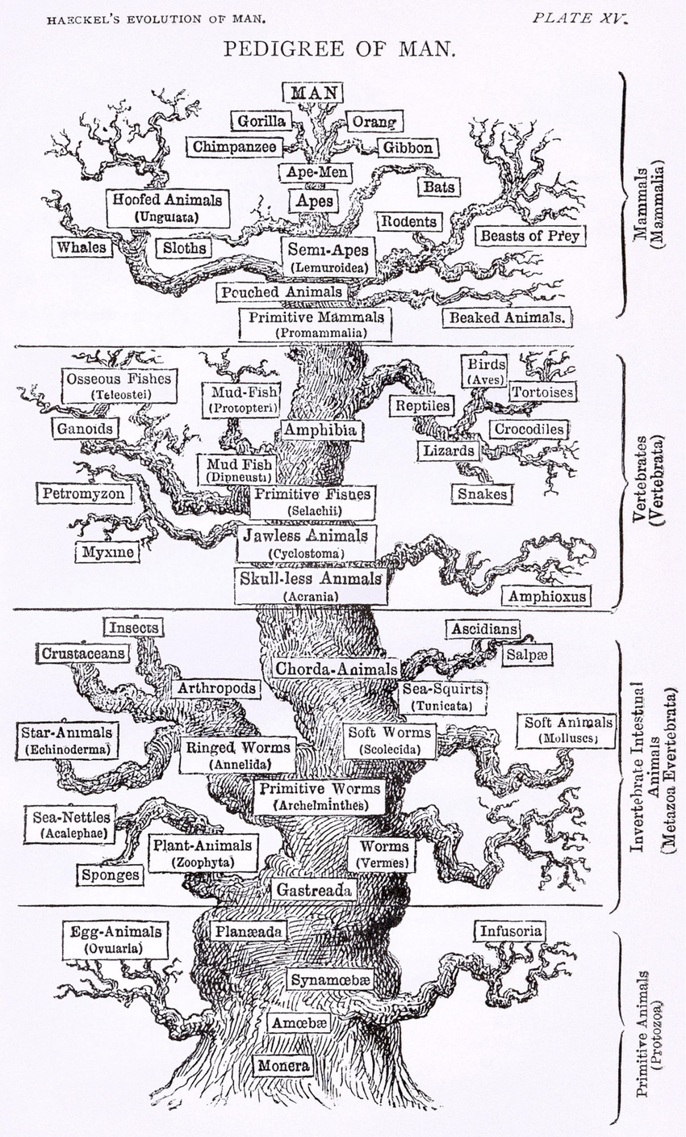
Kafka knew Haeckel’s tree, as did Uexküll, who eventually came to resist Haeckel’s machinic evolutionary thinking. Uexküll, is primarily known today for his Umwelten theory, which updates a term used by Friedrich Ratzel to explore how environmental factors shape human societies (Kinkle 2023). Uexküll, pushed the idea further through its connotations of “surrounding world” and environmental determinism to mean that each species exists within its own (perfectly curated) bubble. To illustrate his theory, he provided the example of a meadow in which each insect’s bubble was perfectly suitable for the larger environmental bubble it lived in, and within which “a new world arises,” all designed by nature (Uxeküll 2010). Geoff Winthrop-Young’s literary exploration of Uexküll’s meanderings in the meadow sets up the political consequences of his work: “Webs versus bubbles, contact versus boundary, connection versus isolation, communication between versus representation within—the tension between these poles will resonate throughout Uexküll and beyond” (2010). The tensions of his thought leads to Uexküll’s embrace of and by the Nazi regime, especially when it comes to his work on “State Biology” as the means for constructing society based on state organs that facilitate the flourishing of its specific volk, defined in ethnic terms (Kinkle 2023, Sprenger 2021).
In a sense, the global has always been an Umwelt harboring the apparently expansive 500-year mercantile and colonial projects, a smuggled in small ecology and world perfect for human thinking that helps separate humans from the planet, from the larger world that is the condition of possibility for their very existence. It is the domestication of the wild planetary plenty to reinscribe the comfy, non-threatening Umwelt of the volk or self by reterritorializing it elsewhere.
To the end, Uexküll resisted the mechanistic vision of evolution and nature’s taxonomies represented by Haeckel and his wide-reaching influence. Haeckel might have carried the day within the contributions of biology and natural history, but von Uexküll’s constitution of the solipsistic closed world of the Umwelt more accurately describes, I would argue, the noetic outlook where natural history and human history intersect, especially with regard to the world view held by the global order, especially in its technocentric geopolitical realignment post-World War II. This is the case in spite of his ”puckish cameo appearance” in thinkers such as Gilles Deleuze and Giorgio Agamben and fields ranging from critical animal studies, post-humanities and biosemiotics, which seemingly would have placed his thought in the planetarity model. These are partial readings of a wide-ranging and complex thinker (Winthrop-Young 2010). We are wise to remember that Uexküll “is a highly detachable theorist,” whose work makes easy-pickings for selective readings (Winthrop-Young 2010).
My own admittedly partial reading of him concentrates, for this essay, on the persistence of the solipsistic scope afforded in the contained Umwelt, as found in the epigraph to this section. Even though he penned a treatise imploring biologists not to abstain from taking part in electoral politics, his solipsistic and self-contained Umwelt found its way into his writings on State Biology, encompassing anatomy, physiology and pathology (Klinke 2023). A similar move occurs with nations, especially those during wartime, as Uexküll argues in a Second World War essay positing an English bubble very different from the one inhabited by Germans. In other words, a scaled-up and disconnected Umwelt is repeated not only in global perspectives (contradicting the global’s expansive embrace) but into multispecies planetarity too.
(Inter-) Planetary Design and Lunar Globalization
I now see the Earth realistically as a sphere and think of it as a spaceship. --Buckminster Fuller, Operating Manual for Spaceship Earth
As the newest era in space exploration begins, the Internet's future now extends into outer space. Today, we are on the cusp of an exciting re-entry into human and robotic space exploration driven by great momentum across the globe. – Preface to Solar System Internet Architecture and Governance
And whitey is on the moon – Gil-Scott Heron Small Talk at 125th and Lenox
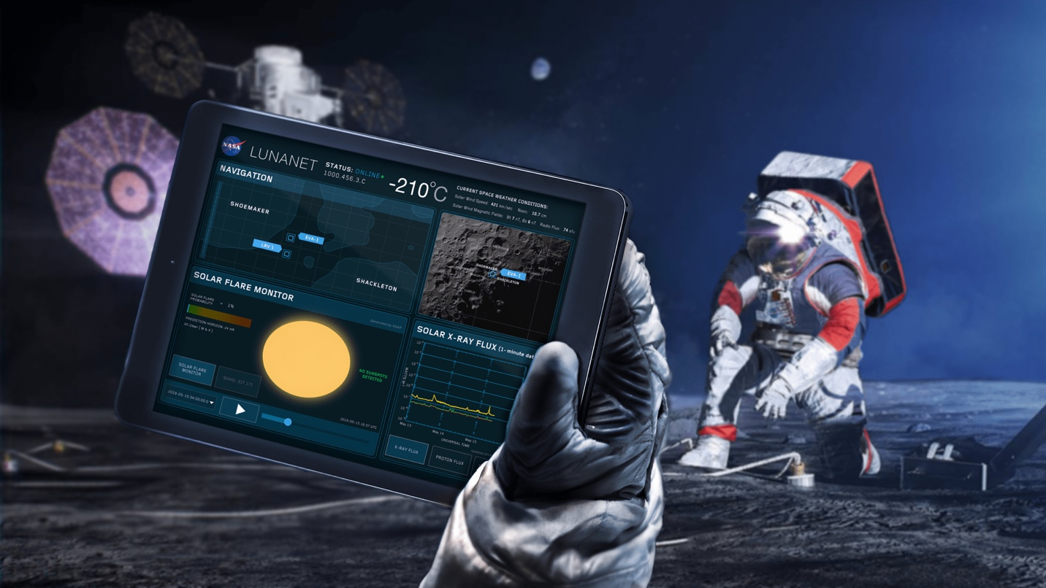
LunaNet: Bringing terrestrial internet capabilities to astronauts, rovers, and orbiters.
NASA / Reese Patillo (https://www.nasa.gov/humans-in-space/lunanet-empowering-artemis-with-communications-and-navigation-interoperability/)
The beeping sound emitted by that first artificial satellite, Sputnik, ushered in a new stage of Cold War fear and optimism, launching the space race, birthing the exoplanetary ring of near-space based telecommunications infrastructure, accelerating the development of poly-scalar autonomous remote sensing systems of the earth, as well as ushering in an era of universal computation, planetary design, and terraforming for both other planets and the earth. The planet became an anthropocentric model for the interplanetary. In other words, why not take our global systems of commerce and telecommunications as well as our existentially necessary environmental Umwelt elsewhere? Much as we took European cosmopolitan centers and national sovereignty elsewhere in the colonial division of the planet over 500 years ago?
The conversion of the lunar landscape into a telecommunications environment via the LunaNet plan NASA and private sector actors furthers plans to bring sustained human colonies primarily for mineral extraction and military advantage. Although reminiscent of the globe’s largely terrestrial internet but traveling through the vacuum of space, LunaNet clearly echoes late 20th, early 21st century technsopheric infrastructural programs, such as the Hewlett-Packard’s “Central Nervous System for the Earth”, NASA and Cisco System’s “The Planetary Skin Institute”, DARPA’s “Smart Dust”, Nokia’s “Sensor Planet”, IBM’s “Smarter Planet” ad nauseum. All of these systems leverage the hopeful vision of technophilic boosters such as Buckminster Fuller’s 1960s World Game, which assumed better planetary design can salvage humanity. A continued anthropocentric domination and control of nature even in the name of planetary good and extinction rollback remains nonetheless yet another manifestation of the human Umwelten imaginary.
For example, the Planetary Skin Institute combines NASA’s and Cisco Systems global the real-time, remote sensing capabilities for planetary eco-surveillance “that goes beyond carbon sensing in rural and urban environment beyond carbon sensing in rural and urban environments into critical sectors including water, food productivity and risk management” (United Nations Framework Convention on Climate Change). Partnering with international environmental agencies, national government and NGOs and acting for “the global public good,” the Planetary Skin Institute articulates a position as altruistic as can be imagined. It is worth noting that “the data and information targets of the system—weather, water, crop conditions, carbon emissions, et cetera—are also areas for resource futures investment that could link rapid profits and high-yield returns to this altruistic sensing” (Bishop 2018). The Institute’s skin is planetary in aspiration and self-representation but Umwelten in practice, providing a solely anthropocentric eco-surveillance bubble.
Extending the global order on an interplanetary scale simply renders the moon a lunar replica of the global Umwelt, just as the human environmental Umwelt necessary for biological survival finds replication in the space suit astronauts wear to avoid near-immediate death. What else will follow the teletechnological extension of global techno-politics and techno-poetics exemplified by LunaNet? What remains of the intellectual planetary agenda? How can we resuscitate the planetary as an intellectual and discursive heuristic capable of working in the public sphere? Especially when the narrow Umwelt resident in and constitutive of the global imaginary and infrastructure persists in many planetary agendas?
Whitey is indeed on the moon…and this time, he took his damn iPad with him.

References
Bishop, Ryan. 2018. “Felo de se: The Munus of Remote Sensing.” boundary2 45 (4): 41-63. DOI 10.1215/01903659-7142717.
Bratton, Benjamin. 2015. The Stack: On Sovereignty and Software. Cambridge, MA and London: MIT Press.
Chakrabarty, Dipesh.2023. One Planet Many Worlds: The Climate Parallax. Chicago and London: University of Chicago Press.
Fuller, Buckminster. 2008 [1969]. Operating Manual for Spaceship Earth. Zurich: Lars Müller Publishers.
Gabrys, Jennifer. 2016. Program Earth: Enviornmental Sensing Technology and the Making of a Computational Planet. Minneapolis and London: University of Minnesota Press.
Heron, Gill-Scott. 1970. “Whitey is on the Moon”. Small Talk at 125th and Lenox. Flying Dutchman Records
Internet Society Planetary Chapter. 2023. Solar System Internet Architecture and Governance. https://bpb-us-e1.wpmucdn.com/blogs.gwu.edu/dist/7/314/files/2023/10/Solar-System-Internet-Architecture-and-Governance.pdf (accessed 25 April 2025)
Kafka, Franz. 1997 [1919]. “A Report to an Academy.” In Best Short Stories/Die schönsten Ezrzählungen, edited and translated by Stanley Appelbaum, 176-191. Mineola, NY: Dover Books.
Kinkle, Ian. 2023. “Arguing with Jakob von Uexküll’s Umwelten.” GeoHumanties 9 (2): 462-479. doi.org/10.1080/2373566X.2023.2204138.
Lapoujade, David. 2018. Powers of Time: Visions of Bergson. Translated by Andrew Goffey. New York: Univocal Publishing.
NASA “Lunanet” https://www.nasa.gov/humans-in-space/lunanet-empowering-artemis-with-communications-and-navigation-interoperability/ (accessed 25 April 2025).
Sprenger, Florian. 2021. “Uexküll and Nazism: ‘Planmäßigkeit’ and ‘Placelessness’.” In Gottfried Schnödl and Florian Sprenger Uexküll’s Surroundings. Lüneburgh: Meson Press. 23-106.

Uexküll, Jakob von. 2010. A Foray into the Worlds of Animals and Humans, with a Theory of Meaning. Translated by Joseph D. O’Neil. Introduction by Dorion Sagan. Afterword by Geoffrey Winthrop-Young. Minneapolis and London: University of Minnesota Press.
United Nations Framework Convention on Climate Change. “Planetary Skin”. https://www4.unfccc.int/sites/NWPStaging/Pages/item.aspx?ListItemId=24041&ListUrl=/sites/NWPStaging/Lists/MainDB (accessed 25 April 2025)
Winthrop-Young, Geoffrey. 2010. “Afterword. Bubbles and Webs: A Backdoor Stroll Through the Readings of Uxekull.” In Jakob von Uexküll. 2010. A Foray into the Worlds of Animals and Humans, with a Theory of Meaning. Translated by Joseph D. O’Neil. Introduction by Dorion Sagan. Afterword by Geoffrey Winthrop-Young. Minneapolis and London: University of Minnesota Press.

I would like to thank Hagen Schulz-Forberg and others at Global Perspectives for their thoughts on this piece. The short essay also benefitted from conversations with Dipesh Chakrabarty, Geoff Winthrop-Young, Mike Featherstone, AbdouMaliq Simone, Tania Roy, Jussi Parikka, Benjamin Bratton, Bobby Pietrusko, Amanda Beech, Peter Middleton and my wonderful colleagues in the Department of Art and Media Technology, Winchester School of Art, University of Southampton.
See Ian Klinke, Florian Sprenger, and Geoffrey Winthrop-Young on this point.
Quoted in Klinke
GWY 223
Bratton, Gabrys, me

