Space-Time Superoscillations
Yijie Shen^{1,2*}, Nikitas Papasimakis³, Nikolay I. Zheludev^{3,4}
1. Centre for Disruptive Photonic Technologies, School of Physical and Mathematical Sciences, Nanyang Technological University, Singapore 637371, Singapore
2. School of Electrical and Electronic Engineering, Nanyang Technological University, Singapore 639798, Singapore
3. Optoelectronics Research Centre & Centre for Photonic Metamaterials, University of Southampton, Southampton SO17 1BJ, UK
4. Institute for Advanced Study, Texas A&M University, USA
* yijie.shen@ntu.edu.sg

Abstract
Superoscillation (SO) implies that electromagnetic waves can locally oscillate in space or time faster than the fastest spatial or temporal Fourier component of the entire function. SO allows to focus light into an arbitrarily small hotspot enabling superresolution imaging and metrology with accuracy far beyond the Abbe-Rayleigh diffraction limit. Here we show that the temporal and spatial SOs can be observed simultaneously in band-limited supertoroidal light pulses, a set of space-time nonseparable solutions of Maxwell's equations, at a specific region in space-time.

Introduction
In the last few years, optical superoscillations (SOs) attracted a considerable attention due to their fascinating electromagnetic properties and applications in imaging and metrology [1,2]. With coherent monochromatic light, SOs can be generated in one, two or three dimensions [3,4], while the concept of SOs to an arbitrary number, D, of spatial dimensions was developed by Berry and Dennis [5], whereby a monochromatic wave satisfying the Helmholtz equation , with r={x₁, …, x_{D}} and k₀=ω/c the free-space wavenumber, contains local regions that oscillate faster than k₀=ω/c. Recently, SOs have been considered in the temporal domain resulting in counterintuitive light-matter interactions and high resolution spectroscopy [6,7]. While, recent advances highlight the emerging spatiotemporal light fields characterized by intricate structures sculptured in space-time [8-10]. This innovation opens new dimensions to explore more extreme SO effects that have been inaccessible before.

Here we demonstrate that spatial and temporal SOs can be observed simultaneously at a given point in space-time, unveiling the existence of space-time superoscillations (STSOs), in the recently introduced family of spatiotemporally structured supertoroidal pulses (STPs) [11]. In contrast to conventional pulses, STPs cannot be expressed as products of spatial and temporal functions, but instead they exhibit nonseparability in the space and time domains resulting in a complex spatiotemporal topological structure [11]. As a result of their nonseparable nature, STPs cannot be presented in the form satisfying the Helmholtz equation. A characteristic member of this family of pulses is the toroidal light pulse or “Flying Doughnut”, the focused finite-energy single-cycle solution of toroidal topology predicted by Hellwarth and Nouchi in 1996 [12] and recently observed experimentally from optical to microwave domains [13-15].

Results
Supertoroidal pulse and bandlimit theories
Generally, an STP can be characterized by two length parameters, q₁ and q₂, representing the dominant wavelength and Rayleigh range, respectively, and a real dimensionless parameter α, which controls the topology of the pulses [11]. It must satisfy that α ≥ 1 to ensure finite energy solutions, while α < 1 results in pulses of infinite energy, such as planar waves and cylindrical waves. With increasing α, the local oscillations become increasing faster leading to stronger confinement [16]. STPs can be either azimuthally (TE) or radially polarized (TM). With no loss of generality, here we focus on the TE case. Such a pulse can be represented by its instantaneous azimuthal electric field E_{θ}(r,z,t)=A(r,z,t)e^{iϕ(r,z,t)}, where A and φ correspond to the amplitude and phase. The azimuthal electric field for a free-space propagating STP is given by (also see supplementary, S1):

(1)
(2)
(3)
where (r, θ, z) are cylindrical coordinates, t is time, $c=1/\sqrt{ε_{0}μ_{0}}$is the speed of light, and ε₀ and μ₀ are the permittivity and permeability of vacuum. where f₀ is a normalizing constant, τ = z − ct, σ = z + ct, q₁ and q₂ are parameters with dimensions of length and act as effective wavelength and Rayleigh range under the paraxial limit, while α is a real parameter as supertoroidal index that must satisfy α ≥ 1 to ensure finite energy solutions. In the condition of propagation in vacuum without dispersion, the group velocity on axis (r=0) of the STPs of different orders is always the constant of c, see detailed proof in Supplementary Materials S1 around Eq. (S20), while the velocity of the centroid of the whole structured pulse is less than c.

STPs are localized finite-energy solutions to Maxwell’s equatiosn, but they are not bandlimited. In order to study SOs, we consider bandlimited versions of STP, i.e. their versions with time domain and space domain spectra truncated at ω<ω_{m} and k<k_{m}=ω_{m}/c. Firstly, we obtain the spectrum of an STP field, E(r, z, t), by Fourier transform from space-time (r, z, t) to spatiotemporal frequency (f_{r}, f_{z}, f) domain.
(4)
The entire spectrum of a space-time light pulse must be confined on the surface of light cone, i.e the conic surface with unit slope of its generatrix in the coordinate (k_{r}, k_{z}, ω/c), where the spatial wavevectors are related to the spatial frequencies by k_{r}=2πf_{r}/c and k_{r}=2πf_{z}/c, and temporal frequency is related to the angular frequency by ω=2πf. We truncate STPs at a cut-off frequency, f_{m}, by multiplying their Fourier transform with a bump function B(f) (see Supplementary Section S2 for details). The corresponding band-limited spatiotemporal STP pulse can be obtained by inverse Fourier transform:
(5)
Truncated STPs retain all the main features of their non-bandlimited counterparts for $ω_{m} ≫ {4c}/{q_{1}}$ (see details in Supplementary Material S2), including collocated spatial and temporal SOs.

Space-time superoscillation in supertoroidal pulse
We illustrate the presence of STSO, i.e. simultaneous spatial and temporal SOs, by considering an STP with α=50, q₂=50q₁, q₁=1 (see Fig. 1). The spatial variation of the electric field along the radial direction at (z=0, t_{s}) is presented in Fig. 1c, where we observe that a segment in the off-axis region (r~ r_{s}) oscillates considerably faster than the harmonic oscillation of the maximal radial frequency k_{m} (dashed red line). Similarly, in Fig. 1d, we show the temporal variation of the electric field at (z=0, r_{s}), which around t~ t_{s} exhibits oscillations faster than the harmonic oscillation of maximal temporal frequency ω_{m} (dashed red line).

We illustrate the emergence of STSOs in STPs by considering their spatial and temporal distribution of the electric field at focus (z=0) for a fixed cut-off frequency ω_{m}=ck_{m}=2c/q₁. Figures 2(a1-a4) show the distribution of the logarithm of the electric field, i.e. log₁₀|Re[E_{θ}(r,z=0,t)]|, unwrapped phase of ϕ(r,z=0,t), large phase gradient, energy and Poynting vector distributions of the fundamental toroidal pulse (α=1). In Fig. 2(a3), there is only a small region with temporal local wavevector ∂ϕ/∂r exceeding k_{m}, but no spatial SO and thus no STSO. This temporal SO is induced by the rapid cycle switching of the focused single-cycle pulse. In Fig. 2(a4), we also highlight the region of energy backflow accompanied by low amplitude values, in accordance with prior works [11,17]. Higher values of α lead to increasingly complex STPs with multi-cycle structure and dramatic spatiotemporal evolution, which results into an extreme spatiotemporal focusing effect with STSO. Figures 2(b1-b4) show the corresponding distribution of the logarithm of the electric field, unwrapped phase, large phase gradient regions, energy and Poynting vector distributions, for an STP with α=50. Figure 2(b3) shows the presence of spatial SOs, where the local wavevector exceeds k_{m}, and temporal SOs, where the local temporal frequency exceeds ω_{m}. Importantly, the spatial and temporal SOs overlap significantly indicating the presence of STSOs. We can also clearly observe that STSOs appear at low amplitude regions surrounded by higher-amplitude regions. Similarly, to the recently observed spatial SOs in the optical domain [17], STSOs are also accompanied by areas of energy backflow, see inset to Fig. 2(b4).
Figures 3(a) and 3(b) show temporal local wavevector profiles at specific radius r=10q₁ and spatial local wavevector profiles at specific time t=2q₁/c, respectively, for a series of STPs with varying value of parameter α. We observe that the spatial and temporal rapid oscillations become increasingly stronger with increasing α. Figure 3(c) shows the ratio between energy within the rapid oscillations region, E_{STSO}, and the total energy of the pulse, E_{T}, as a function of parameter α. We observe that for α>38, STSO behaviour emerges with the energy of STSOs monotonically increasing with increasing α, see Fig. 3(c), although remaining relatively low (~3% or lower) in accordance with conventional SOs [3].
Finally, we demonstrate that the spectra of STSO segments of STPs contain components out of the light cone, i.e. they oscillate faster than what would be expected based on the pulse bandwidth. Figure 4 shows the entire spectra (a1-a4) and local spectra (b1-b4) and of STPs of different order, α = 1, 10, 50, and 100, defined as the Fourier transform of the local space-time segment E_{θ}(r~r_{s},z=0,t~t_{s}) into the (k_{r},ω) domain. The spectra of full pulses are confined on the surface of the light cone, whereas local spectra present spectral components off the light cone. The presence of the off-light-cone components directly reveals the presence of STSOs. Whereas for the fundamental toroidal pulse (α=1), local spectra are fully contained within the light cone, in the case of the STPs (α>1) the off-cone components become stronger with increasing value of α.

Discussion
Potential experimental realizations
Our work extends the concept of SOs to the space-time domain. We prove the existence of the STSO effect in space-time structured electromagnetic pulses, such as the STPs, by demonstrating the spatiotemporal analog of all characteristic features of SO waves.
From a practical standpoint, STSOs can be observed by generating STPs in the optical, THz and microwave ranges, following recent work on the generation of space-time non-separable toroidal pulses [13-15]. For instance, in the optical domain, commercially available Ti:Sa lasers can provide up to Δλ = 200 nm bandwidth (FWHM) central at λ₀ = 800 nm. The corresponding limits to spatial and temporal focusing are λ₀/2 = 400 nm and 4.64 fs (constant K=0.441 for Gaussian profile pulse), respectively. Based on the results shown in Figs. 3(a) and 3(b), for STP of α=100, at STSO spot, the temporal and spatial local wavevectors are 7 times and 5 times larger than the central wavevector, respectively. Here, we evaluate central wavevector as k_{c}=1 (unit: 1/q₁) as the central wavevector, it actually should be less than 1, see Fig. 4a. Therefore, we evaluate such STSO in STP allow temporal and spatial confinements of about Δτ/7=0.66 fs and λ₀/2/5 = 80 nm, respectively. If we apply the temporal SO separately (the central peak of Figs. 3(a) over 45 times than k_{c}=1), the temporal confinements can also be about 45 times shorter than Δτ (about 0.1 fs).
We also note that the amplitude of the STSOs is of the order 10⁻³ of the peak amplitude in a non-optimized case (see Fig. 2b), while the total energy contained in the STSO regions can exceeds 0.3% (see Fig. 3c). This is higher than what is encountered in some prior SO experiments and lies within current experimental capabilities. For instance, in SO super-microscope experiment [18], by applying the center SO hot spot about 0.1% energy of the total energy of the whole field, we can already enable the effective microscope, as the outside high-energy lobs were actually filtered out. Moreover, the practical observation of STSOs, like other superoscillatory features, will require techniques sensitive to weak signals amidst higher-amplitude backgrounds, a challenge successfully overcome in prior spatial SO measurements [6,7,18,19].
In addition to optical domain, based on the recently emerged microwave metasurface for shaping complex spatiotemporal and toroidal structured pulses [20], thus the STSO can be potentially designed in microwave domain by updated metasurface design, which are also with easier measurement technique than the optical experiment.
Future perspectives
Our work expands the concept of SO to include spatiotemporal effects, illustrated by the arbitrarily spatially and temporally confined focal spots in STPs. Further, our work invites key questions about the underlying physics of electromagnetic STSOs. For instance, what are the necessary and sufficient physical conditions for STSOs to emerge? what is the role of space-time nonseparability for the existence of STSOs? Is there a canonical route to the construction of STSOs? In addition to a plane wave based approach (see angular spectra of Fig. 4), a cylindrical basis could be better suited for the building and optimizing STSO fields. Moreover, the STSO spots demonstrated above are in isolated form, which are possible to be extended into more complex structured form, such as STSO spot array and multi-lobe forms. For instance, we can linearly superimpose a pulse chain of many STSOs to generate SO spatiotemporal arrays, analogous to the previous methods to produce multi-lobe SO arrays in the spatial domain [21,22].
The applications of STSOs should be clear and highly anticipated, as spatial temporal SOs have enabled important applications individually. In particular, spatial SOs have recently led to superresolution metrology even with picometric resolution [23,24], microscopy and imaging [1,18,19], while temporal SOs are finding applications in advanced spectroscopies [7]. Therefore, by combining for the first time these two forms of SOs into STSOs, we anticipate applications in metrology, imaging, sensing, and spectroscopy at ultra-fine spatial and ultrafast temporal resolution. Further, STSOs in light pulses pave the way towards novel phenomena arising from the coupling between STSO pulses and novel materials, e.g. controlling the spatiotemporal dynamics of phonons via the STSO light field [25]. Moreover, STSOs emerge in regions of rapid field reversal resulting from a nested skyrmionic structure, which has already been demonstrated in our prior work [11]. Recently, optical skyrmions found their applications in subwavelength sensing, metrology, and light-matter interaction [26-28], we perspective, the skyrmions with SO and STSO has potential to further enhance the deep-subwavelength resolution in these applications.
Finally, we argue that STSOs are not unique to the STPs considered here and we anticipate that STSO behavior may be found in other spatiotemporally structured light fields. Beyond electromagnetic waves, many other different types of waves (e.g. acoustic, gravitational, or water waves) are also expected to exhibit STSO phenomena.

References
- N. I. Zheludev and G. Yuan, Nat. Rev. Phys. 4, 16-32 (2022).
- Chen, G., Wen, ZQ. & Qiu, CW. Light Sci Appl 8, 56 (2019).
- M. V. Berry and S. Popescu, J. Phys. A 29, 6965 (2006).
- M V Berry, J. Phys. A: Math. Theor. 53 225201 (2020)
- M. V. Berry and M. R. Dennis, J. Phys. A: Math. Theor. 42, 022003 (2009).
- Y Eliezer, L Hareli, L Lobachinsky, S Froim, and A Bahabad, Phys. Rev. Lett. 119, 043903 (2017)
- G. McCaul, P. Peng, M. O. Martinez, D. R. Lindberg, D. Talbayev, and D. I. Bondar, Phys. Rev. Lett. 131, 153803 (2023).
- Yessenov, M., Hall, L. A., Schepler, K. L., & Abouraddy, A. F., Adv. Opt. Photon. 14(3), 455-570 (2022).
- Zhan, Q. Adv. Opt. Photon. 16(2), 163-228 (2024).
- Liu, X., Cao, Q., & Zhan, Q. Photonics Insights 3(4), R08-R08 (2024).
- Y. Shen, Y. Hou, N. Papasimakis, and N. I. Zheludev, Nat. Commun. 12, 5891 (2021).
- R. W. Hellwarth and P. Nouchi, Phys. Rev. E 54, 889–895 (1996).
- A. Zdagkas, C. McDonnell, J. Deng, Y. Shen, G. Li, T. Ellenbogen, N. Papasimakis, and N. I. Zheludev, Nat. Photonics 16, 523–528 (2022).
- K. Jana, Y. Mi, S. H. Møller, D. H. Ko, S. Gholam-Mirzaei, D. Abdollahpour, S. Sederberg and P. B. Corkum, Sci. Adv. 10, eadl1803 (2024).
- R. Wang, P.-Y. Bao, Z.-Q. Hu, S. Shi, B.-Z. Wang, N. I. Zheludev, Y. Shen, Appl. Phys. Rev. 11, 031411 (2024).
- Ziolkowski, Localized transmission of electromagnetic energy, Phys. Rev. A 39, 2005 (1989)
- G. H. Yuan, S. Vezzoli, C. Altuzarra, E. TF Rogers, C. Couteau, C. Soci, and N. I. Zheludev, Light. Sci. Appl. 5, e16127 (2016).
- Wong, A., Eleftheriades, G. An Optical Super-Microscope for Far-field, Real-time Imaging Beyond the Diffraction Limit. Sci Rep 3, 1715 (2013)
- Rogers, E., Lindberg, J., Roy, T. et al. A super-oscillatory lens optical microscope for subwavelength imaging. Nature Mater 11, 432–435 (2012)
- R. Wang, B. Ying, S. Shi, J. Wang, B.-Z. Wang, M. Liang, and Y. Shen, "Hybrid electromagnetic toroidal vortices," Sci. Adv. 11, eads4797 (2025)
- Z. Deng, N. Shapira, R. Remez, Y. Li, and A. Arie, Talbot effect in waveforms containing subwavelength multilobe superoscillations. Opt. Lett. 45, 2538–2541 (2020)
- Lim, S.W.D., Park, JS., Kazakov, D. et al. Point singularity array with metasurfaces. Nat Commun 14, 3237 (2023)
- G. H. Yuan, N. I. Zheludev, Science 364, 771-775(2019)
- Liu, T., Chi, CH., Ou, JY. et al. Picophotonic localization metrology beyond thermal fluctuations. Nat. Mater. 22, 844–847 (2023)
- Afanasiev, D., Hortensius, J.R., Ivanov, B.A. et al. Ultrafast control of magnetic interactions via light-driven phonons. Nat. Mater. 20, 607–611 (2021)
- Y. Shen, Q. Zhang, P. Shi, L. Du, X. Yuan, A. V. Zayats, "Optical skyrmions and other topological quasiparticles of light," Nat. Photonics 18, 15–25 (2024).
- Y. Shen, H. Wang, and S. Fan, "Free-space topological optical textures," Adv. Opt. Photonics 17(2) 295-374 (2025)
- R. Wang, P.-Y. Bao, X. Feng, J. Wu, B.-Z. Wang, and Y. Shen, "Single-antenna super-resolution positioning with nonseparable toroidal pulses" Commun. Phys. 7, 356 (2024)

Methods
All methods are shown in Supplementary Materials
Data Availability
The data from this paper can be obtained from the University of Southampton ePrints research repository at https://doi.org/10.5258/SOTON/XXXX (will provide before eProof stage)
Code Availability
The code from this paper and details on the code used can be obtained from the University of Southampton ePrints research repository https://doi.org/10.5258/SOTON/XXXX (will provide before eProof stage).
Competing interests
The authors declare no competing interests.
Acknowledgements
Singapore Ministry of Education (MOE) (MOE2016-T3-1-006), the UKs Engineering and Physical Sciences Research Council (grant EP/M009122/1, Funder Id: 10.13039/501100000266), the European Research Council (Advanced grant FLEET-786851, Funder Id: https://doi.org/10.13039/501100000781), the Defense Advanced Research Projects Agency (DARPA) under the Nascent Light Matter Interactions program, Singapore MOE AcRF Tier 1 grants (RG157/23 & RT11/23), Singapore Agency for Science, Technology and Research (A*STAR) MTC Individual Research Grants (M24N7c0080), and a Nanyang Assistant Professorship Start Up grant.
Author Contributions
Y. S. conceived the idea, performed the theoretical simulations, and wrote the initial manuscript, N. P. and N.I.Z. supervised the project; All authors analyzed the data and revised the manuscript.

Figures

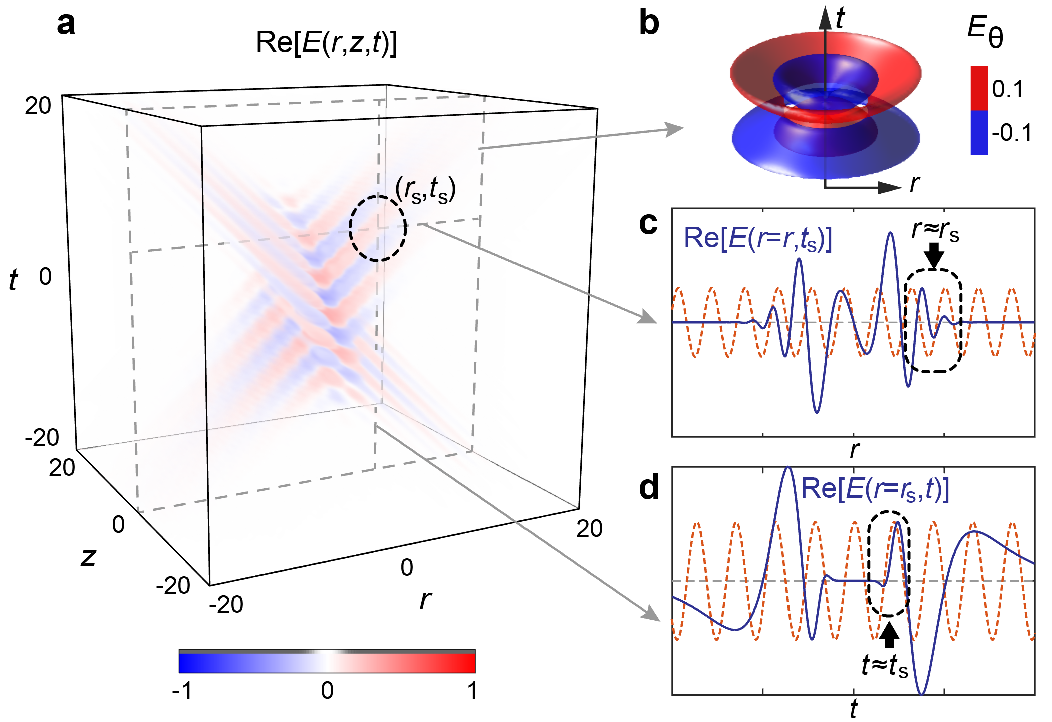
Figure 1: Superoscillations a band-limited supertoroidal light pulse (α=50, q₂=50q₁). a, Spatiotemporal evolution of the azimuthal electric field, E_{θ}(r,z,t). b, Isosurfaces of the electric field, E_{θ}(r,z=0,t), in the focal plane. c,d, Radial (c) and temporal (d) field profiles at focus (z=0) at specific moment in time t_{s}=5 (c, blue line), and at specific radial position r_{s}=10 (d, blue line), respectively. The corresponding fastest spatial (c) and temporal (d) Fourier components are marked by red-dashed lines. The black dashed boxes highlight the SO region. Unit for length: q₁, Unit for time: q₁/c.
​

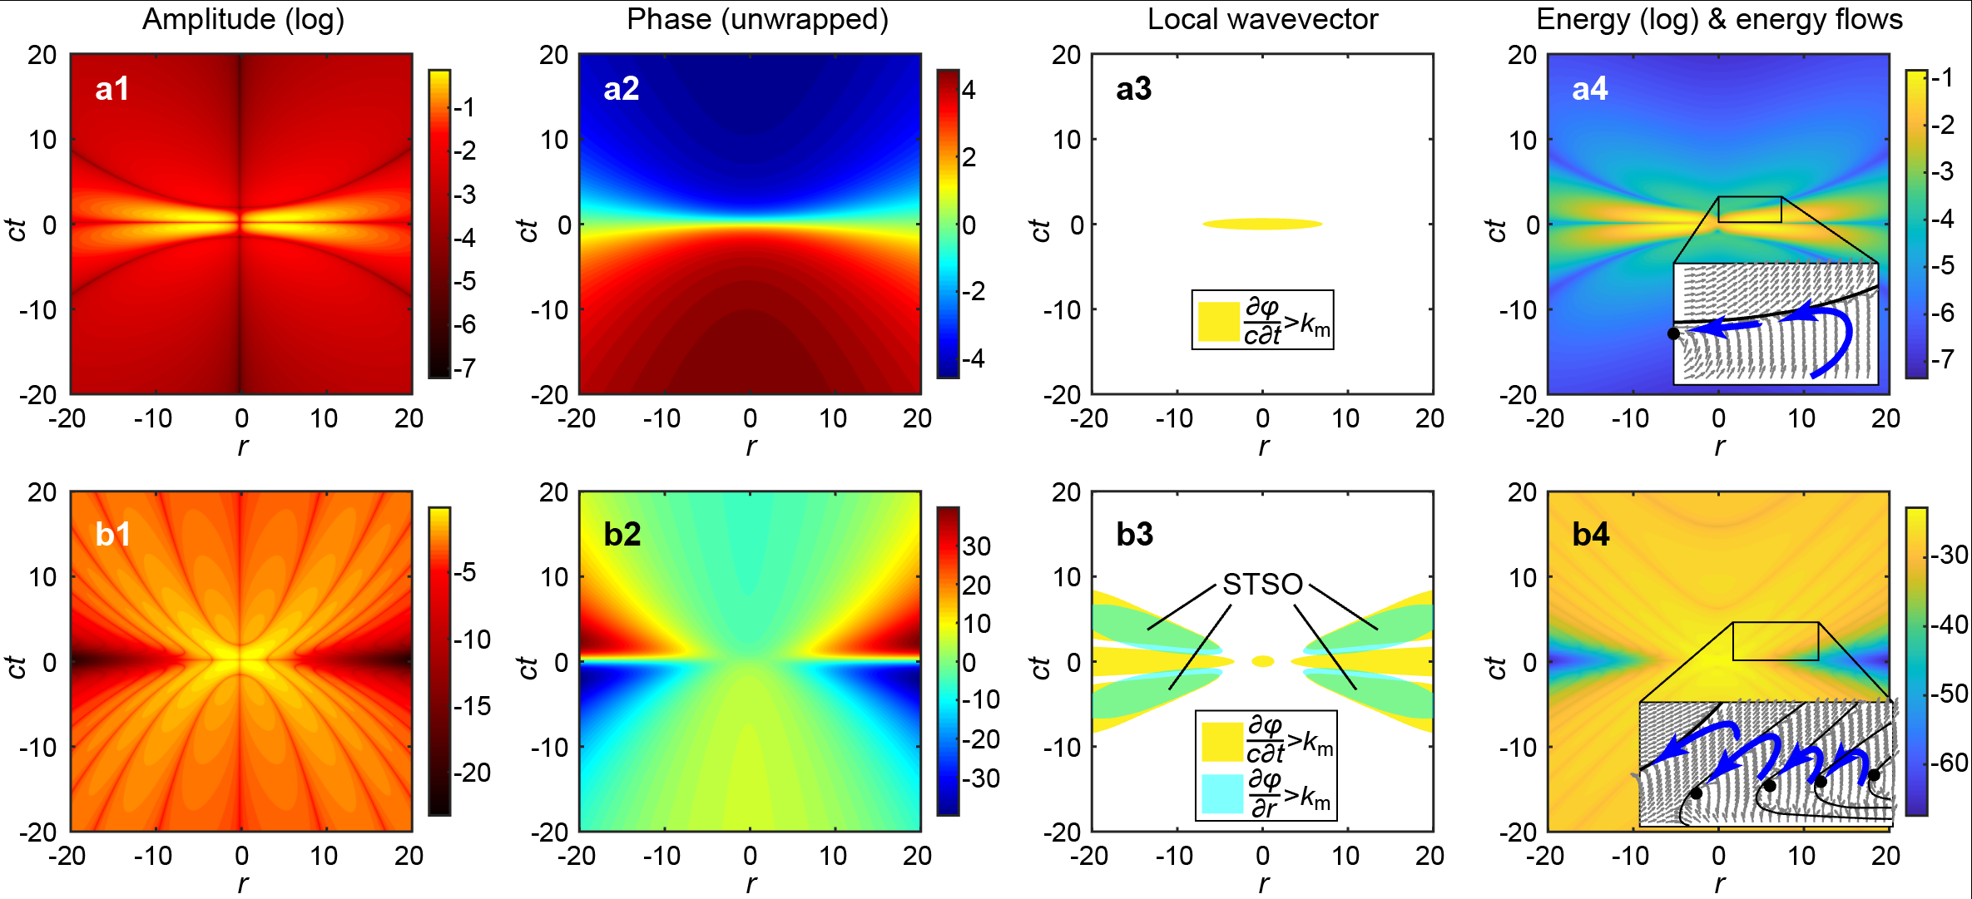
Figure 2: Characterizations of toroidal and supertoroidal pulses. a1,b1, Spatiotemporal field modulus (|E_{θ}(r,z=0,t)|) distributions for a toroidal pulse (α=1) (a1) and an STP (α=50) (b1), at focus (z=0). The amplitude is presented in terms of the logarithm of its real part, log₁₀|Re[E_{θ}(r,z=0,t)]|. a2,b2, Unwrapped phase distributions φ(r,t)=Arg[E_{θ}(r,z=0,t)] of the two pulses presented in (a1,b1). a3,b3, Regions in which the radial local wavevector (∂φ/∂r) and local temporal frequency (∂φ/∂t) of the toroidal (a3) and supertoroidal (b3) pulse exceed the threshold frequency, ω_{m}, and wavevector, k_{m}, respectively (k_{m}=2/q₁). a4,b4, The energy spatial and temporal distribution, w=(ϵ₀E²+μ₀H²)/2, for the two pulses. Insets show the local energy flow with the black solid lines and dots marking the zero lines and singularities, and blue thick arrows marking the areas of energy backflow. Unit for all axes, r and ct, is q₁.
​
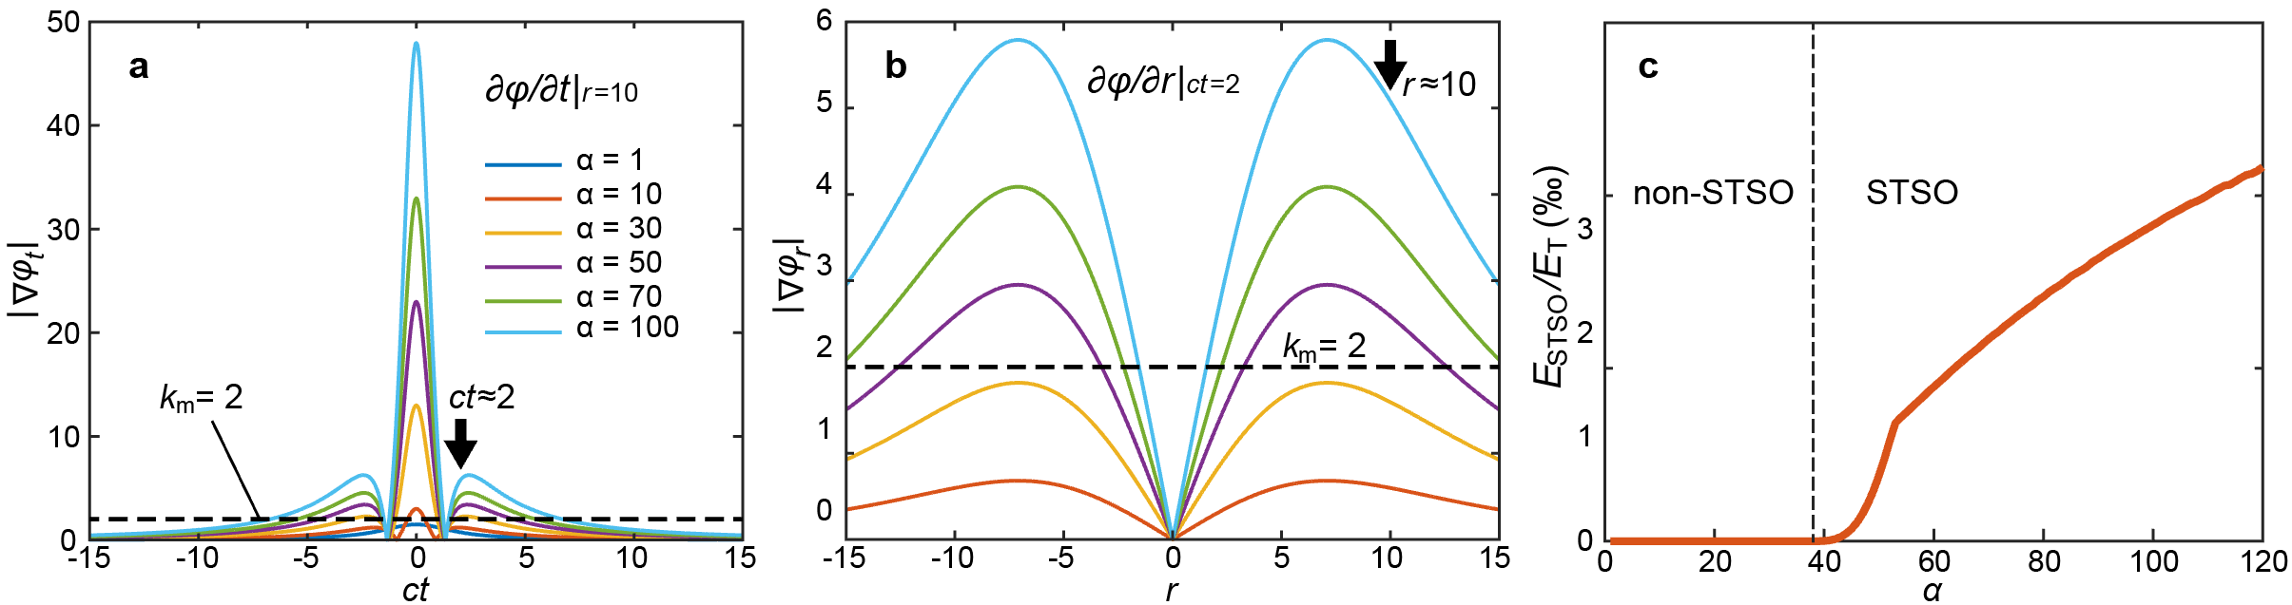
Figure 3: Characterizing space-time superoscillations. a,b, The temporal local frequency at r=10 (a) and the radial local wavevector at t/c=2 (b) of supertoroidal pulses for different values of α. The black dashed lines mark the value of the fastest spatial and temporal frequency component, respectively. c, the ratio of energy in the STSO region over the total energy of the pulse as a function of supertoroidal order α.

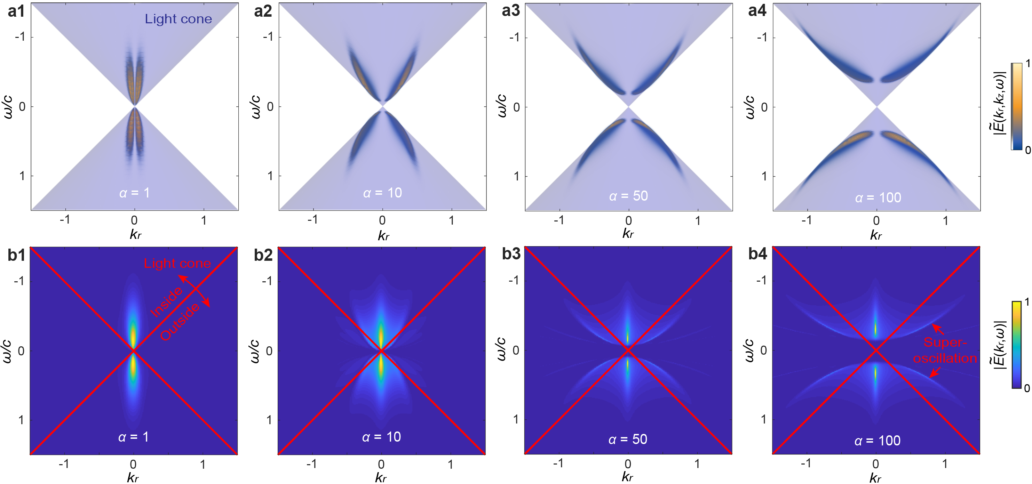
Figure 4: Spectral characterizations. a1-a4, Entire spectral power projected in the (k_{r},ω) plane for toroidal pulses (α=1) and STPs (α=10, 50, 100). The light blue regions mark the light cone. b1-b4, Local spectral power in the (k_{r},ω) plane corresponding to radial-temporal STSO segments of pulses of different order (α=1, 10, 50, 100). The red lines mark the boundary of the light cone. Note that, whereas the spectra of the full pulses (a1-a4) are confined on the surface of the light cone, local segments (b1-b4) exhibit out-of-cone components. Unit: 1/q₁

