Supplemental Figures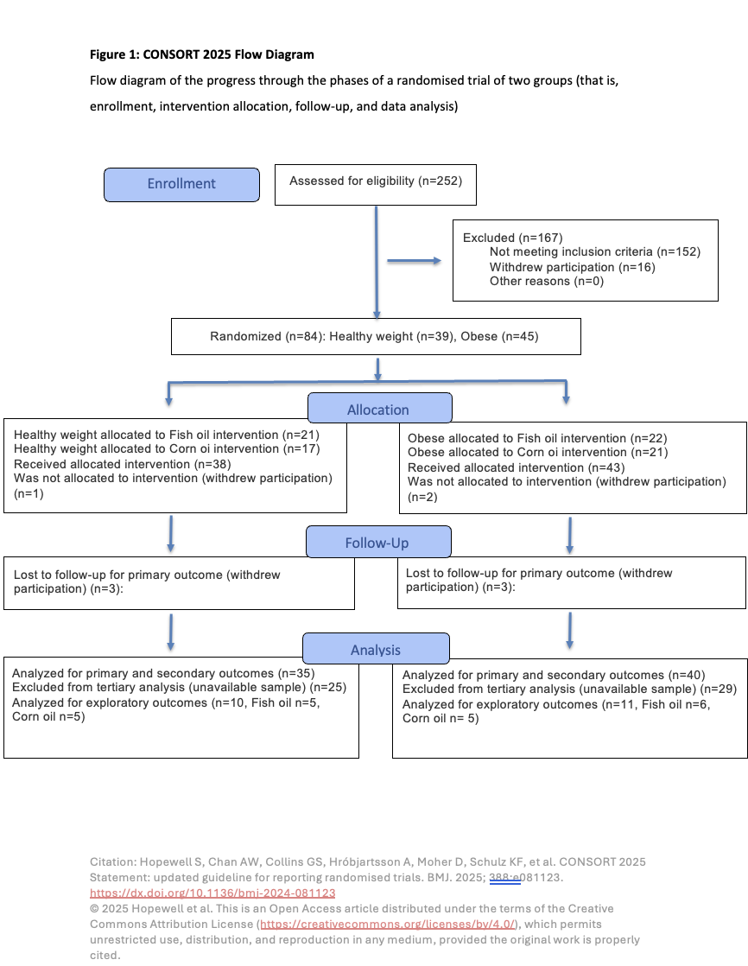
Supplemental Figure 1
Supplemental Figure 2
Supplemental Figure 3
Supplemental Figure 4

Supplemental Figure 5
Supplemental Figure Legends
Supplemental Figure 1. CONSORT diagram depicting the entire study design including sample origin from previous clinical trial.
Supplemental Figure 2. Relative concentrations of fatty acids in plasma phosphatidylcholines and cholesterol esters before (baseline) and after (week-12) EPA+DHA or CO supplementation for n=10 and n=11, respectively. Data are expressed as the percentage of total fatty acids for (A) PC C14:0, (B) PC C16:0, (C) PC C18:0, (D) PC C18:1n-9, (E) CE C14:0, (F) CE C16:0, (G) CE C18:0, (H) CE 18:1n-9. Error bars represent mean ± standard deviation. Statistical significance was assessed as follows: baseline differences between the two groups were evaluated with unpaired t-tests; within-group changes from baseline to week 12 were analyzed using paired t-tests; and between-group comparisons at week 12 were performed with ANCOVA (*/⁺p < 0.05, **/⁺⁺p<0.01,***/⁺⁺⁺p < 0.001, ****/⁺⁺⁺⁺p < 0.0001). CE, cholesteryl esters; CO, Corn oil; DHA, Docosahexaenoic acid; EPA, Eicosapentaenoic acid; PC, Phosphatidylcholines .
Supplemental Figure 3. Relative concentrations of fatty acids in plasma non-esterified fatty acids and triglycerides before (baseline) and after (week-12) EPA+DHA or CO supplementation for n=10 and n=11, respectively. Data are expressed as the percentage of total fatty acids for (A) NEFA C14:0, (B) NEFA C16:0, (C) NEFA C18:0, (D) NEFA C18:1n-9, (E) TAG C14:0, (F) TAG C16:0, (G) TAG C18:0, (H) TAG 18:1n-9. Error bars represent mean ± standard deviation. Statistical significance was assessed as follows: baseline differences between the two groups were evaluated with unpaired t-tests; within-group changes from baseline to week 12 were analyzed using paired t-tests; and between-group comparisons at week 12 were performed with ANCOVA (*/⁺p < 0.05, **/⁺⁺p<0.01,***/⁺⁺⁺p < 0.001, ****/⁺⁺⁺⁺p < 0.0001). CO, Corn oil; DHA, Docosahexaenoic acid; EPA, Eicosapentaenoic acid; NEFA, Non-esterified fatty acids; TAG, Triglycerides.
Supplemental Figure 4. Relative concentrations of circulating omega-3 derived oxylipins before and after EPA+DHA or CO supplementation for n=10 and n=11, respectively. Data are expressed as the percentage of total oxylipins for (A) 11-HDoHE, (B) 14(S)-HDHA, (C) 19,20-DiHDPA, (D) 9-HOTrE. Error bars represent mean ± standard deviation. Statistical significance was assessed as follows: baseline differences between the two groups were evaluated with unpaired t-tests; within-group changes from baseline to week 12 were analyzed using paired t-tests; and between-group comparisons at week 12 were performed with ANCOVA (*/⁺p < 0.05, **/⁺⁺p<0.01,***/⁺⁺⁺p < 0.001, ****/⁺⁺⁺⁺p < 0.0001). CO, Corn oil; DHA, Docosahexaenoic acid; EPA, Eicosapentaenoic acid.
Supplemental Figure 5. Relative concentrations of circulating omega-6 derived oxylipins before and after EPA+DHA or CO supplementation for n=10 and n=11, respectively. Data are expressed as the percentage of total oxylipins for (A) 11(12)-EET, (B) 12,13-DiHOME, (C) 12(13)-EpOME, (D) 12-HHTrE, (E) 14,15-DiHETrE, (F) 15S-HETE, (G) 15-HETrE, (H) 20-hydroxy-LTB4, (I) 5,6-DiHETrE, (J) 5-KETE, (K) 8S-HETE, (L) 8-iso-PGF2a, (M) 9(10)-EpOME, (N) 9-HETE, (O) 9-OxoODE, (P) LTB4, (Q) LXA4, (R) PGD2, (S) PGE2, (T) PGJ2. Error bars represent mean ± standard deviation. Statistical significance was assessed as follows: baseline differences between the two groups were evaluated with unpaired t-tests; within-group changes from baseline to week 12 were analyzed using paired t-tests; and between-group comparisons at week 12 were performed with ANCOVA (*/⁺p < 0.05, **/⁺⁺p<0.01,***/⁺⁺⁺p < 0.001, ****/⁺⁺⁺⁺p < 0.0001). CO, Corn oil; DHA, Docosahexaenoic acid; EPA, Eicosapentaenoic acid.

