Understanding risk of poor outcomes in adults hospitalised with respiratory syncytial virus infection: evidence from a multicentre UK cohort
Tommaso Morelli¹,²*, Martha Purcell¹,², Jon Panaguiton³, Rachel Patel⁴, Sharon Weinburg⁵, George Hulston⁵, Hans Siy-Yap⁵, Emma Davies⁵, Anluan Keating¹,², Ida Saidy⁵, Anna Freeman¹,², Karl J Staples¹,², Pedro Rodrigues⁶, Abigail Jones⁶, Alexander Allen⁶, Aruna T Bansal⁷, Stefan J Marciniak⁸,⁹, Neil Greening¹⁰, Michael G Crooks¹¹, Philip J Mitchelmore⁴, Salman H Siddiqui¹², James Myerson¹³, Matthew Pavitt¹³, Cyrus Daneshvar¹⁴,¹⁵, James D Chalmers¹⁶, Paul H Lee⁶, Tom Lewis⁴, Tristan W Clark¹,², Sarah Denny¹⁷, Dexter Wiseman¹⁷, Huw Ellis⁵, Tom M Wilkinson¹,² UNIVERSAL Study Group
Affiliations
¹ Clinical and Experimental Sciences, Faculty of Medicine, University of Southampton, Southampton, UK
² NIHR Southampton Biomedical Research Centre, University Hospital Southampton NHS Foundation Trust, Southampton, UK
³ Guy’s and St Thomas’s NHS Foundation Trust, London, UK
⁴ Royal Devon University Healthcare NHS Foundation Trust, Exeter, UK
⁵ Manchester University NHS Foundation Trust, Manchester, UK
⁶ Southampton Clinical Trials Unit, University of Southampton and University Hospital Southampton NHS Foundation Trust, Southampton, UK
⁷ Acclarogen Ltd., St John’s Innovation Centre, Cambridge, UK
⁸ Cambridge University Hospitals NHS Foundation Trust, Cambridge, UK
⁹ Royal Papworth Hospital, Cambridge, UK
¹⁰ Department of Respiratory Sciences, Institute for Lung Health, University of Leicester, Leicester, UK
¹¹ Academic Respiratory Medicine, Hull York Medical School, Hull, UK
¹² National Heart and Lung Institute, Imperial College London, London, UK
¹³ Department of Respiratory Medicine, University Hospitals Sussex NHS Foundation Trust, Brighton and Haywards Heath, UK
¹⁴ Department of Respiratory Medicine, University Hospitals Plymouth NHS Trust, Plymouth, UK
¹⁵ Faculty of Health, University of Plymouth, Plymouth, UK
¹⁶ Division of Respiratory Medicine and Gastroenterology, Ninewells Hospital and Medical School, University of Dundee, Dundee, UK
¹⁷ Chelsea and Westminster NHS Foundation Trust, London, UK
Correspondence
Correspondence to: Dr Tommaso Morelli, Clinical and Experimental Sciences, Faculty of Medicine, University of Southampton, Southampton, SO16 6YD, UK. Email: tommaso.morelli@southampton.ac.uk
Word count 3497 words (excluding headings and subheadings)

ABSTRACT
Background
Respiratory syncytial virus (RSV) causes substantial winter pressure on adult services. In the United Kingdom, RSV vaccination currently targets adults aged ≥75 years and care home residents; it remains uncertain whether this age criterion alone identifies hospitalised adults at highest risk of poor outcome.
Methods
We pooled three UK hospital cohorts (one prospective, two retrospective) of adults admitted with acute respiratory infection and PCR-confirmed RSV. The primary outcome was ICU/HDU admission or all-cause mortality within 60 days. Prespecified predictors (age, sex and comorbidities) entered a LASSO-penalised logistic regression; selected variables were refitted using logistic models. Discrimination, calibration and clinical utility were assessed using 1,000-bootstrap internal validation and decision-curve analysis.
Results
Among 334 adults, 37 (11.1%) experienced the primary outcome. An age-only rule mirroring current UK vaccine eligibility (≥75 years) demonstrated limited discrimination (optimism-adjusted AUC 0.578, 95% CI 0.480–0.653) and a compressed distribution of predicted risks. A four-predictor model—including age, chronic obstructive pulmonary disease, active/previous cancer and dementia—achieved higher discrimination [0.766 (0.694–0.847)], a wider spread of predicted risks, and the greatest net benefit across clinically plausible escalation thresholds (5–20%).
Conclusions
In adults hospitalised with RSV-associated acute respiratory infection, the ≥75-year age threshold alone was a suboptimal prognostic marker for ICU/HDU admission or 60-day mortality. A simple comorbidity-inclusive model substantially improved internal discrimination, calibration and clinical utility but should be considered developmental. External validation, more systematic RSV testing across the age spectrum, and comparison with physiology-based scores in larger, vaccinated cohorts are required before implementation.
Keywords: Respiratory Syncytial Virus Infections; Hospitalisation; Comorbidity; Risk Assessment; Decision Support Systems, Clinical; Intensive Care Units; Vaccination; United Kingdom.

Key messages
What is already known on this topic
UK RSV vaccination policy prioritises age (≥75 years) and care-home residence; it is unclear whether age alone identifies those at highest risk once hospitalised.
What this study adds
Current UK age-based eligibility (≥75 years) and other age-only rules were not robust predictors of poor outcome, whereas a simple four-factor model—age plus COPD, cancer and dementia—showed substantially better internally validated performance.
How this study might affect research, practice or policy
Findings support consideration of extending RSV preventive strategies, including vaccination, to high-risk comorbid adults below current age cut-offs, and suggest vaccine-effectiveness studies COULD stratify by COPD, cancer and dementia

INTRODUCTION
Respiratory syncytial virus (RSV) is a major cause of acute respiratory infection (ARI) and winter healthcare pressure in older adults, with an estimated 470,000 hospital admissions and 33,000 in-hospital deaths annually among adults aged ≥60 years in high-income countries¹. Under-diagnosis likely means the true burden is greater¹⁻⁵.
Both age and comorbidity contribute substantially to risk. In US population-based surveillance, RSV hospitalisation incidence rose from 7.7–11.9 per 100,000 at ages 18–49 to 136.9–255.6 per 100,000 among those ≥65 years⁶. Chronic conditions such as COPD, heart failure, chronic kidney disease, diabetes, and malignancy confer independent risk. In some cohorts, younger adults with these conditions experience post-hospitalisation mortality comparable to—or exceeding—that of older adults without comorbidity⁷. There are no specific treatments for hospitalised adults, making accurate early risk stratification central to clinical decision-making and service planning.
Prefusion F-protein vaccines (Arexvy, Abrysvo, mRESVIA) have transformed prevention strategies. Vaccination policies differ internationally. In the United States, the CDC recommends vaccination for all adults ≥75 years and for those aged 50–74 years with high-risk comorbidities⁸. Across Europe, authorities generally recommend vaccination for adults ≥60 years and/or those with chronic conditions³. However, pivotal trials primarily assessed prevention of RSV lower respiratory tract disease, used heterogeneous case definitions, and under-represented hospitalised adults and outcomes such as intensive care unit (ICU) admission or death³ ⁹⁻¹². Real-world evidence is encouraging: a large US test-negative study reported 87–89% vaccine effectiveness against RSV-related hospitalisation or emergency visits in adults ≥60 years¹³.
In the United Kingdom, initial eligibility was restricted to ages 75–79 years on cost-effectiveness grounds¹⁴. Mid-season evaluation demonstrated ≈30% reductions in RSV hospitalisation in this age group—consistent with implied vaccine effectiveness of ~70% at observed uptake¹⁵. End-of-season sentinel data similarly suggested high effectiveness (~82% against RSV hospitalisation)¹⁶. UK policy now includes all adults ≥75 years and care-home residents, with JCVI modelling indicating that targeting ≥80 years may be even more cost-effective, but currently excludes younger adults with comorbidities¹⁷.
Whether age-based vaccine eligibility criteria alone identify those at highest risk once hospitalised remains uncertain¹⁸⁻²⁰. We therefore undertook an exploratory analysis of a multicentre UK cohort of adults hospitalised with PCR-confirmed RSV to: (i) identify demographic and clinical predictors of poor outcome—defined as ICU admission or all-cause mortality within 60 days; and (ii) compare age- and comorbidity-based risk models for discrimination and clinical utility.

METHODS

Study design and data sources
We undertook a pooled individual participant analysis of adults admitted to UK hospitals with acute respiratory infection (ARI) and PCR-confirmed RSV. ARI was defined as an acute upper or lower respiratory illness (e.g. rhinitis, pharyngitis, pneumonia, bronchitis or influenza-like illness) or an acute exacerbation of chronic respiratory disease (e.g. COPD, asthma, bronchiectasis), diagnosed by the treating clinician based on respiratory symptoms and clinical assessment.
Three harmonised cohorts contributed data under a shared protocol and variable dictionary: (i) UNIVERSAL²¹, a prospective multicentre cohort enrolling consecutive adults within 36 h of admission across ten NHS hospitals in England and Scotland (31 August 2022–20 November 2024); (ii) a Royal Devon & Exeter retrospective cohort identified via syndromic PCR testing and electronic health records (1 January 2023–31 January 2024); and (iii) a Manchester retrospective cohort identified from microbiology databases (1 November–31 December 2023). Cohorts were non-overlapping. Given differing recruitment periods and testing strategies, the pooled cohort should be interpreted as a convenience sample of RSV-tested adults rather than a nationally representative population.

Eligibility criteria
Inclusion criteria were: age ≥18 years, hospital admission for ARI, and RSV detected by PCR within 36 h of first hospital contact. Exclusion criteria were: RSV detected >36 h after admission, viral co-infection, non-respiratory primary admission reason, management confined to ED/ambulatory areas, or previous receipt of an RSV vaccine.

Predictors
We recorded age, sex, and prespecified comorbidities: COPD, asthma, interstitial lung disease, bronchiectasis, heart failure, chronic kidney disease, chronic liver disease, diabetes mellitus (type 1 or 2), active or previous cancer (including haematological malignancy), rheumatological disease, dementia, and HIV. Comorbidities were defined from clinician-documented diagnoses recorded at or before admission. Data on solid organ or haematopoietic stem cell transplantation and treatment-related immunosuppression were incompletely recorded and were therefore not analysed as separate predictors.
To examine pragmatic risk strategies aligned with vaccination policy, three binary indicators were defined a priori: age ≥75 years (current UK eligibility threshold), age ≥60 years (international threshold), and ≥1 core comorbidity (COPD, heart failure, diabetes mellitus, active/previous cancer, or chronic kidney disease), based on prior evidence⁷.

Outcome
The primary outcome was a composite of ICU or HDU admission and/or all-cause mortality within 60 days of hospital admission. Sixty-day mortality was ascertained from hospital electronic patient records and associated administrative systems, capturing deaths during admission and those subsequently reported to participating NHS Trusts after discharge.

Missing data and sample size
Predictor data were complete. Six participants (1.8%) lacked 60-day outcome data and were excluded, leaving 334 for analysis.
Sample size adequacy was assessed using the pmsampsize package. Assuming an anticipated C-statistic of 0.80, outcome prevalence of 0.11, four predictor parameters, and target shrinkage ≥0.90, a minimum of 280 participants with ≥32 events was required. The final cohort (n = 334; 37 events) just met these criteria²². Given the modest event count, penalisation and bootstrap internal validation were used to limit and quantify overfitting.

Statistical analysis

Modelling strategy
Univariable p-values were not used for predictor screening. Four prespecified logistic models were evaluated:(A) age ≥75 years; (B) age ≥60 years; (C) ≥1 core comorbidity; and (D) a multivariable model derived by penalised selection.
For Model D, all candidate predictors (continuous age, sex, and comorbidities) were entered into a LASSO-penalised logistic regression. The penalty parameter (λ_min) was selected using 10-fold cross-validation. Predictors with non-zero coefficients at λ_min defined the model structure. The selected predictors (age, COPD, cancer, dementia) were refitted using standard logistic regression to obtain odds ratios (ORs) and 95% confidence intervals (CIs). Firth-penalised logistic regression was used as a sensitivity analysis to assess robustness in the presence of small cell counts.
Prespecified sensitivity analyses examined alternative age specifications around the selected variables: age ≥60, age ≥75 and model excluding age to aassess robustness to vaccine-policy relevant age formulations rather than as additional primary models.

Robustness of variable selection
Stability of LASSO selection was evaluated using bootstrap stability selection (B = 1,000), reporting the proportion of resamples in which each predictor was selected.
Selective inference was performed using the fixedLassoInf procedure to illustrate additional uncertainty introduced by post-selection inference. These results are presented descriptively; primary inference focuses on model-level performance, as selective inference cannot fully correct post-selection bias when selection and estimation occur in the same dataset.

Model performance
Discrimination was assessed using the area under the receiver operating characteristic curve (AUC) with DeLong 95% confidence intervals. Calibration was evaluated using the calibration slope, calibration-in-the-large (CITL), loess-smoothed plots, and decile-based observed versus predicted risks. Overall predictive accuracy was summarised with the Brier score.
Internal validation used 1,000 bootstrap resamples. Mean optimism was subtracted from apparent performance metrics (AUC, slope, CITL, Brier). Using the optimism-adjusted slope and intercept, predicted risks were recalibrated as p** = expit(CITL + slope × logit(p))
These recalibrated predictions were used for calibration plots and all clinical-utility analyses.

Clinical utility
Decision-curve analysis (DCA) was performed using optimism-adjusted, recalibrated predictions. Net benefit was evaluated across threshold probabilities from 1–20%, reflecting clinically plausible escalation ranges in hospitalised adults²³, and reported per 100 patients. For interpretability, results are summarised at prespecified thresholds of 5%, 10% and 15%. The “treat all” curve is included solely as a formal decision-analytic comparator and does not represent a realistic escalation strategy.

Software
Analyses were performed in R 4.5.0

Ethics
Analyses were performed in R 4.5.0. The UNIVERSAL prospective cohort received multicentre NHS Research Ethics Committee approval with written informed consent. The Exeter and Manchester cohorts were approved locally as service evaluations; informed consent was waived as data were anonymised. Reporting follows TRIPOD guidelines.

RESULTS

Cohort description
Across the three contributing cohorts, 340 adults with PCR-confirmed RSV infection were admitted to participating UK hospitals; 6 (1.8%) lacked primary-outcome data, leaving 334 for analysis (Figure 1). Median age was 69.5 years (IQR 59.0–78.0); 73% were aged ≥60 years and 34% ≥75 years. At least one core comorbidity (COPD, heart failure, diabetes, active/previous cancer or chronic kidney disease) was present in 61%. Asthma (36%), COPD (32%), diabetes (21%) and chronic kidney disease (19%) were common. ICU/HDU admission occurred in 3.6% (12/337), 60-day all-cause mortality in 8.7% (29/334), and the composite primary outcome in 11.1% (37/334) (Table 1;). Of those experiencing the primary outcome, 10 (27%) were aged ≥75 years and therefore eligible under current UK vaccination policy. Baseline characteristics by cohort and outcome stratified by key covariates are shown in Tables S1–S2.
Table 1. Baseline demographics, comorbidities, and outcome for adults hospitalised with RSV infection (n = 340)
Characteristic | Value | Missing n | Missing %
Age (years) | 69.5 [59.0, 78.0] | 0 | 0.0%
Age ≥60 years | 247 (73%) | 0 | 0.0%
Age ≥75 years | 117 (34%) | 0 | 0.0%
Male sex | 134 (39%) | 0 | 0.0%
Chronic obstructive pulmonary disease | 107 (31%) | 0 | 0.0%
Asthma | 121 (36%) | 0 | 0.0%
Interstitial lung disease | 15 (4.4%) | 0 | 0.0%
Bronchiectasis | 22 (6.5%) | 0 | 0.0%
Heart failure | 42 (12%) | 0 | 0.0%
Chronic kidney disease | 66 (19%) | 0 | 0.0%
Chronic liver disease | 16 (4.7%) | 0 | 0.0%
Diabetes mellitus | 70 (21%) | 0 | 0.0%
Any cancer | 40 (12%) | 0 | 0.0%
Rheumatological disease | 41 (12%) | 0 | 0.0%
Dementia | 19 (5.6%) | 0 | 0.0%
HIV | 5 (1.5%) | 0 | 0.0%
≥1 core comorbidity* | 209 (61%) | 0 | 0.0%
ICU/HDU admission | 12 (3.6%) | 3 | 0.9%
60-day mortality | 29 (8.7%) | 6 | 1.8%
Primary outcome | 37 (11%) | 6 | 1.8%
Categorical variables are shown as n (%); continuous variables as median [IQR]. Missing n (%) refers to the number and proportion of records with missing data for each variable. The primary composite outcome was ICU or HDU admission, or all-cause mortality within 60 days of the index hospital admission. Core comorbidity denotes the presence of at least one of COPD, heart failure, diabetes mellitus, active/previous cancer, or chronic kidney disease. Abbreviations: ICU, intensive care unit; HDU, high dependency unit. Percentages are calculated using non-missing denominators.

Penalised variable selection
LASSO logistic regression was applied to continuous age, sex and all prespecified comorbidities. At the cross-validated optimal penalty (λ_min), four predictors retained non-zero coefficients: age, COPD, active/previous cancer and dementia (Figures S1–S3). Bootstrap stability selection supported this pattern, with COPD and dementia selected in >94% of resamples, cancer in 79.5%, and age in 60.8%; all remaining candidate predictors were selected in <46% of resamples (Table S3).
Selective inference was undertaken to illustrate additional uncertainty arising from post-selection inference. On the penalised scale, selective-adjusted estimates were robust for COPD and dementia but imprecise for cancer and age(Table S4). These results are presented descriptively. Correlations between age and comorbidities were modest (all |r| ≤ 0.29), and variance inflation factors for the refitted model ranged from 1.02 to 1.15, indicating no concerning multicollinearity (Figure S3; Table S5).

Multivariable predictors
In age-based comparator models, age ≥75 years was associated with approximately doubled odds of the composite outcome (OR 2.01, 95% CI 1.01–4.03), while the broader age ≥60 years threshold yielded a larger but imprecise estimate (OR 4.93, 95% CI 1.71–20.83). Presence of ≥1 core comorbidity was also associated with higher odds (OR 3.07, 95% CI 1.38–7.81).
In the LASSO-derived multivariable model (Model D), including age (continuous), COPD, active/previous cancer and dementia, standard logistic regression produced odds ratios of 1.016 per year increase in age (95% CI 0.987–1.049), 4.46 for COPD (95% CI 2.09–9.95), 2.90 for cancer (95% CI 1.09–7.27), and 8.35 for dementia (95% CI 2.58–27.80) (Table 2). Firth-penalised logistic regression yielded near-identical estimates, supporting robustness despite the modest number of events (Table S6).

Table 2. Predictor estimates from the four standard logistic regression models (Models A–D): age-based, core-comorbidity, and LASSO-derived multivariable models.
Model | Predictor | OR | 95% CI | p-value
Model A | Age ≥75 years | 2.014 | 1.005–4.027 | 0.046
Model B | Age ≥60 years | 4.928 | 1.714–20.833 | 0.010
Model C | ≥1 core comorbidity | 3.072 | 1.379–7.811 | 0.010
Model D | Age (continuous) | 1.016 | 0.987–1.049 | 0.301
 | COPD | 4.457 | 2.094–9.946 | <0.001
 | Cancer | 2.902 | 1.087–7.270 | 0.026
 | Dementia | 8.347 | 2.582–27.799 | <0.001
Model A: age ≥75 years; Model B: age ≥60 years; Model C: ≥1 core comorbidity (COPD, heart failure, diabetes mellitus, active/previous cancer, or chronic kidney disease); Model D: LASSO-derived multivariable model including age (continuous), COPD, active/previous cancer, and dementia. All estimates are odds ratios (ORs) with 95% confidence intervals (CIs) obtained from standard logistic regression (glm). Core comorbidity denotes the presence of at least one of COPD, heart failure, diabetes mellitus, active/previous cancer, or chronic kidney disease. Statistically significant predictors (p < 0.05) are presented in bold. Abbreviations: COPD, chronic obstructive pulmonary disease.

Model Performance
After bootstrap internal validation (1,000 resamples), discrimination of the three simple comparator models remained modest, with optimism-adjusted AUCs of 0.578 (95% CI 0.480–0.653) for age ≥75 years, 0.611 (95% CI 0.564–0.665) for age ≥60 years, and 0.614 (95% CI 0.548–0.686) for the core-comorbidity model (Table 3). Predicted risks from these models occupied a narrow range (approximately 5–15%).
By contrast, the optimism-adjusted AUC for the multivariable model was 0.766 (95% CI 0.694–0.847), indicating materially improved discrimination. Calibration was also more coherent for the multivariable model, with an optimism-adjusted slope of 0.911 (95% CI 0.618–1.269) and calibration-in-the-large near zero. Brier scores were similar across models but lowest for the multivariable specification (0.093, 95% CI 0.070–0.116). Apparent and optimism-adjusted calibration plots are shown in Figures S5–S6.

Table 3. Optimism-adjusted performance of candidate RSV risk prediction models following 1000-boostrap internal validation
Model (definition) | AUC (95% CI) | Slope (95% CI) | CITL (95% CI) | Brier (95% CI)
A (Age ≥75 only) | 0.578 (0.480–0.653) | -0.621 (-3.300–5.792) | 0.017 (-0.304–0.393) | 0.099 (0.074–0.126)
B (Age ≥60 only) | 0.611 (0.564–0.665) | 1.068 (0.027–2.397) | 0.010 (-0.307–0.369) | 0.097 (0.074–0.123)
C (Core comorbidity only*) | 0.614 (0.548–0.686) | 0.990 (0.501–2.945) | 0.015 (-0.317–0.390) | 0.098 (0.075–0.124)
D LASSO-selected (Age (cont) COPD, Cancer, Dementia) | 0.766 (0.694–0.847) | 0.911 (0.618–1.269) | 0.015 (-0.378–0.419) | 0.093 (0.070–0.116)
Optimism-adjusted discrimination, calibration, and overall accuracy for Models A–D after 1,000-bootstrap internal validation of standard logistic regression (glm) fits in the combined cohort. For each model, the table reports the AUC, calibration slope, calibration-in-the-large (CITL), and Brier score with percentile 95% confidence intervals from 1,000 bootstrap resamples. Model A: age ≥75 years only; Model B: age ≥60 years only; Model C: core comorbidity only (≥1 of COPD, heart failure, diabetes, cancer, or chronic kidney disease); Model D: machine-learning (ML) model with LASSO-selected predictors (age [continuous], COPD, cancer, dementia). AUC, area under the receiver operating characteristic curve; CITL, calibration-in-the-large.

Sensitivity analyses
Sensitivity analyses examining alternative age specifications around the selected comorbidity triad are reported in Tables S8–S13. Models combining COPD, cancer and dementia with age ≥60 years or ≥75 years yielded optimism-adjusted AUCs of 0.770 (95% CI 0.701–0.850) and 0.758 (95% CI 0.684–0.836), respectively. A triad-only model excluding age performed similarly (AUC 0.770, 95% CI 0.701–0.851). Across all formulations, calibration slopes ranged from 0.87 to 0.92 with calibration-in-the-large close to zero, supporting robustness of the selected predictors to alternative age banding.

Clinical Utility
Decision-curve analysis based on optimism-adjusted, recalibrated predictions demonstrated limited net benefit for age-only rules and the single-factor comorbidity model across clinically plausible thresholds (5–20%), with rapid attenuation as thresholds increased (Table 4; Figures 4–5). The machine-learning model consistently achieved higher net benefit across this range and retained positive net benefit at higher thresholds where simpler comparators approached or fell below zero.
Table 4. Decision-curve analysis for prediction of ICU/HDU admission or 60-day all-cause mortality: net benefit per 100 patients at 5%, 10%, and 15% risk thresholds (optimism-adjusted predictions)
Model (definition) | Threshold (%) | Net benefit per 100
A (Age ≥75 only) | 5% | 6.4
 | 10% | 1.2
 | 15% | -4.6
B (Age ≥60 only) | 5% | 6.9
 | 10% | 3.3
 | 15% | 0.0
C (Core comorbidity only*) | 5% | 6.4
 | 10% | 3.2
 | 15% | -0.2
D (LASSO-selected age, active/previous cancer, COPD, dementia) | 5% | 7.3
 | 10% | 6.0
 | 15% | 4.1

DISCUSSION
In this multicentre UK cohort of adults hospitalised with PCR-confirmed RSV-associated ARI, simple age-based rules reflecting current or proposed vaccine eligibility thresholds (≥75 or ≥60 years) demonstrated only modest prognostic performance for ICU/HDU admission or 60-day all-cause mortality. By contrast, a parsimonious four-predictor model incorporating age, COPD, active/previous cancer and dementia achieved higher discrimination, more coherent calibration, and greater separation of predicted risk. Decision-curve analyses based on optimism-adjusted predictions suggested greater net benefit for this comorbidity-inclusive model than for age-only or single-comorbidity rules across clinically plausible escalation thresholds, although estimates were imprecise. Overall, within this hospital cohort, incorporating selected comorbidities alongside age provided more informative risk stratification than age-band thresholds alone, but the model should be regarded as developmental rather than a definitive clinical tool⁷ ²² ²³
These findings must be interpreted alongside extensive evidence that RSV incidence, hospitalisation and mortality increase steeply with age at the population level¹ ² Age is also an upstream determinant of frailty and of the prevalence and severity of chronic conditions such as COPD, chronic kidney disease and dementia⁷. Consistent with this, older age was associated with higher odds of poor outcome in univariable analyses. However, once major comorbidities were accounted for, the additional independent effect of age on ICU/HDU admission or 60-day mortality was small and imprecisely estimated. A cautious interpretation is that, among adults already sick enough to require hospital admission with RSV-associated ARI, much of the apparent age-related risk of early severe outcome is mediated through accumulated comorbidity and frailty rather than reflecting a large direct effect of chronological age itself⁶ ⁷ ²⁴. Notably, only a minority of those experiencing ICU/HDU admission or 60-day mortality met the current UK age-based vaccination threshold (≥75 years), indicating that severe in-hospital outcomes in this cohort were concentrated among comorbid adults below the age cut-off (Table S2)¹⁴ ¹⁷ ²⁵
It is important to distinguish the simple age thresholds evaluated here from multivariable prognostic scores more generally. Established tools for community-acquired pneumonia and COVID-19 incorporate age alongside physiological and biochemical parameters rather than using age in isolation (e.g. CURB-65 and the 4C Mortality Score)²⁶ ²⁷ Our focus was deliberately narrow: to evaluate age-band thresholds that mirror current or proposed RSV vaccine eligibility criteria, because these heuristics are prominent in policy.¹⁴⁻¹⁷ Within this specific question, comorbidity-inclusive models outperformed age-band thresholds in this cohort, but they are not intended to replace physiology-based prognostic assessment or clinical judgement.
The pattern of predictors identified here is consistent with prior adult RSV literature, in which severe outcomes cluster among older adults with substantial respiratory, cardiometabolic and neurological disease⁷.⁷ COPD, malignancy and dementia have been repeatedly associated with severe RSV outcomes in adults, supporting their prominence in the penalised model⁷. All prespecified comorbidities were entered into penalised selection; asthma, bronchiectasis and interstitial lung disease were selected less frequently and did not materially improve model performance under strict constraints on model complexity. This should not be interpreted as clinical irrelevance of these conditions, but rather reflects limited incremental prognostic information in a small dataset where parsimony was essential. Important immunocompromised states, including solid organ and haematopoietic stem cell transplantation, were incompletely captured and are likely under-represented; specialised RSV-specific tools developed for transplant populations—such as the Immunodeficiency Scoring Index for RSV (ISI-RSV), which incorporates detailed haematological and treatment-related parameters—remain more appropriate in those settings²⁸
Several limitations warrant emphasis. The composite outcome, while a valid indicator of poor outcome and severity was chosen pragmatically because ICU/HDU admission and 60-day mortality alone yielded too few events for stable multivariable modelling. ICU/HDU admission is influenced by local practice and ceilings of care, while 60-day all-cause mortality is not specific to RSV. RSV testing in adults is non-systematic and shaped by clinician preference and local pathways, with evidence that older adults are under-tested; consequently, this pooled dataset should be interpreted as a convenience sample of RSV-tested hospitalised adults rather than a nationally representative population, and ascertainment bias cannot be excluded⁴ ⁵. The modest number of outcome events constrained model complexity and resulted in imprecise coefficient estimates. We addressed this through penalised selection, bootstrap stability analyses, optimism-adjusted internal validation and recalibration, and by focusing interpretation on model-level performance rather than individual coefficients. Nevertheless, external validation and model updating in independent cohorts, including vaccinated populations, will be essential.
From a clinical perspective, these findings suggest that age-based heuristics alone are unlikely to be sufficient for identifying adults at highest risk of ICU/HDU admission or early death once hospitalised with RSV-associated ARI. If replicated and externally validated, routinely available variables (age, COPD, cancer and dementia) could potentially support electronic health-record prompts for closer monitoring or earlier senior review during periods of winter pressure, as an adjunct to clinical judgement and established early warning approaches.
At a policy level, this analysis does not directly inform optimal vaccine targeting or cost-effectiveness, which depend on population-level RSV incidence and outcomes together with vaccine effectiveness and economic evaluations. Rather, it offers a complementary view of post-admission risk among adults hospitalised with RSV. As adult RSV vaccination becomes more widespread, future analyses should examine model calibration and performance in vaccinated populations and prespecify effect modification by key comorbidities. More broadly, COPD, cancer and dementia are plausible strata for vaccine-effectiveness and therapeutic studies, and may be used to enrich recruitment towards groups at highest absolute risk, improving power to detect meaningful effects.

CONCLUSION
In adults admitted to hospital with RSV-associated acute respiratory infection, simple age-based rules that mirror current or proposed vaccine eligibility thresholds (≥75 or ≥60 years) provided limited prognostic discrimination and poor separation of risk for ICU/HDU admission or 60-day all-cause mortality. In contrast, a parsimonious comorbidity-inclusive model incorporating age alongside COPD, active or previous cancer and dementia demonstrated superior internal discrimination, calibration and decision-analytic performance, indicating that routinely recorded comorbidities capture a substantial proportion of the hospital-level risk signal in this setting.
These findings should be interpreted as developmental and hypothesis-generating. External validation, recalibration and updating in larger, more representative cohorts—including vaccinated populations—are required before any consideration of clinical implementation, alongside direct comparison with physiology-based prognostic scores. Nevertheless, the results suggest that among hospitalised adults with RSV, comorbidity-informed approaches are likely to be more informative than age-based heuristics alone. COPD, cancer and dementia warrant a priori consideration in the design, analysis and stratification of future RSV vaccine-effectiveness, therapeutic and outcome studies, and may help refine understanding of vulnerability in adults hospitalised with RSV infection.

FIGURES AND CAPTIONS
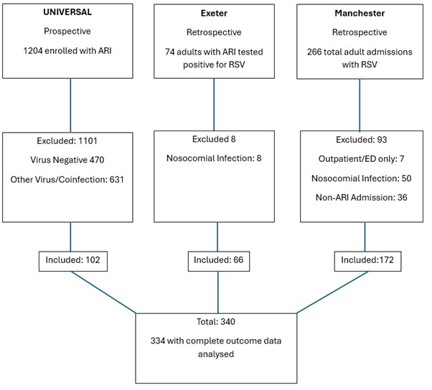
Figure 1. Flow of participants into the analytic cohort. 6 viral coinfection excluded from Universal, 2 from Exeter, 7 from Manchester.
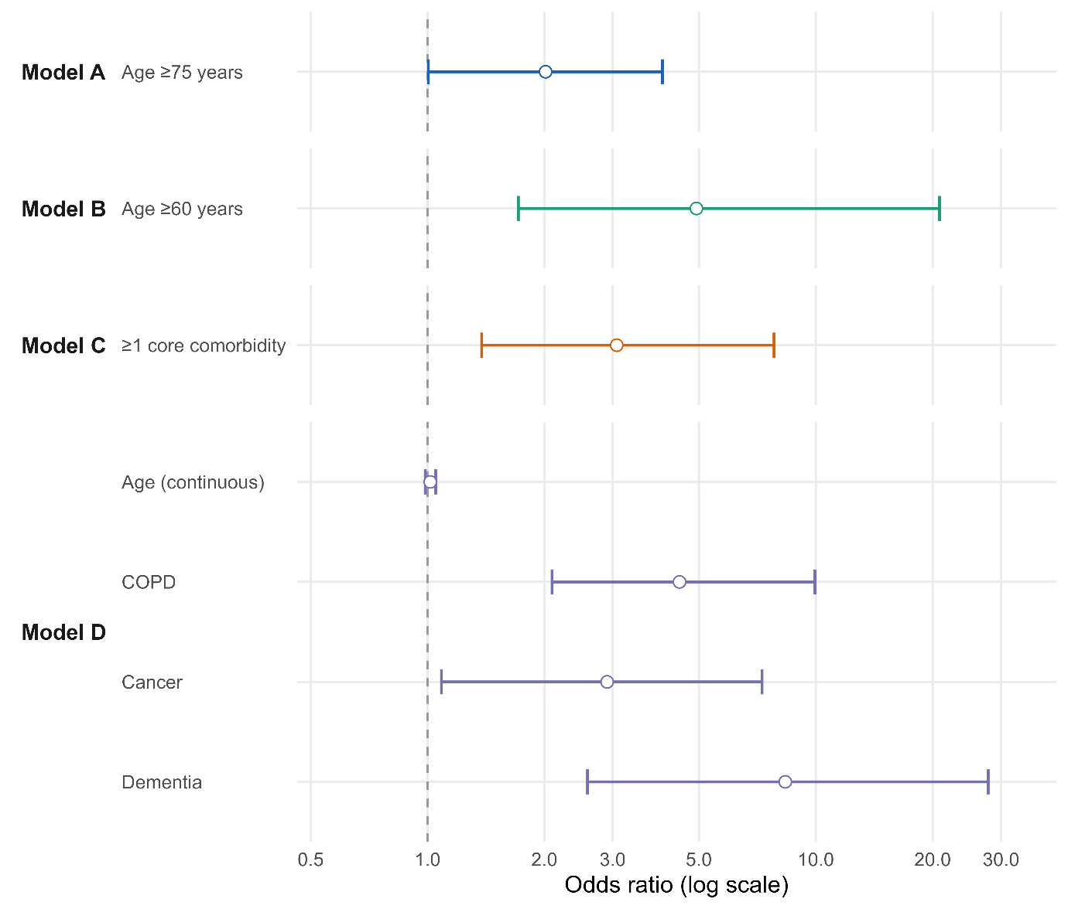
Figure 2. Adjusted odds ratios for predictors across four standard logistic regression (glm) models.
Forest plot showing adjusted odds ratios (ORs) and 95% confidence intervals for predictors included in Models A–D, each fitted using standard logistic regression (glm). Model A (age ≥75 years) and Model B (age ≥60 years) represent age-based rules similar to current or proposed vaccine eligibility thresholds. Model C reflects a pragmatic clinical rule based on ≥1 core comorbidity (COPD, heart failure, diabetes mellitus, active/previous cancer, or chronic kidney disease). Model D, a LASSO-derived multivariable model, included age (continuous), COPD, active/previous cancer, and dementia. COPD, cancer, and dementia showed strong independent associations with adverse outcome, whereas age (continuous) demonstrated only a weak, non-significant association in the multivariable context. Circles denote point estimates and horizontal bars indicate 95% confidence intervals; the dashed line marks OR = 1.

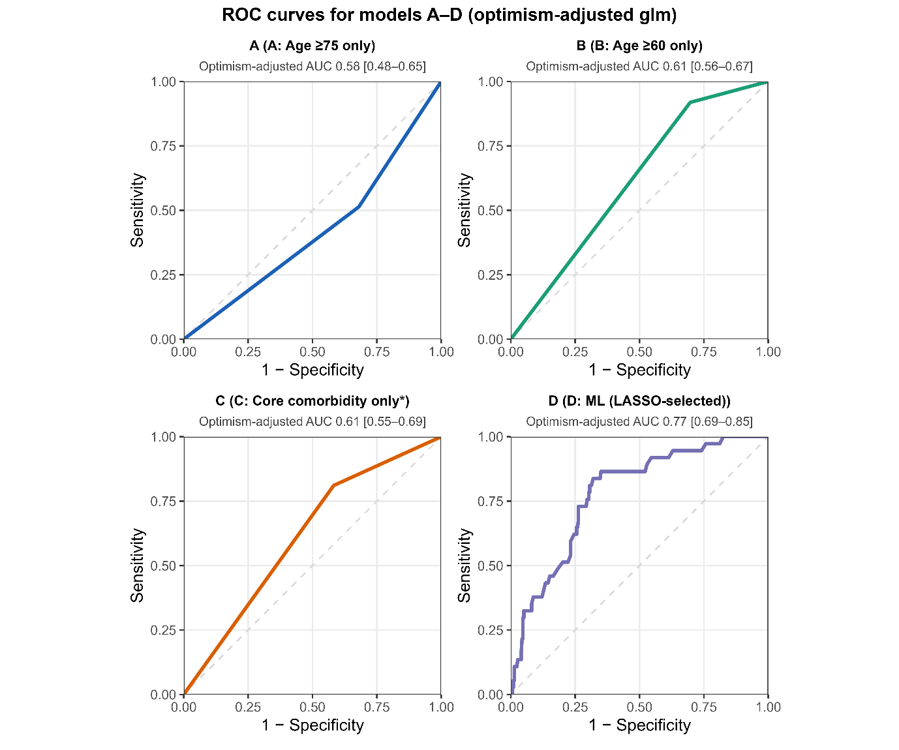
Figure 3. Receiver operating characteristic curves for optimism-adjusted logistic regression models A–D.
ROC curves for Models A–D, each fitted using standard logistic regression (glm), with optimism adjustment obtained from 1000-sample bootstrap internal validation. Each panel shows sensitivity plotted against 1–specificity; the diagonal dashed line indicates no discrimination (AUC = 0.50). Age-based and core-comorbidity models (A–C) demonstrated modest discrimination (optimism-adjusted AUC 0.58–0.61), whereas the LASSO-selected multivariable model (Model D) achieved materially higher discrimination (optimism-adjusted AUC 0.77).

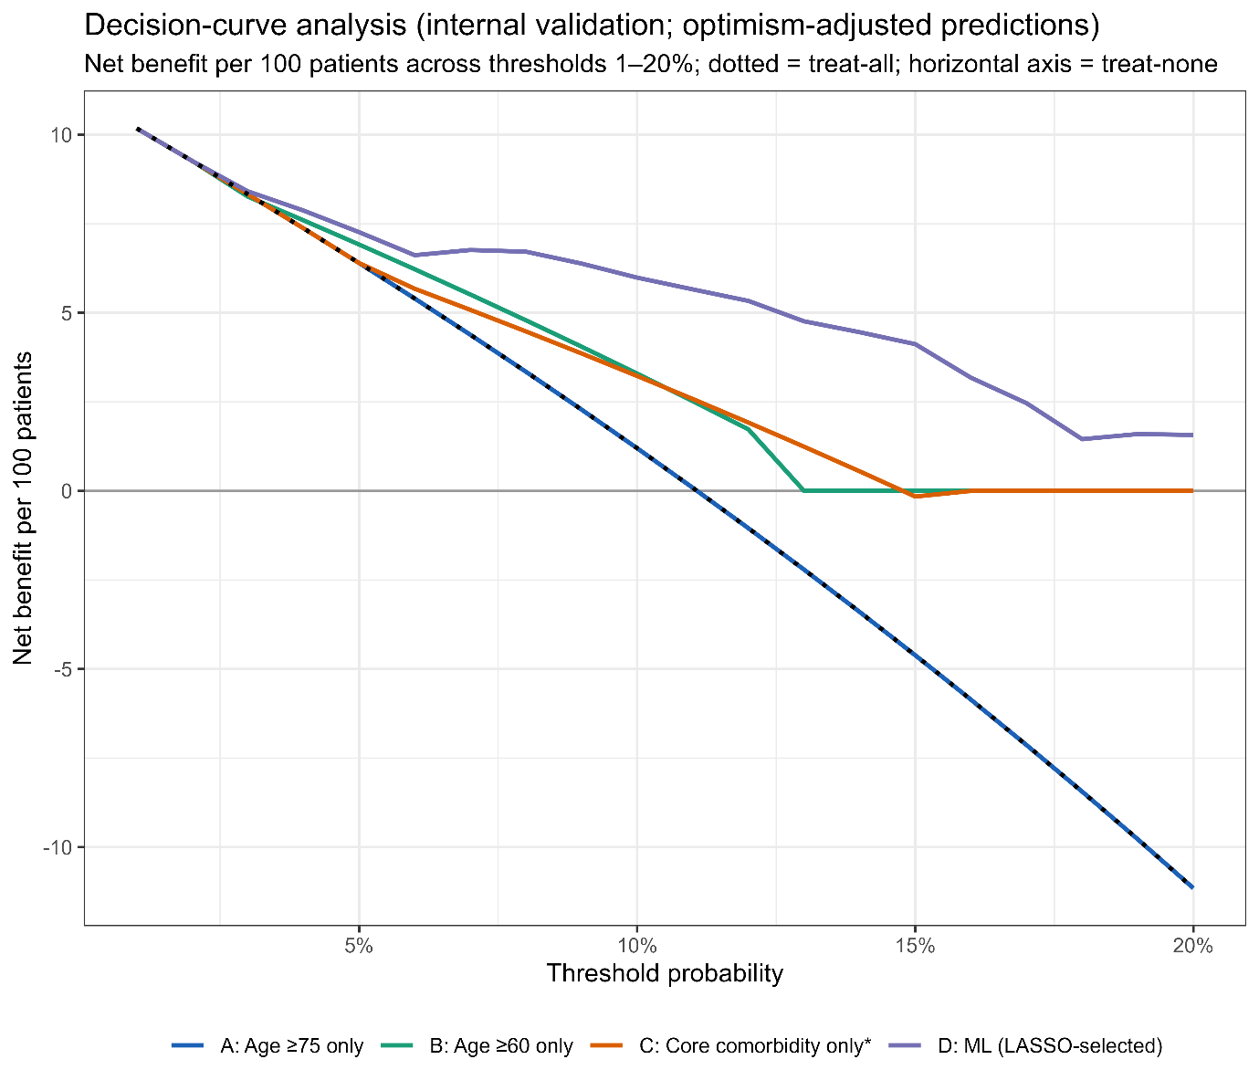
Figure 4. Decision-curve analysis for optimism-adjusted logistic regression models A–D.
Decision-curve analysis for four standard logistic regression models using optimism-adjusted predictions obtained from 1000-sample bootstrap internal validation. Coloured lines show the net benefit of each model across threshold probabilities from 1–20%, compared with strategies of escalating all patients (dashed line) or escalating none (horizontal line). Net benefit reflects the balance between correctly identifying individuals who will experience adverse outcomes (true positives) and the harms of unnecessary escalation (false positives) at a given decision threshold. Age-only models (A–B) and the simple core-comorbidity rule (Model C) provided limited net benefit, whereas the multivariable LASSO-selected model (Model D (age active/previous cancer, COPD, Dementia) demonstrated consistently greater net clinical benefit across most 1-20% thresholds.

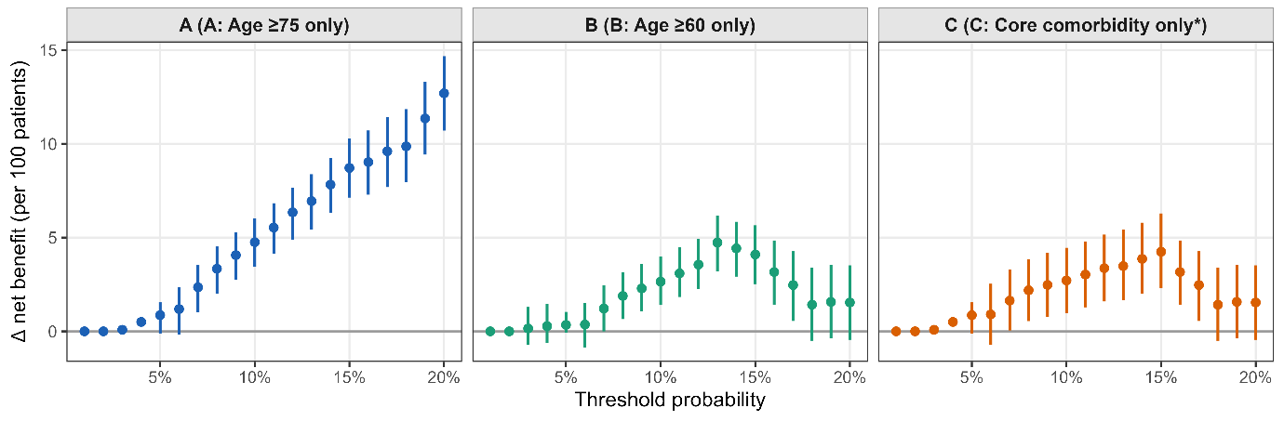
Figure 5. Incremental net benefit of the LASSO-derived Model D compared with Models A–C (optimism-adjusted, recalibrated predictions).
Incremental net benefit (Δ net benefit) comparing the LASSO-derived multivariable logistic regression model—Model D: age, COPD, active/previous cancer, dementia—against Model A: age ≥75 years; Model B: age ≥60 years; Model C: ≥1 core comorbidity (COPD, heart failure, diabetes mellitus, active/previous cancer, or chronic kidney disease). Each panel displays the difference in net benefit between Model D and the comparator model across threshold probabilities from 1–20%, using optimism-adjusted and recalibrated predictions obtained from 1000-sample bootstrap internal validation. Error bars represent percentile 95% confidence intervals. Positive values indicate higher net clinical benefit for Model D, reflecting a more favourable trade-off between correctly identifying patients at risk and avoiding unnecessary escalation; negative values indicate greater benefit for the comparator model. Model D consistently outperformed age-only models (A and B) and showed modest but meaningful improvement over the core-comorbidity rule (Model C).

Contributions
Conceptualisation: Tommaso Morelli, Martha Purcell, Tom M Wilkinson, Dexter Wiseman, Huw Ellis.
Original draft preparation: Tommaso Morelli, Tom M Wilkinson, Aruna T Bansal.
Review and editing: Jon Panaguiton, Rachel Patel, Sharon Weinburg, George Hulston, Hans Siy-Yap, Emma Davies, Anuluan Keating, Ida Saidy, Anna Freeman, Karl J Staples, Pedro Rodrigues, Abigail Jones, Alexander Allen, Stefan J Marciniak, Neil Greening, Michael G Crooks, Philip J Mitchellmore, Salman H Siddiqui, James Myerson, Matthew Pavitt, Cyrus Daneshvar, James D Chalmers, Paul H Lee, Tom Lewis, Sarah Denny.
Guarantor: Tom M Wilkinson.

Acknowledgements
We acknowledge members of the UNIVERSAL Study group.
Elena Dabrio Reina, Amos Gavi, Caroline Childs, Tapan Kumar Paraseth, Grace Mwangi, Syeda Begum (University Hospital Southampton)
Emma Tilt, Jacquelline Nuttall, Gareth Griffiths, Andrew Cook (Southampton Clinical Trials Unit, University of Southampton, Southampton, UK)
Monica Gil (Department of Respiratory Medicine, University Hospitals Sussex Foundation NHS Trust, Brighton and Haywards Heath, UK)
Hugo Farne, Pauline Gallemit, Joan Nanan (St Mary’s London)
Ross Beech, Susie Hardwick (Cambridge University Hospital)
Michaela Harrison, Memory Mwadeyi, Kelly Holton, Louise Surridge (University Hospital Plymouth)
Sarah Edwards (Glenfield Hospital Leicester)
Duncan Sanderson, Emily Ward, Holly Lind, Kateryna Viligorska, Emma Jackson, Isabelle Gallagher, Jaa Ming (Ben) New (Ninewells Hospital Dundee)
Max Ellis, Ingrid Seath, Emma Chamberlain (Royal Devon University Healthcare NHS Foundation Trust, Exeter, UK)
We would also like to acknowledge
The Clinical Informatics Research Unit (CIRU), (University of Southampton, UK).
Giles Rolph (Chelsea and Westminster)

Funding
Janssen Pharmaceuticals, GlaxoSmithKline, Sanofi, and AstraZeneca provided funding in support of the UNIVERSAL Study, an investigator-led, non-commercial study. The BioFire® FilmArray® System kits and machines were provided by Synairgen Research Ltd, together with trained personnel to support study operations. Additional BioFire® FilmArray® kits and machines were provided by bioMérieux SA. The funders had no role in study design, data collection, analysis, interpretation of results, or manuscript preparation.

Declarations/Ethics
The UNIVERSAL prospective cohort received multicentre NHS Research Ethics Committee approval (England reference: 22/WM/0119; Scotland reference: 22/SS/0101), with written informed consent obtained from all participants or from a consultee in accordance with the Mental Capacity Act 2005.
The retrospective cohorts at Royal Devon & Exeter and Manchester were registered and approved locally as service evaluations under NHS Trust Research & Development governance frameworks. For these studies, the requirement for individual informed consent was waived, as data were extracted from existing clinical records and anonymised prior to analysis.

Competing interests
Salman H Siddiqui (SHS): has received fees for advisory services/speaker fees from AstraZeneca, Chiesi, GSK, Areteia Therapeutics, CSL Behring and Medscape.
Karl J Staples (KJS): reports research grants from AstraZeneca and EpiEndo; speakers’ honoraria from AstraZeneca.
Tristan W Clark (TWC): has received research grants from BioFire Diagnostics, bioMérieux, QIAGEN, Sense Biodetection and Inflammatix; speaker fees, honoraria and travel reimbursement from BioFire Diagnostics, bioMérieux, QIAGEN, Cepheid and Janssen; consultancy fees from bioMérieux, QIAGEN, Cepheid, Roche, Janssen and Synairgen; has served on advisory boards for Cepheid, Roche, Roche Diagnostics, Janssen, GSK, Shionogi, Sanofi and Seqirus; member of an independent data monitoring committee for a trial sponsored by Roche; holds shares in Synairgen plc.
Tom M Wilkinson (TW): has received grants and fees from AstraZeneca, BergenBio, Boehringer Ingelheim, Chiesi, GSK, Janssen, Olam, MMH, Synairgen, Union Chimique Belge and Valneva.
All other authors declare no competing interests.

Patient and public involvement
Patients and members of the public were involved in the design and oversight of the UNIVERSAL prospective cohort study. They were not involved in the retrospective data collection or in the design of the present secondary analysis. Patients and/or the public were not involved in the drafting of this manuscript but will be informed of the results through appropriate dissemination activities.

Data availability
The de-identified individual participant data underlying this article are not publicly available due to NHS governance restrictions. Aggregated results are provided in the article and supplementary materials. Data may be available from the corresponding author on reasonable request and subject to NHS Trust approvals. Analysis code is available from the corresponding author on reasonable request.
Transparency statement
The lead author (TM) affirms that this manuscript is an honest, accurate and transparent account of the study being reported; that no important aspects have been omitted; and that any discrepancies from the study as planned have been explained.

References
1. Savic M, Penders Y, Shi T, et al. Respiratory syncytial virus disease burden in adults aged 60 years and older in high-income countries: A systematic literature review and meta-analysis. Influenza Other Respir Viruses 2023;17(1):e13031. doi: 10.1111/irv.13031 [published Online First: 20221111]
2. McLaughlin JM, Khan F, Begier E, et al. Rates of Medically Attended RSV Among US Adults: A Systematic Review and Meta-analysis. Open Forum Infect Dis 2022;9(7):ofac300. doi: 10.1093/ofid/ofac300 [published Online First: 20220617]
3. Anastassopoulou C, Medić S, Ferous S, et al. Development, Current Status, and Remaining Challenges for Respiratory Syncytial Virus Vaccines. Vaccines (Basel) 2025;13(2) doi: 10.3390/vaccines13020097 [published Online First: 20250121]
4. Anderson EJ, Tippett A, Begier E, et al. Relative Contribution of Diagnostic Testing to the Diagnosis of Respiratory Syncytial Virus in Hospitalized Adults in the United States. J Infect Dis 2024;230(6):1342-51. doi: 10.1093/infdis/jiae346
5. Onwuchekwa C, Moreo LM, Menon S, et al. Underascertainment of Respiratory Syncytial Virus Infection in Adults Due to Diagnostic Testing Limitations: A Systematic Literature Review and Meta-analysis. J Infect Dis 2023;228(2):173-84. doi: 10.1093/infdis/jiad012
6. Branche AR, Saiman L, Walsh EE, et al. Change in functional status associated with respiratory syncytial virus infection in hospitalized older adults. Influenza Other Respir Viruses 2022;16(6):1151-60. doi: 10.1111/irv.13043 [published Online First: 20220907]
7. Njue A, Nuabor W, Lyall M, et al. Systematic Literature Review of Risk Factors for Poor Outcomes Among Adults With Respiratory Syncytial Virus Infection in High-Income Countries. Open Forum Infect Dis 2023;10(11):ofad513. doi: 10.1093/ofid/ofad513 [published Online First: 20231020]
8. Centers for Disease Control and Prevention (CDC). Respiratory Syncytial Virus Infection (RSV). Accessed 20th August 2025. Available from https://www.cdc.gov/rsv/hcp/clinical-overview/index.html 2025 [
9. Williams SE, Gessner B, Begier E, et al. Is a Consensus Case Definition for Viral Associated Lower Respiratory Tract Disease (LRTD) in Clinical Trials Possible? Infect Dis Ther 2025;14(1):1-11. doi: 10.1007/s40121-024-01087-x [published Online First: 20241216]
10. Papi A, Ison MG, Langley JM, et al. Respiratory Syncytial Virus Prefusion F Protein Vaccine in Older Adults. N Engl J Med 2023;388(7):595-608. doi: 10.1056/NEJMoa2209604
11. Walsh EE, Pérez Marc G, Zareba AM, et al. Efficacy and Safety of a Bivalent RSV Prefusion F Vaccine in Older Adults. N Engl J Med 2023;388(16):1465-77. doi: 10.1056/NEJMoa2213836 [published Online First: 20230405]
12. Wilson E, Goswami J, Baqui AH, et al. Efficacy and Safety of an mRNA-Based RSV PreF Vaccine in Older Adults. N Engl J Med 2023;389(24):2233-44. doi: 10.1056/NEJMoa2307079
13. Tartof SY, Aliabadi N, Goodwin G, et al. Estimated Vaccine Effectiveness for Respiratory Syncytial Virus-Related Lower Respiratory Tract Disease. JAMA Netw Open 2024;7(12):e2450832. doi: 10.1001/jamanetworkopen.2024.50832 [published Online First: 20241202]
14. UK Department of Health and Social Care. Respiratory syncytial virus (RSV) immunisation programme for infants and older adults: JCVI full statement, 11 September 2023. Available from https://www.gov.uk/government/publications/rsv-immunisation-programme-jcvi-advice-7june-2023/respiratory-syncytial-virus-rsvimmunisation-programme-for-infants-andolder-adults-jcvi-full-statement-11september-2023 2023 [
15. Mensah AA, Whitaker H, Andrews NJ, et al. Early impact of RSV vaccination in older adults in England. Lancet 2025;405(10485):1139-40. doi: 10.1016/s0140-6736(25)00346-0 [published Online First: 20250324]
16. Symes R, Whitaker HJ, Ahmad S, et al. Vaccine effectiveness of a bivalent respiratory syncytial virus (RSV) pre-F vaccine against RSV-associated hospitalisation among adults aged 75-79 years in England. medRxiv 2025:2025.06. 13.25329583.
17. Department of Health & Social Care (advised by the Joint Committee on Vaccination and Immunisation [JCVI]). Respiratory syncytial virus (RSV) immunisation programme for adults aged 80 years and older: JCVI advice, 16 July 2025. https://www.gov.uk/government/publications/rsv-immunisation-programme-jcvi-advice-16-july-2025/respiratory-syncytial-virus-rsv-immunisation-programme-for-adults-aged-80-years-and-older-jcvi-advice-16-july-2025 accessed 20th August 2025. 2025
18. Morelli T, Purcell M, Lee P, et al. P2 Respiratory syncytial virus (RSV) infection in hospitalised adults: who should be vaccinated? Thorax 2024;79(Suppl 2):A109-A09. doi: 10.1136/thorax-2024-BTSabstracts.165
19. Panaguiton J, Patel R, Denny S, et al. P3 Respiratory syncytial virus (RSV) associated admissions and relevant co-morbidities in adults: data from two NHS trusts: BMJ Publishing Group Ltd, 2024.
20. Weinberg S, Hulston G, Davies E, et al. P6 The clinical outcomes in patients hospitalised with respiratory syncytial virus (RSV) Infection: BMJ Publishing Group Ltd, 2024.
21. Morelli T, Purcell M, Rodrigues P, et al. Understanding Infection, Viral Exacerbation and Respiratory Symptoms at Admission-Longitudinal (UNIVERSAL) study: a prospective observational cohort study protocol. BMJ Open 2025;15(4):e093427.
22. Riley RD, Ensor J, Snell KIE, et al. Calculating the sample size required for developing a clinical prediction model. Bmj 2020;368:m441. doi: 10.1136/bmj.m441 [published Online First: 20200318]
23. Vickers AJ, van Calster B, Steyerberg EW. A simple, step-by-step guide to interpreting decision curve analysis. Diagn Progn Res 2019;3:18. doi: 10.1186/s41512-019-0064-7 [published Online First: 20191004]

References
1. Savic M, Penders Y, Shi T, et al. Respiratory syncytial virus disease burden in adults aged 60 years and older in high-income countries: A systematic literature review and meta-analysis. Influenza Other Respir Viruses 2023;17(1):e13031. doi: 10.1111/irv.13031 [published Online First: 20221111]
2. McLaughlin JM, Khan F, Begier E, et al. Rates of Medically Attended RSV Among US Adults: A Systematic Review and Meta-analysis. Open Forum Infect Dis 2022;9(7):ofac300. doi: 10.1093/ofid/ofac300 [published Online First: 20220617]
3. Anastassopoulou C, Medić S, Ferous S, et al. Development, Current Status, and Remaining Challenges for Respiratory Syncytial Virus Vaccines. Vaccines (Basel) 2025;13(2) doi: 10.3390/vaccines13020097 [published Online First: 20250121]
4. Anderson EJ, Tippett A, Begier E, et al. Relative Contribution of Diagnostic Testing to the Diagnosis of Respiratory Syncytial Virus in Hospitalized Adults in the United States. J Infect Dis 2024;230(6):1342-51. doi: 10.1093/infdis/jiae346
5. Onwuchekwa C, Moreo LM, Menon S, et al. Underascertainment of Respiratory Syncytial Virus Infection in Adults Due to Diagnostic Testing Limitations: A Systematic Literature Review and Meta-analysis. J Infect Dis 2023;228(2):173-84. doi: 10.1093/infdis/jiad012
6. Branche AR, Saiman L, Walsh EE, et al. Change in functional status associated with respiratory syncytial virus infection in hospitalized older adults. Influenza Other Respir Viruses 2022;16(6):1151-60. doi: 10.1111/irv.13043 [published Online First: 20220907]
7. Njue A, Nuabor W, Lyall M, et al. Systematic Literature Review of Risk Factors for Poor Outcomes Among Adults With Respiratory Syncytial Virus Infection in High-Income Countries. Open Forum Infect Dis 2023;10(11):ofad513. doi: 10.1093/ofid/ofad513 [published Online First: 20231020]
8. Centers for Disease Control and Prevention (CDC). Respiratory Syncytial Virus Infection (RSV). Accessed 20th August 2025. Available from https://www.cdc.gov/rsv/hcp/clinical-overview/index.html 2025 [
9. Williams SE, Gessner B, Begier E, et al. Is a Consensus Case Definition for Viral Associated Lower Respiratory Tract Disease (LRTD) in Clinical Trials Possible? Infect Dis Ther 2025;14(1):1-11. doi: 10.1007/s40121-024-01087-x [published Online First: 20241216]
10. Papi A, Ison MG, Langley JM, et al. Respiratory Syncytial Virus Prefusion F Protein Vaccine in Older Adults. N Engl J Med 2023;388(7):595-608. doi: 10.1056/NEJMoa2209604
11. Walsh EE, Pérez Marc G, Zareba AM, et al. Efficacy and Safety of a Bivalent RSV Prefusion F Vaccine in Older Adults. N Engl J Med 2023;388(16):1465-77. doi: 10.1056/NEJMoa2213836 [published Online First: 20230405]
12. Wilson E, Goswami J, Baqui AH, et al. Efficacy and Safety of an mRNA-Based RSV PreF Vaccine in Older Adults. N Engl J Med 2023;389(24):2233-44. doi: 10.1056/NEJMoa2307079
13. Tartof SY, Aliabadi N, Goodwin G, et al. Estimated Vaccine Effectiveness for Respiratory Syncytial Virus-Related Lower Respiratory Tract Disease. JAMA Netw Open 2024;7(12):e2450832. doi: 10.1001/jamanetworkopen.2024.50832 [published Online First: 20241202]
14. UK Department of Health and Social Care. Respiratory syncytial virus (RSV) immunisation programme for infants and older adults: JCVI full statement, 11 September 2023. Available from https://www.gov.uk/government/publications/rsv-immunisation-programme-jcvi-advice-7june-2023/respiratory-syncytial-virus-rsvimmunisation-programme-for-infants-andolder-adults-jcvi-full-statement-11september-2023 2023 [
15. Mensah AA, Whitaker H, Andrews NJ, et al. Early impact of RSV vaccination in older adults in England. Lancet 2025;405(10485):1139-40. doi: 10.1016/s0140-6736(25)00346-0 [published Online First: 20250324]
16. Symes R, Whitaker HJ, Ahmad S, et al. Vaccine effectiveness of a bivalent respiratory syncytial virus (RSV) pre-F vaccine against RSV-associated hospitalisation among adults aged 75-79 years in England. medRxiv 2025:2025.06. 13.25329583.
17. Department of Health & Social Care (advised by the Joint Committee on Vaccination and Immunisation [JCVI]). Respiratory syncytial virus (RSV) immunisation programme for adults aged 80 years and older: JCVI advice, 16 July 2025. https://www.gov.uk/government/publications/rsv-immunisation-programme-jcvi-advice-16-july-2025/respiratory-syncytial-virus-rsv-immunisation-programme-for-adults-aged-80-years-and-older-jcvi-advice-16-july-2025 accessed 20th August 2025. 2025
18. Morelli T, Purcell M, Lee P, et al. P2 Respiratory syncytial virus (RSV) infection in hospitalised adults: who should be vaccinated? Thorax 2024;79(Suppl 2):A109-A09. doi: 10.1136/thorax-2024-BTSabstracts.165
19. Panaguiton J, Patel R, Denny S, et al. P3 Respiratory syncytial virus (RSV) associated admissions and relevant co-morbidities in adults: data from two NHS trusts: BMJ Publishing Group Ltd, 2024.
20. Weinberg S, Hulston G, Davies E, et al. P6 The clinical outcomes in patients hospitalised with respiratory syncytial virus (RSV) Infection: BMJ Publishing Group Ltd, 2024.
21. Morelli T, Purcell M, Rodrigues P, et al. Understanding Infection, Viral Exacerbation and Respiratory Symptoms at Admission-Longitudinal (UNIVERSAL) study: a prospective observational cohort study protocol. BMJ Open 2025;15(4):e093427.
22. Riley RD, Ensor J, Snell KIE, et al. Calculating the sample size required for developing a clinical prediction model. Bmj 2020;368:m441. doi: 10.1136/bmj.m441 [published Online First: 20200318]
23. Vickers AJ, van Calster B, Steyerberg EW. A simple, step-by-step guide to interpreting decision curve analysis. Diagn Progn Res 2019;3:18. doi: 10.1186/s41512-019-0064-7 [published Online First: 20191004]
24. Branche A, Ramesh M, Francis B. A Narrative Review of Key Risk Factors for Severe Illness Following SARS-CoV-2, Influenza Virus, and Respiratory Syncytial Virus Infection. Infect Dis Ther 2025;14(Suppl 1):39-61. doi: 10.1007/s40121-024-01081-3 [published Online First: 20241230]
25. (UKHSA) UHSA. Hospital admissions rate (excluding Intensive Care Units (ICUs) and High Dependency Units (HDUs)) per 100,000 people by age - respiratory syncytial virus (RSV) 2025 [Available from: Available from: https://ukhsa-dashboard.data.gov.uk/respiratory-viruses/respiratory-syncytial-virus-rsv; accessed 14 May 2025.
26. Lim WS, van der Eerden MM, Laing R, et al. Defining community acquired pneumonia severity on presentation to hospital: an international derivation and validation study. Thorax 2003;58(5):377-82. doi: 10.1136/thorax.58.5.377
27. Knight SR, Ho A, Pius R, et al. Risk stratification of patients admitted to hospital with covid-19 using the ISARIC WHO Clinical Characterisation Protocol: development and validation of the 4C Mortality Score. bmj 2020;370
28. Shah DP, Ghantoji SS, Ariza-Heredia EJ, et al. Immunodeficiency scoring index to predict poor outcomes in hematopoietic cell transplant recipients with RSV infections. Blood 2014;123(21):3263-8. doi: 10.1182/blood-2013-12-541359 [published Online First: 20140403]

