Supplementary material to: Interannual to multidecadal climate oscillations occurred during Cryogenian glaciation

Figure. S1: The variability in signal detectability quantified from the D32 laminite bed on Garbh Eileach.
Figure. S2: Ice rafted debris (IRD) count data quantified from the 30 discrete layers present in the thin sections.
Figure. S3: Mean annual global temperature from each of the three model scenarios.
Figure. S4: Histograms of signal detectability from a 5x5 grid of cells (~600km radius) around the coordinates of the study site per scenario.
Table S1: Detectability of the signals at the 99% and 95% confidence levels quantified from the uncertainty analysis.
Table S2: Examples of solar and climate cycles recorded in varves throughout geological time.

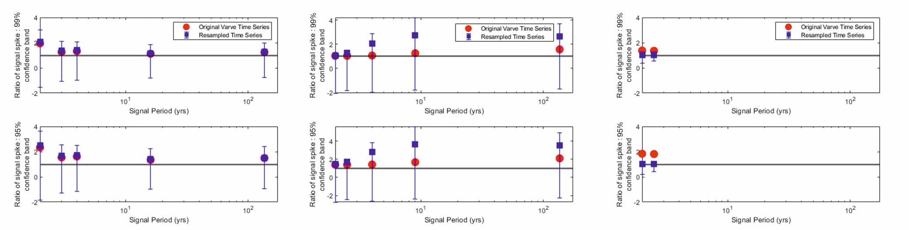
Figure S1: The variability in signal detectability quantified from the D32 laminite bed on Garbh Eileach. Power of the average signal spike (from 1000 iterations of the laminae thickness series) at the imposed periodicity compared to the power of the 99% and 95% confidence bands at the imposed periodicity. Y axis data points are calculated as average power at imposed period/power of confidence band at imposed period; hence, values greater than 1 exceed the confidence band. Left: Full time series (1640 laminae). Middle: Top 1320 laminae. Right: Bottom 1320 laminae.

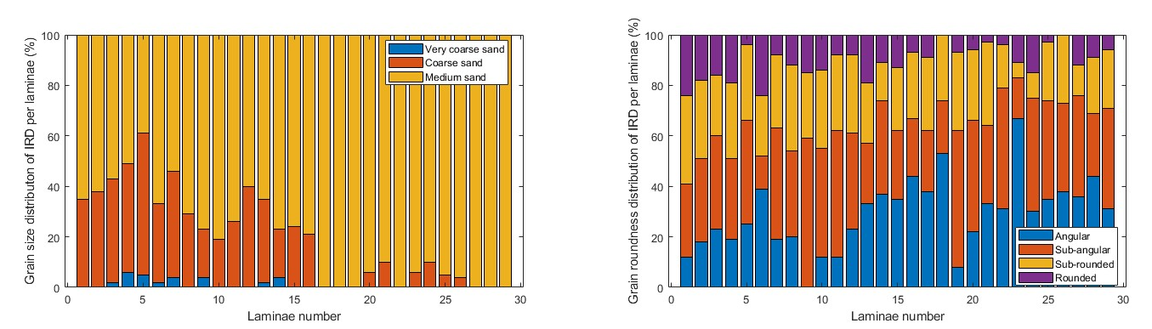

Figure S2: Ice rafted debris (IRD) count data quantified from the 30 discrete layers present in the thin sections. Left: Grain size of IRD per couplet. right: Roundness of IRD per couplet.

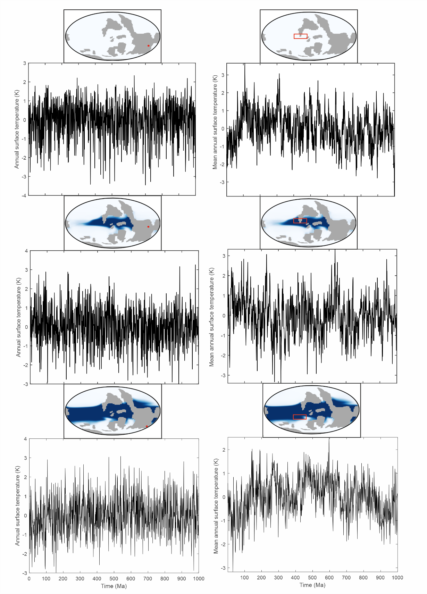
Figure. S3: Annual temperature from each of the three simulated scenarios from both the paleo location of the Garvellach Islands (left) and from a 60° longitude and 10° latitude box in the tropics (right). Top: Hard snowball scenario (5 ppm). Middle: Equatorial oasis scenario (10 ppm). Bottom: Waterbelt scenario (100 ppm).

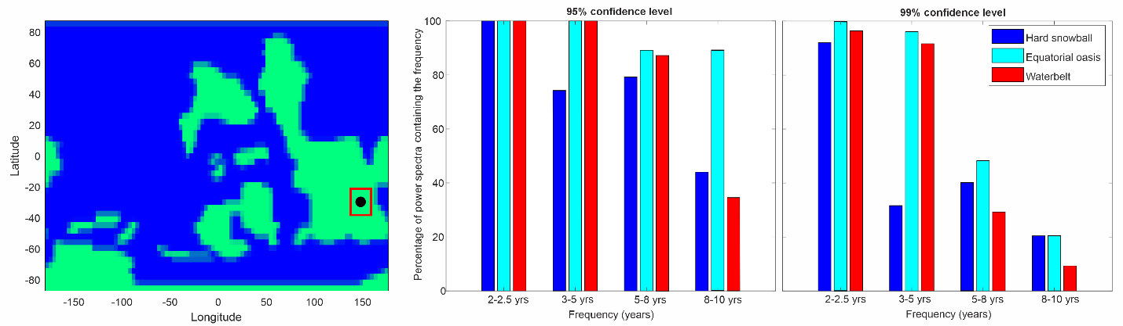
Figure. S4: Histograms of signal detectability from a 5x5 grid of cells (~600km radius) around the coordinates of the study site per scenario. To ensure the signals present in the power spectra from the study site (black circle) are representative of the wider paleogeographic area, annual mean surface temperatures were extracted from a 5x5 grid of cells (~600km radius) around the coordinates of the study site (red box). Power spectra were computed for each of the 25 cells per scenario, and the percentage of the power spectra that contain spectral peaks exceeding the 95% and 99% confidence levels were recorded.

.
Table S1: Detectability of the signals at the 99% and 95% confidence levels quantified from the uncertainty analysis. Uncertainty analysis was conducted on the signals that exceed the 99% confidence level: full time series (5 signals), top 1320 laminae (5 signals), bottom 1320 laminae (2 signals). The detectability of the signals at both the 99% and 95% confidence levels were quantified from the original timeseries. A power spectrum was generated for each of the 1000 iterations and the average power of the signals at the imposed periodicity was calculated and compared to the power of the 99% and 95% confidence levels at the imposed periodicity to quantify the variability.

Table S3: Examples of solar and climate cycles recorded in varves throughout geological time and their sources.
Age | Periodicities recorded (years) | Cycles recorded | Reference
Pleistocene | 6.5-8.5, 9.4, 13.8, 18.9, 24.18, 30 | ENSO, Schwabe | Damnati and Taieb, (1995)
Pleistocene | 3-7 | ENSO | Anderson et al., (1990)
Pliocene | 2-2.5, 6-7, 12 | QBO, ENSO, Schwabe | Munoz et al., (2002)
Miocene | 80-120 | Gleissberg | Kern et al., (2012)
Miocene | 3-5, 9-13, 20-27, 50-100 | ENSO, Schwabe, Hale, Gleissberg | Manzi et al., (2012)
Miocene | 10 | Schwabe | Cosentino et al., (2005)
Eocene | 2.1-8.7 | QBO, ENSO, Schwabe | Han et al., (2025)
Eocene | 8-11,22, 90 | Schwabe, Gleissberg | Zhang et al., (2024)
Eocene | 4.8-5.6, 10.4-14.7 | ENSO, Schwabe | Ripepe et al., (1991)
Paleocene-Eocene | 11, 88 | Schwabe, Gleissberg | (Liu et al., 2024)
Cretaceous | 2-2.8, 4.1-6.2 | QBO, ENSO | Davies et al., (2012)
Cretaceous | 9.1-11.4, 16.2, 125 | Schwabe, Gleissberg | Hasegawa et al., (2022)
Cretaceous | 10-10.6, 16.5, 21.9, 31-40 | Schwabe, Hale | Tian et al., (2021)
Triassic | 2-8, 30, 57, 81-110 | Gleissberg | Lin et al., (2023)
Jurassic | 10-13, 60-85, 170-180 | Schwabe, Gleissberg | Anderson and Kirkland, (1960)
Jurassic | 11.7 | Schwabe | Strasen and Chafetz, (2025)
Jurassic | 8-10 | Schwabe | Chambers et al., (2000)
Jurassic | 13, 20, 69, 105 | Schwabe, Hale, Gleissberg | Dmitriev et al., (2016)
Permo-Carboniferous | 5.5-6.7, 8.6-12.4,24.4 | ENSO, Schwabe | Ernesto and Pacca, (1981)
Permo-Carboniferous | 3-6, 10, 20-25, 80-90 | ENSO, Schwabe, Hale Gleissberg | Franco et al., (2011)
Carboniferous | 23, 70 | Hale, Gleissberg | Alego and Woods, (1994)
Carboniferous | 12, 24-26 | Schwabe, Hale | Milana and Lopez, (1998)
Devonian | 8.6-13.6, 19.6-22.7 | Schwabe, Hale | Andrews et al., (2010)
Neoproterozoic | 10-13 | Schwabe | (Shatsillo et al., 2019)
Neoproterozoic | 2-2.5, 3-5, 9-16, 135 | QBO, ENSO, Schwabe, Gleissberg | This study
Neoproterozoic | 11.4 | Schwabe | Korn and Martin, (1951)
Neoproterozoic | 10-11.4, 18.9-25.6, 71.7, 98.9 | Schwabe | Li et al., (2018)
Mesoproterozoic | 7-11 | Schwabe | Jackson, (1985)
Mesoproterozoic | 9.2-10.6 | Schwabe | Andrews et al., (2010)
Mesoproterozoic | 9.0-11.7,19.7-21,4 | Schwabe, Hale | Tang et al., (2014)
Paleoproterozoic | 9.9-10.7, 14 | Schwabe | Hughes et al., (2003)
Paleoproterozoic | 2.2-2.9, 3-6.9, 8.8-10.2 | QBO, ENSO, Schwabe | Howe et al., (2016)

References
Alego, T.J., Woods, A.D., 1994. Microstratigraphy of the Lower Mississippian Sunbury Shale: A record of solar-modulated climatic cyclicity. Geology 22, 795–798.
Anderson, R.Y., Kirkland, D.W., 1960. Origin, Varves, and Cycles of Jurassic Todilto Formation, New Mexico. Am Assoc Pet Geol Bull 44, 37–52.
Anderson, R.Y., Linsley, B.K., Gardner, J. V, 1990. Expression of seasonal and ENSO forcing in climatic variability at lower than ENSO frequencies: evidence from Pleistocene marine varves off California, Palaeogeography, Palaeoclimatology, Palaeoecology.
Andrews, S.D., Trewin, N.H., Hartley, A.J., Weedon, G.P., 2010. Solar variance recorded in lacustrine deposits from the Devonian and Proterozoic of Scotland. J Geol Soc London 167, 847–856. https://doi.org/10.1144/0016-76492009-105
Chambers, M.H., Lawrence, D.S.L., Sellwood, B.W., Parker, A., 2000. Annual layering in the Upper Jurassic Kimmeridge clay formation, UK, quantifed using an ultra-high resolution SEM-EDX investigation. Sediment Geol 137, 9–23.
Cosentino, D., Cipollari, P., Lo Mastro, S., Giampaolo, C., 2005. High-frequency cyclicity in the latest Messinian Adriatic foreland basin: Insight into palaeoclimate and palaeoenvironments of the Mediterranean Lago-Mare episode. Sediment Geol 178, 31–53. https://doi.org/10.1016/j.sedgeo.2005.03.010
Damnati, B.., Taieb, M., 1995. Solar and ENSO signatures in laminated deposits from Lake Magadi (Kenya) during the Pleistocene/Holocene transition. Journal of African Earth Sciences 21(3), 373-382
Davies, A., Kemp, A.E., Weedon, G.P., Barron, J.A., 2012. El Niño–Southern Oscillation variability from the Late Cretaceous Marca Shale of California. Geology 40, 15–18.
Dmitriev, P.B., Dergachev, V.A., Tyasto, M.I., Blagoveshchenskaya, E.E., 2016. Cycles revealed in Jurassic paleoclimatic data (ca. 200–145 Ma B.P.). Geomagnetism and Aeronomy 56, 914–919. https://doi.org/10.1134/S0016793216070045
Ernesto, M., Pacca, I., 2010. Spectral analysis of Permocarboniferous geomagnetic variation data from glacial rhythmites. Geophys J Int 67, 641–647.
Franco, D.R., Hinnov, L.A., Ernesto, M., 2011. Spectral analysis and modeling of microcyclostratigraphy in late Paleozoic glaciogenic rhythmites, Paraná Basin, Brazil. Geochemistry, Geophysics, Geosystems 12. https://doi.org/10.1029/2011GC003602
Han, Y., Cao, Y., Liang, C., van Loon, A.J., Liu, K., Yang, R., Hao, F., 2025. Fingerprints of El Niño-Southern Oscillation and solar activity cycles recorded in the middle Eocene Bohai Bay Basin (East China). GSA Bulletin 43.
Hasegawa, H., Katsuta, N., Muraki, Y., Heimhofer, U., Ichinnorov, N., Asahi, H., Ando, H., Yamamoto, K., Murayama, M., Ohta, T., Yamamoto, M., Ikeda, M., Ishikawa, K., Kuma, R., Hasegawa, T., Hasebe, N., Nishimoto, S., Yamaguchi, K., Abe, F., Tada, R., Nakagawa, T., 2022. Decadal–centennial-scale solar-linked climate variations and millennial-scale internal oscillations during the Early Cretaceous. Sci Rep 12. https://doi.org/10.1038/s41598-022-25815-w
Howe, T.S., Corcoran, P.L., Longstaffe, F., Webb, E.A., Gerhard Pratt, R., Gerhard, R., 2016. Climatic Cycles Recorded in Glacially Influenced Rhythmites of the Gowganda Formation, Huronian Supergroup. Earth Sciences Publications 16.
Hughes, G.B., Giegengack, R., Kritikos, H.N., 2003. Modern spectral climate patterns in rhythmically deposited argillites of the Gowganda Formation (Early Proterozoic), southern Ontario, Canada. Earth Planet Sci Lett 207, 13–22. https://doi.org/10.1016/S0012-821X(02)01155-X
Jackson, M.J., 1985. Mid-proterozoic dolomitic varves and microcycles from the McArthur basin, Northern Australia. Sediment Geol 44, 301–326.
Kern, A.K., Harzhauser, M., Piller, W.E., Mandic, O., Soliman, A., 2012. Strong evidence for the influence of solar cycles on a Late Miocene lake system revealed by biotic and abiotic proxies. Palaeogeogr Palaeoclimatol Palaeoecol 329–330, 124–136. https://doi.org/10.1016/j.palaeo.2012.02.023
Korn, H., Martin, H., 1951. Cyclic sedimentation in varved sediments of the Nama system in South-West Africa. South African Journal of Geology 54, 65–67.
Li, P., Tang, D., Shi, X., Jiang, G., Zhao, X., Zhou, X., Wang, X., Chen, X., 2018. Sunspot cycles recorded in siliciclastic biolaminites at the dawn of the Neoproterozoic Sturtian glaciation in South China. Precambrian Res 315, 75–91. https://doi.org/10.1016/j.precamres.2018.07.018
Lin, M., Xi, K., Cao, Y., Zhu, R., Niu, X., Xin, H., Ma, W., 2023. Cyclicity related to solar activity in lacustrine organic-rich shales and their significance to shale-oil reservoir formation. Geoscience Frontiers 14. https://doi.org/10.1016/j.gsf.2023.101586
Liu, J., Li, Y., Tan, L., Zhang, R., Liu, X., Zhang, Z., Xiao, A., Kemp, D.B., Huang, C., 2024. Orbital and suborbital climate cycles recorded in terrestrial strata from the late Paleocene-early Eocene in the Subei Basin, East China. Glob Planet Change 242. https://doi.org/10.1016/j.gloplacha.2024.104590
Manzi, V., Gennari, R., Lugli, S., Roveri, M., Scafetta, N., Schreiber, B.C., 2012. High-frequency cyclicity in the mediterranean Messinian evaporites: Evidence for solar-lunar climate forcing. Journal of Sedimentary Research 82, 991–1005. https://doi.org/10.2110/jsr.2012.81
Milana, J.P., Lopez, S., 1998. Solar cycles recorded in Carboniferous glacimarine rhythmites (Western Argentina): relationships between climate and sedimentary environment, Palaeoclimatology, Palaeoecology.
Munoz, A., Ojeda, J., Sanchez-Valverde, B., 2002. Sunspot-like and ENSO / NAO-like periodicities in lacustrine laminated sediments of the Pliocene Villarroya Basin. J Paleolimnol 27, 453–463.
Ripepe, M., Roberts, L.T., Fischer, A.G., 1991. Enso and sunspot cycles in varved Eocene oil shales from image analysis. Journal of Sedimentary Research 61, 1155–1163.
Shatsillo, A. V., Rud’ko, S. V., Latysheva, I. V., Rud’ko, D. V., Fedyukin, I. V., Malyshev, S. V., 2019. Paleomagnetic, Sedimentological, and Isotopic Data on Neoproterozoic Periglacial Sediments of Siberia: A New Perspective on the Low-Latitude Glaciations Problem. Izvestiya, Physics of the Solid Earth 55, 841–863. https://doi.org/10.1134/S1069351319060065
Strasen, J.L., Chafetz, H.S., 2025. Jurassic intercalated micrite and quartz silt lagoonal laminae: Cyclostratigraphic deposition indicative of Schwabe 11-year solar cycles. Sedimentology. https://doi.org/10.1111/sed.13259
Tang, D., Shi, X., Jiang, G., 2014. Sunspot cycles recorded in Mesoproterozoic carbonate biolaminites. Precambrian Res 248, 1–16. https://doi.org/10.1016/j.precamres.2014.04.009
Tian, X., Gao, Y., Kukla, T., Lenz, O., Huang, H., Ibarra, D.E., Sun, S., Wang, C., 2021. EARLY CRETACEOUS SOLAR CYCLES RECORDED IN LACUSTRINE LAMINATIONS IN NORTH CHINA. Am J Sci 321, 1285–1307. https://doi.org/10.2475/09.2021.01
Zhang, R., Jin, Z., Gillman, M., Liu, Q., Wei, R., Li, P., Zhang, Z., 2023. Long-term cycles of the Solar System concealed in the Mesozoic sedimentary basin record. Sci China Earth Sci 66, 358–376. https://doi.org/10.1007/s11430-021-9994-y

