Ring penetrometer for interface shear testing on sand under low-stress conditions
Manuscript submitted to Géotechnique
First revision – September 2024
H. Mohr, V. Singh, S. A. Stanier and D. J. White
Competing interests: The authors declare there are no competing interests.

Henning Mohr (corresponding author)
MSMT Solutions, 44 Kings Park Road
West Perth, WA 6005, Australia
Email: henning@msmt.solutions

Vikram Singh
Centre for Offshore Foundation Systems, Oceans Graduate School
University of Western Australia
Perth, WA 6009, Australia
Email: vikram.singh@uwa.edu.au

Norwegian Geotechnical Institute
Level 7/40 St Georges Terrace
Perth, WA 6000, Australia

Samuel A. Stanier
Department of Engineering
University of Cambridge
7a JJ Thompson Avenue
Cambridge, CB3 0FA, United Kingdom
E-mail: sas229@cam.ac.uk

David J. White
School of Engineering
University of Southampton
Southampton, SO16 7QF, United Kingdom
E-mail: david.white@soton.ac.uk

Number of words (excluding the abstract, list of notation, acknowledgements, references, tables and figure captions): 4439
Number of tables (excluding appendix): 6
Number of figures (excluding appendix): 17

ABSTRACT
Accurate characterisation of near-surface soils is essential for the design of subsea cables, pipelines, and shallow foundations. Conventional laboratory testing equipment is not well adapted to these applications where the operative stress levels are typically <10 kPa. This paper presents and interprets a comprehensive test campaign using a novel flat ring penetrometer. This device measures interface friction at stress levels as low as 1 kPa. Drained friction parameters for a range of sands obtained from the ring penetrometer are compared to other friction measurements from centrifuge sled and interface shear box tests. The results demonstrate the repeatability of the ring penetrometer, and the benefit of the simple but rigorous interpretation approach. The residual friction measured in the ring and centrifuge sled tests shows no dependency on stress level, which contrasts with the interface shear box results. It is shown that the apparent stress-dependency could be an artefact of system friction in the shear box. A correlation between friction coefficient and device settlement rate is identified, with the maximum friction mobilised as the settlement rate approaches zero, consistent with the combined bearing-sliding failure mechanism. These findings highlight the value of the ring device for interface friction measurement.

Keywords
Sands, interface friction, ring penetrometer, interface shear box, in-situ testing, low stress testing

List of notations
γ unit weight of soil
δ shear or sliding displacement
φ friction angle of soil
φ_{cv} critical state friction angle of soil
φ_{r} residual friction angle of soil
μ friction coefficient
μ_{max} maximum friction coefficient
μ_{r} average residual or steady-state friction coefficient
σ_{c} crushing strength of sand grains
σ′_{n} normal effective stress
τ shear stress
A_{c} ring-soil contact surface area
CFS centrifuge sled test
dw/dδ velocity ratio (ring device settlement rate)
D_{ring} width of ring
D₀ outer diameter of ring
f_{roughness} interface roughness
g gravitational acceleration
H equivalent torsional force
I_{C} grain crushing index
I_{D} relative density of soil
I_{R} dilatancy index of soil
ISB interface shear box test
L lever arm of the ring, (D₀ − D_{ring})/2
m_{sled} mass of sled
N centrifuge acceleration level
N_{γ} bearing capacity factor
N_{q} bearing capacity factor
p′ mean effective stress
q_{u} vertical bearing capacity
r_{eff} effective radius at which the resultant of the shear stresses act as a torque
r_{i} inner radius of ring penetrometer device
r_{o} outer radius of ring penetrometer device
RIP ring penetrometer test
T measured torsional resistance
V vertical load
V_{i} vertical load at the start of rotation
V₀ vertical load at the end of penetration
w ring device settlement
z depth

Introduction
Subsea infrastructure such as seabed pipelines, power cables and shallow foundations are founded either directly on the seabed or shallowly buried. Interface friction affects their geotechnical design. Accurate characterisation of near-surface soil layers requires devices and test methods capable of measuring the frictional properties of the soil-structure interface at very low effective stresses of the order of 1-10 kPa.

Previous research on sand-structure interfaces at low stress levels has primarily applied the ring shear test (e.g. Bishop et al., 1971, Ho et al., 2011), modified simple shear devices (e.g. Afzali-Nejad et al. 2021, Fakharian and Evgin, 1997), the direct shear test (e.g. Lehane and Liu, 2013, Ganesan et al., 2014, Wijewickreme et al., 2014, Bruton et al. 2007) and their variants, e.g., the Cam-Tor (Kuo et al., 2015) or the Winged Direct Shear Apparatus (de Leeuw et al., 2021). Other studies have used tilt table tests (Pedersen et al., 2003) and cylinder shear tests (Corfdir et al., 2004, Dumitrescu et al., 2009) to investigate this phenomenon.

Each of these testing methods has strengths and limitations. The conventional shear box and ring shear devices require significant corrections for system resistance at low normal stress (Lehane and Liu, 2013). Such effects can result in apparent but erroneous stress-dependency of friction at low stress levels. The tilt table and ‘Cam-shear’ direct shear device (Bruton et al., 2007) were developed specifically for low stress tests, although the tilt table is intended for clay-like materials and not sands. The ‘Cam-shear’ device minimises system resistance using low-friction materials. Lehane and Liu (2013) proposed correction factors for accurate measurement of interface shear properties at low stress using conventional and modified shear box devices. To avoid or minimise corrections, large-scale testing methodologies have been adopted, wherein plate-like or pipe-like curved objects are subjected to pulling forces while traversing soil beds (White et al., 2011, Wijewickreme et al., 2014, Ge et al., 2024).

More recently, novel shallow penetrometer devices have been developed to characterise shallow seabed sediments (Yan et al., 2011, Yan, 2013, Stanier and White, 2015, White et al., 2017, Randolph et al., 2018, Schneider et al., 2019, 2020a,b, Singh, 2022, Singh et al., 2023, O’Beirne et al., 2023). These devices are actuated by vertical and rotational movement with control of the applied normal stress (and stress history), rate and sequence of shearing movements, and interface material and roughness. These devices, including shapes such as the ‘toroid’, ‘hemiball’ and ‘ring’, have been used in the laboratory and offshore to measure frictional properties of soil-structure interfaces, with prior work focussing primarily on clays and silts (White et al. 2022). The ring penetrometer, being flat, has a straightforward interpretation with no so-called ‘wedging’ correction required (White et al., 2008).

To allow a systematic comparison of shallow penetrometer testing with other low stress interface shear testing, this paper reports a study involving 33 tests measuring the drained interface friction of different sands under constant low vertical stresses of <15 kPa using conventional interface shear box tests, centrifuge sled tests and ring penetrometer tests, as summarised in Table 2. The three techniques are compared, and their different merits evaluated.

EXPERIMENTAL DESIGN
Three sands were tested an artificial coarse silica sand (CSS), an artificial fine silica sand (FSS), and a calcareous sand originating from Australia’s North West Shelf (NWS). In particular, the NWS sand exhibits a high carbonate content which is commonly known to result in significantly different mechanical results to that of a non-calcareous material. Individual grains are typically angular and weak, which usually results in high compressibility, high porosity and brittle particles (Jewell and Khorshid, 1988, Mohr et al. 2013).

Particle size distributions (PSDs) for all three sands are shown in Figure 1 and physical properties are given in Table 1. The critical state friction angle (φ_{cv}) was obtained by pouring sand through a funnel onto the top of an upright machined cylinder of 70 mm diameter. Subsequently, from the height measurement of the resulting cone of sand, the corresponding angle of repose was calculated. The φ_{cv} value in Table 1 is the mean from ten tests on each sand, for which the coefficient of variation was 0.02 or less, indicating high repeatability.

An identical interface surface roughness was created for each set of tests using, a flat surface coated with particles of uniform silica sand (CSS with d₅₀ = 0.54 mm) attached using epoxy adhesive (Loctite). All device surfaces were prepared simultaneously using the same procedure to ensure consistency across the different interface surfaces. Roughness measurements of the contacting surface were performed using a 3D optical microscope (Hirox RH-2000) following ISO 4288-1996, which requires for R_{a} values >10 μm and R_{z} values >50 μm, a limiting value of λ_{c} of 8 mm and an evaluation length of minimum 40 mm (80 mm was used). The resulting roughness values were R_{a} = 120 μm, R_{z} = 614 μm and R_{n} = R_{max}/d = 0.1). From this, the relative interface strength is estimated as, Meyer et al. (2015):
$$f_{\text{roughness }}=0.6+\frac{0.4}{1+2.2R_{a}^{-1.2}}$$ | (1)
giving f_{roughness} = 0.997, indicating that the interface friction will be essentially equal to the internal soil strength.

Interface shear box tests (ISB)
The interface shear box was equipped with Teflon boxes with internal plan dimensions of 100 mm × 100 mm and a height h of 33 mm (Lehane and Liu, 2013). The lower half contained the rough interface to measure the friction against the sand in the top half of the ISB. Small vertical loads (i.e. 5 kg, 10 kg and 15 kg) were applied by masses on the loading plate (see schematic in Figure 2a) so as to facilitate Constant Normal Load (CNL) tests. The upper box was fixed while the lower box was translated at 0.01 mm/s. The upper box was connected to a 500 N load cell which measured the shear force on the sample. Nine interface shear box tests (ISB-1 to ISB-9) were performed on the three soil types (CSS, FSS and NWS) at σ′_{n} = 5, 10 and 15 kPa (Table 2). The samples were prepared in the loosest possible state.

Centrifuge sled tests (CFS)
A centrifuge sled test measures interface resistance by pulling a plate over the underlying soil (Frankenmolen et al., 2016). The self-weight of the plate sets the normal force V on the plate- soil interface and is controlled by the centrifuge acceleration (‘g-level’). Pulling force H and displacement are recorded. The sled test avoids the mechanical complexities of a shear box or ring shear device. The sled tests were performed using the geotechnical beam centrifuge at the University of Western Australia (Randolph et al.,1991) using a sled with dimensions shown in Figure 2b. Dry sand samples were prepared using air pluviation. Two tests, referred to as ‘Drag: Light’ and ‘Drag: Heavy’, were performed on each of the three soil types, using sleds with masses m_{sled} of 160 g and 305 g, respectively, with centrifuge acceleration levels ramped down from 100 g to 1 g during each test (Table 2). The sled was pulled at 0.1 mm/s through a 200 N capacity load cell. Initially the g-level was held at 100 (initially mimicking a CNL test) until the pull force stabilised then the centrifuge acceleration was reduced at ≈ 1 g per second while the pulling continued, giving a steady and controlled reduction in normal load. The friction coefficient is determined as:
$$μ_{r}=\frac{H/{A_{c}}}{V/{A_{c}}}=\frac{H}{m_{\text{sled }}Ng}$$ | (2)
where A_{c} is the contact surface area and V = m_{sled}Ng.

Ring penetrometer tests (RIP)
The ring penetrometer was first described by Yan et al. (2010) and developed further by Schneider (2019), and has been used to characterise the interface friction of soft sediments (Singh et al., 2023). The ring penetrometer is fitted with a combined vertical load and torque cell with a capacity of 444 N and 11.3 Nm, respectively. Furthermore, the underside of the ring is equipped with four differential pressure sensors, each with a capacity of 100 kPa, enabling measurements with a precision of less than 0.005 kPa. More detailed information on the experimental device can be found in Schneider (2019).

A typical shallow penetrometer test in clay involves three stages: (a) penetration stage targeting shear strength; (b) dissipation stage aiming the consolidation properties; and (c) rotation stage targeting the undrained, transition and drained interface friction properties. The shallow penetrometer devices, test procedures and interpretation methods are summarised by White et al. (2022). In sand, the key stage is (c), rotation, to measure interface friction properties. The ring device in this study has a width of D_{ring} = 25 mm and an outer diameter of D_{o} = 125 mm (Figure 2c.). In dry conditions, as used here, or when the penetration and rotation rates cause a fully drained response, the average normal effective stress on the ring penetrometer-soil interface σ′_{n} due to vertical load V is:
$σ_{n}^{'}=\frac{V}{A_{c}}$ | (3)
where A_{c} is the ring-soil contact surface area (Fig. 2c), given by:
$$A_{c}=2πLD_{\text{ring }}$$ | (4)
where the lever arm of the ring, L = (D₀ − D_{ring})/2. The measured torsional resistance T relates to an equivalent torsional force H via:
$$H=\frac{T}{r_{eff}}$$ | (5)

where r_{eff} is the effective radius at which the resultant of the shear stresses act as a torque. Assuming a uniform shear stress on the ring-soil interface gives:
$$r_{eff}=L\left(1+\frac{D_{\text{ring }}^{2}}{12L^{2}}\right)$$ | (6)

which for this device is r_{eff} = 51.04 mm. The average interface shear stress is:
$$τ=\frac{H}{A_{c}}$$ | (7)
and the friction factor μ is:
$$μ=\frac{τ}{σ_{n}^{'}}=\frac{T}{Vr_{eff}}$$ | (8)

At steady torsion conditions these are denoted as residual values, μ_{r} and T_{r} where μ_{r} = tan(φ_{r}), where φ_{r} is the residual friction angle of the soil given the fully rough interface. The tests involved vertical penetration to a defined load, V₀, followed by rotation at 0.1 deg/s in a fully dry sample. Three test sequences termed as ‘Swipe’, ‘Short probe’ and ‘Long probe’ were utilised, with different vertical load control during the rotation stage. Two tests were performed for each sequence with the different initial loading of V_{i} /V₀ = 1 and V_{i} /V₀ = 0.5 where V_{i} is the vertical load at the start of rotation. The test sequences were:

- ‘Swipe’ Test: The rotation stage is carried out at a constant vertical position, preventing device settlement. This condition is similar to the constant volume (height) (CV) approach in a shear box test but is not fully equivalent since the sample is not restrained on the surface adjacent to the penetrometer.
- ‘Short probe’ Test: The rotation stage is carried out in vertical load control mode, maintaining V_{i} until 15° rotation (thereby mimicking a CNL test), following which the vertical load was decreased to zero at 0.1 N/s.
- ‘Long probe’ Test: The rotation stage is carried out in vertical load control mode (i.e. CNL conditions), maintaining V_{i} until 360° rotation, and then the vertical load was decreased to zero at 0.1 N/s.

EXPERIMENTAL RESULTS

Interface shear box tests (ISB)
Interface shear box test results are presented in Figures 3 to 5 for the three sands. For both silica sands (CSS and FSS), no peak in resistance is observed, but the calcareous marine sand shows a peak strength in spite of the samples being loose. The peak is more pronounced at higher stress levels, which could indicate a mechanical artefact from the apparatus rather than the soil response. The average residual friction (μ_{r}) for each soil is calculated by taking an average of the near-constant friction coefficient values interpreted for the three different stress levels at a shear displacement δ > 7 mm (Table 3). The standard deviation (SD) and coefficient of variation (COV) of μ_{r} were computed from the same data. The scatter within the measured values of μ_{r} is higher for the ISB compared to the other tests, so the outlier in the FSS series (Figure 4) is attributed to an artefact of the apparatus and its interpretation, not a feature of the sand, as discussed later in the paper.

Centrifuge sled tests
Centrifuge sled test results are shown in Figures 6 to 8 for the three sands. For comparison, the residual friction coefficient, μ_{r} calculated as tanφ_{cv} (assuming a fully-rough sled-soil interface) is also shown. For both silica and marine sands, a steady μ_{r} similar to the interface shear box results is mobilised at a similar displacement of ≈ 7 mm. μ_{r} is independent of stress level and there is minimal initial peak in resistance. As for the interface shear box tests, summary values are calculated from all data at δ > 7 mm (Table 4), which shows that the centrifuge sled results are more consistent than the interface shear box tests (compare Table 3 with Table 4).

Ring penetrometer tests
Results of ‘Swipe’, ‘Short probe’ and ‘Long probe’ ring penetrometer tests from the rotation phase on CSS sand are presented in Figure 9. The presented data include settlement (w), settlement rate dw/dδ, effective normal stress (σ′_{n}), shear stress (τ) and friction coefficient (μ), all plotted against sliding displacement at the effective radius, δ = r_{eff} θ. During the ‘Swipe’ tests, settlement is prevented during the rotation stage so dw/dδ = 0 (see Fig. 9). The σ′_{n}–δ response shows that the vertical load reduces quickly as soon as rotation begins which is mirrored in the τ – δ response. The measured friction μ stabilises at ≈ 0.60 for V_{i} /V₀ = 1.0 and 0.5.

In both ‘Short probe’ and ‘Long probe’ tests under a controlled load, the ring device settles during rotation. Less settlement is observed at V_{i} /V₀ = 0.5 compared to V_{i} /V₀ = 1.0. In the ‘Short probe’ tests, τ reduces as σ′_{n} falls although μ tends upwards towards a steady limit of 0.60 as the settlement rate tends to zero. A similar response is observed in the ‘Long probe’ tests, although the steady friction of approx. 0.65 and a negligible settlement rate are not achieved until larger displacements. The μ – δ plots for both ‘Short probe’ and ‘Long probe’ tests exhibit that a higher frictional resistance is mobilised at each stage for tests with V_{i} /V₀ = 0.5 compared to tests with V_{i} /V₀ = 1.0 (C.F. 3 with 4 and 5 with 6 in Figure 9). This difference is linked to the lower settlement rate at V_{i} /V₀ = 0.5, meaning that failure is purely from sliding, rather than a combination of sliding and bearing failure. Overall, the steady-state μ in the ‘Long probe’ test is close to tanφ_{cv} (Table 1), and is only slightly lower for the ‘Swipe’ and ‘Short probe’ tests.

The experimental results for FSS and NWS sand exhibit similar trends to CSS and are presented in Figures 10 and 11, respectively. The results of all ring penetrometer tests are summarised in Table 5 and are consistent with the friction coefficients derived from interface shear box and centrifuge sled tests, as well as with the measured φ_{cv} values. Among the ring tests, the maximum standard deviation obtained is 0.022, resulting in a coefficient of variation of 3.5%, which is comparable with the values obtained from the centrifuge sled tests.

DISCUSSION
Comparison of different test types
The measured friction responses for the CSS and FSS silica sands, and the NWS marine sand is compared in Figures 12 to 14, respectively. Effective stress and mobilised friction paths are shown for the centrifuge sled and ring penetrometer tests. The interface shear box results are plotted as discrete data points with error bars representing the variation in the measured response at displacement δ > 7mm. The values of measured tanφ_{cv} are also depicted. The centrifuge sled tests show that μ_{r} is practically constant across the tested stress range for each sand, indicating no stress dependency of interface friction. This behaviour is also observed in the ‘Long probe’ ring penetrometer tests and near the end of the ‘Short probe’ tests.

The lack of stress dependency contrasts with other published data and advice in industry practice (ISO, 2022) which typically indicates that the interface friction angle is stress-dependent at low effective stresses. The data in this study indicates a stress dependency at low stress levels could be merely an artefact of the apparatus in some cases. In the ring penetrometer tests, the settlement rate increases with increasing σ′_{n}, causing a corresponding drop in the mobilised friction. The centrifuge sled tests do not show this effect because the self-weight of the sled (which controls σ′_{n}) and the effective unit weight of the sand are both controlled by the centrifuge g-level. Therefore, any increase in σ′_{n} is balanced by a gain in bearing capacity so that sliding occurs without significant settlement throughout the full test. As a consequence, the centrifuge sled tests give the most consistent measure of μ_{r} from the three methods.

Precision of friction measurements from ring penetrometer test
Figure 15 gives a comprehensive summary of μ_{r} interpreted from the ring penetrometer tests compared with the interface shear box and centrifuge sled results. The friction factor obtained from the ring penetrometer tests aligns well with the centrifuge sled results, indicating consistency between the two methods. The interface shear box results have higher variability between stress levels and are the only device to show a stress-dependency of friction. This repeatability of the ring data adds to previous experience with clayey soils (Yan et al., 2010, Schneider, 2019, Singh et al., 2023) that provides the basis for the use of the ring penetrometer in practice.

Derivation of friction angle and relative density from ring penetrometer test
This section focuses on the derivation of friction angle and relative density from ring penetrometer tests. In the initial stage of each test, the penetration resistance is equal to the vertical bearing capacity (q_{u}) which is linked to friction angle (φ) via the bearing capacity expression as defined in Vali (2019):
$$q_{u}=γzN_{q}+\left(r_{o}-r_{i}\right)\left(1-0.5\frac{r_{i}}{r_{o}}\right)γN_{γ}$$ | (9)
where γ is the unit weight of soil, z is the depth, r_{i} and r_{o} are the inner and outer radius of the ring penetrometer device, respectively (in this case, r_{i} = 0.0375 m and r_{o} = 0.0625 m). The bearing capacity factor N_{q} is:
$N_{q}=\tan^{2}⁡\left(\frac{π}{4}+\frac{ϕ}{2}\right)exp⁡\left(πtan⁡\left(ϕ\right)\right)$ | (10)
and N_{γ} is:
$$N_{γ}=exp⁡\left(\frac{ϕ-p_{2}}{p_{1}}\right)$$ | (11)
where p₁ and p₂ are fitting parameters that depend on the ring geometry. Vali et al. (2019) published N_{γ} factors for different soil friction angles and ring geometry based on their finite element limit analysis. N_{γ} values for friction angles of 10°, 20°, 30° and 40° for the geometry of ring penetrometer in this study (i.e., r_{i} /r_{o} = 0.6) have been interpolated from the published data, and fitted to Equation (11) to find p₁ = 5.27 and p₂ = 16.33 (see Figure 16).
After obtaining φ, the relative density (I_{D}) can be found using Bolton’s correlations for stress-dilatancy (Bolton, 1986):
$$I_{D}=\frac{I_{R}+1}{I_{C}}$$ | (12)
where I_{R} is a dilatancy index:
$$I_{R}=\frac{ϕ-31}{5}$$ | (13)
and I_{C} is a grain crushing index:
$$I_{C}=log⁡\left(\frac{σ_{c}}{p^{'}}\right)$$ | (14)
where σ_{c} is the crushing strength of the sand grains (presented in Table 1) and p′ is the mean effective stress computed using the following expression by White et al. (2008):
$$p^{'}=\left(\frac{1}{1+\tan^{2}⁡\left(ϕ\right)}\right)\left(\frac{1}{1+sin⁡\left(ϕ\right)}\right)\frac{q_{0}+3γw_{0}}{4}$$ | (15)
A summary of back-calculated values of φ and I_{D} from the ring penetrometer tests on the different sands is presented in Table 6. These values confirm that the initial states of the three sands were loose to medium-dense in tests performed in this study.

Link between interface friction and penetrometer settlement rate
To examine more closely the influence of settlement rate on measured friction, Figure 17 compares μ/μ_{max} with settlement rate (dw/dδ) and normalised effective normal stress (σ′_{n} /q_{u}(w)) for the shallow penetrometer tests. μ_{max} is defined as the maximum friction, and occurred at the end of each test. A linear trend is evident between dw/dδ and μ/μ_{max}, with a reduced friction measured at higher settlement. As settlement tends to zero, the maximum friction is reached. The soil strength is mobilised through a combination of the bearing failure and the sliding, so the mobilisable friction is reduced until the penetrometer ceases settling. At lower normalised effective stress there is a lower settlement rate so the measured friction is closer to the maximum value. The reduction in available friction exceeds 10% when more than 20% of the bearing capacity is mobilised (σ′_{n} / q_{u} > 0.2) as highlighted by the arrows on Figure 17.

These observations highlight the interplay between settlement rate, mobilised bearing capacity, and friction mobilisation, which has implications for current design practice. It is usual for the axial friction on seabed pipelines to be considered independent of the mobilised proportion of the bearing capacity (e.g. ISO, 2022, DNV, 2021) and the residual friction coefficient is obtained from shear box testing. However, this is only the case when a low proportion of the bearing capacity is mobilised. For cables and pipelines with a weight that is a significant proportion of the bearing capacity, the available sliding friction could be reduced, consistent with the trend in Figure 17. The ring penetrometer can readily capture this dependency on the effective normal stress and mobilised bearing capacity, allowing this behaviour to be quantified for design.

Further discussion: testing at higher stress levels
The shallow penetrometer testing in this study has involved bearing stresses of <15 kPa, which is the range relevant to many offshore applications, particularly cables and pipelines, but also certain types of shallow foundations. Shallow penetrometers can also be used at higher stress levels, but a larger scale of device is required to increase the bearing capacity, and therefore prevent excessive settlement from occurring. This is because settlement hampers interpretation due to the effects highlighted in Figure 17. In principle, larger scale versions of the shallow penetrometer and sled tests described in this study could be developed for routine use, using the same interpretation framework. There are precedents for such testing being performed on a project-specific basis. For example, Steenfelt (1993) reports tests using sliding blocks up to 1.2 m² in plan area, at stresses of typically 400 kPa, to characterise the sliding resistance of gravity anchors for the Stoerbaelt Crossing. The interpretation follows a similar basis to the shallow penetrometer methods.

Further discussion: testing in alternative control modes
The shallow penetrometer and sled tests in this study have involved a controlled vertical load, creating a known normal stress on the interface. While this load is held constant, the tests represent a CNL condition. When that load is controlled and varied, this can be called a VNL – variable normal load – condition. In principle, shallow penetrometers can also be operated in a constant normal stiffness (CNS) or constant volume (height) (CV) condition, if the vertical load is controlled via feedback in the same way as CNS and CV tests in the shear box. These may be preferable to better represent the relevant soil-structure interaction behaviour, which is the motivation for CNS shear box testing. CNS and CV tests can provide the frictional response over a range of normal stress, as shown in Figure 15 from the VNL tests in this study. A benefit of the VNL approach relative to CNS and CV is that the range of normal stress is controlled, rather than being a consequence of the settlement and soil stiffness.

Further discussion: Application to design and calibration of interface constitutive models
Interface tests of any type – ISB, shallow penetrometer or sled – can be used directly to provide design parameter such as friction coefficients or can be used to calibrate interface constitutive models (e.g. Mortara et al. 2002, Liu & Ling 2008, Lashkari 2017) for subsequent use in simulations of geotechnical systems. Relative to the standard ISB, shallow penetrometer tests have the disadvantage of mobilising a large zone of soil, such that the measured settlement results from deformation both at the interface and deeper below. In contrast, the ISB is treated as an element test, such that measured settlement is attributed wholly to deformation at the interface, which allows direct use to calibrate an interface constative model. Calibration of such a model using shallow penetrometer test data would require a numerical simulation of the soil zone around the penetrometer, for example, as described by Yan et al. (2017). However, an advantage of the shallow penetrometer test is that it can capture directly the interaction effects evident in Figure 17, meaning that the results are more directly representative of the friction response on the soil-structure interface of a cable, pipeline or foundation.

CONCLUSIONS
This paper has described the capabilities and advantages of the ring penetrometer for obtaining reliable interface friction measurements in sands. A series of ring penetrometer and centrifuge sled tests have been carried out on two silica sands and a marine calcareous sand from the North-West Shelf, located offshore Western Australia. The results obtained from ring penetrometer testing are comparable with centrifuge sled testing, confirming the reliability and consistency of these two methods. Shear box tests were also conducted to present a detailed comparison across all three methods. The key findings are summarised as follows:
- The ring penetrometer provides precise measurements of interface friction in sands at very low stress levels. A single test provides more consistent and reliable measurement of friction across a range of normal effective stress than alternative types of interface test.
- The comparison of interpreted results obtained from the ring penetrometer, shear box and the centrifuge sled tests demonstrate the accuracy and reliability of the ring penetrometer and validates its application as an alternative and practical test method for measuring interface friction properties at low stress levels in sands.
- The apparent residual friction coefficient is dependent on the settlement rate. When the device ceases to settle, the full friction is recorded. However, while the device is settling, which occurs when the vertical stress approaches the bearing capacity, the frictional resistance is reduced due to the combined bearing-sliding failure mechanism. This effect has potential implications for the axial friction on on-bottom cables and pipelines, particularly when their weight exceeds 20% of the bearing capacity. Ring penetrometer tests allow this combined loading effect to be quantified.
- The interface friction coefficient does not exhibit a dependency on the normal effective stress over the range of low stress levels for the soils tested in this study, although the shear box tests showed a minor stress level dependency that may be an artefact of the equipment and data correction methods.
In summary, this study provides new evidence of the capabilities of shallow penetrometer testing and demonstrates the reliability of the associated interpretation methods. These tests, undertaken with small devices and feedback-controlled loading, allow low stress soil-structure interface behaviour to be explored through loading histories that can be either simple – akin to standard shear box tests – or more complex, with patterns of normal and shear loading that represent a wider range of stress conditions or design events.

ACKNOWLEDGEMENTS
This research was conducted by the Wave Energy Research Centre and jointly funded by The University of Western Australia and the Western Australian Government, via the Department of Primary Industries and Regional Development (DPIRD). The work was also partly supported by the UK’s EPSRC Offshore Renewable Energy Supergen Hub (grant EP/Y016297/1). The second author acknowledges support from the Norwegian Geotechnical Institute (Perth), which provided funding for him to continue with this work since joining them.

REFERENCES
Afzali-Nejad A, Lashkari A & Martinez A (2021) Stress-displacement response of sand–geosynthetic interfaces under different volume change boundary conditions. Journal of Geotechnical and Geoenvironmental Engineering 147(8): 04021062.

Bishop AW, Green GE, Garga VK, Andresen A & Brown JD (1971) A new ring shear apparatus and its application to the measurement of residual strength. Géotechnique 21(4): 273–328.

Bolton MD (1986) The strength and dilatancy of sands. Géotechnique 36(1): 65–78.

Bruton D, Carr M & White DJ (2007) The influence of pipe-soil interaction on lateral buckling and walking of pipelines - the SAFEBUCK JIP. In Proceedings of the 6th International Offshore Site Investigation and Geotechnics Conference, London, UK.

Corfdir A, Lerat P & Vardoulakis I (2004) A cylinder shear apparatus. Geotechnical Testing Journal 27(5): 447–455.

de Leeuw L, Martin G, Milewski H, Dietz M & Diambra A (2021) Polypropylene pipe interface strength on marine sandy soils with varying coarse fraction. Geotechnical Engineering 174: 3–18.

DNV (2021) DNV-RP-F114: Pipe-soil interaction for submarine pipelines, recommended practice. Det Norske Veritas, Høvik, Norway.

Dumitrescu AI, Corfdir A & Frank R (2009) Influence of the anisotropy of confining stress on the sand/steel interface behaviour in a cylinder shear apparatus. Soils and Foundations 49(2): 167–174.

Fakharian K & Evgin E (1997) Cyclic simple-shear behaviour of sand-steel interfaces under constant normal stiffness condition. Journal of Geotechnical and Geoenvironmental Engineering 123(12): 1096–1105.

Frankenmolen SF, White DJ & O’Loughlin CD (2016) Chain-soil interaction in carbonate sand. In Offshore Technology Conference, Houston, TX, USA, page D041S055R001.

Ganesan S, Kuo M & Bolton MD (2014) Influences on pipeline interface friction measured in direct shear tests. Geotechnical Testing Journal 37(1): 94–106.

Ge B, Martin G, Dietz MS, Mylonakis G & Diambra A (2024) A novel pipe-segment shear test apparatus: Polypropylene pipe behaviour over sand beds vs element interface tests. Canadian Geotechnical Journal (in press).

Ho TYK, Jardine RJ & Anh-Minh N (2011) Large-displacement interface shear between steel and granular media. Géotechnique 61(3): 221–234.

ISO (2022) ISO 19901-4: Specific requirements for offshore structures. Part 4: Geotechnical design considerations. International Standards Organisation.

Jewell RJ & Khorshid MS (1988) Engineering for calcareous sediments: North Rankin A foundation project. State of the art reports. Balkema, Rotterdam, Netherlands.

Kuo M, Vincent CM, Bolton MD, Hill A & Rattley M (2015) A new torsional shear device for pipeline interface shear testing. In Proceedings of the 3rd International Symposium on Frontiers in Offshore Geotechnics, Oslo, Norway, pp. 405–410.

Lashkari A (2017) A simple critical state interface model and its application in prediction of shaft resistance of non-displacement piles in sand. Computers and Geotechnics 88: 95–110.

Lehane BM & Liu QB (2013) Measurement of shearing characteristics of granular materials at low stress levels in a shear box. Geotechnical and Geological Engineering 31(1): 329–336.

Liu H & Ling HI (2008) Constitutive description of interface behaviour including cyclic loading and particle breakage within the framework of critical state soil mechanics. International Journal of Numerical and Analytical Methods in Geomechanics 32(12): 1495–1514.

Meyer VM, Dyvik R & White DJ (2015) Direct shear interface tests for pipe-soil interaction assessment. In Frontiers in Offshore Geotechnics III, London, UK, pp. 423–428.

Mortara G, Boulon M & Ghionna VN (2002) A 2-D constitutive model for cyclic interface behaviour. International Journal for Numerical and Analytical Methods in Geomechanics 26(11): 1071–1096.

Mohr H, Draper S & White D (2013) Free field sediment mobility on Australia’s North West Shelf. In Proceedings of the ASME 32nd International Conference on Ocean, Offshore and Arctic Engineering, Nantes, France, OMAE2013-11490.

O’Beirne C, Watson P, Bransby F, Low HE, White D, Gilbert R & Hussien A (2023) Increasing confidence in the prediction of axial friction factors for offshore pipelines and cables. In 9th International SUT Offshore Site Investigation and Geotechnics Conference, London, UK, pp. 674–681.

Pedersen RC, Olson RE & Rauch AF (2003) Shear and interface strength of clay at very low effective stress. Geotechnical Testing Journal 26(1): 71–78.

Randolph MF, Jamiolkowski MB & Zdravkovic L (2004) Load carrying capacity of foundations. In Proceedings of the Skempton Memorial Conference (Jardine RJ, Potts DM & Higgins KG (eds)). Thomas Telford, London, UK, vol. 1, pp. 207–240.

Randolph MF, Jewell RJ, Stone KJL & Brown TA (1991) Establishing a new centrifuge facility. In Proceedings of Centrifuge 1991, Boulder, CO, USA, pp. 2–9.

Randolph MF, Stanier SA, O’Loughlin CD, Chow SH, Bienen B, Doherty JP, Mohr H, Ragni R, Schneider MA, White DJ & Schneider JA (2018) Penetrometer equipment and testing techniques for offshore design of foundations, anchors and pipelines. In Proceedings of the 4th International Symposium on Cone Penetration Testing, Delft, Netherlands.

Schneider MA (2019) Novel site investigation tools for near-surface seabed characterisation. PhD thesis, The University of Western Australia, Perth, Australia.

Schneider MA, Stanier SA, Chatterjee S, White DJ & Randolph MF (2019) The parkable piezoprobe for determining cv and strength: Modelling and interpretation methods. Géotechnique 69(5): 458–469.

Schneider MA, Stanier SA, White DJ & Randolph MF (2020a) Apparatus for measuring pipe-soil interaction behaviour using shallow pipe-like penetrometers. Geotechnical Testing Journal 43(3): 1–15.

Schneider MA, Stanier SA, White DJ & Randolph MF (2020b) Shallow penetrometer tests: Theoretical and experimental modelling of penetration and dissipation stages. Canadian Geotechnical Journal 57(4): 568–579.

Singh V (2022) Unlocking the changing strength of fine-grained soils in numerical analyses. PhD thesis, The University of Western Australia, Perth, Australia.

Singh V, Mohr H, Stanier SA, Bienen B & Randolph MF (2023) Characterisation of interface friction strain-rate dependency of soft sediments at low stresses using a ring penetrometer. Géotechnique 1-16.

Stanier SA & White DJ (2015) Shallow penetrometer penetration resistance. Journal of Geotechnical and Geoenvironmental Engineering 141(3): 04014117.

Steenfelt JS (1993) Sliding resistance for foundations on clay till. In Proceedings of the Wroth Memorial Conference, Predictive Soil Mechanics, London, UK, pp. 664–684.

Vali R, Beygi M, Saberian M & Li J (2019) Bearing capacity of ring foundation due to various loading positions by finite element limit analysis. Computers and Geotechnics 110: 94–113.

White DJ, Teh KL, Leung CF & Chow YK (2008) A comparison of the bearing capacity of flat and conical circular foundations on sand. Géotechnique 58(10): 781–792.

White DJ, Ganesan SA, Bolton MD, Bruton DAS, Ballard JC & Langford T (2011) Safebuck JIP: Observations from model testing of axial pipe-soil interaction on soft natural clays. In Proceedings of the 2011 Offshore Technology Conference, Houston, TX, USA, paper OTC 21249.

White DJ, Stanier SA, Schneider MA, O’Loughlin CD, Chow SH, Randolph MF, Draper SD, Mohr H, Morton JP & Peuchen J (2017) Remote intelligent geotechnical seabed surveys: Technology emerging from the RIGSS JIP. In Proceedings of the 8th International Conference Offshore Site Investigation Geotechnics, London, UK, pp. 1214–1222.

White DJ, Stanier SA & Mohr H (2022) Characterisation of near-surface sediments using a blend of vertical and shallow rotational penetrometers. In Proceedings of the 5th International Symposium on Cone Penetration Testing, Bologna, Italy.

Wijewickreme D, Amarasinghe RS & Eid H (2014) Macro-scale direct shear test device for assessing soil-solid interface friction under low effective normal stresses. Geotechnical Testing Journal 37: 20120217.

Yan Y (2013) Novel methods for characterising pipe-soil interaction forces in situ in deep water. PhD thesis, The University of Western Australia, Perth, Australia.

Yan Y, White DJ & Randolph MF (2010) Investigations into novel shallow penetrometers for fine-grained soils. In Proceedings of the 2nd International Symposium on Frontiers in Offshore Geotechnics, Perth, Australia, pp. 321–326.

Yan Y, White DJ & Randolph MF (2011) Penetration resistance and stiffness factors for hemispherical and toroidal penetrometers in uniform clay. International Journal of Geomechanics 11(4): 263–275.

Yan Y, White DJ & Randolph MF (2017) Elastoplastic consolidation solutions for scaling from shallow penetrometers to pipelines. Canadian Geotechnical Journal 54: 881–895.

List of Table Captions
Table 1: Physical properties of the tested sediments.
Table 2: Summary of all tests performed.
Table 3: Summary of interface shear box tests.
Table 4: Summary of centrifuge sled tests.
Table 5: Summary of shallow penetrometer tests.
Table 6: Summary of calculated friction angle and relative density from ring penetrometer tests.

Tables
Table 1. Physical properties of the tested sediments.
Soil | Mineralogy | d₅₀  (mm) | G_{s}  (-) | σ_{c}  (kPa)* | Q = ln(σ_{c}) | φ_{cv}  (deg)
CSS | Silica | 0.54 | 2.75 | 20,000 | 9.9 | 32.9
FSS | Silica | 0.19 | 2.67 | 20,000 | 9.9 | 31.7
NWS | Carbonate | 0.16 | 2.77 | 5,000 | 8.5 | 36.6
* Assumed based on guidance in Bolton (1987) and Randolph et al. (2004).

Table 2. Summary of all tests performed.

Test ID | Soil | Test Type | Detail
ISB-1 | CSS | Direct shear | σ'_{n} = 5 kPa
ISB-2 | CSS | Direct shear | σ'_{n} = 10 kPa
ISB-3 | CSS | Direct shear | σ'_{n} = 15 kPa
ISB-4 | FSS | Direct shear | σ'_{n} = 5 kPa
ISB-5 | FSS | Direct shear | σ'_{n} = 10 kPa
ISB-6 | FSS | Direct shear | σ'_{n} = 15 kPa
ISB-7 | NWS | Direct shear | σ'_{n} = 5 kPa
ISB-8 | NWS | Direct shear | σ'_{n} = 10 kPa
ISB-9 | NWS | Direct shear | σ'_{n} = 15 kPa
CFS-1 | CSS | Cont. sliding | Light (160 g)
CFS-2 | CSS | Cont. sliding | Heavy (305 g)
CFS-3 | FSS | Cont. sliding | Light (160 g)
CFS-4 | FSS | Cont. sliding | Heavy (305 g)
CFS-5 | NWS | Cont. sliding | Light (160 g)
CFS-6 | NWS | Cont. sliding | Heavy (305 g)
RIP-1 | CSS | Swipe | V_{i}/V₀ = 1.0
RIP-2 | CSS | Swipe | V_{i}/V₀ = 0.5
RIP-3 | CSS | Short probe | V_{i}/V₀ = 1.0
RIP-4 | CSS | Short probe | V_{i}/V₀ = 0.5
RIP-5 | CSS | Long probe | V_{i}/V₀ = 1.0
RIP-6 | CSS | Long probe | V_{i}/V₀ = 0.5
RIP-7 | FSS | Swipe | V_{i}/V₀ = 1.0
RIP-8 | FSS | Swipe | V_{i}/V₀ = 0.5
RIP-9 | FSS | Short probe | V_{i}/V₀ = 1.0
RIP-10 | FSS | Short probe | V_{i}/V₀ = 0.5
RIP-11 | FSS | Long probe | V_{i}/V₀ = 1.0
RIP-12 | FSS | Long probe | V_{i}/V₀ = 0.5
RIP-13 | NWS | Swipe | V_{i}/V₀ = 1.0
RIP-14 | NWS | Swipe | V_{i}/V₀ = 0.5
RIP-15 | NWS | Short probe | V_{i}/V₀ = 1.0
RIP-16 | NWS | Short probe | V_{i}/V₀ = 0.5
RIP-17 | NWS | Long probe | V_{i}/V₀ = 1.0
RIP-18 | NWS | Long probe | V_{i}/V₀ = 0.5

Table 3. Summary of interface shear box tests.

Test ID | Soil | σ'_{n}  (kPa) | μ_{r}  (-) | SD  (-) | COV  (%)
ISB-1 | CSS | 5.06 | 0.60 | 0.029 | 4.8
ISB-2 | CSS | 9.96 | 0.60 | 0.029 | 4.8
ISB-3 | CSS | 14.86 | 0.60 | 0.029 | 4.8
ISB-4 | FSS | 5.06 | 0.62 | 0.021 | 3.4
ISB-5 | FSS | 9.96 | 0.62 | 0.021 | 3.4
ISB-6 | FSS | 14.86 | 0.62 | 0.021 | 3.4
ISB-7 | NWS | 5.30 | 0.69 | 0.008 | 1.2
ISB-8 | NWS | 10.10 | 0.69 | 0.008 | 1.2
ISB-9 | NWS | 15.00 | 0.69 | 0.008 | 1.2

Table 4. Summary of centrifuge sled tests.

Test ID | Soil | σ'_{n}  (-) | μ_{r}  (-) | SD  (-) | COV  (%)
CFS-1 | CSS | Light | 0.61 | 0.006 | 1.0
CFS-2 | CSS | Heavy | 0.60 | 0.011 | 1.8
CFS-4 | FSS | Light | 0.61 | 0.015 | 2.4
CFS-5 | FSS | Heavy | 0.60 | 0.020 | 3.3
CFS-7 | NWS | Light | 0.68 | 0.017 | 2.4
CFS-8 | NWS | Heavy | 0.70 | 0.020 | 2.9

Table 5. Summary of shallow penetrometer tests.
Test ID | Soil | Test Type | V_{i}/V₀  (-) | μ_{r}  (-) | SD  (-) | COV  (%)
RIP-1 | CSS | Swipe | 1.0 | 0.58 | 0.002 | 0.3
RIP-2 | CSS | Swipe | 0.5 | 0.59 | 0.001 | 0.2
RIP-3 | CSS | Short probe | 1.0 | 0.59 | 0.011 | 1.9
RIP-4 | CSS | Short probe | 0.5 | 0.60 | 0.012 | 1.9
RIP-5 | CSS | Long probe | 1.0 | 0.64 | 0.012 | 1.9
RIP-6 | CSS | Long probe | 0.5 | 0.61 | 0.010 | 1.7
RIP-7 | FSS | Swipe | 1.0 | 0.64 | 0.003 | 0.4
RIP-8 | FSS | Swipe | 0.5 | 0.61 | 0.022 | 3.5
RIP-9 | FSS | Short probe | 1.0 | 0.63 | 0.017 | 2.7
RIP-10 | FSS | Short probe | 0.5 | 0.62 | 0.019 | 3.1
RIP-11 | FSS | Long probe | 1.0 | 0.62 | 0.010 | 1.6
RIP-12 | FSS | Long probe | 0.5 | 0.61 | 0.006 | 1.0
RIP-13 | NWS | Swipe | 1.0 | 0.68 | 0.002 | 0.4
RIP-14 | NWS | Swipe | 0.5 | 0.69 | 0.003 | 0.4
RIP-15 | NWS | Short probe | 1.0 | 0.70 | 0.008 | 1.1
RIP-16 | NWS | Short probe | 0.5 | 0.69 | 0.014 | 2.0
RIP-17 | NWS | Long probe | 1.0 | 0.69 | 0.008 | 1.2
RIP-18 | NWS | Long probe | 0.5 | 0.69 | 0.008 | 1.2

Table 6. Summary of calculated friction angle and relative density from ring penetrometer tests.

 |  |  |  | Calculated based on Eq. (9) – (15)
Test ID | Soil | Test Type | V_{i}/V₀ (-) | φ (-) | I_{D} (-)
RIP-1 | CSS | Swipe | 1.0 | 37.35 | 35
RIP-2 | CSS | Swipe | 0.5 | 37.51 | 35
RIP-3 | CSS | Short Probe | 1.0 | 37.43 | 35
RIP-4 | CSS | Short Probe | 0.5 | 37.62 | 35
RIP-5 | CSS | Long Probe | 1.0 | 37.22 | 34
RIP-6 | CSS | Long Probe | 0.5 | 37.13 | 35
RIP-7 | FSS | Swipe | 1.0 | 37.99 | 34
RIP-8 | FSS | Swipe | 0.5 | 37.56 | 35
RIP-9 | FSS | Short Probe | 1.0 | 37.16 | 35
RIP-10 | FSS | Short Probe | 0.5 | 37.47 | 35
RIP-11 | FSS | Long Probe | 1.0 | 37.43 | 35
RIP-12 | FSS | Long Probe | 0.5 | 37.91 | 35
RIP-13 | NWS | Swipe | 1.0 | 36.50 | 44
RIP-14 | NWS | Swipe | 0.5 | 35.23 | 43
RIP-15 | NWS | Short Probe | 1.0 | 36.08 | 44
RIP-16 | NWS | Short Probe | 0.5 | 35.45 | 43
RIP-17 | NWS | Long Probe | 1.0 | 36.32 | 44
RIP-18 | NWS | Long Probe | 0.5 | 35.12 | 43

List of Figures
Fig. 1: Particle size distribution of sediment.
Fig. 2: Schematic of interface shear box test, centrifuge sliding test and shallow penetrometer test
Fig. 3: Displacement plots of interface shear box tests on uniform silica sand (CSS).
Fig. 4: Interface shear box tests on uniform silica sand (FSS).
Fig. 5: Interface shear box tests on marine sand (NWS).
Fig. 6: Centrifuge sled tests on uniform silica sand (CSS).
Fig. 7: Centrifuge sled tests on uniform silica sand (FSS).
Fig. 8: Centrifuge sled tests on marine sand (NWS).
Fig. 9: Shallow ring penetrometer tests on uniform silica sand (CSS).
Fig. 10: Shallow ring penetrometer tests on uniform silica sand (FSS).
Fig. 11: Shallow ring penetrometer tests on marine sand (NWS).
Fig. 12: Summary of all friction tests on a uniform silica sand (CSS).
Fig. 13: Summary of all friction tests on uniform silica sand (FSS).
Fig. 14: Summary of all friction tests on marine sand (NWS).
Fig. 15: Interpreted friction coefficients of CSS, FSS and NWS sands.
Fig. 16: Bearing capacity factor N_{γ} for the ring penetrometer based on numerical data from Vali et al. (2019).
Fig. 17: Influence of settlement rate and mobilised bearing capacity on available friction.

Figures
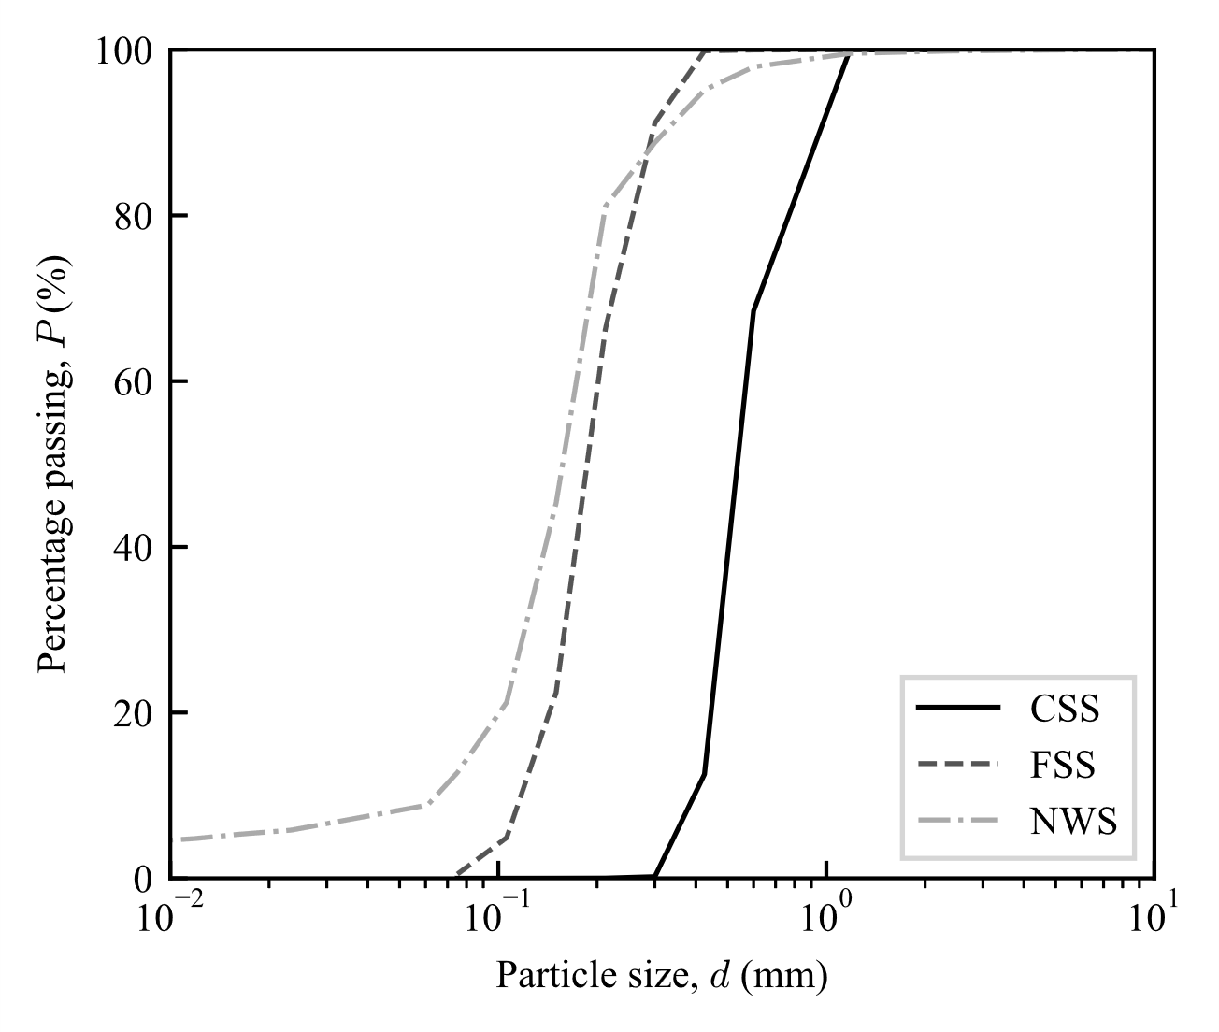
Fig. 1. Particle size distribution of sediments tested.

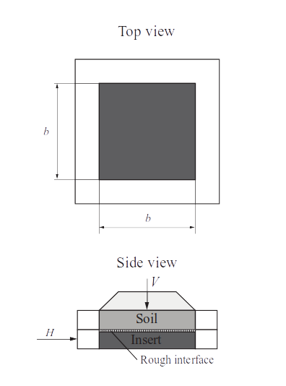

Fig. 2a. Schematic of interface shear box test.
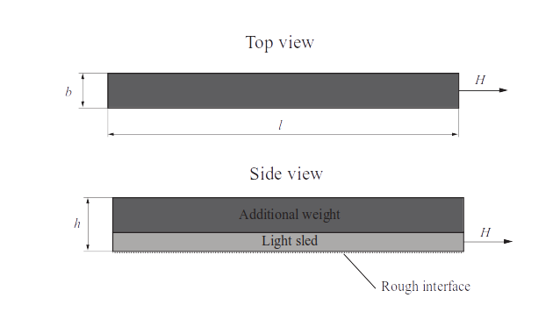
Fig. 2b. Schematic of centrifuge sliding test.
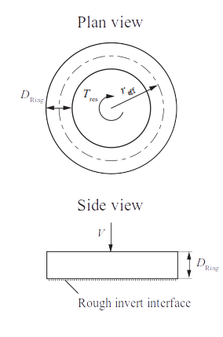

Fig. 2c. Schematic of shallow penetrometer test.
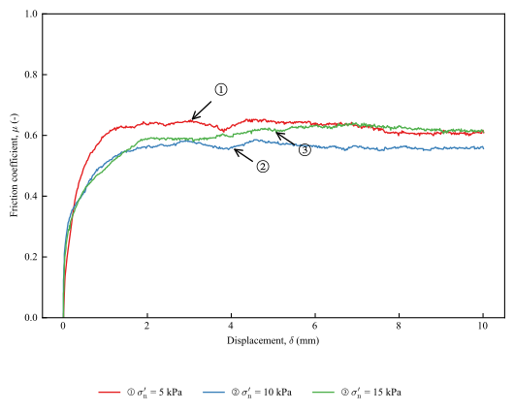

Fig. 3. Displacement plots of interface shear box tests on uniform silica sand (CSS).
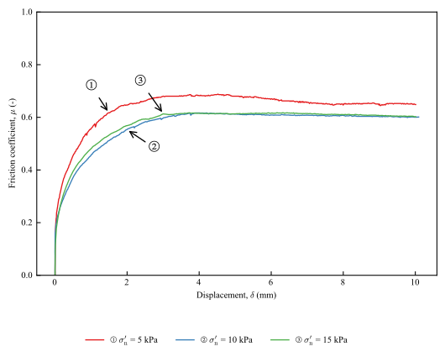

Fig. 4. Interface shear box tests on uniform silica sand (FSS).
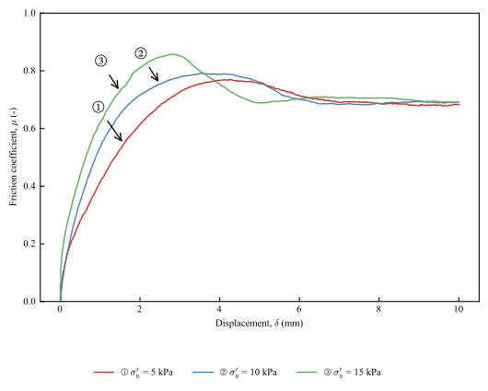

Fig. 5. Interface shear box tests on marine sand (NWS).

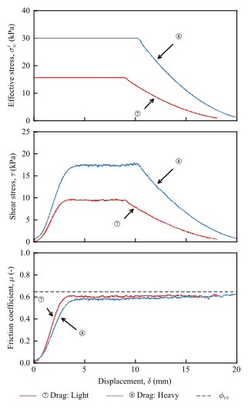

Fig. 6. Centrifuge sled tests on uniform silica sand (CSS).
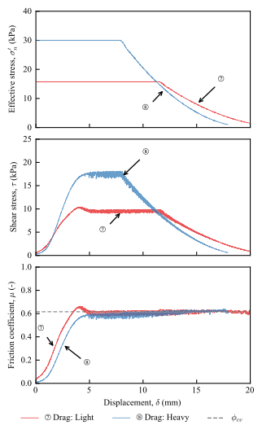

Fig. 7. Centrifuge sled tests on uniform silica sand (FSS).
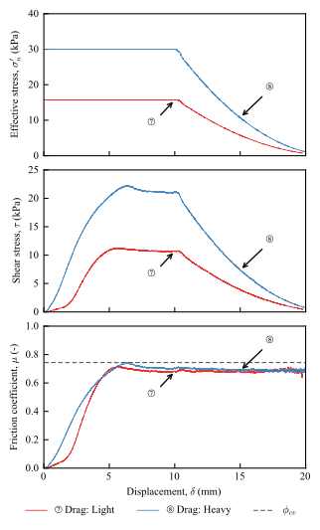

Fig. 8. Centrifuge sled tests on marine sand (NWS).
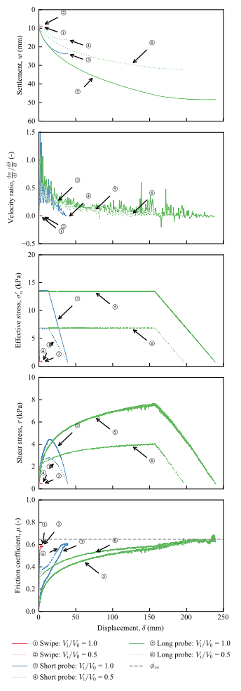

Fig. 9. Shallow ring penetrometer tests on uniform silica sand (CSS).
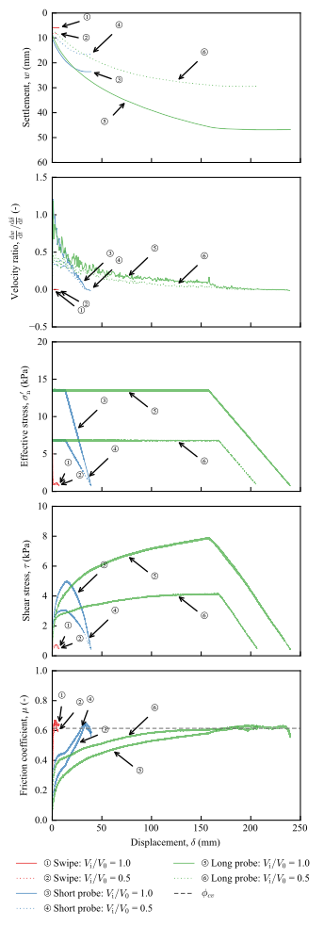

Fig. 10. Shallow ring penetrometer tests on uniform silica sand (FSS).
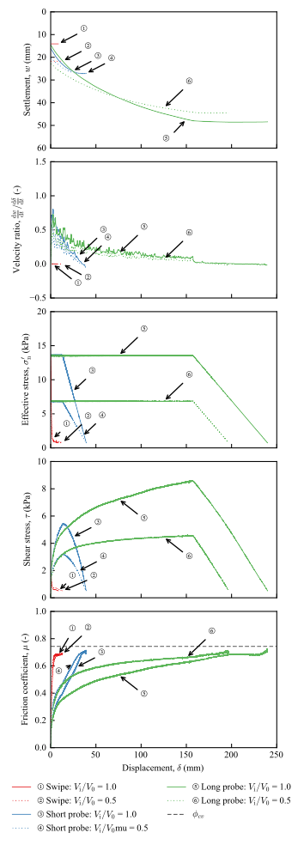

Fig. 11. Shallow ring penetrometer tests on marine sand (NWS).
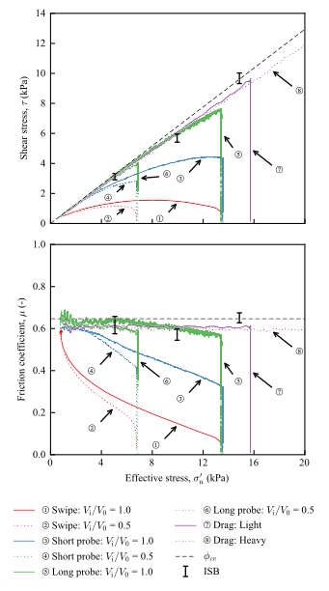

Fig. 12. Summary of all friction tests on a uniform silica sand (CSS).
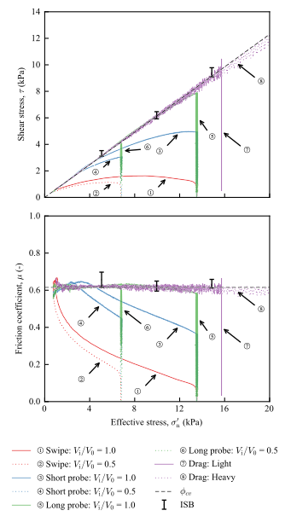

Fig. 13. Summary of all friction tests on uniform silica sand (FSS).
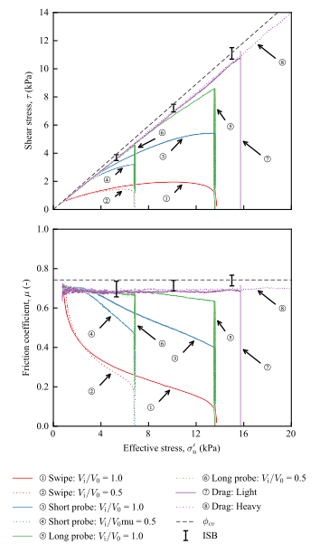

Fig. 14. Summary of all friction tests on marine sand (NWS).
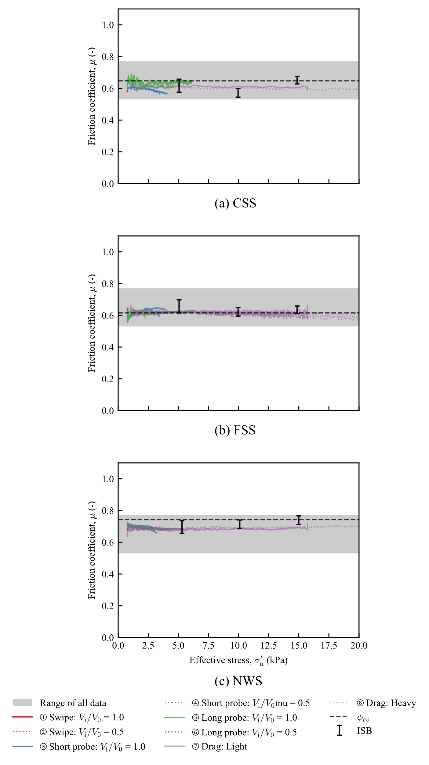
Fig. 15. Interpreted friction coefficients of CSS, FSS and NWS sands.
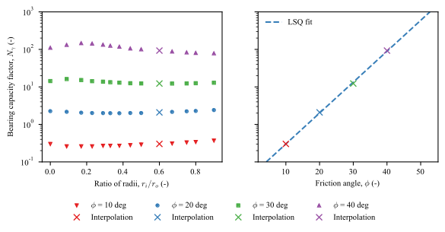
Fig. 16. Bearing capacity factor N_{γ} for the ring penetrometer based on numerical data from Vali et al. (2019).
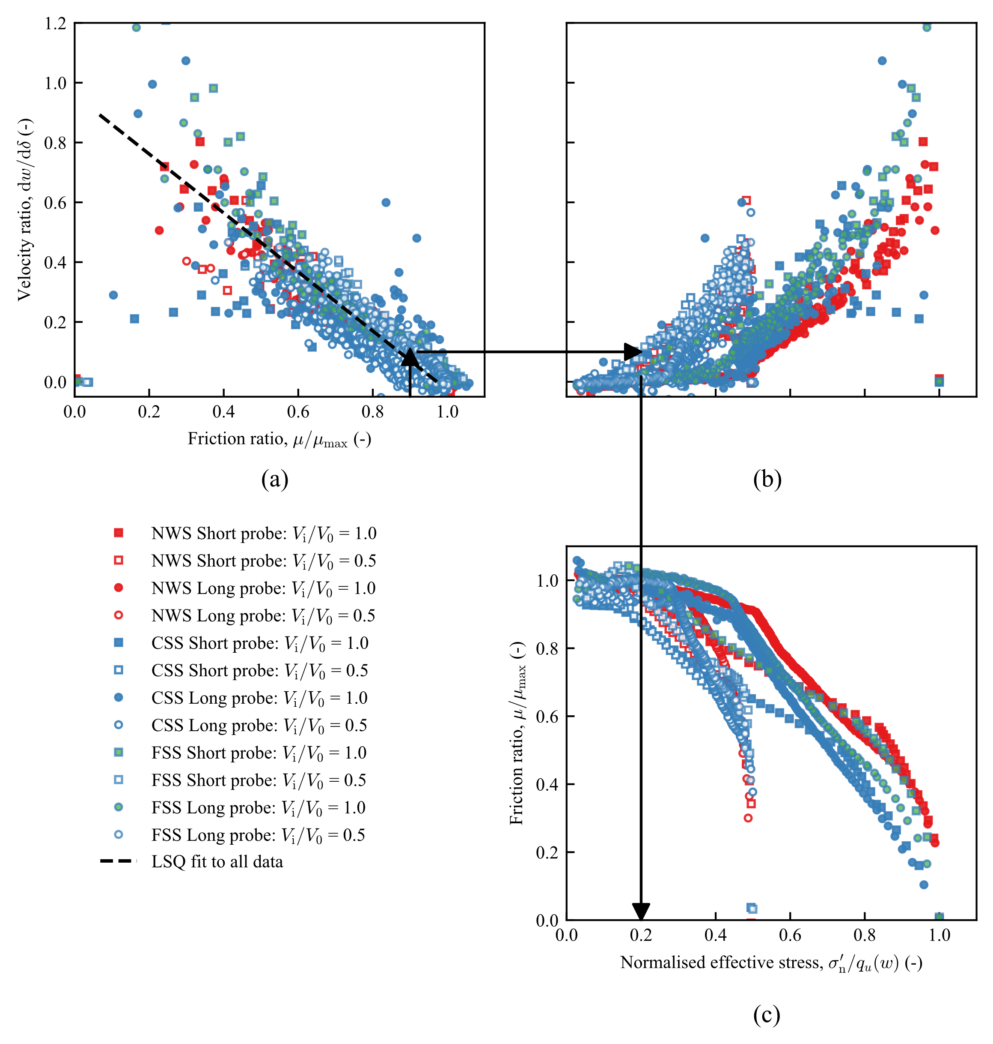
Fig. 17. Influence of settlement rate and mobilised bearing capacity on available friction.

