The stability implications of drag minimization by tail action modelled in the gliding barn owl (Tyto alba)
Changyao Chen¹, Jorn A. Cheney², James R. Usherwood³, Richard J. Bomphrey³, Jialei Song¹
¹School of Mechanical Engineering, Dongguan University of Technology, Dongguan 523808, Guangdong, China
² School of Biological Sciences, University of Southampton, Southampton, SO17 1BJ, UK
³Structure and Motion Laboratory, Department of Comparative Biomedical Sciences, Royal Veterinary College, North Mymms, Hatfield AL9 7TA, UK
Corresponding email: songjl@dgut.edu.cn
Abstract
Tail posture influences lift, drag, trim and stability for birds, yet the interaction between them as the tail spreads and pitches remains unclear, even during steady gliding. In this study, we investigated the aerodynamic consequences of tail morphing, exploring the interactions between weight support, drag, longitudinal trim and stability using data obtained from computational fluid dynamics (CFD) simulations of high-fidelity, photogrammetry-derived geometry of a free-gliding barn owl. Assuming drag to be minimised over a range of speeds, the tail should be more spread and pitched at low speeds, and less so at high speeds. This influences the proportion of weight supported by the tail; in order to prevent net aerodynamic pitching moment and maintain longitudinal moment equilibrium, the relative position of the centre of gravity must shift. These effects shorten the negative static margin at higher speeds, making the model bird less unstable, limiting the reduction in pitch divergence doubling time that would otherwise have been coupled with the increase in speed. The drag-minimising model owl is aerodynamically unstable at all speeds, but the feedback and control challenges of maintaining steady glides at high speeds are partially ameliorated and lower than would be predicted without a morphing airframe.
Keywords: bird flight, gliding aerodynamics, longitudinal stability, tail morphing
- Introduction
The avian tail plays a crucial role in controlling flight^{[1, 2]}, functioning as an ancillary lifting surface that contributes to weight support at low speeds^{[3-5]}, drag reduction^{[6-9]}, and pitching moment adjustment^{[10, 11]}. Additionally, tail pitching modifies torso-tail camber, forming longitudinal dihedral or anhedral configurations that influence pitching stability^{[12, 13]}. When the bird’s flight is unstable^{[12, 14, 15]}, the pitching moment would diverge after a small disturbance in the absence of active control by wings or tail. Meanwhile, bats use their hindlimbs in a similar functional manner^{[16, 17]}, and some species even possess a tail-like structural, the uropatagium, to aid flight control^{[18, 19]}. Therefore, a key question is how the tail contributes to weight support and moment balance during gliding while maintaining low drag and avoiding instability in excess of that which can be compensated for either aeroelastically^{[20]} or actively. A comprehensive understanding of tail function requires not only an analysis of aerodynamic forces but also moments and the degree of stability/instability. Experimental methods such as wind tunnel free-flight tests^{[11]}, quantitative flow visualization^{[10, 21]}, and pressure-sensors measurements on freely-flying birds^{[22, 23]} have been used to estimate aerodynamic forces, revealing mechanisms for lift enhancement and drag reduction^{[3, 24, 25]}. However, determining stability metrics requires calculating or measuring what the aerodynamic forces and moments would be for a small deviation in pitch^{[26]}. Direct observation of a steady glide only reveals the current state, which alone cannot indicate stability quantitatively without a model predicting what would happen under different conditions. Wind tunnel experiments^{[27-29]} and computational fluid dynamics (CFD) ^{[15]} using bird models can predict the moments associated with small changes in pitch for a given airframe. Gliding barn owls have been found to be unstable in pitch^{[12, 29]}; however, how might this (in)stability change with speed? Is it likely that certain flight speeds will impose insurmountable control demands for maintaining a steady glide?
In this study, we reconstructed a high-fidelity model of a free-gliding barn owl (Tyto alba), based on the surface geometry measured in our previous study^{[30]}. Using computational fluid dynamics (CFD), we obtained aerodynamic data for both the reconstructed model and re-morphed models with virtually manipulated tail postures in terms of pitch and spread. Additional simulations were conducted for the re-morphed models across various angles of attack to evaluate the variation of aerodynamic forces with pitch deviation and to identify the neutral point. Based on parameters calibrated from the CFD simulations, we investigated the effect of the tail on aerodynamics and stability at longitudinal trim across a range of speeds. The trimmed condition, with balances for both aerodynamic forces and pitching moments, is illustrated in Figure 1(a). We assess metrics of stability across a range of speeds for owl models able to spread and pitch their tails for steady glides – avoiding net forces and longitudinal moments – assuming drag minimisation is achieved at each speed.
- Results
- Force balance, moment balance, and the stability of a measured owl posture
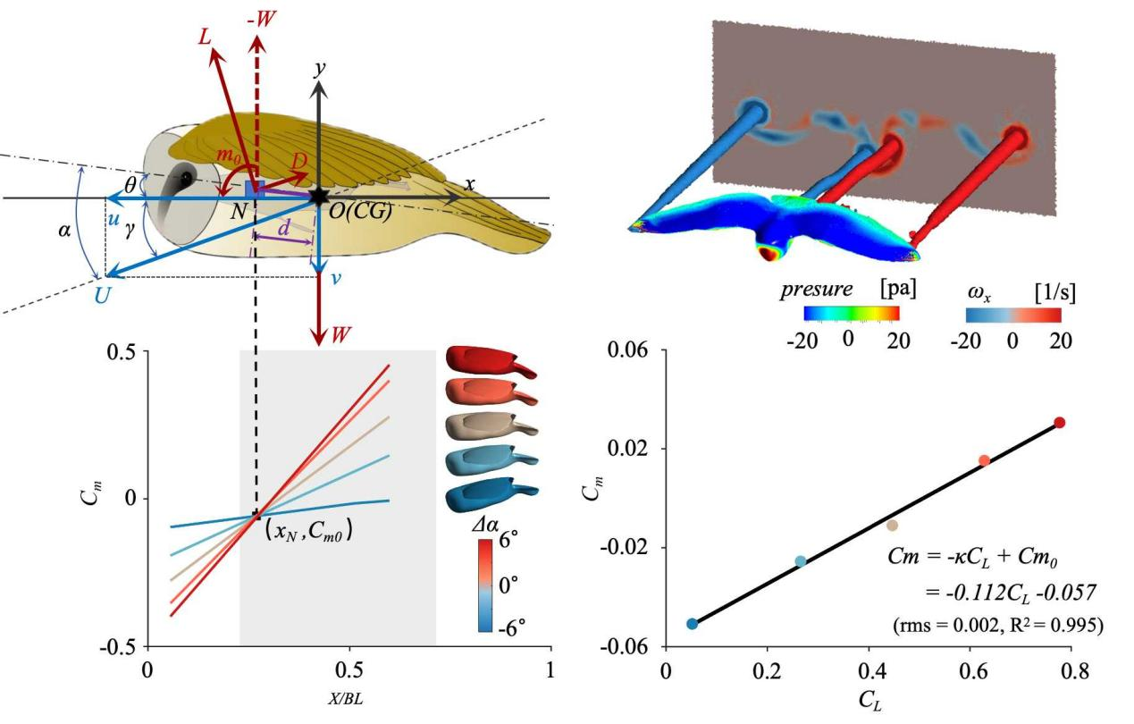Figure 1 (a) Illustration of the kinematic parameters and force diagram for gliding flight of a barn owl. The coordinate system Oxy is on the bird, with O fixed on the centre of gravity (CG), x horizontal and y vertical. The neutral point (N) is illustrated here on the body axis in front of the CG for unstable configuration, with a distance, d. Angle of attack ($α)$, gliding angle ($γ)$, and angle of incidence ($θ$) are shown as well. (b) Pressure distribution on the barn owl’s surface, along with the primary vortex structure and flow field presented by the plenary vortex in streamwise direction ($ω_{x}$), obtained from high-fidelity CFD simulations. (c) Plot of pitching moment varying with the reference center allows for identification of the neutral point and zero-lift moment (C_{m0}) using CFD simulations for the owl’s original posture across five angles of attack relative to the original angle of attack: $∆α$ = [-6°, -3°, 0°, -3°, 6°]. X indicates the location from the front edge, and BL indicates body length. We provide a zoomed-in view around x_{N} to verify that the neutral point’s existence in the Figure S3 in supplementary materials; shaded area indicates the chord location of the wing root, c_{max}. (d) The relationship between moment coefficient (C_{m}) and lift coefficient (C_{L}) follows a linear trend, expressed as C_{m} = -$κ$C_{L} + C_{m0} = 0.112 C_{L} - 0.057 (rms = 0.002, and R² = 0.995).
In the barn owl’s observed gliding state, its flight speed was U = 7.88 m/s with a glide angle of $γ$ = 2.9°. As the bird’s rotational acceleration is negligible (~0.15 rad/s²), the center of pressure is assumed to coincide with CG. Based on the pressure distribution on the surface of the model, the position of the CG is located at 27.9% c_{max} (the wing’s maximal chord length) from the bird’s shoulder, which aligns closely with estimates from computed tomography measurements (25.7% c_{max})^{[29]}. For force balance, lift (L) equals the component of weight (W) perpendicular to the gliding direction, expressed as L = W$∙$cos ($γ$); for moment balance, a nose-down zero-lift moment (M₀) is required at the neutral point (N, also known as aerodynamic center), where the pitching moment remains constant despite changes in angle of attack. N is assumed to lie on the body axis, as its lateral offset is negligible. To identify N, CFD simulations were conducted at five angles of attack ($∆α$) ranging from -6° to 6° relative to the original posture. The simulations predict that the forces support 94.2% of the bird's weight. Later in the study, we make the approximation that this force matches the body weight by adjusting the mass to obtain the equilibrium state. The wake pattern also closely matches particle tracking velocimetry (PTV) measurements from a previous study^{[31]} both qualitatively and quantitatively, with maximum downwash near the left wing of 1.18 m/s (CFD) versus 1.16 $±$ 0.45 m/s (PTV), and tip vortex circulation of 0.29 m²/s (CFD) versus 0.31 $±$ 0.11 m²/s (PTV) (Figure 1(b); see supplementary materials for CFD details). The results show the neutral point (N) is located 15.8% c_{max} anterior to the center of gravity (CG), defining a distance-based static margin of $κ_{d}$ = $\frac{-d}{c_{max}}$ = -0.158, where d is the distance between N and CG (Figure 1(c)). Theoretically in inviscid steady aerodynamics, the static margin can be expressed as -dC_{m}/dC_{L}, which should be the same as the previous distance-based static margin $κ_{d}$. However, nonlinear aerodynamics, flow interaction, tail contribution and simplified calculations yield a different value^{[26]}. The derivative-based static margin is obtained with$κ$=-dC_{m}/dC_{L}, which yields $κ$= -0.112 (Figure 1(d)). Both calculations returning a negative static margin confirms that the barn owl’s gliding posture is longitudinally unstable. The static margin we used is the derivative-based one due to its robustness and aerodynamic relevance^{[32]}.
- Aerodynamic force variation with tail morphing
Tail posture significantly affects both lift and drag, functioning similarly to an aircraft flap^{[8, 9]}. In this study, we performed CFD simulations across 15 postures, varying tail pitch angles (ϕ_{p}) from -46° to 46° and spread angle (ϕ_{s}) from 0° to 35°, with pitch and spread angles illustrated in Figure S4 (Supplementary Materials). As shown in Figure 2(a), the lift coefficient (C_{L}) increases as the tail pitches downward, with the maximum lift-to-drag ratio (10.5) occurring at ϕ_{p} = 26°, matching the original posture’s pitching angle. Meanwhile, tail spread increases the range of lift variation. However, the lift and drag obtained directly from CFD simulations (excluding the original posture) do not reflect balanced conditions. By integrating the linear relationship between C_{L} and angle of attack with CFD-calibrated drag models^{[9]}, we derived angle of attack (α), gliding angle (γ), and angle of incidence (θ_{f} = α − γ) as functions of gliding speed under force equilibrium, though not necessarily under pitching moment equilibrium. These angles are defined in Figure 1(a). We then repeated this for all 15 tail postures, which allows us to assess the aerodynamic performance of tail posture on force-balanced flights at speeds of 5 - 12 m/s (Figure 2(b)–(d)). The algorithm is detailed in Materials and Methods.
The gliding polar (Figure 2(e)) illustrates the relationship between sinking speed (v) and forward speed (u) (defined in Figure 1(a)), highlighting the effect of tail posture on drag minimization. Generally, extreme tail pitching (both upward and downward) results in poorer performance, while a mildly downward-pitched tail achieves the lowest sinking speed across all forward speeds (Figure 2(e)). However, since moment balance was not considered at this stage, the plot in Figure 2(e) does not necessarily reflect a trim condition. Additional constraints accounting for moment balance are required.
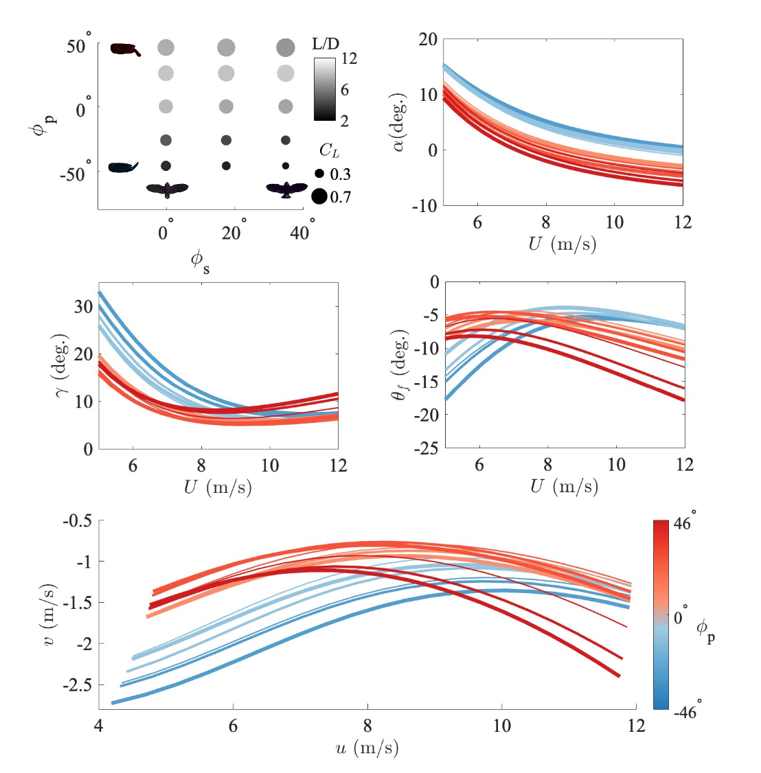
(e)
(d)
(c)
(b)
(a)
Figure 2 (a) The relationship between lift coefficient C_{L} and lift-drag-ratio L/D with tail posture from the CFD simulation. For a given flight speed, we can balance forces if we allow angle of attack $α$ (b), glide angle $γ$ (c), and angle of incidence $θ$_{f} (d) to change. (e) Gliding polar for force balance across different tail postures. The colourmap from (b) to (e) indicates the tail pitching angle ϕ_{p}, and the thickness of lines indicates the three spread angles ϕ_{s} with the thickest one referring to ϕ_{s} = 35° and thinnest one ϕ_{s} = 0°.
- Stability and aerodynamic variations with tail morphing at trim
The relevant gliding postures are those where the longitudinal moments can be balanced. The bird models in this study are assumed to be rigid, and the moment M is given by:
M = m₀ + W$∙$d$∙$cos($θ$) = 0,
for the moment balance, where m₀​ is the moment at the neutral point, and d is the distance between the neutral point and CG. Across all tail postures, each model’s neutral point was located anterior to the CG, denoting longitudinal instability (Figure 3(a)). This aligns with the positive C_{m}​ - $α$ relationship (Figure 3(b)), with static margins κ ranging from -0.069 to -0.139 across configurations. The dimensionless zero-lift moment C_{m0} decreases as the tail pitches downward, with only large downward pitch angles resulting in negative C_{m0}. Since the negative C_{m0}​ is required for trim in longitudinally unstable configurations^{[13]}, this suggests that tail postures with a positive C_{m0} cannot achieve trim (ϕ_{p} $≤$ −26°), as any positive lift leads to a larger positive moment. For other tail postures, trim can potentially be achieved by adjusting the angle of incidence θ; of the 15 tail postures at speeds 5 - 12m/s, only two achieved moment balance with $θ$ between -25° to 0°, a range that $θ$ should be within for force balance. Using the range of ϕ_{p} (−46° to 46°) and ϕ_{s} (0° to 35°), we interpolated aerodynamic data to generate a gliding polar that satisfies both force and moment balance. This interpolation includes 256 values for pitch angles and 9 values for spread angles.
The trimmed gliding polar is, therefore, a subset of the gliding polar shown in Figure 2(e). Only tail postures with pitch angles between 21.2° and 46° achieve moment balance in this study; other configurations fail to meet this condition. Tails that pitch-down more steeply correlate with reduced spreading, and vice versa (Figure 3(e)). This correlation leads to a small change of static margin caused by the tail posture, with κ ranging from -0.111 to -0.113 across the speeds. In these configurations, a mildly pitched-down tail with an intermediate spread achieves the minimal sinking speed across all the forward speeds examined in this study; the relevant models do not fall at extremes of the surveyed tail pitch/spread parameter space. Moment balance is unattainable at low speeds (u < 6.5 m/s), even for tail pitching angle ϕ_{p} $>$ −26°. At these speeds, greater tail pitch-down and spread (i.e., a lower C_{m0}) are required, but the resulting lift for force balance is insufficient to compensate for the excessively low C_{m0.} Overall, the trimmed gliding polar closely aligns with the force-balance gliding polar with minimal sinking speed. However, at higher speeds (with forward speed u > 9 m/s), the zero pitch moment constraint precludes the minimum drag configuration. Whether this is a real issue for the birds, or is one that can be circumvented with trivial but unconsidered planform morphing, is beyond the scope of this study. Here, we focus only on the configurations that do achieve trim.
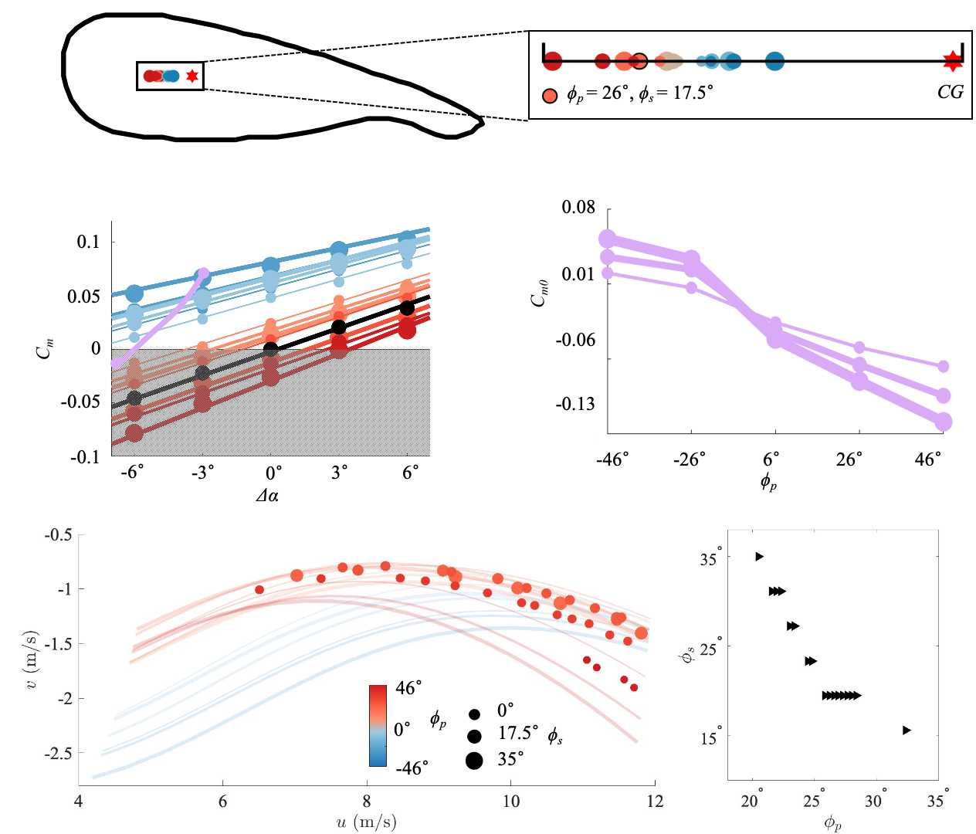
(e)
(b)
(a)
(d)
(c)
Figure 3 (a) Location of neutral points for different tail postures. All neutral points are positioned ahead of the center of gravity, indicating that these gliding postures are longitudinally unstable. The size of circles indicates the spread, and the colour indicates the tail pitch. (b) Moment coefficient versus angle of attack for different tail postures. (c) Zero-lift moment C_{m0} versus tail pitch angle. (d) Gliding polar for trimmed flight, i.e., both force and moment balance, for models with differing tail pitch and spread. The transparent lines are the gliding polars merely at force balance (same as Figure 2(e)). Colourmap in (d) also applies to (a-b). (e) The correlation between tail pitch angle and spread angle for trimmed flight.
- Effect of morphing on stability
Here, we change the static margin by moving the assumed CG. We do not suggest that the real owl shifts its CG to balance moments (although various changes in load distribution, from egg bearing to prey-carrying may have a bearing on its location and interesting stability consequences). Instead, the relative movement of the owl’s CG could be achieved by slight forward/backward wing sweep. While this is not exactly equivalent – because sweep would change geometry and so the aerodynamics – we assume that changes in geometry are small enough that the previous CFD-derived models are sufficiently accurate for subsequent modelling. Simulating the full interaction would be computationally excessive, and rely on further assumptions concerning changes in wing shape and posture. We virtually adjusted the derivative-based static margin by ± 3.0% c_{max} – a value large enough to differentiate between cases, yet small enough to ensure equilibrium is attainable by adjusting tail postures and to justify the assumption of unchanged aerodynamics (Figure 4(a)). In birds, this could be achieved via wing sweep^{[27, 33]}; in aircraft, it would require CG shifts under relaxed static stability. Since wing posture, and hence wing aerodynamics, in this study are held constant, the stability adjustment we apply is similar to aircraft’s CG shifts, but remains relevant to avian morphing wings since the sweep required would be minor. For clarity, we describe stability change as CG shifts hereafter and, because the aerodynamics are unchanged, the force balance shown in Figure 2 still holds. Changing the static margin leads to the change of angle of incidence required for moment balance, contributing to different trim states. In this case, the CG shift is represented by $\overline{κ}$ —the derivative-based static margin for the original tail posture. When there is no CG shift, $\overline{κ}$ = -0.112. Forward shifts of the CG yield a less unstable configuration, with $\overline{κ}=$-0.082. See Figure S5(a) (Supplementary Materials) for the gliding polar in this trim. In these configurations, the minimum trimmable speed increases to 8.10 m/s. Conversely, backward CG shifts ($\overline{κ}$= - 0.142) reduce the minimum speed to 4.59 m/s (Figure S5(c)), but the configuration is more unstable. To achieve equilibrium gliding under varying CG positions, the tail must adjust its posture accordingly. Less unstable configurations ($\overline{κ}$= -0.082) are associated with less tail pitch ($ϕ_{p}$ranging from 9.2° to 19.8°) (Figure 4(c)), with the spread angle ranging from 0° to 35° (Figure 4d). More unstable configurations ($\overline{κ}$= -0.142) are associated with greater tail pitch ($ϕ_{p}$ ranging from 37.1° to 46°) (Figure 4(c)), and larger spread angles (26.2° to 35°) (Figure 4(d)).
(a)
Optimal gliding—defined by the lowest sinking rate at a given speed—occurs with different tail postures dependent upon the CG position. To obtain the gliding polars with tail pitch and spread for trim and lowest sinking speed (Figure 4(b)), we overlaid the supremum 50% of equilibrium cases, defined as those above the binominal fitting of all trim cases (Figure S5 in supplementary materials). Comparing to the tail postures for trim, the range satisfying both trim and drag minimization narrows (Figure 4(c) and 4(d)). By introducing the effect of stability, we observed that as the bird becomes more unstable (CG shifts backward), the optimal tail pitch increases, with average value from 17.8° to 38.7° (Figure 4(c)), along with the spread angle, with average from 8.6° to 33.2° (Figure 4(d)). Overlaying the optimal positions across all three stability scenarios reveals a clear trend, which is, at low speeds, a more unstable configuration with a downward-pitched and spread tail is optimal for minimising sink rate. Conversely, at high speeds, a less unstable configuration with reduced tail pitching and a more folded posture is optimal. These results match observed avian tail morphing trends^{[10, 11, 30]}.

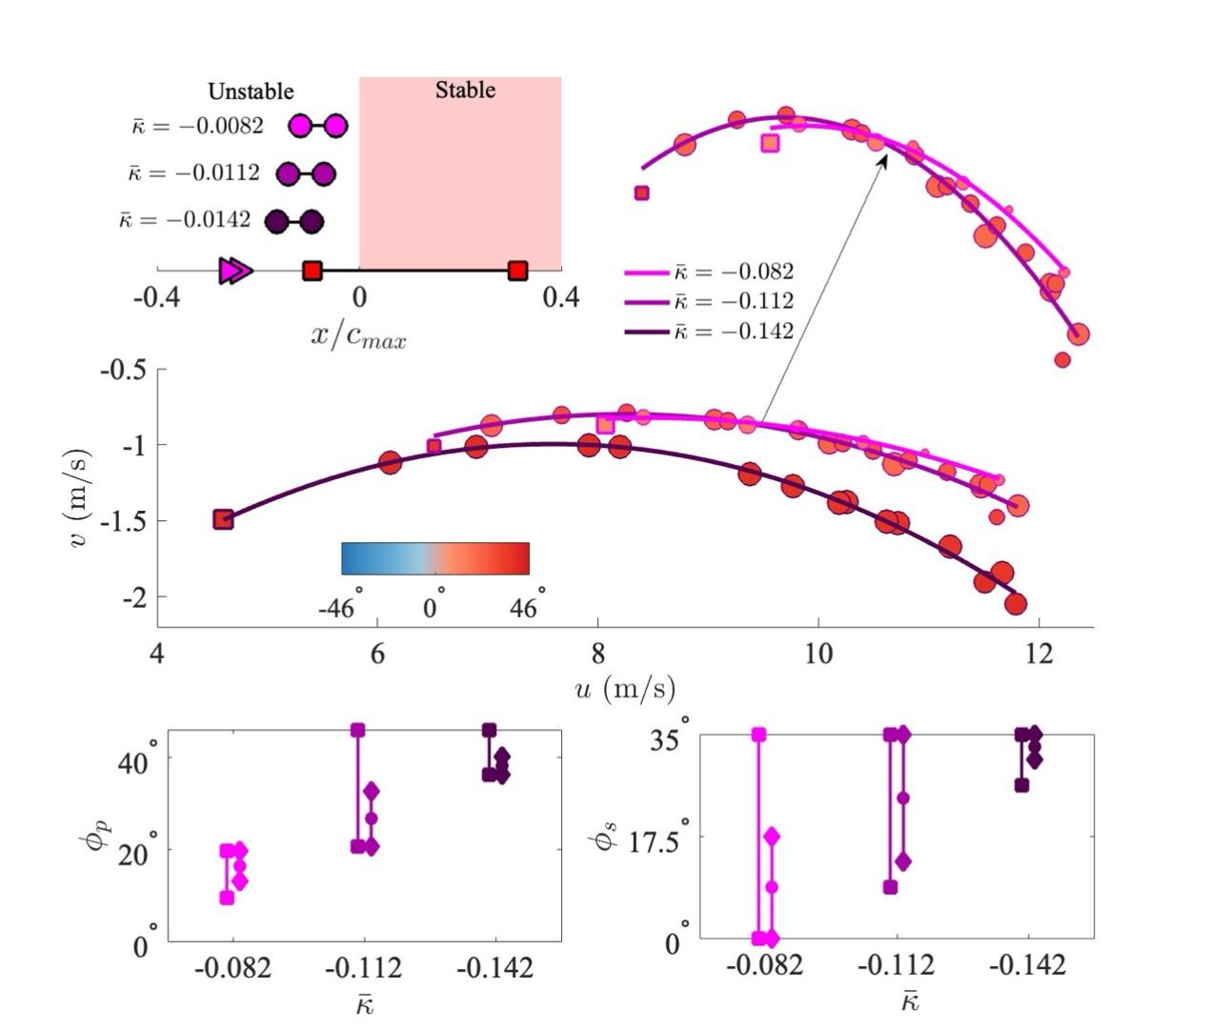
(c)
(b)
(d)
(a)
Figure 4 (a) The shift of the CG to change the static margin. The CG is set at x/c_{max} = 0, with neutral points located in the unstable left region with white background, while location of neutral point at the right region with red background indicate stable gliding. Each dumbbell represents the range achievable through tail manipulation. The red squares indicate minimal and maximal values of the barn owl’s static margin via wing and tail morphing^{[14]}. Triangles are values from 3D-printed model tests^{[29]}. (b) The optimal gliding polars for three different stabilities with CG shift with both the data from trim and the binominal fitting. Circles indicate the data in trim and optimal gliding (data with sinking speed lower than the original fitting on all data in trim). The filled colour indicates the tail pitching angles and radius of circle indicates the spread angle (the reference of circle radius same as Figure 3(d)). Squares indicate the equilibrium state for lowest forward speed of each CG configuration. The binomial fitted line are v = -0.0558u² + 0.846 u - 4.21 (rms = 0.040, R² = 0.986) for backward CG ($\overline{κ}$ = - 0.142, dark red); v = -0.0481u² + 0.792 u - 4.06 (rms = 0.043, R² = 0.960) for original CG ($\overline{κ}$ = - 0.112, brown red); v = -0.0403u² + 0.883 u – 3.72 (rms = 0.0168, R² = 0.988) for forward CG ($\overline{κ}$ = - 0.082, light red). (c) Range of tail pitching angle for equilibrium state (square), and optimal gliding (diamond) for different $\overline{κ}$. (d) Range of tail spread angle for equilibrium state (square), and optimal gliding (diamond) for different $\overline{κ}$.
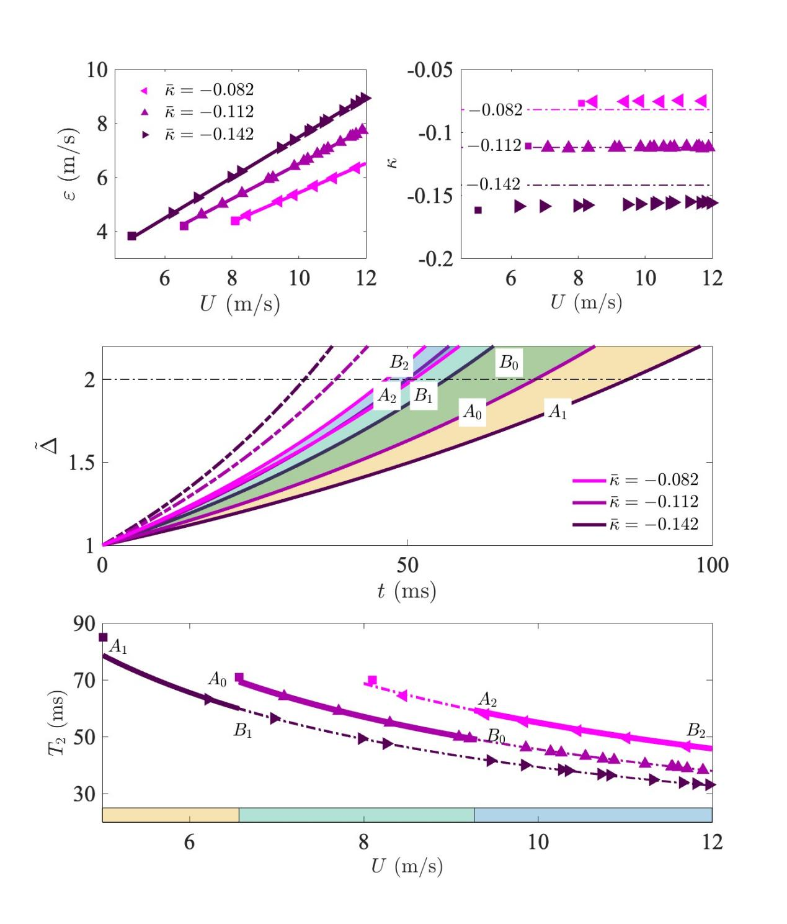Figure 5 (a) The divergence rate $ε$ exhibits a linear relationship with gliding speed U for three CG positions, with $ε$ = 0.543 U (rms = 0.023, R² = 0.999), $ε$ = 0.650 U (rms = 0.006, R² = 0.999), $ε$ = 0.749 U (rms = 0.012, R² = 0.999) for $\overline{κ}$ = -0.082, -0.112 and -0.142, respectively. (b) The variation in static margin with gliding speed U is minimal for three CG positions. The observed differences arise from both CG shifts and the corresponding adjustments in tail posture required to maintain longitudinal trim. (c) Evolution of pitching angle perturbation magnitude with respect to the initial perturbation angle over time for three CG configurations, indicated by different colours. Area I from A₁ to B₁ indicates the region of evolution for $\overline{κ}$ = -0.142 between velocity U = $\sqrt{u^{2}+v^{2}}$= 5.01 m/s and 6.57 m/s; area II from A₀ to B₀ indicates $\overline{κ}$ = -0.112 between U = 6.57 m/s and 9.27 m/s; area III from A₂ to B₂ indicates $\overline{κ}$ = -0.082 between U = 9.27 m/s and 11.7 m/s. (d) Variation of doubling time T₂ with gliding speed U for three CG positions. Region A₁-B₁, A₀-B₀ and A₂-B₂ correspond to the three distinct areas in panel (c) and represent configurations with minimal drag. As speed increases, shifting the CG forward to reduce the instability extends the doubling time while at drag minimization. Solid and dashed lines represent the fitting curves with relationship T₂ ~1/U.
(d)
(c)
(b)
(a)
While the static margin quantifies the degree of longitudinal instability, as reflected by pitch angle divergence, bird pitch angle divergence is also affected by other parameters beyond static margin alone. For short-period pitching dynamics, when an initial angle perturbation $Δθ$ is applied, the perturbation magnitude, denoted as $\tilde{∆}$, is normalized by the initial perturbation angle and can be described theoretically by $\tilde{∆}$ = $e^{εσt}$ (see Materials and Methods). Here, $σ$ incorporates the geometrical and inertial properties of the bird, and varies little in this study. $σ$ = $\sqrt{ρSc_{max}/2I}$​​​ , where $ρ$ is air density, S is the planform area, and I = 8.5$×$10⁻⁴ kg$∙$m² (pitch moment of inertia about CG) ^{[29]}.$ε=\sqrt{{-\frac{∂C_{L}}{∂α}κU}^{2}}$ , defined as divergence rate, theoretically varies with both changes in speed U, and with $κ$. However, as CG shifts, the corresponding adjustments in tail posture attribute to a relatively constant static margin. This results to a linear relationship between $ε$ and U, as shown in Figure 5(a). The near-constant static margin for each CG position, arises from both CG shifts and the corresponding tail posture adjustment required to achieve longitudinal trim, as shown in Figure 5(b). Consequently, the bird exhibits varying degree of pitching divergence, presented as pitch angle $\tilde{∆}$ across different speeds and the static margin. At low speed (U = 5.01 m/s) with high instability ($κ=$- 0.161), the divergence is slowest, labelled as curve A₁ in Figure 5 (c). As speed increases to U = 6.57 m/s, divergence grows rapidly, reaching point B1, and continues to increase up to U = 11.7 m/s along the leftmost dashed curve, assuming constant instability. Reducing the instability to $κ=$- 0.075 at the same speed lowers the divergence, shifting the leftmost curve to B₂ at U = 11.7 m/s. A common aeronautical index representing the divergence is doubling time (T₂), defined as the period taken for the pitching angle to double in value. It is calculated based on T₂ = ln(2)/($εσ$), where T₂ is a function of gliding speed U and static margin $κ$ since $ε$ depends on U and $κ$. The resulting values show the inverse relationship between T₂ and U, with T₂ ~ 1/U, as shown in Figure 5(d).
At low speeds (U < 6.57 m/s), only a backward-shifted CG ( $\overline{κ}$ = -0.142) achieves trim, causing $\tilde{∆}$ to diverge in the area I (A₁-B₁) (Figure 5(c)) across the range of tail postures. In this speed range, the doubling time (T₂), the time taken for the perturbation magnitude to increase by a factor of 2, i.e. $\tilde{∆}$ = 2, is relatively large, varying from 56 milliseconds to 84 milliseconds, labelled as A₁-B₁ in Figure 5(d). At moderate speeds (6.57 m/s < U < 9.27 m/s), the original CG configuration is most efficient. Both backward- and forward- shifted CG can achieve trim when U > 8.10 m/s. Tail posture variation range in original CG configuration leads to the exponential variations of $\tilde{∆}$, with the enveloped area shown in Figure 5(c), area II (A₀-B₀). The doubling time (T₂) ranges from 50 milliseconds to 71 milliseconds, labelled as A₀-B₀. At higher speeds (9.27 m/s < U < 11.7 m/s): A forward-shifted CG configuration (corresponding to a smaller $\overline{κ}$ and a milder tail pitch and spread) is the best of the three CG configurations regarding to efficiency, and the divergence rate is smallest, when compared to the equilibrium configurations achieved with the other two CG positions. At forward-shift CG, T₂ ranges from 46 - 52 milliseconds across tail postures, labelled as A₂-B₂. In comparison, T₂ for the original CG at speed U = 11.7 m/s are 39 milliseconds, representing an ~18% increase in doubling time due to the forward CG shift (Figure 5(d)).

- Discussion

Balancing vertical forces, horizontal forces and pitching moments are three of the constraints with which birds must comply to achieve steady, trimmed gliding flight. Two factors determine pitch divergence doubling time and so presumably the period available for active adjustments to maintain steady gliding: static margin and airspeed. Static margins vary due to shifts in the functional CG; higher speeds reduce doubling time, presumably making active stabilising control more challenging. Similar to aircraft, maintaining weight support is challenging at low speeds, often requiring both large planform areas and high lift coefficients ^{[34]}. Birds spread their tails fully and pitch them down, increasing the effective area and the camber formed by the tail and torso, thereby enhancing lift production for weight support. Similarly, the hindlimb combining the wing membrane of bats, and the tail-like structure uropatagium of some bats, create a similar camber in downstroke during take-off^{[16, 18]}.This configuration is relatively unstable because greater pitch and tail spreading produces a larger nose-down moment and the compensatory functional shift of the CG backwards, increasing the negative static margin.

In the current study, changes in stability are influenced by both the tail posture itself and artificial adjustment of the CG. For birds flying freely in nature, a spread and pitched tail corresponds to a swept-forward wing configuration, which maintains the centre of pressure's position over the centre of gravity^{[30, 35]}. In both of these equivalent cases, the negative static margin is larger at low speeds, resulting in a more unstable aerodynamic configuration^{[13]} , but, inversely, the pitch divergence rate, influenced substantially by flight speed, presumably results in a doubling time within a feasible range for active control by bird, due to the low speed. In contrast, at high speeds, perturbations will cause rapidly divergent changes in pitching angles, making effective control challenging. Active sensorimotor control in birds involves detecting disturbances, processing neural signals in the brain or peripheral nervous system to calculate error from the set point, and executing muscular contractions, which all take time^{[36]}. Large movement responses in birds of similar size typically require 80–100 milliseconds, while the muscles responsible for flight control react in 25–50 milliseconds^{[37-39]}. Tail control muscles may differ, but these timings highlight the potential for constraints on feasible control at high speeds if the pitch divergence doubling time is short. In our simulations, the pitch doubling time ranged from 32 to 84 milliseconds, with the values at high speeds comparable with a previous owl study (22 to 69 milliseconds^{[29]}), giving only a narrow timeframe for adjustment. However, the tail posture necessary for drag minimization at higher speeds (furled and at a smaller angle of attack) has the effect of shortening the static margin, which reduces instability, giving more time for active control than would be the case if the airframe remained the same as at lower speeds. The static margin shortening from CG shift alone lengthens T₂ by 7 ms at high speeds (~18% of the doubling time). Thus, the decrease in doubling time that would be expected with faster speeds if there were no tail adjustment, placing greater demand on the flight controller, is compensated by tail posture reconfiguration. These results indicate that tail adjustment may reduce or eliminate constraints on higher speeds due to stability, and it remains to be seen if birds must ever sacrifice drag minimisation for stability at high speeds.
In this study, the entire bird is assumed to be rigid, without any compliant deformation in response to disturbances. When a gliding barn owl encounters gusts, passive wing deformation contributes to enhanced flight stability^{[38, 40]}. Additionally, the deformation and elasticity of the wings and flight feathers as well as joint movement introduce greater damping^{[41]}, which may reduce the divergence rate and extend the doubling time, though not enough to achieve full stability. Currently, there is a lack of data on the damping ratio of real birds or models with comparable anisotropic structural properties, making it difficult to quantify this effect accurately. Integrating hinged wing and tail models with CFD calibrated data might help to elucidate this effect, which will be the focus of future work.

- Conclusions
This study investigated the impact of tail postures on drag, trim, and control using high-fidelity computational fluid dynamics (CFD) in a gliding barn owl. Our findings reveal that adjusting tail posture to minimize drag while trimmed has consequences for stability. Specifically, drag minimization requires reduced tail pitch and spread at higher gliding speed, and this configuration change would ameliorate the increase in instability otherwise associated with higher speeds. These results explore and quantify the complex interplay between trim, drag reduction, and stability associated with tail morphing during gliding flight.
V. Materials and Methods
- Models for Equilibrium State
The gliding polar provides a straightforward way to evaluate the gliding performance of birds, offering insight into the lift and drag^{[42]}. However, pitching moment is often overlooked, as it is typically assumed to be balanced through control inputs^{[43]}. This simplification introduces potential errors when accounting for the coupling effect between the tail (or flap) and wing aerodynamics. In this study, we developed a model that accounts for the balance of both force and moment, while incorporating these coupling effects. The equilibrium state is illustrated in Figure 1(a).
For steady gliding, the force balance conditions for lift and drag are expressed as:
L = W$∙$cos($γ$); (1)
C_{L} = L/(1/2$∙ρ∙$U²$∙$S); (2)
where W is the weight, γ is the gliding angle, ρ is the air density, U is the velocity, and S is the reference wing area. The drag model follows from our previous work^{[9]}:
C_{D} = (C_{L}²/($π∙$e_{i}$∙$AR) + k_{C}$∙$(C_{L}-C_{L0})²/e_{v} + C_{D0}); (3)
Here, e_{i} is the span efficiency, e_{v}​ is the viscous efficiency, C_{L0}​ and C_{D0} are calibrated parameters obtained from CFD simulations (Figure S1 in supplementary materials). The parameter k_{C} depends on the Reynolds number (Re), estimated from experimental data^{[44, 45]} , and k_{C} = −6.32 × 10⁻⁷Re + 0.166 (N = 20, r² = 0.62).
Substituting the lift equation Eq. 1 to 2 gives:
C_{L}= W$∙$cos($γ$)/(1/2$∙ρ∙$U²$∙$S) (4)
For a given velocity U, the gliding angle $γ$ can be determined by substituting Eqs. 3 and 4 into the equation:
tan($γ$) = v/u = C_{D}/C_{L}
= (C_{L}/($π∙$e_{i}$∙$AR) + k_{C}$∙$C_{L}/e_{v} -2 k_{C}$∙$C_{L0}²/e_{v} + k_{C}$∙$C_{L0}²/(e_{v}$∙$C_{L}) + C_{D0}/C_{L;} (5)
We solve for $γ$ iteratively, using a maximum of 1000 steps a residual tolerance 10⁻⁶. For small angles of attack (α), the lift coefficient is approximated as C_{L} = p₁$∙α$ + p₂, where p₁ and p₂ are parameters calibrated for each tail posture using CFD simulations (Figure S2 in supplementary materials). Combining C_{L} = W$∙$cos($γ$)/( 1/2$∙ρ∙$U²$∙$S) and its linear relationship with $α$ yields the solution for $α$. The angle of incidence for force balance is then given by $θ$_{f} = $α$ – $γ$. By varying the speed U between 4 m/s and 12 m/s, we determine the gliding angle $γ$, angle of attack $α$ and angle of incidence $θ$_{f}, as well as the corresponding gliding polar for the force balance.
The neutral point (or aerodynamic center) is the point at which the pitching moment does not vary with the lift coefficient (or angle of attack). At this point, a zero-lift moment m₀ is exerted, which is negative for the positively cambered wings^{[26]}. To achieve moment balance, we set:
M = m₀ + W$∙$d$∙$cos($θ$) = 0; (6)
where d is the distance between center of gravity and neutral point. Solving for the angle of incidence for moment balance gives:
$θ$_{m} = arccos(-M₀/(W$∙$d)); (7)
To determine the equilibrium state, we calculate the intersection of the angles of incidence for both force balance (θ_{f}) and moment balance (θ_{m}​):
$θ$ = $θ$_{f}$∩$ $θ$_{m} (8)
The corresponding angle of attack $α$ and gliding angle $γ$ at equilibrium states are then identified.
- Pitching Angle Divergence

Considering only the pitching dynamics while keeping long period variables constant and excluding a trivial damping effect for small flyers^{[29]}, the pitching dynamics equation is obtained to govern the variation of pitching angle $θ$^{[46]}:
I$∙\frac{d^{2}θ}{dt^{2}}$ = $\frac{∂M}{∂α}(θ-θ_{0})$ = $\frac{∂C_{m}}{∂C_{L}}\frac{∂C_{L}}{∂α}∙\frac{1}{2}ρU^{2}Sc_{max}$($θ-θ_{0}$) (9)
Substituting $κ$ = - $\frac{∂C_{m}}{∂C_{L}}$ to Eq. 9, and defining
$σ$ = $\sqrt{ρSc_{max}/(2I)}$​​​ and $ε=\sqrt{{-\frac{∂C_{L}}{∂α}κU}^{2}}$ (10)
leads to the simplified form:
$\frac{d^{2}θ}{dt^{2}}$ = ${(σε)}^{2}$ ($θ-θ_{0}$) (11)
With initial condition t= 0, $θ$ = $θ_{0}$+$∆ θ$, and angular velocity q = $∆ θ/(σε)$, the solution for pitching angle as a function of time t becomes
$θ$ = $θ_{0}$ + $∆ θ∙e^{σεt}$ (12)
Therefore, the normalized perturbation variation respect to the initial perturbance is
$\tilde{∆}$ = ($θ-θ_{0}$)/ $∆ θ$ = $e^{σεt}$ (13)
Notably, for initial condition t= 0, $θ$ = $θ_{0}$+$∆ θ$, and angular velocity q = $0,$ the perturbation variation respect to the initial perturbation is
$\tilde{∆}$ = ($θ-θ_{0}$)/ $∆ θ$ = 1/2($e^{σεt}{+ e}^{-σεt})$ (14)

- Subjects
The barn owl (Tyto alba) used in this study has a mass of 340 g and body length (BL) of 0.317 m. During its original gliding posture, the flight speed is 7.88 m/s, with a wingspan (b) of 0.87 m shoulder chord length c_{max} of 0.168 m, and an aspect ratio (AR) of 5.12. The tail span is 0.13 m, with a tail area 4.6$×$10⁻³ m², accounting for 3.1% of the planform area (S = 0.1478 m²).
- CFD Simulations
Computational Fluid Dynamics (CFD) is a key methodology for investigating the aerodynamics of bird and bat flight^{[47, 48]}, enabling the use of both high-fidelity geometries^{[49]} and high-accuracy algorithms^{[50]}. In terms of CFD approaches, Direct Numerical Simulation (DNS) offers highly accurate results but is limited by mesh resolution requirements at high Reynolds numbers, often necessitating either extremely fine meshes^{[51]} or reduced Reynolds numbers^{[52]}, which makes it impractical for large-scale parametric studies including turbulence. In contrast, Reynolds-Averaged Navier-Stokes (RANS) methods, combined with appropriate turbulence models, are widely used in bird aerodynamics studies due to their balance of reasonable accuracy and computational efficiency^{[15, 53]}. In this study, we employed the commercial CFD software FLUENT to solve the governing fluid dynamics equations, utilizing a two-equation SST (Shear Stress Transport) turbulence model. This model combines the advantages of the standard and $k-ϵ$ models, enabling accurate prediction of flow fields and aerodynamic forces around the bird’s body. The inlet velocity is set to 7.88 m/s (U), resulting in a Reynolds number (Re) approximately 88000. The gliding posture is tilted by 2.9º (gliding angle $γ$) to align the inlet velocity horizontally. Neumann boundary conditions are applied for both inlet and outlet pressure, with symmetric far-field side boundaries and 1% turbulence intensity specified as at the inlet. Further detail on the simulation and convergence criteria are given in supplementary materials and validation is provided in our previous study^{[9]}.
Acknowledgements
This work is supported by National Natural Science Foundation of China (No. 12302296) and Natural Science Foundation of Guangdong Province (No. 2023A1515011506) to JS.
Reference
1. Thomas, A.L., On the aerodynamics of birds’ tails. Philosophical Transactions of the Royal Society of London. Series B: Biological Sciences, 1993. 340(1294): p. 361-380.
2. Thomas, A.L., On the tails of birds. Bioscience, 1997: p. 215-225.
3. Maybury, W.J., J.M.V. Rayner, and L.B. Couldrick, Lift generation by the avian tail. Proceedings of the Royal Society of London. Series B: Biological Sciences, 2001. 268(1475): p. 1443-1448.
4. Usherwood, J.R., et al., Dynamic pressure maps for wings and tails of pigeons in slow, flapping flight, and their energetic implications. Journal of experimental biology, 2005. 208(2): p. 355-369.
5. Ros, I.G., et al., Pigeons produce aerodynamic torques through changes in wing trajectory during low speed aerial turns. Journal of Experimental Biology, 2015. 218(3): p. 480-490.
6. Maybury, W. and J. Rayner, The avian tail reduces body parasite drag by controlling flow separation and vortex shedding. Proceedings of the Royal Society of London. Series B: Biological Sciences, 2001. 268(1474): p. 1405-1410.
7. Thomas, A.L.R., Why do Birds have Tails? The Tail as a Drag Reducing Flap, and Trim Control. Journal of Theoretical Biology, 1996. 183(3): p. 247-253.
8. Usherwood, J.R., et al., High aerodynamic lift from the tail reduces drag in gliding raptors. Journal of Experimental Biology, 2020. 223(3): p. jeb214809.
9. Song, J., et al., Virtual manipulation of tail postures of a gliding barn owl (Tyto alba) demonstrates drag minimization when gliding. Journal of the Royal Society Interface, 2022. 19(187): p. 20210710.
10. KleinHeerenbrink, M. and A. Hedenström, Wake analysis of drag components in gliding flight of a jackdaw (Corvus monedula) during moult. Interface Focus, 2017. 7(1): p. 20160081.
11. Rosén, M. and A. Hedenström, Gliding flight in a jackdaw: a wind tunnel study. Journal of Experimental Biology, 2001. 204(6): p. 1153-1166.
12. Durston, N.E., et al., Avian surface reconstruction in free flight with application to flight stability analysis of a barn owl and peregrine falcon. Journal of Experimental Biology, 2019. 222(9): p. jeb185488.
13. Thomas, A.L. and G.K. Taylor, Animal flight dynamics I. Stability in gliding flight. Journal of theoretical biology, 2001. 212(3): p. 399-424.
14. Harvey, C., et al., Birds can transition between stable and unstable states via wing morphing. Nature, 2022. 603(7902): p. 648-653.
15. Selim, O., et al., Peregrine falcon’s dive: Pullout maneuver and flight control through wing morphing. AIAA Journal, 2021. 59(10): p. 3979-3987.
16. Cheney, J.A., et al., Hindlimb motion during steady flight of the lesser dog-faced fruit bat, Cynopterus brachyotis. Plos one, 2014. 9(5): p. e98093.
17. Ramezani, A., S.-J. Chung, and S. Hutchinson, A biomimetic robotic platform to study flight specializations of bats. Science Robotics, 2017. 2(3): p. eaal2505.
18. Chen, Y., et al., Lift of a bio-inspired flapping wing with a dynamic trailing-edge flap in forward flight. Physics of Fluids, 2023. 35(4).
19. Hedenström, A. and L.C. Johansson, Bat flight: aerodynamics, kinematics and flight morphology. The Journal of experimental biology, 2015. 218(5): p. 653-663.
20. Carruthers, A.C., A.L. Thomas, and G.K. Taylor, Automatic aeroelastic devices in the wings of a steppe eagle Aquila nipalensis. Journal of Experimental Biology, 2007. 210(23): p. 4136-4149.
21. KleinHeerenbrink, M., L.C. Johansson, and A. Hedenström, Multi-cored vortices support function of slotted wing tips of birds in gliding and flapping flight. Journal of the Royal Society Interface, 2017. 14(130): p. 20170099.
22. Usherwood, J.R., T.L. Hedrick, and A.A. Biewener, The aerodynamics of avian take-off from direct pressure measurements in Canada geese (Branta canadensis). Journal of Experimental Biology, 2003. 206(22): p. 4051-4056.
23. Usherwood, J.R., The aerodynamic forces and pressure distribution of a revolving pigeon wing. Experiments in fluids, 2009. 46: p. 991-1003.
24. Videler, J., E. Stamhuis, and G. Povel, Leading-edge vortex lifts swifts. Science, 2004. 306(5703): p. 1960-1962.
25. Altshuler, D.L., R. Dudley, and C.P. Ellington, Aerodynamic forces of revolving hummingbird wings and wing models. Journal of zoology, 2004. 264(4): p. 327-332.
26. Etkin, B. and L.D. Reid, Dynamics of flight: stability and control. 1995: John Wiley & Sons.
27. Harvey, C., et al., Wing morphing allows gulls to modulate static pitch stability during gliding. Journal of the Royal Society Interface, 2019. 16(150): p. 20180641.
28. Harvey, C. and D.J. Inman, Gull dynamic pitch stability is controlled by wing morphing. Proceedings of the National Academy of Sciences, 2022. 119(37): p. e2204847119.
29. Durston, N., Quantifying the flight stability of free-gliding birds of prey. 2019, University of Bristol.
30. Cheney, J.A., et al., Raptor wing morphing with flight speed. Journal of The Royal Society Interface, 2021. 18(180): p. 20210349.
31. Song, J., et al., Investigation of models to estimate flight performance of gliding birds from wakes. Physics of Fluids, 2024. 36(9).
32. Phillips, W.F., Mechanics of flight. 2004: John Wiley & Sons.
33. Ajanic, E., et al., Bioinspired wing and tail morphing extends drone flight capabilities. Science Robotics, 2020. 5(47): p. eabc2897.
34. Tucker, V.A., Bird Flight Performance: A Practical Calculation Manual. 1990, JSTOR.
35. KleinHeerenbrink, M., et al., Optimization of avian perching manoeuvres. Nature, 2022. 607(7917): p. 91-96.
36. Tobalske, B.W., Biomechanics of bird flight. Journal of Experimental Biology, 2007. 210(18): p. 3135-3146.
37. Ballerini, M., et al., Empirical investigation of starling flocks: a benchmark study in collective animal behaviour. Animal behaviour, 2008. 76(1): p. 201-215.
38. Cheney, J.A., et al., Bird wings act as a suspension system that rejects gusts. Proceedings of the Royal Society B, 2020. 287(1937): p. 20201748.
39. Edut, S. and D. Eilam, Protean behavior under barn-owl attack: voles alternate between freezing and fleeing and spiny mice flee in alternating patterns. Behavioural brain research, 2004. 155(2): p. 207-216.
40. Stevenson, J.P., et al., Dynamics of hinged wings in strong upward gusts. Royal Society Open Science, 2023. 10(5): p. 221607.
41. Shyy, W., et al., Aerodynamics of low Reynolds number flyers. Vol. 1. 2008: Cambridge university press New York, NY, USA.
42. Tucker, V.A., Gliding birds: the effect of variable wing span. Journal of Experimental Biology, 1987. 133(1): p. 33-58.
43. Handbook, A.F., Federal Aviation Administration. Department of Trans-portation, 1972.
44. Withers, P.C., An aerodynamic analysis of bird wings as fixed aerofoils. Journal of Experimental Biology, 1981. 90(1): p. 143-162.
45. Klaassen van Oorschot, B., E.A. Mistick, and B.W. Tobalske, Aerodynamic consequences of wing morphing during emulated take-off and gliding in birds. Journal of Experimental Biology, 2016. 219(19): p. 3146-3154.
46. Nelson, R.C., Flight stability and automatic control. Vol. 2. 1998: WCB/McGraw Hill New York.
47. Liu, H., S. Wang, and T. Liu, Vortices and forces in biological flight: Insects, birds, and bats. Annual Review of Fluid Mechanics, 2024. 56(1): p. 147-170.
48. Liu, T., et al., Engineering perspective on bird flight: Scaling, geometry, kinematics and aerodynamics. Progress in Aerospace Sciences, 2023. 142: p. 100933.
49. Song, J., H. Luo, and T.L. Hedrick, Three-dimensional flow and lift characteristics of a hovering ruby-throated hummingbird. Journal of The Royal Society Interface, 2014. 11(98): p. 20140541.
50. Wang, S., et al., Lift enhancement by bats' dynamically changing wingspan. Journal of the Royal Society Interface, 2015. 12(113): p. 20150821.
51. Beratlis, N., et al., Direct numerical simulations of a great horn owl in flapping flight. Integrative and comparative biology, 2020. 60(5): p. 1091-1108.
52. Wang, S., G. He, and T. Liu, Estimating lift from wake velocity data in flapping flight. Journal of Fluid Mechanics, 2019. 868: p. 501-537.
53. Xinyu, L., et al., Aerodynamic performance of owl-like airfoil undergoing bio-inspired flapping kinematics. Chinese Journal of Aeronautics, 2021. 34(5): p. 239-252.

