Figures
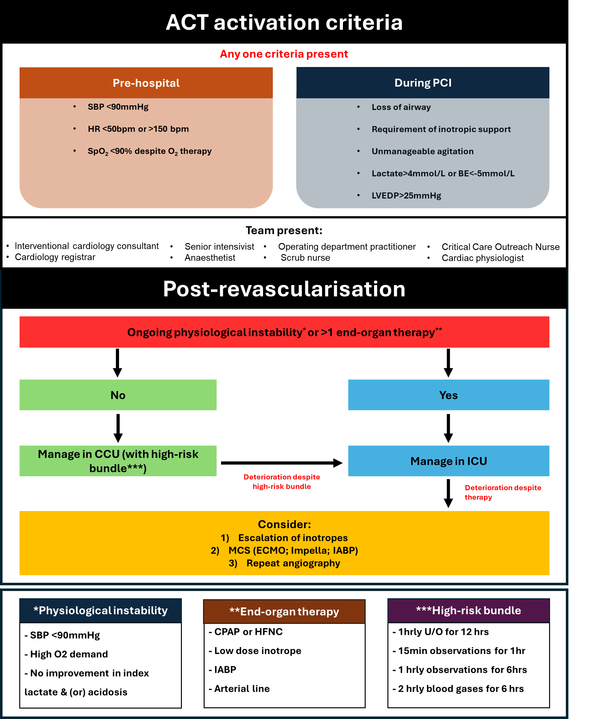
Figure 1

Figure 1 - Advanced cardiogenic shock team (ACT) can be activated pre-hospital and during percutaneous coronary intervention (PCI) as above criteria. It also outlines the patient pathway following revascularisation, including transfer to CCU or ICU. BE – base excess; BPM – beats per minute; HR – heart rate; LVEDP – left ventricular end diastolic pressure; SBP – systolic blood pressure; SpO₂ – oxygen saturation; CCU – Coronary Care Unit; CPAP – continuous positive airway pressure; ECMO – extracorporeal membrane oxygenation; HFNC – high-flow nasal cannula; IABP – intra-aortic balloon pump; ICU – Intensive Care Unit; MCS – mechanical circulatory support; U/O – urine output

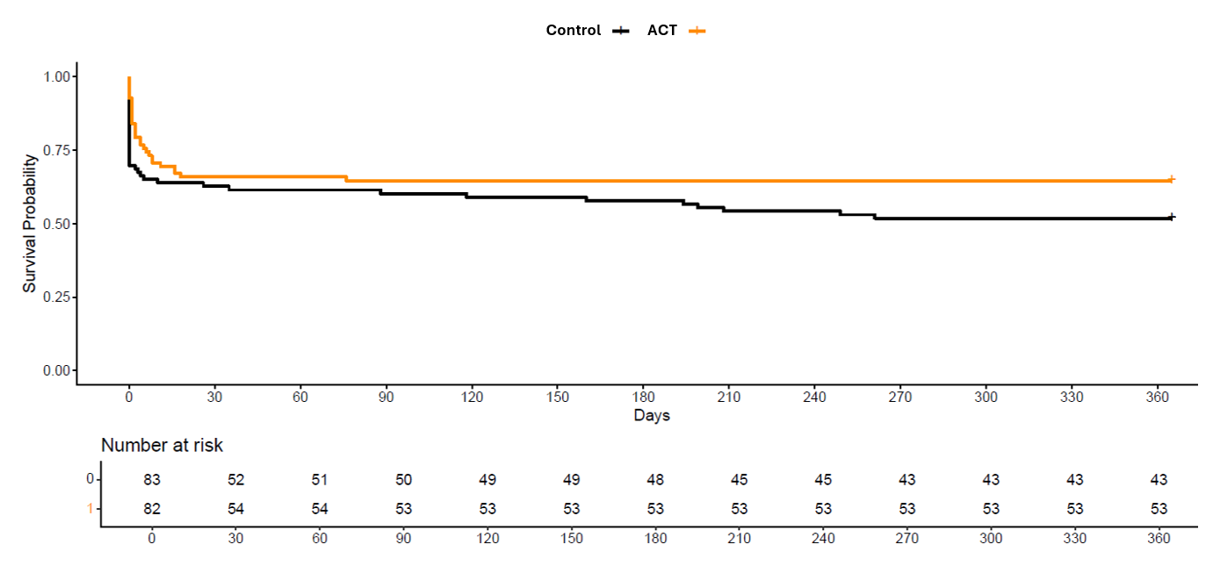
Figure 2

Figure 2 The Kaplan-Meier plot demonstrating lower event rates with shock team support for both 30-day and 1-year mortality compared to the standard care only. ACT – advanced cardiogenic shock team

Figure 3
Standard care
ACT input
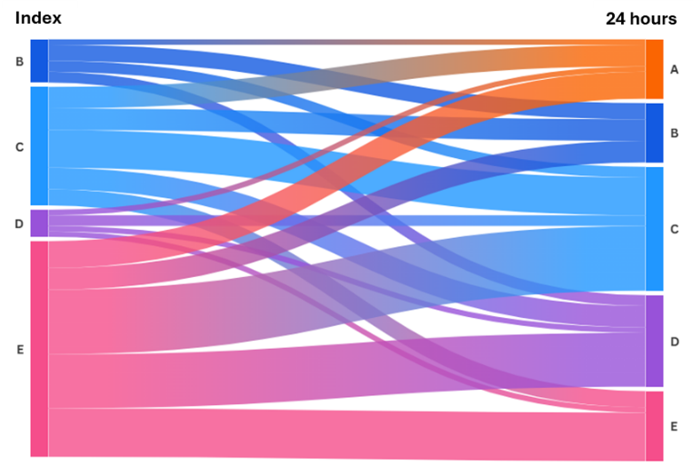
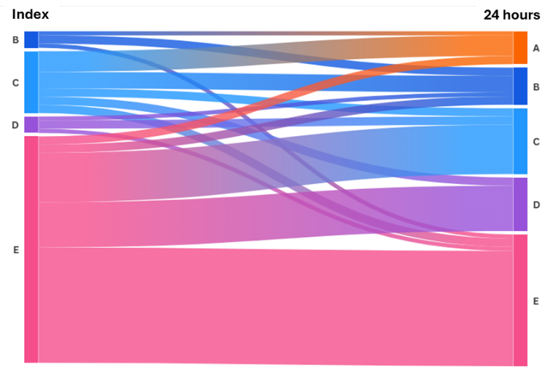

Figure 3 compares changes in patients’ SCAI class at presentation and at 24 hours post-revascularisation. The ACT cohort demonstrated a lower proportion of patients in SCAI class E at baseline and a greater incidence of classes A to C at 24 hours compared with the standard care group. ACT – advanced cardiogenic shock team, SCAI – Society for cardiovascular angiography and interventions

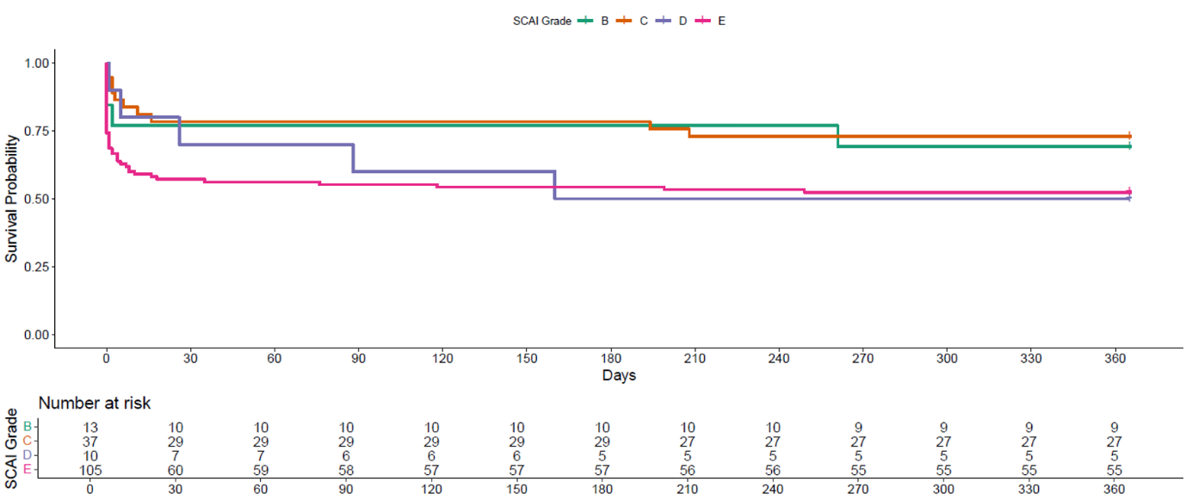
Figure 4

Figure 4 Kaplan–Meier plot demonstrating lower event rates for patients with index SCAI class B/C compared with those presenting with class D/E. SCAI – Society for cardiovascular angiography and interventions

