Saturated, smashed and suppressed: the fate of suspended gravel in large palaeofloods
Yang Zewen.^{1,5}, Carling Paul A.^{2,3 *}, Liu Weiming^{1,4*}, Wang Hao¹, Yang Anna¹, Zhou, Gordon, D..G.^{1,4}
¹Key Laboratory of Mountain Hazards and Engineering Resilience, Institute of Mountain Hazards and Environment, Chinese Academy of Sciences, Chengdu 610041, China
²Geography and Environment, University of Southampton, Southampton SO17 1BJ, UK
³The State Key Laboratory of Geohazard Prevention and Geoenvironment Protection (Chengdu University of Technology), Chengdu 610059, China
⁴China-Pakistan Joint Research Center on Earth Sciences, Islamabad 30001, Pakistan
⁵University of Chinese Academy of Sciences, Beijing 100039, China
*Corresponding author: Paul A. Carling (P.A.Carling@soton.ac.uk) and Liu Weiming (liuwm@imde.ac.cn)

Key points:

Abstract
Natural deposits of clastic sediment, attributed to powerful palaeofloods, frequently consist of thick sequences of extensive parallel laminations consisting of sand to fine-gravel-sized particles. Within the existing literature, these stratal units have been attributed to deposition from a suspended load onto a rapidly aggrading bed with little opportunity for reworking by bedload transport. Herein, this supposition is examined and tested within an analytical model that combines an elementary understanding of turbulent, high-concentration, flows and the style of the resultant deposition.
It is proposed that the turbulence of clear water is modulated by the presence of sediment particles leading to altered hydrodynamic characteristics of the sediment-laden flow, promoting deposition of laminated sedimentary sequences. Using this premise, we show that the extremely high values of near-bed shear stress, in powerful palaeofloods, can result in coarse-gravel particles (> 100 mm) as well as sand being found in suspension at high concentrations. Due to the momentum of large particles, larger-sized suspended particles are subject to considerable comminution (smashing), due to particle-on-particle interactions, that reduces the overall particle size. Particle-on-particle interactions reduce for finer particle sizes, of less momentum, as they are enveloped within finer-scale turbulent eddies, leading to the development of a suspended sediment profile that is saturated close to the bed. The high degree of saturation predominately is related to the development of a suspension dominated by the finer size fractions (ca., 1 mm and finer), which leads to suppression of turbulence, thus allowing deposition of fine granules and sand-sized fractions as laminated bed deposits, as seen in the natural clastic deposits. The arguments supporting the development of laminae of fine-gravel and sand from saturated concentrations in natural high-velocity flows are summarized within a conceptual model.

Plain Language Summary
This study looks at how exceptionally large floods, including prehistoric floods, deposit layers of sand and fine gravel. These layers are often found in old flood deposits and traditionally have been thought to form when suspended sediment settles onto the bed. Using a mathematical model, we tested this idea by studying how fast-moving, sediment-filled water affects the deposition of these materials. Our results show that during powerful floods, the water near the bed is fast enough to keep both large gravel and sand particles suspended in the flow. The larger particles break into smaller pieces as they collide with each other, while the smaller particles get caught in swirling water. This process creates a situation where the water near the bed becomes saturated with fine particles. This buildup of fine particles slows the water's movement, allowing sand and gravel to settle and form layered deposits, which match what we see in natural flood deposits. Our study introduces a new model to explain how these layered deposits form and provides better understanding of how exceptional floods shaped the landscape.

1. Introduction
There is a growing interest in the sediment dynamics associated with prehistoric high-power freshwater palaeofloods (Baker et al., 2021; Carling and Fan, 2020) which primarily have been associated with catastrophic release of water impounded behind natural dams. Herein, we follow Harrison et al. (2025) and term palaeofloods (discharge often > 10⁴ m³s⁻¹) to be those floods that occurred before instrumental records, whereas historical floods, that have been subject to direct measurement, are generally lesser floods (discharge << 10⁴ m³s⁻¹) caused by specific meteorological conditions, or the breaching of anthropogenically-constructed dams. Large palaeofloods associated with the Quaternary Period have been well-studied, not least because successful recognition of palaeoflood deposits in the field is an important criterion for defining the former courses and the magnitudes of the floods (Liu et al., 2022). These studies have modern-day relevance because recent climate change has led to an increase in glacial lake outburst floods from ice and moraine dammed lakes in mountainous terrain (Emmer, 2017; Bhambri et al., 2019; Bazai et al., 2021; Zheng et al., 2021), renewing a focus on the associated deposits. The character of the sediment deposits from these large, highly-unsteady, floods in some regards are distinct from fluvial deposits found within streams and rivers subject to less powerful floods (Carling, 2013). In this respect, an accurate interpretation of the hydrodynamic environment that led to the deposited palaeoflood sediment sequences is essential (Carling, 2013; Liu et al., 2022). Here, using numerical procedures, we present a conceptual model of the deposition processes associated with those palaeoflood sediment beds that consist predominately of coarse sand and fine gravel.
To set the scene we first outline the overall context. Traditionally, sediment transport in an historical flood conveniently is considered as bipartite phases: a bedload, which may include gravel size-fractions (> 1 mm), moved by tractive forces (close to an otherwise immobile bed), and a suspension load (sand and finer fractions) constituted of particles held aloft by turbulence within the flow. Within historical floods, the transport rates for both phases are relatively low in contrast to the modelled transport rates within large palaeofloods (Cao et al., 2004; Lin et al., 2022; Song et al., 2022; Guan et al., 2024). For both historical and palaeofloods, when the power of the flood wave declines, then deposition can occur from one or the other, or both transport phases. In the case of historical river floods, the deposits are dominated by sediment deposited from bedload, whilst for large palaeofloods a significant contribution appears to have been made by deposition from suspension (Carling, 2013; Carling and Fan, 2020).
Deposits from large palaeofloods can be found within the main channel and also notably within more tranquil re-entrants bordering the former flood course (Dong et al., 2024) where they form distinctive large barforms consisting predominantly of coarse sand and fine gravel grainsize fractions that appear to have settled from suspension (Carling, 2013; Liu et al., 2022). Thus, the overall aim of this paper is to understand why large palaeoflood deposits that formed beneath main channel flows and within flow eddies have a high contribution from sediment settled from suspension. This aim is attained by systemically exploring a conceptual framework in which high-concentrations of sediment suspended in flood water lead to rapid accretion of sedimentary deposits at the bed. In order for this aggradation to occur, it is proposed that the turbulence of the clear water is modulated by the presence of sediment particles leading to altered hydrodynamic characteristics of the sediment-laden flow, promoting deposition. The necessary objectives are: 1) to briefly explain the context whereby the sediment dynamics of deposition contrast between historical floods and large palaeofloods; 2) outline how particles at different concentrations and fluid interact within turbulent open-channel flow; 3) develop an analytical framework; 4) present results that show that suspended sediment in large floods evolves by comminution (smashing) towards a grainsize of ~ 1mm or finer, markedly altering the fluid turbulence and promoting deposition.

2. Context
2.1. Field conditions defining the sedimentary environment
Within the main channel of a palaeoflood, the bedload transport can be intense (Guan et al., 2024) with deep, highly-unsteady, high-Reynolds number flow (Liu et al., 2022) and little apparent opportunity for deposition from suspension. Consequently, experimental and modelling studies of catastrophic floods have focussed upon the bedload phase within the main channel below clear water or dilute sediment loads (Bohorquez and Fernandez-Feria, 2008; Shi et al., 2019; Spinewine and Capart, 2013), neglecting consideration of high concentrations of suspended load. However, within flow-marginal re-entrants, flow separation zones (Figure 1: wherein the flow is much slower than within the main flow; Dong et al., 2024) provide the opportunity for rapid deposition of sediment from suspension as well as from bedload transport (Liu et al., 2022). Sediment, crossing the flow separation line of each re-entrant (Figure 1), moves swiftly from a high Reynolds number environment into a low Reynolds number environment (Carling et al., 2020) wherein mean Froude numbers usually are sub-critical (Carling et al., 2010; Winsemann and Lang, 2020; Carrivick et al., 2013; Benito and Thorndycraft, 2020). As a consequence, intense deposition, within each re-entrant, tends to occur from suspended sediment with a smaller or negligible bedload component (Liu et al., 2022) and, very rapidly, eddy-bars are built. As the aggrading bar tops gain in height, the flow depths above the bars are reduced and the near-bed shear stresses and the Reynolds numbers drop (Carling et al., 2020), further promoting rapid deposition of suspended sediment to lower-stage plane beds that are only weakly reworked by bedload transport (Parnachov, 1999; Carling et al., 2002; Carling, 2013). The bar tops are dominated by deposition from suspension, because as the outer bar margins steepen, the bedload component in the main channels is steered preferentially along the outer bar margins (Liu et al., 2022) with little or no bedload reaching the bar tops as the bars increase towards their final heights. Note that the bar top aggradation predominately is from unsteady flow introduced from the main flow across the flow-separation line (Fig. 1) by periodic flow pulses known as Kelvin-Helmholtz flow instabilities (Ge et al., 2022). So, importantly, the concentration of sediment in the flow above the eddy bar is not in equilibrium with the bar-top hydrodynamic conditions and sediment flux cannot be considered simply in terms of net sediment entrainment/deposition models developed from a consideration of steady flows (Dorrell et al., 2018 and references therein). Nonetheless, as we detail below, there are clues from the study of steady flows that may be applied profitably to understand unsteady flows.
In contrast to historical river floods, within large powerful palaeofloods, the suspended load can contain coarse particles, including gravel (Herget, 2005; 2024). The recognition that palaeofloods can deposit gravel from high-concentration suspensions (Komar, 1980; O’Connor, 1993; Russell and Knudsen, 1999a and b; 2002; Larsen and Lamb, 2016; de Leeuw et al., 2020) is important, as an historical focus on the competence of fluvial systems has led to a reluctant to accept the transport of coarse sediment (especially coarse gravel) within suspension (Carling, 2013; Brenna et al., 2025). Rather, there has been a tendency to interpret gravel deposits always as owing to cession of bedload transport (Shanmugam, 1997).
To appreciate the concept of suspended gravel, it is necessary to contrast the eddy bar deposits of exceptionally large outburst floods (Carling, 2013) with those of historical river floods of more modest magnitude in sandy and mixed-grainsize systems (Carling and Fan, 2020). Within sand bedded rivers, including high-energy systems (Carling and Leclair, 2019), sedimentary bar sequences primarily are associated with bedload transport (Strick et al., 2019) with only intermittent suspension from the bedload (McElroy and Mohrig, 2009) and, although there are exceptions (Deng et al., 2007; Venditti et al., 2005), the fully-suspended load can be small (Wright and Parker, 2004; Szupiany et al., 2012). Suspension transport can be sustained but contributes little to the fluvial sediment deposits (McLean et al., 1999; Lamb and Venditti, 2016). In mixed sand/gravel-bedded rivers (Dingle et al., 2021), flood deposits commonly consist of bedload-derived interbedded sands in thin sheets (Hagstrom et al., 2018) with pebbles stringers and, where the supply permits, pebble, cobble and boulder bed layers can predominate (Harms et al., 1982; Miall, 1995). However, bed layers with particles predominately in the range 1 to 5 mm are conspicuously absent (Ferguson, 2003; Lamb and Venditti, 2016; Parker et al., 2024). In these mixed-grainsize rivers, deposits that can be attributed directly to suspended load usually present as localized thin drapes of sand (McKee et al., 1967; Moody and Meade, 2014; Dingle et al., 2021) or as the infiltrated fines within the void space of the bedload-deposited gravel sheets (Evans and Wilcox, 2013).
In contrast to historical river floods, exceptionally powerful floods may emanate from natural prehistoric dam failures (Carling and Fan, 2020; Baker and Carling, 2020). Analysis of the palaeohydraulics of these floods has demonstrated that they can generate bed shear stresses > 10³ N m⁻², often reaching 10⁴ N m⁻² (Baker and Costa, 1987; Baker, 2009). Importantly, Reynolds numbers can exceed 10⁹, indicating exceptionally-high levels of turbulent mixing (Denlinger and O'Connell, 2010; Carling et al., 2010). Such values are two orders of magnitude greater than is typical for historical river floods and are commensurate with the largest recorded values from rainfall-runoff historical floods and the failure of the largest constructed dams in the USA (Baker and Costa, 1987; Baker, 1996).
The high near-bed shear stresses and high Reynolds numbers of these palaeofloods lead to two key differences in transport behaviour in contrast to historical river floods. Firstly, as explained above, gravel-sized particles are transported frequently in suspension and secondly, collisions between suspended large particles and consequent fracture lead to a suspension load consisting of angular small fragments (Carling and Fan, 2020; Lu et al., 2025; Høgaas et al., 2025). Consequently, and as will be shown next, the deposits associated with these large floods tend to be distinctive when compared with river deposits.
Although the base of a palaeoflood eddy bar can consist of cobble-beds and boulder-beds due to bedload transport (Carling, 2013), the sedimentary units higher in the sequence, when exposed in large sections, are impressive in that they consist of extensive thick sets of thin laminations (1mm to ~ 10 mm thick) of well-sorted coarse sand, or fine-gravel (chiefly in the granule to small-pebble grades), the latter interspersed with thin sand lenses (Figure 2 and S1). Individual laminae can be traced across the outcrop for many metres with insignificant changes in the texture and the thickness of each lamination. Often the sequences are dominated by distinctive self-similar sets of laminations (some 10’s of centimetres thick), that conventionally have been termed rhythmites (Figures 3A and S2a to S5a). The distinctive lamination, as well as the rhythmic signatures, has been associated with Kelvin-Helmholtz flow instabilities in the plan-view of the flow (Ge et al., 2022), as fluid incursions occur quasi-periodically across the flow-separation lines (Figure 1), inducing pulsed supply and consequent deposition of sediment largely from suspension (Liu et al., 2022). Thus, there is a presence of fine gravel within laminae, including the 1 mm to 5 mm size range (Figure 3B) that tends to be absent as distinct layers in rivers (Parker et al., 2024). As noted above, most of these fine particles are angular (Figures 3C, S2d and S2g and S3d, S4d), having been fractured within the suspended load and quickly deposited and buried, such that rounding by abrasion in bedload transport did not occur (Carling and Fan, 2020). Both fining-upwards and coarsening upwards laminae can occur but there is usually no distinct fabric to the particle orientations (Figure 3C) and grainsize curves for individual laminae are very similar to one another (Figure 4; see also Figures S6 to S8). Such well-defined lamination is unusual in sediment coarser than very fine sand (i.e., > 0.125 mm; Al-Mufti and Arnott, 2023) and so requires explanation. Although an exact analogy may not hold, these sandy-granule laminations, from exceptionally powerful floods, are reminiscent of the deposits formed by much finer particles from turbidity currents (Carling, 2013), sediment gravity flows (Al-Mufti and Arnott, 2023) or those deposits associated with suspension-dominated fallout with negligible shear-flow (Amy et al., 2006). Turbidity currents exhibit suspended sediment-concentrations up to c., 23% by volume (Lowe, 1982; Marr et al., 2001; Shanmugan, 2019); such a value is not associated with most freshwater river flows but may occur close to the bed during exceptional discharges, such as outburst floods. Nonetheless, the consistent domination of planar contacts between multiple laminae, forming thick sedimentary sequences, argues for a prolonged uniform mechanism of sediment deposition to the aggrading surface.
An important observation in respect to the focus of this paper is that for any sequence of deposits associated with an exceptionally large flood capable of transporting fine gravel, bedforms of ripple-size tend not to be reported in the lower and central portions of these coarse-sand/fine-gravel laminated sequences (Carling, 2013). Ripples cannot form in sediments coarser than about 0.6 - 0.7 mm (Costello and Southard 1981; Allen 1984; Sumer and Bakioglu 1984; Garcia, 2008, p. 87) as the associated depositing flows are hydraulically rough-turbulent (u*D/υ ~ > 23; where u* is the shear velocity, D is a reference grain size and υ is the kinematic viscosity of the flow). However, the upper portions of these depositional sequences, when the flood was waning, can include nascent bedforms in coarse sand and granules (Carling et al., 2005; Carling, 2013), which would indicate that, as the flood wave evolves, the depositing flow transitions (u*D/ν ~ < 23) towards hydraulically smooth-turbulent conditions (u*D/ν ~ < 5; Liu, 1957) allowing bedforms to start to form (Yalin 1972; Allen 1984). The conditions whereby the flow transitions from fully rough-turbulent to smooth-turbulent are considered within the Discussion.
Given the above summary, a hypothesis was developed: “Laminated sequences of fine gravels are deposited from high-concentration flows that are characteristic of exceptionally large powerful floods.” This paper seeks to provide a hydrodynamic interpretation of the flow conditions associated with the depositional processes. In the next section we consider the flow conditions within the suspended particle-laden flow.
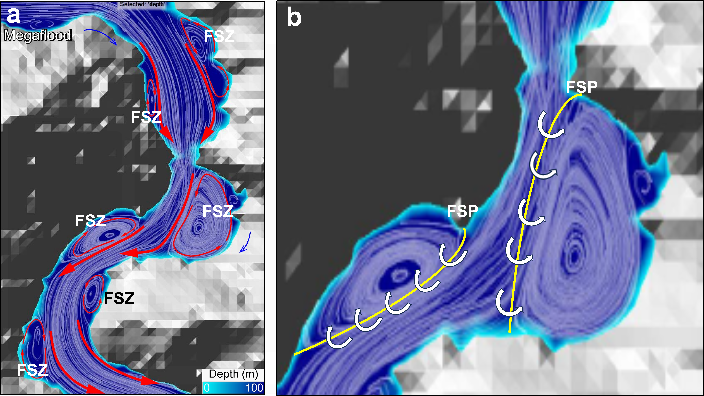
Figure 1 Example of hydraulic model of a floodway along a valley consisting of constrictions and expansions, the latter providing valley-side re-entrants: a) Simplified flow streamlines (white curves) and main flow directions (red arrows) highlight separated flow zones (FSZ) within several valley-side re-entrants; b) Approximate positions of the flow separation lines (FSL- yellow curves) emanating from flow separation points (FSP), along which vorticity exchanges flow from the main channel into and out of the flow separation zone as shown schematically by the white arrows. Redraw from Dong et al., (2024) with permission.

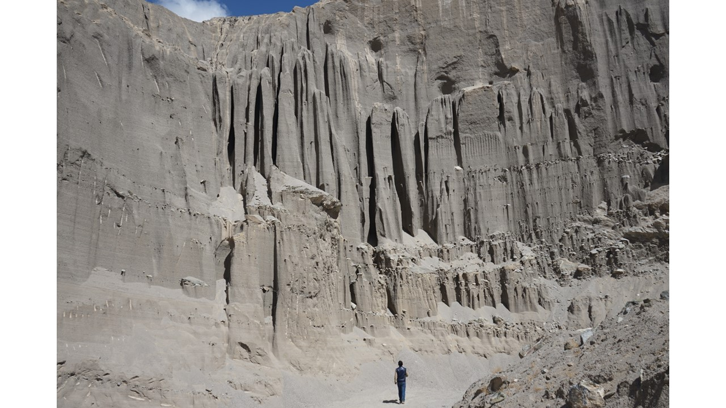
Figure 2 Section beneath eddy bar-top depicting fine-gravel beds largely deposited from suspension in the Nujiang River valley, eastern Tibet (97°14'39.72" E, 30° 5'0.47" N; altitude 2776 m asl). Note that at distance, deposits appear massive but with close inspection extensive near-horizontal lamination is evident. Occasional thin cobble and boulder beds, occurring within the lower portion of the section, are interpreted as due to bedload incursions due to vorticity crossing the FSL, before increasing bar height precludes deposition on the bar top from bedload transport. Isolated boulders also occur which, for paraglacial environments, have been regarded as dropstones from ice-flows (Carling, 2013). Gravel pods and isolated ‘floating’ cobbles or ‘floating’ boulders are also evident in the section that are also atypical of fluvial deposits (Carling, 2013; Carling and Fan, 2020) but the significance of these are not considered herein. The person is 1.8 m in height.
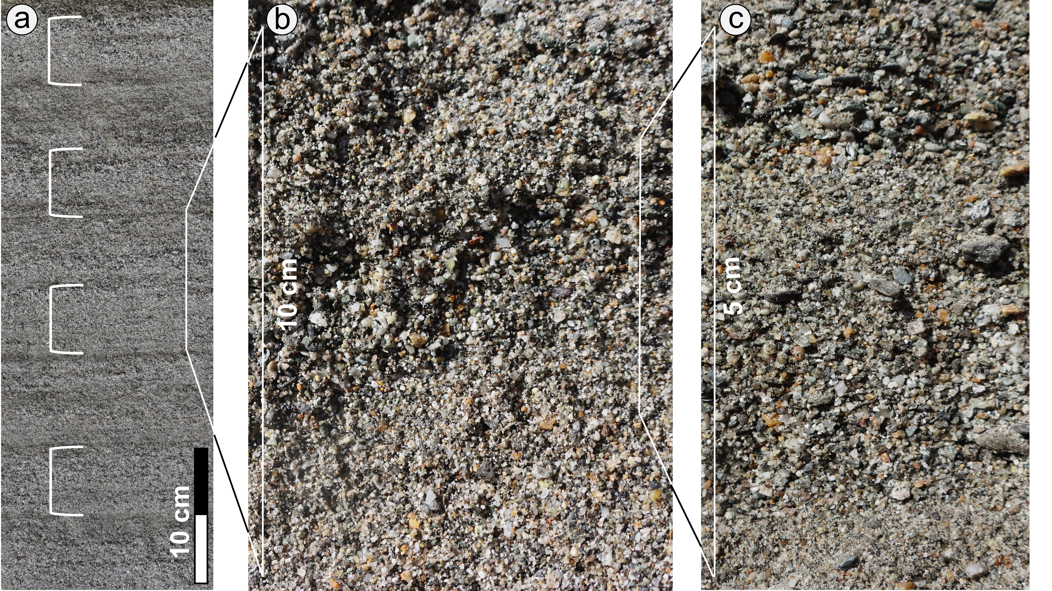
Figure 3 Palaeoflood bar deposits along the margins of the Yarlung Tsangpo River (29.121492 N; 92.683603 E; altitude 324.58 m asl) typify catastrophic freshwater sedimentary sequences found worldwide (Carling, 2013). a) Horizontally-bedded laminated coarse sand, granules and small pebbles show evidence of deposition from pulsating flow that results in fining-upward rhythmic units of deposition of similar thickness. White brackets define every other rhythm; b) When viewed closely, lamination can appear amalgamated although some systematic coarsening and fining upwards is evident within individual rhythms; c) Thin beds of comminuted angular granules and small pebbles coarsen and fine upwards with chaotic particle orientations.
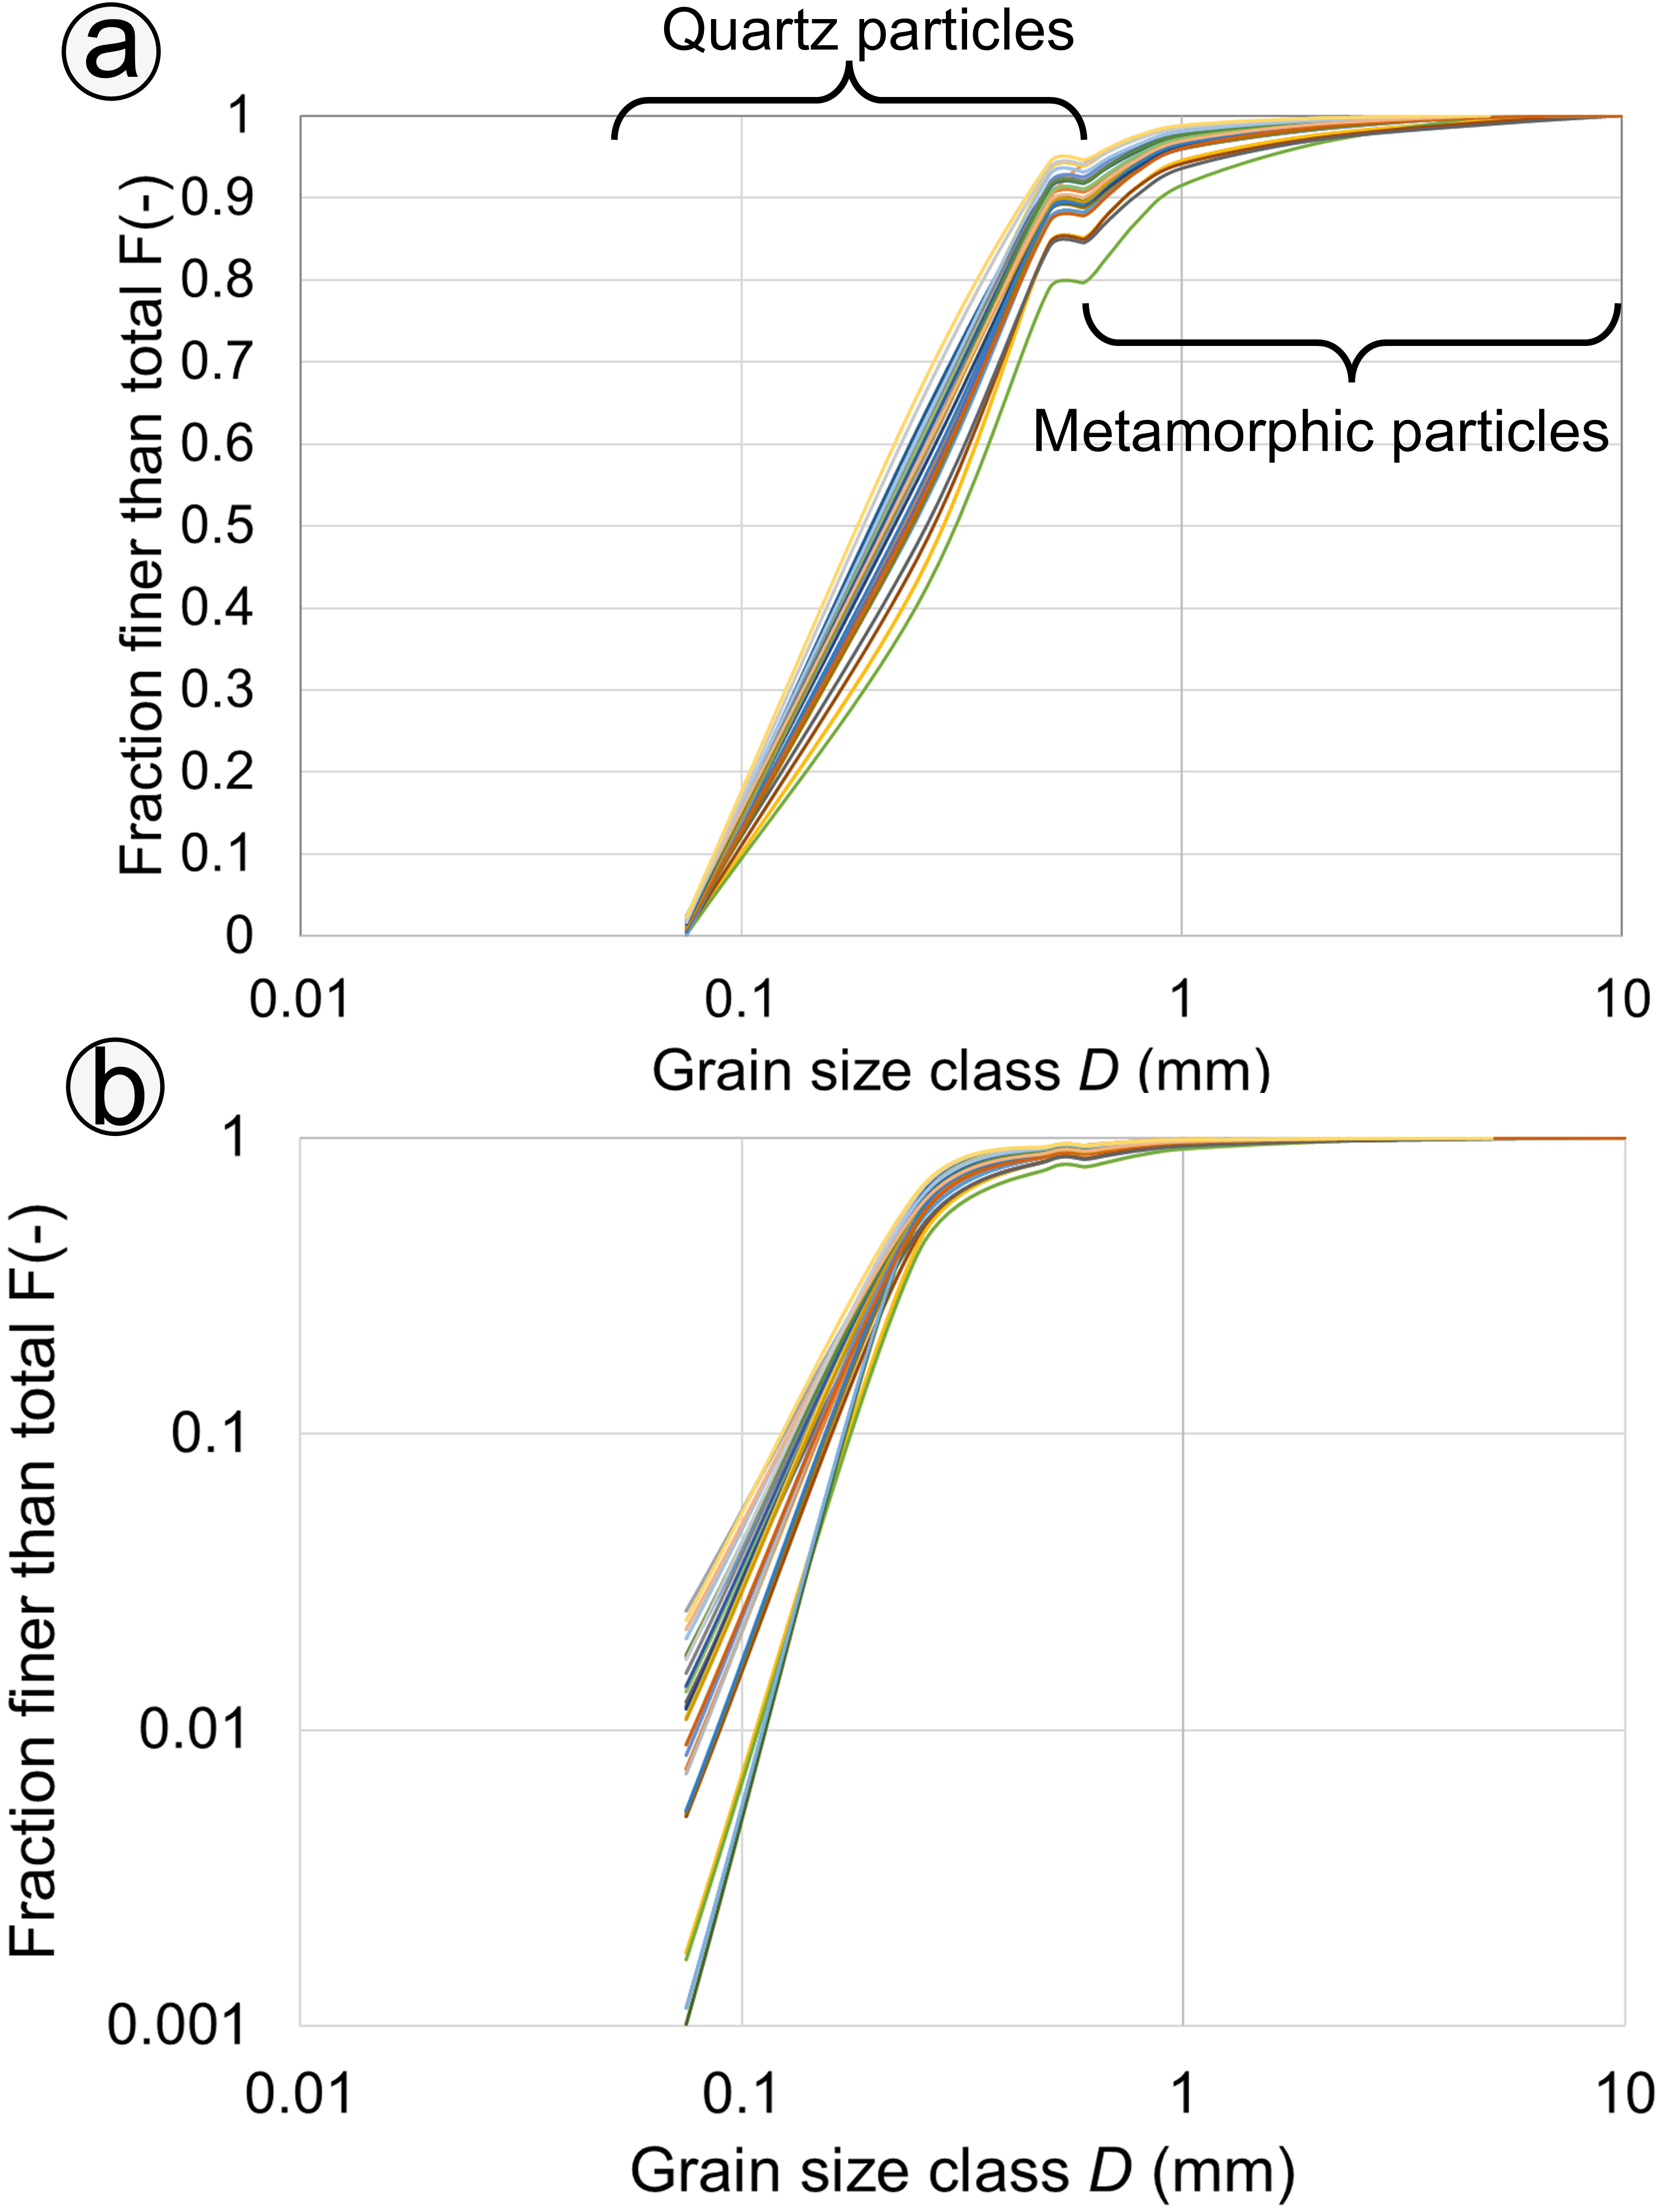
Figure 4: The grainsize distributions of 29 sequential individual laminations in the vertical within a palaeoflood bar deposit at the margin of the Yarlung Tsang River. a) log-normal plot shows clearly the dip in the size distribution around 0.68 mm at which point two size distributions (coarse and fine) meet; b) log-log plot shows clearly the straight-line size distribution of the finer population of particles that is typical for a comminution distribution (Carling and Fan, 2020). Note the paucity of particles finer than 0.075 mm. The overall spread of each grainsize distribution is similar one to another, indicating a consistent mechanism of deposition to the aggrading surface from a suspension of uniform grainsize distribution. The deficiency in the coarser grainsizes is due to comminution of the largest particles in suspension (Lieberwirth and Kühnel, 2021). The coarse size distributions consist primarily of residual, hard, elongate (anisometric) particles of foliated metamorphic rock that have resisted comminution, whilst the finer grainsize ranges consist predominantly of residual, hard, isometric particles of quartz (Figure S9 to S13). The mean grainsize of all 29 samples is 0.23 mm (s.d. 0.03).

2.2 Particle-fluid interactions within turbulent open-channel flow
In open-channel flows, solid particles modify the fluid motions in their vicinity, whereas the fluid imparts forces and moments to the particles. In addition, there are complex interactions between particle collisions in suspension (Elgobashi, 1994; Zhang et al., 2023), and between bedload particles impacting the boundary (O’Regan et al., 2023). All these effects are induced by the turbulent fluid flow as well as by gravity promoting particle settlement and deposition. Turbulence modulation in particle-laden water flows is complex, due to interrelated mechanisms: i) energy transfer through the drag force, ii) particle-eddy interactions; iii) turbulence production caused by the formation of wakes and vortex shedding; iv) energy transfer due to particle trajectories crossing, and; v) the added fluid mass that moves along with particles (Hoque et al., 2024). In summary, particle interactions are mediated by turbulence within the fluid which, in turn, is modulated by the presence of particles.
These various mechanisms of turbulence modulation in particle-laden water flow, may depend on several parameters that include particle size, particle shape and concentration, as well as the dimensionless numbers: Reynolds number, Stokes number, the particle diameter to integral length scale ratio, and the particle to fluid density ratio, which parameters are defined within the ‘Analytical Framework’. Despite considerable research effort taking different approaches, the specific controls on turbulence modulation by the presence of high suspended particle concentrations remain elusive (Cao et al., 2003; Balachandar and Eaton, 2010), although for low concentrations the effects of particles on turbulence are relatively slight (Lyn, 1991, 1992; Best et al., 1997; Muste et al., 2005). Nonetheless, two primary contrasting results have been identified: either turbulence is attenuated, or turbulence is enhanced (Tsuji and Morikawa, 1982; Gore and Crowe, 1989; Rogers and Eaton, 1989, 1991; Hetsroni, 1989, 1993; Gore and Crowe, 1991; Kulick et al., 1994; Elghobashi and Truesdell, 1993; Elghobashi, 1994; Crowe et al., 1996). These several studies, amongst others, demonstrated that the presence of larger particles within the flow tend to increase turbulence intensity (Wang and Larsen, 1994; Niño and Garcia, 1998; Balachandar and Eaton, 2010), whilst increasing concentrations of smaller particles tend to reduce turbulence intensity (Gore and Crowe, 1989; Tsuji and Morikawa, 1982; Tsuji et al., 1988; Muste and Patel, 1997; Rathore et al., 2025).
Noted above was the role that particle comminution might play in reducing suspended sediment grain size. Because particle fracture in suspension has hardly been studied (Lu et al., 2025), herein we do not address the role of suspended particle collisions and comminution in any detail. Limited investigations indicate that particle collisions in turbulent flows are low for coarse grains at high Stokes numbers but may increase for Stokes numbers of around 6 and less, possibly peaking at Stokes number equal to 0.4 before reducing as small particles are enveloped in the turbulent flow structures and the Stokes number approaches zero (Sommerfeld, 2001). Particle collisions are believed to have negligible effect on the flow properties directly, except in high-concentrations close to the bed (Egashira et al., 1989; Egashira et al., 1997; Zhang et al., 2023). However, high-energy impacts between particles in suspension due to turbulence, will lead to particle fracture and a reduction in size of the particles constituting any given volumetric concentration. Interactions between suspended particles increase as the concentration increases (Hetsroni, 1989; Balachandar and Eaton, 2010), contributing significantly to energy dissipation for concentrations greater than ca., 10% (Batchelor and Green, 1972). Thus, although comminution does not directly affect the volume concentration, it does reduce the grain sizes within the overall size distribution of the suspended load, the number of particles in suspension and hence the settling behaviour of the mixture (Dorrell et al., 2018). Cao et al. (2003) noted that the presence of a concentration of suspended fine particles attenuates turbulence more dramatically than the presence of coarse particles. So, as comminution progresses within a broad grainsize distribution, there will be a propensity for the flow to become less turbulent where concentrations are the highest, near the bed. A strong gradient in the suspended sediment near-bed concentration profile will develop, especially where there is a mixed size range of particle (including granules; Parker et al., 2024) which can lead to density stratification and a consequent reduction in the vertical shear stress profile of the flow (Gelfenbaum and Smith, 1986; Cao et al., 2003). The bed constitutes the potential depositional surface (Lee and Durst, 1982; Ljus et al., 2002) within a large flood flow. Above this surface, for flow conditions that conventionally promote suspension from the bed, modulation of the near-bed turbulence (Pedinotti et al., 1992; Hoque et al., 2024) by increasing high concentrations of suspended particles leads to a situation whereby the coarser and denser suspended particles tend to concentrate and then accumulate on the surface (Zaza and Iovieno, 2024). The promotion of steady deposition from suspension thus leads to sustained accretion that suppresses any bedload transport. This latter point is included within the analytical framework.

3. Analytical framework

3.1 Modulation of turbulent flow by suspended particles: influence of grain size, concentration, and Stokes Number
The difficulty in designing facilities sufficient to suspend gravel size fractions in high velocity flows means there are no published data on turbulence modulation in experimental flows with high-concentrations of suspended grainsizes > 1.8 mm. Rather, progress has been made largely through numerical simulation. Vanoni (2006; p152) argued that, despite high concentrations of sand-sized and coarser particles, if the concentration of silt and finer fractions was less than 6% (see Figure 4) then the flow could be considered as Newtonian, which is an assumption we adopt herein when selecting hydrodynamic equations to describe flow behaviour. In this respect, we rely on notable summary conclusions with respect to published experiments of the Newtonian flow dynamics of grainsizes < 1.8 mm to develop an analytic framework. For low particle concentrations there is no turbulence modulation, but turbulence intensity tends to attenuate as the concentration increases (Yang, 2006) to a relative concentration by volume of at least 10 - 15% (Sheen et al., 1994; Vreman, 2007; 2015); subsequently, flows transition firstly to hyperconcentrated flow (10 - 20 %) Van Maren et al., 2009) and subsequently to debris flow (ca., 30 %; Egashira et al., 1997; Hernandez-Moreira et al., 2019). Turbulence data for the higher volume concentrations largely are absent. A critical grain size is around 0.7 – 1 mm, with suppression of turbulence increasingly occurring for smaller grain sizes and intensification occurring for larger grain sizes (Goedde, 1978; Hoque et al., 2024; Bennett et al., 2014). Smaller particles are accelerated by, and move within, the turbulent flow structures suppressing turbulence whereas larger particles create wakes that disrupt the boundary layers around particles, thus increasing turbulence (Hetsroni, 1989; Zhao et al., 2013). Parker et al. (2024) expressed this behaviour in terms of settling of particles < 1 mm being viscosity-dependent, versus a viscosity-independent behaviour for particles > 5 mm, with transitional behaviour in between. Overall, significant suppression of turbulence close to the boundary (Hetsroni, 1989), due to the presence of fine suspended particles at a high concentration, can result in smooth-turbulent near-bed flow, in contrast to the rough-turbulent near-bed flow (Streeter, 1971) often associated with low particle concentrations, the latter condition typical of river flow (Bennett et al., 2014; Parker et al., 2024).
Turbulence intensity tends to attenuate farther from the boundary as particle size and concentration increase at higher Stokes numbers (Kulick et al., 1994). The Stokes number (S_{t}) is defined latterly, but a critical Stokes number, separating flow conditions wherein turbulence is not attenuated from flow conditions in which turbulence is attenuated, lies within the broad range 0.01 to 9.0 (Hoque et al., 2024) for flows of highly variable characteristics. Within this range, S_{t} = 1 has been suggested as an important reference value (Elghobashi, 2006) as, at this value and below, small particles interact with the flow and remain suspended, whereas for S_{t} > 1, large particles are not responsive to the flow, being dominated by inertia and tend to settle due to gravity (Hoque et al., 2024). These simple rules have been challenged (Tanaka and Eaton, 2008; Lucci et al., 2011) and all methods based on a consideration of the Stokes number have been shown to fail to discriminate flow behaviour in some conditions, mostly notably as S_{t} tends to >> 1. Yet, considering the simple S_{t} behaviour as proposed by Hoque et al. (2024) and Elghobashi (2006), it is evident that if the concentration is high and sustained, particle comminution due to coarse gravel-sized particles colliding in suspension will reduce the particle size towards the granule and sand-sized fractions (Carling and Fan, 2020), thus promoting the suppression of turbulence and driving the fully-turbulent flow towards a smooth-turbulent condition. However, the effect of particle comminution on turbulence suppression is hardly addressed in the published literature and as noted above, there are no experimental data for suspensions of particles coarser than 1.8 mm; grain sizes that often constitute the laminated sedimentary sequences within outburst flood eddy bars (Figures 3, 4 and S2 to S5). Nonetheless, the general effects of high near-bed suspended sediment concentrations mediating flow interactions with the bed are well-known, as is explained next.
For sand-sized particles in river flows, the equilibrium suspended sediment concentration (capacity) is reached with volume concentrations usually less than 1% (Winterwerp, 2001), for which condition entrainment from the local bed below the concentration profile is not possible. However, as grain-to-grain interactions are negligible at these concentrations, turbulence production is sustained. As sediment loads exceed the equilibrium value, deposition to a static bed tends to occur although turbulence is otherwise sustaining the suspension (Winterwerp, 2001). Herein, when the concentration at any hight above the bed equals the near-bed reference concentration, we term those concentrations ‘saturated’. These concentrations exceed the equilibrium values. Because saturated concentrations (due to exceptionally high shear stresses in palaeofloods) exceed the equilibrium value, the source of the suspended sediment that settles rapidly to the bed must be from upstream. The critical concentration at which grain-to-grain interactions begin to significantly affect flow behaviour has been reported to vary between 6% - 15% by volume (e.g., Bagnold, 1954; Sheen et al., 1994; Vreman, 2007; 2015; Ge et al., 2022), with settling velocities reduced sharply for particles < 1 mm once concentrations exceed ~ 20% (Goedde, 1978). The critical concentration values at which settling velocities are reduced tend to converge for a range of particle sizes > 1 mm due to the complexity of grain-to-grain interactions (Goedde, 1978). This behaviour can be explained in principle as, for dilute concentrations below 6%, turbulence is the main grain support mechanism (Bagnold, 1954; Vellinga et al., 2018). In contrast, the turbulence grain support mechanism becomes less effective when suspended concentrations exceed ~ 20% by volume (Faddick, 1975) and grain collisions become increasingly important. For concentrations > 20%, Faddick noted that inter-particle collisions of suspended particles significantly attenuated turbulence, thus suppressing vigorous fluid-particle interactions with the bed. Indeed, Kawashima et al., (1978), for any given velocity, found an inverse relationship between the degree of interaction between the particles in the suspended load and the bed as the concentration increased from 4% to 36% by volume.
If the near-bed suspended concentrations approach 30%, flow conditions become transitional to debris flow (Parker et al., 2024) wherein fluid turbulence is fully-suppressed and suspension from the bed does not occur. In summary, from the analysis above (see also Hoque et al., 2024), we can conclude that particles finer than ~ 1-2 mm in open-channel flow will tend to supress turbulence at high concentrations (> ~ 10%), whilst large particles in suspension only significantly augment turbulence when S_{t} > 60 (Hoque et al., 2024). Thus, for concentrations of granule-sized particles > ca., 10%, near-bed suspensions will tend to collapse (Winterwerp, 2001; de Leeuw et al., 2020; Parker et al., 2024).

3.2 Analytical model of palaeoflood sediment deposition
Based on the reasoning presented in the previous section, an analytical framework for the kinematic process of palaeoflood suspended sediment particle interactions is described as follows. An analytical model of sediment-water dynamics starts with a hypothetical unit volume palaeoflood hydrograph that varies through time, rapidly increasing to a peak value and then decreasing in accord with a near-Gaussian distribution of discharge through time (Figure 5). The values of discharge associated with this hydrograph constrain all other parameters considered below. The variation of the discharge is:
Rising limb：
(1)
Falling limb：
(2)
where Q is discharge (m³/s), Q _{peak} is peak discharge (m³/s), T is time (hours), T_{peak} is time corresponding to the peak discharge.
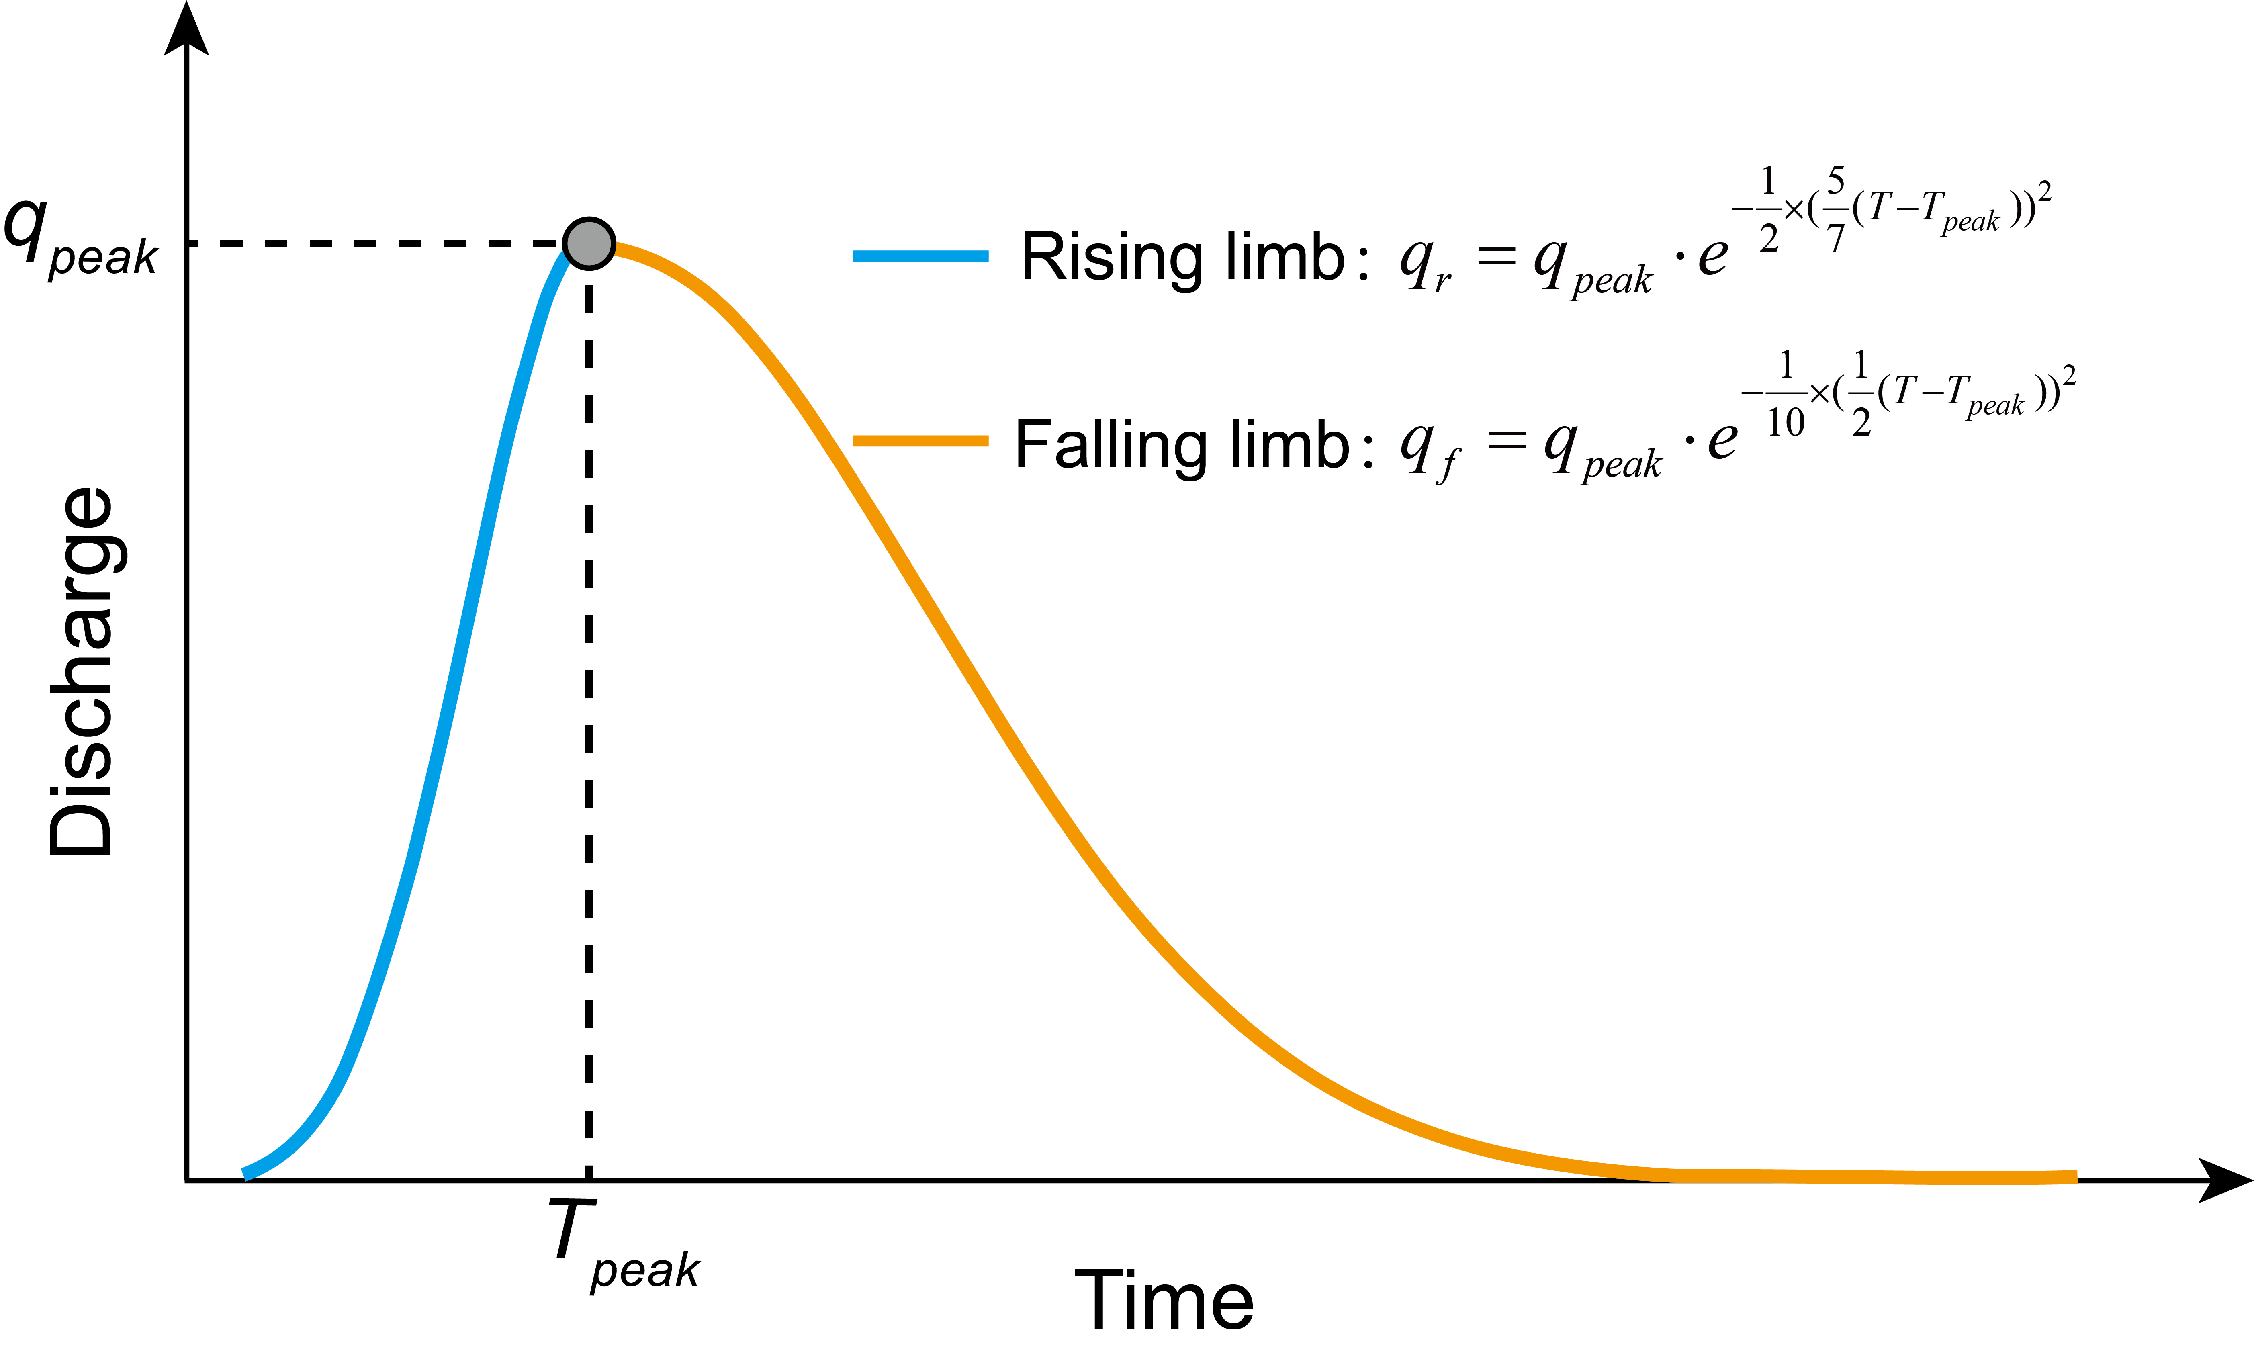
Figure 5 Schematic diagram of a hydrograph. Blue line and orange line are the rising limb and falling limb of the hydrograph, respectively. q_{peak} and T_{peak} are the unit-width peak discharge and the time at which the peak discharge occurs, respectively.
In this study, the total duration of the hydrograph is defined as 24 hours, with the peak discharge occurring at the 4th hour (𝑇_{peak} = 4 hours). The hydrograph shape assumed reflects dam-break processes characteristic of landslide dam outburst floods (Garcia-Castellanos and O'Connor, 2018; Ruan et al., 2024; Yang et al., 2022), debris flow dam outburst floods (Ruan et al., 2021), glacial lake outburst floods (Worni et al., 2012), and Martian crater lake outbursts (Goudge et al., 2023), based on comprehensive references spanning from model-scale experiments to prototype events. We summarized the control parameters of the hydrograph in Table S1 as the input for analytical model.
To simplify the hydrodynamic process and generalize our model, we use a unit-width discharge to derive flood hydraulics by the continuity equation:
, | (3)
where h is the water depth (m) of the flow and u is average flow velocity (m/s). Because such large floods might vary in surface water width, for example up to 1000 m, we model a unit-width hydrograph with a peak discharge per unit width of q_{peak} = 1000 m²/s, for which the total peak discharge (Q) is a megaflood (Q ≥ 10⁶ m³/s; Baker, 2022; Carling and Fan, 2022) if flow width is 1000 m.
u is derived from the Darcy-Weisbach equation (Braat et al., 2024; Burr et al., 2006; Larsen and Lamb, 2016):
, | (4)
where u* is shear velocity (m/s) and C_{f} is a dimensionless friction coefficient, that for a plane bed beneath fully developed turbulent and hydraulically rough flows is regarded as constant (0.1161; Lamb et al., 2015; Parker et al., 2024).
Assuming quasi-steady flow at incremental time-steps through the hydrograph, $u_{*}$, the shear velocity, is derived from Eq. 5. This approximation is a reasonable assumption for gradually- varying flood waves or outburst flows with large temporal scales (Amy and Dorrell, 2021; Lamb et al., 2008; Lamb and Fonstad, 2010; Ovchinnikova et al., 2025):
, | (5)
where g is the acceleration due to gravity and s is the channel slope. Here, we used the slope in the middle reaches of the Yarlung Tsangpo River as an example, as this area is characterized by numerous thick sequences of fine-gravel lamination formed by outburst floods (Figures 3 and S1 to S5).
The boundary shear stress can be determined as:
, | (6)
where $ρ$ is the density of water.
Once entrained, sediment particles of a given size are transported in three phases: bedload, suspended load and wash load depending on the value of u*. In this study, the focus is upon coarse particles in suspension and so we do not consider wash load. The movability number m, defined by (Bagnold, 1966), is used to distinguish the transition between bedload and suspension as determined by the ratio of the downward component (bed shear stress) and the upward component (settling velocity):
, | (7)
where W_{s} is the particle settling velocity. The critical movability number, m_{c}, separating bedload from suspended load, has been defined by slightly different values (Braat et al., 2024; Burr et al., 2006; Carling and Fan, 2020; Valentine, 1987), but herein we adopt m_{c} = 1.0, following Garcia (2008) and Turzewski et al. (2019). For the settling velocity, we considered a wide range of particle sizes (1-100 mm), and used a modified settling velocity equation from Sadat-Helbar et al. (2009) that includes cobble-sized material:
, | (8)
where D is the particle diameter (m); ρ_{s} and ρ are the particle density (kg/m³) and the water density (kg/m³), respectively.
To better understand the flow characteristics in the analytical model, we calculated the Reynolds number R_{e} and Froude number F_{r} of the flow:
 | (9)
. | (10)
For equilibrium suspensions, the reference sediment volume concentration is given by the following equation (Parker et al., 2024):
, | (11)
where C_{b} is the near-bed reference concentration of suspension load (S_{b}) distributed in the vertical. α is a dimensionless constant, give as α = 1.3×10⁻⁷(Garcia and Parker, 1991). Z_{u}, a similarity parameter, is derived following Parker et al. (2024):
 | (12)
 | (13)
, | (14)
where R_{f} is the dimensionless settling velocity and D* is the dimensionless particle diameter.
The vertical suspended sediment concentration profiles were calculated using the Rouse (1937) equation:
, | (15)
for which the depth averaged concentration (C*) is:
, | (16)
where S_{b}(y) is the sediment concentration of at elevation y above the river bed, y_{r} is a near-bed reference height and y_{r} = 0.01h (van Rijn, 1984) is given to calculate S_{b}. K is the von Kármán constant (0.41). $β$, the Schmidt number (υ/δ_{M}, where δ_{M} is the mass diffusivity), depends on both flow and sediment conditions. For clear water conditions, β = 1, but for high concentrations of suspended sediment (Umeyama, 1992), β < 1 where turbulence tends to be suppressed by fine particles (Carstsens, 1952; Lee et al., 2015) and β > 1 where turbulence tends to be enhanced by larger particles (Singamsetti, 1966; Tsujimoto, 2010).
In an effort to better identify variations in the strength of turbulence, the dimensionless parameter, the Stokes Number (S_{t}), is introduced to describe the effect of the size of sediment particles on turbulence modulation:
, | (17)
where T_{p} is the particles response time T_{p} within turbulence is defined by Eq. 18 ( Rogers and Eaton, 1991; Cao et al., 2003;):
. | (18)
The turbulence timescale T_{k} is defined by Eq. 18 ( Elghobashi, 1994; Cao et al., 2003):
, | (19)
where, λ, a turbulence characteristic length scale, is characterized by the Taylor mixing length (Cao et al., 2003):
(20)
The root-mean-square value of the streamwise velocity , along with the turbulence dissipation rate ε, are both calculated using the Eq. 21-23 provided by Nezu and Nakagawa (1993).
 | (21)
 | (22)
. | (23)
The turbulent kinetic energy, k , is commonly used as an indicator of the capacity for sediment suspension in flowing water. To quantify this effect, we calculated the turbulent kinetic energy using the following equations (Noh and Fernando, 1991; Pope, 2000):
. | (24)
The Taylor mixing length (λ) varies with the Schmidt number. Pope (2020) represented this variability as:
, | (25)
where c_{μ} = 0.09 is an empirically-derived constant (Pope, 2000, p. 374). We return to Equation 25 within the Results section.
There is little agreement on how to calculate the Taylor mixing length ($λ)$ in high-concentration flows at large scale (Lyn, 1987; Lyn, 2008; Kovacs, 1998; Kumar et al., 2024) and, as our focus is limited to derivation of basic principles, a precise expression for $λ$ is not required. Rather than scaling $λ$ to a gross length-scale of the flow system (Hutchinson et al., 1971; Bradshaw, 1974; Lyn, 2008), we assume that $λ$ is a variable that scales with the strength of turbulence, e.g., $u^{'}∝ u_{*}$ in clear water (Nezu and Nakagawa, 1993), with an expectation that the rate of energy dissipation will decrease at high concentrations (Li et al., 2001; Bennett et al., 2014) leading to a reduction in the value of $λ$ (Bennett et al., 2014). Because turbulence eddies generally increase in size away from the boundary, so will the value of $λ$, such that for a deep palaeoflood it is evident that the range of length scales for turbulent eddies will include values much greater than a characteristic deposited particle size (Fan et al., 2023). However, smaller eddies will dominate near the bed due to higher shear forces and viscosity effects. Consequently, $λ$ should decrease towards the boundary. As the grainsize in suspension is reduced through comminution, the very high sediment concentrations of fine particles suppress turbulence (Bennett et al., 2014) with turbulence suppression most prominent when $D/{λ<0.1}$(Gore and Crow, 1989; Raffel et al., 2018) as small particles are enveloped in the near-bed turbulent eddies (Hoque et al., 2024).

4. Results

4.1 Variation in key parameters during the hydrograph
We first present a summary of the variation in key parameters throughout the representative hydrograph (Figure 6). At this point, we only need to make two signal observations. First, to note that the parameters values are high when compared with those associated with historical river floods (Baker and Costa, 1987; Baker, 2009; Baker et al., 2021). Second, to note that the Reynolds number rises from ~ 10⁷ at the beginning of the hydrograph to 10⁹ at peak flow before falling towards 10³ near the end of the flood (not illustrated). Because the water depth is large throughout the hydrograph, the Froude number remains sub-critical, Fr ≈ 0.32. The theoretical variation in the suspended sediment concentration profiles for points of time throughout the hydrograph are shown in Figure 7 and described in the next section.
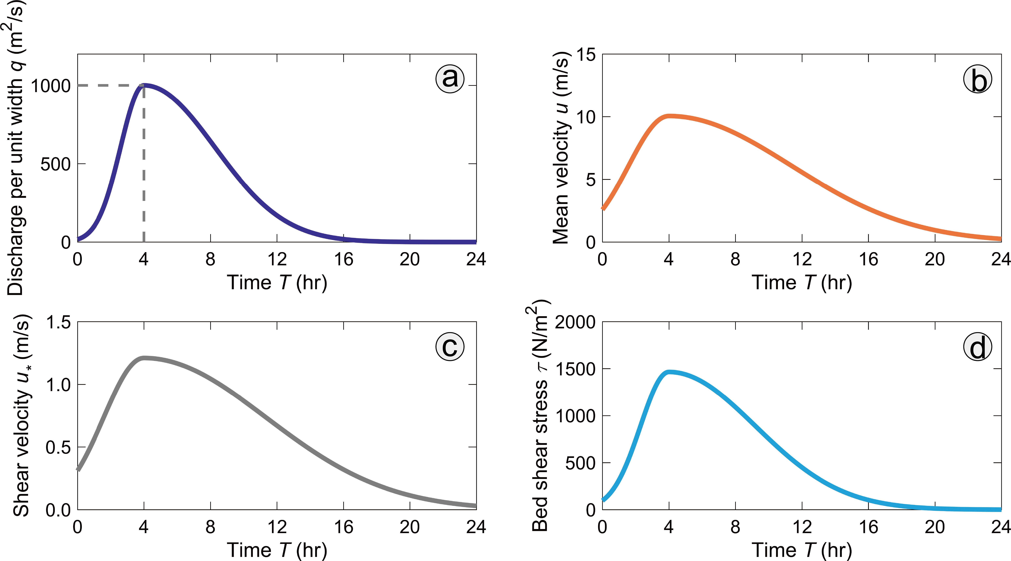

Figure 6 Variation in key parameters through the representative hydrograph; a) Discharge per unit width; b) Mean velocity; c) Shear velocity; d) Bed shear stress.
Figure 7: Non-dimensional volumetric suspended sediment concentration profiles for selected grainsizes. a) sampling points at 2-hour intervals from hour 2 to hour 16 for throughout the representative hydrograph; b-i) individual profiles of sampling points in a). The grey lines in panel b highlight grainsizes of 1, 5 and 10 mm (see main text).

4.2 Development of saturated suspended sediment concentration profiles during the hydrograph
Although there is considerable uncertainty about how to model the vertical distribution of high-concentration suspensions, most accepted procedures are based on the Rouse formulation (Winterwerp, 2001) with debate as to the appropriate value of the coefficient $β$ in Equation 15 (Li et al., 2020). For high concentrations of fine particles, Vanoni (2006) showed that $β$ could be as low as 0.49. Setting $β$ to equal 0.49 tended to result in only weak suspension of the coarser particles, but nonetheless saturated conditions developed for the finer grainsizes (< 15 mm) throughout 5 to 35% of the flow depth (Figure S14). In contrast, setting $β$ equal to 1, coarser grains (> 15 mm) were suspended, with the saturated layer thickening to occupy 20 to 40% of the flow depth with the latter thickness sustained throughout much of the flow hydrograph (Figure 7). Given that coarser particles are commonly found within palaeoflood deposits (Figure 2), the results below pertain to the condition where β = 1.

Within Figure 7, non-dimensional sediment concentration profiles are shown for points in time throughout the hydrograph for eight water depths. Although grainsize fractions (e.g., 100 mm) coarser than 50 mm are suspended, for clarity we only plot particles ranging in size between 1 mm and 50 mm. Within panels b-i, it may be seen that the smaller the particle size, the higher the point in the water column where the concentration agrees with the reference concentration$({S_{b}}/{C_{b}=1}$), both in the rising and falling phases of the flood. Above this point, the concentration profiles are concave upwards. Specifically, as each curve reaches${S_{b}}/{C_{b}=1}$, the related value of $y/h$ gradually increases as the particle size decreases. Take Figure 7b as an example, wherein there are plotted four grey dashed lines for selected grainsizes. Note that the near-bed layer, where${S_{b}}/{C_{b}=1}$, is regarded as saturated and the thickness of this layer decreases as the grainsize coarsens (note that the right boundaries of the grey lines all correspond to${S_{b}}/{C_{b}=1}$, i.e., the area below each grey line represents the same concentration as the reference concentration). In other words, as the particle size increases, $y/h$ is decreasing, yet the near-bed saturated layer remains thick. These observations are summarized within Figure 8, wherein the thickness of the saturated layer is for the most readily suspended size fraction (1 mm)
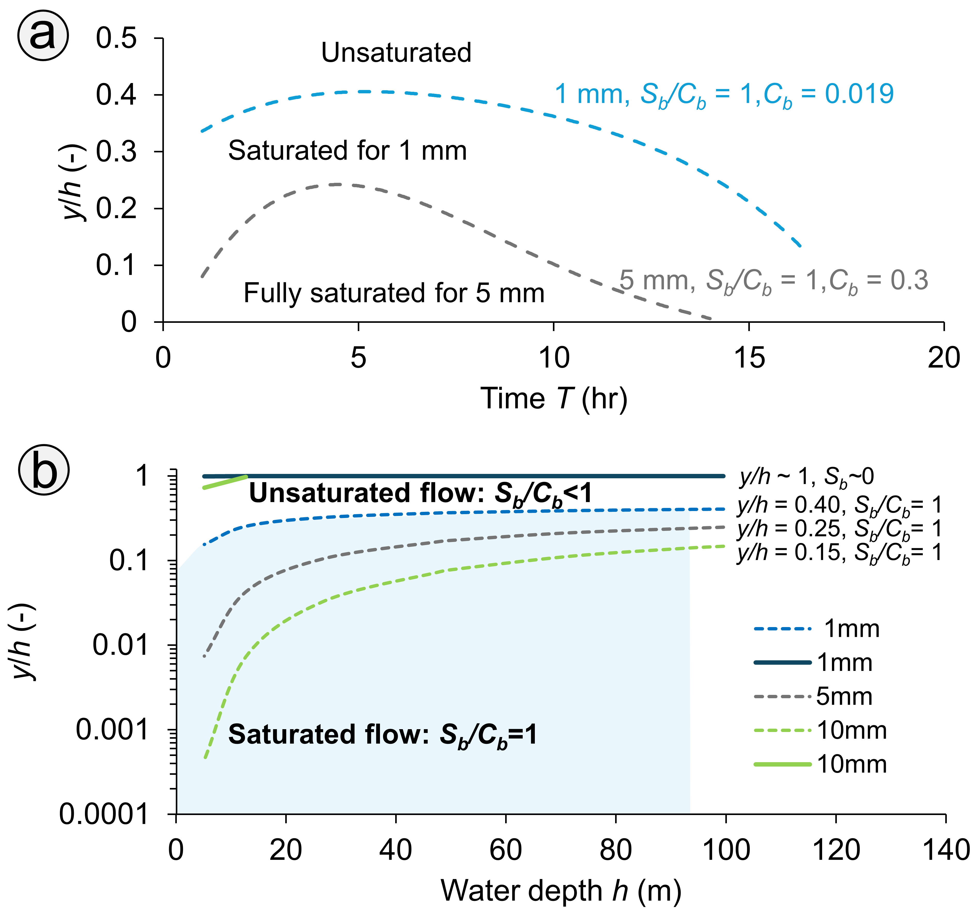
Figure 8 Variation in the degree of flow saturation throughout the hydrograph for finer size fractions. A) Variation in the height of the saturated layer for the finest grainsize fractions (1 to >5 mm); B) Variation in the non-dimensional height above the bed (solid curves) at which S_{b} tends to zero (curve for the 5 mm fraction is not shown as it is coincident with that for 1 mm gravel at the scale of the plot). The variation in the thickness of the saturated layer (pecked curves) as defined by the thickness of the basal saturated layer where S_{b}/C_{b} = 1for the 1 mm, 5 mm and 10 mm size fractions.
thickens rapidly to occupy up to 40% of the depth during the hydrograph, before thinning towards the end of the hydrograph (Figure 8A). Maximum thicknesses decrease as grainsizes increase, reinforcing the saturation close to the bed. So, for the 5 mm fraction the maximum thickness of the saturated layer is 25%. As the water depth increases and the stress on the bed increases (Figure 6), the finest fractions (1 to 10 mm) are soon found near the water surface (y/h ~ 1; S_{b} ~ 0) although the upper 60 to 85% of the water column remains unsaturated depending on stage (Figure 8B).
Although our suspended sediment concentration profiles for gravel (> 1 mm) are based on theory, we have confidence in their general form as similar concave-upward profiles, lying above markedly thick near-bed high-concentration suspensions of granules (1.2 mm), were produced within experimental flows ($C_{b}=0.013)$ by Bennett et al. (2014). As our flow has the competence to sustain a very high near-bed concentration, c., $C_{b}≈0.3$ for each fraction coarser than 5 mm, particles of all sizes must interact to provide an overall expected near-bed concentration of ~ 30%. However, deposition to the bed will have started to occur once the capacity of the flow was exceeded, such that in nature the flow would not likely reach 30% concentration. The finest fractions (e.g., 1 mm) are more evenly distributed throughout the water column, leading to a relatively low near-bed concentration for our simulations ($C_{b} ≈0.019$) as was also observed by Bennett et al. (2014) for 1.2 mm particles. These results indicate that steady-state saturated suspended sediment concentration profiles are achieved early within the hydrograph and are sustained throughout the event, such that there would be little propensity to entrain additional particles from the bed once saturation was reached and so the concentrations must be sustained from an upstream source. Indeed, an increased likelihood of deposition will occur; a point addressed within the Discussion.
For each size fraction it is evident that the modelled high concentration layer for a range of grain sizes is relatively thick, and this is especially the case for grainsize fractions < 10 mm. Such high concentrations of particles will result in a reduction in turbulence and a potential transition from rough turbulence to smooth turbulence conditions just above the bed, about which more is said latterly. The thick, high concentration layer, which persists throughout much of the hydrograph, only collapses near the end of the event but develops initially due to the high mean flow rate and commensurate high near-bed shear stresses (Figure 6) that are substantially higher than those associated with normal river floods (e.g., Quick et al., 2023).
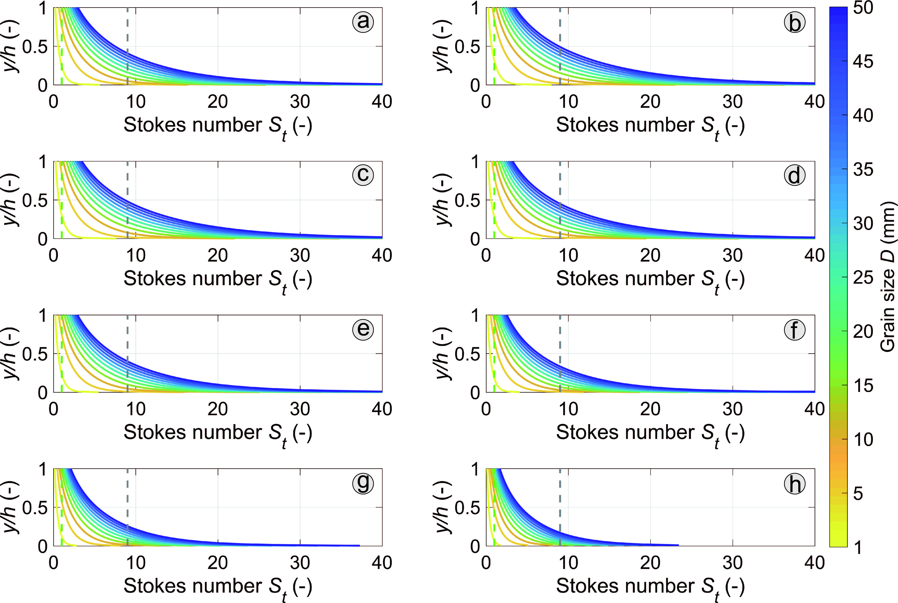
Figure 9 Variation of the Stokes number (S_{t}) with relative height in the water column for given suspended grain sizes. The grey pecked line is S_{t} = 9 and the green pecked line is S_{t} = 1.

4.3 Suppression of turbulence during the hydrograph
Although the flood hydrograph clearly has sufficient power to sustain saturated suspended sediment concentrations through a substantial part of the flow depth, the variation in the Stokes number throughout the hydrograph (Figure 9) shows that the high Stokes numbers for coarser grains will promote comminution of these larger particles to generate smaller particles with lower values of the Stokes number. Thus, comminution will continuously feed finer particles to the near-bed suspension. Note also that the range of Stokes numbers throughout the water column includes values below the value of 9, even at peak flow depth. Values less than 9 commonly are associated with a degree of attenuation of turbulence (Hoque et al., 2024) with substantial attenuation occurring for the finest particles when S_{t} < 1. The significance of these two threshold values is made clear within Figure 10 wherein the Stokes number for 50 mm particles is less than 9 for at least 44% of the duration of the hydrograph. Finer particles have S_{t} values less than 9 for substantially longer periods of time, mostly on the waning limb, at which time deposition will be most intense, with the value lying below S_{t} = 1between 4% of the time (D = 3 mm) and 67% of the time for D = 1 mm. For these conditions, the turbulence intensity should be significantly suppressed (Bennett et al., 2024; Wright and Parker, 2004) within the saturated suspended sediment layer.
Figure 10 Variation of the Stokes number for individual grain sizes throughout the hydrograph. The grey pecked line is S_{t} = 9 and the green pecked line is S_{t} = 1. Panels a through f represent y/h = 0.05, 0.2, 0.4 ,0.6, 0.8 and 0.95 respectively.
To demonstrate the suppression of the TKE is not straight-forward, as high-concentrations of suspended sediment within the lower portion of the boundary layer can modify the flow structure, including producing a non-log layer. Herein we assume that a log-profile is sustained, although the near-bed shear stress will be reduced as concentrations increase (Gelfenbaum and Smith, 1986; Cao et al., 2003). There is no agreed way to demonstrate the exact effect of higher concentrations suspensions on the reduction in $u_{*}$, and the consequent effect on the TKE production so, at this point, we provide a reasonable example. Pope (2000, p.379), amongst others (see Li et al., 2020), varied the Schmidt number (β) to demonstrate the effect of high concentrations on the TKE production (Equation 25).
As was noted in the preceding section, Vanoni (2006) showed that β could be as low as 0.49 in fully-turbulent flows with high suspended loads, Setting β = 0.49 results in an effective reduction in the value of K from 0.41 for clear water to 0.2, which would be an extreme modification. Rather, we adopt β = 0.71 to provide a less extreme example (Figure 11, Table S1), that we surmise is commensurate with the suspended sediment concentrations reported above.
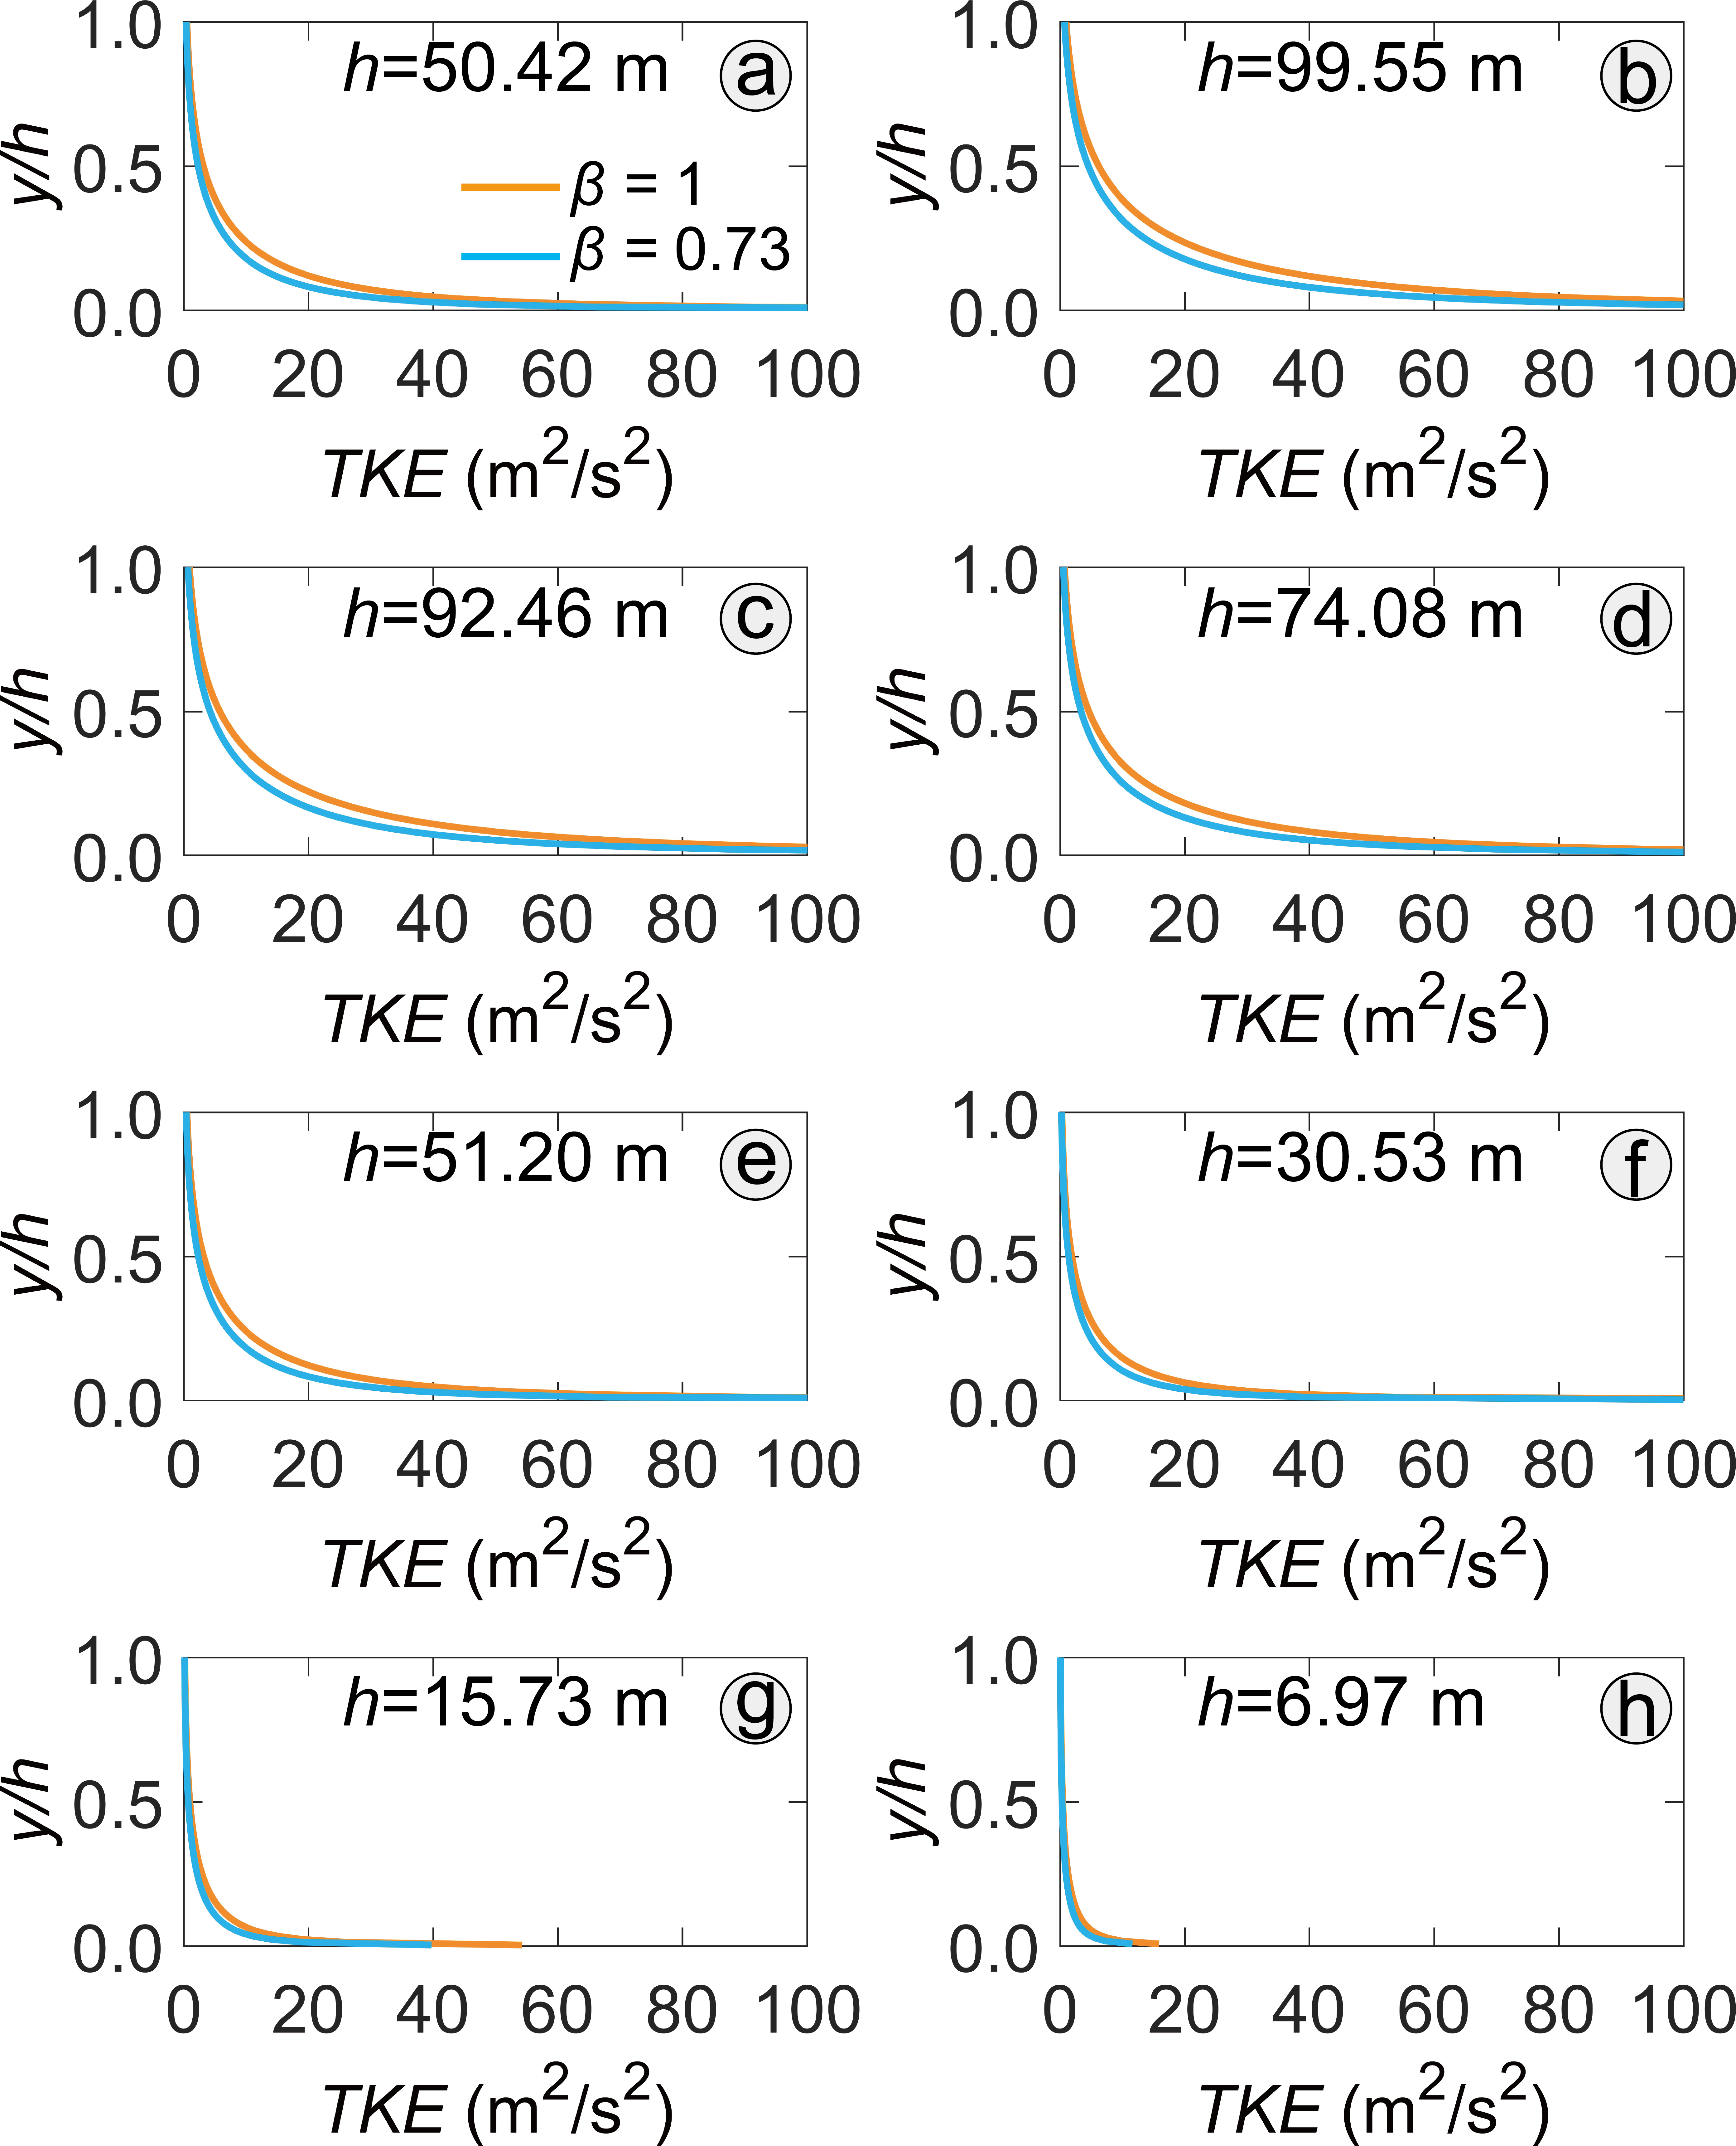
Figure 11 Effect of high concentration of suspended sediment on turbulence production, where the clear-water condition is given by β = 1 and the saturated condition is represented by β = 0.73.
Note that within Figure 11, although the TKE is reduced throughout the water depth with the change from clear-water to high concentrations of particles, the overall trends of the TKE distributions are similar, Nonetheless, for any given height above the bed (y/h) the reduction in the value of TKE is substantial.

5. Discussion

5.1 General points related to modelling
In developing an approach to explain the unusual characteristics of suspension deposition within exceptional water floods, the authors are keenly aware that, perforce, the model is conceptual although embedded within a quantitative framework. The model was developed primarily with reference to the literature on high-concentration open-channel flows, although recourse was made the behaviour of high concentrations of fine particles within small, experimental, closed conduits. This broad approach can be justified, as Hoque et al., (2024) observed that generally similar behaviour is observed in open-channel and closed conduit flows. Moreover, system behaviour is described using standard parameters, often non-dimensional, allowing a degree of extrapolation to the behaviour of exceptional flows greater than the scale of flows that have been studied experimentally.
Considering the condition whereby 0.49 < β ≤ 1 results in differences in the size fractions found in suspension but nonetheless a saturated layer always develops. Thus, the results from the modelled sediment-laden hydrograph indicate that suspension-saturated conditions occur readily, such that suspended gravel particles will deposit to the bed, especially as the particle sizes that are of a smaller diameter than the near-bed mixing length suppress turbulence. However, note that in both the model and within nature, turbulence may not always be fully suppressed. This conclusion is supported by the lack of fines < 0.075 mm within individual laminae constituting a natural deposit at the margin of the Yarlung Tsangpo River (Figures 4, and S6 to S8). In that example, turbulent flow was sufficient to keep the finest material suspended, and so flushed from the system, as coarser fractions were deposited. Although we have not attempted to calculate the reduction in the near-bed vertical shear stress profile due to the density stratification depicted within Figure 7 and 8, any such transformation will promote further deposition (Cao et al., 2003). Note that the calculations herein are for deposition to the bed beneath a steadily-varying hydrograph, whereas we noted in the Introduction that often deposition occurs due to transfer of high velocity sediment-laden fluid across a flow separation line (Figure 1) into a relatively low velocity embayment wherein flow speeds rapidly reduce (Liu et al., 2022). The latter conditions are more akin to the experimental situation where suspension-dominated fallout occurs with negligible shear-flow at the bed surface (Amy et al., 2006), which should reinforce rapid deposition, as is considered next.

5.2 Collapse of suspended sediment concentration profiles
The presence of sharp inflections in the gradients of the suspended sediment concentration profiles was used by Noh and Fernando (1991) to develop a criterion to define when such a density stratification occurs. They argued that the interaction between turbulence and particle diffusion results in the development of a point of inflection of the concentration profile across which the diffusion of particles and the propagation of turbulent energy are inhibited. For larger particles with greater settling velocities and for lower particle concentrations the inflections weaken. As noted in the Results, the form of the concentration profiles (Figure 7) supports the presence of such a near-bed saturated layer. Noh and Fernando (1991) used dimensionless criteria, $R$and $G$, to examine the behaviour of such sediment laden flows.
$$R=c_{1}\frac{W_{s}}{u_{*}}$$ | (26)
$$G=\left(\frac{g\left(ρ_{s}-ρ\right)}{ρ}\right)\frac{LC_{b}}{u^{*2}}$$ | (27)
where a vertical velocity, $u^{* }={\left(ελ\right)}^{1/3}$at y/h≈0, L is a mixing length equivalent to λ. Whereas Noh and Fernando (1991) used a depth-averaged concentration (C*) in Equation 27 to represent the conditions throughout the flow depth, we utilize the reference concentration to better represent the saturated layer. R represents the propensity for suspended particles to settle towards the bed and G is equivalent to a Richardson number, describing the competition between buoyancy and turbulence. When G is large, turbulence is suppressed, enabling saturation to develop, whereas when it is small, vertical mixing is strong, enhancing sediment flux away from the bed. Noh and Fernando (1991) varied the empirical constant c₁ as 0 < c₁ < 5 to account for hindered or enhanced settling. Equation 26 is functionally similar to the moveability number (see Equation 7), that was set to unity to separate bedload from suspension load, so a value of c₁≈1 is appropriate here to discriminate suspension from deposition.
Figure 12 Variation in the parameter $R$ for individual grain sizes throughout the hydrograph. Panels a through f represent y/h = 0.05, 0.2, 0.4 ,0.6, 0.8 and 0.95 respectively.

As $R$ increases (Figure 12), the thickness of the saturated layer decreases (Noh and Frenando, 1991), so the values of $R$ greater than 1 on the rising hydrograph indicate that the potential fully-saturated layer is initially thin and the fall in $R$ towards peak discharge (T = 4 hrs; Figure 6a) is consistent with the growth in the thickness of the saturated layer seen within Figures 7 and 8. However, it is evident that the saturated layer collapses within the latter portion of the hydrograph as $R$ rises sharply, which should result in rapid bed aggradation. The tendency for the saturated layer to form is better illustrated by considering the behaviour of $G/{R^{2}}$ with time (Figure 13). Figure 13, in effect, is a numerical representation of the qualitative interpretation of the growth and decay of the saturated layer depicted within Figure 8. Setting $c_{1}=1$ in Equation 26 is appropriate for the interpretation of these results, as the quantified behaviour of the system illustrated within Fig. 13 is then consistent with the qualitative behaviour observed within Figure 8. Specifically, the saturated layer becomes well-established when $G/{R^{2}}$ > 0.5, being dominated by finer grainsize fractions. Conversely, if the vertical component of velocity was dominant, $c_{1}→0$ , then for $G/{R^{2}>2.2}$ a saturated layer would tend to occur throughout the hydrograph, which is contrary to our observations. Similarly, if the settling velocity was dominant ($c_{1}=5;$) shear-dominated turbulence ($G/{R^{2}>0.032}$) would result in conventional concave-up suspended sediment profiles present throughout the hydrograph, which also is contrary to observations (Figures 7 and 8).
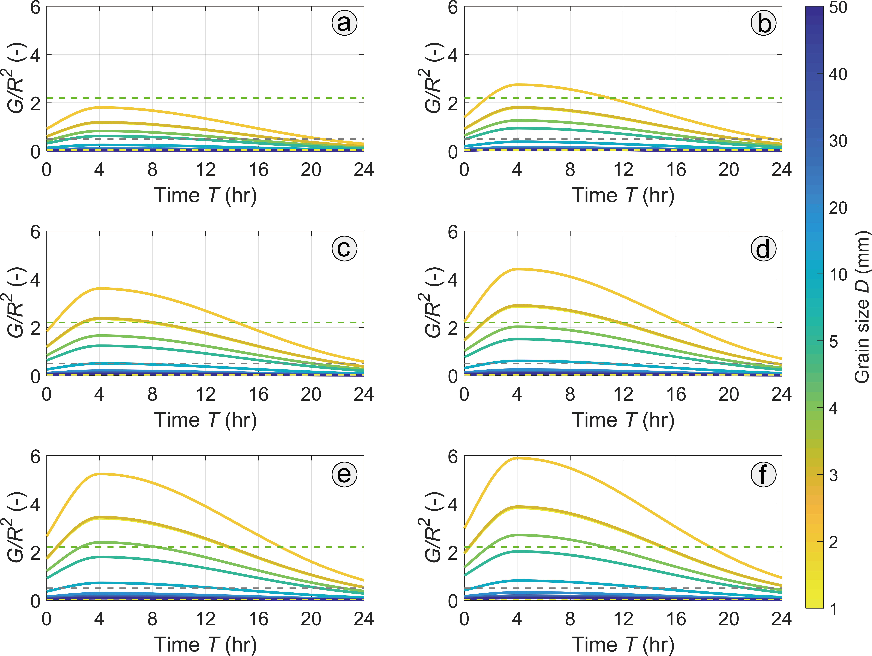
Figure 13 Variation in the parameter $R$ for individual grain sizes throughout the hydrograph. Broken green line represents c₁ → 0, broken grey line represents c₁ = 1, broken yellow line represents c₁ = 5. Panels a through f represent y/h = 0.05, 0.2, 0.4 ,0.6, 0.8 and 0.95 respectively.

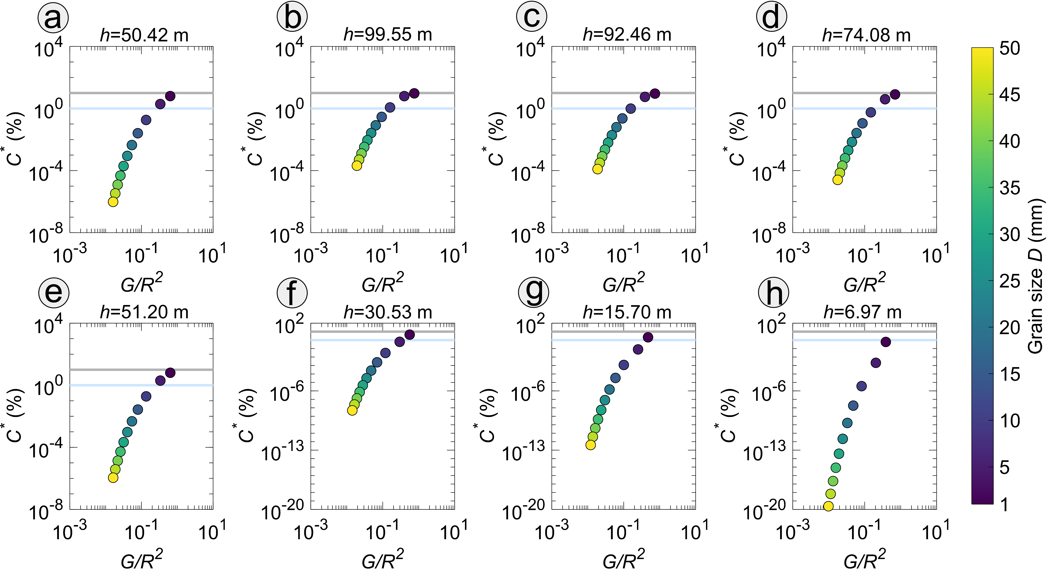
Figure 14 Variation in the depth-averaged suspended sediment concentration (C*) as a function of G/R². As labelled in panel a, the blue and grey horizontal lines separate the three phases: Dilute C* < 10⁻² ; transitional 10⁻² ≤ C* < 10⁻¹ ; hyperconcentrated C* ≥ 10⁻¹.
The considerations above have focussed upon the behaviour of individual particle sizes, especially within the saturated layer. Although very high concentrations were recorded close to the bed (i.e., S_{b} = 0.3), Figure 14 in contrast shows the effect of the changing flow conditions on depth-averaged suspended sediment concentration (C*) wherein the concentration classes are labelled in accord with the notation of Fukuda et al. (2023). At the beginning of the hydrograph, coarser particles (near the bed) are entrained into suspension but hyperconcentrated conditions only just begin to develop throughout the flow depth for the finer size fractions at peak flow and immediately thereafter. Nonetheless, transitional flow conditions are sustained throughout the flow depth for the finer fractions (i.e., 1 to 5 mm) for the duration of the flow event, owing to the persistent high values of G/R², reflecting the sustained supply and deposition of finer particles, particularly towards the end of the event (Figures 12 and 13).

5.3 General relationship of flow conditions to the stratigraphy
The presence of broad particle size distributions in suspension throughout the modelled hydrograph inevitably leads to enhanced vertical concentration stratification near the bed, followed by the collapse of the concentration profile towards the end of the hydrograph (Figures 7, 8, 11 and 12), which drives continued bed aggradation and generally suppresses any bedload transport (Parker et al., 2024). In the numerical model, we do not address bedload transport, as all size fractions considered were in suspension and the bedload component of the natural palaeoflood deposits under consideration is negligible (Carling, 2013). Despite the high velocities, the Froude number for the simulated hydrograph remains low, due to the large flow depths. Subcritical Froude numbers also pertain over bar tops within flow separation zones (Carling et al., 2020) leading to aggradation to a lower-stage plane bed. Thus, the relatively hydrodynamic tranquillity of flow within a re-entrant is not conducive to bed scour (Liu et al., 2022). Consequently, the bar tops within flow-separation zones are dominated by depositional sequences of laminated, lower-stage, plane beds. The poorly-developed fabric of individual laminae (i.e., no preferred particle orientations) is an indication of the lack of reworking by bedload as particles deposit; rather, particles are rapidly buried with random long-axis orientations (Carling, 2013). The frequent amalgamation of indistinct thin laminations (Carling, 2013) reflects the very rapid continued deposition from suspension, leading often to very thick sedimentary sequences (Figure 2). Rhythmicity in deposition from suspension (Figure 3) may be related to strong vortex incursions (Carling, 2013; Liu et al, 2022) across the flow-separation line (Figure 1), as may the occasional episodes of weak traction transport resulting in coarse gravel stringers (Figure 2). However, the present hydrodynamic model cannot replicate the short-term variation in flow parameters including the detail of planview Kelvin-Helmholtz instabilities.
In the absence of hydrodynamic data from experimental flow conditions related to deposition of gravel laminae from suspension within sub-critical flow, the fine-sediment experiments of Amy et al., (2006) provide a possible analogue to the conditions we have produce numerically. In the experiments of Amy et al. (2006), only mud and sand-sized fractions were utilized, but high suspended sediment deposition rates occurred as currents rapidly decelerated and near-bed shear stresses were insufficient to sustain suspensions above the bed. Relatively high rates of laminated bed aggradation occurred from these experimental hyper-concentrated flows. In nature, as with palaeoflood laminations, these thin laminations in fine sediments can extend laterally for many tens of metres with little variation in thickness, yet the process of their formation is still poorly understood (Al-Mufti and Arnott, 2023). It would not be appropriate to extend the analogy between lamination in muddy-sand and within fine gravel without further experimentation and numerical modelling, as the detailed near-bed conditions (viscous sub-layer scale) may differ radically when comparing a sand bed and a gravel bed (e.g., Sharma and Kumar, 2021). Yet, as the style of deposition and the hydraulic conditions clearly are broadly similar for both sandy sediments and for fine gravel, further investigation is warranted.

5.4 Summary deposition model
In the Introduction it was proposed that the turbulence of the clear water is modulated by the presence of sediment particles leading to altered hydrodynamic characteristics of the sediment-laden flow, promoting deposition. The arguments presented within the Results and within the Discussion above support the premise. Similarly, the hypothesis that laminated sequences of fine gravels are deposited from high-concentration flows, characteristic of exceptionally large powerful floods, is equally supported. Below, the arguments presented above are summarized conceptually within Figure 15.
Figure 15 depicts the flow conditions related to continued bed aggradation as laminae. Although the natural particles will be angular we use spheres to illustrate the constituent particles as they enhance the visual clarity more effectively than random angular shapes. Figure 15a represents the initial rising stage of the hydrograph during which suspended sediment concentrations are relatively low and yet high enough to allow a thin saturated layer (SL) to develop above the bed (i.e., ${S_{b}}/{C_{b}=1)}$. These saturated conditions allow aggradation of thin laminae to the static bed as near-bed turbulence is suppressed as indicated by the high near-bed values of $G/{R^{2}}$. By the time the peak flow is attained (Figure 15b), the near-bed region of turbulence suppression has thickened, associated within a thick saturated layer, and frequent particle collisions result in a sustained contribution of comminuted finer particles to the suspension. On the falling stage (Figure 15c) the rate of deposition remains high due to reducing flow competence even though the saturated layer is thinning. The rate of deposition to the static bed likely is high as $G/{R^{2}}$ values are sustained which may account for some of the thicker (c. 10 cm thick) unlaminated beds noted within field examples of deposits (Figure 3). Towards the end of the event (Figure 15d) the bed continues to aggrade due to the persistence of a thin saturated layer as well as declining competence.
Although we have shown the bed as aggrading due to the superimposition of individual laminae, the actual mechanisms related to the formation of individual laminae remain unclear and may relate to short-period unsteadiness in the flow (Carling, 2013) leading to simple unsteadiness in the depositional process. However, poorly-understood processes of how layers of particles final stabilize beneath unsteady flow with high-concentrations of granules may be involved. Specifically, the potential development of rapid variation in near-bed shear driving repetitive gliding layers of particles (Coussot, 2025) may lead to lamination (Vroljik and Southard, 1998). The latter process involves the expulsion of interstitial fluid as the particles within the depositing laminae rearrange (Baas, 2002), potentially within a laminar sub-layer if turbulence is sufficiently suppressed. Aspects of this latter scenario are outlined in the final section below.
Figure 15 Summary model of deposition of laminae from palaeoflow that develops saturated suspended sediment conditions above the bed surface. a) flow conditions within the first hour of the rising hydrograph; b) peak flow around the fourth hour; c) flow conditions around the 8th hour on the falling hydrograph; d) flow conditions around the sixteenth hour on the falling hydrograph at which time the discharge is less than within panel a.

5.5 Rough to smooth bed transition close to the bed?
The detail of the flow conditions related to the stabilization of individual depositing particles at the bed surface beneath saturated flow is not well understood, with publications reporting conflicting results and interpretations (Al-Mufti and Arnott, 2023). Consequently, we can only provide some broad comments here. In considering the equations describing the flow and particle interactions, the fluid viscosity has been considered to be a constant (for a given temperature) as is appropriate for Newtonian fluids. However, high concentrations of suspended sediment (> c., 10%) disrupt the fluid particle motions and distort the viscous drag exerted by the closely-spaced particles on the fluid (Batchelor and Green, 1972) including the turbulent eddies close to the bed, complicating the settling and final stabilization behaviour of individual particles and group of particles (Fan et al., 2023; You and Tinoco, 2023). If non-Newtonian flow conditions develop as the flow saturates, then transport of coarse particles in suspension can occur at the same time as deposition is occurring to an aggrading bed (e.g., Matoušek et al., 2021; Pullum, 2023); a flow condition which is outside the scope of this paper.
Despite these complications, the situation whereby a fully-turbulent particle-laden flow is replaced by smooth-turbulent particle-laden flow has been associated with the deposition of thick units of laminated sediment (Vellinga et al., 2018; Hernandez-Moreira et al., 2019), albeit of finer grainsize than considered herein. Given that it has long been known that increasing the near-bed suspended sediment concentration towards saturated flow promotes a transition from fully rough-turbulent conditions to smooth-turbulent conditions (van Rijn, 1984; Coleman, 1986; Krogstad et al., 1992; Ligrani and Moffat, 1986; Schultz and Flack, 2007), a focus is required on the near-bed conditions. In this respect, Al Mufti and Arnott (2024) have suggested that, within high concentration flows, a transition from rough-turbulent to smooth-turbulent flow occurs near the aggrading bed surface, that results in periodic episodes of shear-thinning, shear thickening and consequent particle jamming that results in textural variations of lamination similar to that seen in geological field sections of palaeoflood deposits. Nonetheless, the presence of near-bed turbulence is indicated as sedimentary rhythms fine-up, or coarsen-up, with ungraded beds being less evident.
The arguments above have been developed from hydrodynamic principles guided by the interpretation of sedimentary successions in the field and numerical modelling; the latter initially to determine the scale and power of palaeofloods (Baker and Costa, 1987; Baker and Carling, 2020.) but advanced herein to consider deposition from suspension. It should be stressed that there are no empirical hydrodynamic field data to support the notion of such catastrophic behaviour in sediment-charged flows as we describe. Nonetheless, it is important to recognize the extent of turbulence damping that seems to occur near the base of palaeofloods, especially during the falling hydrograph when there will be a greater propensity for deposition of suspended sediment. Modelling the near-bed portion of the flood flow, including the viscous sub-layer, is beyond the scope of this paper. Yet, it is evident that although detailed physical experiments in high-velocity, high-concentration flows may shed light on the near-bed processes related to the formation of extensive lamination, numerical modelling will be required to tease-out the complexity of the near-bed flow that can then be linked to the formation of synthetic stratigraphy. With respect to the development of synthetic stratigraphy, greater attention needs to be given to the grain-scale and fabrics of large-flood laminated sequences in field settings, to inform the interpretation of both laboratory and numerical modelling results.

6. Conclusions
An analytical model developed using hydrodynamic relationships that pertain to high concentrations of suspended sediment in deep, high-velocity palaeofloods shows that near-continuous deposition of suspended sand and granules can occur during a hydrograph from material supplied from upstream with very high rates of deposition occurring towards the end of the event.
The approach used herein provides a unified model, linking the hydraulic characteristics of the flow through the size-distributions of the suspended material, to the depositional stratigraphical record. The suspended sediment concentration profile quickly becomes saturated, suppressing turbulence and driving rapid intense deposition of fine gravel and sand during large floods. The preferential size distributions used within the model produce sedimentation outcomes that are broadly consistent with the observed characteristics of the deposits of exceptional floods.
The final narrow size distribution of the material deposited from suspension reflects partitioning due primarily to turbulent sorting but the process is fed by particles that have been comminuted (smashed), which reduces the quantity of coarser particles in suspension. The rapid deposition from a saturated suspension to an aggrading bed largely precludes bedload transport.
Although this study has drawn largely on sedimentary information from prehistoric palaeofloods, landscapes now are responding to hydroclimatic extremes related to anthropogenic warming. The present day is witnessing extreme rainfall and runoff, as well as natural dam failures, which may lead to specific high energy flood sedimentary signatures in the depositional record. Understanding the processes associated with palaeoflood deposition is critical to constrain modelling of more recent sediment-laden flooding, including failures of tailings dams and water impoundments.

Acknowledgments
We thank Ruan Hechun and Fan Niannian for helpful discussions of this study in the earlier period. We agratefully acknowledge Yang Shengli, Zhao Huimin, Huang Yu, and Zhang Haipeng for their assistance with the grain-size analyses. This study was supported by National Key Research and Development Program (Grant No. 2023YFC3008300), the Natural Science Foundation of China (Grant No. W2412138), The Science and Technology Research Program of Institute of Mountain Hazards and Environment, Chinese Academy of Sciences (Grant No. MHE-ZDRW-03) and Chinese Academy of Sciences Overseas Reviewer Program (Grant No. E1R2140140).

Data Availability Statement
All the code related to this paper was written in MATLAB 2017a and can be found on GitHub: https://github.com/ZewenYang1/Analytical-Model-of-Suspended-Gravel.

References

Allen, J.R.L., 1984, Sedimentary Structures; Their Character and Physical Basis: Amsterdam, Elsevier, 539 pp.

Al-Mufti, O.N., Arnott, R.W.C., 2023. The origin of planar lamination in fine-grained sediment deposited by subaqueous sediment gravity flows. The Depositional Record, 10, 496–514. https:// doi: 10.1002/dep2.257

Amy, L., Dorrell, R., 2021. Equilibrium sediment transport, grade and discharge for suspended-load-dominated flows on Earth, Mars and Titan. Icarus, 360. https://doi.org/10.1016/j.icarus.2020.114243

Amy, L.A., Talling, P.J., Edmonds, V.O., Sumner, E.J., Lesueur, A., 2006. An experimental
investigation of sand-mud suspension settling behaviour: implications for bimodal mud contents of submarine flow deposits. Sedimentology, 53, 1411–1434. https://doi.org/10.1111/j.1365-3091.2006.00815.x

Baas, J.H., Best, J.L., 2002. Turbulence modulation in clay-rich sediment-laden flows and some implication for sediment deposition. Journal of Sedimentary Research, 72, 336–340. https://doi.org/10.1306/120601720336

Bagnold, R. A. 1954. Experiments on a gravity-free dispersion of large solid spheres in a Newtonian fluid under shear. Proc. R. Soc. Lond. A, 225, 49–63. https://doi.org/10.1098/rspa.1954.0186

Bagnold, R. A., 1966. An approach to the sediment transport problem from general physics. Geological Survey Professional Paper 422-1, US Government Printing Office, Washington, 37 pp.

Baker, V.R., 1996. Discovering Earth’s future in it past: palaeohydrology and global environmental change. In: Branson, J., Brown, A.G., Gregory, K.J. (Eds.), Global Continental Changes. 115. Geological Society, pp. 73–83 Geological Society Special Publications.

Baker, V.R., 2009. The Channeled Scabland: a retrospective. Annual Review of Earth and Planetary Sciences, 37, 6.1–6.19. https://doi.org/10.1146/annurev.earth.061008.134726

Baker, V.R., Benito, G., Brown, A.G., Carling, P.A., Enzel, Y., Greenbaum, N., Herget, J., Kale, V.S., Latrubesse, E.M., Macklin, M.G., Nanson, G.C., Oguchi, T., Thorndycraft, V.R., Ben Dor, Y., Zituni, R., 2021. Fluvial palaeohydrology in the 21st century and beyond. Earth Surface Processes and Landforms, 47, 58-81. https://doi.org/10.1002/esp.5275

Baker, V.R., Carling, P.A., 2020. Global Late Quaternary megafloods. pp 832-840 In: Treatise on Geomorphology, Elsevier. https://doi.org/10.1016/b978-0-12-409548-9.12459-5

Baker, V.R., Costa, J.E., 1987. Flood power. In: Mayer, L., Nash, D. (Eds.), Catastrophic
Flooding. Allen and Unwin, Boston, pp. 1–21.

Balachandar, S. and Eaton, J.K., 2010. Turbulent dispersed multiphase ﬂow. Annu. Rev. Fluid Mech., 42, 111–133. https://doi.org/10.1146/annurev.fluid.010908.165243

Batchelor, G.K., Green, J.T., 1972. The hydrodynamic interaction of two small freely-moving spheres in a linear flow field. Journal of Fluid Mechanics, 56, 375–400.

Bazai, N. A., Cui, P., Carling, P. A., Wang, H., Hassan, J., Liu, D., Zhang, G., and Jin, W., 2021, Increasing glacial lake outburst flood hazard in response to surge glaciers in the Karakoram. Earth-Science Reviews, 212, 103432. https://doi.org/10.1016/j.earscirev.2020.103432

Benito, G., Thorndycraft, V., 2020. Catastrophic glacial-lake outburst flooding of the Patagonian Ice Sheet. Earth Science Reviews, 200, 102996. https://doi.org/10.1016/j.earscirev.2019.102996

Best, J., Bennett, S., Bridge, J.S., Leeder, M., 1997. Turbulence modulation and particle velocities over flat sand beds at low transport rates. Journal of Hydraulic Engineering, 123, 1118–1129. https://doi.org/10.1061/(ASCE)0733-9429(1997)123:12(1118)

Bhambri, R., Hewitt, K., Kawishwar, P., Kumar, A., Verma, A., Tiwari, S., and Misra, A., 2019. Ice-dams, outburst floods, and movement heterogeneity of glaciers, Karakoram. Global Planetary Change, 180, 100-116. https://doi.org/10.1016/j.gloplacha.2019.05.004

Bohorquez, P., Fernandez-Feria, R., 2008. Transport of suspended sediment under the dam-break flow on an inclined plane bed of arbitrary slope. Hydrological Processes, 22, 2615–2633. https://doi: 10.1002/hyp.6858

Braat, L., Brückner, M. Z. M., Sefton‐Nash, E., and Lamb, M. P., 2024. Gravity‐driven differences in fluvial sediment transport on Mars and Earth. Journal of Geophysical Research: Planets, 129. https://doi.org/10.1029/2023je007788

Bradshaw, P., 1974. Possible origin of Prandtl's mixing-length theory. Nature, 249, 135–136. https://doi:10.1038/249135b0.

Brenna, A., Scorpia, V., Finatello, A., Zarabara, F., Surian, N., 2025. Suspended transport of gravel in rivers: Empirical evidence from the 2022 flood in the Misa River (Eastern Apennines, Italy). Earth Surface Processes & Landforms, 50:e70081. https://doi.org/10.1002/esp.70081

Burr, D., Emery, J., Lorenz, R., Collins, G., and Carling, P. (2006). Sediment transport by liquid surficial flow: Application to Titan. Icarus, 181, 235-242. https://doi.org/10.1016/j.icarus.2005.11.012

Cao, Z., Egashira, S., Carling, P.A., 2003. Role of suspended-sediment particle size in modifying velocity profiles in open channel flows. Water Resources Research, 39, 1029. https://doi:10.1029/2001WR000934

Cao, Z., Pender, G., Wallis, S., and Carling, P., 2004. Computational dam-break hydraulics over erodible sediment bed. Journal of Hydraulic Engineering, 130, 689–703. https://doi.org/10.1061/(ASCE)0733-9429(2004)130:7(689)

Carling, P.A., 2013. Freshwater megaflood sedimentation: What can we learn about generic processes? Earth-Science Reviews, 125, 87-113. https://doi.org/10.1016/j.earscirev.2013.06.002

Carling, P.A., Borhorquez, P., Fan, X., 2020. Hydraulic control on the development of megaﬂood runup deposits. Geomorphology, 361, 107203. https://doi.org/10.1016/j.geomorph.2020.107203

Carling, P.A., Fan, X., 2020. Particle comminution defines megaflood and superflood energetics. Earth-Science Reviews, 204, 103087. https://doi.org/10.1016/j.earscirev.2020.103087

Carling, P.A., Kirkbride, A.D., Parnachov, S.V., Borodavko, P.S., Berger, G.W., 2002. Late Quaternary catastrophic flooding in the Altai Mountains of south-central Siberia: a Synoptic overview and an introduction to the flood deposit sedimentology. pp 17-35, In: P.I. Martini, V.R. Baker, G. Garson (editors) Flood and Megaflood Processes and Deposits: Recent and Ancient Examples, Int. Ass. of Sedimentologists Spec. Publ. 32, Oxford, England.

Carling, P.A., Leclair, S.F., 2019. Alluvial stratification styles in a large, flash-flood influenced dryland river: The Luni River, Thar Desert, north-west India. Sedimentology, 66, 102-128. https://doi.org/10.1111/sed.12487

Carling, P.A., Richardson, K., Ikeda, H., 2005. A flume experiment on the development of subaqueous fine-gravel dunes from a lower-stage plane bed. Journal of Geophysical Research: Earth Surface, 110, F04S05. http://dx.doi.org/ 10.1029/2004JF000205

Carling, P.A., Villanueva, I., Herget, J., Wright, N., Borodavko, P., Morvan, H., 2010.
Unsteady 1D and 2D hydraulic models with ice-dam break for Quaternary megaflood,
Altai Mountains, southern Siberia. Global and Planetary Change, 70, 24–34. https://doi.org/10.1016/j.gloplacha.2009.11.005

Carrivick, J.L., Turner, A.G., Russell, A.J., Ingeman-Nielsen, T., Yde, J.C., 2013. Outburst
flood evolution at Russell Glacier, western Greenland: effects of a bedrock channel cascade with intermediary lakes. Quaternary Science Reviews, 67, 39–58. https://doi.org/10.1016/j.quascirev.2013.01.023

Carstens, M. R., 1952. Accelerated motion of a spherical particle. Transactions American Geophysical Union, 33, 713–720.

Coleman, N.L., 1986. Effects of suspended sediment on the open-channel velocity distribution. Water Resources Research, 22, 1377-1384. https://doi.org/10.1029/WR022i010p01377

Costello, W.R., Southard, J.B., 1981. Flume experiments on lower-ﬂow-regime bed forms in coarse sand. Journal of Sedimentary Petrology, 51, 849–864. https://doi.org/10.1306/212F7DC4-2B24-11D7-8648000102C1865D

Coussot, P., 2025. Fifty shades of yield stress fluids: rheological challenges
and engineering perspectives. Rheologica Acta, https://doi.org/10.1007/s00397-025-01488-w

Crowe, C. T., Troutt, T.R., Chung, J.N., 1996. Numerical models for two phase turbulent flows. Annu. Rev. Fluid Mech., 28, 11– 43. https://doi.org/10.1146/annurev.fl.28.010196.000303

Deng, A., Guo, Q., and Chen, J., 2007. Study on the roughness in sediment-laden flows. Journal of Sediment Research, 5, 24–29. (in Chinese). https://doi:10.16239/j.cnki. 0468-155x.2007.05.005

Denlinger, R.P., O’Connell, D.R.H., 2010. Simulations of cataclysmic outburst floods from
Pleistocene Glacial Lake Missoula. GSA Bulletin, 122, 678–689. https:// doi: 10.1130/B26454.1

Dong, X., Wang, X., Yang, L., Pan, P., Lu, H., 2024. Dependence of erosion processes on the magnitudes of outburst floods: evidence from 2D hydrodynamic simulations. ESS Open Archive, July 11, 2024. https://doi.org/10.22541/essoar.172070535.50495444/v1

Dorrell, R. M., Amy, L. A., Peakall, J., McCaffrey, W. D., 2018). Particle size distribution controls the threshold between net sediment erosion and deposition in suspended load dominated flows. Geophysical Research Letters, 45, 1443–1452. https://doi.org/10.1002/2017GL076489

Dingle, E.H., Kusack, K.M., Venditti, J.G., 2021. The gravel-sand transition and grain size gap in river bed sediments. Earth-Science Reviews, 222, 103838. https://doi.org/10.1016/j.earscirev.2021.103838

Egashira, S., Ashida, K., Yajima, H., Takahama, J., 1989. Constitutive equation of debris flow. Annu. Disaster Preven. Res. Inst., 32(B-2), 487– 501. (in Japanese)

Egashira, S., Miyamoto, K., Itoh, T., 1997. Constitutive equation of debris flow and their applicability. pp 340-349 In: Debris-Flow Hazards Mitigation: Mechanics, Prediction, and Assessment, Proceedings of First International Conference Water Resources Engineering Division, ASCE, August 7-9, 1997, San Francisco, CA. http://dx.doi.org/10.13140/2.1.4623.7122
Elghobashi, S., 1994. On predicting particle-laden turbulent flows. Appl. Sci. Res.,
52, 309– 329. https://doi.org/10.1007/BF00936835

Elghobashi, S., 2006. An updated classification map of particle-laden turbulent flows. pp 3-10 In: Balachandar, S., Prosperetti, A. (eds) IUTAM Symposium on Computational Approaches to Multiphase Flow. Fluid Mechanics and Its Applications, vol 81. Springer, Dordrecht. https://doi.org/10.1007/1-4020-4977-3_1

Elghobashi, S., Truesdell, G.C., 1993. On the two-way interaction between homogeneous turbulence and dispersed solid particles, I, Turbulence modification. Phys. Fluids A, 5, 1790– 1801. https://doi.org/10.1063/1.858854

Emmer, A., 2017. Glacier retreat and glacial lake outburst floods (GLOFs). In: Oxford Research Encyclopedia of Natural Hazard Science.

Evans, E., Wilcox, C., 2013. Fine sediment infiltration dynamics in a gravel-bed river following a sediment pulse. River Research and Applications, https://doi: 10.1002/rra.2647

Faddick, R.R., 1975. Pipeline wear from abrasive slurries. pp. G3-29 ̶ G3-37 In: Proceedings of the First International Conference on the Internal and External Protection of Pipes, J.A. Clarke and N.G. Coles (editors), Durham University, BHRA Fluid Engineering, Cranfield.

Fan, N., Zhong, Q., Nie, R., Liu, X., 2023. Interaction of various-sized particles in river flow. Scientific Reports, 13, 10503. https://doi.org/10.1038/s41598-023-37460-y

Ferguson, R. I., 2003. Emergence of abrupt gravel to sand transitions along rivers through sorting processes. Geology, 31, 159–162. https://doi.org/10.1130/0091-7613(2003)031%3C0159:EOAGTS%3E2.0.CO;2

Garcia-Castellanos, D., O'Connor, J. E., 2018. Outburst floods provide erodibility estimates consistent with long-term landscape evolution. Sci Rep, 8, 10573. https://doi.org/10.1038/s41598-018-28981-y
Garcia, M. H., 2008. Sediment Transport and Morphodynamics, pp 21-163 In: Sedimentation Engineering, M. H. Garcia (editor), ASCE, Reston, Virginia, ISBN: 13:978-0-7844-0814-8
Garcia, M., Parker, G., 1991. Entrainment of bed sediment into suspension. Journal of Hydraulic Engineering, 117, 414-435. https://doi.org/10.1061/(asce)0733-9429(1991)117:4(414)

Ge, Z., Nemec, W., Vellinga, A.J., Gawthorpe, R.L., 2022. How is a turbidite actually deposited? Science Advances, 8, eabl9124, https://www.science.org/doi/10.1126/sciadv.abl9124

Gelfenbaum, G., Smith, J.D., 1986. Experimental evaluation of a generalized suspended-sediment transport theory. In Shelf Sands and Sandstones, edited by R.J. Knight and J.R. McLean, 133-144, Can. Soc. Of Pet. Eng., Calgary, Alberta, USA.

Goedde, E., 1978. The critical velocity of heterogeneous hydraulic transport, B4-81 ̶ B4-98 In: Hydrotransport 5, 5th International Conference on the Hydraulic Transport of Solids in Pipes, H.S. Stephens and L. Gittins (Editors), Technical University, Hanover, May 8 to 11, 1978, Published by BHRA Fluid Engineering, Cranfield, UK.

Gore, R.A. and Crowe, C.T., 1989. Eﬀect of particle size on modulating turbulent intensity. International Journal of Multiphase Flow, 15, 279–285. https://doi.org/10.1016/0301-9322(89)90076-1

Gore, R.A., Crowe, C.T., 1991. Modulation of turbulence by a dispersed phase. Journal of Fluids Engineering, 113,304–307. https://doi.org/10.1115/1.2909497

Goudge, T. A., Fassett, C. I., Coholich, M., & Bamber, E. R. (2023). Assessing Controls on the Incomplete Draining of Martian Open-Basin Lakes. Journal of Geophysical Research: Planets. https://doi.org/10.1029/2022JE007443

Guan, X., Hu, K., Chen, X., Gao, J., and Shi, H., 2024. Investigating the intense sediment load by dam‐break floods using a meshless two‐phase mathematical model. Water Resources Research, 60, e2023WR035399. https://doi.org/10.1029/ 2023WR035399

Hagstrom, C.A., Leckie, D.A., Smith, M.G., 2018. Point bar sedimentation and erosion produced by an extreme flood in a sand and gravel-bed meandering river. Sedimentary Geology, 377, 1-16. https://doi.org/10.1016/j.sedgeo.2018.09.003

Harms, J.C., Southard, J.B., Walker, R.G., 1982. Structures and Sequences in Clastic Rocks. Society of Economic Paleontologists and Mineralogists, Tulsa, USA.

Harrison, S., Macklin, M.G., Toonen, W.H., Benito, G., Cohen, K.M., 2025. Robust climate attribution of modern floods needs palaeoflood science. Climate Change, 178.71. https://doi.org/10.1007/s10584-025-03904-9

Herget, J., 2005. Reconstruction of Pleistocene ice-dammed lake outburst floods in the Altai Mountains, Siberia. Geological Society of America Special Paper 386, pp 386. https://doi.org/10.1130/0-8137-2386-8.1

Herget, J., 2024. Flood Reconstruction: Palaeohydrological Approaches, Methods
and Results, Springer, 158 pp. https://doi.org/10.1007/978-3-031-66815-9

Hernandez-Moreira, R., Jafarinek, S., Sanders, S., Kendall, C. G. St., Parker, G., and Viparelli, E., 2019. Emplacement of massive deposits by sheet flow. Sedimentology, 67, 1951–1972, https://doi.org/10.1111/sed.12689

Hetsroni, G., 1989. Particle-turbulence interaction. Int J Multiph Flow, 15, 735–746. https://doi.org/10.1016/0301-9322(89)90037-2

Hetsroni, G., 1993. The effect of particles on the turbulence in a boundary layer. In: Particulate Two Phase Flow, edited by M. C. Rocco, pp. 244– 264, Butterworth-Heinemann, Woburn, Mass., 1993.

Høgass, F., Romundset, A., Aurand, K., Bendle, J., van Boeckel, M., Hansen, L., Longva, O., 2025. A watery ice sheet demise: Formation and drainage of ice-dammed lakes in southern Norway during the Early Holocene. Quaternary Science Reviews, 355, 109250. https://doi.org/10.1016/j.quascirev.2025.109250

Hoque, M.M., Joshi, J.B., Evans, G.M., Mitra, S., 2024. A critical analysis of turbulence modulation in particulate ﬂow systems: a review of the experimental studies. Rev. Chem. Eng., 40, 511–544. https://doi.org/10.1515/revce-2022-0068

Hutchinson, P., Hewitt, G., Dukler, A.E., 1971. Deposition of liquid or solid dispersion from turbulent gas streams: a stochastic model. Chemical Engineering Science, 26, 419–439. https://doi.org/10.1016/0009-2509(71)83016-6

Kawashima, T., Yagi, T., Ise, T., Sato, E., Washimi, H., Yokogawa, A., 1978. Wear of pipes for hydraulic transport of solids. E3-25 ̶ E3-44 In: Hydrotransport 5, 5th International Conference on the Hydraulic Transport of Solids in Pipes, H.S. Stephens and L. Gittins (Editors), Technical University, Hanover, May 8 to 11, 1978, Published by BHRA Fluid Engineering, Cranfield, UK.

Komar, P.D., 1980. Modes of sediment transport in channelized water flows with ramifications to the erosion of the Martian outflow channels. Icarus, 37, 156–181.
https//doi: 10.1016/0019-1035(80)90097-4

Kovacs, A.E., 1998. Prandtl's mixing length concept modified for equilibrium sediment-laden flows. Journal of Hydraulic Engineering, 124, 803-812. https://doi.org/10.1061/(ASCE)0733-9429(1998)124:8(803)

Krogstad, P.A., Antonia, R.A., Browne, L.W.B. 1992. Comparison between rough-wall and smooth-wall turbulent boundary layers. Journal of Fluid Mechanics, 245, 599-617. http://dx.doi.org/10.1017/S0022112092000594

Kulick, J.D., Fessler, J.R., and Eaton, J.K., 1994. Particle response and turbulence modiﬁcation in fully developed channel ﬂow. Journal of Fluid Mechanics, 227, 109–134. https//doi.10.1017/S0022112094002703

Kumar, A., Hossain, S., Sen, S., Mohan, S., Ghoshal, K., 2024. Grain-size distribution in suspension under non-equilibrium conditions. International Journal of Sediment Research, 39, 774-794. https://doi.org/10.1016/j.ijsrc.2024.06.003

Lamb, M. P., Dietrich, W. E., Aciego, S. M., DePaolo, D. J., & Manga, M., 2008. Formation of Box Canyon, Idaho, by Megaflood: Implications for Seepage Erosion on Earth and Mars. science, 320(5879), 1067-1070. https://doi.org/doi:10.1126/science.1156630

Lamb, M. P., Finnegan, N. J., Scheingross, J. S., and Sklar, L. S., 2015. New insights into the mechanics of fluvial bedrock erosion through flume experiments and theory. Geomorphology, 244, 33-55. https://doi.org/10.1016/j.geomorph.2015.03.003

Lamb, M. P., & Fonstad, M. A., 2010. Rapid formation of a modern bedrock canyon by a single flood event. Nature Geoscience, 3, 477-481. https://doi.org/10.1038/ngeo894

Lamb, M. P., Venditti, J. G., 2016. The grain size gap and abrupt gravel-sand transitions in rivers due to suspension fallout. Geophysical Research Letters, 43, 3777–3785. https://doi.org/10.1002/2016GL068713

Larsen, I. J., Lamb, M. P., 2016. Progressive incision of the Channeled Scablands by outburst floods. Nature, 538(7624), 229-232. https://doi.org/10.1038/nature19817

Lee, S., Durst, F., 1982. On the motion of particles in turbulent duct ﬂows. International Journal of Multiphase Flow, 8, 125–146. https://doi.org/10.1016/0301-9322(82)90013-1

Lee, C. H., Huang, Z., Chiew, Y. M., 2015. A multi‐scale turbulent dispersion model for dilute flows with suspended sediment. Advances in Water Resources, 79, 18–34. https://doi.org/10.1016/j.advwatres.2015.02.002

de Leeuw, J., Lamb, M.P., Parker, G., Moodie, A.J., Haught, D., Venditti, J.G., Nittrouer, J.A., 2020. Entrainment and suspension of sand and gravel. Earth Surface Dynamics, 8, 485-504. https://doi.org/10.5194/esurf-8-485-2020

Li, Y., McLaughlin, J.B., Kontomaris, K., Portela, L., 2001. Numerical simulation of particle-laden turbulent channel flow. Physics of Fluids, 13, 2957–2967. https://doi:10.1063/1.1396846

Lieberwirth, H., Kühnel, L., 2021. Particle size effects on selectivity in confined bed comminution. Minerals, 11, 342. https://doi.org/ 10.3390/min11040342
Ligrani, P. M., Moffat R. J. 1986. Structure of transitionally rough and fully rough, turbulent boundary layers. Journal of Fluid Mechanics, 162, 69–98. https://doi.org/10.1017/S0022112086001933

Lin, Y.-P., An, C.-G., Parker, G., Liu, W.-M., Fu, X.-D., 2022. Morphodynamics of bedrock-alluvial rivers subject to landslide dam outburst floods. Journal of Geophysical Research-Earth, 127, 2022JF006605, https://doi.org/10.1029/2022JF006605.

Liu, D., Carling, P.A., Wang, H., Liu, W., Cui, Y., Wu, C., Jin, W., Bazai, N.A., 2022. The morphology and stratification of giant eddy bars reflect the variation in shape of palaeoflood hydrographs: A flume study. Earth Surf. Process. Landforms, 48, 332–349. https//doi: 10.1002/esp.5488

Liu, H.K., 1957. Mechanics of sediment-ripple formation. Journal of Hydraulics Division, ASCE 83 (HY2), 1–23.

Ljus, C., Johansson, B., Almstedt, A.E., 2002. Turbulence modiﬁcation by particles in a horizontal pipe ﬂow. International Journal of Multiphase Flow, 28, 1075–1090. https://doi.org/10.1016/S0301-9322(02)00020-4

Lowe, D.R., 1982. Sediment gravity flows; II, depositional models with special reference to the deposits of high-density turbidity currents. Journal of Sedimentary Research, 52, 279–297. https://doi.org/10.1306/212F7F31-2B24-11D7-8648000102C1865D

Lu, Z.; He, M.; Xu, J.; Cao, X.; Zhang, J.; Zhang, Z.; Kong, X.; Zhao, Z., 2025. An exploratory study of quartz grain surface microtextures in dam-break flood deposits from the middle reaches of the Yarlung Tsangbo River. Minerals, 2025, 15, 183. https://doi.org/10.3390/ min15020183

Lucci, F., Ferrante, A., Elghobashi, S., 2011. Is Stokes number an appropriate indicator for turbulence modulation by particles of Taylor-length-scale size. Physics of Fluids, 025101, https://doi.org/10.1063/1.3553279

Lyn, D.A., 1987. Turbulence and Turbulent Transport in Sediment-laden Open-channel Flows. Unpublished PhD thesis, California Institute of Technology, Pasadena, California, 244pp. https://thesis.library.caltech.edu/872/

Lyn, D.A., 1991. Resistance in flat-bed sediment-laden flows. Journal of Hydraulic Engineering, 117, 94–114. https://doi.org/10.1061/(ASCE)0733-9429(1991)117:1(94)

Lyn, D.A., 1992. Turbulence characteristics of sediment-laden flows in open-channels. Journal of Hydraulic Engineering, 118, 971–988. https://doi.org/10.1061/(ASCE)0733-9429(1992)118:7(971)

Lyn, D.A., 2008. Turbulence Models for Sediment Transport Engineering, pp 763-825 In: Sedimentation Engineering, M. H. Garcia (editor), ASCE, Reston, Virginia, ISBN: 13:978-0-7844-0814-8
Marr, J., Harff, P., Shanmugam, G., Parker, G., 2001. Experiments on subaqueous sandy gravity flows: The role of clay and water content in flow dynamics and depositional structures. Geological Society of America Bulletin, 113, 1377–1386. https://doi.org/10.1130/0016-7606(2001)113%3C1377:EOSSGF%3E2.0.CO;2

Matoušek, V., Chryss, A., Pullum, L., 2021. Modelling vertical concentration distributions of solids in turbulent visco-plastic fluid. Journal of Hydrology and Hydromechanics, 3, 255-262. https://doi: 10.2478/johh-2021-0013

McElroy, B., Mohrig, D., 2009. Nature of deformation of sandy bed forms. Journal of Geophysical Research, 114, F00A04.http://dx.doi.org/10.1029/2008JF001220

McKee, E.D., Crosby, E.J., Berryhill Jr., H.L., 1967. Flood deposits, Bijou Creek, Colorado, June 1965. Journal of Sedimentary Petrology, 37, 829–851. https://doi.org/10.1306/74D717B2-2B21-11D7-8648000102C1865D

McLean, D.G., Church, M., Tassone, B., 1999. Sediment transport along lower Fraser River: 1. Measurements and hydraulic computations. Water Resources Research, 35, 2533–2548. https://doi.org/10.1029/1999WR900101

Miall, A.D., 1995. The Geology of Fluvial Deposits: Sedimentary Facies, Basin Analysis, and Petroleum Geology. Springer, New York.

Moody, J.A., Meade, R.H., 2014. Ontogeny of point bars on a river in a cold semi-arid climate. Geological Society of America Bulletin, 126, 1301–1316. https://doi.org/10.1130/B30992.1

Muste, M., Patel, V.C., 1997. Velocity profiles for particles and liquid in open-channel flow with suspended sediment. Journal of Hydraulic Engineering, 123, 719– 725. https://doi.org/10.1061/(ASCE)0733-9429(1997)123:9(742)

Muste, M., Yu, K., Fujita, I., Ettema, R., 2005. Two-phase versus mixed-flow perspective on suspended sediment transport in turbulent channel flows. Water Resources Research, 41, W10402. https://doi:10.1029/2004WR003595

Nezu, I., Nakagawa, H., 1993. Turbulence in Open-Channel Flows. AA Balkema, Brookfield, Vt, USA.

Niño, Y., Garcia, M.H., 1998. Engelund’s analysis of turbulent energy and suspended load. Journal of Engineering Mechanics, 124, 480-483. https://doi.org/10.1061/(ASCE)0733-9399(1998)124:4(480)
Noh, Y., Fernando, H. J. S., 1991. Dispersion of suspended particles in turbulent flow. Physics of Fluids A: Fluid Dynamics, 3, 1730-1740. https://doi.org/10.1063/1.857952
O'Connor, J.E., 1993. Hydrology, Hydraulics, and Geomorphology of the Bonneville Flood. Geological Society of America, Special Paper 274, 83pp.

O’Regan, S., Frawley, P.J., Shardt, O., 2023. The effects of particle shape, orientation, and Reynolds number on particle-wall collisions. Computers and Fluids, 266, 106053. https://doi.org/10.1016/j.compfluid.2023.106053

Ovchinnikova, A., Jaumann, R., Walter, S. H. G., Gross, C., Zuschneid, W., & Postberg, F., 2025. A modeling approach for water and sediment transport in Jezero crater on Mars based on new geomorphological evidence. Icarus, 426. https://doi.org/10.1016/j.icarus.2024.116349

Parker, G., An, C., Lamb, M.P., Garcia, M.H., Dingle, E.H., Venditti, J.G., 2024. Dimensionless argument: a narrow grain size range near 2 mm plays a special role in river sediment transport and morphodynamics. Earth Surf. Dynam., 12, 367–380. https://doi.org/10.5194/esurf-12-367-2024

Parnachov, S.V., 1999. Geology of giant Altay terraces. Tomsk : Tomsk Polytechnic University, 1999, 137 p. (in Russian)

Pedinotti, S., Mariotti, G., Banerjee, S., 1992. Direct numerical simulation of particle behaviour in the wall region of turbulent flows in horizontal channels. International Journal of Multiphase Flow, 18, 927-941. https://doi.org/10.1016/0301-9322(92)90068-R
Pope, S.B., 2000. Turbulent Flows. Cambridge University Press, Cambridge, ISBN: 0 521 59125 2
Pullum, L., 2023. High concentration, coarse particle, hydraulic conveying. In, Advances in Slurry Technology, T.F. Jones (ed.), published by IntechOpen, https://doi:10.5772/intechopen.107230
Quick, L., Creed, M.J., Sinclair, H.D., Attal, M., Borthwick, A.G.L., Sinha, R., 2023. Hyperconcentrated ﬂoods cause extreme gravel transport through the sandy rivers of the Gangetic Plains. Communications Earth and Environment, 4:297, https://doi.org/10.1038/s43247-023-00953-9
Raffel, M., Willert, C. E., Scarano, F., Kahler, C. J., Wereley, S. T., Kompenhans, J., 2018. Particle Image Velocimetry (3rd ed.). Springer International Publishing, Switzerland. ISBN 978-3-319-68851-0

Rathore, R.K., Kumar, N., Gupta, P.K., 2025. Enhanced slurry transport efficiency and energy reduction through swirl-inducing pipes. Powder Technology, 450, 120441 https://doi.org/10.1016/j.powtec.2024.120441

Rogers, C.B., Eaton, J.K., 1989. Report No. MD-52. Thermoscience Division, Standford University, Stanford, California, USA.

Rogers, C. B., Eaton, J.K., 1991. The effect of small particles on fluid turbulence in a flat-plate turbulent boundary layer in air. Physics of Fluids A, 3, 928– 937. https://doi.org/10.1063/1.857969

Rouse, H., 1937. Modern conceptions of the mechanics or fluid turbulence. Transactions of the American Society of Civil Engineers, 102, 463–505. https://doi.org/10.1061/TACEAT.0004872

Ruan, H., Chen, H., Li, Y., Chen, J., Li, H., 2021. Study on the downcutting rate of a debris flow dam based on grain-size distribution. Geomorphology, 391. https://doi.org/10.1016/j.geomorph.2021.107891
Ruan, H., Chen, H., Chen, X., Zhao, W., Chen, J., Wang, T., Li, X., Yang, Z., 2024. An investigation of discharge control in landslide dam failures utilizing flexible protecting nets. Engineering Failure Analysis, 159. https://doi.org/10.1016/j.engfailanal.2024.108134
Russell, A.J., Knudsen, Ó., 1999a. Controls on the sedimentology of the November 1996
jökulhlaup deposits, Skeiðarársandur, Iceland. In: Smith, N.D., Rogers, J. (Eds.), Fluvial
Sedimentology VI. IAS Special Publication, 28, pp. 315–329.

Russell, A.J., Knudsen, Ó., 1999b. An ice-contact rhythmite (turbidite) succession deposited
during the November 1996 catastrophic outburst flood (jökulhlaup), Skeiðarárjökull, Iceland. Sedimentary Geology, 127, 1–10. https://doi.org/10.1016/S0037-0738(99)00024-X

Russell, A.J., Knudsen, Ó., 2002. The effects of glacier outburst flood flow dynamics on ice contact deposits: November 1996 jökulhlaup, Skeiðarársandur, Iceland. In: Martini, I.P., Baker, V.R., Garcon, G. (Eds.), Flood and Megaflood Processes and Deposits: Recent and Ancient Examples, Special Publication 32 of the IAS. Blackwell Science, Oxford, pp. 17–35.

Sadat-Helbar, S., Amiri-Tokaldany, E., Darby, S., Shafaie, A., 2009. Fall velocity of sediment particles, pp 39-45 In: Proceedings of the 4th IASME / WSEAS International Conference on Water Resources, Hydraulics and Hydrology (WHH'09), ISBN: 978-960-474-057-4

Schultz, M.P., Flack, K.A., 2007. The rough-wall turbulent boundary layer from the hydraulically smooth to the fully rough regime. Journal of Fluid Mechanics, 580, 381-405. https:// doi:10.1017/S0022112007005502

Shanmugan, G., 1997. The Bouma Sequence and the turbidite mind set. Earth-Science Reviews, 42, 201-229. https://doi.org/10.1016/S0012-8252(97)81858-2

Shanmugam, G., 2019. Slides, slumps, debris flows, turbidity currents, hyperpycnal flows, and bottom currents. In: Encyclopedia of Ocean Sciences, 3rd edn. Elsevier, pp. 228–257.

Sharma, A., Kumar, B., 2021. Comparison of flow turbulence over a sand bed and gravel bed channel. Water Supply, 21, 4581-4592. https://doi.org/10.2166/ws.2021.201
Sheen, H.J., Jon, B.H., Lee, Y.T., 1994. Effect of particle size on a two-phase turbulent jet. Experimental Thermal and Fluid Science, 8, 315-327.

Shi, H., Si, P., Dong, P., Yu, X., 2019. A two‐phase SPH model for massive sediment motion in free surface flows. Advances in Water Resources, 129, 80–98. https://doi.org/10.1016/j.advwatres.2019.05.006

Singamsetti, S. R., 1966. Diffusion of sediment in a submerged jet. Journal of the Hydraulics Division, 92, 153–168. https://doi.org/10.1061/JYCEAJ.0001409

Sommerfeld, M., 2001. Validation of a stochastic Lagrangian modelling approach for inter-particle collisions in homogeneous isotropic turbulence. International Journal of Multiphase Flow, 27, 1829-1853. https://doi.org/10.1016/S0301-9322(01)00035-0

Song, Y., Fu, X., Lin, Y., An, C., Ma, H., 2022. What controls the magnitude and the shape of landslide dam-breaching flood hydrograph? Case studies of emergent forecasts for outburst floods of Jiala and Baige Barrier Lakes. Frontiers in Water, 4, 834132, https://doi.org/10.3389/frwa.2022.834132, 2022.

Spinewine, B., and Capart, H., 2013. Intense bed‐load due to a sudden dam‐break. Journal of Fluid Mechanics, 731, 579–614. https://doi.org/10.1017/jfm.2013.227

Streeter, V. L., 1971. Fluid Mechanics, McGraw-Hill, 741 pp., ISBN 0-07-062232-9

Strick, R.J.P., Ashworth, P.J., Sambrook Smith, G.H., Nicholas, A.P., Best, J.L., Lane, S.N., Parsons, D.R., Simpson, C.J., Unsworth, C.A., Dale, J., 2019. Quantification of bedform dynamics and bedload sediment flux in sandy braided rivers from airborne and satellite imagery. Earth Surface Processes and Landforms, 44, 953-972. https://doi.org/10.1002/esp.4558

Sumer, B.M., AND Bakioglu, M., 1984, On the formation of ripples on an erodible bed. Journal of Fluid Mechanics, 144, 177–180. https://doi.org/10.1017/S0022112084001567

Szupiany, R.N., Amsler, M.L., Hernandez, J., Parsons, D.R., Best, J.L., Fornari, Trento, A., 2012. Flow fields, bed shear stresses, and suspended bed sediment dynamics in bifurcations of a large river. Water Resources Research, 48, W11515, doi:10.1029/2011WR011677

Tanaka, T., Eaton, J.K., 2008. Classification of turbulence modification by dispersed spheres using a novel dimensionless number. Physical Review Letters, 101,114502

Tsuji, Y. and Morikawa, Y., 1982. LDV measurements of an air-solid two-phase ﬂow in a horizontal pipe. Journal of Fluid Mechanics, 120, 385–409. https://doi:10.1017/S002211208200281X

Tsuji, Y., Morikawa, Y., Tanaka, T., Karimine, K., and Nishida, S., 1988. Measurement of an axisymmetric jet laden with coarse particles. International Journal of Multiphase Flow, 14, 565–574. https://doi.org/10.1016/0301-9322(88)90058-4

Tsujimoto, T. (2010). Diffusion coefficient of suspended sediment and kinematic eddy viscosity of flow containing suspended load. pp 801–806 In: Proceedings of the International Conference on Fluvial Hydraulics, Braunschweig, Germany, September 08-10, 2010: River flow 2010, A. Dittrich, K. Koll, J. Aberle, J., P. Geisenhainer (eds.), Bundesanstalt für Wasserbau, ISBN 978-3-939230-00-7

Turzewski, M. D., Huntington, K. W., and LeVeque, R. J.,2019. The Geomorphic impact of outburst floods: Integrating observations and numerical simulations of the 2000 Yigong flood, Eastern Himalaya. Journal of Geophysical Research: Earth Surface, 124, 1056-1079. https://doi.org/10.1029/2018jf004778

Umeyama, M., 1992. Vertical distribution of suspended sediment in uniform open‐channel flow. Journal of Hydraulic Research, 118, 936–941. https://doi.org/10.1061/(asce)0733‐9429(1992)118:6(936)

Valentine, G. A. (1987). Stratified flow in pyroclastic surges. Bulletin of Volcanology, 49, 616-630. https://doi.org/10.1007/BF01079967

van Maren, D. S., Winterwerp, J. C., Wang, Z. Y., and Pu, Q., 2009. Suspended sediment dynamics and morphodynamics in the Yellow River, China. Sedimentology, 56, 785–806. https://doi.org/10.1111/j.1365-3091.2008.00997.x

Vanoni, A.A., 2006. Sedimentation Engineering, ASCE, Reston, Virginia, ISBN: 0-7844-0823-8

van Rijn, L. C., 1984. Sediment Transport, Part I: Bed Load Transport. Journal of Hydraulic Engineering, 110, 1431–1456.

Vellinga, A.J., Cartigny, M.J.B., Eggenhuisen, J.T., Hansen, E.W.M., 2018. Morphodynamics and depositional signature of low-aggradation cyclic steps: New insights from a depth-resolved numerical model. Sedimentology, 65, 540–560. https://doi.org/10.1111/sed.12391

Venditti, J.G., Church, M., Bennett, S.J., 2005. Bed form initiation from a flat sand bed. Journal of Geophysical Research, 110, F01009.http://dx.doi.org/10.1029/ 2004JF000149

Vreman, A.W., 2007. Turbulence characteristics of particle-laden pipe ﬂow. Journal of Fluid Mechanics, 584, 235–279. https://doi:10.1017/S0022112007006556

Vreman, A.W., 2015. Turbulence attenuation in particle-laden flow in smooth and rough channels. Journal of Fluid Mechanics, 773, 103-136. https://doi.org/10.1017/jfm.2015.208

Vrolijk, P., Southard, J.B., 1998. Experiments on rapid deposition of sand from high-velocity flows. Geoscience Canada, 2, 45-54.

Wang, Z., Larsen, P., 1994. Turbulent structure of water and clay suspensions with bed load. Journal of Hydraulic Engineering, 120, 577–600. https://doi.org/10.1061/(ASCE)0733-9429(1994)120:5(577)

Winsemann, J., Lang, J., 2020. Flooding Northern Germany: impacts and magnitudes of
middle Pleistocene glacial-lake-outburst floods. In: Herget, J., Fontana, A. (Eds.),
Palaeohydrology, Springer, pp. 29–47.

Winterwerp, J.C., 2001. Stratification effects by cohesive and noncohesive sediment. Journal of Geophysical Research, 106, 22,559-22,574. https://doi.org/10.1029/2000JC000435

Worni, R., Stoffel, M., Huggel, C., Volz, C., Casteller, A., & Luckman, B., 2012. Analysis and dynamic modeling of a moraine failure and glacier lake outburst flood at Ventisquero Negro, Patagonian Andes (Argentina). Journal of Hydrology, 444-445, 134-145. https://doi.org/10.1016/j.jhydrol.2012.04.013

Wright, S., Parker, G., 2004. Flow resistance and suspended load in sand-bed rivers: simplified stratification model. Journal of Hydraulic Engineering, 130, 796–805. https://doi.org/10.1061/(ASCE)0733-9429(2004)130:8(796)

Yalin, M.S., 1972, Mechanics of Sediment Transport: Oxford, U.K., Pergamon Press, 298 pp.

Yang, C. T., 2006. Erosion and Sedimentation Manual. Denver, CO: US Department of the Interior, Bureau of Reclamation.

Yang, Z., Liu, W., Garcia-Castellanos, D., Ruan, H., Luo, J., Zhou, Y., & Sang, Y., 2022. Geomorphic response of outburst floods: Insight from numerical simulations and observations--The 2018 Baige outburst flood in the upper Yangtze River. Science of The Total Environment, 851, 158378. https://doi.org/10.1016/j.scitotenv.2022.158378

You, H., Tinoco, R. O., 2023. Turbulent coherent flow structures to predict the behavior of particles with low to intermediate Stokes number between submerged obstacles in streams. Water Resources Research, 59, e2022WR032439. https://doi. org/10.1029/2022WR032439
Zaza, D., Iovieno, M., 2024. On the preferential concentration of particles in turbulent channel flow: the effect of the added-mass factor. Energies, 17, 783. https://doi.org/ 10.3390/en17040783
Zhang, L., Guan, J., Zhing, D., Wang, Y., 2023. Effect of sediment particles on the velocity profile of sediment-water mixtures in open-channel flow. International Journal of Sediment Research, 38, 361-373. https://doi.org/10.1016/j.ijsrc.2022.11.005

Zhao, L., Andersson, H.I., Gillissen, J.J.J., 2013. Interphasial energy transfer and particle dissipation in particle laden wall turbulence. Journal of Fluid Mechanics, 715, 32–59. https://doi.org/10.1017/jfm.2012.492

Zheng, G., Allen, S. K., Bao, A., Ballesteros-Cánovas, J. A., Huss, M., Zhang, G., Li, J., Yuan, Y., Jiang, L., and Yu, T., 2021. Increasing risk of glacial lake outburst floods from future Third Pole deglaciation. Nat. Clim. Change, 11, 411-417. https://doi.org/10.1038/s41558-021-01028-3

