Cardiometabolic Prediction Models for Young People with Psychosis Spectrum Disorders in the UK (Psychosis Metabolic Risk Calculator, PsyMetRiC 2.0): Development, Refinement and External Validation
Perry B.I. et al
Supplementary Data

The PsyMetRiC Network
Javier Vazquez-Bourgon, PhD, University of Cantabria, Santander, Spain.
Frederik Vandenberghe, PhD, Department of Psychiatry, Lausanne University Hospital, Lausanne, Switzerland.
Sherry Chan, PhD, Department of Psychiatry, Hong Kong University, Hong Kong.
Scott Teasdale, PhD, School of Clinical Medicine, UNSW Sydney, Kensington, NSW, Australia.
Jackie Curtis, FRANZCP, School of Clinical Medicine, UNSW Sydney, Kensington, NSW, Australia.
Philip Ward, PhD, School of Clinical Medicine, UNSW Sydney, Kensington, NSW, Australia.
Jaakko Keinänen, PhD, Department of Psychiatry, Helsinki University Hospital, Helsinki, Finland and Mental Health Team, Promotional and Preventive Work Unit, Department of Healthcare and Social Welfare, Finnish Institute for Health and Welfare, Helsinki, Finland.
Sebastien Brodeur, MD, Faculty of Medicine, University of Laval, Quebec City, Canada.
Davy Quadackers, MD, Department of Psychiatry, University of Groningen, Groningen, The Netherlands.
Marco Solmi, PhD, SCIENCES lab, Department of Psychiatry, Faculty of Medicine, University of Ottawa, Ontario, Canada; Department of Mental Health, The Ottawa Hospital, Ontario, Canada; Ottawa Hospital Research Institute (OHRI) Ottawa, Ontario, Canada; Department of Child and Adolescent Psychiatry, Charité Universitätsmedizin, Berlin, Germany; School of Epidemiology and Public Health, Faculty of Medicine, University of Ottawa, Ottawa, Canada.
Salim S. Virani, MD PhD, Aga Khan University, Karachi, Pakistan; Aga Khan University, Nairobi, Kenya.
Gerardo A Zavala, PhD, Department of Health Sciences, University of York, York, UK.

Supplementary Methods
Outcome Definitions
Metabolic Syndrome
As per previous PsyMetRiC studies²⁻⁶ we used the development of metabolic syndrome (per the harmonized definition⁷) within one to six years as a binary outcome: ethnicity-specific waist circumference ≥94cm in males and ≥80cm in females for Caucasians; ≥90cm in males and ≥80cm in females for other ethnic groups, or obesity per ethnicity-specific body mass index (BMI) thresholds (see below); alongside two of: triglycerides ≥1.7mmol/L; high-density lipoprotein (HDL) ≤1·0mmol/L (males) or ≤1·3mmol/L (females); systolic blood pressure ≥130mmHg; fasting plasma glucose (FPG) ≥5·6mmol/L.

Type 2 Diabetes
We defined a time-to-event type 2 diabetes outcome as present at the soonest of either: recorded diagnosis from primary care or HES record, or clinical assessments (the second consecutive glycated haemoglobin (HbA1C) ≥48mmol/mol on different days; or second consecutive FPG ≥7mmol/L on different days), using all available follow-up data for each participant. Participants were censored either at the end of the study, from loss-to-follow-up (e.g., moving primary care practice), or death from any cause. We assessed outcomes up-to 20 years after baseline for visualisations (see below) but report predictive accuracy at 10y based on stakeholder feedback (see below).

Clinically-Significant Weight Gain
We considered several options to define clinically-significant weight gain, and discussed these a priori with biostatisticians, and stakeholders in focus groups. The options we considered were: 1) absolute weight change as a continuous outcome; 2) percentile change in weight as a binary outcome; 3) recognised clinical cut-offs as a binary outcome.
We acknowledge that absolute change (continuous outcome) is the most statistically appropriate means to classify a continuous measure. However, clinicians had concerns about the relevance and meaningfulness of receiving an absolute weight change score, telling us that it would require an additional calculation to ascertain whether the result was clinically meaningful. People with lived experience and carers found the approach confusing.
Percentile changes in weight have been proposed as a suitable means to characterise “clinically significant weight gain”. However, thresholds to define “clinically significant” have varied in previous studies from e.g., 3%,⁸ 5%,⁹ 7%,¹⁰ and 10%.¹¹ While our clinical academic and clinician groups were mostly familiar with percentile changes being used to define “clinically-significant weight gain”, people with lived experience their carers were not, and did not find it meaningful or useful. We received general consensus between groups with using accepted clinical cut-offs – clinicians told us it made sense because there are recognised, guideline-based treatment pathways; and people with lived experience and carers had an awareness of “overweight” and “obesity” and so told us the results would be more meaningful and impactful for them.
Therefore, we defined a binary clinically-significant weight gain outcome as the transition to a less-healthy ethnicity-specific BMI category within 1 year after baseline. We chose this outcome timeframe in response to stakeholder feedback: several stakeholders across groups wished for a shorter-term outcome to be included, feeling this may be more impactful for young people.
To code this outcome, for White European participants who were of normal or underweight at baseline the outcome would be met if BMI crossed 24·9kg/m² during the follow-up period; for those who were overweight at baseline the outcome would be met if BMI crossed 29·9 kg/m² during the follow-up period. For non-White European participants, lower thresholds were used¹² (overweight ≥23kg/m²; obesity ≥27·5kg/m²).

Revision of Existing PsyMetRiC Predictors
Ethnic Group
In the original PsyMetRiC study, ethnicity was coded as White European or not recorded (reference), Black African/Caribbean, or Asian/Other. This coding was derived in the context of the available sample size for the study to limit the risk of overfitting, while noting oversimplicity as a limitation.⁶ Given the larger sample sizes available in this study we planned a priori to revise the ethnicity predictor for increased granularity. Ethnicity was based on self-assigned ethnicity recorded in primary care (QResearch) using standard NHS categories; in CPRD, a single derived ethnicity category per patient was used, drawing on primary care and linked HES where available. We were unable to use the complete Office for National Statistics categories (around 20 in total) due to sample size considerations, thus opted for a balanced approach to increase granularity while preserving precision and reducing overfitting. Our new ethnicity coding comprises White European or not recorded (reference), Black African/Caribbean, South Asian, Mixed, East Asian/Other. We specifically sought to capture South Asian ethnicity separately due to the increased risk of adverse cardiometabolic outcomes experienced by this group.¹³
Antipsychotics
In the original PsyMetRiC study, antipsychotics were coded as a binary “more” or “less” cardiometabolically-active based on meta-analytic evidence.⁶ While acknowledging that this was an oversimplification, we stated “with increasing numbers of risk-distinguishing categories comes increased subjectivity of group classification for some antipsychotics” and “when development and validation samples of young people with psychosis are large enough, it would be most appropriate to model the cardiometabolic risk associated with each antipsychotic medication individually”.⁶ Given the larger sample sizes available in this study we planned a priori to revise the antipsychotic predictor for finer predictor coding. We explored two different approaches at re-coding antipsychotics at the model development/revision stage: a) coding antipsychotics individually; b) coding antipsychotics based on a recent data-driven nomenclature according to receptor affinity profile (muscarinic antagonist; dopamine partial agonist and adrenergic antagonist; serotonergic and dopaminergic antagonist; dopaminergic antagonist),¹⁴ which we expanded slightly to include four additional antipsychotics present in the data but not the classification. In both approaches we used nil or not recorded as the reference category. We found negligible differences in predictive accuracy between the two approaches (data available on request) and so opted for the latter more parsimonious coding (see below) to reduce the risk of overfitting and maximise potential generalisability.

Antipsychotic Coding Based on Receptor Affinity From McCutcheon et al (2023)¹⁴
Muscarinic Antagonist | Dopamine Partial Agonist / Adrenergic Antagonist | Serotonergic & Dopaminergic Antagonist | Dopaminergic Antagonist
Chlorpromazine | Aripiprazole | Fluphenazine | Amisulpride
Clozapine | Asenapine | Haloperidol | Molidone
Flupentixol | Brexipiprazole | Paliperidone | Pimozide
Loxapine | Cariprazine | Perphenazine | Sulpiride
Olanzapine | Ziprasidone | Risperidone | Zuclopenthixol¹
Pericyazine¹ |  | Sertindole
Pipotiazine¹
Prochlorperazine¹
Quetiapine
Trifluoperazine
¹These antipsychotics were not included in McCutcheon et al (2023)¹⁴ but were recorded in the data so we used an additional sources to aid classification.^{15,16}

We could not consider the impact of antipsychotic dose or treatment changes from a single baseline measure of predictor assessment, though we acknowledge that these features are relevant. Antipsychotics are usually commenced at a low dose and upwardly titrated over time depending on response, yet a clinically-useful model must have all available information available at the time of use (i.e., it would not be possible to know at baseline what antipsychotic treatment changes may occur in the future). We were also unable to consider the potential impact of antipsychotic medication adherence, because this information is not routinely nor accurately recorded in health record datasets. Nevertheless, should larger and more comprehensive samples in future become available, a dynamic model that could update predictions based on treatment changes and/or adherence could be considered, although this should be considered carefully due to a) the increase in model complexity and thus risk of overfitting; b) the increased length of time required to generate predictions may narrow the window for effective early preventative intervention.

Addition of New PsyMetRiC Predictors
Family History of Cardiometabolic Disorders
Multiple sources of feedback received since conducting the original PsyMetRiC study has requested the inclusion of a family history of cardiometabolic disorders as a predictor. Cardiometabolic disorders convey a co-aggregating genetic component¹⁷ and may also convey shared familial environmental risk.¹⁸ In addition, there is growing evidence for genetic overlap between psychotic and cardiometabolic disorders.^{19,20} Therefore we planned a priori to include family history of cardiometabolic disorders as a new predictor. We coded the predictor as binary based on the recorded presence of: a family history of type 2 diabetes; cardiovascular disease or cardiovascular event; or, familial hypercholesterolaemia, recorded at any point during the study period. The reference category was nil or not recorded. Due to irregularities in recording this information in secondary mental health records, we could not reliably include this variable in the weight gain analysis.

Antidepressant Prescription
Multiple sources of feedback received since conducting the original PsyMetRiC study has requested the inclusion of antidepressant medications as a predictor. Antidepressants are commonly prescribed in psychosis²¹ as therapies for comorbid depressive and/or negative symptoms.²² Further, some antidepressants may convey direct cardiometabolic risk for example through influences on appetite via histamine H₁ receptors.²³ Therefore we planned a priori to include antidepressant prescription as a new predictor. We chose a binary classification based on the recorded presence of any antidepressant medication within the baseline predictor window (reference category was no antidepressant or not recorded within the baseline predictor window). We took this step due to preserve statistical power and in response to evidence reporting similar cardiometabolic impacts across a range of commonly prescribed antidepressants.²⁴

Glycated Haemoglobin (HbA1C)
HbA1C is routinely measured in psychosis early intervention services as part of the baseline physical health assessment. While meta-analyses do not show differences in HbA1C on average in first episode psychosis compared with matched healthy controls,²⁵ HbA1C is an independent predictor of incident type 2 diabetes²⁶ and is longitudinally associated with weight gain and the development of metabolic syndrome.²⁷ Therefore we planned a priori to include HbA1C as a new predictor. Where multiple measurements were made during the predictor window we used the measurement closest to the index record. In primary care this was the date that a psychosis-spectrum diagnosis was recorded. In secondary care this was the date of enrolment into the psychosis early intervention service.

Systolic Blood Pressure (SBP)
SBP is routinely measured in psychosis early intervention services as part of the baseline physical health assessment. There is growing evidence for inherent cardiovascular changes in psychosis,²⁸ and some evidence suggestive of differences in SBP in first episode psychosis compared with matched healthy controls.²⁹ SBP is associated with weight gain, metabolic syndrome and type 2 diabetes.³⁰⁻³² Therefore we planned a priori to include SBP as a new predictor. Where multiple measurements were made during the predictor window, we used the measurement closest to the index record. In primary care this was the date that a psychosis-spectrum diagnosis was recorded. In secondary care this was the date of enrolment into the psychosis early intervention service.

Timing of Baseline Predictor Ascertainment
Time-varying baseline predictors were derived using prespecified windows relative to the index date to reflect routine care and reduce missingness due to cross-setting coding delays. In primary care data sources where a psychotic disorder diagnosis may be delayed in being coded, predictors were ascertained within −365 to +100 days. A prolonged pre-index window was decided to reflect that psychosis is usually diagnosed in secondary care and there may be a delay in coding in the primary care record. In secondary care, predictors within −100 to +30 days of index, with the shorter post-index window consistent with the shorter time-frame of the weight gain outcome. For time invariant predictors, we did not define a window. Where multiple records were available, the record closest to index was selected. The table below summarises the timing of baseline measurements for time-varying predictors relative to index in the primary care development dataset. Negative values indicate measurements before index and positive values after index.

Average Measurement Time for Baseline Time-Varying Predictors in Model Development Data (CPRD)
Predictor Variable | Median (IQR) Days from Index
Body Mass Index | -21 (-62, 0)
High Density Lipoprotein Cholesterol | -22 (-84, 26)
Triglycerides | -27 (-96, 23)
Glycated Haemoglobin | -39 (-86, 16)
Systolic Blood Pressure | -38 (-98, 2)
Current Smoking Status | -54 (-120, 0)
Antipsychotic Prescription | 5 (0, 36)
Antidepressant Prescription | -58 (-150, 28)
Index defined as the date of recorded diagnosis of psychosis-spectrum disorder in the primary care system

Sample Size Calculations / Tests of Analytic Precision
We performed tests of analytic precision for both model development and external validation using recommended statistical equations³³⁻³⁵ via pmsampsize³⁶ and pmvalsampsize³⁷ R packages.
PsyMetRiC1-MetS and PsyMetRiC2-MetS Development
We did not re-estimate the entire PsyMetRiC model in this study, rather we refined two existing predictors (PsyMetRiC1-MetS) and additionally added four new ones (PsyMetRiC2-MetS). However, for the abundance of caution we performed calculations based on completely redeveloping the PsyMetRiC2-MetS full model version (18 parameters). Outcome prevalence (21%) and C-statistic (C=0·78) criteria were derived from the original PsyMetRiC study,⁶ and we used the default shrinkage setting (0·9). Based on these parameters, a minimum of n=901 participants would be required (see full output below).
Criteria | Sample Size | Shrinkage | Parameters | C-Statistic | Events Per Predictor
Criteria 1 | 901 | 0·900 | 18 | 0·78 | 10·51
Criteria 2 | 504 | 0·835 | 18 | 0·78 | 5·88
Criteria 3 | 255 | 0·900 | 18 | 0·78 | 2·97
Final | 901 | 0·900 | 18 | 0·78 | 10·51

PsyMetRiC1-MetS and PsyMetRiC2-MetS External Validation
We used the approximate linear predictor distribution from the original PsyMetRiC external validation⁶ (alpha=1·00, beta=8·25) alongside the outcome prevalence (21%) and C-statistic (C=0·78). To determine the likely precision of external validation analysis given the available sample we iterated the calibration slope and C-statistic confidence interval width parameters until the required sample size closely matched the available sample size. Based on these calculations, a sample size of n=4,329 would permit a confidence interval width of 0·036 for the C-statistic and 0·232 for the calibration slope (see full output below).
Criteria | Sample Size | Performance | Standard Error | CI width
Criteria 1 | 1,447 | 1·000 | 0·051 | 0·200
Criteria 2 | 4,329 | 1·000 | 0·059 | 0·232
Criteria 3 | 3,795 | 0·780 | 0·009 | 0·036
Final | 4,329 | 1·000 | 0·059 | 0·232

PsyMetRiC2-T2D – Model Development
We approximated the Cox-Snell R₂ using conversion equations³⁴ from an existing cardiometabolic prediction model for older adults with severe mental illness.³⁸ We also used the event rate from that study.³⁸ We specified 10 years as the time-point for prediction (see Methods) and assumed a mean follow-up of 5 years. Based on these parameters, a minimum of n=5,910 participants would be required (see full output below).
Criteria | Sample Size | Shrinkage | C-SR₂ | Parameters | Events Per Predictor
Criteria 1 | 5,910 | 0·900 | 0·027 | 18 | 82·08
Criteria 2 | 501 | 0·437 | 0·027 | 18 | 6·96
Criteria 3 | 5,910 | 0·900 | 0·027 | 18 | 82·08
Final | 5,910 | 0·900 | 0·027 | 18 | 82·08

However, we noted that the observed event rate in our development dataset (0.005) was significantly lower than the proposed event rate (0.05). To explore the implications of this discrepancy, we repeated the sample size calculation post hoc using observed values from the development dataset (see full output below). The Cox-Snell R₂ was converted from the model development Harrell’s C-statistic (0.86).
Criteria | Sample Size | Shrinkage | C-SR₂ | Parameters | Events Per Predictor
Criteria 1 | 3,668 | 0·900 | 0·0431 | 18 | 7·54
Criteria 2 | 1,284 | 0·760 | 0·0431 | 18 | 2·64
Criteria 3 | 3,668 | 0·900 | 0·0431 | 18 | 7·54
Final | 3,668 | 0·900 | 0·0431 | 18 | 7·54

Type 2 Diabetes – Validation
We used information derived from the validation sample to determine the precision with which we could estimate the calibration slope of the PsyMetRiC2-T2D model in the external sample using the methods described by Riley et al. (2021). The linear predictor was approximately normally distributed with mean (SD) of 8.55 (1.14). We identified the baseline rate parameter (lambda = 0.0000011455) required to closely match the observed outcome proportion (0.097) at the time point of interest (10-year prediction). We then identified the rate (lambda = 0.1235) required to approximate the censoring probability (p=0.71) at the time point of interest. Combining these parameters, we derived through simulation that the calibration slope would be estimated with adequate precision (standard error = 0.072) using the validation sample of 7,487.
PsyMetRiC2-WG - Development
We performed calculations based on the complete full model (18 parameters). The C-statistic (C=0·78) was derived from the original PsyMetRiC study⁶. The outcome prevalence (25%) was derived from a prospective randomised controlled trial.³⁹ we used the default shrinkage parameter (0·9). Based on these parameters, a minimum of n=802 participants would be required (see full output below).
Criteria | Sample Size | Shrinkage | Parameters | C-Statistic | Events Per Predictor
Criteria 1 | 802 | 0·900 | 18 | 0·78 | 11·14
Criteria 2 | 474 | 0·843 | 18 | 0·78 | 6·58
Criteria 3 | 289 | 0·900 | 18 | 0·78 | 4·01
Final | 802 | 0·900 | 18 | 0·78 | 11·14

Statistical Analysis
We initially planned to use QResearch as the development dataset and CPRD as validation dataset. However, due to delays in accessing QResearch data and to minimise delays to the overall project timeline, we conducted model development work in CPRD and performed validation analysis in QResearch when the data were available.
We first externally validated the original PsyMetRiC full and partial versions in CPRD. Then, for PsyMetRiC1-MetS we calculated the linear predictors (LPs) without intercepts, antipsychotic and ethnicity predictors, and fit regression models of the metabolic syndrome outcome on offsets of the LP and revised predictors. We applied optimism-adjusted shrinkage parameters derived using heuristic shrinkage.⁴⁰ Intercepts were re‐estimated by fitting regression models with only intercepts and shrunken LPs as offset. For PsyMetRiC2-MetS, we extended PsyMetRiC1-MetS to include the new predictors yielding a second set of shrunken coefficients, intercepts, and LP slopes. Tests of predictive accuracy (see below) were conducted at each stage. The final models were externally validated using QResearch.
For PsyMetRiC2-WG, we used logistic regression with intercepts stratified by ethnicity-specific baseline BMI category,¹² hypothesizing that individuals already overweight at baseline may have a differential baseline risk of weight gain. Full and partial models were developed using secondary care data. Internal validation (500 bootstraps) was performed, coefficients were shrunk for optimism using the pooled corrected calibration slope, then we re-estimated the intercepts. We could not perform external validation of PsyMetRiC2-WG due to the unavailability of a sufficiently powered validation sample. Primary care sources did not contain sufficient outcome data within 1 year, likely because routine physical health follow-ups are commonly conducted in secondary care in the first few years.⁴¹ Therefore, we have not currently included PsyMetRiC2-WG in the web application.
For PsyMetRiC2-T2D, we fit a Weibull survival model using the flexsurv R package⁴² i.e., a Royston-Parmar spline model without internal knots, in favour of more commonly used Cox proportional hazards regression for time-to-event prediction models, for three reasons: 1) the Weibull distribution yields analytic expressions for hazard, survival and cumulative incidence functions allowing for enhanced visualisation of risk over time (see below); 2) only two parameters (shape and scale) are required to construct the baseline hazard, conducive for transportability (i.e., international validation, as we have done previously with PsyMetRiC²⁻⁵); 3) both approaches demonstrate similar performance.⁴³ Internal validation (200 bootstraps) was performed to estimate the pooled calibration slope, which was applied as a shrinkage factor, then we recalibrated the baseline hazard. External validation was conducted in QResearch.
Across all analyses, we used multiple imputation using chained equations⁴⁴ for missing data and numerical estimates were pooled using Rubin’s rules (see below). For completely new models (PsyMetRiC2-WG and PsyMetRiC2-T2D), using the pminternal R package⁴⁵ we used a bootstrapping procedure to derive prediction instability plots, mean absolute prediction error, and calibration, classification, and decision curve instability plots.⁴⁶ While we initially intended to conduct internal-external cross-validation, the available sample size meant held-out folds would be underpowered for reliable performance estimation. We therefore relied on bootstrap internal validation in CPRD and independent external validation in QResearch.
Distributions of predicted outcome probabilities were inspected using histograms. Plots of the relative contribution of predictors were drawn after standardising coefficients. Predictive accuracy was assessed using measures of discrimination, calibration, and clinical usefulness via decision curve analysis, as recommended.⁴⁷ Decision curve analysis estimates net benefit expressed as TP/N − FP/N × (pt/(1−pt)), where pt is the threshold probability at which an intervention would be considered, and pt/(1−pt) represents the relative harm of a false positive versus the benefit of a true positive. Equivalently, net benefit may be written as sensitivity × prevalence − (1−specificity) × (1−prevalence) × (pt/(1−pt)). We also report standardised net benefit, calculated as net benefit divided by outcome prevalence, to aid interpretability and comparisons across outcomes with different base rates. Decision curve plots display net benefit across thresholds for the prediction model alongside competing strategies of intervening in all patients (“treat-all”) or in none (“treat-none”). “Treat-all” corresponds to assuming everyone is above the threshold and therefore captures the trade-off of maximising true positives at the cost of increased false positives, whereas “treat-none” assumes no one is treated and yields net benefit of zero across thresholds. A model is considered clinically useful within ranges of pt where its net benefit exceeds both competing strategies. As customary, we focus on the range of risk thresholds that may reasonably be considered in clinical practice.
For models developed using logistic regression (PsyMetRiC1-MetS; PsyMetRiC2-MetS; PsyMetRiC2-WG), we report pooled numerical estimates of C-statistic, calibration intercept, and calibration slope with 95% confidence intervals, alongside pooled calibration plots⁴⁸ and decision curve metrics. For PsyMetRiC2-T2D, we report pooled numerical estimates of Harrell’s C-statistic, calibration metrics (mean [Eavg]; 50th and 90th percentile [E50, E90] and maximum [Emax] calibration error; and a summary-based global calibration estimate [estimated calibration index, ECI]) with 95% confidence intervals, decision curve metrics, alongside calibration and decision curve plots. We used multiple imputation using chained equations⁴⁴ (MICE) for missing data for included variables (10 imputed datasets). Where possible we included auxiliary variables used as ‘indicators of missingness’ to reduce the impact of ‘missing not at random’ bias.^{49,50} Posterior predictive checks of the of the imputation process were performed using Box-and-Whisker plots (see below). Estimates were pooled using Rubin’s rules.

Box and Whisker Plots of Present (Blue) and Imputed (Pink) Data
- Metabolic Syndrome Analysis – CPRD B. Metabolic Syndrome Analysis - QResearch

C. Type 2 Diabetes Analysis – CPRD D. Type 2 Diabetes Analysis - QResearch

Development of the PsyMetRiC Web Application
Stakeholder Focus Groups
We held five focus groups with young people with experience of psychosis (n=9 across two focus groups), carers (n=4), multi-disciplinary clinicians (n=3) and multi-disciplinary clinical academics (n=3), to help inform the conduct of this study and inform future qualitative research. Focus groups were held between 19th February and 29th April 2025 on Microsoft Teams, each lasting 1-2 hours. Focus group participants were recruited through professional networks, mental health services and existing lived experience advisory groups. Focus groups considered the visual presentation of risk information on the web application, potential risk thresholds and interventions, and risk communication.
We found several differences in perceived interpretability / ease of understanding of different visual risk communication approaches between groups. For example, clinicians and clinical academics favoured numerical estimates particularly for inter-professional communication, yet people with experience of psychosis and carers felt that percentages could be difficult to interpret. Clinical academics favoured larger denominators with waffle plots as they felt this may be more impactful, whereas people with experience of psychosis and carers felt lower denominators may aid in relatability. We also found some universal within-group differences. For example, across all groups there was a tendency for some individuals to prefer graphical representations of risk, while others felt that graphs may be too scientific and be off-putting. Across all groups there was a difference of opinion of showing risk over time, some perceived the information to be stimulating and motivating, whereas others found the information to be potentially worrying.
We found clear consensus across all groups that a plot that could show how differences in modifiable risk factors may impact on risk estimates would be optimistic, reassuring and motivating for behaviour change. We therefore designed a visualisation that could show a comparison between the individual and a hypothetical “similar individual” (who is the same on the non-modifiable characteristics included in PsyMetRiC but who has different potentially modifiable characteristics). All groups agreed that only potentially modifiable risk factors should be available for alteration. Some participants in each group commented that psychotropic medications should not be included, due to the risk of encouraging medication non-adherence. Our lived experience advisory panel disagreed strongly with this view (see below). We designed this visualisation with the aim of maximising usefulness while preventing or limiting causal interpretations. Given the clear consensus preference for the “similar individual” visualisation, we held an additional meeting with a risk prediction statistical methodology research group specifically to discuss this (see below).
All groups agreed that a “heart age” style graphic was the most provocative depiction of risk. The lived experience groups felt that it was accessible and motivating (i.e., wanting to get the heart age score closer to their actual age).
All groups agreed that risk should be presented in a variety of ways to suit different individuals, that visual information would not suffice alone, and that information provision should be tailored to be meaningful to the individual.
Focus groups also considered risk thresholds. There was broad consensus among all groups that a binary distinction between “low” and “high” risk is too simplistic, and all groups favoured including more risk categories (e.g., “lower”, “medium” and “higher”). We found large between-group differences in where risk thresholds might be set. For example, clinicians and clinical academics felt that risk thresholds should be dependent on the perceived severity of outcome (i.e., lower risk thresholds for more severe outcomes). People with experience of psychosis and carers did not make this distinction. Broadly, people with experience of psychosis and carers considered higher risk thresholds (30-70%) to define “higher risk” than clinicians and clinical academics (5-10%).
There was clear consensus between people with experience of psychosis and carers that blanket recommendations for interventions at specific risk thresholds would not be suitable. There was clear preference within these groups that interventions should be tailored to the individual, and contextualised within the specific environment (challenges, barriers, facilitators) of the individual. However, clinicians and clinical academics optioned for clearly delineated interventions, citing how existing prediction models are used within healthcare.
Focus group findings have been used to co-design an initial risk communication guide for clinicians to use when communicating risk to young people with psychosis and their carers. The guide was designed with the aim of amplifying the voices of people who have lived experience of psychosis and who are involved in their care. The guide, which is available to download on the web application, will be further developed during planned and ongoing qualitative research and stakeholder consultation.

Additional Meeting to Discuss “Similar Individual” Plot
In response to universal stakeholder preference for a hypothetical “similar individual” visualisation, we held a meeting on 14th July 2025 with a risk prediction statistical methodology research group at University of Birmingham (n=7 attendees across seniority levels). We sought advice on how best to present the visualisation in a way that is statistically appropriate and limits causal interpretations while still being motivating and impactful for behaviour change. There was broad agreement with other stakeholders that the visualisation may aid in shared decision making and enhance motivation. All agreed that the distinction between “individual” and “similar individual” would help to mitigate against users generating multiple risk scores for a single patient while iterating values to “see what would happen to your risk if you did X”. There was broad agreement that such a visualisation would not be suitable for all prediction models. All advised that clear guidance on use and interpretation of the visualisation in the “instructions” section of the app, alongside disclaimers and clarifications in the user interface would help to mitigate the risk of misinterpretation. A previous iteration of the visualisation that was presented at the meeting displayed numerical estimates for both the “individual” and “similar individual”. However, based on feedback received at this meeting the numerical estimates for the “similar individual” were removed to further limit causal interpretations.

Lived Experience Advisory Panel
We recruited 8 young people aged 16-25y with experience of psychosis through the national networks of The McPin Foundation and Centre for Mental Health to form a lived experience advisory panel (LEAP) for the PsyMetRiC project. Two LEAP members have received training to join as co-researchers in planned and future qualitative research studies, and one member received training in graphic design and will play a key role in future refinements to the web application and associated resources. The LEAP met on five occasions and completed two pieces of ad-hoc work during the conduct of this study. The LEAP will continue meeting regularly through the next phase of dissemination, implementation and evaluation. For this phase of the project discussions focused on the choice of additional predictors, outcomes and time-frames, implementation considerations and visualisation. See below.

Lived Experience Advisory Panel Input Across the Study
Discussion Topic | Guidance Received | Actions Taken
Predictors | Acceptability of additional predictors was considered. We initially considered Townsend Deprivation Index as a potential predictor to include; however concerns were raised about loss of anonymity if postcodes were used in the generation of risk scores. | We did not include Townsend Deprivation Index as a predictor
Outcomes | Consensus that metabolic syndrome is not well understood by patients and by itself would be more challenging for risk communication and motivating behaviour changes. We proposed the consideration of a continuous cardiometabolic score as an outcome, although the LEAP found this confusing and felt it would be difficult to interpret, and would not be meaningful for risk communication or behaviour changes. Encouragement was made to focus on clinically-relevant and well-understood outcomes. | New models developed predicting weight gain and type 2 diabetes.
Time-scales for Prediction | Mixed preference among the LEAP for shorter vs longer term outcomes. Some members felt that shorter-term risks may be more motivating and that young people may struggle to think about events that may or may not occur long into the future, while others felt that seeing how risk may accumulate over time would be impactful for motivation. | New models developed that predict outcomes across a range of time-frames; the type 2 diabetes model allows for visualisations showing how risk changes over time.
Exploring equity | Discussions were held around the use of subgroup-specific thresholds to reduce potential health inequalities (e.g., having lower thresholds for different ethnic groups to reduce the chance that PsyMetRiC may propagate existing biases that may be present in the data). There was a mixed view among the group on this – some felt that it could help to reassure that PsyMetRiC would be less likely to exacerbate existing health inequalities, however others felt uncomfortable that it could be seen as racial profiling. There was consensus that we don’t have enough information to make that decision yet, and more research into risk thresholds and their potential impacts is required. | We intend to address this external to the data within the implementation process, informed by further research and stakeholder consultation.
Visualising Risk and Motivating Behaviour Change | Discussions focused on ensuring the visualisations were accessible and varied to accommodate different patient preferences. For example, there was a consensus that some patients may struggle with the graphical animations of how risk changes over time as they may be too scientific or statistical, and this may contribute to disengagement by patients.  There was consensus that risk information must be presented in a balanced, non-alarming way to avoid medication non-adherence.  Discussions considered the hypothetical “similar individual” visualisation. There was agreement with stakeholder focus groups that only modifiable risk factors should be featured. However, there was a clear consensus disagreement between the LEAP and some stakeholder group members about the exclusion of antipsychotic medication as a potentially modifiable risk factor. The LEAP felt strongly that excluding antipsychotic medication from this visualisation would mean that all included risk factors are ones that, in their view, the individual has primary responsibility for (e.g., through healthier eating or increasing exercise). The LEAP felt this was imbalanced and could lead to patients feeling blamed or shamed. The LEAP strongly felt that addressing cardiometabolic risk should be a collaborative endeavour between health professionals and patient, i.e., it is a shared problem necessitating a shared solution. The LEAP felt that including antipsychotics in this visualisation would encourage health professionals and patients to recognise the shared nature of addressing cardiometabolic risk.  The LEAP felt it was positive that the app could undergo updates and iterative improvement over time to respond to feedback from stakeholders, and underscored that all changes must be mindful of ensuring usability. | The addition of the “Crowd of 1000” visualisation, which shows how risk changes over time in a less statistical graph-like manner.  Ensure app encourages shared decision-making and patient-results are presented in accessible manner  Antipsychotics were included as a potentially modifiable risk factor in the hypothetical “similar individual” visualisation.  Involve LEAP in discussions around future updates and changes to the app.
Implementation Considerations | Discussions were held around implementation and the use of risk thresholds that could be seen as gatekeepers to different treatments. There was a broad consensus that risk thresholds should not be definitive/absolute, and that they should feature as a guide to inform discussions only. | Ensure clarity on the app that clinical decisions should not be made solely on the outputs of PsyMetRiC, and ensure that PsyMetRiC does not provide specific recommendations on interventions.

PsyMetRiC Web Application Development Process
The developed prediction models were implemented within a web application compliant with regulatory standards as a Class 1 Medical Device under UK MDR 2002 (as amended).⁵¹ This was achieved through a partnership with a University Hospital Clinical Engineering Innovation team over a 15-month period. The partnership involved tutoring; iterative review of all key aspects and documents of the technical file for compliance; and development of standard operating procedures for the maintenance and post-market surveillance of the application and associated documentation via a quality management system. This iterative process focused on documentation and procedure while simultaneously informing the required specifications for the web application.
At a high level, the technical documentation comprised: a device description and intended purpose; evidence of compliance with relevant essential requirements and standards; a risk management file; software design and verification/validation documentation; multiple rounds of usability testing; and information governance and cybersecurity considerations. This documentation is maintained within a quality management system with procedures for change control, complaint handling, incident reporting, and corrective and preventive actions. Post-market surveillance activities were defined in a proportionate PMS plan, with outputs feeding back into risk management and updates to the technical documentation. Thus, regulatory compliance can be seen as an ongoing, living process ensuring safety, quality and accuracy.
The web application was built in R 4.4.2 with Shiny 1.7.4,⁵² and deployed on Ubuntu via Shiny Server, Nginx, and Node.js. The web application was developed to prioritise acceptability (appraised through detailed stakeholder involvement – see below), usability (assessed via two rounds of usability testing), safety (e.g., the app comprises several features to minimise risk of user error), and data privacy (e.g., anonymised input data is discarded after calculation is complete), and to facilitate informed discussion between health professional and patient toward shared decision-making. The PsyMetRiC web application is not intended to replace or dictate clinical decisions, and PsyMetRiC risk scores should be used as one part of the clinical decision-making process alongside all other available information including patient preference. The web application provides risk estimates in various numerical and graphical formats, informed by stakeholders and existing research on clinical prediction model risk communication and behaviour change motivation.⁵³⁻⁵⁷ PDF readouts of the results can be downloaded, either for health professionals (numerical estimates only, for inclusion in patient records) or to print and give to patients (a customisable selection of numerical and graphical results, alongside accessible explanations informed by the LEAP). While the web application is optimised for larger screens (i.e., computers), it can also be used on mobile browsers. The web application can be accessed at https://psymetric.app/.
As with any software, the PsyMetRiC web application will be updated iteratively over time. Updates will be made to address user feedback, improve usability, safety or functionality, or incorporate improvements to the underlying algorithms. For example, PsyMetRiC2-WG is currently disabled on the web application but will be enabled in future once sufficient clinical evaluation has been performed (and model updating/recalibration as necessary). Users who register their email address on the web application will be informed when important updates are applied.
We recognise that manual input of predictor information may be a barrier to uptake. Therefore, we have configured the application to support a light-touch, API-enabled pre-population workflow that allows structured clinical data to be transferred to the app to prefill predictor fields, while retaining a deliberate clinician review step. In this architecture, an EHR (or a locally governed integration layer) can transmit a structured payload of predictor values to a secure endpoint associated with the web application. The system can then generate a short-lived, single-use prefill token that is appended to a launch link into the PsyMetRiC interface. When the clinician opens the link, the application retrieves the associated predictor values and pre-populates the input fields, after which the clinician must review, amend if needed, and actively initiate calculation. Risk estimates are therefore not generated automatically within the EHR and are only produced following intentional use within the PsyMetRiC environment. The prefill mechanism is designed to be compatible with local information governance requirements, with token-based handover enabling time-limited access to pre-population data and reducing the need for persistent storage within the application. This supports a privacy-by-design approach in which identifiable or sensitive clinical data are not retained beyond the active session. Standard safeguards consistent with clinical software integration (e.g., secure transport, time-limited tokens, and rate-limiting) can be applied to ensure appropriate access control and auditability
This approach offers a practical intermediate pathway between fully manual use and deep native embedding within EHR software. By keeping the calculation and user interface within the regulated PsyMetRiC application—and limiting the EHR’s role to securely passing structured inputs and launching the app—this model may facilitate local implementation without necessarily requiring EHR vendors to assume the responsibilities that would be associated with direct embedding of the risk calculation within their own systems.

Depictions of Risk Estimates on the PsyMetRiC Web Application
Below we describe examples of the different forms of risk presentation available on the web application alongside screenshots of the visualisations for simulated patients. For PsyMetRiC2-T2D due to the modelling approach we provide additional visualisations incorporating how risk changes over time.
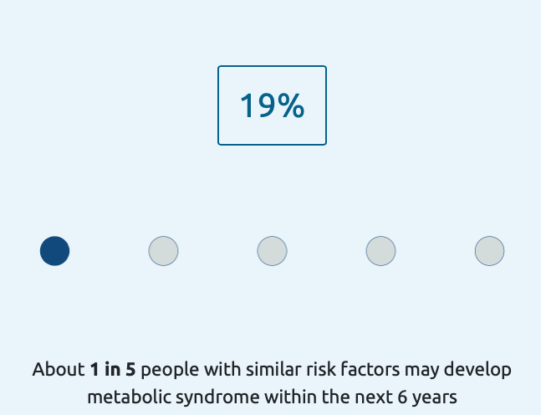
Numerical Estimate (PsyMetRiC1-MetS; PsyMetRiC2-MetS and PsyMetRiC2-T2D)
Similar to existing prediction models, we show the risk probability converted to a percentage, alongside a waffle plot. Based on stakeholder feedback, the app calculates the lowest denominator for the risk score as a basis for the waffle plot, to aid relatability.

Uncertainty (PsyMetRiC1-MetS; PsyMetRiC2-MetS
and PsyMetRiC2-T2D)
Influenced by methodological research on maximising shared decision making in prediction modelling,¹ we display a measure of uncertainty in risk estimates, estimated using a parametric bootstrap approach. The app simulates 200 sets of model coefficients from a multivariate normal distribution defined by the point estimates and their covariance matrices and recalculating predicted probabilities for each simulation. We display this uncertainty within a gauge plot.

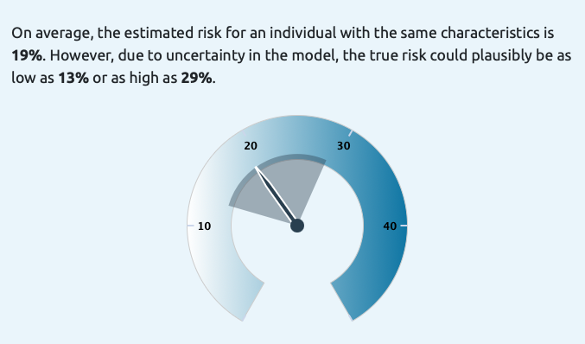

Contributors to the Risk Score (PsyMetRiC1-MetS;
PsyMetRiC2-MetS and PsyMetRiC2-T2D))
To aid in interpretability alongside maximising transparency and trust we display a graph displaying how each risk factor included in PsyMetRiC contributed to the risk score.
This graph was derived by standardising continuous predictors using the standard deviations of those variables in the development data and standardising patient values using the means of those variables also in the development data. Contributions are presented as a proportion of the total contribution to the risk score. In this visualisation, we round relative contributions to the nearest 5%.

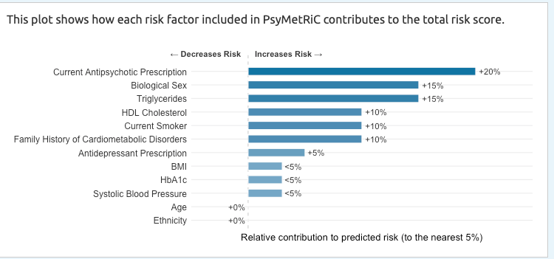

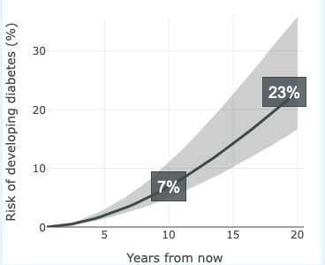
Risk Over Time (PsyMetRiC2-T2D)
We show how risk changes over time as an animation by calculating the risk at interval timepoints between 0-20 years using the model baseline hazard function (shape and scale parameters) and individual covariates via a linear predictor. The cumulative incidence function was applied to generate a risk score over time, with uncertainty intervals derived from 200 parametric bootstrap simulations as above.

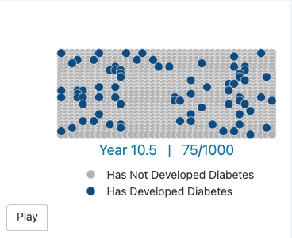
In addition, in response to stakeholder feedback that some individuals may struggle with graphs (that may seem too scientific or statistical), we present the same information as an animation over time of a “crowd of 1000 people with similar characteristics” tracking how many may develop type 2 diabetes over time.

Comparison with Similar Individual (PsyMetRiC2-T2D)
Drawn using a similar approach to the “Risk over Time” plot described above, we allow users to make adjustments to potentially modifiable risk factors (smoking status, BMI, HDL, triglycerides, systolic blood pressure, HbA1C and medication) while fixing non-modifiable characteristics to those of the individual. We report this plot as a comparison to a hypothetical similar individual, and take steps in the description and presentation of this visualisation to limit causal interpretation. This plot received consensus preference by all stakeholder groups in how it may encourage motivation toward behaviour change.
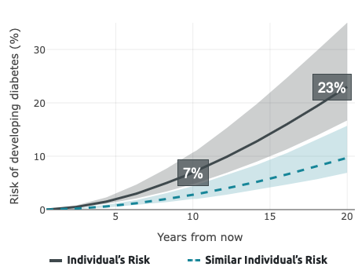

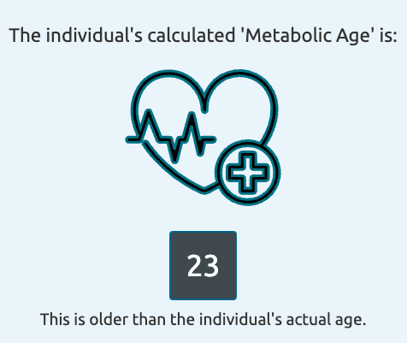
PsyMetRiC Metabolic Age (PsyMetRiC2-T2D)
Following the concept of “heart age” calculators from cardiovascular disease prediction models, the PsyMetRiC metabolic age is computed by comparing an individual’s predicted risk to that of a hypothetical reference individual of varying chronological age but with optimal potentially modifiable risk factors. The metabolic age corresponds to the age at which the reference individual exhibits the same predicted risk as the observed individual.

Supplementary Tables

Supplementary Table 1: Missing Sample Comparison for PsyMetRiC1-MetS and PsyMetRiC2-MetS in CPRD & QResearch
Variable | Level | QResearch |  |  | CPRD
Variable | Level | Excluded | Included | p | Excluded | Included | p
n |  | 41,010 | 4,347 | - | 14,594 | 3,989 | -
Age Baseline (mean (SD)) |  | 26·1 (5·4) | 25·5 (5·6) | <0·001 | 24·52 (5·36) | 24·20 (5·6) | 0·001
Male Sex (n, %) |  | 20,710 (50·5) | 2,220 (51·1) | <0·001 | 7220 (49·7) | 2060 (51·6) | 0·025
Ethnic Group (n, %) | Black African / Caribbean | 3,404 (8·3) | 438 (10·1) | <0·001 | 1093 (7·5) | 404 (10·1) | <0·001
Ethnic Group (n, %) | East Asian / Other | 4,101 (10·0) | 419 (9·6) | <0·001 | 1,532 (10·5) | 452 (11·3) | <0·001
Ethnic Group (n, %) | Mixed | - | - | <0·001 | 934 (6·4) | 303 (7·6) | <0·001
Ethnic Group (n, %) | South Asian | 4,306 (10·5) | 510 (11·7) | <0·001 | 1,319 (9·0) | 422 (10·5) | <0·001
Ethnic Group (n, %) | White | 29,199 (71·2) | 2,972 (68·4) | <0·001 | 10016 (68·6) | 2468 (60·9) | <0·001
Baseline Smoking (n, %) |  | 22,801 (55·6) | 3,039 (55·7) | 0·393 | 8,376 (57·4) | 2,493 (62·5) | 0·132
Townsend Deprivation Index (mean, SD) |  | 3·80 (1·24) | 3·63 (1·31) | <0·001 | 3·48 (1·32) | 3·58 (1·33) | <0·001

Variable | Level | QResearch |  |  | CPRD
Variable | Level | Excluded | Included | p | Excluded | Included | p
n |  | 37,870 | 7,487 | - | 9,402 | 9,181 | -
Age Baseline (mean (SD)) |  | 26·6 (5·6) | 25·4 (5·5) | <0·001 | 24·8 (5·3) | 24·1 (5·5) | 0·023
Male Sex (n, %) |  | 23434 (62·5) | 4268 (54·5) | <0·001 | 4762 (51·2) | 4,689 (51·1) | 0·108
Ethnic Group (n, %) | Black African / Caribbean | 3,589 (9·5) | 768 (10·3) | <0·001 | 925 (9·8) | 1,151 (12·5) | <0·001
Ethnic Group (n, %) | East Asian / Other | 3,218 (8·5) | 778 (9·0) | <0·001 | 836 (8·9) | 901 (9·8) | <0·001
Ethnic Group (n, %) | Mixed | - | - | <0·001 | 479 (5·1) | 537 (5·8) | <0·001
Ethnic Group (n, %) | South Asian | 2,310 (6·1) | 736 (9·8) | <0·001 | 874 (9·3) | 954 (10·4) | <0·001
Ethnic Group (n, %) | White | 28,743 (75·9) | 5,205 (69·5) | <0·001 | 6,288 (66·9) | 5,638 (61·4) | <0·001
Baseline Smoking (n, %) |  | 21,055 (55·6) | 4,252 (56·8) | <0·001 | 6,054 (64·4) | 5,823 (64·5) | 0·227
Townsend Deprivation Index (mean, SD) |  | 3·65 (1·29) | 3·71 (1·28) | 0·001 | 3·57 (1·32) | 3·55 (1·31) | 0·189
Supplementary Table 2: Missing Sample Comparison for PsyMetRiC2-T2D in CPRD & QResearch

Variable | Level | Secondary Care Data
Variable | Level | Excluded | Included | p
n |  | 3,119 | 846 | -
Age Baseline (mean (SD)) |  | 25·2 (5·1) | 24·8 (4·9) | 0·040
Male Sex (n, %) |  | 2,003 (64·2) | 538 (63·6) | 0·767
Ethnic Group (n, %) | Black African / Caribbean | 1,445 (46·3) | 452 (53·4) | <0·001
Ethnic Group (n, %) | East Asian / Other | 323 (4·3) | 39 (4·6) | <0·001
Ethnic Group (n, %) | Mixed | 189 (6·1) | 43 (5·1) | <0·001
Ethnic Group (n, %) | South Asian | 106 (3·4) | 39 (4·6) | <0·001
Baseline Smoking (n, %) |  | 21,055 (55·6) | 4,252 (56·8) | <0·001
Supplementary Table 3: Missing Sample Comparison for PsyMetRiC2-WG in Secondary Care Data

Supplementary Table 4: Linear Predictor Distribution of PsyMetRiC1-MetS and PsyMetRiC2-MetS in CPRD and QResearch
Model | Mean (SD) | Median (IQR) | Skew
CPRD
PsyMetRiC Original – Full Model | -1·64 (1·04) | -1·78 (1·32) | 0·76
PsyMetRiC Original – Partial Model | -1·14 (1·08) | -1·28 (1·35) | 0·80
PsyMetRiC1-MetS - Full Model | -1·63 (1·18) | -1·80 (1·52) | 0·80
PsyMetRiC1-MetS – Partial Model | -1·55 (1·02) | -1·72 (1·28) | 0·89
PsyMetRiC2-MetS - Full Model | -1·66 (1·23) | -1·80 (1·63) | 0·69
PsyMetRiC2-MetS - Partial Model | -1·59 (1·08) | -1·72 (1·40) | 0·72
QResearch
PsyMetRiC2-MetS – Full Model | -1·68 (1·14) | -1·81 (1·57) | 0·43
PsyMetRiC2-MetS - Partial Model | -1·37 (0·98) | -1·47 (1·31) | 0·50

Supplementary Table 5: Numerical Estimates of Predictive Accuracy for PsyMetRiC Metabolic Syndrome Models in CPRD
Model | Metric | Original PsyMetRiC | PsyMetRiC1-MetS | PsyMetRiC2-MetS
Full Model | C-statistic | 0·78 (0·76-0·81) | 0·79 (0·76-0·81) | 0·80 (0·77-0·82)
Full Model | Calibration intercept | 0·06 (0·02-0·09) | 0 SE=0 | 0 SE=0
Full Model | Calibration slope | 1·02 (0·91-1·14) | 1 SE=0 | 1 SE=0
Full Model | Brier score | 0·13 (0·12-0·14) | 0·13 (0·12-0·14) | 0·12 (0·11-0·12)
Partial Model | C-statistic | 0·77 (0·74-0·79) | 0·77 (0·75-0·79) | 0·78 (0·76-0·80)
Partial Model | Calibration intercept | -0·067 (-0·12-0·01) | 0 SE=0 | 0 SE=0
Partial Model | Calibration slope | 0·921 (0·82-1·01) | 1 SE=0 | 1 SE=0
Partial Model | Brier score | 0·14 (0·13-0·15) | 0·14 (0·13-0·15) | 0·13 (0·12-0·14)

Supplementary Table 6: External Validation Numerical Decision Curve Analysis Results for PsyMetRiC2-MetS in QResearch
Threshold | Net Benefit Full Model | Net Benefit Partial Model | Standardised Net Benefit Full Model | Standardised Net Benefit Partial Model
0·00 | 0·199 (0·188, 0·210) | 0·199 (0·187, 0·209) | 1·000 (1·000, 1·000) | 1·000 (1·000, 1·000)
0·01 | 0·190 (0·180, 0·202) | 0·190 (0·178, 0·201) | 0·959 (0·956, 0·962) | 0·959 (0·956, 0·962)
0·02 | 0·182 (0·171, 0·194) | 0·182 (0·170, 0·193) | 0·918 (0·912, 0·923) | 0·918 (0·912, 0·923)
0·03 | 0·174 (0·163, 0·186) | 0·174 (0·162, 0·185) | 0·876 (0·867, 0·884) | 0·878 (0·869, 0·886)
0·04 | 0·165 (0·154, 0·178) | 0·167 (0·154, 0·178) | 0·833 (0·821, 0·846) | 0·841 (0·827, 0·852)
0·05 | 0·158 (0·146, 0·170) | 0·160 (0·148, 0·172) | 0·795 (0·779, 0·810) | 0·808 (0·793, 0·822)
0·06 | 0·151 (0·139, 0·163) | 0·155 (0·142, 0·166) | 0·758 (0·741, 0·776) | 0·779 (0·760, 0·793)
0·07 | 0·144 (0·132, 0·157) | 0·149 (0·137, 0·160) | 0·723 (0·703, 0·744) | 0·752 (0·731, 0·769)
0·08 | 0·138 (0·126, 0·151) | 0·144 (0·132, 0·155) | 0·694 (0·671, 0·716) | 0·724 (0·700, 0·742)
0·09 | 0·133 (0·121, 0·146) | 0·139 (0·127, 0·151) | 0·670 (0·645, 0·694) | 0·701 (0·672, 0·721)
0·10 | 0·128 (0·117, 0·142) | 0·135 (0·123, 0·146) | 0·647 (0·621, 0·671) | 0·678 (0·650, 0·700)
0·11 | 0·125 (0·113, 0·138) | 0·129 (0·117, 0·141) | 0·628 (0·600, 0·657) | 0·650 (0·619, 0·676)
0·12 | 0·121 (0·110, 0·134) | 0·124 (0·111, 0·135) | 0·611 (0·582, 0·641) | 0·622 (0·588, 0·650)
0·13 | 0·117 (0·105, 0·130) | 0·119 (0·105, 0·130) | 0·591 (0·560, 0·622) | 0·599 (0·562, 0·627)
0·14 | 0·115 (0·102, 0·127) | 0·116 (0·102, 0·127) | 0·577 (0·547, 0·610) | 0·583 (0·547, 0·610)
0·15 | 0·112 (0·100, 0·125) | 0·112 (0·100, 0·123) | 0·563 (0·529, 0·599) | 0·566 (0·529, 0·597)
0·16 | 0·109 (0·096, 0·121) | 0·108 (0·095, 0·120) | 0·548 (0·512, 0·583) | 0·546 (0·506, 0·579)
0·17 | 0·107 (0·094, 0·119) | 0·105 (0·091, 0·116) | 0·537 (0·502, 0·572) | 0·529 (0·489, 0·558)
0·18 | 0·105 (0·093, 0·117) | 0·099 (0·087, 0·110) | 0·528 (0·491, 0·566) | 0·500 (0·462, 0·531)
0·19 | 0·103 (0·091, 0·115) | 0·096 (0·084, 0·107) | 0·520 (0·480, 0·553) | 0·483 (0·446, 0·516)
0·20 | 0·100 (0·088, 0·112) | 0·094 (0·083, 0·106) | 0·503 (0·466, 0·541) | 0·476 (0·441, 0·512)
0·21 | 0·097 (0·085, 0·109) | 0·091 (0·080, 0·102) | 0·488 (0·447, 0·528) | 0·458 (0·421, 0·495)
0·22 | 0·094 (0·083, 0·106) | 0·088 (0·077, 0·100) | 0·474 (0·438, 0·510) | 0·444 (0·402, 0·483)
0·23 | 0·092 (0·080, 0·104) | 0·086 (0·075, 0·097) | 0·462 (0·422, 0·504) | 0·435 (0·392, 0·474)
0·24 | 0·088 (0·076, 0·100) | 0·083 (0·073, 0·095) | 0·443 (0·402, 0·485) | 0·419 (0·380, 0·454)
0·25 | 0·088 (0·077, 0·100) | 0·080 (0·069, 0·091) | 0·445 (0·403, 0·486) | 0·401 (0·360, 0·437)
0·26 | 0·086 (0·075, 0·097) | 0·077 (0·064, 0·086) | 0·431 (0·388, 0·472) | 0·386 (0·342, 0·421)
0·27 | 0·083 (0·072, 0·094) | 0·073 (0·060, 0·083) | 0·417 (0·371, 0·459) | 0·366 (0·319, 0·403)
0·28 | 0·081 (0·070, 0·093) | 0·069 (0·056, 0·079) | 0·410 (0·364, 0·450) | 0·349 (0·299, 0·388)
0·29 | 0·078 (0·068, 0·089) | 0·067 (0·055, 0·076) | 0·394 (0·347, 0·432) | 0·337 (0·287, 0·374)
0·30 | 0·075 (0·064, 0·086) | 0·065 (0·052, 0·075) | 0·377 (0·328, 0·418) | 0·326 (0·278, 0·367)
0·31 | 0·072 (0·062, 0·083) | 0·063 (0·050, 0·073) | 0·365 (0·315, 0·405) | 0·315 (0·261, 0·356)
0·32 | 0·071 (0·060, 0·082) | 0·061 (0·049, 0·071) | 0·357 (0·306, 0·398) | 0·306 (0·253, 0·344)
0·33 | 0·070 (0·058, 0·081) | 0·058 (0·046, 0·069) | 0·353 (0·301, 0·396) | 0·294 (0·244, 0·336)
0·34 | 0·068 (0·057, 0·079) | 0·057 (0·045, 0·067) | 0·342 (0·294, 0·382) | 0·286 (0·236, 0·330)
0·35 | 0·067 (0·056, 0·078) | 0·056 (0·044, 0·065) | 0·340 (0·288, 0·379) | 0·281 (0·229, 0·324)
0·36 | 0·067 (0·054, 0·077) | 0·054 (0·043, 0·065) | 0·336 (0·285, 0·378) | 0·274 (0·223, 0·313)
0·37 | 0·066 (0·054, 0·076) | 0·053 (0·042, 0·062) | 0·331 (0·286, 0·372) | 0·266 (0·215, 0·305)
0·38 | 0·062 (0·051, 0·072) | 0·048 (0·038, 0·058) | 0·313 (0·264, 0·352) | 0·243 (0·198, 0·285)
0·39 | 0·060 (0·049, 0·069) | 0·047 (0·036, 0·056) | 0·303 (0·255, 0·342) | 0·235 (0·187, 0·275)
0·40 | 0·060 (0·049, 0·069) | 0·044 (0·033, 0·052) | 0·300 (0·253, 0·340) | 0·221 (0·172, 0·261)
0·41 | 0·058 (0·047, 0·067) | 0·041 (0·031, 0·050) | 0·294 (0·247, 0·331) | 0·209 (0·163, 0·242)
0·42 | 0·055 (0·045, 0·064) | 0·038 (0·029, 0·046) | 0·277 (0·235, 0·316) | 0·192 (0·147, 0·227)
0·43 | 0·053 (0·043, 0·062) | 0·036 (0·027, 0·044) | 0·265 (0·219, 0·307) | 0·179 (0·139, 0·219)
0·44 | 0·051 (0·041, 0·060) | 0·034 (0·024, 0·043) | 0·258 (0·214, 0·295) | 0·172 (0·126, 0·210)
0·45 | 0·047 (0·038, 0·057) | 0·032 (0·022, 0·040) | 0·238 (0·199, 0·281) | 0·163 (0·117, 0·200)
0·46 | 0·045 (0·037, 0·054) | 0·032 (0·022, 0·041) | 0·226 (0·190, 0·267) | 0·161 (0·119, 0·203)
0·47 | 0·044 (0·035, 0·053) | 0·030 (0·021, 0·039) | 0·221 (0·183, 0·259) | 0·150 (0·106, 0·192)
0·48 | 0·041 (0·032, 0·050) | 0·029 (0·020, 0·038) | 0·208 (0·165, 0·248) | 0·148 (0·101, 0·191)
0·49 | 0·040 (0·031, 0·048) | 0·029 (0·020, 0·038) | 0·201 (0·155, 0·239) | 0·148 (0·102, 0·189)
0·50 | 0·037 (0·028, 0·046) | 0·028 (0·019, 0·036) | 0·188 (0·145, 0·229) | 0·143 (0·097, 0·181)
Supplementary Table 7: Confusion Matrix and Associated Metrics at Illustrative Thresholds for PsyMetRiC2-MetS in QResearch
Threshold | Sensitivity | Specificity | PPV | NPV | FPR | FNR
Full Model
0·05 | 0·99 | 0·12 | 0·20 | 0·99 | 0·88 | 0·01
0·10 | 0·95 | 0·41 | 0·26 | 0·97 | 0·59 | 0·05
0·20 | 0·79 | 0·74 | 0·74 | 0·94 | 0·26 | 0·21
Partial Model
0·05 | 1·00 | 0·04 | 0·18 | 1·00 | 0·96 | 0·00
0·10 | 0·99 | 0·25 | 0·22 | 0·99 | 0·75 | 0·01
0·20 | 0·85 | 0·63 | 0·33 | 0·95 | 0·36 | 0·15
PPV=positive predictive value; NPV=negative predictive value; FPR=false positive rate; FNR=false negative rate

Supplementary Table 8: Linear Predictor Distribution of PsyMetRiC2-T2D in CPRD and QResearch
Dataset | Mean (SD) | Median (IQR) | Skew
CPRD | 8·12 (1·43) | 8·07 (1·82) | 0·27
QResearch | 8·55 (1·14) | 8·62 (1·44) | 0·37

Supplementary Table 9: External Validation Numerical Decision Curve Analysis Results for PsyMetRiC2-T2D in QResearch
Threshold | Net Benefit | Standardised Net Benefit
0·00 | 0·075 | 1·000
0·01 | 0·065 | 0·875
0·02 | 0·058 | 0·778
0·03 | 0·053 | 0·715
0·04 | 0·048 | 0·648
0·05 | 0·047 | 0·626
0·06 | 0·043 | 0·585
0·07 | 0·040 | 0·541
0·08 | 0·038 | 0·509
0·09 | 0·037 | 0·497
0·10 | 0·035 | 0·469
0·11 | 0·034 | 0·460
0·12 | 0·033 | 0·443
0·13 | 0·032 | 0·426
0·14 | 0·030 | 0·403
0·15 | 0·029 | 0·389
0·16 | 0·027 | 0·363
0·17 | 0·026 | 0·365
0·18 | 0·025 | 0·354
0·19 | 0·024 | 0·334
0·20 | 0·023 | 0·322
0·21 | 0·023 | 0·324
0·22 | 0·022 | 0·313
0·23 | 0·022 | 0·308
0·24 | 0·022 | 0·295
0·25 | 0·021 | 0·295
0·26 | 0·021 | 0·290
0·27 | 0·021 | 0·278
0·28 | 0·020 | 0·278
0·29 | 0·020 | 0·270
0·30 | 0·019 | 0·266
0·31 | 0·018 | 0·266
0·32 | 0·017 | 0·260
0·33 | 0·016 | 0·245
0·34 | 0·015 | 0·226
0·35 | 0·014 | 0·220
0·36 | 0·014 | 0·207
0·37 | 0·013 | 0·191
0·38 | 0·013 | 0·186
0·39 | 0·012 | 0·176
0·40 | 0·012 | 0·170

Supplementary Table 10: Confusion Matrix and Associated Metrics at Illustrative Thresholds for PsyMetRiC2-T2D at 10y in QResearch
Threshold | Sensitivity | Specificity | PPV | NPV | FPR | FNR
0·05 | 0·93 | 0·57 | 0·08 | 0·99 | 0·43 | 0·07
0·10 | 0·79 | 0·79 | 0·14 | 0·99 | 0·21 | 0·21
0·20 | 0·58 | 0·92 | 0·24 | 0·98 | 0·08 | 0·41
PPV=positive predictive value; NPV=negative predictive value; FPR=false positive rate; FNR=false negative rate

Supplementary Table 11: Numerical Decision Curve Analysis Results for PsyMetRiC2-WG
Threshold | Net Benefit (Full Model) | Net Benefit (Partial Model) | Standardised Net Benefit (Full Model) | Standardised Net Benefit (Partial Model)
0·00 | 0·288 (0·260, 0·314) | 0·288 (0·255, 0·323) | 1·000 (1·000, 1·000) | 1·000 (1·000, 1·000)
0·01 | 0·280 (0·252, 0·308) | 0·280 (0·246, 0·312) | 0·971 (0·961, 0·978) | 0·971 (0·961, 0·978)
0·02 | 0·273 (0·244, 0·301) | 0·272 (0·238, 0·306) | 0·948 (0·935, 0·957) | 0·944 (0·928, 0·956)
0·03 | 0·267 (0·238, 0·295) | 0·266 (0·232, 0·300) | 0·926 (0·911, 0·938) | 0·921 (0·904, 0·937)
0·04 | 0·259 (0·229, 0·285) | 0·259 (0·225, 0·292) | 0·897 (0·876, 0·915) | 0·898 (0·875, 0·913)
0·05 | 0·253 (0·224, 0·280) | 0·253 (0·219, 0·286) | 0·877 (0·854, 0·898) | 0·876 (0·852, 0·895)
0·06 | 0·247 (0·218, 0·275) | 0·246 (0·213, 0·280) | 0·857 (0·831, 0·880) | 0·852 (0·826, 0·876)
0·07 | 0·238 (0·209, 0·266) | 0·238 (0·205, 0·274) | 0·825 (0·795, 0·852) | 0·826 (0·797, 0·858)
0·08 | 0·233 (0·204, 0·262) | 0·231 (0·197, 0·267) | 0·807 (0·776, 0·837) | 0·800 (0·764, 0·833)
0·09 | 0·224 (0·196, 0·251) | 0·226 (0·191, 0·263) | 0·777 (0·740, 0·807) | 0·785 (0·748, 0·823)
0·10 | 0·217 (0·191, 0·244) | 0·217 (0·185, 0·253) | 0·754 (0·717, 0·790) | 0·753 (0·710, 0·794)
0·11 | 0·212 (0·182, 0·239) | 0·212 (0·181, 0·248) | 0·734 (0·693, 0·771) | 0·734 (0·691, 0·778)
0·12 | 0·200 (0·168, 0·227) | 0·202 (0·171, 0·236) | 0·692 (0·640, 0·734) | 0·699 (0·642, 0·746)
0·13 | 0·195 (0·165, 0·222) | 0·197 (0·168, 0·230) | 0·678 (0·628, 0·717) | 0·684 (0·627, 0·731)
0·14 | 0·194 (0·164, 0·221) | 0·191 (0·161, 0·225) | 0·671 (0·618, 0·710) | 0·662 (0·606, 0·710)
0·15 | 0·188 (0·157, 0·215) | 0·188 (0·157, 0·221) | 0·652 (0·595, 0·692) | 0·650 (0·594, 0·699)
0·16 | 0·182 (0·151, 0·210) | 0·184 (0·153, 0·216) | 0·633 (0·572, 0·680) | 0·637 (0·580, 0·688)
0·17 | 0·176 (0·143, 0·200) | 0·178 (0·149, 0·212) | 0·600 (0·532, 0·648) | 0·616 (0·557, 0·677)
0·18 | 0·175 (0·137, 0·194) | 0·171 (0·142, 0·205) | 0·596 (0·508, 0·689) | 0·583 (0·533, 0·652)
0·19 | 0·170 (0·131, 0·189) | 0·166 (0·135, 0·200) | 0·585 (0·486, 0·678) | 0·575 (0·515, 0·642)
0·20 | 0·166 (0·128, 0·186) | 0·159 (0·128, 0·193) | 0·562 (0·475, 0·660) | 0·550 (0·489, 0·617)
0·21 | 0·161 (0·122, 0·180) | 0·153 (0·121, 0·186) | 0·552 (0·458, 0·652) | 0·530 (0·462, 0·596)
0·22 | 0·154 (0·115, 0·173) | 0·147 (0·117, 0·180) | 0·523 (0·428, 0·649) | 0·509 (0·443, 0·577)
0·23 | 0·152 (0·114, 0·170) | 0·143 (0·114, 0·176) | 0·517 (0·423, 0·633) | 0·494 (0·428, 0·563)
0·24 | 0·152 (0·114, 0·171) | 0·139 (0·112, 0·172) | 0·491 (0·426, 0·619) | 0·481 (0·418, 0·555)
0·25 | 0·144 (0·107, 0·165) | 0·136 (0·109, 0·171) | 0·486 (0·395, 0·591) | 0·473 (0·405, 0·546)
0·26 | 0·141 (0·102, 0·162) | 0·136 (0·109, 0·171) | 0·482 (0·377, 0·589) | 0·471 (0·403, 0·548)
0·27 | 0·133 (0·097, 0·155) | 0·126 (0·099, 0·158) | 0·468 (0·355, 0·570) | 0·435 (0·370, 0·513)
0·28 | 0·131 (0·093, 0·151) | 0·123 (0·095, 0·157) | 0·458 (0·341, 0·526) | 0·428 (0·358, 0·503)
0·29 | 0·127 (0·090, 0·150) | 0·114 (0·086, 0·145) | 0·447 (0·331, 0·507) | 0·395 (0·321, 0·465)
0·30 | 0·123 (0·084, 0·145) | 0·113 (0·084, 0·144) | 0·432 (0·311, 0·494) | 0·391 (0·314, 0·462)
0·31 | 0·122 (0·084, 0·144) | 0·110 (0·082, 0·140) | 0·422 (0·306, 0·491) | 0·382 (0·305, 0·455)
0·32 | 0·121 (0·081, 0·143) | 0·107 (0·078, 0·136) | 0·395 (0·297, 0·482) | 0·370 (0·288, 0·440)
0·33 | 0·118 (0·078, 0·140) | 0·101 (0·071, 0·132) | 0·376 (0·291, 0·458) | 0·351 (0·260, 0·423)
0·34 | 0·115 (0·077, 0·139) | 0·096 (0·065, 0·127) | 0·364 (0·279, 0·449) | 0·333 (0·244, 0·402)
0·35 | 0·112 (0·072, 0·138) | 0·096 (0·067, 0·124) | 0·359 (0·271, 0·445) | 0·334 (0·245, 0·408)
0·36 | 0·111 (0·071, 0·139) | 0·097 (0·066, 0·125) | 0·351 (0·269, 0·449) | 0·337 (0·245, 0·415)
0·37 | 0·111 (0·073, 0·136) | 0·093 (0·062, 0·119) | 0·351 (0·267, 0·443) | 0·322 (0·233, 0·391)
0·38 | 0·114 (0·075, 0·138) | 0·094 (0·066, 0·119) | 0·361 (0·277, 0·445) | 0·327 (0·240, 0·397)
0·39 | 0·112 (0·072, 0·133) | 0·098 (0·068, 0·124) | 0·358 (0·268, 0·432) | 0·338 (0·252, 0·407)
0·40 | 0·107 (0·068, 0·126) | 0·096 (0·069, 0·121) | 0·346 (0·258, 0·412) | 0·332 (0·242, 0·402)
0·41 | 0·102 (0·065, 0·122) | 0·090 (0·062, 0·116) | 0·338 (0·234, 0·410) | 0·313 (0·232, 0·384)
0·42 | 0·101 (0·062, 0·120) | 0·083 (0·055, 0·111) | 0·326 (0·222, 0·407) | 0·288 (0·200, 0·361)
0·43 | 0·099 (0·062, 0·122) | 0·081 (0·051, 0·109) | 0·320 (0·222, 0·401) | 0·280 (0·185, 0·360)
0·44 | 0·094 (0·056, 0·116) | 0·079 (0·051, 0·106) | 0·300 (0·227, 0·384) | 0·273 (0·185, 0·356)
0·45 | 0·092 (0·055, 0·118) | 0·079 (0·050, 0·106) | 0·294 (0·194, 0·378) | 0·274 (0·177, 0·363)
0·46 | 0·085 (0·047, 0·112) | 0·071 (0·043, 0·098) | 0·280 (0·170, 0·371) | 0·247 (0·161, 0·329)
0.47 | 0.085 (0.050, 0.107) | 0.071 (0.043, 0.099) | 0.280 (0.170, 0.350) | 0·246 (0·160, 0·335)
0.48 | 0.081 (0.042, 0.105) | 0.067 (0.038, 0.097) | 0.275 (0.151, 0.349) | 0·234 (0·137, 0·314)
0.49 | 0.072 (0.034, 0.096) | 0.065 (0.038, 0.091) | 0.264 (0.121, 0.331) | 0·227 (0·137, 0·296)
0.50 | 0.071 (0.033, 0.096) | 0.059 (0.032, 0.083) | 0.263 (0.116, 0.329) | 0·205 (0·117, 0·276)

Supplementary Figures
Supplementary Figure 1: Flow Chart of Included Participants
Age 16-35 with first recorded psychosis-spectrum disorder between 2005-1015 and >1 year follow-up
CPRD
MetS
n=18,453
T2D
n=18,453
With sufficient data on predictors and outcome variables
MetS
n=4,051
T2D
n=9,229
Without outcome at baseline
MetS
n=3,989
T2D
n=9,181
Age 16-35 with first recorded psychosis-spectrum disorder between 2005-1015 and >1 year follow-up
QResearch
MetS
n=45,357
T2D
n=45,357
With sufficient data on predictors and outcome variables
MetS
n=4,442
T2D
n=7,519
Without outcome at baseline
MetS
n=4,347
T2D
n=7,487
Age 16-35 accepted onto the EIS caseload between 2012-2024
SLaM EIS
Weight Gain
n=3,965
With sufficient data on predictors and outcome variables
Weight Gain
n=1,042
Without outcome at baseline?
Weight Gain
n=846

CPRD=Clinical Practice Research Datalink; SLaM EIS = South London and Maudsley NHS Foundation Trust Early Intervention Service; MetS=Metabolic Syndrome; T2D=Type 2 Diabetes
Supplementary Figure 2: Developmental Lineage and Translational Trajectory of PsyMetRiC Models
Stage 1 (2021-2025)
PsyMetRiC (Full & Partial, MetS) UK Development & External Validation, Secondary Care, Perry et al, (2021)

International External Validation & Site-Specific Recalibrations (2022-2025)

Spain (PsyMetRiC-ES), Perry et al, (2022)
Switzerland (PsyMetRiC-CH), Perry et al, (2022)
Hong Kong (PsyMetRiC-HK), Tse et al, (2023)
Finland (PsyMetRiC-FI), Keinenan et al, (2024)
Australia (PsyMetRiC-AUS), Teasdale et al, (2025)
Stage 2 (2022-2025)
Canada (PsyMetRiC-CAN), Brodeur et al, (2025)

Validation in Primary Care
PsyMetRiC1-MetS
Model Revision
PsyMetRiC2-MetS
Model Extension
PsyMetRiC
SaMD
PsyMetRiC2-T2D
Stage 1 describes work conducted prior to this study: Original PsyMetRiC models (predicting metabolic syndrome (MetS); full and partial versions) were developed and externally validated in UK secondary care data. Subsequent international external validations included site-specific recalibrations (intercept and slope terms). Stage 2 describes work described in this study: The original PsyMetRiC models were validated in primary care data (CPRD), before being revised for granularity (creating PsyMetRiC1-MetS), then extended (creating PsyMetRiC2-MetS; PsyMetRiC2-T2D; PsyMetRiC2-WG). Sufficient external validation (in QResearch) was possible for PsyMetRiC1-MetS; PsyMetRiC2-MetS; PsyMetRiC2-T2D, allowing their inclusion in the web application, which is certified as a Class 1 Medical Device under UK MDR (2002, as amended) for clinical use in Great Britain.
PsyMetRiC2-WG

Supplementary Figure 3: Geographical Spread of CPRD and QResearch Samples
- CPRD Gold (n=18,453) B. QResearch (n=45,357)
Supplementary Figure 4: Distributions of Predicted Outcome Probabilities for PsyMetRiC Metabolic Syndrome Models in CPRD
- Original PsyMetRiC Full Model
- PsyMetRiC1-MetS - Full Model
- PsyMetRiC2-MetS - Full Model

- Original PsyMetRiC Partial Model

E. PsyMetRiC1-MetS - Partial Model

F. PsyMetRiC2-MetS - Partial Model

Supplementary Figure 5: Distributions of Predicted Outcome Probabilities for PsyMetRiC2-MetS in QResearch
- PsyMetRiC2-MetS - Full Model
- PsyMetRiC2-MetS - Partial Model

Supplementary Figure 6: Calibration Plots of Original PsyMetRiC Metabolic Syndrome Models in CPRD
- Original PsyMetRiC – Full Model
- PsyMetRiC1-MetS - Full Model
- PsyMetRiC2-MetS – Full Model

- Original PsyMetRiC – Partial Model
- PsyMetRiC1-MetS – Partial Model
- PsyMetRiC2-MetS – Partial Model
Supplementary Figure 7: Predicted Outcome Probabilities of PsyMetRiC2-T2D in CPRD and QResearch
- Model Development in CPRD
- External Validation in QResearch

Supplementary Figure 8: Internal Validation Calibration Plot of PsyMetRiC2-T2D in CPRD

Supplementary Figure 9: Distributions of Predicted Outcome Probabilities for PsyMetRiC2-WG in Secondary Care Data

- Partial Model
- Full Model

Supplementary Figure 10: Prediction Stability for PsyMetRiC2-WG in Secondary Care Data

- Partial Model
- Full Model

Supplementary Figure 11: Internal Validation Calibration Plots of PsyMetRiC2-WG in Secondary Care Data

- Full Model
- Partial Model

Supplementary Figure 12: Decision Curve Analysis of PsyMetRiC2-WG in Secondary Care Data

Supplementary Figure 13: Differences in Discrimination Accuracy of PsyMetRiC2-MetS by Sex and Ethnicity in QResearch
Partial Model
Full Model
- Stratified by Biological Sex
Full Model
Partial Model
- Stratified by Ethnic Group

Supplementary Figure 14: Differences in Calibration Accuracy of PsyMetRiC2-MetS by Sex in QResearch
- Full Model
- Partial Model
Supplementary Figure 15: Differences in Calibration Accuracy of PsyMetRiC2-MetS by Ethnicity in QResearch
- Full Model
Black African/Caribbean
South Asian
East Asian / Other
White European
- Partial Model
Black African/Caribbean
White European
South Asian
East Asian / Other

Supplementary Figure 16: Differences in Clinical Usefulness of PsyMetRiC2-MetS by Sex and Ethnicity in QResearch
A. Stratified by Biological Sex
Partial Model
Full Model
B. Stratified by Ethnic Background
Su
Full Model
Partial Model
Supplementary Figure 17: Differences in Discrimination Accuracy of PsyMetRiC2-T2D by Sex and Ethnicity in QResearch
- Stratified by Ethnic Group
- Stratified by Biological Sex

Supplementary Figure 18: Differences in Calibration Accuracy of PsyMetRiC2-T2D by Sex and Ethnic Background in QResearch
Females
Males
- Sex
- Ethnic Background
White European
Black African/Caribbean
South Asian
East Asian / Other

Supplementary Figure 19: Differences in Clinical Usefulness of PsyMetRiC2-T2D by Sex and Ethnicity in QResearch
Males
Females
- Stratified by Biological Sex
- Stratified by Ethnic Background
White European
East Asian / Other
South Asian
Black African/Caribbean

Supplementary Figure 20: Impact of Including Ethnicity as a Predictor in PsyMetRiC2-T2D on Calibration Accuracy in CPRD
Black African/Caribbean
South Asian
White European

East Asian / Other
Mixed
Supplementary Figure 21: Impact of Including Ethnicity as a Predictor in PsyMetRiC2-T2D on Calibration Accuracy in CPRD
South Asian
Black African/Caribbean
White European
East Asian / Other
Mixed

Supplementary Figure 22: Examples of Results Visualisations from the PsyMetRiC Web Application
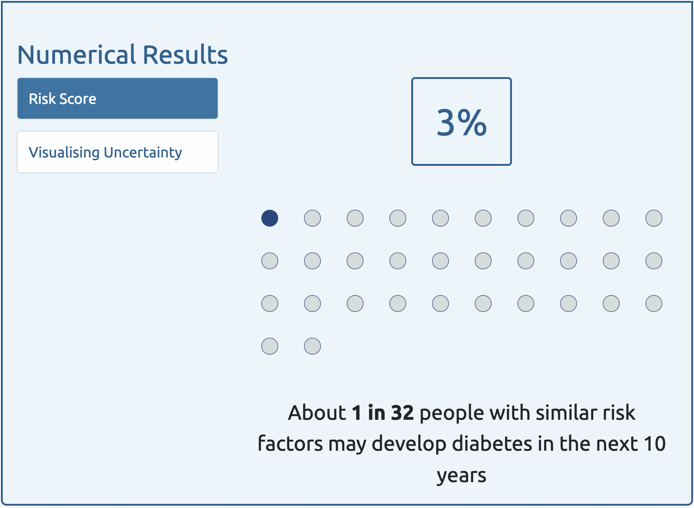
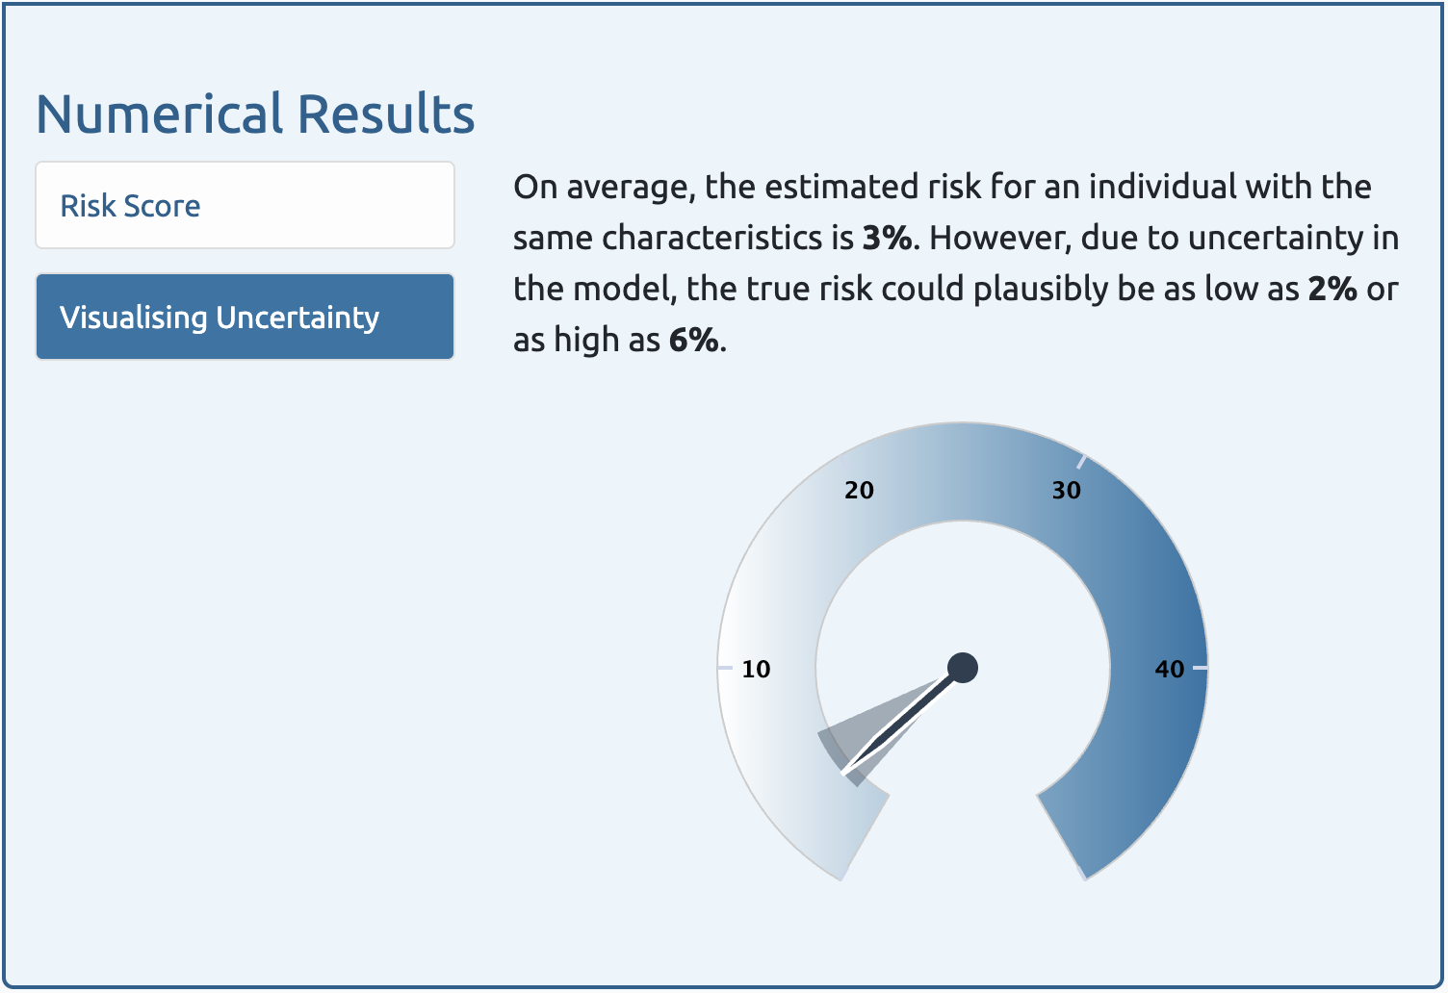
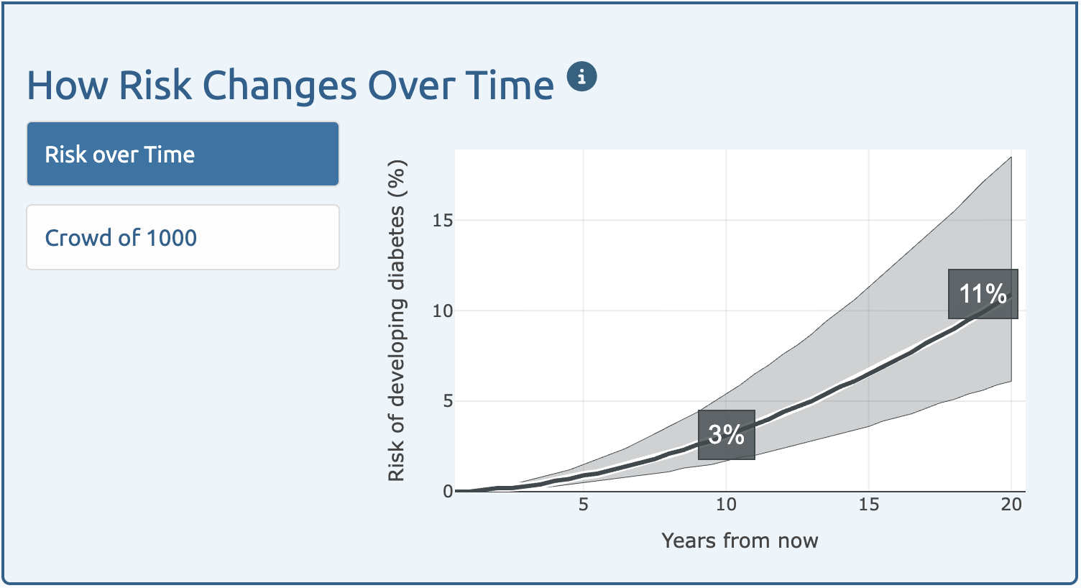
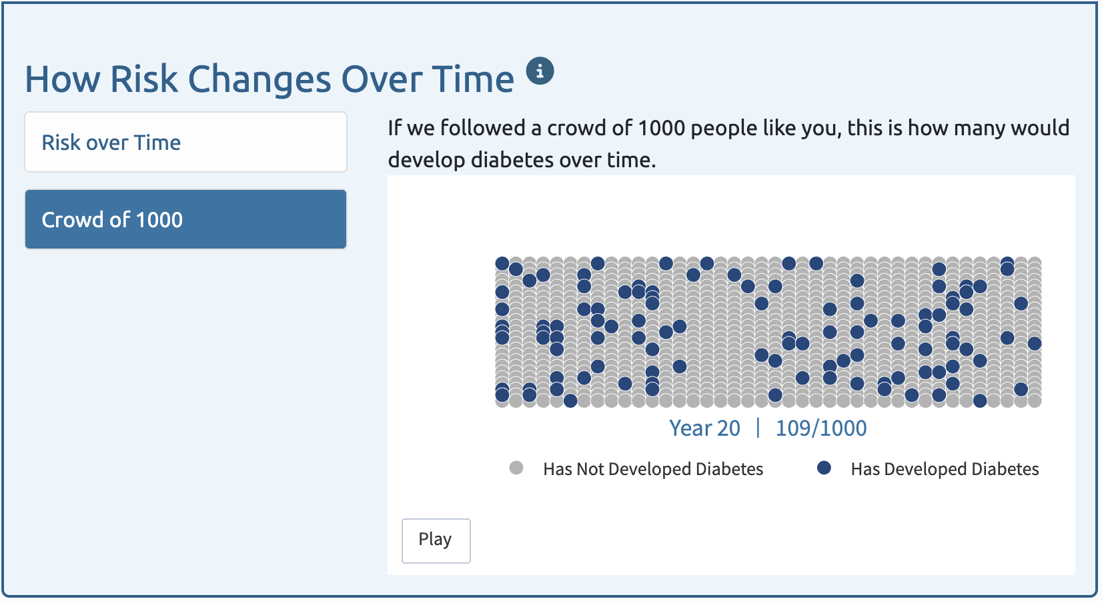
The web application presents results in a variety of graphical and numerical formats, informed by stakeholders and existing evidence. The web application can be accessed by health professionals at https://psymetric.app/

Section/Topic Item Development Checklist item  / evaluation¹ |  |  |  | Section Reported
TITLE |  |  |  | Section Reported
Title | 1 | D;E | Identify the study as developing or evaluating the performance of a multivariable prediction model, the target population, and the outcome to be predicted | Title
ABSTRACT
Abstract | 2 | D;E | See TRIPOD+AI for Abstracts checklist | See Checklist Below
INTRODUCTION
Background | 3a | D;E | Explain the healthcare context (including whether diagnostic or prognostic) and rationale for developing or evaluating the prediction model, including references to existing models | Research in Context, Background
Background | 3b | D;E | Describe the target population and the intended purpose of the prediction model in the context of the care pathway, including its intended users (e.g., healthcare professionals, patients, public) | Background, Methods – Development of the PsyMetRiC Web Application, Discussion
Background | 3c | D;E | Describe any known health inequalities between sociodemographic groups | Background, Methods – Statistical Analysis - Sensitivity Analysis – Appraising Equity
Objectives | 4 | D;E | Specify the study objectives, including whether the study describes the development or validation of a prediction model (or both) | Background, Methods – Statistical Analysis - Primary Analysis
METHODS
Data | 5a | D;E | Describe the sources of data separately for the development and evaluation datasets (e.g., randomised trial, cohort, routine care or registry data), the rationale for using these data, and representativeness of the data | Methods – Data Sources
Data | 5b | D;E | Specify the dates of the collected participant data, including start and end of participant accrual; and, if applicable, end of follow-up | Methods – Data Sources
Participants | 6a | D;E | Specify key elements of the study setting (e.g., primary care, secondary care, general population) including the number and location of centres | Methods – Data Sources
Participants | 6b | D;E | Describe the eligibility criteria for study participants | Methods – Study Population
Participants | 6c | D;E | Give details of any treatments received, and how they were handled during model development or evaluation, if relevant | N/A
Data preparation | 7 | D;E | Describe any data pre-processing and quality checking, including whether this was similar across relevant sociodemographic groups | Methods – Predictors; Methods – Statistical Analysis
Outcome | 8a | D;E | Clearly define the outcome that is being predicted and the time horizon, including how and when assessed, the rationale for choosing this outcome, and whether the method of outcome assessment is consistent across sociodemographic groups | Methods – Outcomes, Supplementary Methods; Discussion
Outcome | 8b | D;E | If outcome assessment requires subjective interpretation, describe the qualifications and demographic characteristics of the outcome assessors | N/A
Outcome | 8c | D;E | Report any actions to blind assessment of the outcome to be predicted | N/A
Predictors | 9a | D | Describe the choice of initial predictors (e.g., literature, previous models, all available predictors) and any pre-selection of predictors before model building | Methods – Predictors; Supplementary Methods
Predictors | 9b | D;E | Clearly define all predictors, including how and when they were measured (and any actions to blind assessment of predictors for the outcome and other predictors) | Methods – Predictors; Supplementary Methods
Predictors | 9c | D;E | If predictor measurement requires subjective interpretation, describe the qualifications and demographic characteristics of the predictor assessors | N/A
Sample size | 10 | D;E | Explain how the study size was arrived at (separately for development and evaluation), and justify that the study size was sufficient to answer the research question. Include details of any sample size calculation | Methods – Statistical Analysis; Supplementary Methods
Missing data | 11 | D;E | Describe how missing data were handled. Provide reasons for omitting any data | Methods – Statistical Analysis; Supplementary Methods
Analytical methods | 12a | D | Describe how the data were used (e.g., for development and evaluation of model performance) in the analysis, including whether the data were partitioned, considering any sample size requirements | Methods – Statistical Analysis; Supplementary Methods
Analytical methods | 12b | D | Depending on the type of model, describe how predictors were handled in the analyses (functional form, rescaling, transformation, or any standardisation). | Methods – Statistical Analysis; Supplementary Methods
Analytical methods | 12c | D | Specify the type of model, rationale², all model-building steps, including any hyperparameter tuning, and method for internal validation | Methods – Statistical Analysis
Analytical methods | 12d | D;E | Describe if and how any heterogeneity in estimates of model parameter values and model performance was handled and quantified across clusters (e.g., hospitals, countries). See TRIPOD-Cluster for additional considerations³ | Methods – Statistical Analysis
Analytical methods | 12e | D;E | Specify all measures and plots used (and their rationale) to evaluate model performance (e.g., discrimination, calibration, clinical utility) and, if relevant, to compare multiple models | Methods – Statistical Analysis
Analytical methods | 12f | E | Describe any model updating (e.g., recalibration) arising from the model evaluation, either overall or for particular sociodemographic groups or settings | Methods – Statistical Analysis
Analytical methods | 12g | E | For model evaluation, describe how the model predictions were calculated (e.g., formula, code, object, application programming interface) | Methods – Statistical Analysis
Class imbalance | 13 | D;E | If class imbalance methods were used, state why and how this was done, and any subsequent methods to recalibrate the model or the model predictions | N/A
Fairness | 14 | D;E | Describe any approaches that were used to address model fairness and their rationale | Methods – Statistical Analysis
Model output | 15 | D | Specify the output of the prediction model (e.g., probabilities, classification). Provide details and rationale for any classification and how the thresholds were identified | Methods – Statistical Analysis; Supplementary Methods

Training versus  evaluation | 16 | D;E | Identify any differences between the development and evaluation data in healthcare setting, eligibility  criteria, outcome, and predictors | Table 1; Supplementary Methods
Ethical approval | 17 | D;E | Name the institutional research board or ethics committee that approved the study and describe the participant-informed consent or the ethics committee waiver of informed consent | Methods – Data Sources
OPEN SCIENCE
Funding | 18a | D;E | Give the source of funding and the role of the funders for the present study | Abstract; Methods – Role of Funding Source; Acknowledgements
Conflicts of interest | 18b | D;E | Declare any conflicts of interest and financial disclosures for all authors | Declaration of Interests
Protocol | 18c | D;E | Indicate where the study protocol can be accessed or state that a protocol was not prepared | N/A
Registration | 18d | D;E | Provide registration information for the study, including register name and registration number, or state  that the study was not registered | N/A
Data sharing | 18e | D;E | Provide details of the availability of the study data | Results – Availability of PsyMetRiC
Code sharing | 18f | D;E | Provide details of the availability of the analytical code⁴ | Results – Availability of PsyMetRiC
PATIENT & PUBLIC INVOLVEMENT
Patient & Public Involvement | 19 | D;E | Provide details of any patient and public involvement during the design, conduct, reporting, interpretation, or dissemination of the study or state no involvement. | Methods – Stakeholder Engagement; Supplementary Methods
RESULTS
Participants | 20a | D;E | Describe the flow of participants through the study, including the number of participants with and without the outcome and, if applicable, a summary of the follow-up time. A diagram may be helpful. | Supplementary Figure 1
Participants | 20b | D;E | Report the characteristics overall and, where applicable, for each data source or setting, including the key dates, key predictors (including demographics), treatments received, sample size, number of outcome events, follow-up time, and amount of missing data. A table may be helpful. Report any  differences across key demographic groups. | Table 2; Supplementary Methods; Supplementary Tables 1-3
Participants | 20c | E | For model evaluation, show a comparison with the development data of the distribution of important predictors (demographics, predictors, and outcome). | Table 2
Model development | 21 | D;E | Specify the number of participants and outcome events in each analysis (e.g., for model development, hyperparameter tuning, model evaluation) | Results – Sample Characteristics; Table 2
Model specification | 22 | D | Provide details of the full prediction model (e.g., formula, code, object, application programming interface) to allow predictions in new individuals and to enable third-party evaluation and implementation, including any restrictions to access or re-use (e.g., freely available, proprietary)⁵ | Results – Availability of PsyMetRiC
Model performance | 23a | D;E | Report model performance estimates with confidence intervals, including for any key subgroups (e.g., sociodemographic). Consider plots to aid presentation. | Results (whole section); Supplementary Tables; Supplementary Figures
Model performance | 23b | D;E | If examined, report results of any heterogeneity in model performance across clusters. See TRIPOD  Cluster for additional details³. | N/A
Model updating | 24 | E | Report the results from any model updating, including the updated model and subsequent performance | Results (whole section); Supplementary Tables; Supplementary Figures
DISCUSSION
Interpretation | 25 | D;E | Give an overall interpretation of the main results, including issues of fairness in the context of the  objectives and previous studies | Discussion
Limitations | 26 | D;E | Discuss any limitations of the study (such as a non-representative sample, sample size, overfitting, missing data) and their effects on any biases, statistical uncertainty, and generalizability | Discussion
Usability of the model in the context of current care | 27a | D | Describe how poor quality or unavailable input data (e.g., predictor values) should be assessed and handled when implementing the prediction model | Discussion
Usability of the model in the context of current care | 27b | D | Specify whether users will be required to interact in the handling of the input data or use of the model,  and what level of expertise is required of users | Discussion
Usability of the model in the context of current care | 27c | D;E | Discuss any next steps for future research, with a specific view to applicability and generalizability of  the model | Discussion

From: Collins GS, Moons KGM, Dhiman P, et al. BMJ 2024;385:e078378. doi:10.1136/bmj-2023-078378



References
1. Riley RD, Collins GS, Kirton L, et al. Uncertainty of risk estimates from clinical prediction models: rationale, challenges, and approaches. BMJ 2025; 388: e080749.
2. Tse W, Khandaker GM, Zhou H, et al. Assessing the generalisability of the psychosis metabolic risk calculator (PsyMetRiC) for young people with first-episode psychosis with validation in a Hong Kong Chinese Han population: a 4-year follow-up study. Lancet Reg Health West Pac 2024; 47: 101089.
3. Teasdale SB, Ardill-Young O, Morell R, et al. Metabolic syndrome risk prediction in an Australian sample with first-episode psychosis using the psychosis metabolic risk calculator: A validation study. Australas Psychiatry 2024: 10398562241269171.
4. Keinanen J, Eskelinen S, From T, et al. Psychosis metabolic risk calculator (PsyMetRiC) in early psychosis: External validation study in Finland. Acta Psychiatr Scand 2024.
5. Perry BI, Vandenberghe F, Garrido-Torres N, et al. The psychosis metabolic risk calculator (PsyMetRiC) for young people with psychosis: International external validation and site-specific recalibration in two independent European samples. Lancet Reg Health Eur 2022; 22: 100493.
6. Perry BI, Osimo EF, Upthegrove R, et al. Development and external validation of the Psychosis Metabolic Risk Calculator (PsyMetRiC): a cardiometabolic risk prediction algorithm for young people with psychosis. Lancet Psychiatry 2021; 8(7): 589-98.
7. Alberti KG, Eckel RH, Grundy SM, et al. Harmonizing the metabolic syndrome: a joint interim statement of the International Diabetes Federation Task Force on Epidemiology and Prevention; National Heart, Lung, and Blood Institute; American Heart Association; World Heart Federation; International Atherosclerosis Society; and International Association for the Study of Obesity. Circulation 2009; 120(16): 1640-5.
8. Carolan A, Hynes-Ryan C, Agarwal SM, et al. Metformin for the Prevention of Antipsychotic-Induced Weight Gain: Guideline Development and Consensus Validation. Schizophr Bull 2024.
9. Perry BI, Mitchell C, Holt RI, Shiers D, Chew-Graham CA. Lester positive cardiometabolic resource update: improving cardiometabolic outcomes in people with severe mental illness. Br J Gen Pract 2023; 73(736): 488-9.
10. Bak M, Fransen A, Janssen J, van Os J, Drukker M. Almost all antipsychotics result in weight gain: a meta-analysis. PLoS One 2014; 9(4): e94112.
11. Correll CU, Newcomer JW, Silverman B, et al. Effects of Olanzapine Combined With Samidorphan on Weight Gain in Schizophrenia: A 24-Week Phase 3 Study. Am J Psychiatry 2020; 177(12): 1168-78.
12. National Institute for Health and Care Excellence. NICE Guideline [NG246]: Overweight and obesity management. 2025.
13. Tillin T, Forouhi N, Johnston DG, McKeigue PM, Chaturvedi N, Godsland IF. Metabolic syndrome and coronary heart disease in South Asians, African-Caribbeans and white Europeans: a UK population-based cross-sectional study. Diabetologia 2005; 48(4): 649-56.
14. McCutcheon RA, Harrison PJ, Howes OD, McGuire PK, Taylor DM, Pillinger T. Data-Driven Taxonomy for Antipsychotic Medication: A New Classification System. Biol Psychiatry 2023; 94(7): 561-8.
15. Zhou C, Nutt DJ, Davies SJ. Visualizing classification of drugs used in psychotic disorders: A 'subway map' representing mechanisms, established classes and informal categories. J Psychopharmacol 2022; 36(9): 1007-15.
16. Global Core Biodata Resource. IUPHAR database (IUPHAR-DB). https://www.guidetopharmacology.org (accessed 15 March 2025).
17. Triatin RD, Chen Z, Ani A, et al. Familial co-aggregation and shared genetics of cardiometabolic disorders and traits: data from the multi-generational Lifelines Cohort Study. Cardiovasc Diabetol 2023; 22(1): 282.
18. Jermendy G, Horvath T, Littvay L, et al. Effect of genetic and environmental influences on cardiometabolic risk factors: a twin study. Cardiovasc Diabetol 2011; 10: 96.
19. Meijsen J, Hu K, Krebs MD, et al. Quantifying the relative importance of genetics and environment on the comorbidity between mental and cardiometabolic disorders using 17 million Scandinavians. Nat Commun 2024; 15(1): 5064.
20. Perry BI, Bowker N, Burgess S, et al. Evidence for Shared Genetic Aetiology Between Schizophrenia, Cardiometabolic, and Inflammation-Related Traits: Genetic Correlation and Colocalization Analyses. Schizophr Bull Open 2022; 3(1): sgac001.
21. Puranen A, Koponen M, Lahteenvuo M, Tanskanen A, Tiihonen J, Taipale H. Real-world effectiveness of antidepressant use in persons with schizophrenia: within-individual study of 61,889 subjects. Schizophrenia (Heidelb) 2023; 9(1): 34.
22. Barnes TR, Drake R, Paton C, et al. Evidence-based guidelines for the pharmacological treatment of schizophrenia: Updated recommendations from the British Association for Psychopharmacology. J Psychopharmacol 2020; 34(1): 3-78.
23. Croom KF, Perry CM, Plosker GL. Mirtazapine: a review of its use in major depression and other psychiatric disorders. CNS Drugs 2009; 23(5): 427-52.
24. Petimar J, Young JG, Yu H, et al. Medication-Induced Weight Change Across Common Antidepressant Treatments : A Target Trial Emulation Study. Ann Intern Med 2024; 177(8): 993-1003.
25. Perry BI, McIntosh G, Weich S, Singh S, Rees K. The association between first-episode psychosis and abnormal glycaemic control: systematic review and meta-analysis. Lancet Psychiatry 2016; 3(11): 1049-58.
26. Cheng P, Neugaard B, Foulis P, Conlin PR. Hemoglobin A1c as a predictor of incident diabetes. Diabetes Care 2011; 34(3): 610-5.
27. van Dieren S, Czernichow S, Chalmers J, et al. Weight changes and their predictors amongst 11 140 patients with type 2 diabetes in the ADVANCE trial. Diabetes Obes Metab 2012; 14(5): 464-9.
28. Pillinger T, Osimo EF, de Marvao A, et al. Effect of polygenic risk for schizophrenia on cardiac structure and function: a UK Biobank observational study. Lancet Psychiatry 2023; 10(2): 98-107.
29. Sayed SE, Gomaa S, Alhazmi A, ElKalla I, Khalil D. Metabolic profile in first episode drug naive patients with psychosis and its relation to cognitive functions and social cognition: a case control study. Sci Rep 2023; 13(1): 5435.
30. Julius S, Valentini M, Palatini P. Overweight and hypertension : a 2-way street? Hypertension 2000; 35(3): 807-13.
31. Ma L, Li H, Zhuang H, et al. The Incidence of Metabolic Syndrome and the Valid Blood Pressure Cutoff Value for Predicting Metabolic Syndrome Within the Normal Blood Pressure Range in the Population Over 40 Years Old in Guiyang, China. Diabetes Metab Syndr Obes 2021; 14: 2973-83.
32. Emdin CA, Anderson SG, Woodward M, Rahimi K. Usual Blood Pressure and Risk of New-Onset Diabetes: Evidence From 4.1 Million Adults and a Meta-Analysis of Prospective Studies. J Am Coll Cardiol 2015; 66(14): 1552-62.
33. Riley RD, Debray TPA, Collins GS, et al. Minimum sample size for external validation of a clinical prediction model with a binary outcome. Stat Med 2021.
34. Riley RD, Snell KI, Ensor J, et al. Minimum sample size for developing a multivariable prediction model: PART II - binary and time-to-event outcomes. Stat Med 2019; 38(7): 1276-96.
35. Riley RD, Collins GS, Ensor J, et al. Minimum sample size calculations for external validation of a clinical prediction model with a time-to-event outcome. Stat Med 2022; 41(7): 1280-95.
36. Ensor J, Martin, E.C., Riley, R.D.,. pmsampsize: Calculates the Minimum Sample Size Required for Developing a Multivariable Prediction Model. https://CRAN.R-project.org/package=pmsampsize; 2019.
37. Ensor J. pmvalsampsize: Sample Size for External Validation of a Prediction Model.2023. https://CRAN.R-project.org/package=pmvalsampsize (accessed.
38. Osborn DP, Hardoon S, Omar RZ, et al. Cardiovascular risk prediction models for people with severe mental illness: results from the prediction and management of cardiovascular risk in people with severe mental illnesses (PRIMROSE) research program. JAMA Psychiatry 2015; 72(2): 143-51.
39. Perez-Iglesias R, Crespo-Facorro B, Martinez-Garcia O, et al. Weight gain induced by haloperidol, risperidone and olanzapine after 1 year: findings of a randomized clinical trial in a drug-naive population. Schizophr Res 2008; 99(1-3): 13-22.
40. Steyerberg EW, Borsboom GJ, van Houwelingen HC, Eijkemans MJ, Habbema JD. Validation and updating of predictive logistic regression models: a study on sample size and shrinkage. Stat Med 2004; 23(16): 2567-86.
41. National Institute for Health and Care Excellence. [CG178] Psychosis and schizophrenia in adults: prevention and management, 2014.
42. Jackson C. flexsurv: A Platform for Parametric Survival Modeling in R. Journal of Statistical Software 2016; 70(8): 1-33.
43. Royston P, Parmar MK. Flexible parametric proportional-hazards and proportional-odds models for censored survival data, with application to prognostic modelling and estimation of treatment effects. Stat Med 2002; 21(15): 2175-97.
44. Buuren Sv, Groothuis-Oudshoorn, K. MICE: Multivariate Imputation by Chained Equations in R. Journal of Statistical Software 2011; 45(3): 1-67.
45. Rhodes S. pminternal: Internal validation of clinical prediction models. https://stephenrhogithubio/pminternal/, 2025. (accessed.
46. Riley RD, Collins GS. Stability of clinical prediction models developed using statistical or machine learning methods. Biom J 2023; 65(8): e2200302.
47. Steyerberg EW, Vergouwe Y. Towards better clinical prediction models: seven steps for development and an ABCD for validation. Eur Heart J 2014; 35(29): 1925-31.
48. Barreñada L, Campo, B.D.C., Wynants, L., Calster, B.V.,. Clustered Flexible Calibration Plots For Binary Outcomes Using Random Effects Modeling. arXiv 2025; arXiv:2503.08389
49. Dong Y, Peng CY. Principled missing data methods for researchers. Springerplus 2013; 2(1): 222.
50. Madley-Dowd P, Hughes R, Tilling K, Heron J. The proportion of missing data should not be used to guide decisions on multiple imputation. J Clin Epidemiol 2019; 110: 63-73.
51. UK Government. The Medical Devices Regulations 2002 (as amended). SI 2002/618. 2002.
52. Chang W, Cheng, W., Allaire, J.J., Xie, Y., McPherson, J.,. shiny: Web Application Framework for R.; 2020.
53. Usher-Smith JA, Silarova B, Schuit E, Moons KG, Griffin SJ. Impact of provision of cardiovascular disease risk estimates to healthcare professionals and patients: a systematic review. BMJ Open 2015; 5(10): e008717.
54. Silarova B, Sharp S, Usher-Smith JA, et al. Effect of communicating phenotypic and genetic risk of coronary heart disease alongside web-based lifestyle advice: the INFORM Randomised Controlled Trial. Heart 2019; 105(13): 982-9.
55. Silarova B, Douglas FE, Usher-Smith JA, Godino JG, Griffin SJ. Risk accuracy of type 2 diabetes in middle aged adults: Associations with sociodemographic, clinical, psychological and behavioural factors. Patient Educ Couns 2018; 101(1): 43-51.
56. Shefer G, Silarova B, Usher-Smith J, Griffin S. The response to receiving phenotypic and genetic coronary heart disease risk scores and lifestyle advice - a qualitative study. BMC Public Health 2016; 16(1): 1221.
57. Bayne M, Fairey M, Silarova B, et al. Effect of interventions including provision of personalised cancer risk information on accuracy of risk perception and psychological responses: A systematic review and meta-analysis. Patient Educ Couns 2020; 103(1): 83-95.

