Urbanisation and the Political Demography of African Cities

Nick Dorward & Kristian Hoelscher

Abstract
Africa is undergoing a rapid process of urban demographic change. Increasingly youthful population structures are defining the continent’s towns and cities. Scholarship suggests this will be associated with greater protest incidence and lower levels of voting and electoral participation. However, these findings often rely on national-level data, despite there being considerable subnational variation in population structures between African cities. Building on existing theory, we argue that local demographic contexts matter for political behaviour. Specifically, we hypothesise that youthful urban demographic structures will be associated with lower levels of formal political participation (voting) and greater levels of informal contentious mobilisation (protest) for all individuals, and that the magnitude of this effect will be greater for younger people. We test these expectations using novel geospatial data on the spatial extent of unique urban settlements, urban-level age and sex structures, and geolocated individual-level survey data from 399 cities in 36 countries across Africa. Using multilevel regression, we find that individuals are more likely to vote in more youthful urban contexts, with young people no more or less likely to vote than their older counterparts. Conversely, we find no significant relationship between individual protest participation and city youth shares overall. However, young people in more youthful cities are significantly more likely to protest than older people. In light of these findings, we discuss how the demographic composition of individual cities in Africa nuances our understanding of political behaviour and contentious mobilisation.

Key words: Demography; Age Structure; Youth Bulges; Urbanization; Mobilization; Political Behaviour; Cities; Voting; Protest; Africa

- Introduction
Africa is undergoing a rapid demographic transformation characterised by urbanisation, an increase in the share of people living in urban vs rural areas. Yet in contrast to the experiences of Europe and North America, African urbanisation has been largely driven by the natural increase (higher annual rates of births than deaths) of urban populations (Bocquier et al., 2023; Menashe‐Oren & Bocquier, 2021). Rather than growing because of rural-urban migration, Africa’s cities and emerging urban regions are growing from the in-situ growth and densification of populations (Fox & Goodfellow, 2022; Randolph & Storper, 2023; Dorward et al., 2023), leading to urban and national population structures that are increasingly defined by large youth cohorts, both in absolute and relative terms.
This broad demographic shift that encompasses larger numbers of people residing in urban areas across the continent is having important yet often poorly understood political effects on the continent (Cheeseman, 2022; Gutheil, 2022; Hoelscher et al., 2023). It has also been of keen interest to political demographers for decades, with particular emphasis placed on the developmental and security implications of large urban youth cohorts (Goldstone, 2002; Urdal, 2006). Yet youthful urban populations also have implications for broader political participation, particularly in relation to how young people will be appealed to by political actors, or how they will engage with formal modes of politics (Gutheil, 2022; Hoelscher et al., 2023).
An extensive literature has since examined the nexus between youth and political participation and mobilisation in Africa, offering a relatively consistent theorisation of why age and demographic structure may matter for formal and informal modes of political behaviour. Broadly, large youth cohorts in urban areas are thought to face crowded labour markets and limited economic opportunities, shaping grievances toward formal political institutions that will: (i) decrease the likelihood of formal political participation through voting (Resnick & Casale, 2014), and (ii) increase the likelihood of informal political participation through protest mobilisation (Branch & Mampilly, 2015; Resnick & Casale, 2011). The implication is that as Africa urbanises and population structures become younger; protest will increase while voting intention will wane.
Many of these studies examining the relationship between urbanisation, demographic structure, and political mobilisation and participation do so in one of two ways. One strand of literature has examined youthful demographic composition and in/formal political behaviour (e.g. voting/protest) primarily using national level data (Resnick & Casale, 2011, 2014; Thomson et al., 2021; Urdal & Hoelscher, 2012). A second body of literature has used individual level survey data to focus more exclusively upon the behaviours of individual respondents (Reichenberg & Tambe, 2022; Schmiedl & Lioy, 2024; Tambe & Kopacheva, 2023), often using country level data to explore variation in individual behaviour across national contexts. Very few studies have explicitly pursued a meso-level approach as we do, examining how the local demographic context of heterogenous African cities is associated with individual political participation.
However, situating these studies at the city level is important for two key reasons. First, the theoretical mechanisms that link demographic structure and different forms of political participation generally relate to how individuals experience local – not national – economic opportunities, service delivery, and political responsiveness. Secondly, as we show in this paper, there is considerable subnational variation in the demographic structure of individual African cities, both within and between countries. As such, treating African cities as homogenous entities, even within the same country, is imprudent. In aiming to bring further nuance to the literature on the political demography of Africa’s rapid urbanisation, this paper offers two key empirical and theoretical innovations.
First, we develop what to our knowledge is the first set of urban population structures at the city level across Africa. Spanning 2000-2020 for 399 African cities in 36 countries, we demonstrate that cities in Africa are not demographically homogenous places but are characterised by diverse population structures. Simply, to understand the political implications of Africa’s urban transition, we must account for heterogeneous urban population structures and how they may shape individuals’ political participation in specific urban places.
Second, in taking a place-based perspective on the politics of African urbanisation (Hoelscher et al., 2023), we examine how specific demographic characteristics in cities across Africa are associated with political participation and mobilisation in the places in which this change is occurring. Building upon recent advances in geospatial data analysis (Dorward & Fox, 2022), we combine fine-grained geospatial data on the spatial extent of unique urban settlements with estimates of urban age structures from WorldPop and geocoded individual-level survey data from three rounds of the Afrobarometer survey. This cross-sectional dataset allows us to measure both formal (voting) and informal (protests) political participation of 18,433 individuals in 399 cities in 36 African countries.
Our analysis fits a series of multilevel regression models with cross-level effects nesting individuals within cities within countries to estimate how the demographic contexts of unique urban settlements are associated with indicators of individual political attitudes and behaviour (voting and protest participation) at the city level. We find that individuals are more likely to participate formally in urban contexts characterised by higher youth shares. Furthermore, young people in more youthful cities are no more or less likely to participate formally than their older counter parts. Conversely, we find no significant relationship between individual protest participation and city youth shares. However, young people in more youthful cities are significantly more likely to protest than older people. Together, this offers a nuanced understanding of how demographic factors underpinning Africa’s urban transformation are shaping political behaviour.

- Political Demography in African Cities
Previous research on the political impacts of large youth cohorts has largely focused upon the macro, primarily national, level, emphasising the potential for so called ‘youth bulges’ to fuel violence and insecurity (Goldstone, 2002, 2010; Urdal, 2006, 2008). Here, high youth shares create crowded labour markets and constrain socioeconomic opportunities leading to grievances against, and disaffection with, formal politics. This results in disengagement from associated institutions and processes (i.e., elections) and a predisposition towards contentious and even violent forms of mobilisation (e.g., protests, riots, and, in extremis, armed conflict). This is thought to be especially salient in urban areas characterised by rapid population growth and upward pressures on labour markets and key urban services including healthcare, education, and infrastructure (Buhaug & Urdal, 2013; Menashe-Oren, 2020; Urdal & Hoelscher, 2012).
Common to this literature is the assumption that in contexts characterised by high youth shares, young people are more likely to disengage from formal politics and consequently become more predisposed to informal modes of participation. However, such approaches use national level demographic data to infer how youth may experience local demographic conditions. Essentially, national level studies assume homogeneous demographic structures and labour markets across an entire country, when this is unlikely to be true. Moreover, this assumption risks an ecological fallacy: that large youth cohorts translate to youth disengagement and mobilisation because the demographic context to which they are exposed drives individuals to do so. However, to our knowledge, this assumption has not been tested. While young people are generally more inclined to protest (Branch & Mampilly, 2015; Honwana, 2015; Resnick, 2015; Resnick & Casale, 2014), it remains an open question whether their propensity to disengage from formal politics and engage in protest and violence is further amplified within the demographic context of cities characterised by large youth cohorts.
We argue that local demographic contexts, specifically large urban youth shares, will influence the political behaviour of individuals residing within particular cities. This is because the mechanisms linking demographic structure and political participation are fundamentally subnational, operating at the local job market and service delivery context of individual cities and urban regions. Furthermore, as we demonstrate below, there is significant subnational variation in urban youth shares across African cities, which national-level analyses frequently overlook. Central to our argument, and for understanding of how the demographic structure of a city may influence individual behaviour, is the distinction between compositional and contextual effects in the study of politics (Johnston & Pattie, 1998, 2006).
Composition effects arise when observed geographical differences in political behaviour can be explained by the individual characteristics of the people living within a given area. For example, longstanding evidence demonstrates that young people are significantly less inclined to vote and display greater levels of dissatisfaction with formal political institutions than their older counterparts (Franklin, 2004; Henn & Foard, 2012; Lekalake & Gyimah-Boadi, 2016; Nie et al., 1974; Nkansah, 2022; Nkansah & Bartha, 2023; Nkansah & Papp, 2023; Norris, 2002; Resnick & Casale, 2011, 2014; Tambe & Kopacheva, 2023). We would, therefore, expect a city with a higher proportion of young people to exhibit lower overall voting rates and more informal participation, simply because of its demographic composition. Compositional effects imply that similar people will behave similarly regardless of their geographical setting and that all geographical differences in behaviour are driven by the clustering of particular types of people in specific places (Johnston & Pattie, 2006).
Contextual effects, on the other hand, operate when the characteristics of an individual’s local environment itself influences their behaviour, independent of individual attributes. Geographical differences in political behaviour are not solely attributable to aggregate social or demographic characteristics of people within an area, but the characteristics of an area itself (Johnston & Pattie, 1998, 2006). This implies that individuals with similar demographic profiles are likely to behave quite differently depending upon their geographical setting. The key mechanisms linking local context to political behaviour are social interaction and contact (Johnston & Pattie, 2006; Nathan & Sands, 2023). Local urban environments and the arrangement of individuals within them affect the types of interactions people have, conditioning both the breadth and depth of social contact and fundamentally shaping the political beliefs and behaviours of individuals (Enos, 2017; Nathan, 2019; Nathan & Sands, 2023). Our aim is to understand how living in a city with high youth shares will influence individual political behaviour (context), in addition to how political behaviour is shaped by an individual’s own age (composition).

2.1 Individual level effects of city youth shares
The mechanisms linking both compositional and contextual effects to individual political behaviour are typically framed in terms of the motives, means, and opportunity for distinct types of political action. We take these in turn, discussing the specific mechanisms within each general category and the links to distinct modes of political behaviour – both formal and informal.

2.1.1 Motive – local economic opportunities, grievances, and dissatisfaction
Large youth cohorts in urban contexts can shape the social and economic environment in which individual political motivations are formed. In cities characterised by high youth shares, individuals, especially youths, are more likely to encounter competitive, overcrowded labour markets leading to higher rates of unemployment, underemployment, or employment in marginal, informal jobs with poor pay and working conditions (Apolte & Gerling, 2018; Bricker & Foley, 2013; Resnick & Casale, 2014). Large youth shares are also likely to result in upward pressures on key urban services including healthcare, education, and other infrastructure (Fetzek & Vivekananda, 2015; Menashe-Oren, 2020; Urdal & Hoelscher, 2009). This environment is likely to amplify dissatisfaction, fostering grievances directed towards formal political institutions or other social groups (Weber, 2019). Such contexts are likely to suppress formal forms of political participation such as voting in national and local elections, while creating an environment conducive to informal modes of expression including participation in protests or violent demonstrations (Akinyetun, 2023; Resnick & Casale, 2014).
Furthermore, the literature suggests that a combination of expanding youth cohorts and increased access to post-primary education can contribute to heightened political violence, even in context of low youth unemployment (Weber, 2019). The resulting gap between educational attainment and available economic opportunities can generate significant frustrations among the youth, serving as a potential motivation for political apathy, disconnection, and disengagement (Nkansah, 2025; Nkansah & Papp, 2023). This is not merely a point about the educational composition of urban youths in African cities but the broader economic climate to which they are exposed. Economic opportunities, or lack thereof are fundamentally local, operating at the city level rather than nationally. The economic productivity of a city and its capacity to provide employment for a growing young population, are, therefore, crucial contextual factors influencing individual grievances.

2.2.2 Means – participation costs and resource constraints
The demographic composition of a city can also influence the resources available to individuals and perceived costs associated with political participation. Large youth cohorts are typically comprised by individuals with comparatively limited social or economic responsibilities, i.e., unmarried, non-primary carers who are for aforementioned reasons more likely to be informally employed if at all (Nkansah, 2022). These individuals have lower opportunity costs vis-a-vis engaging in informal political activities that carry greater risk, such as protests and violent demonstrations (Urdal, 2006). Moreover, younger people without good jobs, familial obligations, or caring responsibilities will also have less stake in, and therefore fewer incentives to participate in, formal politics. The net result of these reduced costs is to make participation in informal collective action more appealing in cities where there are high concentrations of young people (Hartmann & Biira, 2021; Mueller, 2018; Tambe & Kopacheva, 2023).
Conversely, resource-based theories of political participation present a counterargument. Participation in political processes is costly to individuals in terms of time, financial resources, and the accumulation of political knowledge (Brady et al., 1995; Nkansah, 2022). Young people, therefore, lacking employment opportunities, reliable incomes, and facing significant economic challenges, might prioritise addressing their immediate material needs over political participation, particularly in socioeconomic contexts defined by large urban youth cohorts (Nkansah & Papp, 2023). This could lead to disengagement from political processes altogether, yet less pronounced for informal participation which requires less time, fewer financial resources, and relatively little political knowledge.

2.2.3 The opportunity mechanism – peer effects, social networks, and anonymity
Cities are uniquely conducive to political mobilisation and collective action (Dorward & Fox, 2022; Fox & Bell, 2016). The urban environment, especially when characterised by large youth cohorts, offer unique opportunities for individual engagement and mobilisation. Young people, in general, are more idealistic, are less likely to have significant responsibilities, and typically engage in riskier behaviour than older groups (Goldstone, 2002; Steinberg, 2004; Weber, 2013). Large youth cohorts thus provide a plentiful pool of potential recruits for political actors and entrepreneurs to mobilise in pursuit of their political aims (Urdal, 2006, 2012). However, urban youth can represent a considerable pool of peers, which can significantly amplify peer influence. Young people in communities with a high concentration of their age group tend to interact more frequently, shaping political identities, facilitating information sharing, and mobilising for participation (Nkansah & Papp, 2023; Weber, 2013). On the one hand, these peer effects can motivate political interest and participation. On the other, they may also make individuals more susceptible to anti-establishment or anti-democratic ideologies, giving them a predisposition for informal and contentious modes of political expression (Cincotta & Weber, 2021; Nkansah & Papp, 2023).
Importantly, cities make collective action easier. Higher population densities in urban areas facilitate connectivity between people and foster the formation of dense social networks. These networks are crucial for the exchange of information vital to coordinating protest activities (e.g. transportation, turnout, police presence, and legal access) (Jost et al., 2018). There is also growing evidence that social media platforms, which have higher user rates in urban areas and among youths (Conroy-Krutz et al., 2024; Mast et al., 2025), amplify the coordination and mobilisation capacities of urban social movements (Eltantawy & Wiest, 2007; Hoelscher et al., 2023; Mutsvairo, 2016). Access to social media might also support grievance formation and withdrawal from formal politics through the sharing of emotional, motivational, and sometimes misleading content, such as expressions of anger, social identification, and highlighting concerns about fairness, justice, and deprivation (Boxell & Steinert-Threlkeld, 2022; Garbe et al., 2023; Jost et al., 2018).
We have argued that the demographic context of large youth cohorts might plausibly lead to the fostering grievances, dissatisfaction, and scepticism of formal politics that undermine personal efficacy and reduce formal participation. However, the presence of a large youth cohorts in a city can also foster a heightened sense of collective efficacy, even when there may be scepticism of formal political institutions. Observing large numbers of people with similar demographic profiles willing to engage in coordinated collective action, such as protests, can reinforce the belief that collective action is effective, and increase willingness to participate (McDonnell, 2020). This is particularly relevant for protest mobilisation which, by design, is a more visible form of participation than voting. Finally, the demographic context of large youth cohorts also provides young people with a greater degree of anonymity. When individuals are part of a large group sharing a similar demographic profile, there is a lower probability of detection associated with protest and informal mobilisation (Dorward & Fox, 2022; Fox & Bell, 2016). This ‘safety in numbers’ effect can lower the psychological costs to participation, making individuals more inclined to join collective action.

2.3 Hypotheses
Our review of the literature on youth and political participation suggests that intensified competition for jobs and services in densely populated, youthful cities generates grievances and dissatisfaction, suppressing formal political participation and predisposing individuals toward informal actions. Furthermore, lower opportunity costs for informal activities among young people in these contexts make informal protest more appealing than formal political engagement. Moreover, urban density and high social media penetration foster dense social networks, amplify peer effects, and offer a degree of anonymity, all of which likely facilitate informal collective action and reinforce collective efficacy. This set of local-level mechanisms help explain why individuals, particularly young people, in cities with higher youth shares may be significantly more likely to engage in informal politics while simultaneously disengaging from formal political activity. This leads us to develop the following set of hypotheses:
- H1a. Individuals in cities with higher youth shares will be less likely to participate in formal politics
- H1b. Individuals in cities with higher youth shares will be more likely to participate in informal politics
We further anticipate that the association between urban youth shares and political participation will be stronger for young people, such that:
- H2a. Young people in in cities with higher youth shares will be less likely to participate in formal politics than their older counterparts.
- H2b. Young people in in cities with higher youth shares will be more likely to participate in informal politics than their older counterparts.

- Data and Methods
We test these expectations with an empirical analysis of individual political participation in 399 distinct African cities. We constructed a dataset that matches individual respondents in the Afrobarometer Survey to individual cities in the Urban Centres Database (UCDB) (Melchiorri et al., 2024) and high-resolution subnational estimates of population age and sex structures from WorldPop (Pezzulo et al., 2017; Tatem et al., 2013). This unique city-level dataset allows us to analyse the effect of a city’s demographic context on individual rates of formal and informal political participation.
3.1 Identifying urban areas
To analyse the relationship between political participation and local urban demographic contexts, we need a consistent method for situating individuals within specific urban areas. While Afrobarometer data provides a rural-urban classifications, the definitions underpinning this classification vary across countries and lack the spatial precision required for subnational analysis. We therefore use the Urban Centres Database (UCDB) (Melchiorri et al., 2024), which applies a globally standardised geospatial definition of urban areas based on the DEGURBA methodology endorsed by the UN (Dijkstra et al., 2021). This defines urban centres as contiguous 1km² grid cells with at least 1,500 people and a minimum total population of 50,000. We overlay these urban polygons onto georeferenced Afrobarometer respondent data, linking individuals to specific urban areas and measure contextual characteristics accordingly.
This geospatial approach offers several advantages. First, it ensures cross-national consistency by avoiding reliance on country-specific definitions of ‘urban’, which are often inconsistent or outdated (Dorward et al., 2023). Second, it allows us to align the resolution at which we are measuring demographic context with the scale at which contextual mechanisms operate an impact individual behaviour. Third, it the enables inclusion of a broader range of cities, including secondary and smaller urban centres, beyond the handful of major metropolitan areas typically analysed in previous research. This improves the representativeness of the urban sample and, given the rapid population growth and political significance of these emerging towns and cities, captures more variation in demographic conditions across the urban spectrum (Koechlin & Förster, 2018; Kumar & Stenberg, 2023; Zimmer et al., 2020).
There are, however, limitations to this approach. In particular, the UCDB’s relatively high population density thresholds may underrepresent urban areas in Africa, where urban growth often occurs at lower densities and in more diffuse settlement patterns (Blei & Angel, 2021; Dorward et al., 2023). As a result, our analysis likely captures more established and densely populated urban centres, potentially excluding newer or peri-urban areas where different patterns of political behaviour may emerge. This introduces a conservative bias, meaning our estimates reflect stronger contextual effects in more clearly defined urban environments, but may not generalise to all urbanising areas (see Appendix A in the supplementary material for detailed discussion of the geospatial data and approach).

3.2 Dependent variables
Our dependent variables are measures of political participation at the individual level. These data are taken from the Afrobarometer geocoded survey Rounds 5 (2011-13), 6 (2015-16) and 7 (2018-20). Afrobarometer is a nationally representative survey conducted in a large sample of African countries through a standardised questionnaire implemented through face-to-face interviews. Individual respondents are selected via full probability sampling of the national population over the age of 18, with a minimum of 1200 respondents per country. We adopt two primary measures capturing an individual's self-reported levels of formal and informal political participation.
First, formal political participation is primarily measured by whether an individual reports voting in the most recent national or local election. This is operationalised as a dichotomous variable, taking a value of one if an individual voted and zero if they did not. Second, to measure informal political participation, we leverage a question asking respondents to report whether they have attended a demonstration or protest march in the last year. The original response scale for this question ranges from zero (“no, would never do this”) to four (“yes, often”). For our analysis, we have collapsed these responses into a dichotomous variable, taking the value of one if an individual reports having attended a protest in the last year, and zero otherwise.

3.3 Independent variables: youth and demographic context
We have two main independent variables: the age of an individual respondent and the demographic context of the individual city in which that person lives. Specifically, we examine how the share of young people in a city’s population is associated with individual political behaviour. To measure the age of an individual respondent we created a categorical variable from Afrobarometer’s continuous age attribute. The definition of youth varies substantially depending upon context. The United Nations defines the term ‘youth’ as anyone between the ages of 15-24 years whereas the African Union uses the 15-35 range, acknowledging the extended period of transitioning to adulthood in many African contexts, which can include prolonged education, delayed employment, and marriage (Honwana, 2014). Following Resnick and Casale (2011) we categorise individuals as: ‘young adults’ (18-29), ‘mid adults’ (30-49), and ‘older adults’ (50+years). This categorisation is consistent with past literature as well as both the specific conditions of disrupted youth transitions in the African context and wider demographic studies.
To measure local demographic context, we use subnational population estimates from WorldPop’s age and sex structure data (Pezzulo et al., 2017; Tatem et al., 2013). These estimates are provided at a 1km² resolution in raster files disaggregated by year, sex, and age group. We use the unconstrained version of the WorldPop data, which – unlike the constrained version – does not rely on satellite imagery of human settlements and buildings to allocate population. While other gridded population datasets exist, none provide the granular demographic detail required for our analysis. WorldPop remains the best option and has been shown to outperform alternatives like the Global Human Settlement Population Grid and the Gridded Population of the World in estimating subnational populations. Notably, it offers higher accuracy and lower error rates across a variety of countries and income levels (Kuffer et al., 2022; Yin et al., 2021), and performs particularly well in urban areas (Kuffer et al., 2022) and across the city-size distribution (Statham, 2024).
To construct our dataset, we developed a custom program to: (i) automatically download each raster file; (ii) extract pixel-level population values for each year, age, and sex category; (iii) aggregate these values to UCDB city polygons; (iv) merge all files, and
(v) calculate zonal statistics to describe city-level demographic characteristics. For both males and females, we calculated total population, total working-age/adult population (ages 15–70), and total youth population (ages 15–29). From these, we computed male and female youth shares as proportions of the total population and of the working-age population. The result is a cross-sectional time-series panel dataset providing total population estimates and detailed demographic pyramids for each city from 2000 to 2020. To our knowledge, this represents the first published use of WorldPop’s urban age-sex structures in such a panel format. Given the potential relevance of this data for demographic and development research, we provide a detailed description of the data processing steps in Appendix B.
It is worth noting that descriptive analysis of the dataset reveals a high degree of variation in demographic structures and youth shares both within and between countries (Figure 1). Importantly, the data support our contention that urban demographic structures in Africa are heterogenous, showing that national level figures can hide significant subnational variation between cities within regions and countries. This implies markedly different demographic contexts across the spectrum of Africa’s urban settlements, which we expect to be associated with local variation in individual political behaviours between cities.
Figure 1. City youth shares by region
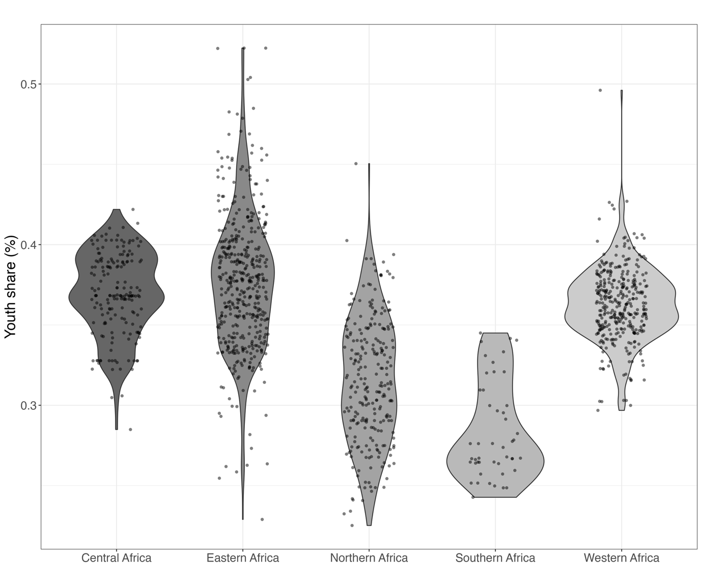Note: The y-axis displays the share of youth people in a city’s population in percentage terms. Each point represents the average for a unique city between 2000-2020. The shape around the points of each region describes the density of the points at that point on the y-axis.

3.4 Controls
At the city level, we control for the total size of the urban population, population density, and population growth. The total population is the sum across all the age-sex bins in the WorldPop data. Population density is this figure divided by the city’s total area. Density is likely to be a strong determinant of political participation. However, it is difficult to say in what direction. Elementary economic geography would suggest that density would yield agglomeration effects which should stimulate economic opportunities and improve efficiency in service delivery, promoting formal models of political participation whilst limiting incentives for demonstrations and protest (Glaeser, 2011). However, density may also present distinct challenges including disease burden, crime, congestion pressure on urban resources that represent acute governance issues and stimulate dissatisfaction leading to suppressed formal participation and increased protests (ibid).
The local economic context may also affect both political participation and the demographic structure of a city. More prosperous cities should see more formal participation and less informal participation because wealthier urban residents, all else equal, should have a greater stake in formal political processes and be less dissatisfied with these processes. Higher economic output also implies higher government revenues, resources that can be diverted into the provision of public goods and services. However, these cities may also have younger population structures given that young people are likely to migrate to prosperous areas in search of jobs.
Local economic output is often measured by Night-time lights data which has been shown to be a reliable proxy in certain applications (Gibson et al., 2020, 2021; Weidmann & Theunissen, 2021). We use a new, high-resolution dataset that estimates local real GDP from night-time emissions (Chen et al., 2022). The dataset calibrates the DMSP/OLS and NPP/VIIRS night-time light series and re-calculated revised measures of local economic output for a global 1km² grid between 1992-2019. Since our study period extends beyond the end of the local GDP series, we use linear interpolation to fill the missing data from 2020-2022. We also log transform this variable to account for the left-skewed distribution.
At the individual level, we also control for a respondent’s education, employment status, and experienced poverty taken from Afrobarometer. The education variable accounts for an individual’s level of education ranging from 0, ‘no formal schooling, 9, indicating that an individual holds a post-graduate qualification). Employment status is a binary variable indicating whether an individual has a job yielding a cash income (0 is no and 1 is yes). Experienced poverty is a composite index measuring the extent to which an individual reported goings without one of the following essentials in the month prior to the interview: food, water, medicine, cooking fuel, and a cash income.

3.5 Sample and Model Estimation
Our sample includes all urban residents in cities with populations greater than 50,000 persons, where there is a minimum of three respondents per city. This leaves us with a final sample of 11,831 individuals nested within 354 cities, across 32 countries across Rounds 5, 6, and 7 of Afrobarometer (2011-2020).
Given that both our dependent variables are binary measures of political participation, we test our hypotheses using a series of Bayesian multilevel logistic regression models. The data have a strict nesting structure – individuals within cities and cities within countries – making multilevel models the most appropriate and statistically robust method, as they inherently account for the dependencies among observations within groups (Gelman & Hill, 2007; Hox et al., 2017; McElreath, 2018).
We specify a random intercept for both cities and countries. This design captures the hierarchical nature of the data, allowing us to estimate the average effect of predictors at both the individual- and city-level while acknowledging city- and country-specific heterogeneity in the baseline level of political participation (Hox et al., 2017). The inclusion of random intercepts best reflects our prior knowledge of the data generating process, while explicitly accounting for unobserved heterogeneity at both the city and country levels, which would otherwise lead to biased uncertainty estimates. The choice of random intercepts is also essential for facilitating the estimation of cross-level effects and interactions, which are central to our hypotheses regarding how city youth shares influence the political participation of individuals and of individuals within distinct age groups differently. Multilevel models are specifically designed to analyse the effects of higher-level variables on individual outcomes, inherently addressing within-group (city and country) correlations by modelling variance at each level.
Furthermore, the multilevel structure, particularly the city-level random intercepts, helps to absorb unobserved, time-invariant city characteristics that might be correlated with both youth shares and political participation. This implicitly accounts for some of these confounding factors that remain constant over the relatively short observation period. Similarly, country-level random intercepts account for unobserved national factors such as shared language, history, culture, and institutional conditions, as well as possible cross-national differences in political behaviour during the survey enumeration period (e.g., the impact of ongoing elections in certain countries). This allows the models to implicitly account for this heterogeneity.
Our models thus allow the relationship between each independent variable and the outcome to vary systematically across individuals within cities and cities within countries. This is crucial because the functional relationship between local demographic context and political outcomes may vary depending upon national and subnational contextual factors. The model has the form:
$logit\left(p_{ijk}\right)= β_{0}+ β_{1}\left({Youth share}_{jk}\right)+ β_{2}\left({Age}_{ijk}\right)+ β_{3}\left({Youth share}_{jk}×{Age}_{ijk}\right)+ βX_{ijk}+ βX_{jk}+\sum_{r=3}^{R}{γ({round}_{r})}+ u_{jk} + ϵ_{ijk}$
Where $p_{ijk}$ is the probability of participation (formal or informal) for an individual, i, in city, j, in country, k. $β_{0}$is the baseline probability of participation across all individuals when all other variables are zero. $β_{1}\left({Youth share}_{jk}\right)$represents the effect of the city's youth share on the outcome and $β_{2}\left({Age}_{ijk}\right)$gives the effect of an individual's age on the outcome. $β_{3}\left({Youth share}_{jk}×{Age}_{ijk}\right)$is the interaction term, showing whether the effect of city youth share on political participation differs across age groups. $βX_{ijk}$ and $βX_{jk}$ are vectors if individual and country-level control respectively while $\sum_{r=3}^{R}{γ({round}_{r})}$ is the fixed effect accounting for heterogeneity in political behaviour across the distinct survey rounds. $u_{jk}$ is the country random effect, accounting for unobserved heterogeneity at the country level, this is assumed to follow a normal distribution such that $u_{jk} \sim N(0,σ_{jk}^{2})$. $ϵ_{ijk}$ is the individual error term.
All models were estimated using 10,000 Markov Chain Monte Carlo (MCMC) iterations, with the first 2,500 iterations discarded as warm-up (burn-in). We employed flat (non-informative) priors for all parameters, allowing the posterior distributions to be predominantly shaped by the data (McElreath, 2020). The Bayesian framework differs from frequentist methods in that it directly estimates full posterior distributions for all model parameters, quantifying uncertainty while accounting for the hierarchical structure of the data. Model results are presented in the usual way with point estimates and uncertainty intervals.
The model coefficients presented are Bayesian point estimates (i.e., the mean of the posterior distribution) of the odds ratios. An odds ratio (OR) more/less than one indicates that an outcome is more/less likely given the level of exposure to an independent variable. 95% credibility intervals representing uncertainty around point estimates are presented in parenthesis. In the context of odds ratios, credibility intervals crossing one indicate a statistically significant association in the traditional, frequentist sense. Unlike frequentist confidence intervals, 95% credibility intervals directly imply a 95% probability that the true parameter value lies within that range.
Full posterior distributions and convergence diagnostics are presented in Appendix D. All variables have been mean-centred and rescaled to enable model convergence and comparability of coefficients. Individual-level variables have been group-mean-centred (Bell et al., 2018). All analysis was undertaken in R Version 2025.05.0+496. Multilevel models were estimated using the lme4 (Version 1.1-37) (Bates et al., 2015) and brms (Version 2.22.0) (Bürkner, 2017) packages. Model diagnostics and trace plots indicate stable, well-mixed Markov chains that converge to the target posterior distribution with no divergent transitions (see Appendix D).
- Empirical Findings
Table 1 presents the results of the Bayesian multilevel logistic regression models. Models 1-3 present results for voting behaviour whilst Models 4-6 present result for protest participation. Model 1 reports the baseline association between individual age and city-level youth shares with respect to individual self-reported voting behaviour.

Table 1. Age, demographic context, and political participation
 | Dependent variables:
 | Voted |  |  |  |  |  | Attended Protest
 | (1) |  | (2) |  | (3) |  | (4) |  | (5) |  | (6)
Youth share (%) | 1.01  (0.92 – 1.11) |  | 1.01  (0.92 – 1.11) |  | 1.03  (0.93 – 1.14) |  | 0.80  (0.71 – 0.89) |  | 0.78  (0.70 – 0.87) |  | 0.84  (0.75 – 0.95)
Total population (ln) | 1.04  (0.90 – 1.20) |  | 1.04  (0.90 – 1.20) |  | 1.03  (0.90 – 1.20) |  | 1.16  (0.98 – 1.39) |  | 1.13  (0.96 – 1.35) |  | 1.13  (0.95 – 1.35)
Population density | 0.95  (0.83 – 1.09) |  | 0.95  (0.82 – 1.09) |  | 0.95  (0.83 – 1.09) |  | 0.82  (0.69 – 0.97) |  | 0.85  (0.71 – 1.00  ) |  | 0.85  (0.72 – 1.00)
Local GDP (ln) | 0.83  (0.75 – 0.93) |  | 0.82  (0.73 – 0.92) |  | 0.82  (0.73 – 0.92) |  | 0.92  (0.80 – 1.03) |  | 0.91  (0.80 – 1.03) |  | 0.91  (0.80 – 1.03)
Mid-age adults | 1.78  (1.65 – 1.92) |  | 1.78  (1.65 – 1.93) |  | 1.78  (1.65 – 1.93) |  | 0.86  (0.78 – 0.95) |  | 0.89  (0.80 – 0.99) |  | 0.89  (0.81 – 0.99)
Older adults | 2.57  (2.30 – 2.90) |  | 2.64  (2.35 – 2.97) |  | 2.64  (2.36 – 2.97) |  | 0.54  (0.46 – 0.62) |  | 0.60  (0.51 – 0.69) |  | 0.59  (0.50 – 0.69)
Gender | 0.88  (0.82 – 0.94) |  | 0.90  (0.84 – 0.97) |  | 0.90  (0.84 – 0.97) |  | 0.61  (0.56 – 0.67) |  | 0.64  (0.58 – 0.71) |  | 0.64  (0.58 – 0.70)
Round 6 | 0.63  (0.57 – 0.70) |  | 0.62  (0.56 – 0.69) |  | 0.62  (0.56 – 0.69) |  | 1.22  (1.07 – 1.39) |  | 1.26  (1.11 – 1.44) |  | 1.26  (1.11 – 1.44)
Round 7 | 0.59  (0.53 – 0.66) |  | 0.59  (0.53 – 0.66) |  | 0.59  (0.53 – 0.66) |  | 1.39  (1.22 – 1.59) |  | 1.34  (1.17 – 1.53) |  | 1.33  (1.17 – 1.52)
Education |  |  | 1.02  (1.00 – 1.04) |  | 1.02  (1.00 – 1.04) |  |  |  | 1.14  (1.11 – 1.17) |  | 1.14  (1.11 – 1.16)
Experience poverty (ln) |  |  | 0.87  (0.79 – 0.96) |  | 0.87  (0.80 – 0.95) |  |  |  | 1.69  (1.50 – 1.90) |  | 1.70  (1.51 – 1.91)
Employment Status |  |  | 1.08  (1.00 – 1.17) |  | 1.09  (1.00 – 1.18) |  |  |  | 0.91  (0.82 – 1.00) |  | 0.91  (0.82 – 1.00)
Youth share x Mid adults |  |  |  |  | 0.98  (0.90 – 1.06) |  |  |  |  |  | 0.89  (0.81 – 0.98)
Youth share x Older adults |  |  |  |  | 0.97  (0.87 – 1.08) |  |  |  |  |  | 0.86  (0.75 – 0.99)
Observations | 18321 |  | 18321 |  | 18321 |  | 18321 |  | 18321 |  | 18321
Marginal R² / Conditional R² | 0.036 / 0.095 |  | 0.038 / 0.096 |  | 0.038 / 0.096 |  | 0.017 / 0.049 |  | 0.027 / 0.060 |  | 0.027 / 0.060

The results in Model 1 indicate that individuals living in cities with high youth shares are no more or less likely to vote than individuals in less youthful urban contexts. Conversely, the coefficients for mid-age and older adults suggest that individuals both categories are significantly more likely to vote than their younger counterparts. The odds of voting for mid-aged adults in the sample are 78% higher than for young adults while the odds for older adults are 157% higher. Figure 2 visualises the marginal effects of age group of voting showing that older adults are more likely again to vote than mid-aged adults.
Model 2 includes education, experienced poverty, and employment status as further controls. These were excluded from Model 1 as they may be determined, at least in part, by both the age of an individual and the age structure of the city in which they live and are therefore post-treatment variables. However, there are strong theoretical reasons for including them as controls since they represent fundamental individual-level resources and grievances that could directly influence political participation, irrespective of an individual's specific age or the city's overall youth share. Excluding them would lead to omitted variable bias, as they are well-established determinants of political behaviour. That said, results remain consistent across models with and without these controls, suggesting that the observed associations are not biased by their inclusion.
Models 4 and 5 report results for individual protest participation. Both models indicate a statistically significant, negative link between city youth shares and protest participation, with each percentage point increase in the city youth share associated with a 78-80% decrease in the odds of protest participation for all individuals (see Figure 3). Similarly, the coefficient for mid-age and older adults also reveals strong negative associations between age and protest behaviour (Figure 2). The odds of mid-age adults reporting having attended a protest are 11-14% lower than for young adults whilst the odds for older adults protesting a are 40-46% lower.

Figure 2. Marginal Effect of Age on Voting and Protest participation.
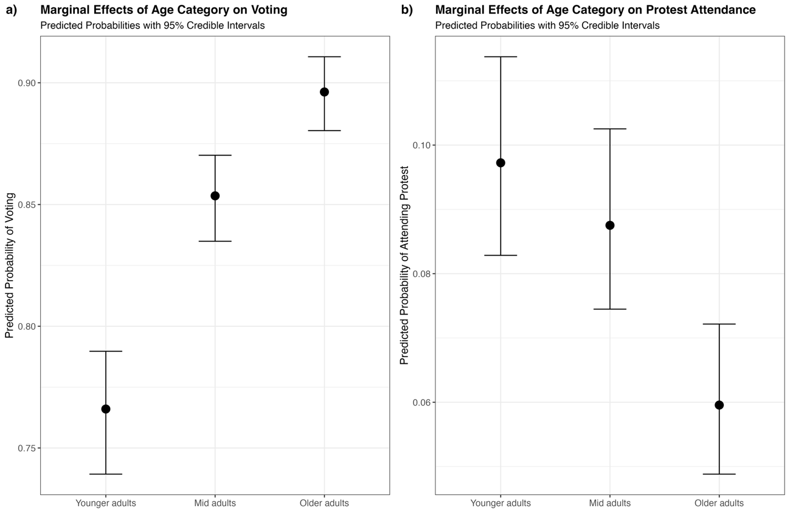
Note: Marginal effects of individual age with respect to the predicted probability of (a) voting and (b) protest participation. Estimates are taken from Models 3 and 6. 95% credibility intervals are reported around Bayesian point estimates.

With respect to our hypotheses, these models do not provide support for H1a. The observed odds ratios for youth share with respect to voting are not statistically significant and are close in magnitude to one, indicating no discernible effect of youthful urban demographic structure on individual voting behaviour. Furthermore, we do not find support for H1b. The hypothesis posits that individuals in cities with higher youth shares will be more likely to participate in informal politics (protesting). In contrast, the results consistently show a statistically significant negative relationship, indicating that higher youth shares are associated with a lower likelihood of protest attendance. This is notable as it is in opposition to what much of the literature would suggest and directly contrasts our own H1b.
Columns 3 and 6 present the results of models featuring cross-level interaction terms between city youth shares and individual age. The interaction terms Youth share x Mid-age adults and Youth share x Older adults in both models are designed to capture whether the effect of city youth shares on individual voting and protest participation are different for younger adults than for mid-age and older adults, as their political behaviour is theoretically more likely to be impacted by such demographic contexts. With respect to voting, both coefficients have odds ratios close to 1 with credibility intervals crossing 1, indicating no significant interaction effect. For protest attendance, on the other hand, both coefficients have odds ratios less than 1 and their 95% credibility intervals do not cross 1. This indicates statistically significant negative interaction effects. The odds ratio for the Youth share x Mid-age adults coefficient is 0.89 (95% CI: 0.81 – 0.98) and 0.86 (95% CI: 0.75 – 0.99) for Youth share x Older adults. This indicates that the gap in protest likelihood between young people and older people gets wider in cities with more youthful age structures. While all age groups are less likely to protest in more youthful cities, this negative effect is much stronger for mid-age and older adults. While younger people are still the most likely to protest, the difference between them and older people becomes most pronounced in cities with high youth share.
Figure 4 plots this interaction effect graphically. The negative slopes for all age categories across the range of youth share support the main results from models 4-5 indicate a negative association between city youth shares and protest participation. With younger adults being more likely to protest than mid adults who are, in turn, more likely to protest than older adults. However, the plot shows that the gap in protest probability between ‘Younger adults’ relative to Mid-age and older adults appears to widen with these groups having a steeper rate of decrease compared to ‘Younger adults’, especially at higher youth share values.

Figure 3. Marginal effect of city youth shares on voting and protest participation.
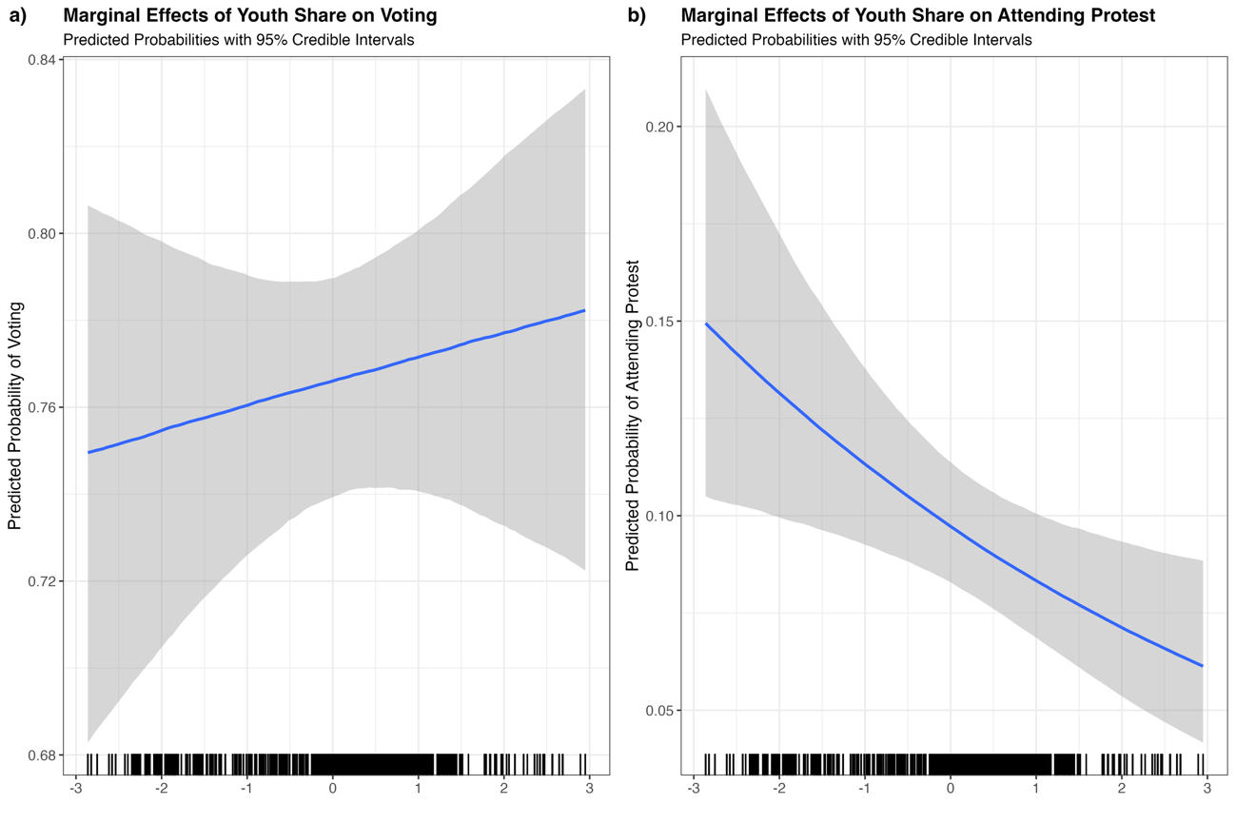 Note: Marginal effects of city-level youth shares with respect to the predicted probability of an individual reporting having (a) voted and (b) attending a protest. Estimates are taken from Models 3 and 6. 95% credibility intervals are reported around Bayesian point estimates.

With respect to hypotheses H2a and H2b, these interaction models do not provide support for H2a. The data does not indicate that any difference in the odds of voting participation between young people and their older counterparts is significantly modified by the youth share of a city. In other words, the relative likelihood of young people voting compared to older adults does not significantly decrease as youth share increases.
The significant interaction effect for in Model 6 does not support H2b in the expected way. H2b implies that in more youthful cities, young people's propensity to protest increases relative to their older counterparts. However, the negative Age group coefficients and interaction term suggest that, while younger adults always show a higher probability of protesting, the relative difference in protest likelihood between younger adults and older adults actually becomes more pronounced as youth share increases. This is because the probabilities for mid-age and older adults decline more steeply or fall to lower absolute values faster than for younger adults.
Figure 4. Cross-level interaction of city youth shares and age group on protest participation.
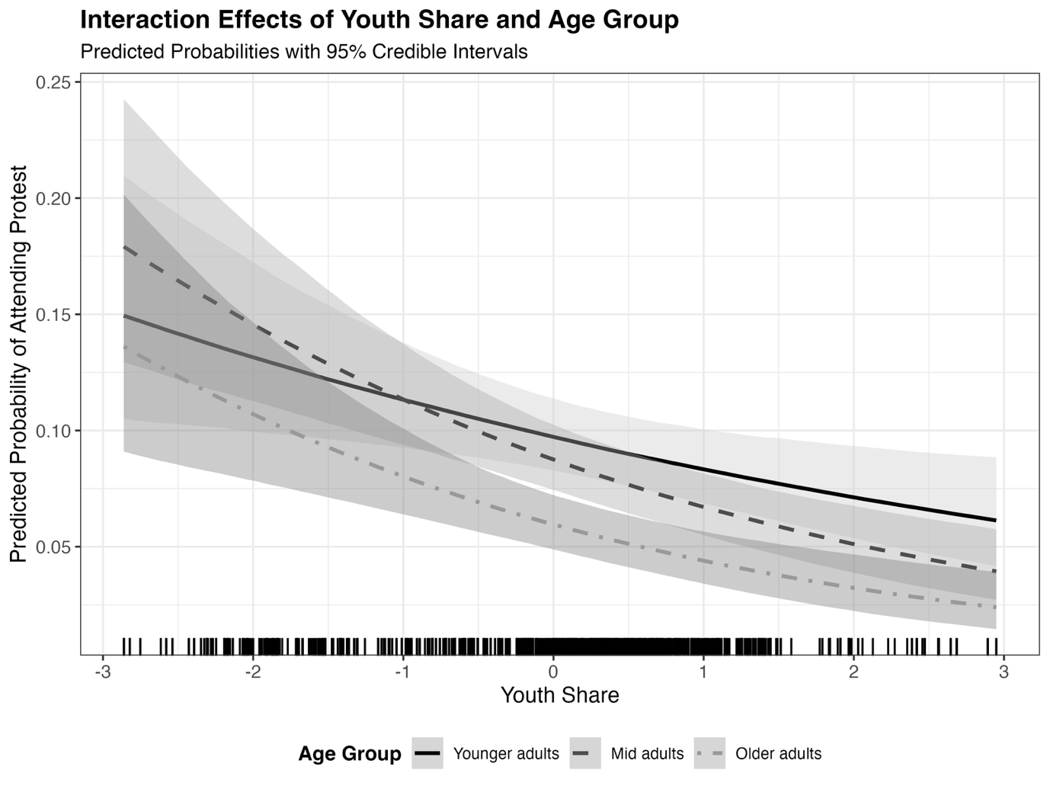 Note: Cross-level interaction effect of city-level youth share and individual age with respect to the predicted probability of protest participation. Estimates are taken from Model 6. 95% credibility intervals are reported around Bayesian point estimates.

- Discussion and Conclusion
Our results present a nuanced picture of the political demography of African cities. Overall, after controlling for other urban and individual characteristics, we find that the demographic structure of a city does not make individuals more or less likely to vote. Conversely, individuals are less likely to protest in more youthful cities, a statistically significant negative association that runs counter to expectations.
We also find that political behaviour is shaped by age. All else being equal, and as expected based on the existing literature, younger people are more likely to protest and less likely to vote. This effect is linear with age, with older people being more likely to vote and less likely to protest than mid-age people, who in turn are more likely to vote and less likely to protest than younger people.
Finally, while living in a youthful urban area does not seem to mediate the voting behaviour of specific age groups (young, mid-age, and older residents), it does have a differential effect on protest behaviour. The relationship between age and protest remains negative for all age groups, but this negative effect is weaker for younger people. In other words, while all age groups protest less in more youthful cities, the difference between young people and older people is at its greatest in these contexts. Importantly, young people do not become more likely to protest relative to their older counterparts; instead, their older counterparts become even less likely, widening the age-cohort gap.
How might we understand these somewhat counter-intuitive findings, and what do they mean for future research? We identify two theoretically situated propositions that may underlie our unexpected finding that youthful cities have no effect on individual voting and a negative effect on individual protest.
The first relates to the nature of urban growth and economic conditions in African cities as distinct geographies. While large urban youth shares are often assumed to lead to an oversupply of labour and fewer economic opportunities (ref), some urban areas may be places of opportunity, attracting and/or retaining large youth shares precisely because they offer wide labour markets, improved livelihoods, and social mobility (McKenzie, 2017; Sladoje et al., 2020). This is likely to have differential effects on dynamics of political action (Elfversson et al., 2023). If more youthful cities are indeed becoming places of broader economic opportunity, citizens should be more likely to be invested in the maintenance of these local political-economic systems, leading to higher formal engagement and lower protest activity.
A second potential explanation may reflect the changing incentives for political actors to appeal to younger voters. As Africa urbanises, young urban dwellers are becoming increasingly important constituencies to mobilize in order to win elections (Resnick & Casale, 2011). Given this, political entrepreneurs are incentivised to increasingly target appeals to younger people and/or direct public goods and services in ways that benefit youth cohorts (Cheeseman, 2018; Macdonald et al., 2023; Resnick, 2013, 2015, 2017). Our results – that both residents overall and younger people protest less and that voting is not negatively affected – are consistent with political operators targeting their appeals to younger people where large youth shares represent a larger voting bloc. If more inclusive or ‘youth-focused’ political appeals are indeed present in cities with large youth cohorts, then individuals may be more (or not less) likely to engage in formal political behaviours and less likely to engage in informal protest behaviour.
While our findings provide important nuance to the political demography of African cities, they also point to several limitations of this study and avenues for future research. One key limitation is that we do not directly test the causal mechanisms linking city-level youth shares to political behaviour. For example, changes in local economic conditions or political appeals that prime the motive, means, and opportunities for distinct types of political engagement. Instead, we situate these mechanisms at the appropriate spatial scale, demonstrating that local context matters. Building off of our study, future research could conduct survey work in demographically different cities to directly probe these causal mechanisms.
Furthermore, future research could build upon these results by gathering data on the type and nature of urban growth (e.g., migration, natural increase, or reclassification) to determine how this relates to demographic structure and political behaviours. Similarly, studies on the political demography of African urbanisation would benefit from being attuned to the different types of political appeals directed at young people and how this might shape participation and mobilisation in various institutional contexts. A more nuanced picture of these dynamics would be a significant scholarly advance and have important implications for devising sustainable urban policy.
In closing, this article has made three key contributions to the literature. First, we develop and operationalise new subnational estimates of the demographic composition of individual urban settlements, the first article to do so to our knowledge. Second, we use these to empirically demonstrate how the local demographic characteristics of particular cities may shape the political behaviours of individuals living in these places. The results nuance and challenge common theoretical assumptions and empirical findings about demographic structure and political behaviour and point to future research directions. Third, by demonstrating the benefits of a place-based analysis of urban demographic structure and political behaviour, we contribute to research agendas (Hoelscher et al., 2023) taking a subnational perspective when studying the political implications of urbanisation in Africa.

References
Akinyetun, T. S. (2023). Demography and insecurity: Youth bulge and the Lake Chad Basin security quandary. African Security Review, 32(2), 184–199.
Apolte, T., & Gerling, L. (2018). Youth bulges, insurrections and labor-market restrictions. Public Choice, 175(1), 63–93.
Bates, D., Mächler, M., Bolker, B., & Walker, S. (2015). Fitting linear mixed-effects models using lme4. Journal of Statistical Software, 67, 1–48.
Bell, A., Jones, K., & Fairbrother, M. (2018). Understanding and misunderstanding group mean centering: A commentary on Kelley et al.’s dangerous practice. Quality & Quantity, 52, 2031–2036.
Blei, A., & Angel, S. (2021). Global monitoring with the atlas of urban expansion. Urban Remote Sensing: Monitoring, Synthesis, and Modeling in the Urban Environment, 247–282.
Bocquier, P., Menashe-Oren, A., & Nie, W. (2023). Migration’s contribution to the urban transition. Demographic Research, 48, 681–732.
Boxell, L., & Steinert-Threlkeld, Z. (2022). Taxing dissent: The impact of a social media tax in Uganda. World Development, 158, 105950.
Brady, H. E., Verba, S., & Schlozman, K. L. (1995). Beyond SES: A resource model of political participation. American Political Science Review, 89(2), 271–294.
Branch, A., & Mampilly, Z. (2015). Africa uprising: Popular protest and political change. Bloomsbury Publishing.
Bricker, N. Q., & Foley, M. C. (2013). The effect of youth demographics on violence: The importance of the labor market. International Journal of Conflict and Violence (IJCV), 7(1), 179–194.
Buhaug, H., & Urdal, H. (2013). An urbanization bomb? Population growth and social disorder in cities. Global Environmental Change, 23(1), 1–10.
Bürkner, P.-C. (2017). brms: An R package for Bayesian multilevel models using Stan. Journal of Statistical Software, 80, 1–28.
Cheeseman, N. (2018). Populism in Africa and the potential for “ethnically blind” politics. Routledge Handbook of Global Populism, 351–369. https://doi.org/10.4324/9781315226446-29
Cheeseman, N. (2022). (Mis) Understanding Urban Africa: Toward A Research Agenda on the Political Impact of Urbanization. African Studies Review, 1–21.
Chen, J., Gao, M., Cheng, S., Hou, W., Song, M., Liu, X., & Liu, Y. (2022). Global 1 km× 1 km gridded revised real gross domestic product and electricity consumption during 1992–2019 based on calibrated nighttime light data. Scientific Data, 9(1), 202.
Cincotta, R., & Weber, H. (2021). Youthful Age Structures and the Risks of Revolutionary and Separatist Conflicts. In A. Goerres & P. Vanhuysse (Eds), Global Political Demography: The Politics of Population Change (pp. 57–92). Palgrave Macmillan.
Conroy-Krutz, J., Amakoh, K., & Amewunou, K. (2024). Africa’s shifting media landscapes: Digital media use grows, but so do demographic divides (Afrobarometer Dispatch 800). Afrobarometer.
Dijkstra, L., Florczyk, A. J., Freire, S., Kemper, T., Melchiorri, M., Pesaresi, M., & Schiavina, M. (2021). Applying the degree of urbanisation to the globe: A new harmonised definition reveals a different picture of global urbanisation. Journal of Urban Economics, 125, 103312.
Dorward, N., & Fox, S. (2022). Population pressure, political institutions, and protests: A multilevel analysis of protest events in African cities. Political Geography, 99, 102762.
Dorward, N., Fox, S., Statham, T., & Wolf, L. J. (2023). A spatial-demographic analysis of Africa’s emerging urban geography. Environment & Urbanization, 35(2), 310–327.
Elfversson, E., Höglund, K., Sellström, A. M., & Pellerin, C. (2023). Contesting the growing city? Forms of urban growth and consequences for communal violence. Political Geography, 100, 102810.
Eltantawy, N., & Wiest, J. B. (2007). The Arab Spring | Social Media in the Egyptian Revolution: Reconsidering Resource Mobilization Theory. Journal of Communication, 5, 1207–1224.
Enos, R. (2017). The Space Between Us: Social Geography and Politics. Cambridge University Press.
Fetzek, S., & Vivekananda, J. (2015). Climate change, violence and young people: Report for Unicef UK. IISS.
Fox, S., & Bell, A. (2016). Urban geography and protest mobilization in Africa. Political Geography, 53, 54–64.
Fox, S., & Goodfellow, T. (2022). On the conditions of ‘late urbanisation’. Urban Studies, 59(10), 1959–1980.
Franklin, M. N. (2004). Voter turnout and the dynamics of electoral competition in established democracies since 1945. Cambridge University Press.
Garbe, L., Selvik, L.-M., & Lemaire, P. (2023). How African countries respond to fake news and hate speech. Information, Communication & Society, 26(1), 86–103.
Gelman, A., & Hill, J. (2007). Data analysis using regression and multilevel/hierarchical models. Cambridge university press.
Gibson, J., Olivia, S., & Boe‐Gibson, G. (2020). Night lights in economics: Sources and uses 1. Journal of Economic Surveys, 34(5), 955–980.
Gibson, J., Olivia, S., Boe-Gibson, G., & Li, C. (2021). Which night lights data should we use in economics, and where? Journal of Development Economics, 149, 102602.
Glaeser, E. (2011). Triumph of the city: How urban spaces make us human. Pan Macmillan.
Goldstone, J. A. (2002). Population and security: How demographic change can lead to violent conflict. Journal of International Affairs, 3–21.
Goldstone, J. A. (2010). The new population bomb: The four megatrends that will change the world. Foreign Aff., 89, 31.
Gutheil, L. (2022). The Impact of Urbanisation on Political Regimes in Africa: A Literature Review (No. Megatrends Working Paper 3). Stiftung Wissenschaft und Politik.
Hartmann, C., & Biira, C. P. (2021). Demographic Change and Political Order in Sub-Saharan Africa: How Côte d’Ivoire and Uganda Deal with Youth Bulge and Politicized Migration. In A. Goerres & P. Vanhuysse (Eds), Global Political Demography: The Politics of Population Change (pp. 219–246). Springer International Publishing. https://doi.org/10.1007/978-3-030-73065-9_9
Henn, M., & Foard, N. (2012). Young people, political participation and trust in Britain. Parliamentary Affairs, 65(1), 47–67.
Hoelscher, K., Dorward, N., Fox, S., Lawanson, T., Paller, J. W., & Phillips, M. L. (2023). Urbanization and political change in Africa. African Affairs, 122(488), 353–376.
Hoelscher, K., Lawanson, T., & Paller, J. W. (forthcoming). Political Change in African Cities: Transforming State-Society Relations. World Development.
Honwana, A. (2015). “Enough is enough!”: Youth Protests and Political Change in Africa. In K. Tall, M.-E. Pommerolle, & M. Cahen (Eds), Collective Mobilisations in Africa / Mobilisations collectives en Afrique (pp. 43–66). Brill.
Hox, J., Moerbeek, M., & Van de Schoot, R. (2017). Multilevel analysis: Techniques and applications. Routledge.
Johnston, R., & Pattie, C. (1998). Composition and context: Region and voting in Britain revisited during Labour’s 1990s’ revival. Geoforum, 29(3), 309–329.
Johnston, R., & Pattie, C. (2006). Putting voters in their place: Geography and elections in Great Britain. OUP Oxford.
Jost, J. T., Barberá, P., Bonneau, R., Langer, M., Metzger, M., Nagler, J., Sterling, J., & Tucker, J. A. (2018). How social media facilitates political protest: Information, motivation, and social networks. Political Psychology, 39, 85–118.
Koechlin, L., & Förster, T. (2018). Secondary cities and the formation of political space in West and East Africa. The Palgrave Handbook of Urban Ethnography, 351–368.
Kuffer, M., Owusu, M., Oliveira, L., Sliuzas, R., & van Rijn, F. (2022). The missing millions in maps: Exploring causes of uncertainties in global gridded population datasets. ISPRS International Journal of Geo-Information, 11(7), 403.
Kumar, T., & Stenberg, M. (2023). Why political scientists should study smaller cities. Urban Affairs Review, 59(6), 2005–2042.
Lekalake, R., & Gyimah-Boadi, E. (2016). Does less engaged mean less empowered? Political participation lags among African youth, especially women.
Macdonald, A., Owor, A., & Tapscott, R. (2023). Explaining youth political mobilization and its absence: The case of Bobi Wine and Uganda’s 2021 election. Journal of Eastern African Studies, 17(1–2), 280–300.
Mast, J., Sapena, M., Debray, H., Inkoom, J. N., Lemoine-Rodríguez, R., Geiß, C., & Taubenböck, H. (2025). The digital urban frontier: Disparities in social media activity between consolidated and newly urbanized areas in Africa. Applied Geography, 181, 103687.
McDonnell, J. (2020). Municipality size, political efficacy and political participation: A systematic review. Local Government Studies, 46(3), 331–350.
McElreath, R. (2018). Statistical rethinking: A Bayesian course with examples in R and Stan. Chapman and Hall/CRC.
McKenzie, D. (2017). How effective are active labor market policies in developing countries? A critical review of recent evidence. The World Bank Research Observer, 32(2), 127–154.
Melchiorri, M., Freire, S., Schiavina, M., Florczyk, A., Corbane, C., Maffenini, L., Pesaresi, M., Politis, P., Szabo, F., & Ehrlich, D. (2024). The Multi-temporal and Multi-dimensional Global Urban Centre Database to Delineate and Analyse World Cities. Scientific Data, 11(1), 82.
Menashe-Oren, A. (2020). Migrant-based youth bulges and social conflict in urban sub-Saharan Africa. Demographic Research, 42, 57–98.
Menashe‐Oren, A., & Bocquier, P. (2021). Urbanization is no longer driven by migration in low‐and middle‐income countries (1985–2015). Population and Development Review, 47(3), 639–663.
Mueller, L. (2018). Political protest in contemporary Africa. Cambridge University Press.
Mutsvairo, B. (2016). Digital activism in the social media era. Switzerland: Springer Nature.
Nathan, N. L. (2019). Electoral politics and Africa’s Urban transition: Class and ethnicity in Ghana. Cambridge University Press.
Nathan, N. L., & Sands, M. L. (2023). Context and contact: Unifying the study of environmental effects on politics. Annual Review of Political Science, 26.
Nie, N. H., Verba, S., & Kim, J. (1974). Political participation and the life cycle. Comparative Politics, 6(3), 319–340.
Nkansah, G. B. (2022). Youth cohort size, structural socioeconomic conditions, and youth protest behavior in democratic societies (1995–2014). SAGE Open, 12(2), 21582440221096146.
Nkansah, G. B. (2025). The “Demo-conomics” in African Youth Politics: Youth Bulge and Unemployment Meet Political Attitude and Participation. Megatrends Afrika Working Paper 15, Bonn, Germany.
Nkansah, G. B., & Bartha, A. (2023). Anti-democratic youth? The influence of youth cohort size and quality of democracy on young people’s support for democracy. Contemporary Politics, 29(5), 553–575.
Nkansah, G. B., & Papp, Z. (2023). Does cohort size matter? Assessing the effect of youth cohort size and peer influence on young people’s electoral participation. Journal of Youth Studies, 26(7), 859–877.
Norris, P. (2002). Democratic phoenix: Reinventing political activism. Cambridge University Press.
Pezzulo, C., Hornby, G. M., Sorichetta, A., Gaughan, A. E., Linard, C., Bird, T. J., Kerr, D., Lloyd, C. T., & Tatem, A. J. (2017). Sub-national mapping of population pyramids and dependency ratios in Africa and Asia. Scientific Data, 4(1), 1–15.
Randolph, G. F., & Storper, M. (2023). Is urbanisation in the Global South fundamentally different? Comparative global urban analysis for the 21st century. Urban Studies, 60(1), 3–25.
Reichenberg, O., & Tambe, E. B. (2022). The political sociology of voting participation in Southern Africa: A multilevel study of regional and social class predictors in 11 countries. International Journal of Sociology, 52(2), 156–177.
Resnick, D. (2013). Urban Poverty and Party Populism in African Democracies: Drivers of Voting Behavior among Africa’s Urban Poor. https://doi.org/10.1017/cbo9781139568265.002
Resnick, D. (2015). Varieties of African populism in comparative perspective. The Promise and Perils of Populism: Global Perspectives, 317, 348.
Resnick, D. (2017). Populism in Africa. https://doi.org/10.1093/oxfordhb/9780198803560.013.4
Resnick, D., & Casale, D. (2011). The political participation of Africa’s youth: Turnout, partisanship, and protest.
Resnick, D., & Casale, D. (2014). Young populations in young democracies: Generational voting behaviour in sub-Saharan Africa. Democratization, 21(6), 1172–1194. https://doi.org/10.1080/13510347.2013.793673
Schmiedl, M., & Lioy, A. (2024). Patterns of Protest in Contemporary Africa: An Empirical Investigation of Regional Trends Employing Multiple Imputation. Political Studies Review, 14789299241239913.
Sladoje, M., Randolph, G., & Khan, L. (2020). Transforming Secondary Urban Areas for Job Creation A Study of Uganda.
Steinberg, L. (2004). Risk taking in adolescence: What changes, and why? Annals of the New York Academy of Sciences, 1021(1), 51–58.
Stratham, T. A. (2024). The Global Inconsistencies of Gridded Population Data at Different Spatial Scales [PhD Dissertation].
Tambe, E. B., & Kopacheva, E. (2023). Age and Political Participation in Africa’s Electoral Regimes. Representation, 1–19. https://doi.org/10.1080/00344893.2023.2173281
Tatem, A. J., Garcia, A. J., Snow, R. W., Noor, A. M., Gaughan, A. E., Gilbert, M., & Linard, C. (2013). Millennium development health metrics: Where do Africa’s children and women of childbearing age live? Population Health Metrics, 11, 1–11.
Thomson, H., Buhaug, H., Urdal, H., & Rosvold, E. (2021). Group organization, elections and urban political mobilization in the developing world. Democratization, 28(8), 1525–1544. https://doi.org/10.1080/13510347.2021.1944117
Urdal, H. (2006). A Clash of Generations? Youth Bulges and Political Violence. International Studies Quarterly, 50(3), 607–629. JSTOR.
Urdal, H. (2008). Population, Resources, and Political Violence: A Subnational Study of India, 1956-2002. The Journal of Conflict Resolution, 52(4), 590–617. JSTOR.
Urdal, H. (2012). Youth bulges and violence. Political Demography: How Population Changes Are Reshaping International Security and National Politics, 117–132.
Urdal, H., & Hoelscher, K. (2009). Urban youth bulges and social disorder: An empirical study of Asian and sub-Saharan African cities. World Bank Policy Research Working Paper, 5110.
Urdal, H., & Hoelscher, K. (2012). Explaining Urban Social Disorder and Violence: An Empirical Study of Event Data from Asian and Sub-Saharan African Cities. International Interactions, 38(4), 512–528. https://doi.org/10.1080/03050629.2012.697427
Wattenberg, M. P. (2003). Electoral turnout: The new generation gap. British Elections & Parties Review, 13(1), 159–173. https://doi.org/10.1080/13689880308413092
Weber, H. (2013). Demography and democracy: The impact of youth cohort size on democratic stability in the world. Democratization, 20(2), 335–357.
Weber, H. (2019). Age structure and political violence: A re-assessment of the “youth bulge” hypothesis. International Interactions, 45(1), 80–112.
Weidmann, N. B., & Theunissen, G. (2021). Estimating local inequality from nighttime lights. Remote Sensing, 13(22), 4624.
Yin, X., Li, P., Feng, Z., Yang, Y., You, Z., & Xiao, C. (2021). Which gridded population data product is better? Evidences from mainland Southeast Asia (MSEA). ISPRS International Journal of Geo-Information, 10(10), 681.
Zimmer, A., Guido, Z., Tuholske, C., Pakalniskis, A., Lopus, S., Caylor, K., & Evans, T. (2020). Dynamics of population growth in secondary cities across southern Africa. Landscape Ecology, 35, 2501–2516.

Appendix A: Defining urban areas
This paper aims to identify the associations between the political participation of urban residents and the distinct demographic context of the individual city in which they live, which we argue will have greater salience in shaping their behaviours than national level factors. Providing valid empirical tests of our hypotheses, therefore, relies on being able to consistently situate individuals within their local urban demographic context. In principle, respondents in the Afrobarometer surveys are assigned a binary classification indicating whether they live in a rural or urban area, which could be combined with the settlement or administrative unit name strings to distinguish individuals in different urban locations. However, this may also be problematic, as these classifications are dependent upon the various urban definitions adopted across difference countries (Dorward et al., 2023).
To address this, we use the geospatial definition of urban areas provided by the Urban Centres Database and based upon human settlement patterns and land use classifications. The dataset contains a set of polygons defining the spatial extent of continuous densely populated and built-up areas for every country on earth (Melchiorri et al., 2024). The definition of each ‘urban centre’ is based upon the Degree of Urbanisation measure (DEGURBA) put forward by the European Commissions’ Joint Research Centre and endorsed by the UN statistical Commission in 2020 (Dijkstra et al., 2021). DEGURBA is designed to provide a global standard for the consistent measurement of urban areas across space and time, avoiding the inherent weakness of official UN estimates that are biased by inconsistent definitions across countries and the variable capacities of individual country statistics offices. DEGURBA/UCDB draws the boundaries of urban centres by dividing the earth’s surface into 1km² grids. It then combines contiguous grid cells with a population density of 1,500 people and a combined population density of 50,000 inhabitants to form each urban centre. We link surveyed individuals from Afrobarometer to the urban areas in which they are located by overlaying the urban centre polygons onto the georeferenced location of each respondent. A visual example of this is shown in Figure 1, showing the locations of respondents in the Lagos urban agglomeration.

Location of Afrobarometer respondents within Lagos, Nigeria
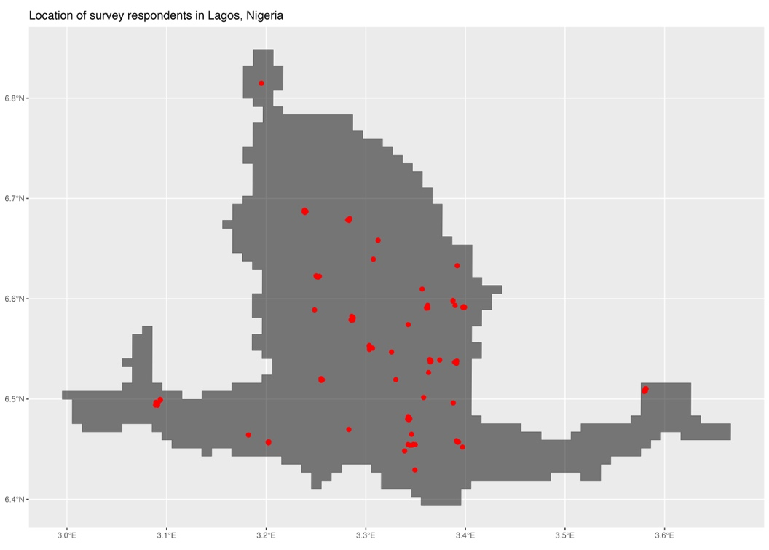
Note: Location of survey respondents within the wider Lagos urban area, Nigeria. Fewer points are readable due to proximity of sampling locations.

This approach yields several benefits. First, we are able to link individuals to the specific urban area in which they live, and, by leveraging geospatial estimates at this scale, measure characteristics of the local context they experience. This creates greater consistency between the scale of measurement and that at which processes theoretically operate. Second, utilising this approach means that the operational definition of an urban area is consistent across countries. While the question of whether these boundaries ‘correctly’ zone an urban context at a meaningful scale remains an issue, our study is not subject to biases that may arise from cross-national heterogeneity in ‘urban’ definitions. Furthermore, the DEGURBA/UCDB definition, which identifies contiguous built-up areas of a minimum population density, is arguably a better approximation of urban settlements than is available from either survey measures or administrative definitions, which are highly variable. Finally, the UCDB enables us to expand our sample beyond the comparatively small number of large and politically significant cities featured in previous studies. This is particularly important given the rapid growth, political relevance, and increasing importance of secondary and smaller cities in sustainable urbanisation in Africa (Koechlin & Förster, 2018; Kumar & Stenberg, 2023; Zimmer et al., 2020). The resulting sample offers a better reflection of urban system as a whole and allows us to exploit greater variation in specific urban demographic contexts within it.
There are, however, valid concerns surrounding how well the UCDB identifies urban areas in certain cases, particularly on the suburban and peri-urban fringes of cities (Blei & Angel, 2021; Dorward & Fox, 2022). This could be of particular relevance in the African context. Here, urban growth is typically characterised by lower population densities than those of cities Europe and North America, suggesting that a lower bounding to the population density threshold used by the DEGURBA/UCDB would be appropriate (Dorward et al., 2023). This infers that the UCDB parameters we utilise would provide a more conservative estimate of urban areas on the African continent. Consequently, our study will likely provide conservative estimates of the association between urban demographic context and individual political behaviour as it restricts our sample to more established urban centres where urban density ensures that these contextual effects are strongest. How the demographic context may affect an individual’s political behaviour within Africa’s numerous newly emerging towns and smaller urban areas (that are not captured by our empirical approach) remains an outstanding question we are unable to address here.

Appendix B: Construction of Age-Sex structures for African cities
The dataset reveals a high degree of variation in urban demographic structures and youth shares within and between countries. Figure 2 displays country-level trends in youth shares between 2000-2020 for the Central, Eastern, Northern, Southern, and Western regions of Africa. We observe substantial variation in urban youth shares between regions, with Southern and North African countries having lower urban youth shares on average. West African countries generally have higher urban youth shares while Eastern African countries display greater between variation. The temporal trend in youth shares is generally downward for most countries across Africa. However, there are a few notable exceptions where urban youth shares are increasing including Mozambique, Niger, Somalia, and South Sudan. Sudan is the only North African country where urban you shares have increased over the period.

Figure 2. Urban youth shares over time, by region.
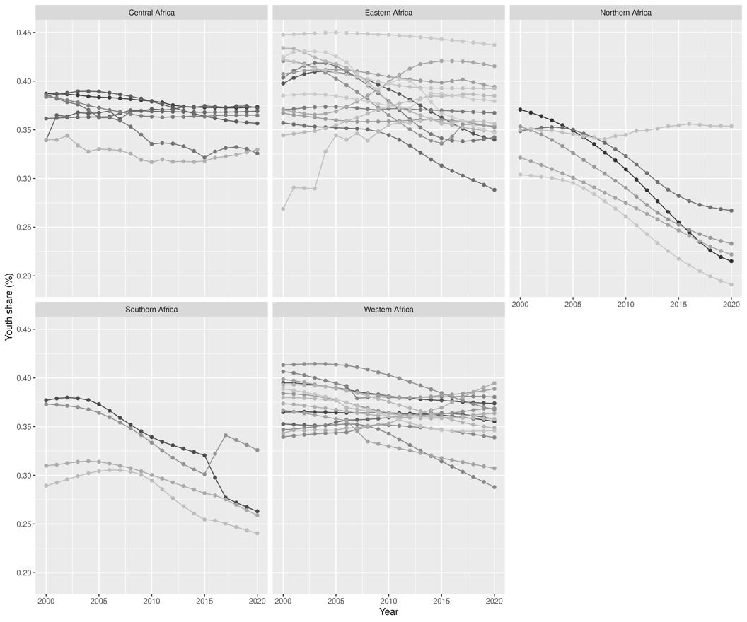

Importantly, this data show that national level figures can hide significant subnational variation between cities within regions and countries. Figure 3 shows city-level variation in urban youth shares for cities within Africa’s subregions. Each point represents a unique city and the width of the body of the ‘violin’ indicates the density of city points at each value of youth share in the data. The figure reveals substantial variation in youth shares both within and between regions. Again, we see greater variation within Eastern Africa, and North Africa also displays a high degree of variance between cities. Southern African cities have by far the oldest demographic compositions. The bulk of where these cities sit on the youth share distribution is broadly comparable to the least youthful cities of other regions. Similarly, Figure 4 shows substantial variation between cities within countries. It confirms that there is also substantial variation in youth shares within countries. Ethiopia and Nigeria in particular display high level of variation.
Overall, these subnational estimates of the age and sex composition of urban populations reveal substantial variation in youth shares both between countries and between cities within countries. This implies markedly different demographic contexts across the spectrum of Africa’s urban settlements. Moreover, we expect this heterogeneity to be associated with local variation in demographic contexts between more and less youthful cities which will plausibly be associated with variation in individual political behaviours between cities.

City-level variation in urban youth shares by region (2000-2020)
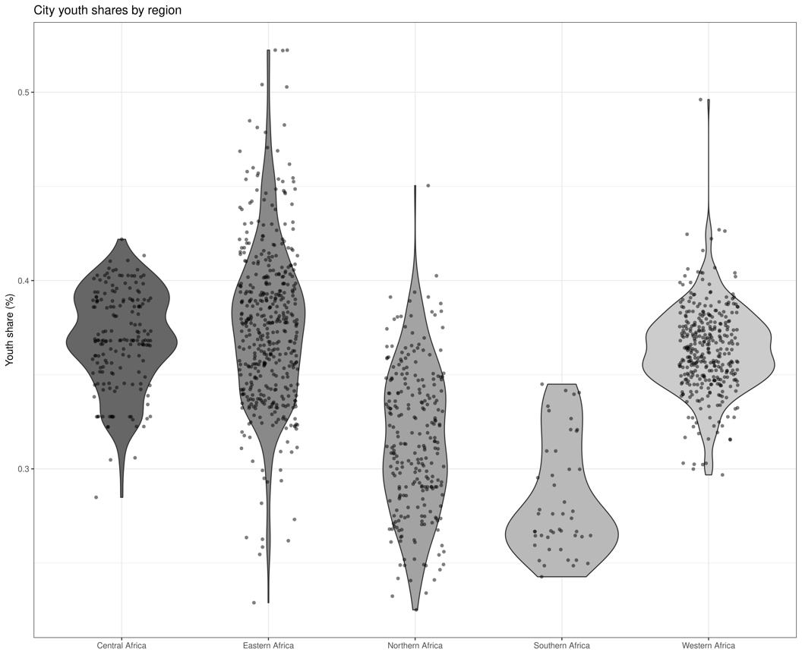

Figure 4. City-level variation in urban youth shares (2000-2020) within and between countries
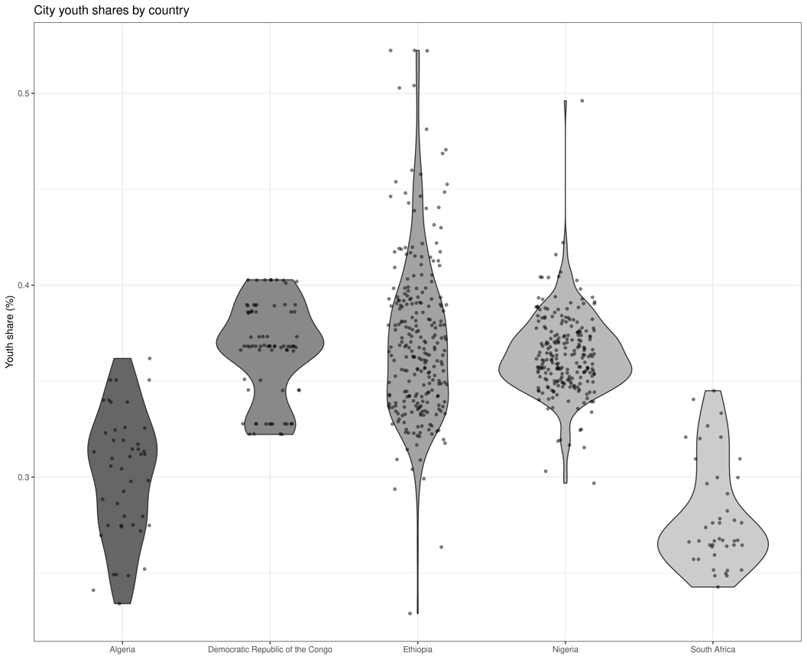

Appendix C: Descriptive Statistics
Name | N | Mean | SD | Min | Pctl. 25 | Pctl. 75 | MAX
Attend Protest | 18433 | 0.12 | 0.32 | 0 | 0 | 0 | 1
Voted | 18433 | 0.76 | 0.43 | 0 | 1 | 1 | 1
Youth share (%) | 18433 | 0.34 | 0.055 | 0.19 | 0.32 | 0.38 | 0.51
Total population (ln) | 18433 | 13 | 1.7 | 7 | 12 | 15 | 16
Population density | 18433 | 0.0052 | 0.0029 | 0.00016 | 0.0031 | 0.0067 | 0.015
GDP (ln) | 18433 | 1.9 | 1.3 | -2.2 | 0.9 | 3 | 3.5
Age group | 18433
Young adult | 6701 | 37%
Mid adult | 8519 | 46%
Older Adult | 3010 | 17%
Education | 18433 | 4.4 | 2.2 | 0 | 3 | 6 | 9
Gender | 18433 | 0.48 | 0.5 | 0 | 0 | 1 | 1
Experienced poverty (ln) | 18433 | 0.57 | 0.45 | 0 | 0.14 | 0.96 | 1.6
Employment status | 18433 | 0.46 | 0.5 | 0 | 0 | 1 | 1

Appendix D: Bayesian model diagnostics

Voting (Model 3)

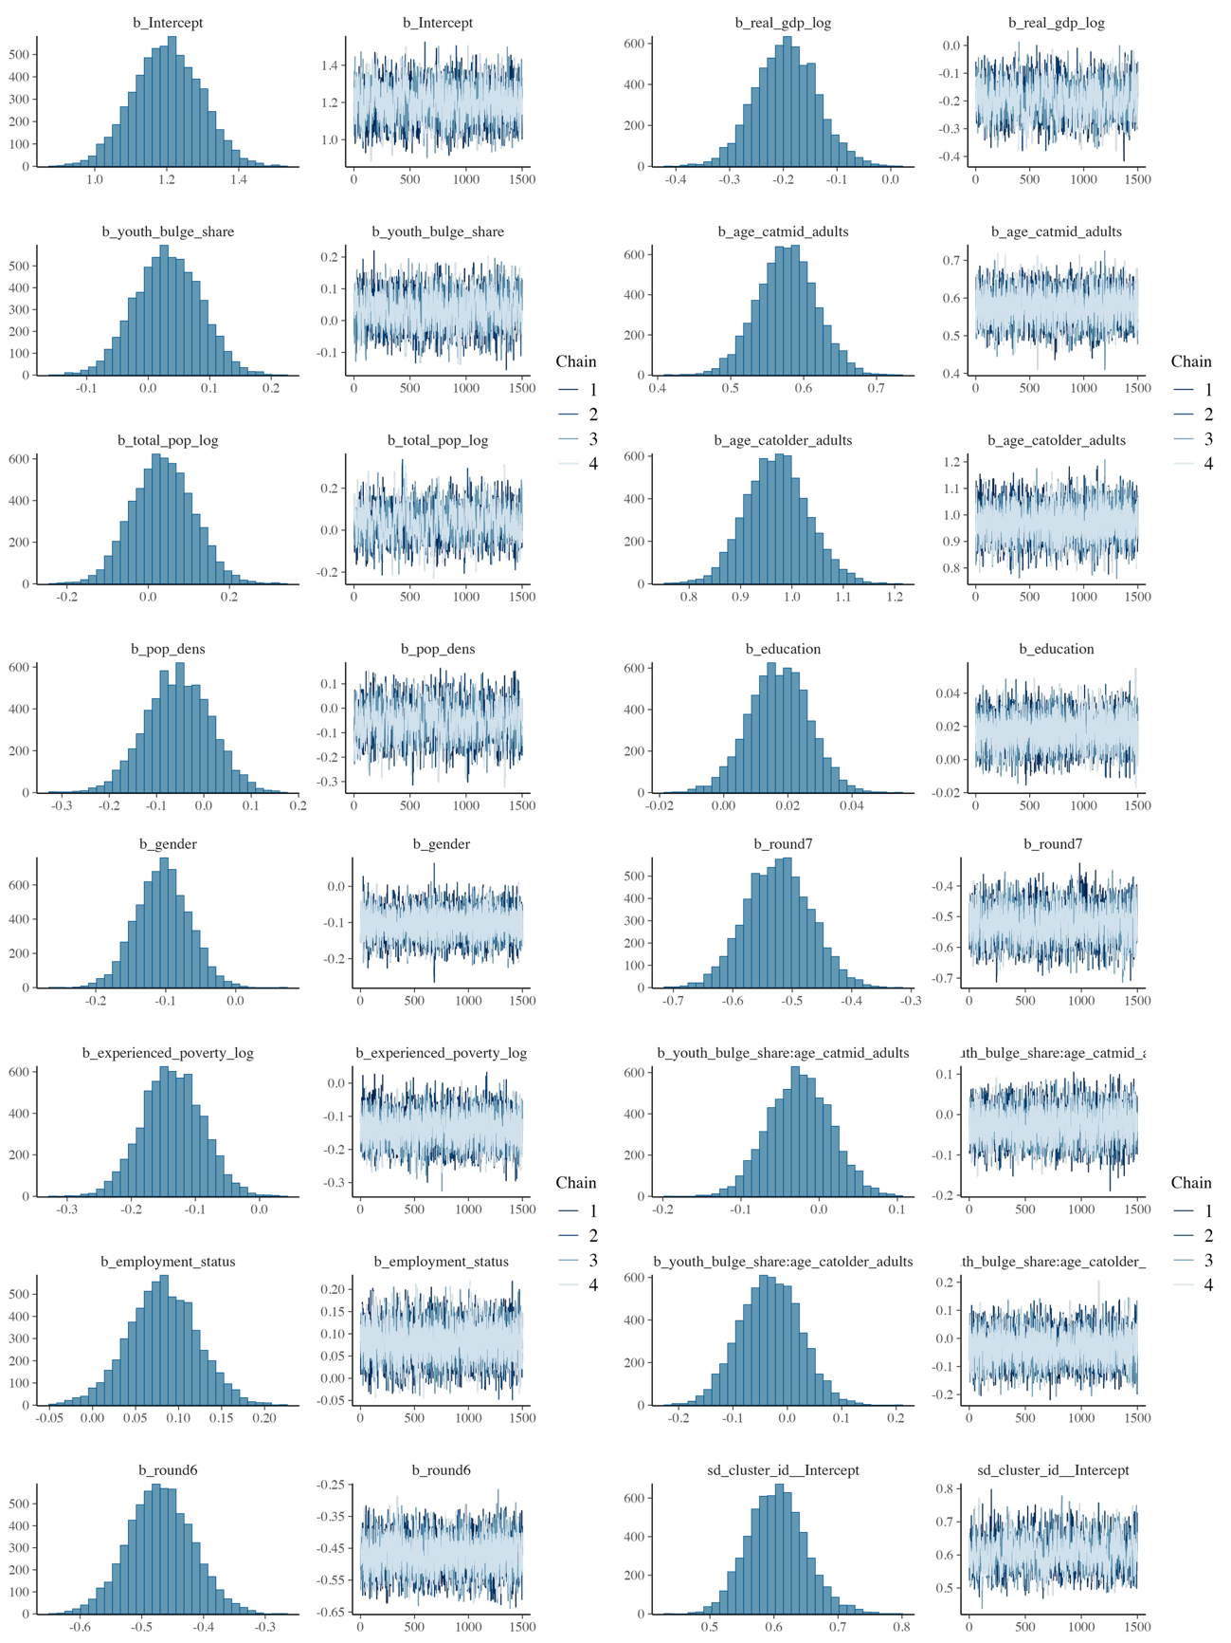

Protest (Model 6)

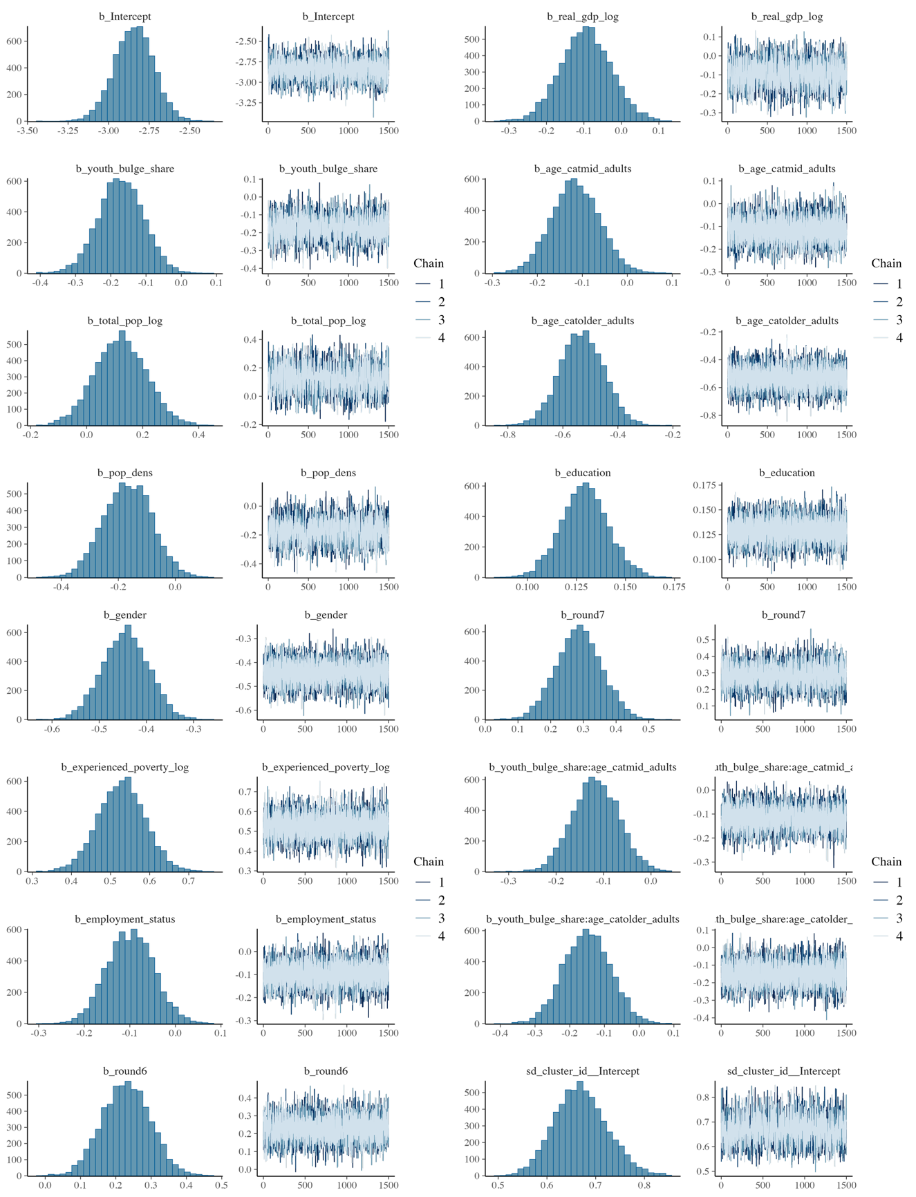

Appendix E: Robustness checks with Correlated Random Effects (CRE) models
Multilevel models of the kind we using in this paper implicitly assumes that unobserved cluster-level random effects (individual city intercepts) are uncorrelated with the Level 1 regressors (individual level characteristics e.g., age, gender., education). Violating this so-called random effects assumption can introduce endogeneity bias, making the model coefficients inconsistent and preventing causal interpretations.
The Correlated Random Effects (CRE) approach addresses this by explicitly modelling the correlation between the random effects and individual level regressors. This is done by adding the cluster means of all Level 1 explanatory variables as additional fixed effects to the model (see Antonakis, Bastardoz, and Rönkko, 2021).
By including these cluster means, the CRE approach provides consistent estimates for the level 1 (within-cluster) effects. Furthermore, it simultaneously allows for the estimation of Level 2 (between-cluster) and contextual effects, which FE models cannot.
We re-estimated the models in Table 1 of the main manuscript including a vector of cluster means for all individual level variables, $β{\overline{X}}_{j}$, such that:
$$logit\left(p_{ijk}\right)= β_{0}+ β_{1}\left({Youth share}_{jk}\right)+ β_{2}\left({Age}_{ijk}\right)+ β_{3}\left({Youth share}_{jk}×{Age}_{ijk}\right)+ βX_{ijk}+ β{\overline{X}}_{jk}+ βX_{jk}+\sum_{r=3}^{R}{γ({round}_{r})}+ u_{jk} + ϵ_{ijk}$$
The results are shown in the table below. The results are broadly consistent with those of our main analysis. However, calculating city means for individual variables forced us to collapse the categorical age variable into a binary outcome, shrinking the information and nuance contained within hat categorisation. This means that the interaction effect in Model 6, which is statistically significant for both age categories in our main results, is no longer statistically significant.

Bayesian (brms) CRE Models Summary
 | Voted (Model 1a) | Attended Protest (Model 2a) | Voted (Model 1b) | Attended Protest (Model 2b) | Voted (Model 1c) | Attended Protest (Model 2c)
Predictors | Odds Ratios | Odds Ratios | Odds Ratios | Odds Ratios | Odds Ratios | Odds Ratios
Intercept | 5.05  (4.40 – 5.83) | 4.94  (4.32 – 5.65) | 4.93  (4.30 – 5.61) | 0.10  (0.08 – 0.11) | 0.09  (0.08 – 0.11) | 0.09  (0.08 – 0.11)
youth bulge share | 0.99  (0.90 – 1.10) | 1.04  (0.94 – 1.15) | 1.04  (0.93 – 1.15) | 0.79  (0.70 – 0.88) | 0.81  (0.72 – 0.92) | 0.80  (0.71 – 0.91)
total pop log | 1.05  (0.91 – 1.21) | 1.04  (0.91 – 1.20) | 1.04  (0.91 – 1.21) | 1.15  (0.97 – 1.37) | 1.10  (0.92 – 1.33) | 1.11  (0.93 – 1.33)
pop dens | 0.95  (0.82 – 1.08) | 0.94  (0.82 – 1.07) | 0.93  (0.82 – 1.07) | 0.82  (0.69 – 0.97) | 0.85  (0.72 – 1.00) | 0.84  (0.71 – 0.99)
real gdp log | 0.83  (0.74 – 0.93) | 0.83  (0.74 – 0.93) | 0.83  (0.74 – 0.93) | 0.91  (0.80 – 1.04) | 0.90  (0.79 – 1.03) | 0.90  (0.78 – 1.03)
age cat centered | 1.41  (1.36 – 1.47) | 1.42  (1.37 – 1.48) | 1.42  (1.37 – 1.48) | 0.84  (0.80 – 0.88) | 0.86  (0.82 – 0.90) | 0.86  (0.82 – 0.90)
gender centered | 0.94  (0.91 – 0.97) | 0.95  (0.92 – 0.99) | 0.95  (0.92 – 0.99) | 0.78  (0.75 – 0.82) | 0.80  (0.77 – 0.84) | 0.80  (0.77 – 0.84)
age mean | 1.06  (0.99 – 1.13) | 1.04  (0.97 – 1.11) | 1.04  (0.97 – 1.11) | 0.92  (0.86 – 1.00) | 0.98  (0.90 – 1.07) | 0.98  (0.90 – 1.06)
gender mean | 0.98  (0.93 – 1.03) | 0.98  (0.93 – 1.03) | 0.98  (0.93 – 1.03) | 1.01  (0.95 – 1.08) | 1.02  (0.96 – 1.08) | 1.02  (0.95 – 1.08)
round: round 6 | 0.63  (0.57 – 0.70) | 0.63  (0.56 – 0.70) | 0.63  (0.56 – 0.69) | 1.22  (1.07 – 1.40) | 1.26  (1.11 – 1.45) | 1.27  (1.11 – 1.44)
round: round 7 | 0.59  (0.53 – 0.66) | 0.60  (0.53 – 0.67) | 0.60  (0.54 – 0.67) | 1.40  (1.22 – 1.59) | 1.35  (1.18 – 1.55) | 1.35  (1.18 – 1.54)
education centered |  | 1.05  (1.01 – 1.09) | 1.05  (1.00 – 1.09) |  | 1.29  (1.23 – 1.36) | 1.29  (1.23 – 1.36)
experienced poverty log  centered |  | 0.96  (0.92 – 1.00) | 0.96  (0.93 – 1.00) |  | 1.24  (1.19 – 1.30) | 1.24  (1.19 – 1.30)
employment status  centered |  | 1.04  (1.01 – 1.08) | 1.04  (1.01 – 1.08) |  | 0.98  (0.93 – 1.02) | 0.98  (0.93 – 1.02)
education mean |  | 0.92  (0.84 – 1.00) | 0.92  (0.85 – 1.00) |  | 1.20  (1.08 – 1.33) | 1.20  (1.08 – 1.33)
experienced poverty log  mean |  | 0.86  (0.79 – 0.94) | 0.86  (0.79 – 0.94) |  | 1.03  (0.92 – 1.15) | 1.03  (0.93 – 1.15)
employment status mean |  | 1.04  (0.96 – 1.12) | 1.04  (0.96 – 1.12) |  | 0.89  (0.81 – 0.98) | 0.89  (0.81 – 0.97)
youth_bulge_share:  age_cat_centered |  |  | 0.99  (0.95 – 1.02) |  |  | 0.96  (0.92 – 1.00)
Observations | 18321 | 18321 | 18321 | 18321 | 18321 | 18321
Marginal R² / Conditional R² | 0.035 / 0.095 | 0.043 / 0.096 | 0.044 / 0.096 | 0.017 / 0.048 | 0.029 / 0.060 | 0.029 / 0.060

References
Antonakis, J., Bastardoz, N. and Rönkkö, M., 2021. On ignoring the random effects assumption in multilevel models: Review, critique, and recommendations. Organizational Research Methods, 24(2), pp.443-483.
Blei, A., & Angel, S. (2021). Global monitoring with the atlas of urban expansion. Urban Remote Sensing: Monitoring, Synthesis, and Modeling in the Urban Environment, 247–282.
Dijkstra, L., Florczyk, A. J., Freire, S., Kemper, T., Melchiorri, M., Pesaresi, M., & Schiavina, M. (2021). Applying the degree of urbanisation to the globe: A new harmonised definition reveals a different picture of global urbanisation. Journal of Urban Economics, 125, 103312.
Dorward, N., & Fox, S. (2022). Population pressure, political institutions, and protests: A multilevel analysis of protest events in African cities. Political Geography, 99, 102762.
Dorward, N., Fox, S., Statham, T., & Wolf, L. J. (2023). A spatial-demographic analysis of Africa’s emerging urban geography. Environment & Urbanization, 35(2), 310–327.
Koechlin, L., & Förster, T. (2018). Secondary cities and the formation of political space in West and East Africa. The Palgrave Handbook of Urban Ethnography, 351–368.
Kumar, T., & Stenberg, M. (2023). Why political scientists should study smaller cities. Urban Affairs Review, 59(6), 2005–2042.
Melchiorri, M., Freire, S., Schiavina, M., Florczyk, A., Corbane, C., Maffenini, L., Pesaresi, M., Politis, P., Szabo, F., & Ehrlich, D. (2024). The Multi-temporal and Multi-dimensional Global Urban Centre Database to Delineate and Analyse World Cities. Scientific Data, 11(1), 82.

School of Geography and Environmental Science, University of Southampton.
Peace Research Institute Oslo
The index was computed using inverse distance weighting and the components showing a high degree of internal consistency with a coefficient alpha of α = 0.79.
All cities with a population less than 50,000 people have been dropped as these are settlements for which measurement errors in the UCDB and WorldPop data are likely to be higher (Blei and Angel, 2021). Furthermore, all cities with fewer than three responses have been dropped from the sample ensuring that there is enough within city information for model convergence. The countries covered are Algeria, Cameroon, Morocco, Nigeria, South Africa, Tanzania, Uganda, Zambia, Ghana, Kenya, Mozambique, Burkina Faso, Burundi, Niger, Togo, Madagascar, Benin, Mali, Tunisia, Guinea, Sudan, Côte d'Ivoire, Sierra Leone, Zimbabwe, Botswana, Lesotho, Namibia, Liberia, and Gabon.
The random effects model implicitly assumes no correlation between the individual level regressors and the random intercept. A violation of this assumption would bias our interpretation of those parameters. In Appendix E we conduct robustness checks explicitly model this assumption using a Correlated Random Effects model. The results of these models are consistent with our main analysis.
For age and voting, our findings contrast slightly with evidence from Europe and North America suggesting a curvilinear relationship between age and voting, with highest rates in the mid-age groups (Franklin, 2004; Henn & Foard, 2012; Wattenberg, 2003)
Each urban centre must have a minimum of four cells.

