Remobilisation of fine sediment from chalk stream gravel beds under flushing flows: A flume experiment

Abstract
Groundwater dominated chalk streams regularly exhibit higher quantities of accumulated fine sediment (inorganic and organic particles <2 mm) within their gravel beds compared with other UK systems due to their natural flow conditions, notably low bed mobilising flows. This characteristic, in combination with their fine sediment-sensitive species, creates a high propensity for lethal/sub-lethal ecological impacts. Current approaches to management targets and targeted interventions have failed in chalk streams due to a lack of scientific knowledge underpinning them. Whilst research has quantified fine sediment infiltration and accumulation in chalk stream gravel beds, little is understood regarding remobilisation that leads to the “cleanout” of fine sediment. To address this gap, flume experiments were carried out to investigate the remobilisation depths of fine sediment (especially cohesive sediment <62.5 μm) from the ecologically-sensitive surface layer (0 – 10 cm) of a typical chalk stream gravel bed, across a range of flow conditions. Bed shear stresses in the flume experiments ranged from 0.6 to 8.1 Pa; increases in bed shear stress corresponded to increases in fine sediment cleanout depth. Fine sediment remaining after experiment runs indicated two processes of remobilisation important in keeping the surface layer of gravel beds clean of excessive fine sediment: flushing from the bed framework and hydraulic winnowing within the bed framework. The data were used to evaluate the validity of established models for predicting fine sediment remobilisation from gravel beds. Comparisons between observed and predicted cleanout depths demonstrated that established models tend to overpredict cleanout depths. Existing models appear unsuitable for use in chalk streams due to assumptions within these models and their failure to represent the natural characteristics of chalk stream gravel beds. The novel data generated by this study can be applied to direct revised fine sediment targets, management, and restoration activities.

Keywords: Interstitial cohesive sediment, groundwater-dominated systems, bed substrate, river restoration, sediment management.

Introduction
Elevated quantities of fine sediment (inorganic and organic particles <2 mm) in the gravel beds of freshwater systems are known to cause substantial ecological degradation (Bilotta and Brazier, 2008; Kemp et al., 2011; Jones et al., 2012; 2017). These impacts are particularly evident in lowland systems with intensive agricultural catchments (Collins and Zhang, 2016; Naden et al., 2016); estimates indicate, for example, that 72-76% of fine sediment in English and Welsh river systems originates from agricultural sources (Collins et al., 2009; Zhang et al., 2014).

Chalk stream gravel beds have been shown to be particularly sensitive to elevated inputs of fine sediment due to their propensity for entrapment (Mondon et al., 2021; 2024). Chalk streams are typically characterised by low stream powers and stable framework gravel beds (Acornley and Sear, 1999; Sear et al., 1999; Mondon et al., 2021). These characteristics have been compounded by anthropogenic activities including increased connectivity as a result of field underdrainage (in areas prone to seasonal waterlogging), ditching, and construction of roads and farm tracks, that have increased sediment delivery and fine sediment loads (Sear et al., 1999). Channel widening, construction of weirs and hatches, and over-abstraction of chalk aquifers (reducing groundwater inputs) have also encouraged fine sediment deposition (Bickerton et al., 1993; Grabowski and Gurnell, 2016). The net result is a stable gravel bed into which fine sediments can accumulate at elevated rates.

Chalk stream gravel beds provide crucial habitats for numerous aquatic species of national and international conservation importance including Atlantic salmon (Salmo salar L.), brown trout (Salmo trutta L.), and white-clawed crayfish (Austropotamobius pallipes L.) (Mainstone, 1999; Mondon et al., 2021). These biota are naturally vulnerable to elevated levels of fine sediment both in the water column and in the river bed (e.g., Greig et al., 2005a; 2005b; 2007; Rosewarne et al., 2014; Sear et al., 2016; 2017). Analysis of fine sediment in 90 UK chalk stream gravel beds (Mondon et al., 2024), found that 78% exceeded the threshold for Atlantic salmon (S. salar L.) egg mortality proposed by Heywood and Walling (2007) and 91.3% exceeded the threshold proposed by Greig et al. (2005a; 2005b). Elevated fine sediment accumulation alters the conditions in gravel beds via a number of mechanisms. The blocking of interstitial pores by cohesive sediment (silt and clay sized particles <62.5 μm) reduces intra-gravel permeability and porosity, and limits rates of dissolved oxygen exchange (Sear et al., 2014; 2016; Wharton et al., 2017), which, in turn, limits the transfer of resources between the surface and groundwater habitats and, disconnects the hyporheic zone from the benthic substrate (Mathers et al., 2014; Hartwig and Borchardt, 2015). In addition, the surface 10 cm of chalk stream gravel beds have been noted to be ecologically-sensitive to elevated quantities of fine sediment (e.g., Louhi et al., 2008; Silva et al., 2015; Stubbington et al., 2015; Dunscombe et al., 2018; Bunting et al., 2021). Yet, current management approaches, such as the use of suspended sediment targets, are unsuccessful in chalk streams, since they do not consider differences in hydro-sedimentological responses and fail to recognise key mechanisms controlling fine sediment deposition and accumulation in gravel beds (Collins et al., 2011; Mondon et al., 2021; 2024). Whilst tackling sources is an important aspect of fine sediment management, the reduction of inputs alone (i.e., via management of catchment land use, erosion, and runoff) cannot address the issue of accumulated fine sediment quantities already present in systems, nor improve their resilience to potentially elevated fine sediment inputs in future (e.g., during extreme rainfall events). As such, ambitions for the management of fine sediment in chalk streams must also focus on its removal from the surface 10 cm of the gravel bed (particularly cohesive sediment, silt and clay <62.5 μm), but without causing detrimental impacts on the relict and naturally irreplaceable gravel framework (Mondon et al., 2024).

The quantity of fine sediment within the gravel beds of rivers is controlled by four factors: A) inputs of fine sediment; B) the transportation of fine sediment; C) infiltration of fine sediment into the gravel bed, and; D) exfiltration of fine sediment from the gravel bed (Mondon et al., 2021). Numerous experimental flume studies have examined the transportation, deposition, and infiltration of fine sediment into immobile gravel beds (e.g., Einstein, 1968; Beschta and Jackson, 1979; Gibson et al., 2010; 2011; Dudill et al., 2017). In contrast, there have been relatively few studies investigating exfiltration of fine sediment from immobile gravel beds (Grams and Wilcock, 2007; Kuhnle., 2015; 2016; Stradiotti et al., 2020; Trevisson and Eiff, 2022). The imbalance in previous studies is potentially due to the complexity of factors influencing fine sediment exfiltration but, may also reflect that most river systems (i.e., flashy, more responsive systems compared to chalk streams) experience flows sufficient to remobilise fine sediment from gravel beds and therefore the issue is potentially of lower priority. Moreover, due to the laborious nature of setting up an experimental bed that is representative of natural conditions, prior studies of exfiltration tend not to have represented the natural conditions occurring in chalk stream gravel beds, with few experiments using either the natural grain size distribution (GSD) of the gravel bed frameworks or the infiltrating fine sediment found in chalk streams (Mondon et al., 2024). For example, framework GSDs used in previous flume studies were often characterised by marked distinctions between the fractions representing the gravel framework and interstitial fine sediment and/or very well sorted sediment with a limited grain size (e.g., Grams and Wilcock, 2007; Trevisson and Eiff, 2022). Furthermore, most studies have focused on fine sediment in the sand-sized fraction (0.125 – 2 mm); there are few examples where cohesive sediment (silt and clay <62.5 μm) has been considered (e.g., Mooneyham and Strom, 2018). Whilst some studies have considered cohesive sediment (<62.5 μm), these have done so within a bed framework consisting of sand-sized particles (e.g., Cunningham et al., 1987; Fetzer et al., 2017; Du et al., 2018) and are therefore unrepresentative of natural conditions in chalk streams (Mondon et al., 2024). Importantly, exfiltration of a full GSDs of fine sediment similar to those observed in rivers (including sand, silt, and clay) have not been investigated in a flume study. Investigating the interactions of only specific sediment sizes and not the full GSD of fine sediment fails to represent what is actually occurring in the natural environment and, therefore, potentially critical interactions that are taking place between different sediment fractions are neither identified nor characterised (e.g., the influence of cohesion between silt and clay and its influence on sand erosion within a grave bed framework). Subsequently, this brings into question the reliability of the use of data accrued by previous experimental studies for fine sediment modelling in chalk streams and could potentially result in unacceptably high uncertainties for established models and river management decisions (Mondon et al., 2024).

Studies of fine sediment exfiltration from gravel beds have proposed models to predict maximum cleanout depths of fine sediment, in an attempt to inform restoration and management techniques in degraded freshwater systems. Detert and Parker (2010) proposed a model to estimate washout depths of sand (0.125 – 2 mm), based on the experimental data from the study by Detert et al. (2010) of flow and pressure fluctuations above and within a gravel bed (median grain diameter, D₅₀ of 10.2 mm and 25.4 mm). Equation (1) describes this model:
(Eq. 1)
$$\frac{λ_{c}}{k_{s}}=-1.0\ln{(\frac{u_{*}}{v_{f}})}$$

where 𝜆_{𝑐} is the cleanout depth of sand from the top of the gravel, 𝑘_{𝑠} is the Nikuradse sand-equivalent grain roughness (skin friction), 𝑢∗ is the shear velocity of the flow, and 𝜈_{𝑓} is the fall (settling) velocity of sand. The Detert and Parker (2010) model assumed that the threshold of erosion occurs when the fine sediment fall velocity equals the shear velocity and that bed roughness was a function of the bed median grain diameter. Kuhnle et al. (2016) tested this model using data from their flume experiments and concluded that it did not accurately predict cleanout depths of fine sediment, attributing this outcome to issues arising from the model’s assumptions.

Aiming to improve the representation of grain roughness in the Detert and Parker (2010) model, Kuhnle et al. (2015; 2016) proposed an alternative model based on the cumulative probability distribution of the gravel bed surface elevations (CPDG), combined with a representative grain size (median grainsize, D₅₀) to predict the cleanout depths of sand-sized (D₅₀ of 0.2 mm, 0.3 mm and 0.86 mm) particles from an immobile gravel bed (D₅₀: 36.1 mm, sorting coefficient: 1.17) (Supporting Information S.1). CPDG and representative grain sizes have been demonstrated to scale bed surface shear stresses to the shear stresses in the upper layer pores of a gravel bed (e.g., Pellachini, 2011). Sand transport above an immobile bed has been previously predicted using bed shear stress multiplied by the CPDG (Kuhnle et al., 2013; Wren et al., 2014). Subsequently, Kuhnle et al. (2016) found that their CPDG model accurately predicted cleanout depths of sand-sized fine sediment for their own flume experiments. Building on this study, Stradiotti et al. (2020) proposed a model for erosion rate and the maximum depth of fine sediment erosion from a gravel bed, based on their study of erosion rates of fine particulate bakelite (a synthetic plastic particle, D₅₀: 0.45 mm) from a stable gravel bed (D₉₀: 30.44 mm). Unlike the Kuhnle et al. (2016) study, where fine sediment elevations were measured after each flume run, Stradiotti et al. (2020) adopted a laser line/video camera technique to take direct and continuous measurements of fine sediment erosion from the gravel bed. They proposed an approach relating the maximum cleanout depth of fine sediment, as a function of the shear velocity at the gravel crest (Supporting Information S.2). Their model was calibrated using data from their own study and from Kuhnle et al. (2016) but was not validated using any additional experimental data.

Despite the exfiltration of fine sediment from chalk streams gravel beds being highlighted as a key mechanism in maintaining gravel beds clean of elevated fine sediment quantities (Mondon et al., 2021; 2024), the flushing flows required to achieve this remains poorly understood. In addition, previous experimental studies have not represented the natural sedimentological conditions occurring in chalk stream gravel beds and bring in to question their suitability in determining management and targets. As such, our objectives were to (1) collect data on the cleanout depths of mixed size fine sediment, particularly cohesive sediment (silt and clay <62.5 μm in diameter), from a typical chalk stream gravel bed under a range of flow conditions through progressive flume experiments; (2) use these data to develop and improve understanding of the relationship between chalk stream flow parameters, gravel beds, and cohesive sediment cleanout depths; and (3) investigate the validity of the previously proposed models by Kuhnle et al. (2016) and Stradiotti et al. (2020) in predicting the cleanout depths of fine sediment from a chalk stream gravel bed framework.

Methods

Experimental set-up
Experiments were conducted in a 5 m-long by 0.3 m-wide by 0.45 m-deep, tilting straight recirculating flume channel, as described by Paphitis and Collins (2001) and Kassem (2021). The 0.16 m deep immobile chalk stream gravel bed began 1.35 m downstream of a honeycomb baffle block at the end of a header tank, and continued downstream for 2.3 m, ending 1.35 m upstream of the tailgate (bottom hinged weir; flume design; Figure 1). The initial 1.35 m and final 1.35 m of the gravel bed set-up consisted of a 1 m long slope (tan α = 0.15) and 0.35 m section of gravel bed with a generic GSD. These were installed to generate a fully mixed flow over the bed and trigger the early development of the rough boundary layer. The experimental flow and turbulence conditions thus represented a more natural river condition and were not just a product of the pumps and input structure of the flume. The replicate gravel bed depth was chosen on the basis that the surface 10 cm of chalk stream gravel beds are the most ecologically-sensitive to elevated quantities of fine sediment (Mondon et al., 2024).

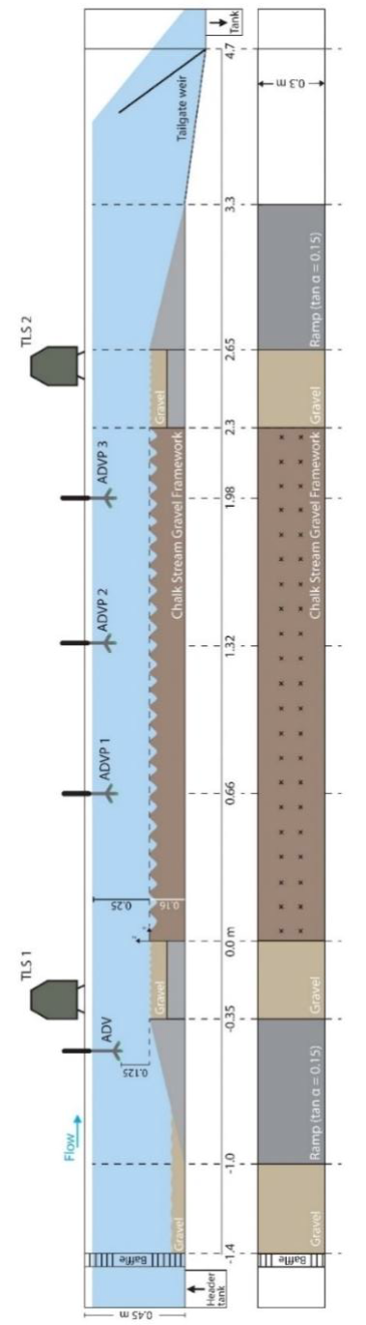
Figure 1: Experimental flume design, detailing the location of the replicate chalk stream gravel bed and sampling points for the TLS (Terrestrial Laser Scanner), ADV (Acoustic Doppler Velometer), and ADVP (Acoustic Doppler Velometer Profiler). Fine sediment elevation measuring points are indicated by x points.

The GSD of the replicate chalk stream fine sediment fraction (Figure 2A) and gravel bed framework (Figure 2B) were selected to reflect the mean GSDs from the surface layers of 90 gravel bed freeze-coring sites from 11 chalk streams across the UK (Mondon et al., 2024; Supporting Information S.3). The replicate chalk stream gravel bed framework consisted of quarry-sourced particles with a D₅₀ of 19.8 mm and a sorting coefficient of 2.95. The desired GSD was prepared by weighing and sieving. The fine sediment fraction consisted of quarry-sourced sand (2 mm <d< 0.125 mm) and fine sediment (d <0.125 mm), where d is the particle diameter, collected from the River Itchen (a chalk stream in southern England, UK; UK National Grid Reference SU 56461 31777, 51º04’57’’N 001º11’43’’W), which had a D₅₀ of 0.32 mm and a sorting coefficient of 2.8 (quantities of the different fine sediment fractions with the bed are given in Section 3). The fine sediment fraction was pre-mixed with the gravel bed particles and placed simultaneously into the flume, then saturated and left to consolidate for four days before the initiation of the experiments (Figure 3A & B).

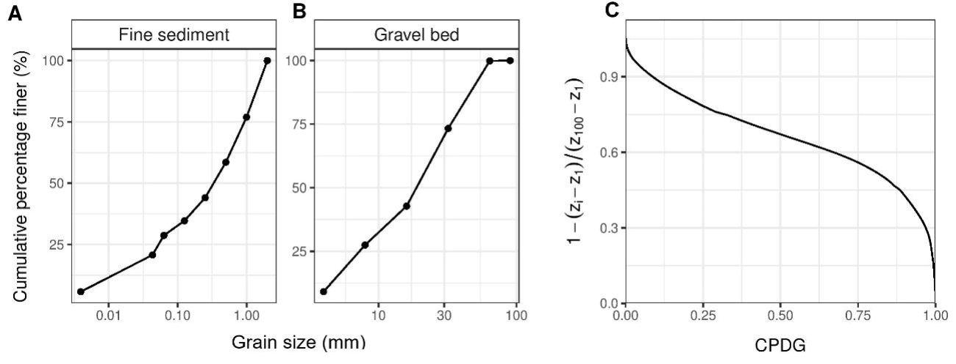
Figure 2: Sedimentary characteristics of the replicate chalk stream surface layer gravel bed used in this study; (A) GSD of the fine sediment, (B) GSD of the gravel bed, and (C) the CPDG of the gravel bed surface substrate (Z₁₀₀ is the elevation at the top of the highest bed particle and Z₁ is the elevation of the CPDG for which 99% of the particles are higher).

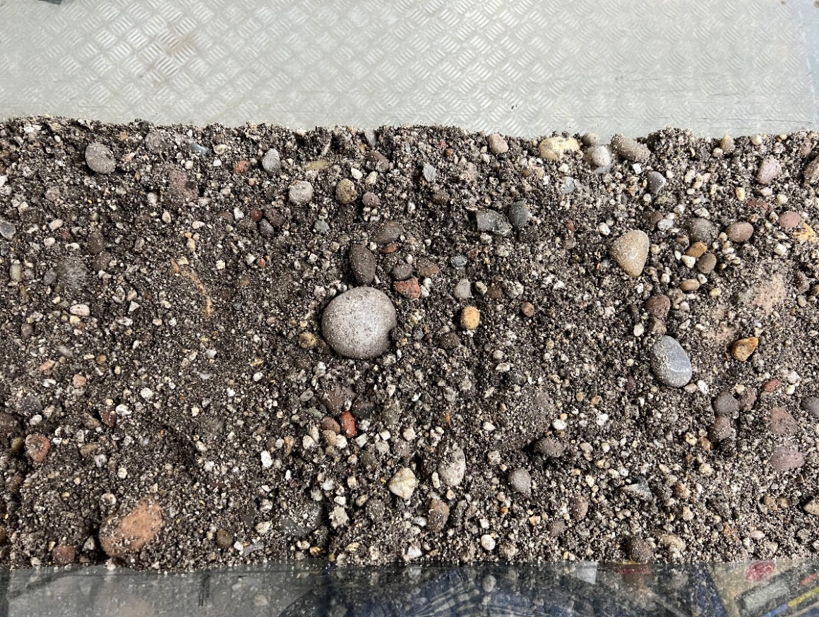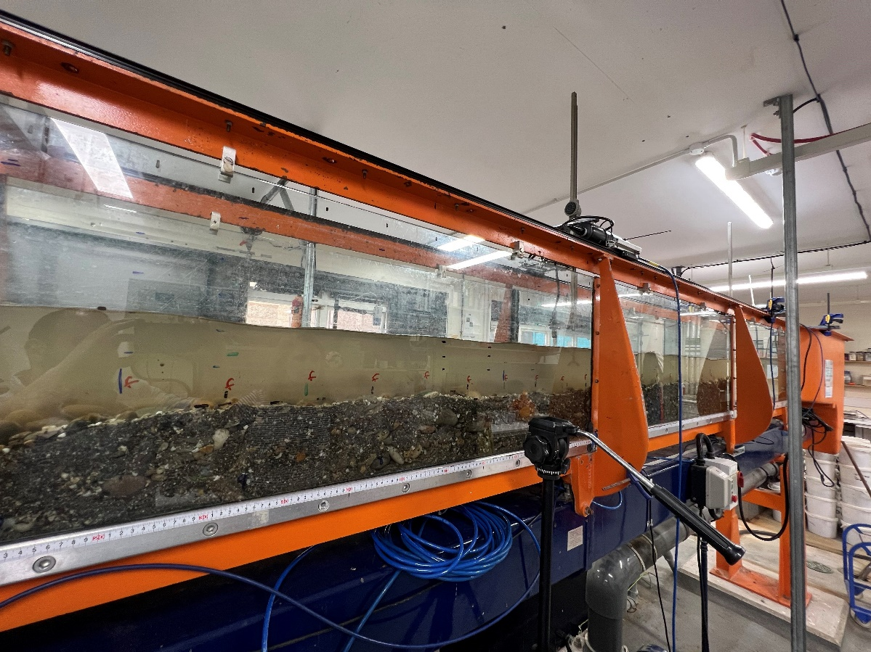
A. Above View
B. Side View
Figure 3: The replicate chalk stream gravel bed set-up in the experiments from (A) above and (B) the side of the flume.

After the initial installation of the replicate gravel bed, a digital scan of the surface elevation was carried out using a Leica ScanStation P20 terrestrial laser scanner (TLS), mounted on top of channel rails at two locations (Figure 1). Scans were conducted at an average distance of 1 m from the instrument to the bed, with an estimated laser spot size of 3.1 mm. To reduce errors in the scans, optimisation of target locations used for georeferencing was conducted (yielding an accuracy of s.d. 0.5 mm in the measured locations). Bed scans were repeated after each of the experimental runs once the gravel bed had been drained – this was done to prevent any distortion of the laser scans caused by the presence of surface water, as the adopted TLS operates in the infrared region (where water strongly absorbs incident light, resulting in a lack of/spurious laser returns for submerged and/or wet surfaces). An example of a TLS scan of the experimental gravel bed is shown Supporting Information S.4. The recirculating flume used in this study uses a slump tank to settle and remove fine sediment that has been entrained into suspension however, it is not 100% efficient and a very low level of ‘background’ suspended fine sediment is retained and recirculated into the flume (akin to a wash load in nature). This recirculated ‘background’ suspended fine sediment was used to represent conditions with low levels of upstream suspended fine sediment supply, for example, those occurring on the falling limb of a high flow/flood event, which due to their long duration in chalk streams, typically exhaust fine sediment early on (e.g., Heywood and Walling, 2003). As such, the experimental runs were carried out under fine sediment supply-limited conditions, and no additional upstream sediment supply was implemented.

The setup and conditions for each of the experimental runs are shown in Table 1. Each experimental flume run was carried out for 8 hours, due to laboratory access restrictions. It should also be noted that each experimental run was carried out progressively, instead of independently: eroded fine sediment was not restored to original quantities within the bed framework after each experimental run. The outlined approach followed the procedure by Kuhnle et al. (2016), in order to test the validity of the previously proposed models in predicting cleanout depths of mixed size fine sediment. The increasing exposure of the gravel bed particles in each consecutive experimental run will have an influence on observed patterns of bed shear stress through reductions in the stress acting on fine sediment by exerting drag on the flow and by introduction of localised velocity and pressure excursions in their wakes (Grams and Wilcock, 2007; Schmeeckle et al., 2007), potentially exaggerating the extremes of the cleanout depths observed. However, restoring fine sediment quantities after each experimental run is also not without limitations. For example, disturbance of the bed framework and changes in the sediment packing, would influence patterns of bed shear stress and thus influence cleanout depths.

Table 1: Mean conditions during each of the experimental flume runs. Calculation of shear velocity is based on Equations (3 and 4). Additional flow characteristics are given in Supporting Information S.5.
Run | Water surface slope (m/m) | Flow depth (m) | Flow velocity at flow depth midpoint (m s⁻¹) | Shear velocity (m s⁻¹) | Bed shear stress (Pa) | Cleanout depth (m)
Run 1 | 0.001 | 0.25 | 0.2135 | 0.0240 | 0.580 | 0.0109
Run 2 | 0.001 | 0.25 | 0.2494 | 0.0321 | 1.032 | 0.0134
Run 3 | 0.001 | 0.25 | 0.2592 | 0.0357 | 1.275 | 0.0168
Run 4 | 0.002 | 0.23 | 0.2827 | 0.0550 | 3.060 | 0.0222
Run 5 | 0.002 | 0.20 | 0.3269 | 0.0624 | 3.925 | 0.0285
Run 6 | 0.002 | 0.18 | 0.3301 | 0.0640 | 4.112 | 0.0347
Run 7 | 0.003 | 0.15 | 0.3471 | 0.0819 | 6.728 | 0.0476
Run 8 | 0.003 | 0.10 | 0.3214 | 0.0766 | 5.875 | 0.0428
Run 9 | 0.003 | 0.12 | 0.3732 | 0.0915 | 8.078 | 0.0648

Uniform flow and depth were maintained by regulating the weir at the downstream end of the flume and altering pump speeds. The flume was also mounted on a rigid framework and was tilted via a calibrated screw jack, which allowed for accurate slope adjustment of the channel (channel slope was maintained at 0.002 m/m). Flow depths ranged from 0.25 m to 0.10 m (Table 1) and were calculated as the difference between the height of the bed and the water surface at each of the 21 bed sampling cross-sections denoted in the flume design (Figure 1). It was endeavoured to measure water depths to mm resolution but uncertainty in estimation of a moving water surface, resulting in uncertainty approaching 0.005 m, which was assumed across all the experimental runs. Water-surface slope was calculated for each run using the distance between the water-surface and the top of the flume at 21 positions. Slope was extracted using a linear fit to these measurements. Average outflow velocity (upstream) was measured four times in each experimental run by a downward-looking, 1.1 MHz Nortek Vectrino Acoustic Doppler Velocimeter (ADV), sampling a 7 mm cylindrical volume (single point) at 25 Hz, at the ADV location (Figure 1). Velocity profile data were collected twice at three positions (AVDP 1-3; Figure 1) in each experimental run by a downward-looking 1.1 MHz Nortek Vectrino II Acoustic Doppler Velocimeter Profiler (ADVP) positioned in the centre of the channel. The ADVP sampled a 30 mm profile at 25 Hz (1 mm resolution) for 60 seconds, at four elevations in the water column (0.20 m, 0.15 m, 0.10 m, and 0.05 m) to provide a vertical velocity profile. Cohesive sediment (<62.5 µm) elevations in the bed were measured manually after each experimental run, at the 42 bed sampling locations (i.e., two parallel rows of 21 sampling locations, Figure 1). These were calculated as the difference between the height of the interstitial cohesive sediment and the bed surface height, compared with the top of the flume sides, creating two fine elevation long profiles for each flume run. The height of the interstitial cohesive sediment was based on the visual differences in the interstitial fine sediment, with the sand fraction (250 µm > d > 62.5 µm), white in colour due to its quarry-sourced origins and cohesive sediment (silt and clay, < 62.5 µm), brown in colour due to its fluvial-sourced origins. Overall cleanout depth for each experimental run was calculated as the average of the 42 measurements. Where necessary, surface gravel particles were temporally moved to allow for the measurement of the interstitial fine sediment and re-placed afterward, preserving the bed framework and limiting disturbance of the fine sediment below. Suspended sediment samples were obtained by hand, sampling the water column, taken hourly during each experimental run. The samples were then processed using a Malvern MasterSizer 3000 laser diffraction particle size analyser to determine the GSD of the suspended sediment (<1 mm) in the water column. After the completion of the final run, samples of the interstitial cohesive sediment (< 62.5 µm) and sand (<1 mm) present in the gravel bed were taken at each of the 42 bed sampling locations (Figure 1) at three depths within the bed: surface layer (0 – 5 cm), middle layer (5 – 10 cm), and subsurface layer (10 – 16 cm). A Malvern MasterSizer 3000 laser diffraction particle size analyser was used to measure the absolute GSD of both the suspended sediment and interstitial cohesive sediment and (<1 mm) samples.

Data analysis
Following the procedure by Kuhnle et al. (2016), digital scans of the surface elevation were used to calculate the cumulative probability distribution of the elevations of the gravel, which were scaled by the thickness of the surface roughness layer (Equation 2):
(Eq. 2)
$${\tilde{Z}}_{l}=1-\frac{Z_{i}-Z_{1}}{Z_{100}-Z_{1}}$$

where 𝑍₁₀₀ is the elevation at the top of the highest bed particle, 𝑍₁ is the elevation of the CPDG for which 99% of the particles are higher, and 𝑍₁₀₀ − 𝑍₁ represents the roughness geometry thickness (RGT). As in the Kuhnle et al. (2016) study, the elevation 𝑍₁ was used instead of 𝑍₀ to represent the lower boundary of the CPDG to remove erroneous data points introduced by the orientation of the laser scanner relative to the gravel bed. The CPDG of the gravel bed used in this study is shown in Figure 2C.

ADV and ADVP data were processed in MatLab R2022b. The ADVP measured the 3D instantaneous flow velocity field (in 30 mm profiles), representing the streamwise (u, along the flume), the crosswise (v, transverse along the flume), and the vertical (w, positive upwards) flow components. Extraction of the fluctuations from the processed velocity components by Reynolds decomposition followed the approach detailed in Kassem et al. (2015; 2020). This included a quality check, whereby no more than 20% of a record falls below the correlation threshold, set at 70% signal-to-noise (SNR) ratio, following the approach by Elgar et al. (2005). This approach accounts for any noise arising from signal aliasing. A zero-phase moving average algorithm was then applied to replace values falling below the threshold by interpolation (Thompson et al., 2012). Signals were de-spiked using the 3D phase-space method by Goring and Nikora (2002; 2003), as modified by Mori et al. (2007). An axis-rotation algorithm was applied to the data to ensure alignment with the flow, eliminating the effects of sensor misalignment (Elgar et al., 2001). The data were then zero-meaned, de-trended and the mean velocity ($\overline{U}$) calculated from the three components. Time-averaged vertical velocity profiles were extracted for each of the ADVP recordings, generating 108 velocity profiles in total (12 per experimental run). These were then averaged and combined to give three (one for each ADVP recording location) average velocity profiles for each experimental run (Supporting Information S.6). Using the average velocity profiles from each experimental run, the shear velocity 𝑢∗ was calculated using the von Kármán-Prandtl logarithmic law of the wall equation (von Kármán, 1930). This states that the average velocity of a turbulent flow at a certain height is proportional to the logarithm of the distance from that point to the “wall” (Equation 3):
(Eq. 3)
$$\overline{U}=(u_{*})\frac{1}{κ}\ln\left(\frac{h}{z_{0}}\right)$$

where $\overline{U}$ is the mean velocity at given height (h), 𝑢∗ is the shear velocity, κ is the von Kármán’s constant (κ =0.4), ℎ is the height above the bed and 𝑧₀ is the bed roughness height. Linear regression was used to obtain these parameters, from the logarithmic velocity profiles, 𝑧₀ is thus defined as the intersection of the best-fit of the semi-log plot of depth and velocity where 𝑧₀ is the elevation at which velocity is reduced to zero (Sternberg, 1970; Middleton, 1984). Using the shear velocity (𝑢∗), Equation (4) was then used to calculate the bed shear stresses for each experimental run:
(Eq. 4)
$$τ_{0}=ρu_{*}^{2}$$

where $ρ$ is the density of fresh water (1000 kg m⁻³) and 𝜏₀ is the bed shear stress. The resulting parameters from these calculations are shown in Supporting Information S.7. A full velocity profile was fitted to the data to estimate shear velocity and roughness height. Although this includes data points outside of the log region, both the exclusion of near bed data points and the application of the Coles-Wake correlation (Coles, 1952) demonstrated only moderate refinements in the estimation of both shear velocities and roughness height (Supporting Information S.8). As such the application of the log-law without caveats was deemed suitable and beneficial, given its simplicity and ease of application by non-expert practitioners. Although other methods can be used to determine bed shear stress (e.g., Reynolds stress and the turbulent kinetic energy (TKE) methods), the decision was taken to determine bed shear stress estimates using the logarithmic profile method as opposed to single measurements of flow velocity for two key reasons: (1) an independent estimate of the roughness height is not required to determine the shear velocity; and (2) the approach provides coefficient of determination (R²) values that allow the goodness of the fit for the data to be assessed (Wilcock, 1996; Petrie et al., 2010).

Results
The mean cleanout depth of cohesive fine sediment (<62.5 μm) from the gravel bed ranged from 0.0109 m (standard deviation, s.d. 0.0027 m) to 0.0648 m (s.d. 0.0116 m), in Run 1 and Run 9, respectively (Table 1). Patterns of erosion varied across the bed, with some regions along the flume experiencing greater depths of erosion than others (Figure 4). The largest increase in cleanout depths occurred in Run 9 (the highest flow velocity), with a 490% increase in cleanout depths compared with Run 1. For all runs, no significant linear relationships were found between cleanout depth and distance downstream (r² < 0.18, p > 0.05).

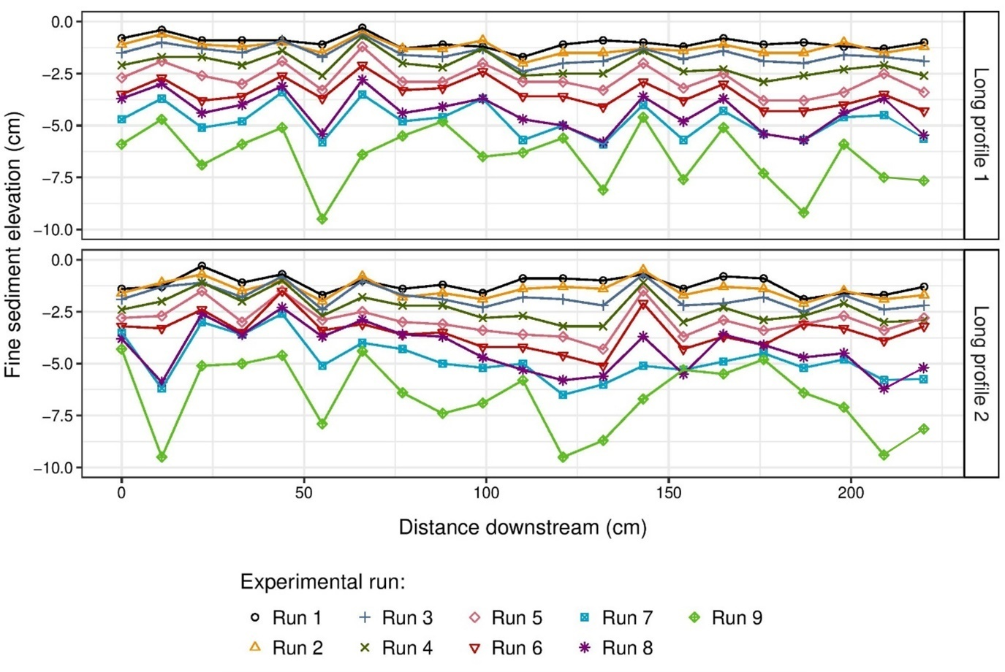
Figure 4: Cohesive fine sediment (silt and clay <62.5 μm) cleanout depths below the replicate gravel bed surface with distance downstream post the experimental runs, for each long profile (i.e., the two parallel rows of 21 sampling locations).

Increases in cleanout depths corresponded with increases in bed shear stress (Figure 5), both in terms of the cumulative depth of fine sediment erosion in each consecutive run and the depth of erosion in each individual experimental run (Figure 5). The deepest mean cleanout depths were reached in Run 9, 0.0648 m (s.d. 0.0156 m), corresponding with the highest mean bed shear stress, 8.08 Pa (s.d. 0.63 Pa). This trend was not observed in Run 1, where the lowest bed shear stresses were observed to cause fine sediment erosion similar to those occurring in Run 6.

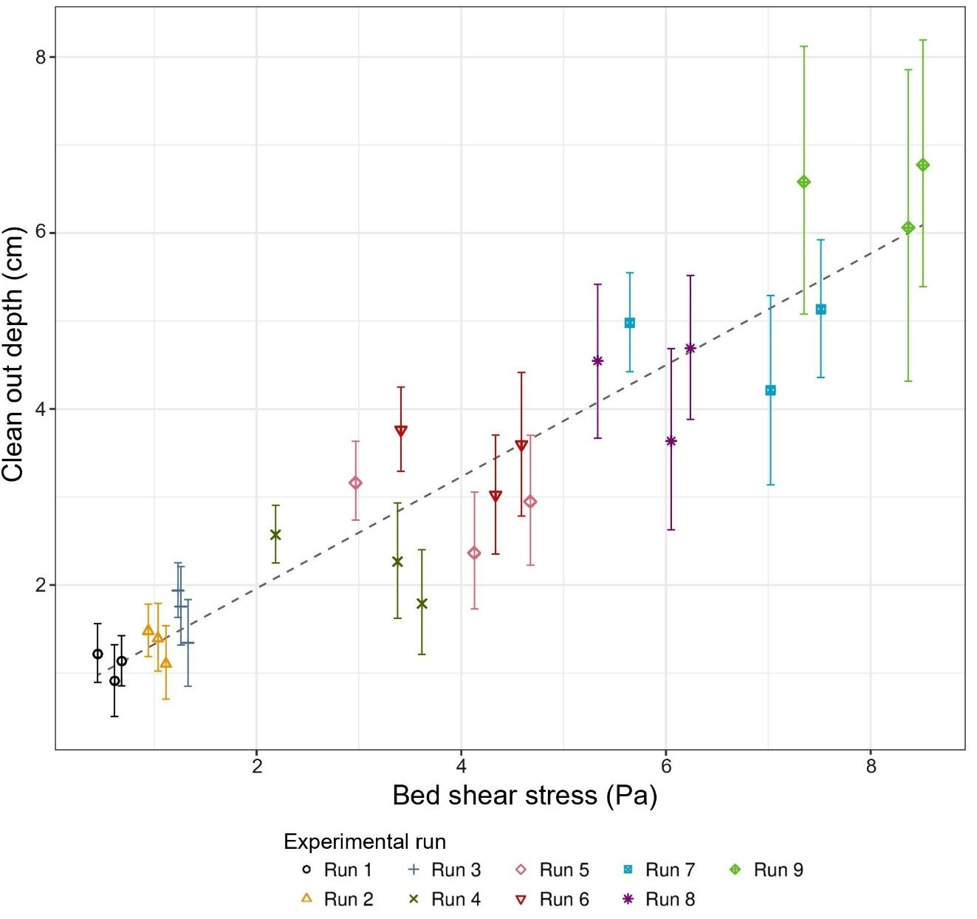
Figure 5: Average cumulative cleanout depth of cohesive fine sediment (silt and clay <62.5 µm) post each experimental run compared with the average bed shear stress from the closest ADVP measuring location. Points are grouped by experimental run.

Prior to the experimental runs, cohesive particles (<62.5 μm) were 33.1%, as a proportion of interstitial sediment (silt to medium sand, <1 mm) in the gravel bed. The GSD of the interstitial sediment (<1 mm) prior to the experimental runs was consistent through the whole depth of the gravel bed (0 – 16 cm). After the experimental runs, the GSD of the interstitial sediment (<1 mm) in the gravel bed became finer with increasing depth in the bed (Figure 6), with the coarsest sediment (<1 mm) in the surface layer (0 – 5 cm) and the finest in the subsurface layer (5 – 16 cm). The average proportion of cohesive sediment (<62.5 µm) in the surface layer (0 – 5 cm) was 15.8% (s.d. 3.2%) of the total sediment quantity (<1 mm), a 52.8% decrease in cohesive sediment compared with the pre-experimental run quantities (Table 2). Medium-sized sand (0.25 – 0.5 mm) was the largest fraction of interstitial sediment <1 mm (33.6 s.d. 3.9%) in the surface layer of the gravel bed. In contrast, in the subsurface layer (10 – 16 cm), silt and clay particles (< 62.5 µm) made up the largest fraction of fine sediment (<1 mm; 38.7 s.d. 3.9%) (Figure 6). The experimental data exhibited an average increase in cohesive sediment by 114% between the surface (0 – 5 cm) and subsurface layers (10 – 16 cm) of the post-experimental run gravel bed and a 15.2% increase compared with the pre-experimental run gravel bed. There was a 77% increase in silt and clay (<62 μm) quantities between the surface (0 – 5 cm) and middle (5 – 10 cm) layer of the experimental gravel bed, and a 37.6% increase between the middle (5 – 10 cm) and subsurface (10 -16 cm) layer of the experimental gravel bed.

Table 2: Quantities of the different fine sediment fractions within the experimental gravel bed prior and post the experimental runs. d – particle diameter.
Sediment fraction | Experimental bed layer | Proportion of fine sediment <1 mm |  | % Change
Sediment fraction | Experimental bed layer | Prior experimental runs | Post experimental runs | % Change
Cohesive sediment  (d <62.5 μm) | Surface (0 – 5 cm) | 33.1 | 15.8 (s.d. 3.2) | - 52.8
Cohesive sediment  (d <62.5 μm) | Middle (5 – 10 cm) | 33.1 | 28.1 (s.d. 5.9) | - 15.1
Cohesive sediment  (d <62.5 μm) | Sub-surface (10 – 16 cm) | 33.1 | 38.7 (s.d. 3.9) | + 15.2
Very fine/fine sand  (62.5 μm >d< 0.25 mm) | Surface (0 – 5 cm) | 43.2 | 33.7 (s.d. 5.0) | - 21.9
Very fine/fine sand  (62.5 μm >d< 0.25 mm) | Middle (5 – 10 cm) | 43.2 | 40.0 (s.d. 5.3) | - 7.4
Very fine/fine sand  (62.5 μm >d< 0.25 mm) | Sub-surface (10 – 16 cm) | 43.2 | 37.1 (s.d. 4.2) | - 14.1
Medium/coarse sand  (0.25 mm >d< 1 mm) | Surface (0 – 5 cm) | 23.7 | 50.4 (s.d. 8.0) | + 112.6
Medium/coarse sand  (0.25 mm >d< 1 mm) | Middle (5 – 10 cm) | 23.7 | 31.8 (s.d. 6.9) | + 31.8
Medium/coarse sand  (0.25 mm >d< 1 mm) | Sub-surface (10 – 16 cm) | 23.7 | 24.2 (s.d. 6.3) | + 2.1

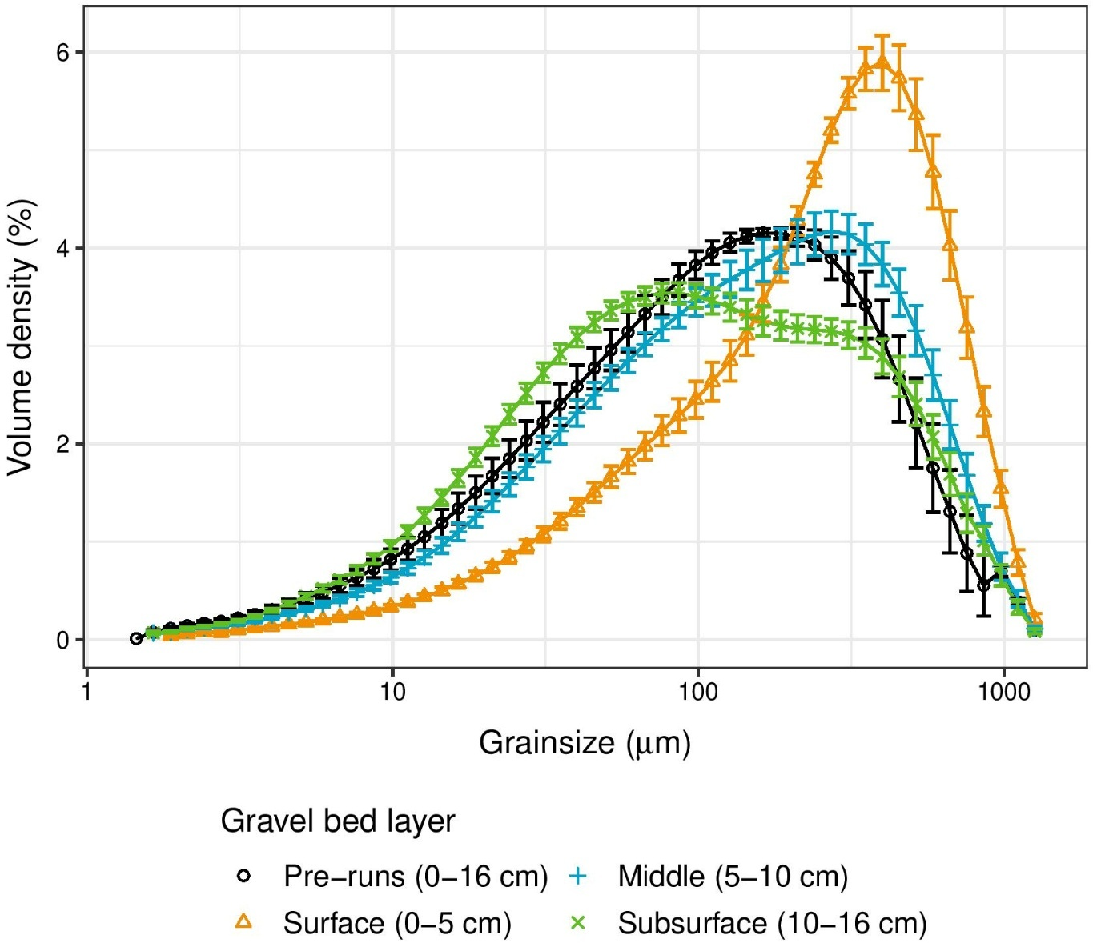
Figure 6: GSD of interstitial fine sediment (<1 mm) samples taken from both the replicate gravel bed pre-experimental runs and post- the final experimental run (Run 9). Points are grouped by depth in the gravel bed.

The GSD of the suspended fine sediment within the water column became coarser with each progressive run, corresponding with the increase in shear velocity and bed shear stress (Figure 7). There was an increase in the D₅₀ of the suspended fine sediment from 36 μm to 64 μm. Silt and clay sized sediment (<62.5 μm) dominated the total suspended sediment volume (>64% s.d. 8.4%) in all the experimental runs, aside from Runs 7 and 9 (54% and 45%, respectively). The largest proportion of silt and clay sized particles in the suspended sediment was observed in Run 2 (79% s.d. 4.3%) (Figure 7). The largest proportion of sand sized particles transported in the water column was observed in Run 9 (57% s.d. 6.4%); 99% of the sand consisted of very-fine and fine sand sized particles (62.5 μm >d< 250 μm). This was a 171% increase in the volume of sand sized particles within the suspended sediment compared with Run 2. The largest grain sizes transported in the water column were medium sand sized particles (250 μm >d< 500 μm) (Figure 7); however, these constituted <1% of the total suspended sediment volume of any experimental run.

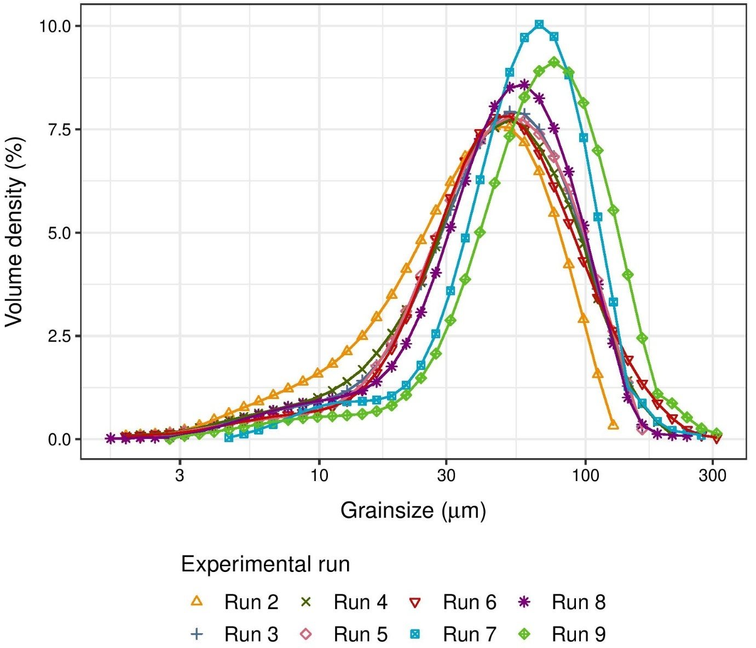
Figure 7: Average GSD of the suspended fine sediment (<1 mm in diameter) in the water column throughout the experimental runs. Points grouped by experimental run. Run 1, data were lost due to technical failure of the Malvern MasterSizer during the processing of data.

Validity of cleanout depth models
Measured cleanout depths from the present study were compared with the predicted cleanout depths from the Kuhnle et al. (2016) model. When considering bed shear stress calculated using the log profile approach, 𝜏₀ (log profile), the comparison demonstrates that the Kuhnle et al. (2016) model does not reproduce the observed cleanout depths for either the eroded fine sediment (suspended sediment in the water column) (D₅₀: 36 – 64 μm) or the bed fine sediment grain sizes (interstitial fine sediment) (D₅₀: 320 μm) and overestimates the cleanout depths (Figure 8). The model does perform slightly better when considering the bed fine sediment grain sizes, but only for bed shear stresses >3 Pa. Values lower than this were deemed insufficient to remobilise fine sediment of this size, based on their velocity predictions. In the determination of the Kuhnle et al. (2016) model, the 𝜏₀ (log profile) was not used, instead bed shear stress was calculated using the relation proposed by Vanoni and Brookes (1957), as modified by Cheng (2011) (Supporting Information S.9), 𝜏₀ (bulk flow). To reproduce such conditions, cleanout depths for the experimental runs in our study were also predicted using the 𝜏₀ (bulk flow) approach (Figure 8A). However, the model does not perform any better when considering bed shear stress calculated using this approach and still overestimates the cleanout depths. In this scenario, bed shear stresses did not exceed 3 Pa and, consequently, the Kuhnle et al. (2016) model did not provide cleanout depths for the interstitial fine sediment. Nevertheless, these conditions were not observed in this study, with bed shear stresses >8 Pa recorded. This brings into question the representativeness of the Kuhnle et al. (2016) model in terms of observed bed shear stresses.

Measured maximum cleanout depths from the present study were also compared with the predicted maximum cleanout depths derived using the Stradiotti et al. (2020) model (Figure 8B). When considering shear velocities calculated using the 𝜏₀ (log profile) from the present study, comparison demonstrates that the Stradiotti et al. (2020) model performs relatively well when considering the bed fine sediment. However, it does not perform so well when considering the eroded fine sediment, and overpredicts the maximum cleanout depths. Like the Kuhnle et al. (2016) model, the Stradiotti et al. (2020) model was established using experiments where shear velocity was calculated using the 𝜏₀ (bulk flow) approach and not the 𝜏₀ (log profile) approach. To reproduce these conditions, maximum cleanout depths were also predicted using shear velocity values calculated using the 𝜏₀ (bulk flow) approach (Supporting Information S.1). Despite having relatively high R² values, the model does not accurately reproduce the observed maximum cleanout depths, when considering either the eroded fine sediment (suspended fine sediment in the water column) or the bed fine sediment (interstitial fine sediment) (Figure 8B); the model overpredicts for the lower calculated values and underpredicts for the higher calculated values. Subsequently, none of the predicted maximum cleanout depths using shear velocities calculated via the 𝜏₀ (bulk flow) approach represented our observed maximum cleanout depths well.

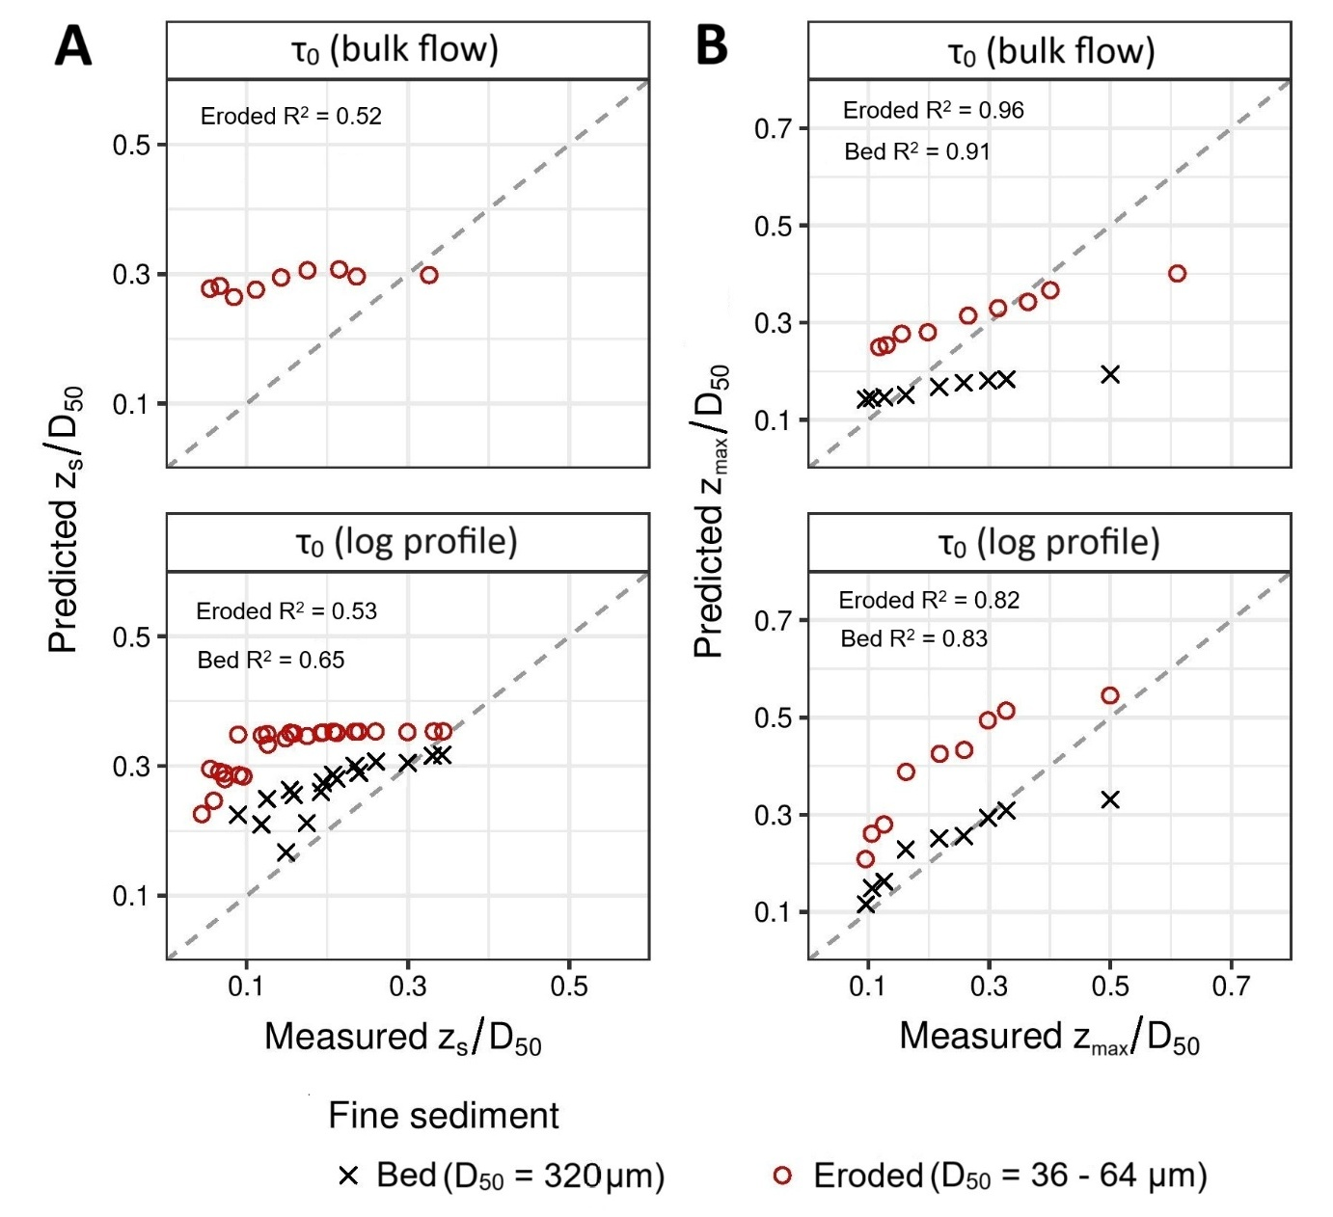
Figure 8: Comparison of cleanout depths measured in this study and those predicted by the (A) Kuhnle et al. (2016) and (B) Stradiotti et al. (2020) models. For (B), measured and predicted cleanout depths represent maximum values. Cleanout depth predictions are shown for bed shear stress calculated using both the bulk flow (top row) and the log profile (bottom row) approaches. The dashed lines represent a 1:1 relationship. Note that the bulk flow approach resulted in bed shear stress values that did not exceed 3 Pa, and the Kuhnle et al. (2016) model (top right) did not provide cleanout depths in this case.

Discussion
It has been well-established that bed mobilising flows in chalk streams need to be increased to initiate the remobilisation of accumulated fine sediment from the ecologically-sensitive surface layer (0 – 10 cm) of their gravel beds. However, there is limited understanding of the processes of fine sediment flushing and, thus, a gap in knowledge that requires attention to help set operational ecological targets for chalk stream river beds. To address this critical knowledge gap, this study investigated the influence of differing flow conditions on the remobilisation of fine sediment (in particular, cohesive sediment <62.5 μm) from a typical chalk stream gravel bed.

Increased shear velocity and near bed shear stress resulted in an increase in the depth of fine sediment erosion from the bed, with the greatest cleanout depths, 6.5 cm (s.d. 1.6 cm), observed under flow conditions with a mean bed shear stress of 8.2 Pa. The higher cleanout depths observed in Run 1 can likely be attributed to the flushing of fine sediment surface drapes during the initial filling of the flume. Cleanout depths were influenced by two processes within the bed. Firstly, flushing of cohesive sediment from the bed occurred, as evident by the marked decrease (52%) in cohesive sediment (<62.5 μm) quantities in the surface layer (0 – 5 cm) of the post-experimental bed compared with the pre-experimental bed. Secondly, hydraulic winnowing of cohesive sediment within the bed was apparent, as evidenced by the increase (17%) in cohesive sediment (<62.5 μm) quantities in the subsurface layer (10 – 16 cm) of the post-experimental bed compared with the pre-experimental bed (Figure 7). The observed variations in the cleanout depths during experimental runs can likely be attributed to the influence of protrusions of the gravel bed (Grams and Wilcock, 2007; Trevisson and Eiff, 2022), which create localised areas of scour and deposition. Gravel protrusions can reduce the stress acting on fine sediment by exerting drag on the flow and can also influence fine sediment entrainment by introducing local velocity and pressure excursions in their wakes (Grams and Wilcock, 2007; Schmeeckle et al., 2007). The hide-exposure effect of the gravel protrusions can also influence the remobilisation of fine sediment, where the sheltering effect of the gravel protrusions increases the shear stress required to mobilise fine sediment hidden in their wakes (McCarron et al., 2019).

The observations of this study support the findings of previous experimental studies (e.g., Kuhnle et al., 2016; Stradiotti et al., 2020), which showed that the depth of fine sediment erosion in a gravel bed was positively related to the shear velocity at the bed. However, despite comparable shear stresses and subsequent cleanout depths being observed, the fine sediment eroded in the present study was considerably smaller in GSD (average D₅₀ of 0.042 mm across the runs) compared with those observations reported the Kuhnle et al. (2016) study (D₅₀: 0.2 mm), despite a coarser fine sediment D₅₀ within the gravel bed (0.32 mm) in the present study, indicating that other factors are influencing the depth of fine sediment erosion and/or the corresponding critical thresholds of erosion. One such factor is the influence of cohesion. Cohesive particles (silts and clays <62.5 μm), experience interparticle attractive forces which shear stresses must exceed if the electrochemical bonds are to be broken (Wu et al., 2018). Several studies have demonstrated that the addition of clay to sand deposits increased their resistance to erosion (e.g., Panagiotopoulos et al., 1997; Lick et al., 2004; Grabowski et al., 2010). The addition of clay has been demonstrated to fill the voids between the sands, smoothing the bed surface, and making it more resistant to erosion. The influence of cohesive particles is a potential explanation for the minimal erosion of sand from the chalk stream gravel bed observed in the present study.

Differences in the GSDs of the experimental gravel bed frameworks will have also influenced the erosion depths of interstitial fine sediment. For example, the gravel beds used in both the Kuhnle et al. (2016) and Stradiotti et al. (2020) studies comprised large gravel particles, resulting in a substantial difference between the gravel framework GSD and the interstitial fine sediment GSD. Bed porosity is influenced by the size and heterogeneity of the sediment: gravel beds, for example, with relatively uniform particles sizes, will have greater porosity than a bed with a more heterogenous range and mixture of particle sizes (Wooster et al., 2008; Núñez-González et al., 2016). Subsequently, the experimental gravel beds used by Kuhnle et al. (2016) and Stradiotti et al. (2020) will likely have a higher porosity compared with the gravel bed utilised in our study. A higher porosity in the gravel bed increases intra-gravel flows and movement of interstitial fine sediment (Wooster et al., 2008; Núñez-González et al., 2016), which has the potential to increase both fine sediment remobilisation and cleanout depths, resulting in the deeper cleanout depths for coarser fine sediment. Importantly, the gravel bed conditions in previous studies do not fully represent those occurring in the natural environment, where gravel beds consist of a full range of grain sizes and often show little size difference between the smallest bed particles and largest fine sediment (e.g., Carling and Reader, 1982; Carling, 1983; Lambert and Walling, 1988; Milan et al., 2000) due to the presence of cohesive fine sediment >62.5 μm (e.g., Owens et al., 1999; Walling and Amos, 1999; Collins et al., 2005; Collins and Walling, 2007a; 2007b).

Implications for modelling
Experiment based modelling requires robust quantification of erosion parameters such as the critical shear stress for erosion. The present study provides new knowledge on the critical shear stresses required to remobilise fine sediment from the ecologically-sensitive surface layer (0 – 10 cm) of a typical chalk stream gravel bed and used these data to test the suitability of established models in predicting cleanout depths for fine sediment in chalk stream gravel beds.

Comparison between the observed and predicted cleanout depths using the Kuhnle et al. (2016) and Stradiotti et al. (2020) models, under both types of bed shear stress scenarios, demonstrated that these established models overpredict the cleanout depths in chalk stream gravel beds in 86% and 50% of cases, respectively. These outcomes can potentially be attributed to a number of factors that were not considered in these models and/or differences between experimental conditions. For example, the Kuhnle et al. (2016) model was calibrated using cleanout depths of sand-sized particles, which influences several aspects of the model. The Kuhnle et al. (2016) model uses a fall velocity equation that is based on sand-sized particles, proposed by Cheng (2009) (Supporting Information S.10), which assumes that as a particle diameter decreases, so does the fall velocity of the particle and thus, the critical bed shear stress required to mobilise the particle is lower. Similarly, the Stradiotti et al. (2020) model was calibrated using the cleanout depths of sand-sized particles; however, their model does not consider the fall velocity of the fine sediment. Instead, the Stradiotti et al. (2020) model considers the geometric characteristics of the fine sediment (D₅₀). Subsequently, these models neglect the potential influence of cohesion in particles of <62.5 μm (silts and clays), which influences the critical thresholds for particle remobilisation (Amos et al., 2018; Kassem et al., 2021). Cohesive sediment has been shown to react with gravel beds, stabilising them and entrapping fine sediment, thereby increasing the critical shear stress required for erosion of the sequestered fine sediment (Glasbergen et al., 2014; Stone et al., 2021). Our results indicate that recalibration with a wider range of particles sizes (i.e., including cohesive sediment) is necessary if particle size is to be used to determine critical thresholds for particle motion. Future work, including flume experiments with and without cohesive fines, could allow this finding to be more explicitly confirmed.

Furthermore, the GSDs of the gravel beds used to determine both the Kuhnle et al. (2016) and Stradiotti et al. (2020) models influence a number of factors that control interstitial fine sediment erosion from the bed. Estimates of the porosity of the gravel beds used in both the Kuhnle et al. (2016) experiments and the chalk stream gravel bed in our study, 0.37 and 0.16 respectively (estimated using the approach proposed by Wooster et al. (2008), Supporting Information S.11), are substantially different. The lower porosity in the gravel bed within our study, compared with the experimental beds used to establish the existing models, could explain why those models overpredict cleanout depths, as porosity was not considered in either instance. However, given the full range of grain sizes considered in this study as opposed to the very-well sorted and limited GSDs used in the previous studies, it would indicate the porosity of the gravel bed used in this study was more representative of conditions occurring naturally in river systems. In addition, using the Kuhnle et al. (2016) model, predicted fine sediment erosion is limited to the surface layer of the gravel bed (Figure 8), the depth of which is determined based on the calculated CPDG which is assumed to be directly related to the roughness geometry thickness (RGT). However, observed cleanout depths in our study indicate that this assumption may be incorrect, with erosion occurring deeper than the measured RGT, with maximum cleanout depths exceeding 9 cm compared with an RGT of approximately 7.1 cm. This indicates that the RGT is not representative of the surface layer of the experimental gravel bed and/or that fine sediment erosion under these conditions is not limited to the surface layer of the bed. Since the Stradiotti et al. (2020) model does not use the CPDG/RGT of the bed to predict the cleanout depth, their predictions are not limited to the bed surface. Instead, the Stradiotti et al. (2020) model is valid until shear velocity values for the threshold of the bed framework sediment movement are exceeded. As no bed framework movement was observed in our study, the Stradiotti et al. (2020) predictions, based on this factor, should, in principle should, remain valid.

Implications for management/sediment targets
Both sediment source and the transport capacity of a system influence the propensity of chalk streams to accumulate fine sediment within their gravel beds. Therefore, management that addresses both these factors is critical if the problem of excessive fine sediment in chalk streams is to be addressed efficiently and effectively. The majority of chalk stream gravel beds already have elevated quantities of fine sediment present within their frameworks; for example, 89% of 90 analysed English chalk stream gravel beds were found to be over-saturated (based on the concept proposed by Wooster et al., 2008) with fine sediment (Mondon et al., 2024). Reducing fine sediment inputs will not impact the fine sediment already accumulated in chalk stream gravel beds because chalk stream bed material is not naturally remobilised, even during bank-full events. Subsequently, improvements in the propensity of chalk stream systems to remobilise fine sediment from the gravel beds must be a focus of targeted management, alongside reductions of fine sediment inputs.

The data presented herein can be applied to inform revised sediment targets and management needed in chalk streams to restore their bed mobilising flows to the levels required to remobilise elevated quantities of fine sediment. However, neither bed shear stress nor shear velocity are easily measured in the field (requiring extensive and costly monitoring) and consequently there is a lack of data from chalk streams regarding these factors. It is challenging to establish if the required bed shear stresses and shear velocities are being reached in chalk streams, or if they are even attainable under current hydro-geomorphological conditions. In order to make the shear velocities more appropriate and comparable with factors readily and routinely measured in chalk streams, the depth averaged velocities needed to achieve the required shear velocity were predicted for a number of chalk stream sites, investigated in Mondon et al. (2024) (site characteristics; Supporting Information S.12). These predictions were then compared with depth averaged velocities that have been previously measured in chalk streams under several different channel conditions (Figure 9). This comparison highlights that for the most part, chalk streams are not achieving the depth averaged velocities required to remobilise fine sediment from their gravel beds. This supports the findings of Mondon et al. (2024), where >75% of the investigated chalk stream gravel beds manifested fine sediment quantities exceeding thresholds for ecological degradation. Most of the observed velocities achieving values similar to predicted velocities were recorded in flows around patches of aquatic macrophytes, which have been widely documented to introduce localised spatial variations in flow velocities (e.g., Cotton et al., 2006; Wharton et al., 2006; Gurnell and Bertoldi, 2022).

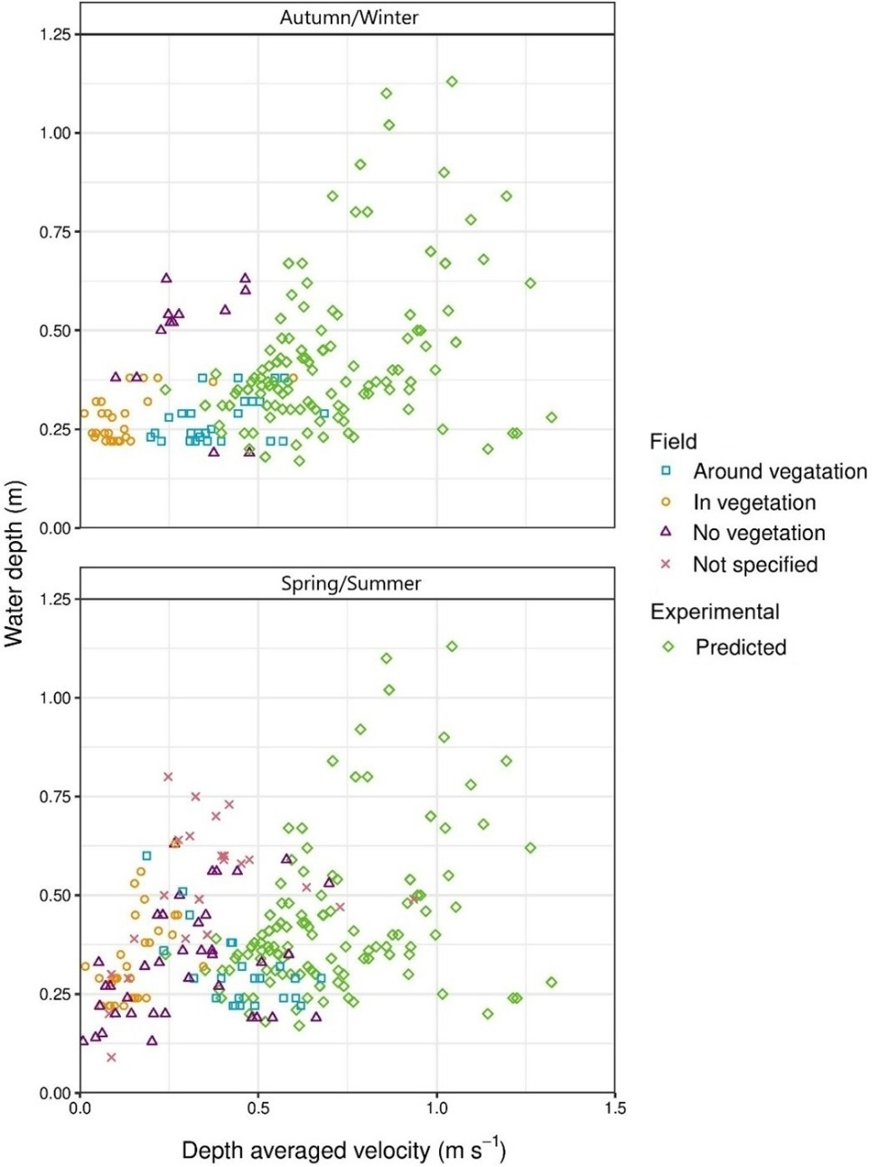
Figure 9: Predicted depth averaged velocities needed to achieve the average shear velocity (0.0915 m s⁻¹) where the highest fine sediment cleanout depths were observed in the experimental runs, compared with depth average velocities previously recorded in chalk streams (Marshall and Westlake, 1990; Green, 2005; Gurnell et al., 2006; Wharton et al., 2006; Warren et al., 2009; Grabowski, 2011; Old et al., 2014; Mullen, 2016). Depth average velocities recorded in chalk streams are split by autumn/winter months (September – February) and spring/summer (March – August).

Other reach-scale restoration measures can also create localised areas of increased flow that would increase the shear velocities and bed shear stress. For example, the installation of instream woody material can create localised regions of higher velocity, promoting increased bed shear stress and, potentially, the remobilisation of fine sediment (Gurnell et al., 2006; Heppell et al., 2009; Osei et al., 2015; Parker et al., 2017). In addition, the removal of channel obstructions such as weirs can increase localised flow velocity (Lenders et al., 2016). These types of restoration and management techniques are more self-sustaining than previous approaches such as manual gravel washing (Pander et al., 2015) as they restore hydrological and sedimentological processes instead of focusing on moving fine sediment from one place to another. Furthermore, these approaches create heterogenous flow patterns within systems, which in turn, create a heterogeneous habitat within the gravel bed. For example, instream macrophytes create regions of lower flow within their stands, promoting highly localised fine sediment deposits (Gurnell et al., 2006; Heppell et al., 2009; Osei et al., 2015), which are critical for certain life-cycle stages of some chalk stream species, e.g., the ammocoete stage of European river lamprey (Lampetra fluviatilis L.) (Silva et al., 2015). Our study gives new insight into the critical shear velocities and bed shear stresses required to remobilise fine sediment, notably cohesive sediment (silt and clay sized particles, <62.5 μm), from a typical chalk stream gravel bed and provides much-needed and robust empirical data. These data can direct the extent to which these management and restoration techniques need to be applied to chalk streams to deal with the widely reported fine sediment problem (e.g., Collins and Walling, 2007a) and improve the ecological status of chalk stream gravel beds.

Limitations and potential for future work
Due to the nature and set-up of the experiments conducted and to address the specific objectives in this study, a number of assumptions and limitations were observed. Subsequently, there is potential for additional study to develop further the data provided here. Firstly, experiments were carried out under sediment supply-limited conditions, whereby there is no upstream fine sediment supply aside from the ‘background’ concentrations of recirculating suspended fine sediment. This was done to replicate the conditions used in Kuhnle (2017) and those occurring in natural chalk streams, such as on the falling limb of a high flow/flood event, which due to their long duration typically exhaust fine sediment early on (Heywood and Walling, 2003) and/or where flows are constricted by weed beds, large wood, or physical structures (Sear et al., 1999; Wharton et al., 2006). However, fine sediment supply regimes do naturally vary in terms of supply rate, timing, and texture, which could potentially influence the degree and distribution of fine sediment cleanout depths. As such, future research exploring the influence of varying upstream sediment supply (including timing and magnitude) on fine sediment cleanout depths in chalk stream gravel beds, should be conducted. Secondly, as each experimental run was carried out progressively (i.e., eroded fine sediment was not restored to original quantities within the bed framework after each run), there is potential that increased exposure of framework particles could introduce localised increases in velocity (Grams and Wilcock, 2007; Schmeeckle et al., 2007), potentially exaggerating the extremes of the cleanout depths observed. This approach was taken to both replicate the conditions used in Kuhnle (2017) and to minimise the disturbance of bed framework particles, which would influence patterns of bed shear stress and thus, influence cleanout depths. Consequently, future research could be carried out to assess the trade-off between increasing exposure of framework particles and changes in framework packing on cleanout depths.

Although chalk stream gravel beds are immobile under typical flows, and their gravel bed framework GSDs are relativity static, there are spatial variations, even at a localised, within-reach-scale. This study compiled data on cleanout depths for a gravel bed with a typical chalk stream gravel bed framework GSD, but did not consider the influence of the observed spatial variation in GSD (Supporting Information S.3). As such, further work could be carried out to establish the influence on cleanout depth of a wider range of gravel bed framework GSD observed in freeze-cores taken from chalk stream gravel beds. In addition, distinct regional differences were observed in fine sediment GSDs analysed in Mondon et al. (2024), the influence of this on cleanout depths could be investigated further. For example, the gravel beds of Norfolk chalk streams were observed to have higher proportions of sand-sized fine sediment particles than Hampshire/Dorset chalk streams. Under these conditions, the remobilisation of fine sediment may occur differently, i.e., larger sediment grain sizes are remobilised under lower bed shear stress values and/or deeper cleanout depths are observed due to the reduced influence of cohesive sediment. To prevent distortion of the laser scans caused by the presence of surface water, the gravel bed was drained overnight after each experimental run. Whilst draining the flume inevitably led to some drying overnight, this was observed to be limited to the very surface layer of the bed, reducing the potential for the drying of deeper bed substrate. Indeed, it is worth noting that previous work investigating drying effects on sediment cohesion has required the bed to be allowed to dry over a substantially longer time period (e.g., 15 days, see Ge et al., 2025). Nevertheless, it is possible that overnight surface drying may have led to slightly reduced cohesion, which could have resulted in a minor overestimation of the clean out depths observed in our study.

No movement of the gravel bed framework was observed under the investigated scenarios, indicating that the chalk stream gravel bed frameworks could potentially withstand higher shear stress conditions than achieved in this study, before the movement of bed particles is initiated. However, the presence of cohesive sediment can stabilise the gravel bed framework and therefore increase the critical threshold of movement (e.g., Glasbergen et al., 2014; Stone et al., 2021). Future research should identify the maximum shear stresses chalk stream gravel bed frameworks can experience before initiation of framework particle movement, aiming to help direct the limits of future fine sediment management without impacting the chalk stream gravel bed frameworks. In addition, the impact of climate change on flow conditions and fine sediment remobilisation in chalk streams should be considered in potential sediment targets and management. Groundwater recharge of chalk aquifers in England is expected to occur over shorter periods due to climate change, a consequence of longer, hotter, and drier summers, where evapotranspiration is greater, and shorter, and more intense winter rainfall periods, which end earlier in the year (Allen and Crane, 2019; Stubbington et al., 2022). Shorter periods of groundwater recharge will reduce the groundwater-dominated flows in chalk streams, further decreasing their bed mobilising capacity and increasing fine sediment retention (Mondon et al., 2021). In contrast, increases in rainfall intensity during winter months (when soils are already likely to be saturated) have the potential to increase sediment-laden runoff, increasing fine sediment inputs into river systems (Serpa et al., 2015; Bussi et al., 2016). Chalk stream systems will, therefore, likely lack resilience to climate change and exacerbated erosion and sediment delivery to channel systems.

Conclusions
Cleanout depths of interstitial fine sediment were measured in a series of progressive flume experiments using fine sediment and a gravel bed framework with GSDs typical of UK chalk streams, and under differing flow conditions. Increased bed shear stresses corresponded with increased fine sediment cleanout depths, with the greatest cleanout depths of 6.5 cm (±1.6 cm) observed under flow conditions with an average bed shear stress of 8.2 Pa. Cleanout depths varied across the experimental gravel bed, reflecting likely patterns of scour and deposition created by areas of varying shear stress around protruding bed particles. Two processes of fine sediment movement were observed as important to remobilising fine sediment from the surface layer of gravel beds: flushing and hydraulic winnowing. These were evident by the patterns in the cohesive sediment quantities within the gravel beds after experimental runs. The validity of previously established models used to predict fine sediment cleanout depths from immobile gravel beds was tested using the data from these experiments. Comparison between observed and predicted cleanout depths demonstrated that, for most of the scenarios considered, established models did not reproduce accurately the observed cleanout depths, but often overpredicted them. This outcome can be attributed to assumptions in the existing models and failure to consider characteristics of naturally occurring gravel beds, importantly those in chalk streams. Subsequently, the application of such models is not suitable to direct efforts to mitigate excessive deposited fine sediment in chalk streams. The established bed shear stress values required for the cleanout of fine sediment from the ecologically-sensitive surface layer (0 – 10 cm) of chalk streams from our experiments can be used to help direct revised sediment targets, management, and restoration activities. Further improvements to these measurements could be made by considering the regional differences in the sedimentological characteristics of chalk streams and by establishing the maximum bed shear stresses a chalk stream gravel bed could experience without the motion of the gravel framework which provides essential benthic refuges.

References
Acornley, R.M. and Sear, D.A. 1999. Sediment transport and siltation of brown trout (Salmo trutta L.) spawning gravels in chalk streams. Hydrological Processes, 13(3), 447-458. https://doi.org/10.1002/(SICI)1099-1085(19990228)13:3<447::AID-HYP749>3.0.CO;2-G.

Allen, D.J. and Crane, E.J. 2019. The Chalk aquifer of the Wessex Basin. Keyworth, Nottingham: British Geological Survey.

Amos, C.L., Brylinsky, M., Forbes, D.L., Robertson, A., Thompson, C.E.L. and Kassem, H. 2018. Stability of Seabed Sediments in the Embayments of North Rustico, Prince Edward Island, Canada. Journal of Coastal Research, 34 (2), 293–307. https://doi.org/10.2112/JCOASTRES-D-16-00192.1.

Beschta, R.L. and Jackson, W.L. 1979. The Intrusion of Fine Sediments into a Stable Gravel Bed. Journal of the Fisheries Research Board of Canada, 36(2), 204-210. https://doi.org/10.1139/f79-030.

Bickerton, M., Petts, G., Armitage, P. and Castella, E. 1993. Assessing the ecological effects of groundwater abstraction on chalk streams: Three examples from Eastern England. Regulated Rivers: Research & Management, 8(1‐2), 121-134. https://doi.org/10.1002/rrr.3450080115.

Bilotta, G.S. and Brazier, R.E. 2008. Understanding the influence of suspended solids on water quality and aquatic biota. Water Research, 42(12), 2849-2861. https://doi.org/10.1016/j.watres.2008.03.018.

Brown, A.G., Lespez, L., Sear, D.A., Macaire, J.J., Houben, P., Klimek, K., Brazier, R.E., Van Oost, K. and Pears, B. 2018. Natural vs anthropogenic streams in Europe: History, ecology and implications for restoration, river-rewilding and riverine ecosystem services. Earth-Science Reviews, 180, 185-205. https://doi.org/10.1016/j.earscirev.2018.02.001.

Bunting, G., England, J., Gething, K., Sykes, T., Webb, J. and Stubbington, R. 2021. Aquatic and terrestrial invertebrate community responses to drying in chalk streams. Water and Environment Journal, 35(1), 229-241. https://doi.org/10.1111/wej.12621.

Bussi, G., Dadson, S.J., Prudhomme, C. and Whitehead, P.G. 2016. Modelling the future impacts of climate and land-use change on suspended sediment transport in the River Thames (UK). Journal of Hydrology, 542, 357-372. https://doi.org/10.1016/j.jhydrol.2016.09.010.

Carling, P. 1983. Composition and bulk properties of Dorset river gravels. Barnard Castle: Freshwater Biological Association, Teesdale Unit.

Carling, P.A. and Reader, N.A. 1982. Structure, composition and bulk properties of upland stream gravels. Earth Surface Processes and Landforms, 7(4), 349-365. https://doi.org/10.1002/esp.3290070407.

Cheng, N.S. 2009. Comparison of formulas for drag coefficient and settling velocity of spherical particles. Powder Technology, 189(3), 395-398. https://doi.org/10.1016/j.powtec.2008.07.006.

Cheng, N.S. 2011. Revisited Vanoni-Brooks sidewall correction. International Journal of Sediment Research, 26(4), 524-528. https://doi.org/10.1016/S1001-6279(12)60010-9.

Coles, D. 1952. The law of the wake in the turbulent boundary layer. Journal of Fluid Mechanics, 1(2), 191-226. https://doi.org/10.1017/S0022112056000135.

Collins, A.L., Naden, P.S., Sear, D.A., Jones, J.I., Foster, I.D.L. and Morrow, K. 2011. Sediment targets for informing river catchment management: international experience and prospects. Hydrological Processes, 25(13), 2112-2129. https://doi.org/10.1002/hyp.7965.

Collins, A., Walling, D. and Leeks, G. 2005. Storage of fine-grained sediment and associated contaminants within the channels of lowland permeable catchments in the UK. International Symposium on Sediment Budgets, Wallingford: IAHS Press, pp. 259-268.

Collins, A.L. and Walling, D.E. 2007a. Fine-grained bed sediment storage within the main channel systems of the Frome and Piddle catchments, Dorset, UK. Hydrological Processes, 21(11), 1448-1459. https://doi.org/10.1002/hyp.6269.

Collins, A.L. and Walling, D.E. 2007b. Sources of fine sediment recovered from the channel bed of lowland groundwater-fed catchments in the UK. Geomorphology, 88(1), 120-138. https://doi.org/10.1016/j.geomorph.2006.10.018.

Collins, A.L. and Zhang, Y. 2016. Exceedance of modern ‘background’ fine-grained sediment delivery to rivers due to current agricultural land use and uptake of water pollution mitigation options across England and Wales. Environmental Science & Policy, 61, 61-73. https://doi.org/10.1016/j.envsci.2016.03.017.

Collins, A.L., Anthony, S., Hawley, J. and Turner, T. 2009. Predicting potential change in agricultural sediment inputs to rivers across England and Wales by 2015. Marine and Freshwater Research, 60(7), 626-637. https://doi.org/10.1071/MF08033.

Cunningham, A.B., Anderson, C.J. and Bouwer, H. 1987. Effects of sediment-laden flow on channel bed clogging. Journal of Irrigation and Drainage Engineering, 113(1), 106-118. https://doi.org/10.1061/(ASCE)0733-9437(1987)113:1(106).

Detert, M. and Parker, G. 2010. Estimation of the Washout Depth of Fine Sediments from a Granular Bed. Journal of Hydraulic Engineering, 136(10), 790-793. https://doi.org/10.1061/(ASCE)HY.1943-7900.0000263.

Detert, M., Weitbrecht, V. and Gerhard, H.J. 2010. Laboratory Measurements on Turbulent Pressure Fluctuations in and above Gravel Beds. Journal of Hydraulic Engineering, 136(10), 779-789. https://doi.org/10.1061/(ASCE)HY.1943-7900.0000251.

Du, X., Ye, X. and Zhang, X. 2018. Clogging of saturated porous media by silt‐sized suspended solids under varying physical conditions during managed aquifer recharge. Hydrological Processes, 32(14), 2254-2262. https://doi.org/10.1002/hyp.13162.

Dudill, A., Frey, P. and Church, M. 2017. Infiltration of fine sediment into a coarse mobile bed: a phenomenological study. Earth Surface Processes and Landforms, 42(8), 1171-1185. https://doi.org/10.1002/esp.4080.

Dunscombe, M., Robertson, A., Peralta-Maraver, I. and Shaw, P. 2018. Community structure and functioning below the streambed across contrasting geologies. Science of the Total Environment, 630, 1028-1035. https://doi.org/10.1016/j.scitotenv.2018.02.274.

Einstein, H. 1968. Deposition of Suspended Particles in a Gravel Bed. Journal of Hydraulic Engineering, 94, 1197-1206. https://doi.org/10.1061/JYCEAJ.0001868.

Elgar, S., Raubenheimer, B. and Guza, R. 2001. Current meter performance in the surf zone. Journal of Atmospheric and Oceanic Technology, 18(10), 1735-1746. https://doi.org/10.1175/1520-0426(2001)018<1735:CMPITS>2.0.CO;2.

Elgar, S., Raubenheimer, B. and Guza, R. 2005. Quality control of acoustic Doppler velocimeter data in the surfzone. Measurement Science and Technology, 16(10), 1889. https://doi.org/10.1088/0957-0233/16/10/002.

Fetzer, J., Holzner, M., Plötze, M. and Furrer, G. 2017. Clogging of an Alpine streambed by silt sized particles – Insights from laboratory and field experiments. Water Research, 126, 60-69. https://doi.org/10.1016/j.watres.2017.09.015.

Ge, R., Zhao, Y., Gong, Z., Wang, S., Wei, A., Peng. And Liu, H. 2025. Effects on biofilm-mediated sediment stability in intertidal mudflats: transition from biostabilisation to biodestabilisation. Sedimentary Geology, 482, 106883. https://doi.org/10.1016/j.sedgeo.2025.106883

Gibson, S., Abraham, D., Heath, R. and Schoellhamer, D. 2009. Vertical gradational variability of fines deposited in a gravel framework. Sedimentology, 56(3), 661-676. https://doi.org/10.1111/j.1365-3091.2008.00991.x.

Gibson, S., Abraham, D., Heath, R. and Schoellhamer, D. 2010. Bridging Process Threshold for Sediment Infiltrating into a Coarse Substrate. Journal of Geotechnical and Geoenvironmental, 136(2), 402-406. https://doi.org/10.1061/(ASCE)GT.1943-5606.0000219.

Glasbergen, K., Stone, M., Krishnappan, B., Dixon, J. and Silins, U. 2014. The effect of coarse gravel on cohesive sediment entrapment in an annular flume. IAHS-AISH Proceedings and Reports, 157-162.

Goring, D.G. and Nikora, V.I. 2002. Despiking acoustic Doppler velocimeter data. Journal of Hydraulic Engineering, 128(1), 117-126. https://doi.org/10.1061/(ASCE)0733-9429(2002)128:1(117).

Goring, D.G. and Nikora, V.I. 2003. Closure to “Depiking Acoustic Doppler Velocimeter Data” by Derek G. Goring and Vladimir I. Nikora. Journal of Hydraulic Engineering, 129(6), 487-488. https://doi.org/10.1061/(ASCE)0733-9429(2003)129:6(487).

Grabowski, R.C. 2011. The erodibility of fine sediment deposits in lowland chalk streams. PhD thesis, Queen Mary University of London.

Grabowski, R.C. and Gurnell, A.M. 2016. Diagnosing problems of fine sediment delivery and transfer in a lowland catchment. Aquatic Sciences, 78(1), 95-106. https://doi.org/10.1007/s00027-015-0426-3.

Grabowski, R.C., Droppo, I.G. and Wharton, G. 2010. Estimation of critical shear stress from cohesive strength meter‐derived erosion thresholds. Limnology and Oceanography: Methods, 8(12), 678-685. https://doi.org/10.4319/lom.2010.8.0678.

Grams, P.E. and Wilcock, P.R. 2007. Equilibrium entrainment of fine sediment over a coarse immobile bed. Water Resources Research, 43(10), W10420. https://doi.org/10.1029/2006WR005129.

Green, J.C. 2005. Velocity and turbulence distribution around lotic macrophytes. Aquatic Ecology, 39(1), 01-10. https://doi.org/10.1007/s10452-004-1913-0.

Greig, S.M., Sear, D.A. and Carling, P.A. 2005a. The impact of fine sediment accumulation on the survival of incubating salmon progeny: Implications for sediment management. Science of the Total Environment, 344(1), 241-258. https://doi.org/10.1016/j.scitotenv.2005.02.010.

Greig, S.M., Sear, D.A. and Carling, P.A. 2007. A review of factors influencing the availability of dissolved oxygen to incubating salmonid embryos. Hydrological Processes, 21(3), 323-334. https://doi.org/10.1002/hyp.6188.

Greig, S.M., Sear, D.A., Smallman, D.J. and Carling, P.A. 2005b. Impact of clay particles on the cutaneous exchange of oxygen across the chorion of Atlantic salmon eggs. Journal of Fish Biology, 66(6), 1681-1691. https://doi.org/10.1111/j.0022-1112.2005.00715.x.

Gurnell, A.M. and Bertoldi, W. 2022. The impact of plants on fine sediment storage within the active channels of gravel-bed rivers: A preliminary assessment. Hydrological Processes, 36(7), e14637. https://doi.org/10.1002/hyp.14637.

Gurnell, A.M., Oosterhout, M.P.V., Vlieger, B.D. and Goodson, J.M. 2006. Reach-scale interactions between aquatic plants and physical habitat: River Frome, Dorset. River Research and Applications, 22(6), 667-680. https://doi.org/10.1002/rra.929.

Hartwig, M. and Borchardt, D. 2015. Alteration of key hyporheic functions through biological and physical clogging along a nutrient and fine‐sediment gradient. Ecohydrology, 8(5), 961-975. https://doi.org/10.1002/eco.1571.

Heppell, C.M., Wharton, G., Cotton, J.A.C., Bass, J.A.B. and Roberts, S.E. 2009. Sediment storage in the shallow hyporheic of lowland vegetated river reaches. Hydrological Processes, 23(15), 2239-2251. https://doi.org/10.1002/hyp.7283.

Heywood, M.J.T. and Walling, D.E. 2003. Suspended sediment fluxes in chalk streams in the Hampshire Avon catchment, U.K. Hydrobiologia, 494(1), 111-117. https://doi.org/10.1023/A:1025445711343.

Heywood, M.J.T. and Walling, D.E. 2007. The sedimentation of salmonid spawning gravels in the Hampshire Avon catchment, UK: implications for the dissolved oxygen content of intragravel water and embryo survival. Hydrological Processes, 21(6), 770-788. https://doi.org/10.1002/hyp.6266.

Jones, J.I., Doughwright, T.A., Arnold, A., Duerdoth, C.P., Murphy, J.F., Edwards, F.K. and Pretty, J.L. 2017. Diatoms as indicators of fine sediment stress. Ecohydrology, 10(5), e1832. https://doi.org/10.1002/eco.1832.

Jones, J.I., Murphy, J.F., Collins, A.L., Sear, D.A., Naden, P.S. and Armitage, P.D. 2012. The impact of fine sediment on macro‐invertebrates. River Research and Applications, 28(8), 1055-1071. https://doi.org/10.1002/rra.1516.

Kassem, H. 2021. Assessment of scour around eco-reef armour beds. Consultancy Report for Exo-Environmental Ltd, UOS_G&G-Coastal21002v1. Southampton: University of Southampton.

Kassem H., Sutherland, T.F. and Amos, C.L. 2021. Hydrodynamic Controls on the Particle Size of Resuspended Sediment from Sandy and Muddy Substrates in British Columbia, Canada. Journal of Coastal Research, 37 (4), 691–707. https://doi.org/10.2112/JCOASTRES-D-20-00135.1.

Kassem, H., Thompson, C.E.L., Amos, C.L. and Townend, I.H. 2015. Wave-induced coherent turbulence structures and sediment resuspension in the nearshore of a prototype-scale sandy barrier beach. Continental Shelf Research, 109, 78-94. https://doi.org/10.1016/j.csr.2015.09.007.

Kassem, H., Thompson, C.E.L., Amos, C.L., Townend, I.H., Todd, D., Whitehouse, R.J.S. and Chellew, E. 2020. Observations of Nearbed Turbulence over Mobile Bedforms in Combined, Collinear Wave-Current Flows. Water, 12(12), 3515. https://doi.org/10.3390/w12123515.

Kemp, P., Sear, D., Collins, A., Naden, P. and Jones, I. 2011. The impacts of fine sediment on riverine fish. Hydrological Processes, 25(11), 1800-1821. https://doi.org/10.1002/hyp.7940.

Kuhnle, R., Wren, D. and Langendoen, E. 2015. Erosion depth of sand from an immobile gravel bed. Proceedings of IAHS, 367, 117-121. https://doi.org/10.5194/piahs-367-117-2015.

Kuhnle, R., Wren, D. and Langendoen, E. 2016. Erosion of Sand from a Gravel Bed. Journal of Hydraulic Engineering, 142(2), 04015052. https://doi.org/10.1061/(ASCE)HY.1943-7900.0001071.

Kuhnle, R., Wren, D., Langendoen, E. and Rigby, J. 2013. Sand Transport over an Immobile Gravel Substrate. Journal of Hydraulic Engineering, 139, 167-176. https://doi.org/10.1061/(ASCE)HY.1943-7900.0000615.

Lambert, C.P. and Walling, D.E. 1988. Measurement of channel storage of suspended sediment in a gravel-bed river. CATENA, 15(1), 65-80. https://doi.org/10.1016/0341-8162(88)90017-3.

Lenders, H.J.R., Chamuleau, T.P.M., Hendriks, A.J., Lauwerier, R.C.G.M., Leuven, R.S.E.W. and Verberk, W.C.E.P. 2016. Historical rise of waterpower initiated the collapse of salmon stocks. Scientific Reports, 6, 29269-29269. https://doi.org/10.1038/srep29269.

Lick, W., Jin, L. and Gailani, J. 2004. Initiation of movement of quartz particles. Journal of Hydraulic Engineering, 130(8), 755-761. https://doi.org/10.1061/(ASCE)0733-9429(2004)130:8(755).

Louhi, P., Mäki-Petäys, A. and Erkinaro, J. 2008. Spawning habitat of Atlantic salmon and brown trout: general criteria and intragravel factors. River Research and Applications, 24(3), 330-339. https://doi.org/10.1002/rra.1072.

Mainstone, C.P. 1999. Chalk rivers - nature conservation and management. Peterborough: Water Research Centre.

Marshall, E.J.P. and Westlake, D.F. 1990. Water velocities around water plants in chalk streams. Folia Geobotanica et Phytotaxonomica, 25(3), 279-289. https://doi.org/10.1007/BF02913028.

Mathers, K.L., Millett, J., Robertson, A.L., Stubbington, R. and Wood, P.J. 2014. Faunal response to benthic and hyporheic sedimentation varies with direction of vertical hydrological exchange. Freshwater Biology, 59(11), 2278-2289. https://doi.org/10.1111/fwb.12430.

McCarron, C.J., Van Landeghem, K.J.J., Baas, J.H., Amoudry, L.O. Malarkey, J. 2019. Ther hiding-exposure effect revisited: A method to calculate the mobility of bimodal sediment mixtures. Marine Geology, 410, 22-31. https://doi.org/10.1016/j.margeo.2018.12.001.

Middleton, G.V. 1984. Mechanics of Sediment Movement. Tulsa, Oklahoma: Society of Economic Paleontologists and Mineralogists.

Milan, D.J., Petts, G.E. and Sambrook, H. 2000. Regional variations in the sediment structure of trout streams in southern England: benchmark data for siltation assessment and restoration. Aquatic Conservation: Marine and Freshwater Ecosystems, 10(6), 407-420. https://doi.org/10.1002/1099-0755(200011/12)10:6<407::AID-AQC421>3.0.CO;2-4.

Mondon, B., Sear, D.A., Collins, A.L., Shaw, P.J. and Sykes, T. 2021. The scope for a system-based approach to determine fine sediment targets for chalk streams. CATENA, 206, 105541. https://doi.org/10.1016/j.catena.2021.105541.

Mondon, B., Sear, D.A., Collins, A.L., Shaw, P.J. and Sykes, T. 2024. The sedimentology of gravel beds in groundwater-dominated chalk streams: Implications for sediment modelling and management. River Research and Applications, 40(4), 508-528. https://doi.org/10.1002/rra.4250.

Mooneyham, C. and Strom, K. 2018. Deposition of Suspended Clay to Open and Sand-Filled Framework Gravel Beds in a Laboratory Flume. Water Resources Research, 54(1), 323-344. https://doi.org/10.1002/2017WR020748.

Mori, N., Suzuki, T. and Kakuno, S. 2007. Noise of acoustic Doppler velocimeter data in bubbly flows. Journal of Engineering Mechanics, 133(1), 122-125. https://doi.org/10.1061/(ASCE)0733-9399(2007)133:1(122).

Mullen, C. 2016. An investigation into the effects of drought and drought recovery on macroinvertebrate communities. PhD thesis, University of Birmingham.

Naden, P.S., Murphy, J.F., Old, G.H., Newman, J., Scarlett, P., Harman, M., Duerdoth, C.P., Hawczak, A., Pretty, J.L., Arnold, A., Laizé, C., Hornby, D.D., Collins, A.L., Sear, D.A. and Jones, J.I. 2016. Understanding the controls on deposited fine sediment in the streams of agricultural catchments. Science of the Total Environment, 547, 366-381. https://doi.org/10.1016/j.scitotenv.2015.12.079.

Núñez-González, F., Martín-Vide, J.P. and Kleinhans, M.G. 2016. Porosity and size gradation of saturated gravel with percolated fines. Sedimentology, 63(5), 1209-1232. https://doi.org/10.1111/sed.12257.

Old, G.H., Naden, P.S., Rameshwaran, P., Acreman, M.C., Baker, S., Edwards, F.K., Sorensen, J.P.R., Mountford, O., Gooddy, D.C., Stratford, C.J. and Scarlett, P.M., 2014. Instream and riparian implications of weed cutting in a chalk river. Ecological Engineering, 71, 290-300. https://doi.org/10.1016/j.ecoleng.2014.07.006.

Osei, N.A., Gurnell, A.M. and Harvey, G.L. 2015. The role of large wood in retaining fine sediment, organic matter and plant propagules in a small, single-thread forest river. Geomorphology, 235, 77-87. https://doi.org/10.1016/j.geomorph.2015.01.031.

Owens, P.N., Walling, D.E. and Leeks, G.J.L. 1999. Deposition and storage of fine-grained sediment within the main channel system of the River Tweed, Scotland. Earth Surface Processes and Landforms, 24(12), 1061-1076. https://doi.org/10.1002/(SICI)1096-9837(199911)24:12<1061::AID-ESP35>3.0.CO;2-Y.

Panagiotopoulos, I., Voulgaris, G. and Collins, M. 1997. The influence of clay on the threshold of movement of fine sandy beds. Coastal Engineering, 32(1), 19-43. https://doi.org/10.1016/S0378-3839(97)00013-6.

Pander, J., Mueller, M. and Geist, J. 2015. A Comparison of Four Stream Substratum Restoration Techniques Concerning Interstitial Conditions and Downstream Effects. River Research and Applications, 31(2), 239-255. https://doi.org/10.1002/rra.2732.

Paphitis, D. and Collins, M.B. 2001. The 5m long recirculating flume at the School of Ocean and Earth Sciences (SOES), University of Southampton. Part I: Descriptive manual. Southampton: Southampton Oceanography Centre.

Parker, C., Henshaw, A.J., Harvey, G.L. and Sayer, C.D. 2017. Reintroduced large wood modifies fine sediment transport and storage in a lowland river channel. Earth Surface Processes and Landforms, 42(11), 1693-1703. https://doi.org/10.1002/esp.4123.

Pellachini, C. 2011. Modelling fine sediment transport over an immobile gravel bed. PhD thesis, University of Trento.

Petrie, J., Diplas, P., Nam, S. and Gutierrez, M. S. 2010. Local boundary shear stress estimates from velocity profiles measured with an ADCP. In: River Flow, pp. 1749-1755.

Rosewarne, P.J., Svendsen, J.C., Mortimer, R.J.G. and Dunn, A.M. 2014. Muddied waters:
suspended sediment impacts on gill structure and aerobic scope in an endangered native
and an invasive freshwater crayfish. Hydrobiologia, 722(1), 61-74.
https://doi.org/10.1007/s10750-013-1675-6.

Schmeeckle, M.W., Nelson, J.M. and Shreve, R.L. 2007. Forces on stationary particles in near-bed turbulent flows. Journal of Geophysical Research: Earth Surface, 112(F2). https://doi.org/10.1029/2006JF000536.

Sear, D.A., Armitage, P.D. and Dawson, F.H. 1999. Groundwater dominated rivers. Hydrological Processes, 13(3), 255-276. https://doi.org/10.1002/(SICI)1099-1085(19990228)13:3<255::AID-HYP737>3.0.CO;2-Y.

Sear, D.A., Jones, J.I., Collins, A.L., Hulin, A., Burke, N., Bateman, S., Pattison, I. and Naden, P.S. 2016. Does fine sediment source as well as quantity affect salmonid embryo mortality and development?. Science of the Total Environment, 541, 957-968. https://doi.org/10.1016/j.scitotenv.2015.09.155.

Sear, D.A., Newson, M., Old, J.G. and Hill, C. 2006. Geomorphological appraisal of the River Nar Site of Special Scientific Interest. English Nature Research Reports, No 684.

Sear, D.A., Pattison, I., Collins, A.L., Newson, M.D., Jones, J.I., Naden, P.S. and Carling, P.A. 2014. Factors controlling the temporal variability in dissolved oxygen regime of salmon spawning gravels. Hydrological Processes, 28(1), 86-103. https://doi.org/10.1002/hyp.9565.

Sear, D.A., Pattison, I., Collins, A.L., Smallman, D.J., Jones, J.I. and Naden, P.S. 2017. The
magnitude and significance of sediment oxygen demand in gravel spawning beds for the
incubation of salmonid embryos. River Research and Applications, 33(10), 1642-1654.
https://doi.org/10.1002/rra.3212.

Serpa, D., Nunes, J., Santos, J., Sampaio, E., Jacinto, R., Veiga, S., Lima, J., Moreira, M., Corte-Real, J. and Keizer, J. 2015. Impacts of climate and land use changes on the hydrological and erosion processes of two contrasting Mediterranean catchments. Science of the Total Environment, 538, 64-77. https://doi.org/10.1016/j.scitotenv.2015.08.033.

Silva, S., Gooderham, A., Forty, M., Morland, B. and Lucas, M.C. 2015. Egg drift and hatching success in European river lamprey Lampetra fluviatilis: is egg deposition in gravel vital to spawning success?. Aquatic Conservation: Marine and Freshwater Ecosystems, 25(4), 534-543. https://doi.org/10.1002/aqc.2486.

Sternberg, R.W. 1970. Field measurements of the hydrodynamic roughness of the deep-sea boundary. Deep Sea Research and Oceanography Abstracts, 17(3), 413-420. https://doi.org/10.1016/0011-7471(70)90056-2

Stone, M., Krishnappan, B.G., Granger, S., Upadhayay, H.R., Zhang, Y., Chivers, C.A., Decent, Q. and Collins, A.L. 2021. Deposition and erosion behaviour of cohesive sediments in the upper River Taw observatory, southwest UK: implications for management and modelling. Journal of Hydrology, 598, 126145. https://doi.org/10.1016/j.jhydrol.2021.126145.

Stradiotti, G., Righetti, M., Tarekegn, T.H., Wharton, G. and Toffolon, M. 2020. New Conceptual Framework for the Erosion of Fine Sediment from a Gravel Matrix Based on Experimental Analysis. Journal of Hydraulic Engineering, 146(9), 04020061. https://doi.org/10.1061/(ASCE)HY.1943-7900.0001795.

Stubbington, R., Boulton, A., Little, S. and Wood, P. 2015. Changes in invertebrate assemblage composition in benthic and hyporheic zones during a severe supraseasonal drought. Freshwater Science, 34, 344-354. https://doi.org/10.1086/679467.

Stubbington, R., Dimon, J., England, J. and Watts, G. 2022. Chalk streams of the future: the effects of climate change on biodiversity in England's iconic river ecosystems. Nottingham: Nottingham Trent University.

Thompson, C., Williams, J., Metje, N., Coates, L. and Pacheco, A. 2012. Turbulence based measurements of wave friction factors under irregular waves on a gravel bed. Coastal Engineering, 63, 39-47. https://doi.org/10.1016/j.coastaleng.2011.12.011.

Trevisson, M. and Eiff, O. 2022. Fine-Sediment Erosion and Sediment-Ribbon Morphodynamics in Coarse-Grained Immobile Beds. Water Resources Research, 58(11), e2021WR031837. https://doi.org/10.1029/2021WR031837.

Vanoni, V.A. and Brooks, N.H. 1957. Laboratory Studies of the Roughness and Suspended Load of Alluvial Streams, Report No. E-68. Passadena, CA: Sedimentation Laboratory, California Institute of Technology.

von Kármán, T. 1930. Mechanische Ähnlichkeit und Turbulenz [Mechanical similitude and turbulence]. In: Nachrichten der Akademie der Wissenschaften Göttingen, Mathematisch-Physikalische Klasse; Technical Memorandum N611; National Advisory Committee for Aeronautics: Washington, DC, USA, pp. 58–76. http://gdmltest.u-ga.fr/item/GDZPPN00250801X/.

Walling, D.E. and Amos, C.M. 1999. Source, storage and mobilisation of fine sediment in a chalk stream system. Hydrological Processes, 13(3), 323-340. https://doi.org/10.1002/(SICI)1099-1085(19990228)13:3<323::AID-HYP741>3.0.CO;2-K.

Warren, L.L., Wotton, R.S., Wharton, G., Bass, J.A.B. and Cotton, J.A. 2009. The transport of fine particulate organic matter in vegetated chalk streams. Ecohydrology, 2(4), 480-491. https://doi.org/10.1002/eco.86.

Wharton, G., Cotton, J.A., Wotton, R.S., Bass, J.A.B., Heppell, C.M., Trimmer, M., Sanders, I.A. and Warren, L.L. 2006. Macrophytes and suspension-feeding invertebrates modify flows and fine sediments in the Frome and Piddle catchments, Dorset (UK). Journal of Hydrology, 330(1), 171-184. https://doi.org/10.1016/j.jhydrol.2006.04.034.

Wharton, G., Mohajeri, S. H. and Righetti, M. 2017. The pernicious problem of streambed colmation: a multi-disciplinary reflection on the mechanisms, causes, impacts, and management challenges. WIREs Water, 4(5), e1231. https://doi.org/10.1002/wat2.1231.

Whiteman, C.A. and Haggart, B.A. 2018. Chalk Landforms of Southern England and Quaternary Landscape Development. Proceedings of the Geologists' Association. https://doi.org/10.1016/j.pgeola.2018.05.002.

Wilcock, P.R. 1996. Estimating local bed shear stress from velocity observations. Water Resources Research, 32(11), 3361-3366. https://doi.org/10.1029/96WR02277.

Wohl, E. 2015. Legacy effects on sediments in river corridors. Earth-Science Review, 147, 30-53. https://doi.org/10.1016/j.earscirev.2015.05.001.

Wooster, J.K., Dusterhoff, S.R., Cui, Y., Sklar, L.S., Dietrich, W.E. and Malko, M. 2008. Sediment supply and relative size distribution effects on fine sediment infiltration into immobile gravels. Water Resources Research, 44(3), W03424. https://doi.org/10.1029/2006WR005815.

Wren, D.G., Kuhnle, R.A., Langendoen, E.J. and Rigby, J.R. 2014. Turbulent Flow and Sand Transport over a Cobble Bed in a Laboratory Flume. Journal of Hydraulic Engineering, 140(4), 04014001. https://doi.org/10.1061/(ASCE)HY.1943-7900.0000838.

Wu, W., Perea, C., Smith, J. and Sanchez, A. 2018. Critical shear stress for erosion of sand and mud mixtures. Journal of Hydraulic Research, 56(1), 96 -110. https://doi.org/10.1080/00221686.2017.1300195.

Zhang, Y., Collins, A.L., Murdoch, N., Lee, D. and Naden, P.S. 2014. Cross sector contributions to river pollution in England and Wales: Updating waterbody scale information to support policy delivery for the Water Framework Directive. Environmental Science & Policy, 42, 16-32. https://doi.org/10.1016/j.envsci.2014.04.010.

