Supporting Information

S.1 Kuhnle et al. (2016) – Cleanout depth model
Model proposed by Kuhnle et al. (2016) to prediction the cleanout depth of sand-sized fine sediment from an immobile gravel bed, based on bed shear stress and the CPDG (cumulative probability distribution of gravels) of the bed. Calculation of constant c:

$$c=0.023{\left(\frac{d}{RGT}\right)}^{-0.749}$$
$$RGT= z_{100}-z_{1}$$

where 𝑑 is the median diameter of the fine sediment, 𝑧₁₀₀ is the elevation of the top of the highest grain on the bed, 𝑧₁ is the elevation for the CPDG for which 99% of the measured elevations are higher, 𝑅𝐺𝑇 is the roughness geometry thickness. Calculation of 𝐴(𝑧̃_{𝑠}), the value of the CPDG at the elevation of the sand interface:

$$A\left({\tilde{z}}_{s}\right)={\left[\frac{c^{2}v_{f}^{2}ρ}{τ_{b}}\right]}^{2}$$

where 𝑣_{𝑓} is the fall velocity of the fine sediment, 𝜌 is the density of water and 𝜏_{𝑏} is the bed shear stress. Calculation of 𝑧̃_{𝑠}, the dimensionless cleanout depth from CPDG graph (Inverse of CPDG or the quantile function):

$${\tilde{z}}_{s}\left[A({\tilde{z}}_{s})\right]={\left[CPDG(\tilde{z})\right]}^{2}$$

Calculation of cleanout depth, 𝑧_{𝑠}:
$${\tilde{z}}_{s}=1-\frac{z_{s}-z_{1}}{z_{100}-z_{1}}$$
$$z_{s}={\tilde{z}}_{s} x RGT$$

S.2 Stradiotti et al. (2020) – Maximum cleanout depth model
Model proposed by Stradiotti et al. (2020) to predict the maximum cleanout depth of fine sediment from an immobile gravel bed (𝑧_{𝑚𝑎𝑥}), based on characteristics of the flow and the fine and coarse fractions of the sediment. Calculation of the dimensionless grain size (𝑑∗):

$$d_{*}=d_{50}{\left(\frac{Rg}{v^{2}}\right)}^{\frac{1}{3}}$$

where 𝑑₅₀ is the median sediment diameter of the fine sediment, 𝑅 is the relative density (𝑅 = (𝜌_{𝑠} − 𝜌)/𝜌, where 𝜌𝑠 is the sediment density and 𝜌 is the density of the water), 𝑔 is the acceleration due to gravity (9.81 ms⁻²) and 𝑣 is the kinematic viscosity. Calculation of the critical Shields parameter for incipient motion (𝜃_{𝑐𝑟}) for the dimensionless grain size:

$$θ_{cr}={0.22d}_{*}^{-0.9}+0.06({10}^{{-7.7d}_{*}^{-0.9}})$$

Calculation of the Shields parameter (𝜃₀) for the fine sediment:

$$θ_{0}=\frac{u_{*0}^{2}}{{gd}_{s}}\left(\frac{1}{R}\right)$$

where 𝑢_{∗0} is the shear velocity at the gravel crest level and 𝑑_{𝑠} is the characteristic grain size of fine sediment (equal to 𝑑₅₀ in this instance). Calculation of the dimensionless excess of shear stress at the gravel crest (𝑇₀):

$$T_{0}=\frac{θ_{0}-θ_{cr}}{θ_{cr}}$$

Calculation of 𝑧_{𝑚𝑎𝑥}, maximum depth of erosion of fine sediment, only valid for values of 𝑢_{∗0} for which coarse material does not move:

$$z_{max}=D_{90}(-aT_{0}^{b})$$

where 𝐷₉₀ is the bed particle diameter for which 90% of particles are finer and 𝑎 and 𝑏 are coefficients based on the original studies data (𝑎 – 0.32 and 𝑏 – 0.37).

S.3 GSD of the replicate chalk stream gravel bed
GSD of the replicate chalk stream gravel bed used within the flume experiments (black line), which was calculated as the mean of the surface layer (0 – 20 cm) GSDs from 90 gravel bed freeze-coring sites from 11 chalk streams across the UK (grey lines) (Mondon et al., 2024).

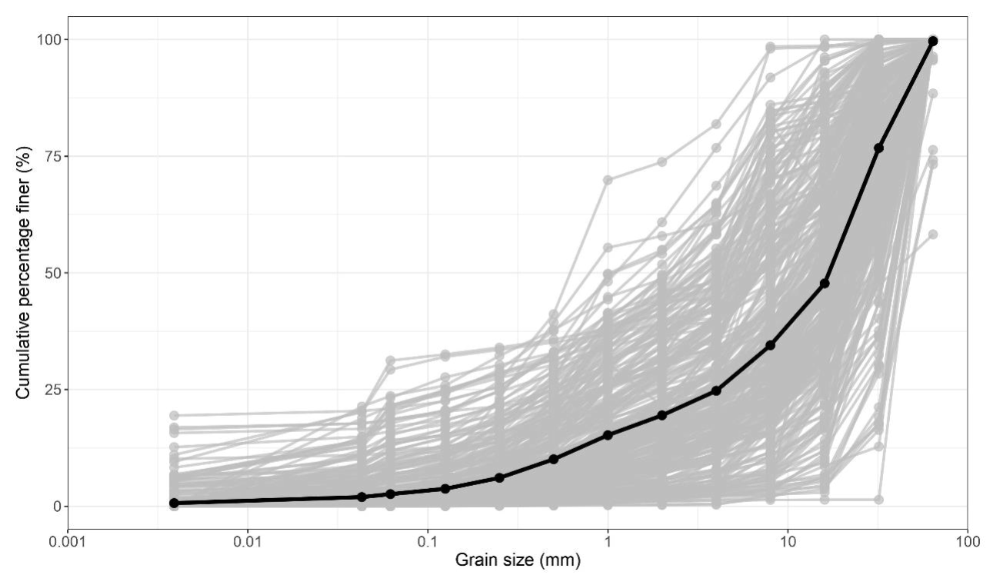

S.4 Terrestrial laser scan of flume
Terrestrial laser scan of the replicate chalk stream gravel bed post experimental flume run 9.

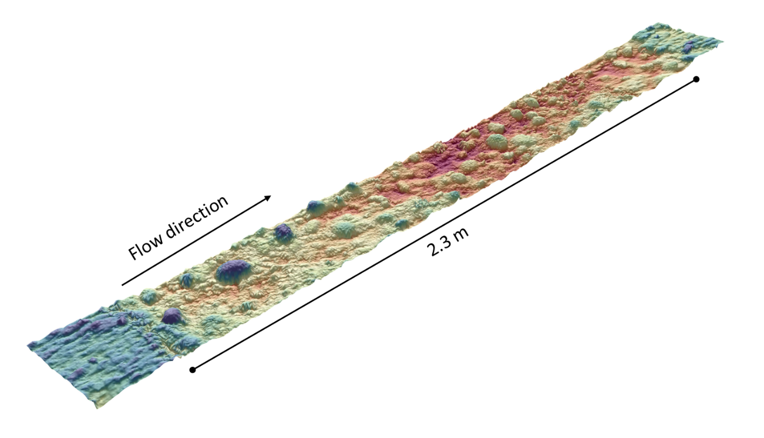

S.5 Additional flow characterises during each of the experimental flume runs
Reynolds number and Froude number for each of the three ADVP locations and the mean for each of the experimental runs (Re – Reynolds number, Fr – Froude number). Reynolds and Froude numbers were calculated as part of the post-processing methods carried out in MatLab.
Run | ADVP 1 |  | ADVP 2 |  | ADVP 3 |  | Mean
Run | Re (x 10⁴) | Fr | Re (x 10⁴) | Fr | Re (x 10⁴) | Fr | Re (x 10⁴) | Fr
Run 9 | 4.81 | 0.457 | 5.09 | 0.485 | 4.98 | 0.531 | 4.96 | 0.492
Run 8 | 4.81 | 0.461 | 4.08 | 0.419 | 4.59 | 0.363 | 4.46 | 0.408
Run 7 | 4.86 | 0.438 | 4.52 | 0.395 | 5.07 | 0.433 | 4.86 | 0.424
Run 6 | 3.40 | 0.205 | 4.45 | 0.428 | 4.96 | 0.404 | 4.37 | 0.362
Run 5 | 3.12 | 0.312 | 3.59 | 0.328 | 4.64 | 0.342 | 3.79 | 0.328
Run 4 | 3.45 | 0.265 | 3.56 | 0.205 | 3.30 | 0.280 | 3.42 | 0.248
Run 3 | 3.71 | 0.208 | 3.17 | 0.209 | 3.15 | 0.203 | 3.32 | 0.207
Run 2 | 3.10 | 0.188 | 3.11 | 0.180 | 3.31 | 0.167 | 3.19 | 0.176
Run 1 | 2.95 | 0.181 | 2.78 | 0.165 | 2.87 | 0.158 | 2.87 | 0.167

Calculation of Reynolds number:
$$Re=\frac{uL}{v}$$
where u is the velocity, L is the length scale (in this instance the height of the measurement above the bed was used), and v is the kinematic viscosity.

S.6 Velocity profiles
Velocity profiles for each of the three ADVP recording locations for each of the experimental runs.
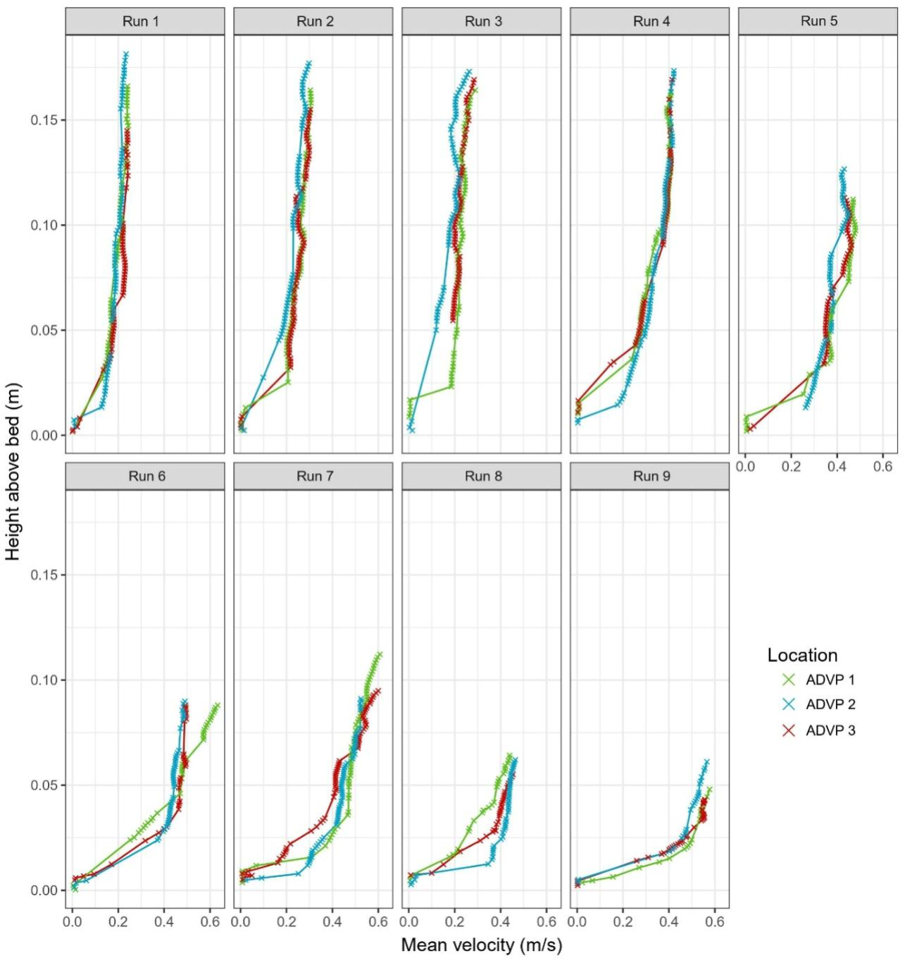
S.7 Measured shear velocities and bed shear stresses from flume experiments
Measured shear velocities, height above the bed and bed shear stress for each of the three ADVP locations in each of the experimental runs (𝑢∗ - shear velocity (m s⁻¹), 𝑧₀ – roughness height (m), 𝜏₀ – bed shear stress (Pa)).

Run | ADVP 1 |  |  | ADVP 2 |  |  | ADVP 3
Run | $$u_{*}$$ | $$z_{0}$$ | $$τ_{0}$$ | $$u_{*}$$ | $$z_{0}$$ | $$τ_{0}$$ | $$u_{*}$$ | $$z_{0}$$ | $$τ_{0}$$
Run 1 | 0.0247 | 0.0034 | 0.6120 | 0.0261 | 0.0030 | 0.6809 | 0.0211 | 0.0021 | 0.4470
Run 2 | 0.0334 | 0.0071 | 1.1150 | 0.0322 | 0.0052 | 1.0381 | 0.0307 | 0.0067 | 0.9429
Run 3 | 0.0365 | 0.0075 | 1.3303 | 0.0355 | 0.0028 | 1.2615 | 0.0351 | 0.0047 | 1.2331
Run 4 | 0.0601 | 0.0042 | 3.6153 | 0.0581 | 0.0044 | 3.3781 | 0.0468 | 0.0042 | 2.1870
Run 5 | 0.0643 | 0.0104 | 4.1302 | 0.0684 | 0.0116 | 4.6769 | 0.0545 | 0.0019 | 2.9689
Run 6 | 0.0658 | 0.0033 | 4.3358 | 0.0677 | 0.0034 | 4.5892 | 0.0584 | 0.0022 | 3.4105
Run 7 | 0.0838 | 0.0069 | 7.0232 | 0.0867 | 0.0069 | 7.5133 | 0.0751 | 0.0045 | 5.6475
Run 8 | 0.0778 | 0.0068 | 6.0509 | 0.0790 | 0.0051 | 6.2393 | 0.0730 | 0.0060 | 5.3336
Run 9 | 0.0915 | 0.0031 | 8.3676 | 0.0923 | 0.0034 | 8.5114 | 0.0857 | 0.0036 | 7.3487

S.8 Validity of shear velocities, roughness height, and bed shear stress estimated with the log-law from measurements outside the boundary layer
The log region is defined to be within wall units z⁺>50 (where z⁺=z𝑢∗/v) and, conventionally, the bottom 10-20% of the boundary layer (Pope, 2000). Given that some of our data points appear to fall outside these bounds, our estimates could be potentially contaminated in the near bed (if a viscous sub-layer exists), and by the wake in the outer region (z⁺>50), when fitting the velocity profile. In such cases, the log-law of the wall can be adjusted, for example by using the Coles-Wake correction (Coles, 1956) for rough, turbulent open channel flows and zero-pressure gradients.
To assess the potential impact of including these data points within our calculations, we reprocessed our data to estimate the shear velocity (𝑢∗) and roughness height (𝑧₀) through: (1) the exclusion of the near bed datapoints that fall within (z⁺ <11.6 where viscous effects may be important in the viscous and boundary layers; Figure S8.1) in the log-law profile fitting; and (2) the application Coles-Wake corrected log-law of the wall where data spans beyond the theoretical bounds of the log region.
The Coles-Wake correction to the log-law:
$$U_{z}=\frac{u_{*}}{κ}\ln{\ln\left(\frac{z}{z_{0}}\right)+\frac{2Πu_{*}}{κ}(\frac{Πz}{2H})}$$
where Uz is the mean (ensemble averaged) velocity at a height 𝑧 above the bed, 𝑢∗ is the shear velocity, 𝑧₀ is the roughness height, κ is von Kármán’s constant (κ=0.4), $Π$ is the wake strength parameter, and H is the water depth.
We implemented a non-linear least-squares regression to simultaneously estimate 𝑢∗, 𝑧₀, and $Π$. The model was optimised to ensure minimisation of the square residuals between measured mean velocities and wake-corrected prediction, and with no slope constraints imposed on the dataset such that all parameters were estimated directly from the measured data without bias. This approach explicitly resolves the wake contribution within the outer region without assuming a purely logarithmic velocity profile structure through the full depth of the water column. The resulting values of 𝑢∗ and 𝑧₀ were compared to the values reported in S.7, which were estimated using the standard log-law approach.
When excluding values in the immediate vicinity of the bed (including the boundary layer) where viscous effects may not be negligible, the differences between the two estimates of friction velocity were, on average, up to 12% between the three ADVP locations, whilst the median difference was 9% (Table S8.1). The maximum difference was observed in Run 3 at ADVP 1 (44%), indicating a difference of < 1 Pa in the resulting bed shear stress. The differences between the two techniques in terms of estimated roughness lengths (𝑧₀) were more pronounced, with median differences of 23%, 29% and 27% at the three ADVP locations, respectively. The two highest differences were observed in Run 3 at ADVP 1 (91%) and ADVP 2 (55%), corresponding to a difference in roughness length of 6 mm and 1.6 mm, respectively.
The relatively small deviations between the standard and wake-corrected estimates (median of 19% at ADVP 1; 11% at ADVP 2, and 9% at ADVP 3; Table S8.2) indicate that the dominant structure of the velocity field remains logarithmic and that wake effects in the outer regions of the flow do not bias our estimates of shear velocity. We note that the differences become better constrained with distance downstream, and highlight two outliers, Run 2 and 6 at ADVP 1. However, when double averaging is applied (spatial averaging is applied to the mean, time (ensemble) averaged velocity field), these estimates improve further (Run 2 - 32% and Run 6 - 22%). This translates to a difference in the calculated bed shear stress of 0.4 Pa in the worst-case scenario. Similarly, the estimates of roughness length present a median difference of 13% at ADVP 1, 15 % at ADVP 2, and 10% at ADVP 3. When double averaging is applied, these are reduced to <19.1% for all runs (except Run 2 at 48%). This translates to a difference of ~1 mm in the roughness lengths.

Table S8.1: Comparison between reported values of 𝑢∗ and 𝑧₀ using the log-law of the wall applied to the entire profile, and when excluding the data points falling within the viscous and boundary layers (z⁺ <11.6).
Run | ADVP 1 |  |  |  |  |  | ADVP 2 |  |  |  |  |  | ADVP 3
Run | 𝑢∗  Log-law | 𝑢∗  Log-law  z+>11.6 | % differ-ence | 𝑧₀  Log-law | 𝑧₀  Log-law  z+>11.6 | % differ-ence | 𝑢∗  Log-law | 𝑢∗  Log-law  z+>11.6 | % differ-ence | 𝑧₀  Log-law | 𝑧₀  Log-law  z+>11.6 | % differ-ence | 𝑢∗  Log-law | 𝑢∗  Log-law  z+>11.6 | % differ-ence | 𝑧₀  Log-law | 𝑧₀  Log-law  z+>11.6 | % differ-ence
1 | 0.0247 | 0.0262 | 6 | 0.0034 | 0.0040 | 19 | 0.0261 | 0.0286 | 10 | 0.0030 | 0.0040 | 35 | 0.0211 | 0.0164 | -22 | 0.0021 | 0.0007 | -65
2 | 0.0334 | 0.0334 | 0 | 0.0071 | 0.0071 | 0 | 0.0322 | 0.0328 | 2 | 0.0052 | 0.0054 | 5 | 0.0307 | 0.0350 | 14 | 0.0067 | 0.0120 | 79
3 | 0.0365 | 0.0203 | -44 | 0.0075 | 0.0006 | -91 | 0.0355 | 0.0289 | -19 | 0.0028 | 0.0044 | 58 | 0.0351 | 0.0340 | -3 | 0.0047 | 0.0040 | -15
4 | 0.0601 | 0.0549 | -9 | 0.0042 | 0.0032 | -24 | 0.0581 | 0.0581 | 0 | 0.0044 | 0.0024 | -45 | 0.0468 | 0.0428 | -9 | 0.0042 | 0.0032 | -25
5 | 0.0643 | 0.0574 | -11 | 0.0104 | 0.0079 | -24 | 0.0684 | 0.0630 | -8 | 0.0116 | 0.0096 | -17 | 0.0545 | 0.0533 | -2 | 0.0019 | 0.0018 | -3
6 | 0.0658 | 0.0658 | 0 | 0.0033 | 0.0032 | -1 | 0.0677 | 0.0526 | -22 | 0.0034 | 0.0015 | -56 | 0.0584 | 0.0501 | -14 | 0.0022 | 0.0018 | -18
7 | 0.0838 | 0.0782 | -7 | 0.0069 | 0.0050 | -27 | 0.0867 | 0.1210 | 40 | 0.0069 | 0.0083 | 20 | 0.0751 | 0.0677 | -10 | 0.0045 | 0.0033 | -27
8 | 0.0778 | 0.0778 | 0 | 0.0068 | 0.0068 | -1 | 0.0790 | 0.0790 | 0 | 0.0051 | 0.0051 | 1 | 0.073 | 0.0778 | 7 | 0.0060 | 0.0068 | 13
9 | 0.0915 | 0.0847 | -7 | 0.0031 | 0.0026 | -15 | 0.0923 | 0.1007 | 9 | 0.0034 | 0.0041 | 20 | 0.0857 | 0.0850 | -1 | 0.0036 | 0.0036 | 1

Table S8.2: Comparison between reported values of 𝑢∗ and 𝑧₀ using the log-law of the wall applied to the entire profile, and using the wake corrected log-law of the wall. wc – wake corrected.
Run | ADVP 1 |  |  |  |  |  | ADVP 2 |  |  |  |  |  | ADVP 3
Run | 𝑢∗  Log-law | 𝑢∗  Log-law (wc) | % differ-ence | 𝑧₀  Log-law | 𝑧₀  Log-law  (wc) | % differ-ence | 𝑢∗  Log-law | 𝑢∗  Log-law  (wc) | % differ-ence | 𝑧₀  Log-law | 𝑧₀  Log-law  (wc) | % differ-ence | 𝑢∗  Log-law | 𝑢∗  Log-law (wc) | % differ-ence | 𝑧₀  Log-law | 𝑧₀  Log-law  (wc) | % differ-ence
1 | 0.0247 | 0.0214 | -13 | 0.0034 | 0.0024 | -28 | 0.0261 | 0.02606 | 0 | 0.0030 | 0.0028 | -6 | 0.0211 | 0.0229 | 9 | 0.0021 | 0.0023 | 9
2 | 0.0334 | 0.0140 | -58 | 0.0071 | 0.0001 | -98 | 0.0322 | 0.0296 | -8 | 0.0052 | 0.0042 | -19 | 0.0307 | 0.0211 | -31 | 0.0067 | 0.0047 | -29
3 | 0.0365 | 0.0420 | 15 | 0.0075 | 0.0069 | -8 | 0.0355 | 0.0300 | -16 | 0.0028 | 0.0031 | 13 | 0.0351 | 0.0377 | 7 | 0.0047 | 0.0047 | -1
4 | 0.0601 | 0.0597 | -1 | 0.0042 | 0.0038 | -9 | 0.0581 | 0.0516 | -11 | 0.0044 | 0.0031 | -30 | 0.0468 | 0.0509 | 9 | 0.0042 | 0.0047 | 12
5 | 0.0643 | 0.0767 | 19 | 0.0104 | 0.0118 | 13 | 0.0684 | 0.0867 | 27 | 0.0116 | 0.0135 | 17 | 0.0545 | 0.0602 | 10 | 0.0019 | 0.0021 | 9
6 | 0.0658 | 0.1045 | 59 | 0.0033 | 0.0063 | 91 | 0.0677 | 0.0667 | -1 | 0.0034 | 0.0029 | -15 | 0.0584 | 0.0629 | 8 | 0.0022 | 0.0024 | 10
7 | 0.0838 | 0.1027 | 23 | 0.0069 | 0.0064 | -8 | 0.0867 | 0.0726 | -16 | 0.0069 | 0.0059 | -14 | 0.0751 | 0.0808 | 8 | 0.0045 | 0.0044 | -1
8 | 0.0778 | 0.0721 | -7 | 0.0068 | 0.0063 | -7 | 0.0790 | 0.1028 | 30 | 0.0051 | 0.0064 | 25 | 0.0730 | 0.0626 | -14 | 0.006 | 0.0053 | -12
9 | 0.0915 | 0.1132 | 24 | 0.0031 | 0.0035 | 15 | 0.0923 | 0.0908 | -2 | 0.0034 | 0.0033 | -4 | 0.0857 | 0.1044 | 22 | 0.0036 | 0.0040 | 12

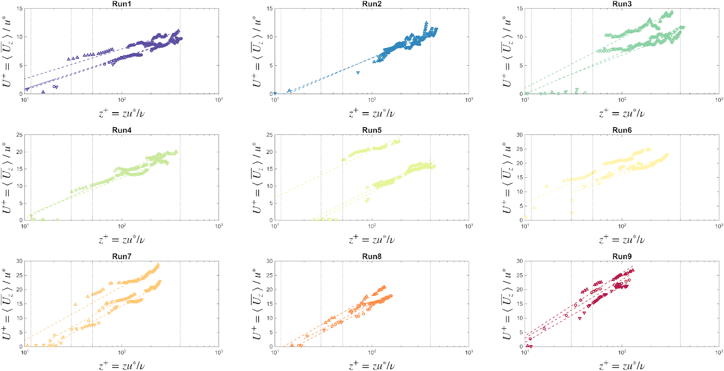
Figure S8.1: Testing the different flow regions where the data is collected.

S.9 Bed shear stress calculation and Cheng (2011) – Hydraulic radius sidewall correction
Bed shear stress:
$$τ_{0}= ρgr_{b}S$$
where, $r_{b}$ is the hydraulic radius, $g$ is the acceleration due to gravity (9.81 ms⁻²), $ρ$ is the density of water, and $S$ is the slope.
Correction of hydraulic radius by Cheng (2011):

$$f_{ω}=31{\left[\ln{(1.3\frac{R_{e}}{f})}\right]}^{-2.7}$$

$$R_{e}=\frac{VD}{v}$$

$$f=\frac{8grS}{V^{2}}$$

$$f_{b}=f+\frac{2h}{B}(f-f_{ω})$$

$$r_{b}=\frac{f_{b}}{f}r$$

where, 𝑅_{𝑒} – hydraulic diameter, D = 4r, where r is the hydraulic radius (A/P, where A is the cross-section area of the flow (m²) and P is the wetted perimeter (m)), f is the bulk friction factor, V is the cross-sectional average velocity, S is the energy slope and g is the acceleration due to gravity (9.81 ms⁻²), h is the flow depth, B is the channel width, r_{b} is the hydraulic radius in the presence of sidewalls.

S.10 Cheng (2000) – Fall velocity model
Calculation of fall velocity used by Kuhnle et al. (2016), proposed by Cheng (2009):

$$d_{*}={(∆\frac{g}{v^{2}})}^{\frac{1}{3}}d$$

$$∆ =(ρ_{s}-ρ)/ρ$$

$$C_{D}=\frac{432}{d_{*}^{3}}(1+0.22d_{*}^{3})^{0.54}+0.47\left[1+exp⁡(-0.15d_{*}^{0.45})\right]$$

$$ω_{*}=\sqrt{4d_{*}/(3C_{D})}$$

where 𝑑 is the particle diameter, 𝜌_{𝑠} is the sediment density, 𝜌 is the water density, 𝑣 is the kinematic viscosity of water and 𝑔 is the acceleration due to gravity (9.81 ms⁻²).

S.11 Wooster et al. (2008) – Porosity predictor
Porosity of gravel bed predictor proposed by Wooster et al. (2008):

$$n=0.621e^{{-0.457σ}_{gg}}$$

where 𝜎𝑔𝑔 is the standard deviation of the gravel bed grain size distribution.

S.12 Chalk stream site characteristics
Characteristics of the chalk stream sites used to predict the required depth average velocities needed to remobilise fine sediment. From Mondon et al. (2024).
River | Site | Depth (m) | D50 (mm) | Velocity (m/s⁻¹)
Wissey | Northwold | 0.40 | 4.99 | 0.991
Babingley | Castle Rising | 0.20 | 0.83 | 1.242
Arle | Alresford | 0.20 | 15.44 | 0.573
Candover Brook | Abbotstone | 0.18 | 11.44 | 0.618
Cheriton Stream | Tichbourne | 0.17 | 7.12 | 0.713
Itchen | Ovington | 0.40 | 5.35 | 0.975
Itchen | Martyr Worthy | 0.34 | 9.62 | 0.803
Itchen | Winchester | 0.27 | 8.79 | 0.771
Itchen | Shawford House | 0.30 | 13.99 | 0.689
Itchen | Bishopstoke | 0.24 | 17.71 | 0.584
Itchen | Gators Mill | 0.30 | 12.44 | 0.716
Nadder | Wilton | 0.31 | 22.73 | 0.585
Nadder | Ugford | 0.32 | 23.07 | 0.589
Nadder | South Burcombe | 0.48 | 27.90 | 0.638
Nadder | Barford St Martin | 0.35 | 22.83 | 0.612
Nadder | Fovant | 0.31 | 25.52 | 0.559
Nadder | Panters | 0.28 | 20.58 | 0.585
Wylye | Wilton | 0.45 | 24.89 | 0.650
Wylye | South Newton | 0.37 | 15.70 | 0.710
Wylye | Langford | 0.23 | 27.83 | 0.471
Wylye | Boyton | 0.24 | 19.73 | 0.559
Wylye | Norton Bavant | 0.18 | 29.02 | 0.405
Avon | Britford | 0.43 | 17.33 | 0.722
Avon | Hale | 0.43 | 14.20 | 0.768
Avon | Burgate | 1.32 | 32.00 | 0.838
Upper Avon | Salisbury | 0.52 | 23.58 | 0.695
Upper Avon | Durnford | 0.26 | 26.42 | 0.511
Upper Avon | Heale | 0.32 | 26.95 | 0.553
Upper Avon | Upavon | 0.24 | 26.10 | 0.495
Bourne | Porton | 0.26 | 27.60 | 0.501
Bourne | Hurdcot | 0.43 | 22.63 | 0.661
Bourne | Laverstock | 0.67 | 27.13 | 0.721
Itchen | Shawford - Site A | 0.28 | 19.35 | 0.599
Itchen | Shawford - Site B | 0.32 | 12.05 | 0.738
Itchen | Shawford - Site C | 0.19 | 15.42 | 0.562
Itchen | Shawford - Site D | 0.23 | 7.17 | 0.781
Itchen | Brandy - Site A | 0.44 | 3.70 | 1.080
Itchen | Brandy - Site B | 0.44 | 4.92 | 1.015
Itchen | Falloden - Site A | 0.25 | 1.81 | 1.115
Stiffkey | Fort | 0.37 | 8.76 | 0.844
Stiffkey | Water Hall | 0.37 | 6.05 | 0.928
Stiffkey | Whey Curd | 0.37 | 3.95 | 1.026
Stiffkey | 2003 - A | 0.35 | 18.92 | 0.655
Stiffkey | 2003 - B | 0.35 | 27.54 | 0.569
Stiffkey | 2003 - C | 0.35 | 75.52 | 0.338
Stiffkey | 2009 - A | 0.31 | 33.37 | 0.497
Stiffkey | 2009 - D | 0.31 | 30.55 | 0.518
Stiffkey | 2009 - F | 0.31 | 11.20 | 0.747
Stiffkey | 2009 -J | 0.31 | 41.12 | 0.450
Avon | Site 1 | 1.02 | 15.83 | 0.940
Avon | Site 2 | 0.98 | 14.21 | 0.956
Avon | Site 3 | 0.92 | 18.23 | 0.884
Avon | Site 4 | 0.72 | 14.52 | 0.880
Upper Avon | Site 5 | 0.26 | 18.36 | 0.594
Upper Avon | Site 6 | 0.26 | 14.29 | 0.651
Upper Avon | Site 7 | 0.32 | 21.16 | 0.609
Upper Avon | Site 8 | 0.32 | 31.17 | 0.520
Piddle | Site 1 | 0.40 | 16.00 | 0.724
Piddle | Site 2 | 0.36 | 14.15 | 0.728
Piddle | Site 3 | 0.31 | 23.91 | 0.574
Piddle | Site 4 | 0.22 | 16.79 | 0.576
Wylye | Site 1 | 0.36 | 13.13 | 0.745
Wylye | Site 2 | 0.33 | 8.83 | 0.816
Wylye | Site 3 | 0.30 | 17.85 | 0.633
Wylye | Site 4 | 0.24 | 22.88 | 0.525
Frome | Site 1 | 0.43 | 16.65 | 0.731
Frome | Site 2 | 0.59 | 27.10 | 0.692
Frome | Site 3 | 0.36 | 21.73 | 0.630
Frome | Site 4 | 0.41 | 24.87 | 0.629
Nadder | Site 1 | 0.80 | 16.80 | 0.871
Nadder | Site 2 | 0.50 | 15.32 | 0.785
Nadder | Site 3 | 0.35 | 16.87 | 0.681
Nadder | Site 4 | 0.31 | 17.46 | 0.646
Test | Foxdown | 0.20 | 7.30 | 0.745
Test | Freefolk | 0.36 | 6.45 | 0.908
Test | Gravelacre | 0.40 | 3.16 | 1.095
Test | Middleton | 0.35 | 5.34 | 0.944
Test | Wherwell | 0.62 | 2.98 | 1.209
Test | Bossington | 0.70 | 23.40 | 0.765
Test | Tufton | 0.27 | 17.45 | 0.614
Wissey | Site A | 0.28 | 3.30 | 1.003
Wissey | Site B | 0.24 | 9.10 | 0.736
Wissey | Site C | 0.20 | 5.50 | 0.810
Wissey | Site E | 0.34 | 6.10 | 0.907
Wissey | Site F | 0.18 | 0.70 | 1.257
Wissey | Site H | 0.30 | 10.30 | 0.759
Babingley | Site A | 0.21 | 9.13 | 0.705
Babingley | Site E | 0.23 | 4.97 | 0.865
Babingley | Site F | 0.20 | 0.73 | 1.270
Babingley | Site G | 0.20 | 0.53 | 1.343
Babingley | Site J | 0.21 | 8.05 | 0.734
Kennet | Freedmans Marsh | 0.23 | 31.25 | 0.444
Kennet | Eddington Mill | 0.25 | 45.35 | 0.378
Test | Bossington | 0.40 | 4.74 | 1.002
Test | Foxdown | 0.19 | 7.29 | 0.733
Test | Lynch | 0.25 | 3.81 | 0.945
Test | Freefolk | 0.30 | 6.45 | 0.866
Test | Whitchurch | 0.27 | 4.85 | 0.907
Test | LarkWhistle Farm | 0.13 | 6.56 | 0.671
Test | Middleton | 0.25 | 5.34 | 0.867
Test | Gavel Acre | 0.34 | 2.89 | 1.078
Test | Wherwell - Site 1 | 0.32 | 4.09 | 0.985
Test | Wherwell - Site 2 | 0.80 | 2.78 | 1.283
Test | Leckford | 0.50 | 5.86 | 1.005
Test | HomeStead | 0.62 | 1.53 | 1.361
Test | Bossington | 0.34 | 4.74 | 0.965
Test | Pittleworth Farm | 0.54 | 5.82 | 1.024
Test | Mottisfont | 0.43 | 4.69 | 1.021
Test | Greatbridge | 0.78 | 3.99 | 1.194
Test | Romsey | 0.80 | 6.40 | 1.092
Test | Lee Park Farm | 1.13 | 7.29 | 1.141
Piddle | Mean | 0.45 | 14.01 | 0.781
Bere Stream | Mean | 0.56 | 22.25 | 0.725
Tadnoll Brook | Mean | 0.23 | 27.51 | 0.473

