Please cite:
Agusita, E. and Ashton, D. (2026) Unexpected Enterprises: Rethinking Employment, Education and Training for Creative Economy Entrepreneurship. Response to Youth Employment, Education and Training - Call for Evidence. DOI: https://doi.org/10.5258/SOTON/P1275

Unexpected Enterprises: Rethinking Employment, Education and Training for Creative Economy Entrepreneurship

Response to:
Youth Employment, Education and Training - Call for Evidence
Authors
Dr Emma Agusita
Senior Lecturer: Media Communications and Culture, Media and Creative Industries
School of Arts
University of the West of England
Emma3.Agusita@uwe.ac.uk

Professor Dan Ashton
Professor of Cultural and Creative Industries
Winchester School of Art
Faculty of Arts and Humanities
University of Southampton
d.k.ashton@soton.ac.uk

Date
19th February 2026

1. Introduction

  - This response focuses on young people’s aspirations to establish careers in the cultural and creative industries, and the barriers they face in doing so. This emphasis is important because the creative industries have been identified as one of the eight sectors in the UK’s Modern Industrial Strategy. The Creative Industries Sector Plan (UK Government, 2025) identifies the significance of the economic contribution of the cultural and creative industries and the challenge of building a resilient, skilled and diverse workforce. The cultural and creative industries workforce has a higher proportion of self-employed workers compared to the wider UK workforce and several of these subsectors typically comprise micro, small, and medium-sized businesses.

  - The evidence and insight used to respond to this Call for Evidence comes from the Unexpected Enterprises project funded by Enterprise Educators UK (Agusita and Ashton, 2020a). Unexpected Enterprises used a collaborative innovation approach with creative entrepreneurs and higher education students and educators to consider emerging forms of entrepreneurship, particularly those which leverage digital technologies. This work created opportunities for participants to consider how digital and social innovation can give rise to ‘unexpected enterprises’ (Ashton, 2017) and to question existing ideas about creative entrepreneurship.

  - The project was a collaboration between 24 students from creative arts and media undergraduate and postgraduate programmes, at the University of the West of England and Winchester School of Art (University of Southampton), 11 educators with an interest in creative and cultural entrepreneurship, and 4 creative entrepreneurs who use digital media and creative technologies in their work. Our co-design methods and an open innovation approach enabled the project to develop a set of pedagogical considerations and resources that were informed by the lived experience of the participants (Agusita and Ashton, 2020b).

  - Rather than focus on finding employment, this response focuses on creating employment and how young people can understand and pursue entrepreneurial opportunities.

The following sections responds to four consultation questions with insights from Unexpected Enterprises and corresponding recommendations:

- What are the main barriers to employers supporting young people into employment and how can the Government better work with employers to address these?
- What impact may developments in technologies, such as AI, have on the employment of young people? How should Government respond?
- How can employers be encouraged to invest in Skills training?
- How well is support for young people tailored to local labour market conditions and how can this be improved?

2. What are the main barriers to employers supporting young people into employment and how can the Government better work with employers to address these?

A barrier to young people participating in employment is knowledge of opportunities and the extent to which guidance and advice sufficiently expands on what employment can look like within our current and changing digital society. The addition of job roles such as ‘social media influencer’ and ‘content creator’ to the National Careers Service have gone some way to address this. However, further guidance on the ways to start up and approach this challenge as an entrepreneur is required. Established business start-up pathways and guidance cannot always align with and enable more unexpected enterprises, such as social media influencer, to emerge.

In the Unexpected Enterprises project, our innovative remix and remake approach enabled participants to rethink the business plan as a resource and a process. We found this process can allow more open-ended thinking about starting points for creative careers and business in emerging industry and technological contexts.
  - Recommendation: We recommend that cultural and creative industries careers and business plan guidance is reviewed to avoid assumptions and requirements on the structure and nature of creative entrepreneurial ventures. This action will support young people to explore the fine balance between drawing on established experience and methods and encouraging unexpected enterprises.

3. What impact may developments in technologies, such as AI, have on the employment of young people? How should Government respond?

  - Emerging and new digital technologies are unsettling and reshaping creative work opportunities and careers, disrupting traditional and established work roles and models. Developments in technologies can create challenges in identifying possibilities and understanding what employment and entrepreneurial opportunities involve or require. A barrier to young people pursuing entrepreneurial career pathways is understanding the steps and stages of ‘non typical’ roles and careers paths.
  - In the Unexpected Enterprises project, students, educators and entrepreneurs discussed biographical accounts and career narratives of the participating creative entrepreneurs. This perspective enabled the students to consider underlying assumptions about how pathways to creative work are articulated in existing learning and teaching approaches and careers guidance. The activity showed the extent to which career stories reflect narratives that are unexpected, accidental and complex (e.g. serendipitous encounters and unanticipated challenges). We found that examples of pathways to creative entrepreneurship need to move beyond taken-for-granted ideas that characterise career development as seamless and coherent.

  - Recommendation: We recommend that cultural and creative industries careers and business plan guidance emphasises multiple starting points, avoids typical progression routes and questions the necessity that currently established roles, pathways and training must be completed. This approach, which emphasises adaptability and responsiveness to increasingly rapid technological and social developments, will enable young people to imagine new possibilities for where they can see themselves and their entrepreneurial journeys.

4. How can employers be encouraged to invest in Skills training?
  - A barrier to young people pursuing entrepreneurial career pathways is understanding the skills associated with ‘non typical’ jobs and careers paths. Skills training for specific jobs identified at a particular moment in time can be a challenge with the changing nature of jobs and what they involve.

  - In the Unexpected Enterprises project, we identified that a generative and developmental approach is needed to understand and foster skills and knowledge, not restricted to developing definitive skills. We found there is an increased need to identify and build young people’s capacity to do creative work in new cultural spaces and modes that are informal, organic, experimental and co-creative. During the research project innovation labs, participants reflected on everyday and less archetypal practices of creative entrepreneurship, which require more rapidly evolving social and technical skills. This included growing and managing relationships and interactions across different digital platforms/channels and in non-traditional workspaces. These practices and settings can blur the lines between people’s personal and professional lives. For example, someone DIY vlogging or podcasting using a bedroom as their production base and trying to build a social media following across multiple platforms and channels, as well as developing collaborations with other online content producers and navigating the 24/7 nature of online audience interaction and engagement.
  - Recommendation: We recommend that employers invest in skills training that are determined less by the identified skills needs of specific business and organisations at a moment in time, and that are more open to what might benefit creative production and content creation more widely. Employers expanding the investment in skills training beyond employees to freelancers and SMEs they work with could have a ‘net gain’ that encourages and enables entrepreneurship and collaboration in innovation.

5. How well is support for young people tailored to local labour market conditions and how can this be improved?

  - A barrier to young people pursuing entrepreneurial career pathways can be representation and visibility. The dominant representation of a creative entrepreneur is limited in terms of demographics and characteristics (see Naudin and Patel, 2017, who explored gender and ethnic inequalities and representations). Relatedly, the UK creative and cultural industries do not reflect the diversity of the UK population, with geographic patterning acting as a contributing factor (McCabe, 2025). Widely circulating stereotypes include the combative/gladiatorial figure and the ‘tech bro’.

  - In the Unexpected Enterprises project, the exploration of entrepreneurial life stories enabled participants to consider a range of entrepreneurial identities, beyond narrow ideas about what counts as entrepreneurial activity or identity. Using a LinkedIn profile template as a basis for discussion, they reflected on norms of professional presentation that are designed into social media platforms and alternatives for self-representation.

In another project activity, participants reflected on the relational aspects of networking and co-working, and the accessibility and inclusiveness of creative workspaces. Through a process of asset-mapping—identifying and prioritising tangible and intangible resources to do creative work (e.g. equipment, skills, connections, supportive relationships)—they were able to think beyond established norms. Plasticine modelling was employed to imagine a more inclusive vision for creative work.
Images: asset mapping (left) plasticine modelling (right)
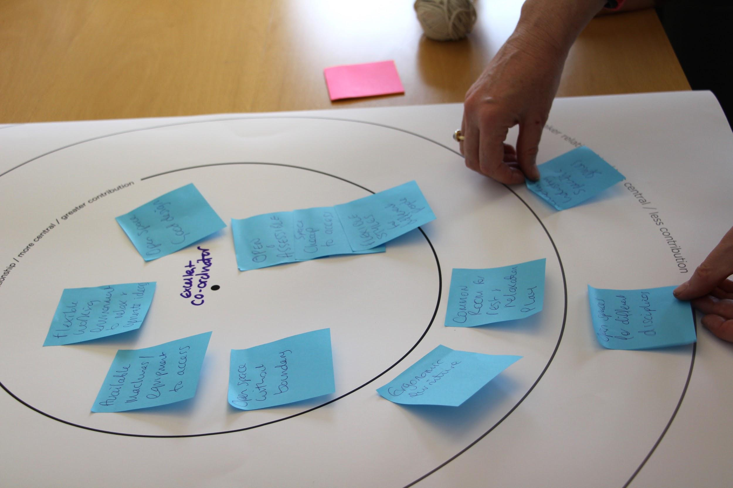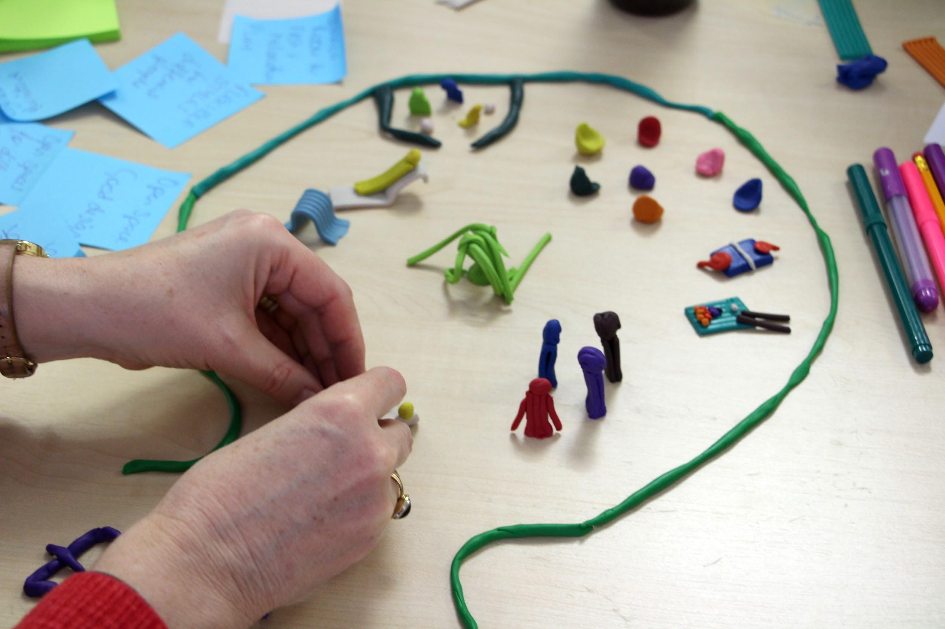
  - Recommendation: We recommend that cultural and creative industries careers and business plan guidance give visibility to and prompts for discussing the opportunities for and constraints of generating self-narratives and communicating self-identity. This focus will enable young people to identify and challenge the limited representations which can be barriers to pursuing entrepreneurial opportunities in a UK creative industries context (national and local). In this way, local labour market conditions can be understood and addressed as issues of access and opportunity. Acknowledging geographic disparities that impact inclusion echoes cluster-based approaches to supporting equitable opportunities for creative industries growth.

6. Policy Implications
From the above recommendations (2.3, 3.3., 4.3., 5.3), we suggest the following:

- Employers and careers guidance bodies review existing cultural and creative industries guidance and resources to reimagine how young people can understand and pursue entrepreneurial opportunities through multiple starting points.

- Employers invest in skills training for freelancers and SMEs that they work with (as well as employees) to benefit creative production and content creation more widely and encourage and enable entrepreneurship and collaboration in innovation.

- Employers and careers guidance bodies review existing cultural and creative industries guidance and resources to explore opportunities for and constraints of generating self-narratives. This should align with place and geographic disparities to understand how opportunities and constraints for self-narratives impact on local labour markets and the vitality of creative industries clusters. Relatedly, guidance and resources should acknowledge differing identities and must embed equity and belonging because not all entrepreneurial opportunities are equally accessible to young people.

- Employers and careers guidance bodies explore the use of creative methods to capture and share a diverse range of young people's stories and experiences that are relevant, meaningful and engaging.

References
Agusita, E. & Ashton, D. (2020a) Unexpected Enterprises: Investigating the pedagogic potential of emerging forms of entrepreneurship for media enterprise education.
DOI: 10.5258/soton/p1269

Agusita, E. and Ashton, D. (2020b) Unexpected enterprises: Remixing creative entrepreneurship. In S.Luckman and S.Taylor (eds.) Pathways into Creative Working Lives. Palgrave Macmillan, pp. 31-47. DOI: 10.1007/978-3-030-38246-9

Ashton, D. (2017) Media enterprise education: professional practices and everyday creativity. In B. De Abreu, P. Mihailidis, A. Lee, J. Melki & J. McDougall (Eds.), The international handbook of media literacy (pp. 289–304). Abingdon, Oxon: Routledge.
DOI: 10.4324/9781315628110
Available at: https://eprints.soton.ac.uk/410431/

McCabe, H. (2025) Horizon Scanning: Participation, Diversity and Inclusion in the cultural and creative industries. UK Parliament. DOI: https://doi.org/10.58248/HS115

Naudin, A. & Patel, K. (2017) Entangled expertise: Women’s use of social media in entrepreneurial work. European Journal of Cultural Studies, 22(5-6), 511-527.
DOI: 10.1177/1367549417743037

UK Government (2025) The UK’s Modern Industrial Strategy: Creative Industries Sector Plan. Available at: https://assets.publishing.service.gov.uk/media/68920e22dc6688ed50878479/industrial_strategy_creative_industries_sector_plan_accessible.pdf

