Supplementary Figures
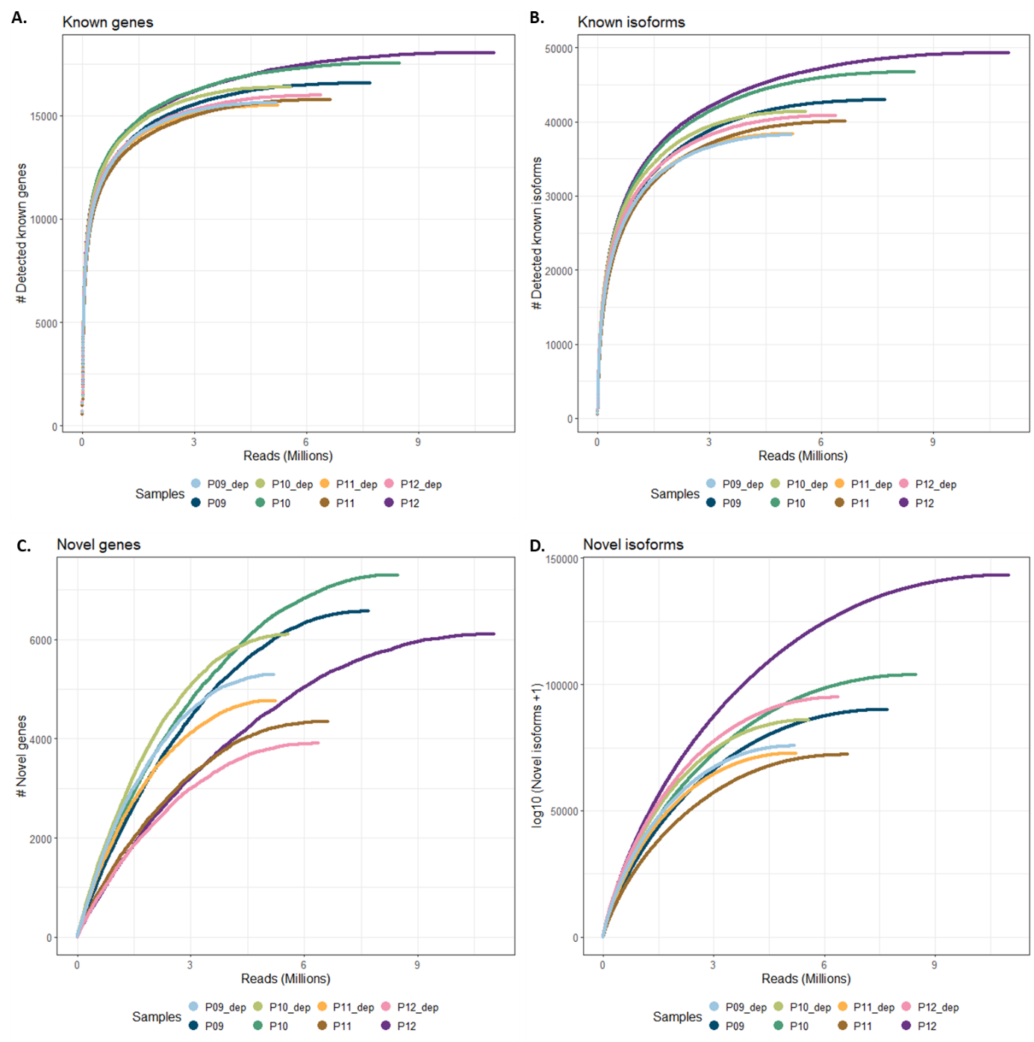
Supplementary Figure 1. Saturation curves comparing globin depleted vs undepleted libraries. A-B. Number of known genes and isoforms (present in GENCODE) detected by Iso-Seq pigeon in Run 1 Pools 3 and 4, across various levels of down sampled sequencing reads. C-D. Number of novel genes and isoforms (not present in GENCODE) detected by Iso-Seq pigeon in Run 1 Pools 3 and 4, across various levels of down sampled sequencing reads. Run 1 Pool 3 underwent globin depletion, while Run 1 Pool 4 did not. Libraries were sequenced from biological replicates, with “_dep” indicating globin depleted libraries.

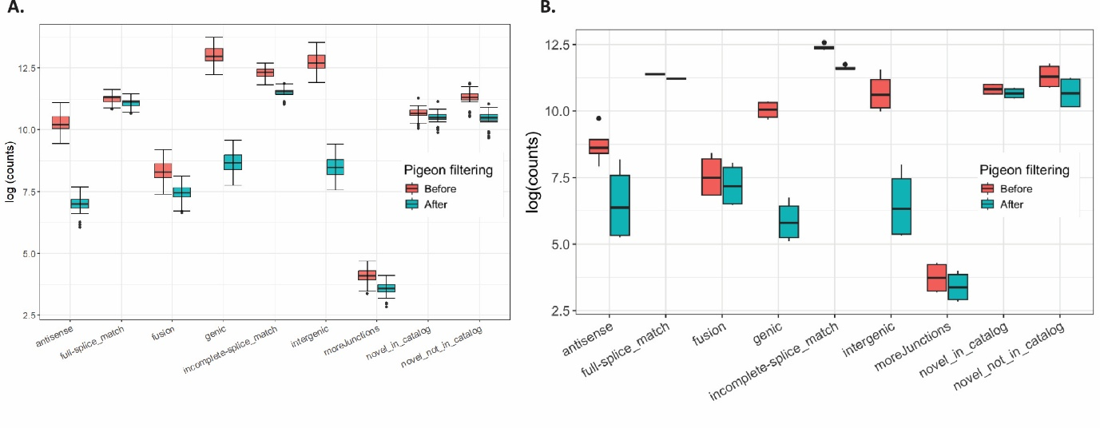Supplementary Figure 2. Comparison of isoform count in each category before and after Pigeon filtering in A. blood and B. fibroblasts.
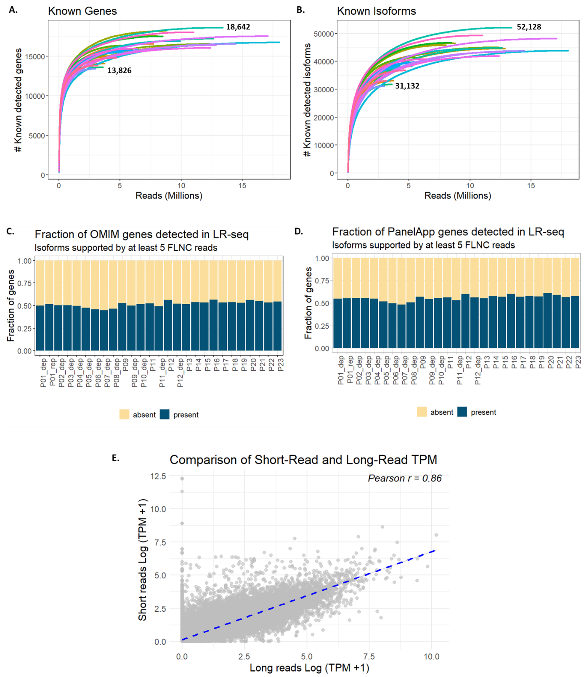
Supplementary Figure 3. Gene and isoform detection rates in blood. A-B Saturation plots for all blood libraries (n=28) showing the number of known genes and isoforms (present in GENCODE) across varying depths. The numbers show the min and max number of genes and isoforms detected. C-D. Fraction of OMIM (n=16,630) and PanelApp (n=3,643) genes detected by the Iso-Seq pipeline across all libraries. E. Correlation of transcript abundance measured in transcripts per million (TPM) in long versus short read RNA-seq.
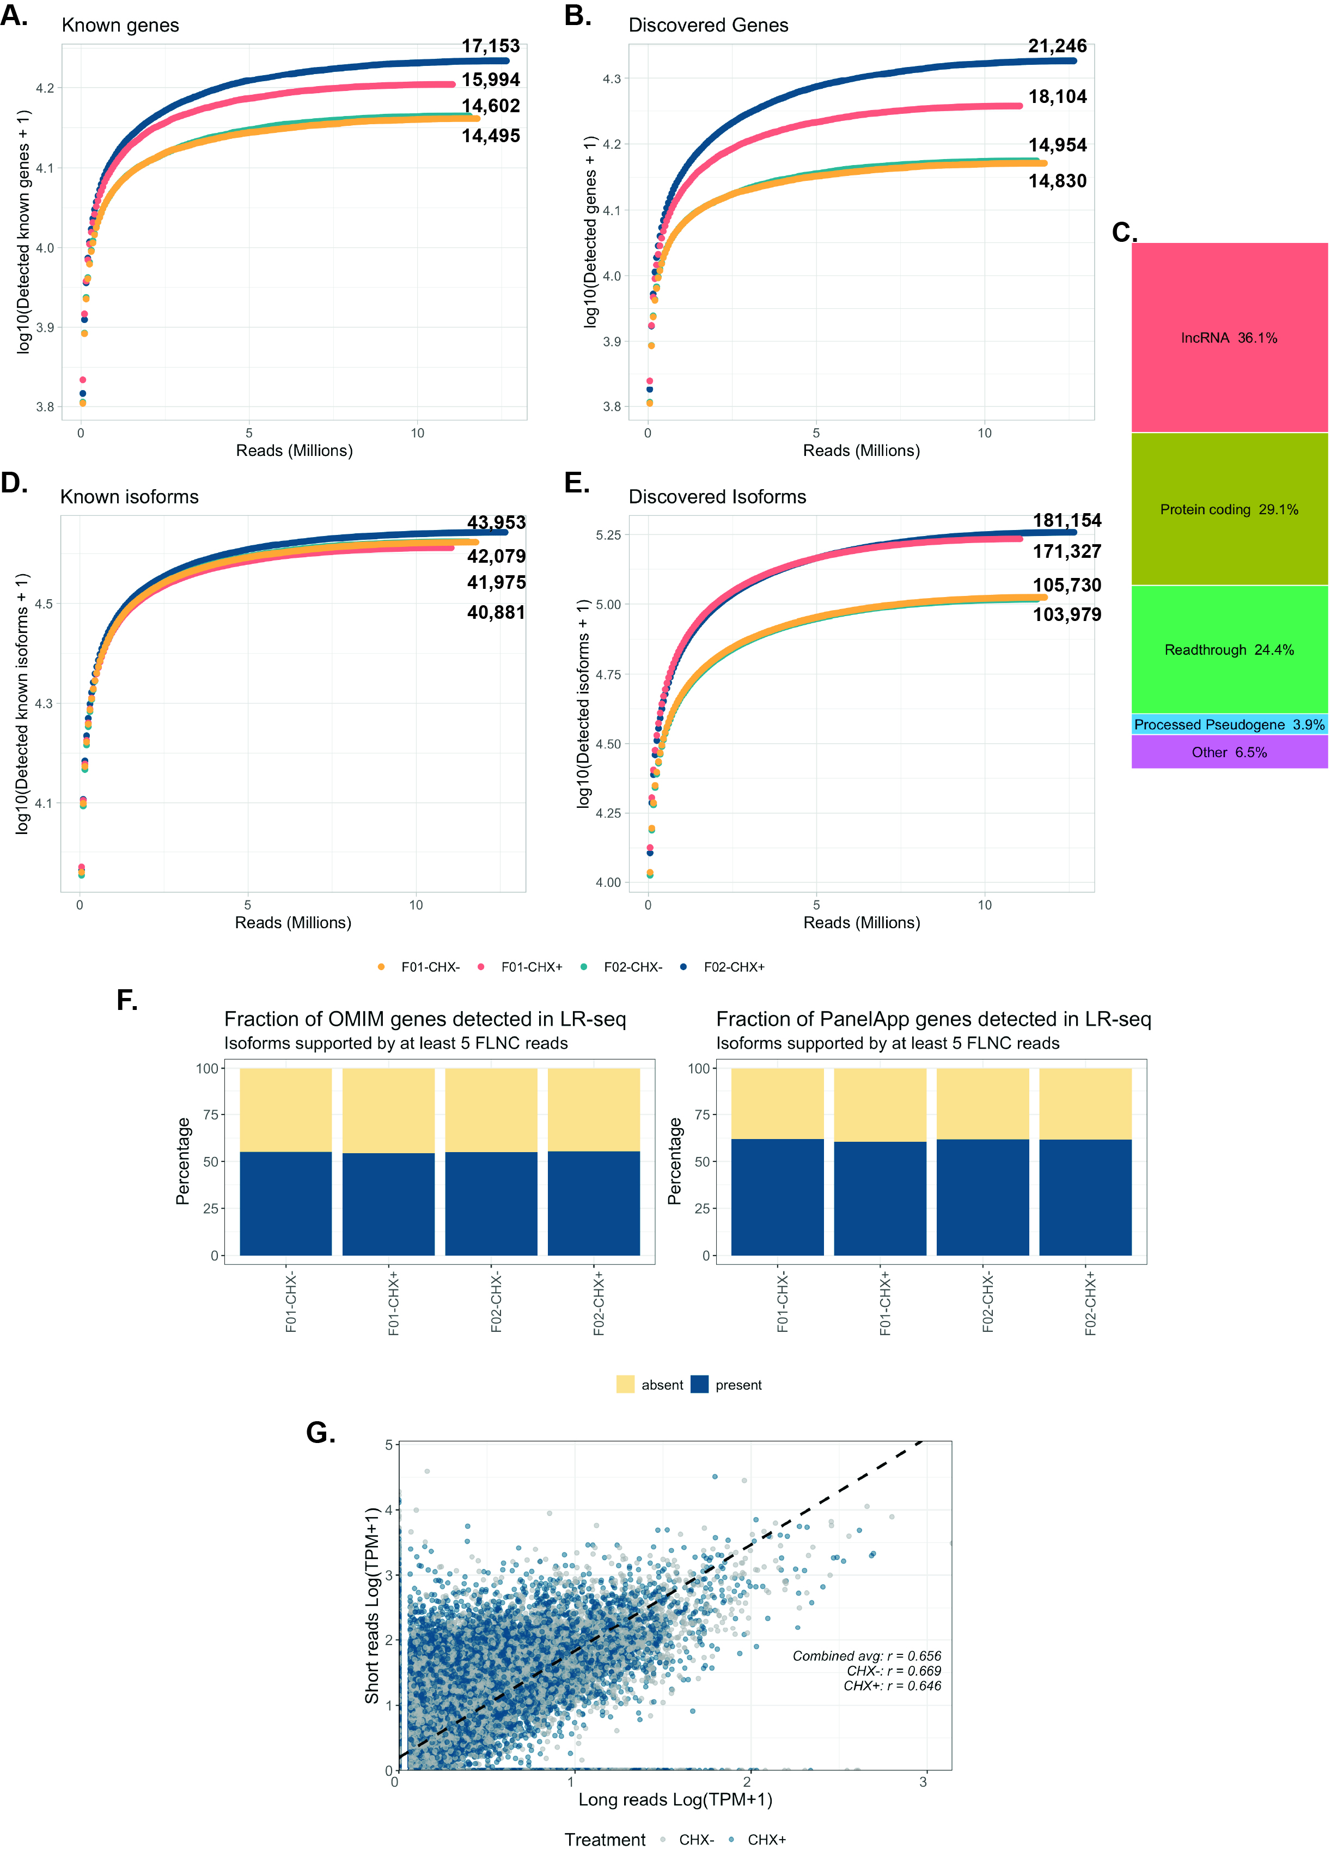
Supplementary Figure 4. Gene and isoform detection rates in fibroblast cell lines. A-B. Saturation curves showing the number of detected genes present in GENCODE or discovered by Iso-Seq pigeon from the fibroblast cell lines at different numbers of down sampled sequencing reads. Numbers indicate maximum detection achieved. C. Biotype annotation of genes detected only in cycloheximide-treated (CHX+) fibroblast cell lines. F01, F02 represent the two fibroblast lines; CHX- specifies lines not treated with cycloheximide, while CHX+ indicates cycloheximide-treated lines. D-E. Saturation curves for transcripts annotated in GENCODE or discovered from sequencing data by Iso-Seq pigeon at different numbers of down sampled sequencing reads. Numbers indicate maximum detection achieved. F. Fraction of OMIM (n=16,630) and PanelApp (n=3,643) genes identified by the Iso-Seq pipeline in the fibroblast lines. G. Correlation of transcript abundance measured in transcripts per million (TPM) in long versus short read RNA-seq from fibroblast lines.

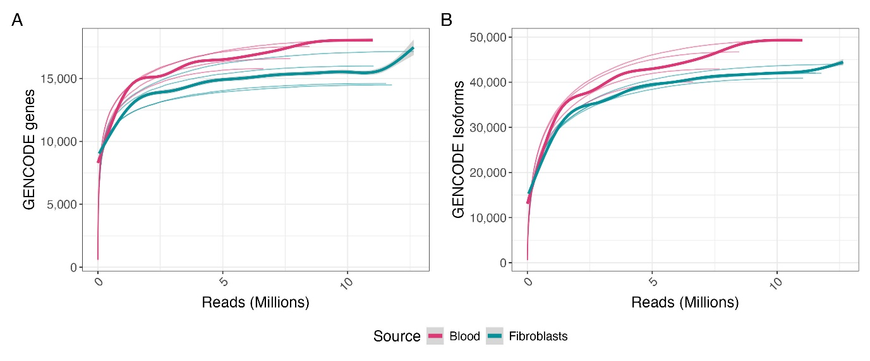
Supplementary Figure 5. Gene and transcript detection saturation analysis in blood and fibroblasts. Saturation curves showing the number of GENCODE-annotated A genes and B transcripts detected as a function of sequenced reads (in millions). Each thin line represents a patient sample, and the thick smoother curves represent the average. For blood, 4 random samples were used, for fibroblasts all 4 lines were used.

