Supplemental Material

Analysis
Binary logistic regressions tested whether sexual information acquired from religious sources was associated with relationship status and sexual orientation, treating it as a continuous predictor to avoid dichotomisation and loss of power (MacCallum et al. 2002).
Greater religious information was associated with a higher likelihood of being in a relationship (B=0.20, SE=0.07, Wald=8.53, p=.003, OR=1.23, χ²(1)=9.84, p=.002) and a lower likelihood of identifying as non-heterosexual (B=–0.28, SE=0.08, Wald=13.17, p<.001, OR=0.76, χ²(1)=16.12, p<.001).

Table A.
Number and Percentages of Demographic Characteristics.
 | Option | China (N = 782) |  | UK (N = 771)
 | Option | N | % | N | %
Gender | Men | 400 | 51.2 | 366 | 47.5
 | Women | 382 | 48.8 | 405 | 52.5
Ethnicity | White | . | . | 616 | 79.9
 | Black | . | . | 38 | 4.9
 | Chinese | 776 | 99.2 | 5 | 0.6
 | Other Asian | 6 | 0.8 | 53 | 6.9
 | Arab | . | . | 4 | 0.5
 | Mixed or multiple ethnic groups | . | . | 47 | 6.1
 | Any other ethnic group | . | . | 8 | 1.0
Sexual Orientation | Heterosexual or straight | 686 | 87.7 | 563 | 73.0
 | Gay or lesbian | 28 | 3.6 | 45 | 5.8
 | Bisexual | 60 | 7.7 | 143 | 18.5
 | Asexual | 3 | 0.4 | 10 | 1.3
 | Prefer not to say | 4 | 0.5 | 7 | 0.9
 | Other Sexual Orientation | 1 | 0.1 | 3 | 0.4
Relationship Status | Single | 102 | 13.0 | 206 | 26.7
 | Dating | 92 | 11.8 | 117 | 15.2
 | Committed relationship/s but not cohabiting | 352 | 45.0 | 271 | 35.1
 | Married or in cohabiting relationship/s | 235 | 30.1 | 168 | 21.8
 | Other | 1 | 0.1 | 9 | 1.2
Current Occupation | Working full-time or part-time | 307 | 39.3 | 283 | 36.7
 | Student | 327 | 41.8 | 394 | 51.1
 | Student with part-time work | 131 | 16.8 | 63 | 8.2
 | Student and stay-home parent | 12 | 1.5 | 2 | 0.3
 | Student and stay-home parent with part-time work | 5 | 0.6 | 1 | 0.1
 | Unemployed |  | . | 26 | 3.4
 | Prefer not to say | . | . | 2 | 0.3
Pornography Use | Used in past 1 year | 778 | 99.5 | 749 | 97.1
 | Not used in past 1 year | 4 | 0.5 | 22 | 2.9
Importance of Religion | Not at all important | 230 | 29.4 | 415 | 53.8
 | Low | 209 | 26.7 | 137 | 17.8
 | A little | 133 | 17.0 | 69 | 8.9
 | Medium | 59 | 7.5 | 59 | 7.7
 | A lot | 96 | 12.3 | 47 | 6.1
 | High | 38 | 4.9 | 25 | 3.2
 | Very important | 17 | 2.2 | 19 | 2.5

Table B.
Estimated marginal means (source × culture × gender)
Source | China Men  M (SE) | China Women  M (SE) | UK Men  M (SE) | UK Women  M (SE)
School | 3.27 (0.07) | 3.32 (0.07) | 3.65 (0.07) | 3.59 (0.07)
Healthcare | 3.47 (0.07) | 3.43 (0.07) | 2.97 (0.07) | 3.00 (0.07)
Religious | 1.78 (0.07) | 1.67 (0.07) | 1.41 (0.07) | 1.34 (0.07)
Community | 2.65 (0.07) | 2.44 (0.07) | 1.64 (0.07) | 1.55 (0.07)
Peers | 5.25 (0.07) | 5.09 (0.07) | 4.81 (0.07) | 5.52 (0.07)
Parents | 2.82 (0.07) | 2.81 (0.07) | 2.77 (0.07) | 2.95 (0.07)
Sibling | 2.62 (0.07) | 2.55 (0.07) | 1.94 (0.07) | 2.11 (0.07)
Internet | 6.43 (0.07) | 6.26 (0.07) | 5.70 (0.07) | 5.65 (0.07)
Pornography | 5.67 (0.07) | 4.77 (0.07) | 4.91 (0.07) | 4.06 (0.07)
Movies | 4.87 (0.07) | 4.98 (0.07) | 3.91 (0.07) | 4.10 (0.07)
Note. M=estimated marginal mean; SE=model-based standard error. Values are estimated marginal means from a linear mixed-effects model; random intercepts for participants.

Table C.
Gender differences (men–women) within each source×culture
Source | Culture | Estimate (Men–Women) | z | p
School | China | –0.05 | –0.53 | 0.593
Healthcare | China | 0.04 | 0.35 | 0.728
Religious | China | 0.11 | 1.07 | 0.283
Community | China | 0.21 | 2.08 | 0.037
Peers | China | 0.17 | 1.65 | 0.099
Parents | China | 0.01 | 0.11 | 0.913
Sibling | China | 0.07 | 0.66 | 0.507
Internet | China | 0.18 | 1.72 | 0.085
Pornography | China | 0.89 | 8.74 | <.001
Movies | China | –0.12 | –1.17 | 0.243
School | UK | 0.06 | 0.56 | 0.576
Healthcare | UK | –0.03 | –0.24 | 0.807
Religious | UK | 0.07 | 0.69 | 0.489
Community | UK | 0.09 | 0.91 | 0.363
Peers | UK | –0.71 | –6.89 | <.001
Parents | UK | –0.18 | –1.75 | 0.08
Sibling | UK | –0.17 | –1.69 | 0.091
Internet | UK | 0.05 | 0.46 | 0.644
Pornography | UK | 0.85 | 8.24 | <.001
Movies | UK | –0.19 | –1.88 | 0.06
Note. Positive estimates indicate higher scores for men.

Table D.
Culture differences (China–UK) within each source×gender
Source | Gender | Estimate (China–UK) | z | p
School | Men | –0.38 | –3.68 | 0.0002
Healthcare | Men | 0.5 | 4.82 | <.001
Religious | Men | 0.38 | 3.63 | 0.0003
Community | Men | 1.01 | 9.81 | <.001
Peers | Men | 0.44 | 4.27 | <.001
Parents | Men | 0.05 | 0.46 | 0.649
Sibling | Men | 0.68 | 6.59 | <.001
Internet | Men | 0.73 | 7.1 | <.001
Pornography | Men | 0.76 | 7.31 | <.001
Movies | Men | 0.96 | 9.25 | <.001
School | Women | –0.27 | –2.63 | 0.0085
Healthcare | Women | 0.44 | 4.29 | <.001
Religious | Women | 0.34 | 3.31 | 0.0009
Community | Women | 0.89 | 8.78 | <.001
Peers | Women | –0.44 | –4.29 | <.001
Parents | Women | –0.14 | –1.42 | 0.157
Sibling | Women | 0.44 | 4.31 | <.001
Internet | Women | 0.61 | 5.94 | <.001
Pornography | Women | 0.71 | 6.98 | <.001
Movies | Women | 0.88 | 8.64 | <.001
Note. Positive estimates indicate higher scores in China.

Table E.
Pearson correlations among variables included in the SEM
China (N_{male}=400, N_{female}=382)
 | Community | Healthcare | Pornography | Internet | Religious | Satisfaction | Pleasure | Sexual Inferiority | Relational Sexual Shame
Community | — | .55*** | -.07 | .05 | .57*** | .37*** | .06 | -.08 | -.11*
Healthcare | .54*** | — | 0 | .09 | .45*** | .37*** | .09 | -.08 | -.1
Pornography | .06 | .02 | — | .54*** | -.04 | .11* | .34*** | .20*** | .10*
Internet | .07 | .07 | .44*** | — | -.11* | .12* | .36*** | .10* | .06
Religious | .55*** | .39*** | .12* | 0 | — | .26*** | 0 | -.08 | -.16**
Satisfaction | .25*** | .25*** | .17*** | .09 | .19*** | — | .43*** | -.33*** | -.27***
Pleasure | .06 | .08 | .30*** | .28*** | .06 | .57*** | — | -.06 | -.07
Sexual Inferiority | -.01 | -.01 | .14** | .11* | .03 | -.18*** | .01 | — | .66***
Relational Sexual Shame | -.03 | -.05 | -.04 | .04 | -.06 | -.20*** | -.12* | .60*** | —
UK (N_{male}=366, N_{female}=405)
 | Community | Healthcare | Pornography | Internet | Religious | Satisfaction | Pleasure | Sexual Inferiority | Relational Sexual Shame
Community | — | .43*** | .04 | -.03 | .49*** | .04 | -.01 | .10* | .13*
Healthcare | .25*** | — | .06 | .07 | .26*** | -.01 | .04 | .14** | .12*
Pornography | .15** | .03 | — | .56*** | .08 | .06 | .03 | .02 | .11*
Internet | .17*** | 0 | .43*** | — | -.01 | .12* | .14** | .03 | .07
Religious | .28*** | .13* | .11* | -.02 | — | 0 | -.01 | .04 | .14**
Satisfaction | -.02 | .19*** | .16** | .12* | -0.01 | — | .32*** | -.39*** | -.37***
Pleasure | -.02 | .08 | .11* | .05 | -.04 | .38*** | — | -.15** | -.24***
Sexual Inferiority | .06 | -.06 | 0 | .14** | -.02 | -.20*** | -.39*** | — | .68***
Relational Sexual Shame | .08 | .01 | .05 | .11* | -.02 | -.18*** | -.37*** | .65*** | —
Note. Pearson correlations (two-tailed) with pairwise deletion among all SEM variables. For each country, the upper triangle (above the diagonal) reports coefficients for men, and the lower triangle (below the diagonal) reports coefficients for women; *p < .05, **p < .01, *** p < .001.

Table F.
Estimated Marginal Means and Simple Slopes of Gender and Culture for Satisfaction and Relational Sexual Shame
Outcome | Culture | Gender | Estimated Mean (SE) | 95% CI | Contrast (Mdiff) | SE | t (1549) | p
Sexual Satisfaction | China | Men | 4.67 (0.06) | [4.56, 4.78] | 0.02 | 0.08 | 0.25 | .80
Sexual Satisfaction | China | Women | 4.65 (0.06) | [4.54, 4.76]
Sexual Satisfaction | UK | Men | 4.67 (0.06) | [4.56, 4.78] | 0.56 | 0.08 | 7.07 | < .001
Sexual Satisfaction | UK | Women | 4.11 (0.05) | [4.00, 4.21]
Sexual Inferiority | China | Men | 3.41 (0.08) | [3.25, 3.56] | 0.28 | 0.11 | 2.42 | .02
Sexual Inferiority | China | Women | 3.13 (0.08) | [2.97, 3.29]
Sexual Inferiority | UK | Men | 3.10 (0.08) | [2.93, 3.26] | -0.5 | 0.12 | -4.35 | < .001
Sexual Inferiority | UK | Women | 3.60 (0.08) | [3.44, 3.75]
Note. Estimated means are EMMs from linear models of each outcome on Gender×Culture (emmeans). “Contrast (Mdiff)” is Women–Men within each culture. SE = Standard Error; CI = Confidence Interval.

Table G.
Slopes of Source Effects on Psychosexual Well-Being Outcomes by Culture
Outcome | Culture | Slope Estimate | SE | 95% CI
Satisfaction (Community) | China | 0.22 | 0.03 | [0.16, 0.29]
Satisfaction (Community) | UK | −0.06 | 0.05 | [−0.15, 0.03]
Pleasure (Pornography) | China | 0.2 | 0.04 | [0.12, 0.28]
Pleasure (Pornography) | UK | 0.05 | 0.04 | [−0.03, 0.13]
Pleasure (Internet) | China | 0.22 | 0.05 | [0.12, 0.31]
Pleasure (Internet) | UK | 0.04 | 0.04 | [−0.03, 0.12]
Inferiority (Pornography) | China | 0.12 | 0.04 | [0.04, 0.20]
Inferiority (Pornography) | UK | −0.05 | 0.04 | [−0.13, 0.03]
Relational Sexual Shame (Religious) | China | −0.09 | 0.03 | [−0.16, −0.03]
Relational Sexual Shame (Religious) | UK | 0.07 | 0.04 | [−0.01, 0.16]
Note. Standardised simple slopes (β) indicate within-culture associations between information sources and psychosexual outcomes. SE = standard error; CI = confidence interval (95%).

Table H.
Pearson correlations among other variables
China (N_{male}=400, N_{female}=382)
 | School | Peers | Parents | Sibling | Movies | Satisfaction | Pleasure | Sexual Inferiority | Relational Sexual Shame
School | — | .29*** | .57*** | .48*** | .25*** | .26*** | -.04 | -.10 | -.07
Peers | .29*** | — | .27*** | .31*** | .28*** | .10 | .18*** | -.01 | -.07
Parents | .48*** | .28*** | — | .63*** | .15** | .23*** | -.06 | -.13* | -.12*
Sibling | .40*** | .29*** | .55*** | — | .14** | .28*** | -.04 | -.10* | -.12*
Movies | .13* | .27*** | .14** | .19*** | — | .22*** | .13* | -.02 | 0
Satisfaction | .21*** | .18*** | .14** | .12* | .19*** | — | .43*** | -.33*** | -.27***
Pleasure | .04 | .13* | -.05 | -.04 | .20*** | .57*** | — | -.06 | -.07
Sexual Inferiority | -.08 | .04 | -.04 | -.12* | .07 | -.18*** | .01 | — | .66***
Relational Sexual Shame | -.09 | -.04 | -.01 | -.09 | .01 | -.20*** | -.12* | .60*** | —
UK (N_{male}=366, N_{female}=405)
 | School | Peers | Parents | Sibling | Movies | Satisfaction | Pleasure | Sexual Inferiority | Relational Sexual Shame
School | — | .17** | .20*** | .14** | .01 | .03 | .04 | .08 | .07
Peers | .16** | — | .20*** | .20*** | .34*** | .02 | .03 | .12* | .11*
Parents | .23*** | .15** | — | .44*** | .07 | 0 | .05 | -.05 | -.02
Sibling | 0 | .23*** | .31*** | — | .26*** | -.01 | .02 | .08 | .12*
Movies | .07 | .36*** | .17*** | .14** | — | .02 | .05 | .13* | .16**
Satisfaction | .02 | .01 | .07 | .09 | -.03 | — | .32*** | -.39*** | -.37***
Pleasure | -.05 | .05 | .01 | .03 | -.03 | .38*** | — | -.15** | -.24***
Sexual Inferiority | -.01 | -.01 | -.10* | -.10* | .04 | -.20*** | -.39*** | — | .68***
Relational Sexual Shame | -.01 | .05 | -.11* | -.08 | .04 | -.18*** | -.37*** | .65*** | —
Note. Pearson correlations (two-tailed) with pairwise deletion among other variables. For each country, the upper triangle (above the diagonal) reports coefficients for men, and the lower triangle (below the diagonal) reports coefficients for women; *p < .05, **p < .01, *** p < .001.

Figure A.
Reported Sexual Information Across Ten Sources by Culture and Gender
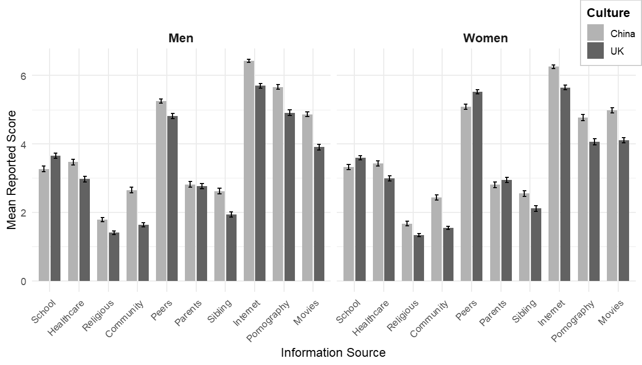
Note. Each bar represents the mean reported raw score for one of ten sexual information sources, separated by culture (China vs. UK) and gender (Men vs. Women). Error bars reflect standard errors of the mean. Gender is displayed in separate panels, while colour indicates culture.

