Sexual information sources and psychosexual well-being: Cultural and gender differences among young people in China and the UK

Yishu Li*, Roger Ingham, and Heather Armstrong

Centre for Sexual Health Research, School of Psychology, University of Southampton, United Kingdom

*Corresponding author: Email: yl6y22@soton.ac.uk.

ABSTRACT

This study examined how reported acquisition of sexual information from ten sources (school, healthcare, religious institutions, community, parents, siblings, peers, internet, pornography and movies/TV) was associated with sexual satisfaction, sexual pleasure, sexual inferiority, and relational sexual shame among 1,553 young people (18-25 years) in China and the UK. Linear mixed-effects models tested cultural and gender differences in reported information acquisition, and structural equation modelling assessed associations with psychosexual well-being. In both countries, the most common sources for sexual information were peers, the internet, and pornography; religious institutions were the least common. Acquisition of sexual information from healthcare or pornography (and community in China) was positively associated with sexual satisfaction. Acquisition from pornography or the internet was positively associated with sexual pleasure in China. Acquisition from the internet was positively associated with feelings of sexual inferiority, as was (only in China) pornography. Relational sexual shame was positively associated with acquisition from the internet and was also negatively associated with acquisition from religious institutions (only in China). In the UK, women reported lower satisfaction and higher sexual inferiority than men, whereas in China, men reported higher sexual inferiority than women. Findings highlight the need for culturally and gender-responsive sex and sexuality education.

Keywords: sexual information sources; sexual satisfaction; sexual shame; cross-cultural; young people; digital media and pornography

Introduction

Psychosexual well-being, encompassing positive experiences of intimacy, pleasure and mutual respect, is increasingly recognised as a key component of overall health (World Health Organization 2022). During the transition to adulthood, integrating sexuality into identity and relationships represents a central developmental task for young people (Branje et al. 2021), and access to sexual information during this period shapes knowledge, attitudes, and well-being (Li et al. 2025b). Rapid technological and social changes have expanded sexual information sources beyond families and schools to include digital and peer-based channels (Peter and Valkenburg 2016; Power et al. 2024), raising questions about how different sources relate to psychosexual well-being across cultural contexts. The UK, with comparatively established sex and sexuality education provision, and China, where sex and sexuality education remains more limited, provide contrasting settings in which to examine these dynamics.

Historical and Policy Developments in Sexuality Education

Sex education in the UK and China has developed along notably different policy paths.
In the UK, provision was historically guided by non-statutory frameworks until the Children and Social Work Act 2017 established Relationships and Sex Education (RSE) as statutory, with compulsory implementation across most state-funded schools from 2020 and national guidance outlining core content and expectations (Department for Education 2019; Setty 2023). This reform aimed to clarify school responsibilities and reduce earlier variation in provision (Setty 2023; Sex Education Forum 2022).
In China, the development of sex sexuality education has been more fragmented. Earlier provision was embedded within biology, moral education, or population education curricula and lacked a unified national framework (UNESCO and UNFPA 2018; Qin 2023; Yu 2023). Since 2020, policy activity has expanded through the adaptation of United Nations Technical Guidance on Sexuality Education and pilot programmes led by education authorities and social organisations. Nevertheless, national reviews continue to report uneven implementation across countries, regions and school types, reflecting substantial local discretion (UNESCO and UNFPA 2018; Liu et al. 2023; Qin 2023; Yu 2023).
These contrasting policy contexts shape the institutional environments in which young people encounter sex ann sexuality information and help explain potential cross-cultural differences in how information sources relate to psychosexual well-being.

Sexual Information Sources

Young people obtain information about sex, sexuality and relationships from a broad range of formal, interpersonal, and digital sources. These choices often reflect considerations of accessibility, privacy, perceived reliability, and relevance, with evidence consistently showing that multiple sources jointly influence sexual knowledge, attitudes, and behaviours (Engel 2023; Sex Education Forum 2024; Silva et al. 2024).

Formal or Institutional Sexual Information Sources

In the majority of countries, schools are expected to be primary formal providers of information about sex and sexuality, although provision varies between contexts. In the UK, statutory Relationships and Sex Education (RSE) aims to deliver comprehensive coverage but remains affected by uneven implementation, limited teacher education and training, and insufficient attention to topics such as consent and pleasure, leading many students to seek additional information elsewhere (Department for Education 2019; House of Commons Library 2024; Sex Education Forum 2024). In China, school-based provision remains fragmented, although emerging teacher-facilitated and internet-supported programmes have shown improvements in knowledge and behavioural intentions (Liu et al. 2023; Qin and Zhang 2023).
Healthcare services provide another formal source of information but face barriers in both countries, including system navigation, access difficulties, and concerns about privacy, particularly following expanded digital provision during the COVID-19 pandemic in the UK (Dema et al. 2022). In China, service uptake also remains limited due to stigma, confidentiality concerns, and uneven availability (Liang et al. 2022).
Religious and community organisations typically exert indirect influence by reinforcing values and guiding help-seeking behaviours rather than serving as primary informational sources (Silva et al. 2024).

Interpersonal Sexual Information Sources

Families, particularly parents, are often regarded as legitimate sources of guidance on sex and sexuality matters but frequently avoid explicit discussion due to discomfort or perceived risks of encouraging early sexual activity, with these constraints being particularly evident in China (Qin and Zhang 2023). Siblings may partly fill this gap, offering informal guidance and support (Zapata et al. 2024).
Peers are widely perceived as approachable and accessible information sources. Peer networks can support sexual health promotion, particularly when supported by digital interventions, but they also facilitate the spread of misinformation, especially regarding contraception and sexual risk behaviours (Purcell et al. 2023; Chola et al. 2023; McNee 2024).

Digital Sexual Information Sources

The internet, including online searches, social media, and dedicated sexual health websites, provides accessible and often anonymous information. Young people in both the UK and China rely heavily on online sources for topics underrepresented in formal education, such as LGBTQ+ issues in the UK and reproductive health knowledge in China, although substantial variation exists in their ability to evaluate information quality (Zhang et al. 2021).
Pornography represents a distinct digital source often used when formal education omits practical sexual knowledge (Rothman et al. 2021). Although some young people report educational benefits, pornography frequently reproduces restrictive sexual scripts that depict male dominance and female passivity, potentially influencing attitudes towards consent, gender roles, and aggression (Bhuptani et al. 2024; Wright et al. 2021). The increasing normalisation of rough-sex depictions may further contribute to pressure on women to engage in unwanted behaviours (Herbenick et al. 2022). Impacts on psychosexual well-being vary according to exposure patterns, content, and motivations for use (Li et al. 2025a; Nolin et al. 2025). In China, where pornography is prohibited yet widely accessed, legal and moral stigma may intensify shame and internal conflict associated with its use (Li et al. 2026a); ironically, age verification policies may have similar effects (Li et al. 2026b).

Psychosexual Well-Being & Cultural and Gender Differences

Psychosexual well-being is widely conceptualised as a multidimensional construct encompassing positive experiences such as sexual satisfaction and pleasure, alongside the relative absence of negative experiences, including sexual inferiority and relational sexual shame (Štulhofer et al. 2010; World Health Organization 2022). As such, psychosexual well-being is increasingly recognised as integral to broader mental and relational health, reflecting both individual intimacy and interpersonal communication processes (Yu et al. 2022).
Emerging cross-cultural evidence suggests that the sexual information sources young people rely on are embedded within broader sociocultural settings. For example, a recent study of young adults in Spain and Portugal found that the perceived importance of different formal and informal information sources was differentially associated with sexual health and well-being indicators, underscoring the need to consider cultural variation when examining these relationships (Rodrigues et al. 2024). The UK and China provide contrasting settings in this respect. In the UK, statutory RSE reflects strong policy recognition, although provision remains uneven and key topics are inconsistently addressed (Department for Education 2019; Sex Education Forum 2024). In China, sexuality education remains more fragmented and culturally constrained, leading many young people to rely on peers, online platforms, and social media, with pornography sometimes serving as a supplemental source (Qin and Zhang 2023; Zhang et al. 2021)
Gender differences further complicate these dynamics. Although young people of all genders access pornography, men typically report more frequent use and arousal-oriented motivations, whereas women more often describe relational or exploratory motivations, with differing associations observed for psychosexual outcomes such as satisfaction and shame (Li et al. 2025a; Litsou et al. 2021; Li et al. 2026a).
Overall, despite increasing scholarly attention to sexual information sources, important limitations remain. First, many studies are confined to single cultural contexts, limiting systematic cross-cultural comparison (Mukoro et al. 2025). Second, research has predominantly focused on knowledge, attitudes, and risk behaviours, with comparatively limited attention to psychosexual well-being outcomes such as satisfaction, pleasure, and sexual shame (Kim et al. 2023). Third, few studies examine multiple information sources simultaneously, and stigmatised channels, particularly pornography, are frequently excluded from major sexuality and health surveys, restricting understanding of how different sources are drawn upon in varying sociocultural contexts (Macdowall et al. 2015).

The Current Study

In this study, we examined young people’s (18–25) reported acquisition of sexual information from ten sources, and the associations of these sources with four dimensions of psychosexual well-being: sexual satisfaction, sexual pleasure, sexual inferiority, and relational sexual shame. Participants from China and the UK enabled cross-cultural comparison and tests of culture and gender differences, as well as possible moderating factors. The specific research questions were as follows:
RQ1. Does the acquisition of sexual information from different sources differ by culture (China vs. UK) and gender (men vs. women)?
RQ2. How is acquiring more (or less) information from a particular source associated with sexual satisfaction, sexual pleasure, sexual inferiority, and relational sexual shame and do (a) culture and (b) gender moderate source–well-being associations?

Methods

Participants

In China, data were collected through a large public university in the southeast of the country and via Credamo, a widely used online research platform. In the UK, participants were recruited through an undergraduate participant pool at the authors’ institution and via Prolific, a research-oriented online platform. To increase diversity, respondents were encouraged to snowball the study invitation within their personal networks. Eligibility was limited to individuals aged 18–25 who self-identified as a man or a woman, and had lived in either the UK or China for at least ten years.

Measures

Demographics and Sexual Information Sources

Participants reported gender, age, ethnicity (White, Black/African/Caribbean, Chinese, Other Asian, Mixed or multiple ethnic groups, Any other ethnic group, or Prefer not to say), sexual orientation (Heterosexual or straight, Gay or lesbian, Bisexual, Other sexual orientation, or Prefer not to say), relationship status (Single, Dating, In a committed relationship but not cohabiting, Married or in a cohabiting relationship, Other, or Prefer not to say), religious affiliation (Rate from 1 Not at all important to 7 Very important), education/employment (Working full-time or part-time, Student, Stay-home parent, Living on benefits, Unemployed, or Prefer not to say), and countries of residence over the past decade (China, UK, Both, or Neither; participants who selected “Both” were asked to indicate the country in which they had lived for the longer period, and those who selected “Neither” were excluded from the study). Education/employment was a multi-select item; all other demographic items were single-choice.
They then rated how much sexual knowledge they had obtained from 10 sources (schools, healthcare providers, religious institutions, community organisations, parents, siblings, peers/friends, internet resources, internet pornography, and movies/television), adapted from Hooley (2018). Responses ranged from 1 (Not at all) to 7 (A great deal).

Sexual Well-being Factors

Before responding, participants were asked to reflect on their sexual experiences, whether with a current or past partner or alone; for items concerning partnered experiences, those not currently in a relationship were asked to respond with reference to a recent partner, or, if they had never had a sexual partner, an imagined partner.

Sexual Satisfaction. The 10-item Sexual Satisfaction Questionnaire (Nomejko and Dolińska-Zygmunt 2015; α=0.89) was administered to evaluate participants’ sexual satisfaction (e.g., “I find my sexual life fulfilling”). Responses ranged from 1 (Strongly Disagree) to 7 (Strongly Agree). Higher mean scores indicate greater satisfaction.

Sexual Pleasure. Sexual pleasure was measured using the three-item Sexual Pleasure Scale (Pascoal et al. 2016; α=0.94), which included items such as “I find sexual intimacy…”. Participants responded from 1 (Not pleasurable) to 7 (Very pleasurable). Higher scores reflect greater pleasure.

Sexual Shame. Sexual shame was evaluated using seven items adapted from the Sexual Shame Inventory (Seebeck 2021; α=0.76-0.86), designed to measure two dimensions: Sexual Inferiority (e.g., “I worry people will find out about my sexual flaws.”) and Relational Sexual Shame (e.g., “I feel ashamed to talk to others about my sexuality/sexual experiences.”). Responses range from 1 (Strongly Disagree) to 7 (Strongly Agree). Higher mean scores on each subscale indicate greater shame.

Procedure

Data were collected anonymously via Qualtrics and Credamo between February 2024 and April 2025. Participants first read an information sheet and provided informed consent. UK participant-pool respondents received very modest course credit; those recruited via Prolific received GBP1. Chinese students recruited via the university or Credamo received either entry into a prize draw containing six GBP25 vouchers or 5 CNY, respectively. Contact information for incentives was collected through a separate link to preserve data anonymity.

Statistical Analyses

All statistical analyses were conducted using R (version 4.3.3) (Rosseel 2012). We first computed descriptive statistics for the ten sexual-information sources by culture (China vs. UK) and gender (men vs. women). The data were then reshaped to long format so that each participant contributed ten within-participant observations (one per source). Culture and gender were treated as categorical factors; sum-to-zero (effects) contrasts were used to obtain Type III tests.
To test the effects of culture, gender, and source, we fitted a linear mixed-effects model (LMM) with a 2 (Culture) × 2(Gender) × 10(Source; within-participants) design and random intercepts for participants (lme4 1.1-37). Type III ANOVA with Satterthwaite degrees of freedom was obtained (lmerTest 3.1-3), suitable for interaction models under potential imbalance. Significant interactions were followed up with Tukey-adjusted pairwise comparisons of estimated marginal means within each Culture × Gender group (emmeans 1.11.1). Effect sizes are reported as partial eta squared (ηₚ²) with 95% confidence intervals (effectsize 1.11.1).
To explore associations between the ten sources, culture, gender, and the four psychosexual well-being dimensions (sexual satisfaction, sexual pleasure, sexual inferiority, and relational sexual shame), we fitted structural equation models (SEM) in lavaan 0.6-19. All continuous variables were z-standardised; culture and gender were effect-coded (China/man=-1, UK/women=+1), and their interaction (culture × gender) was included as a unified moderator. Starting from a full model, we retained paths meeting data-driven criteria (p<.05 and |β|≥.04) to form a reduced model. Model fit was evaluated using CFI, TLI, RMSEA, and SRMR, and models were compared using χ² difference tests, AIC, and BIC. For moderation interpretation, we (i) derived simple slopes with Wald z-tests for significant source × culture effects from the SEM coefficient–covariance matrices, and (ii) obtained estimated marginal means and within-culture contrasts for significant gender × culture effects from linear models (emmeans 1.11.1). For visualisation, semPlot (1.1-6) was used for path diagrams and ggplot2 (3.5-2) was used for plots of standardised coefficients with 95% confidence intervals, bar charts of estimated marginal means, and simple-slope panels with asterisk annotations.

Ethics

The study was approved by the University of Southampton Faculty Research Ethics Committee (ERGO number 91077).

Results

Scale Quality

In this study, the Sexual Satisfaction Questionnaire (α=.82) and the Sexual Pleasure Scale (α=.84) showed good consistency. The two subscales of the Sexual Shame Inventory demonstrated acceptable internal consistency (Sexual Inferiority: α=0.70; Relational Sexual Shame: α=0.74).

Participants

A total of 1,553 young people participated: 50.4% from China (M_{age}=22.4, SD=2.12) and 49.6% from the UK (M_{age}=21.6, SD=2.36); individuals who had lived in both countries were classified by the country of longer residence. Gender was evenly split. Most Chinese participants identified their ethnicity as Chinese, whereas the UK sample was more ethnically diverse (predominantly White).
Most participants were heterosexual and in relationships, with greater sexual orientation diversity in the UK. Religious importance was generally low but higher among Chinese than UK participants (see online supplemental Table A). Greater sexual information attainment from religious sources was associated with higher odds of being in a relationship and lower odds of a non-heterosexual identity (see analyses in online supplemental material).

RQ1: Differences in Reported Sexual Information Sources Across Gender and Culture

Main Effects

A 10(Source; within-participants) × 2(Culture: China, UK) × 2(Gender: men, women) LMM with random intercepts for participants revealed a very large main effect of Source, F(9, 13,941)=2115.40, p<.001, η_{p}²=.58, and a significant main effect of Culture, F(1, 1,549)=117.54, p<.001, η_{p}²=.07, but no main effect of Gender, F(1, 1,549)=2.86, p=.09, η_{p}²=.002.

Interaction Effects

There were significant Source-related interactions for Source × Culture, F=45.00, p<.001, η_{p}²=.03, and Source × Gender, F=23.37, p<.001, η_{p}²=.01. The Culture × Gender interaction, F(1, 1,549)=4.43, p=.035, η_{p}²=.003, and the three-way Source × Culture × Gender interaction, F(9, 13,941)=4.35, p<.001, η_{p}²=.003, were small but also statistically significant.

Summary of Group Differences

Across groups, the Internet and Peers received the highest mean ratings for information acquisition, whereas Religious and Community sources were consistently the lowest. Gender differences were generally small; the exceptions being that men reported more knowledge attained from Pornography (China: z=8.74, p<.001; UK: z=8.24, p<.001) while, in the UK, women reported more knowledge attained from Peers z=6.89, p<.001. Cross-cultural contrasts indicated broadly higher means in China than the UK for most sources (e.g., Sibling, Internet, Pornography, Movies), with the sole reverse pattern for School z=3.68, p<.001. See Figure 1 and online supplemental Figure A and Tables B–D for the full results.

[Please insert Figure 1 about here]

RQ2 (a&b): Associations Between Reported Sexual Information Sources and Psychosexual Well-Being: Moderating Roles of Gender and Culture

Model Overview

Results focus on effects retained in the reduced, well-fitting SEM (AIC=15,878.25 vs. 15,990.44; BIC=16,065.43 vs. 16,985.16; CFI=0.993, TLI=0.986, RMSEA=0.017). The Chi-square difference test was not significant, Δχ²(27)=39.69, p=.06, indicating no meaningful loss of fit, so the reduced model was retained. For each psychosexual dimension, we report only predictors retained in the reduced model; effects not reported were removed during reduction (i.e., failed retention thresholds) and are not interpreted. Standardised coefficients are shown in Figure 2; estimated marginal means and simple slopes for significant gender × culture and source × culture interactions appear in Figures 3–4. Online supplemental Table E presents Pearson correlations for all SEM variables, and Tables F–G report the corresponding estimated marginal means and culture-specific slopes.

[Insert Figure 2 about here]

Sexual Satisfaction

Greater acquisition from pornography (β=0.152, z=6.21, p<.001), healthcare providers (β=0.143, z=5.26, p<.001), and community organisations (β=0.083, z=2.77, p=.006) were associated with higher sexual satisfaction. The main effect of culture was not significant. A significant culture × gender interaction (β=-0.131, z=-5.50, p<.001) indicated that in the UK, women reported lower satisfaction than men t(1549)=7.07, p<.001; there was no gender difference in China t(1549)=0.25, p=.80. There was a significant community × culture interaction such that higher attainment of sexual knowledge from community sources as associated with greater sexual satisfaction in China (β=0.224, z=6.58, p<.001) but not the UK.

Sexual Pleasure

Greater acquisition of sexual information from pornography (β=0.125, z=4.26, p<.001) and the internet (β=0.130, z=4.37, p<.001) were associated with higher sexual pleasure. Women reported lower pleasure than men (β=-0.151, z=-6.02, p<.001). Significant interactions showed that attaining more sexual information from pornography (pornography × culture, β=-0.073, z=-2.65, p=.008) and the internet (internet × culture β=-0.083, z=-2.85, p=.004) was associated with greater sexual pleasure in China, but not in the UK. Interactions indicated stronger positive associations in China (pornography: β=0.200, z=4.72, p<.001; internet: β=0.217, z=4.43, p<.001) but were not evident in the UK.

Sexual Inferiority

Greater acquisition of sexual information from the internet (β=0.090, z=3.02, p=.003) was associated with higher sexual inferiority, whereas the pornography main effect was not significant. A significant main effect of culture was observed (β=0.060, z=2.27, p=.023) such that participants in the UK reported greater sexual inferiority than those in China. A significant interaction between culture and gender (β=0.096, z=3.71, p<.001) was evident, indicating that Chinese men reported higher sexual inferiority than Chinese women t(1549)=2.42, p=.02, whereas in the UK, women reported higher sexual inferiority than men t(1549)=-4.35, p<.001. A pornography × culture interaction (β=-0.084, z=-3.23, p=.001) indicated that greater attainment of sexual knowledge from pornography was positively associated with sexual inferiority in China (β=0.122, z=3.03, p=.002), but not in the UK.

Relational Sexual Shame

Greater acquisition of sexual information from the internet (β=0.075, z=2.92, p=.004) was associated with higher relational sexual shame. A significant main effect of culture (β=-0.163, z=-6.20, p<.001) indicated lower relational sexual shame in the UK than in China. The main effect of source was not significant, but a significant religious × culture interaction (β=0.083, z=3.22, p=.001) indicated that in China, but not the UK, attaining greater sexual information from religious institutions was associated with decreased relational sexual shame in China β=-0.094, z=-2.97, p=.003 but was not significant in the UK.

Discussion

RQ1: Sexual Information Sources Across Gender and Culture

Participants in both countries reported obtaining most sexual information from internet resources, pornography, and peers, with religious institutions contributing least (see Figure 1). This aligns with evidence that young people favour sources offering accessibility, immediacy, and privacy, particularly where formal provision is perceived as insufficient (Engel 2023; Silva et al. 2024).
Reliance on digital sources was more pronounced among Chinese participants, who reported greater use of general internet content and pornography. This likely reflects limitations in school-based provision in China (Liu et al. 2023). However, despite the statutory status of Relationships and Sex Education (RSE) in the UK, young people continue to report gaps in provision (Sex Education Forum 2024). The findings therefore suggest a cross-cultural gradient, with higher reliance in China but widespread digital engagement in the UK, including incidental exposure via algorithmically curated social media environments (Lim et al. 2024).
Peers were also significant sources of sexual knowledge in both countries. Peer communication is particularly influential where formal education is perceived as inadequate and is often viewed as less constrained than family discussions (Silva et al. 2024). However, peer networks simultaneously facilitate both accurate information dissemination, as demonstrated in interventions such as the UK STASH programme (Purcell et al. 2023), and the spread of misinformation, particularly regarding contraception (Chola et al. 2023).
A culture-by-gender interaction was evident. Men in China reported greater peer-based knowledge than men in the UK, potentially reflecting stronger within-gender permissibility of sexual discussions (Liu et al. 2023). Conversely, women in China reported lower peer-derived knowledge than women in the UK, consistent with gender norms that stigmatise women’s sexual health communication. In China, sexual and reproductive health discussions are often framed as taboo and potentially harmful to unmarried women’s social reputation, which may encourage reliance on anonymous sources, which allow greater control over social exposure (Dong et al. 2023; Qi et al. 2023; Zhang et al. 2016).
Religious institutions were the least utilised sources of information in both countries, supporting evidence that religion plays a limited role in young people’s everyday sexual communication (Silva et al. 2024). In the UK, religious influence is largely confined to specific faith communities (Sex Education Forum 2024), while in China religious institutions have a comparatively minor public and educational presence (Reiss 2023). Nevertheless, religious norms may continue to shape sexual attitudes and values indirectly.
For the remaining sources (see Figure 1), formal sources (healthcare, community) and movies/TV were reported more often in China, consistent with their structured regulation (Qin and Zhang 2023).
Family sources, including parents and siblings, were reported at low levels in both countries. This is consistent with evidence that parental discomfort and concerns about age-appropriateness constrain family sexual communication in the UK (Stone et al. 2012). Although UK youth are more likely to have siblings due to China’s one-child policy era, this did not produce systematic cultural or gender differences, suggesting that digital pathways may outweigh family structure in shaping sexual learning for this cohort (Zhang et al. 2021).

RQ2 (a): Cultural Differences Between Sexual Information Sources and Psychosexual Well-Being

Associations between sexual information sources and psychosexual well-being varied across cultural contexts. Across multiple sources, these associations were generally stronger among participants in China than those in the UK. In more conservative settings, such as China, where taboos restrict open sexual communication, information may carry heightened interpretive weight and exert stronger psychological influence within a more restrictive normative environment (Gan et al. 2024; Yu et al. 2022).
Healthcare and community organisations are widely recognised as credible sources of sexual health support, providing accurate information and psychosocial guidance often lacking in informal or digital channels (UNESCO 2021). Greater knowledge obtained from these sources was associated with higher sexual satisfaction, particularly among participants in China. Although prior research has focused primarily on knowledge and service uptake, access to professional services can enhance health literacy, reduce misinformation, and build relational confidence, which may indirectly support sexual satisfaction (Liang et al. 2022; Peng et al. 2025). In China, where youth-friendly services remain limited, such encounters may be especially influential by offering reliable information and interpersonal support that foster comfort and confidence in sexual relationships. While causality cannot be inferred, these findings highlight the potential value of expanding access to structured sexual health services, particularly in resource-limited contexts.
Sexual information obtained from digital sources, including general internet content and pornography, showed both beneficial and adverse associations. Greater engagement with these sources was associated with higher sexual satisfaction and pleasure, potentially reflecting the diversity, immediacy, and anonymity of digital platforms, which enable exploration of topics often absent from formal education, including sexual techniques and LGBTQ+ issues (Engel 2023; Silva et al. 2024). However, negative associations were source- and culture-specific. Pornography was associated with greater sexual inferiority among participants in China only, but was unrelated to relational sexual shame in either country. This is consistent with research suggesting that stereotypical sexual scripts can promote unfavourable social comparison, although such effects appear contingent on cultural context (Peter and Valkenburg 2016). Among participants in China, stronger positive and negative associations may reflect high digital engagement combined with limited formal provision, positioning online sources as primary sexual learning avenues (Ma et al. 2025). The stronger association between pornography and sexual inferiority in China may also reflect its legal prohibition and moral framing as deviant (National People’s Congress Standing Committee 1997), which may reinforce stigma and negative self-perceptions. Moreover, stigma surrounding sexual and reproductive health may increase information avoidance, while exposure to misinformation and information overload can exacerbate misperceptions (Dong et al. 2024). Nevertheless, many Chinese young people continue to use pornography and report perceived gains in sexual knowledge and pleasure (Chen 2022; Li et al. 2026a). This coexistence of prohibition and use highlights the need to move beyond a simple harm–benefit framework and instead consider how motivations, usage patterns, and cultural norms shape the role of digital media in sexual learning and well-being (Li et al. 2025a).
Information obtained from religious organisations was associated with lower relational sexual shame among participants in China only. Religious teachings may reduce shame by providing moral-relational frameworks that emphasise responsibility, fidelity, and legitimacy of intimacy within committed partnerships (Kaplan et al. 2025). Alternatively, more religious individuals may be more likely to form partnerships with similarly religious partners and delay or restrict sexual activity, thereby encountering fewer situations that elicit relational sexual shame. Empirical research has associated religiosity with assortative mating and behavioural regulation within intimate relationships (McClendon 2016), as well as with conservative sexual attitudes that influence the internalisation of sexual norms and experiences of shame (Ahrold and Meston 2010). Lower reported shame may therefore reflect selection and behavioural regulation rather than attitudinal change. Notably, the higher levels of relational sexual shame observed among participants in China may reflect broader internalisation of restrictive norms that attach moral and emotional sanction to sexual intimacy across genders, consistent with evidence that cultural taboos foster collective silence around sex (Gan et al. 2024; Yu et al. 2022). In contrast, lower levels of relational sexual shame among participants in the UK may relate to public discourses emphasising sexual rights and gender equality, which frame sexual communication and agency as legitimate and socially supported (Beres 2014).

RQ2 (b): Gender Differences in Psychosexual Well-Being Across Cultures

Gender did not moderate source–well-being associations; however, gender differences in outcomes were observed.
In the UK, women reported lower sexual satisfaction than men, whereas no gender difference was present in China. In Western contexts, the persistent orgasm gap and male-centred sexual scripts likely depress women’s sexual satisfaction (McElroy and Perry 2024). In China, stricter sexual norms may constrain sexual expression for both sexes, masking satisfaction gaps even while inequities persist in orgasm frequency and “orgasm management” (Ford et al. 2023). Women in both countries reported lower sexual pleasure than men, consistent with sexual scripts that prioritise men’s orgasm and underemphasise clitoral stimulation, reducing women’s partnered orgasms and pleasure (Andrejek et al. 2022; Dienberg et al. 2023). In China, limited discussion of women’s pleasure and expectations to prioritise men’s orgasm may sustain this pleasure gap despite similar mean satisfaction (Ford et al. 2023).
A gendered cultural divergence emerged for sexual inferiority: men in China reported higher inferiority than women, whereas the reverse was observed in the UK. In China, masculinity remains tied to performance, responsibility, and ‘face’, making perceived sexual competence central to masculine role fulfilment and increasing self-evaluative distress when expectations are unmet (Chen 2022; Li et al. 2025a). In the UK, individualised and ostensibly liberal norms position women as both entitled to, and responsible for, sexual fulfilment, requiring the “labour of pleasure” and intensifying self-monitoring and comparison, which can heighten sexual inferiority when ideals are not met (Andrejek et al. 2022). This pattern is compatible with lower relational sexual shame in the UK, as reduced shame can coexist with heightened performance pressure under individualised pleasure norms.

Beyond the Main Models: Subtle but Meaningful Trends

Supplementary correlations (online Figure H) examined source–well-being associations not retained in the SEM. Although the effect sizes were smaller, several trends were theoretically informative.
First, school- and parent-based sources were associated with higher sexual satisfaction only among participants in China. This may reflect selective engagement, whereby students or parents willing to initiate sexual discussions already hold more open attitudes, producing localised positive associations despite generally limited provision. In contrast, UK provision continues to prioritise risk and consent over sexual feelings and relational skills, while variation in timing, dose, and quality of RSE may further dilute its influence (House of Commons Library 2024). Parental communication in the UK is also often limited in scope and continuity, reducing its potential contribution to young people’s sexual satisfaction or skills development (Stone et al. 2012).
Second, among men in the UK only, obtaining sexual information from peers and siblings was associated with higher sexual shame. This pattern may reflect peer cultures associated with hegemonic masculine norms, in which sexual discussions emphasise performance, conquest, and comparison, increasing vulnerability to shame when ideals are not met. Endorsement of dominant masculine norms has been linked to embarrassment and stigma when men perceive themselves as failing to meet culturally sanctioned expectations (Hogan et al. 2022). Masculinity has also been conceptualised as a precarious status maintained through peer regulation, such that perceived threats to masculine identity can elicit interpersonal shame (Vescio et al. 2025). In China, peer discussions may also be constrained by conservative norms and policy contexts discouraging explicit sexual discourse (Qin and Zhang 2023).

Implications

This study demonstrates that sexual information sources are multidimensionally associated with psychosexual well-being and highlights the need to move beyond risk-focused approaches to understanding young people’s sexual information environments. In both countries, the internet, pornography, and peers were identified as key sources associated with both beneficial and adverse outcomes, underscoring the importance of integrated frameworks for designing sexuality education that reflects young people’s diverse information experiences (Lewis et al. 2025).
The findings also highlight the limitations of formal provision. In the UK, statutory RSE is frequently supplemented by informal learning (Sex Education Forum 2024). Sex education and public health initiatives should therefore seek to integrate formal, interpersonal, and digital learning pathways to strengthen critical digital literacy (Byron 2024), and should adopt gender-responsive approaches that support women’s expression of sexual needs while encouraging men to critically reflect on traditional sexual norms. Programmes should also equip young people with the skills to evaluate peer-shared information and identify trustworthy online resources, thereby strengthening sexual knowledge and self-efficacy.

Limitations and Future Research

This study has several limitations. First, cross-sectional and self-report data restrict causal inference and may involve recall/social-desirability bias; longitudinal designs (albeit challenging in practice) should test directionality and mediating pathways (e.g., whether sexual knowledge mediates source–well-being associations; Frøyland et al. 2024). Second, sexuality and gender minority groups, who face unique barriers and stressors in accessing sexual information, could not be examined in subgroup analyses because their numbers in our sample were too small to support robust inference; targeted studies are needed. Third, the UK-China focus prevents generalisability; multi-country work could test how cultural scripts condition these associations in wider contexts. Fourth, responses from participants without prior partnered experience may reflect anticipated rather than experienced dynamics, and their interpretations of partnered items may therefore differ from those with direct sexual relationship experience. Although relationship status was recorded (single: China 13%; UK 26.7%), we did not assess participants’ prior sexual experience, so relationship status should not be treated as a direct indicator of sexual experience in this sample. Fifth, for participants who had lived in both China and the UK (n=3), our decision to classify them by country of longer residence does not capture the developmental timing of residence (e.g., childhood versus adolescence), which may shape opportunities to receive formal sexuality education and access to other sources of sexual information; future research with more detailed migration histories could address this more directly. Lastly, we did not assess the context (solitary vs. partnered) or content of pornography use; these features should be incorporated in future analyses of pornography–well-being associations (Li et al. 2026a).

Conclusion

This study examined sexual knowledge acquisition from multiple sources and its association with four dimensions of psychosexual well-being among young people in China and the UK. Digital and peer-based sources predominated, whereas formal and religious sources contributed comparatively less. Importantly, the same sources, including pornography, were linked to both beneficial (sexual satisfaction and pleasure) and adverse outcomes (sexual inferiority and relational sexual shame), with patterns influenced by cultural and gendered contexts. These findings extend beyond risk-focused perspectives and emphasise the need for culturally and gender-responsive sexuality education that recognises the distinct and context-dependent effects of different information sources.

Acknowledgements

The author would like to express sincere appreciation to Professor Roger Ingham and Dr Heather Armstrong for their guidance and supervision throughout the course of this research. The author is also grateful for the institutional support provided by the School of Psychology at University of Southampton.

Funding

The first author was funded by the China Scholarship Council.

Conflicts of interest

The second author serves on the Editorial Board of Sex Education journal but was not involved in any way in the review of this article.

Data availability

Study data may be available upon reasonable request.

Use of AI statement

Grammarly and OpenAI ChatGPT (GPT-5) were used for language editing and stylistic refinement. No AI tools were used for data generation, analysis, figure or table creation, or scientific interpretation. All AI-assisted text was reviewed and approved by the authors, who take full responsibility for the content.

References

Ahrold, Tierney K., and Cindy M. Meston. 2010. “Ethnic Differences in Sexual Attitudes of U.S. College Students: Gender, Acculturation, and Religiosity Factors.” 39 (1): 190–202. https://doi.org/10.1007/s10508-008-9406-1
Andrejek, Nicole, Tina Fetner, and Melanie Heath. 2022. “Climax as Work: Heteronormativity, Gender Labor, and the Gender Gap in Orgasms.” Gender & Society 36 (2): 189–213. https://doi.org/10.1177/08912432211073062.
Beres, Melanie Ann. 2014. “Rethinking the Concept of Consent for Anti-Sexual Violence Activism and Education.” Feminism & Psychology 24 (3): 373–89. https://doi.org/10.1177/0959353514539652.
Bhuptani, Prachi H., Shannon R. Kenney, Lucy E. Napper, and Lindsay M. Orchowski. 2024. “Pornography Use, Perceived Peer Norms, and Attitudes Toward Women: A Study of College Men.” American Journal of Sexuality Education 19 (3): 280–301. https://doi.org/10.1080/15546128.2023.2233414.
Branje, Susan, Elisabeth L. De Moor, Jenna Spitzer, and Andrik I. Becht. 2021. “Dynamics of Identity Development in Adolescence: A Decade in Review.” Journal of Research on Adolescence 31 (4): 908–27. https://doi.org/10.1111/jora.12678.
Byron, Paul. 2024. “Porn Literacy and Young People’s Digital Cultures.” Porn Studies 11 (1): 32–39. https://doi.org/10.1080/23268743.2023.2174173.
Chen, Lijun. 2022. “Problematic Pornography Use in China.” Current Addiction Reports 9 (2): 80–85. https://doi.org/10.1007/s40429-022-00408-9.
Chola, Mumbi, Khumbulani Hlongwana, and Themba G. Ginindza. 2023. “Understanding Adolescent Girls' Experiences with Accessing and Using Contraceptives in Zambia.” BMC Public Health 23 (1): 2149. https://doi.org/10.1186/s12889-023-17131-3.
Dema, Emily, Andrew J Copas, Soazig Clifton, et al. 2022. “Methodology of Natsal-COVID Wave 1: A Large, Quasi-Representative Survey with Qualitative Follow-up Measuring the Impact of COVID-19 on Sexual and Reproductive Health in Britain.” Wellcome Open Research 6 (March): 209. https://doi.org/10.12688/wellcomeopenres.16963.2.
Department for Education. 2019. Relationships Education, Relationships and Sex Education (RSE) and Health Education: Statutory Guidance. https://www.gov.uk/government/publications/relationships-education-relationships-and-sex-education-rse-and-health-education.
Dienberg, Marie-Feline, Tanja Oschatz, Eden Kosman, and Verena Klein. 2023. “Does Clitoral Knowledge Translate into Orgasm? The Interplay Between Clitoral Knowledge, Gendered Sexual Scripts, and Orgasm Experience.” Journal of Sex & Marital Therapy 49 (5): 484–96. https://doi.org/10.1080/0092623X.2022.2147112.
Dong Yujie. 2023. “ 'Premature' Girls with 'Illegitimate' Diseases: A Qualitative Exploration of the Stigma of Gynecological Diseases for Unmarried Young Women in China.” Journal of Health Communication, 28(2), 111–120. https://doi.org/10.1080/10810730.2023.2185322
Dong, Yujie, Lianshan Zhang, Chervin Lam, and Zhongwei Huang. 2024. “Counteracting Sexual and Reproductive Health Misperceptions: Investigating the Roles of Stigma, Misinformation Exposure, and Information Overload.” Patient Education and Counseling 120: 108098. https://doi.org/10.1016/j.pec.2023.108098
Engel, Elena. 2023. “Young Peoples' Perceived Benefits and Barriers of Sexual Health Promotion on Social Media - a Literature Review.” International Journal of Health Promotion and Education, July 26, 1–20. https://doi.org/10.1080/14635240.2023.2241035.
Ford, Jessie V., Allison Carter, and Horas Th Wong. 2023. “Orgasm and Faking Orgasm: Heterosexual Interactions in China.” The Journal of Sex Research 60 (4): 484–97. https://doi.org/10.1080/00224499.2021.2023087.
Frøyland, Lars Roar, Rikke Tokle, Jasmina Burdzovic Andreas, and Geir Scott Brunborg. 2024. "Sexting and Mental Health in Adolescence: A Longitudinal Study.” Journal of Adolescent Health 75 (4): 584–90. https://doi.org/10.1016/j.jadohealth.2024.04.018.
Gan, Yongtao, Chang Liu, Jing Deng, and Jiahao Zhang. 2024. “Typological Classification of Attitudes toward Premarital Sexual Behavior among Chinese Undergraduates.” BMC Public Health 24 (1): 2651. https://doi.org/10.1186/s12889-024-20172-x.
Herbenick, Debby, Tsung-chieh Fu, Heather Eastman-Mueller, et al. 2022. “Frequency, Method, Intensity, and Health Sequelae of Sexual Choking Among U.S. Undergraduate and Graduate Students.” Archives of Sexual Behavior 51 (6): 3121–39. https://doi.org/10.1007/s10508-022-02347-y.
Hogan, Kevin F., Victoria Clarke, and Tony Ward. 2024. “The Impact of Masculine Ideologies on Heterosexual Men’s Experiences of Intimate Partner Violence: A Qualitative Exploration.” Journal of Aggression, Maltreatment & Trauma 33 (1): 123–142. https://doi.org/10.1080/10926771.2022.2061881
Hooley, E. M. 2018. “The Relationship between Transmission of Sexual Knowledge, Sexual Attitude, and Culture.” PhD diss., Andrews University. ProQuest Dissertations & Theses Global. https://www.proquest.com/dissertations-theses/relationship-between-transmission-sexual/docview/1900050895/se-2?accountid=13963.
House of Commons Library. 2024. Relationships and Sex Education in Schools (England). Briefing Paper No. 06103. London. https://researchbriefings.files.parliament.uk/documents/SN06103/SN06103.pdf.
Kaplan, Maor, Yael Lazter, and Ateret Gewirtz-Meydan. 2025. “Caught Between Two Worlds: The Association Between Moral Disapproval of Prohibited Sexual Behaviors and Sexual Shame Among Jewish Religious Adolescents.” Sexuality & Culture, ahead of print, June 20. https://doi.org/10.1007/s12119-025-10400-w.
Kim, Eun Joo, Bitna Park, Seong Kwang Kim, et al. 2023. “A Meta-Analysis of the Effects of Comprehensive Sexuality Education Programs on Children and Adolescents.” Healthcare 11 (18): 2511. https://doi.org/10.3390/healthcare11182511.
Lewis, R., R. Bosó Pérez, K.J. Maxwell, et al. 2025. “Conceptualizing Sexual Wellbeing: A Qualitative Investigation to Inform Development of a Measure (Natsal-SW).” The Journal of Sex Research 62 (5): 693–711. https://doi.org/10.1080/00224499.2024.2326933.
Li, Yishu, Roger Ingham, and Heather Armstrong. 2025a. “Associations between Young People’s Internet Pornography Use and Psychosexual Well-Being: A Systematic Review.” Sexual Health, ahead of print. https://doi.org/10.1071/SH25118.
Li, Yishu, Roger Ingham, and Heather Armstrong. 2025b. “Attitudes Towards Pornography and Sexual Well-Being Among Young Women in the UK.” Journal of Sex & Marital Therapy, September 15, 1–18. https://doi.org/10.1080/0092623X.2025.2559005.
Li, Yishu, Roger Ingham, and Heather Armstrong. 2026a. “Pornography-Use Patterns and Psychosexual Well-Being: Cultural and Gender Differences among Partnered Young People in China and the UK.” Culture, Health & Sexuality, January, 1–15. doi:10.1080/13691058.2025.2599255.
Li, Yishu, Roger Ingham, and Heather Armstrong. 2026b. “A Timely Exploratory Study of Young Adults’ Psychosexual Responses to the UK’s New Age Verification Law on Online Pornography.” Manuscript submitted for publication.
Liang, Yun, Jiayi Hee, Chunxiao Peng, Chunyan Li, Wenzhen Cao, and Kun Tang. 2022. “Comparing Access to Sexual and Reproductive Health Services among Sexual Minority Youths and Their Peers: Findings from a National Survey in China.” BMC Public Health 22 (1): 2075. https://doi.org/10.1186/s12889-022-14508-8.
Lim, Gene, Andrea Waling, Alexandra James, and Jennifer Power. 2025. ‘sex Education on the Newsfeed: Exploring Young People’s Incidental Exposure to Information about Sex and Relationships.” Sex Education 25 (4): 513–528. https://doi.org/10.1080/14681811.2024.2359989
Litsou, Katerina, Paul Byron, Alan McKee, and Roger Ingham. 2021. “Learning from Pornography: Results of a Mixed Methods Systematic Review.” Sex Education 21 (2): 236–52. https://doi.org/10.1080/14681811.2020.1786362.
Liu, Wenli, Jiayang Li, Hongyan Li, and Haoran Zheng. 2023. “Adaptation of Global Standards of Comprehensive Sexuality Education in China: Characteristics, Discussions, and Expectations.” Children 10 (2): 409. https://doi.org/10.3390/children10020409.
Ma, Yexuan, Sikky Shiqi Chen, Holroyd Eleanor, and William Chi Wai Wong. 2025. “Perspectives of Young People on Social Media-Based Sexuality Education Using a Feminist Approach in China: A Qualitative Study.” Archives of Sexual Behavior 54 (2): 589–604. https://doi.org/10.1007/s10508-024-03015-z.
Macdowall, Wendy, Kyle G Jones, Clare Tanton, et al. 2015. “Associations between Source of Information about Sex and Sexual Health Outcomes in Britain: Findings from the Third National Survey of Sexual Attitudes and Lifestyles (Natsal-3).” BMJ Open 5 (3): e007837. https://doi.org/10.1136/bmjopen-2015-007837.
McClendon, David. 2016. “Religion, Marriage Markets, and Assortative Mating in the United States.” Journal of Marriage and Family 78 (5): 1399–1421. https://doi.org/10.1111/jomf.12353
McElroy, Elizabeth E., and Samuel L. Perry. 2024. “The Gender Gap in Partnered Orgasm: A Scoping Review of Evidence with Graphical Comparisons.” The Journal of Sex Research 61 (9): 1298–315. https://doi.org/10.1080/00224499.2024.2390672.
McNee, Rosie. 2024. “Tackling Contraceptive Misinformation on Social Media.” BMJ, February 29, q472. https://doi.org/10.1136/bmj.q472.
Mukoro, Jude, Emily Setty, and Karen Bullock. 2025. “Cultural Conflicts in Sexuality Education and Stakeholders” Responses to Them: A Systematic Review.” Teachers and Teaching 31 (6): 1009–23. https://doi.org/10.1080/13540602.2025.2452197.
National People’s Congress Standing Committee. 1997. Criminal Law of the People’s Republic of China. https://www.npc.gov.cn/zgrdw/npc/lfzt/rlys/2008-08/21/content_1882895.htm.
Nolin, Marie-Chloé, Marie-Ève Daspe, Beáta Bőthe, Audrey Brassard, Christian Joyal, and Marie-Pier Vaillancourt-Morel. 2025. “Associations Between Contents of Pornography and Sexual Satisfaction and Function Among Young Adults.” The Journal of Sex Research 62 (4): 568–81. https://doi.org/10.1080/00224499.2024.2311874.
Nomejko, Agnieszka, and Grażyna Dolińska-Zygmunt. 2015. “The Sexual Satisfaction Questionnaire – Psychometric Properties.” Polish Journal of Applied Psychology. https://doi.org/10.1515/pjap-2015-0017.
Pascoal, Patrícia M., Diana T. Sanchez, Catarina Fonseca Raposo, and Pedro Pechorro. 2016. “Initial Validation of the Sexual Pleasure Scale in Clinical and Non-Clinical Samples of Partnered Heterosexual People.” The Journal of Sexual Medicine 13 (9): 1408–13. https://doi.org/10.1016/j.jsxm.2016.06.010.
Peng, Hongyu, Yanchen Su, and Yong Zheng. 2025. ‘sexual Shame and Associations with Social Evaluation Among Chinese Adults: The Effect of Mianzi and Negative Body Consciousness.” Sexuality Research and Social Policy 22 (2): 1008–21. https://doi.org/10.1007/s13178-024-01028-w.
Peter, Jochen, and Patti M. Valkenburg. 2016. “Adolescents and Pornography: A Review of 20 Years of Research.” The Journal of Sex Research 53 (4–5): 509–31. https://doi.org/10.1080/00224499.2016.1143441.
Power, Jennifer, Alexandra James, Andrea Waling, Tinonee Pym, and Gene Lim. 2024. “Digital Sexual Literacy: The Potential for Online Spaces to Support Sexual Literacy among Young People.” Frontiers in Education 9 (October): 1401252. https://doi.org/10.3389/feduc.2024.1401252.
Purcell, Carrie, Lisa McDaid, Ross Forsyth, et al. 2023. “A Peer-Led, School-Based Social Network Intervention for Young People in the UK, Promoting Sexual Health via Social Media and Conversations with Friends: Intervention Development and Optimisation of STASH.” BMC Public Health 23 (1): 675. https://doi.org/10.1186/s12889-023-15541-x.
Qi, Wenjing, Hui Li, Qun Lian, Xiaoqin Zuo, Chun Yu, Chenyang Lou, and Xiaoming Tu. 2023. “Knowledge Level and Access Barriers Related to Sexual and Reproductive Health Information among Youth with Disabilities in China: A Cross-Sectional Study.” Reproductive Health 20 (1): 84. https://doi.org/10.1186/s12978-023-01625-9
Qin, Qian, and Jiali Zhang. 2023. ‘sex Education in China: Actors and Dynamics of China’s Policies and Practices.” Cogent Education 10 (2): 2270289. https://doi.org/10.1080/2331186X.2023.2270289.
Reiss, Michael J. 2023. Sexuality and Religion in Schools (Chinese Context). UCL Discovery. https://discovery.ucl.ac.uk/id/eprint/10189405.
Rodrigues, David L., Marco Costa, Cátia Alves, and Cícero R. Pereira. 2024. “Do Different Sources of Sexuality Education Contribute Differently to Sexual Health and Well-being Outcomes? Examining Sexuality Education in Spain and Portugal.” Journal of Social and Personal Relationships 41 (2): 465–487. https://doi.org/10.1177/02654075241249172.
Rosseel, Yves. 2012. “Lavaan : An R Package for Structural Equation Modeling.” Journal of Statistical Software 48 (2). https://doi.org/10.18637/jss.v048.i02.
Rothman, Emily F., Jonathon J. Beckmeyer, Debby Herbenick, Tsung-Chieh Fu, Brian Dodge, and J. Dennis Fortenberry. 2021. “The Prevalence of Using Pornography for Information About How to Have Sex: Findings from a Nationally Representative Survey of U.S. Adolescents and Young Adults.” Archives of Sexual Behavior 50 (2): 629–46. https://doi.org/10.1007/s10508-020-01877-7.
Seebeck, J. 2021. “Development of the Sexual Shame Inventory.” Unpublished doctoral dissertation, Seattle Pacific University. https://digitalcommons.spu.edu/cpy_etd/63.
Setty, E. 2023. "Department for Education statutory guidance for relationships and sex education in England: A rights-based approach?" Archives of Sexual Behavior 52(2): 445–458. https://doi.org/10.1007/s10508-022-02340-5
Sex Education Forum. 2022. Relationships and Sex Education: The Evidence. https://www.sexeducationforum.org.uk.
Sex Education Forum. 2024. Young People’s RSE Poll 2024: Report. https://www.sexeducationforum.org.uk/resources/young-peoples-rse-poll-2024.
Silva, Sofia, Joana Romão, Catarina Braz Ferreira, Patrícia Figueiredo, Eduarda Ramião, and Ricardo Barroso. 2024. ‘sources and Types of Sexual Information Used by Adolescents: A Systematic Literature Review.” Healthcare 12 (22): 2291. https://doi.org/10.3390/healthcare12222291.
Stone, Nicole, Roger Ingham, and Katie Gibbins. 2013. ““Where Do Babies Come from?” Barriers to Early Sexuality Communication between Parents and Young Children.” Sex Education 13 (2): 228–240. https://doi.org/10.1080/14681811.2012.737776
Štulhofer, Aleksandar, Vesna Buško, and Ivan Landripet. 2010. “Pornography, Sexual Socialization, and Satisfaction Among Young Men.” Archives of Sexual Behavior 39 (1): 168–78. https://doi.org/10.1007/s10508-008-9387-0.
UNESCO, and UNFPA. 2018. Implementation of Sexuality Education in Middle Schools in China. https://unesdoc.unesco.org/ark:/48223/pf0000367530.
UNESCO. 2021. International Technical Guidance on Sexuality Education: An Evidence-Informed Approach (Rev. Ed.). https://unesdoc.unesco.org/ark:/48223/pf0000374945.
Vescio, Theresa K., Nathan E. C. Schermerhorn, Kelsey A. Lewis, Karla Yamaguchi-Pedroza, and Alyssa J. Loviscky. 2025. “Masculinity Threats Sequentially Arouse Public Discomfort, Anger, and Positive Attitudes toward Sexual Violence.” Personality and Social Psychology Bulletin 51 (1): 96–109. https://doi.org/10.1177/01461672231179431
World Health Organization. 2022. Redefining Sexual Health for Benefits throughout Life. https://www.who.int/news/item/11-02-2022-redefining-sexual-health-for-benefits-throughout-life.
Wright, Paul J., Bryant Paul, and Debby Herbenick. 2021. “Preliminary Insights from a U.S. Probability Sample on Adolescents” Pornography Exposure, Media Psychology, and Sexual Aggression.” Journal of Health Communication 26 (1): 39–46. https://doi.org/10.1080/10810730.2021.1887980.
Yu, Jia, Weixiang Luo, and Yu Xie. 2022. "Sexuality in China: A Review and New Findings.” Chinese Journal of Sociology 8 (3): 293–329. https://doi.org/10.1177/2057150X221114599.
Yu, Xiaowei. 2023. “The Global Mobility of Sex Education in a Chinese Context.” Transactions on Comparative Education 5: 50–57. https://doi.org/10.23977/trance.2023.050108.
Zapata, Juan Pablo, Edwin Rojas, Petra Durán, Angel J. Martínez, and Homero E. Del Pino. 2024. “The Impact of Sibling Relationships on Behavioral and Sexual Health among Latino Sexual Minority Men.” Archives of Sexual Behavior 53 (7): 2751–63. https://doi.org/10.1007/s10508-024-02832-6.
Zhang, Dangui, Weixin Zhan, Chunwen Zheng, et al. 2021. “Online Health Information-Seeking Behaviors and Skills of Chinese College Students.” BMC Public Health 21 (1): 736. https://doi.org/10.1186/s12889-021-10801-0.
Zhang, Jie, Cara Nurik, and John B. Jemmott III. 2016. “Boundaries of Sexual Communication: A Mixed-Method Study Exploring Chinese Young Adults” Engagement with Online Sexual Health Information.” Sexual Health 13 (3): 281–288. https://doi.org/10.1071/SH16009

Figure 1. Proportion of Sexual Information Sources by Gender and Culture
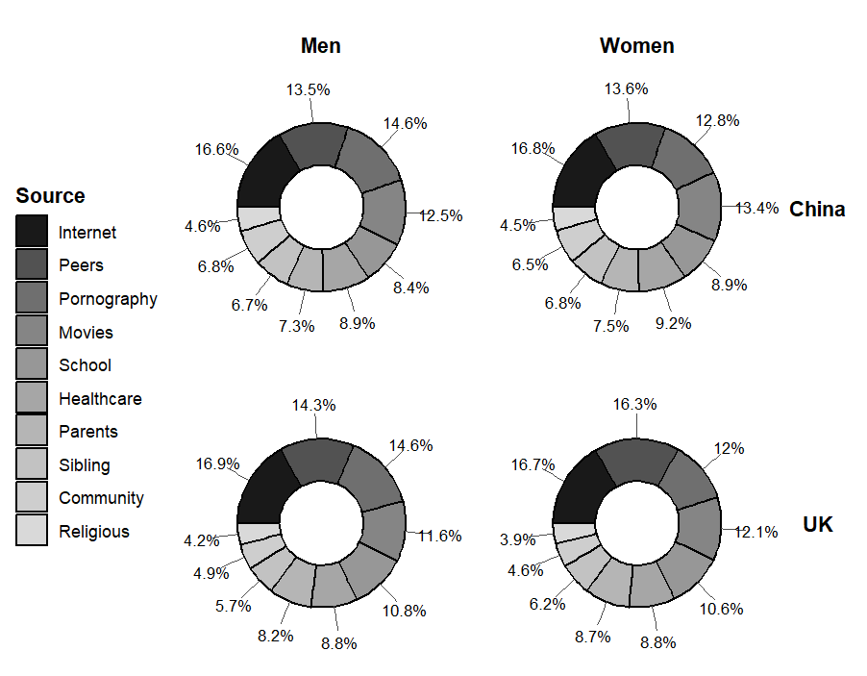
Notes: Each pie chart represents the percentage distribution of sexual information sources across ten possible sources, grouped by participant gender (men, women) and culture (China, UK). Percentages indicate the proportion of total reported sources within each subgroup.
Figure 2. Standardised Regression Coefficients for Sexual Well-Being Variables Across all Models
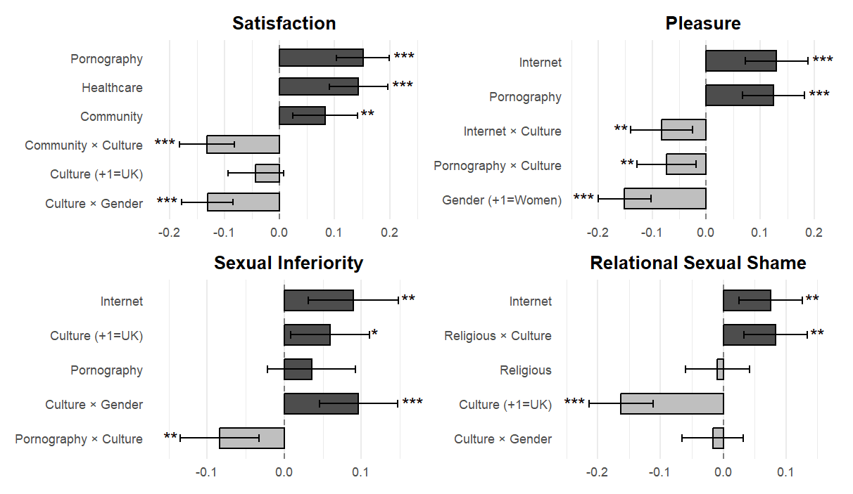
Notes: Standardised regression coefficients (β) with 95% confidence intervals for predictors of five sexual well-being dimensions: sexual satisfaction and inferiority (left panel), and sexual pleasure and relational sexual shame (right panel). Red = positive coefficients; blue = negative coefficients. p < .05, p < .01, p < .001. Gender coded Men=-1 and Women=1; culture coded China=-1 and UK=1.

Figure 3. Estimated Marginal Means of Sexual Satisfaction and Sexual Inferiority by Gender and Culture.
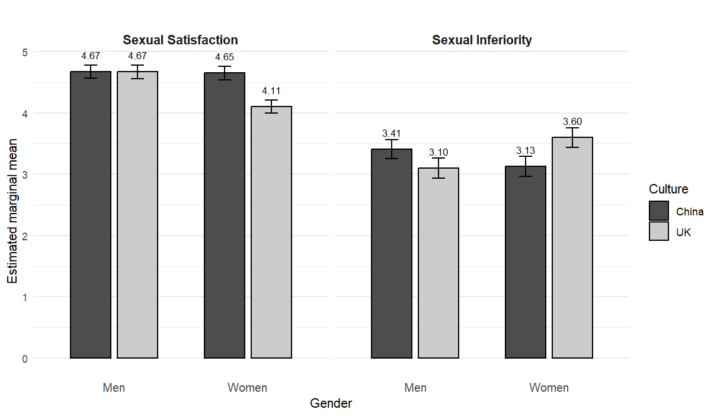
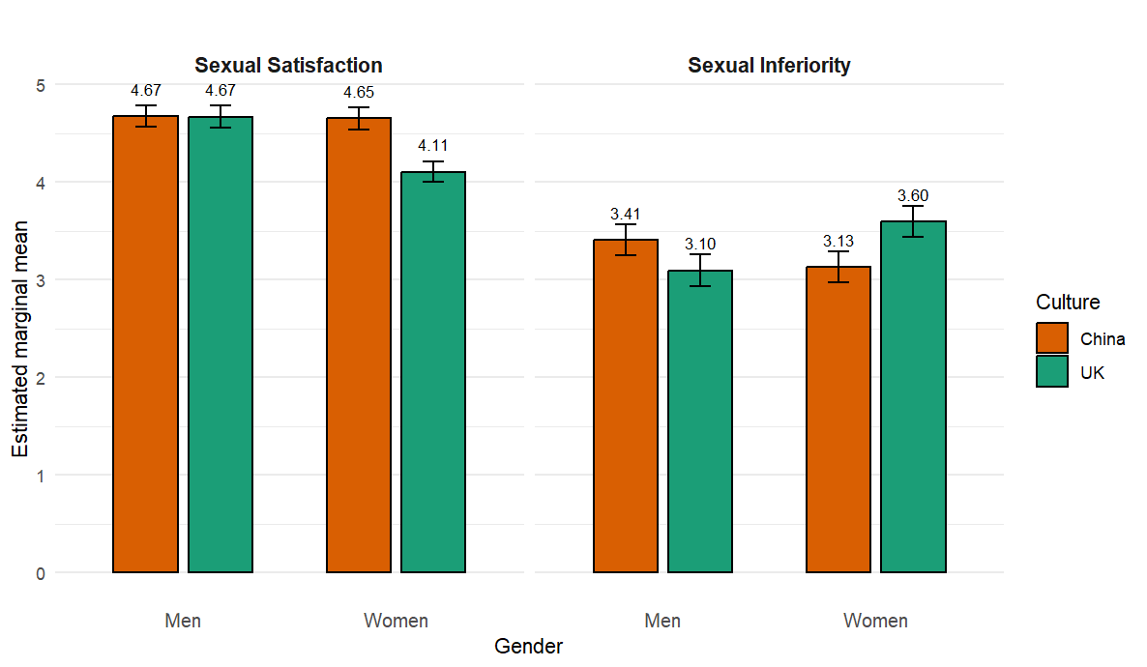

Notes: Bars reflect estimated marginal means derived from linear models including the Gender × Culture interaction. Error bars represent 95% confidence intervals. Estimates are presented separately for men and women within each cultural group (China and the UK). Bars show model-based estimated marginal means (EMMs) with 95% CIs from linear models. CIs are based on normal approximations and may slightly exceed the 1–7 response range.
Figure 4. Simple Slopes of Significant Sources × Culture Interactions Predicting Sexual Outcomes.

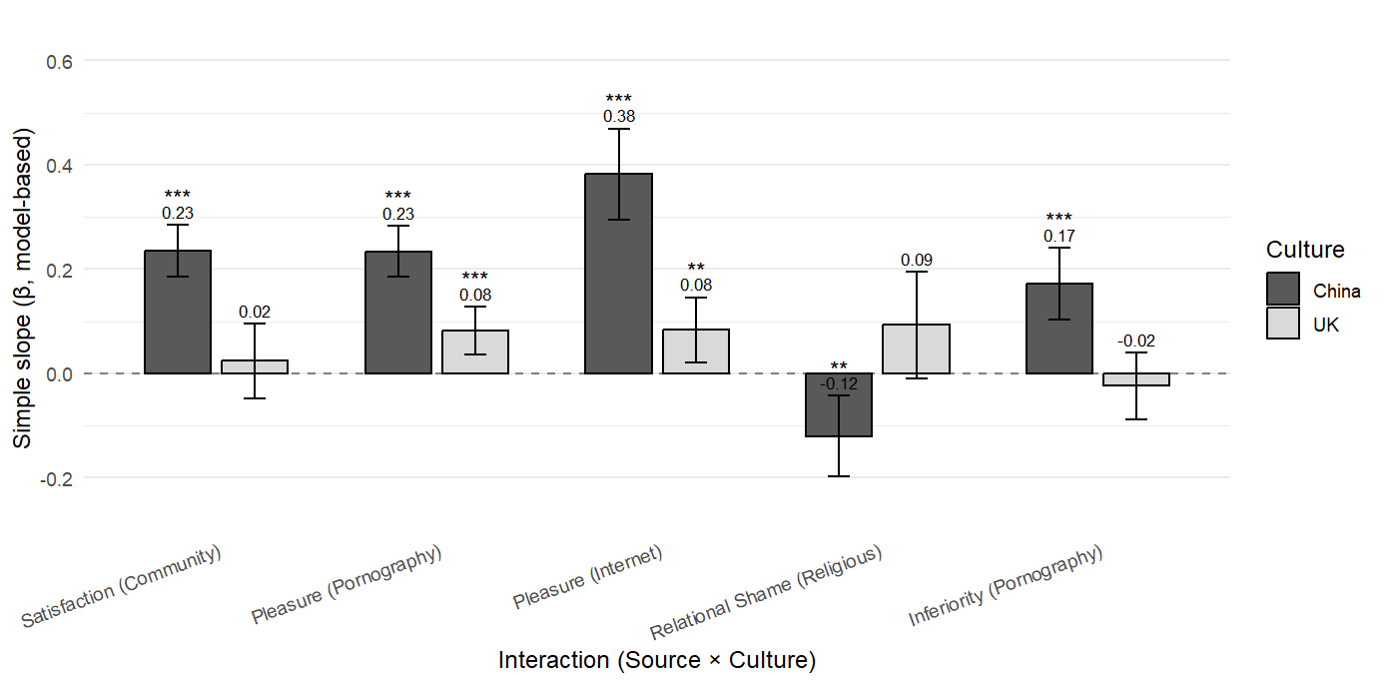
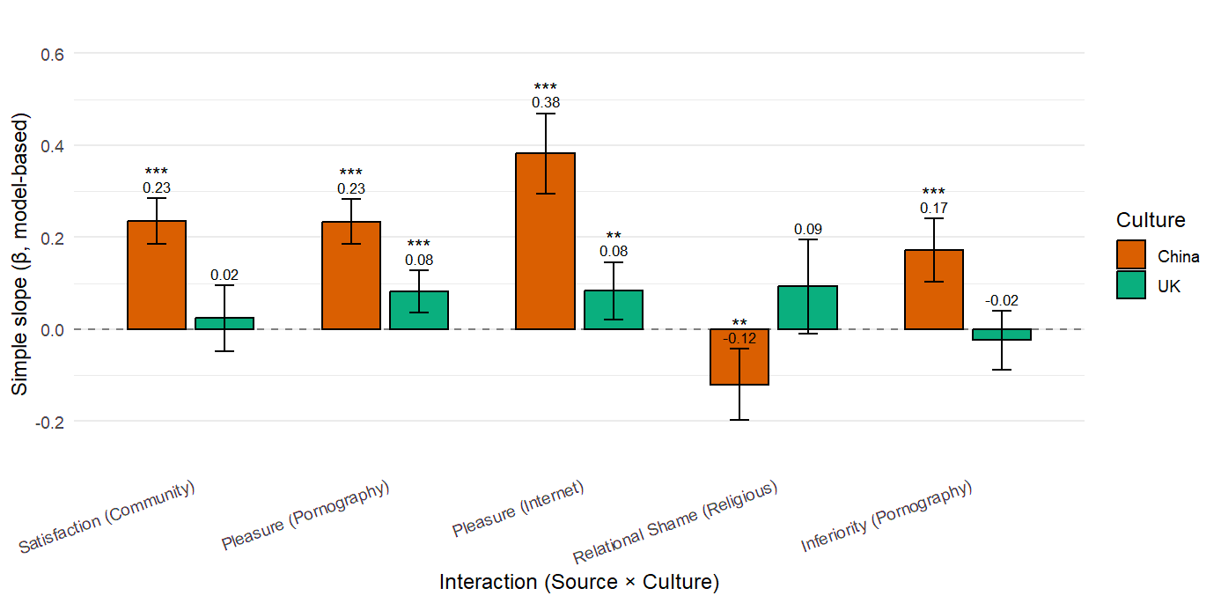
Notes: Bars represent model-based simple slopes (β) estimated separately by culture, with 95% confidence intervals. Asterisks denote significance levels (p<.05=*, p<.01=**, p<.001=***).

