Of commensals and opportunists: Genomics of coagulase-negative staphylococci during sequential ear and eye infections in a healthy adult
Soo Sum Lean¹, Chew Chieng Yeo², Zain Illyaaseen³, Sargit Kaur³, Yun Fong Ngeow³,
Stuart C. Clarke^{1,2,4,5,6*} and Hien Fuh Ng^{3*}

¹ Faculty of Medicine and Institute for Life Sciences, University of Southampton, Southampton, UK; ²Centre for Research in Infectious Diseases & Biotechnology (CeRIDB), Faculty of Medicine, Universiti Sultan Zainal Abidin, 20400 Kuala Terengganu, Terengganu, Malaysia; ³M. Kandiah Faculty of Medicine and Health Sciences, Universiti Tunku Abdul Rahman, Jalan Sungai Long, Bandar Sungai Long, 43000 Kajang, Selangor, Malaysia; ⁴Department of Biological Sciences, Faculty of Science, Universiti Tunku Abdul Rahman, Kampar, Malaysia; ⁵Institute for Research, Development and Innovation, International Medical University, Kuala Lumpur, Malaysia; ⁶NIHR Southampton Biomedical Research Centre, University Hospital Southampton Foundation NHS Trust, Southampton, UK.

*Corresponding authors: Hein Fuh Ng – hfng@utar.edu.my
Stuart C. Clarke – S.C.Clarke@soton.ac.uk

Abstract
Coagulase-negative staphylococci (CoNS) are ubiquitous skin commensals but can cause opportunistic infections and may serve as reservoirs for mobile genetic elements such as the staphylococcal cassette chromosome mec (SCCmec) associated with healthcare-adapted lineages. In this longitudinal, single-participant case study, we characterised CoNS isolates obtained over time from a healthy 32-year-old male who experienced two infection episodes six months apart (left ear, followed by the left eye), together with post-recovery sampling from additional body sites. Six CoNS isolates were recovered, tested for antimicrobial susceptibility and subjected to whole-genome sequencing. Genome-based identification showed that the ear and arm isolates were Staphylococcus capitis (subsp. urealyticus and subsp. capitis), whereas three isolates from the symptomatic left eye were Staphylococcus epidermidis. The three S. capitis isolates belonged to distinct sequence types (ST1, ST2, and ST10), while the three S. epidermidis isolates shared a novel sequence type, ST1284. A non-typable, mosaic SCCmec type IV element homologous to SCCmec IVa/IVn was identified in the multidrug-resistant S. capitis subsp. urealyticus ST1 isolate E_e2, recovered from the infected ear. Core-genome phylogeny and genomic signatures placed E_e2 within the proto-NRCS-A clade, indicating that a lineage closely related to hospital-associated outbreak strains can be encountered in a community-dwelling individual without known prior healthcare exposure. These findings provide a within-host genomic snapshot of CoNS dynamics across contiguous anatomical sites, and while the study does not establish causality for infection or permit population-level inference, it highlights the need for broader, systematic community surveillance of CoNS lineages and their mobile genetic elements.
(Total = 248 words)

Keywords: coagulase-negative staphylococci; Staphylococcus capitis; Staphylococcus epidermidis; SCCmec; whole-genome sequencing; community-associated

Running title: Genomics of sequential CoNS infections (39/50 characters)

1 Introduction
The skin surface, in particular the epidermis, constitutes the human body’s first line of defence, forming a physical barrier against harmful microbes. As the largest organ that covers approximately 25 m², the skin is home to a diverse community of commensal microorganisms (Boxberger et al., 2021). Members of the genera Staphylococcus, Corynebacterium, and Streptococcus are among the commonly detected taxa (Parlet et al., 2019). This barrier extends to anatomically contiguous sites such as the external auditory canal and eyelid margins, while the ocular surface itself hosts a low-biomass but distinct microbiota in which Staphylococcus, Streptococcus and related genera are frequently detected (Petrillo et al., 2020; Flores-Páez et al., 2015). Within these cutaneous and peri-mucosal niches, Staphylococcus is one of the most frequently isolated genera (Parlet et al., 2019). Staphylococci can be broadly divided into coagulase-positive staphylococci (CoPS) and coagulase-negative staphylococci (CoNS) with CoPS being best exemplified by the major pathogen Staphylococcus aureus (Becker et al., 2014). Although S. aureus can cause severe skin infections, particularly in immunocompromised patients, as well as at ocular sites (Chiang and Chern, 2022), it is outnumbered on healthy skin and related surfaces by CoNS (Parlet et al., 2019). CoNS communities appear to outcompete S. aureus through the production of a diverse arsenal of antimicrobial compounds (Janek et al., 2016). Thus, CoNS are better adapted to the harsh conditions of the skin surfaces including lower temperatures, acidity and nutrient limitation (Parlet et al., 2019; Boxberger et al., 2021).

Although the composition of CoNS varies across body sites, species such as S. epidermidis, S. hominis, S. capitis, S. haemolyticus and S. saprophyticus are generally observed on the skin (Cavanagh et al., 2016; Parlet et al., 2019). Similar CoNS species are also recovered from the external auditory canal and ocular surfaces where they are frequently reported as commensals but can also act as opportunistic pathogens in otitis media/externa and superficial ocular infections such as conjunctivitis and keratitis (Flores-Páez et al., 2015; Kim and Yeo, 2017; Petrillo et al., 2020; Chiang and Chern, 2022). Historically, CoNS have been regarded as non-dominant staphylococci and largely harmless commensals, and consequently often escaped rigorous pathogen surveillance. This underestimation has led to the surge of CoNS infections in vulnerable settings such as the occurrence of several outbreaks of the S. capitis NRCS-A clone in neonatal intensive care units (NICUs) (Laurent and Butin, 2019; Hilmarsdóttir et al., 2025). The global spread of S. capitis has redefined this species as a significant pathogen, in particular those categorized as subsp. urealyticus of the National Reference Center for Staphylococci-A (NRCS-A) lineage, while it continues to exist as a commensal in healthy communities (Wirth et al., 2020; Pinheiro-Hubinger et al., 2021; Hilmarsdóttir et al., 2025). In the neonatal healthcare settings, S. capitis has been shown to be more life-threatening than other CoNS (Isaacs, 2003). The emergence of S. capitis as a neonatal pathogen is closely associated with late-onset sepsis (LOS), which accounts for 20-30% of infections among preterm neonates in NICUs (Stoll et al., 2010; Laurent and Butin, 2019). Eradication of S. capitis remains challenging in healthcare settings, as the pathogen readily colonizes abiotic surfaces, including incubators and indwelling medical devices, and also exhibits reduced susceptibility to antiseptics (Laurent and Butin, 2019; Felgate et al., 2023).

Staphylococcus epidermidis is another human skin commensal that is frequently implicated in medical device colonization and infection, especially in neonatal and immunocompromised patients (Thomas et al., 2014a; Datta et al., 2021). Similar to S. capitis, the pathogenic potential of S. epidermidis was long underestimated because of its status as a core commensal microbiota. However, reports of S. epidermidis responsible for 35% of monomicrobial prosthetic joint infections (PJI) and 59% of polymicrobial PJI (Flurin et al., 2019) underscores its importance as a serious opportunistic pathogen. Beyond implant-associated infections, S. epidermidis is also recognized as a causal agent of several ocular infections including keratitis, conjunctivitis and endophthalmitis, highlighting its opportunistic behaviour on the eye surface (Flores-Páez et al., 2015; Petrillo et al., 2020). The “accidental” pathogenic success of S. epidermidis lies in its genomic plasticity, which enables rapid acquisition of antimicrobial resistance genes along with virulence traits such as biofilm formation (Both et al., 2021; Datta et al., 2021). The adaptability of S. epidermidis in healthcare settings is further exemplified by the global dissemination of sequence type 2 (ST2), a lineage characterized by antimicrobial resistance and robust biofilm production (Miragaia et al., 2007; Lee et al., 2018; Both et al., 2021). As more S. epidermidis lineages are identified as hospital-adapted (Thomas et al., 2014a; Lee et al., 2018), it becomes a pressing matter to understand the diverse lifestyle and persistence strategies of this species across different anatomical sites.

The skin and its contiguous structures, including the external auditory canal and peri-ocular skin, thus represent one of the most diverse reservoirs of CoNS, yet the composition and distribution of CoNS across these body sites remain poorly understood. While strain diversification of S. epidermidis in infants has been demonstrated (Datta et al., 2021), data on other CoNS species in healthy adults are still limited. Lately, healthcare settings are increasingly affected by CoNS infections (Lee et al., 2018; Wirth et al., 2020; Wan et al., 2023), but the routes by which these strains disseminate from the community to the hospital environment are unclear. Although it has been proposed that CoNS may originate from community sources such as healthcare personnel or pre-colonized patients (Michels et al., 2021), strain selection and adaptation within specific microenvironments such as the ear canal and ocular surface, remain largely understudied.

Here, we investigate the genomic features of S. capitis and S. epidermidis strains isolated from a healthy individual who developed sequential ear and eye infections. By characterizing these isolates and comparing their distribution across various body sites, we aim to capture shifts in CoNS species and strains, providing a genomic snapshot of potential links between community- and hospital-colonising CoNS.

2 Methodology

2.1 Study individual and symptom descriptions
A 32-year-old male experienced two distinct infection episodes occurring six months apart, affecting the left ear and subsequently the left eye. During the first episode, the individual reported that his left ear felt moist, congested, and heavy. A discharge sample from the ear canal was collected for microbiological analysis. From the primary culture, one colony representing the predominant colony morphotype was selected for downstream purification and characterization; this colony was designated E_e2. The individual was subsequently treated with trimethoprim-sulfamethoxazole due to his allergy to penicillin. Follow-up sampling was performed 88 days (~3 months) after the initial sampling and corresponded to the individual’s follow-up visit. This time point was intended to reduce short-term antimicrobial perturbation effects and allow re-establishment of commensal flora. Swab samples were collected from various body sites (scalp, ear canals, neck, arms, and legs) of the individual. Two samples, designated T_3b and T_5b, were recovered from the left ear and left arm (at the cubital fossa), respectively.

Six months after the ear infection, the same individual developed ocular symptoms involving the left lower eyelid which appeared slightly swollen, producing thick and watery eye discharge differing from normal tears. He also reported discomfort in contact lens use during this occurrence. A swab sample was obtained from the red granulation tissue by gently pulling down the lower eyelid. Three isolates, namely ZG, ZW and ZH, were recovered from this swab sample. The individual was prescribed chloramphenicol eye drops for this infection.

2.2 Bacterial isolation, preliminary identification, and antimicrobial susceptibilities
All swab samples were inoculated onto sheep blood agar (Isolab, Malaysia) and incubated at 37 °C for 24 – 48 hours. Subsequently, colonies were sub-cultured and purified on sheep blood agar for further identification. For the ear discharge sample, colonies with the predominant morphotype were prioritised for selection. Minor morphotypes, where present, were not retained for further characterization. Gram staining was carried out to identify morphologies of the purified bacterial colonies. These isolates were then subjected to 16S rDNA PCR-Sanger sequencing for preliminary identification as described in Lean et al (2025). Antimicrobial susceptibilities were determined using the disk diffusion (Oxoid, UK) and the BD PhoenixTM M50 system’s PMIC-GPC panel (Becton, Dickinson and Company, USA).

2.3 Whole genome sequencing
Total genomic DNA were extracted from the six identified isolates and short-read Illumina sequencing was performed as described previously (Lean et al., 2025). Meanwhile, long-read sequencing was performed on one of the isolates (designated E_e2) using the Oxford Nanopore Technologies (ONT) platform. A total of 500 ng of total DNA, quantified with the Qubit High Sensitivity dsDNA Assay (Thermo Fisher Scientific, Waltham, MA, USA), was used as input for library preparation with the Ligation Sequencing Kit LSK114 (ONT), following the manufacturer’s instructions. Sequencing was conducted on a Flongle R10.4.1 flow cell attached to a MinION Mk1B sequencer (ONT), retaining only raw signal data with predicted read lengths exceeding 1,000 bp. Basecalling of the POD5 files was performed using Dorado v0.7.0 (available from https://github.com/nanoporetech/dorado) with the simplex dna_r10.4.1_e8.2_400bps_sup_v5.0.0 model.

2.4 Sequence quality assessments and genome assemblies
Short-read sequences (2 × 150 bp) of the six isolates were quality assessed and filtered from poor quality reads via fastP (Chen et al., 2018). The quality of the long-read sequences was checked and filtered (q ≥ 10) using Nanoplot and Nanofilt, respectively. Filtered short- and long- reads were subjected to (i) short-read assembly, (ii) hybrid assembly and (iii) long-read assembly using different assemblers. For (i) and (ii), genome assemblies were carried out using the Unicycler pipeline (Wick et al., 2017) whereas Autocycler (Wick et al., 2025) was applied to the long-read assembly. Secondary quality check using CheckM (Parks et al., 2015) was applied to all genome assemblies to detect contamination and evaluate their completeness.

2.5 Bioinformatics analysis
Resulting genome assemblies were subjected to species identification using Kraken2 (Wood and Salzberg, 2014) and fastANI, followed by multilocus sequence type (MLST) determination via mlst software. MLST profiles of the genomes were also cross-checked with existing sequence types (STs) in PubMLST (https://pubmlst.org/). Genome annotation was performed using PROKKA 1.14.6 (Seemann, 2014) and Bakta v1.11.4 (https://github.com/oschwengers/bakta). The genomes were also screened for Staphylococcal Chromosome Cassette mec (SCCmec) using staphopia-sccmec (https://github.com/staphopia/staphopia-sccmec) and sccmec (https://github.com/rpetit3/sccmec) tools. Novel and/or unusual SCCmec regions were further investigated through manual BLAST. Genotypic antimicrobial resistance (AMR) of the genomes was determined through AMRFinderPlus (Feldgarden et al., 2021) and Abricate, utilising databases from NCBI, Resfinder (Bortolaia et al., 2020) and CARD (Alcock et al., 2023). Virulomes were determined using VFAnalyzer, in addition to the --plus function from AMRFinderPlus and virulence factor database (VFDB) (Liu et al., 2022) utilised in Abricate. Unique virulence factors (VFs) were identified using manual BLAST, according to relevant published sources. Defence systems and phage embedded within the genomes were identified using defense-finder and PHASTER webtool (available from https://phaster.ca/), respectively. Pangenome analysis was performed using Panaroo (Tonkin-Hill et al., 2020), alongside reference genomes obtained from NCBI and ENA databases. Phylogenetic trees were constructed using VeryFastTree (Piñeiro et al., 2020) and visualized in iTOL v7 (Letunic and Bork, 2024). Graphical visualization of the genomes and mobile genetic elements (MGEs) were carried out using Bandage (Wick et al., 2015) and EasyFig (Sullivan et al., 2011), respectively. Graphs and charts were plotted using R packages available in RStudio version 2023.06.0+421.

2.6 Ethical approval
Informed consent was obtained from the patient, and the study was approved by the UTAR Scientific and Ethical Review Committee (U/SERC/78-297/2024). All experiments were performed in accordance with relevant guidelines and regulations.

3 Results and Discussions

3.1 Presumptive CoNS isolation
Initial swab sample from the infected left ear of the otherwise healthy individual resulted in the isolation of the presumptive staphylococcal strain designated E_e2, which showed haemolysis on sheep blood agar. The individual was prescribed a ten-day course of oral trimethoprim-sulfamethoxazole which resolved the ear infection. Eighty-eight days after the infection, swabs were taken from the left ear as well as other parts of the individual’s body (as indicated in the Methods) corresponding to the individual’s follow-up visit. Two presumptive staphylococci strains on sheep blood agar were obtained from the left ear (designated T_3b) and the cubital fossa of the left arm (designated T_5b). All three strains (i.e., E_e2, T_3b and T_5b) were Gram-positive cocci and preliminary identification via 16S rDNA PCR-sequencing analysis revealed them as S. capitis/S. caprae. The same individual returned with a left eye infection six months later, and three presumptive staphylococci were recovered from a single swab of the infected eye. These additional three isolates were designated ZG, ZH and ZW. These isolates were similarly Gram-positive cocci but preliminary species identification through 16S rDNA sequencing showed them as S. epidermidis.

3.2 Preliminary Genome Analysis
Whole genome sequencing of the six presumptive staphylococcal strains (i.e., E_e2, T_3b, T_5b, ZG, ZH and ZW) resulted in assembled genome sizes ranging from ~2.41 Mb to ~2.55 Mb (Table 1). Among the genomes, strain T_5b was found to harbour the highest number of plasmids (n = 3), while T_3b harboured only one plasmid. E_e2 was found to carry two plasmids (Table 1) and was also subjected to long-read sequencing using the ONT platform. The three strains that originated from the infected left eye (i.e., ZG, ZH and ZW) all harboured two plasmids, as shown in Table 1. Basic statistics of the genome assemblies were as listed in Table 1.
Species identification based on average nucleotide identity (ANI) validated strains E_e2, T_3b and T_5b as S. capitis, with > 98% homology to S. capitis reference genomes in Figure 1. Detailed identification revealed strains E_e2 and T_5b as S. capitis subsp. urealyticus, whereas strain T_3b was identified as S. capitis subsp. capitis. Strains ZG, ZH and ZW were identified as S. epidermidis, based on the homology shown in Figure 1. Hence, these findings validated the presence of two CoNS species from two different body sites during the course of different infections in the same individual. It is apparent that the left ear and left arm of the infected individual were dominated by S. capitis, whereas the left eye was dominated by S. epidermidis (Figure 1).
The three S. capitis strains were each of different STs, with E_e2 being ST1 [of Clonal Complex 1 (CC1)], T_3b was typed as ST2 (CC2), and T_5b was ST10 (CC1), based on the MLST scheme recently proposed by (Wang et al., 2025). In the case of the S. epidermidis strains, all three were of the same novel ST and which was assigned as ST1284 [arc(1)-aroE(1)-gtr(2)-mutS(6)-pyrR(2)-tpiA(16)-yqiL(86)] (Table 1) by the PubMLST curators.

Table 1: Strains obtained from the infected individual and their preliminary genomic information.
 | Short-read assembly |  |  |  |  |  | Hybrid assembly | Long-read assembly
 | E_e2 | T_3b | T_5b | ZG | ZH | ZW | E_e2 | E_e2
Isolation site | Left ear | Left ear | Left arm | Left eye | Left eye | Left eye | Left ear | Left ear
Species | S. capitis | S. capitis | S. capitis | S. epidermidis | S. epidermidis | S. epidermidis | S. capitis | S. capitis
MLST | ST1 | ST2 | ST10 | ST1284 | ST1284 | ST1284 | ST1 | ST1
SCCmec type | IVa/IVn | NA | NA | NA | NA | NA | IVa/IVn | IVa/IVn
Total reads | 9,913,492 | 9,803,118 | 9,800,682 | 12,724,750 | 10,838,248 | 12,122,260 | 514,515,499 | 504,602,007
GC content (%) | 33.29 | 33.28 | 32.94 | 32.37 | 32.76 | 32.25 | 33.02 | 33.02
Contigs (n) | 65 | 55 | 90 | 84 | 79 | 79 | 3 | 3
Size (bp) | 2,522,730 | 2,415,952 | 2,488,172 | 2,428,418 | 2,428,575 | 2,428,227 | 2,554,961 | 2,554,960
N50 (bp) | 557,042 | 697,389 | 1,284,241 | 138,739 | 138,740 | 138,740 | 2,546,540 | 2,546,540
Completeness (%) | 99.81 | 99.81 | 99.81 | 99.78 | 99.78 | 99.78 | 99.81 | 99.81
Contamination (%) | 0.36 | 0.06 | 0.08 | 0 | 0 | 0 | 0.36 | 0.36
Plasmids (n) | 2  p1-E_e2  (2,473 bp)  p2-E_e2  (5,948 bp) | 1  p1-T_3b  (3,594 bp) | 3  p1-T_5b  (8,387 bp)  p2-T_5b  (31,185 bp)  p3-T_5b  (67,531 bp) | 2  p1-ZG  (1,318 bp)  p2-ZG  (17,387 bp) | 2  p1-ZH  (1,318 bp)  p2-ZH  (17,737 bp) | 2  p1-ZW  (1,318 bp)  p2-ZW  (17,387 bp) | 2  p1-E_e2  (2,473 bp)  p2-E_e2  (5,948 bp) | 2  p1-E_e2  (2,473 bp)  p2-E_e2  (5,948 bp)

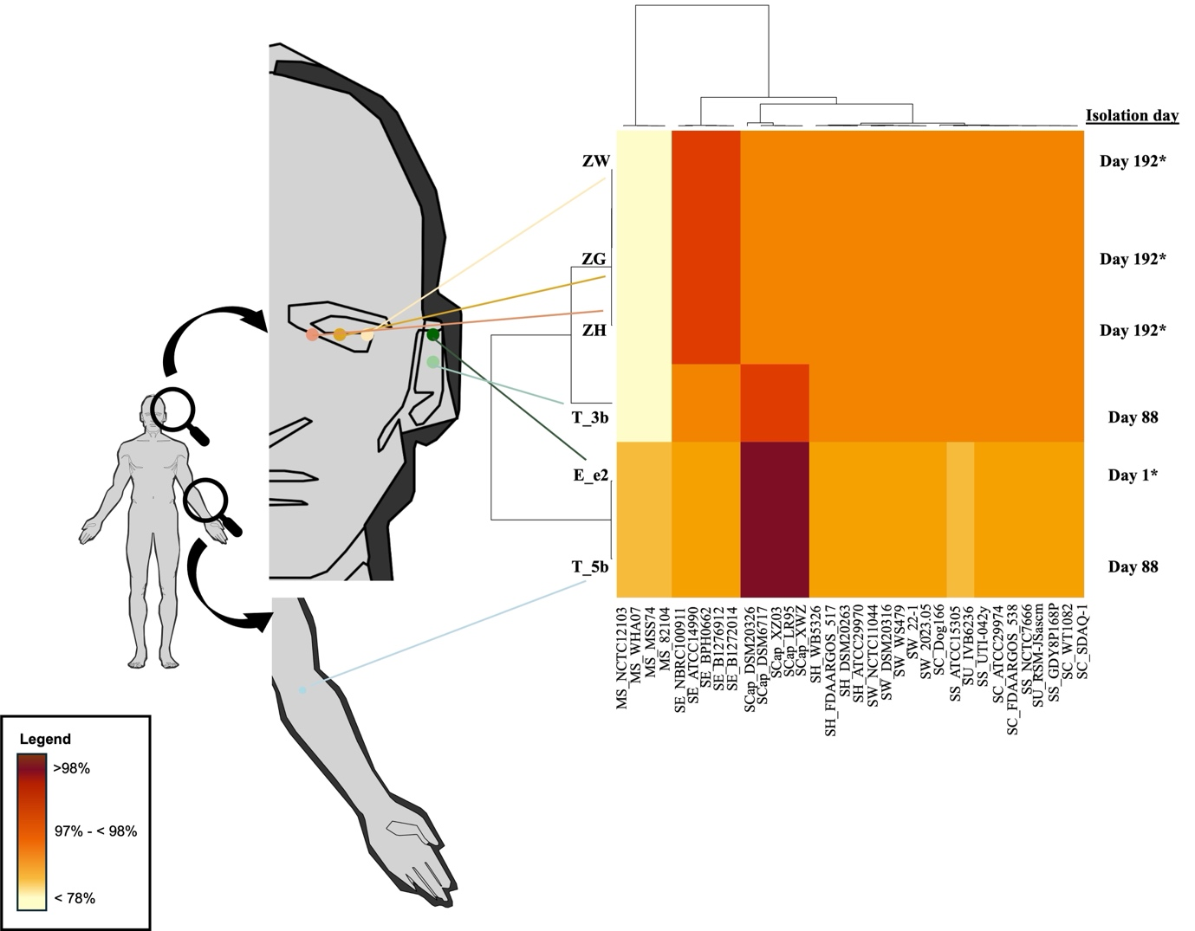
Figure 1: The origin of the CoNS strains in this study and their average nucleotide identity (ANI) values. Anatomical diagrams on the left indicate swab sites from which the CoNS strains were isolated, while the heatmap on the right shows the corresponding ANI values for the genomes of the six CoNS that were sequenced. An asterisk (*) in the isolation day column denotes strains isolated prior to any antibiotic treatment. Abbreviations used: Mammaliicoccus sciuri (MS), Staphylococcus epidermidis (SE), Staphylococcus capitis (SCap), Staphylococcus haemolyticus (SH), Staphylococcus warneri (SW), Staphylococcus cohnii (SC), Staphylococcus saprophyticus (SS) and Staphylococcus urealyticus (SU).

3.3 Novel SCCmec cassette discovered from the community-associated S. capitis subsp. urealyticus strains
S. capitis subsp. urealyticus strains E_e2 and T_5b, together with S. capitis subsp. capitis T_3b, were found to contain SCC elements (Figure 2). Among the three genomes, only the SCC cassette from S. capitis subsp. urealyticus E_e2 fulfilled the definitions of a bona fide SCCmec cassette (Uehara, 2022; Wolska-Gębarzewska et al., 2023). Although complete with mec and ccr complexes (Figure 2), the SCCmec cassette from S. capitis subsp. urealyticus E_e2 displayed unusual combinations of genes and mobile elements. The mec complex was composed of the IS431-mecA-ΔmecR1-IS1272 structure (Figure 2), which classified it as a class B mec complex (Wolska-Gębarzewska et al., 2023). Paired with the presence of ccrA2 and ccrB2 within the ccr complex (Figure 2), the SCCmec cassette from S. capitis subsp. urealyticus E_e2 was classifiable as a SCCmec type IV (Uehara, 2022; Wolska-Gębarzewska et al., 2023). However, further classification of the SCCmec type IV depends on the “junkyard” regions (J regions) (Uehara, 2022). The J region from the SCCmec cassette of strain E_e2 showed combinations from SCCmec type IVa and IVn, whereby its J1 region matched to that in SCCmec type IVa and its J3 region to SCCmec type IVn. These unusual features of the SCCmec in E_e2 was validated through obtaining its complete sequence by long-read sequencing and hybrid assembly (Figure 2). These unusual combinations of genetic elements resulted in homology to multiple subtypes of the currently known SCCmec type IV, and thus the SCCmec cassette from S. capitis subsp. urealyticus E_e2 can be deemed as non-typable. In our previous study (Lean et al., 2025), we reported a novel SCCmec element from another community-isolated S. capitis subsp. urealyticus. The SCCmec cassette from S. capitis subsp. urealyticus E_e2 presented yet another novel cassette, albeit of a type IV composite element, from a community isolate. Besides mecA and the bla operon, the SCCmec in E_e2 also harboured the qacAR antiseptic resistance genes along with several metal resistance genes such as arsenic, cadmium and copper (Figure 2). Previous studies have shown that several S. capitis NRCS-A isolates harbour composite or mosaic SCCmec–SCCars/cad/cop elements (Simões et al., 2013; Carter et al., 2018). However, the composite SCCmec element identified in E_e2 is markedly different as it is a type IV composite, whereas the elements reported in S. capitis NRCS-A strains CR-01 (Simões et al., 2013) and NZ-SC16875 (Carter et al., 2018) are type V composites. Notably, the SCCmec composites in CR-01 and NZ-SC16875 also carry a subtype IIIA CRISPR–Cas locus, which is absent in E_e2 (Figure A1).

The SCC cassettes found immediately downstream of the rlmH/orfX integration site in S. capitis subsp. capitis T_3b and S. capitis subsp. urealyticus T_5b showed entirely different combinations of genetic elements (Figure 2). Both cassettes lacked the mec complex but harboured the ccr complex, which consists of ccrA and ccrB (Figure 2). S. capitis subsp. capitis T_3b exhibited the simplest SCC cassette in this collection, whereas the cassette from S. capitis subsp. urealyticus T_5b was embedded with heavy metal resistance determinants (Figure 2). Genes responsible for resistance towards metalloids and transition metals with toxic/bactericidal properties, encompassing arsenic (ars), cadmium (cad), copper (copB) and mercury (mer) (Becker et al., 2014), were discovered within the SCC cassette from S. capitis subsp. urealyticus T_5b. Therefore, this cassette was denoted as SCCars-cad-cop-mer and similar compositions in SCC cassettes have also been reported in other staphylococcal species (Kinnevey et al., 2013; Becker et al., 2014). Although untypable, the SCC cassettes from S. capitis subsp. capitis T_3b and S. capitis subsp. urealyticus T_5b (Figure 2) can be classified as pseudo (Ψ) SCC elements (Becker et al., 2014), which highlighted the lesser-studied variation of the SCC family of elements that are without the mec complex.

These observations suggest temporal changes in the S. capitis strains recovered from this individual during a symptomatic ear episode and at follow-up after antibiotic treatment. Specifically, the S. capitis isolate recovered during the ear infection (subsp. urealyticus strain E_e2) differed from the follow-up ear isolate (subsp. capitis strain T_3b) (Figure 1). In parallel, SCCmec was detected in E_e2 but not in T_3b (Figure 2). Given that SCCmec elements encompass diverse subtypes and are frequently reported among clinical staphylococcal isolates (Becker et al., 2014; Du et al., 2021; Uehara, 2022; Hilmarsdóttir et al., 2025), the identification of a composite SCCmec type IV element in S. capitis E_e2 indicates the potential for clinically relevant mobile genetic elements to occur outside healthcare settings. However, with the current sampling design and single-colony selection for the symptomatic ear episode, we are unable to infer causality, directionality of acquisition or loss, or that SCCmec is required for symptomatic presentation. Broader longitudinal sampling would be needed to resolve these dynamics.

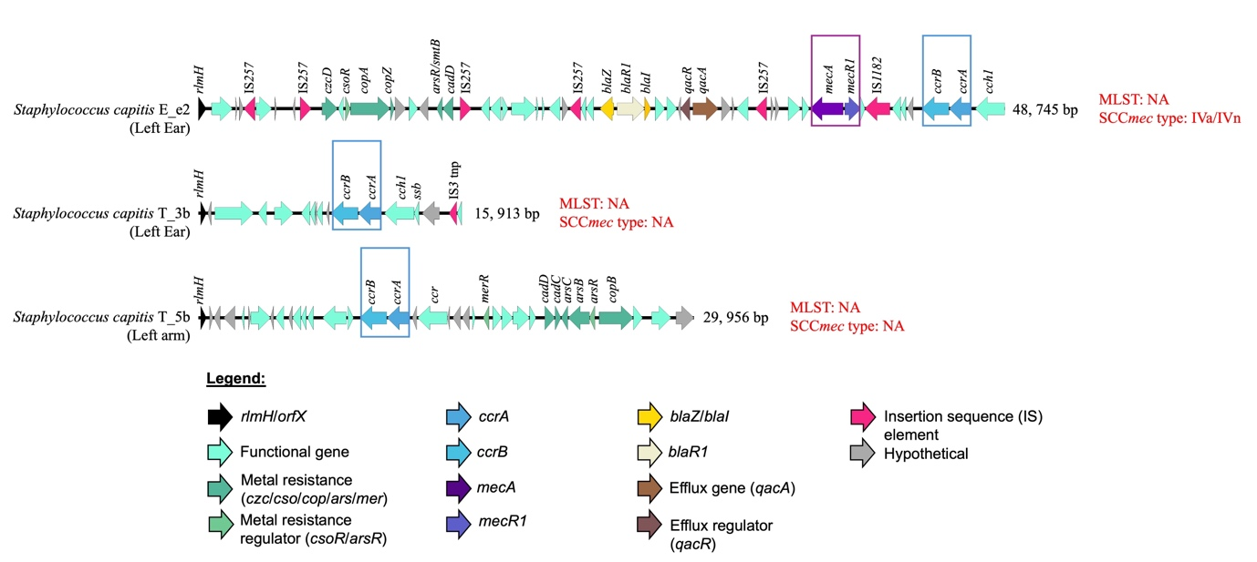
Figure 2: Structural maps of Staphylococcal Chromosome Cassette mec (SCCmec) discovered in the genomes of S. capitis strains isolated in this study. The hallmark mec and ccr complexes are bracketed in purple and blue boxes, respectively. Nearest SCCmec type identified in each genome is stated in red fonts. Note that in strains T_3b and T_5b, the mec genes were absent, and thus these elements can be categorized as ΨSCC elements (Becker et al., 2014). Abbreviations: MLST, multilocus sequence type; NA, not available.

3.4 The community-associated CoNS demonstrated multidrug resistance capability
In the earlier sections, two different CoNS species (i.e., S. capitis and S. epidermidis) from the healthy individual were described. To further elucidate their differences at interspecies and intraspecies levels, AMR profiles of these isolates were investigated. First, we will describe the differences in their resistomes at interspecies level (i.e., S. capitis versus S. epidermidis) and then narrow down to intraspecies level (i.e., S. capitis subsp. capitis versus S. capitis subsp. urealyticus), particularly pre- and post-antibiotic treatment for the latter.

Figure 3 shows the spectrum of AMR obtained, in which the S. capitis strains (E_e2, T_3b and T_5b) showed a stark difference to the S. epidermidis strains (i.e., ZG, ZH and ZW) in their AMR profiles. However, all three S. epidermidis strains displayed uniform genotypic and phenotypic AMR profiles whereby each strain harboured resistance determinants of up to four classes of antimicrobials (Figure 3). The S. epidermidis strains carried the blaZ-blaR1-blaI operon which was responsible for beta-lactam resistance (Becker et al., 2014; Espadinha et al., 2019) and was reflected in the phenotypic resistance towards ampicillin and penicillin shown by all three strains (Figure 3). The S. epidermidis strains also shared fusidic acid phenotypic resistance (all three had MIC of >8 µg/ml) through the carriage of the fusB gene (Figure 3; Table A1), which encodes the elongation factor G (EF-G)-protecting protein that prevents binding of fusidic acid to the ribosome (Becker et al., 2014; Fernandes, 2016; Schoenfelder et al., 2017; Espadinha et al., 2019). In contrast, all three S. capitis strains were susceptible to fusidic acid (with MIC of ≤ 0.5 µg/ml).

The fosB fosfomycin resistance determinant was detected in the three S. epidermidis genomes but not in the S. capitis strains, which harboured the murA gene instead (Figure 3). However, phenotypic fosfomycin susceptibility could not be determined due to the absence of disk dilution and broth microdilution breakpoints for staphylococci in both CLSI and EUCAST. Previously, fosfomycin susceptibility in staphylococci was determined by the agar dilution method using Mueller-Hinton agar supplemented with 25 mg/L glucose 6-phophate (Chen et al., 2022) but the latest EUCAST recommendations (v16.0, 2026; available at https://www.eucast.org/bacteria/clinical-breakpoints-and-interpretation/clinical-breakpoint-tables/) no longer listed breakpoints for fosfomycin with a note that antimicrobial susceptibility testing is discouraged.

The three S. epidermidis genomes also harboured the dfrC gene which mediates resistance towards trimethoprim (Totake et al., 1998). However, all three strains were susceptible to the trimethoprim/sulfamethoxazole combination (Figure 3) due likely to the absence of the sul gene which mediates sulfamethoxazole resistance.

Figure 3: AMR profiles of the six strains in this study, as identified genotypically and observed phenotypically. Heatmap on the left represents resistance determinants identified in the six genomes, marked with percentage identities to the homologous genes in S. aureus. Phenotypic AST results are shown on the right, specified with colour coded resistance levels. Drug panels used in the AST were abbreviated as listed below, and antibiotics marked with an asterisk (*) indicate that the susceptibility test was only performed using disk diffusion. All other AST results were obtained from the BD Phoenix M50 system. Details of MIC values and zone of inhibition diameters are in Table A1. AMC = Amoxicillin-Clavulanate, AMP = Ampicillin, CFZ = Cefazolin, CPT = Ceftaroline, FOX = Cefoxitin, OXA = Oxacillin, PEN = Penicillin G, LZD = Linezolid, CHL = Chloramphenicol, CIP = Ciprofloxacin, MOX = Moxifloxacin, NOR = Norfloxacin, ERY = Erythromycin, DA = Clindamycin, GEN = Gentamicin, DOX = Doxycycline, TIG = Tigecycline, SXT, trimethoprim/sulfamethoxazole, TEI = teicoplanin, VAN = Vancomycin, DAP = Daptomycin, MUP = Mupirocin, NIT = Nitrofurantoin, RIF = Rifampin, FUS = Fusidic acid.
Comparatively, the S. capitis strains E_e2, T_3b and T_5b displayed a more diverse spectrum of AMR (Figure 3), likely reflecting differences in sampling timepoints and body sites. While there were variations in the AMR profiles between the S. epidermidis and S. capitis strains, both species carried the mgrA gene (Figure 3), a conserved global regulator found across various staphylococci, orchestrating a plethora of virulence and AMR genes (Crepin et al., 2024; Guo et al., 2024). The norA gene was found in all three S. epidermidis strains and two of the three S. capitis strains (it was absent in S. capitis T_3b) (Figure 3). Although norA encodes an efflux pump associated with fluoroquinolone and biocide resistance (Ferreira et al., 2022), its presence did not consistently predict phenotypic fluoroquinolone resistance in this dataset, which was only recorded for S. capitis E_e2 (Figure 3).

Zooming into S. capitis intraspecies comparison, differences in AMR profiles are more evident between subspecies capitis and urealyticus. Figure 1 and Figure 2 have already illustrated the changes in S. capitis subspecies pre- and post-antibiotic treatment in the individual. Regardless, it is worthwhile to note the multidrug resistant (MDR) characteristic of S. capitis subsp. urealyticus E_e2 which was isolated during the symptomatic ear episode as compared to the more susceptible profile displayed by S. capitis subsp. capitis strain T_3b isolated from the same ear following symptomatic resolution (Figure 3).

E_e2 was resistant to most tested beta-lactams, consistent with the carriage of mecA-mecR1 and the bla operon, and showed only intermediate susceptibility to ceftaroline, a fifth-generation cephalosporin (Figure 3). Its resistance to erythromycin and clindamycin corresponded with its carriage of ermC (Figure 3), a determinant linked to resistance towards macrolides, lincosamides and streptogramin B (MLS_{B}) in staphylococci (Nemeghaire et al., 2014). The ermC gene in E_e2 resides on a small 2,473 bp plasmid, p1-E_e2, discussed further in the subsection on plasmids. E_e2 also harboured qacB with qacR (Figure 3), genes associated with tolerance to quaternary ammonium compounds and acriflavine (Chavignon et al., 2022). However, since benzalkonium chloride and acriflavine susceptibility was not tested here, the functional impact of qacB-qacR in S. capitis remains unknown.

E_e2 additionally showed phenotypic resistance to tigecycline without identifiable canonical determinants. Common drivers of tigecycline resistance in S. aureus, such as tetL and mepA along with mutation in rpsJ that encodes ribosomal protein S10 (Angeles Argudin et al., 2018; Wang et al., 2021), were not detected, pointing to possibly alternative mechanisms. This is clinically relevant given the role of tigecycline as a last-line agent alongside vancomycin and linezolid, and the rarity of tigecycline resistance in Staphylococcus spp. (Wang et al., 2021). However, tigecycline resistance in E_e2 was observed only by disk diffusion and could not be confirmed on the BD Phoenix M50 (as tigecycline is not included in the PMIC-GPC panel). Thus, tigecycline resistance in S. capitis E_e2 is unresolved and requires validation by broth microdilution.

By contrast, S. capitis subsp. capitis strain T_3b, isolated from the patient’s left ear 88 days post-infection, was susceptible to all the tested antimicrobials except for erythromycin where it displayed intermediate susceptibility (MIC of 1 μg/ml) (Figure 3). Concurrently, S. capitis subsp. urealyticus T_5b, which was isolated from the left arm, was resistant to ampicillin and penicillin but susceptible to erythromycin (with an MIC of 0.5 μg/ml) and all other tested antibiotics. The beta-lactam resistance in T_5b is explained by the presence of the complete bla operon, which was absent in T_3b. However, the mechanism driving the intermediate erythromycin susceptibility in T_3b remains unresolved given the absence of ermC in both strains and the shared presence of mgrA.

3.5 Virulome profiles reveal the presence of the pathogenic S. capitis NRCS-A clone
To the best of our knowledge, only Cameron et al (2015) has reported a comparison of VFs between S. capitis subsp. capitis and S. epidermidis originated from bloodstream infection of the same patient. Scarce data is available on the VFs of these two CoNS species, particularly S. capitis subsp. urealyticus from the community. Figure 4 showed the differences in the virulomes between S. capitis subsp. capitis T_3b and S. capitis subsp. urealyticus E_e2 and T_5b, as well as the distinct variation unique to the S. epidermidis strains in this study. The three S. epidermidis genomes (i.e., ZG, ZH and ZW) contained fewer VFs as compared to the S. capitis strains, with ZG and ZH harbouring 11 VFs, whilst ZW contained only ten VFs (Figure 4). The S. epidermidis virulomes consisted of surface associated proteins (atl, ebh, ebp and sdrD), exoenzymes (hlb, lip, geh, nuc, sspA and sspB) and pro-inflammatory peptides (hld) (Figure 4). The virulomes of the three S. epidermidis strains were almost identical with the ebp gene only absent in strain ZW (Figure 4). Most of these VFs were cell wall-related and played a vital role in the formation of biofilms, and facilitating adherence of S. epidermidis on (a)biotic surfaces (Cameron et al., 2015; Foster, 2020). The exoenzyme VFs were also reported to be involved in biofilm formation and AMR, resulting from their pro-inflammatory traits (Cameron et al., 2015). The sparse distribution of VFs among the S. epidermidis strains was in stark contrast to that displayed in the S. capitis strains, whereby their genome contained at least 38 VFs each (Figure 4).

Figure 4: Two-dimensional plot indicating the total number of related genes present (a) and breakdown of gene variants (b) in each CoNS genome. Gene variants were marked with the abbreviation VF, DF and PH, representing virulence factor, defence system and phage, respectively. Boxed numbers on the left represent VF categories; 1 = adherence/surface proteins, 2 = gene regulation, 3 = exoenzymes, 4 = iron acquisition, 5 = ABC permeases, 6 = host immune invasion, 7 = others. Red arrow-pointed genes were marker genes crucial to the definition of NRCS-A and proto groups. A high-definition copy of this diagram can be found at https://doi.org/10.6084/m9.figshare.31429514
The plethora of VFs present within S. capitis subsp. urealyticus E_e2 and T_5b, and S. capitis subsp. capitis T_3b spans across seven categories, possibly influencing the persistence and survival of the bacteria (Figure 4). Strain E_e2 harboured the highest number of VFs (n = 46) with T_3b and T_5b having the same number of VFs (n = 38 each). Majority of the VFs identified were adherence/surface proteins encoding genes (such as tarI, tarJ, tarL, atl, ebh, ebp, sdrD, sdrH, sdrX, tagAHGBXD, tagE, icaADBC, icaR, sesF), which function in biofilm formation and/or surface adhesions (Simões et al., 2016; Felgate et al., 2023; Crepin et al., 2024). This is followed by regulatory genes (sarA, sarR, sarV, sarX, luxS, rsbU, sigB, walKR, agrAB, saeRS, arlRS, rot, mgrA) and VFs encoding exoenzymes (hlb, hld, clpP, clpB, clpC, clpX, lip, geh, nuc, sspA, sspB) (Simões et al., 2016; Crepin et al., 2024). Of concern, S. capitis subsp. urealyticus E_e2 recorded the presence of tarJ and the nisin-resistant determinant nsr (Figure 4b), which were defining virulence markers for the pathogenic NRCS-A and proto-NRCS-A groups (Felgate et al., 2023). The NRCS-A clone, in particular, has been implicated in various outbreaks in neonatal intensive care units (NICUs). These two genes, along with the presence of the potassium pump encoding loci kdpDC, the cntABCDEFKLM operon, oppDF loci and nikC gene (Felgate et al., 2023), are suggestive of strain E_e2 being a S. capitis NRCS-A or proto-NRCS-A clone. These genes were absent in strains T_3b and T_5b (Figure 4), and are required for the acquisition of metals such as zinc and nickel that are crucial for the pathogenic clone to thrive in the nutrient-limited environment of the hospital and the human body (Grim et al., 2017). The discovery of these hallmark virulence genes thus indicates strain E_e2 as possibly the sole community-associated NRCS-A/proto-NRCS-A clone isolated in this study.

3.6 Phage types and phage defence systems in the community-associated CoNS
Phage therapy has emerged as a promising alternative to combat AMR in recent years, especially in infections caused by MDR bacteria including CoNS, for which treatment options are limited (Oliveira et al., 2019; Göller et al., 2021). Thus, characterizing the types of prophages which has successfully integrated into the host CoNS chromosome will enable us to identify phages that can be potentially activated under specific conditions. In our collection of six CoNS strains, phages were discovered exclusively in S. capitis subsp. urealyticus (i.e., strains E_e2 and T_5b) with none detected in the three S. epidermidis strains. Two types of temperate siphoviruses were identified, namely StB12 and CNPx (Figure 4), both of which are known to infect various Staphylococcus species (Oliveira et al., 2019; Chou-Zheng and Hatoum-Aslan, 2022; Verbanic et al., 2022; Lopes et al., 2025). Intact copies of both phage types were present in the E_e2 genome, whereas only StB12 was found in T_5b (Figure 4). The StB12 phage is known as a member of the B10 subcluster, the largest within siphovirus cluster B, a group previously reported in multiple staphylococci, including S. capitis (Oliveira et al., 2019). This phage type was also classified under the Azeredovirinae subfamily and encodes lysogeny-related proteins (Lopes et al., 2025) although it retains the capacity to trigger bacterial cell death and virion release upon induction. Similarly, the CNPx phage exhibits a lysogenic life cycle and comparable functionality (Verbanic et al., 2022; Zhang, 2025). CNPx is a member of the Rockefellervirus subfamily (Lopes et al., 2025) but has not yet been assigned to a specific cluster. To date, CNPx phages have been described primarily in S. epidermidis hosts and have been associated with the healing of chronic wounds (Depardieu et al., 2016; Chou-Zheng and Hatoum-Aslan, 2022; Verbanic et al., 2022; Zhang, 2025) although no phages were found in our three S. epidermidis strains. The finding of the CNPx phage in S. capitis subsp. urealyticus expands the known reservoir of these phages beyond S. epidermidis and adds to our catalogue of phages from community-associated CoNS, warranting further investigations regarding their functionality.

Bacteria have also developed their own antiphage mechanisms, or phage defence systems, to protect from viral invasions (Georjon and Bernheim, 2023; Hossain et al., 2024). Figure 4 indicated that the S. capitis and S. epidermidis strains in this study harbour different repertoires of phage defence systems. The three S. epidermidis strains possess seven types of defence systems, encompassing Type_I_S51, Type_II_REase_34, Type_II_Mtases_FAM_22, Type_I_Mtases_FAM_10, Type_I_Mtases_FAM_0_einsi_trimmed, GajA and GajB_1, and these defence systems hardly overlap with those found in S. capitis (Figure 4). Of note, the Gabija phage defence system, made up of the GajA and GajB proteins, was found exclusively in the three S. epidermidis strains. Gabija functions through an abortive infection mechanism where the infected host cell is self-induced to be killed to prevent the phage from replicating and spreading to other cells (Huo et al., 2024). Among the S. capitis strains (Figure 4), S. capitis subsp. urealyticus E_e2 possessed the highest number of defence systems (n = 9) as compared to the other two strains (n = 3 each for T_3b and T_5b).

The defence system gcu233, also known as gene cassette of unknown function, was found in all the three S. capitis genomes (Figure 4). Although the actual mechanism of gcu233 in phage defence awaits experimental validation, other variants of gcu (such as gcu22 and gcu23) have been found to enable some levels of phage resistance (Kieffer et al., 2024). Several restriction modification (RM) systems were identified from S. capitis subsp. urealyticus (Figure 4); the RM type I-III systems function to protect host DNA through sequence motif modification mediated by their corresponding methyltransferase (MTase), preventing host DNA cleavage by restriction endonuclease (REase) during phage invasion (Birkholz et al., 2022; Takahashi et al., 2025). Different from types I-III, the RM type IV system functions to recognise methylated foreign DNA (i.e., phage) and cleaves it using the REase encoded by the system (Birkholz et al., 2022; Takahashi et al., 2025). A type IV RM system, denoted as RM_Type_IV_FAM_1, was detected in both S. capitis subsp. urealyticus E_e2 and T_5b but not in S. capitis subsp. capitis T_3b (Figure 4). This system was recently studied in other bacteria, such as Helicobacter pylori, Enterococcus faecalis and Pectobacterium carotovorum, and demonstrated antiphage properties through the production of its REase (Birkholz et al., 2022; Bullen et al., 2024; Takahashi et al., 2025). Types I and II RM systems were also identified, but these were only found in S. capitis subsp. urealyticus E_e2 (Figure 4). Interestingly, CRISPR-Cas systems were not identified in either of the S. capitis or the S. epidermidis strains. Since the presence of a CRISPR-Cas system, specifically CRISPR-Cas Type III, is one of the markers of the S. capitis NRCS-A clone (Felgate et al., 2023), its absence indicates that E_e2 is possibly a proto-NRCS-A clone instead.

3.7 Core genome phylogeny of the community-associated S. capitis and S. epidermidis strains
SCCmec typing, AMR and virulome profiles (see sections above) indicate that S. capitis subsp. urealyticus strain E_e2 bears the characteristic hallmarks of the epidemic S. capitis NRCS-A clone. In particular, the presence of the composite SCCmec-SCCcad-SCCars-SCCcop cassette (Figure 2), an MDR profile (Figure 3) and detection of NRCS-A signature virulence genes (Figure 4) (Felgate et al., 2023) classifies E_e2 as an NRCS-A clone. While NRCS-A isolates that have been described were predominantly of clinical origin (Simões et al., 2016; Laurent and Butin, 2019; Wirth et al., 2020; Wan et al., 2023; Crepin et al., 2024), E_e2 represents a community-originated NRCS-A strain.

Core genome analysis places strain E_e2 within the NRCS-A cluster (Figure 5), phylogenetically adjacent to the proto-outbreak I (also known as clade A1) S. capitis strains AK81, BA08 and LZD7 (Wirth et al., 2020; Wang et al., 2022; Wan et al., 2023). Notably, these reference strains harbour SCCmec type IV (Wang et al., 2022), which aligns with the identification of the novel composite SCCmec homologous to SCCmec IVa/IVn in strain E_e2 (see SCCmec section above). Furthermore, the absence of a CRISPR-Cas system in E_e2 is also indicative of its proto-NRCS-A lineage (Felgate et al., 2023). Conversely, the S. capitis subsp. urealyticus strain T_5b clustered outside the NRCS-A lineage (Figure 5), and grouped closely with strain UTAR-CoNS20 (Figure 5) from our previous study (Lean et al., 2025). As both strains (i.e., T_5b and UTAR-CoNS20) were isolated from the same university campus (Universiti Tunku Abdul Rahman, Sungai Long Campus, Malaysia), their close phylogenetic relationship (with ANI values of 99.93%) likely reflects the convergence of microbiota among individuals in shared environments (Bewick et al., 2019). Nevertheless, these were not identical isolates, as supported by their different SCC cassette composition (Lean et al., 2025). Finally, strain T_3b clustered within the S. capitis subsp. capitis clade (Figure 5), which validates its taxonomic identity.

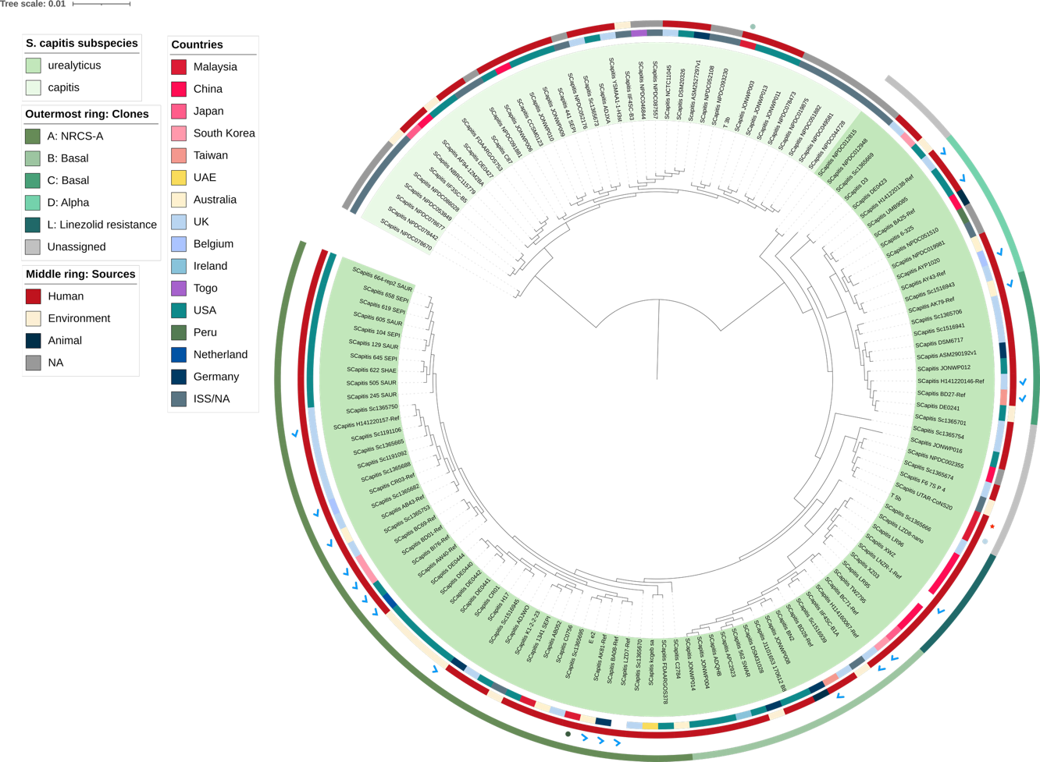
Figure 5: Core-genome maximum-likelihood phylogenetic analysis of S. capitis genomes, encompassing the subspecies urealyticus and capitis. Strains from this study were indicated with coloured dots in the second outermost ring, UTAR-CoNS20 from our previous study (Lean et al., 2025) was marked with red star in the same ring. Known references of S. capitis subsp. urealyticus lineages (i.e., clades A, B, C, D and L; (Wang et al., 2022)) were indicated in blue ticks.

The S. epidermidis strains ZG, ZH and ZW were assigned to the novel sequence type ST1284 (Table 1), which is a single locus variant of ST218, indicating recent diversification from this background. In the core-genome phylogeny, ZG, ZH and ZW map alongside ST218 isolates, forming a distinct subclade (Figure 6), consistent with recovery of a closely related lineage from the same symptomatic ocular episode. ST218 S. epidermidis has been detected in both clinical and non-clinical sources, including community carriage and animals, with isolates often being methicillin susceptible (Du et al., 2013; Arora et al., 2025; Waller et al., 2025). This aligns with our findings as strains ZG, ZH and ZW were also identified as methicillin susceptible S. epidermidis.

Beyond core-genome phylogeny placement, the accessory genome profiles of the S. epidermidis strains were also broadly congruent. The three S. epidermidis genomes contained relatively fewer VFs compared with the S. capitis strains, and with largely overlapping repertoires dominated by surface-associated proteins, exoenzymes and the hld-encoded pro-inflammatory peptide (section 3.5, Figure 4). No SCC elements or prophages were detected in any of the three S. epidermidis genomes, and each strain harboured two plasmids – one which is 1.3 kb in size and the other one larger at 17.4 kb (see following section 3.8). These findings collectively contextualise ST1284 as a methicillin-susceptible GC1 S. epidermidis lineage with a conserved accessory-genome profile in this case study. As S. epidermidis is a common commensal and opportunist, recovery from a symptomatic site should be interpreted cautiously and does not, on its own, establish causality.

The majority of currently sequenced S. epidermidis genomes are dominated by the ST2 lineage (Figure 6), largely due to sampling bias towards clinical isolates (Lee at al., 2018). The population structure of S. epidermidis as assessed by MLST, comprises six genetic clusters (GCs) (Thomas et al., 2014) with isolates from GC5 (comprising ST2 and ST23) predominantly nosocomial (Tolo et al., 2016). ST218, and by extension, ST1284, is categorised as GC1 (Tolo et al., 2016), and the detailed characterization of these less predominant lineages provides complementary perspectives on the ecology and spread of S. epidermidis which has so far been dominated by ST2 (Miragaia et al., 2007; Rolo et al., 2012; Du et al., 2013; Côrtes et al., 2022; Arora et al., 2025). For instance, the discovery of the global dissemination of the S. epidermidis ST23 lineage by Lee et al (2018) highlighted the largely independent co-evolution of ST2 and ST23 lineages in hospital settings. In the present study, the placement of ST1284 within GC1, together with its methicillin-susceptible profile, is more consistent with a non-nosocomial background that with the canonical hospital-adapted ST2/GC5 lineages, although broader sampling would be required to confirm its prevalence or transmission dynamics.

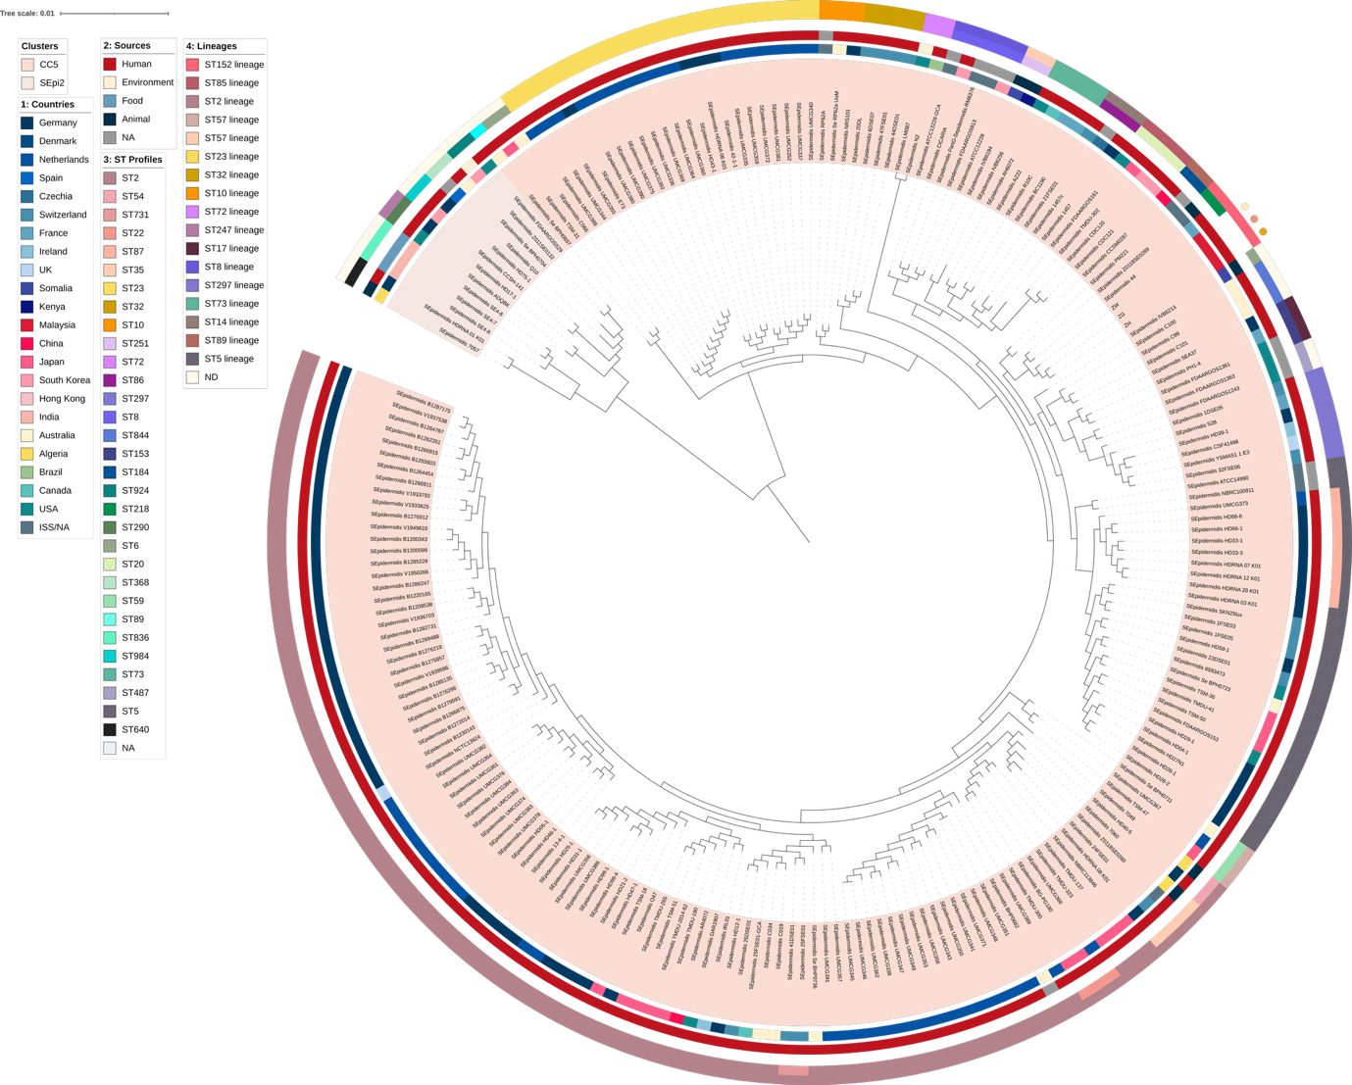
Figure 6: Core genome maximum-likelihood phylogenetic tree of S. epidermidis genomes, labelled with ST lineages known till date. Colours of lineages (i.e., ring 4 from the centre) were based on the assigned ST (i.e., ring 3 from the centre), whereby lineage colour was taken from the ST if it was the founder ST. For example, the ST23 lineage (ring 4) was coloured yellow due to the founder ST23 (ring 3). The S. epidermidis strains from the current study were marked with coloured dots on the outermost ring, and map alongside ST218 isolates, forming a distinct subclade within this background. Reference S. epidermidis genomes were taken from previously established lineages (Miragaia et al., 2007; Rolo et al., 2012; Lee at al., 2018).

3.8 Plasmids of the S. capitis and S. epidermidis strains: only the small plasmid of S. capitis subsp. urealyticus E_e2 harboured an AMR gene
Plasmids serve as key mobile genetic elements that facilitate the acquisition and transmission of AMR determinants between closely related bacteria. Among the S. capitis and S. epidermidis strains analysed, only S. capitis subsp. urealyticus E_e2 harboured a plasmid-borne AMR gene, ermC. The gene was encoded on a small 2,473 bp plasmid designated p1-E_e2 (Figure 7). Sequence analysis revealed the presence of the leader peptide gene, ermCL, upstream of ermC. This arrangement allows for the regulation of ermC expression via translational attenuation, resulting in an inducible MLS_{B} (iMLS_{B}) phenotype (Catchpole et al., 1988; Lüthje and Schwarz, 2007; Al-Trad et al., 2023), which was phenotypically validated using the D-test. As shown in Figure 7, p1-E_e2 is nearly identical to the common small staphylococcal plasmids that are typically between 2.3 to 2.5 kb in size (Feßler et al., 2018) found in species such as S. epidermidis (e.g., the p5 plasmid; accession no. CP093178) and S. aureus (e.g., pSWS371; accession no. HG380317). This category of plasmids is known to carry the plasmid replication gene repL alongside ermC (Catchpole et al., 1988; Feßler et al., 2018). Strain E_e2 also harboured a second, larger plasmid (p2-E_e2; of 5,948 bp) which appeared cryptic. While the two other S. capitis strains, T_3b and T_5b, also harboured plasmids of varying sizes (Table 1), none encoded AMR determinants.

Similarly, the S. epidermidis strains ZG, ZH and ZW each carried two plasmids, neither of which harboured AMR genes (Figure A1). The first group of plasmids (p1-ZG, p1-ZH and p1-ZW) were very small plasmids of only 1,318 bp and encoded only the plasmid replication gene along with a hypothetical open reading frame (ORF) (Figure A2). The second group (p2-ZG, p2-ZH and p2-ZW) were approximately 17.4 kb in size and carried genes facilitating plasmid mobilisation (Feßler et al., 2018).

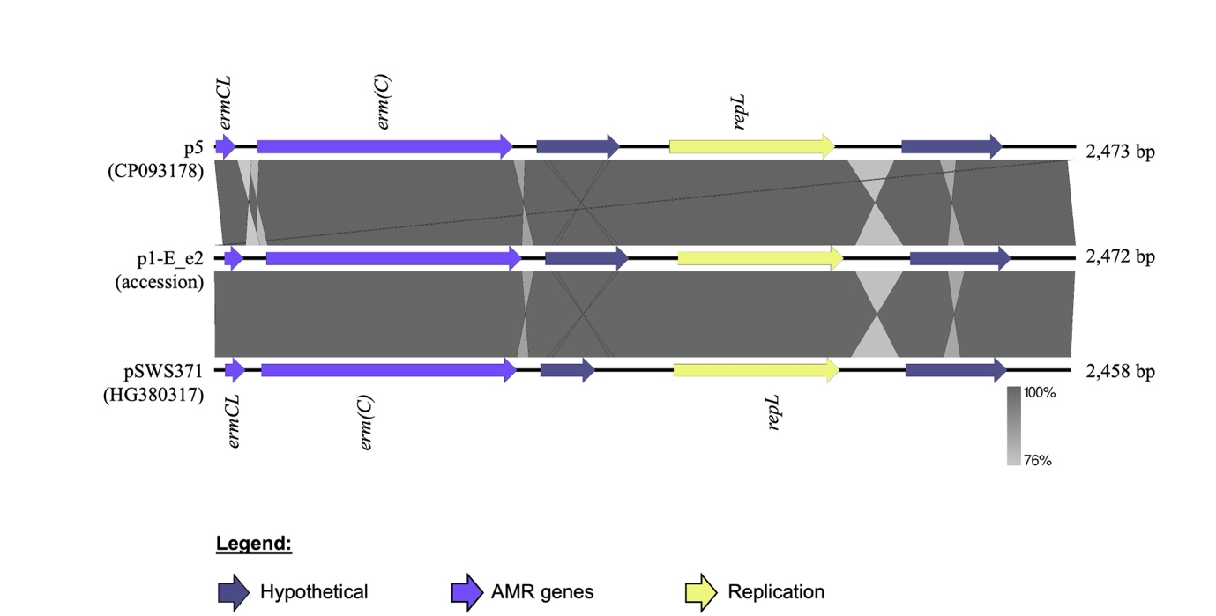

Figure 7: Plasmid map of p1-E_e2 from S. capitis subsp. urealyticus E_e2 in comparison with similar plasmids p5 from S. epidermidis and pSWS371 from S. aureus. These plasmids harbour the ermC gene that mediates erythromycin resistance and its upstream ermCL that encodes the ermC leader peptide enabling regulation by attenuation, thereby yielding the inducible erythromycin resistance (or iMLS_{B}) phenotype in their hosts.

4. Conclusions
The coagulase-negative staphylococci (CoNS) have previously been regarded as commensals, yet they can act as opportunistic pathogens and their potential impact on health should not be underestimated. As highlighted by Lee et al (2018), S. epidermidis was routinely excluded from routine screening in hospitals for this reason, and greater vigilance towards CoNS was thus recommended. The growing number of recent reports on CoNS, particularly the S. capitis NRCS-A clone (Wang et al., 2022; Wan et al., 2023; Crepin et al., 2024), has drawn attention due to their pathogenicity. However, these reports raised unresolved questions on the source and routes of dissemination of these pathogens.

In this context, the detection and genomic characterization of S. capitis in this study, in particular the identification of S. capitis subsp. urealyticus E_e2 as a proto-outbreak I (proto-NRCS-A) clone from the infected ear of an otherwise healthy individual, suggests that healthcare-associated lineages can be encountered outside of healthcare settings. However, it should be noted that this observation is based on a single case and therefore does not establish population-level community circulation, transmission routes, or a definitive reservoir. Nevertheless, it supports the rationale for broader surveillance to determine how frequently NCRS-A-like lineages occur in community carriage and under what environmental or clinical conditions they may emerge. Consistent with the individual’s lack of prior healthcare-associated antibiotic selection pressure, E_e2 remained vancomycin-susceptible (Figure 3). While the strain recovered here was not associated with severe disease, lineages of similar genetic background could become clinically consequential if introduced into healthcare environments where selection and transmission pressures differ.

Skin microbiota within a specific community, especially in settings where individuals coexist or interact in close proximity, tend to converge even among unrelated individuals (Bewick et al., 2019; Boxberger et al., 2021). The observed genetic relatedness between S. capitis subsp. urealyticus T_5b (from this study) and UTAR-CoNS20 (obtained from a nasal swab of a previous study in 2023; (Lean et al., 2025)), is an example of this correlation among community-derived CoNS. The hosts of these two strains were complete strangers within the UTAR campus community, but they do share the same environment. Movement of people around this shared space likely facilitated an indirect exchange of bacteria, making it plausible for CoNS and other species to circulate without direct physical contact. This phenomenon underscores the community as a dynamic potpourri and reservoir of microbiota and highlights the potential for closed-loop transmission where strains circulate between individuals and persist over time. Nevertheless, the extent, directionality, and frequency of such exchange cannot be hypothesized and resolved from the current dataset.

From birth, infants are exposed to multiple sources of microbiota (e.g., their mothers, caregivers, household contacts and the surrounding environment) which may shape early colonisation patterns and influence later carriage (Datta et al., 2021). Each individual can thus be considered a ‘vessel’ for numerous bacteria. Under selection pressures imposed by lifestyle factors such as hygiene practices and antibiotic use, these bacteria adapt to survive the harsh and challenging environment of the skin surface. The coexistence of S. capitis (strains E_e2, T_3b and T_5b) and S. epidermidis (strains ZG, ZH and ZW) in this study not only hints at dominating CoNS species on a healthy individual, but also illustrates the shifts in bacterial communities under specific conditions. Longitudinal sampling enabled us to document the changes in S. capitis carriage during and after an ear infection, including the recovery of different S. capitis subspecies (S. capitis subsp. urealyticus E_e2 during symptoms and strains T_3b and T/5_b post-recovery). We also recovered S. epidermidis isolates (ZG, ZH and ZW) during a subsequent symptomatic ocular episode, highlighting site- and episode-specific variability within common CoNS strains. These findings are best interpreted as illustrating the dynamic nature of CoNS colonisation and the opportunistic nature of particular lineages under perturbed conditions, rather than providing definitive evidence of causality for infection. Given that most epidermal infections are treated with topical antibiotics, careful consideration of antibiotics selected for treatment and awareness of selection pressure from antibiotic overuse are essential to prevent the emergence and enrichment of more harmful traits in otherwise commensal organisms.

This study has limitations, including sampling from a single individual and the inability to perform more extensive follow-up sampling due to loss of contact. Participant withdrawal is an unavoidable aspect of human-subject research. In addition, for the ear episode, only a single colony representing the predominant colony morphotype was selected for downstream characterization and WGS; minor morphotypes were not retained and hence, within-sample strain diversity or mixed colonisation during the infection episode cannot be excluded. Collectively, these constraints limit the generalisability and preclude population-level inference. A more systematic sampling strategy involving larger cohorts with denser longitudinal sampling (and ideally, integrating culture-independent profiling alongside isolate genomics) would be required to better understand CoNS transmission routes, persistence of colonisation, and the extent to which healthcare-associated lineages such as NRCS-A circulate in the community.

Acknowledgements
Hien Fuh Ng was supported by UTAR Strategic Fund: 6274/0016 and Malaysia Toray Science Foundation: 4417/0004.

Ethics Statement
Informed consent was obtained from the patient, and the study was approved by the UTAR Scientific and Ethical Review Committee (U/SERC/78-297/2024). All experiments were performed in accordance with relevant guidelines and regulations.

Author contributions
Soo Sum Lean: Writing – original draft (lead); formal analysis (lead); investigation (equal); methodology (equal); data curation (lead); software (lead); validation (equal); visualization (lead); writing – review & editing (equal); Chew Chieng Yeo: Conceptualization (equal); writing – original draft (equal); formal analysis (equal); investigation (equal); validation (equal); writing – review & editing (equal); Zain Illyaaseen: Conceptualization (equal); formal analysis (equal); investigation (equal); methodology (equal); writing – review & editing (equal); Sargit Kaur: Conceptualization (equal); formal analysis (equal); investigation (equal); methodology (equal); writing – review & editing (equal); Yun Fong Ngeow: Conceptualization (equal); funding acquisition (supporting); resources (supporting); writing – review & editing (equal); Stuart C. Clarke: Writing – original draft (equal); resources (supporting); writing – review & editing (equal); Hien Fuh Ng: Conceptualization (lead); writing – original draft (equal); funding acquisition (lead); investigation (lead); methodology (equal); data curation (equal); validation (equal); resources (lead); supervision (lead); writing – review & editing (equal).

Consent
All authors have provided consent for publication.

Conflict of Interest
None declared.

Data Availability Statement
The genomes of the three Staphylococcus capitis and three Staphylococcus epidermidis isolates have been deposited in the National Center for Biotechnology Information (NCBI)’s Genomes database under BioProject No. PRJNA1377288.

References
Alcock, B. P., Huynh, W., Chalil, R., Smith, K. W., Raphenya, A. R., Wlodarski, M. A., et al. (2023). CARD 2023: expanded curation, support for machine learning, and resistome prediction at the Comprehensive Antibiotic Resistance Database. Nucleic Acids Res 51, D690–D699. doi: 10.1093/nar/gkac920
Al-Trad, E. I., Chew, C. H., Che Hamzah, A. M., Suhaili, Z., A. Rahman, N. I. Ismail, S., et al. (2023). The Plasmidomic Landscape of Clinical Methicillin-Resistant Staphylococcus aureus Isolates from Malaysia. Antibiotics 12, 733. doi: 10.3390/antibiotics12040733
Angeles Argudin, M., Roisin, S., Dodémont, M., Nonhoff, C., Deplano, A., and Denisa, O. (2018). Mutations at the ribosomal s10 gene in clinical strains of Staphylococcus aureus with reduced susceptibility to tigecycline. Antimicrob Agents Chemother 62, 2017–2019. doi: 10.1128/AAC.01852-17
Arora, S., Li, X., Hillhouse, A., Konganti, K., Little, S. V, Lawhon, S. D., et al. (2020). Staphylococcus epidermidis MSCRAMM SesJ Is Encoded in Composite Islands. mBio. 11, e02911-19. doi: 10.1128/mBio.02911-19
Becker, K., Heilmann, C., and Peters, G. (2014). Coagulase-negative staphylococci. Clin Microbiol Rev 27, 870–926. doi: 10.1128/CMR.00109-13
Bewick, S., Gurarie, E., Weissman, J. L., Beattie, J., Davati, C., Flint, R., et al. (2019). Trait-based analysis of the human skin microbiome. Microbiome 7, 101. doi: 10.1186/s40168-019-0698-2
Birkholz, N., Jackson, S. A., Fagerlund, R. D., and Fineran, P. C. (2022). A mobile restriction-modification system provides phage defence and resolves an epigenetic conflict with an antagonistic endonuclease. Nucleic Acids Res 50, 3348–3361. doi: 10.1093/nar/gkac147
Bortolaia, V., Kaas, R. S., Ruppe, E., Roberts, M. C., Schwarz, S., Cattoir, V., et al. (2020). ResFinder 4.0 for predictions of phenotypes from genotypes. Journal of Antimicrobial Chemotherapy 75, 3491–3500. doi: 10.1093/jac/dkaa345
Both, A., Huang, J., Qi, M., Lausmann, C., Weißelberg, S., Büttner, H., et al. (2021). Distinct clonal lineages and within-host diversification shape invasive Staphylococcus epidermidis populations. PLoS Pathog 17, e1009304. doi: 10.1371/JOURNAL.PPAT.1009304
Boxberger, M., Cenizo, V., Cassir, N., and La Scola, B. (2021). Challenges in exploring and manipulating the human skin microbiome. Microbiome 9, 125. doi: 10.1186/s40168-021-01062-5
Bullen, N. P., Johnson, C. N., Andersen, S. E., Arya, G., Marotta, S. R., Lee, Y. J., et al. (2024). An enterococcal phage protein inhibits type IV restriction enzymes involved in antiphage defense. Nat Commun 15, 6955. doi: 10.1038/s41467-024-51346-1
Cameron, D. R., Jiang, J. H., Hassan, K. A., Elbourne, L. D. H., Tuck, K. L., Paulsen, I. T., et al. (2015). Insights on virulence from the complete genome of Staphylococcus capitis. Front Microbiol 6, 980. doi: 10.3389/fmicb.2015.00980
Carter, G. P., Ussher, J. E., Da Silva, A. G., Baines, S. L., Heffernan, H., Riley, T. V., et al. (2018) Genomic analysis of multiresistant Staphylococcus capitis associated with neonatal sepsis. Antimicrob Agents Chemother. 62, e00898-18. doi: 10.1128/AAC.00898-18
Catchpole, I., Thomas, C., Davies, A., and Dyke, K. G. H. (1988). The Nucleotide Sequence of Staphylococcus aureus Plasmid pT48 Conferring Inducible Macrolide-Lincosamide-Streptogramin B Resistance and Comparison with Similar Plasmids Expressing Constitutive Resistance. J Gen Microbiol 134, 697–709. doi: 10.1099/00221287-134-3-697
Cavanagh, J. P., Wolden, R., Heise, P., Esaiassen, E., Klingenberg, C., and Aarag Fredheim, E. G. (2016). Antimicrobial susceptibility and body site distribution of community isolates of coagulase-negative staphylococci. APMIS 124, 973–978. doi: 10.1111/apm.12591
Chavignon, M., Coignet, L., Bonhomme, M., Bergot, M., Tristan, A., Verhoeven, P., et al. (2022). Environmental Persistence of Staphylococcus capitis NRCS-A in Neonatal Intensive Care Units: Role of Biofilm Formation, Desiccation, and Disinfectant Tolerance. Microbiol Spectr 10, e0421522. doi: 10.1128/spectrum.04215-22
Chen, S., Zhou, Y., Chen, Y., and Gu, J. (2018). Fastp: An ultra-fast all-in-one FASTQ preprocessor. Bioinformatics 34, i884–i890. doi: 10.1093/bioinformatics/bty560
Chen, T., Zhao, L., Liu, Y., Wang, Y., Jian, Y., et al. (2022) Mechanisms of high-level fosfomycin resistance in Staphylococcus aureus epidemic lineage ST5. J Antimicrob Chemother 77, 2816–2826. doi: 10.1093/jac/dkac236
Chiang, M.-C., and Chern, E. (2022). Ocular surface microbiota: Ophthalmic infectious disease and probiotics. Front Microbiol 13, 952473. doi: 10.3389/fmicb.2022.952473
Chou-Zheng, L., and Hatoum-Aslan, A. (2022). Critical roles for ‘housekeeping’ nucleases in type III CRISPR-Cas immunity. Elife 11, e81897. doi: 10.7554/ELIFE.81897
Côrtes, M. F., Andre, C., Martins Simões, P., Corvec, S., Caillon, J., Tristan, A., et al. (2022). Persistence of a multidrug-resistant worldwide-disseminated methicillin-resistant Staphylococcus epidermidis clone harbouring the cfr linezolid resistance gene in a French hospital with evidence of interspecies transfer to several Staphylococcus aureus lineages. J Antimicrob Chemother 77, 1838–1846. doi: 10.1093/jac/dkac119
Crepin, D. M., Chavignon, M., Verhoeven, P. O., Laurent, F., Josse, J., and Butin, M. (2024). Staphylococcus capitis: insights into epidemiology, virulence, and antimicrobial resistance of a clinically relevant bacterial species. Clin Microbiol Rev 37, e0011823. doi: 10.1128/cmr.00118-23
Datta, M. S., Yelin, I., Hochwald, O., Kassis, I., Borenstein-Levin, L., Kugelman, A., et al. (2021). Rapid methicillin resistance diversification in Staphylococcus epidermidis colonizing human neonates. Nat Commun 12, 6062. doi: 10.1038/s41467-021-26392-8
Depardieu, F., Didier, J. P., Bernheim, A., Sherlock, A., Molina, H., Duclos, B., et al. (2016). A Eukaryotic-like Serine/Threonine Kinase Protects Staphylococci against Phages. Cell Host Microbe 20, 471–481. doi: 10.1016/j.chom.2016.08.010
Du, X., Larsen, J., Li, M., Walter, A., Slavetinsky, C., Both, A., et al. (2021). Staphylococcus epidermidis clones express Staphylococcus aureus-type wall teichoic acid to shift from a commensal to pathogen lifestyle. Nat Microbiol 6, 757–768. doi: 10.1038/s41564-021-00913-z
Du, X., Zhu, Y., Song, Y., Li, T., Luo, T., Sun, G., et al. (2013). Molecular Analysis of Staphylococcus epidermidis Strains Isolated from Community and Hospital Environments in China. PLoS One 8, e62742. doi: 10.1371/journal.pone.0062742
Espadinha, D., Sobral, R. G., Mendes, C. I., Méric, G., Sheppard, S. K., Carriço, J. A., et al. (2019). Distinct phenotypic and genomic signatures underlie contrasting pathogenic potential of Staphylococcus epidermidis clonal lineages. Front Microbiol 10, 1971. doi: 10.3389/fmicb.2019.01971
Falagas, M. E., Athanasaki, F., Voulgaris, G. L., Triarides, N. A., and Vardakas, K. Z. (2019). Resistance to fosfomycin: Mechanisms, Frequency and Clinical Consequences. Int J Antimicrob Agents 53, 22–28. doi: 10.1016/j.ijantimicag.2018.09.013
Feldgarden, M., Brover, V., Gonzalez-Escalona, N., Frye, J. G., Haendiges, J., Haft, D. H., et al. (2021). AMRFinderPlus and the Reference Gene Catalog facilitate examination of the genomic links among antimicrobial resistance, stress response, and virulence. Sci Rep 11, 12728. doi: 10.1038/s41598-021-91456-0
Felgate, H., Sethi, D., Faust, K., Kiy, C., Härtel, C., Rupp, J., et al. (2023). Characterisation of neonatal Staphylococcus capitis NRCS-A isolates compared with non NRCS-A Staphylococcus capitis from neonates and adults. Microb Genom 9, 001106. doi: 10.1099/mgen.0.001106
Fernandes, P. (2016). Fusidic acid: A bacterial elongation factor inhibitor for the oral treatment of acute and chronic staphylococcal infections. Cold Spring Harb Perspect Med 6, 1–17. doi: 10.1101/cshperspect.a025437
Ferreira, C., Abrantes, P., Costa, S. S., Viveiros, M., and Couto, I. (2022). Occurrence and Variability of the Efflux Pump Gene norA across the Staphylococcus Genus †. Int J Mol Sci 23, 15306. doi: 10.3390/ijms232315306
Feßler, A. T., Wang, Y., Wu, C., and Schwarz, S. (2018). Mobile macrolide resistance genes in staphylococci. Plasmid 99, 2–10. doi: 10.1016/j.plasmid.2018.05.001
Flores-Páez, L. A., Zenteno, J. C., Alcántar-Curiel, M. D., Vargas-Mendoza, C. F., Rodríguez-Martínez, S., Cancino-Diaz, M. E., et al. (2015). Molecular and phenotypic characterization of Staphylococcus epidermidis isolates from healthy conjunctiva and a comparative analysis with isolates from ocular infection. PLoS One 10, e0135964. doi: 10.1371/journal.pone.0135964
Flurin, L., Greenwood-Quaintance, K. E., and Patel, R. (2019). Microbiology of polymicrobial prosthetic joint infection. Diagn Microbiol Infect Dis 94, 255–259. doi: 10.1016/j.diagmicrobio.2019.01.006
Foster, T. J. (2020). Surface Proteins of Staphylococcus epidermidis. Front Microbiol 11, 1829. doi: 10.3389/fmicb.2020.01829
Georjon, H., and Bernheim, A. (2023). The highly diverse antiphage defence systems of bacteria. Nat Rev Microbiol 21, 686–700. doi: 10.1038/s41579-023-00934-x
Göller, P. C., Elsener, T., Lorgé, D., Radulovic, N., Bernardi, V., Naumann, A., et al. (2021). Multi-species host range of staphylococcal phages isolated from wastewater. Nat Commun 12, 6965. doi: 10.1038/s41467-021-27037-6
Grim, K. P., San Francisco, B., Radin, J. N., Brazel, E. B., Kelliher, J. L., Párraga Solórzano, P. K., et al. (2017). The metallophore staphylopine enables Staphylococcus aureus to compete with the host for zinc and overcome nutritional immunity. mBio 8, e01281-17. doi: 10.1128/mBio.01281-17
Guo, X., Wang, L., Zhang, J., Liu, Q., Wang, B., Liu, D., et al. (2024). Thwarting resistance: MgrA inhibition with methylophiopogonanone a unveils a new battlefront against S. aureus. NPJ Biofilms Microbiomes 10, 15. doi: 10.1038/s41522-024-00485-w
Hilmarsdóttir, I., Helgason, K. O., Thórsdóttir, Á., Bonhomme, M., Stefánsdóttir, J. D., Jelle, Á. E., et al. (2025). Neonatal infection with Staphylococcus capitis NRCS-A in Iceland: A 12-year longitudinal, retrospective study of strains from patients, staff and the environment in a neonatal intensive care unit. Antimicrob Resist Infect Control 14, 107. doi: 10.1186/s13756-025-01623-5
Hossain, M., Aslan, B., and Hatoum-Aslan, A. (2024). Tandem mobilization of anti-phage defenses alongside SCCmec elements in staphylococci. Nat Commun 15, 8820. doi: 10.1038/s41467-024-53146-z
Huo, Y., Kong, L., Zhang, Y., Xiao, M., Du, K., Xu, S., et al. (2024). Structural and biochemical insights into the mechanism of the Gabija bacterial immunity system. Nat Commun 15, 836. doi: 10.1038/s41467-024-45173-7
Isaacs, D. (2003). A ten year, multicentre study of coagulase negative staphylococcal infections in Australasian neonatal units. Arch Dis Child-Fetal Neonatal Ed 88, F89-93. doi: 10.1136/fn.88.2.F89
Janek, D., Zipperer, A., Kulik, A., Krismer, B., and Peschel, A. (2016). High Frequency and Diversity of Antimicrobial Activities Produced by Nasal Staphylococcus Strains against Bacterial Competitors. PLoS Pathog 12, e1005812. doi: 10.1371/journal.ppat.1005812
Kieffer, N., Hipólito, A., Ortiz-Miravalles, L., Blanco, P., Delobelle, T., Vizuete, P., et al. (2024). Mobile Integrons Encode Phage Defense Systems. Science 388, eads0915. doi: 10.1126/science.ads0915
Kim, S. H., and Yeo, S. G. (2017). The bacterial etiology of otitis media and specimen collection. J Korean Med Sci 32, 1559–1560. doi: 10.3346/jkms.2017.32.9.1559
Kinnevey, P. M., Shore, A. C., Brennan, G. I., Sullivan, D. J., Ehricht, R., Monecke, S., et al. (2013). Emergence of sequence type 779 methicillin-resistant Staphylococcus aureus harboring a novel pseudo staphylococcal cassette chromosome mec (SCCmec)-SCC-SCCCRISPR composite element in Irish Hospitals. Antimicrob Agents Chemother 57, 524–531. doi: 10.1128/AAC.01689-12
Laurent, F., and Butin, M. (2019). Staphylococcus capitis and NRCS-A clone: the story of an unrecognized pathogen in neonatal intensive care units. Clin Microbiol Infect 25, 1081–1085. doi: 10.1016/j.cmi.2019.03.009
Lean, S. S., Wetthasinghe, L., Sim, K. S., Chong, H. X., Sharfudeen, S. I. Bin, Chen, Y. W., et al. (2025). Genomic characterisation of nasal isolates of coagulase-negative Staphylococci from healthy medical students reveals novel Staphylococcal cassette chromosome mec elements. Sci Rep 15, 21770. doi: 10.1038/s41598-025-05159-x
Lee, J. Y. H., Monk, I. R., Gonçalves da Silva, A., Seemann, T., Chua, K. Y. L., Kearns, A., et al. (2018). Global spread of three multidrug-resistant lineages of Staphylococcus epidermidis. Nat Microbiol 3, 1175–1185. doi: 10.1038/s41564-018-0230-7
Letunic, I., and Bork, P. (2024). Interactive Tree of Life (iTOL) v6: Recent updates to the phylogenetic tree display and annotation tool. Nucleic Acids Res 52, W78–W82. doi: 10.1093/nar/gkae268
Liu, B., Zheng, D., Zhou, S., Chen, L., and Yang, J. (2022). VFDB 2022: A general classification scheme for bacterial virulence factors. Nucleic Acids Res 50, D912–D917. doi: 10.1093/nar/gkab1107
Lopes, M. S., Silva, M. D., Azeredo, J., and Melo, L. D. R. (2025). Coagulase-Negative Staphylococci phages panorama: Genomic diversity and in vitro studies for a therapeutic use. Microbiol Res 290, 127944. doi: 10.1016/j.micres.2024.127944
Lüthje, P., and Schwarz, S. (2007). Molecular analysis of constitutively expressed erm(C) genes selected in vitro in the presence of the non-inducers pirlimycin, spiramycin and tylosin. J Antimicrob Chemother 59, 97–101. doi: 10.1093/jac/dkl459
Michels, R., Last, K., Becker, S. L., and Papan, C. (2021). Update on coagulase-negative staphylococci - what the clinician should know. Microorganisms 9, 830. doi: 10.3390/microorganisms9040830
Miragaia, M., Thomas, J. C., Couto, I., Enright, M. C., and De Lencastre, H. (2007). Inferring a population structure for Staphylococcus epidermidis from multilocus sequence typing data. J Bacteriol 189, 2540–2552. doi: 10.1128/JB.01484-06
Nemeghaire, S., Vanderhaeghen, W., Angeles Argudín, M., Haesebrouck, F., and Butaye, P. (2014). Characterization of methicillin-resistant Staphylococcus sciuri isolates from industrially raised pigs, cattle and broiler chickens. J Antimicrob Chemother 69, 2928–2934. doi: 10.1093/jac/dku268
Oliveira, H., Sampaio, M., Melo, L. D. R., Dias, O., Pope, W. H., Hatfull, G. F., et al. (2019). Staphylococci phages display vast genomic diversity and evolutionary relationships. BMC Genomics 20, 357. doi: 10.1186/s12864-019-5647-8
Parks, D. H., Imelfort, M., Skennerton, C. T., Hugenholtz, P., and Tyson, G. W. (2015). CheckM: Assessing the quality of microbial genomes recovered from isolates, single cells, and metagenomes. Genome Res 25, 1043–1055. doi: 10.1101/gr.186072.114
Parlet, C. P., Brown, M. M., and Horswill, A. R. (2019). Commensal Staphylococci Influence Staphylococcus aureus Skin Colonization and Disease. Trends Microbiol 27, 497–507. doi: 10.1016/j.tim.2019.01.008
Persson Waller, K., Myrenås, M., Kim, H., Widerström, M., Monsen, T., Börjesson, S., et al. (2025). Dissemination of Staphylococcus epidermidis in Swedish bovine dairy herds: minimal overlap with human isolates. Front Microbiol 16, 1512461. doi: 10.3389/fmicb.2025.1512461
Petrillo, F., Pignataro, D., Lavano, M. A., Santella, B., Folliero, V., Zannella, C., et al. (2020). Current evidence on the ocular surface microbiota and related diseases. Microorganisms 8, 1033. doi: 10.3390/microorganisms8071033
Piñeiro, C., Abuín, J. M., and Pichel, J. C. (2020). Very fast tree: Speeding up the estimation of phylogenies for large alignments through parallelization and vectorization strategies. Bioinformatics 36, 4658–4659. doi: 10.1093/bioinformatics/btaa582
Pinheiro-Hubinger, L., Riboli, D. F. M., Abraão, L. M., Pereira Franchi, E. P. L., and Ribeiro de Souza da Cunha, M. de L. (2021). Coagulase-negative staphylococci clones are widely distributed in the hospital and community. Pathogens 10, 792. doi: 10.3390/pathogens10070792
Rolo, J., de Lencastre, H., and Miragaia, M. (2012). Strategies of adaptation of Staphylococcus epidermidis to hospital and community: Amplification and diversification of SCCmec. J Antimicrob Chemother 67, 1333–1341. doi: 10.1093/jac/dks068
Schoenfelder, S. M. K., Dong, Y., Feßler, A. T., Schwarz, S., Schoen, C., Köck, R., et al. (2017). Antibiotic resistance profiles of coagulase-negative staphylococci in livestock environments. Vet Microbiol 200, 79–87. doi: 10.1016/j.vetmic.2016.04.019
Seemann, T. (2014). Prokka: Rapid prokaryotic genome annotation. Bioinformatics 30, 2068–2069. doi: 10.1093/bioinformatics/btu153
Simões, P. M., Rasigade, J. P., Lemriss, H., Butin, M., Ginevra, C., Lemriss, S., Goering, R. V., Ibrahimi, A., Picaud, J. C., El Kabbaj, S., Vandenesch, F., and Laurent, F. (2013) Characterization of a novel composite staphylococcal cassette chromosome mec (SCCmec-SCCcad/ars/cop) in the neonatal sepsis-associated Staphylococcus capitis pulsotype NRCS-A. Antimicrob Agents Chemother. 57, 6354-6357. doi: 10.1128/AAC.01576-13
Simões, P. M., Lemriss, H., Dumont, Y., Lemriss, S., Rasigade, J. P., Assant-Trouillet, S., et al. (2016). Single-molecule sequencing (PacBio) of the Staphylococcus capitis NRCS-A clone reveals the basis of multidrug resistance and adaptation to the neonatal intensive care unit environment. Front Microbiol 7, 1991. doi: 10.3389/fmicb.2016.01991
Stoll, B. J., Hansen, N. I., Bell, E. F., Shankaran, S., Laptook, A. R., Walsh, M. C., et al. (2010). Neonatal Outcomes of Extremely Preterm Infants From the NICHD Neonatal Research Network. Pediatrics 126, 443 – 456. doi: 10.1542/peds.2009-2959.
Sullivan, M. J., Petty, N. K., and Beatson, S. A. (2011). Easyfig: a genome comparison visualizer. Bioinformatics 27, 1009–1010. doi: 10.1093/bioinformatics/btr039
Takahashi, M., Hiraoka, S., Matsumoto, Y., Shibagaki, R., Ujihara, T., Maeda, H., et al. (2025). Host-encoded DNA methyltransferases modify the epigenome and host tropism of invading phages. iScience 28, 112264. doi: 10.1016/j.isci.2025.112264
Thomas, J. C., Zhang, L., and Robinson, D. A. (2014). Differing lifestyles of Staphylococcus epidermidis as revealed through Bayesian clustering of multilocus sequence types. Infect Genet Evol 22, 257–264. doi: 10.1016/j.meegid.2013.06.020
Tolo, I., Thomas, J. C., Fischer, R. S. B., Brown, E. L., Gray, B. M., and Robinson, D. A. (2016). Do Staphylococcus epidermidis genetic clusters predict isolation sources? J Clin Microbiol 54, 1711–1719. doi: 10.1128/JCM.03345-15
Tonkin-Hill, G., MacAlasdair, N., Ruis, C., Weimann, A., Horesh, G., Lees, J. A., et al. (2020). Producing polished prokaryotic pangenomes with the Panaroo pipeline. Genome Biol 21, 180. doi: 10.1186/s13059-020-02090-4
Totake, K., Kobayashi, N., and Odaka, T. (1998). Trimethoprim resistance and susceptibility genes in Staphylococcus epidermidis. Microbiol Immunol 42, 497–501. doi: 10.1111/j.1348-0421.1998.tb02315.x
Uehara, Y. (2022). Current Status of Staphylococcal Cassette Chromosome mec (SCCmec). Antibiotics 11, 86. doi: 10.3390/antibiotics11010086.
Verbanic, S., Deacon, J. M., and Chen, I. A. (2022). The Chronic Wound Phageome: Phage Diversity and Associations with Wounds and Healing Outcomes. Microbiol Spectr 10, e0277721. doi: 10.1128/spectrum.02777-21
Wan, Y., Ganner, M., Mumin, Z., Ready, D., Moore, G., Potterill, I., et al. (2023). Whole-genome sequencing reveals widespread presence of Staphylococcus capitis NRCS-A clone in neonatal units across the United Kingdom. J Infect 87, 210–219. doi: 10.1016/j.jinf.2023.06.020
Wang, N., Li, D., Schwarz, S., Qin, S., Yao, H., and Du, X.-D. (2021). Novel Tet(L) Efflux Pump Variants Conferring Resistance to Tigecycline and Eravacycline in Staphylococcus spp. Microbiol Spectr 9, e01310. doi: 10.1128/Spectrum.01310-21
Wang, Z., Gu, C., Sun, L., Zhao, F., Fu, Y., Di, L., et al. (2022). Development of a novel core genome MLST scheme for tracing multidrug resistant Staphylococcus capitis. Nat Commun 13, 4254. doi: 10.1038/s41467-022-31908-x
Wang, Z., Sun, L., Zhang, J., Di, L., Zhou, J., Hu, H., et al. (2025). A new approach for establishing multilocus sequence typing scheme: Staphylococcus capitis as an example. BMC Microbiol 25, 645. doi: 10.1186/s12866-025-04339-z
Wick, R. R., Howden, B. P., and Stinear, T. P. (2025). Autocycler: long-read consensus assembly for bacterial genomes. Bioinformatics 41, btaf474. doi: 10.1093/bioinformatics/btaf474
Wick, R. R., Judd, L. M., Gorrie, C. L., and Holt, K. E. (2017). Unicycler: Resolving bacterial genome assemblies from short and long sequencing reads. PLoS Comput Biol 13, e1005595. doi: 10.1371/journal.pcbi.1005595
Wick, R. R., Schultz, M. B., Zobel, J., and Holt, K. E. (2015). Bandage: Interactive visualization of de novo genome assemblies. Bioinformatics 31, 3350–3352. doi: 10.1093/bioinformatics/btv383
Wirth, T., Bergot, M., Rasigade, J. P., Pichon, B., Barbier, M., Martins-Simoes, P., et al. (2020). Niche specialization and spread of Staphylococcus capitis involved in neonatal sepsis. Nat Microbiol 5, 735–745. doi: 10.1038/s41564-020-0676-2
Wolska-Gębarzewska, M., Międzobrodzki, J., and Kosecka-Strojek, M. (2023). Current types of staphylococcal cassette chromosome mec (SCCmec) in clinically relevant coagulase-negative staphylococcal (CoNS) species. Crit Rev Microbiol 50, 1020 – 1036. doi: 10.1080/1040841X.2023.2274841
Wood, D. E., and Salzberg, S. L. (2014). Kraken: Ultrafast metagenomic sequence classification using exact alignments. Genome Biol 15, R46. doi: 10.1186/gb-2014-15-3-r46
Zhang, Y. E. (2025). Protein Kinases in Mediating Phage-Bacteria Interactions. Kinases Phosphatases 3, 14. doi: 10.3390/kinasesphosphatases3030014

APPENDICES
List of appendices available with this manuscript:
Figure A1. Comparative genetic map of the composite SCCmec type IV identified from the Staphylococcus capitis subsp. urealyticus E_e2 genome with the SCCmec type V-SCCcad/ars/cop composite found in the genome of S. capitis strain CR01 (accession no. KF049201) (Simões et al., 2014), along with the canonical SCCmec type IVa (accession no. AB063172) and SCCmec type IVn (accession no. KX385846.1). Grey-shaded areas in between the linear maps of each SCCmec depict areas of DNA sequence identities as indicated by the vertical bar at the bottom right of the figure.

Figure A2: Plasmids identified from S. epidermidis strains ZG, ZH and ZW in this study. Blue-coloured thread and needle icons represent points whereby contigs that were identified as plasmid-origin were patched together into a single scaffold based on homologous plasmids in the database.

Table A1 (included as a separate Excel file): Antimicrobial susceptibility assay results for the six CoNS isolates in this study. Susceptibility was determined using the BD Phoenix M50 PMIC-GPC panel to obtain MIC values and Kirby-Bauer disk-diffusion tests with zones of inhibition shown in mm.

