Correlating topographic features and mechanisms for macropitting, micropitting, and electrical pitting in bearing steel contacts
Zaihao Tian^{1) *}, Terence Harvey¹⁾, Shifeng Zhuo²⁾, Haidong Pan²⁾, Robert Wood¹⁾
¹⁾ National Centre for Advanced Tribology, University of Southampton, Southampton, SO17 1BJ, UK
²⁾ Department of Mechanical Engineering, University of Southampton, Southampton, SO17 1BJ, UK
*Corresponding author: Zaihao.Tian@soton.ac.uk

Abstract
Pitting is a critical damage mode in rolling–sliding contacts that can arise from distinct mechanisms, including rolling contact fatigue and electrically induced discharge. This paper presents insights into the formation and characteristics of macropitting, micropitting, and electrical pitting in rolling–sliding contacts of bearing steels. Experiments were conducted using a TE74 twin-disc tribometer under controlled lubrication and electrical conditions. Under boundary to mixed lubrication, macropitting and micropitting were generated using a base oil and a ZDDP-enriched oil, respectively. Electrical pitting was produced by applying a low electrical potential across the lubricated contact under elastohydrodynamic lubrication conditions.
The three pitting modes exhibited distinct pit morphologies, crack features, and surface topography evolution. Macropitting was characterised by large, irregular pits formed through aggressive secondary crack propagation, whereas micropitting produced smaller, crescent-shaped pits with limited crack growth. Electrical pitting resulted in near-circular pits without surrounding cracks, indicating a discharge-dominated damage mechanism. Roughness parameters also revealed mechanism-dependent surface modifications, providing a unified topography-based framework for differentiating fatigue-driven and electrically induced pitting.
Keywords: macropitting, micropitting, electrical pitting, rolling–sliding contact, surface topography

Introduction
Pitting is recognised as a critical tribological problem in rolling and sliding contacts, as it can drastically shorten component life and compromise machine reliability [1, 2]. As bearings and gears are increasingly required to transmit higher loads, meet stricter efficiency targets, and in some applications operate under electrical potentials, their susceptibility to pitting damage has become more pronounced [1, 3, 4]. This challenge is particularly evident in applications such as wind turbine drivetrains [5, 6], electric motors and generators [7, 8], aircraft engines [9] and rail-axle bearings [10], where downtime and failure costs are substantial.
Based on their mechanisms and characteristic geometry, three primary forms of pitting, macropitting, micropitting, and electrical pitting, are commonly identified in rolling–sliding contacts. Macropitting and micropitting are failure modes associated with rolling contact fatigue (RCF). Macropitting consists of fully developed craters with lateral dimensions of hundreds of micrometres and depths of tens to hundreds of micrometres, originating from surface or subsurface fatigue cracks under repeated contact stresses [11]. Micropitting appears as surface-initiated shallow pits, typically with depths of up to 20 μm, and is primarily caused by plastic deformation at the asperity level under cyclic contact stresses [12, 13]. In contrast, electrical pitting occurs when an electrical potential across the lubricating film, such as that caused by common-mode voltages from inverter-driven motors [8], exceeds the dielectric strength of the lubricant, resulting in localised electrical breakdowns. The transient currents can cause local melting and micro-cratering of the raceway and roller surface of a bearing, leading to electrical pits [8, 14, 15].
To identify pitting mechanisms and evaluate damage severity, a variety of experimental characterisation techniques and surface descriptors have been employed. Topographic parameters quantifying surface height and distribution are widely used to differentiate among pitting mechanisms and to assess the extent. Among various studies, roughness amplitude and functional parameters, such as root-mean-square (RMS) deviation ($R_{q}$ for profile or $S_{q}$ for 3D areal form), maximum height of peaks ($R_{p}/S_{p}$), maximum depth of valleys ($R_{v}/S_{v}$), skewness ($R_{sk}/S_{sk}$), kurtosis ($R_{ku}/S_{ku}$), core roughness depth ($R_{k}/S_{k}$), reduced peak height ($R_{pk}/S_{pk}$), and reduced valley depth ($R_{vk}/S_{vk}$), have been identified as key indicators of pitting mode and severity.
The RMS deviation represents the standard deviation of the surface height distribution [16]. The maximum valley depth corresponds to the vertical distance between the deepest valley and the mean line of the surface profile, while the maximum peak height represents the vertical distance between the highest peak and the mean line. The skewness describes the asymmetry of the height distribution about the mean line, with skewness = 0 indicating a symmetrical distribution. Negative skewness is associated with peak removal or deep valleys, whereas positive skewness indicates surfaces dominated by high peaks [16]. The kurtosis characterises the sharpness of the height distribution, with kurtosis < 3 indicating relatively smooth surfaces and kurtosis > 3 reflecting the presence of pronounced peaks and deep valleys [16].
These amplitude parameters have been widely used to characterise changes in surface topography [17] or surface damage such as pitting [18-20], spalling, and scuffing [21]. T. J. Harvey et al. studied changes in surface topography of bearing steel discs after running-in using $R_{q}$, $R_{p}$, and $R_{v}$ and found reduction in these parameters due to surface smoothing. In contrast, pitting damage has been shown to increase RMS deviation and kurtosis while making skewness more negative. S. Roy et al. [18] examined changes in $R_{q}$, $R_{sk}$, and $R_{ku}$ during micropitting tests and found that $R_{q}$ increased with micropitting propagation, accompanied by decreasing $R_{sk}$ and increasing $R_{ku}$. D. K. Prajapati and M. Tiwari [19, 20] investigated the evolution of micropitting and associated surface roughness parameters under varying slide-to-roll ratios (SRR). Similarly, $S_{q}$ was found to increase with micropitting severity as SRR rose from 5% to 10% [19]. It was further reported that as pitting progressed, $S_{v}$ increased with decreasing $S_{sk}$ and increasing $S_{ku}$, indicating formation of valleys and removal of surface peaks [20]. J. C. Poletto et al. [21] characterised micropitting, macropitting, spalling and scuffing on gears using $S_{q}$ and $S_{sk}$. Negative $S_{sk}$ was corresponded to the presence of micropitting, macropitting and spalling, and $S_{q}$ exhibited a clear correlation with increasing damage severity.
Furthermore, $R_{k}$, $R_{pk}$and $R_{vk}$ have been shown to be sensitive to micropitting [22] and pitting [23] in gears, where experimental investigations have shown that the occurrence of pitting was typically accompanied by an increase in $R_{k}$, $R_{vk}$and a decrease in $R_{pk}$[22, 23], reflecting the formation of deep valleys and the removal of surface peaks.
Fatigue-related pitting and electrical pitting are often studied separately. To date, they have not been compared within a unified experimental and metrology framework, in which surface topography features are analysed using consistent measurement methods and parameters. The present work addresses this gap by producing macropitting, micropitting, and electrical pitting using a controlled twin-disc tribometer setup. The bearing steel was kept constant throughout, while the initial surface roughness and lubricant formulation were varied to promote different pitting mechanisms. Pitting morphology is characterised using optical 3D profilometer and SEM, while surface topography is quantified through 2D surface roughness measurements. The operating conditions leading to different pitting mechanisms are further compared and identified, offering insights for predicting and mitigating specific pitting modes in practical applications.

Methodology

Experimental equipment and materials
In order to reproduce bearing pitting under controlled laboratory conditions, rolling–sliding experiments were conducted using a TE74 twin-disc configuration (Phoenix Tribology Ltd, Kingsclere, UK). Figure 1 depicts the test configuration, in which a pair of discs operates under lubricated rolling or rolling–sliding contact conditions. The normal load is applied to the disc interface via a bellows-driven pneumatic actuator acting through a pivot-mounted load arm.
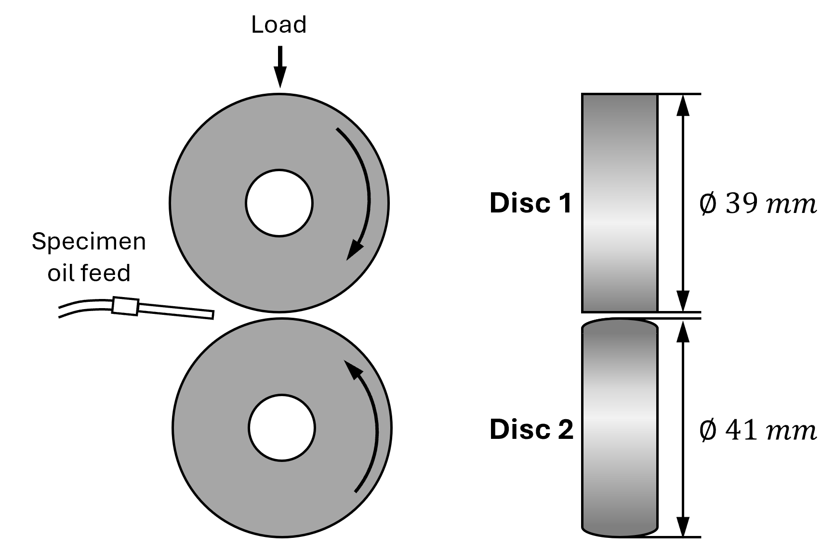
Figure 1 TE74 twin-disc setup

In each test, a pair of discs made of AISI52100 bearing steel (Schaeffler Technologies GmbH & Co. KG, Schweinfurt, Germany) was used. The material and disc geometries simulated the roller-raceway contact in rolling element bearings. The chemical composition and mechanical properties of the bearing steel have been reported in [24]. As illustrated in Figure 1, Disc1 had a diameter of 39 mm with a cylindrical surface geometry, while Disc 2 had a diameter of 41 mm with a crowned surface geometry with a transverse diameter of 100 mm. This combination resulted in a self-aligning elliptical contact, which effectively minimises stresses induced by edges.
Disc 1 had a roughness $R_{q}$ of 0.03 μm, while Disc 2 had an $R_{q}$ of 0.04 μm or 0.026 μm for different lubrication conditions. An $R_{q}$ of 0.03-0.04 μm is typical for rolling element bearings [25]. Disc 2 was roughened to $R_{q}$ = 0.26 μm in selected tests to accelerate pitting formation. Optical images of untested Disc1 and Disc 2 surfaces are shown in Figure 2.
(a) 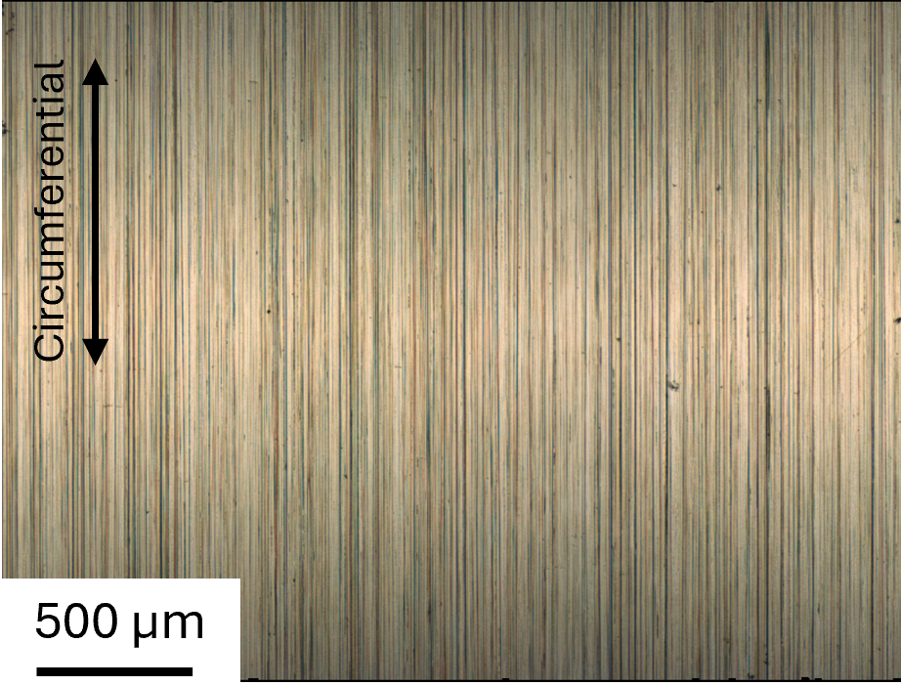 (b) 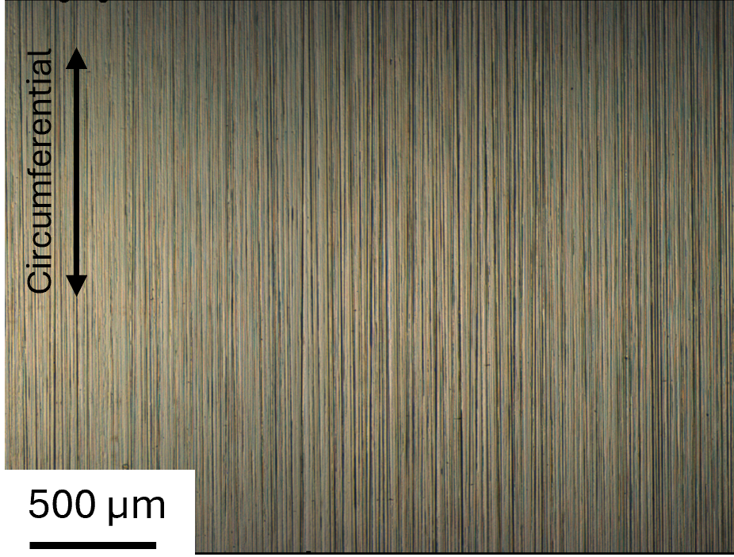
(c) 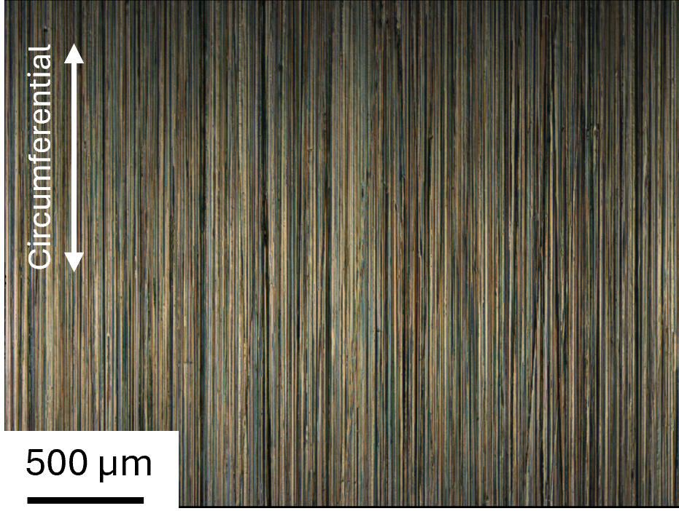
Figure 2 Optical images of untested (a) Disc 1 with $R_{q}$ of 0.03 μm, (b) Disc 2 with $R_{q}$ of 0.04 μm, and (c) Disc 2 with $R_{q}$ of 0.26 μm
Two lubricants were used in this study. The first was SpectraSyn 8 Polyaphaolefin (PAO) base oil, provided by Exxon Mobil Corporation, Texas, US, with properties provided in Table 1. PAO oils are synthetic and commonly used in rolling contact fatigue studies [26, 27], as their well-characterised and stable properties provide a reproducible baseline for isolating the effects of surface conditions, operating conditions, and additive packages.
Table 1 Properties of PAO8 oil
Properties | Metric
Kinematic viscosity, cSt, 100℃ | 8.0
Kinematic viscosity, cSt, 40℃ | 48
Viscosity index | 139
Flash point, ℃ | >286
Specific gravity (60/60℉) | 0.833
Dielectric strength | 37.7 kV (ASTM D877)

The second lubricant was the PAO8 base oil mixed with 2wt% HiTEC 1656, which is a primary-secondary mixed Zinc dithiophosphate (ZDDP) additive, provided by AFTON Chemical Corporation, Bracknell. Details of this additive are provided in Table 2. The addition of 2 wt% ZDDP is expected to cause only a marginal increase in viscosity, so the viscosity of the ZDDP-enriched oil can be considered comparable to that of the base PAO8 oil for the purposes of lubrication condition estimation. As reported in previous studies [28, 29], adding ZDDP into PAO base oils can increase the dielectric strength by approximately 11 – 29%. This is attributed to the polar functional groups in ZDDP, which can trap charge carriers and reduce their mobility [29].

Table 2 Compositions of ZDDP additive
Alcohol used | Zinc | % Phosphorus | % Sulphur
IPA, IBA, 2-EH | 8.35 | 9.2 | 17.8

Test conditions and execution
The test conditions are summarised in Table 3. These conditions were selected based on studies reported in the literature [26, 27, 30-33] in which pitting was generated. In these studies, the maximum Hertzian contact pressure was typically controlled between 1.5 and 3.14 GPa. Lubrication conditions were controlled to produce boundary to mixed lubrication regimes, to promote sufficient asperity interaction. Slide-to-roll ratios (SRR) between 1 and 30% were applied to introduce controlled sliding to promote crack and pitting initiation.
Table 3 Test conditions
Group | No. | Disc 1 vs Disc 2 Rq (μm) | Disc 1 vs Disc 2 speed (rpm) | Lubricant | Lambda (λ) | SRR (%) | Duration (Mc) | Voltage (V)
Macropitting | M1 | 0.03 vs 0.04 | 600 vs 631 | PAO8 | 1.15 | -10 | 6 | 0
Macropitting | M2 | 0.03 vs 0.26 | 600 vs 631 | PAO8 | 0.23 | -10 | 1.5 | 0
Macropitting | M3 |  |  |  |  |  | 6 | 0
Micropitting | MP1 | 0.03 vs 0.04 | 600 vs 631 | PAO8+ZDDP | 1.15 | -10 | 6 | 0
Micropitting | MP2 | 0.03 vs 0.26 | 600 vs 631 | PAO8+ZDDP | 0.23 | -10 | 1.5 | 0
Micropitting | MP3 |  |  |  |  |  | 6 | 0
Electrical pitting | E1 | 0.03 vs 0.04 | 600 vs 631 | PAO8+ZDDP | 1.15 | -10 | 1.5 | 10
Electrical pitting | E2 | 0.03 vs 0.04 | 1200 vs 1262 | PAO8+ZDDP | 1.84 | -10 | 1.5 | 10
Electrical pitting | E3 | 0.03 vs 0.04 | 1200 vs 1395 | PAO8 | 1.91 | -20 | 0.5 | 10

In this study, all the tests were carried out under a load of 2.42 kN, which produced a maximum Hertzian contact pressure of 2.5 GPa, representative of typical rolling element bearing contacts [34, 35]. The oil temperature was maintained at 100 ± 5 ℃ to promote boundary to mixed lubrication conditions through reduced lubricant viscosity and to activate the ZDDP additive.
The tests were categorised into three types: ‘Macropitting’ (M-series), ‘Micropitting’ (MP-series), and ‘Electrical pitting’ (E-series). The macropitting tests were conducted with PAO8 base oil. As a baseline test, test M1 used a smooth–smooth disc pair ($R_{q}$ 0.03 μm vs 0.04 μm), and no pitting was anticipated. In M2 and M3, Disc 2 was rougher to promote and localise pitting on Disc 1, reducing the lambda ratio ($λ$) to 0.23. The ‘Micropitting’ tests were identical except the lubricant was changed to the ZDDP enriched oil. In the ‘Electrical pitting’ group, a smooth–smooth surface combination was used to achieve higher lambda ratios, increasing the separation between opposing asperities and providing conditions suitable for dielectric breakdown and electrical pitting. E1 replicated the conditions of MP1 except that an external potential was applied across the discs. In addition, E2 and E3 employed different rotational speeds and SRR values to validate the repeatability of electrical pitting generation.
Macropitting and micropitting are fatigue pitting modes and therefore require extended durations for crack initiation and propagation. In contrast, electrical pitting is caused by lubricant dielectric breakdown rather than fatigue accumulation. Therefore, damage can develop within a much shorter duration and 0.5-1.5 million cycles is sufficient to generate representative electrical pitting. Macropitting and micropitting tests were repeated under comparable conditions, and pitting was consistently reproduced [36]. Electrical pitting tests were repeated twice with pitting observed in the repeats.

Electric test configuration
An external electrical circuit powered by a 10 V power supply was used to apply voltage across the two rotating discs, as schematically shown in Figure 3. The voltage was chosen based on literature evidence. Shaft voltage peaks of up to 8 V have been reported in inverter-driven motors [37], representative of practical conditions. In addition, previous experimental studies employing a similar test configuration used a 15 V power supply and successfully generated electrical pitting [33]. The rig’s contact potential different setup of brushes and slip rings was used to connect the circuit. A 30 kΩ current-limiting resistor was employed to restrict the discharge current to approximately 0.33 mA, ensuring that breakdown events manifest as localised Electrical Discharge Machining (EDM)-like micro-discharges rather than catastrophic melting or sustained arcing. A Picoscope 4424 oscilloscope (Pico Technology, Eaton Socon, UK) was used to measure the voltage between the discs.
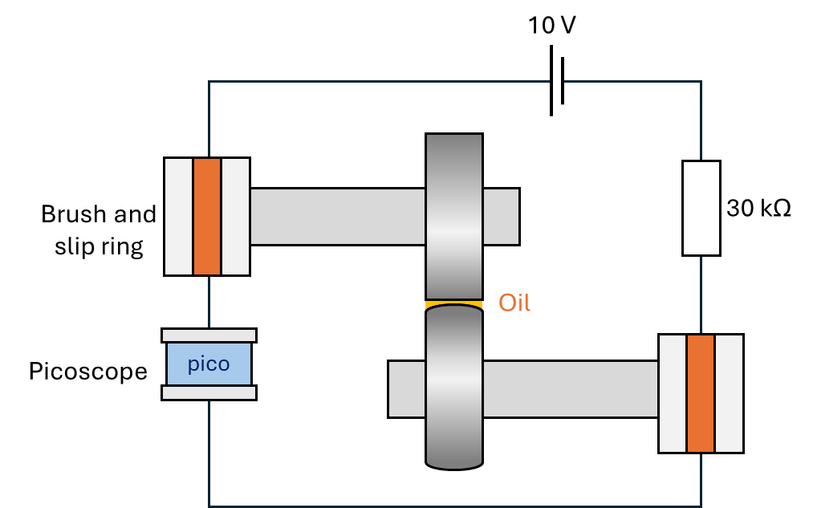
Figure 3 Voltage supply for the disc contact
In the ‘Electrical pitting’ tests, the minimum oil film thickness was calculated using the Hamrock–Dowson EHL film-thickness model [38] to be approximately 58–96 nm,. Using the bulk dielectric strengths for PAO8 (14–15 kV/mm) [39, 40], the theoretical breakdown voltage at the minimum oil thickness is estimated to be between 1–1.5 V. Interestingly during testing, it was observed that the voltage measurements between the discs never exceeded ~1.4 V. Previous studies have likewise reported that small voltages are sufficient to produce electrical breakdown in lubricated contacts [41].

Surface topography measurement methods
Post-test analysis involved measurements of surface roughness and topography of the discs. 2D surface profiles and roughness were measured using an Intra Touch profilometer (Taylor Hobson, Leicester, UK), with a vertical range of 1 mm and a resolution of 4 nm. 2D roughness parameters were analysed in this work rather than 3D roughness parameters because portions of the disc surfaces were too smooth to be measured using an optical profilometer due to excessive surface reflection [17]. For each disc, four measurements were taken at angular intervals of 90°. Prior to roughness evaluation, the profiles were levelled and surface form was removed. The profiles were then filtered using a Gaussian filter with cut-off wavelengths selected according to the measured surface characteristics. The filtered surfaces were then analysed using amplitude and functional parameters. Three amplitude parameters defined in ISO 4287, $R_{q}$ (root-mean-square deviation), $R_{p}$ (peak), $R_{v}$ (valley), $R_{sk}$ (skewness), and $R_{ku}$ (kurtosis), were considered. These parameters provide statistical measures of surface height distribution, capturing the overall roughness magnitude ($R_{q}$), largest profile peak height ($R_{p}$), largest profile valley depth ($R_{v}$), distribution asymmetry ($R_{sk}$), and profile sharpness ($R_{ku}$) [16].
Furthermore, functional parameters $R_{k}$ (core roughness depth), $R_{pk}$ (reduced peak height), and $R_{vk}$ (reduced valley depth), as defined in ISO 13565-2, were evaluated. These parameters are derived from the Abbott-Firestone (material ratio) curve [42], as shown in Figure 4. The material ratios $M_{r1}$and $M_{r2}$ define the transitions between the peak, core, and valley regions. A linear regression is fitted to the region of minimum slope, representing the core roughness. The parameter $Rk$ is defined as the vertical distance between the intersections of the extended regression line with the 0% and 100% material ratio levels. The parameters $Rpk$ and $Rvk$ are determined from the areas between the material ratio curve and the regression line above $M_{r1}$ and below $M_{r2}$, respectively, and are expressed as the heights of equivalent triangular areas [43].
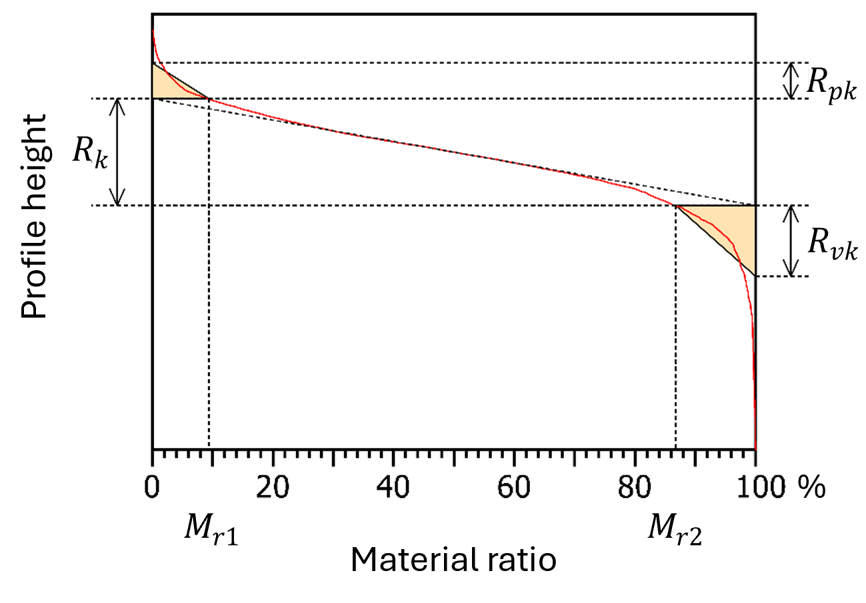
Figure 4 Abbott-Firestone (material ratio) curve of a fresh disc surface, shown for indication of functional parameters $Rk$, $Rvk$, and $Rpk$
Additionally, 3D surface measurements were performed using an Alicona G4 profilometer (Alicona Imaging GmbH, Raaba, Austria) with vertical and lateral resolutions of 50 nm and 2 μm, respectively. In the software, the original disc form was removed and the coordinate axes were adjusted to align the unworn surface as the reference plane. Pit depth was determined directly from the 3D topography by measuring the vertical distance from this reference plane to the lowest point of each pit, while pit width was defined as the maximum lateral dimension of the pit at the surface level. To quantify the pitting area, the images were converted into binary format through manual segmentation in ImageJ to identify and separate the pitted regions from the surrounding surface. To observed detailed features, such as crack propagation, the discs were observed using a JEOL JSM-7200F scanning electron microscope (SEM) (JEOL Ltd, Tokyo, Japan).

Results

Optical observations and quantitative pit geometry
Optical images of the ‘Macropitting’ wear tracks are presented in Figure 5. Compared with the untested discs shown in Figure 2, the smooth–smooth surface combination (M1, $λ$ = 1.15) showed only minor wear in the rolling–sliding direction on both discs, with no clear evidence of pitting. As this was the baseline test, the absence of pitting was expected. Decreasing the lambda ratio to 0.23 resulted in small surface cracks initiated on Disc 1 by 1.5 million cycles, but no pitting was observed (M2). By 6 million cycles (M3), macropits were observed, which were characterised by large, irregular surface breakouts with jagged boundaries, with lateral dimensions on the order of hundreds of micrometres.
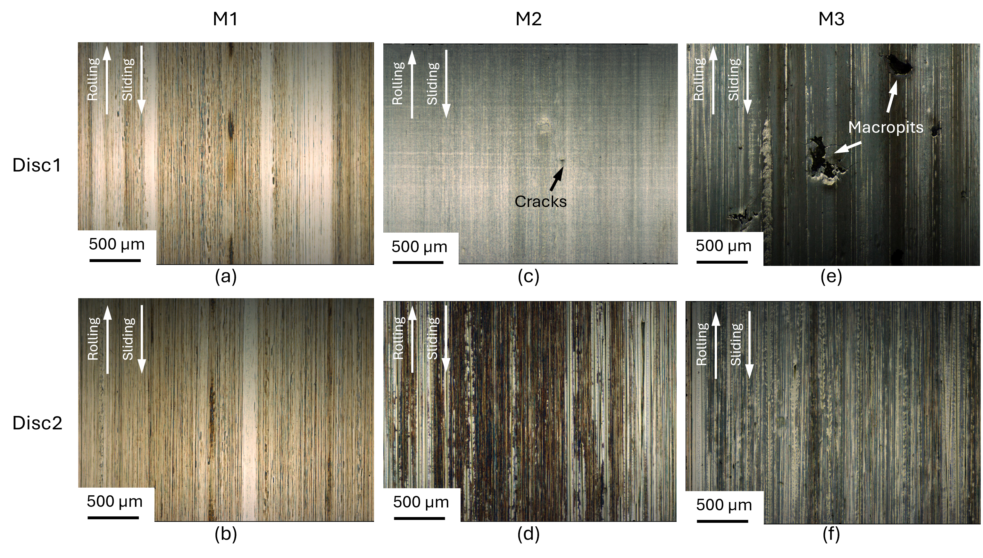
Figure 5 Optical images of wear tracks after macropitting tests
Optical images of the ‘Micropitting’ wear tracks are presented in Figure 6. Similar to M1, the smooth–smooth test condition (MP1, $λ$ = 1.15) resulted in only minor wear and no pronounced pitting features, as expected. The difference in M1 and MP1 was the blue tint on the wear track commonly seen in tribological tests with ZDDP containing lubricants, which was identified as ZDDP tribofilm [36]. Under the smooth–rough combination (MP2 and MP3, $λ$ = 0.23), pits were observed on Disc 1 at 1.5 million cycles (MP2) with features typical of micropitting, characterised by small pits which were tens of micrometres in width with surface confined shapes. After 6 million cycles (MP3), the micropitted regions exhibited slight growth in pit size and area.
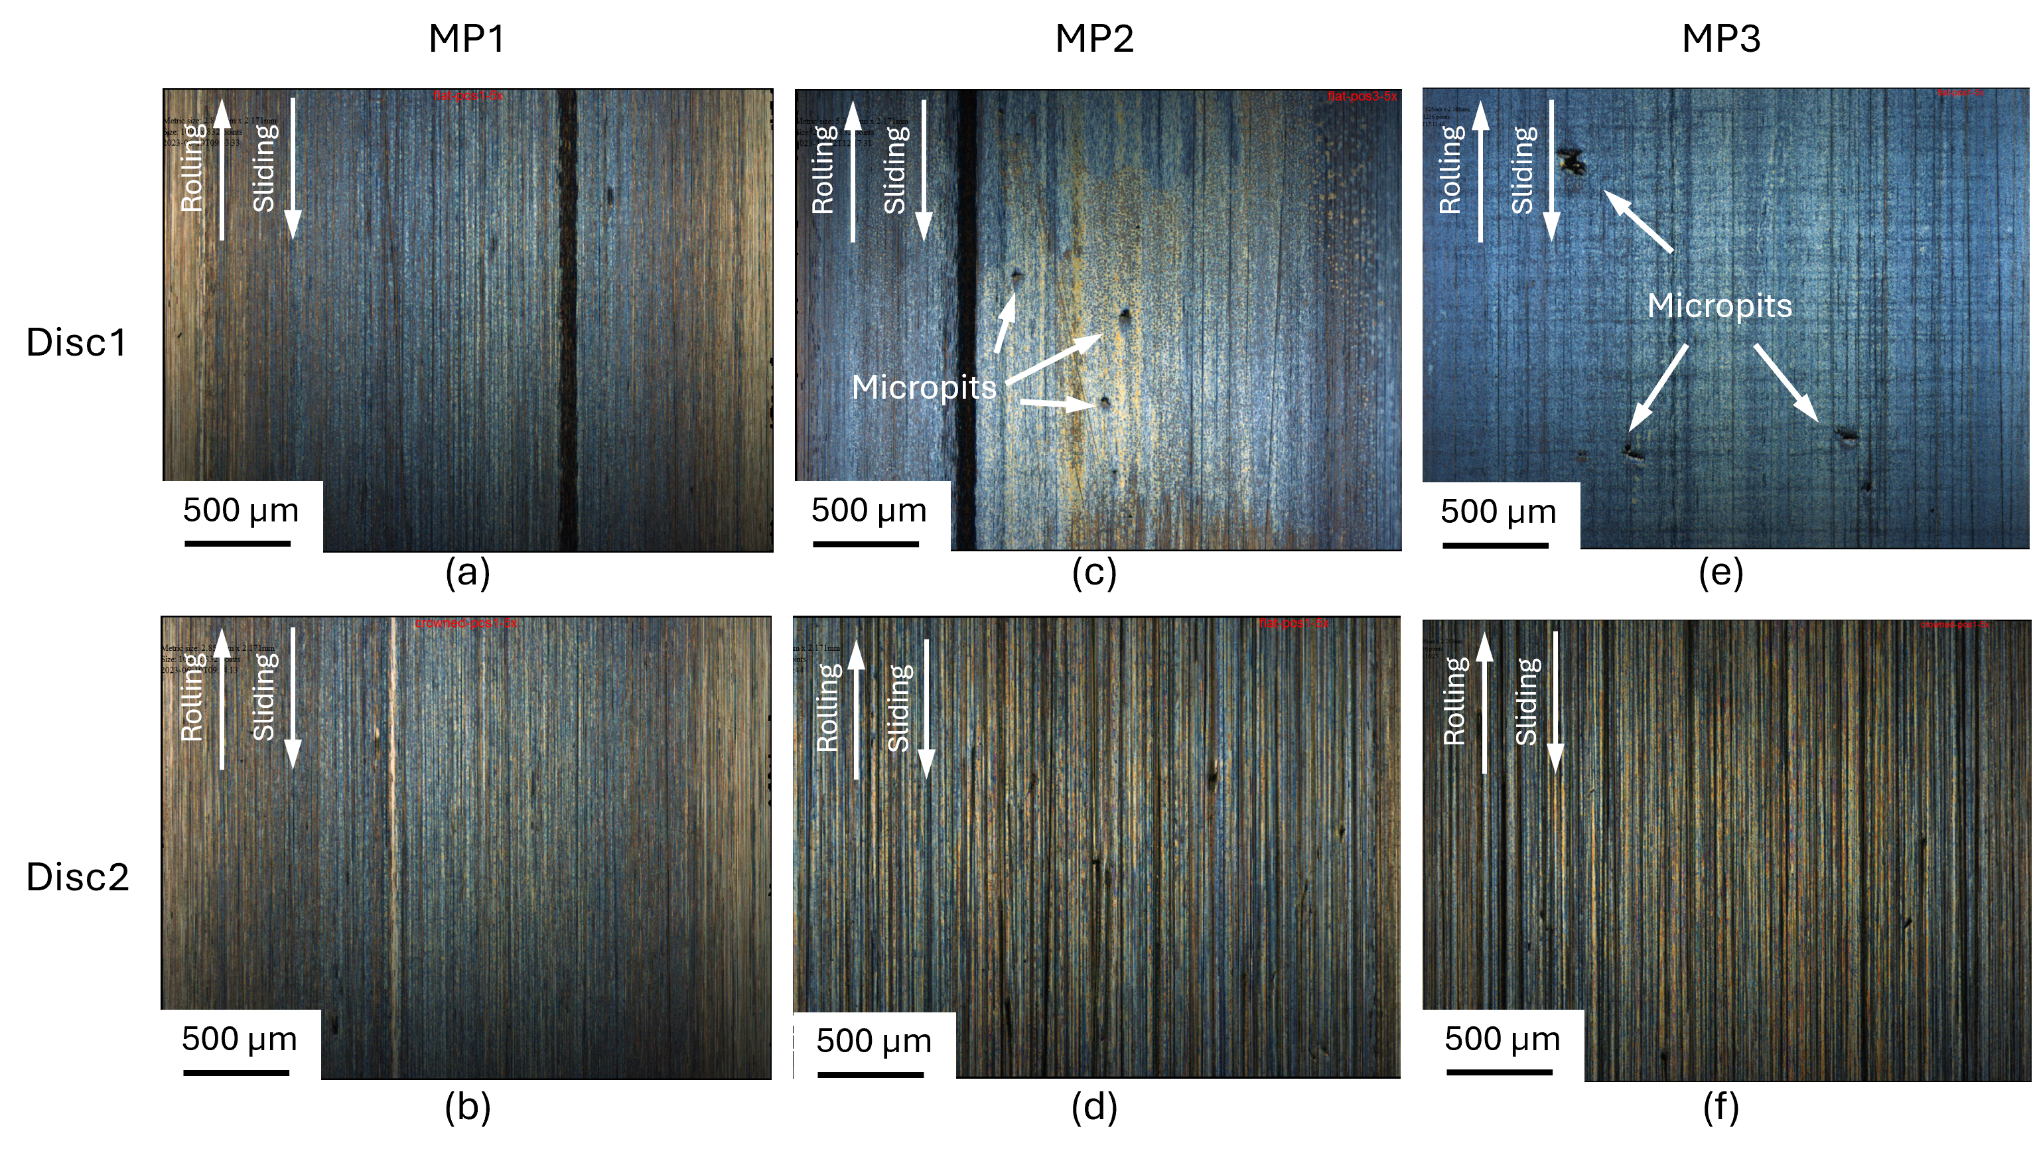
Figure 6 Optical images of wear tracks after micropitting tests
It was observed that both macropitting and micropitting occurred exclusively on the smooth discs (Disc 1) in the smooth–rough contact configurations. This behaviour has been explained by the stress transfer mechanism described in [36], where under boundary or mixed lubrication conditions, the stress history is dominated by the rough surface. When a rough surface slides or rolls against a smooth counter surface, the smooth surface is subjected to pronounced pressure fluctuations imposed by the rough surface. Individual asperities on the rough surface form highly localised contacts generating elevated near-surface stresses. These promote crack initiation close to the surface, ultimately leading to the development of pitting.
Optical images of the ‘Electrical pitting’ wear tracks are presented in Figure 7. Unlike the pure RCF test, pits were found on both discs in E1 ($λ$ = 1.15). The wear tracks were characterised by small and crater-like pits that tended to occur in localised clusters. With different combinations of lubricant, lambda ratio, and SRR, electrical pits were also found in E2 and E3, supporting the repeatability of producing electrical pitting under the applied-voltage configuration.
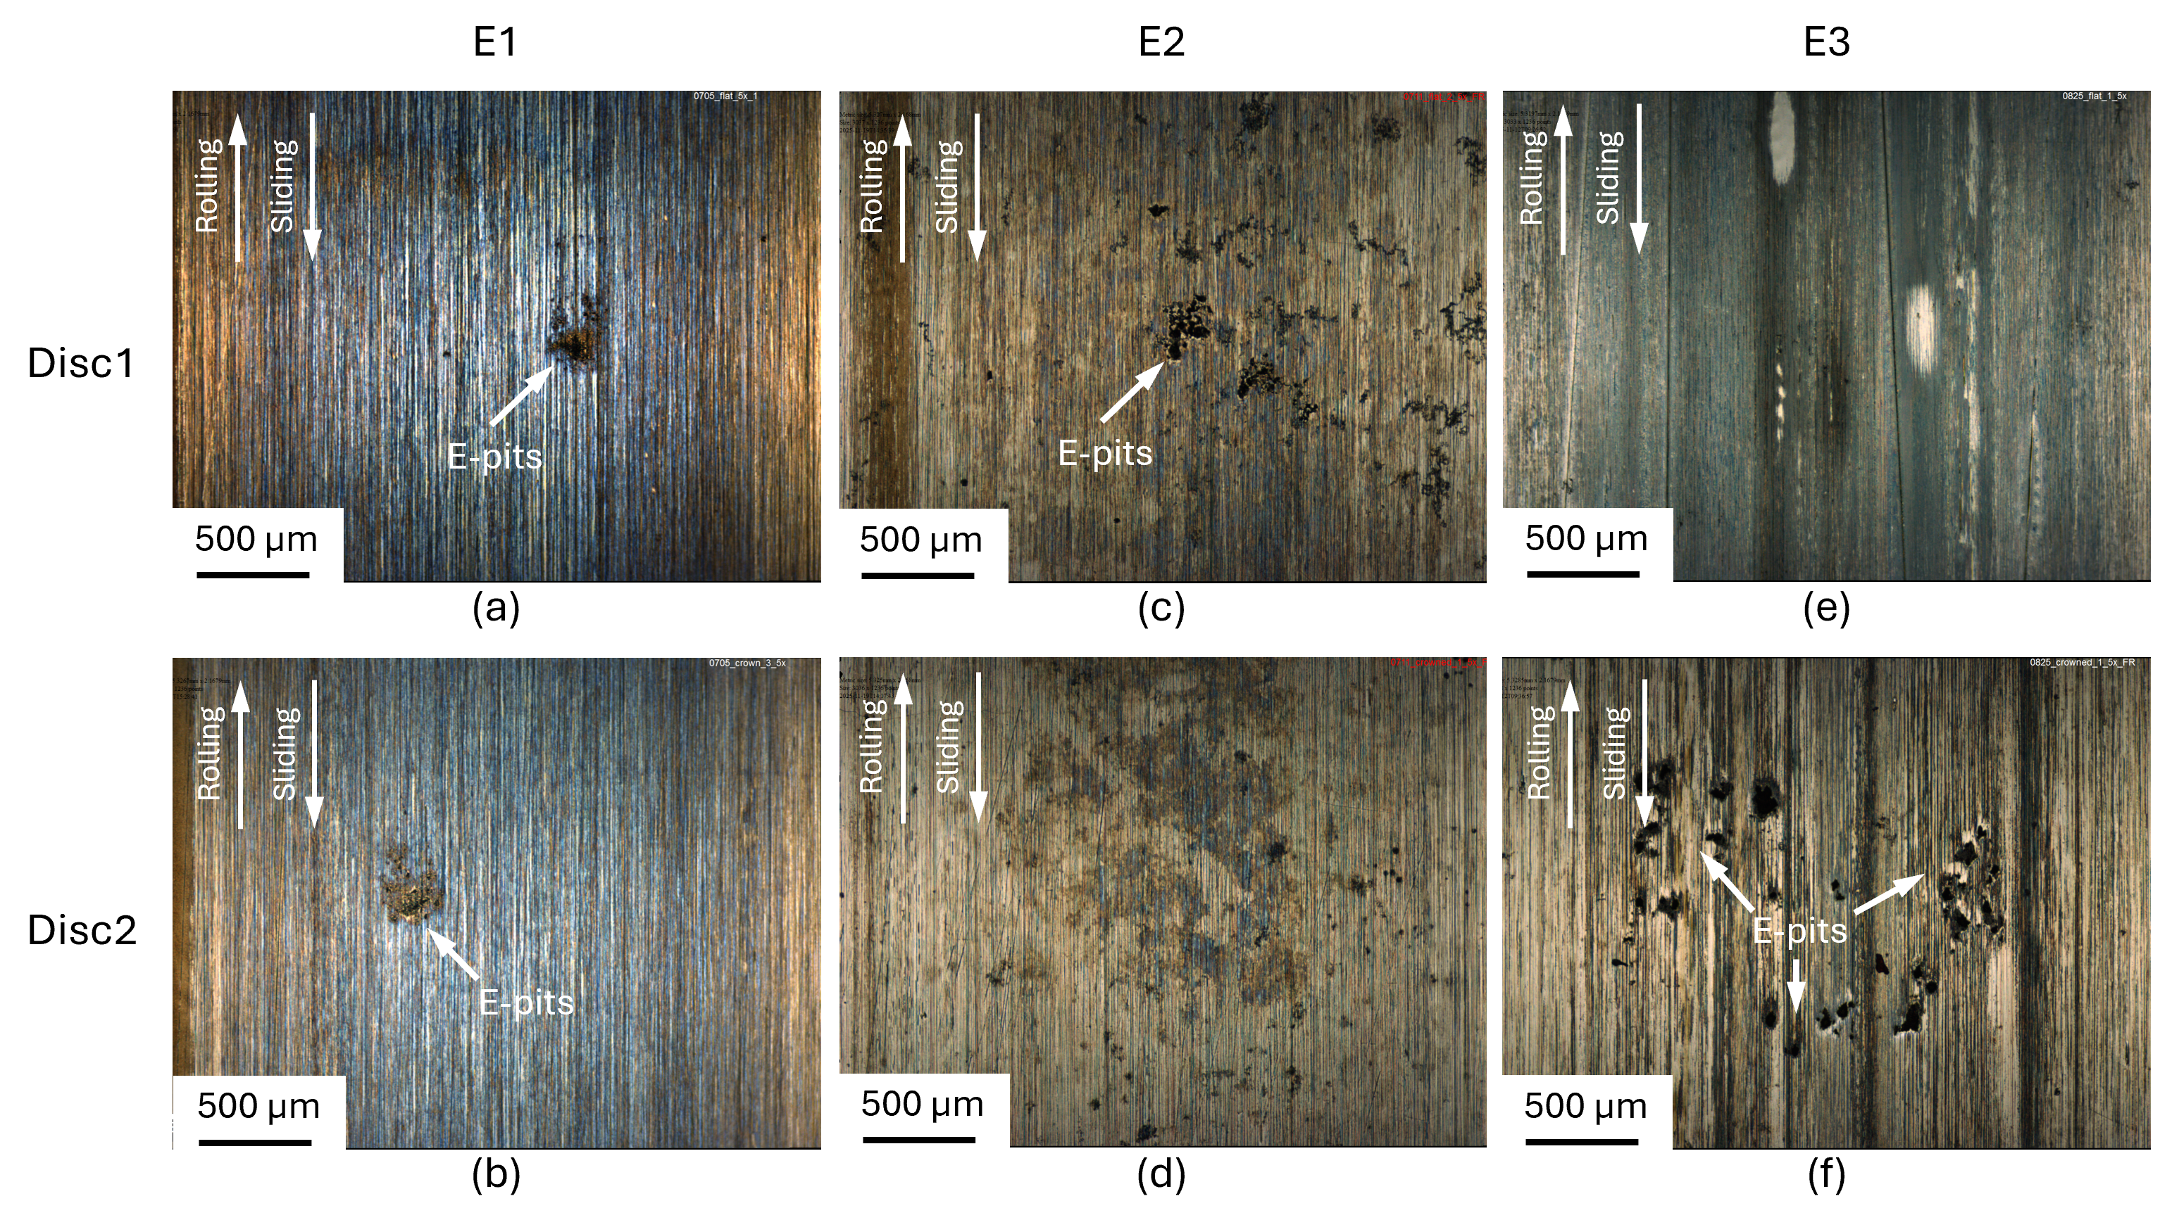
Figure 7 Optical images of wear tracks after electrical pitting tests
To characterise the differences in topography and depth variation among the three pitting modes, 3D optical topography and corresponding height maps were obtained. Representative examples are shown in Figure 8 as a qualitative visual representation, while in Figure 9 quantitative pit geometry and coverage is explored. For the RCF pitting, mature pit formation was observed in the longest tests (M3 and MP3) and thus characterisation of those tests gives better representation for comparing.
For M3, the macropits had an average width of 475 µm, an average depth of 35 µm, an average volume of 2.2 × 10⁵ um³ with a surface coverage of 1.9%. In contrast, for MP3 the micropits had a smaller average width of 138 µm, a shallower depth of 4.9 µm, a smaller volume of 4000 um³ with a lower coverage of 0.24%. All the electrical pitting tests were run shorter duration and their pit width (average 32 µm), volume (average 2600 um³), and coverage (0.03 - 0.15%) were smaller. However, the maximum pit depths reached up to 4.8 µm, comparable to those observed for micropitting.
(a) 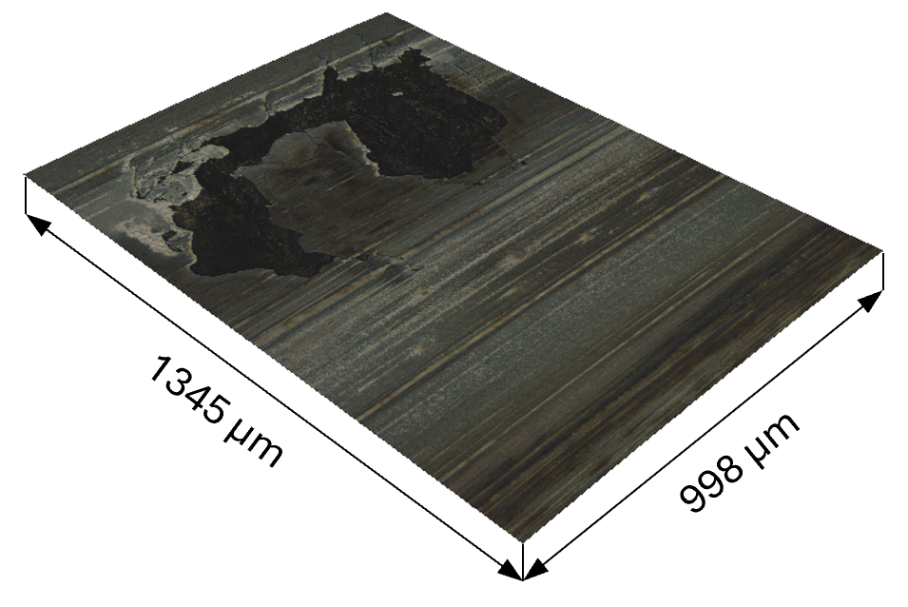(b) 10, mar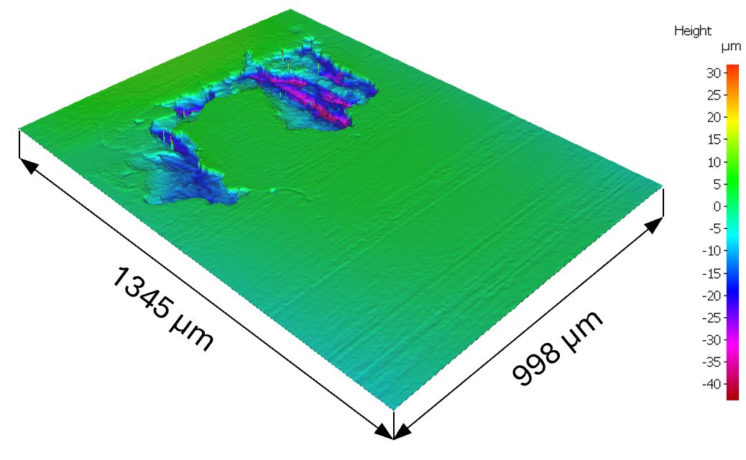
(c) 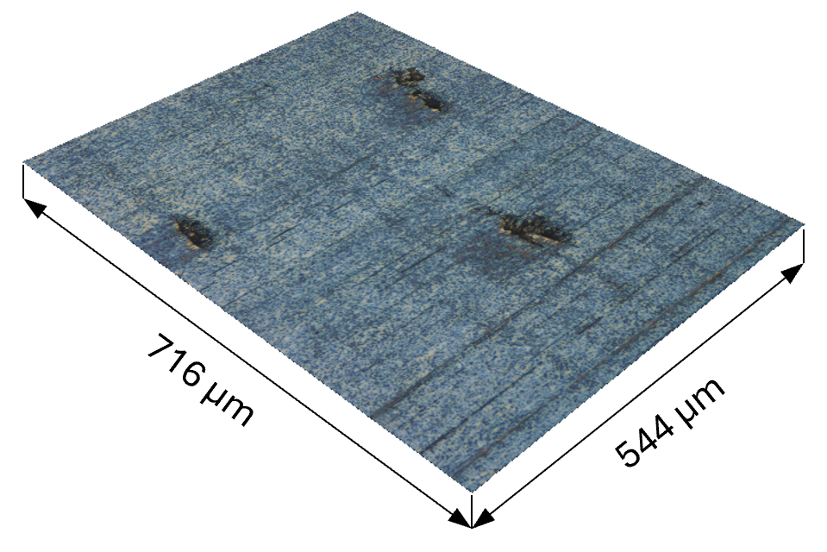(d) 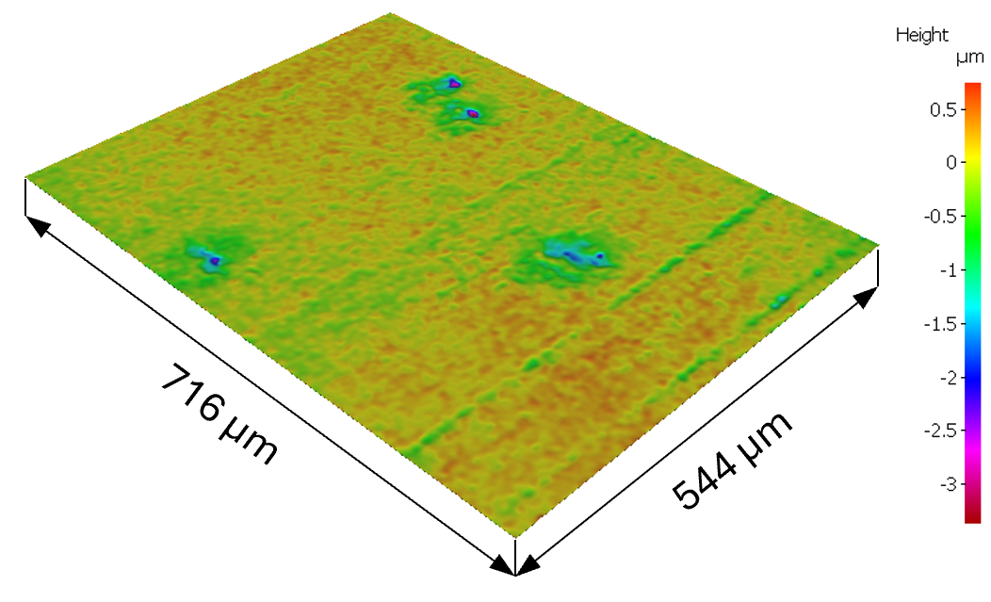
(e) 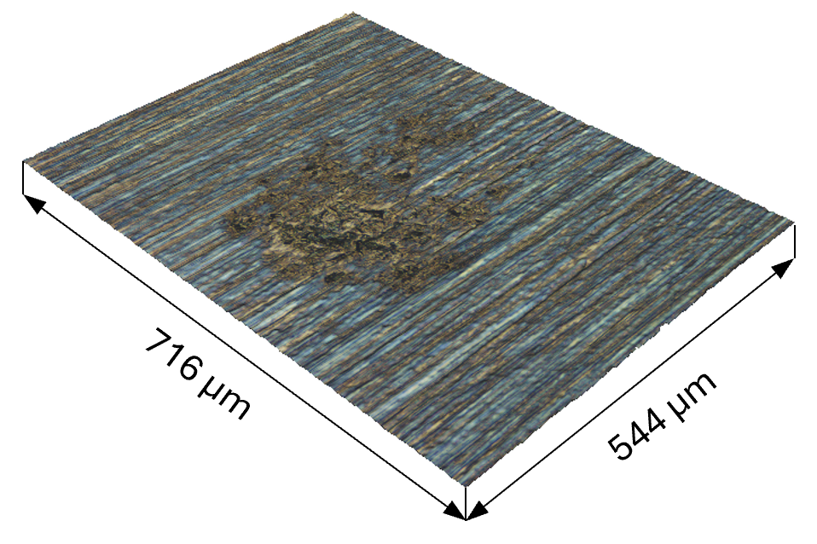(f) 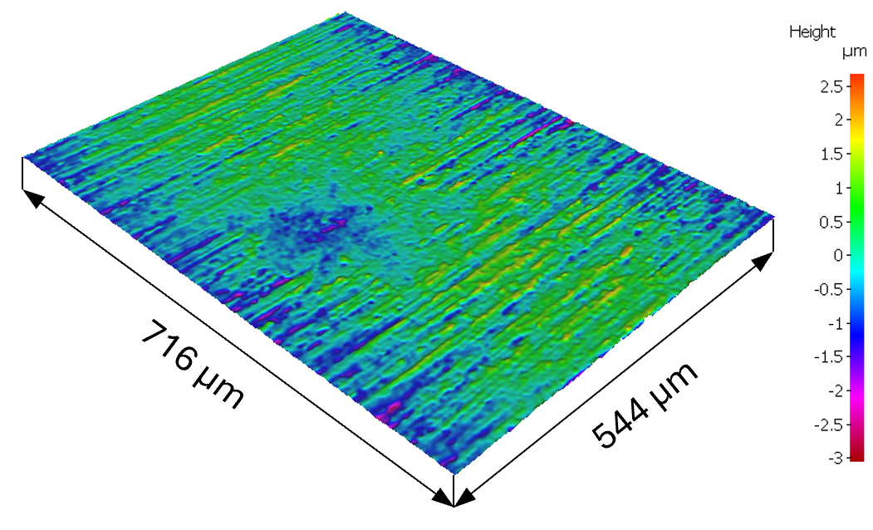
Figure 8 Representative optical images and corresponding height maps of (a, b) macropitting, (c, d) micropitting, and (e, f) electrical pitting
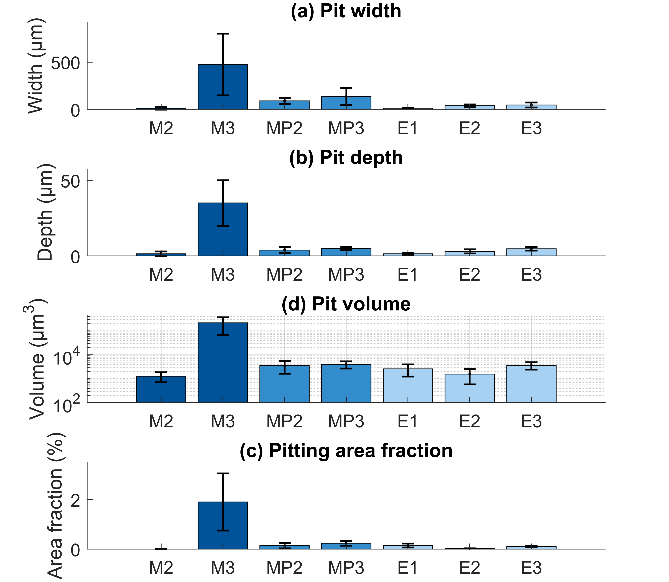
Figure 9 Pit geometry: (a) pit width, (b) pit depth, (c) pitting volume, and (d) pit area fraction for macropitting, micropitting, and electrical pitting tests (mean ± SD)

SEM observations and mechanism analysis of pitting
SEM was employed to study the pit morphologies at high resolutions. Figure 10 presents images of macropits from Test M3. The pit is characterised by extensive cracks creating regions of fine flakes/plates. The overall morphology is similar to macropits reported in [44] and [45]. In the current study, it is further found macropits originated from surface cracks oriented in the axial direction (i.e. transverse to the rolling/sliding direction), from which the pit floor slopes downward against the sliding direction. From the initiation crack, multiple secondary cracks, which can be two to three times longer than the initiation crack, propagated opposite to the sliding direction in a fan-shaped pattern, forming a pitted area with an opening angle of 110-120°, as illustrated by the dotted arrow lines in Figure 10. Material detachments subsequently occurred between adjacent cracks due to secondary crack propagation and interaction, leading to an irregular trailing edge with extensive cracking. The secondary crack network and material detachments between adjacent cracks are clearly visible in a pre-mature macropit, as shown in Figure 10 (a). With continued crack growth and coalescence, material detachments can join, forming large pitted areas on the order of several hundred micrometres, as presented in Figure 10 (b) and (c).
(a) 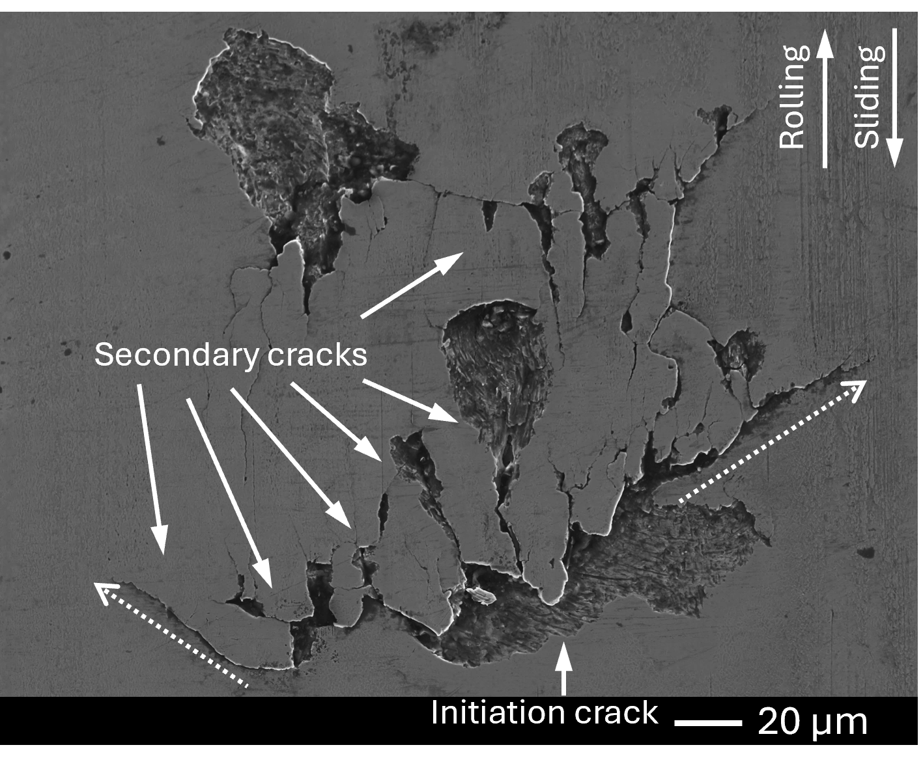 (b) 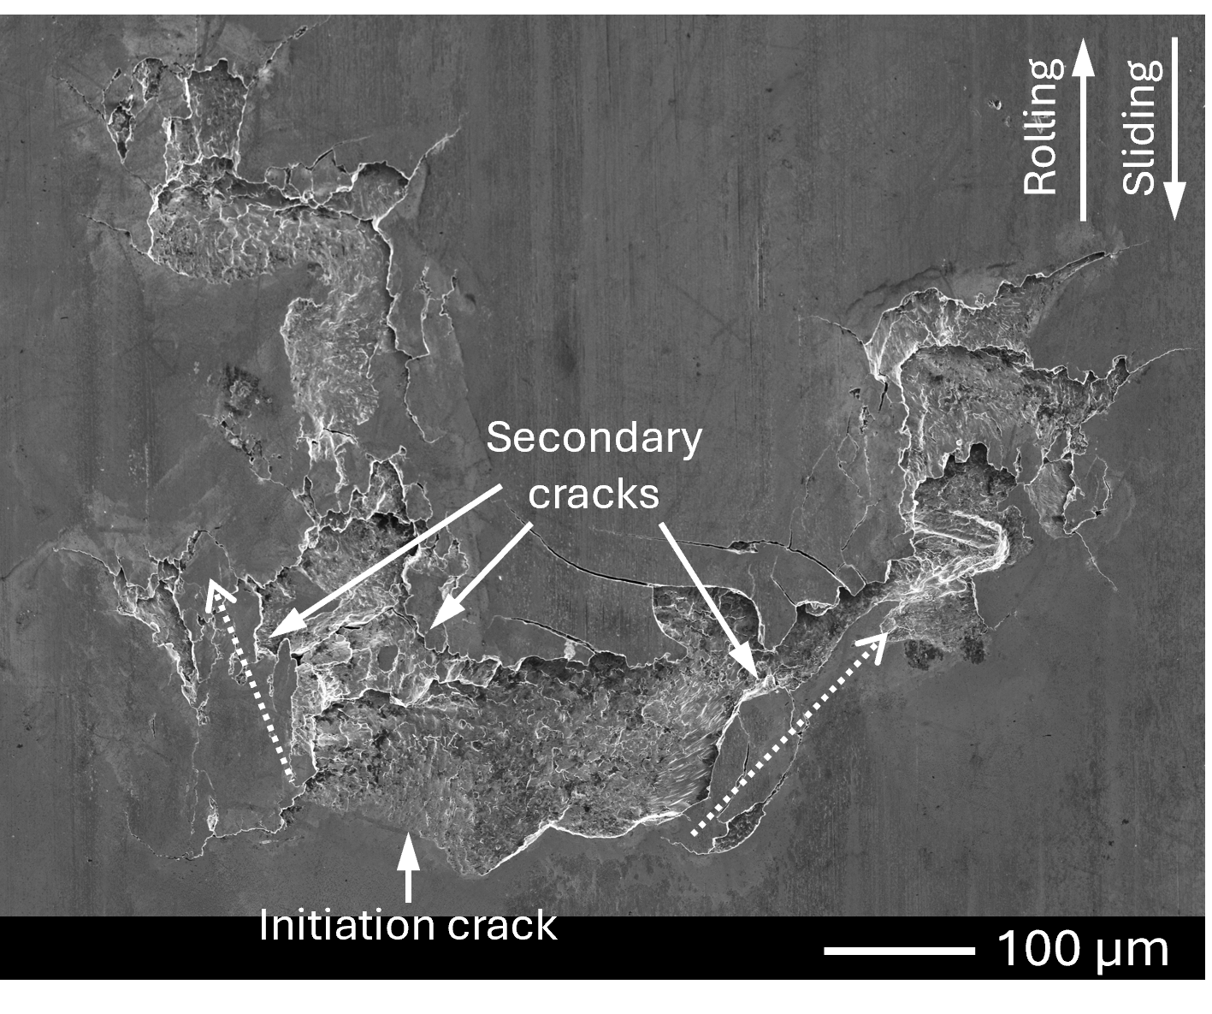
(c) 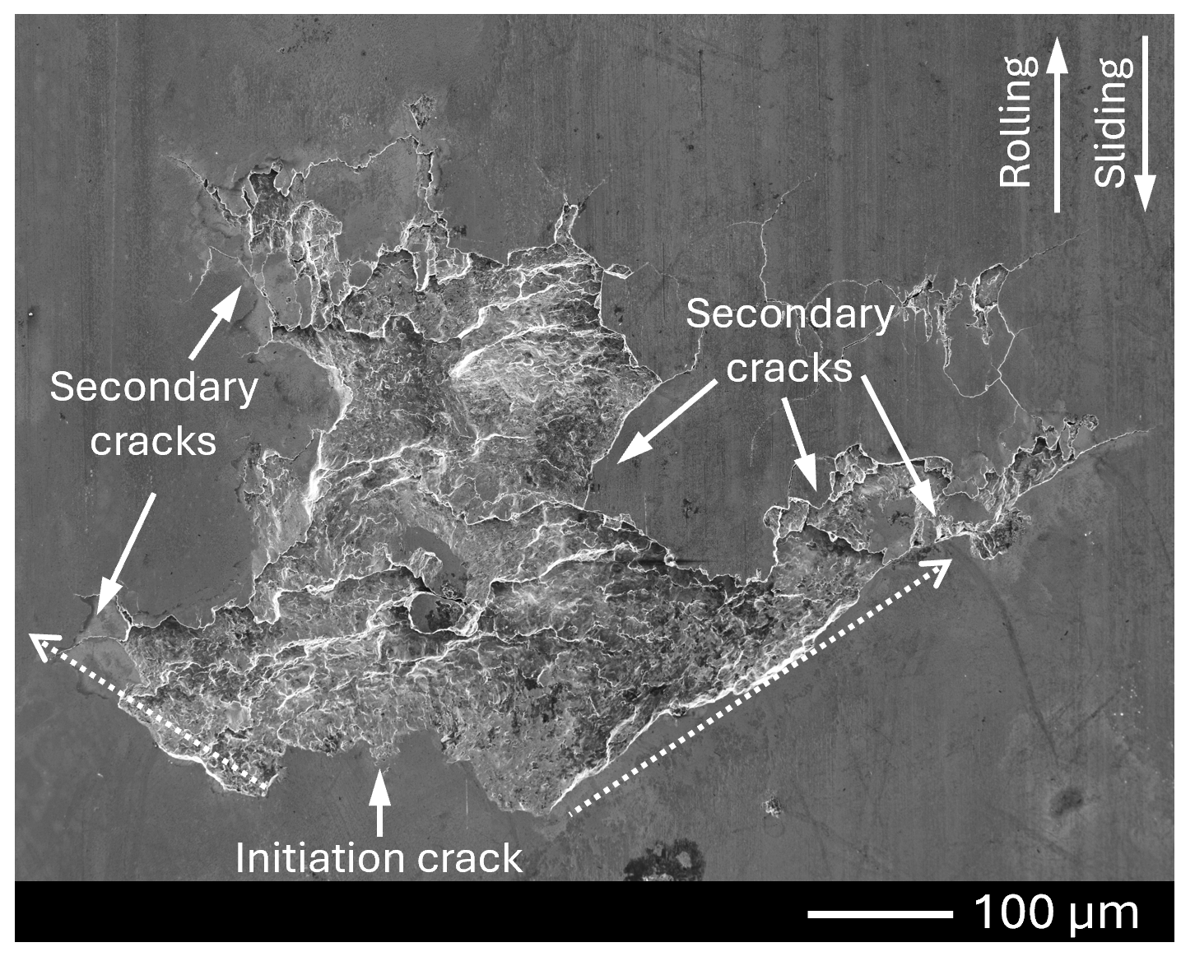
Figure 10 SEM images of macropits after test M3
The occurrence of cracks and pits can be explained by the numerical modelling of the EHL of rough surface contacts presented in [46, 47]. Under low lambda ratios, the frequency and severity of asperity contacts increase, and aggressive asperity interactions can generate highly localised pressure spikes that exceed the nominal maximum Hertzian contact pressure by several orders, increasing the likelihood of crack initiation and subsequent pit formation. However, as this occurred only over several million cycles, it is likely that work hardening led to embrittlement of the material which also contributed.
Figure 11 shows representative micropits from MP3. These crescent-shaped pits are typical of micropitting features reported in the literature [30, 48-50]. The pits originated from surface cracks initiated in the axial direction, as shown in Figure 11 (a), or at an angle of up to 40° to the axial direction, as shown in Figure 11 (b) and (c). The geometry of the initiation cracks is approximately outlined by the dotted curves. Subsequently, multiple short secondary cracks developed from the initiation crack and propagated predominantly opposite to the sliding direction. Material detachment between adjacent cracks, as evidenced in Figure 11 (a), led to the formation of pitted regions.
The initiation cracks, with typical axial lengths of 100–200 µm, largely governed the width of the pits. In contrast, secondary cracks extended only 60–70 µm in the rolling/sliding direction. The confined crack propagation and the shorter length of secondary cracks relative to the initiation cracks resulted in the surface-confined crescent-shaped morphology of micropits.
(a)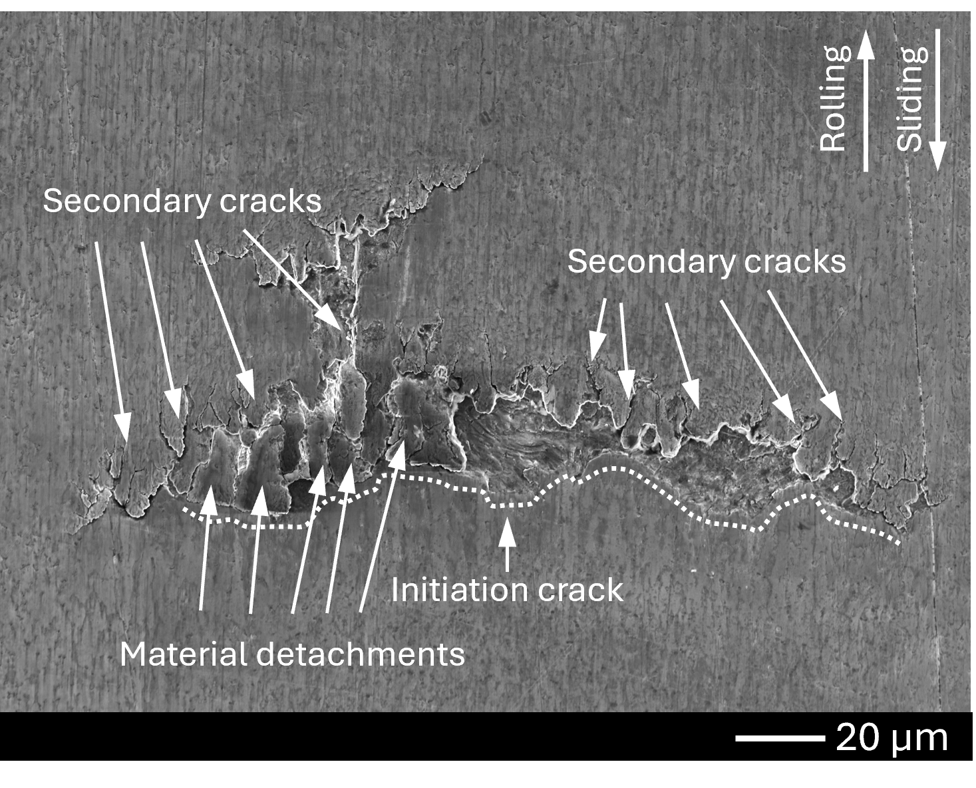 (b)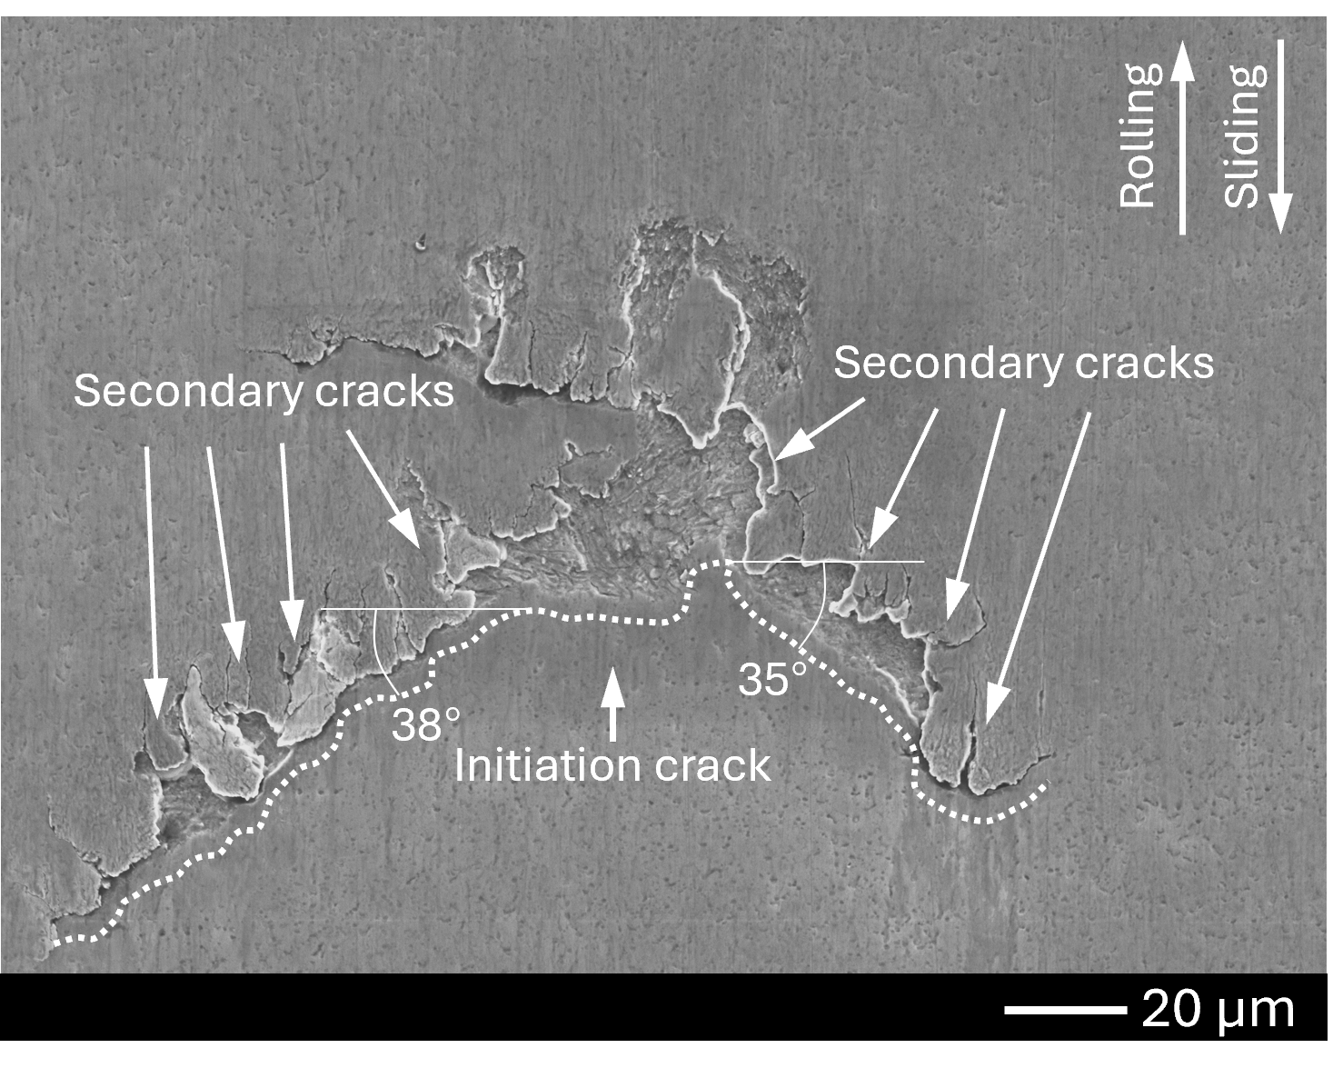
(c) 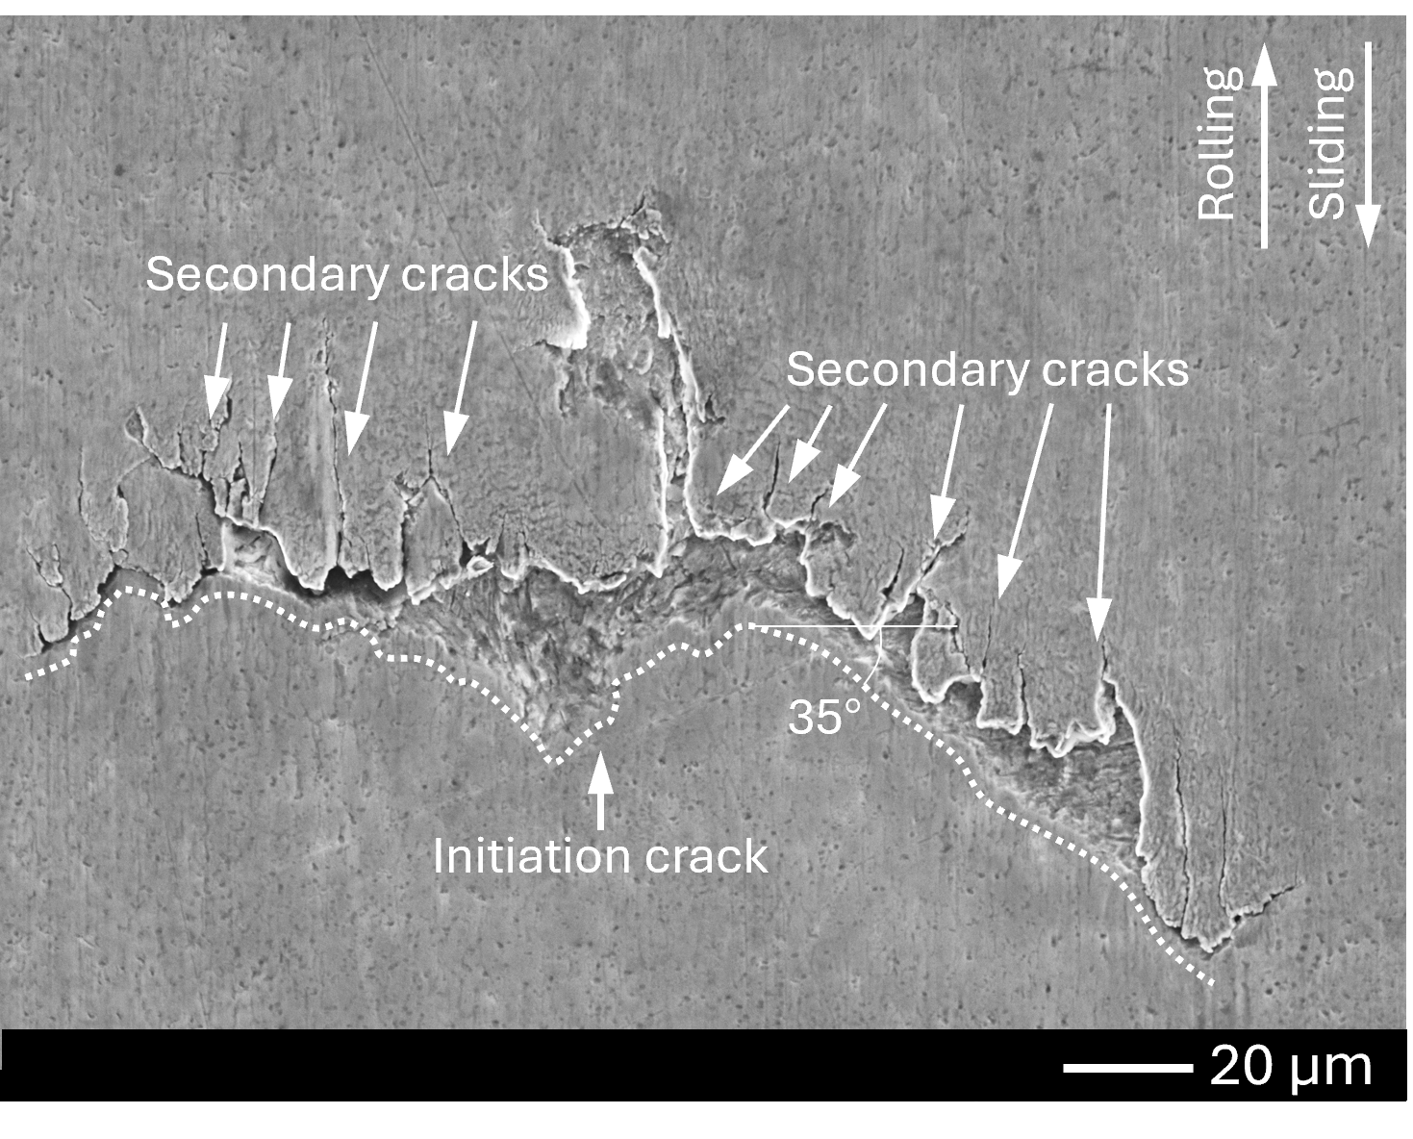
Figure 11 SEM images of micropits after test MP3
SEM images of electrical pits are shown in Figure 12. The crater-like pits exhibited close to circular morphologies with sharp edges, with a circularity of approximately 0.7. These are characteristic features of electrically induced discharge damage reported in previous studies [8, 15]. The pits typically had areas in the range of 310–1200 μm², while some larger pits exceeded 2000 μm². In test E1, the pits show more pronounced irregularity, which can be attributed to more severe asperity contact at the lower lambda ratio. The lambda ratios for E1, E2, and E3 were 1.15, 1.84, and 1.91, respectively. Apart from pits, grooves and ridges along the rolling/sliding directions were observed.
(a)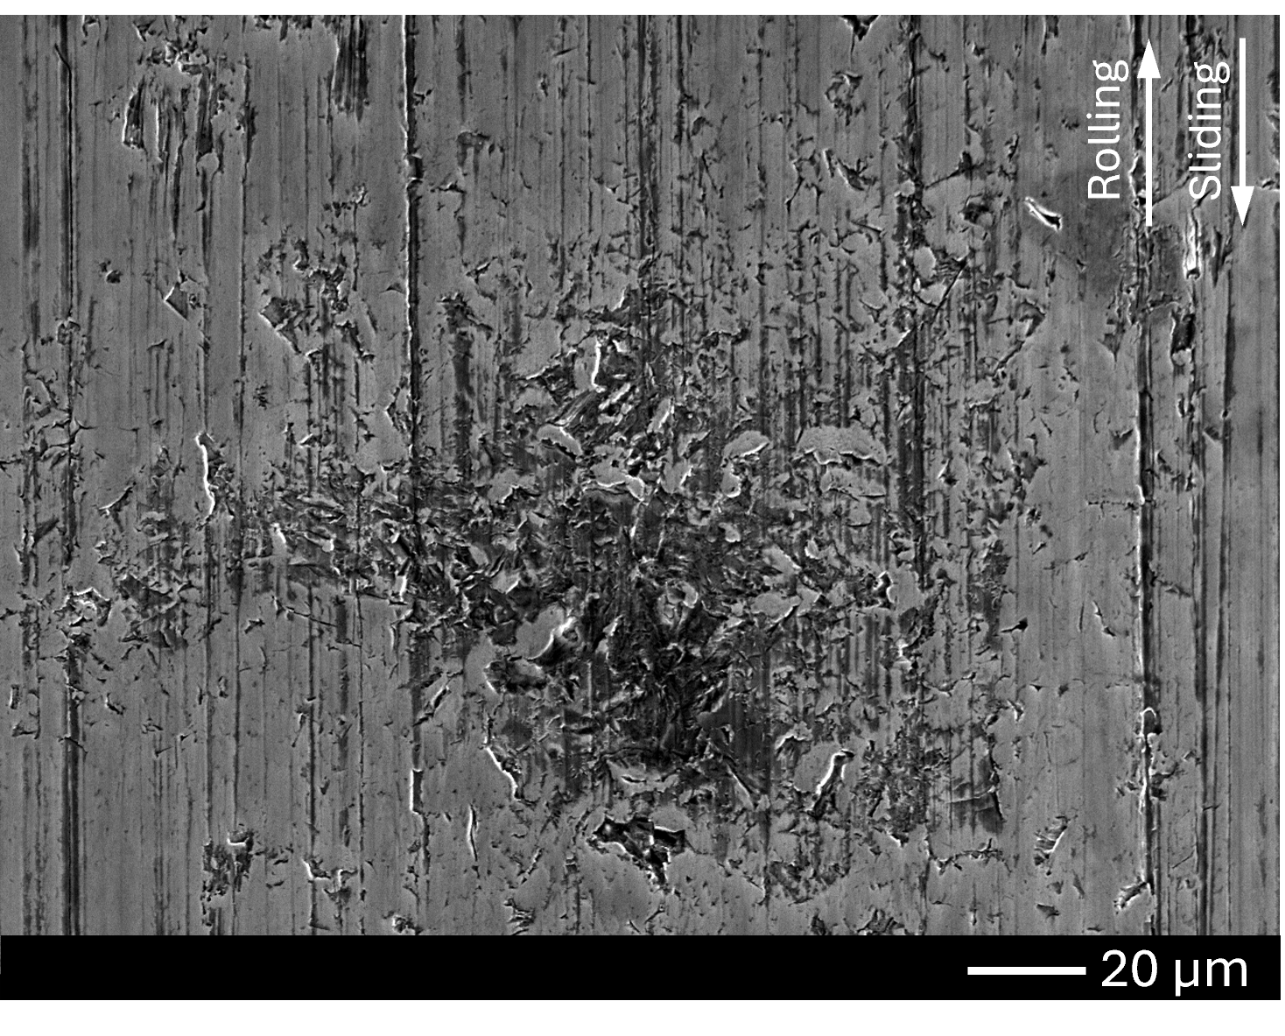 (b)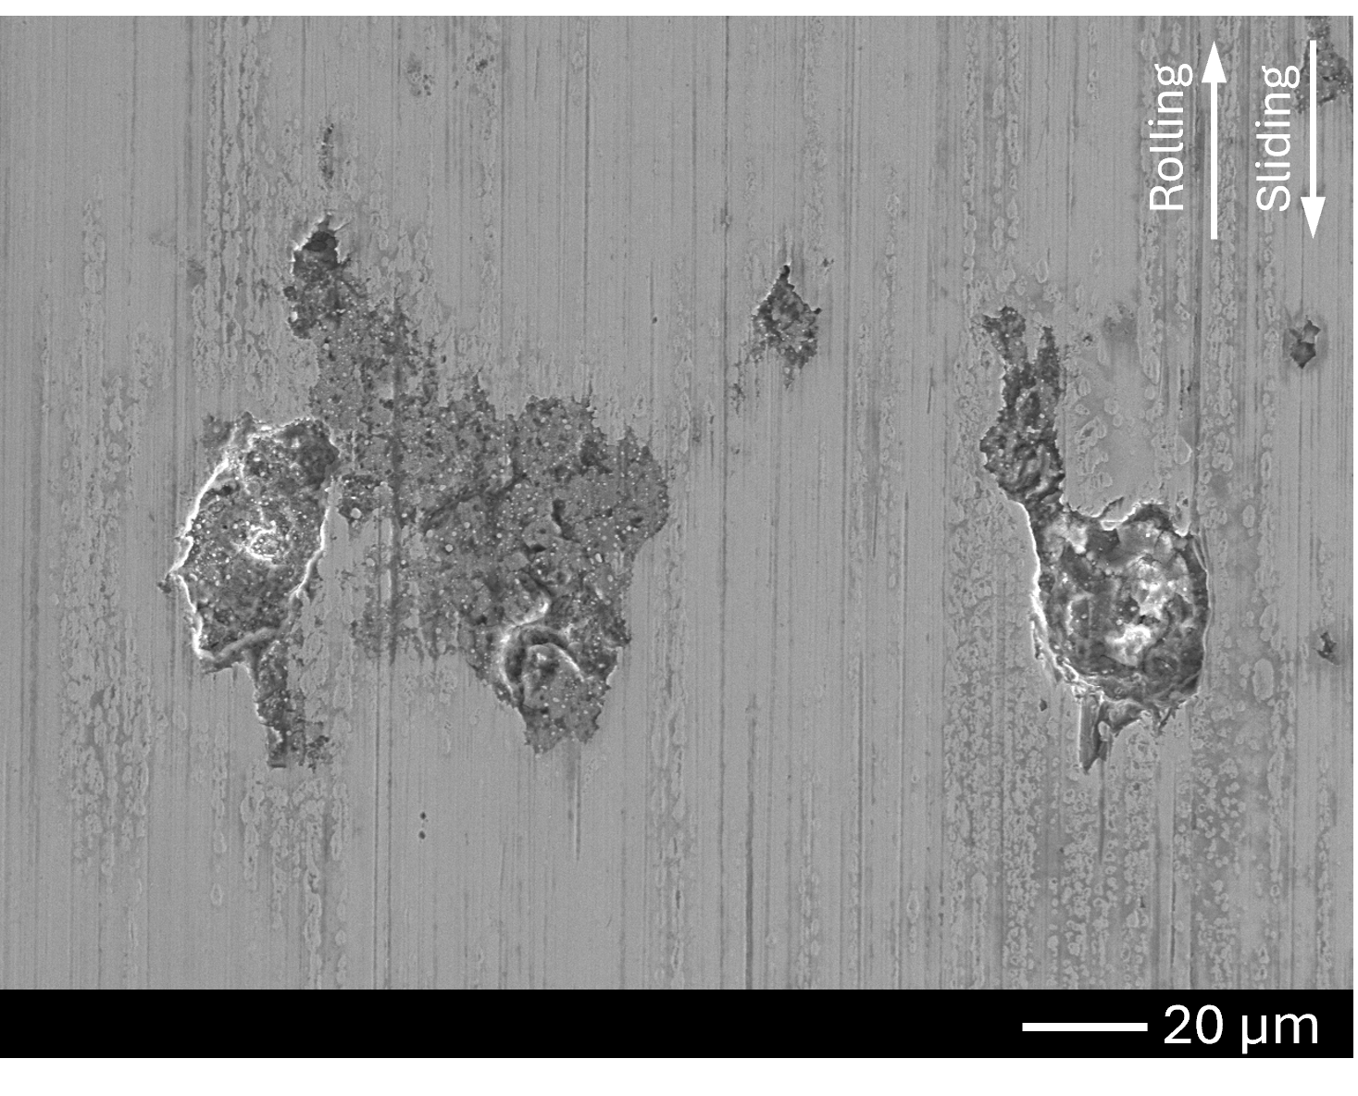
(c)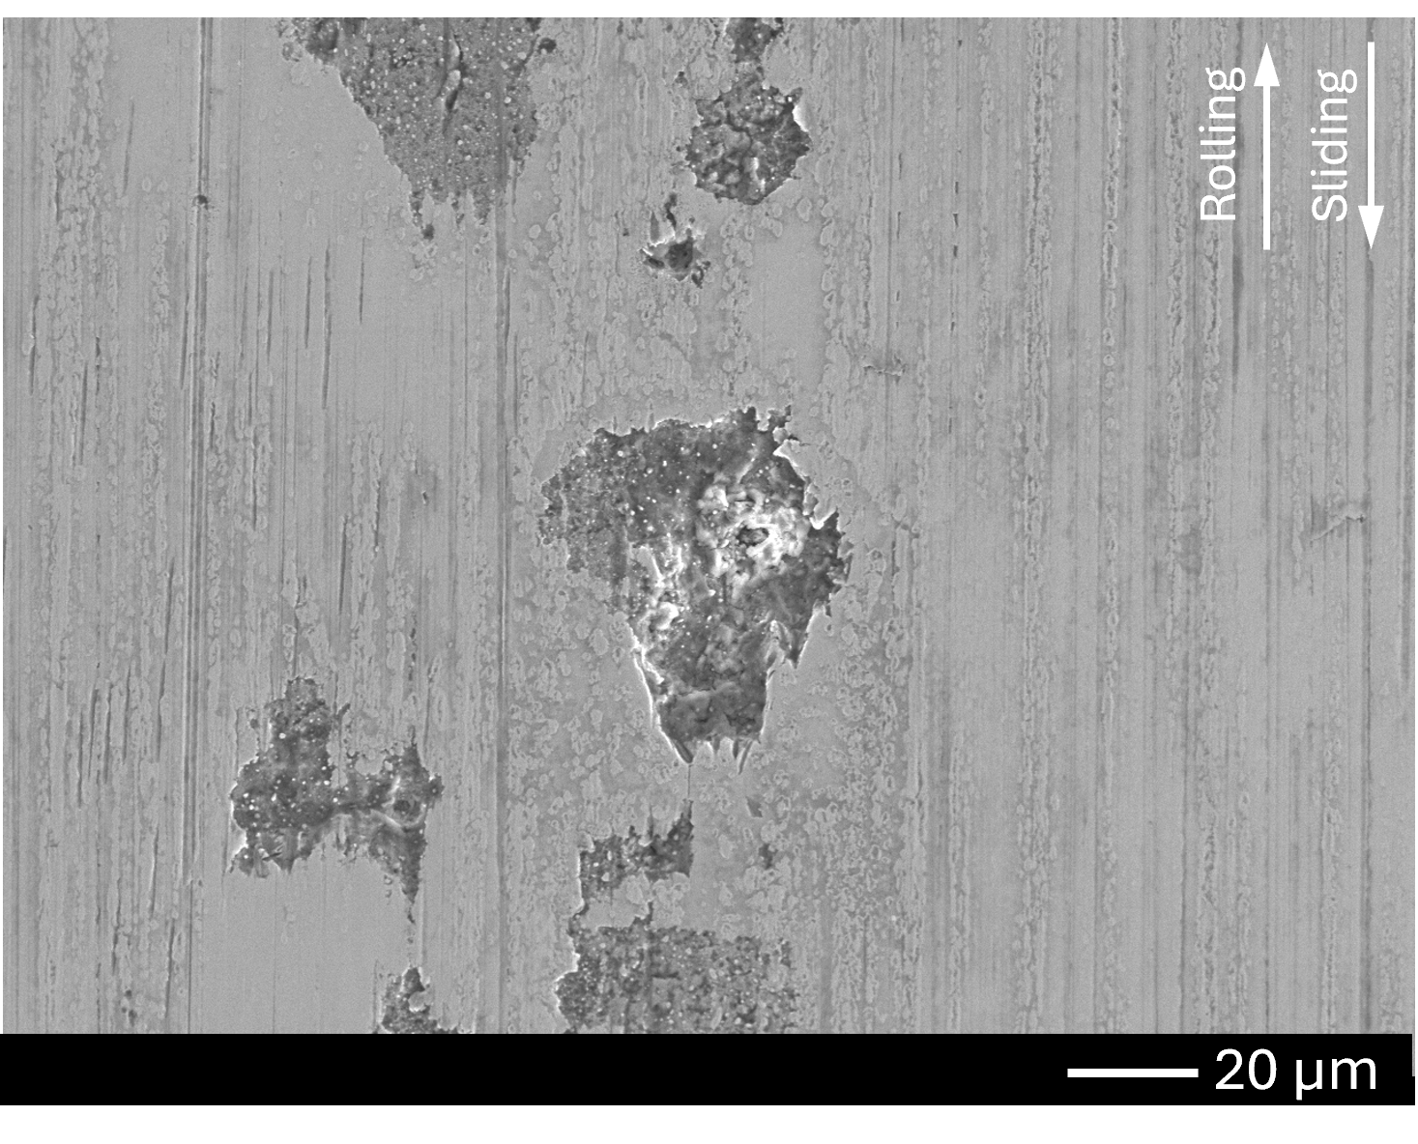
Figure 12 SEM images of electric pits in test (a) E1, (b) E2, and (c) E3

Surface roughness evolution
Roughness parameters were measured within the wear scar in the axial direction, with an evaluation length of 2 mm at four positions for each disc. The measurements were positioned in non-pitted areas, because the presence of pits can introduce deep localised valleys that dominate the height distribution and bias roughness parameters. To minimise edge effects, the measurement lines were positioned at least 1 mm away from pitting edges.
Figure 13 presents the average difference of $R_{q}$, $R_{v}$, $R_{p}$, $R_{sk}$, and $R_{ku}$ of Disc1 in the pitting tests relative to the untested Disc1, which had an $R_{q}$ of 0.03 μm, an $R_{v}$ of 0.06 μm, an $R_{p}$ of 0.05 μm, a slightly negative skewness of -0.21 and a nominal kurtosis value of 3.28. Functional roughness parameters are shown in Figure 14. The untested surface showed values of $R_{k}$=0.06 μm, $R_{vk}$=0.04 μm and $R_{pk}$=0.03 μm.
Minimal changes in roughness were observed for the baseline macropitting test, where only minor wear was observed. For the short macropitting test (M2), $R_{q}$ increased by 25 nm (83%), and $R_{v}$ and $R_{p}$ increased by 76 nm (127%) and 53 nm (106%), respectively. The functional parameters showed increases of 127% for $R_{k}$ and 166% for $R_{vk}$. The most pronounced surface evolution was observed for the longer macropitting test (M3). $R_{q}$ increased significantly by 130 nm (433%) and the deepest valley ($R_{v}$) increased by 490 nm (817%). Correspondingly, pronounced increases in functional parameters were observed relative to the virgin surface, with $R_{k}$, $R_{vk}$, and $R_{pk}$ increasing by 250%, 660%, and 60%, respectively. The dominant growth in $R_{q}$, $R_{v}$, and $R_{vk}$ indicates the surface change was governed by valley formation resulting from plastic deformation induced by cyclic stresses.
For the micropitting tests, the increases in surface roughness were comparable across all three conditions (MP1, 2, 3), regardless of whether visible micropitting was produced. The magnitude of roughness change was greater than that observed in the baseline macropitting test (M1), but lower than that measured for discs exhibiting surface cracks or macropits (M2 and M3). The increase in $R_{q}$ ranged from 6 to 20 nm (20 – 67%), while $R_{v}$ increased by 65 to 100 nm (108 – 167%) and $R_{p}$ by 26 to 50 nm (52 – 100%). The functional roughness parameters showed similar trends across the micropitting tests. Compared with the untested surface, $R_{pk}$ remained comparable, whereas $R_{k}$and $R_{vk}$increased by approximately 30–90% and 70–88%, respectively. Compared with the macropitting tests, the milder roughness changes indicate that the ZDDP reduced asperity interaction and suppressed significant surface damage.
For the electrical pitting tests, surface roughness exhibited larger increases than those observed in the short macropitting test and all micropitting tests. The increase in $R_{q}$ ranged from 32 to 61 nm (107 – 203%), while $R_{v}$ increased by 133 to 181 nm (222 – 302%) and $R_{p}$ by 74 to 153 nm (148 – 306%). Correspondingly, all functional roughness parameters showed significant increases, with $R_{k}$ increasing by 161–205%, $R_{vk}$ by 151–335%, and $R_{pk}$ by 30–165% relative to the untested surface. The changes are likely due to localised surface melting and resolidification from electrical discharges.
As seen in Figure 13 (a), increases in $R_{v}$ were more pronounced than those of $R_{p}$. Furthermore, as shown in Figure 13 (b), a decrease in skewness accompanied by an increase in kurtosis was observed for most of the tests. This indicates that surface evolution in pitting tests was dominated by valley formation, with roughness evolution governed by localised valleys rather than uniform surface modification.
(a)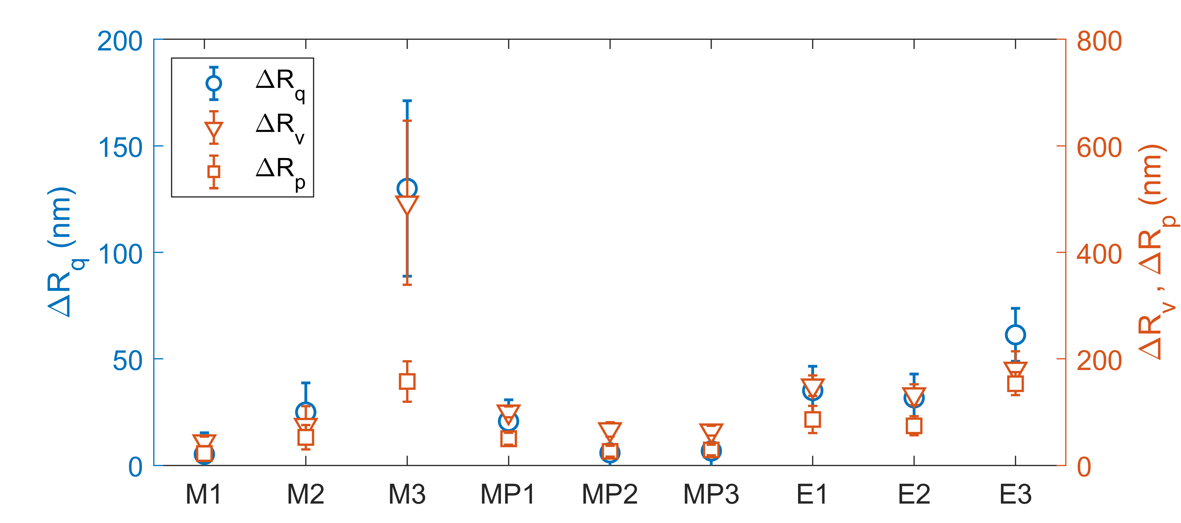
(b) 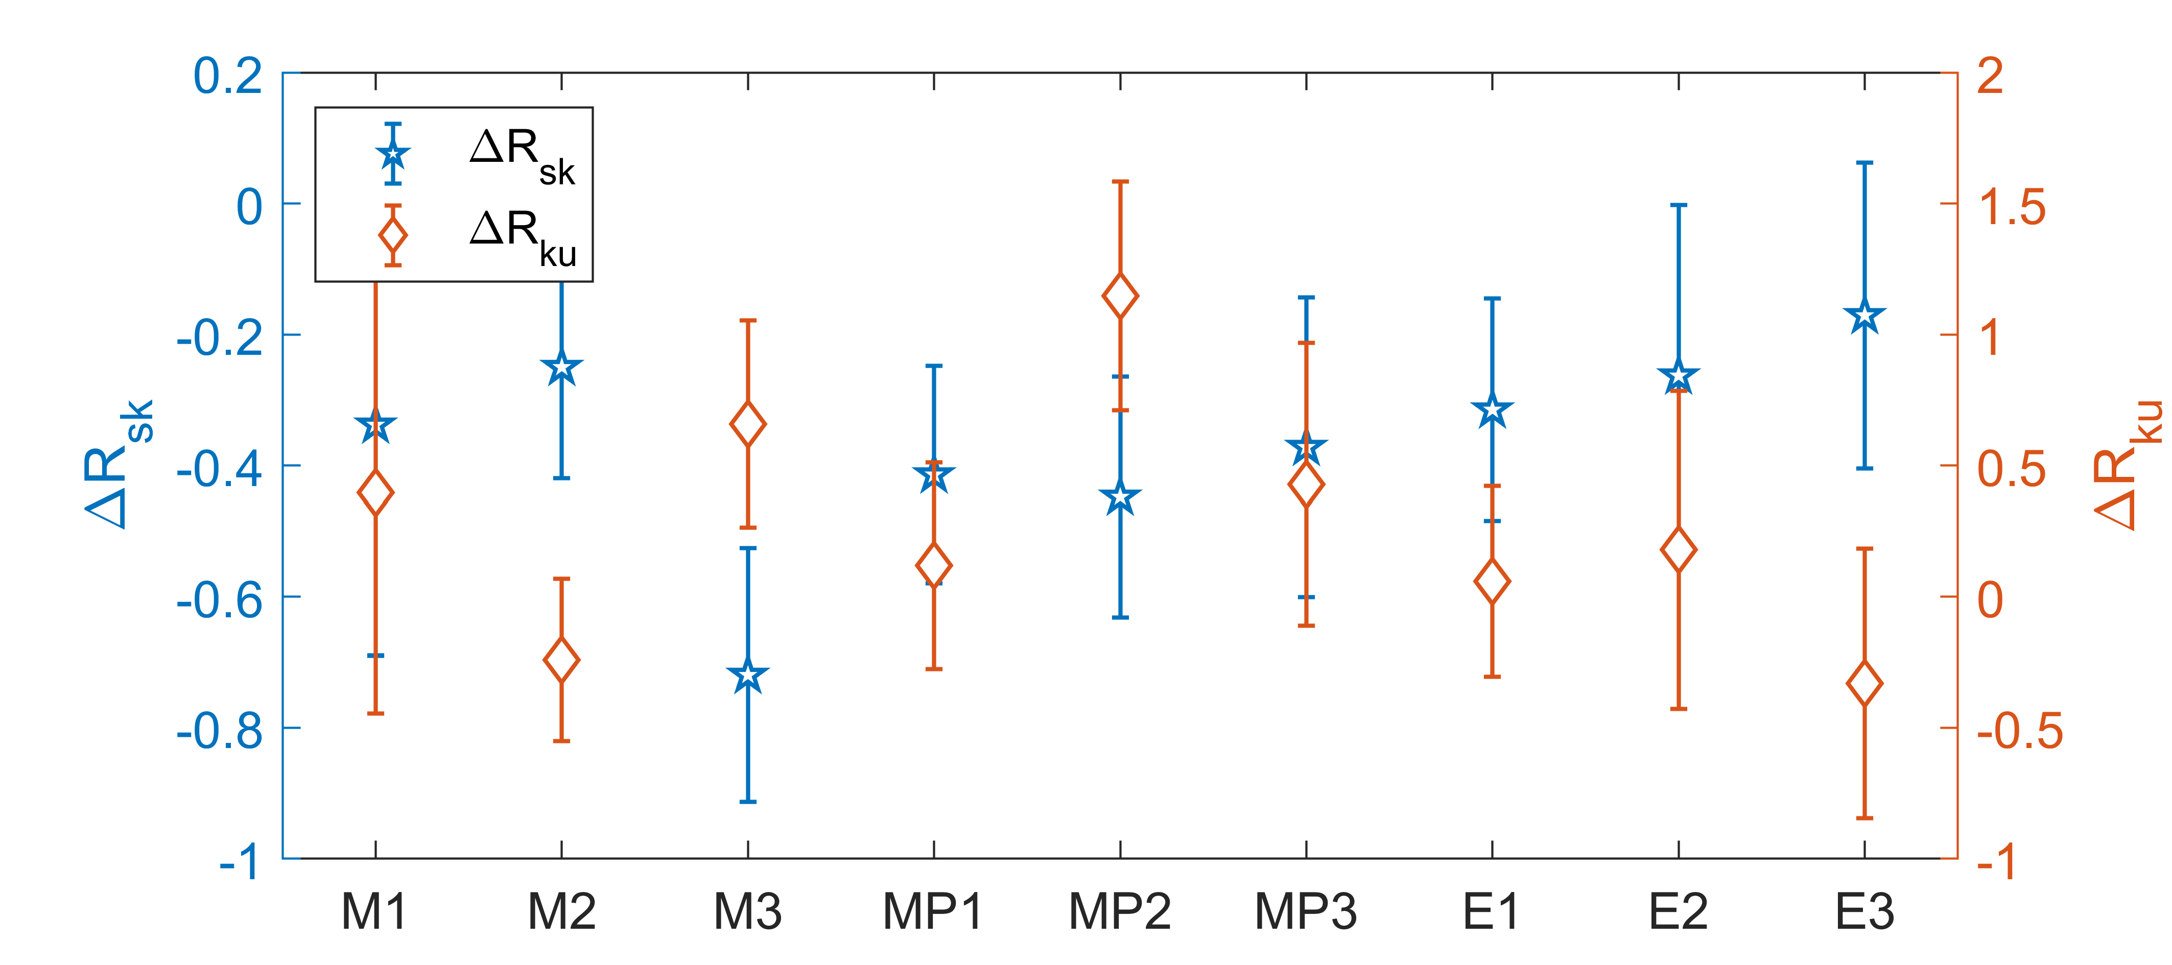
Figure 13 Changes in roughness parameters of Disc 1 surfaces: (a) $R_{q}$, $R_{v}$, and $R_{p}$ (b) $R_{sk}$ and $R_{ku}$ for the virgin, macropitted, micropitted, and electrically pitted conditions

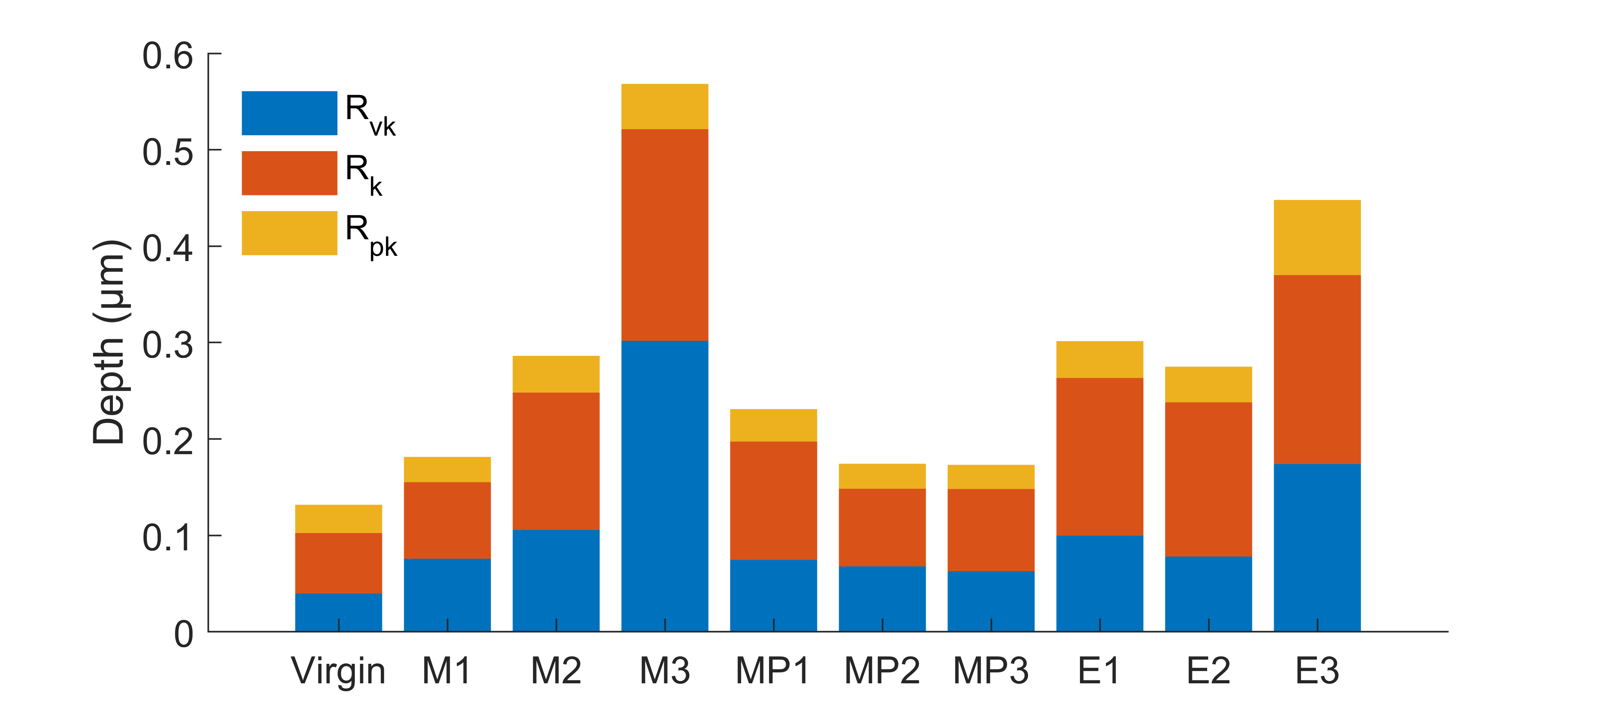
Figure 14 Functional parameters ($R_{k}$, $R_{pk}$, and $R_{vk}$) of Disc 1 surfaces for the virgin, macropitted, micropitted, and electrically pitted conditions
Typical surface profiles are shown in Figure 15 to support the roughness analysis, with the shaded yellow regions indicating the wear track. The macropitted surface exhibits pronounced valley features due to material loss, whereas the micropitted surface remains comparatively smooth. The electrically pitted surface shows intermediate behaviour.
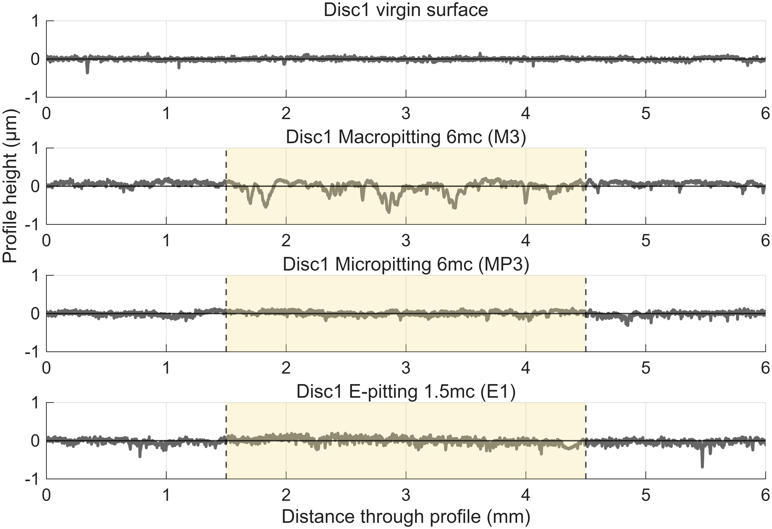
Figure 15 Typical profiles of Disc 1 surfaces for the virgin, macropitted, micropitted, and electrically pitted conditions
Figure 16 presents the average difference of $R_{q}$, $R_{v}$, $R_{p}$, $R_{sk}$, and $R_{ku}$ of Disc2 relative to the untested Disc2. Specifically, M1, MP1, E1, E2, and E3 are compared with the smooth Disc2 ($R_{q}$ = 0.04 μm), and M2, M3, MP2, and MP3 are compared with the roughened Disc2 ($R_{q}$ = 0.26μm). Functional roughness parameters are shown in Figure 17. For the smooth discs, only minor to mild changes were observed in the fatigue pitting tests (M1 and MP1), which can be attributed to limited wear under relatively high lambda ratios. Under comparable lambda conditions, the electrical pitting tests resulted in slightly larger changes in roughness due to surface alterations caused by electrical discharge. In contrast, larger changes were observed for the roughed discs in the fatigue pitting tests. In macropitting tests, $R_{q}$ increased by 67 - 96 nm (25 – 37%) and $R_{v}$ and $R_{p}$ increased by 130 – 200 nm (84 – 178%), accompanied by an increase in skewness and a decrease in kurtosis. This suggests the surface became more peak dominated while extreme asperity features were reduced, likely due to plastic deformation during sliding. In micropitting tests, $R_{q}$ increased by 40 – 150 nm (15 – 58%) and $R_{v}$ and $R_{p}$ increased by 156 – 410 nm (101 – 366%), with both skewness and kurtosis increasing. This indicates the development of more pronounced asperities, which may be associated with ZDDP tribofilm formation.
In fatigue pitting tests, the relative changes in Disc2 were smaller than those for Disc1. This is consistent with observations in Figure 5 and Figure 6, which show that fatigue pitting was predominantly localised on Disc1, as it was subjected to pronounced pressure fluctuations imposed by the rough Disc2, as discussed in Section 3.1.
(a) 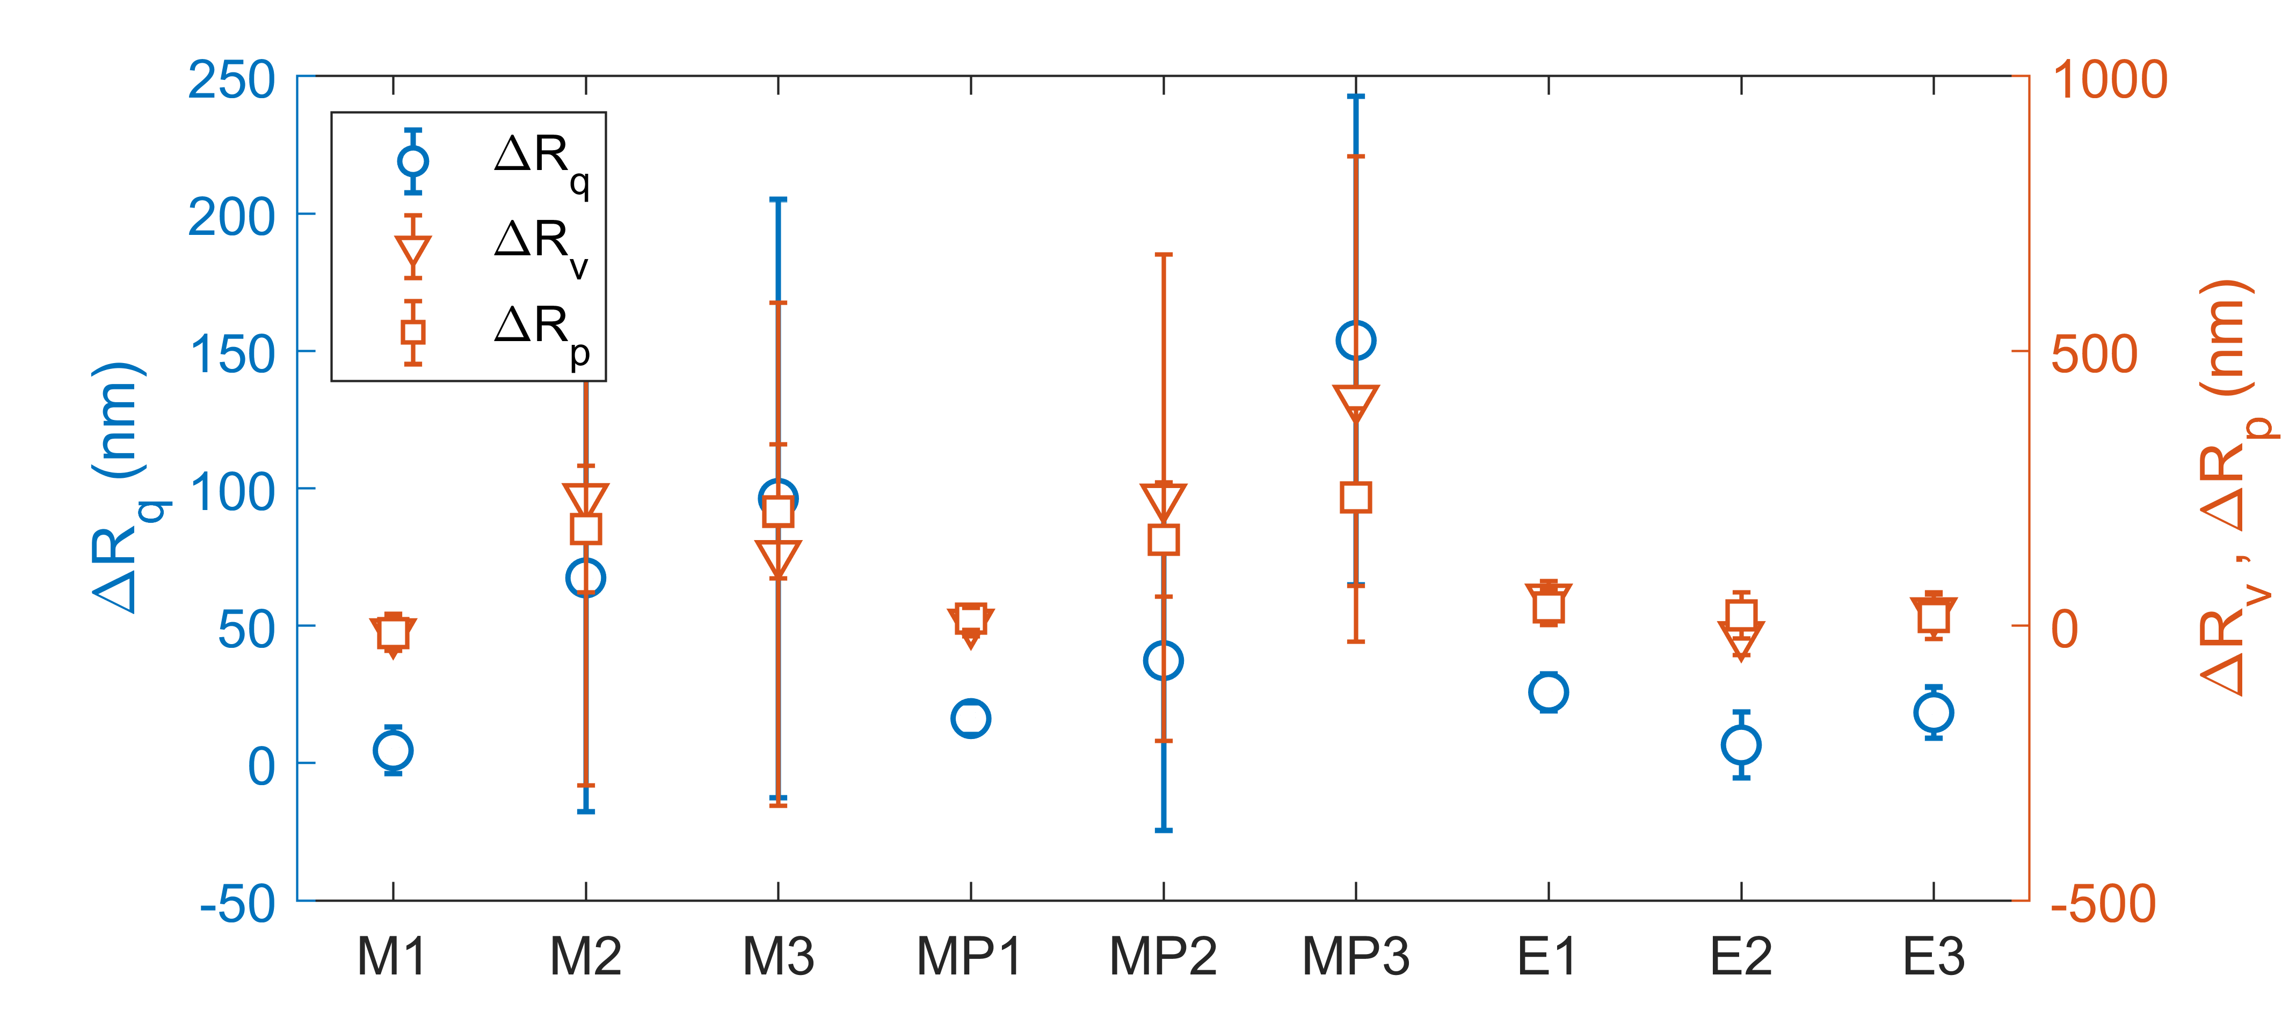
(b) 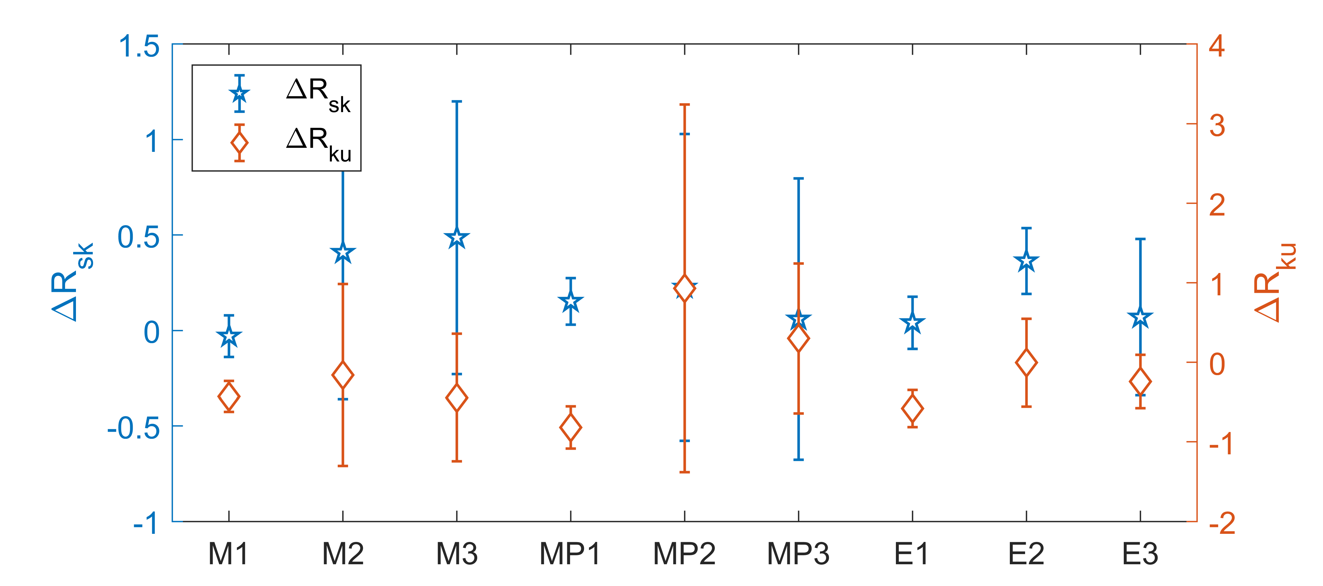
Figure 16 Changes in roughness parameters of Disc 2 surfaces: (a) $R_{q}$, $R_{v}$, and $R_{p}$ (b) $R_{sk}$ and $R_{ku}$ for the virgin, macropitted, micropitted, and electrically pitted conditions

(a) 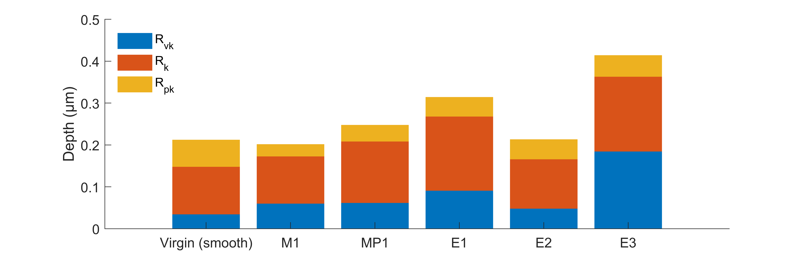
(b) 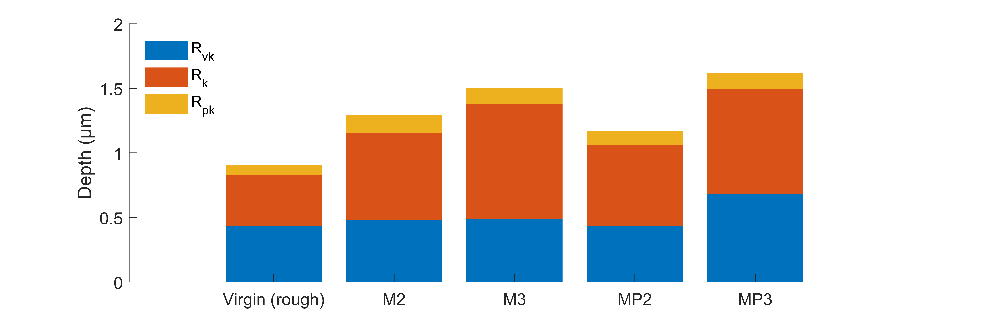
Figure 17 Functional parameters ($R_{k}$, $R_{pk}$, and $R_{vk}$) of Disc 2 surfaces for the virgin, macropitted, micropitted, and electrically pitted conditions

Discussion
The results demonstrate that macropitting, micropitting, and electrical pitting produce fundamentally different surface topographies that reflect their underlying damage mechanisms. Although all three pitting modes manifest as localised material removal, clear differences were observed in pit size, surface coverage, morphology, crack features, and roughness evolution.

RCF driven pitting: macropitting and micropitting
Macropitting was characterised by large pits with dimensions on the order of hundreds of micrometres, substantial depths, and extensive surface coverage. In contrast, micropitting produced more than three times smaller, surface-confined pits with limited growth in size and area fraction.
A common feature of both macropitting and micropitting is that pit initiated from surface cracks oriented in the axial direction, followed by material detachments caused by secondary cracks, as observed in Figure 10 and Figure 11. Crack initiation and opening are dominated by tensile (Mode I) loading [51, 52]. When tensile stress acts in the rolling/sliding direction, cracks open normal to this stress, resulting in surface crack traces oriented perpendicular to the rolling/sliding direction, i.e. in the axial direction [48]. As crack growth proceeds, crack paths may deflect, as crack propagation can also be influenced by shear (Mode II) and tearing (Mode III) loading [48].
The difference between macropitting and micropitting is the extent of crack propagation and material liberation. It is observed from Figure 5 and Figure 6 that, although macropits initiated later than micropits, their progression was faster. Macropits exhibited aggressive secondary crack growth and coalescence, producing deep and large pits with irregular trailing edges, as illustrated in Figure 18 (a). In contrast, micropitting produced smaller pits confined to the near-surface region. The initiation crack was relatively short, with multiple shorter secondary cracks propagating from it. Small volumes of material attachments between adjacent cracks resulted in crescent-like shapes, as indicated in Figure 18 (b).
(a) 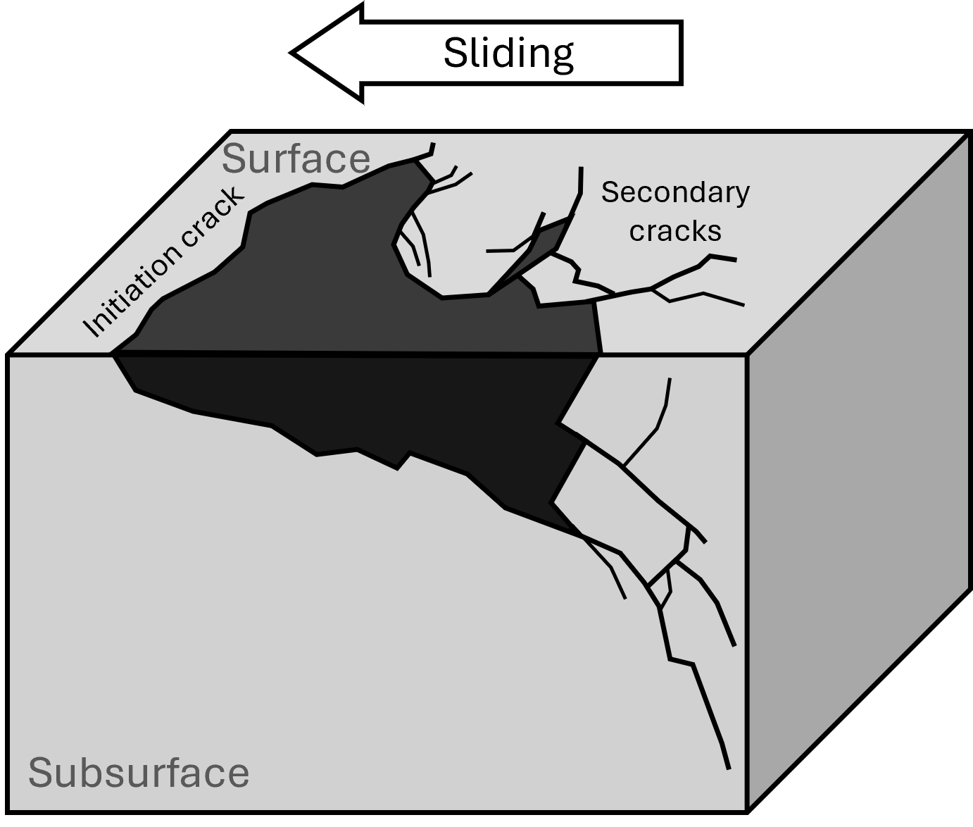 (b) 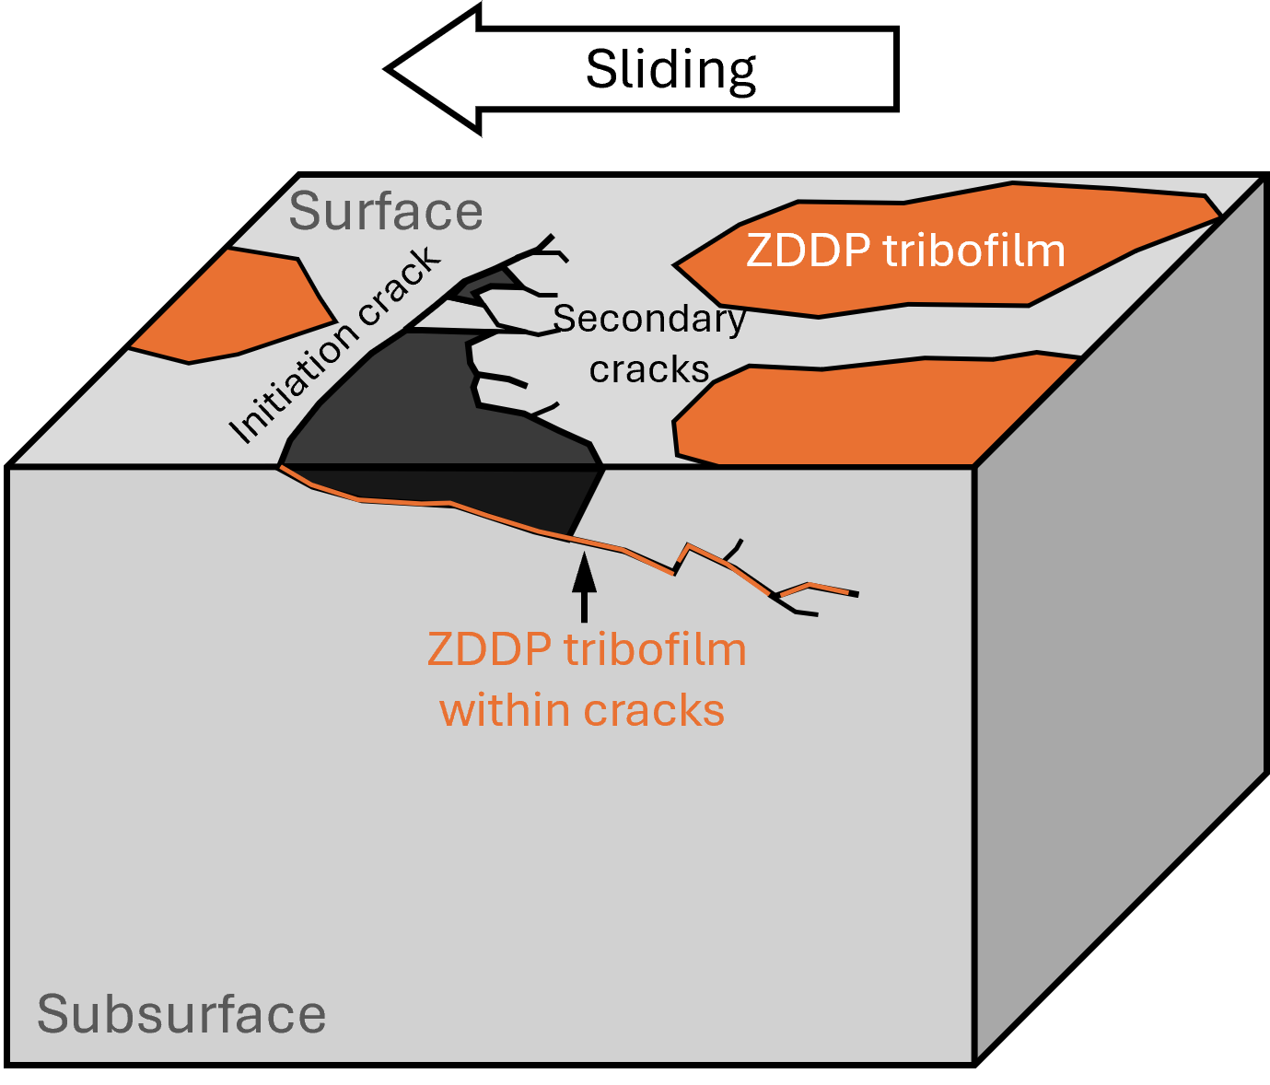
Figure 18 Illustration of formation of (a) macropitting and (b) micropitting
The difference between macropitting and micropitting can be attributed to the effect of ZDDP, which promotes near-surface crack initiation but only leads to small-scale material liberation and suppressed crack propagation. [36, 52] has suggested that elevated surface friction caused by ZDDP tribofilm enhances tensile and shear stresses in the near-surface region, promoting crack initiation. Friction moves the location of the maximum shear stress towards the surface, further increasing the likelihood of surface initiated cracking [52]. Further, ZDDP tribofilm also protects surfaces from wear, enabling accumulation of fatigue and therefore promoting crack initiation. This behaviour is reflected in the roughness and surface profile measurements. In macropitting tests, substantial increases in $R_{q}$, $R_{sk}$, $R_{k}$, and $R_{vk}$ were observed, indicating the formation of deep valleys and severe modification of the load-bearing surface. In contrast, surfaces subjected to micropitting exhibited much smaller changes in roughness parameters, indicating limited material removal. Following initiation, the presence of tribofilm on crack faces increases crack face friction, reducing crack opening and sliding and thereby inhibiting crack propagation and slowing the progression of micropitting.
It has been reported that macropits originated from micropits under prolonged testing durations (6–30 million cycles), high Hertzian contact pressures (> 2 GPa), and higher lambda ratios within the mixed lubrication regime, where micropitting severity remained moderate [45]. In the present study, such a transition was not observed, which may be attributed to differences in material properties, test conditions, and test machine configuration. Nevertheless, given the common crack initiation and propagation characteristics identified for both pitting modes, a transition from micropitting to macropitting may occur under extended testing or more severe operating conditions.

Electrically induced pitting: discharge-dominated material removal
Electrical pitting exhibited a fundamentally different damage signature compared with RCF pitting. Observations revealed crater-like pits with sharp edges, approximately circular morphologies, and a notable absence of surrounding cracks.
Literature indicated in EHL contacts, when the bearing voltage exceeds the dielectric strength of the lubricant film, electrical breakdown occurs and the stored electrical energy is released as an EDM-like pulse through the contact [8, 14]. At microscopic asperity junctions, the resulting high current density causes rapid local melting and vaporisation of the metal; when the discharge ceases, the molten material cools and resolidifies, forming a pit [8, 14].
The circular morphology of the electrical pits has been explained to be due to the axisymmetric nature of the discharge process [53, 54], who employed electro-thermal models with Gaussian-distributed heat flux over a circular plasma channel predicted radially symmetric melting and bowl-shaped craters. In addition, thermo-fluidic modelling showed that subsequent symmetric bubble collapse expelled molten material radially, further reinforcing crater circularity [53].

Surface roughness and topographical evolution for different pitting modes
Distinct surface roughness and topographical features were observed for the different pitting modes. In [17], surface topography evolution during running-in was investigated using the same bearing steel, test machine, and lubricant viscosity grade. A general reduction in roughness parameters ($R_{a}$, $R_{v}$, and $R_{p}$) was observed under varying entrainment velocity, contact pressure, and slip, indicating surface smoothing as asperity peaks were plastically deformed or mildly worn during running-in. In the present pitting tests, an opposite trend was observed, with increases in surface roughness, particularly in $R_{q}$and $R_{v}$. This difference reflects a transition from running-in behaviour to damage-dominated surface evolution, where cyclic contact stresses or electrical effects promote roughness growth and valley formation.
Macropitting tests exhibited the largest changes in surface roughness. The pronounced increases in $R_{q}$, $R_{v}$, and $R_{vk}$ indicate that surface evolution was dominated by valley formation. This behaviour is attributed to cyclic contact stresses that promote near-surface plastic deformation, leading to surface degradation and the development of deep valleys. The resulting increase in surface roughness reduces the lambda ratio, thereby accelerating the progression of macropitting.
In contrast, micropitting tests showed the smallest changes in roughness, which is attributed to the presence of ZDDP tribofilm. The tribofilm, typically 50–150 nm thick [55, 56] and formed preferentially on contact asperities under high shear stress [57], stabilised the surface roughness and mitigated wear by reducing direct metal-to-metal contact [55, 57]. As a result, the tribofilm effectively protected the surface from significant material removal, limiting roughness evolution.
Electrical pitting tests exhibited moderate increases in roughness, exceeding those observed in the short macropitting and all micropitting tests, but remaining lower than those of the long-duration macropitting test. This indicates that the application of an electrical potential altered the surface through repeated discharge events, with evidence of groove-like features along the rolling/sliding direction observed in Figure 12.
This work has linked pitting morphology to underlying damage mechanisms using surface topography. While previous studies have examined individual pitting modes in isolation, the present work provides a unified framework that distinguishes fatigue-driven and electrically induced pitting based on pit geometry, crack features, and roughness evolution under controlled rolling–sliding conditions. This mechanistic interpretation enables more reliable diagnosis of pitting origin in practical applications.

Conclusions
This study systematically investigated macropitting, micropitting, and electrical pitting in rolling–sliding contacts using a controlled twin-disc tribometer and consistent surface characterisations. The three pitting modes exhibit fundamentally different surface morphologies and damage severities. The main conclusions can be summarised as follows:
- Macropitting, micropitting, and electrical pitting exhibited distinct morphological characteristics. Macropitting produced large, irregular pits with extensive cracking, with an average pit width of approximately 475 µm. Micropitting generated smaller, confined pits with an average width of 138 µm and a crescent-like morphology. Electrical pitting produced approximately circular pits with an average width of 32 µm, typically occurring in clusters.
- Both macropitting and micropitting were initiated from surface cracks oriented in the axial direction, indicating a common crack initiation mechanism governed by tensile stresses. However, the extent of secondary crack propagation and material liberation differed substantially. Macropitting was characterised by aggressive secondary crack growth and coalescence, leading to rapid pit growth, while micropitting remained confined due to limited crack propagation.
- Electrical pitting displayed a fundamentally different formation mechanism from RCF pitting. It is dominated by localised discharge-induced melting and resolidification rather than crack growth. Electrical pitting could occur earlier than fatigue-driven pitting under comparable test durations and resulted in more pronounced surface roughening of the disc surfaces.
- Roughness measurements revealed clear, mechanism-dependent surface modifications. Macropitting tests exhibited substantial roughness increases, with $R_{q}$increasing by up to 130 nm. In contrast, micropitting tests showed only limited roughness growth ($R_{q}$ increases of up to 20 nm), reflecting the protective effect of the ZDDP tribofilm in mitigating material removal. Electrical pitting resulted in moderate roughness increases ($R_{q}$ increases of 32–61 nm), associated with widespread groove formation induced by electrical discharge.
The identified trends in roughness parameters provide insight into the evolution of different pitting modes. While direct topographic measurement is not feasible in practical machinery during operation, the characteristic surface features can serve as failure indicators. They may assist in correlating condition monitoring signals with underlying surface damage mechanisms, thereby supporting failure mode identification in engineering applications.

Acknowledgements
The authors would like to thank the Engineering and Physical Sciences Research Council (EPSRC) funding: EP/S005463/1 Early detection of contact distress for enhanced performance monitoring and predictive inspection of machines for providing financial support for this work. The authors also thank Schaeffler Technologies GmbH &Co. KG for providing the experimental samples.

References
1. Liu, H., et al., A review on micropitting studies of steel gears. Coatings, 2019. 9(1): p. 42.
2. Schneider, V., et al., Electrical bearing damage, a problem in the nano-and macro-range. Lubricants, 2022. 10(8): p. 194.
3. Peng, H., et al., Review of tribological failure analysis and lubrication technology research of wind power bearings. Polymers, 2022. 14(15): p. 3041.
4. Ma, J., et al., Motor bearing damage induced by bearing current: A Review. Machines, 2022. 10(12): p. 1167.
5. Jantara Jr, V.L. and M. Papaelias, Wind turbine gearboxes: Failures, surface treatments and condition monitoring, in Non-Destructive Testing and Condition Monitoring Techniques for Renewable Energy Industrial Assets. 2020, Elsevier. p. 69–90.
6. Aikin, A.R., Bearing and gearbox failures: Challenge to wind turbines. Tribology & Lubrication Technology, 2020. 76(8): p. 38–44.
7. Guo, L., et al., Study on the electric discharge behaviour of a single contact in EV motor bearings. Tribology International, 2023. 187: p. 108743.
8. Li, Z., R. Cai, and X. Nie, Experimental Study: Bearing Degradation Caused by Electrical Currents and Voltages at Low Speeds. Lubricants, 2025. 13(4): p. 175.
9. Gloeckner, P. and F.-J. Ebert, Micro-sliding in high-speed aircraft engine ball bearings. Tribology transactions, 2010. 53(3): p. 369–375.
10. Corni, I., et al., Characterization and mapping of rolling contact fatigue in rail-axle bearings. Engineering Failure Analysis, 2017. 82: p. 617–630.
11. Symonds, N. Rolling contact fatigue–review and case study. in Conference Proceedings NATO-RTA-AVT-109: The Control and Reduction of Wear in Military Platforms. Session. 2004.
12. Errichello, R., Morphology of micropitting. Gear technology, 2012. 4: p. 74–81.
13. Kissling, U., Application of the first international calculation method for micropitting. Gear Technol, 2012. 5: p. 54–60.
14. He, F., G. Xie, and J. Luo, Electrical bearing failures in electric vehicles. Friction, 2020. 8(1): p. 4–28.
15. Janik, J.R., et al., Exploring the boundaries of electrically induced bearing damage in grease-lubricated rolling contacts. Lubricants, 2024. 12(8): p. 268.
16. Gadelmawla, E., et al., Roughness parameters. Journal of materials processing Technology, 2002. 123(1): p. 133–145.
17. Harvey, T.J., et al., Changes in surface topography during running-in of bearing steel contacts under mixed lubrication. Surface Topography: Metrology and Properties, 2025. 13(3): p. 035020.
18. Roy, S., D. White, and S. Sundararajan, Correlation between evolution of surface roughness parameters and micropitting of carburized steel under boundary lubrication condition. Surface and Coatings Technology, 2018. 350: p. 445–452.
19. Prajapati, D.K. and M. Tiwari, Experimental analysis of contact fatigue damage using fractal methodologies. Wear, 2020. 450: p. 203262.
20. Prajapati, D.K. and M. Tiwari, Experimental investigation on evolution of surface damage and topography parameters during rolling contact fatigue tests. Fatigue & Fracture of Engineering Materials & Structures, 2020. 43(2): p. 355–370.
21. Poletto, J.C., et al., Identification of gear wear damage using topography analysis. Wear, 2023. 522: p. 204837.
22. Cardoso, N., et al., Micropitting performance of nitrided steel gears lubricated with mineral and ester oils. Tribology International, 2009. 42(1): p. 77–87.
23. Martins, R., J. Seabra, and L. Magalhães, Austempered ductile iron (ADI) gears: Power loss, pitting and micropitting. Wear, 2008. 264(9-10): p. 838–849.
24. Tian, Z., et al., Monitoring and mapping of pitting in bearing steel contacts via vibration-based analysis. Tribology International, 2025: p. 111563.
25. Ai, X., Rolling Element Bearing Surface Finish, in Encyclopedia of Tribology. 2013, Springer. p. 2927–2932.
26. Vrček, A., et al., Micro-pitting damage of bearing steel surfaces under mixed lubrication conditions: effects of roughness, hardness and ZDDP additive. Tribology International, 2019. 138: p. 239–249.
27. Rycerz, P. and A. Kadiric, The influence of slide–roll ratio on the extent of micropitting damage in rolling–sliding contacts pertinent to gear applications. Tribology Letters, 2019. 67: p. 1–20.
28. Farfan-Cabrera, L., et al., Electrified four-ball testing of ZDDP and MoDTC as additives in low-viscosity synthetic oil. Wear, 2025: p. 205835.
29. Ali, M.K.A., et al., Do electrification-temperature effects deteriorate ZDDP tribofilms in electric vehicles transmission? Insights into antiwear mechanisms using low-SAPS oils. Wear, 2025. 564: p. 205746.
30. Rycerz, P., A. Olver, and A. Kadiric, Propagation of surface initiated rolling contact fatigue cracks in bearing steel. International Journal of Fatigue, 2017. 97: p. 29–38.
31. Zhou, Y., et al., The effect of contact severity on micropitting: Simulation and experiments. Tribology International, 2019. 138: p. 463–472.
32. Brizmer, V., et al., The influence of tribolayer formation on tribological performance of rolling/sliding contacts. Tribology Letters, 2017. 65(2): p. 57.
33. Esmaeili, K., et al., A Study on the Influence of Electrical Discharges on the Formation of White Etching Cracks in Oil-Lubricated Rolling Contacts and Their Detection Using Electrostatic Sensing Technique. Lubricants, 2023. 11(4): p. 164.
34. Arakere, N.K., Gigacycle rolling contact fatigue of bearing steels: A review. International Journal of Fatigue, 2016. 93: p. 238–249.
35. Wandel, S., et al., Wear development in oscillating rolling element bearings. Lubricants, 2023. 11(3): p. 117.
36. Tian, Z., et al., Influence of ZDDP tribofilm on micropitting formation and progression. Tribology International, 2024. 199: p. 109938.
37. Lokhande, R., et al., Review on Tribological and Vibration Aspects in Mechanical Bearings of Electric Vehicles: Effect of Bearing Current, Shaft Voltage, and Electric Discharge Material Spalling Current. Lubricants, 2025. 13(8): p. 349.
38. Spikes, H., Basics of EHL for practical application. Lubrication science, 2015. 27(1): p. 45–67.
39. Yin, Y., et al., Frequency-Dependent Molecular Relaxation and Interfacial Polarization in Electrical Pitting: Unveiling Tribochemical Mechanisms in PAO8 under Alternating Electric Fields. Tribology International, 2025: p. 111296.
40. Jablonka, K., R. Glovnea, and J. Bongaerts, Evaluation of EHD films by electrical capacitance. Journal of physics D: applied physics, 2012. 45(38): p. 385301.
41. Torres, J. and R. Dhariwal, Electric field breakdown at micrometre separations. Nanotechnology, 1999. 10(1): p. 102.
42. Salcedo, M.C., I.B. Coral, and G.V. Ochoa, Characterization of surface topography with Abbott Firestone curve. Contemp. Eng. Sci, 2018. 11(68): p. 3397–3407.
43. Pawlus, P., et al., Material ratio curve as information on the state of surface topography—A review. Precision Engineering, 2020. 65: p. 240–258.
44. Errichello, R., Morphology of micropitting. Gear Technol, 2012. 4: p. 74–81.
45. Wainwright, B. and A. Kadiric, Surface fatigue in lubricated contacts: Mapping the failure modes of micropitting versus macropitting. International Journal of Fatigue, 2025. 197: p. 108908.
46. Sharif, K., Predictive modelling of fatigue failure in concentrated lubricated contacts. Faraday discussions, 2012. 156(1): p. 105–121.
47. Clarke, A., H.P. Evans, and R. Snidle, Understanding micropitting in gears. Proceedings of the Institution of Mechanical Engineers, Part C: Journal of Mechanical Engineering Science, 2016. 230(7-8): p. 1276–1289.
48. Ren, Z., B. Li, and Q. Zhou, Rolling contact fatigue crack propagation on contact surface and subsurface in mixed mode I+ II+ III fracture. Wear, 2022. 506: p. 204459.
49. Soltanahmadi, S., et al., Tribochemical study of micropitting in tribocorrosive lubricated contacts: The influence of water and relative humidity. Tribology International, 2017. 107: p. 184–198.
50. Ueda, M., H. Spikes, and A. Kadiric, In-situ observations of the effect of the ZDDP tribofilm growth on micropitting. Tribology International, 2019. 138: p. 342–352.
51. Sun, C.-T. and Z. Jin, Fracture mechanics. 2011: Academic press.
52. Ueda, M., et al., The effect of friction on micropitting. Wear, 2022. 488: p. 204130.
53. Tao, J., J. Ni, and A.J. Shih, Modeling of the anode crater formation in electrical discharge machining. 2012.
54. Shao, B. and K.P. Rajurkar, Modelling of the crater formation in micro-EDM. Procedia CIRP, 2015. 33: p. 376–381.
55. Zhang, J. and H. Spikes, On the mechanism of ZDDP antiwear film formation. Tribology Letters, 2016. 63: p. 1–15.
56. Spikes, H., The history and mechanisms of ZDDP. Tribology letters, 2004. 17(3): p. 469–489.
57. Spikes, H., Mechanisms of ZDDP—an update. Tribology Letters, 2025. 73(1): p. 38.

