Investigation towards isolated epoxy impregnated REBCO windings

Owain Atkins*, Masood Rauf Khan, Zhenzhou Wang, Wendell Bailey, and Yifeng Yang

Abstract—This work presents the development and characterisation of an 11-turn REBCO coil. The coil was dry-wound on a G10 former with copper electrodes and ultra-thin 30 micron-thick glass fibre insulation to compensate for the lack of mechanical stability offered by alternative insulations, while still enabling complete vacuum resin impregnation of the coil. Prior to coil fabrication, transport measurements were performed on single-tape and insulated tape-stack samples to evaluate the electrical and thermal performance of the REBCO tape under the influence of self-generated magnetic fields with different current configurations at 77 K. As expected, the self-field significantly affected the parallel configuration. However, a notable and unexpected reduction in critical current was also observed in the antiparallel configuration. Data from short-tape experiments were used to inform simulations of the coil, providing theoretical performance predictions that were later compared with the actual performance of the fabricated coil. The coil itself was designed and wound, and its thermal and electrical behaviour was analysed by experiments conducted at both 77 K and 65 K. The coils electrical performance seemed to match the simulation results reasonably well, lending encouraging support to the insulation/impregnation strategy and an operational reliability upon multiple quenches and thermal cycles. Furthermore, the fully impregnated structure improves coil handleability for future integration into larger machines compared to non-insulated coils with little to no penalty in performance.

Index Terms— High temperature superconductors, Pancake Coil, turn-to-turn insulation, HTS coils, 2G HTS Conductors, Superconducting tapes, Composite insulation.

*Corresponding author: Owain Atkins
The authors are with the Institute of Cryogenics, Faculty of Engineering and Physical Sciences, University of Southampton, Southampton SO17 1BJ, U.K.
(e-mails: O.Atkins@soton.ac.uk; M.R.Khan@soton.ac.uk;
Zhenzhou.Wang@soton.ac.uk; W.O.S.BAILEY@soton.ac.uk; Y.Yang@soton.ac.uk)

Introduction
Rare-Earth Barium Copper Oxide (REBCO) conductors are renowned for their exceptional performance in high-field and high-power environments; these materials can sustain high current densities even under strong magnetic fields and at high temperatures [1], [2], [3]. Their properties make them highly suitable for applications such as power cables, high-field magnets, transformers, fault current limiters, and rotating machines [4], [5], [6]. Due to these superior electromagnetic and thermal properties, REBCO conductors have become the preferred choice for fabricating next-generation high-field superconducting magnets [7], [8], [9].
Since its introduction to High-Temperature Superconductors (HTS) research in 2011, no-insulated and metal-insulated coils have taken centre stage due to the ability to current share [10] across adjacent turns to provide a better quench mitigation and cryogenic stability [11], [12]. However, fast field changes, integral to transformers and AC armatures of rotating machines as well as some laboratory magnets, require turn-to-turn insulation to deliver the short time constant necessary for the superconducting windings. Furthermore, for coil windings and insulations as heterogeneous composites, impregnation has long been a preferred technology for the mechanical stability and efficient heat transfer between adjacent turns [13], [14]. The type and thickness of the insulation depend on the specific requirement of the coil design and by the need to achieve matching of thermal contraction between the conductors, insulation and impregnation matrix. In contrast, the choice of impregnation resin is governed by breakdown voltage, thermal contraction, and thermal and electrical conductivity [15], [16], [17].
A variety of materials have been used for insulation, including, but not limited to, Kapton tape, polyurethane, Vanadium Oxide, and polyester [18], [19], [20]. Among these, Kapton tape is very thin, widely available, and has sufficient insulating performance. However, the low yield strength and relatively high thermal contraction of Kapton limits its effectiveness in providing shear support required for REBCO windings. Furthermore, its poor wettability often leads to inhomogeneous bonding with the impregnant. Vanadium Oxide, often used in more complex fabrication processes, suffers from degradation in its insulating properties at low temperatures [21], [22]. Overall, the main challenge remains managing the mechanical strain generated because of the thermal expansion mismatch between insulation material and HTS tapes, which can eventually lead to delamination and degradation of critical current [23], [24].
To address these challenges, we have developed a novel fibreglass-based insulation technique for HTS windings. This approach has been applied successfully in the BSCCO-2223 racetrack coils for the superconducting rotors of two 100-kW synchronous generators, and in a REBCO Roebel cable pancake coil [25], [26], [27].
In this study, a similar insulating methodology was applied to produce short REBCO samples (e.g. single-tape and stacked-tape samples) to evaluate electrical and thermal performance under self-field conditions at 77 K and varying the direction of current injection. As expected, current-voltage (I-V) data obtained from short stacked-tape samples showed how the generated self-field significantly reduced critical current when current was injected in parallel. Unexpectedly, a reduction was observed when the current was injected in the anti-parallel configuration, with further investigation required to fully understand the effects. Based on these results, a turn-to-turn insulated coil was designed and fabricated using a thin fibreglass mesh as the insulator. Its thermal and electrical behaviours were analysed through numerical simulations and transport measurements at 77 K and 65 K, with the measured performance closely matching theoretical predictions.

Materials and Experimental Apparatus
To make the insulation, a thin (30 µm) fibreglass sheet was coated with diluted GE varnish to facilitate handling and precise cutting while remaining permeable to epoxy. The sheet was then cut into narrow strips of 4 to 4.5mm width. GE varnish is widely used in cryogenic applications with good thermal conductivity and electrical insulation properties [28]. The fibregalss strips are then spooled together after being inspected.
The superconducting tapes selected for this study included a 4-mm-wide, 75-μm-thick REBCO tape supplied by Shanghai Superconductor, and 4.5-mm-wide, 230-μm-thick Ag-sheathed PbBi2223 tape from Sumitomo Electric Industries. Eventually, Sumitomo tape was used only for producing short-tape samples. Stycast 1266 resin was used for impregnating coils and bonding short samples.
All experiments at 77 K were conducted in a vacuum-insulated cryostat with the samples/coils fully submerged in liquid nitrogen t. The cryostat could be sealed and evacuated to close to the triple point of nitrogen for measurements at 65K. The transport current was supplied by an Agilent 6680A DC power supply with a maximum output of 875 A, while voltage and temperature were recorded using an Agilent 34970A data logger interfaced with Benchlink software. All experiments were conducted with resistive protection, which required post-processing of the results to determine the current during the experiment.

Method and Assembly

Short Sample Assembly
Three sets of short-stacked sample (Fig. 1A) were prepared in four sequential steps. In step 1, the “top” tape was attached to a G10 substrate. In step 2, the same tape was layered with a thin fibreglass strip while leaving one end of the tape exposed to make the electrical connection with the bottom tape. The third step required careful alignment using an optical microscope at 4× magnification before bonding the top and bottom tapes together. In the fourth and final step, the bottom and top tapes were soldered to the sample holder with the superconducting side of the sample tape placed in contact with the copper contact for soldering.
The critical current of the tape was measured using the standard four-probe method. Two voltage taps were attached to each tape, spaced 29–35 mm apart and positioned symmetrically about the centre of the 100 mm long sample.
To control the direction of current flow in the sample, current lead A was connected to the top tape, current lead B connected to the bottom tape, and current lead C connected to the end of the sample where both top and bottom tapes were joined as indicated in Fig. 1A.
For “anti-parallel” current flow or currents flowing in opposite directions, current lead A and B are operational with current lead C disconnected. Current flows into the top tape through lead A and exits the bottom tape through lead B as indicated in Fig. 1B.
.
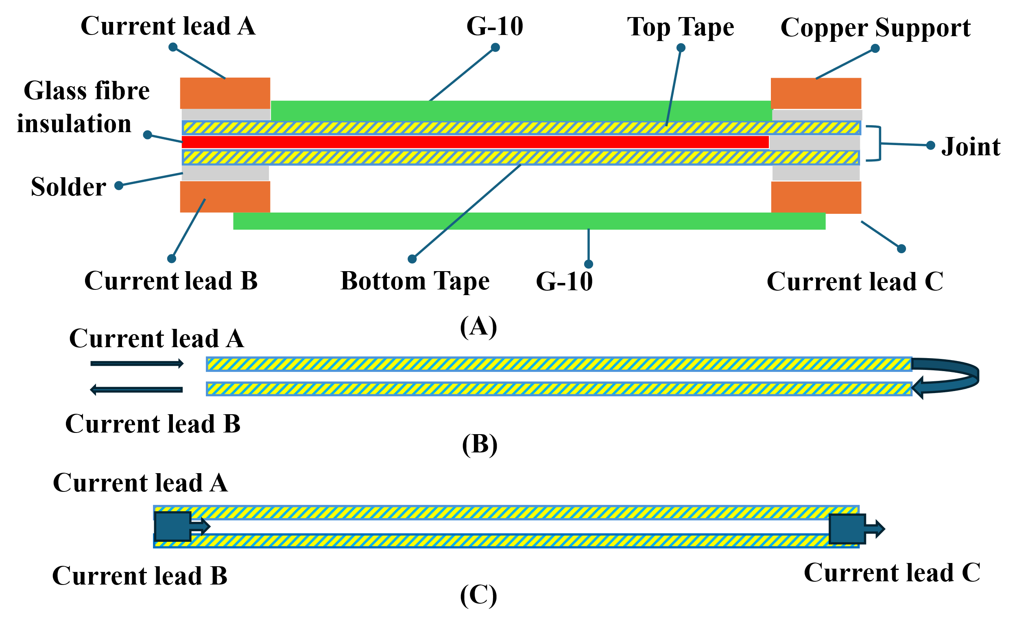
Fig. 1. A) Schematic diagram of the short sample holder. B) anti-parallel current flow, current direction shown by arrows. C) parallel current flow, current direction shown by arrows.

The 11-Turn Coil Assembly
The coil was wound on a bespoke 50 mm diameter G10 former machined as pictured in Fig. 2, with a 1mm-thick copper shim preformed to match the former radius providing the interface for the coil's inner terminal. The REBCO tape and glass fibre insulation were co-wound and fixed to the former using GE varnish before starting the winding. The coil was formed by dry winding a total of ten full turns, each interleaved with a layer of insulation. A second copper preformed shim was fixed to the G10 former with countersunk screws and the final turn wound over the outer terminal. All solder joints between HTS tape and copper were conducted in a low-oxygen environment, and the final coil had a measured outer diameter of 52mm. The loosely bounded coil was impregnated with resin under the medium vacuum.
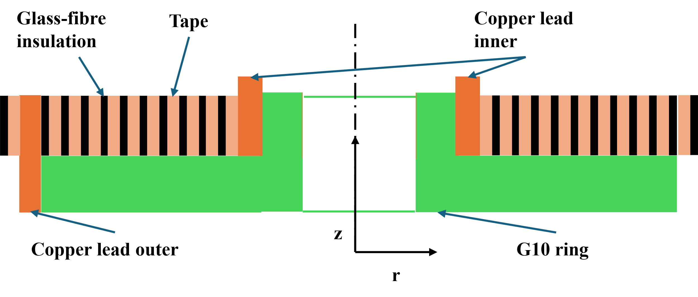
Fig. 2. 2-D diagram showing the cross-section of the 11-turn coil.

Results and Discussion

A. Short Tape Simulation
Alongside the experimental measurements, simulations of the current distribution and transport critical currents of single and stacked tapes were carried out for the parallel and anti-parallel configurations with the self-field effect included. For a tape of width $2a$, the transport critical current $I_{c}=\int_{-a}^{a}{σ\left(x\right)dx }$is obtained upon the current density $σ\left(x\right)$ everywhere along the width reaches the critical density at corresponding local field, i.e., $σ\left(x\right)=σ_{c}\left(B\left(x\right)\right)$ with $B\left(x\right)=μ_{0}/2π\int_{-a}^{a}{σ_{c}(B(x'))/((x'-x) ) dx'}$ where, instead of the usual area current density $J$, the linear current density $σ$ per unit width is used since its critical value $σ_{c}=I_{c}/2a$ is well-defined irrespective of the thin tape thickness $δ$, which plays a negligible role in the self-field distribution and often is only notionally specified by the conductor manufacturers. The self-field equation above can be solved numerically over a regular mesh by self-consistent iterations for any given $σ_{c}\left(B\right)$ dependence. For the present work, an anisotropic critical current density:

${ σ}_{c}\left(B,θ\right)=σ_{C0}{\left(1+γ\left(θ\right)\left|B\right|/B_{0}\right)}^{-p}$
with $γ\left(θ\right)=\sqrt[m]{{\left|\cos{θ}\right|}^{m}+{\left|ϵ^{-1}\sin{θ}\right|}^{m}}$ is used with $θ$ being the angle between $\vec{B}$ and the normal direction of the tape face and the anisotropy parameter $ϵ≫1$.

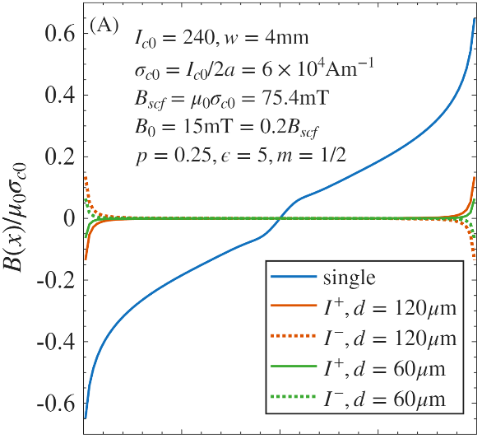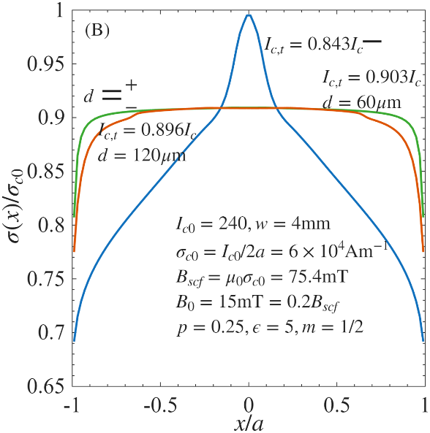
Fig. 3. Simulation results for single-tape and anti-parallel double-tape configurations. I+ is the first tape with current flowing through it, I- is the second tape with equal and opposite current, and d is the distance between the HTS tapes. The green line shows the A) magnetic field distribution across tapes. B) critical current distribution in the tapes at a separation of 60µm. The orange line shows the A) magnetic field distribution across tapes. B) critical current distribution in the tapes at a separation of 120µm.

Simulation results for both the single-tape and anti-parallel double-tape configurations are presented in Fig. 3. From the double-tape case, the magnetic field generated by the anti-parallel configuration is nearly zero across almost the entire width of the tape, with only a noticeable residual field at the tapes’ edges (see Fig, 3(A)). This results in a higher critical current capacity, as illustrated in Fig. 3(B).

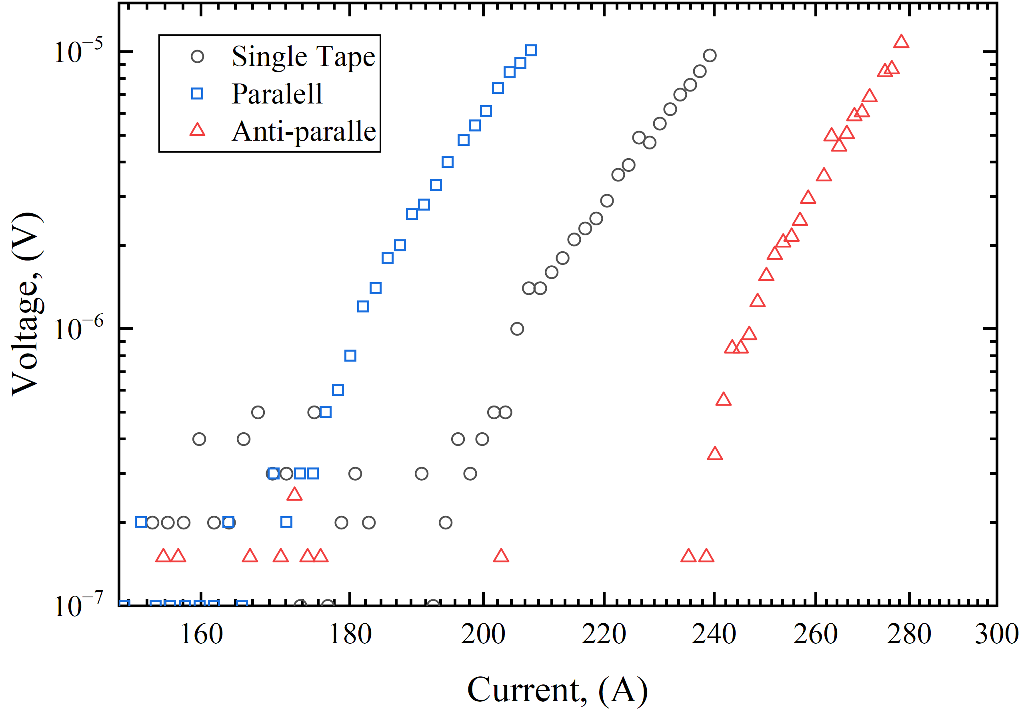
Fig. 4. Ag-sheathed PbBi-2223 short-tape measurement with different current flow configurations: i) double-tape anti-parallel, ii) double-tape parallel, and iii) single tape.

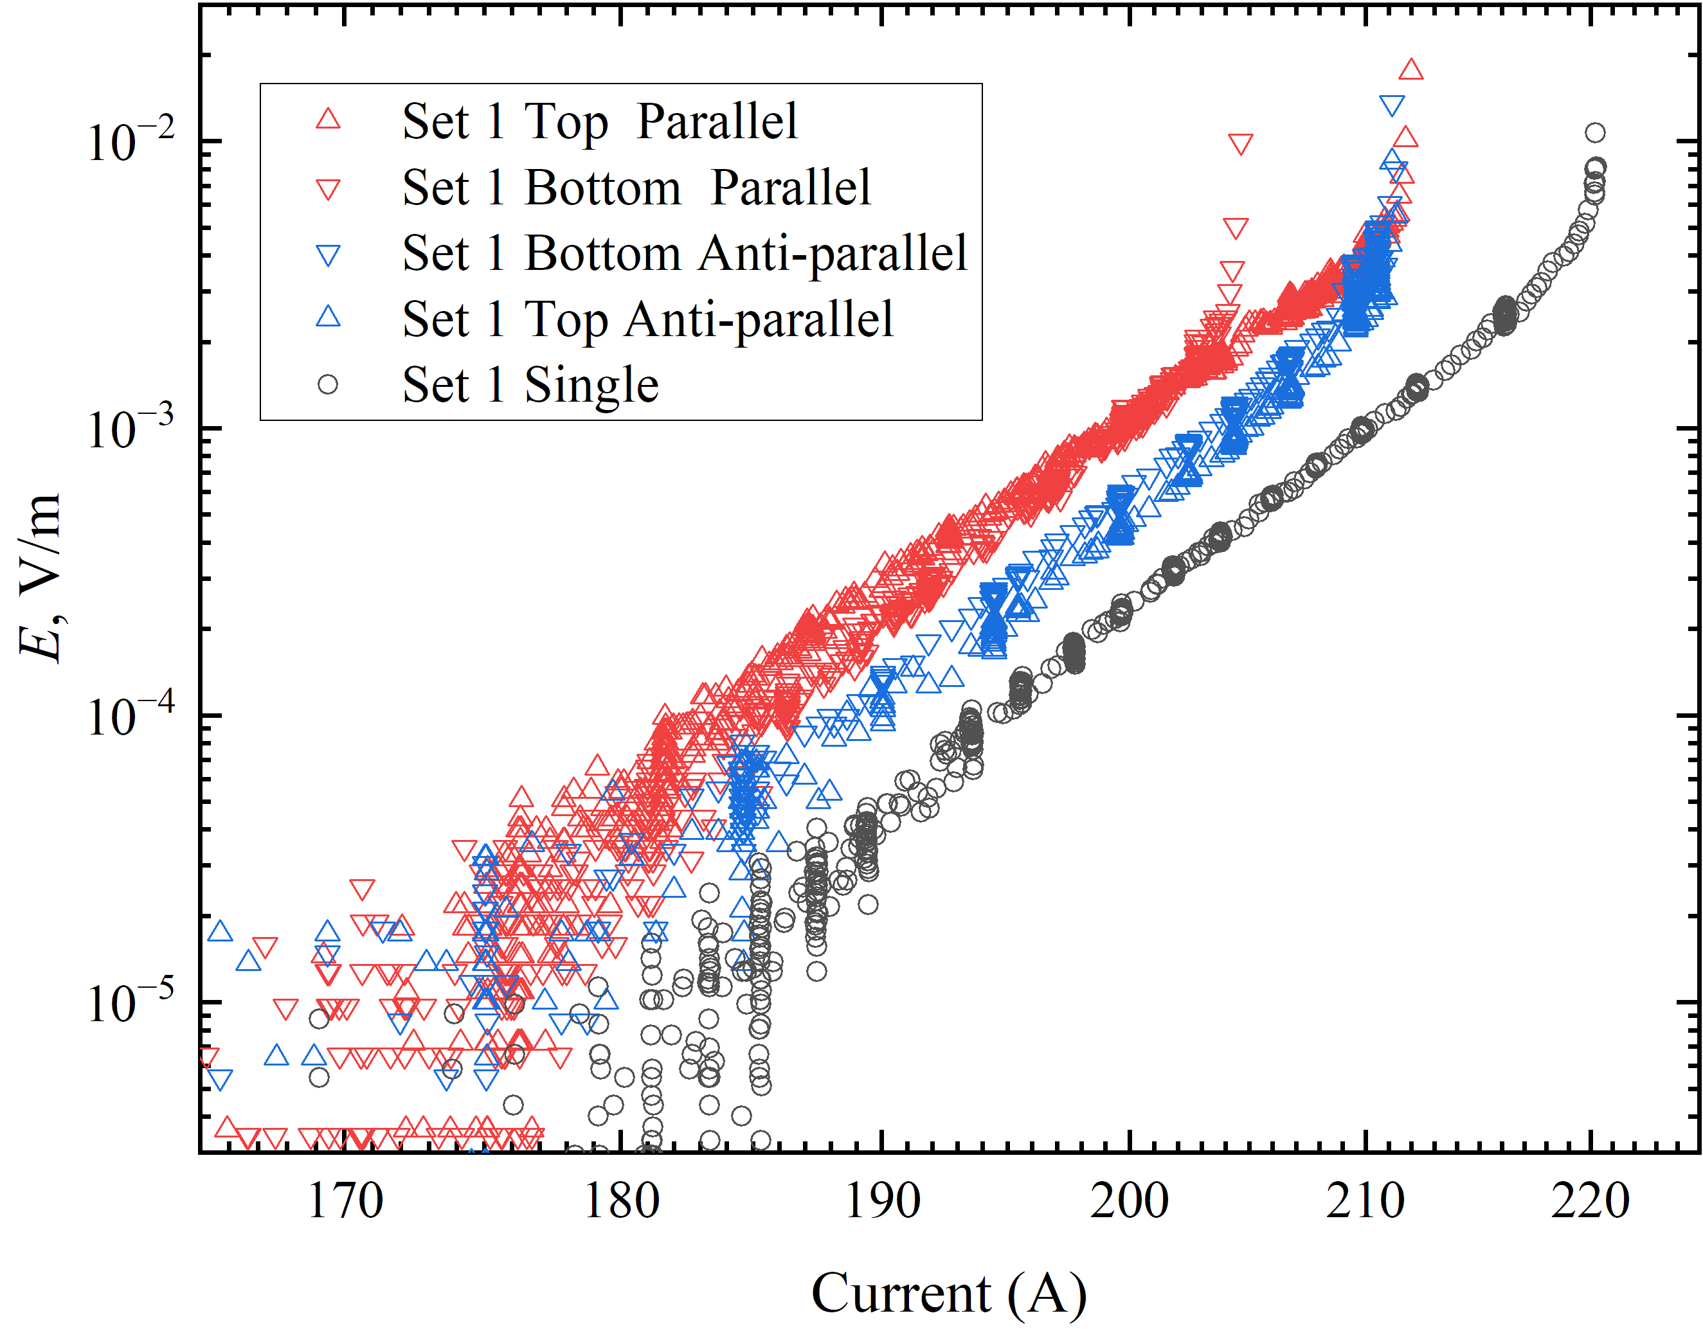
Fig. 5. REBCO measurement short-tape measurement with different current flow configurations: i) double-tape anti-parallel, ii) double-tape parallel, and iii) single tape

TABLE I
short tape measurement results
Tape type | Single tape  $I_{c}$ [A] | Anti-parallel $I_{c}$ [A] | Parallel  $I_{c}$ [A]
PbBi2223 | 216 | 252 | 188
Set 1 - REBCO | 195 | 190 | 184
Set 2 - REBCO | 194 | 184/187 | N/A
Set 3 - REBCO | 194 | 208 | 177

B. Short Tape Measurements
To investigate self-field effects, short samples of Ag-sheathed PbBi2223 tape were prepared for transport measurements. The results are shown in Fig. 4 and Table I. As predicted by the modeling described above and consistent with previous result [29], the parallel current configuration exhibited a lower critical current than a single tape, whereas the anti-parallel configuration enhanced critical current. Owing to the strong $J_{c}-B$ dependence of PbBi2223 tapes in low magnetic fields at 77 K, the augmentation and cancellation of the self-fields in the parallel and anti-parallel configurations increase and decrease the apparent critical current, respectively by, as much as 20%.
I-V Measurements on a pair of REBCO tapes (Set-1) are shown in Fig 5. The current (I) in Fig. 5 corresponds to the current carried by individual tapes. While the anti-parallel tapes were configured in series to carry the same current, the currents in the parallel tapes (set 2) were measured independently and were not identical. A small difference of ~7A was observed, attributed to differences in contact resistance at the terminal. The parallel configuration (red triangles in Fig. 5) showed a modest reduction in critical current of ~11 A (5%) compared to the single tape $I_{c}$ of ~195 A (black circles).. The result is consistent with expectations for REBCO conductors, given their stronger flux pinning and moderated $J_{c}-B$ dependence. Unexpectedly, the anti-parallel configuration (blue triangles in Fig. 5) also exhibited a reduced critical current of ~5A (2.5%), rather than the anticipated increase caused by the cancellation of the self-field. Table 1 summarises experimental data and shows that the anti-parallel $I_{c}$ for Set 2 is also lower than for single tape, and similar to the behaviour observed for Set 1, though with a larger reduction.

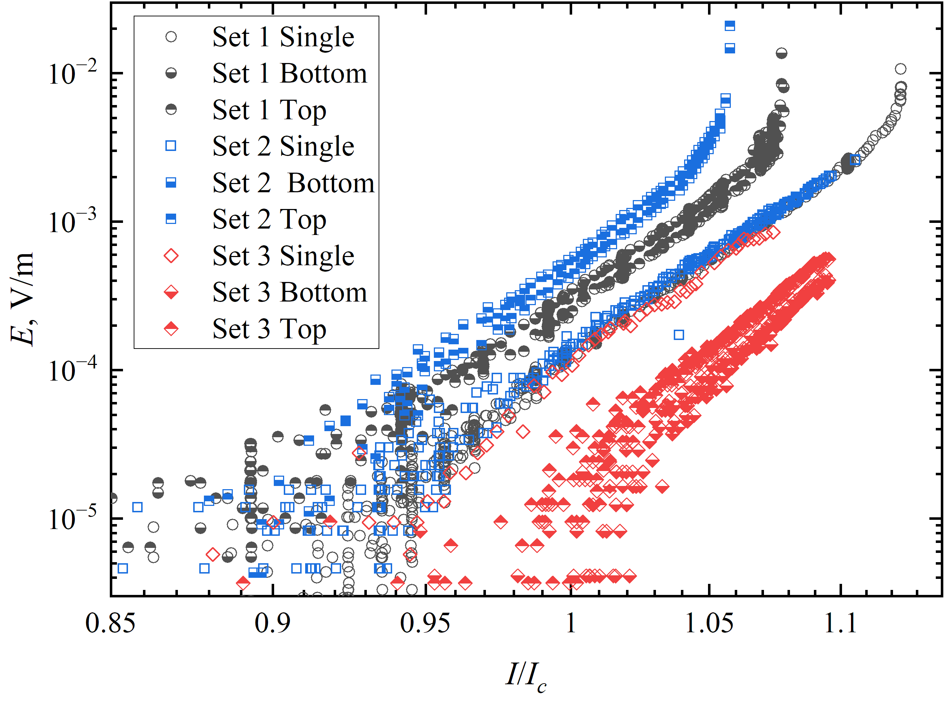
Fig. 6. Summary of the I-V results for samples tested in the anti-parallel configuration. In Set 1 and Set 2, the superconducting layers of both tapes were oriented facing each other. Set 3, the superconducting layers of both tapes were oriented facing away from each other.

A third REBCO sample (Set 3) was prepared differently, with the superconducting layers facing each other while placing the substrates on the outside instead of between superconducting layers. This arrangement brought the superconducting layers closer together and eliminated any potential contribution from the substrate’s magnetism, however weak. In this case, the expected enhancement in transport critical current in the anti-parallel configuration was observed. The measured value of 208 A agrees remarkably with the model prediction for $d=60 μm$ (Fig. 3(B) green line). For example, $0.903I_{c0}=0.903⋅I_{c}/0.842=1.07⋅194 A=207.8 A$. The differences between Sets 1, 2 and 3 are further compared in Fig. 6, which plots the electric field $E$ as a function of the normalised transport current $I{/I}_{c}$. The absence of thermal runaways in Set 3 is attributed to the quench initiating at the current injections on the substrate sides. Although the Set 3 results are consistent with magnetic field concentration arising from the (weakly magnetic) substrate, the shorter separation between the superconducting layers remains a plausible contributing factor.

C. Results of an 11-turn Coil
The coil was successfully fabricated and tested, withstanding 14 induced quench events, during which a portion of the coil transitioned from the superconducting state to the normal state [30] .Each event was indicated by a transient spike in the voltage measured between coil voltage taps when ramping the current. Based on the 1×10−4 V/m criterion used in short tape experiments, the quench detection threshold was set to 0.17 mV. No degradation or damage was detected either through performance or through visual inspection or after these quench processes or the associated thermal cycles. The measured critical current ranged from 122 A to 132 A at 77 K, as summarised in Table II. At this critical value, the voltage increased rapidly to 0.1V. The highest current measured at 77K was 132A. The single test at 65 K yielded a critical current of 247 A, with a maximum recorded voltage of 0.2V at this current. The quench was initiated and propagated in the same manner observed during the 77 K tests, with no degradation or damage to the coil detected.
TABLE II
Test results from the 11-turn coil
Temperature  [K] | Critical/Quench Current, [A] | Number of Quenches | Max. Coil Voltage, [V]
77 | 122-132 | 14 | 0.1
65 | 247 | 1 | 0.2

These results are sufficiently encouraging for further investigations using larger coils with significantly more. Translation into large-scale coils is an essential step towards insulated windings with reliable quench recovery and thermal cycling which are critical for AC electrical machines.

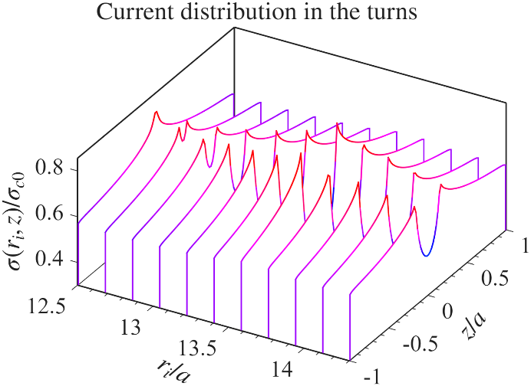

Fig. 7. Simulated results showing current distribution across the tape cross-section for each turn in the radial cross-section of the coil.

D. 11-turn Coil Simulations
An 11-turn coil was simulated and used as a benchmark to evaluate the coil’s performance. The pancake coil, consisting of N turns, was modelled turn-by-turn as a set of concentric rings composed of thin strips. The distribution of induce currents in the ring carrying a transport current $It$ is obtained by minimising the magnetic energy,
$$ε=\frac{1}{2}σ^{T}Mσ$$
where, for each turn $i=1,…,N_{r}]$ of a $N_{r}$-turn coil, the current distribution along the tape width is constrained by the local critical current density $|σ(\left.z\right|r_{i})| ≤ σ_{c}(B\left(r_{i},z\right))$ and transport current $\int_{a}^{a}{σ\left(z | r_{i}\right)dz}= It$. Discretizing the width into $Nz$ elements, the current distribution is represented as a vector $σ\left(z | r_{i}\right)=σ\left(\left.z_{j}\right|r_{i}\right)→σ^{\left(l\right)}, l=\left(ⅈ-1\right)Nz + j$, and the mutual inductance as a matrix with between $l$ and $l^{'}$ elements is
$$M_{l,m}=μ_{0}\sqrt{r_{l}r_{m}}\left(\left(\frac{2}{k_{l,m}}-k_{l,m}\right)K\left(k_{l,m}\right)-\frac{2}{k_{l,m}}E\left(k_{l,m}\right)\right)$$
where $K(k)$ and $E(k)$ are the incomplete elliptic integral of the first and second kinds respectively with
$$k_{l,m}^{2}=\frac{4r_{l}r_{m}}{{\left(r_{l}+r_{m}\right)}^{2}+{\left(z_{l}-z_{m}\right)}^{2}}$$
The formulation is an extension to that described for assemblies of long conductors in [31].

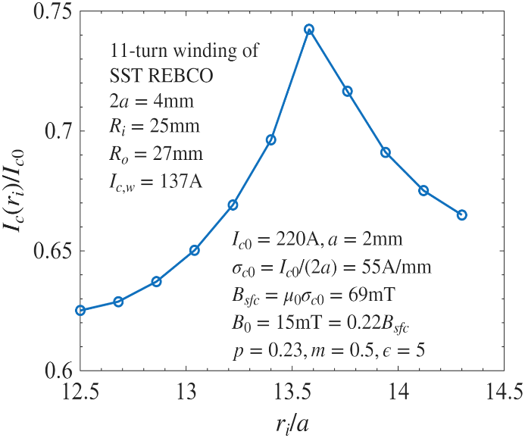
Fig. 8. Simulated results showing critical current distribution within the coil, with each point representing an individual turn.

The current distribution within the tape for each turn was first modelled for different transport currents. For the 11-turn coil of SST tape, Fig. 7 shows that the innermost turn would be the first to become saturated at it local $σ\left(z|r_{1}\right)=σ_{c}(B(z|r_{1})$ everywhere along the tape width $-a≤z≤a$ while all the other turns are only partially saturated with residual capacities in the middle region of the tape width. Integration of the current distribution across the tape width in turn 1 leads to the critical current of the 11-turn coil winding $I_{c,w}=I_{c}\left(r_{1}\right)=137 A$ which is reasonably close to the observed coil $I_{c}\sim 132 A$. Using the field distribution at $I_{c,w}$, the critical current of each turn is also obtained with the maximum of $0.74I_{c,0}=163 A$ at turn 7 as shown in Fig. 8.
Although the critical current of the 11-turn coil initially occurs at turn 1, the field distribution identifies the minimum critical current density occurring in turns 2 and 3 at only $0.56σ_{c,0}$, as seen in Fig 9. Subsequently, a quench may be initiated in one of two ways, according to the modelling. The first is by exceeding the local minimum critical current, and the second by exceeding the critical current of the tape cross-section. This provides a valid explanation for the spread observed in quench currents occurring between $122 A$ and $132 A$ and the close agreement between simulation and experimental results. Consequently, it appears that no significant damage or degradation were introduced by either the coil winding/construction processes or the thermal cycling. While the results are encouraging, variations in the current distribution amongst individual turns could not be directly measured due to the limited spatial resolution of the measurement diagnostics. Therefore, only the overall critical current can be reliably compared with the simulated results. Nonetheless, the consistent performance over fourteen quench cycles at 77 K demonstrates well the mechanical and thermal robustness of the coil, with no observable degradation resulting from repeated quenches or thermal cycling.

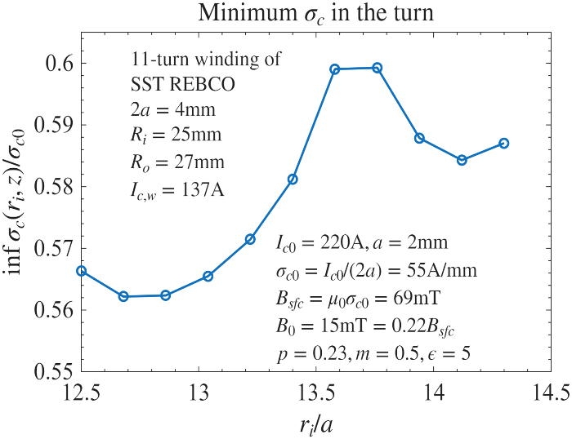

Fig. 9. The simulated lowest critical current density within each turn, with each dot representing an individual turn.

Conclusions And Future Work
Coil construction using glass fibre insulation has been demonstrated to be effective on a small scale in this study and achieving performance close to the simulated performance while also highlighting minimal reduction in performance attributed to thermal cycling.
To reinforce the accuracy of simulations, a series of short-tape samples were experimentally measured. These results provided a solid foundation to confidently construct an 80-turn double pancake coil using 30-micron glass fibre insulation, and epoxy resin impregnation. This next step is essential to validate the characteristics of the scaled-down coil described in this paper and its applicability for larger-scale applications. In addition, the short tape measurements provide the baseline to design and develop a coil that enables both anti-parallel and parallel current configurations over five metre tape length and its investigation across the near-zero to higher magnetic field range.

Acknowledgment
The authors would like to thank (1) Oxford Instruments for the PhD studentship of EPSRC CASE award for OA, (2) Shanghai Superconductor Technology for supplying superconducting tapes used in this study, and CERN support (KE6046) for HFM collaboration. Rob Loades provided technical assistance throughout many aspects of the coil manufacturing processes. Grammarly was used to check the spelling and grammar.

References
[1] G. Jiang et al., “Recent development and mass production of high Je 2G-HTS tapes by using thin hastelloy substrate at Shanghai Superconductor Technology,” Supercond. Sci. Technol., vol. 33, no. 7, p. 074005, Jun. 2020, doi: 10.1088/1361-6668/AB90C4.
[2] C. Senatore, M. Bonura, and T. Bagni, “REBCO tapes for applications in ultra-high fields: critical current surface and scaling relations,” Supercond. Sci. Technol., vol. 37, no. 11, p. 115013, Oct. 2024, doi: 10.1088/1361-6668/AD7F95.
[3] X. Li, M. Ainslie, D. Song, W. Yang, and R. Macián-Juan, “REBCO coated conductors: enabling the next generation of tokamak reactors,” Supercond. Sci. Technol., vol. 38, no. 3, p. 033001, Feb. 2025, doi: 10.1088/1361-6668/ADA9D2.
[4] J. L. MacManus-Driscoll and S. C. Wimbush, “Processing and application of high-temperature superconducting coated conductors,” Nature Reviews Materials 2021 6:7, vol. 6, no. 7, pp. 587–604, Mar. 2021, doi: 10.1038/s41578-021-00290-3.
[5] N. Martucciello, F. Giubileo, … G. G.-Supercond. S., and undefined 2015, “Introduction to the focus on superconductivity for energy,” academia.eduN Martucciello, F Giubileo, G Grimaldi, V CoratoSupercond. Sci. Technol, 2015•academia.edu.
[6] C. Yao and Y. Ma, “Superconducting materials: Challenges and opportunities for large-scale applications,” iScience, vol. 24, no. 6, p. 102541, Jun. 2021, doi: 10.1016/j.isci.2021.102541.
[7] P. H. Chen et al., “Watch-sized 12 Tesla all-high-temperature-superconducting magnet,” Journal of Magnetic Resonance, vol. 357, p. 107588, Dec. 2023, doi: 10.1016/J.JMR.2023.107588.
[8] M. R. Khan et al., “Characterization of Critical Fields and Flux Pinning Energy of REBCO Tapes,” IEEE Transactions on Applied Superconductivity, vol. 34, no. 3, pp. 1–5, May 2024, doi: 10.1109/TASC.2024.3375268.
[9] L. Bottura and B. Bordini, “HTS Potential and Needs for Future Accelerator Magnets,” ArXiv, Mar. 2025.
[10] S. Hahn, D. K. Park, J. Bascuñán, and Y. Iwasa, “HTS pancake coils without turn-to-turn insulation,” IEEE Transactions on Applied Superconductivity, vol. 21, no. 3 PART 2, pp. 1592–1595, Jun. 2011, doi: 10.1109/TASC.2010.2093492.
[11] D. Liu, W. Zhang, H. Yong, and Y. Zhou, “Thermal stability and mechanical behavior in no-insulation high-temperature superconducting pancake coils,” Supercond. Sci. Technol., vol. 31, no. 8, p. 085010, Jul. 2018, doi: 10.1088/1361-6668/AAD00C.
[12] Y. Liu et al., “Self-protection mechanisms in no-insulation (RE)Ba2Cu3Ox high temperature superconductor pancake coils,” Supercond. Sci. Technol., vol. 29, no. 4, p. 045007, Mar. 2016, doi: 10.1088/0953-2048/29/4/045007.
[13] I. Kesgin, Q. Hasse, Y. Ivanyushenkov, and U. Welp, “Performance of 2G-HTS REBCO Undulator Coils Impregnated Epoxies Mixed with Different Fillers,” IEEE Transactions on Applied Superconductivity, vol. 27, no. 4, Jun. 2017, doi: 10.1109/TASC.2016.2638431.
[14] M. Yazdani-Asrami, M. Staines, G. Sidorov, and A. Eicher, “Heat transfer and recovery performance enhancement of metal and superconducting tapes under high current pulses for improving fault current-limiting behavior of HTS transformers,” Supercond. Sci. Technol., vol. 33, no. 9, p. 095014, Aug. 2020, doi: 10.1088/1361-6668/ABA542.
[15] G. Messina, M. Yazdani-Asrami, F. Marignetti, and A. Della Corte, “Characterization of HTS Coils for Superconducting Rotating Electric Machine Applications: Challenges, Material Selection, Winding Process, and Testing,” IEEE Transactions on Applied Superconductivity, vol. 31, no. 2, Mar. 2021, doi: 10.1109/TASC.2020.3042829.
[16] S. Yin et al., “Degradation of REBCO coated conductors due to a combination of epoxy impregnation, thermal cycles, and quench: Characteristics and a method of alleviation,” J. Appl. Phys., vol. 128, no. 17, Nov. 2020, doi: 10.1063/5.0026000/1062863.
[17] C. Barth, N. Bagrets, K. P. Weiss, C. M. Bayer, and T. Bast, “Degradation free epoxy impregnation of REBCO coils and cables,” Supercond. Sci. Technol., vol. 26, no. 5, p. 055007, Mar. 2013, doi: 10.1088/0953-2048/26/5/055007.
[18] C. J. Hyeon et al., “Quench Behavior of 2G HTS Coils with Polyimide Film and MIT Material under over Pulse-Current,” IEEE Transactions on Applied Superconductivity, vol. 28, no. 4, Jun. 2018, doi: 10.1109/TASC.2018.2801883.
[19] L. Rossi, C. Senatore, L. Rossi, and C. Senatore, “HTS Accelerator Magnet and Conductor Development in Europe,” Instruments 2021, Vol. 5, vol. 5, no. 1, Feb. 2021, doi: 10.3390/INSTRUMENTS5010008.
[20] K. Baburin et al., “Design, Manufacturing and Tests of an All-HTS 20 T Magnet,” IEEE Transactions on Applied Superconductivity, vol. 34, no. 5, pp. 1–4, Aug. 2024, doi: 10.1109/TASC.2024.3391755.
[21] M. Bonura, G. Bovone, P. Cayado, and C. Senatore, “Contact Resistance Between REBCO Coated Conductors in the Presence of a V2O3 Inter-Layer,” IEEE Transactions on Applied Superconductivity, vol. 33, no. 5, Aug. 2023, doi: 10.1109/TASC.2023.3251291.
[22] M. M. Mussa et al., “Quench initiation and normal zone propagation characteristics of smart insulated high-temperature superconducting coil,” Current Applied Physics, vol. 56, pp. 24–35, Dec. 2023, doi: 10.1016/J.CAP.2023.09.010.
[23] D. Liu, W. Wei, Y. Tang, H. Yong, Y. Z.-E. F. Mechanics, and undefined 2023, “Delamination behaviors of an epoxy-impregnated REBCO pancake coil during a quench,” Engineering Fracture Mechanics, 2023•Elsevier.
[24] D. Liu, H. Yong, Y. Zhou, D. H. Yong, H. D. Zhou, and Y. H. Critical, “Critical current degradation in an epoxy-impregnated rare-earth Ba2Cu3O7−x coated conductor caused by damage during a quench,” Applied Mathematics and Mechanics 2024 45:9, vol. 45, no. 9, pp. 1557–1572, Aug. 2024, doi: 10.1007/S10483-024-3141-8.
[25] W. Bailey, H. Wen, M. Al-Mosawi, K. Goddard, and Y. Yang, “Testing of a lightweight coreless HTS synchronous generator cooled by subcooled liquid nitrogen,” IEEE Transactions on Applied Superconductivity, vol. 21, no. 3 PART 2, pp. 1159–1162, Jun. 2011, doi: 10.1109/TASC.2010.2093486.
[26] Q. Zhang et al., “Performance and Quench Characteristics of a Pancake Coil Wound with the 2G YBCO Roebel Cable,” IEEE Transactions on Applied Superconductivity, vol. 28, no. 4, Jun. 2018, doi: 10.1109/TASC.2018.2799140.
[27] Z. Jiang et al., “Quench in a pancake coil wound with REBCO Roebel cable: model and validation,” Supercond. Sci. Technol., vol. 34, no. 10, p. 105002, Aug. 2021, doi: 10.1088/1361-6668/AC1BF7.
[28] “Varnish.” Accessed: Oct. 03, 2025. [Online]. Available: https://www.lakeshore.com/products/categories/overview/temperature-products/cryogenic-accessories/varnish?srsltid=AfmBOorbZCOpIMTwNEHkJfjfEIGF2j5QwZYApKK0NGVWfONs_PPcNFqI
[29] J. Lehtonen, A. Korpela, W. Nah, J. Kang, P. Kováč, and T. Melišek, “Influence of self-field on the critical current of Bi-2223/Ag tapes,” Physica C Supercond., vol. 403, no. 4, pp. 257–262, Apr. 2004, doi: 10.1016/J.PHYSC.2003.12.014.
[30] M. N. Wilson, “Superconducting magnets,” 1983.
[31] Y. Yang, “Electric Centrelines and Magnetic Coupling of Superconducting Strands in Assemblies and Cables,” IEEE Transactions on Applied Superconductivity, vol. 33, no. 5, Aug. 2023, doi: 10.1109/TASC.2023.3242931.

