Received 00th January 20xx,
Accepted 00th January 20xx
DOI: 10.1039/x0xx00000x

Mechanistic investigation of the denitrosylation activity of a water-soluble copper(II) compound probed by experimental and computational approaches
Bruna B. Segat ª, Adolfo Horn Jr.ª, Bruno Szpoganicz ª, Lino Meurer ª, Roberta Cargnelutti ^{b},Rodrigo Cervo ^{b}, Luis Gabriel Wagner ª, Sreerag N. Moorkkannur Narayanan ^{c}, Rajeev Prabhakar ^{c}, Lucas C. Pinheiro ^{d}, Siti Noriza Kamel ^{e}, Sumeet Mahajan ^{e}, Martin Feelisch ^{f}, and Christiane Fernandes*ª
Overproduction of nitric oxide (•NO) with subsequent formation of peroxynitrite has a major impact on cell death, inflammation, and disease development. •NO exerts a significant part of its biological activity through S-nitrosylation, leading to the formation of protein and low-molecular-weight nitrosothiols such as S-nitrosoglutathione (GSNO). Excessive oxidative/nitrosative stress contributes to disease by S-nitrosylating multiple targets, culminating in the accumulation of misfolded proteins and cytotoxicity. We here report on the discovery that a water-soluble copper(II) compound [Cu(HL)Cl₂] (1) (HL = N-2[(pyridine-2-ylmethyl)aminoethanol)]) promotes homolytic cleavage of the S-NO bond to form •NO and glutathione disulfide (GSSG), following initial coordination of the sulfur atom of GSNO to the Cu(II) center. The X-ray crystal structure of complex 1 is presented. Potentiometric titration studies indicate that the species [Cu(HL)(H₂O)₂]²⁺ is the major species at physiological pH (K_{f} = 9.33x10⁶). Monitoring the reaction between 1 and GSNO by EPR spectroscopy revealed that the Cu(II) signal remains stable throughout the reaction. The release of •NO was confirmed using the spin trap [Fe(DETC)₂], while formation of the GS• intermediate was detected using DMPO. EPR analysis also confirmed the formation of a Cu–S bond, as evidenced by superhyperfine coupling, further corroborated by Raman spectroscopy and UV–Vis studies. The latter indicates that two equivalents of GSNO coordinate to the copper centers, in agreement with the kinetic studies. The formation of several intermediate species and production of GSSG was confirmed by ESI-(+)-MS. Gas-phase chemiluminescence experiments performed under both aerobic and anaerobic conditions showed that the amounts of •NO produced are independent of the presence of oxygen. Taken together, our experimental data suggest that, during GS–NO bond cleavage, the Cu(II) center does not undergo reduction, allowing the proposal of a novel reaction mechanism, the feasibility of which is supported by theoretical calculations. Thus, copper(II) complexes with tridentate ligands promote efficient denitrosylation without undergoing bulk electron transfer of the transition metal, potentially opening new avenues for modulating S-nitrosothiol stability in disease conditions known to be associated with excessive nitrosation.

Introduction
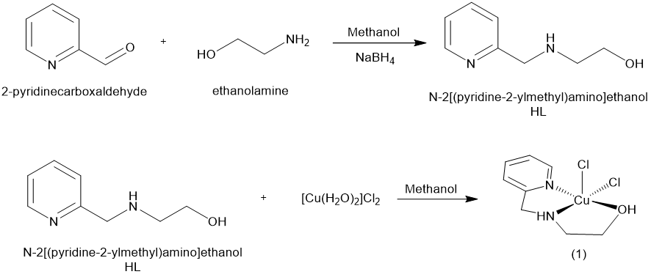
Nitric oxide (•NO) is a gaseous, highly reactive signaling and effector molecule with a short half-life.¹ Depending on its rate of formation and the outcome of chemical interactions with other reactive oxygen, nitrogen, and sulfur species (ROS, RNS, and RSS), it exhibits both beneficial and deleterious effects. ²⁻⁴ Endogenous concentrations range from picomolar to nanomolar in physiology to micromolar in infectious disease and inflammatory conditions. At higher rates of •NO production, its reaction with oxygen and/or ROS leads to the production of high fluxes of N-oxides (RNS), causing nitrosative stress with consecutive S-nitrosylation of cysteine thiols.⁵ Abnormal S-nitrosylation has been associated with inflammation and is involved in the development of various diseases such as inflammatory bowel disease, type 2 diabetes, ulcerative colitis, Crohn´s disease, and neurodegenerative diseases.^{6,7} In addition, the interaction of •NO with ROS, such as superoxide anions, can generate peroxynitrite (ONOO⁻).⁸ This process causes protein oxidation, DNA damage, and sepsis-related kidney injury.² Several studies have shown that septic patients have increased levels of circulating S-nitrosothiols, presumably as a consequence of the body’s attempt to combat the infection.⁹ In sepsis, both •NO and ONOO⁻ contribute to vascular hyporeactivity,¹⁰ which is a result of increased nitrosylation of vascular receptors. This process leads to low blood pressure and reduced responsiveness to vasoconstrictors.¹¹ Abnormal S-nitrosothiol levels may be related to worse clinical outcomes.
- Departamento de Química, Universidade Federal de Santa Catarina, 88040-900, Florianópolis, SC, Brazil
- Departamento de Química, Universidade Federal de Santa Maria, 97105-900, Santa Maria, RS, Brazil
- Department of Chemistry, University of Miami, Coral Gables, FL 33146, USA
- Departamento de Farmacologia, Universidade Federal de Santa Catarina, 88040-900, Florianópolis, SC, Brazil
- Institute for Life Sciences, University of Southampton, Southampton, United Kingdom
- Clinical & Experimental Sciences, Faculty of Medicine, Southampton General Hospital, University of Southampton, Southampton, United Kingdom.
† Footnotes relating to the title and/or authors should appear here.

Scheme 1. Synthesis of ligand HL and its copper(II) compound [Cu(HL)Cl₂] 1.³⁰

Sustained overproduction of ROS and RNS can lead to irreversible oxidation of thiol residues, impaired protein functions, and perturbation of local and/or systemic redox balance.¹² Multiple thiol- and/or selenium-dependent disulfide reductases possess the intrinsic capability to reverse excessive S-nitrosylation by facilitating the release of •NO. S-nitrosoglutathione reductase (GSNOR) directly metabolizes GSNO and indirectly controls the amount of protein-SNO and their related signals, maintaining the balance between GSNO and protein-SNO.¹³ Additionally, antioxidants such as reduced glutathione (GSH) can affect S-nitrosothiol distribution through transnitrosylation reactions.¹⁴
S-nitrosoglutathione (GSNO) has been used as a relevant low-molecular-weight model compound to test the efficacy of a variety of chemicals as denitrosylation agents. Among the most efficient are metals or metal-containing compounds, presumably due to their high affinity for sulfur. However, although inorganic copper salts lead to efficient decomposition of GSNO in vitro,¹⁵ toxicity prevents their therapeutic use in vivo. Moreover, free copper ions can support both degradation and formation of nitrosothiols, depending on the redox state.¹⁶ In 2020, Reynolds and coworkers successfully demonstrated •NO formation by direct monitoring via ¹H-NMR of the reaction between a metal-organic framework (MOF) H₃[(Cu₄Cl)³⁻(BTTri)₈], H₃BTTri = 1,3,5-tris(1H-1,2,3-triazol-5-yl)¹⁷ benzene and GSNO, highlighting the potential for impactful therapeutic application.¹⁸ Attempting to investigate the nature of the transitions metal/•NO interaction and to shed light on the chemical mechanism, previously reported by Reynolds in 2019,¹⁸ Hammes-Schiffer and co-workers used computational investigations to support a mechanism that involves the coordination of GSNO to copper, via sulfur, with the formation of the Cu(I) intermediate, GSSG and •NO, implicating the involvement of a redox-active copper site.¹⁹
Reversible release of •NO from RSNO by a mimetic compound of type 1 Cu site present in ceruloplasmin and ascorbate oxidase, tris(pyrazolyl)borate copper thiolate, is related to the formation of diamagnetic copper nitrosyl complexes {Cu(NO)} and formal reduction of Cu(II) to Cu(I), motivating the study of biomimetic systems and computational analysis, as reported by Warren and others.²⁰⁻²³ In 2019, Cho and co-workers reported a light-sensitive metal-nitrosyl complex containing Co(III), which can deliver and selectively release •NO in the cytosol. ²⁴ In 2023, the same group reported the photodynamic treatment of acute vascular disease using a Fe(II) complex.²⁵
We have utilized a wide range of metal complexes to alter oxidative stress in lab settings, tissue samples, and living organisms. ²⁶⁻²⁹ In the present study, we demonstrate through kinetic, spectroscopic (EPR, electronic, and Raman spectroscopies), spectrometric (ESI-(+)-MS) experiment that a water-soluble Cu(II) compound effectively promotes the denitrosylation of GSNO at room temperature and physiological pH, which allowed us to propose a reaction mechanism whose reaction pathways, transition states, and intermediates are supported by DFT calculation.
Results and Discussion
The syntheses and characterization of the ligand (HL) and the compound [Cu(HL)Cl₂] 1 (Scheme 1) have been described previously.³⁰
Compound 1 was obtained as a blue powder, and recrystallization in CH₃CN resulted in crystals suitable for investigation by X-ray diffraction. Its infrared and electronic spectra are provided in Figures 1S-3S and supported by published data. The single-crystal X-ray data obtained for compound 1 reveal the formation of a mononuclear pentacoordinated copper(II) complex connected to one molecule of HL and two chloro ligands, [Cu(HL)Cl₂] (Figure 1). Crystallographic data for 1 are presented in Table 1S, and the most relevant geometrical parameters are in Table 2S. The bond lengths of the copper(II) ion with the tridentate ligand are similar (Cu1–N1 1.9943(12), Cu1–N2 2.0127(12), Cu1–O1 2.0244(11) Å) and much shorter than Cu-Cl (Cu1–Cl1 2.2430(5), Cu1–Cl2 2.6135(6)). A value of τ of 0.27 indicates a distorted square-pyramidal geometry.³¹ Compound 1 is water-soluble, and potentiometric titration studies (Figures 4S-6S) showed three pKa values in the pH range of 3 to 12. The first one (6.52) is related to the protonation/deprotonation equilibrium involving the secondary amine. The second (8.39) is associated
Figure 1. X-ray molecular structure of compound 1 solved by monocrystal X-ray diffraction. Thermal ellipsoids are shown at the 50% probability level. Main bond lengths: Cu1–N1 1.9943(12), Cu1–N2 2.0127(12), Cu1–O1 2.0244(11), Cu1–Cl1 2.2430(5), Cu1–Cl2 2.6135(6).

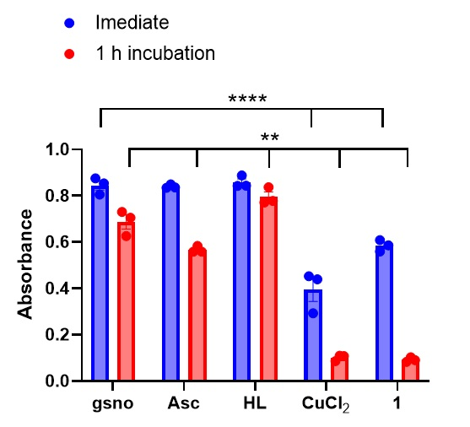
with the deprotonation of the alcohol group of the ligand, generating [Cu(L)(H₂O)₂]⁺, while the third pKa (10.30) refers to the formation of [Cu(L)(H₂O)(OH)] species (Table 3S). Thus, employing potentiometric titration, it is possible to infer that the major species at pH 7.4 is [Cu(HL)(H₂O)₂]²⁺. The calculated formation constant (Kf) is 9.33x10⁶, indicating that the resulting compound exhibits high stability. This was experimentally confirmed by stability studies in aqueous solution and PBS, which revealed no sign of decomposition over 24h at RT and 37°C (Figure 3S).
Figure 2. Decrease of the GSNO absorbance at 335 nm, promoted by ascorbate (Asc) (positive control), the ligand HL, CuCl₂, and compound 1, immediately after plating and after 1h of incubation at 37°C. Initial concentration of GSNO = 2 mmol L⁻¹, concentration of Asc, HL, CuCl₂ and compound 1 = 0.5 mmol L⁻¹ (i.e. the ratio of GSNO over 1 (and other reactants) was 4:1). **** p<0.0001, ** p = 0.0015
The denitrosylating activity of compound 1 was initially investigated using electronic spectroscopy to monitor the absorption band of GSNO at 335 nm (SN charge transfer) (Figures 7S and 8S). While ascorbic acid (Asc), a standard denitrosylating agent, decomposed GSNO by 0.55 and 32%, at 0 and 60 min of incubation (Figure 2), respectively, compound 1 promoted GSNO decomposition of 30.78 and 89.10%, respectively, during the same time. By comparison, free copper(II) in the form of CuCl₂ yielded a GSNO decomposition of 53.23 and 87.99%, respectively. The ligand itself (HL) did not show any denitrosylating activity, reducing the initial absorbance after 1h of incubation by only 5.86%, thus confirming the crucial role of copper for GSNO decomposition.
Due to its significant activity, additional kinetic studies were performed employing a pseudo-first order approach (Figure 3, Table 4S, and Figures 9S and 10S). Exponential regression revealed that the concentration necessary for compound 1 to reach half-maximal effective concentration (EC₅₀) is 27.0 ± 0.4 µmol L⁻¹ (Figure 8S). The initial velocity method was applied to evaluate the kinetic parameters related to GSNO denitrosylation. The Hill model was used to fit the experimental curve (Figure 3), resulting in Vmax = 5.2 ± 0.1x10⁻⁴ mmol L⁻¹ s⁻¹ and k_{0.5} = 1.40±0.05 mmol L⁻¹. The Hill coefficient (n) of 2.6 indicates the presence of two or more binding sites in compound 1 and demonstrates cooperativity in substrate binding (see Table 4S and Figures 9S and 10S).
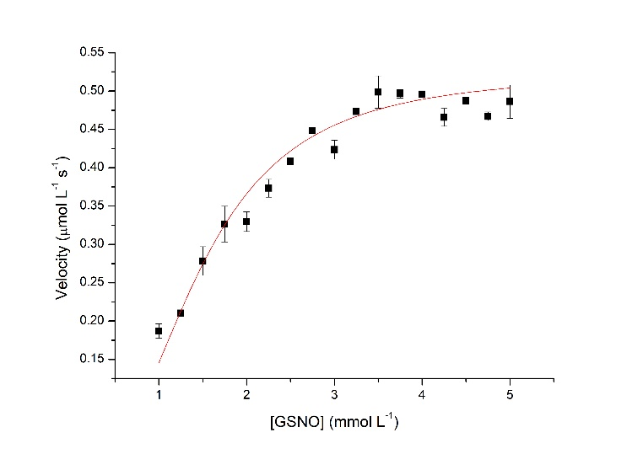
Changes in the full electronic spectra of the interaction between compound 1 and GSNO over time were investigated to potentially detect the formation of intermediate species (Figure 4). Compound 1 presents an absorption band at 257 nm, attributed to a ππ* intra-ligand transition and a dd transition at 692 nm (Figure 3S). The GSNO spectrum (red line, Figure 4) presents a band at 335 nm attributed to the SN charge transfer of the nitrosothiol moiety. This band shifts to 312 nm and decreases with time after the addition of 1 to the reaction, in a molar ratio of 1:GSNO of 1:10 (Figure 4a, blue line), indicating the decomposition of GSNO. When the reaction was repeated using an even lower concentration of 1 (ratio of 1:GSNO 1:40, Figure 4b), we were able to discern the formation of a second band at 305 nm (orange line), which was responsible for the apparent shift in the previous study. This band increases in intensity in the first couple of hours of the reaction and subsequently decreases until it disappears completely. To get a better understanding of the reaction stoichiometry involving 1 and GSNO and to monitor the oxidation state of the copper center throughout the reaction, the interaction was followed using higher concentrations of 1 and GSNO, allowing us to observe changes at the dd absorption band of 1 (Figure 5). The electronic spectrum of compound 1 shows a d-d band at 692 nm, ε = 51.8 mol L⁻¹ cm⁻¹. The addition of successive amounts of GSNO (molar ratio GSNO:1 = 0.5, 1, 2, 3) promotes a hypsochromic shift. At a 1:GSNO molar ratio of 1:2, the λmax shifts to 592 nm (∆ = 101 nm), and it remains the same at the 1:3 molar ratio, supporting a 1:2 stoichiometry for the reaction. After 24 h, the λmax observed is 665 nm (∆ = 31 nm), almost returning to its original wavelength. An isosbestic point is observed at 650 nm, suggesting an interconversion reaction without intermediates.
Figure 3. Velocity dependence of GSNO denitrosylation concerning the substrate concentration measured at 25ºC in PBS (pH = 7.4). [1] = 0.1 mmol L⁻¹.
The interaction of 1 with GSSG (Figure 5 inset A) was performed as a control and results in a hypsochromic shift of the d-d band relative to the Cu(II) centre from 692 nm to 600 nm, similarly to the spectral alterations characterizing the interaction of 1 with GSNO. Such behaviour suggests that the spectral signature of the d-d band observed in the reaction between 1 and GSNO represents the product 1-GSSG. Moreover, it seems that the oxidation state of the copper centre stays the same during the reaction, considering that the dd band does neither decrease nor disappear at any point. However, rapid formation of a transient Cu(I) species during the reaction cannot be excluded with certainty.
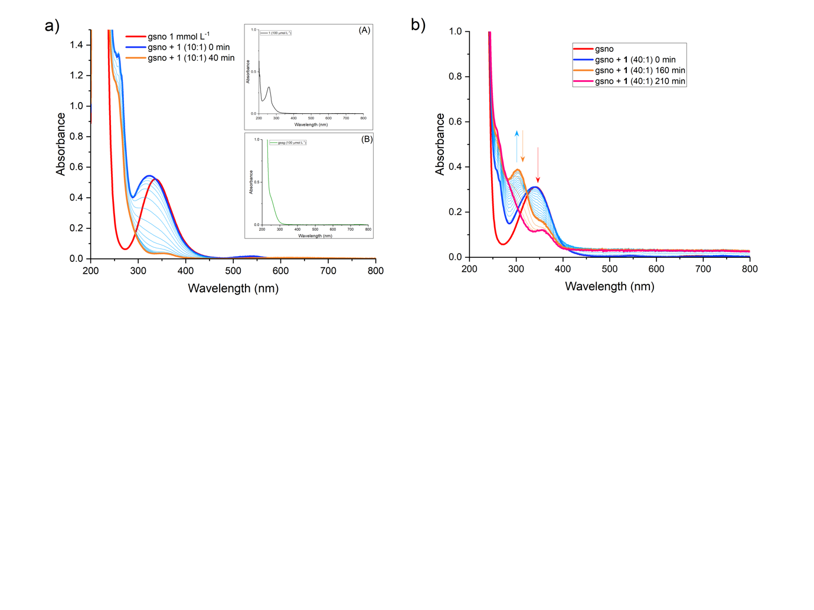
The reaction mechanism was further explored by EPR, ESI-(+)-MS, and Raman spectroscopy. To ascertain the release of •NO from GSNO promoted by 1, EPR measurements were performed using ferrous-diethyldithiocarbamate [Fe(DETC)₂] as spin trap for •NO, as described in more detail in section S3.3 and depicted in Figure 11S.³² EPR analysis showed a three-line spectrum with similar intensities (Figure 6) for the gas released by the system 1+GSNO and trapped by [Fe(DETC)₂], characterizing the coupling of one electron with the nitrogen nuclear spin (I = 1) at g = 2.01 and A =13.0 G. ³³ It is worth emphasizing that this reaction does not occur in the absence of 1. Using the same methodology, the species [Fe(DETC)₂(•NO)] (Figure 12S) was also detected in the reaction of GSNO with the equivalent Zn(II) compound, [Zn(HL)Cl₂], which was previously described by us.³⁰ These experiments are consistent with the notion that no change in oxidation state of the metal is required for denitrosylation by compounds of this class.
Figure 4. Interaction between GSNO and compound 1 over time in a molar ratio of a) 10:1 and b) 40:1. The red line depicts the spectrum of GSNO 1 mmol L⁻¹, the dark blue line is from the interaction immediately after addition of 1 at a concentration of a) 100 µmol L⁻¹ and b) 25 µmol L⁻¹; readings were performed every a) 2 min and b) 10 min (light blue lines). The orange line represents the interaction after a) 40 min and b) 210 min of incubation. Inset A shows the electronic spectra of 1 (100 µmol L⁻¹) and inset B the electronic spectra of GSSG (1 mmol L⁻¹).
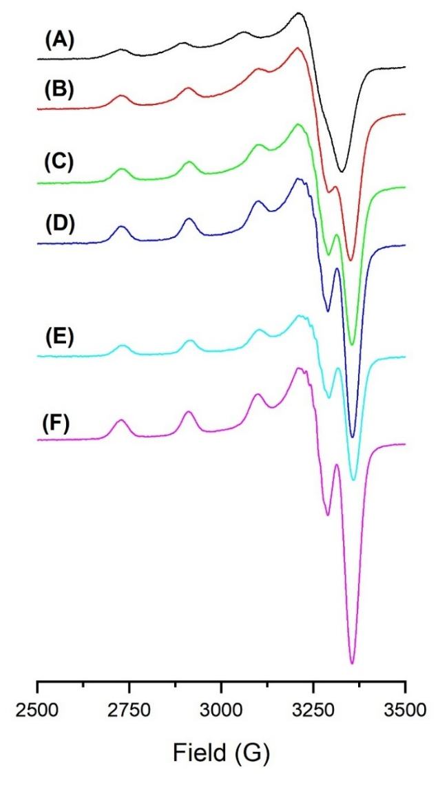
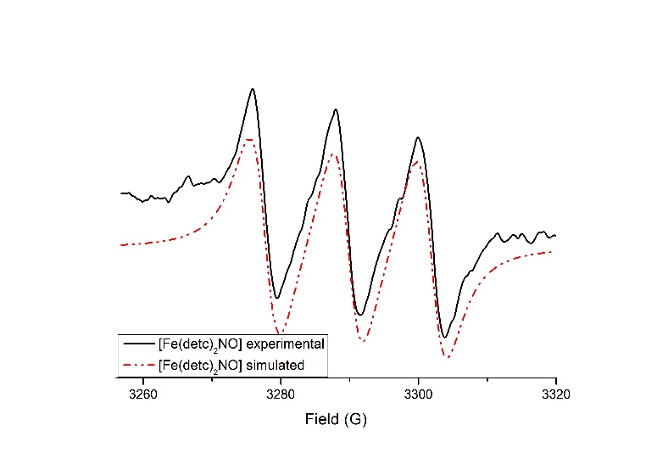
Since •NO formation results from the homolytic cleavage of the GS–NO bond, EPR experiments employing the spin trap DMPO were conducted to investigate the possible generation of additional radical species. As shown in Figure 13S, two distinct radical adducts were detected and labelled as radical A and radical B. Radical A exhibits a six-line EPR spectrum with hyperfine coupling constants of $A_{N}=15.768$G and $A_{H}=22.8098$G. Similar spectral patterns have been reported in the literature for systems involving L-cysteine (SCys) and 4-mercaptophenylacetic acid (MPAA),^{34, 35} which were assigned to DMPO-SCys and DMPO-MPAA adducts, respectively. However, for thiyl radical–DMPO adducts, the reported hyperfine coupling constants typically fall within the ranges of $A_{N}≈15\text{–}16$G and $A_{H}≈15\text{–}18$G. In contrast, the larger $A_{H}$value observed for radical A is more consistent with a carbon-centered radical species.³⁶ Notably, similar carbon-centered radicals have been previously identified in systems involving glutathionyl radicals, where hydrogen abstraction from the α-carbon of the amino acid backbone leads to the formation of α-carbon-centered radicals.^{37, 38} Regarding radical B, the literature describes that the DMPO-SG adduct, formed from the reaction between DMPO and the glutathionyl radical, typically displays a four-line EPR spectrum.³⁴ Based on this characteristic spectral signature, radical B is tentatively assigned to the DMPO-SG adduct.EPR spectroscopy was also used to determine the spin state and changes in the coordination environment of the Cu(II) center in the presence of GSNO. Solid state EPR spectra of compound 1 indicate an axial g tensor (g// = 2.225 and g_{ꓕ} = 2.0738, data not shown). When compound 1 was dissolved in PBS (pH = 7.4), the EPR spectrum obtained at 100K confirmed the presence of an axially distorted Cu(II) center (Figure 14S). Using a 1 mM concentration of compound 1, the parallel region (z axis) is better resolved. Such resolution is not observed at 4 and 2 mM, due to dipolar interactions. However, even using a 1 mM solution, the experimental spectrum could be satisfactorily simulated (Figure 15S) only by considering the contribution of two species (anisotropic and isotropic species), indicated as species A and B in Table 1. The simulated anisotropic signal (contribution of 76%) confirms that the unpaired electron is in the dx²-y² orbital, since g//>g_{ꓕ}>2.0023 and A//>A_{ꓕ}.³³ The g// (2.252) and A// (154x10⁻⁴ cm⁻¹) support the presence of a Cu(II) centre in a square pyramidal geometry,³⁹ and a ratio g///A// = 146 cm is between the values observed for compounds showing typically planar arrangement (105-135 cm⁻¹) and those with tetrahedral distortion of the equatorial plane (150-250 cm⁻¹).⁴⁰
Figure 7. EPR spectra of: A) compound 1, and for the reaction between complex 1 and GSNO at ratios: B) 1:0.5, C) 1:1, D) 1:2, E) 1:3, and F) 1:4. PBS buffer, at 100 K.

Figure 6. Experimental and simulated EPR spectra obtained in the reaction of [Fe(DETC)₂] (in DMSO) with gaseous •NO generated from the reaction of GSNO and compound 1, in PBS buffer, T = 298 K
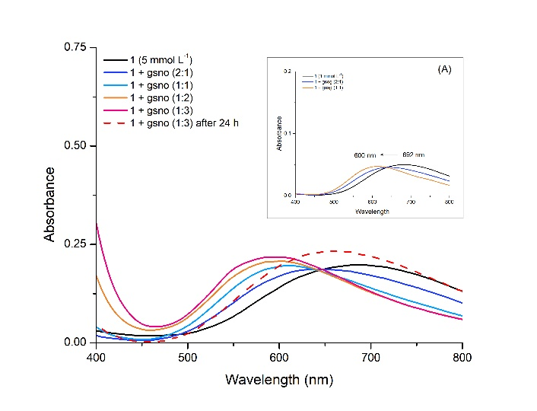
The interaction of GSNO with 1 was followed by EPR, preparing mixtures containing different molar ratios of 1:GSNO (1:0.5 to 1:4) as shown in Figure 7. The presence of GSNO induces changes in both the parallel and perpendicular tensors, supporting that GSNO coordinates to the copper centre. The broad and intense signal related to the perpendicular tensor observed for 1 (g⊥ = 2.047) becomes narrower and splits into two signals, resulting in g_{x} very different from g_{y}, reflecting a change in the local symmetry from axial to rhombic. The simulated data shows that the gx increased from 2.0500 (pure 1) to 2.064-2.059 (ratio 1:GSNO 1:0.5, 1:1, 1:2, 1:3 and-1:4) while the gy values decreased from 2.044 (pure 1) to 2.033-2.0346 (ratio 1:GSNO 1:0.5-1:4). (Table 1 and Table 5S) Concerning g//, its values decreased from 2.252 to 2.230, considering the ratios 1:GSNO 1:0 and 1:4, respectively. Of relevance is the fact that the A// increased from 154$x$10⁻⁴ cm⁻¹
Figure 5. Spectral changes during the interaction between compound 1 and GSNO, focusing on the d-d absorption band. The band initially shifts to a lower wavelength (692 nm – black line, to 591 nm – pink line, ∆ = 101 nm). After 24 h, the absorption band is almost completely back to its original position (665 nm – red dotted line, ∆ = 31 nm), showing possible recycling of compound 1. Inset A shows the reaction between 1 and GSSG.
Table 1. Simulated EPR data for the systems containing different ratios 1:GSNO.
Figure 8. a) CLD quantification of NO release from GSNO promoted by compound 1 in the presence of air or under an inert atmosphere (N₂). The reaction chamber was filled with 13 mL of PBS and purged for at least 5 min before 10 μL of GSNO (1 mmol L⁻¹) was injected into the chamber; the amount of •NO released during GSNO decomposition was considered 100%. For the interaction between 1 and GSNO, 10 µL of 1 (100 µmol L⁻¹) was injected in the chamber containing PBS, followed by the injection of 10 µL of GSNO (1 mmol L⁻¹). The reactions were performed in triplicate with N₂ or synthetic air as carriers, and the chamber was washed three times with Milli-Q water between reactions. a) Amount of •NO released during the reaction between 1 and GSNO under an inert atmosphere and synthetic air. b) CLD chromatogram for the reaction in the presence of oxygen, and c) in an inert atmosphere (N₂). No significant difference was observed between both reactions p = 0.6061.
Ratio  1:GSNO | Species | g_{x} | g_{y} | g_{z} |  | A_{x}  ₍₁₀⁻⁴ _{cm}⁻¹ ₎ | A_{y}  ₍₁₀⁻⁴ _{cm}⁻¹ ₎ |  | A_{z}  ₍₁₀⁻⁴ _{cm}⁻¹ ₎ |  | g///A//  _{(cm)}
1:0 | A | 2.050 | 2.044 | 2.252 |  | 9 | 10 |  | 154 |  | 146
1:0 | B | 2.108 | 2.029 | 2.272 |  | 0 | 0 |  | 0
1:0.5 | A | 2.064 | 2.033 | 2.231 |  | 15 | 25 |  | 172 |  | 130
1:1 | A | 2.061 | 2.035 | 2.230 |  | 0 | 29 |  | 171 |  | 130
1:2 | A | 2.060 | 2.035 | 2.229 |  | 0 | 31 |  | 172 |  | 130
1:3 |  |  |  | A | 2.060 |  | 2.035 | 2.230 | 0 | 31 | 172 | 128
1:4 |  |  |  | A | 2.059 |  | 2.034 | 2.230 | 5 | 30 | 172 | 130
to 172$x$10⁻⁴ cm⁻¹ when GSNO was added. Now, the g///A//ratio value is 130 cm, indicating a more planar coordination
environment related to the equatorial plane. According to Garribba and co-workers, an increase in the donor character of the ligand results in a decrease in the gz and an increase in the Az values due to a higher covalency.⁴¹ Therefore, considering that S (from GSNO) is replacing O donor ligands (H₂O), it increases the covalency of the bond, justifying the lower gz and the higher Az values observed. Another important point that supports that sulfur is coordinating to the Cu(II) centre is the observation of super-hyperfine coupling, clearly observed at ratios 1:2 or higher. Seven lines are observed (see Figures 16S-20S), and the spectra could be satisfactorily simulated considering the coordination of two S (I = 3/2) atoms (2nI+1= 7), from GSNO, to the copper(II) center in compound 1, indicating effective coordination of two molecules of GSNO to the copper(II) centre during the denitrosylation of GSNO. Such a ratio is in agreement with the UV-Vis data.
As observed in Figure 7, the copper centre remains as Cu(II) even with 1: GSNO at a molar ratio of 1:4. To evaluate quantitatively the change in the amount of paramagnetic Cu(II) center during the interaction between compound 1 and GSNO, a reaction using a 1:4 ratio 1:GSNO was conducted under an argon atmosphere, aiming to avoid contact with oxygen (O₂) which could rapidly reoxidize any Cu(I) generated during the reaction with GSNO. Spin quantification was performed for both anaerobic and aerobic systems, yielding comparable results within the instrumental error limit of 10%
This behaviour is significantly different from that observed for a similar copper(II) compound with superoxide dismutase, recently published by us.⁴² In this system, the EPR signal of copper(II) disappear immediately after the interaction with O₂⁻ anion. To have a better insight related to the redox behaviour of 1, it was incubated with GSH, a known reduction agent, at a molar ratio of 1:1, 1:2, and 1:3, and followed by EPR and electronic spectroscopy (Figures 21 and 22S). In this case, the EPR signal associated with the Cu(II) center as well as the dd absorption band both disappeared.
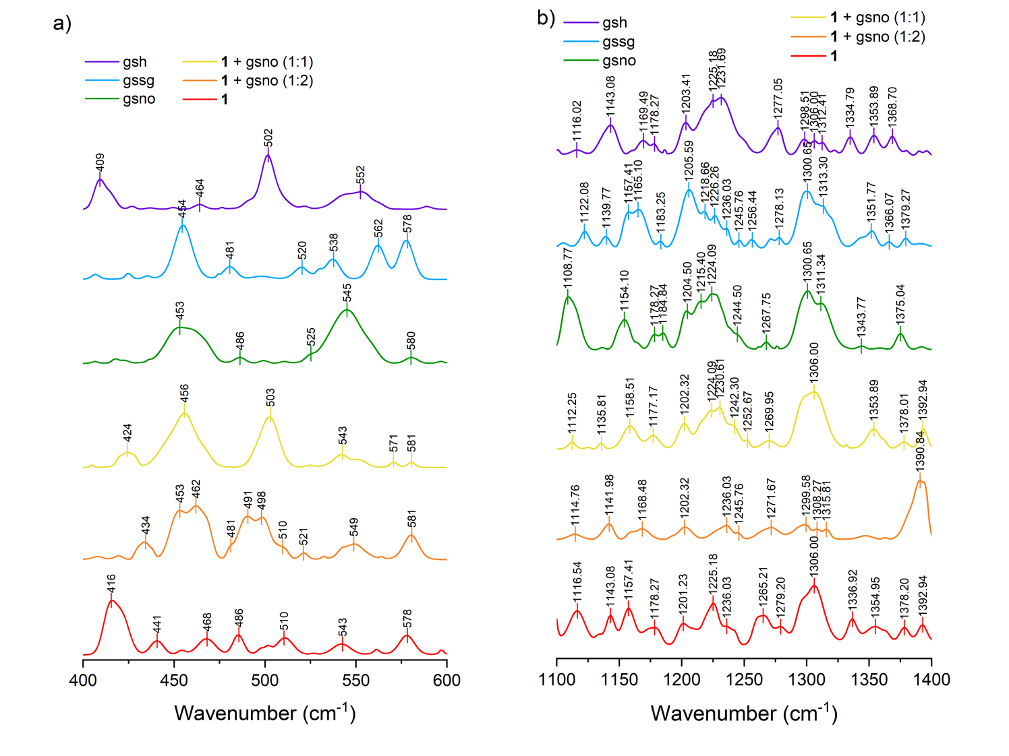
An EPR study was also performed incubating 1 and GSSG (Figure 23S). The obtained result was similar to that observed in the UV-Vis study (Figure 5); the EPR spectra obtained in the reaction between 1 and GSSG is equivalent to that observed in the reaction with GSNO, confirming the presence of Cu(II) with rhombic symmetry and the coordination of S atom to the Cu(II) center, as revealed by the superhyperfine lines resulting from the coupling between the unpaired electron of the Cu(II) center and S nuclear spin (I = 3/2).
Figure 9. a) Raman spectra of standard solutions, in PBS in the range (a) 400-600 cm⁻¹ and (b) 100-1400 cm⁻¹. GSH (purple line); GSSG (blue line); GSNO (green line); Compound 1 (yellow line); the interaction between compound 1 and GSNO (1:1) (orange line); the interaction between compound 1 and GSNO (1:2) (red line).
To evaluate the possible contribution of O₂ in the reaction of compound 1 with GSNO we also studied using chemiluminescence detection (CLD) of NO (Figure 8). These studies were performed by comparing the amounts of •NO released from the interaction of compound 1 with GSNO under anaerobic (N₂) or aerobic (synthetic air) conditions. A 1 mmol L⁻¹ solution of GSNO was added to the glass reaction chamber containing PBS, and the spontaneous decomposition of GSNO was monitored. Full decomposition of GSNO alone took approximately 10 min, at which time the CLD signal reached baseline. With the previous addition of compound 1 to the glass chamber, at a 1:10 molar ratio versus GSNO, the decomposition is accelerated, with the reaction taking only 5 min to complete. Thus, the addition of compound 1 reduced the time required for full decomposition of GSNO by half, further corroborating the catalytic nature of compound 1 in interacting with nitrosothiols. Importantly, there were no significant differences in the amounts of •NO released between aerobic and anaerobic condition, confirming that O₂ does not participate in the mechanism proposed for the reaction. Furthermore, to confirm that the activity shown is promoted by 1 and not due to the presence of traces of free copper(II) ions in solution, the reaction was studied by electronic spectroscopy and CLD in the presence of copper(I) and (II) chelators, bathocuproine and neocuproine (see Figures 24S and 25S). Both approaches demonstrated that the activity of the compound 1 is preserved, and even enhanced, in the presence of copper chelators, thereby ruling out the possibility that GSNO decomposition is promoted by free copper ions in solution.
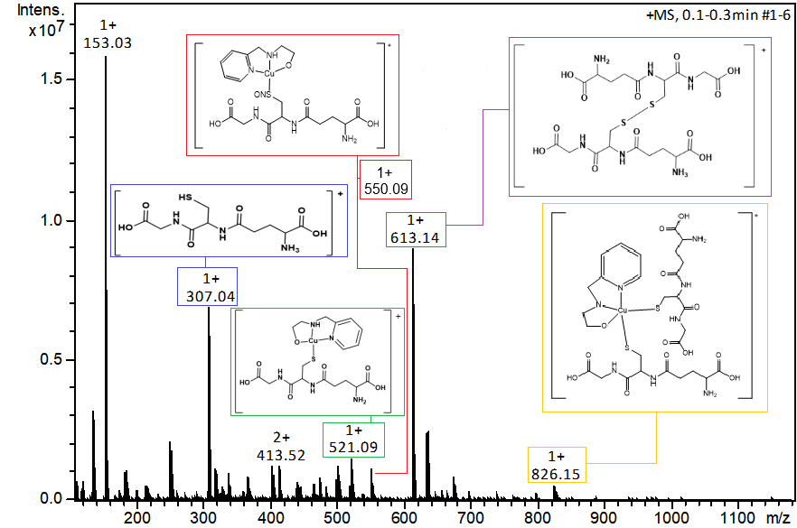
To further evaluate possible changes in the complex structure and formation of intermediates, the reaction was also monitored by surface-enhanced Raman spectroscopy (SERS) (Figure 9). Compound 1 presents an intense band at 416 cm⁻¹, which results from the superposition of two bands at 414 and 421 cm⁻¹, respectively, according to spectral deconvolution (Figure 26S). These are attributed to the Cu-OH₂ stretching vibration of the two water ligands that replace the chloro ligands in the complex in solution, in accordance with the potentiometric titration data (Figure 6S). This band disappears when GSNO is added at either 1:1 or 1:2 molar ratio, suggesting that the aquo ligands are replaced by GSNO. The appearance of new bands at 424 cm⁻¹ and 434 cm⁻¹ in both reaction spectra corroborates that. In both cases, the deconvolution showed the presence of 3 bands at 419, 424, 428 cm⁻¹ and 429, 434, 438 cm⁻¹ for proportions 1:1 and 1:2, respectively. None of these bands are present in the GSH, GSSG, or GSNO spectra, which indicates they are a result of the interaction between compound 1 and GSNO, suggesting formation of a Cu-S bond (the Cu-N and Cu-O bands appear in the region between 440 and 500 cm⁻¹). Since the compound maintains its main structure with the tridentate ligand HL, these bands are still observed in the reaction spectra, with slight shifts, which can be attributed to the delocalization of the electron cloud around these atoms, promoted by the bond between the copper centre and GSNO. The spectrum of the reaction between compound 1 and GSNO at a 1:1 proportion shows a new band at 456 cm⁻¹. Through deconvolution, it was possible to separate 3 different bands at 447, 456 and 469 cm⁻¹, respectively. The band in 456 cm⁻¹ is sharp and attributed to an S-S stretch, indicative of the formation of GSSG. The same band can be observed in the GSSG spectrum at 454 cm⁻¹. In the spectrum employing a 1:2 ratio, the bands start to separate. The deconvolution also shows 3 bands, with slight dislocation to a higher wavenumber 452, 462 and 469 cm⁻¹, respectively. The band at 520 cm⁻¹ that appears in the 1:2 reaction and is present as a weak feature in the 1:1 reaction is again attributed to an S-S stretch vibration, since it is also observed in the GSSG spectrum. Figure 10b shows a different region of the spectra; the band at 1108 cm⁻¹ in the GSNO spectrum was deconvoluted and is composed of two bands at 1106 and 1114 cm⁻¹, both being attributed to an S-N stretch. The band decreases in intensity significantly in the reactions with compound 1, consistent with the decomposition of GSNO.
Figure 10. ESI-(+)-MS spectrum of the reaction between compound 1 and GSNO, in water, and the chemical nature of the main species is discussed in the text.

Scheme 2. Experimentally proposed mechanisms for the reaction of 1 with GSNO.

ESI-(+)-MS studies were carried out to characterize intermediates formed in the reaction between compound 1 and GSNO. As shown in Figure 10, several relevant species were detected, including the following cations: [Cu(HL)Cl]⁺, m/z 249.98; [GSH+H]⁺ m/z 308.03; [GSNO+H]⁺, m/z 338.02; [Cu(L)(GS)]⁺, m/z 521.09; [Cu(L)(GSNO)]⁺ m/z 550.09; [GSSG + H]⁺ m/z 613.14; [Cu(L)(GS)₂]⁺ m/z 826.17. (Figures 27-36SS). It is important to highlight the observation of three cationic species that confirm the formation of different intermediates: [Cu(L)(GSNO)]⁺, [Cu(L)(GS)]⁺ and [Cu(L)(GS)₂]⁺ that must be considered in the catalytic cycle. Furthermore, the observation of the cation [Cu(L)(GS)₂]⁺ supports the kinetic and spectroscopic data that showed the existence of at least two interaction sites between complex 1 and the substrate GSNO. Additionally, the formation of [GSSG + H]⁺ is another indication that two GS• species must be in close proximity to generate this species (Figure 35S). Figure 37S presents the monitoring, using ESI-(+)-MS, of the interaction between compound 1 and GSNO, in water. The spectrum obtained immediately and 48h after the reaction revealed the instantaneous formation of the cation [Cu(L)(GSNO)]⁺. After a period of 48h, such signal is not more observed, indicating the decomposition of GSNO.
Combining all the information discussed above, we propose the mechanism for denitrosylation of GSNO catalyzed by compound 1 depicted in Scheme 2. It is worth mentioning that all the data presented above indicate that the Cu(II) centre does not undergo reduction to Cu(I), which is in controversy with other systems already reported in the literature.¹⁹ Therefore, in the proposed mechanism, the copper center retains its oxidation state. However, it is not possible to completely exclude that a transient Cu(I) species is formed and reoxidized during the denitrosylation process.
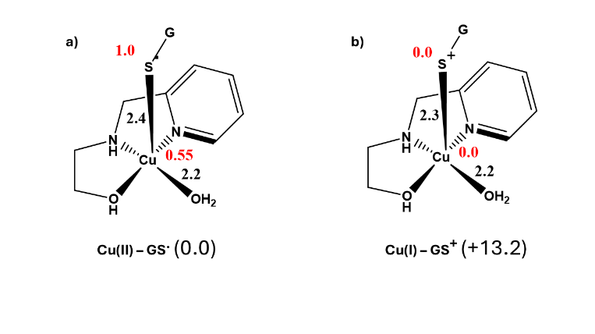
As supported by potentiometric titration and SERS, in aqueous solution, the chloro ligands are substituted by water molecules, giving rise to species B. UV-Vis, EPR, SERS data suggest a direct interaction of 1 with GSNO, resulting in the formation of intermediates C, D and E. The ESI-(+)-MS measurements confirmed the formation of the [Cu(L)(GSNO)]⁺ (C), [Cu(L)(GS)]⁺ (D) and [Cu(L)(GS)₂]⁺ (F) intermediates. These results, in combination with kinetic data and UV-Vis experiments, suggest that two GSNO molecules are interacting with the Cu(II) centre in compound 1 (Scheme 2). Using EPR spectroscopy and gas-phase chemiluminescence, the •NO radical was unambiguously identified, confirming its release as a gaseous molecule. These results support the proposed C, D, and E intermediates in Scheme 2. •NO release quantification under an inert atmosphere confirmed that there is no contribution of O₂ to the reaction mechanism. The mass spectral analysis also showed the formation of the species [Cu(L)(GS)₂]⁺ (F in Scheme 2). From F, a combination of two GS• radicals form the GSSG molecule, as observed by Raman spectroscopy and ESI-(+)-MS studies, and completes the catalytic cycle by restoring species B.
Figure 11. Gibb’s free energies are shown in parentheses (kcal/mol). The Mulliken spin densities are shown in red.
Figure 12. Different oxidation states of Cu center. Enthalpies given in parentheses are in kcal/mol, and distances are in Angstroms. Spin densities are mentioned in red.

The likelihood of this mechanism, based on our experimental results, was further investigated through DFT calculations. The structures and energies of all optimized maxima and minima are provided in Figure 11. The starting point of the mechanism shown in Figure 12 is species B [Cu(HL)(H₂O)₂]²⁺, which is created from compound A [Cu(HL)Cl₂] by substituting both chloro ligands with water molecules. All structures shown in Figure 12 exist in the doublet spin state, and two plausible pathways for the reaction have been explored. In compound B, the HL ligand and two water molecules are coordinated to the metal (Cu²⁺) ion in the axial and equatorial positions. Due to the Jahn-Teller effect, the bond of 2.26 Å between the Cu and axial water is substantially weaker than the bond (2.04 Å) with the equatorial water. In the first step, a water molecule from complex B is replaced by GSNO to form species C. Here, GSNO can replace either the axial or the equatorial water. However, due to steric reasons and the Jahn-Teller effect, GSNO ends up occupying the axial position in both cases. From B, the generation of C is exergonic by 9.5 kcal/mol. Compound C is also stabilized by multiple additional hydrogen bonds (Figure 39S). From C, there are two plausible pathways associated with either the cleavage of the S-NO bond or the substitution of ligated water by the second GSNO molecule. In the first pathway, a NO• molecule is released and the GS• coordinates to the Cu²⁺ ion to form compound D. D shows a distorted square pyramidal geometry like a piano stool structure in which water, ⁻OH, and GS• occupy the legs in a pyramidal way and both nitrogen atoms occupy the seat position. Due to its radical character, D is 21.5 kcal/mol endergonic than B. The replacement of the equatorial water ligand by another GSNO molecule in D creates species E. In E, the GS• radical and GSNO are coordinated in the equatorial and axial positions, respectively. The D → E transformation is exergonic by 4.0 kcal/mol. In an alternative pathway, E can be generated from C without the mediation of D. In this pathway, from C, the second water is replaced by another GSNO molecule to form D’. In D’, two GSNO molecules are bound to the Cu²⁺ ion in axial and equatorial locations. The Cu-S bond of 2.82 Å in the axial position is significantly weaker than the corresponding bond (2.44 Å) in the equatorial location due to the Jahn-Teller distortion. Consequently, the equatorial S-NO bond (2.08 Å) is substantially more activated than the axial bond (1.83 Å). The generation of D’ from C is 10.8 kcal/mol endergonic. From D’, the species E is created through the release of •NO from the equatorially bound GSNO molecule. From E, the second •NO molecule is also released to form the compound F in which two GS• radicals are coordinated to the Cu²⁺ ion. The spins of 0.93e and 0.70e on axial and equatorial GS• radicals confirm its generation. In the final step, these two radicals combine to form the GS-SG molecule, and two water molecules occupy the vacant site on the Cu²⁺ compound (species B’), which is an exergonic reaction (-23.7 kcal).
There are two possibilities in the mechanism shown in Figure 11: i) the coordination of two GSNOs and the release of one •NO, and the formation of GS• and then GSGS, and ii) coordination of one GSNO, the release of one •NO, and the formation of GS• and then the binding of the second GSNO, with the formation of GSSG. In this case, the two GSNOs cannot interact with each other without breaking the Cu-S bond, because of steric hindrance. Both pathways converge with the same species, E. But the coordination of two GSNO molecules is less endergonic (1.3, species D´) while the formation of D is more endergonic (21.5), suggesting the coordination of two GSNOs in the same copper(II) center should be more favorable.
Aiming to compare the energy associated with the systems in which the Cu(II) remains as Cu(II) or is reduced to Cu(I) (Cu(I)-SG⁺ vs. Cu(II)-SG•) DFT calculations were performed (Figure 12). The formation of Cu(I) through the electron transfer from GS• to Cu(II) is computed to be endothermic by 13.2 kcal/mol, and the generation of the Cu³⁺ oxidation state is prohibitively high; thus the formation of Cu(II)-SG• species is the most favorable.
As before, we cannot rule out with certainty the formation of a transient Cu(I) species in this process.

Conclusions
In this combined experimental and theoretical study, we demonstrated that a water-soluble compound [Cu(HL)Cl₂] 1 can promote the homolytic sulfur-nitrogen cleavage of S-nitrosoglutathione (GSNO) to generate •NO and glutathione disulfide (GSSG). Results obtained from EPR, electronic and Raman spectroscopy, and ESI-(+)-MS measurements confirmed the Cu-S bond and GSSG species formation. Additional kinetic, electronic spectroscopy, ESI-(+)-MS, and theoretical data suggest that two GSNO molecules interact with the Cu(II) center. Gas-phase chemiluminescence data confirm the generation of •NO and discard the contribution of O₂ in the reaction mechanism. Our results reveal that copper(II) compounds formed by tridentate ligands provide an attractive option as denitrosylation agents, acting catalytically, even in aqueous media.
Author contributions
Bruna B. Segat: Investigation, Methodology, Resources, Writing – original draft; Luis Gabriel Wagner: Investigation; Bruno Szpoganicz and Lino Meurer: Investigation, Formal analysis; Seerag Moorkkannur and Rajeev Prabhakar: Investigation, Formal analysis, Writing – original draft; Siti Noriza Kamel and Sumeet Mahajan: Investigation, Formal analysis; Adolfo Horn Jr.: Investigation, Formal analysis; Funding acquisition; Writing – original draft; Lucas C. Pinheiro: Conceptualization, Funding acquisition, Writing – original draft; Martin Feelisch: Supervision, Formal analysis, Writing – original draft;. Christiane Fernandes: Conceptualization, Funding acquisition, Project administration, Supervision, Writing – original draft, Writing – review & editing.
Conflicts of interest
There are no conflicts to declare
Data availability
The data supporting this article have been included in the supplementary information (SI). Supplementary information: Experimental section, extra characterization (data, tables and graphs), crystallography data, EPR simulation data, SERS Raman deconvolution graphs, ESI-(+)-MS simulated patterns.
Acknowledgements
This work was also financed in part by Coordenação de Aperfeiçoamento de Pessoal de Nível Superior (CAPES), Brazil, Finance Code 001. We thank LABIME (Laboratório de Biologia Molecular e Estrutural- UFSC) for the ESI-(+)-MS analysis, and Central de Análises- UFSC. B.B.S. thanks Conselho Nacional de Desenvolvimento Científico e Tecnológico (CNPq), Brazil, 140294/2022-8. This material is based upon work supported by a grant from the National Science Foundation (Grant Number CHE- 2102563) to R.P. B.B.Segat thanks Coordenação de Aperfeiçoamento de Pessoal de Nível Superior (CAPES), Brazil, 88881.981162/2024-01.
Notes and references
- P. Ghosh, T. H. Warren, Get to Know NO, Nat. Chem 2024, 16, 1382. doi:org/10.1038/s41557-024-01606-w
- L. J. Ignarro, R. E. Byrns, G. M. Buga, K. S. Wood, Endothelium-derived relaxing factor from pulmonary artery and vein possesses pharmacologic and chemical properties identical to those of nitric oxide radical, Circ Res 1987, 61(6), 866. https://doi.org/10.1161/01.RES.61.6.86
- F. R. M. B. Oliveira, J. Assreuy, R. Sordi, The role of nitric oxide in sepsis-associated kidney injury, Biosci Rep 2022, 42 (7), BSR20220093. https://doi.org/10.1042/BSR20220093
- J. O. Lundberg, E. Weitzberg , Nitric oxide signaling in health and disease, Cell 2022, 185 (16), 2853-2878. https://doi.org/10.1016/j.cell.2022.06.010
- B. Wolszczak-Biedrzycka, J. Dorf, J. Matowicka-Karna, et al., Significance of nitrosative stress and glycoxidation products in the diagnosis of COVID-19, Sci Rep 2024, 14, 9198. https://doi.org/10.1038/s41598-024-59876-w
- A. Chatterji, D, Banerjee, T. R. Billiar, R. Sengupta, Understanding the role of S-nitrosylation/nitrosative stress in inflammation and the role of cellular denitrosylases in inflammation modulation: Implications in health and diseases, Free Radic Biol Med 2021, 20 (172), 604-621. https://doi.org/10.1016/j.freeradbiomed.2021.07.015
- H. Fanlo-Ucar, P. Picón-Pagès, V. Herrera-Fernández, G. Ill-Raga, F. J. Muñoz FJ, The Dual Role of Amyloid Beta-Peptide in Oxidative Stress and Inflammation: Unveiling Their Connections in Alzheimer's Disease Etiopathology, Antiox, 2024, 13(10), 1208.https://doi.org/10.3390/antiox13101208
- J. M. Pérez de la Lastra, C. A. Juan, F. J. Plou, E. Pérez-Lebeña, The nitration of proteins, lipids, and DNA by peroxynitrite derivatives-chemistry involved and biological relevance, Stresses 2022, 2, 53-64. https://doi.org/10.3390/stresses2010005
- G. Bertozzi, M. Ferrara, A. Di Fazio, A. Maiese, G. Delogu, N. Di Fazio, V. Tortorella, R. La Russa, V. Fineschi, Oxidative stress in sepsis: A focus on cardiac pathology, Int J Mol Sci. 2024, 25(5), 2912. https://doi.org/10.3390/ijms25052912
- A. K. Khanna, T. Kinoshita, A. Natarajan, A. et al., Association of systolic, diastolic, mean, and pulse pressure with morbidity and mortality in septic ICU patients: a nationwide observational study, Ann. Intensive Care 2023, 13, 9. https://doi.org/10.1186/s13613-023-01101-4
- O. Hamzaoui, A. Goury, J. L. Teboul, The eight unanswered and answered questions about the use of vasopressors in septic shock, J Clin Med 2023, 12(14), 4589. https://doi.org/10.3390/jcm12144589
- S. Panday, R. Talreja, M. Kavdia, The role of glutathione and glutathione peroxidase in regulating cellular level of reactive oxygen and nitrogen species, Microvascular Research 2020, 131, 104010. https://doi.org/10.1016/j.mvr.2020.104010
- M. S. Choi. Pathophysiological role of S-nitrosylation and transnitrosylation depending on S-nitrosoglutathione levels regulated by S-nitrosoglutathione reductase, Biomolecules and Therapeutics 2018, 26(6), 533. doi: 10.4062/biomolther.2018.179
- a) E. Sircar, D. A. Stoyanovsky, T. R. Billiar, A. Holmgren, R. Sengupta, Analysis of glutathione mediated S-(De) nitrosylation in complex biological matrices by immuno-spin trapping and identification of two novel substrates, Nitric Oxide 2022, 118, 26-30. https://doi.org/10.1016/j.niox.2021.10.008 b) Peroxinitrite Reductase Activity of Selenoprotein Glutathione Peroxidase (GPx): A Density Functional Study. Rajeev Prabhakar, K. Morokuma, and D. G. Musaev Biochemistry 2006, 45 (22), 6967-6977. https://doi.org/10.1021/bi060456e c) Elucidation of the Mechanism of Selenoprotein Glutathione Peroxidase (GPx) Catalyzed Hydrogen Peroxide Reduction by two Glutathione Molecules: A Density Functional Study Rajeev Prabhakar, T. Vreven, K. Morokuma, and D. G. Musaev Biochemistry, 2005, 44(35) 11864-11871) https://doi.org/10.1021/bi050815q
- https://pubmed.ncbi.nlm.nih.gov/8660650/
- https://pubmed.ncbi.nlm.nih.gov/10497164/
- R. R, Tuttle, S. J. Folkman, H. N. Rubin, R. G. Finke, M. M. Reynolds, Copper Metal-Organic Framework Surface Catalysis: Catalyst Poisoning, IR Spectroscopic, and Kinetic Evidence Addressing the Nature and Number of the Catalytically Active Sites En Route to Improved Applications, ACS Appl Mater Interfaces. 2020, 12(35) 39043-39055. https://doi.org/10.1021/acsami.0c08961
- R. R. Tuttle, H. N. Rubin, C. D. Rithner, R. G. Finke, M. M. Reynolds, Copper ion vs copper metal–organic framework catalyzed NO release from bioavailable S-Nitrosoglutathione in route to biomedical applications: Direct ¹H NMR monitoring in water allowing identification of the distinct, true reaction stoichiometries and thiol dependencies, J Inorg Biochem, 2019,199, 110760. https://doi.org/10.1016/j.jinorgbio.2019.110760
- B. J. G. Rousseau, A. V. Soudackov, R. R.Tuttle, M. M. Reynolds, R. G. Finke RG, S. Hammes-Schiffer, Computational Insights into the Mechanism of Nitric Oxide Generation from S-Nitrosoglutathione Catalyzed by a Copper Metal–Organic Framework, J Am Chem Soc 2023, 145(18), 10285-10294. https://doi.org/10.1021/jacs.3c01569
- S. Zhang, M. Melzer, S. Sen et al. A motif for reversible nitric oxide interactions in metalloenzymes, Nature Chem 2016, 8, 663–669. https://doi.org/10.1038/nchem.2502
- R. Wever, F. X. R.Van Leeuwen, B. F. Van Gelder. The reaction of nitric oxide with ceruloplasmin. Biochim. Biophys. Acta 1973, 302, 236–239 https://doi.org/10.1016/0005-2744(73)90152-6
- A. C. F. Gorren, E. De Boer, R. Wever. The reaction of nitric oxide with copper proteins and the photodissociation of copper–nitric oxide complexes. Biochim. Biophys. Acta 1987, 916, 38–47. https://doi.org/10.1016/0167-4838(87)90208-1
- V. Hosseininasab, A. C. McQuilken, A. Bakhoda, J. A. Bertke, Q. K. Timerghazin, T. H. Warren, Lewis acid coordination redirects S‐nitrosothiol signaling oput, Angew.Chem In. Ed 2020, 59, 10854.
https://doi.org/10.1002/ange.202001450

- 24- S. Shin, J. Choe, Y. Park, D. Jeong, H. Song, Y. You, D. Seo, J. Cho, Angew. Chem. Int. Ed. 2019, 58, 10126.
- 25- J. Choe, S. J. Kim, J-H. Kim, M-H. Baik, J. Lee, J. Cho. Chem. 2023, 9, 1309.
- L. Constantino, R. C. Gonçalves, V. R. Giombelli, C. D. Tomasi, F. Vuolo, L. W. Kist, G. M. T. de Oliveira, M. A. de B. Pasquali, M. R. Bogo, T. Mauad, A. Horn, K. V Melo, C. Fernandes, J. C. F. Moreira, C. Ritter, F. Dal-Pizzol, Regulation of lung oxidative damage by endogenous superoxide dismutase in sepsis, Intensive Care Med Exp 2014, 2, 17. https://doi.org/10.1186/2197-425X-2-17
- L. B. Menezes, B. B. Segat, H. Tolentino, D. C. Pires, L. M. de M. Mattos, H. M. Hottum, M. D. Pereira, A. Latini, A. Horn Jr., C. Fernandes, ROS scavenging of SOD/CAT mimics probed by EPR and reduction of lipid peroxidation in S. cerevisiae and mouse liver, under severe hydroxyl radical stress condition, J Inorg Biochem 2023, 239, 112062. https://doi.org/10.1016/j.jinorgbio.2022.112062
- L. B. Menezes, R. M. S. N. Sampaio, L. Meurer, B. Szpoganicz, R. Cervo, R. Cargnelutti, L. Wang, J. Yang, R. Prabhakar, C. Fernandes, A. Jr. Horn, A Multipurpose Metallophore and Its Copper Complexes with Diverse Catalytic Antioxidant Properties to Deal with Metal and Oxidative Stress Disorders: A Combined Experimental, Theoretical, and In Vitro Study, Inorg Chem 2024, 63, 14827. https://doi.org/10.1021/acs.inorgchem.4c00232
- T. P. Ribeiro, C. Fernandes, K. V. Melo, S. S. Ferreira, J. A. Lessa, R. W. A. Franco, G. Schenk, M. D. Pereira, A. Horn, Iron, copper, and manganese complexes with in vitro superoxide dismutase and/or catalase activities that keep Saccharomyces cerevisiae cells alive under severe oxidative stress, Free Radic Biol Med 2015, 80, 67. https://doi.org/10.1016/j.freeradbiomed.2014.12.005
- A. P. Cardoso, L. M. P. Madureira, B. B. Segat, J. do N. C. Menezes, R. Cargnelutti, D. R. S. Candela, D. L. Mariano, R. L. T. Parreira, A. Horn, S. H. Seabra, R. A. DaMatta, F. F. Moreira, R. V. Moreira, G. F. Caramori, C. Fernandes, Development, structural, spectroscopic and in silico investigation of new complexes relevant as anti-toxoplasma metallopharmacs, J Mol Struct 2022, 1265, 133380. https://doi.org/10.1016/j.molstruc.2022.133380
- A. W. Addison, T. N. Rao, J. Reedijk, J. van Rijn, G. C. Verschoor, Synthesis, structure, and spectroscopic properties of copper(II) compounds containing nitrogen–sulphur donor ligands; the crystal and molecular structure of aqua[1,7-bis(N-methylbenzimidazol-2′-yl)-2,6-dithiaheptane]copper(II) perchlorate, J. Chem. Soc. Dalton Trans 1984, 1349 DOI
https://doi.org/10.1039/DT9840001349
- S. Ghosh, P. Roy, S. Prasad, G. Mugesh, Crystal-facet-dependent denitrosylation: modulation of NO release from S-nitrosothiols by Cu₂O polymorphs, Chem Sci 2019, 10, 5308. DOI: 10.1039/C9SC01374A
- N. Puač, M. Miletić, M. Mojović, A. Popović-Bijelić, D. Vuković, B. Miličić, D. Maletić, S. Lazović, G. Malović, Z. Petrović. Sterilization of bacteria suspensions and identification of radicals deposited during plasma treatment, Open Chemistry 2015, 13, 000010151520150041. https://doi.org/10.1515/chem-2015-0041
- S. Pou, G. M. Rosen. Generation of thiyl radical by nitric oxide: a spin trapping study. J. Chem. Soc., Perkin Trans. 1998, 2, 1507-1512. https://doi.org/10.1039/A707662B
- C. E. Weller, A. Dhall, F. Ding, E. Linares, S. D. Whedon, N. A. Senger, E. L. Tyson, J. D. Bagert, X. Li, O. Augusto, C. Chatterjee. Aromatic thiol-mediated cleavage of N–O bonds enables chemical ubiquitylation of folded proteins. Nature Communications, 2016, 7, 12979. https://doi.org/10.1038/ncomms12979
- G. R. Buettner. Spin trapping: ESR parameters of spin adducts. Free Radical Biology and Medicine, 1987, 3, 259-303. https://doi.org/10.1016/S0891-5849(87)80033-3
- H. Karoui, N. Hogg, C. Fréjaville, P. Tordo, B. Kalyanaraman. Characterization of Sulfur-centered Radical Intermediates Formed during the Oxidation of Thiols and Sulfite by Peroxynitrite: ESR-Spin trapping and oxygen uptake studies. The Journal of Biological Chemistry, 1996, 271, 6000 –6009. https://doi.org/10.1074/jbc.271.11.6000
- L. Grierson, K. Hildenbrand, E. Bothe. Intramolecular Transformation Reaction of the Glutathione Thiyl Radical into a Non-sulphur-centred Radical: A Pulse-radiolysis and EPR Study. International Journal of Radiation Biology, 1992, 62, 265–277. https://doi.org/10.1080/09553009214552111
- G. Tabbì, A. Giuffrida, R. P. Bonomo, Determination of formal redox potentials in aqueous solution of copper(II) complexes with ligands having nitrogen and oxygen donor atoms and comparison with their EPR and UV–Vis spectral features, J Inorg Biochem 2013, 128, 137. https://doi.org/10.1016/j.jinorgbio.2013.07.035
- E. Faggi, R. Gavara, M. Bolte, L. Fajarí, L. Juliá, L. Rodríguez, I. Alfonso, Copper (II) complexes of macrocyclic and open-chain pseudopeptidic ligands: synthesis, characterization and interaction with dicarboxylates, Dalton Trans 2015, 44, 12700. DOI: 10.1039/C5DT01496D
- DFT Protocol for EPR Prediction of Paramagnetic Cu(II) Complexes and Application to Protein Binding Sites.Magnetochemistry 2018, 4, 55; doi:10.3390/magnetochemistry4040055.
- L. B. Menezes, R.M.S.N. Sampaio, L. Meurer, B. Szpoganicz, R. Cervo, R. Cargnelutti, L. Wang, L. Yang, R. Prabhakar, C. Fernandes, A. Horn Jr. A Multipurpose Metallophore and Its Copper Complexes with Diverse Catalytic Antioxidant Properties to Deal with Metal and Oxidative Stress Disorders: A Combined Experimental, Theoretical, and In Vitro Study. Inorg. Chem., 2024, 63 (32), 14827. DOI: 10.1021/acs.inorgchem.4c00232

