Title: Lessons learnt from long-term monitoring of river restoration in an English chalk stream
Running title (70 characters): Long-term responses at two chalk stream restoration projects.
Authors: Lewis A. Dolman, Andrew S. Vowles, Paul S. Kemp
Affiliations: International Centre for Ecohydraulics Research, Faculty of Engineering and Physical Sciences, University of Southampton, Hampshire, Southampton, United Kingdom
Corresponding Author: Lewis Dolman (lewis.dolman@environment-agency.gov.uk)
Acknowledgements: We thank the manager of Bossington Estate for granting access to carry out this research and all those who assisted with fieldwork. This project was funded by the Engineering and Physical Sciences Research Council and Environment Agency as a part of the Centre for Doctoral Training in Sustainable Infrastructure Systems (EP/L01582X/1). The funders had no role in study design, data collection and analysis, decision to publish, or preparation of the manuscript.
Data accessibility statement: All data files are available from the University of Southampton repository at https://eprints.soton.ac.uk/487563/ [Chapter 7].

Abstract
River restoration can be difficult to evaluate due to insufficient monitoring over timescales too short to adequately capture physical and ecological response. To better understand restoration outcomes, this study quantified changes in physical habitat (depth, velocity, substrate composition) and macroinvertebrates at two restoration projects on a chalk stream (River Test, UK) over 8 - 9 years using a Before-After repeated measures approach. Restoration involved coarse substrate addition, tree hinging/ woody material placement and planform reprofiling. At both sites, habitat heterogeneity (e.g. cross-sectional depth variability) and macroinvertebrate abundance and diversity increased, whilst non-rheophilic taxa increased in dominance at one site. Substrate composition varied over time but generally became coarser post-restoration. Macroinvertebrate metrics remained relatively stable following restoration, except in 2016 (one- and three-years post-restoration) when several metrics were lower (e.g. abundance and taxon richness). The reasons for this are unclear but could represent local disturbance (e.g. river management) or variability in data collection between surveyors. This study provides evidence for the effectiveness of restoration and highlights the benefits and challenges of longer-term monitoring. Considering the cost of restoration, there is a need to adequately evaluate project outcomes over the long-term to ascertain reasons for success and failure and overall cost: benefit. Equally, it is recognised that due to the small-scale of many opportunistic projects it is not economically viable to include extensive monitoring. Therefore, we recommend a strategic programme of robust, long-term appraisals be developed assessing exemplar restoration sites to evidence restoration effectiveness and guide future efforts.
Keywords: rehabilitation, groundwater river, macroinvertebrates, ecology

Introduction
River restoration is applied globally to mitigate the impacts of historical modification (United Nations, 2023; European Commission, 2000). Typically, these projects are biased to the enhancement of physical habitat for specific groups and species (e.g. salmonids; Zeug et al., 2014), whilst some set broader targets to enhance biodiversity and river function (Addy et al., 2016). A wide variety of approaches are employed, which can be categorised as being either form- (e.g. woody material placement, flow deflectors, e.g. Pretty et al., 2003) or process-based (e.g. infrastructure removal; e.g. Stanley et al., 2002). Whilst the number of restoration projects and monitoring studies published are growing (e.g. RESTORE, 2023), inter-project variability in ecological responses remains high (Friberg et al., 2016). For example, whilst some studies report desirable ecological outcomes as expected (e.g. increased macroinvertebrate and macrophyte diversity: Staentzel et al., 2018), others have found limited (e.g. fish: Pretty et al., 2003; macroinvertebrates: Harrison et al., 2004), temporary (e.g. Pulg et al., 2013) and even negative outcomes (e.g. decreased macroinvertebrate density; Orr et al., 2008). Several factors potentially contribute to the mixed responses reported, including the targeting of restoration at inappropriate scales (Polvi et al., 2020), setting of unclear goals (Suding, 2011), failure to address the root cause of degradation (Pulg et al., 2013; Wolff et al., 2021), poor site recovery potential (e.g. a lack of species pools for recolonisation; Sundermann et al., 2011) and inadvertent negative impacts of the restoration itself (Albertson et al., 2011). However, one of the most significant limitations relates to insufficient evaluation of outcomes due to inadequate monitoring (Pander and Geist, 2013) over temporal scales too short to capture the full ecological response (Feld et al., 2011; Kail et al., 2015).
Understanding the physical and ecological consequences of river restoration over appropriate spatial and temporal scales is essential in advancing sound practice (Lu et al., 2019; England et al., 2021). Time since restoration is known to be a key predictor of ecological response (e.g. Kail et al., 2015), although trajectories are often non-linear (e.g. the reversal of initial benefits due to gradual silt ingression; Pulg et al., 2013) and vary with site characteristics (e.g. river discharge; Carlson et al., 2018), colonisation potential (Langford et al., 2009), ecological group of interest (Thompson et al., 2018) and restoration approach adopted (Gilvear et al., 2013; Al-Zankana et al., 2020). Longer-term appraisals are needed to develop a more comprehensive understanding of project effectiveness, recovery times, adaptive management requirements and the influence of environmental variables and perturbation (e.g. flood events; England et al., 2008; Weber et al., 2018). Ultimately, such evaluation is valuable because it reduces uncertainties around different restoration approaches, contributes to defining best practice, and facilitates decision making through better understanding of cost effectiveness.
Despite recognising its importance, longer-term evaluations of river restoration projects remain rare. This is in part due to the limited funding typically allocated to appraisal, particularly for small projects for which even limited monitoring would deem many unviable. Robust monitoring can be resource intensive, requires appropriate expertise, and is often challenging to implement, e.g. when results are confounded by further manipulation of the restoration site. There is also pressure to obtain results rapidly to satisfy stakeholders (Palmer et al., 2007; Smith et al., 2014; Borgström et al., 2016), including those that deliver restoration projects and who will likely benefit from the publicity of positive outcomes.
It is not clear what proportion of restoration projects are evaluated in the first instance, but a review of those that were (n = 74) indicated that the median duration of monitoring conducted was 2.5 years (Feld et al., 2011). Establishing the timescale needed to effectively monitor the response to the restoration approaches applied is difficult and requires consideration of an array of factors, including goals of the intervention relative to site-specific context. For example, systems with low stream power, such as groundwater dominated chalk streams, lack the ability to mobilise bedload sediments in the same way as high gradient hard bedrock rivers, consequently relying more on ecological processes to generate complexity, likely extending the time taken to respond (CaBA, 2021). Likewise, rate of recovery may be much slower for rivers that have suffered long-term degradation of water quality and have lost the species pools needed for rapid recolonisation (Langford et al., 2009). In such cases, short-term monitoring may result in misleading conclusions as they fail to capture effectiveness over appropriate temporal scales (Dolman et al., 2024).
This study quantified the responses of physical habitat and benthic macroinvertebrates over 8 - 9 years at two case study restoration projects in which several approaches were combined (coarse substrate addition, bank reprofiling, instream placement of woody material, bankside tree hinging) on the River Test, a chalk stream in Hampshire, England. It was predicted that the restoration would: (1) enhance flow velocity, bathymetric and velocity heterogeneity, increase the proportion of substrate comprising larger particles (e.g. gravel and cobble relative to silt), and reduce water depth; (2) increase macroinvertebrate abundance and taxon richness and the contribution of taxa that indicate high water quality to the community, such as Ephemeroptera, Plecoptera and Tricoptera (EPT) (percentage of the total abundance [EPTA] and taxon richness [EPTN] per sample comprised of EPT), silt-intolerant (Proportion of Sediment Sediment-sensitive Invertebrates [PSI]; Extence et al., 2010) and rheophilic taxa (Lotic-invertebrate Index for Flow Evaluation [LIFE]; Extence et al., 1999); and (3) after an initial rapid change in macroinvertebrate communities, the study metrics would stabilise over time as the new habitat is colonised.

Methods
Study sites
The River Test (Hampshire, England) is a 50 km chalk stream with a catchment of 1260 km² (AEDA, 2013) and base flow of > 0.9 (NFRA, 2013). Geology and land use is respectively predominantly chalk and arable/pasture in the upper catchment, becoming increasingly sand/clay dominated and urbanised lower in the catchment (AEDA, 2013). Over several centuries, the River Test has been widely channelised, dredged and impounded by weirs to support a range of activities (e.g. mechanical power generation, navigation, agriculture, water abstraction). These modifications, alongside an array of other impacts (e.g. point and diffuse source pollution, over abstraction), has resulted in a highly engineered system that deviates considerably from a natural reference state (Skinner, 2013). Indeed, 52% of sampling sites failed to achieve good ecological status under the Water Framework Directive (WFD) in 2019, with physical modification being identified as the primary driver of 75% of these (Environment Agency, 2021a, Environment Agency, 2021b).
Physical habitat and macroinvertebrate communities were monitored at two restoration sites, Old Station Beat (OSTN) and Old Stews Beat (OSTW), at Bossington Estate, a recreational dry fly fishery on the River Test (Figure 1). Prior to restoration, both reaches had historically been engineered, exhibiting straightened, widened, and dredged channel characteristics. The substrate had a high component of fine sediments and the ecological condition was considered deteriorated (Cain Bio Engineering, 2020, 2023). As part of the Test and Itchen River Restoration Strategy, 450 m of OSTN and 250 m of OSTW was restored in October 2013 and September 2015, respectively (Environment Agency, 2015). The reason for the restoration was to restore more ‘naturalised’ chalk stream hydrogeomorphology through enhancing the dynamics of flow and width and depth variation (Restoring Europe's Rivers, 2017). The riverbed was raised at both sites by adding washed mixed size coarse substrates obtained on-site (OSTN = 1,600 tonnes, OSTW = 2,500 tonnes). The river channels were narrowed and planform reprofiled with pools and other geomorphic features landscaped on the riverbed. The banks were reprofiled with gentler slopes to facilitate greater lateral connectivity, whilst bankside trees were hinged and woody material installed within the channel. In 2019, two small (~ 1 m diameter) pools were created in OSTN using a long-reach excavator (see Figure 1). Overall, this was expected to have a limited impact on the rest of the reach.
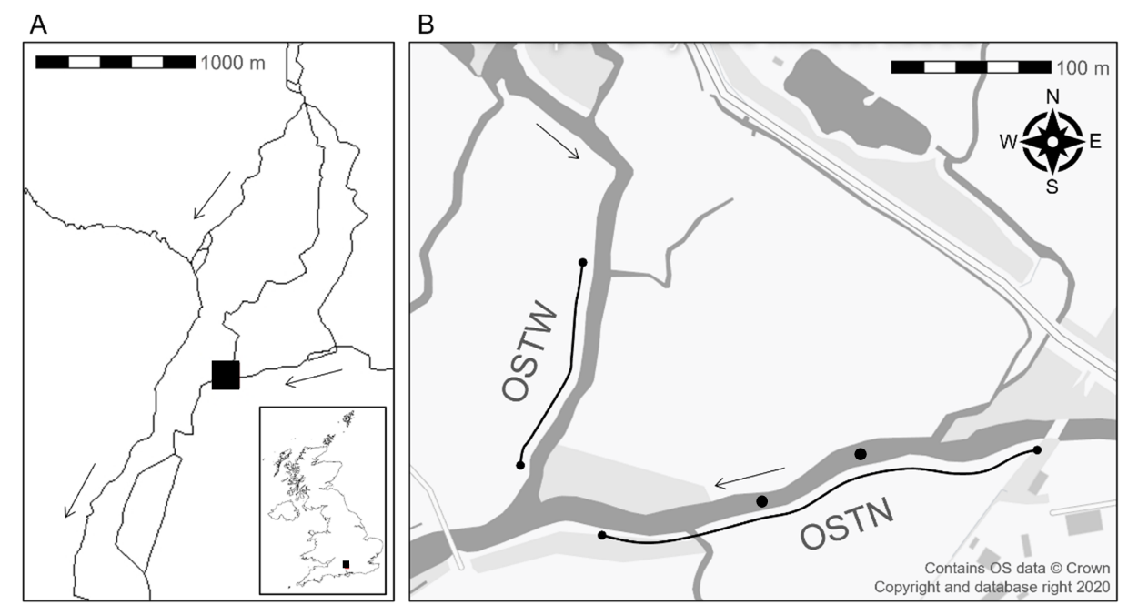
Figure 1 (A) Location of the restoration sites (black box) studied on the River Test (Hampshire, United Kingdom) with greater detail for (B) OSTN and OSTW monitoring sites. Arrows indicate direction of flow. Dots show the approximate location of the small pools created in 2019. Line shows the extent of the study sites. River and United Kingdom shapefile used in ‘A’ was obtained from Ordnance Survey (2022) and GADM (2023), respectively. Map in ‘B’ was obtained from Ordnance Survey (2016).

Between 2013 and 2021 data was collected as part of several Undergraduate, Masters and PhD (lead author) student research projects. Focusing on study reaches that incorporated 300 m and 140 m of the restored sections of OSTN and OSTW, respectively, a Before-After repeated measures design was applied. At both sites data was collected along cross-channel transects perpendicular to the flow spaced at 20 m intervals (n = 16 at OSTN, 8 at OSTW) along the study reach in September 2013 (OSTN only) and late July/August 2014, 2016, 2020 and 2021 (both sites) (Figure 2). As such, one pre- and three (OSTW) or four (OSTN) post-restoration surveys were conducted. WFD monitoring data indicated that physicochemical, hydromorphological and macroinvertebrate classifications remained consistent between 2013 and 2019 (DEFRA, 2022). The area was impacted moderately by copper and lead in 2014, and by mercury and polybrominated diphenyl ethers in 2019, but this did not alter WFD macroinvertebrate classifications (DEFRA, 2022).

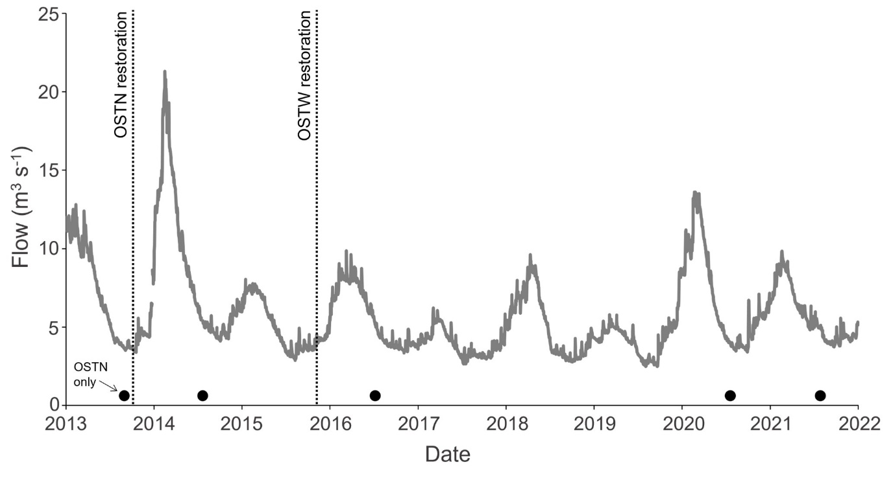
Figure 2 Flow on the River Test during a study designed to assess physical and ecological responses at two chalk stream restoration projects. Vertical dashed lines and solid circles along the x-axis indicate restoration activities and periods of data collection, respectively. Flow data was obtained from the Chilbolton flow gauging station (DEFRA, 2021) approximately 10 km upstream from the study sites. Public sector information licensed under the Open Government Licence v3.0.

Physical habitat
Depth (cm), velocity (m s⁻¹; mean of ten readings over 10 secs at 1 Hz at 60% depth from the substrate to surface using a Valeport Model 801 flow meter) and dominant substrate (silt [< 0.06 mm], sand [0.06 - 2 mm], gravel [2 - 64 mm], cobble [> 64 mm] in a 50 cm² quadrat) was assessed at three equidistant points along each transect in each year. Depth (DCSV) and velocity (VCSV) cross-sectional variability were calculated as the standard deviation of the three measurements taken across each transect. To visualise spatial changes in depth, velocity and dominant substrate, interpolation maps were created in ArcMap 10.8 (ArcGIS, 2020) using an inverse distance weighting approach and river boundary and sampling point coordinates extracted from Google (2022).

Macroinvertebrates
Macroinvertebrates were sampled at nine points at each site using a standard 3 minute kick sample and 1 minute hand search (e.g. water surface, beneath larger substrates) with a 250 mm² square-framed net (1 mm mesh; WFDUK, 2022). Sampling methodology was consistent between years. After collection, samples were stored in 70% methylated spirit and processed within one month of collection. Macroinvertebrates were identified to the family level, aside from Oligochaeta and Nematomorpha that were classified as such, and abundance, taxon richness, EPTA, EPTN, LIFE (Extence et al., 1999) and PSI (Extence et al., 2010) calculated for each sample.
Natural fluctuations in macroinvertebrates across time were controlled for by collating datasets from Environment Agency (Environment Agency, 2023) and Salmon and Trout Conservation group (SmartRivers, 2023) databases and calculating the same metrics as those assessed in this study. Data focussed on those that used standard 3-minute kick samples from the River Test and its tributaries (e.g. River Anton) between 2013 and 2021. To control for differences between seasons, only data collected between May and October was extracted. Where multiple datasets were collected for the same location in a year, the mean of the metrics for each sample was used. To ensure control sites had not been previously restored, the River Restoration Centre’s National River Restoration Inventory (River Restoration Centre, 2023) was checked, and any datasets potentially influenced by restoration excluded. As direct statistical analyses were not possible due to the lack of data for 2020/2021, metrics were qualitatively assessed visually to compare variability over time.

Statistical analysis
To quantify the responses of physical habitat and macroinvertebrate metrics to restoration over time, a generalised linear mixed model (GLMM; taxon richness) with a Poisson error distribution and log-link function and linear mixed models (LMM; all other metrics aside from substrate cover) were created. Models included the term ‘year’ as a fixed factor and ‘transect/sampling point’ as a random effect to account for repeated measures. The significance of year was assessed using likelihood ratio tests by comparing full and null models (i.e. not containing ‘year’) and model assumptions were checked using diagnostic plots (QQ and fitted vs residual plots). Abundance was log transformed to conform to model assumptions. For models where differences between years were found, these differences were further investigated using TukeyHSD pairwise comparisons.
For substrate metrics, diagnostic plots suggested model assumptions were not met by linear or generalised linear mixed models. Therefore, a non-parametric rank-based repeated measures approach (NPS), which is free of distributional assumptions, robust to small sample sizes and outliers and produces an ANOVA-type statistic (ATS; Noguchi et al., 2012) was used. Models were created with the same terms as for the LMMs and GLMM. Where year was significant, TukeyHSD pairwise comparisons were carried out using the ‘mctp.rm’ function in ‘nparcomp’ (Konietschke et al., 2015).
Each restoration site was analysed separately. Statistical analyses were conducted in R Studio (R Studio Team, 2020) and the packages ggplot2 (Wickham, 2016), Lme4 (Bates et al., 2015), LSmeans (Lenth, 2016), performance (Lüdecke et al., 2020), patchwork (Pedersen, 2020), nparLD (Noguchi et al., 2012) and nparcomp (Konietschke et al., 2015) were used.

Results
Physical habitat
At OSTN, all physical habitat metrics differed among years (Table 1; Figures 3, 4, 5a). Compared to the pre-restoration period, velocity was lower in 2016 and 2020, VCSV higher in 2014, and the DCSV was higher in 2014 and 2016 (Appendix 1a for post-hoc statistics). Sand and cobble cover was respectively lower and higher in 2020 and 2021, whilst silt cover was higher in 2020. River depth was greater after restoration.
Compared to the immediate post restoration period (2014), velocity and VCSV was lower in 2016, 2020 and 2021. DCSV was lower in 2020 and 2021. The cover of cobble and gravel were respectively higher and lower in 2020 and 2021, whilst silt cover was higher in 2020.
Compared to three years post-restoration in 2016, sand cover was lower and silt higher in 2020 and cobble cover was greater in 2020 and 2021.
Table 1 Results of GLMMs, LMMs and NPMs assessing the effect of sampling year on physical habitat and ecological metrics at two restoration projects at OSTN and OSTW. Significant p values are highlighted in bold.
Variable | Model | OSTN |  |  | OSTW
Variable | Model | X2/ATS | df | p | X2/ATS | df | p
Depth | LMM | 42.833 | 4 | < 0.001 | 11.437 | 3 | < 0.01
Velocity | LMM | 36.817 | 3 | < 0.001 | 14.027 | 3 | < 0.01
DCSV | LMM | 27.341 | 4 | < 0.001 | 32.817 | 3 | < 0.001
VCSV | LMM | 15.104 | 4 | < 0.01 | 0.578 | 3 | 0.901
Cobble | NPM | 8.259 | 2.5 | < 0.001 | 6.258 | 2.3 | < 0.01
Gravel | NPM | 5.766 | 3.5 | < 0.001 | 1.473 | 2.6 | 0.225
Sand | NPM | 6.220 | 3.3 | < 0.001 | 3.892 | 2.0 | < 0.05
Silt | NPM | 4.141 | 3.5 | < 0.01 | 1.467 | 2.3 | 0.229
Abundance | LMM | 55.567 | 4 | < 0.001 | 27.902 | 3 | < 0.001
Taxon richness | GLMM | 61.640 | 4 | < 0.001 | 65.222 | 3 | < 0.001
EPTA | LMM | 9.008 | 4 | 0.061 | 8.314 | 3 | < 0.05
EPTN | LMM | 14.070 | 4 | < 0.01 | 5.742 | 3 | 0.125
PSI | LMM | 21.359 | 4 | < 0.001 | 6.796 | 3 | 0.079
LIFE | LMM | 25.849 | 4 | < 0.001 | 1.035 | 3 | 0.793

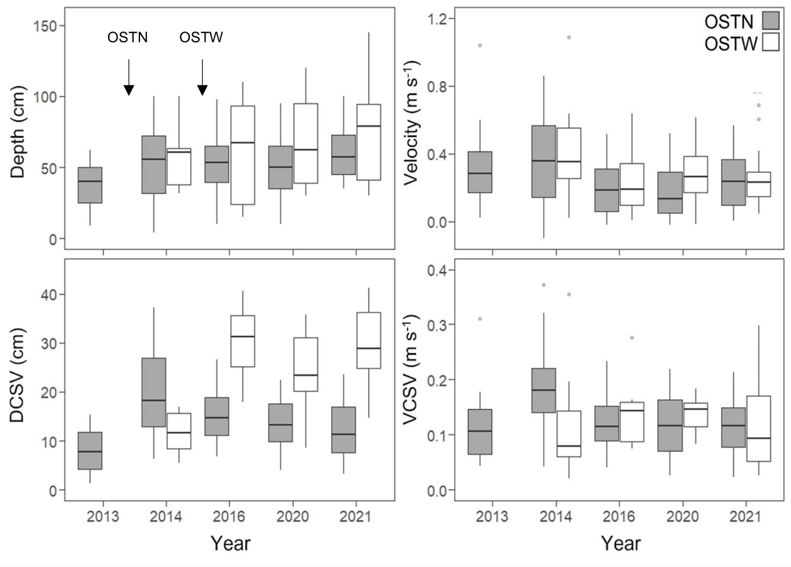Figure 3 Physical habitat metrics collected in OSTN and OSTW restoration sites on the River Test, Hampshire, across years. Arrows show the point of restoration. Black bar and boxes show median and 25th and 75th percentile, respectively. Whiskers represent minimum and maximum values excluding outliers. Dots show outliers (values > 1.5 x the interquartile range).
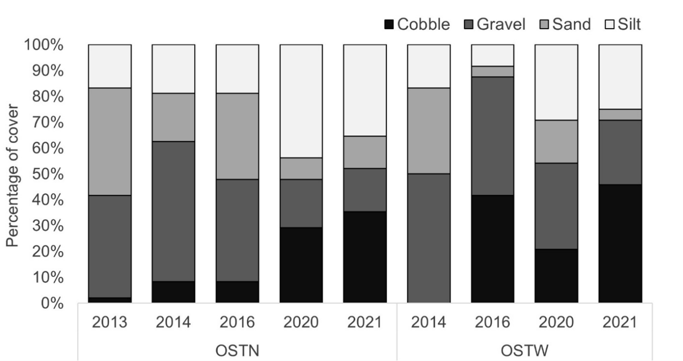
Figure 4 The percentage of sampling points in each sampling period in which each substrate type assessed was dominant at the OSTN and OSTW restoration project on the River Test, Hampshire. Pre-restoration (OTSN: 2013, OSTW: 2014), post-restoration (OSTN: 2014-2021, OSTW: 2016-2021).
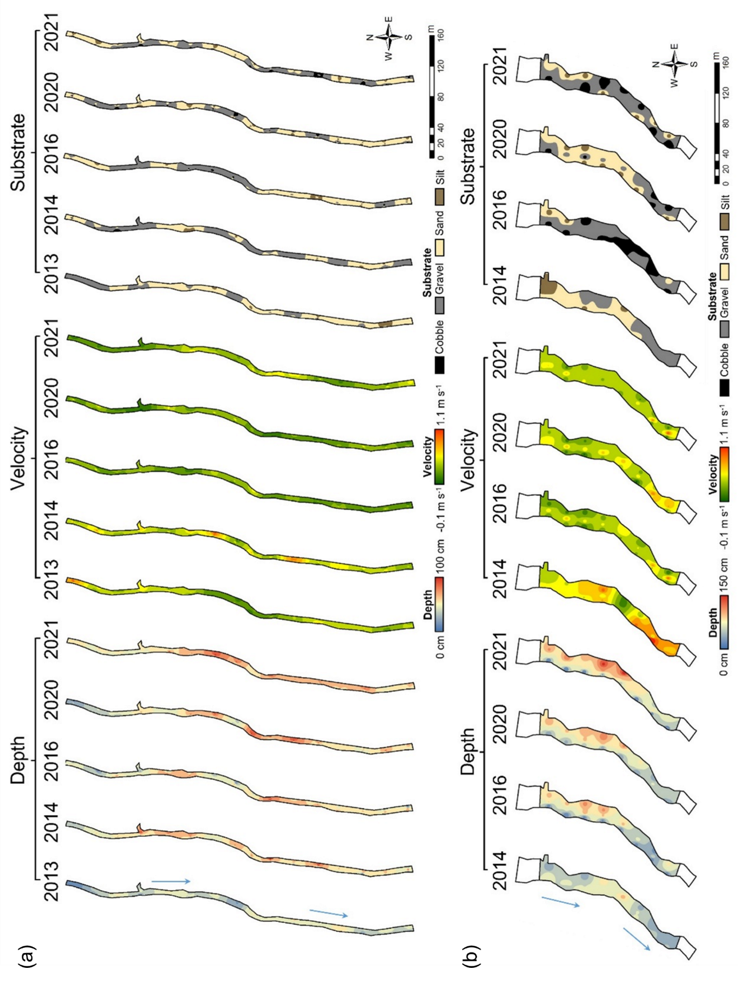
Figure 5 Spatial variability in depth, velocity and substrate cover across each sampling date for the (a) OSTN and (b) OSTW restoration sites. Blue arrows indicate flow direction.

At OSTW, year influenced depth, velocity, DCSV and cobble and sand cover (Table 1; Figure 3, 4, 5b), with differences observed between the pre-restoration (2014) and post-restoration samples. Compared to pre-restoration, DCSV was higher in all post-restoration sampling years, velocity was lower and cobble cover higher in 2016 and 2021. Depth was higher in 2021. Despite finding an overall effect of year on sand cover, no interannual differences were detected for sand cover in post-hoc analysis.

Macroinvertebrates
Visual inspection of macroinvertebrate metrics calculated from available data collected during routine monitoring of sites on the River Test and associated tributaries between May and October from 2012 to 2021 indicated limited variability (Appendix 2). An apparently higher variability between 2019-2021 may have reflected a low number of samples (2019 = 1, 2021 = 2) during this period.
At OSTN, 11,236 individuals comprising 60 different families were recorded. Year influenced abundance and taxon richness (Table 1; Figure 6). Compared to pre-restoration (2013), abundance and taxon richness were higher in 2014, 2020 and 2021 (Appendix 1b). No differences in these metrics were observed between 2014, 2020 and 2021. Abundance and taxon richness in 2016 was lower compared to 2014, 2020 and 2021. Time had no significant influence on EPTA, while EPTN was higher in 2013 compared to 2016. PSI was lower in 2016 compared to 2020 and 2021. LIFE was greater in 2013 compared to 2014, 2016 and 2021, and in 2020 compared to 2014 and 2016.
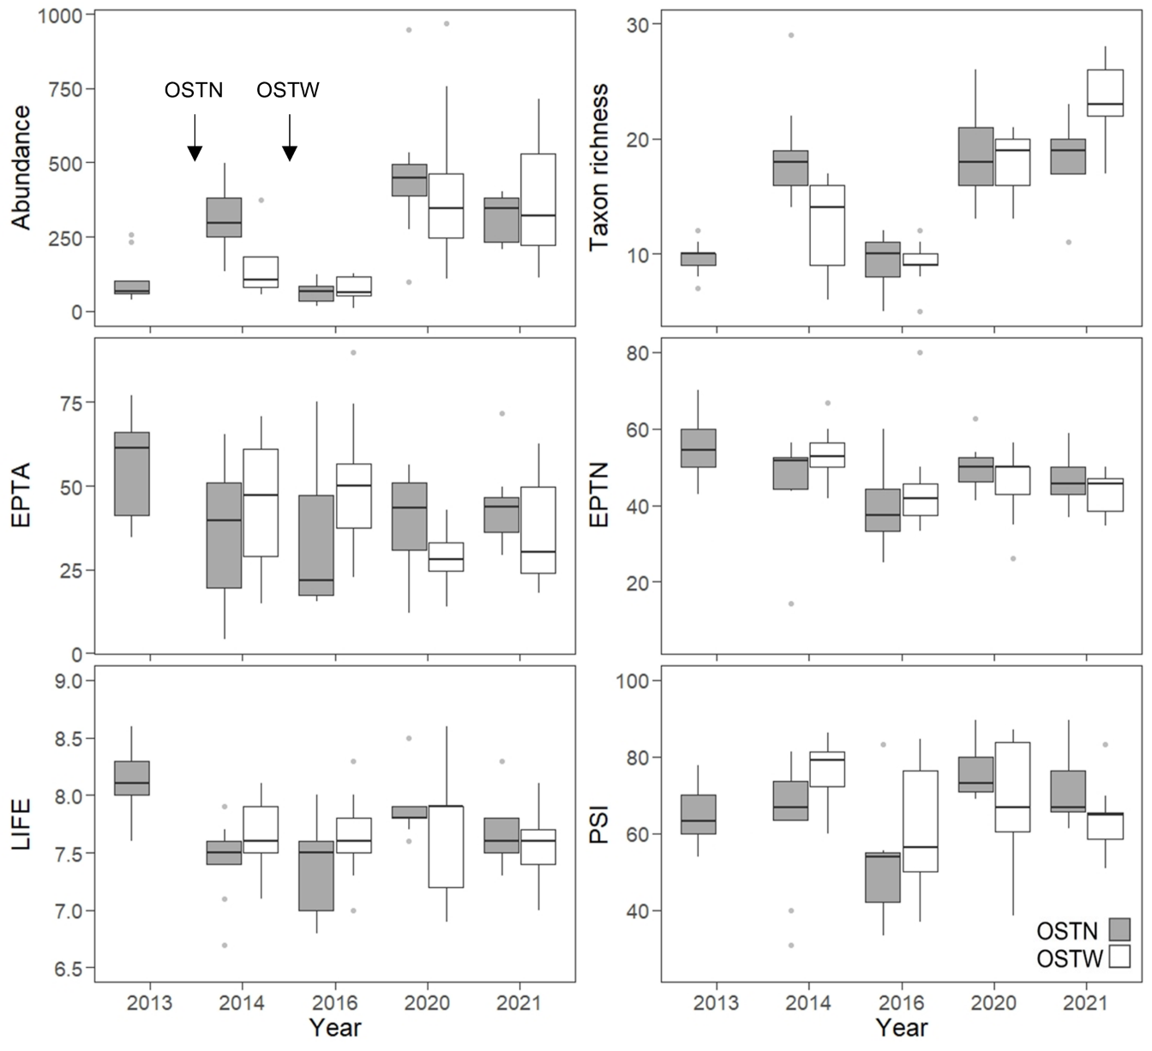

Figure 6 Changes in macroinvertebrate metrics in OSTN and OSTW restoration sites on the River Test, Hampshire, in response to restoration projects across years. Arrows show point of restoration. Black bar and boxes show median and 25th and 75th percentile, respectively. Whiskers represent minimum and maximum values excluding outliers. Dots show outliers (values > 1.5 x the interquartile range).

A total of 8,976 macroinvertebrate individuals belonging to 65 different families were recorded for OSTW. Over the study period, both macroinvertebrate abundance and taxon richness increased, being higher in 2020 and 2021 compared to 2014 and 2016 (Table 1; Figure 6). There was no difference in these metrics between 2014 and 2016. Considering EPT, although an effect of time was observed for EPTA, post-hoc analysis failed to indicate a difference between specific years. There was no influence of time on EPTN, PSI or LIFE metrics.
There was little evidence suggesting the macroinvertebrate metrics stabilised over time after an initial rapid change following restoration. Most metrics remained consistent across post-restoration sampling dates, except for an apparent decline in several metrics (e.g. abundance, taxon richness) in 2016.

Discussion
The physical restoration of rivers can play an important role in mitigating the impacts of historical river degradation (United Nations, 2023) to regenerate biodiversity and improve ecological status. The effectiveness of river restoration approaches employed can, however, be highly variable and the results of interventions often deviate from expectation (e.g. Orr et al., 2008). One of the challenges of river restoration is the poor understanding of long-term response to the actions taken due to a lack of monitoring (Pander and Geist, 2013; England et al., 2021), often dictated by limited resources available to do so. This study assessed how physical habitat and macroinvertebrate communities changed in response to two chalk stream restoration projects over an 8 - 9 years period, using three predictions to test our hypotheses. First, we expected that a combination of actions, which included the addition of coarse substrates and woody material, bankside reprofiling and the hinging of trees, would increase velocity and bathymetric and velocity heterogeneity, elevate the percentage of substrate comprising larger particles sizes, and reduce overall depth. Interestingly, while the physical environment did adjust to the interventions, the changes did not always meet expectations. For example, while variation in cross-sectional depth increased as expected, average depth increased despite the addition of substrates in OSTN, and variation in cross-sectional velocity showed little change. Second, while the results supported our prediction that macroinvertebrate abundance and taxon richness would increase after restoration, an elevated contribution of Ephemeroptera, Plecoptera and Tricoptera to the community was not realised. Likewise, there was no clear change in the contribution of silt-intolerant (PSI) taxa to the community, whilst LIFE scores were indicative of an unexpected increase in non-rheophilic taxa in OSTN compared to pre-restoration. Finally, our third prediction that macroinvertebrate metrics would stabilise over time following an initial response to restoration had little support, with most metrics showing little post-restoration change aside from a decline in several metrics in 2016 (e.g. abundance, taxon richness).
Both restoration projects were intended to revitalise historically modified and degraded river channels towards a more ‘naturalised’ state, with the expectation that this would enhance ecological condition. Physically, actions taken were expected to reduce channel depth and increase velocity, coarse substrate cover and habitat heterogeneity, measured in terms of variability in cross-sectional depth (DCSV) and velocity (VCSV). This prediction was partially met at both sites, with DCSV increasing immediately post restoration. An overall increase in depth in OSTN, however, is counter-intuitive considering the addition of coarse substrates. This might reflect a counterbalancing effect related to increasing heterogeneity through the construction of pools that aid transition from a homogenous channel to one with a greater abundance of pools and riffles, but the average depth values being disproportionately influenced by the deeper areas. An alternative explanation may be rapid alteration of bed materials through natural sediment dynamics of the river, including the influence of flooding, such as occurred at OSTN in 2014. This may have facilitated restructuring of sediments, e.g. by transporting new substrates away from the restored reach (Kil and Bae, 2012; Arnaud et al., 2017). However, the cover of larger (cobble) substrate increased at both sites as would be predicted following coarse substrate addition, although this was not detected until 2020 at OSTN (change occurred between 3-7 years post-restoration). Likewise, the proportion of fine substrates (e.g. silt) was higher in the latter years of monitoring (e.g. OSTN 2020), potentially indicating the long-term influence of catchment scale processes, including the stress of fine sediment input to chalk streams from agricultural sources (Mondon et al., 2024).
The macroinvertebrate community responded to the physical habitat modification through an increase in both abundance and taxon richness. This was likely driven by elevated occupiable space through increasing surface area and variability of microhabitat through creating more complex riverbed structure (Duan et al., 2008; Barnes et al., 2013). Despite some variability, there was no clear difference between the pre- and post-restoration periods for either the EPT metrics or measures of silt intolerance, suggesting that the extent of the reach scale restoration activities was insufficient to override catchment-scale processes that determine water quality and fine sediment dynamics. However, a reduction in the LIFE score in OSTN indicated that the community composition was influenced by a larger proportion of rheophilic taxa prior to restoration. An increase in LIFE scores might have been expected post restoration, but this result may reflect an enhancement in habitat structure, e.g. due to the placement of woody materials, offering refuge to taxa more sensitive to high flows (e.g. Mathers et al., 2022). Nevertheless, scores obtained both prior to and after restoration indicated a high contribution of rheophilic taxa to the community overall.
Following an initial response to the disruption in physical characteristics, it was expected that several macroinvertebrate metrics would adjust and stabilise over time as rarer taxa recolonise the modified habitat (Lorenz, 2021; Sinclair et al., 2023). There was, however, little evidence to support this prediction, with limited change in most metrics over time post restoration, except for a dip in 2016 for some metrics (e.g. taxon richness). The projects described in this study used traditional feature-based approaches, such as the placement of large woody material and the addition of coarse substrates, to kick-start habitat development. Due to their low stream power chalk streams typically respond slowly to physical modification (Sear et al., 1999), with process-based changes taking years or even decades to attain the changes sought after (CaBA, 2021). For example, restoring normative rates of woody material inputs through tree hinging may take many years to realise (e.g. Beechie et al., 2000). Therefore, complementing this through the addition of large woody materials to encourage habitat development is likely a positive strategy to enhance the ecological response over the short-term. However, the role of other factors, such as the proximity of species pools (Sundermann et al., 2011) and patch connectivity (Tonkin et al., 2014), are also likely to influence the speed and longevity of the ecological response observed.
A challenge of long-term monitoring relates to accounting for confounding variables that influence interannual variability for reasons unrelated to habitat modification. The probability of factors operating at the catchment scale influencing study results, such as changes in water quality (e.g. pollution events) and quantity (intermittent floods and droughts), increase with time scale of the study. Before-After-Control-Impact (BACI) study designs are considered the ‘gold standard’ in monitoring river restoration (England et al., 2021), but even when these are employed the number of viable replicates is typically limited by pragmatic constraints. Furthermore, the design of the monitoring programme is of lower priority than achieving the goals of the restoration project itself, which may often be based on opportunism (e.g. selected based on participation of a willing landowner) and sometimes initiated with little warning (e.g. sudden and time-limited access to funding opportunities), challenging planning. The ability to develop long-term strategically implemented restoration programmes supported by well-designed and appropriately funded monitoring tends to be rare in the context of southern English chalk streams. Limitations in funding for monitoring means that those long-terms studies that are realised tend to be based on opportunistic “bolt-on” initiatives that may not always integrate well with the original restoration strategy. This study was conducted by an academic institution and for extended periods was reliant on unfunded Undergraduate and Masters-level students to collect data as part of their dissertation projects. Over the long-term, sampling bias and inconsistent skill levels are likely to have an effect, creating data compatibility or quality issues and increasing the probability of error that can weaken robustness of the study and conclusions that can be drawn (e.g. Albertson et al., 2013). For example, this may explain the apparent anomalous dip in abundance and taxon richness at OSTN in 2016 compared to all other post-restoration years. It is important, therefore, to mitigate such risks through providing rigorous training and quality control through appropriate supervision by experienced practitioners.
Sub-optimal studies, such as those that fail to employ a full BACI design (e.g. Harrison et al., 2004), can nevertheless provide important information to those working in river restoration (Albertson et al., 2013), provided limitations are recognised. This is especially so for those that are conducted over longer-time frames, which remain rare in the restoration literature and can provide invaluable evidence, provided sufficient rigour is developed (Lu et al., 2019; England et al., 2021).

Conclusion
The findings of this study contribute to a growing body of evidence demonstrating the effectiveness of restoration practices in changing chalk stream habitat and ecology towards a more desirable state. The value of longer-term monitoring in discerning these effects, in addition to the wide-ranging challenges in its implementation, are also highlighted. To effectively guide restoration practice, there is a clear need for the development of evidence that does not simply evaluate restoration effectiveness, but does so with sufficient rigour considering a range of systems and ecological components over ecologically relevant time scales. To implement high quality monitoring programmes within an economic environment in which funding is limited, and in the case of small restoration projects where robust monitoring would not be cost effective (and could cost more than the project itself), there is a need to strategically design monitoring programmes by selecting representative case-studies that provide lessons for the wider community (e.g. CaBA, 2022). Supplemented by more opportunistic studies, these exemplar case studies provide a foundation of evidence on which future restoration projects can be inspired and built.

References
ADDY, S., COOKSLEY, S., DODD, N., WAYLEN, K., STOCKAN, J., BYG, A. & HOLSTEAD, K. 2016. River Restoration Nature-Based Solutions for Restoring the Rivers of the UK and Republic of Irelandand Biodiversity. Aberdeen, United Kingdom.
AEDA. 2013. Test and Itchen catchment [Online]. Available: http://www.environmentdata.org/archive/geopref:3493 [Accessed].
AL-ZANKANA, A. F. A., MATHESON, T. & HARPER, D. M. 2020. How strong is the evidence – based on macroinvertebrate community responses – that river restoration works? Ecohydrology & Hydrobiology, 20, 196-214.
ALBERTSON, L., KOENIG, L., LEWIS, B., ZEUG, S., HARRISON, L. & CARDINALE, B. 2013. How Does Restored Habitat For Chinook Salmon (Oncorhynchus Tshawytscha) In The Merced River In California Compare With Other Chinook Streams? River Research and Applications, 29, 469-482.
ALBERTSON, L. K., CARDINALE, B. J., ZEUG, S. C., HARRISON, L. R., LENIHAN, H. S. & WYDZGA, M. A. 2011. Impacts of Channel Reconstruction on Invertebrate Assemblages in a Restored River. Restoration Ecology, 19, 627-638.
ARCGIS 2020. ArcMap. 10.8 ed.
ARNAUD, F., PIÉGAY, H., BÉAL, D., COLLERY, P., VAUDOR, L. & ROLLET, A.-J. 2017. Monitoring gravel augmentation in a large regulated river and implications for process-based restoration. Earth Surface Processes and Landforms, 42, 2147-2166.
BARNES, J. B., VAUGHAN, I. P. & ORMEROD, S. J. 2013. Reappraising the effects of habitat structure on river macroinvertebrates. Freshwater Biology, 58, 2154-2167.
BATES, D., MÄCHLER, M., BOLKER, B. & WALKER, S. 2015. Fitting Linear Mixed-Effects Models Using lme4. Journal of Statistical Software, 67, 1 - 48.
BEECHIE, T. J., PESS, G., KENNARD, P., BILBY, R. E. & BOLTON, S. 2000. Modeling Recovery Rates and Pathways for Woody Debris Recruitment in Northwestern Washington Streams. North American Journal of Fisheries Management, 20, 436-452.
BORGSTRÖM, S., ZACHRISSON, A. & ECKERBERG, K. 2016. Funding ecological restoration policy in practice—patterns of short-termism and regional biases. Land Use Policy, 52, 439-453.
CABA 2021. Chalk stream restoration strategy 2021 main report.
CABA 2022. Chalk Stream Restoration Strategy 2021 Implementation Plan 2022.
CAIN BIO ENGINEERING. 2020. River Test – Bossington ‘Old Station’ beat restoration [Online]. Available: https://www.cainbioengineering.co.uk/project/river-test-bossington-estate-old-station-beat-restoration [Accessed].
CAIN BIO ENGINEERING. 2023. River Test – Bossington ‘Old Stews’ beat restoration [Online]. Available: https://cainbioengineering.co.uk/project/chalk-stream-restoration-river-test/ [Accessed].
CARLSON, P. E., DONADI, S. & SANDIN, L. 2018. Responses of macroinvertebrate communities to small dam removals: Implications for bioassessment and restoration. Journal of Applied Ecology, 55, 1896-1907.
DEFRA. 2021. Hydrology Data Explorer [Online]. Available: https://environment.data.gov.uk/hydrology/explore [Accessed].
DEFRA. 2022. Test - conf Anton to conf Dun Water Body [Online]. Available: https://environment.data.gov.uk/catchment-planning/WaterBody/GB107042022670?cycle=2 [Accessed].
DOLMAN, L. A., VOWLES, A. S. & KEMP, P. S. 2024. Chalk stream restoration: Physical and ecological responses to gravel augmentation. PLOS ONE, 19, e0313876.
DUAN, X., WANG, Z. & TIAN, S. 2008. Effect of streambed substrate on macroinvertebrate biodiversity. Frontiers of Environmental Science & Engineering in China, 2, 122-128.
ENGLAND, J., ANGELOPOULOS, N., COOKSLEY, S., DODD, J., GILL, A. B., GILVEAR, D., JOHNSON, M., NAURA, M., O’HARE, M., TREE, A., WHEELDON, J. & WILKES, M. 2021. Best Practices for Monitoring and Assessing the Ecological Response to River Restoration. Water, 13, 3352.
ENGLAND, J., SKINNER, K. S. & CARTER, M. G. 2008. Monitoring, river restoration and the Water Framework Directive. Water and Environment Journal, 22, 227-234.
ENVIRONMENT AGENCY 2015. Test and Itchen River Restoration Strategy projects completed in 2015.
ENVIRONMENT AGENCY 2021a. Reasons for not achieving good status dataset.
ENVIRONMENT AGENCY 2021b. The Water Framework Directive 2000/60/EC (WFD) Classification Status Cycle 2.
ENVIRONMENT AGENCY. 2023. Ecology and Fish Data Explorer [Online]. Available: https://environment.data.gov.uk/ecology/explorer/ [Accessed].
EUROPEAN COMMISSION. 2000. Water Framework Directive [Online]. Available: https://environment.ec.europa.eu/topics/water/water-framework-directive_en [Accessed].
EXTENCE, C., BALBI, D. & CHADD, R. 1999. River Flow Indexing Using British Benthic Macroinvertebrates: A Framework for Setting Hydroecological Objectives. Regulated Rivers Research & Management, 15, 545-574.
EXTENCE, C., CHADD, R., ENGLAND, J., DUNBAR, M. J., WOOD, P. & TAYLOR, E. D. 2010. The Assessment of Fine Sediment Accumulation in Rivers Using Macro-Invertebrate Community Response. River Research and Applications, 29, 17-55.
FELD, C. K., BIRK, S., BRADLEY, D. C., HERING, D., KAIL, J., MARZIN, A., MELCHER, A., NEMITZ, D., PEDERSEN, M. L., PLETTERBAUER, F., PONT, D., VERDONSCHOT, P. F. M. & FRIBERG, N. 2011. Chapter Three - From Natural to Degraded Rivers and Back Again: A Test of Restoration Ecology Theory and Practice. Advances in Ecological Research, 44, 119-209.
FRIBERG, N., ANGELOPOULOS, N. V., BUIJSE, A. D., COWX, I. G., KAIL, J., MOE, T. F., MOIR, H., O’HARE, M. T., VERDONSCHOT, P. F. M. & WOLTER, C. 2016. Chapter Eleven - Effective River Restoration in the 21st Century: From Trial and Error to Novel Evidence-Based Approaches. Advances in Ecological Research, 55, 535-611.
GADM. 2023. GADM maps and data [Online]. Available: https://gadm.org/ [Accessed].
GILVEAR, D. J., SPRAY, C. J. & CASAS-MULET, R. 2013. River rehabilitation for the delivery of multiple ecosystem services at the river network scale. Journal of Environmental Management, 126, 30-43.
GOOGLE. 2022. Google Maps [Online]. Available: https://www.google.com/maps [Accessed].
HARRISON, S. S. C., PRETTY, J. L., SHEPHERD, D., HILDREW, A. G., SMITH, C. & HEY, R. D. 2004. The effect of instream rehabilitation structures on macroinvertebrates in lowland rivers. Journal of Applied Ecology, 41, 1140-1154.
KAIL, J., BRABEC, K., POPPE, M. & JANUSCHKE, K. 2015. The effect of river restoration on fish, macroinvertebrates and aquatic macrophytes: A meta-analysis. Ecological Indicators, 58, 311-321.
KIL, H. & BAE, Y. 2012. Effects of low-head dam removal on benthic macroinvertebrate communities in a Korean stream. Animal Cells and Systems 16, 69-76.
KONIETSCHKE, F., PLACZEK, M., SCHAARSCHMIDT, F. & HOTHORN, L. 2015. nparcomp : An R Software Package for Nonparametric Multiple Comparisons and Simultaneous Confidence Intervals. Journal of Statistical Software, 64, 1-17.
LANGFORD, T. E. L., SHAW, P. J., FERGUSON, A. J. D. & HOWARD, S. R. 2009. Long-term recovery of macroinvertebrate biota in grossly polluted streams: Re-colonisation as a constraint to ecological quality. Ecological Indicators, 9, 1064-1077.
LENTH, R. V. 2016. Least-Squares Means: The R Package lsmeans. Journal of Statistical Software, 69, 1 - 33.
LORENZ, A. W. 2021. Continuous riverine biodiversity changes in a 10-years-post-restoration-study—Impacts and pitfalls. River Research and Applications, 37, 270-282.
LU, W., ARIAS FONT, R., CHENG, S., WANG, J. & KOLLMANN, J. 2019. Assessing the context and ecological effects of river restoration – A meta-analysis. Ecological Engineering, 136, 30-37.
LÜDECKE, D., BEN-SHACHAR, M., PATIL, I., WAGGONER, P. & MAKOWSKI, D. 2020. performance: An R Package for Assessment, Comparison and Testing of Statistical Models. Journal of Open Source Software, 6, 3139.
MATHERS, K. L., ROBINSON, C. T. & WEBER, C. 2022. Patchiness in flow refugia use by macroinvertebrates following an artificial flood pulse. River Research and Applications, 38, 696-707.
MONDON, B., SEAR, D. A., COLLINS, A. L., SHAW, P. J. & SYKES, T. 2024. The sedimentology of gravel beds in groundwater-dominated chalk streams: Implications for sediment modelling and management. River Research and Applications, 40, 508-528.
NFRA. 2013. National River Flow Archive search for data [Online] [Online]. Available: https://nrfa.ceh.ac.uk/data/search [Accessed 07/04/2023].
NOGUCHI, K., GEL, Y. R., BRUNNER, E. & KONIETSCHKE, F. 2012. nparLD: An R Software Package for the Nonparametric Analysis of Longitudinal Data in Factorial Experiments. Journal of Statistical Software, 50, 1 - 23.
ORDNANCE SURVEY. 2016. OS Open Grey Tile Layer [Online]. Available: https://hub.arcgis.com/maps/eba4e059903747f7b0aa9e92e85ff716/about [Accessed].
ORDNANCE SURVEY 2022. OS Open Rivers dataset.
ORR, C., KROISS, S., ROGERS, K. & STANLEY, E. 2008. Downstream benthic responses to small dam removal in a coldwater stream. River Research and Applications, 24, 804-822.
PALMER, M., ALLAN, J. D., MEYER, J. & BERNHARDT, E. S. 2007. River Restoration in the Twenty-First Century: Data and Experiential Knowledge to Inform Future Efforts. Restoration Ecology, 15, 472-481.
PANDER, J. & GEIST, J. 2013. Ecological indicators for stream restoration success. Ecological Indicators, 30, 106-118.
PEDERSEN, T., L. 2020. Patchwork: The Composer of Plots. R package version 1.1.1.
POLVI, L. E., LIND, L., PERSSON, H., MIRANDA-MELO, A., PILOTTO, F., SU, X. & NILSSON, C. 2020. Facets and scales in river restoration: Nestedness and interdependence of hydrological, geomorphic, ecological, and biogeochemical processes. Journal of Environmental Management, 265, 110288.
PRETTY, J. L., HARRISON, S. S. C., SHEPHERD, D. J., SMITH, C., HILDREW, A. G. & HEY, R. D. 2003. River rehabilitation and fish populations: assessing the benefit of instream structures. Journal of Applied Ecology, 40, 251-265.
PULG, U., BARLAUP, B., STERNECKER, K., TREPL, L. & UNFER, G. 2013. Restoration of Spawning Habitats of Brown Trout (Salmo trutta) in a Regulated Chalk Stream. River Research and Applications, 29.
R STUDIO TEAM 2020. RStudio: Integrated Development for R. RStudio, Inc. 1.3.1093 ed. Boston, MA.
RESTORE. 2023. RESTORE case studies [Online]. Available: https://www.restorerivers.eu/wiki/index.php?title=Main_Page [Accessed].
RESTORING EUROPE'S RIVERS. 2017. Case study:Old Station Beat restoration, River Test at Bossington [Online]. Available: https://www.restorerivers.eu/wiki/index.php?title=Case_study%3AOld_Station_Beat_restoration,_River_Test_at_Bossington [Accessed].
RIVER RESTORATION CENTRE 2023. NRRI database: custom dataset containing rivers with chalk geology (provided on request).
SEAR, D. A., ARMITAGE, P. D. & DAWSON, F. H. 1999. Groundwater dominated rivers. Hydrological Processes, 13, 255-276.
SINCLAIR, J. S., MADEMANN, J. A., HAUBROCK, P. J. & HAASE, P. 2023. Primarily neutral effects of river restoration on macroinvertebrates, macrophytes, and fishes after a decade of monitoring. Restoration Ecology, 31, e13840.
SKINNER, K. 2013. Test and Itchen River Restoration Strategy. . Oxford, United Kingdom.
SMARTRIVERS. 2023. SmartRivers [Online]. Available: https://login.cartographer.io/workspace [Accessed].
SMITH, B., CLIFFORD, N. J. & MANT, J. 2014. The changing nature of river restoration. WIREs Water, 1, 249-261.
STAENTZEL, C., ARNAUD, F., COMBROUX, I., SCHMITT, L., TRÉMOLIÈRES, M., GRAC, C., PIÉGAY, H., BARILLIER, A., CHARDON, V. & BEISEL, J.-N. 2018. How do instream flow increase and gravel augmentation impact biological communities in large rivers: A case study on the Upper Rhine River. River Research and Applications, 34, 153-164.
STANLEY, E. H., LUEBKE, M. A., DOYLE, M. W. & MARSHALL, D. W. 2002. Short-term changes in channel form and macroinvertebrate communities following low-head dam removal. Journal of the North American Benthological Society, 21, 172-187.
SUDING, K. N. 2011. Toward an Era of Restoration in Ecology: Successes, Failures, and Opportunities Ahead. Annual Review of Ecology, Evolution, and Systematics, 42, 465-487.
SUNDERMANN, A., STOLL, S. & HAASE, P. 2011. River restoration success depends on the species pool of the immediate surroundings. Ecological Applications, 21, 1962-1971.
THOMPSON, R. M., KING, A. J., KINGSFORD, R. M., MAC NALLY, R. & POFF, N. L. 2018. Legacies, lags and long-term trends: Effective flow restoration in a changed and changing world. Freshwater Biology, 63, 986-995.
TONKIN, J. D., STOLL, S., SUNDERMANN, A. & HAASE, P. 2014. Dispersal distance and the pool of taxa, but not barriers, determine the colonisation of restored river reaches by benthic invertebrates. Freshwater Biology, 59, 1843-1855.
UNITED NATIONS. 2023. About the UN decade [Online]. Available: https://www.decadeonrestoration.org/about-un-decade [Accessed].
WEBER, C., ÅBERG, U., BUIJSE, A. D., HUGHES, F. M. R., MCKIE, B. G., PIÉGAY, H., RONI, P., VOLLENWEIDER, S. & HAERTEL-BORER, S. 2018. Goals and principles for programmatic river restoration monitoring and evaluation: collaborative learning across multiple projects. WIREs Water, 5, e1257.
WFDUK 2022. Biological Status Methods Rivers - Benthic Invertebrates.
WICKHAM, H. 2016. ggplot2: Elegant Graphics for Data Analysis, New York, Springer-Verlag
WOLFF, B. A., POMERANZ, J. P. F., KOTALIK, C. J., HALL, E. K. & CLEMENTS, W. H. 2021. Habitat restoration for brown trout (Salmo trutta) has limited effects on macroinvertebrate communities in a historically metal-contaminated stream. Integrated Environmental Assessment and Management, 18, 1047-1055.
ZEUG, S. C., SELLHEIM, K., WATRY, C., ROOK, B., HANNON, J., ZIMMERMAN, J., COX, D. & MERZ, J. 2014. Gravel augmentation increases spawning utilization by anadromous salmonids: a case study from California, USA. River Research and Applications, 30, 707-718.

Appendix
 |  |  | Site | Contrast | Depth |  | Velocity |  | DCSV |  | VCSV |  | Cobble |  | Gravel |  | Sand |  | Silt
 |  |  | Site | Contrast | t | p | t | p | t | p | t | p | ATS | p | ATS | p | ATS | p | ATS | p
 |  |  | OSTN | 2013 - 2014 | -4.678 | < 0.001 | -1.962 | 0.289 | -5.536 | < 0.001 | -3.238 | 0.016 | 1.354 | 0.624 | 1.261 | 0.709 | -2.380 | 0.132 | 0.275 | 0.999
 |  |  | OSTN | 2013 - 2016 | -4.387 | < 0.001 | 3.037 | 0.023 | -3.213 | 0.017 | -0.186 | 1.000 | 1.357 | 0.622 | 0.000 | 1.000 | -0.891 | 0.892 | 0.275 | 0.999
 |  |  | OSTN | 2013 - 2020 | -4.691 | < 0.001 | 3.430 | 0.007 | -2.424 | 0.121 | -0.078 | 1.000 | 3.755 | 0.004 | -2.102 | 0.231 | -4.352 | 0.001 | 2.877 | 0.044
 |  |  | OSTN | 2013 - 2021 | -6.535 | < 0.001 | 1.486 | 0.573 | -2.132 | 0.219 | -0.065 | 1.000 | 4.734 | < 0.001 | -2.667 | 0.072 | -3.413 | 0.010 | 2.128 | 0.220
 |  |  | OSTN | 2014 - 2016 | 0.291 | 0.998 | 4.999 | < 0.001 | 2.323 | 0.150 | 3.052 | 0.026 | 0.000 | 1.000 | -1.470 | 0.579 | 1.544 | 0.525 | 0.000 | 1.000
 |  |  | OSTN | 2014 - 2020 | -0.013 | 1.000 | 5.392 | < 0.001 | 3.113 | 0.022 | 3.160 | 0.019 | 3.484 | 0.008 | -3.988 | 0.002 | -1.703 | 0.427 | 3.251 | 0.017
 |  |  | OSTN | 2014 - 2021 | -1.857 | 0.344 | 3.448 | 0.006 | 3.404 | 0.010 | 3.173 | 0.019 | 3.210 | 0.017 | -4.181 | 0.001 | -0.903 | 0.888 | 1.733 | 0.417
 |  |  | OSTN | 2016 - 2020 | -0.304 | 0.998 | 0.393 | 0.995 | 0.789 | 0.933 | 0.108 | 1.000 | 2.843 | 0.043 | -2.465 | 0.113 | -3.266 | 0.016 | 3.028 | 0.030
 |  |  | OSTN | 2016 - 2021 | -2.148 | 0.204 | -1.551 | 0.531 | 1.081 | 0.816 | 0.122 | 1.000 | 3.025 | 0.027 | -2.513 | 0.102 | -2.462 | 0.111 | 1.823 | 0.366
 |  |  | OSTN | 2020 - 2021 | -1.844 | 0.352 | -1.944 | 0.298 | 0.292 | 0.998 | 0.014 | 1.000 | 0.595 | 0.970 | -0.256 | 0.999 | 0.704 | 0.951 | -0.850 | 0.910
 |  |  | OSTW | 2014 - 2016 | -0.753 | 0.875 | 3.420 | 0.006 | -6.891 | < 0.001 | NA | NA | 3.993 | 0.003 | NA | NA | -2.549 | 0.071 | NA | NA
 |  |  | OSTW | 2014 - 2020 | -1.707 | 0.327 | 2.587 | 0.055 | -4.589 | 0.001 | NA | NA | 2.476 | 0.083 | NA | NA | -1.271 | 0.567 | NA | NA
 |  |  | OSTW | 2014 - 2021 | -3.263 | 0.009 | 3.192 | 0.011 | -6.678 | < 0.001 | NA | NA | 4.296 | 0.001 | NA | NA | -2.547 | 0.072 | NA | NA
 |  |  | OSTW | 2016 - 2020 | -0.954 | 0.776 | -0.832 | 0.839 | 2.302 | 0.122 | NA | NA | -1.538 | 0.409 | NA | NA | 1.363 | 0.510 | NA | NA
 |  |  | OSTW | 2016 - 2021 | -2.510 | 0.067 | -0.228 | 0.996 | 0.213 | 0.997 | NA | NA | 0.272 | 0.992 | NA | NA | 0.000 | 1.000 | NA | NA
 |  |  | OSTW | 2020 - 2021 | -1.556 | 0.410 | 0.604 | 0.930 | -2.089 | 0.182 | NA | NA | 1.988 | 0.205 | NA | NA | -1.812 | 0.274 | NA | NA
Appendix 1a Results of Tukey HSD post-hoc comparison analysis for physical metrics following a significant effect of ‘year’ in main GLMM, LMM or NPS models.

Site | Comparison | Abundance |  | Taxon richness |  | EPTA |  | EPTN |  | LIFE |  | PSI
Site | Comparison | t | p | z | p | t | p | t | p | t | p | t | p
OSTN | 2013-2014 | -4.756 | < 0.001 | -4.982 | < 0.001 | NA | NA | 1.977 | 0.295 | 4.458 | < 0.001 | 0.124 | 1.000
OSTN | 2013-2016 | 1.876 | 0.347 | 0.152 | 1.000 | NA | NA | 3.701 | 0.006 | 4.834 | < 0.001 | 2.454 | 0.122
OSTN | 2013-2020 | -6.009 | < 0.001 | -4.831 | < 0.001 | NA | NA | 1.115 | 0.798 | 1.403 | 0.629 | -2.377 | 0.142
OSTN | 2013-2021 | -5.021 | < 0.001 | -4.932 | < 0.001 | NA | NA | 1.889 | 0.339 | 3.049 | 0.031 | -1.212 | 0.745
OSTN | 2014-2016 | 6.632 | < 0.001 | 5.119 | < 0.001 | NA | NA | 1.723 | 0.432 | 0.376 | 0.996 | 2.330 | 0.157
OSTN | 2014-2020 | -1.253 | 0.721 | 0.164 | 1.000 | NA | NA | -0.862 | 0.909 | -3.055 | 0.031 | -2.502 | 0.110
OSTN | 2014-2021 | -0.265 | 0.999 | 0.055 | 1.000 | NA | NA | -0.088 | 1.000 | -1.409 | 0.625 | -1.336 | 0.671
OSTN | 2016-2020 | -7.885 | < 0.001 | -4.968 | < 0.001 | NA | NA | -2.586 | 0.092 | -3.431 | 0.012 | -4.831 | < 0.001
OSTN | 2016-2021 | -6.896 | < 0.001 | -5.069 | < 0.001 | NA | NA | -1.811 | 0.381 | -1.785 | 0.396 | -3.666 | 0.006
OSTN | 2020-2021 | 0.988 | 0.859 | -0.110 | 1.000 | NA | NA | 0.774 | 0.937 | 1.646 | 0.478 | 1.165 | 0.771
OSTW | 2014-2016 | 1.999 | 0.211 | 2.134 | 0.142 | -0.496 | 0.959 | NA | NA | NA | NA | NA | NA
OSTW | 2014-2020 | -3.181 | 0.017 | -2.885 | 0.021 | 2.100 | 0.176 | NA | NA | NA | NA | NA | NA
OSTW | 2014-2021 | -2.996 | 0.026 | -5.266 | < 0.001 | 1.226 | 0.616 | NA | NA | NA | NA | NA | NA
OSTW | 2016-2020 | -5.181 | < 0.001 | -4.903 | < 0.001 | 2.596 | 0.065 | NA | NA | NA | NA | NA | NA
OSTW | 2016-2021 | -4.996 | < 0.001 | -7.118 | < 0.001 | 1.722 | 0.330 | NA | NA | NA | NA | NA | NA
OSTW | 2020-2021 | 0.185 | 0.998 | -2.488 | 0.062 | -0.874 | 0.818 | NA | NA | NA | NA | NA | NA
Appendix 1b Results of Tukey HSD post-hoc comparison analysis for macroinvertebrate metrics following a significant effect of ‘year’ in GLMM, LMM or NPS main tests.

Appendix 1 Results of Tukey HSD post-hoc comparison analysis for physical metrics following a significant effect of ‘year’ in LMM, GLMM or NPS models.

Table C1 Results of Tukey HSD post-hoc comparison analysis for physical metrics following a significant effect of ‘year’ in main tests.
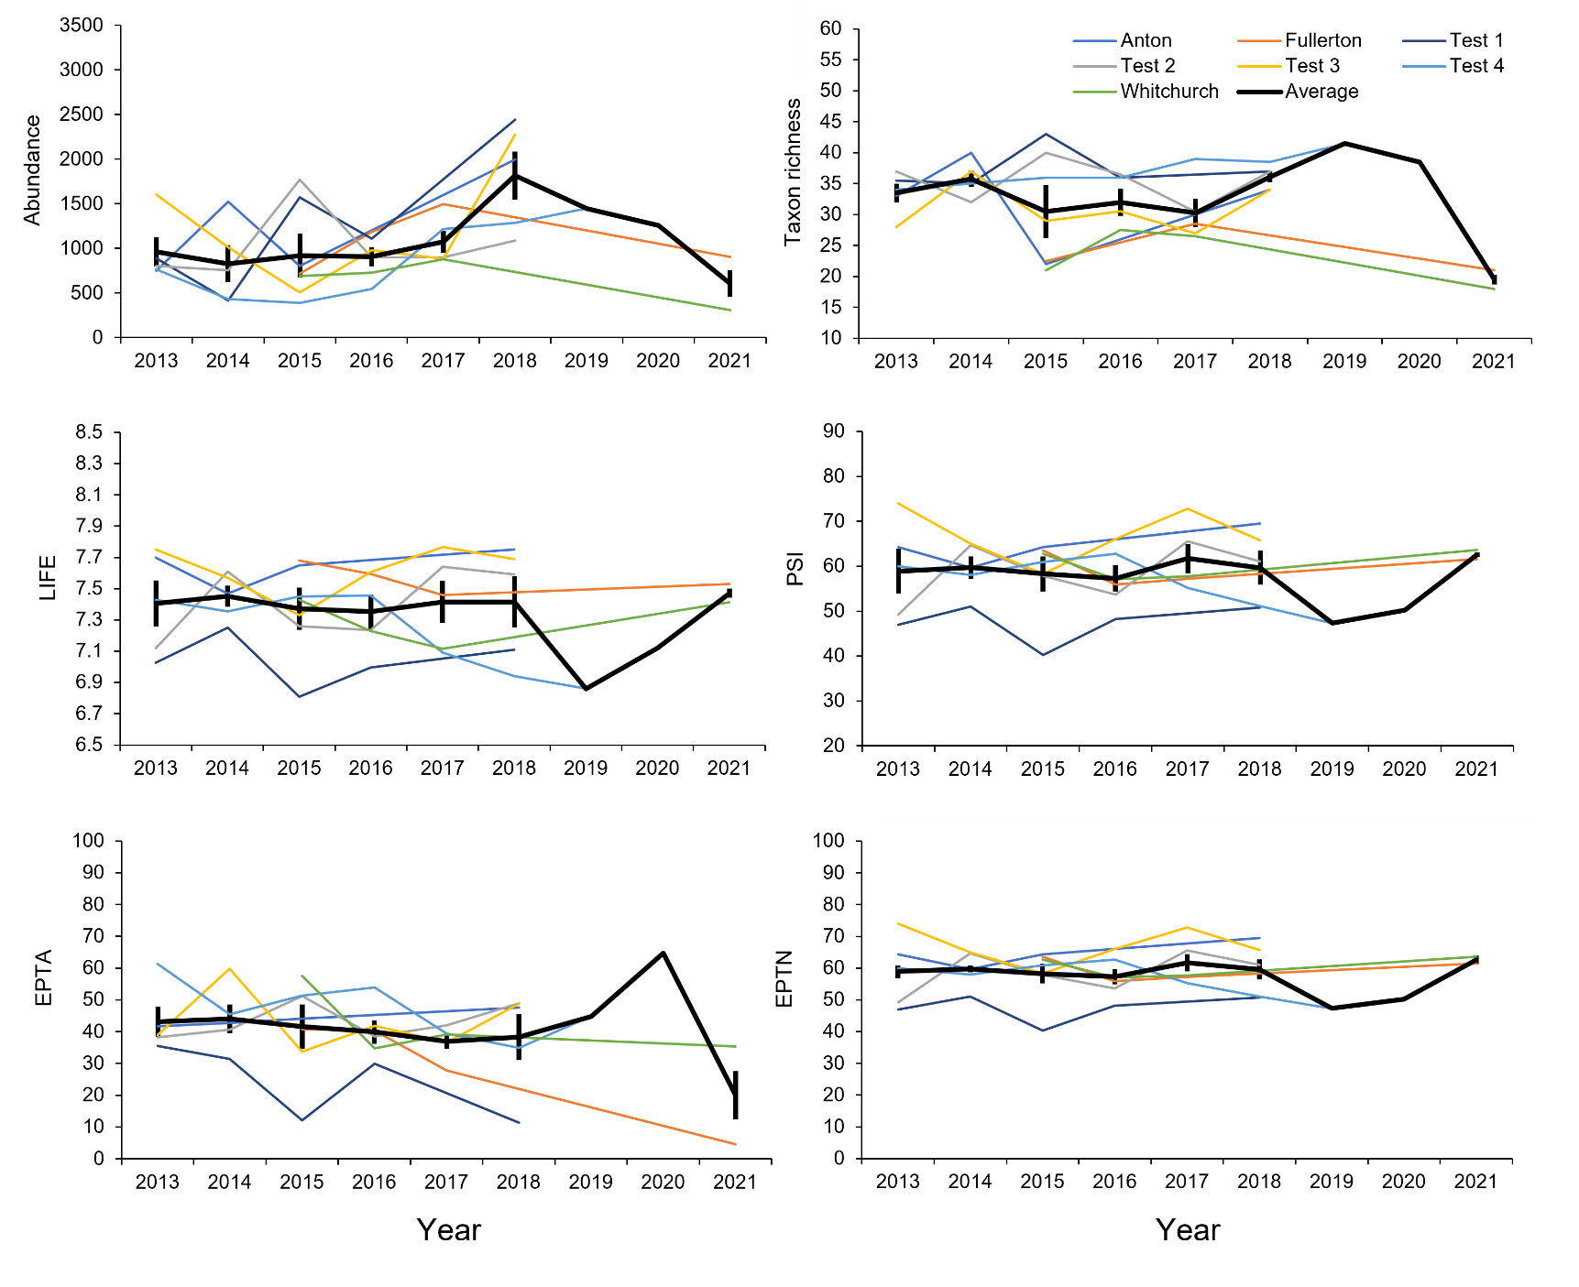
Appendix 2 Macroinvertebrate metrics at seven control sites collected from Environment Agency (2023) and SmartRivers (2023) across the River Test and its tributaries and the average of these (mean ± SD). National grid references: Anton = SU3787039460, Fullerton = SU3822139000, Test 1 = SU3443032520, Test 2 = SU3316025230, Test 3 = SU3547917847, Test 4 = SU3535015300, Whitchurch = SU4776448086.

