Tables and Figures Related to the Qualitative Findings
Table 2. Students’ metaphors illustrating [ChatGPT as a knowledge access tool]
Sub-theme | Metaphor | Reason
Knowledge access tool | having a conversation with a teacher | because you instantly get your answer, response.
Knowledge access tool | grandpa or grandma | they can provide any information….. Of course they all don't have to be wisdom [wise]about everything but they saw [experienced] a lot compared to us. I learned a lot from my grandpa for instance.
 | having a virtual personal teaching assistant | it provides me with instant access to limitless knowledge and opportunities to practice language.
Development tool | Getting help from god  because it knows everything | it knows everything
 | library | it hosts a deep knowledge where you can find all the information you are looking for.
 | sky | it has a wider view of everything.
 | reading a textbook | I have access to the answers to my questions and get different ideas about the subjects I am studying. I can ask detailed questions, and I always have the answers to them or ask for the researchers to read about my essay subjects.
 | drinking water | it's highly beneficial for my learning. It represents someone utilizing an efficient and entertaining way of getting access to the knowledge.
 | torch | the students will know that there will be a torch that can guide them towards some paths that are dark and hard to see. However, they will know that it’s not the sun and that if they will be patient enough (to learn) the sun will rise, the darkness will be gone. The sun is the knowledge of the student here.



Fig.1 Representative student-generated visual metaphor illustrating ChatGPT as a mediational resource for accessing and illuminating knowledge

Table 3. Students’ metaphors about illustrating [affective mediation and epistemic development through the use of ChatGPT].
Sub-theme | Metaphor | Reason
 | god being on my side | it shows me ways to correct myself and live more happily with my work.
Affective mediation | a tow truck | it helps me to complete the way… It hooks me and helps me go when I am stuck.
Affective mediation | Studying with my imaginary friend | because it’s never judges me and helps me a lot mentally and physically. I never get anxious when i work with that.
 | Discussing and studying with friends because | they give help,ideas, tips also copy
 | supportive | It helps students a lot with their homework, presentations, correcting mistakes and also translating.
Epistemic development when in need | a wise person who can give you the right information every time you are in trouble | no matter what you ask it, no matter what source you want information from, it can deliver it all to you within seconds.
Epistemic development when in need | having a teaching assistant who's available 24/7, | it provides instant responses to my questions, generates creative ideas for lesson plans, and offers feedback whenever I need it. It's like a teacher who speeds up my learning process and I can get a lot of explanations when I don't understand. A teacher who helps me with all my homework assignments, assignments, checks and gives me suggestions.
Epistemic development when in need | getting help from superior power. | when i asked it about the feedbacks and applied the feedbacks it gave to me, my article seemed like perfect and i can work with ChatGPT like this and with the help of it I can improve myself.
Epistemic development when in need | having a ghostwriter | it will provide me examples I couldn’t think of, help me to search in different fields based on mindstormings I wrote in the chat and I could edit and add various ideas I get it from ChatGPT without giving full credits to my saviour ghostwriter.It will always help me out immediately based on my specific needs and the way that I like it.Just like how ghostwriters help their artist to accelerate[enhance] the meaning and lyrics without credits and help them as much as they can however they want while broadening the aspects[horizons].
 | being a superhuman | I can generate infinite amount of ideas and create more sub-ideas within them, then use those things to talk about the things I want to talk about. By doing so I am able to express myself a lot better, and make my points clearer. By using ChatGPT I am also very rapid in the way which I get information….These things combined it feels like I am a better version of myself just like superhumans in science fiction movies.
 | reading a textbook | I have access to the answers to my questions and get different ideas about the subjects I am studying. I can ask detailed questions and I always have the answers to them or ask for the researches to read about my essay subjects.
 | like drinking water | it's highly beneficial for my learning
 | using a calculator in a math exam | you do not really cheat but it helps you
 | playing game | it is fun. I explain that you would like to emphasize how the use of chatgpt in a history class can enhance our imagination. By asking questions that prompt students to change history, they can gain different perspectives and develop a better understanding of historical events. Additionally, imagining a historical female character with an artificial intelligence interface who narrates the events during the class is not entirely unlikely in the near future.
 | light bulb | light bulb brings brightness to a dark space. While a light bulb illuminates darkness, ChatGPT enlightens conversations it enriches our perspective and understandig capability when we feel stuck ,so it is a valuable tool if it is used in a effective and appropriate way, we can integrate it in our daily lives to use our time fast and fruitfully… my perspective enlarged.
 | following the North Star | following the North Star  The North Star always shows the way to the North. In order to find which way is North, you could look for which side of the trees have moss, you could figure out where the wind is coming from, or you could use a compass. You could try all of these things in order to find the North. However, there will be always the North Star in the skies precisely telling you where the north is.
 | using pencil sharpener with eraser | it is useful
 | helper | it enhances our ideas and makes us broaden our minds with different perspectives.
 | torch | the students will know that there will be a torch that can guide them towards some paths that are dark and hard to see. However, they will know that it’s not the sun and that if they will be patient enough (to learn) the sun will rise, the darkness will be gone. The sun is the knowledge of the student here.

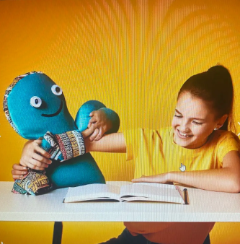

Fig. 2 Representative student-generated visual metaphor illustrating the construction of ChatGPT as an affective mediational resource in TEFL coursework.

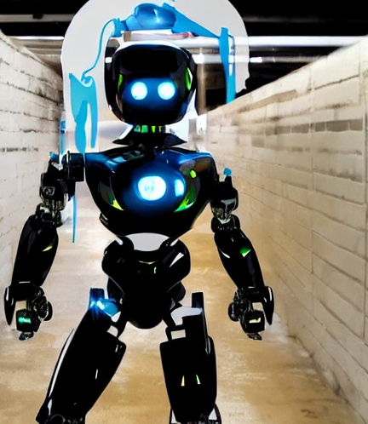

Fig.3 Representative student-generated visual metaphor illustrating the construction of ChatGPT as a resource for epistemic development



Fig. 4 Representative student-generated visual metaphor illustrating the construction of ChatGPT as a resource for epistemic development

Table 4 Student Metaphors illustrating [ChatGPT use for TEFL coursework as pedagogically problematic rather than facilitative]

Sub-theme | Metaphor | Reason
 | not doing anything for a whole semester but getting AA's in all courses | you cheated in every exam. At the end of the day if every person uses it, they will not learn anything from it. They are just going to use it to pass their exams or doing their homeworks. So instead of helping, it will harm students
Deteriorating development  Lacking human touch | driving a car with the wheels off | there isn't any benefit to students…it [using ChatGPT for coursework]was of no use and that it made you forget the information you know and turned people into ignorant.
Deteriorating development  Lacking human touch | It kills creativity | People think that robots will replace teachers in the future, but with chatgpt, people become robots. Because students who will become teachers in the future should know what they are doing. They need to know how to intervene accordingly if their students apply the knowledge and behavior they have experienced during the lessons in the future.
Deteriorating development  Lacking human touch | watching comedy movie | you can laugh but it is fake and not in real life.
Deteriorating development  Lacking human touch | adding water to milk | from the outside it looks and smells good but the work that it will put out will never resemble a human work.
Deteriorating development  Lacking human touch | black and white | ChatGPT clearing of the other colors.

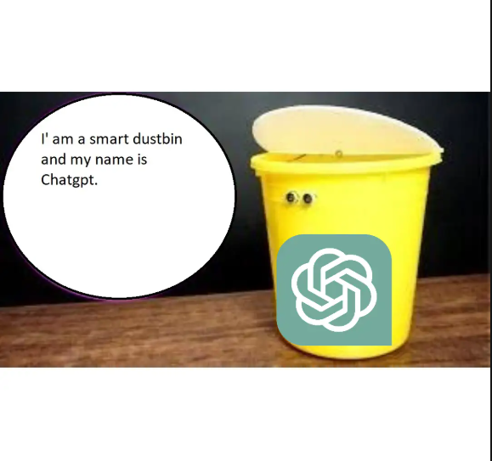

Fig. 5 Representative student-generated visual metaphor constructing ChatGPT as pedagogically ineffective in TEFL coursework.

Table 5 Student Metaphors illustrating [ChatGPT use for TEFL coursework as facilitative for writing]

Sub-theme | Metaphor | Reason
Supporting language development in writing | having a language wizard in the classroom. | It magically conjures up responses, troubleshoots linguistic challenges, and adds a touch of enchantment to the language learning journey.  it provides real-time language support, fosters interactive communication, and offers diverse language examples, enhancing the overall learning experience for students. Integrating ChatGPT into my TEFL coursework is akin to having a language wizard in the classroom.
Supporting language development in writing | having a knowledgeable language mentor | ChatGPT aids in diverse language exercises, from crafting complex sentences to exploring cultural nuances. Its adaptive nature accommodates various language proficiency levels, fostering individualized learning experiences. This tool serves as a catalyst for interactive conversations, enabling students to practice and refine language skills. While not a replacement for human interaction, ChatGPT enhances language acquisition by providing immediate feedback, promoting engagement, and creating an immersive language-learning atmosphere.
Supporting language development in writing | having a linguistic co-pilot | supporting learners in navigating the complexities of language, practicing communication in many circumstances, and offering quick support to boost their overall language ability.
Supporting language development in writing | wielding a linguistic Swiss Army knife in the classroom. | ChatGPT effortlessly navigates the diverse linguistic landscapes of my teaching environment. Its ability to generate contextually relevant responses mirrors the adaptability needed for effective language instruction. Just as a Swiss Army knife provides a range of functionalities, ChatGPT offers a spectrum of language support, from grammar explanations to vocabulary expansion, enriching the learning experience. As an ever-ready companion, it empowers both educators and students, transforming the language learning journey into a dynamic and engaging expedition.
Supporting writing organization & style | having a helpful assistant always available to guide me | It makes learning and completing tasks easier by offering quick suggestions and ideas when I need them. For example, when I’m planning a lesson or working on a writing assignment, ChatGPT helps me organize my thoughts and provides feedback to make my work better. It also explains difficult concepts in simple terms, making complex topics easier to understand. ChatGPT’s suggestions are personalized, so it feels like it’s tailoring its help to fit my specific needs. This saves me time and helps me improve the quality of my work.
Supporting writing organization & style | second teacher | ChatGPT helps me in my writing, lessons, homeworks. I learned a lot of knowledges. It teaches me new words and new writing methods.



Fig. 6 Representative student-generated visual metaphor constructing ChatGPT as effective in writing.

Table 6 Student Metaphors illustrating [ChatGPT use for TEFL coursework as a time-efficient tool to receive feedback]

Sub-theme | Metaphor | Reason
Time-efficent | washing machine | because people can do their work in a short time effectively instead of spending hours completing tasks. Similarly, dishwashing machines cut the process of washing dishes short with satisfying results.
Time-efficent | is like a navigation | it is a system that allows us to reach answers a short and fast way and guides us.
Time-efficent | jet | it reaches to destination faster than a normal plane.In other words, we can get the information faster. For example, a student without using ChatGPT searches on the internet or in the books and it may take time. If s/he has a limited amount of time, s/he may not finish it in time. The same situation but the student is using ChatGPT will finish it on time beacuse of the quickness of the AI tool ChatGPT. It helps by making things more easier and more quicker for students homworks or reasearches. Therefore, using ChatGPT in my TEFL coursework is like a jet which is students who use ChatGPT because it reaches the destination quicker than a normal plane which is students who don't use ChatGPT.
 | having a study buddy | I don't have to be in other places or interact with different, challenging tasks or people. It saves a lot of time.
 | having a conversation with a teacher | having a conversation with a teacher because you instantly get your answer, response.
 | freedom | because it is reachable[accessible] and fast.
 | a whole new experience | I have never gotten feedback this fast and i get the specific information i want immediately.



Fig. 7 Representative student-generated visual metaphor constructing ChatGPT as a time-efficient and practical resource.

Table 7. Student Metaphors illustrating [ChatGPT use for TEFL coursework as a time-efficient tool to receive feedback]
Sub-theme | Metaphor | Reason
Responding to students' needs | teacher and student are equally focused on freedom and dedication to studies. | Having an AI assistant would be useful to speed up research and provide support when the teacher is unavailable. This can help me improve my tasks and my skills.
Responding to students' needs | robot | robot because it makes our life easier and allows us to be quick on some important tasks, when there are subjects that need working.
 | having a personal teacher | It [ChatGPT] gives feedback quickly for your project only and whenever you want. You can get feedback by using it and improve your projects

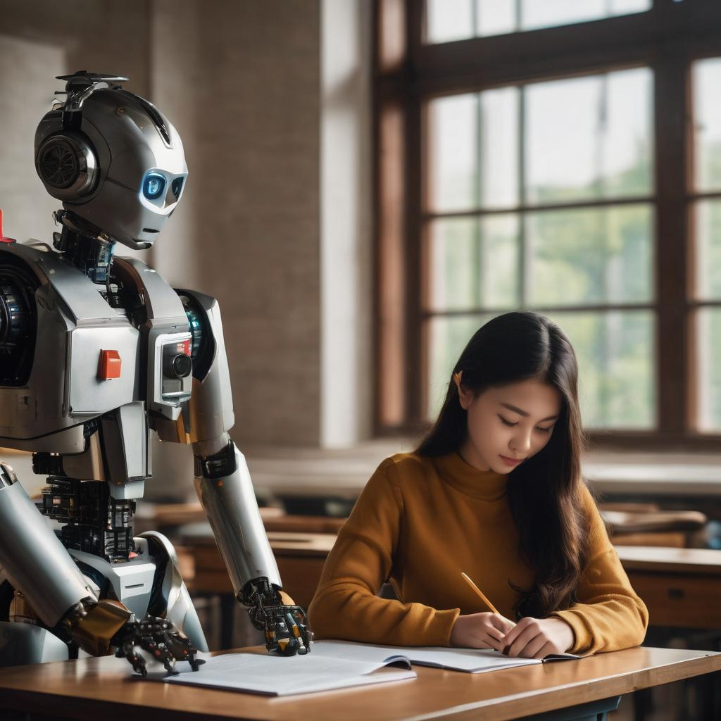

Fig. 8 Representative student-generated visual metaphor constructing ChatGPT as a tool responding to students' needs

Table 8. Student Metaphors illustrating [ChatGPT use for TEFL coursework as a replacement tool]
Sub-theme | Metaphor | Reason
Replacement tool | hiring a butler for courses | if you use it properly and wisely it can lessen your workload significantly. Thus creates more time for yourself to spend. A butler that do my homework for me
Replacement tool | having a servant for everything | I do not do the work for me when there is someone else doing it…it feels like you are having the work done for you so you don’t have to try which feels relaxing.



Fig. 9 Representative student-generated visual metaphor constructing ChatGPT as a replacement tool

Table 9. Student Metaphors illustrating [ChatGPT use for TEFL coursework
deteriorating development when used as a replacement tool]
Sub-theme | Metaphor | Reason
Being caught cheating | eating candy | it is very easy and lovely to access information but if you used so much it can harm your teeths and body so as ChatGPT because of plagrism. This is kunefe and it is very tasty you want to eat it so much but you should not eat it everyday because it can harm your teeths and also your body because of the sweet and cheese (it can also cause kidney problems) so ChatGPT is also like that because if you start to use it everyday it can give a wrong answers or it can cause starting the doing plagrism in assignments so you need to use it when it neccessary.
Being caught cheating | like steroid | you can improve yourself by just going to the gym and having a good diet but even the exintence of steroid is trying to get in to your mind because you see other people that are using it and they are developing faster compared to you, but if they have heatlh problems, this situation can even go to their death, just like using to much chatgpt on your cousework can get you caught and it can even rolling you down into a process that there can be a probablity for your academic carerr fall.
Being caught cheating | trusting a stranger who promises you candy but instead, they just kidnap you with their white van with free candy as their signature. | you agree that you are using a program to get a passing grade on your course and teachers can use other programs that can detect ChatGPT.
Being caught cheating | fire | because if you know how to use it effectively it is a great thing in language learning and enhance my skills but if you don't use it in a positive side and use it for cheating it may cause some bad results.
Inhibiting learning | A big "No No" | I feel like I am doing nothing and an artificial intelligence is doing everything for me.
Inhibiting learning | a crime scene | it consists of abandoning our critical thinking abilities and murdering it. Just like in a crime scene, our abilities lie helplessly, covered in blood and there is no evidence of the usage of ChatGPT  because the user has fled the scene. This transcribes[translates] to the ability of ChatGPT responses to be disguised as one's own voice.



Fig. 10 Representative student-generated visual metaphor constructing ChatGPT as a tool that gets students caught cheating

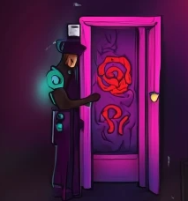

Fig. 11 Representative student-generated visual metaphor constructing ChatGPT as a tool inhibiting learning

Table 10. Student Metaphors illustrating [ChatGPT use for TEFL coursework
Creating concerns related to professional identity]
Sub-theme | Mataphor | Reason
Concerns related to future professional identity | getting help from an alien  a simplified way of passing | By choosing the word alien, I do not mean that it is trivial and scary for the coursework. I really get a lot of help from ChatGPT although it is not perfect and automatic, yet I am in favor of the fact that AI will take over the world without the subsequent usage. If we, as teachers and students continue in a way like we do now, it is possible that internet creatures will affect us much more in the future. By means of some limitations or strict restrictions, we can control the harmful ways that this tool could cause.  it gives me a satisfied answer and solution in order to complete my task. Today, robots and AI takes places of people. One day, "Worker" description will be gone and poor countries will begin to fade because robots are doing "harsh-jobs" instead of people who couldn't get educated.
 | revolution | everything in our life should be changed in time. These changes can be good or bad but changes will let us to help us keep up with the modern age. Good things can be easier to understand the courses material and subjects. Bad things can be plagiarism and taking the easy way out. So, using ChatGPT told us what AIs can change in our lives. Revolution is inevitable in our age. We should try to figure it out and use in our life efficiently.


Fig. 12 Representative student-generated visual metaphor illustrating the ambivalent positioning toward ChatGPT

